# Ministry of Social Development logo

# Advisor Operational Policy

# Business Enterprise Support Services

## Our purpose

**Manaaki tangata, Manaaki whānau**

We help New Zealanders to be safe, strong and independent

## Our commitment to Māori

As a **Te Tiriti o Waitangi** partner we are committed to supporting and enabling Māori, whānau, hapū, Iwi and communities to realise their own potential and aspirations.

## Our strategic direction

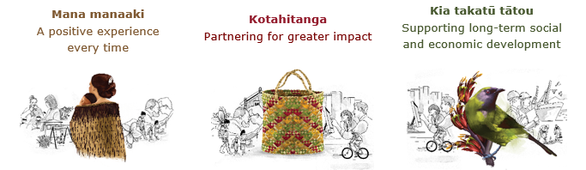

## Our Values

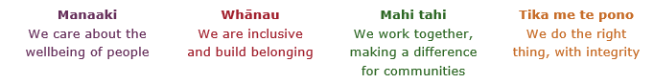

## Working in the Public Service

Ka mahitahi mātou o te ratonga tūmatanui kia hei painga mō ngā tāngata o Aotearoa i āianei, ā, hei ngā rā ki tua hoki. He kawenga tino whaitake tā mātou hei tautoko i te Karauna i runga i āna hononga ki a ngāi Māori i raro i te Tiriti o Waitangi. Ka tautoko mātou i te kāwanatanga manapori. Ka whakakotahingia mātou e te wairua whakarato ki ō mātou hapori, ā, e arahina ana mātou e ngā mātāpono me ngā tikanga matua o te ratonga tūmatanui i roto i ā mātou mahi.

In the public service we work collectively to make a meaningful difference for New Zealanders now and in the future. We have an important role in supporting the Crown in its relationships with Māori under the Treaty of Waitangi.  We support democratic government. We are unified by a spirit of service to our communities and guided by the core principles and values of the public service in our work.

## The outcomes we want to achieve

|  |  |  |
| --- | --- | --- |
| New Zealanders get the support they require | New Zealanders are resilient and live in inclusive and supportive communities | New Zealanders participate positively in society and reach their potential |

## We carry out a broad range of responsibilities and functions including

* Employment, income support and superannuation
* Community partnerships, programmes and campaigns
* Advocacy for seniors, disabled people and youth
* Public Housing assistance and emergency housing
* Resolving claims of abuse and neglect in state care
* Student allowances and loans

## **He whakataukī\***

|  |  |
| --- | --- |
| Unuhia te rito o te harakeke  Kei hea te kōmako e kō?  Whakatairangitia, rere ki uta, rere ki tai;  Ui mai ki ahau,  He aha te mea nui o te ao?  Māku e kī atu,  He tangata, he tangata, he tangata* | If you remove the central shoot of the flaxbush  Where will the bellbird find rest?  Will it fly inland, fly out to sea, or fly aimlessly;  If you were to ask me,  What is the most important thing in the world?  I will tell you,  It is people, it is people, it is people |

* We would like to acknowledge Te Rūnanga Nui o Te Aupōuri Trust for their permission to use this whakataukī

## Position detail

### Overview of position

The role of the Advisor Operational Policy is to enhance frontline service delivery to the Ministry’s clients through:

* developing policy guidelines for service delivery
* participating in managing projects to implement policy changes and operational changes for service delivery.

### Location

National Office, Wellington

### Reports to

Team Manager Operational Policy

## Key responsibilities

**Contribute to the development of operational policy and supporting tools and resources**

* Work within strategic policy frameworks to support the translation of strategic policy into high quality operational policy design.
* Provide analysis of issues, development of alternative solutions, assessment of their feasibility within operational policy and presentation of recommendations.
* Contribute to the design and development of the systems, methodologies, tools and policy instruments required to translate design into operational guidelines and work with Service Delivery teams to assure their effective use.
* Develop policy guidelines using approved operational policy design and ensure guidelines reflect policy intent, provide clear and complete information for staff, and are linked to the appropriate legislative authority.
* Provide quality operational policy design advice and support, including advice which ensures compliance with statutory/regulatory obligations, and provides guidance on how statutory obligations and Government decisions should be implemented.
* Provide analysis and advice to other teams throughout the Ministry who are working on related issues and contribute to the effective integration and co-ordination of related policies.
* Contribute to the establishment and co-ordination of information collection, planning and consultation processes which feed into the development of operational policy design.

### Monitor and support implementation of operational policy

* Support Service Delivery staff in the implementation and maintenance of operational policy.
* Providing advice and clarification to service delivery staff on policy guidelines.
* Promoting policy guidelines and the Ministry’s approach to regions and frontline staff

## Embedding te ao Māori

* Embedding Te Ao Māori (te reo Māori, tikanga, kawa, Te Tiriti o Waitangi) into the way we do things at MSD.
* Building more experience, knowledge, skills and capabilities to confidently engage with whānau, hapū and iwi.

## Health, safety and security

* Understand and implement your Health, Safety and Security (HSS) accountabilities as outlined in the HSS Accountability Framework.
* Ensure you understand, follow and implement all Health, Safety and Security and wellbeing policies and procedures.

## Emergency management and business continuity

* Remain familiar with the relevant provisions of the Emergency Management and Business Continuity Plans that impact your business group/team.
* Participate in periodic training, reviews and tests of the established Business Continuity Plans and operating procedures.

## Know-how

* Previous experience in developing operational guidelines in a Service Delivery environment preferred.
* MSD business knowledge and understanding of state sector environment and machinery of Government preferred.
* Level of professional and technical knowledge in job related areas such as design, research and policy or legislation.
* Proven understanding of information management techniques.
* Proven record of excellent communication skills (oral and written) and ability to establish credibility across different levels of the organisation.
* Computer literacy.
* Write clear and concise reports at both a strategic and operational level

## Attributes

* Ability to influence
* Strong analytical skills
* Exercise strong judgement and problem solving skills
* Ability to research, plan and organise
* Professionalism at the highest standard

### Internal

* Members of National Office Service Delivery teams
* Regional Commissioners, Managers and frontline staff
* Offices of the Chief Executive and Deputy Chief Executive for Service Delivery
* MSD Communications group
* MSD Policy
* Legal Services
* Other MSD staff as appropriate

### External

* Other government agencies and departments as appropriate
* External parties relevant to project areas being managed
* Other relevant external parties

## Other

### Delegations

* Financial –No
* Human Resources - No

### Direct reports - No

### Security clearance - No

### Children’s worker - No

Limited adhoc travel may be required

**Position Description Updated:** January 2022