# Ministry of Social Development logo

# Advisor

# Service Delivery

## Our purpose

**Manaaki tangata, Manaaki whānau**

We help New Zealanders to be safe, strong and independent

## Our commitment to Māori

As a **Te Tiriti o Waitangi** partner we are committed to supporting and enabling Māori, whānau, hapū, Iwi and communities to realise their own potential and aspirations.

## Our strategic direction

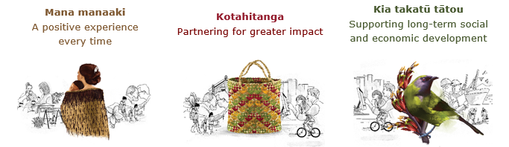

## Our Values

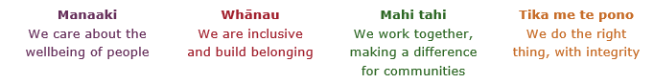

## Working in the Public Service

Ka mahitahi mātou o te ratonga tūmatanui kia hei painga mō ngā tāngata o Aotearoa i āianei, ā, hei ngā rā ki tua hoki. He kawenga tino whaitake tā mātou hei tautoko i te Karauna i runga i āna hononga ki a ngāi Māori i raro i te Tiriti o Waitangi. Ka tautoko mātou i te kāwanatanga manapori. Ka whakakotahingia mātou e te wairua whakarato ki ō mātou hapori, ā, e arahina ana mātou e ngā mātāpono me ngā tikanga matua o te ratonga tūmatanui i roto i ā mātou mahi.

In the public service we work collectively to make a meaningful difference for New Zealanders now and in the future. We have an important role in supporting the Crown in its relationships with Māori under the Treaty of Waitangi.  We support democratic government. We are unified by a spirit of service to our communities and guided by the core principles and values of the public service in our work.

## The outcomes we want to achieve

|  |  |  |
| --- | --- | --- |
| New Zealanders get the support they require | New Zealanders are resilient and live in inclusive and supportive communities | New Zealanders participate positively in society and reach their potential |

## We carry out a broad range of responsibilities and functions including

* Employment, income support and superannuation
* Community partnerships, programmes and campaigns
* Advocacy for seniors, disabled people and youth
* Public Housing assistance and emergency housing
* Resolving claims of abuse and neglect in state care
* Student allowances and loans

## **He whakataukī\***

|  |  |
| --- | --- |
| Unuhia te rito o te harakeke  Kei hea te kōmako e kō?  Whakatairangitia, rere ki uta, rere ki tai;  Ui mai ki ahau,  He aha te mea nui o te ao?  Māku e kī atu,  He tangata, he tangata, he tangata* | If you remove the central shoot of the flaxbush  Where will the bellbird find rest?  Will it fly inland, fly out to sea, or fly aimlessly;  If you were to ask me,  What is the most important thing in the world?  I will tell you,  It is people, it is people, it is people |

* We would like to acknowledge Te Rūnanga Nui o Te Aupōuri Trust for their permission to use this whakataukī

## Position detail

### Overview of position

The Advisor, Service Delivery will be involved in supporting the design, development and implementation of national strategies and initiatives to support MSD to achieve client outcomes. In addition, the Advisor will support with professional advice, analysis and support and develop effective relationships with key stakeholders, colleagues and staff throughout the Ministry.

The Advisor role will operate at a support level across all key accountabilities, and have responsibility for supporting complex work, relationship management and representation of the work programme in different forums (internal and external).

### Location

National Office, Wellington

### Reports to

People Lead

## Key responsibilities

### Advice and Support

* Proactively provides high-quality, timely advice and analysis.
* Provides proactive support to the team and keeps fully up to date and aware of issues and developments.
* Uses knowledge, expertise and experience to define and understand issues and to identify and anticipate needs.
* Translates thinking into practical actions.
* Provides advice on implications of strategy, policy or design initiatives including trends, risks and developments, identifying significant issues that may impact on work programmes and delivery.
* Analyse and review all available information and recommends options for planning and implementation that meet strategic goals.
* Leverage lessons learned and collective experiences to adopt a focus on continuous improvement.

### Implementation and Research

* Contribute to the implementation of policies and programmes to achieve the strategic direction of Service Delivery.
* Support the co-ordination of research into trends, technological developments and best practice, to aid strategic direction, design and development.
* Support the analysis of operational and statistical information and reports, forecasts and formulate strategies to ensure employment resources are effectively maximized.
* Presents findings in report format.
* Use appropriate resources and techniques to source, research, and report on relevant information.

### Stakeholder and Relationship Management

* Build sustainable relationships with a variety of stakeholders and ensure that all relevant stakeholders are kept informed.
* Communicate information relating to initiatives, interagency projects and timeframes within the Ministry and other key agencies.
* Build and maintain excellent relationships and partnerships with internal and external stakeholders.
* Participate as an active team member and contribute knowledge and expertise across the team and wider Service Delivery.
* Develop effective working relationships with Ministry staff in order to transfer knowledge and learning from the team to the wider organisation.

### Risk Management

* Support risk and issues management including identifying, managing, monitoring and mitigating risk and issues.

## Embedding te ao Māori

* Embedding Te Ao Māori (te reo Māori, tikanga, kawa, Te Tiriti o Waitangi) into the way we do things at MSD.
* Building more experience, knowledge, skills and capabilities to confidently engage with whānau, hapū and iwi.

## Health, safety and security

* Understand and implement your Health, Safety and Security (HSS) accountabilities as outlined in the HSS Accountability Framework.
* Ensure you understand, follow and implement all Health, Safety and Security and wellbeing policies and procedures.

## Emergency management and business continuity

* Remain familiar with the relevant provisions of the Emergency Management and Business Continuity Plans that impact your business group/team.
* Participate in periodic training, reviews and tests of the established Business Continuity Plans and operating procedures.

## Know-how

* Understanding of key relevant issues facing the Ministry and the Government
* Proven experience in strategy and policy development, service design or implementation of projects and initiatives
* Proven ability to work collaboratively and responsively in both government and non-government settings
* Has a strong client focus and is able to bring that into the work they do
* Highly effective level communication skills and demonstrated ability to build and maintain strong stakeholder networks and relationships
* Clear and articulate communicator demonstrated by high levels of written and verbal presentations
* Understands linkages and commonalities and sector differences between public, private and NGOs sector
* Demonstrated experience working in a national team supporting a distributed service delivery network
* Write clear and concise reports at both a strategic and operational level
* A relevant tertiary qualification or relevant equivalent experience.

## Attributes

* Strong communication skills, both written and verbal
* Exercises sound judgement and political sensitivity
* Highly effective communication skills
* Flexible, adaptable and pragmatic
* Strong client focus
* Business acumen

## Key relationships

### Internal

* Service Delivery Leadership
* Senior Executives in the Ministry and their teams
* Policy
* Strategy and Insight Group
* Communications and Media teams
* DCE Advisors
* Ministerial and Executive Services

### External

* Minister’s office
* External Agencies
* Other government agencies and departments

## Other

### Delegations

* Financial – No
* Human Resources – No

### Direct reports - No

### Security clearance - No

### Children’s worker - No

Limited adhoc travel may be required