Heartland Services
quarterly provider reporting

Guide for providers

Version: HSGFP-2026/06/23-Final
Contents
Introduction 3
Purpose of this document 3
About the data 3
Collecting data 4
What you are collecting data about 4
Data collection tools 4
How to submit your reporting 6
Guidance for reporting 6
Section 1: Support interactions between Heartlands staff and clients 7
Section 2: Connecting clients to government agencies 11
2a) Support from Heartlands staff to access agencies 11
2b) Meetings and workshops with government agencies 14
Section 3: Connecting clients to NGOs and community services 17
Section 4: Other services provided through Heartlands 22
Section 5: Qualitative reporting 26
Qualitative: Case examples 26
Qualitative: Issues and patterns in client access 27
Qualitative: Quarterly news from your Heartlands site 27
Qualitative: Additional comments 28
Frequently asked questions (FAQs) 29

Introduction

Purpose of this document
This document is the primary guide for Heartland Services (Heartlands) providers for collecting and preparing data for quarterly reporting to the Ministry for Social Development (MSD). It supports new provider reporting requirements that come into effect from 1 July 2026 onwards.
The guide covers:
- the data that Heartlands providers are required to collect and report on to MSD
- how to use the reporting template
- how to use the data collection tools
- Frequently Asked Questions (FAQs) (to be added to the final version).
This document sits alongside the Service Guidelines for Heartlands. It does not replace any guidance from MSD Service and Contracts Management around how to submit reporting to MSD.

About the data
The data you collect and report to MSD serves two important purposes: it helps MSD understand and support the work of Heartlands providers, and it is a requirement of your contract with MSD.
This includes the services and support delivered directly by Heartlands staff, and the services and support delivered by other parties (such as government agencies and community services) through Heartlands.
The data collected through reporting provides us with information about:
- services and support you provide to Heartlands clients, including support accessing agencies, non-governmental organisations (NGOs) and community services
- support government agencies provide to clients through Heartlands
- client case examples and patterns in client support needs.

Collecting data

What you are collecting data about
The reporting asks providers to collect data about the services and support that clients access through Heartlands. This includes support and services provided by Heartlands staff directly, and support provided by government agencies through Heartlands.
Anytime a client accesses a service, support, advice, assistance or navigation through Heartlands, this is called a ‘support interaction’. In the reporting, a support interaction is defined as: any support, assistance or services provided through Heartlands to one client during one calendar day.
Capturing ‘support interactions’ enables us to capture a count of support provided to clients across the quarter. The reporting also captures the nature and type of assistance and support Heartlands provides to clients.
When a client accesses Heartlands, staff need to record a small number of datapoints about the support interaction. These include:
- where the client accessed support (in-person at the office, at an outreach/offsite location, not in-person (i.e. over the phone or email))
- government agencies Heartlands staff supported the client to access
- NGOs or community services Heartlands staff supported the client to access
- if the client attended any meetings or workshops with government agencies at the Heartlands site
- other services provided such as digital access support, printing and scanning.

Data collection tools
We have developed some tools to help you collect this data: the Data Collection Spreadsheet, Data Collection Printable Sheet and Data Collection Printable Table. These tools are optional and have been designed to support you in collecting and calculating your data for reporting. They are available for download on the MSD Guidance and resources for Heartlands providers webpage.
Training and support for using the Data Collection Spreadsheet is available to Heartlands staff. Please contact your Relationship Manager to arrange this.

Tool: Data Collection Spreadsheet
The Data Collection Spreadsheet helps you quickly collect data about support interactions using drop-down, multi-choice options. It then automatically calculates the outputs needed for your reporting.
The spreadsheet has been developed for use with Microsoft Excel. It will not work correctly on Google Docs or other online platforms. The spreadsheet cannot be edited or changed by providers – this is because it uses formulas to calculate the data outputs.
If you choose to use the Data Collection Spreadsheet to help you record data, please download a fresh copy each quarter from the MSD webpage “Guidance and Resources for Heartlands Providers” to ensure you have the most up-to-date version, and that data from previous quarters is not included in your report.
Tools: Data Collection Printable Sheet and Table
The Data Collection Printable Sheet is a one-page sheet that helps you manually record data about support interactions. All the datapoints you need to collect about a single support interaction are listed together on a single page, with boxes that can be ticked or highlighted to indicate relevant information across each of the report sections.
The Data Collection Printable Table is another tool which you can use manually record data about support interactions. Similar to the Sheet, the Table has all the datapoints you need to collect about a single support interaction listed together in columns across a single page. You may find it helpful to refer to the one-page summary sheet, ‘Lists of categories and agencies for Heartland Services provider reporting’, to ensure you record the correct agencies and categories of support in the Table.
Both tools have developed as templates that you can adapt and change to the needs of your individual service.

How to submit your reporting
Please email completed quarterly reports in the Excel format to:
- MSD National Contracts Admin Hub at National_Contracts_Admin_Hub@msd.govt.nz
- CC in the MSD Relationship Manager listed in your Outcome Agreement and the Heartlands inbox (Heartland_Services@msd.govt.nz)
Reporting due dates and the latest reporting template and supporting tools are available on the Guidance and resources for Heartlands providers webpage.

Guidance for reporting
The reporting requires you to collect and report data across five sections:
- Section 1: Support interactions between Heartlands and clients
- Section 2: Connecting clients to government agencies
- 2a) Support from Heartlands staff to access agencies
- 2b) Client meetings and workshops with government agencies
- Section 3: Connecting clients to NGOs and community services
- Section 4: Other services accessed through Heartlands
- Section 5: Qualitative reporting
The following sections of this guide explain how to collect data for each section and how to enter this data into the reporting template.

Section 1: Support interactions between Heartlands staff and clients
Data collected in this section
This section counts the number of support interactions between clients and Heartlands across the reporting period. These are counted based on where the client was when they accessed Heartlands: either in-person at the Heartlands office, at an offsite/outreach location, or not in-person (i.e. by phone, email, chat, etc). The next three sections of the quarterly report (Sections 2, 3 and 4) capture information about the type of support and services that are provided within the support interactions.
A ‘support interaction’ is defined: as any support, assistance or services provided through Heartlands to one client during one calendar day. Support interactions include both instances where support was provided directly by Heartlands staff, and instances where a client accesses support from a government agency through Heartlands but support is not provided directly by Heartlands staff (for example, when someone visits Heartlands only to attend a scheduled meeting with an agency).
Over the quarterly reporting period, a client may have accessed Heartlands across multiple days. Each day they accessed Heartlands is counted as a separate support interaction.
What you need to count and report on
Count the clients that access Heartlands each day, and the primary location where they accessed Heartlands. There are three location options:
- In-person at the Heartlands office
- In-person at outreach and offsite services
- Not in-person (for example, email, phone, chat or text)
Specific rules
If a client accesses Heartlands more than once on the same day, count this as one support interaction. A single ‘support interaction’ count includes:
- All support accessed by one client during one calendar day
- The same client making multiple visits in the same day
- Helping the same client with several different issues
- In-person interactions which involve any support that is provided to a client face-to-face by Heartlands staff (including in the Heartlands office, at an outreach service, or other site or event where Heartlands staff and clients are in-person)
- Any blend of phone, email, text or chat (i.e. Messenger, WhatsApp) contact on the same day from a client (counted as not in-person)
- A client attending a pre-arranged appointment
- A whānau coming in for support that impacts the whānau as a whole, would count as one support interaction. However, if the whānau comes in with individual support needs for different people within the whānau – count each of these as separate support interactions.
If a client receives support across multiple days, count each day as separate support interaction. For example, if a client comes in on three different days in the same week, count this as three interactions.
If a client accesses Heartlands both in-person and not in-person (i.e. by email or phone) in the same day, don’t record multiple support interactions. In this case, use your discretion to decide which support location is most appropriate – for example, if there was a short phone call followed by a longer in-person meeting, you may opt to count this as 'In-person at Heartlands office' given the support was primarily provided in-person. However, if your site logs interactions by how the client first makes contact in a day, recording it as 'Not in-person' is also acceptable.
How to identify Heartlands support interactions if a provider offers other co-located services
Many Heartlands services are co-located with other services (for example, Building Financial Capability or budgeting advice, youth coaches, or disability support) and are often also delivered by the same organisation that delivers Heartlands.
A support interaction requires a client to receive some support from Heartlands. This could include examples such as direct support from a Heartlands staff member, attending a workshop run by an agency or NGO at Heartlands, or using a Heartlands computer to access free internet or printing. If a client asks for advice from Heartlands staff, and then as a result is referred to another service delivered by their own organisation, the support from Heartlands staff to make the internal referral counts as a support interaction.

Situations where a client does not receive any support from Heartlands do not count as a support interaction. If a client comes on site only to access another non-Heartlands service, and they do not interact with Heartlands in any way during their visit, this is not a support interaction.
For example: if a young person has an appointment with a youth coach, and attending their appointment is all they do while visiting, then this is not a Heartlands support interaction. However: if the young person speaks with Heartlands staff while on site and receives support (for example, around their benefit), or uses a Heartlands computer to access free printing, this should be counted as a support interaction.
Examples of support interactions
Example | Recorded in Section 1 as…
Ava visits the office for help using MyIR. | One support interaction (in-person at Heartlands office)
Sam calls for information about ACC and books a meeting with a coordinator for the following week. | One support interaction (not in-person) for the initial phone call  One support interaction (in-person at Heartlands office) the following week
Mika visits the office twice on Tuesday once in the morning for MyIR assistance and once in the afternoon for MyIR and online banking assistance | One support interaction (in-person at Heartlands office)
Brett visits the office three times on Monday and once on Friday for help with his benefit. | Two support interactions, one for each day (in-person at Heartlands office)
Hāmiora visits the office on Monday and Friday and attends an outreach service on Thursday. | Three support interactions in total:  - One support interaction on Monday (in-person at Heartlands office)  - One support interaction on Friday (in-person at Heartlands office)  - One support interaction on Thursday (in-person at outreach and offsite services)
Steve attends an appointment with his Probation Officer at his local Heartlands site. This appointment was arranged directly between Steve and his Probation Officer, with no Heartlands staff involvement. | One support interaction as the meeting uses Heartlands facilities (in-person at Heartlands office)
Ana and her mother, Miriama come to Heartlands to discuss what support is available for Ana’s teenage son who is experiencing mental health difficulties. | One support interaction (in-person at Heartlands office)

Template example – Total support interactions for the quarter
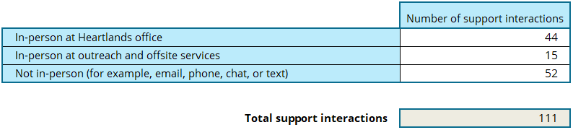
In this example, over the quarter:
- 44 support interactions occurred in-person at the HS office,
- 15 support interactions at outreach services, and
- 52 support interactions were provided when the client was not in-person.

Section 2: Connecting clients to government agencies

2a) Support from Heartlands staff to access agencies
Data collected in this section
This section records how often Heartlands staff help clients access government agencies.
This includes any support Heartlands staff give to clients to access an agency, including:
- providing general information about the services or supports available through the agency
- supporting them to use a website or complete an application
- making a referral to an agency for a client
- organising a one-on-one meeting for the client with an agency representative
- booking a client into an agency-run workshop
- calling an agency on behalf of the client
What you need to count and report on
Each time Heartlands staff help a client access a government agency, count the agency or agencies the client was supported to access.
Specific rules and guidance
- Each agency you help a client access during a support interaction equals one count for that agency
- If there are multiple actions for a single agency for the same client during a support interaction – count this only once for that agency
- If you help a client access several different agencies in a single support interaction, count against all of the agencies (not just one of them)
- Include all contact types (in-person, phone, email)
Examples for Section 2a
Example | Recorded in Section 2a as…
You supported Sarah to book a meeting with MSD Work and Income and helped her log into her MyIR portal. | - One count for MSD Work and Income  - One count for Inland Revenue  - And one ‘support interaction’ count in Section 1
You helped Natalie access Corrections and Te Puni Kōkiri (TPK) in one visit. | - One count for Corrections  - One count for TPK  - And one ‘support interaction’ count in Section 1
You supported Ana on Monday, Wednesday and Thursday with an ACC issue. | - Three counts for ACC  - And three ‘support interaction’ counts in Section 1
You supported Andrew by calling IR on his behalf, then helped him set up his MyIR portal, and fill out a required form in one visit. | - One count for IR  - And one ‘support interaction’ count in Section 1

Template example – Total supports to access agencies for quarter
In this example, Heartlands staff supported 121 connections to agencies across the reporting period.
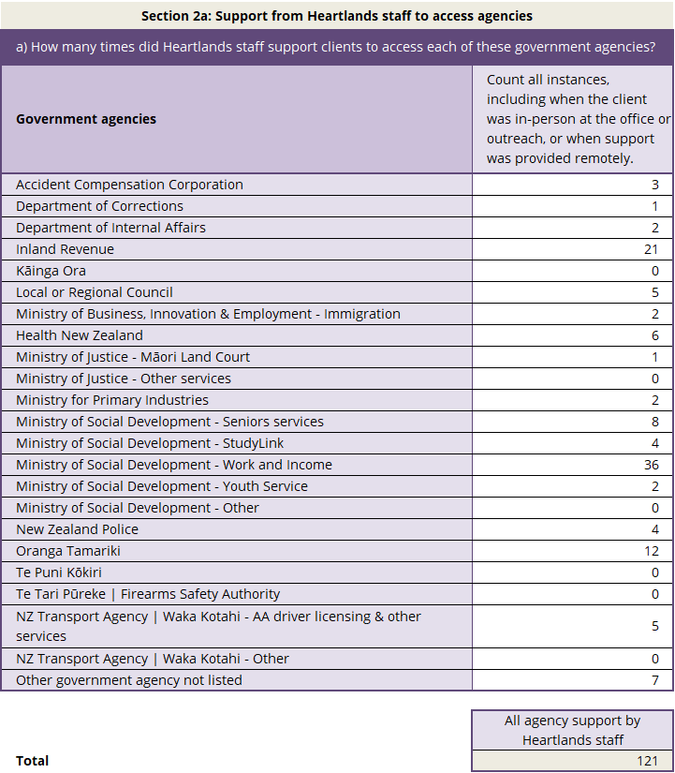

2b) Meetings and workshops with government agencies

Data collected in this section
This section collects data about the number of times clients meet directly with government agencies or attend an agency-run workshop or training session while in-person at Heartlands. This includes face-to-face meetings at appointments and drop-in clinics; scheduled calls and videoconferences; and attendance at workshops, seminars or training sessions.
This information is counted across three categories. All three categories include the client being in-person (at a Heartlands office, outreach service or other offsite Heartlands event), but how the agency connects with them varies across the categories:
- All in-person at Heartlands: The client and agency meet in-person at Heartlands (either at the office or at an outreach/offsite service)
- Agency remote: The client is in-person at Heartlands for a scheduled individual meeting, and the agency attends the meeting remotely (i.e. via Zoom or teleconference)
- Agency-run workshop: The client is in-person at Heartlands to attend an agency-run workshop or training session. The agency may be running the workshop in-person or online (i.e. via Zoom).

What you need to count and report on
Count the number of clients who:
- Meet with a government agency directly through Heartlands for a scheduled appointment. This includes:
- face-to-face meetings and drop-in clinics (All in-person at Heartlands); and
- videoconferencing and scheduled phone appointments (Agency remote)
- Attend workshop(s), seminars or training sessions run by an agency (Agency-run workshop)
Clients must be in-person at the Heartlands office or in-person at an outreach / offsite service for the meeting or workshop to be counted.

What not to count
- You do not need to collect data about meetings that do not happen at Heartlands. For example, if you organise for IR to call a client back when the client has left Heartlands, you do not need to record this information in Section 2b. However, you would still record the relevant information in Sections 1 and 2a, capturing the support provided to set up the phone call.
- Don’t count unscheduled, informal interactions between clients and agencies: these are counted under Section 2a. For example, if Heartlands staff helped a client make an unscheduled call to an 0800 number for an agency, or you call someone on their behalf during a support interaction.

Specific rules and guidance
- Double counting can occur across Sections 2a and 2b.
- If Heartlands staff helped a client arrange an in-person meeting with an agency, then you would count:
- the support for the arrangement of the meeting by Heartlands staff in Section 2a
- the client attendance at the meeting with the agency in Section 2b
- the number of support interactions in Section 1.
- For example: if a client came into Heartlands and requested a meeting with Te Puni Kōkiri, and then they came back to Heartlands for a scheduled meeting with Te Puni Kōkiri that afternoon – this would be counted in both sections 2a and 2b, alongside one count in Section 1.
- A client receiving individualised one-on-one and face-to-face support at an agency-run drop-in clinic would count towards ‘All in person at Heartlands’ in 2b. A client attending a group-based workshop or information session would count towards ‘Agency-run workshop’.

Examples
Example | Recorded in 2b as…
MSD Work and Income run an in-person seminar at the Heartlands office that five people attend, following which they have three individual client meetings with clients who did not attend the seminar | - Five counts in Section 2b (MSD W&I, ‘Agency-run workshop’)  - Three counts in Section 2b (MSD W&I, ‘All in-person at Heartlands’)  - And eight support interactions in Section 1
Whetu is helped by a coordinator on Monday to schedule a video meeting with IR on Tuesday morning. Whetu also attends a pre-organised MSD Youth Service workshop at Heartlands on Thursday afternoon which he organised directly with MSD. | - Monday:  - One count in Section 2a Inland Revenue  - One support interaction in Section 1  - Tuesday:  - One count Section 2b (IR, ‘Agency remote’)  - One support interaction in Section 1  - Thursday:  - One count in Section 2b (MSD Youth Service, ‘Agency-run workshop’)  - One support interaction in Section 1
Steve attends an appointment with his Probation Officer, at his local Heartlands site. | - One count in 2b (Department of Corrections, ‘All in-person at Heartlands’),  - And one support interaction in Section 1

Template example – Total meetings and workshops with government agencies for the quarter
In the example below, there were meetings and workshops across all categories during the quarter. IR, MBIE Immigration, MSD W&I and OT all held in-person meetings at Heartlands (total: 17 meetings); MSD W&I also met with clients via Zoom (total: 3 meetings); and DIA ran a workshop (total: 12 workshop attendees).
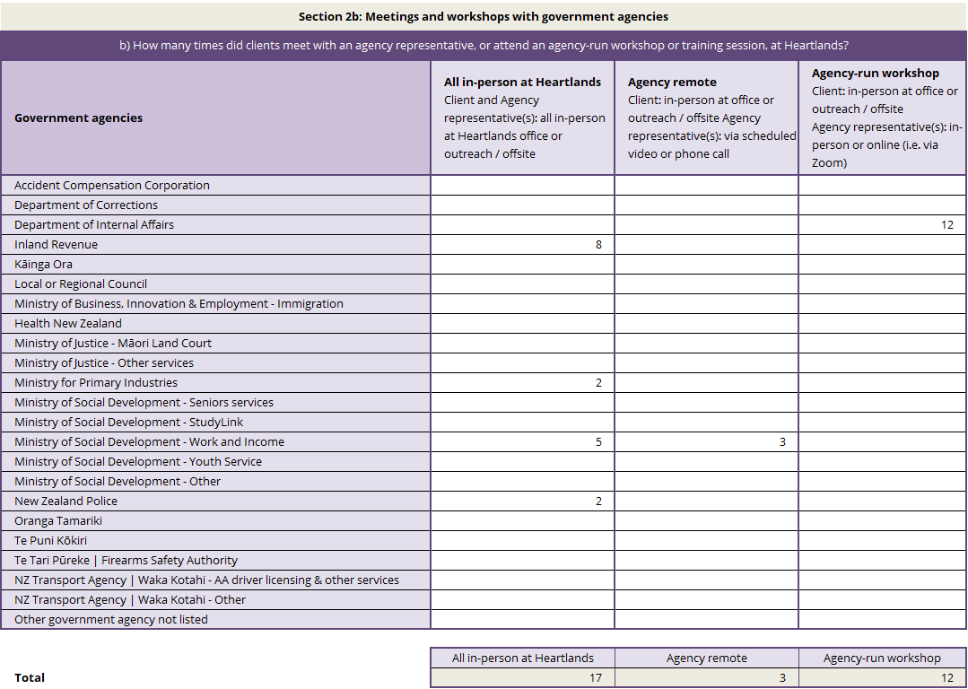

Section 3: Connecting clients to NGOs and community services
Data collected in this section
This section collects data about the number of times Heartlands staff support clients to access NGOs and community services. This is similar to data collected in Section 2a. This includes:
- providing general information about the services or supports available through the NGO or community service
- supporting them to use a website or complete an application
- making a referral to an NGO or community services for a client
- organising a one-on-one meeting for the client with an NGO or community service
- booking a client into a workshop being run by the NGO or community service
- calling an NGO or community service on behalf of the client
What you need to count and report on
Each time Heartlands staff help a client access an NGO or community service, count which category of organisation or services the client was supported to access.
Specific rules and guidance
- Each support interaction that includes support for a client access a category of NGO or community service, equals one count for that category
- If there are multiple actions or referrals for a single category of NGO or community service in a single support interaction – count this only once for that category. For example, if you refer someone to three different parenting support organisations, count this only once against ‘Family and parenting programmes’
- Counting against multiple categories is allowed. If an NGO/community service fits multiple categories, you can count it in all relevant categories. For example, if you refer a client to a service because it is both a kaupapa Māori service and an older person’s health service, you can count the single referral in both categories.
- Include all contact types (in-person, phone, email)

Descriptions for categories
Category | Description of category
Adverse weather events and natural disasters | Support related to emergencies such as floods, earthquakes, storms, landslips, or other disasters.
Child health and maternity | Services supporting pregnancy, childbirth, and the health and development of babies and young children.
Counselling and therapy | Counselling, psychology, therapy or other services.
Digital health care or telehealth | Health or support services delivered remotely using phone, video, or online platforms (e.g. virtual GP or counselling appointments).
Disability support | Services that support disabled people (e.g. support services, funding assistance, needs assessments).
Driving lessons and licensing | Support with obtaining or maintaining a driver licence, including lessons or licence-related programmes.
Elder abuse support | Services that respond to or prevent harm, abuse, neglect, or exploitation of older people.
Employment or career support, incl. CV support | Services that help people find, prepare for, or maintain employment (e.g. CV writing, job search support, etc).
Ethnic communities services | Services for specific ethnic communities, including community-based organisations and culturally aligned services.
Family and parenting programmes | Services that support parenting skills and family relationships (e.g. parenting courses, family support programmes).
Family violence or sexual violence services | Services supporting people experiencing or affected by family or sexual violence, including crisis support, advocacy, and safe housing.
Financial and budgeting | Services that help people manage money, budgeting, debt, or financial planning (e.g. budgeting services, financial mentoring).
Food bank or other food support | Services providing food assistance, including food banks, food parcels, or community meal programmes.
Homelessness | Services supporting people who are experiencing homelessness or without stable accommodation.
Housing, including heating, insulation, rental issues | Services related to housing needs, including tenancy advice, housing conditions, and rental support.
Interpreting and translation services, or English / other language lessons | Services that help overcome language barriers, including interpreters, translation, or language learning programmes.
Iwi and hapū organisations | Connections to Rūnanga, marae and other services delivered by and/or connected to iwi or hapū.
Justice of the Peace (JP) | Access to a Justice of the Peace for witnessing documents, certifying copies, or other JP services.
Kaupapa Māori services | Services that are built on Māori cultural values, practices, and tikanga.
Legal advice or support, including Community Law | Services providing legal information, advice, or representation (e.g. Community Law centres).
Mental health and addictions services | Clinical or specialist services supporting mental health conditions or addiction issues.
Navigation or advocacy services | Services that help clients understand systems, access services, or advocate on their behalf (e.g. social navigators, advocates).
Older people, including aged care | Services for older people, including wellbeing, social connection and other supports.

Examples
Example | Recorded in Section 3 as…
You supported Marama to connect to a budgeting adviser and a career adviser in one visit. | - One count for ‘Financial and budgeting services’  - One count for ‘Employment or career support, including CV support’,  - And one support interaction in Section 1
You supported Andy to connect with a social group for parents. | - One count for ‘Family and parenting programmes’  - And one support interaction in Section 1
Hera came into your site for assistance connecting to the nearest kaupapa Māori mental health service for her son | - One count for ‘Kaupapa Māori services’  - One count for ‘Mental health and addiction services’  - And one support interaction in Section 1

Template example – Total supports to access NGO or community services for the quarter
In this example, Heartlands staff supported clients to access a range of services from NGOs and community services 117 times across the reporting period.
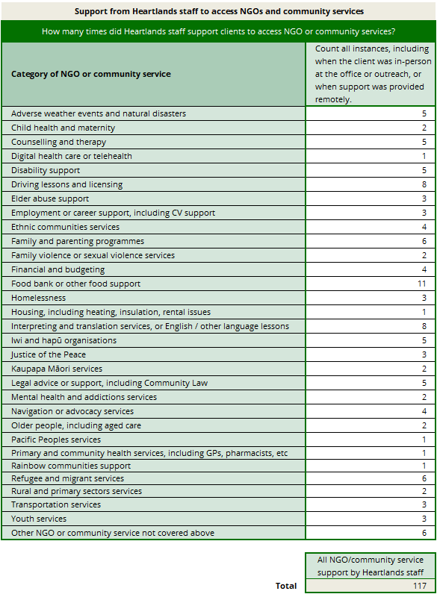

Section 4: Other services provided through Heartlands
Data collected in this section
This section collects data about other services provided to clients by Heartlands staff. We are collecting data about five services:
- Access to computers, email, Wi-Fi and phone
- Informal drop-in support and chats over a cuppa
- Printing and scanning
- Support to learn how to use digital technology and devices
- Support with forms or online platforms for banking, insurance and other financial tasks
What you need to count and report on
Each time clients access one of these five services through Heartlands, count which type of service was provided.
Specific rules and guidance
- Count the number of times that each of the services are provided to Heartlands clients. This includes:
- When a client has come in specifically for one of these types of service (e.g. they have come in exclusively to scan a copy of their passport, or they only drop in for a cup of tea and a chat with staff)
- When these types of service are provided as part of a support interaction that involves being connected to an agency or a service (e.g. as part of the support they receive from Heartlands to access IR, they have material printed for them)
- Each instance of other services equals one count for that type of service
- One support interaction can include multiple types of other services provided.
- Double counting may occur alongside counts in Sections 2 and 3.
- For example, if Heartlands staff supported a client in-person with accessing the MyIR account online, and also supported them to check their email and use their internet banking, then you would count:
- the support interaction in Section 1 (one count for ‘In-person at Heartlands office’)
- the support with accessing their MyIR account in Section 2a (one count for ‘Inland Revenue’)
- the support to check their email and use their internet banking in Section 4 (one count for ‘Access to computers, email, WiFi and phone’, and one count for ‘Support with forms or online platforms for banking, insurance and other financial tasks’).

Types of services and examples
Services | What to count |  | Examples
Access to computers, email, Wi-Fi and phone | Each time a client accesses the computers, email, telephone or uses the Wi-Fi. | Sanjay uses the computer to access his e-mail and social media (one count ‘Access to computers, email, Wi-Fi, and phone’).  Ana meets with a Heartlands coordinator regarding a letter she received from Work and Income. She uses a phone at Heartlands to call the 0800 number to talk to someone from MSD (one count ‘Access to computers, email, Wi-Fi and phone’)
Informal drop-in support and chats over a cuppa | Each time Heartlands staff spend time one-on-one with a client providing social connection or conversational support. | Mark comes by the office every Thursday morning for a cup of tea and a chat on his regular walk. He doesn’t usually need any referrals or agency support – he just wants to spend some time having a chat with the staff. (one count ‘Informal drop-in support and chats over a cuppa’)
Printing and scanning | Each time a client uses the printer or scanner. | Leilani prints and scans some forms for applying for government support (one count ‘Printing and scanning’).  Meari receives support to apply for a passport from a Heartlands coordinator, which involves the scanning of a passport picture (one count ‘Printing and scanning’)
Support with forms or online platforms for banking, insurance and other financial tasks | Each time Heartlands staff provide support to a client with using their online banking, insurance or other financial platforms, or filling in related forms.  Please note: Heartlands staff should never provide financial advice, and should prioritise client privacy and security when supporting them with financial tasks. |  | Hine receives help from a Heartlands coordinator on how to pay a bill over the phone (one count ‘Support with forms or online platforms for banking, insurance and other financial tasks’)  Kitty receives help on how to use an online banking app (one count ‘Support with forms or online platforms for banking, insurance and other financial tasks’)
Support to learn how to use digital technology and devices | Each time Heartlands staff assist a client with learning how to use digital technology or how to do tasks using digital technology. |  | Ariki needs help setting a new pin code on his mobile phone and learning how to do video calls with his grandkids (one count ‘Support to learn how to use digital technology and devices’).  Amy receives help setting up an email account (one count ‘Support to learn how to use digital technology and devices’).

Template example – Total Other Services for the quarter
In this example, Heartlands clients received 66 instances of other services across the reporting period.
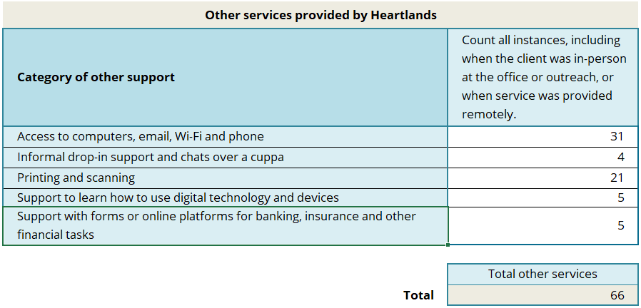

Section 5: Qualitative reporting

Qualitative: Case examples
Data collected in this section
This section collects anonymised examples of support provided to clients by Heartlands. The chosen case examples may highlight complexity, demonstrate impact, or reflect trends and barriers affecting people in your community.
Guidance
You are required to provide one case example. You have the option of providing a second case example as well. Each case example should be:
- Approximately 100-150 words long
- Based on support provided to a real client
- Anonymised – any identifying details should be removed
Each case example should cover:
- The situation: presenting needs, challenges or barriers
- Your actions: What you did to help the client
- Outcome: What happened? What was the result for the client? Were there any unresolved issues?
Example
Mr A is an older man in his 70s. He came to Heartlands on Monday morning asking for support with purchasing a new phone. His phone had recently stopped working. Heartlands staff contacted the local MSD Work and Income team to check the process for accessing a grant or benefit advance payment. We supported him to get together all the documentation he needed, including researching a new phone and options, and then helped him call MSD W&I. Mr A spoke to MSD W&I, who approved an advance payment which was put onto Mr A’s payment card. Mr A now has a new phone, and we have spent several hours showing him how to use the new functions, including video calling his grandchildren and installing online banking apps.

Qualitative: Issues and patterns in client access
Data collected in this section
This section asks you to share common issues that are resulting in clients needing to access Heartlands, or patterns and themes you are noticing in client support needs.
Guidance
This section is optional. The information you share through this section will help us to better understand the issues that are impacting people in your community and their access to the services they need, and common challenges they experience.
Your response should be a maximum of 150 words long.
Example
We have seen an overall increase in requests for support this past quarter. We have seen more requests for financial assistance and KiwiSaver Hardship withdrawals. We are also seeing more people experiencing homelessness and are providing significantly more food parcels than we have before. We have noticed that more people are asking us for help with accessing Telehealth/online GPs since the local GP clinic closed down. However, we have also noticed an expected decrease in requests for support around visa applications due to there being significantly less seasonal workers in our area over the winter months.

Qualitative: Quarterly news from your Heartlands site
Data collected in this section
This section asks you to share about what your Heartlands team has been doing over the past quarter to support your community, build networks or improve access to services. For example, this could include sharing about community hui that you facilitate or attend, market days or events that you’ve attended, or new promotional initiatives or efforts.
Guidance
This section is optional. The information you share through this section will help us understand more about the other activities and work that you are doing in your communities.
Your response should be a maximum of 150 words long.

Qualitative: Additional comments
Data collected in this section
This section asks you to share any additional comments about the last quarter that you feel are relevant for MSD to be aware of, but which the report has not been able to capture. This could include, for example, agencies that you often support people to access but which aren’t listed in Section 2.
Guidance
This section is optional.
Please don't use this section to request support from MSD or share information with MSD that requires a response or action. For any requests or urgent information, please contact your MSD Relationship Manager (RM).

Frequently asked questions (FAQs)
1. Understanding support interactions
If a client comes in multiple times in one day, how is it counted?
Count one support interaction per client per calendar day, regardless of multiple visits or multiple types of support. If a client comes in on multiple days, each day is counted as a separate support interaction.
If a client returns on another day with the same issue, how is it counted?
Each day of support is counted as a separate support interaction. For example, if you help someone with the same issue over two days, this is recorded as two support interactions, and you record any support you give client in each support interaction.
If a client has multiple support needs in one visit, how is this recorded?
Record one support interaction for the visit and log each support type in the relevant reporting section.
For example: a client needs information about their benefit and also needs documents scanned. Record this as one support interaction, and count one for Section 2a), ‘MSD Work & Income’, and count one for Section 4), ‘Printing and Scanning’.
If you interact with a client but cannot help them, does it count?
Yes, it still counts as a support interaction.
If a client comes in for a scheduled meeting but does not need support from Heartlands staff, is it counted?
It depends on the type of meeting. If the client is meeting with a government agency at Heartlands, such as Inland Revenue, it is counted as a support interaction. If the meeting is only with an NGO and Heartlands staff are not involved in providing support to the client during the visit, it is not counted.
If a client is referred to multiple organisations during one visit, how is this counted?
Record one support interaction, and a count against each agency (Section 2a) or each category of NGO and community services (Section 3) the client is referred to.
For counts in Section 3, remember that you are counting the categories referred to, not the number of organisations – so, for example, referrals to three different food banks would only be counted once against the category of ‘Food bank or other food support’.
Do we need to count if we are providing manaaki, such as cups of tea and a chat, or providing kai for community groups who are meeting on site?
It depends. If you are taking time to chat or spend time with someone who has come in for support, then count this in Section 4 under ‘Informal drop-in support and chats over a cuppa’.
However, if you are providing manaaki in the form of kai for meetings that are happening at Heartlands, for example, you don’t record this in the reporting.
2. Recording different types of contact
How do we record clients contacting us via Facebook or messaging tools?
Record these as a support interaction against the 'Not in-person (for example, email, phone, chat, or text)' option.
If support is provided via a third party, how is location recorded? For example, if a volunteer at another organisation calls to ask for support on behalf of a client.
It depends on where the client is located. If Heartlands staff provide support to a client through a third party, such as a volunteer or social worker at another organisation, and the client does not visit Heartlands, then you would record this as a not-in-person support interaction. If the client visits Heartlands in person with the support of a third party, count this as an in-person support interaction.
If a client approaches a Heartlands staff member for support when they aren’t at work, how should this be counted? This includes situations where they run into someone in the community, i.e. at the supermarket, or they contact them outside business hours, i.e. phone call or Facebook Messenger.
Interactions that occur outside of Heartlands business hours can still be recorded as support interactions. These should be recorded based on where the client was when interaction took place, and how the staff member communicated with the client.

For example, if a client sees a staff member while shopping at the supermarket and asks them a question about Inland Revenue, this could be recorded as a support interaction in Section 1) as ‘In-person at Offsite or Outreach Services’, and you could count this in Section 2a) for Inland Revenue. Or, if a client calls or messages a staff member late at night with an urgent request for support with contacting Oranga Tamariki, this could be counted as a recorded as a support interaction in Section 1) as ‘Not-in-person (for example, email, phone, chat or text)’, and you could count this in Section 2a) for Oranga Tamariki.

3. Recording different types of support
If a client only uses Wi-Fi or computers, does it count?
Yes, this would count as a support interaction and a count in the relevant ‘Other Support’ section. For example, if the client needs access to a computer and document printed, this would count as a support interaction, and you would add a count under ‘Access to computers, email, Wi-Fi and phone’ and a count under ‘Printing and scanning’.
If Heartlands holds a wānanga or info session for community members about the support available from Heartlands, how should this be counted?
If the wānanga only provides general information about Heartlands services and does not include individual support or connection to services, you can count each person attending as a support interaction.

4. Appointments and bookings
If a client books a meeting, such as a counselling session, through Heartlands and attends it later at Heartlands, how is it counted?
Record the support that you give the client to organise the session as one support interaction when the booking is made and record one count against ‘Therapy and Counselling’ in the NGO and Community Services section.
Do not count a support interaction for when the client attends the counselling session; you only need to count meetings that clients have with agencies.
If a client books an agency appointment and attends it several days later, how is this counted?
When the appointment is made, count one support interaction and one count for the relevant government agency in Section 2a).
When the client returns on the different day to attend the appointment with the agency, record this as a separate support interaction and record the meeting in Section 2b).
Note: Do not count the return visit if the meeting is with an NGO or community group unless Heartlands support is needed during that visit.
5. Events and workshops
If someone attends a workshop at Heartlands, is it counted?
Yes, this is counted as one support interaction if it occurs within the same day. Additional support provided on the same day is counted as part of the same support interaction.
How should large events or marketplace-type activities be recorded?
Information about events like these could be shared in the qualitative section of the reporting under ‘Quarterly news from your Heartlands site’. In this section, you can share details about the event, the impact you see the event has delivered and any other information you want to share.
Depending on the format of the event, you may also want to record support interactions between agencies and clients. If Heartlands organised and/or hosted the event, then you can count any interactions that clients have with government agencies where they receive similar support to what would be provided normally at your Heartland site. Count these as support interactions (using the appropriate location category) and against the relevant agency. Agencies attending your event may need to count interactions and provide you the data at the end of the event.
However, some discretion may be needed around when to record support or not. There is potential for large events to create double ups in counting of support interactions as some attendees may visit multiple agencies within one visit. Again, you can use your discretion to decide how to report these events. We encourage you to speak to your RM if you aren’t sure how to or if you should record data about an event.
6. Data collection and reporting process
How do we ensure previous quarter data is not included in the data we calculate using the Data Collection Spreadsheet for the next quarter?
We strongly recommend that each quarter you download and use new documents from the MSD Heartlands ‘Guidance and resources’ website. The template, data collection spreadsheet and guide for providers may be updated by MSD. The tools and template are available here: https://www.msd.govt.nz/what-we-can-do/community/rural-communities/guidance-and-resources-for-heartlands-providers.html
Does the data collection spreadsheet automatically calculate totals for the quarter?
Yes, the data collection spreadsheet automatically calculates reporting totals in the Outputs for Reporting tab of the spreadsheet. If all data for the quarter has been entered into the data collection sheet these totals can be copied directly into your quarterly reporting template.
Can we include client names in reporting?
Client names must not be included in reports sent to MSD. You can write client names in the Data Collection Spreadsheet or the Printable Sheet, so long as these are not communicated to MSD. All data sent to MSD should be deidentified.

