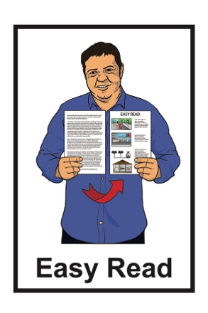

May 2022
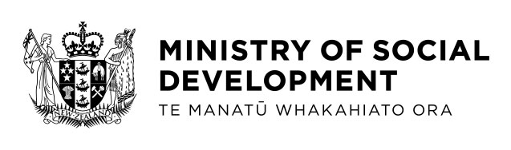

Have your say about
Working for Families tax credits
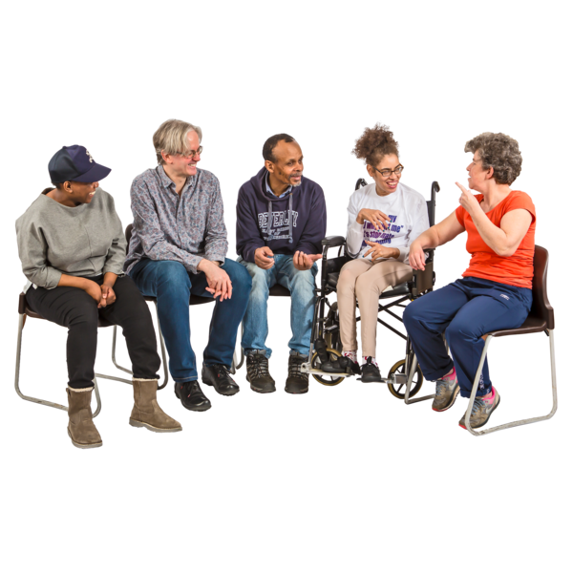

What this document is about

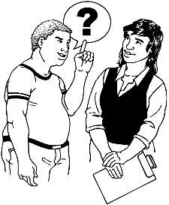
The Government wants to know what you think about Working for Families tax credits.

Working for Families tax credits are payments for families in New Zealand with lower incomes.

The payments make sure people can get the important things their family needs like:

- food

- clothes

- transport.

The Government wants to know what parts of Working for Families tax credits need to:

- stay the same

- change.

Why is the Government looking at this?

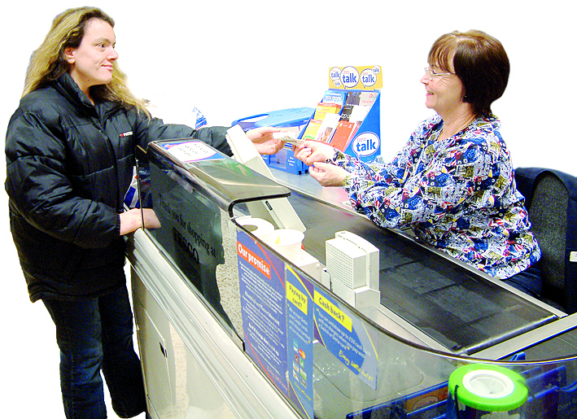
The Government wants to:

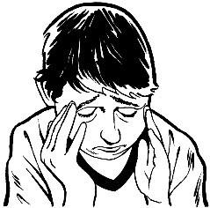
- make sure that families on low incomes have enough money to live

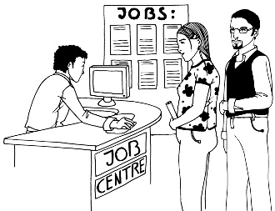
- make sure that there are less children living in poverty

- support people to take up work.

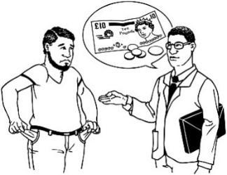
Poverty can mean that people do not have enough money to pay for things they need.

About Working for Families tax credits

About half of families with children get Working for Families tax credits each year.

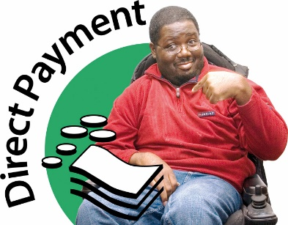
Working for Families tax credits are paid by the:

- Inland Revenue Department

- Ministry of Social Development.

There are 4 types of tax credits:
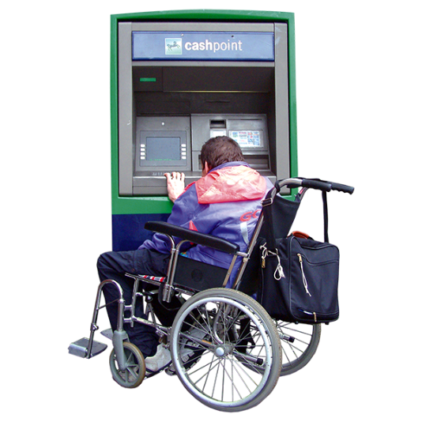
- Family tax credit

- In work tax credit

- Minimum family tax credit

- Best Start tax credit.
You can find more information about Working for Families tax credits on the Inland Revenue Department website:

www.ird.govt.nz/working-for-families/payment-types
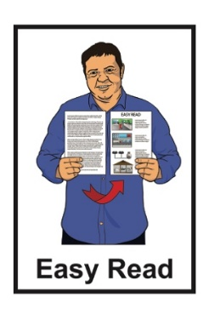

The information at this link is not in Easy Read.

Questions about Working for Families

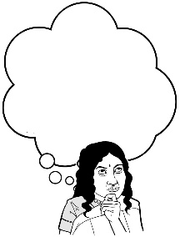
Tell us what you think about Working for Families tax credits.

- What do you like?

- What do you not like?

- What is 1 change you would make?

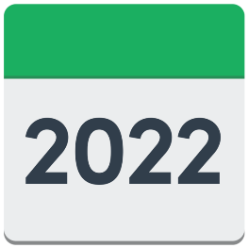
You have until 31 May 2022 to tell us what you think.

How to tell us what you think
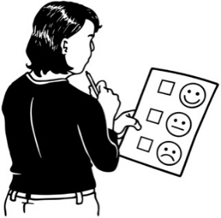

1 way you can tell us what you think is by filling in our online survey:

https://consultations.msd.govt.nz/wff-survey/working-for-families-tax-credits/consultation/

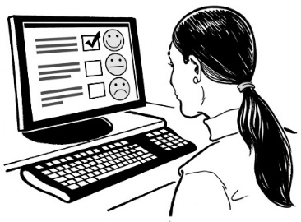
An online survey is when we ask you questions about Working for Families tax credits.

The online survey is not in Easy Read.

You can ask someone you know to support you with filling in the online survey.

You can also:

- email your answers to:

WFFReview@msd.govt.nz

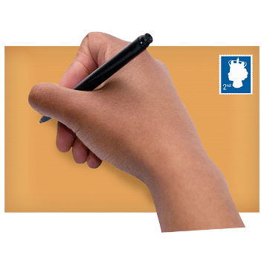
- post your answers to:

Working for Families Review

Ministry of Social Development

PO Box 1556

Wellington 6140

Your answers may be shared with other government agencies.

Make sure your answers do not give personal information like your:

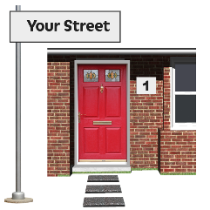
- name

- street address
- payments you get.

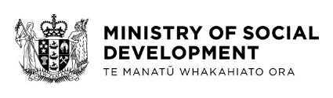
This information has been written by the Ministry of Social Development.
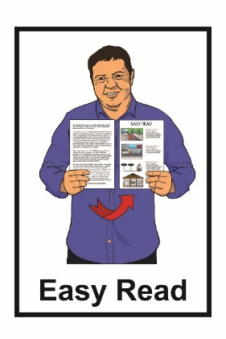
It has been translated into Easy Read by the Make It Easy service of People First New Zealand Inc. Ngā Tāngata Tuatahi.

The ideas in this document are not the ideas of People First New Zealand Inc. Ngā Tāngata Tuatahi.
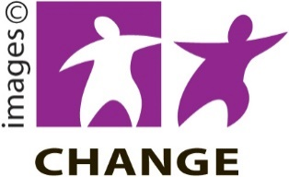
Make It Easy uses images from:

- Changepeople.org
- Photosymbols.com
- Sam Corliss

- Huriana Kopeke-Te Aho.

All images used in this Easy Read document are subject to copyright rules and cannot be used without permission.

