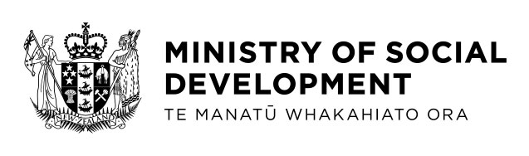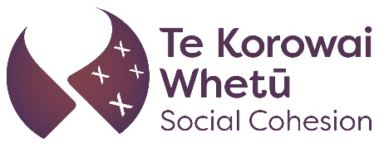

Working to strengthen social cohesion in Aotearoa New Zealand

Christchurch and the Royal Commission of Inquiry
The Royal Commission of Inquiry into the terrorist attack in Christchurch on 15 March 2019 made recommendations to improve social cohesion in Aotearoa New Zealand. As part of the work to carry out those social cohesion recommendations, the Ministry of Social Development (MSD) spoke to a wide range of people and communities about developing a strategy to improve and measure social cohesion across Aotearoa New Zealand. These conversations or engagements happened between July 2021 and March 2022.

Talking to communities about social cohesion
Communities we spoke to said there is a social cohesion problem in Aotearoa New Zealand and talked about experiences of discrimination or being treated differently because of their, gender, faith, sexuality, geographic location and other differences. Many people experienced multiple types of discrimination all at the same time, which intensified their negative experiences. Communities we spoke to want these differences to be valued and respected, rather than ignored or generalised.

Te Tiriti o Waitangi and social cohesion
Communities we spoke to talked about the strong link between Te Tiriti o Waitangi (the Treaty of Waitangi) and social cohesion. It was recognised that Te Tiriti o Waitangi can teach us valuable lessons about strengthening social cohesion among all people in Aotearoa New Zealand, not just Māori.

A definition and vision for social cohesion
The Royal Commission provided a definition of social cohesion which was discussed with communities. Following their feedback, social cohesion in Aotearoa New Zealand was defined where: All people, whānau and communities connect and feel a sense of belonging, are able to participate, are recognised and respected, are equitably included and have trust in others and in government organisations.
This definition informs the vision of social cohesion we want to work towards in Aotearoa New Zealand where “people, families, whānau and communities are thriving together”. This vision is at the centre of our strategy to strengthen social cohesion in Aotearoa New Zealand.

Te Korowai Whetū Social Cohesion
Te Korowai Whetū Social Cohesion comes from the whakatauāki, “Whatua te korowai i ngā tini whetū”, meaning: “to weave the korowai (cloak) from the myriad stars”
The name ‘Te Korowai Whetū Social Cohesion’ reflects the vision of social cohesion in Aotearoa New Zealand described in the social cohesion strategic framework, where we can support each other to thrive and shine bright like whetū or stars, together.

Te Korowai Whetū Social Cohesion action areas
Six areas we can work on to achieve social cohesion, based on current research around social cohesion, were also discussed with communities. The six areas are:
1. Discrimination or people being treated differently because of race, age, gender, disability, sexuality or other differences.
2. Positive opportunities for diverse groups to grow and connect.
3. Participation in important activities like voting, employment or education, etc.
4. Wellbeing and barriers to wellbeing.
5. Inclusiveness and shared values.
6. Protecting our society and the environment for future generations.
The discussion with communities about these six action areas covered significant issues of equity, power, harm, trust, diversity and identity. Communities said each of the six areas were equally important to achieve social cohesion. These action areas would also reinforce, complement and expand the work government agencies are already doing to support social cohesion in Aotearoa New Zealand.
Working alongside communities, a set of Te Korowai Whetū Social Cohesion outcomes was developed to help with evaluating and measuring progress.

Te Korowai Whetū Social Cohesion outcomes
Progress towards strengthening Te Korowai Whetū Social Cohesion in the six action areas can be measured by five outcomes. These five outcomes are that people, whānau and communities:
1. are connected and feel like they belong;
2. are willing and able to participate;
3. are included and experience equity;
4. are recognised for who they are and respect others;
5. trust each other and public organisations.
We’ll also make progress towards our Te Korowai Whetū Social Cohesion vision by working to make the places where people live, work, play and learn more safe, inclusive and supportive. This includes work to make the systems and services in our society more fair and able to respond to different needs and issues.

Te Korowai Whetū Social Cohesion guiding principles
Based on discussions with communities, there are four guiding principles or enablers for work in each of the six action areas. The four principles are:
1. Brave leadership and willingness to try new things.
2. Being led by the aspirations and needs of communities.
3. Flexibility and acknowledging people’s differences.
4. Inclusive data and research that better reflects real needs.

Measuring social cohesion
There is no single way to measure social cohesion in Aotearoa New Zealand, so we must use multiple sources of information and data to get an understanding of what social cohesion actually looks like in Aotearoa New Zealand. We used current data sources and surveys collected between 2016 and 2021. Generally, there was positive information in relation to social cohesion outcomes, but sometimes the information did reflect more complex issues. For example, the information that is regularly collected cannot always be used to understand social cohesion over time for smaller groups in society.
In addition, the information also shows that discrimination is a significant barrier to social cohesion in Aotearoa New Zealand. Some groups experience higher levels of discrimination, such as resettled peoples (refugees) and migrants from Asia and the Pacific Islands, single parents and unemployed people. Many people experienced multiple types of discrimination all at the same time, which intensified their negative experiences. For example, women and rainbow communities (LGBTQIA+) experienced higher discrimination overall, but there were differences in discrimination experienced by people in these groups based on their ethnicity or disability, etc.
The data also shows that more ethnic diversity in senior leadership roles in government and public service is needed. This would better reflect the makeup of society in Aotearoa New Zealand.
COVID-19 has had an impact on social cohesion in Aotearoa New Zealand in both positive and negative ways. For example, communities have joined together to support each other, but many people have not been able to see their family and friends face-to-face. While we are yet to see the full impacts of the pandemic, it will be important to continue to monitor the effects on social cohesion over time.

Te Korowai Whetū Social Cohesion community fund
Alongside this Te Korowai Whetū Social Cohesion strategic framework, a $2 million social cohesion community fund is available for community-based social cohesion initiatives.
This funding will enable communities to create or progress initiatives that strengthen social cohesion. That might include, for example, workshops, activities or resources that promote understanding or respectful relationships between different groups, etc.
More information about the Te Korowai Whetū Social Cohesion community fund can be found online at the Ministry of Social Development website. There is information about the eligibility criteria and application process.
Go to the Ministry of Social Development website (www.msd.govt.nz) and search “Te Korowai Whetū Social Cohesion”.

End of information: Working to strengthen social cohesion in Aotearoa New Zealand.

