MSD Working Paper 01/25

The financial and material wellbeing of older New Zealanders:
A background paper for MSD’s 2025 Long-Term Insights Briefing (LTIB) on ‘Meeting the future needs of older New Zealanders –
trends, risks and opportunities’

Bryan Perry, MSD
20 August 2025
.

About this Working Paper

This paper reports on the financial and material wellbeing of older New Zealanders based mainly on analysis of data from Stats NZ’s Household Economic Survey (HES). Its first use is as a background paper for MSD’s LTIB, but it is also intended as a resource to inform policy development, other research and public discussion more widely. Subject to resource availability the intention is to expand and improve the paper, taking account of feedback from users and stakeholders, updating with 2023-24 Net Worth data as it becomes available, and to publish it on MSD’s website as a stand-alone report alongside the Child Poverty Report, Household Incomes Report and so on.

While the analysis and range of findings presented in the paper are reasonably comprehensive, covering key policy-relevant themes and including international comparisons, there are many other New Zealand research publications on similar or related themes that are needed to fill out the full picture. The paper does not attempt a synthesis using this other related research though it does use some findings from them in selected places.

The paper is available on the MSD website at the link below:

https://www.msd.govt.nz/about-msd-and-our-work/publications-resources/working-papers/index.html

Contents

Introduction and Overview …………………………………………………………………………. 4

Part A: Some demographics and other contextual information ……………………………… 8
- Living arrangements
- Tenure
- ‘Retirement’ and paid employment
- Ethnicity
- Inflation

Part B: The household incomes of older New Zealanders …….……………………………… 15
- The BHC distribution, locating the 65+ in the overall distribution – the pensioner spike
- NZS relative to wages and median household income
- Low-income measures, including the sensitivity of low-income rates to the threshold used (because of pensioner spike and movement of NZS relative to median)
- The AHC distribution, locating the 65+ in the overall distribution
- Trends in the real BHC and AHC incomes for the households in which older New Zealanders live
- Sources of income for older New Zealanders, including the proportion of gross income that comes from government sources for different BHC income levels

Part C: Material hardship and material wellbeing ……………….……………………………… 28
- The three indices used
- Material hardship trend from 2007 to 2024
- International ranking
- Material hardship by living arrangements and tenure
- Material wellbeing from low to high
  - with breakdowns by selected population groups
  - by self-assessed health status
- Keeping warm
- Is pensioner poverty increasing?

Part D: Tenure and housing costs ………………………………….……………………………… 37
- Tenure trends for 65+ and those aged 45-64
- Housing costs as measured using OTIs

Part E: Joint income-savings analysis …………………………….……………………………… 41

Part F: Self-assessed income adequacy ………….……………….……………………………… 44

Introduction and Overview

This paper reports on the financial and material wellbeing of older New Zealanders based mainly on analysis of data from Stats NZ’s Household Economic Survey (HES), with some supplementary material based on MSD’s Living Standards surveys and research from the early 2000s and some recent research from the Retirement Commission.

The analysis covers those in private dwellings, whether owned by a resident or rentals (including government or council social housing). It also includes those in retirement villages, but not those in rest homes, hostels, emergency or transitional housing, caravan parks, or those living rough.

In this paper ‘financial and material wellbeing’ refers to the income and other financial resources that a household has (eg KiwiSaver or other retirement funds, bank deposits), and to the material things that money can buy (including household goods, vehicles and the accommodation itself where it is owned) - the goods and services a household consumes.
      - As used in this paper, the notion of ‘financial and material wellbeing’ (‘living standards’ for short) is quite different from the wider notions of ‘quality of life’ and ‘life satisfaction’, and also from the way ‘living standards’ is used in the New Zealand Treasury’s ‘Living Standards framework’. These are much broader notions that go well beyond financial and material wellbeing.
- When discussing financial and material hardship and disadvantage (unacceptably low living standards or ‘poverty’ for short), the analysis focuses on income and other financial resources, and on rankings using indices measuring material and financial hardship – it’s about the things that money can buy. It is not about all the ‘difficult things’ that some older New Zealanders face (including loneliness, anxiety, discrimination, abuse, poor health, limited mobility, and so on).

The measurement approach

To describe the financial and material wellbeing of older New Zealanders the report uses data on household income, housing costs, liquid assets / savings, material deprivation and wellbeing indices, and self-rated adequacy of income for being able to afford the basics. There are breakdowns by tenure, living arrangements / household type, household employment status, and the ethnicity and health status of individuals.

For assessing the financial and material wellbeing of households and for comparing different groups in the population, household income has long been used in OECD countries as a convenient and easily understood measure. The income measure is usually ‘equivalised disposable household income’. This is:
- total household income from all sources, including employment, interest on investments, and all government transfers such as NZ Superannuation (NZS), the Accommodation Supplement, the Winter Energy Payment, main benefits, Working for Families tax credits, and so on
- less income tax
- and adjusted for household size and composition.

While household income is an important contributor to financial and material wellbeing, there are many other factors that can also make a sizeable difference to the actual living standards people experience such as housing costs, access to savings from past income and from gifts, support from extended family, friends or institutions, other financial and material assets, and special demands on the budget (such as health-related costs).

Households with similar incomes before deducting housing costs (BHC incomes) can have quite different day-to-day living standards. Using incomes after deducting housing costs (AHC incomes) is an improvement but households with similar AHC incomes can still have quite different levels of financial and material wellbeing. The use of household income to assess and compare household financial and material wellbeing has considerable limitations within a country, and for international comparisons it is not reliable at all.

A second stream of research uses more direct non-income measures to assess and compare financial and material wellbeing. With these measures or indices, the impact of both income and the other factors is captured based on the answers to survey questions. This report uses three indices for this purpose:
- DEP-17 with a threshold of 6+, as used by Stats NZ for measuring material hardship in households with children for Child Poverty Reduction Act statistics
- EU-13 with a threshold of 5+, as used in official Eurostat measurement of material hardship
- MWI-24 – this index allows households to be ranked across the full material wellbeing spectrum, from high to low (Level 1), with ‘Level 1’ defined to be consistent with the DEP-17 analysis.

One of the challenges for the material hardship analysis is that there are relatively few older New Zealanders reporting material or financial hardship. To address this the paper looks at smoothed rolling averages for trends, averages over several surveys for point estimates of small sub-groups, and sometimes uses DEP-17 4+/17 … that is, a ‘hardship or near hardship’ approach rather than the standard 6+/17 hardship approach.

Despite the considerable limitations when using household income as a reliable measure (even a proxy measure) of financial and material wellbeing, the monitoring and understanding of income levels is still a very important aspect of the fuller picture. For most older New Zealanders, household income is a major resource that contributes to financial and material wellbeing. The information has public policy relevance as income is a key factor that governments have some control over through NZS, the WEP, AS, DA and through policy settings that impact retirement savings, tenure and so on. Monitoring and understanding the differing proportions in the sources of income and how these have been changing over time is also an important understanding to have.

Giving the numbers meaning: the need for reference points

Unlike measurements for length, temperature and the like, there is no universally agreed measure for household financial and material wellbeing (‘living standards’) or for financial and material hardship (‘poverty’), even when considering only the ‘richer’ nations such as those in the OECD. It is therefore difficult to give practical meaning to findings such as ‘around 3-4% of older New Zealanders (~25,000) are in material hardship’. Anything above zero is less than ideal, but how serious an issue is this? Key reference points are essential to give practical meaning to the numbers. They include:
- comparing rates with those for other population groups in New Zealand using the same measure(s)
- comparing with rates in other countries when using measures that are valid for international comparisons
- comparing with rates in earlier years:
  - are the rates increasing, decreasing or staying much the same on a given measure?
  - what do the reported trends mean on the different measures?
  - do the rates for those in deeper poverty change in much the same way as for those in less severe poverty?
- examining and reporting on the relationship between those identified as poor on the different measures (eg material hardship v AHC 50).

Rates v numbers

The number of older New Zealanders (65+) is rapidly increasing and will continue to do so for some time yet. One consequence of this is that even when rates of material or financial hardship are reasonably steady, the numbers in stressful circumstances will be increasing. It is important to be clear whether it is numbers or rates that are being reported on as the summary statements and public policy implications can be quite different if reports of ‘increasing pensioner poverty’ are referring primarily to numbers rather than increases in rates.

Summary of Findings

Material hardship

The great majority of older New Zealanders (65+) have sufficient income and assets to provide at least a reasonable standard of living. Many have a very good standard of living.

There is evidence of a small group (~3% or 25,000) who are clearly experiencing financial and material hardship, and another 3-4% (30,000) who are in ‘near hardship’. Some of the latter could easily move into the hardship group given the sort of cost-of-living challenges that are currently being experienced, and the lag before the annual NZS adjustment compensates for cost-of-living increases.

The hardship rate for older New Zealanders is lower than for any other age group: the rate for children (aged under 18 years) is 13% and for the whole population 9%.

For those aged 65+, New Zealand ranks well relative to European countries, with a material hardship rate of 5% using the Eurostat’s official measure (EU-13). This puts New Zealand in the top part of the league table with Austria, the Netherlands, Denmark and Finland (all in the 4-5% range). For those aged 65+, the EU country median is 8% and the weighted mean for the whole 65+ population is 11%.

These relatively good outcomes for older New Zealanders are longstanding and are due to the mix of current public provision (mainly NZS), the private provision built up by most of the current cohort over their lifetime, and paid employment income for some. A key component of the private provision is mortgage-free home ownership which is relatively high among the current cohort (~71%, albeit down from 83% in the mid-1990s). The provision in New Zealand of a non-means tested pension (NZS) means that recipients are not discouraged from paid work beyond pension age nor the accumulation of assets over the life course.

The proportion of older New Zealanders in paid employment is higher now than in the 2000s (22% compared with 16%), though the proportion seems to have plateaued. The majority of older New Zealanders in employment report that they are working because they want to not because they have to (of those working and aged 65-69 years, some 68% are doing so because they want to, 78% for those aged 70+).

Material hardship rates vary among sub-groups of older New Zealanders. For example, on average from 2019 to 2024, the rates were:
- couple households (1%), one-person households (4%), 65+ adults in households with dependent children, with or without other adults (11%)
- mortgage-free (1%), mortgaged (5%), private renting without AS (5%), private renting with AS (16%)
- European (2%), Asian (3%), Māori (8%), Pacific (14%).

The 1.0 ppt rise in the overall hardship rate from 2022-23 to 2023-24 (2.9% to 3.9% using the DEP-17, 6+ measure) is not large enough to be statistically significant, though it is the largest year-on-year change since the DEP-17 measure began in 2013. There is however other evidence from the HES that is indicative of increasing hardship for some population groups. For example:
- the steady fall in the ‘not enough’ response rate to the self-assessed income adequacy question reversed for 2023-24, for those in low-income households and for all 65+
  - this is consistent with the finding of falling real incomes for older New Zealanders noted in the incomes section below (Part B)
- private renters receiving the AS report increased inability to afford basics like fresh fruit and vegetables, local trips, repairing or replacing broken appliances … because of costs.
- between May 2019 and July 2025 the number of NZS/VP recipients receiving Temporary Additional Support doubled, from 6,660 to 13,321 – of the 13,321, 83% are single people.

There is a more general ‘lag’ effect for all NZS recipients. The annual increase in nominal NZS level is determined by the higher of inflation and net average wage change, and should over time compensate for a period of high inflation. In the short-run, before the adjustments take effect, those with limited financial resources other than NZS and who struggle to get by each fortnight can find themselves in financial stress.

Incomes

Just over 40% of those aged 66+ in one-person or couple households have less than $100 income per week from non-government sources (ie their income is almost entirely from NZS, DA, AS, WEP, and so on). For one-person households the proportion is 64% and for couple households it is 31%. For one-person households around 35% have no income or very close to no income from non-government sources.

In the late 1990s, NZS was equivalent to around 60% of the population median (BHC 60). It then declined through to BHC 50 in 2010 and rose to BHC 54 in 2013. It has fallen since to below BHC 50 (~ BHC 48) for the last three HES (2021-22, 2022-23, 2023-24).

NZS is adjusted annually, by the higher of the CPI or the change in Net Average Ordinary Time Weekly Earnings (NAOTWE). This means that NZS can rise in real terms if the NAOTWE does and if taxation changes are neutral or favourable. From 2007 to 2024 NZS rose 21% in real CPI-adjusted terms.

Real CPI-adjusted household incomes for deciles 2 to 5 of older New Zealanders have decreased a little since 2022, the first reversal of the steady rise since this statistic was first generated in 2007. For deciles 6 to 8, real incomes have plateaued since around 2018. These trends are similar for BHC and AHC incomes.

Using the Gini measure of income inequality, increasing inequality within the 65+ group is evident through to 2018, after which there is a break in the Gini series. The AHC 50 relative low-income measure is in essence a measure of income inequality in the lower half of the income distribution. AHC 50 rates for older New Zealanders rose from a steady 6% in the 2000s and earlier to 11% in 2018 and 15% in 2024. In the same period, the whole population rate was steady at 12-15% in the 2000s and up to 2018, and was still at 15% in 2024. Taken together these findings indicate ongoing rising household income inequality for older New Zealanders.

A joint income-‘savings’ analysis for better understanding material and financial wellbeing

There are considerable limitations in using household income alone (even AHC incomes) as a proxy for the resources available for purchasing the goods and services needed for a minimum acceptable standard of living and for higher standards. As noted above, households with similar AHC incomes can have quite different levels of financial and material wellbeing depending on a range of other factors, one of which is their level of ‘savings’ (=’accessible liquid assets’). While this is self-evident from first principles, especially for households with older members, it is not easy to find datasets / surveys that have all the needed information in the one place to allow a joint incomes-‘savings’ analysis.

Each three years Stats NZ’s HES collects information on individual assets, liabilities and net worth in addition to the core HES information on incomes, housing costs, material hardship and wellbeing. The latest available collection was for the 2020-21 HES. The joint incomes-savings results reported in this paper are not surprising, but this analysis provides real-life confirmation of the theoretical ‘self-evident’ claim, and gives an idea of the size of the impact. For example:
- older households with low BHC incomes (only NZS and very little more) and less than $5000 of savings, have much greater levels of material and financial disadvantage than those with the same income but more than $40,000 in savings (eg an 18% self-rated income adequacy of ‘not enough’ compared with 5%)
- older households with low BHC incomes (as above) and more than $40K findings are better off than households with higher incomes near the median but less than $5000 in savings (eg a 5% self-rated income adequacy of ‘not enough’ compared with 22% for those with higher income; 2% report having to put up with feeling cold ‘a lot’ compared with 6% for the higher income / low savings group).

It is intended to update the analysis once the 2023-24 HES-based net worth dataset is available.

Housing costs

There has been a steady rise in the proportion of low-income 65+ households with housing costs more than 40% of disposable income. Low-income here means incomes in the two lower BHC quintiles. From 2009 to 2024:
- for all 65+, the rise was from 8% to 12%
- for those paying a mortgage, from 23% to 37%
- for private renters, 50% to 68% (higher for renters receiving AS).

Rising costs since the 2023-24 survey

The 2023-24 HES finished on 30 June 2024. Since then there have been several factors that may lead to an increase in reported hardship rates for older New Zealanders in the next survey (2024-25): fast rising food and electricity prices in the period of the survey; the cumulative impact of general inflation and rising housing costs for renters, owners with and without mortgages (this latter group still pays rates, insurance and maintenance costs, and if they have little financial resources beyond NZS, the pressure on the budget will mount despite being ‘asset-rich’).

The annual increase in nominal NZS level is determined by the higher of inflation and net average wage change, and should over time compensate for a period of high inflation. In the short-run, before the adjustments take effect, those with limited financial resources other than NZS and who struggle to get by each fortnight can find themselves in financial stress.

Part A:
Some demographics and other contextual information

This section does not contain a full account of 65+ demographics. It is limited to those aspects that are relevant to the rest of the paper.

It covers:
- Living arrangements
- Tenure
- Employment and ‘retirement’
- Ethnicity
- Recent trends in inflation.

Living arrangements

Around half of those aged 66+ live in couple households, just over a quarter in one-person households and one in eight in other family households with no dependent children (Figure A.1).

The right-hand chart in Figure A.2 shows the strong rise in the numbers of the 66+ ‘boomer’ cohort.
- In the last ten years or so, the number in ‘other family households with no dependent children’ has doubled from 50,000 to 100,000 (steady at around 14% for the last few years).
- The number of one-person households has shown a noticeable rise (up 40%) in the last few years from around 150,000 to 210,000.
- Around 40,000 older New Zealanders (5%) live in households with dependent children.

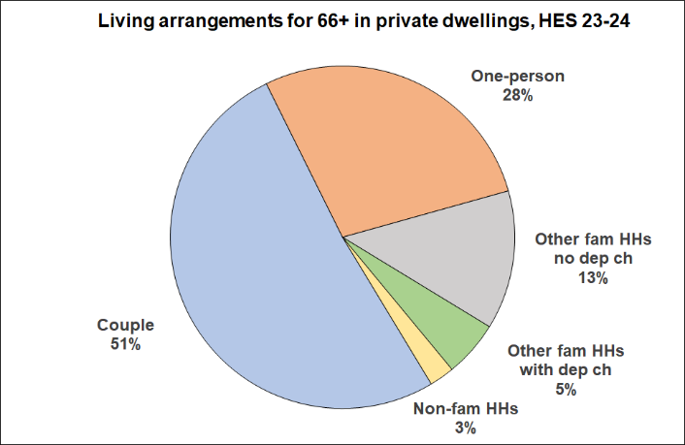
Figure A.1
Living arrangements for older New Zealanders (aged 66+) in private dwellings, HES 2023-24

Figure A.2
Living arrangements for older New Zealanders (aged 66+), in private dwellings, % and numbers (#)
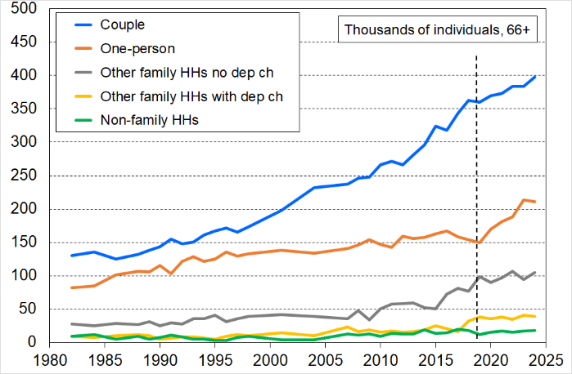
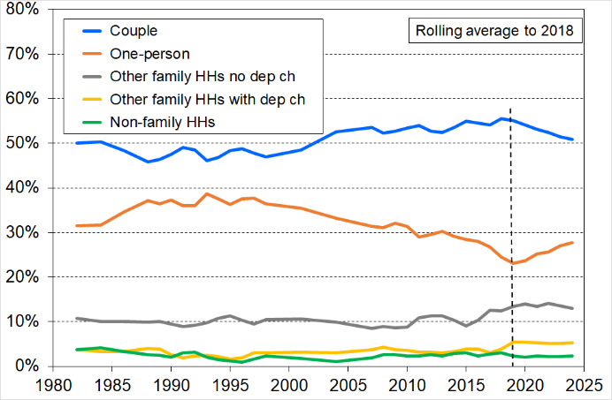
HES 1982 to 2024

Table A.1 shows the steady rise in the proportion of males in one-person 66+ households, though there are still more female one-person 66+ households than male.
Table A.1
Gender split for older New Zealanders (aged 66+) in one-person households, HES 2015 to 2024
 | 15 | 18 | 19 | 20 | 21 | 22 | 23 | 24
One-person 66+ - all | 163,000 | 154,000 | 150,000 | 170,000 | 182,000 | 188,000 | 214,000 | 211,000
Female (#) | 114,000 | 111,000 | 106,000 | 118,000 | 122,000 | 125,000 | 142,000 | 133,000
Male (#) | 48,000 | 43,000 | 43,000 | 52,000 | 59,000 | 64,000 | 72,000 | 78,000
Female (%) | 70 | 72 | 71 | 69 | 67 | 66 | 66 | 63
Male (%) | 30 | 28 | 29 | 31 | 33 | 34 | 34 | 37
Tenure

Over the last three decades (1994 to 2024), the HES shows that home ownership for older New Zealanders has been steady at 84-86%. The proportion in rentals has been steady at ~12-13%, with ~2-3% in a residual category that includes those living with others in a home that another resident owns (eg a grandparent with daughter and partner, and their children).

Since the mid-1990s there has however been a downward trend in the proportion of older New Zealanders whose dwellings are mortgage-free, down from 83% in the mid-1990s to 76% in the mid-2000s and to 71% on average from 2022 to 2024 (see Figure A.3 below). Over the last three surveys, around 13% were in a dwelling for which there were still mortgage payments being made, a similar proportion to those renting. In the 1990s around 5% of those aged 65+ lived in households with mortgages.
Figure A.3
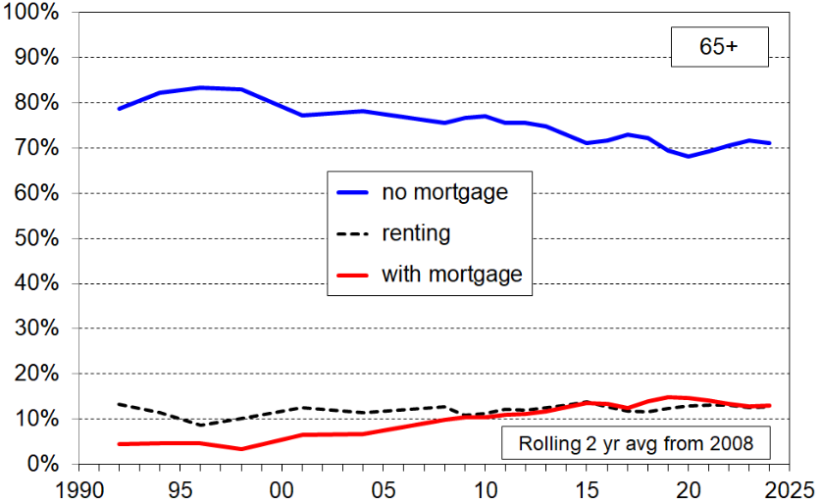
Tenure for individuals aged 65+, based on HES data 1992 to 2024, two year rolling average

Tenure for 45-64 year olds

The tenure trends for those in the years before ‘retirement’ are shown in Figure A.4 below.
- renting has doubled from around 10% in the 1990s to 23% in 2024, with a corresponding fall in home ownership to 74%
- there has been a strong decline over the last twenty-five years in those who are mortgage-free in these ‘pre-retirement’ years, halving from 60% in the early 1990s to 32% in 2024.

Figure A.4
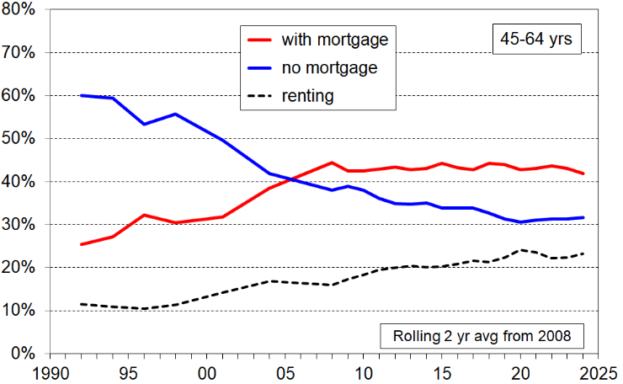
Tenure for individuals aged 45-64, based on HES data, 1992 to 2024, two year rolling average

‘Retirement’ and paid employment

Figure A.5 shows the paid employment trends for older New Zealanders (65+) from 2007 to 2024. These are the figures for 65+ individuals in their own right, not those of the HH in which they live.
- In HES 2023-24 around 10% of 65+ were in full-time employment and 8% part-time. 4% were in self-employment (defined here for the individual as having self-employment income larger than the total from all other sources of income). The overall rate (~22%) has plateaued in the last ten years. Around half of younger seniors (aged 65-69 yrs) are in paid employment.
- The numbers in full-time and part-time employment more than doubled in the period, from around 40,000 to close to 90,000, and 30,000 to 70,000 respectively.
- The increase in numbers of 65+ in paid employment is driven by two factors: (a) increasing proportions in paid employment and (b) the increased numbers of 65+ per se, reflecting the impact of the post-war baby boom. This latter change (b) explains why the percentage increases are more muted (left-hand chart in Figure A.5) compared with the trends in overall numbers in paid work (right-hand chart).
Figure A.5
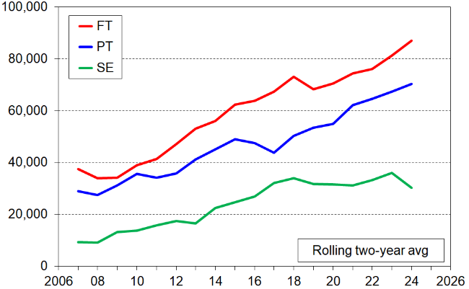
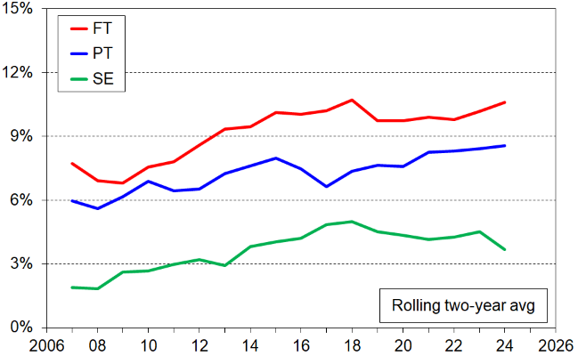
Numbers and proportions (%) of 65+ in paid employment or self-employed (SE)
Figure A.6 reports on the proportions of 65+ in one-person or couple households where there is paid employment (excluding self-employment). Paid employment is much more common in 65+ couple households, but the rate for one-person households has increased more than for couple households from 2007 to 2024. In HES 2023-24 there is some paid employment for:
- one in three 65+ in couple households
- one in six 65+ in one-person households.

Figure A.6
Proportion (%) of individuals for whom there is some paid employment in their household -
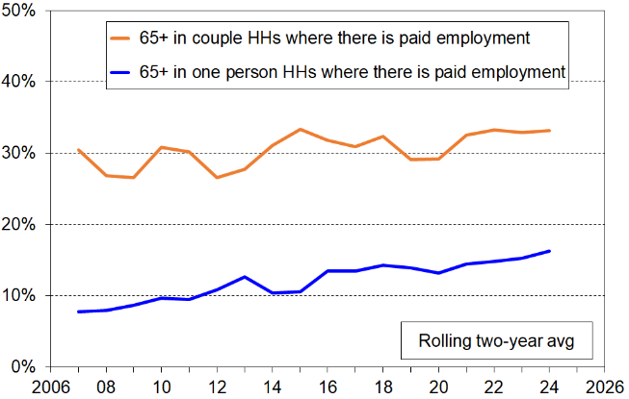
trends for individuals in one-person and couple households

Around one in five older New Zealanders (65+) live in households with other non-partner adults. The living arrangements include living with adult siblings, non-family adults, multi-generational whānau and so on. Two-thirds of these households have some paid employment income, the bulk of which is from full-time employment.
Paid work in retirement – choice or necessity

In 2021, Te Ara Ahunga Ora Retirement Commission investigated a range of themes related to the retirement and pre-retirement years using a sample from the 250,000 strong Dynata panel. Random samples within three age-groups were drawn (55-64, 65-69 and 70+) with around 710 completed surveys in each group. The older group were mainly in their 70s. The numbers reported in the findings are not weighted.

One of the themes was on ‘retirement’ and working (paid employment). The research found that:
- Retiring at 65 is common, but many retire at other ages:
  - almost one in five retired before reaching 65
  - one in three were still employed in the 65-69 age-group
  - almost one in ten were still employed at 70+
  - altogether one in five aged 65+ said they were not retired.

- 15% of those aged over 65 years work for pay part-time
- 12% of those aged over 65 years work for pay full-time.

- Of those who are working:
  - for those aged 65-69, 68% are working because they want to, 32% because they have to (similar by gender)
  - for those aged 70+, 78% because they want to, 22% because they have to (similar by gender).

Table A.2 shows that those aged 65+ who work because they have to are less likely to own their home than those who want to (74% v 91%), but are more likely to still have a mortgage compared to those who work because they want to (44% v 15%).

Table A.2
Main reason for working, by home ownership and having a mortgage, 65+ (2021)
 | Home-owner | Have mortgage
Have to work for financial reasons | 74% | 44%
Want to work | 91% | 15%

Ethnicity

The older New Zealand age group is slowly becoming more ethnically diverse, though still predominantly ‘European’ (currently around 78%), and less diverse than other age groups and the population as a whole (see Figure A.7 and Table A.3 below). Stats NZ projections for 2043

Figure A.7
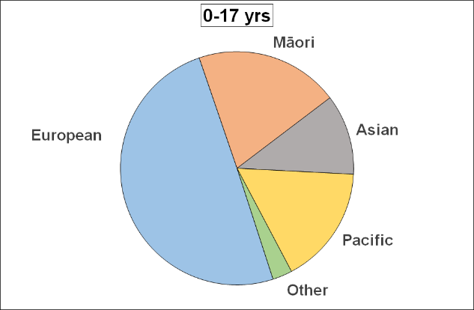
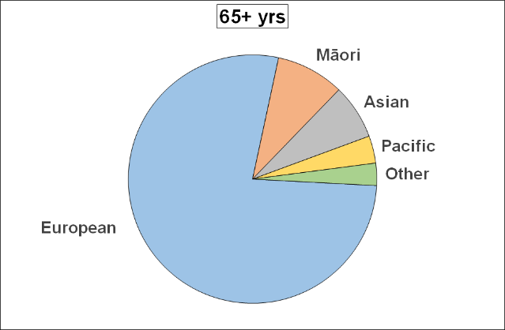
Ethnicity of older New Zealanders (65+) and of those under 18 years, HES 2023-24

Table A.3
Ethnicity of older New Zealanders (65+) and of younger age-groups, HES 2023-24
 | 65+ |  | 45-64 | 0-17 | All
 | # | % | % | % | %
All in group | 879,000 | 100 | 100 | 100 | 100
European | 682,000 | 78 | 65 | 50 | 58
Māori | 78,000 | 9 | 12 | 20 | 15
Asian | 63,000 | 7 | 14 | 11 | 16
Pacific | 31,000 | 4 | 7 | 16 | 8
Other | 26,000 | 3 | 3 | 3 | 3

Table A.4
The changing ethnic composition of the older New Zealander population (65+), total ethnicity
 | HES | HES | StatsNZ projection – recalibrated to 100% total | StatsNZ projection
 | 2008 to 2010 (avg) | 2024 | 2043 | 2043
European | 84 | 78 | 70 | 75
Māori | 5 | 9 | 10 | 11
Asian | 4 | 7 | 14 | 15
Pacific | 2 | 4 | 5 | 5
Other | 4 | 3 | 1 | 1
TOTAL | 100 | 100 | 100 | 107

- Source for StatsNZ projections:
National ethnic population projections: 2018(base)–2043 (update) | Stats NZ
- The analysis in the table uses the total ethnicity approach. Each person’s total ethnicity is counted which means that individuals can be counted more than once. Hence the ‘107%’ in the right-hand column. The recalibrated percentages in the second-from-right column multiply the right-hand column by 100/107 to give a 100% total and to square with the approach in the other columns.

Inflation

General CPI inflation, food/grocery inflation and power inflation are important factors to consider for understanding recent trends in the financial and material wellbeing of older New Zealanders The impacts are especially strong for those who rent or have a mortgage; have little income each week apart from NZS, the WEP and the AS if eligible; and little in the way of liquid assets to draw on apart from perhaps their ring-fenced emergency savings for a serious ‘rainy day’ event such as dental work or a health crisis.

Figure A.8 shows the percentage change from the same quarter in the previous year for food inflation, household energy inflation and the general CPI inflation in recent years.

The latest HES ran from July 2023 to June 2024. Many of the relevant questions ask about ‘the previous 12 months’, so those interviewed early in the survey will reflect their circumstances in the 2022-23 period. While the 2023-24 HES will be giving information in the main about 2023-24, it will also reflect 2022-23 to a considerable degree too. The dashed vertical lines are a reminder of the extended period and the seriously high levels of inflation at the time.

Since the HES 2023-24 finished its data collection on 30 June 2024, both food and power inflation have risen strongly. This will undoubtedly have made life more difficult for the already vulnerable and those close to the edge. This impact should be captured in the 2024-25 survey, but is by definition not a part of the 2023-24 survey, the latest we have.

Figure A.8
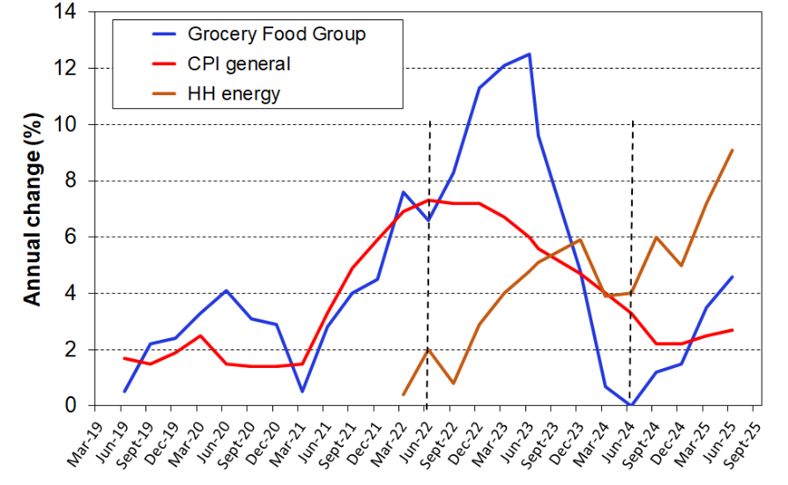
Food inflation, household energy inflation and general CPI inflation - annual % change

Local Authority Rates and insurance costs have increased significantly and in excess of the general CPI in recent years and this is likely to continue. This is a significant issue for older homeowners who are heavily reliant on the pension.

Part B:
The household incomes of older New Zealanders

Even though factors other than income have a major impact on the financial and material wellbeing of older New Zealanders (eg the level of savings, support from the wider family, non-income resources such as consumer durables, home ownership, and so on, together with special demands on the household budget such as debt-servicing and health costs), household income is nevertheless a critical resource.

The monitoring and understanding of income levels is a very important aspect of the fuller picture. For most older New Zealanders, household income is a major resource that contributes to financial and material wellbeing. The information has public policy relevance as income is a key factor that governments have some control over through NZS, the WEP, AS, DA and through policy settings that impact retirement savings, tenure and so on. Monitoring and understanding the differing proportions in the sources of income and how these have been changing over time is also an important understanding to have.

This section reports on:
- The BHC distribution, locating the 65+ in the overall distribution – the pensioner spike
- NZS relative to wages and median household income
- Low-income measures, including the sensitivity of low-income rates to the threshold used (because of pensioner spike and movement of NZS relative to median)
- The AHC distribution, locating the 65+ in the overall distribution
- Trends in the real BHC and AHC incomes for the households in which older New Zealanders live
- Sources of income for older New Zealanders, including the proportion of gross income that comes from government sources for different BHC income levels

The BHC incomes of older New Zealanders and ‘the pensioner spike’

Figure B.1 shows the distribution of equivalised household disposable income for individuals aged 65+. The individuals are grouped by their household incomes in multiples of $1500 pa ($30 pw). The graph clearly shows the ‘pensioner spike’ at close to the 50% of median poverty line, and also the high proportion with incomes between 50% and 60% of the median (~20%).

The spike is a direct consequence of (a) New Zealand having a universal NZS (New Zealand Superannuation) that is neither income nor asset tested, and (b) there being a large proportion of older New Zealanders with very little other income over and above NZS. Further information on the latter point is reported on pp23ff below.

Figure B.1
BHC household income distribution for older New Zealanders (65+) relative to the rest of population,
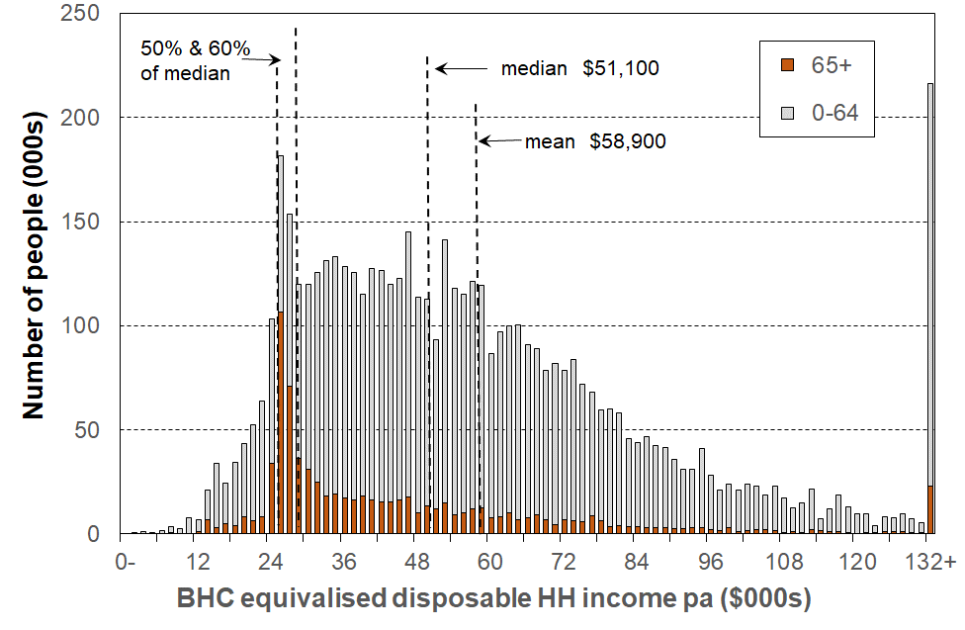
HES 2022-23

The presence of the spike has a significant impact on the reported BHC low-income ‘poverty’ rates, depending on where the value of NZS sits relative to the median household income and therefore to the BHC 50 and BHC 60 thresholds (see below).

There is also a ‘pensioner spike’ for AHC incomes but it is less pronounced / more spread out than the BHC spike, reflecting the range of housing costs experienced by lower income 65+ households (see Figure B.8 below).

NZS relative to average earnings and median BHC household income

For a large proportion of older New Zealanders, NZS provides the bulk of their income (see below pp23ff for details). In assessing the financial and material wellbeing of older New Zealanders it is therefore useful to know how NZS tracks:

in real terms

relative to average earnings

relative to median household incomes.

In these comparisons, NZS is the equivalised NZS which puts couple and single living alone rates at very close to the same equivalised dollar value when using the ‘modified OECD scale’. Average earnings are net average ordinary time weekly earnings (NAOTWE), and median incomes are median equivalised household disposable incomes. Average earnings are just one factor impacting on household incomes. Another major factor is the total number of hours of paid employment being worked by households. These hours have been increasing, so household incomes have risen more rapidly than average wages (since c1994). Tax cuts at various times also increased net average wages and after-tax household incomes, though the GFC put a (temporary) halt to the steady rise in the median. The recent flattening of the earnings and household income lines in Figure B.2 to a large degree reflects the COVID impact and subsequent downturn.

The bottom line in Figure B.2 shows that the value of NZS (and its predecessors) remained reasonably steady in real terms from the mid-1980s through to 2007, whereas there were considerable movements in average earnings and median household incomes in the period. From 2007 to 2024 NZS rose by 21% in real terms, as a result of the rising NAOTWE (a combination of gross wage rises and tax cuts).

Figure B.2
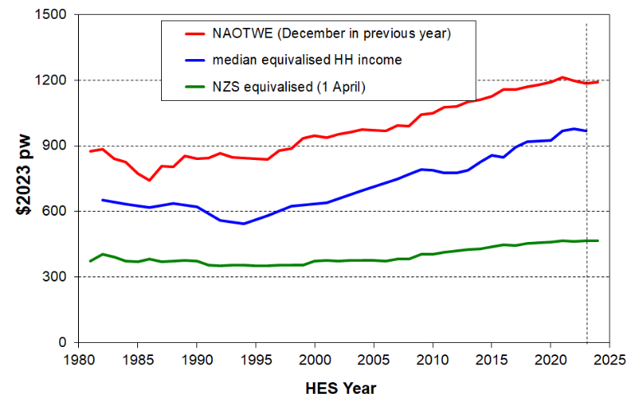
Trends in average earnings, median household incomes and NZS (in $2023)

Figure B.3 reformats the information in Figure I.2 to more directly show the trends in NZS relative to average earnings and median household income.
- NZS declined in value relative to median household incomes from the mid-1990s to 2009. This is because median household income rose steadily in real terms, while the value of NZS did not change greatly in real terms in the period.
- From 2009 to 2013 NZS rose in real terms relative to median household income as median income plateaued during and after the GFC (see Fig I.2 above).
- From 2013 to 2021 NZS again declined in value relative to median household income as median income steadily increased in real terms. In 2021 NZS ended up at around 49% of the median, which means that the BHC 50 low-income measure showed a large increase from that time. Those with NZS and very little more drop ‘below the line’. (See Table B.1 below).
- In the three years to the latest 2023-24 survey, median incomes have plateaued again in real terms, so NZS has remained at around 48% of median household income.

In 2024, the NZS married couple rate was at 67% of net average ordinary time weekly earnings.

Figure B.3
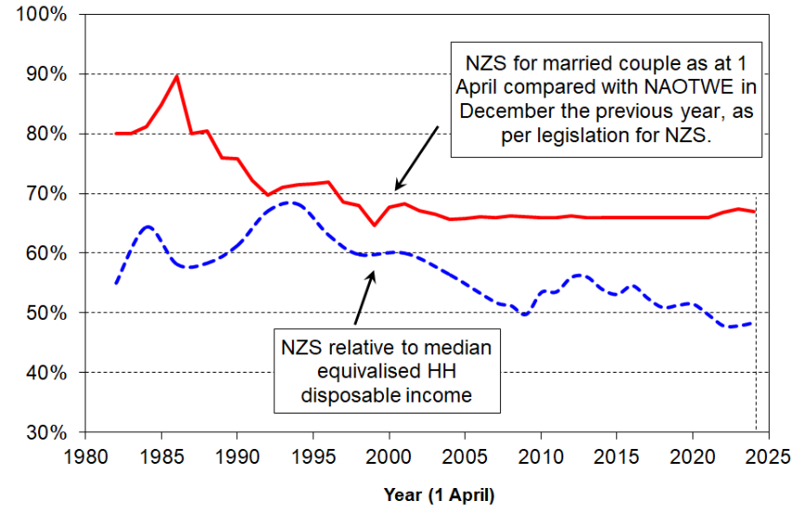
NZS relative to average earnings and median household incomes
Table B.1
NZS relative to the median equivalised BHC household income median (%),
using both the modified OECD scale and the square root scale as used by the OECD
 | 84 | 86 | 88 | 90 | 92 | 94 | 96 | 98 | 01 | 04 | 07 | 08 | 09 | 10 | 11 | 12 | 13 | 14 | 15 | 16 | 17 | 18
mOECD - all | 64 | 58 | 58 | 61 | 67 | 68 | 63 | 60 | 60 | 56 | 52 | 51 | 50 | 53 | 54 | 56 | 56 | 54 | 53 | 55 | 52 | 51
sq rt - MC | - | - | 56 | 60 | 65 | 66 | 62 | 59 | 57 | 55 | 50 | 50 | 49 | 51 | 52 | 53 | 54 | 52 | 52 | 53 | 51 | 49
sq rt -SLA | - | - | 52 | 55 | 61 | 61 | 57 | 54 | 53 | 50 | 46 | 46 | 45 | 47 | 48 | 49 | 49 | 48 | 47 | 48 | 47 | 45

 | 19 | 20 | 21 | 22 | 23 | 24
mOECD - all | 51 | 51 | 49 | 48 | 48 | 48
sq rt - MC | 49 | 50 | 48 | 46 | 47 | 47
sq rt -SLA | 45 | 46 | 44 | 42 | 43 | 43

Notes for Table:
- NZS is updated on 1 April each year. The HES interviews are carried out from 1 July to 30 June. For Figure B.3 and Table B.1, the NZS in year ‘n’ is compared with the HES median for year ‘n to n+1’. For example, the 1 April 2009 NZS is compared with the median for the 2009-10 HES. This is a reasonable approximation, but note that the actual NZS amount received over the 12 months prior to interview depends on the actual interview date for each household. The trend of NZS relative to the household median income in Figure B.3 and Table B.1 is robust for the purpose used above, but not for a precise forensic analysis.
- When the modified OECD equivalence scale is used the married couple (MC) and single living alone (SLA) NZS rates have almost the same dollar value. When the “square root” equivalence scale is used (as the OECD does) the two rates are numerically different when equivalised – hence the two OECD rows in Table B.1.
Sensitivity of reported BHC ‘poverty’ rates to the choice of poverty line

While there is good value in understanding how the incomes of low-income older households track relative to median household incomes, the use of household income on its own for understanding ‘poverty’ trends within a country has little if any value, especially for older New Zealanders. For a given income, household tenure and access to savings have a material impact on actual day-to-day living standards. The pensioner spike in the income distribution noted in Figure B.1 also has implications for reporting on income poverty for the 65+ and for comparisons of subgroups within the population as a whole. For international comparisons the use of household incomes for ‘poverty’ comparisons is better avoided as it produces misleading findings. Countries reporting very similar low-income rates can have quite different material hardship rates.

The main use for the information below is to show how the incomes of low-income households track relative to the median. For a better assessment of hardship levels this report uses material hardship measures (see Part C) or a joint income-savings approach (see Part E).

Table B.2 shows the proportion of older New Zealanders (65+) in households with incomes under common BHC low-income lines, sometimes referred to as ‘poverty lines’. The ones reported in the table use thresholds set as a proportion of the median. The first two rows use the ‘modified OECD’ equivalence scale to adjust household incomes for size and composition – this scale is the most commonly used one in household income research, including in all Eurostat publications. Stats NZ and MSD reports use the modified OECD scale. The bottom row uses the ‘square root’ equivalence scale – this scale is used by the OECD in its household incomes analysis and related publications.
- Using the BHC 50 measure with the modified OECD scale the reported ‘poverty’ rate is consistently very low through to 2018, with a small rise in 2019 to 2021. The large increase for 2022 to 2024 corresponds to the period when the equivalised NZS value dropped below 50% of the median (to 48%) – see Table B.1 above.
- In contrast, using a 60% threshold and the modified OECD scale the poverty rates fell from 18% in 1990 to close to zero in the mid-1990s when the median fell in real terms and NZS was above the 60% threshold. By 2004, the rising median had led to 30% of older New Zealanders being classed as ‘in poverty’ on this measure and has remained high since (~40% on average over the last three surveys, 2022 to 2024).
- The BHC 50 measure (with the square root scale) is the one used most often in OECD publications. Using that measure, the third row shows a very low ‘poverty’ rate for older New Zealanders for the whole period 1984 to 2001. This was because the value of NZS was (well) above 50% of the median. By 2007 the value of NZS for those living alone had fallen below the 50% threshold (see Table B.1 above), and the 50% of median ‘poverty’ rate had risen to 19% in 2009. It was 24% in the 2018 survey and in the last two surveys (2023 and 2024) had risen to around 30%. When this measure is used in international league tables (eg by the OECD) it looks as if New Zealand currently has a very large ‘poverty’ issue for older New Zealanders compared with earlier years and with other OECD countries currently. When a material hardship measure is used, the overall hardship rate for older New Zealanders is shown to be quite low over time and relative to other OECD-type countries (see Part C).
Table B.2
Proportion (%) of older New Zealanders (65+) in households with incomes below the BHC 50 and BHC 60 moving line (relative) low-income thresholds (‘poverty lines’), ‘moving line’ measures:
with comparisons using different equivalence scales
 | 84 | 86 | 88 | 90 | 92 | 94 | 96 | 98 | 01 | 04 | 07 | 08 | 09 | 10 | 11 | 12 | 13 | 14 | 15 | 16 | 17 | 18
50% mOECD equiv | 1 | 1 | 1 | 1 | 1 | 0 | 1 | 2 | 2 | 3 | 6 | 3 | 3 | 4 | 3 | 2 | 3 | 3 | 3 | 3 | 4 | 5
60% mOECD equiv | 9 | 14 | 17 | 18 | 2 | 1 | 3 | 5 | 7 | 30 | 36 | 36 | 33 | 28 | 28 | 25 | 25 | 31 | 29 | 29 | 32 | 34
50% sq rt equiv | 2 | 1 | 8 | 2 | 1 | 1 | 1 | 3 | 2 | 9 | 18 | 15 | 19 | 13 | 10 | 9 | 9 | 14 | 11 | 11 | 15 | 24

 | 19 | 20 | 21 | 22 | 23 | 24
50% mOECD equiv | 10 | 9 | 7 | 17 | 22 | 17
60% mOECD equiv | 36 | 36 | 33 | 40 | 42 | 38
50% sq rt equiv | 23 | 19 | 19 | 31 | 32 | 29

AHC incomes

Using incomes after deducting housing costs (AHC income) is a more reliable way of understanding and comparing the financial and material circumstances of households, given the critical importance of housing to wellbeing and the fact that households cannot in short order ‘economise’ on housing costs.

Figure B.4 below repeats Figure B.1 but for AHC incomes. Individuals are grouped by their household AHC incomes in multiples of $1500 pa ($30 pw). The graph shows how the original BHC ‘pensioner spike’ at close to the 50% of median poverty line has moved up to closer to the 60% AHC threshold and has been flattened / dispersed a little.

Figure B.4
AHC household income distribution for older New Zealanders (65+) relative to the rest of population,
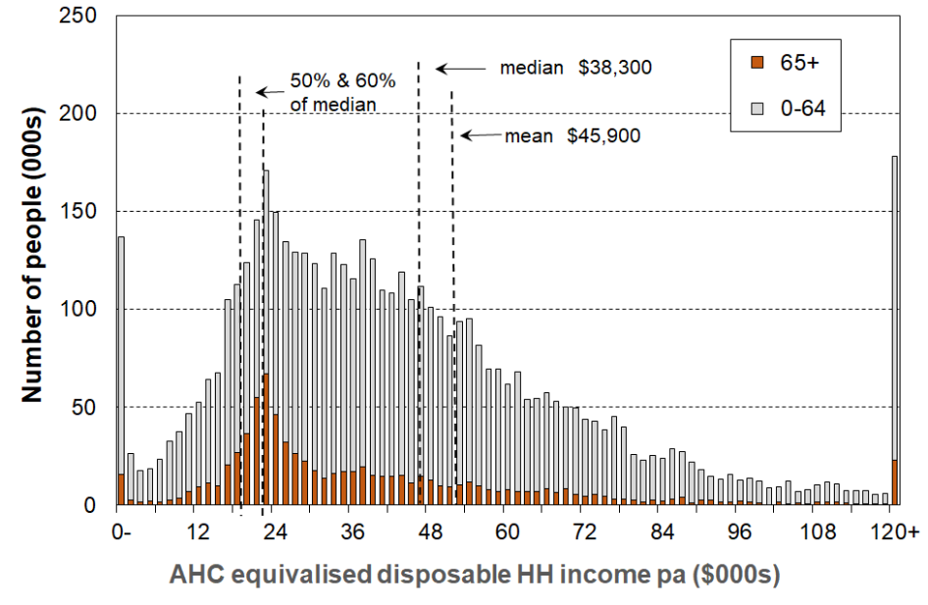
HES 2022-23

Table B.3 reports the trend in AHC 50 (relative) low-income rates. These have risen in recent years in line with the falling value of NZS relative the BHC median - see Figure B.3 above.

Table B.3
Proportions of older New Zealanders (aged 65+) in low-income households, by HH type:
AHC 50% of median measure – a relative measure
 | 82 | 84 | 86 | 88 | 90 | 92 | 96 | 98 | 01 | 04 | 07 | 08 | 09 | 10 | 11 | 12 | 13 | 14 | 15 | 17 | 18
All 65+ | 3 | 2 | 4 | 4 | 3 | 2 | 4 | 5 | 4 | 6 | 8 | 7 | 6 | 7 | 6 | 6 | 6 | 6 | 7 | 9 | 11
Single 65+ | 5 | 2 | 9 | 8 | 5 | 3 | 6 | 10 | 7 | 11 | 12 | 10 | 10 | 16 | 8 | 9 | 10 | 7 | 13 | 19 | 23
Couple 65+ | 0 | 1 | 2 | 2 | 2 | 1 | 2 | 2 | 3 | 2 | 5 | 5 | 2 | 2 | 4 | 5 | 4 | 5 | 3 | 5 | 6
Fam HHs no deps 65+ | Sample size too small to support reporting for this group until 2019
Total popln (all ages) | 9 | 9 | 8 | 9 | 9 | 14 | 14 | 14 | 16 | 16 | 13 | 12 | 14 | 15 | 14 | 14 | 14 | 15 | 14 | 14 | 15

 | 19 | 20 | 21 | 22 | 23 | 24
All 65+ | 12 | 12 | 12 | 15 | 17 | 15
Single 65+ | 23 | 22 | 21 | 30 | 35 | 30
Couple 65+ | 10 | 9 | 8 | 10 | 11 | 10
Fam HHs no deps 65+ | 9 | 7 | 8 | 9 | 8 | 8
Total popln (all ages) | 14 | 14 | 14 | 14 | 15 | 15

Table B.4 reports the AHC 60 (fixed line) rates using 2018 as the reference year. The trend has been reasonably flat since 2013.

Table B.4
Proportions of older New Zealanders (aged 65+) in low-income households, by HH type:
AHC CV-18 50% of median measure
 | 13 | 14 | 15 | 17 | 18 | 19 | 20 | 21 | 22 | 23 | 24
All 65+ | 13 | 13 | 10 | 10 | 11 | 12 | 11 | 8 | 10 | 12 | 11
Single 65+ | 22 | 25 | 21 | 21 | 23 | 21 | 18 | 14 | 17 | 24 | 20
Couple 65+ | 7 | 7 | 5 | 5 | 6 | 9 | 9 | 6 | 8 | 8 | 7
Fam HHs no deps 65+ | Sample too small to report |  |  |  |  | 9 | 6 | 6 | 7 | 7 | 7
Total popln (all ages) | 20 | 19 | 17 | 15 | 15 | 14 | 13 | 11 | 11 | 12 | 12

Trends in the real (inflation-adjusted) incomes of the households in which older New Zealanders live

The charts in this section use equivalised disposable income – that is, after-tax income from all household members from all sources, adjusted for household size and composition.

Of the older New Zealanders who live in private dwellings, around 80% live alone or are in a couple household, and 15% live with other adult family members. The incomes of one-person and couple households have the main impact on the incomes reported below.

Figure B.5 shows the trends in the BHC incomes for older New Zealanders by income decile. The deciles are deciles of older New Zealanders, not those for the whole population. The bottom and top deciles are excluded (deciles 1 and 9&10) as they show volatility as is the case for most incomes analysis whether from surveys, administrative data or a mix. Deciles 2 to 5 are shown in one chart as they have similar low levels, and deciles 6 to 8 in the other (note the different vertical scale used in each).

Figure B.5
Trends in real BHC household incomes for those aged 66+ and living in private dwellings,
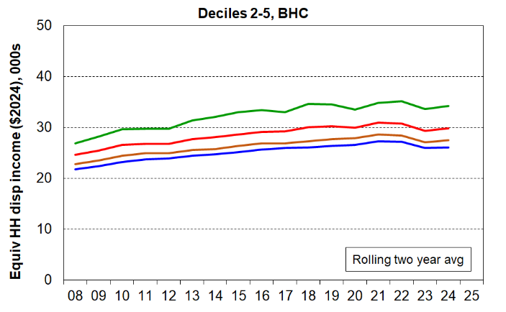
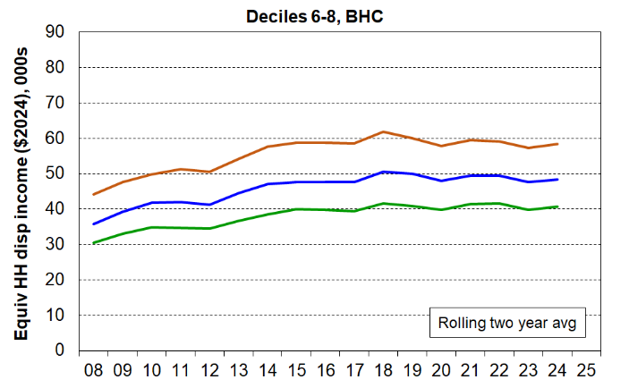
decile means ($2024)

BHC incomes for deciles 2 to 5 rose steadily in real terms from 2008 to around 2021 or 2022, then fell through to 2024 (the 23-24 HES year). The value of NZS in real terms was close to flat in real terms from 2021 to 2023 (in line with the average wage reference point) so the slight drop through to HES 22-23 must reflect a fall in other non-government income or investment income or just be a sampling variation in the survey.

BHC incomes in deciles 6 to 8 rose steadily through to around 2018 and have been flat since.
Figure B.6 repeats the analysis for real CPI-adjusted AHC incomes. The findings are similar to those for BHC incomes.

Figure B.6
Trends in real AHC household incomes for those aged 66+ and living in private dwellings,
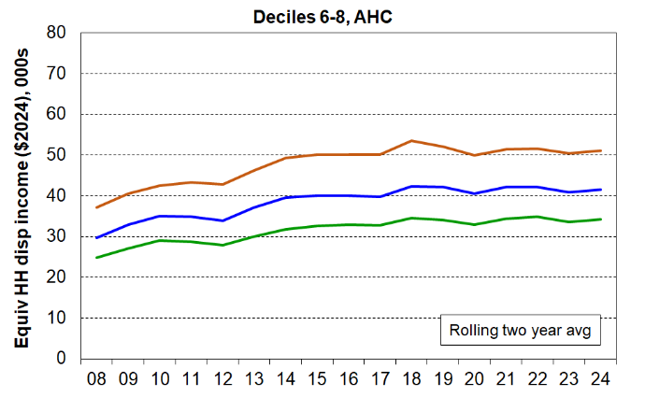
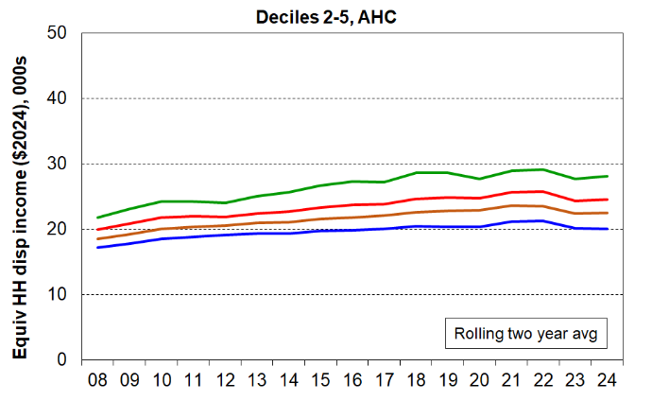
decile means ($2024)

Sources of income for older New Zealanders

This section reports on the sources of income for older New Zealanders using a three-way division:

government transfers - New Zealand Superannuation (NZS), Veterans Pension (VP) and other state support such as the Disability Allowance (DA), the Winter Energy Payment (WEP), and the Accommodation Supplement (AS)
- income from employment and self-employment
- other private income from private superannuation and other investments.

NZS and VP make up around 99% of government transfers for older New Zealanders as a group. Around 5% receive the AS, and 13% the DA. Around 5-6% do not receive any government transfer support.

For this subsection, older New Zealanders are those in private dwellings aged 66 and over. Those aged 65 are not considered as almost all of them will have received NZS for only a part of the 12 months prior to interview.

All the surveyed 66+ can be classed as belonging to one of two economic family unit (EFU) types: couple EFU with at least one partner aged 66 or more, or one-person EFU with the person aged 66 or more. The analyses for couple and one-person EFUs are sometimes kept separate as there are quite significant differences between the two groups regarding sources and levels of income.

In looking at the sources of income for older New Zealanders, the 66+ EFUs are ranked on their equivalised gross income and put into 66+ deciles for comparison. These are different from the deciles based on a ranking of the whole population. Older New Zealanders are clustered more strongly in the lower four deciles of the population income distribution (around 35% were in the lower two deciles in 2024).

With the advent in 2018-19 of income data based mainly on administrative sources, there is a discontinuity in HES incomes data for older New Zealanders in higher-income households. The first charts and tables below therefore go only to HES 2017-18. A different approach is used for 2024 reporting, but the high-level findings e\main the same for lower-income households and EFUs.

Figure B.7
Proportion of gross income of older New Zealanders (66+)
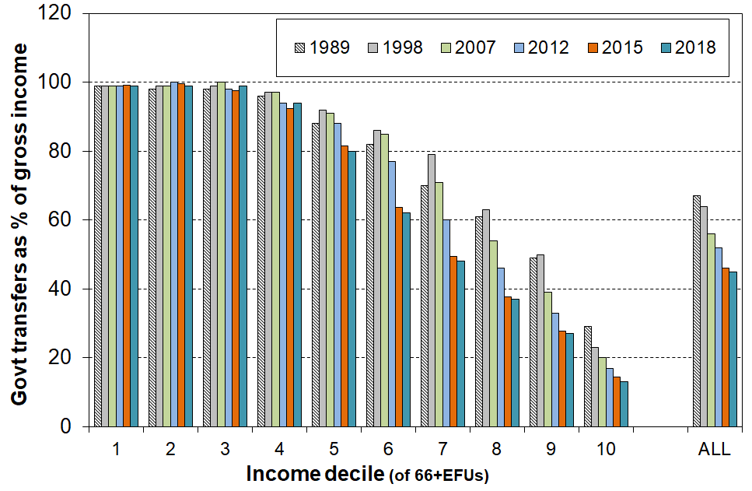
coming from government transfers (almost entirely NZS and VP)

Table B.5
Proportion (%) of gross income coming from government transfers (almost entirely NZS and VP):
Age 66+ EFUs, one person and couple EFUs with no under-65s, 1989 to 2018
Income decile of group | 1 | 2 | 3 | 4 | 5 | 6 | 7 | 8 | 9 | 10 | ALL
All 66+ (EFUs with no under-65s)
1989 | 100 | 99 | 97 | 97 | 91 | 84 | 74 | 65 | 58 | 35 | 72
1998 | 100 | 99 | 100 | 97 | 94 | 90 | 81 | 71 | 58 | 30 | 70
2009 | 99 | 100 | 98 | 96 | 91 | 83 | 72 | 58 | 41 | 24 | 61
2015 | 100 | 100 | 98 | 95 | 93 | 80 | 66 | 50 | 36 | 18 | 53
2018 | 100 | 100 | 100 | 96 | 92 | 78 | 62 | 47 | 34 | 16 | 50
Single 66+
1989 | 100 | 100 | 98 | 96 | 92 | 84 | 73 | 66 | 56 | 38 | 73
1998 | 100 | 99 | 100 | 99 | 96 | 92 | 85 | 80 | 65 | 44 | 80
2009 | 99 | 100 | 99 | 97 | 94 | 89 | 80 | 70 | 51 | 25 | 67
2015 | 99 | 100 | 99 | 97 | 95 | 93 | 81 | 66 | 47 | 21 | 63
2018 | 100 | 99 | 100 | 99 | 96 | 92 | 80 | 60 | 41 | 19 | 60
Couple 66+ - with no under-65s
1989 | 100 | 100 | 97 | 93 | 87 | 81 | 74 | 65 | 58 | 32 | 70
1998 | 100 | 100 | 97 | 94 | 90 | 83 | 71 | 62 | 47 | 21 | 61
2009 | 100 | 99 | 97 | 91 | 82 | 68 | 58 | 44 | 35 | 23 | 55
2015 | 100 | 99 | 96 | 91 | 76 | 62 | 51 | 40 | 30 | 16 | 47
2018 | 100 | 100 | 96 | 90 | 75 | 63 | 50 | 41 | 29 | 13 | 45

Note: each group (all, single and couple) is ranked separately on their incomes, then divided into deciles – the deciles are therefore the selected group’s deciles, not the deciles for the whole population

Figure B.8
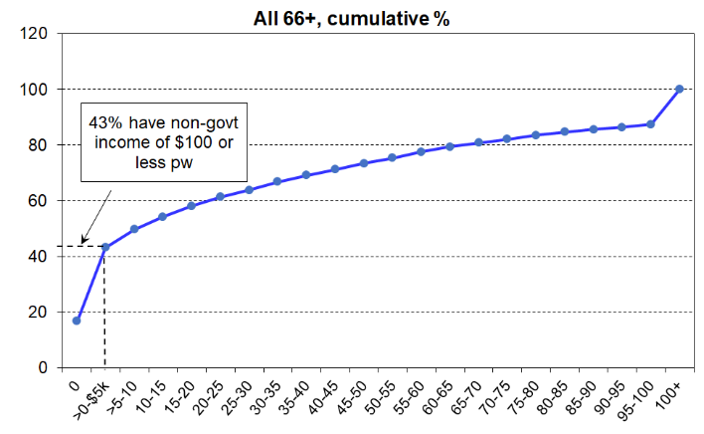
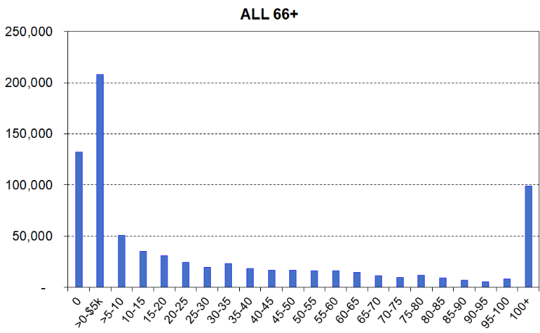
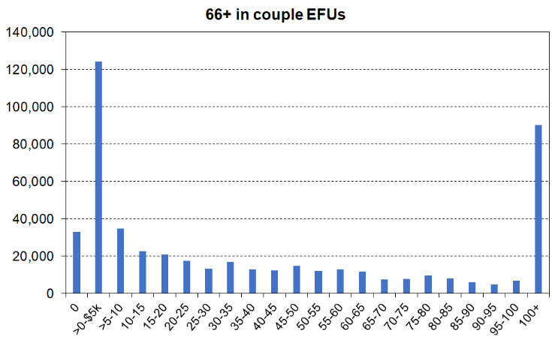
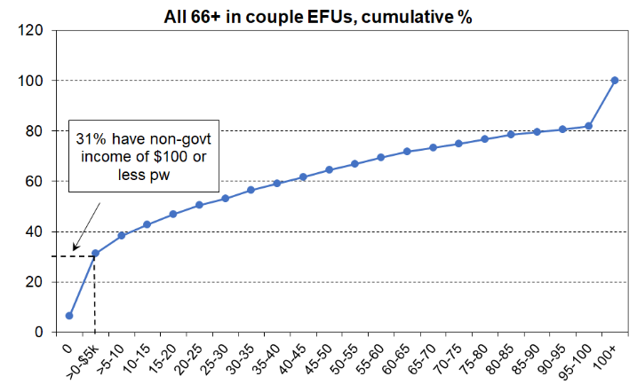
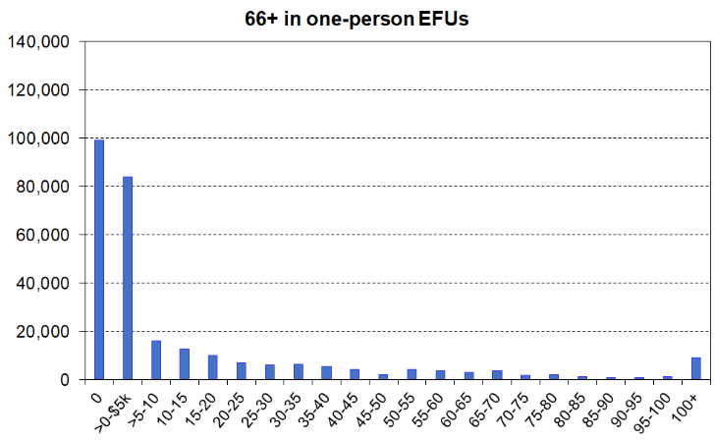
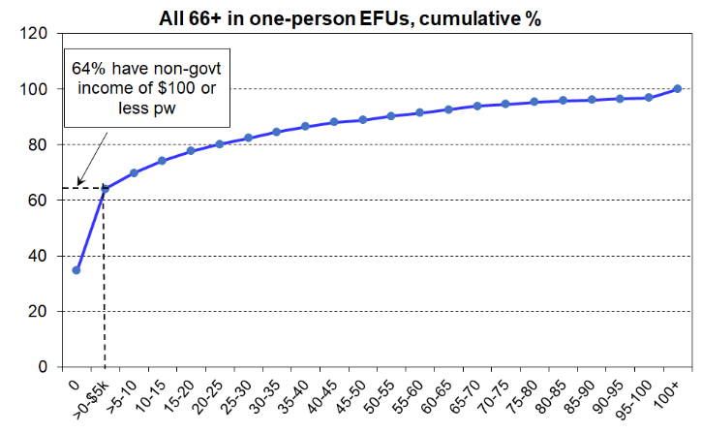
Distribution of non-government income for 66+ EFUs, including breakdown for couple and one-person EFUs, HES 2023-24

See text on p23 for the definition of EFUs and the rationale for their use here.

Table B.6
Non-government EFU income for individuals 66+, $5k pa, HES 2023-24
 | 66+ in One-person EFUs |  |  | 66+ Couple EFUs - all 66+ |  |  | All 66+
Non-govt inc band  pa ($) | # | % | cum % | # | % | cum % | # | % | cum %
0 | 99,100 | 34.7 | 35 | 32,900 | 6.6 | 7 | 132,000 | 16.8 | 17
>$0-5k | 84,000 | 29.4 | 64 | 124,100 | 24.8 | 31 | 208,000 | 26.5 | 43
>5k-10k | 16,100 | 5.6 | 70 | 34,700 | 6.9 | 38 | 50,900 | 6.5 | 50
>10k-15k | 12,700 | 4.5 | 74 | 22,600 | 4.5 | 43 | 35,400 | 4.5 | 54
>15k-20k | 10,100 | 3.5 | 78 | 20,800 | 4.2 | 47 | 31,000 | 3.9 | 58
>20k-25k | 7,100 | 2.5 | 80 | 17,600 | 3.5 | 50 | 24,700 | 3.1 | 61
>25k-30k | 6,200 | 2.2 | 82 | 13,300 | 2.7 | 53 | 19,500 | 2.5 | 64
>30k-35k | 6,400 | 2.2 | 85 | 16,900 | 3.4 | 57 | 23,300 | 3.0 | 67
>35k-40k | 5,600 | 1.9 | 87 | 12,800 | 2.6 | 59 | 18,300 | 2.3 | 69
>40k-45k | 4,300 | 1.5 | 88 | 12,400 | 2.5 | 62 | 16,600 | 2.1 | 71
>45k-50k | 2,100 | 0.7 | 89 | 14,900 | 3.0 | 65 | 17,000 | 2.2 | 73
>50k-55k | 4,100 | 1.4 | 90 | 12,000 | 2.4 | 67 | 16,100 | 2.1 | 75
>55k-60k | 3,500 | 1.2 | 91 | 13,000 | 2.6 | 70 | 16,500 | 2.1 | 77
>60k-65k | 3,100 | 1.1 | 93 | 11,600 | 2.3 | 72 | 14,700 | 1.9 | 79
>65k-70k | 3,700 | 1.3 | 94 | 7,600 | 1.5 | 73 | 11,300 | 1.4 | 81
>70k-75k | 2,000 | 0.7 | 95 | 7,700 | 1.5 | 75 | 9,700 | 1.2 | 82
>75k-80k | 2,300 | 0.8 | 95 | 9,700 | 1.9 | 77 | 12,000 | 1.5 | 84
>80k-85k | 1,200 | 0.4 | 96 | 8,000 | 1.6 | 78 | 9,200 | 1.2 | 85
>85k-90k | 1,000 | 0.4 | 96 | 5,900 | 1.2 | 80 | 6,900 | 0.9 | 86
>90k-95k | 800 | 0.3 | 96 | 4,800 | 1.0 | 81 | 5,600 | 0.7 | 86
>95k-100k | 1,200 | 0.4 | 97 | 7,000 | 1.4 | 82 | 8,200 | 1.0 | 87
>100k | 9,000 | 3.2 | 100 | 90,300 | 18.0 | 100 | 99,300 | 12.6 | 100
All | 285,700 | 100 |  | 500,500 | 100 |  | 786,200 | 100

Summary of findings regarding the sources of income for older New Zealanders

- The great majority of older New Zealanders (aged 66+) are very dependent on NZS and other government transfers for their income
- 40% have less than $100 pw from non-government sources (63% for one-person households and 31% for couple households)
- the next 20% have on average around 70% of their income from NZS and other government transfers
- those in couple EFUs generally have higher per capita non-government income than do those in single person EFUs.

Income inequality for older New Zealanders as a group

Using the Gini measure of income inequality, increasing inequality within the 65+ group is evident through to 2018. (see Figure B.9).
Figure B.9
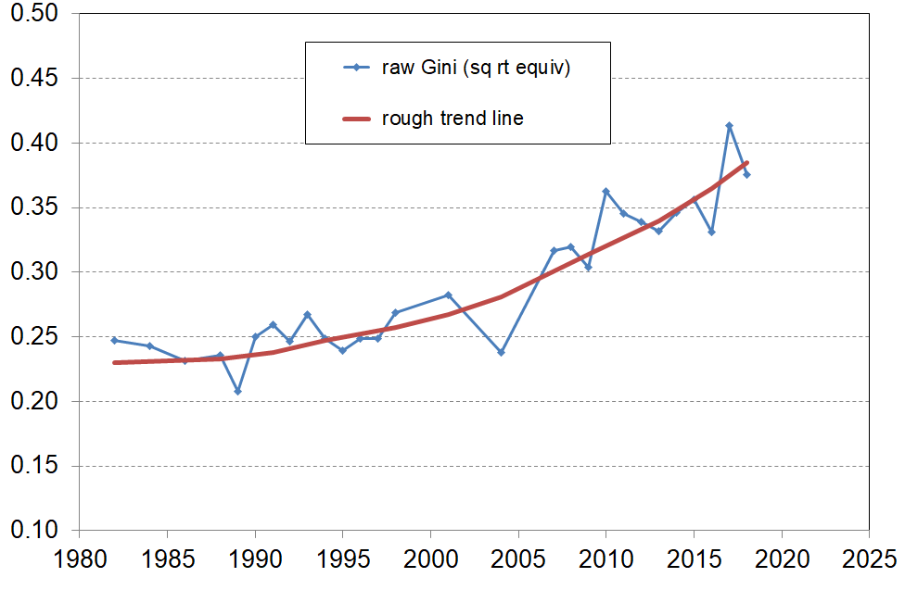
Gini for 65+, household disposable income (BHC)

There is a break in the Gini series after 2017-18. As noted above, when the HES moved to mainly administrative sources for income information in 2018-19, there was a difference in the trend for reported incomes for higher income households and EFUs.

By using information on the incomes around the median and below (which are not impacted by the ‘higher-incomes’ issue), a good indication of the ongoing trend is possible.

The AHC 50 relative low-income measure is in essence a measure of income inequality in the lower half of the income distribution. AHC 50 rates for those aged 65+ rose from a steady 6% in the 2000s and earlier to 11% in 2018 and 15% in 2024. In the same period, the whole population rate was steady at 12-15% in the 2000s and up to 2018, and was still at 15% in 2024. Taken together these findings indicate ongoing rising inequality for older New Zealanders.

This increasing income inequality (whether overall or in the lower half) reflects a growing disparity in the distribution of non-government income (from employment and private investment).

Part C:
Material hardship and material wellbeing

The report uses three indices, depending on the specific analysis undertaken:
- DEP-17 with a threshold of 6+, as used by Stats NZ for measuring material hardship in households with children for Child Poverty Reduction Act statistics
- EU-13 with a threshold of 5+, as used in official Eurostat measurement of material hardship
- MWI-24 – this index allows households to be ranked across the full material wellbeing spectrum, from high (Level 5) to low (Level 1), with ‘Level 1’ defined to be consistent with the DEP-17 analysis.

The three indices give very similar numbers and trends for the material hardship / deprivation of older New Zealanders, as shown below in Tables C.1 and C.2

Table C.1
Material hardship rates for older New Zealanders (65+),
three indices compared
Index and threshold | 2019 | 2020 | 2023 | 2024
DEP-17, 6+ | 3.3 | 2.6 | 2.9 | 3.9
MWI-24, 12- | 3.0 | 2.5 | 2.7 | 3.5
EU-13, 5+ | 4.3 | 4.3 | 3.9 | 4.6

Table C.2
Material hardship rates by ethnicity (total) for older New Zealanders (65+),
two indices compared
 |  | 2019 | 2020 | 2023 | 2024 | average of  19-20-23-24
All 65+ | DEP-17, 6+ | 3 | 3 | 3 | 4 | 3
All 65+ | MWI-24, 12- | 3 | 2 | 3 | 4 | 3
European 65+ | DEP-17, 6+ | 2 | 2 | 2 | 3 | 2
European 65+ | MWI-24, 12- | 2 | 2 | 2 | 2 | 2
Māori 65+ | DEP-17, 6+ | 9 | 8 | 7 | 9 | 8
Māori 65+ | MWI-24, 12- | 8 | 8 | 8 | 7 | 8
Asian 65+ | DEP-17, 6+ | Sample numbers too small to support reliable estimates |  |  |  | 3
Asian 65+ | MWI-24, 12- |  |  |  |  | 3
Pacifica 65+ | DEP-17, 6+ |  |  |  |  | 14
Pacifica 65+ | MWI-24, 12- |  |  |  |  | 17
Notes for Tables.
- Sample numbers prior to 2019 are too small to reliably report on material hardship rates for 65+ by ethnicity.
- Sample numbers for 2019-2024 are too small to reliably report on material hardship rates for 65+ Pacifica and 65+ Asian on a single year basis. The average is reported.
- The ‘2024’ rates on charts that follow are usually part of a rolling two-year average time series and they come out at more like 3% than the 4% noted above.

Part C reports on:
- The material hardship trend from 2007 to 2024
- International ranking for older New Zealanders
- Material hardship by living arrangements and tenure
- Material wellbeing from low to high
  - with breakdowns by selected population groups
  - by self-assessed health status
- Keeping warm
- Is pensioner poverty increasing?

Material hardship trend and international ranking

Over the last decade or so, the material hardship trend for older New Zealanders has been flat overall (3-4%) and much lower than children in their households and the population overall.

Figure C.1
Material hardship / deprivation trends for older New Zealanders compared with
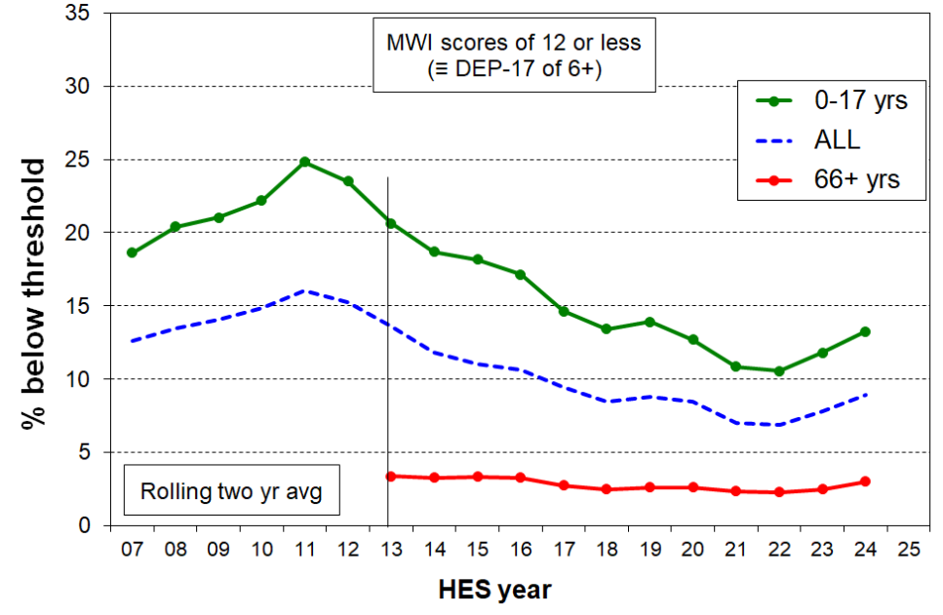
children (under 18s) and the population overall, 2007 to 2024
Note for chart: Prior to 2013 the predecessor of the MWI is used. It is suitable / good enough for other age-groups, not as good for older people. The 65+ line therefore starts in 2013.

For those aged 65+, New Zealand ranks well relative to European countries, with a material hardship rate of 5% using the Eurostat’s official measure (EU-13). This puts New Zealand in the top part of the league table with Austria, the Netherlands, Denmark and Finland (all in the 4-5% range). For those aged 65+, the EU country median is 8% and the weighted mean for the whole 65+ population is 11%. The New Zealand hardship rate for children is 13% using the same measure. This is above the EU country median of 11%, but below the full population-weighted EU average of 15%.

Figure C.2
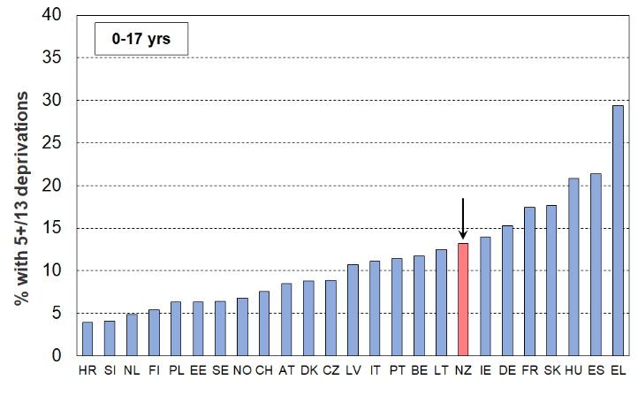
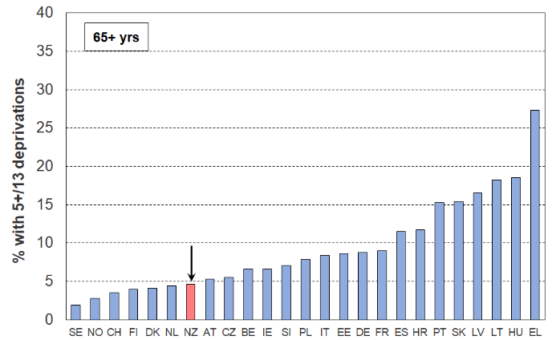
Material hardship / deprivation rates for older New Zealanders (65+) and children (under 18s) compared with European countries (EU-SILC 2023, HES 2023-24)

These relatively good outcomes for older New Zealanders are longstanding and are due to the mix of current public provision (mainly NZS), the private provision built up by most of the current cohort over their lifetime, and paid employment income for some. A key component of the private provision is mortgage-free home ownership which is relatively high among the current cohort (~71%, albeit down from 83% in the mid-1990s). The provision in New Zealand of a non-means tested pension (NZS) means that recipients are not discouraged from paid work beyond pension age nor the accumulation of assets over the life course.
Material hardship for older New Zealanders (65+) by their living arrangements

Table C.3a
Material hardship rates and numbers for 65+ by their living arrangements (DEP-17, 6+)
 | % |  |  |  |  |  | #
 | 18 | 19 | 20 | 23 | 24 | Avg for 19-20-23-24
Couple 65+ | 1 | 1 | 1 | 1 | 2 | 1.3 | 5,500
One-person 65+ - all | 4 | 4 | 4 | 3 | 5 | 4.1 | 8,000
female | 4 | 4 | 5 | 3 | 5 | 4.3 | 5,500
male | 5 | 4 | 3 | 3 | 5 | 3.6 | 2,500
Other Family households no dep ch | 5 | 5 | 3 | 5 | 6 | 4.8 | 5,000
Other Family households with dep ch | 5 | 11 | 9 | 11 | 13 | 11.0 | 4,500
Non-family households | Sample numbers too small to support reliable estimates |  |  |  |  | 6.5 | 1,000
Other |  |  |  |  |  | 6.3 | 500
ALL 65+ | 2.7 | 3.3 | 2.6 | 2.9 | 3.9 | 3.2 | 24,500

Table C.3b
Material hardship rates and numbers for 65+ by their living arrangements (DEP-17, 4+)
 | % |  |  |  |  |  | #
 | 18 | 19 | 20 | 23 | 24 | Avg for 19-20-23-24
Couple 65+ | 3 | 4 | 3 | 4 | 4 | 3.7 | 15,000
One-person 65+ - all | 9 | 9 | 8 | 7 | 10 | 8.6 | 16,500
female | 9 | 8 | 8 | 7 | 10 | 8.3 | 10,500
male | 8 | 10 | 9 | 7 | 10 | 9.1 | 5,500
Other Family households no dep ch | 15 | 13 | 10 | 13 | 11 | 11.9 | 13,000
Other Family households with dep ch | 19 | 18 | 20 | 20 | 22 | 19.9 | 8,000
Non-family households | Sample numbers too small to support reliable estimates |  |  |  |  | 15.0 | 2,500
Other |  |  |  |  |  | 14.0 | 1,000
ALL 65+ | 7.2 | 7.5 | 6.8 | 7.0 | 7.8 | 7.3 | 56,000

Material hardship of older New Zealanders (66+) by tenure

Table C.4a
Material hardship rates and numbers for 65+ by their household tenure (DEP-17, 6+)
 | % |  |  |  |  |  | #
 | 18 | 19 | 20 | 23 | 24 | Avg for 19-20-23-24
Owned (any) | 1 | 2 | 1 | 2 | 2 | 2 | 11,500
Owned - with mortgage | 4 | 5 | 4 | 7 | 6 | 5 | 5,500
Owned - without mortgage | 1 | 1 | 1 | 1 | 1 | 1 | 6,000
Rented - Private (AS) | 10 | 19 | 10 | 12 | 21 | 16 | 5,500
Rented - Private (no AS) | 10 | 6 | 2 | 4 | 7 | 5 | 1,500
Rented - HNZ/KO & Local Auth | 18 | 16 | 19 | 14 | 24 | 18 | 4,500
Age 66+ in HHs currently paying rent or mortgage | 8 | 9 | 7 | 8 | 11 | 9 | 17,500
ALL 65+ | 3 | 3 | 3 | 3 | 4 | 3 | 24,500

Table C.4b
Material hardship rates and numbers for 65+ by their household tenure (DEP-17, 4+)
 | % |  |  |  |  |  | #
 | 18 | 19 | 20 | 23 | 24 | Avg for 19-20-23-24
Owned (any) | 5 | 5 | 4 | 4 | 5 | 5 | 29,500
Owned - with mortgage | 14 | 10 | 10 | 14 | 13 | 12 | 12,500
Owned - without mortgage | 3 | 4 | 3 | 3 | 3 | 3 | 17,000
Rented - Private (AS) | 25 | 32 | 26 | 31 | 36 | 31 | 11,500
Rented - Private (no AS) | 12 | 12 | 9 | 10 | 14 | 11 | 4,000
Rented - HNZ/KO & Local Auth | 35 | 36 | 38 | 30 | 39 | 36 | 9,500
Age 66+ in HHs currently paying rent or mortgage | 20 | 18 | 16 | 19 | 21 | 18 | 37,000
ALL 65+ | 7 | 8 | 7 | 7 | 8 | 7 | 56,000

There is some evidence from the HES of rising material hardship for some groups. An example is those who rent privately and receive the AS. For this group there is an increased inability to afford basics like fresh fruit and vegetables, local trips, repairing or replacing broken appliances … because of costs (Table C.5). See also the inflation chart in Part One (Figure A.8).

Table C.5
Older New Zealanders (66+) who rent privately and receive the AS:
% reporting selected deprivations
 | 17, 18 (avg) | 19 | 20 | 21 | 22 | 23 | 24
Total numbers (000s) | 36 | 28 | 31 | 37 | 35 | 37 | 38
Gone without fresh fruit and vegetables - a lot | 7 | 5 | 3 | 5 | 9 | 7 | 12
Buy cheaper cuts or bought less meat than you would like - a lot | 16 | 22 | 16 | 24 | 20 | 24 | 30
Do without or cut back on trips to the shops or other local places - a lot | 14 | 17 | 17 | 12 | 18 | 17 | 24
Delay replacing or repairing broken or damaged appliances - a lot | 10 | 14 | 10 | 10 | 8 | 11 | 20
Adequacy of income to cover basics - not enough | 18 | 21 | 16 | 22 | 21 | 20 | 26
DEP-17 6+ | 12 | 18 | 9 | 14 | 10 | 13 | 21
Of the 5 items above (not including DEP-17 6+):
0 items | 68 | 55 | 63 | 57 | 51 | 59 | 46
1+ items | 32 | 45 | 37 | 43 | 49 | 41 | 54
2+ items | 18 | 19 | 18 | 20 | 16 | 23 | 28
3+ items | 8 | 10 | 5 | 7 | 8 | 11 | 18

Material wellbeing from low to high

One of the values of the Material Wellbeing Index (MWI) is that it provides a ranking of households across the full MWB spectrum from low to high, rather than mainly targeting the bottom end as the DEP-17 and EU-13 indices do. It is not as sensitive in the top half as in the lower half but still provides good discrimination across the whole range. The MSD reports divide the full spectrum into six categories:
- The boundary for the lowest category (Group 1) was selected to make the MWI hardship rate correspond as close as possible to the 6+/17 DEP-17 hardship rate for the whole population (9%), the DEP-17 measure and threshold used by Stats NZ in the Child Poverty Reduction Act poverty statistics.
- Group 2 could be labelled ‘just getting by’ (the next 10% of people).
- The red band is for those in material hardship, and the dark green for those who are very well off. The data behind the charts above are in Table C.6 on the next page.
- The proportions in each group in 2023-24 are very close to what they were in 2018-19.

Figure C.3
Material wellbeing from low (hardship) to high for selected age groups, HH type and tenure
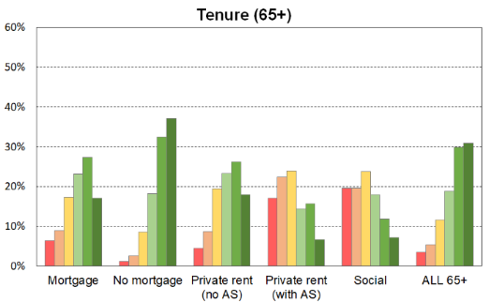
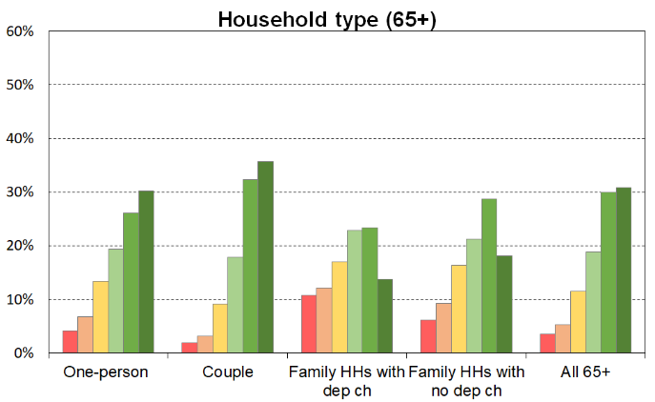
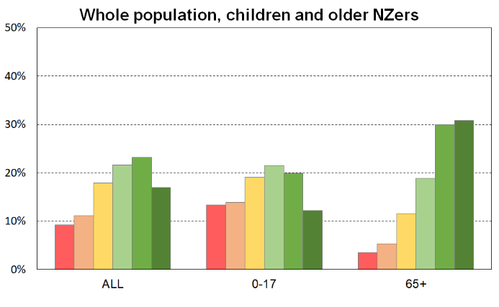
Table C.6
The material wellbeing of 65+ in selected household contexts:
6 groupings using MWI scores, HES 2023-24
(1-6 sum to 100% across)
MWI level (6=highest material wellbeing) → | 1 | 2 | 3 | 4 | 5 | 6 | Size of group
 | 0-12 | 13-18 | 19-24 | 25-29 | 30-33 | 34-35 | 000s | %
Material wellbeing distribution
Population | 9 | 11 | 18 | 22 | 23 | 17 | 5,180 | 100
Age group
0-17 | 13 | 14 | 19 | 22 | 20 | 12 | 1,170 | 23
18-24 | 12 | 14 | 22 | 24 | 18 | 11 | 440 | 9
25-44 | 10 | 12 | 21 | 23 | 22 | 12 | 1,475 | 28
45-64 | 8 | 10 | 17 | 21 | 25 | 20 | 1,265 | 24
65+ | 4 | 5 | 12 | 19 | 30 | 31 | 830 | 16
Household type
Single <65 | 16 | 12 | 18 | 20 | 18 | 14 | 250 | 5
Single 65+ | 4 | 7 | 13 | 19 | 26 | 30 | 220 | 4
Couple only maxage <65 | 4 | 9 | 15 | 22 | 29 | 22 | 550 | 11
Couple only maxage 65+ | 2 | 3 | 9 | 18 | 32 | 36 | 495 | 10
2P HH with any dep children | 8 | 12 | 19 | 24 | 24 | 14 | 1,765 | 34
SP HH with any dep children | 29 | 23 | 19 | 14 | 10 | 5 | 295 | 6
Other fam HHs with any dep children | 17 | 15 | 22 | 21 | 16 | 9 | 475 | 9
Family HHs no deps maxage <65 | 7 | 11 | 20 | 23 | 23 | 16 | 610 | 12
Family HHs no deps maxage 65+ | 6 | 9 | 16 | 21 | 29 | 18 | 250 | 5
Non-family HHs | 13 | 13 | 25 | 24 | 18 | 7 | 275 | 5
Household type (65+)
Single 65+ | 4 | 7 | 13 | 19 | 26 | 30 | 220 | 26
Couple only maxage 65+ | 2 | 3 | 9 | 18 | 32 | 37 | 435 | 52
Other fam HHs with any dep children 65+ | 11 | 12 | 15 | 24 | 23 | 15 | 35 | 4
Family HHs no deps maxage 65+ | 5 | 9 | 15 | 20 | 31 | 20 | 115 | 14
Other | Suppressed – see note |  |  |  |  |  | 25 | 3
Tenure (65+)
Owned with mortgage (incl FT) | 6 | 9 | 17 | 23 | 27 | 17 | 105 | 13
Owned no mortgage (incl FT) | 1 | 3 | 9 | 18 | 32 | 37 | 590 | 71
Private rental | 11 | 16 | 22 | 19 | 21 | 12 | 80 | 10
Social rental (KO/HNZ/other) ** | 17 | 18 | 24 | 18 | 15 | 9 | 30 | 3
Labour market status of household (for 65+)
Self-employed (>50% of HH income from SE) | Suppressed – see note |  |  | 21 | 29 | 40 | 25 | 3
At least one FT worker | 4 | 6 | 13 | 20 | 33 | 25 | 210 | 25
No FT worker (may have PT) | 4 | 5 | 11 | 18 | 29 | 32 | 595 | 71
PT work only | 2 | 5 | 10 | 17 | 32 | 34 | 85 | 10
Some work (excl SE) | 3 | 6 | 12 | 19 | 32 | 28 | 300 | 36
Workless | 4 | 5 | 11 | 19 | 29 | 32 | 510 | 61
Labour market status of household (for 65+)
Self-employed (any SE) | 2 | 3 | 8 | 18 | 34 | 35 | 100 | 12
At least one FT worker | 4 | 7 | 14 | 20 | 32 | 23 | 170 | 20
No FT worker (may have PT) | 4 | 5 | 12 | 19 | 29 | 32 | 560 | 67
PT work only | 3 | 5 | 11 | 19 | 28 | 34 | 65 | 8
Some work (excl SE) | 4 | 6 | 13 | 20 | 31 | 26 | 235 | 28
Workless | 4 | 5 | 12 | 18 | 29 | 32 | 495 | 60
Note for Table C.6: information is suppressed in cells with fewer than 20 individuals in the unweighted data.
** The sample numbers for the Social Rental (KO/HNZ/other) row are relatively small, especially for Level 6. The reported figures use the average from 2022-23 and 2023-24 to improve their reliability by in effect increasing the sample numbers for each cell. The resulting overall pattern and relativities are reliable, but more detailed conclusions are not supported.

Material hardship of older New Zealanders (65+) by health status

Table C.7 shows the association between self-assessed health ratings and household material wellbeing level for both those aged 65+ and 55-64 year olds.

A useful way of summarising the relationship is via ‘risk ratios’. See Table C.8. They give an idea of the over- or under-representation in the various categories, with ratios greater than 1 indicating over-representation and less than 1 indicating under-representation. For example, the ‘2.4’ for those in material hardship with fair or poor self-rated health means that those in material hardship are around two-and-a-half times more likely to be in fair or poor health than a random distribution would produce.

Table C.7
The self-assessed health of 65+ by the material wellbeing level of their household, HES 2023-24
(MWI levels 1-6, sum to 100% across and 100% down)
MWI level (6=highest material wellbeing) → | 1 | 2 | 3 | 4 | 5 | 6 | Size of group
 | 0-12 | 13-18 | 19-24 | 25-29 | 30-33 | 34-35 | 000s | %
Material wellbeing distribution
Population - all | 9 | 11 | 18 | 22 | 23 | 17 | 5,181 | 100
Population - age 65+ | 4 | 5 | 12 | 19 | 30 | 31 | 831 | 16
Population - age 55-64 | 7 | 9 | 15 | 20 | 25 | 23 | 621 | 12
65+ self-assessed health (% across)
Excellent | 1 | 3 | 6 | 14 | 34 | 42 | 116 | 14
Very good | 2 | 3 | 9 | 19 | 33 | 35 | 276 | 33
Good | 3 | 5 | 13 | 20 | 30 | 29 | 253 | 30
Fair or Poor | 8 | 10 | 18 | 20 | 23 | 20 | 155 | 19
65+ self-assessed health (% down)
Excellent | 4 | 7 | 8 | 10 | 16 | 19 | 116 | 14
Very good | 14 | 21 | 25 | 33 | 36 | 37 | 276 | 33
Good | 23 | 31 | 33 | 32 | 30 | 29 | 253 | 30
Fair or Poor | 45 | 34 | 30 | 20 | 14 | 12 | 155 | 19
No response | 15 | 6 | 4 | 4 | 3 | 2 | 32 | 4
Total | 100 | 100 | 100 | 100 | 100 | 100 | 831 | 100
55-64 self-assessed health (% across)
Excellent | 2 | 4 | 8 | 19 | 30 | 37 | 111 | 13
Very good | 4 | 6 | 13 | 20 | 30 | 26 | 204 | 25
Good | 7 | 11 | 19 | 22 | 22 | 18 | 166 | 20
Fair or Poor | 19 | 16 | 21 | 18 | 15 | 11 | 110 | 13
55-64 self-assessed health (% down)
Excellent | 4 | 9 | 10 | 17 | 21 | 29 | 111 | 18
Very good | 19 | 22 | 28 | 33 | 39 | 38 | 204 | 33
Good | 26 | 33 | 33 | 29 | 24 | 21 | 166 | 27
Fair or Poor | 47 | 30 | 24 | 16 | 11 | 8 | 110 | 18
No response | 4 | 6 | 4 | 6 | 5 | 4 | 30 | 5
Total | 100 | 100 | 100 | 100 | 100 | 100 | 621 | 100

Table C.8
The ‘risk ratio’ of different health ratings for 65+ for a given level of material wellbeing, HES 2023-24
MWI level (6=highest material wellbeing) → | 1 | 2 | 3 | 4 | 5 | 6 | Size of group
 | 0-12 | 13-18 | 19-24 | 25-29 | 30-33 | 34-35 | 000s | %
65+ self-assessed health
Excellent | 0.3 | 0.5 | 0.6 | 0.7 | 1.1 | 1.4 | 116 | 14
Very good | 0.4 | 0.6 | 0.7 | 1.0 | 1.1 | 1.1 | 276 | 33
Good | 0.7 | 1.0 | 1.1 | 1.1 | 1.0 | 1.0 | 253 | 30
Fair or Poor | 2.4 | 1.8 | 1.6 | 1.1 | 0.8 | 0.7 | 155 | 19

Keeping warm

There are three questions in the HES about keeping warm or putting up with feeling cold. Each produces the same reasonably flat trend for those aged 65+.
- In the last 12 months have you put up with feeling cold to keep down costs to help pay for other basic items (not at all / a little / a lot)?
- Can you afford to keep your accommodation adequately warm? (yes, no)
- Does your accommodation have (no problem / a minor problem / a major problem) with heating and/or keeping it warm in winter?

The first one is used in Table C.8. The proportion forced to put up with the cold ‘a lot’ has remained steady at 3-4% over the last ten years. Those living on their own report a higher rate than couples, typically 5% compared with 2%. There is a smaller group who live with others in wider households. Their rate in 2023-24 was around 7-8%. In terms of numbers, in 2023-24 34,000 aged 65+ reported having to put up with feeling cold – 14,000 in one-person households, 11,000 in couple households and 8,000 in wider households.

Table C.9 uses the second question for ranking relative to European countries. It shows that New Zealand ranks at the better end of the table and shares the same general relativity between one and two-adult households as European countries.

Table C.8
% reporting "Put up with feeling cold – a lot", 2-yr rolling averages from 2014
 | 14 | 15 | 16 | 17 | 18 | 19 | 20 | 21 | 22 | 23 | 24
All age 65+ | 4 | 4 | 4 | 3 | 4 | 4 | 4 | 4 | 3 | 3 | 4
Single 65+ | 6 | 6 | 5 | 5 | 6 | 6 | 6 | 5 | 5 | 4 | 5
Individuals in couple 65+ HHs | 1 | 2 | 2 | 2 | 2 | 3 | 3 | 2 | 1 | 2 | 2
All age 0-64 | 9 | 8 | 7 | 7 | 7 | 8 | 8 | 6 | 6 | 6 | 6

Table C.9
‘Cannot afford to keep home adequately warm’ – selection for Europe for 65+,
EuroStat 2023, HES avg 2023 & 2024 (%)
One-adult HH, 65+ |  |  | Two-adult HH, at least one aged 65+
Switzerland | 1 |  | Switzerland | 0
Norway | 3 |  | Norway | 2
Finland | 3 |  | Finland | 2
New Zealand | 5 |  | Austria | 2
Austria | 5 |  | New Zealand | 2
Sweden | 5 |  | Denmark | 3
Germany | 6 |  | Sweden | 3
Denmark | 7 |  | Slovenia | 3
Slovenia | 8 |  | Ireland | 3
Poland | 10 |  | Netherlands | 4
Netherlands | 10 |  | Germany | 5
Ireland | 10 |  | Slovakia | 5
Italy | 14 |  | Poland | 6
France | 14 |  | Latvia | 6
Slovakia | 15 |  | Italy | 8
Latvia | 16 |  | France | 8
Spain | 20 |  | Spain | 17
Greece | 26 |  | Greece | 18
Portugal | 32 |  | Portugal | 27
Lithuania | 33 |  | Lithuania | 28
EU-27 wgted mean | 13.1 |  | EU-27 wgted mean | 8.4
EU-27 median | 12.0 |  | EU-27 median | 6.3
Note: The latest UK figure is from 2018. The average rates for 2017 and 2018 for
the UK were 5% for one-adult HHs and 3% for two-adult HHs.
Is pensioner poverty increasing?

A first step in seeking to answer the question is to be clear whether we are talking about rates or numbers. For example, a low-income or material hardship rate that is trending flat will mean that the numbers will be increasing as the number of older New Zealanders is rapidly increasing. This could be reported as ‘pensioner poverty rising …’ which is true if it is numbers (thousands) being referred to but false if rates are in mind or implied.

The 1.0 ppt rise in the overall hardship rate from 2022-23 to 2023-24 (2.9% to 3.9% using the DEP-17, 6+ measure) is not large enough to be statistically significant, though it is the largest year-on-year change since the DEP-17 measure began in 2013.

While there is no conclusive evidence for any overall rise in rates, there is evidence that is indicative of increasing hardship for some population groups. For example:
- the steady fall in the ‘not enough’ response rate to the self-assessed income adequacy question reversed for 2023-24, for those in low-income households and for all 65+ (see Part F)
  - this is consistent with the finding of falling real incomes for older New Zealanders noted in the incomes section above (Part B)
- private renters receiving the AS report increased inability to afford basics like fresh fruit and vegetables, local trips, repairing or replacing broken appliances … because of costs (see Table C.5 above)
- between May 2019 and July 2025 the number of NZS/VP recipients receiving Temporary Additional Support doubled, from 6,660 to 13,321 – of the 13,321, 83% are single people.

There is a group of around 3-4% (30,000) who are in ‘near hardship’ – their DEP-17 scores are 4 or 5, a little below the standard 6+ threshold. Some of the latter could easily move into the hardship group given the sort of cost-of-living challenges that are currently being experienced, and the lag before the annual NZS adjustment compensates for cost-of-living increases.

Rising costs since the 2023-24 survey

The 2023-24 HES finished on 30 June 2024. Since then there have been several factors that may lead to an increase in reported hardship rates for older New Zealanders in the 2024-25 survey (at least relative to 2022-23): fast rising food and electricity prices in the period of the survey; the cumulative impact of general inflation and rising housing costs for renters, owners with and without mortgages (this latter group still pays rates, insurance and maintenance costs, and if they have little in the way of financial resources beyond NZS, the pressure on the budget will mount despite being ‘asset-rich’).

The annual increase in nominal NZS level is determined by the higher of inflation and net average wage change, and should over time compensate for a period of high inflation. In the short run, before the adjustments take effect, those with limited financial resources other than NZS and who struggle to get by each fortnight can find themselves in financial stress.

Part D
Tenure and Housing Costs

Over the last three decades (1994 to 2024), the HES shows that home ownership for older New Zealanders has been steady at 84-86%. The proportion in rentals has been steady at ~12-13%, with ~2-3% in a residual category whose tenure is not clear.4

Since the mid-1990s there has however been a downward trend in the proportion of older New Zealanders whose dwellings are mortgage-free, down from 83% in the mid-1990s to 76% in the mid-2000s and to 71% on average from 2022 to 2024 (Figure D.1). Over the last three surveys, around 13% were in a dwelling for which there were still mortgage payments being made, a similar proportion to those renting. In the 1990s around 5% of those aged 65+ were renting.
Figure D.1
Tenure for individuals aged 65+, based on HES data 1992 to 2024, two year rolling average

The rising trend in the proportion of older New Zealanders (still) paying a mortgage is a potential concern because it increases the chances of there being more with inadequate after-housing-costs incomes. Whether this trend translates into a real-world increase in the proportion of older New Zealanders experiencing financial or material hardship depends on the characteristics of the households in question. For example, if the bulk of the increase in those with mortgages is households with higher incomes, or are households using their primary dwelling as security to raise funds for purchasing another property (eg for renting out), then there are few grounds for concern. If on the other hand the bulk of the increase is from less well-off households coming into ‘retirement’ but still paying a mortgage on the primary dwelling, then there are grounds for concern, depending on the size of the mortgage and repayment rates.

The version of the HES data currently used by MSD does not allow us to fully investigate the questions related to other properties, but the full HES dataset does allow this. Preliminary analysis of the full HES data (2018-19) by Stats NZ on MSD’s behalf indicates that it is very unlikely that the increase is driven by any increase in the numbers using the primary dwelling as security for purchasing another.

Tenure for 45-64 year olds

The tenure trends for those in the years before ‘retirement’ are shown in Figure D.2 below.
- renting has doubled from around 10% in the 1990s to 23% in 2024, with a corresponding fall in home ownership to 74%
- there has been a strong decline over the last twenty-five years in those who are mortgage-free, halving from 60% in the early 1990s to 32% in 2024
- this points to further declines in mortgage-free home ownership for older New Zealanders (65+) and, all else equal, to pressure on the household budgets of more 65+ households.

Figure D.2
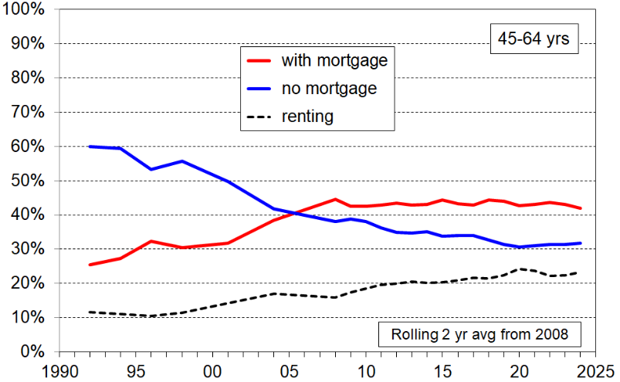
Tenure for individuals aged 45-64, based on HES data, 1992 to 2024, two year rolling average

Housing costs

As shown in Figure D.1 and Table D.3 below, there has been a steady rise in the proportion of low-income 65+ households with housing costs more than 40% of disposable income. Low-income here means incomes in the two lower BHC quintiles. From 2009 to 2024:
- for all 65+ in low-income households, the rise was from 6% to 11%
- for those in one-person or couple households paying a mortgage, from 23% to 37%
- for private renters in one-person or couple households, 51% to 68% (higher for renters receiving AS).

Figure D.1
Trends in the proportion of 65+ in low-income one-person and couple households (BHC Q1 & Q2)
that spend more than 30% or 40% of income on housing costs
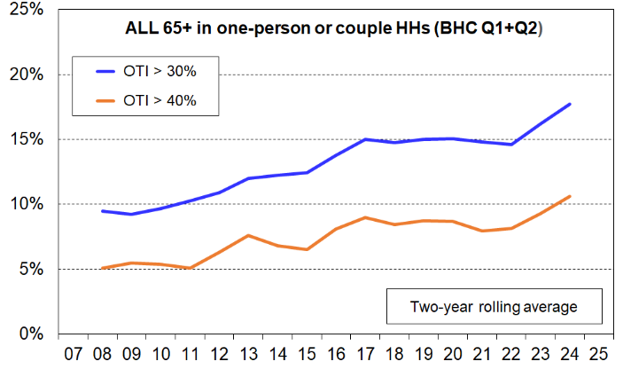
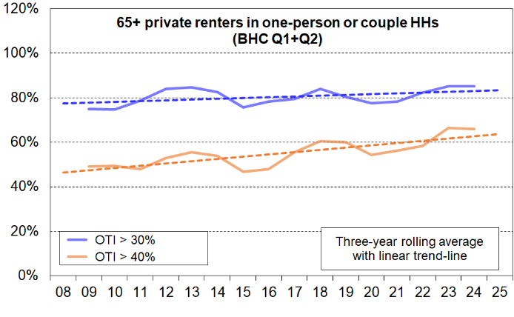
(all 65+, and private renters 65+)

Table D.3a
65+ in low-income one-person and couple households (BHC Q1 and Q2), by tenure
OTIs >30% (%) smoothed rolling 2 yr
 | 08 | 09 | 10 | 11 | 12 | 13 | 14 | 15 | 17 | 18 | 19 | 20 | 21 | 22 | 23 | 24
Owned with mortgage (incl FT) | 38 | 35 | 47 | 55 | 44 | 43 | 42 | 35 | 39 | 49 | 48 | 49 | 50 | 47 | 47 | 52
Owned no mortgage (incl FT) | 1 | 1 | 1 | 0 | 1 | 1 | 1 | 2 | 3 | 4 | 5 | 5 | 4 | 5 | 7 | 8
Private rental | 76 | 75 | 74 | 81 | 88 | 83 | 79 | 75 | 77 | 83 | 78 | 76 | 80 | 85 | 86 | 84
Social rental (incl KO, community, council) | 11 | 9 | 7 | 5 | 12 | 15 | 9 | 8 | 22 | 26 | 15 | 13 | 14 | 8 | 10 | 13
Other | 21 | 30 | 32 | 25 | 15 | 13 | 19 | 28 | 22 | 22 | 20 | 15 | 18 | 23 | 23 | 23
All 65+ in low-income one-person and couple households | 9 | 9 | 10 | 10 | 11 | 12 | 12 | 12 | 13 | 15 | 15 | 15 | 15 | 15 | 16 | 18
65+ in other low-income households | 21 | 22 | 23 | 24 | 20 | 15 | 16 | 23 | 20 | 16 | 23 | 23 | 20 | 19 | 21 | 22
All 65+ in low-income households | 11 | 11 | 11 | 12 | 12 | 12 | 13 | 14 | 14 | 15 | 16 | 16 | 16 | 15 | 17 | 18

Table D.3b
65+ in low-income one-person and couple households (BHC Q1 and Q2), by tenure
OTIs >40% (%) smoothed rolling 2 yr
 | 08 | 09 | 10 | 11 | 12 | 13 | 14 | 15 | 17 | 18 | 19 | 20 | 21 | 22 | 23 | 24
Owned with mortgage (incl FT) | 23 | 26 | 23 | 23 | 21 | 18 | 28 | 25 | 17 | 23 | 30 | 30 | 27 | 27 | 32 | 37
Owned no mortgage (incl FT) | 1 | 0 | 0 | 0 | 0 | 1 | 1 | 1 | 2 | 2 | 2 | 2 | 1 | 1 | 2 | 3
Private rental | 49 | 51 | 48 | 47 | 56 | 60 | 48 | 43 | 54 | 62 | 57 | 52 | 56 | 63 | 68 | 68
Social rental (incl KO, community, council) | 4 | 0 | 2 | 2 | 4 | 8 | 6 | 5 | 11 | 12 | 6 | 4 | 6 | 4 | 5 | 8
Other | 1 | 6 | 11 | 7 | 5 | 4 | 2 | 7 | 8 | 3 | 2 | 5 | 7 | 6 | 6 | 10
All 65+ in low-income one-person and couple households | 5 | 5 | 5 | 5 | 6 | 8 | 7 | 7 | 8 | 8 | 9 | 9 | 8 | 8 | 9 | 11
65+ in other low-income households | 13 | 7 | 7 | 7 | 7 | 8 | 9 | 12 | 10 | 7 | 10 | 12 | 12 | 11 | 11 | 12
All 65+ in low-income households | 6 | 6 | 6 | 5 | 6 | 8 | 7 | 7 | 8 | 8 | 9 | 9 | 9 | 9 | 9 | 11

Table D.4 shows the tenure proportions and financial hardship outcomes across OTI bands for 65+ in low-income households. ‘Low income’ here refers to the lower two BHC income quintiles for the whole population.

There is a clear gradient of outcomes across the increasing OTI bands.

Table D.4
Demographics and financial hardship outcomes across OTI bands
for 65+ in low-income one-person and couple households, average of HES 2022-23 and 2023-24
OTI bands (housing outgoings to income ratios) → | ≤ 15% | 15+ to 30% | 30+ to 40% | 40%+ | All in  Q1 - Q2
Number of 65+ in low-income households in each band | 190,000 | 154,000 | 29,000 | 44,000 | 418,000
Average housing costs ($pa) | 4,300 | 7,000 | 11,500 | 21,600 | 7,600
Average housing costs ($pw) | 83 | 133 | 220 | 415 | 146
Median liquid assets ($) – 2020-21 only | 43,000 | 27,000 | 5,000 | 1,000 | ***
Tenure composition (% across)
private rent | 5 | 11 | 17 | 67 | 100
KO/community/council rent | 6 | 63 | 20 | 11 | 100
owned with mortgage | 19 | 29 | 16 | 36 | 100
owned no mortgage | 53 | 40 | 5 | 3 | 100
Material and financial hardship profile | % | % | % | % | %
DEP-17 score of 6+ | 2 | 2 | 6 | 10 | 3
DEP-17 score of 4+ | 4 | 6 | 11 | 21 | 7
HH income ‘not enough’ for the basics | 6 | 8 | 14 | 20 | 9
Used a foodbank once or more in last 12 months | 1 | 2 | 6 | 9 | 3
Borrowed from family or friends to meet everyday living costs once or more in the 12 months before interview | 1 | 2 | 5 | 10 | 3
Behind on utilities or rent/mortgage or HP or other loans once or more in the 12 months before interview | 2 | 3 | 6 | 10 | 3
Could not pay an essential but unexpected $500 expense in a month without borrowing | 5 | 9 | 18 | 28 | 10
To keep costs down to help pay for other basics:
- put up with feeling cold ‘a lot’ | 3 | 3 | 5 | 9 | 4
- delayed replacing or repairing broken appliances ‘a lot’ | 2 | 3 | 6 | 9 | 4
No computer or internet access at home | 14 | 17 | 19 | 24 | 16
Notes for table:
- ‘All’ refers to all in one-person and couple households.
- Low-income = BHC income in the bottom two quintiles (66% of 65+ in one-person and couple HHs are in these quintiles.
- Quintiles are on BHC income for whole population.
- Housing costs include rent, rates, building insurance, mortgage principal and interest repayments.

*** = not available

Part E:
A joint income-savings analysis for better understanding material and financial wellbeing

As noted in the Introduction and Overview and in the Incomes section, the level of ‘savings’ held by a household has a significant impact on its material and financial wellbeing. This holds for households of all ages and stages in the life-course, but is particularly relevant for understanding differences in the lived experiences of older New Zealanders, many of whom have low to modest incomes.

Each three years Stats NZ’s HES collects information on individual assets, liabilities and net worth in addition to the core HES information on incomes, housing costs, material hardship and wellbeing. The latest available collection was in the 2020-21 HES.

The chart and table below (Figure E.1 and Table E.1) report the levels of material hardship for older New Zealanders across a joint income-savings matrix. ‘Savings’ is used as short-hand for a range of (reasonably) liquid assets: foreign and NZ currency greater than $1000, bank deposits, pension funds, managed funds and other investment funds, shares in listed corporations.

The material hardship rate for older New Zealanders is relatively low (~3%), which is challenging for the sort of analysis in this section as even where suppression is not formally required the relatively small number of households in these cells means that sampling uncertainties can be large. In this section and elsewhere in the report the material hardship threshold is lowered to 4+/17 (for DEP-17) to help address this issue, covering those in ‘near hardship’ as well as those in the standard hardship zone (in all, ~6%). This is done in the right-hand chart of Figure Q.1.

The impact of the level of savings on the material hardship outcomes for households with similar incomes is clear in Figure E.1. The results are not surprising, but this analysis provides real-life confirmation of the theoretical claim, and quantifies the size of the impact.

Figure E.1
Distribution of material hardship using a joint income-savings analysis, HES 2020-21
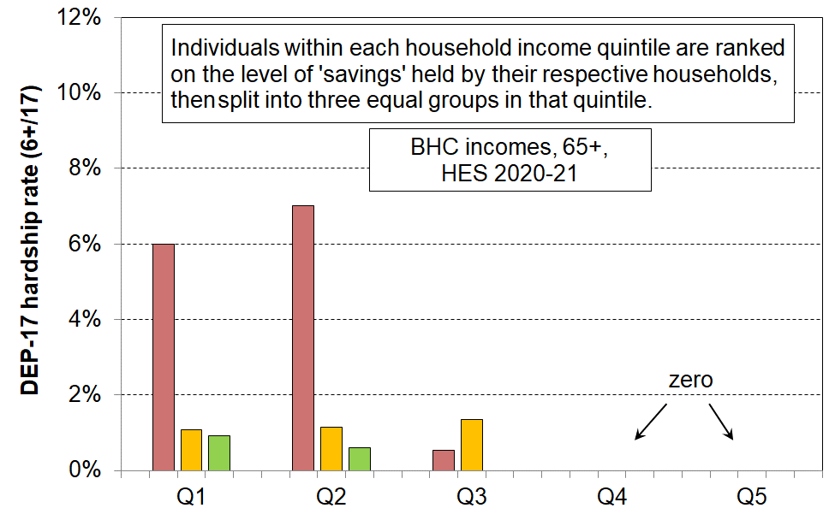
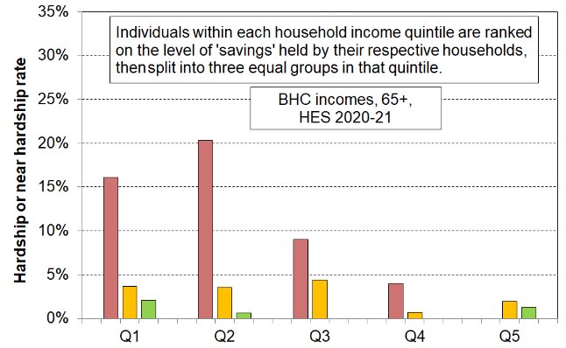
Standard material hardship (DEP-17 6+) Near material hardship / hardship (DEP-17 4+)

Table E.1
To assist with interpretation of Figure E.1
BHC whole popln HH income quintile (equiv) | Q1 |  |  | Q2 |  |  | Q3
Savings band (unequiv) | Low | Medium | High | Low | Medium | High | Low | Medium | High
Avg BHC household income ($) (equivalised) | 23,000 | 24,000 | 24,000 | 33,000 | 33,000 | 34,000 | 45,000 | 46,000 | 45,000
Savings - median ($) | 1,200 | 29,000 | 210,000 | 4,500 | 91,300 | 430,000 | 18,600 | 103,900 | 472,600
Savings - mean ($) | 2,400 | 34,500 | 316,900 | 10,600 | 96,100 | 616,200 | 18,900 | 115,700 | 663,800
Population - age 65+ (#) | 93,000 | 93,000 | 93,000 | 48,000 | 48,000 | 48,000 | 43,000 | 45,000 | 44,000

Note: incomes and savings in lower 4 rows are for 65+ only
Table E.2 fills out the picture of the lived experience of those in different parts of the income-savings matrix. The first three rows and the last row simply repeat Table Q1 for ease of reference.

Table E.2
Distribution of material hardship using a joint income-savings analysis, HES 2020-21,
with information on related deprivations that fill out the picture of the daily lived experience of those in different parts of the income-savings matrix
BHC whole popln HH income quintile (equiv) | Q1 |  |  | Q2 |  |  | Q3
Savings band (unequiv) | Low | Medium | High | Low | Medium | High | Low | Medium | High
Avg BHC household income ($) (equivalised) | 23,000 | 24,000 | 24,000 | 33,000 | 33,000 | 34,000 | 45,000 | 46,000 | 45,000
Savings - median ($) | 1,200 | 29,000 | 210,000 | 4,500 | 91,300 | 430,000 | 18,600 | 103,900 | 472,600
Savings - mean ($) | 2,400 | 34,500 | 316,900 | 10,600 | 96,100 | 616,200 | 18,900 | 115,700 | 663,800
Material hardship rate (%) (6+/17, DEP-17) | 6 | 1 | 1 | 7 | 1 | 1 | 1 | 1 | 0
Material hardship/near-hardship rate (%) (4+/17, DEP-17) | 16 | 4 | 2 | 20 | 4 | 1 | 9 | 4 | 0
cannot pay an unexpected + essential $500 bill within a month without borrowing (%) | 25 | 8 | 3 | 32 | 9 | 1 | 11 | 4 | 2
used a foodbank more than once in previous 12 months (%) | 4 | 1 | 0 | 3 | 2 | 1 | 2 | 0 | 0
put up with feeling cold ‘a lot’ to save on heating costs (%) | 8 | 2 | 2 | 5 | 5 | 2 | 5 | 3 | 0
borrowed from fam/friends more than once in previous 12 months to pay for basics (%) | 9 | 1 | 0 | 4 | 0 | 0 | 0 | 0 | 0
Population - age 65+ (#) | 93,000 | 93,000 | 93,000 | 48,000 | 48,000 | 48,000 | 43,000 | 45,000 | 44,000

Tables E.2 and E.3 repeat the above analysis, but use specific income bands rather than quintiles, and specific ‘savings/liquid assets’ bands rather than just splitting the income quintiles into three equal sub-groups. The same finding is shown.

For the HES 2020-21 survey, the value of NZS was 49% of the BHC median. The BHC 55 threshold for the lowest income group includes those whose incomes are ‘NZS and a little more’.

The analysis in Tables E.2 and E.3 help in answering the question – ‘how do older New Zealanders get by if their income is only from NZS and other government support or this plus only a little more income from other sources?’

Table E.3
Distribution of material hardship for older New Zealanders (66+) using joint income-savings analysis,
with specified BHC income and savings bands, HES 2021
HES 2021 |  | BHC band
 |  | under BHC55 |  |  | BHC55-75 |  |  | BHC75-100
Savings band (unequiv) |  | <$5k | $5k-40k | $40k+ | <$5k | $5k-40k | $40k+ | <$5k | $5k-40k | $40k+
Population (65+) |  | 52,700 | 59,100 | 70,500 | 34,000 | 34,600 | 105,900 | 12,600 | 26,700 | 85,000
LA plus MPF (unequiv) | Median | 600 | 15,000 | 123,200 | 300 | 22,600 | 172,800 | 700 | 20,800 | 249,500
LA plus MPF (unequiv) | Mean | 1,100 | 16,700 | 206,900 | 900 | 22,400 | 322,900 | 1,300 | 21,000 | 417,300
Non-vehicle consumer durables (unequiv) | Median | 25,000 | 45,000 | 60,000 | 15,000 | 48,800 | 48,800 | 15,000 | 60,000 | 85,000
Non-vehicle consumer durables (unequiv) | Mean | 34,900 | 55,900 | 77,900 | 29,300 | 63,700 | 73,800 | 42,000 | 74,100 | 103,000
BHC income (equiv) | Median | 23,400 | 23,400 | 23,500 | 27,800 | 28,600 | 28,500 | 39,000 | 40,500 | 40,500
BHC income (equiv) | Mean | 22,500 | 22,300 | 22,500 | 28,300 | 28,700 | 29,000 | 40,000 | 40,500 | 40,300
Accomm costs (unequiv) | Median | 5,000 | 5,000 | 4,700 | 8,300 | 4,500 | 5,100 | 10,400 | 6,200 | 5,900
Accomm costs (unequiv) | Mean | 6,700 | 6,300 | 6,000 | 10,200 | 6,300 | 7,000 | 13,900 | 8,200 | 9,300
avg MWI score |  | 26 | 29 | 32 | 25 | 28 | 31 | 25 | 30 | 31
Dep-17 6+ | # | 4,600 | - | - | 3,000 | 1,000 | - | - | - | -
Dep-17 6+ | % | 9 | - | - | 9 | 3 | - | 2 | - | -
Dep-17 4+ | # | 10,800 | 3,000 | 1,800 | 6,600 | 4,600 | 1,600 | 2,300 | 2,500 | 1,800
Dep-17 4+ | % | 20 | 5 | 3 | 20 | 13 | - | 18 | 9 | 2

Table E.4
Distribution of selected deprivations for older New Zealanders (66+) using joint income-savings analysis,
with specified BHC income and savings bands, HES 2021 (%)
HES 2021 | BHC band
HES 2021 | under BHC55 |  |  | BHC55-75 |  |  | BHC75-100
Savings band (unequiv) | <$5k | $5k-40k | $40k+ | <$5k | $5k-40k | $40k+ | <$5k | $5k-40k | $40k+
cut back on fruit/veg ‘a lot’ | 7 | - | - | 4 | - | - | - | - | -
used foodbanks more than once | 6 | - | - | 4 | - | - | 3 | - | -
put up with feeling cold ‘a lot’ | 9 | 3 | 2 | 10 | 2 | 2 | 6 | 6 | 2
can pay $500 expense = No | 30 | 10 | 3 | 40 | 16 | 4 | 20 | 14 | 2
borrowed from fam/friends = once only | 3 | - | - | 8 | - | - | 10 | - | -
borrowed from fam/friends = > once | 12 | 2 | - | 6 | 2 | - | - | - | -
income adequacy = not enough | 18 | 12 | 5 | 16 | 4 | 4 | 22 | 4 | 9
income adequacy = only just enough | 33 | 24 | 22 | 28 | 24 | 15 | 23 | 26 | 14
computer/internet = don't have (any reason) | 29 | 31 | 24 | 35 | 23 | 15 | 33 | 18 | 6
life satisfaction = dissatisfied or very dissatisfied | 10 | 5 | 4 | 8 | 3 | - | - | 3 | -
Notes for Tables T,1 and T.2:
- MWI = Material Wellbeing Index. For the MWI, a higher score means a higher level of material wellbeing.
- 'Savings' includes Liquid assets and mutual/pension funds (sometimes also abbreviated to LA+MPF).
- Percentage cells with values less than 1.5% and numeric cells with values of less than 1500 are masked with a '-'. Read these as "very small".

Part F:
Self-assessed ‘income adequacy’ of older New Zealanders compared with the rest

Figure F.1 shows the proportion of older New Zealanders (65+) reporting ‘not enough’ and ‘more than enough’ household income for paying for food, accommodation, clothing, electricity, and other basics. The trends for those aged under 65 years are included for comparison (dashed lines).

When people are asked if their household’s income is adequate to cover the basics, there is good evidence that their responses take account not only of their income but also of all the other factors that make demands on or contribute to the household budget. In that sense the ‘income adequacy’ descriptor is misleading – it’s more about ‘income adequacy, given all other resources and demands’.

The left-hand chart in Figure F.1 shows a small downward trend from 2013 to 2019 for the ‘not enough’ assessment for all older New Zealanders (65+), then little change through to 2023, with a small rise to 2024. The rest of the population reported a stronger downward trend through to 2022 in the decade from 2013, after the GFC impact faded, followed by a rise through to 2024.

A similar picture emerges in the right-hand chart when looking only at low-income households (the bottom AHC quintile), though the 65+ decrease is steeper and goes a little later, to 2023.

The ‘more than enough’ lines rose strongly post recession through to 2021 or 2022, followed by a decline after that.

The picture painted by this information is consistent with the rest of the evidence that points to the current cohort of older New Zealanders (65+) generally having a good standard of living, with only a small group reporting financial and material hardship. The up-tick to 2024 points to some increasing financial hardship for some groups, though there is no evidence here of any recent widespread increasing financial hardship.

Figure F.1
Self-assessed income adequacy for meeting basic costs for food, accommodation, electricity, etc,
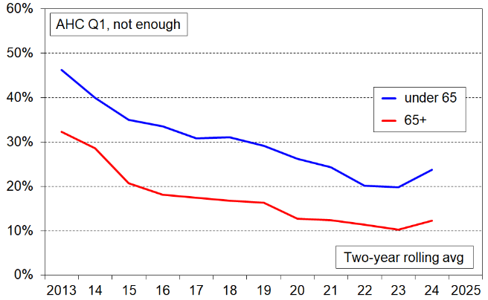
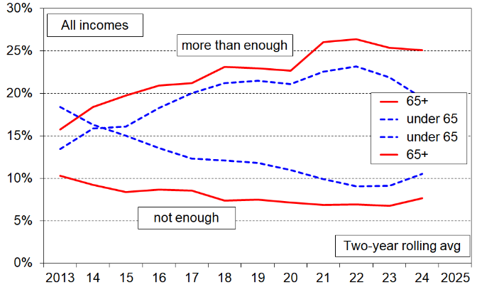
for all incomes (left) and the bottom income quintile (right)
Note for charts:
Respondents were given four options for their responses: not enough, only just enough, enough, more than enough. The charts use only the ‘not enough’ and the ‘more than enough’ options.

Access to the HES data was provided by Statistics New Zealand under conditions designed to meet the confidentiality provisions of the Statistics Act 1975. The results presented in this analysis are the work of the Ministry of Social Development except where otherwise stated.
Does not include draw-down on savings or investment accounts or gifts from other households.
A very similar change is reported using the MWI-24 index: the hardship rate ‘increased’ from 2.7% in 2022-23 to 3.5% in 2023-24.
See further on this in n21 below.
The analysis here uses 66+ rather than 65+ to ensure that all those counted are eligible for NZS. The survey runs over 12 months and some turn 65 well into the period. This creates unnecessary noise in the analysis as these people are not eligible for NZS in their own right.
These are deciles of older New Zealanders ranked on their household incomes, not whole population income deciles.
Figure A.2 illustrates the importance of considering both numbers and proportions (%) when reporting on trends for older New Zealanders, given the rapidly rising numbers in the age-group.
Renters include those in government-funded and council social housing, as well as those in private rentals.
See Infometrics for more detail. https://es.infometrics.co.nz/article/2023-07-more-people-working-later-in-life
Gamble, J. (2021). ‘Asset drawdown (decumulation) and paid work profile of Pre- and Post-Retirees’, Te Ara Ahunga Ora - Retirement Commission. Available at TAAO - Retiree-preretiree-report (retirement.govt.nz)
This is consistent with the HES figure of ~22% either PT or FT or SE in 2022 (Figure A.5 above).
Analysis of HES 2021 data reports 10% FT, 9% PT and 4% self-employed (Figure A.5 above). Assuming that most SE are part-time, this gives around 13% PT and 10% FT, which squares off reasonably well with the Dynata panel numbers of 15% and 12%. PT here means between 5 and 30 hrs pw. FT is 30+ hrs pw.
See the more detailed framework in Part Three of the main LTIB report, and the useful diagram in NZIER’s Feb 2024 report for Seniors.
For older New Zealanders living alone, NZS is paid at 65% of the married couple rate. The equivalence ratio for a one-person household relative to a couple household is 0.67 (for the equivalences usually used in this report). This means that equivalised household income is very close to the same for older (65+) one person and couple households where there is little or no other income over and above NZS.
Income analysis is sometimes done using 66+ rather than 65+ to reduce the noise from those who retire during the collection period for HES.
The HES gathers information on those in private dwellings. This means that older New Zealanders in residential care are not included in the survey findings, whether owned by a resident or rentals (including government or council social housing). It also includes those in retirement villages, but not those in rest homes, hostels, emergency or transitional housing, caravan parks, or those living rough.
In all other places this report uses the household as the income sharing unit, as the focus is usually on (household) income as an indicator of material wellbeing. This subsection has a different focus – the sources of income for older New Zealanders – and it uses the EFU as the income sharing unit rather than the household, as the EFU is better suited for the task. Some older New Zealanders live in wider households and share in and/or contribute to the overall standard of living of the household, sometimes having their living standards raised by the participation and sometimes having them lowered (eg where the rest of the household contributes little other income). Using the EFU enables the analysis to look just at the 66+ units to report their income sources, distinct from the incomes of the rest of the household.
MSD is working with Stats NZ to better understand and resolve the matter.
See Section E in the 2021 Material Wellbeing report for a fuller discussion. The report is available at: https://www.msd.govt.nz/about-msd-and-our-work/publications-resources/monitoring/living-standards/
A very similar change is reported using the MWI-24 index: the hardship rate ‘increased’ from 2.7% in 2022-23 to 3.5% in 2023-24.
Around 5% of NZS recipients also receive the AS, and the great majority of these (78%) are renting in the private market. Reports of increased financial stress among this group are likely to reflect the impact of several factors: - this group generally has low assets and low income - the maximum weekly rates of the AS were last adjusted in April 2018, based on 2016 rents – they haven’t kept up with housing costs - along with other NZS recipients there is the noticeable catch-up lag in rate adjustment during times of high inflation.
See, for example Table E.3 which shows households with similar incomes reporting differently about income adequacy depending on their level of liquid assets.
This is line with the TAAORC sentiment survey reported in Most Kiwis say they’re ‘not prospering’: Retirement Commission data | The Post

