MWI-26:
the revised Material Wellbeing Index replacing MWI-24 following Stats NZ’s changes to the Material Wellbeing Questions
when moving from the HES to HILS 2024-25

MSD Working Paper 02/26

Prepared by Bryan Perry

Ministry of Social Development
Wellington

23 July 2026

This Working Paper (WP) sets out the revision to MSD’s Material Wellbeing Index (MWI) given the changes to the material wellbeing questions in Stats NZ’s Household Incomes and Living Survey 2024-25 (HILS) compared with those used for previous years in the Household Economic Survey (HES). It is a companion paper to WP 01/26 which is the paper commissioned by Stats NZ in 2025 as a contribution to their work programme to revise the DEP-17 material hardship measure used in the measurement regime mandated by the Child Poverty Reduction Act.

The analysis supporting this work used data from a Living in Aotearoa research dataset that was built specifically to support decision-making for the revised material hardship methodology, as well as pre-final versions of HILS 2024/2025 (updated versions were made available as Stats NZ progressed their survey processing). The HILS data in this paper uses a near-to-final dataset, made available to MSD in late November to deliver the commissioned work. Some estimates presented will therefore differ to published material by Stats NZ (and MSD) that uses final HILS data.

Introduction and outline of the paper

When moving from the Household Economic Survey (HES) to the Household Income and Living Survey (HILS) in 2024-25 Stats NZ used a revised set of material wellbeing questions (MWQs). These changes created a clear break in continuity between the former HES-based DEP-17 (6+) material hardship time series and the HILS-based measurement when applying the DEP-17 measure to the revised MWQs. The matter has been addressed through the development and use of a revised measure of material hardship (MH-18, 7+) starting with HILS 2024-25 – see Stats NZ’s paper at https://www.stats.govt.nz/methods/measuring-child-poverty-material-hardship-in-the-household-income-and-living-survey/.

The change in MWQs also had an impact on MSD’s material wellbeing index (MWI-24). Although the MWI-24 covers the whole spectrum of material wellbeing from low to high, one of its main uses is to measure and monitor trends in material hardship, with a time series going back further than the DEP-17 measure can. Up to HES 2023-24, where there were survey years for which both measures could be used, the MWI-24 (12-) material hardship trend and levels were very close to those produced by DEP-17 (6+). The discontinuity in the material hardship time series from HES to HILS using DEP-17 is also clearly evident for the MWI-24 measure.

This paper reports on how the HES to HILS discontinuity issue for MWI-24 has been addressed through the creation of MWI-26 and the use of a new threshold (11-).

- Part One
  - outlines what the MWI is, its conceptualisation and how it is used by MSD and Stats NZ.

- Part Two
  - notes the changes made to the MWQs and discusses their likely impact;
  - describes the discontinuity issue that arises between HES and HILS for the measurement of material hardship using the MWI … and thus the need for a revised measure;
  - outlines the analysis strategy and associated success criteria that are used in the work for resolving the issue;
  - reports the MWI-26 solution including the scoring rules, material hardship thresholds and the other boundaries for the six MWI levels for the revised index;
  - shows how MWI-26 performs against the key success criteria.

- Part Three gives some more detailed analysis in support of the MWI-26 solution, including:
  - the distribution of deprivations and ‘freedoms’ across MWI-26 deciles … compared with the same for MWI-24;
  - the distribution of mean MWI-26 scores across NZDep deciles, compared with MWI-24;
  - sub-group comparisons between MWI-24 and MWI-26 for different levels of material wellbeing, including for the ‘good to very good’ levels of material wellbeing as used by Stats NZ in their Wellbeing indicators;
  - MWI-26 performance compared with MWI-24 for showing how different life is for children in the hardship zone compared with elsewhere on the material wellbeing spectrum (an important use for MSD).

- Appendix Two gives a detailed comparison of the HES and HILS MWQs and reports the deprivation rates for individual items for HES and HILS.

Part One:
The MWI, what it is, its conceptual basis and main uses

Material hardship or deprivation indices such as MH-18 and DEP-17 do a good job in discriminating between households in differing depths of hardship, and also in identifying those in ‘near hardship’. While they provide valuable information on the lower 20-30% or so of the material wellbeing distribution, such indices are unable to make meaningful distinctions for the remaining 70-80% of households.

The development of the Material Wellbeing Index (MWI) in 2015, built off the earlier work on the Economic Living Standards Index (ELSI), enabling usable distinctions between households across the bulk of material wellbeing spectrum, albeit with decreasing discriminating ability as the level of material wellbeing increases. The stylised diagram in Figure 1 shows the difference in the distributions of DEP-17 and MWI-24 scores. While still itself functioning as a deprivation index at its lower end, the MWI enables distinctions to be made within most of the 70-80% of the population who have very low scores on deprivation indices such as DEP-17 (ie have living standards above the hardship zone).
Figure 1
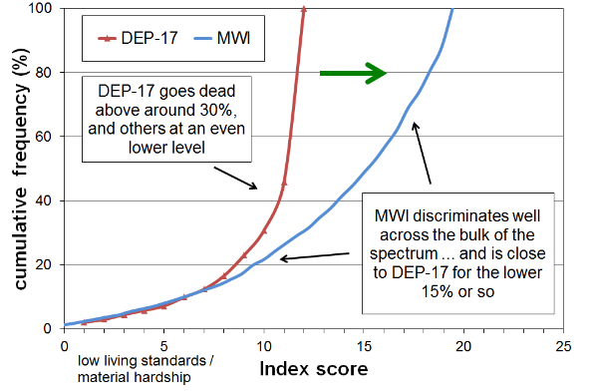
Moving from a deprivation index to a full material wellbeing index
Note for Figure 1: the stylised comparison was constructed by deducting the DEP-17 scores from 12 (thus reversing the scale), and re-scaling the MWI scores.

The greatest challenge to the satisfactory development of an index which delivers a usable ranking of households across the full spectrum from lower to higher material wellbeing, rather than just having a focus on the lower 20-30% as with DEP-17, is the differing tastes and preferences that individuals and households have for the consumption of non-necessities. This means that the ‘enforced lack’ approach cannot simply be extended to a list including non-necessities as a ‘don’t have or do’ response could either be because of constraints or because of tastes and preferences. An index would lack credibility and validity if the rankings were impacted by differing preferences.

To illustrate – while items such as “not having a decent meal at least once a day” or “having to put up with being cold” are almost always a matter of financial constraint rather than personal preference and are appropriate for deprivation indices, the enforced lack of items such as “dines out at a good quality restaurant at least once a week” or “has an extensive range of tools and workshop equipment for DIY activities” or “has a sauna“ or “has a vehicle for each adult member” are of no use for developing a broader index of material wellbeing as there is not a sufficiently widespread common aspiration to possess these, even among the better-off. While possessing these sorts of items do for some reflect higher living standards, too many respondents would state that the reason they do not have the item is not lack of money, but because they simply do not want them. Their non-possession does not necessarily indicate low living standards. Other well-off individuals or households may have tastes and preferences that lead them instead to possessing high quality vehicles, or very well-appointed homes with high quality furniture and appliances, or private health insurance, and so on.

There are some intermediate items which are neither “necessities” nor “luxuries or near luxuries”, but which can be characterised as desirable non-essentials that most aspire to (for example, “a holiday away from home for at least a week once a year”), but this sort of item is not easy to find.

The challenge therefore is to find several “non-necessities”, the presence or absence of which reflects differences in levels of material wellbeing rather than in the main being reflections of tastes or preferences. To achieve this, the MWI uses the four approaches outlined in Table 1. The left-hand column describes the strategies employed and the right-hand column gives examples of the way the strategies are operationalized for the MWI.

Table 1
MWI items that assist in discriminating between households above the hardship / near hardship zone
Type of survey item that helps produce discrimination between households in the 60-70% above the “hardship” and “near hardship” zones | Application in MWI
no enforced lack for two desirable non-essentials | - a week’s local annual holiday away from home  - an overseas holiday at least once each three years
economising “not at all”  (ie never having to cut back on or put off key purchases or activities such as those listed) | - purchasing fresh fruit or vegetables  - making trips to the shops or other local places  - replacing or repairing broken or damaged appliances  - visiting the doctor or dentist  - spending less on hobbies or other special interests than you would like
financial strain “not at all”  (ie never being in arrears or late on payments because of lack of money) | - for rates and utilities  - for vehicle registration or warrant of fitness
freedom to purchase  (degrees of constraint or freedom indicate different levels of material wellbeing) | - clothes and shoes for self  - spot purchase of a $300 ($400 in HILS) non-necessity  - ability to pay an unexpected and unavoidable $500 bill within a month without borrowing

The DEP-17 is itself a development of the earlier 24-item Material Wellbeing Index (MWI-24) that was developed using MSD’s 2008 Living Standard Survey. The MWI-24 can measure material hardship by selecting an appropriate threshold to define its lowest level of material wellbeing, but some users and stakeholders asked for a measure that focused on the material hardship end of the spectrum alone and whose scoring was more intuitive (more deprivations = higher score = worse off) – hence DEP-17.

To create the MWI scores, the component items are scored from two different perspectives:
- From an enforced lack perspective in which respondents report not having essential items or necessities because of the cost, or having to severely cut back on the purchase or consumption of such items because the money is needed for other essentials: for example, being unable to have regular good meals, two pairs of shoes in good repair for everyday activities, or visit the doctor; or having to put up with the cold, and so on because money is needed for other basics.

- From the perspective of the degree of restriction or freedom reported for having or purchasing desirable non-essentials (while having the essentials) – a freedoms enjoyed perspective, for short: for example, having all the essentials on the list, and in addition not having to cut back on local trips, not having to put off replacing broken or damaged appliances, being able to take an overseas holiday every three years or so if desired, not having any great restrictions on purchasing clothing, and being able to spend on hobbies and special interests as desired, and so on.

Material hardship (unacceptably low material wellbeing) is characterised by having many enforced lacks of essentials or near essentials and few or no freedoms. Higher living standards are characterised by having all the essentials (no enforced lacks of essentials), and also having many or all the freedoms and few or none of the restrictions in relation to the non-essential items that are asked about.

Figure 2 below shows how those in the different MWI deciles fare in terms of both enforced lacks (ELs) of essentials and also of freedoms enjoyed.

Figure 2
Distribution of ‘enforced lacks’ and ‘freedoms / non-essentials enjoyed’ for MWI deciles,
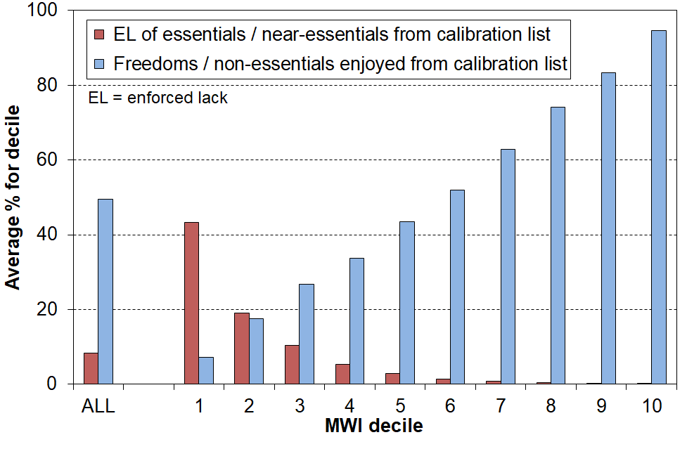
MWI-24, HES 2023-24

Main uses of the MWI

- MSD
  - For the conceptual narrative, to emphasise that while the MH / not in MH binary classification has its uses it needs supplementing with a more nuanced aspects that recognise that there are households above a material hardship threshold who experience restrictions and live precariously, vulnerable to being relatively easily falling into material hardship.
  - To create a material hardship time series that can go back further than a DEP-17 series as the MWI (and its immediate predecessor) have the HES data available to do this.
  - To use six material wellbeing levels and/or decilisation to show: how different life at the MH end is; the distributions across the MWB spectrum for selected demographic groups; the relationship with household income; and so on.)

- Stats NZ
  - Table 12 (Material Wellbeing) in their Household Income and Housing costs releases – reporting on good to very good MWB using a 15+ MWI-24 threshold.
  - Wellbeing indicators – time series for various using the 15+ threshold as above.

Part Two:
The need for a revision of the MWI, the success criteria for a revised MWI, and the MWI-26 (the revised index)

The MWQ changes

In 2022 Stats NZ went to the field with the first wave of their new Living in Aotearoa (LIA) survey that was to have been the replacement for the HES, albeit with a longitudinal dimension. In developing the LIA several changes were made to the HES material wellbeing questions (MWQs), including changes to the wording of some of the MWQ items themselves, changes to some of the response options, and changes to where in the questionnaire the MWQs were located. For various reasons the LIA was ended in early 2024 after the second wave (2023).

When the LIA was discontinued, Stats NZ developed the Household Income and Living Survey (HILS) to replace the HES from 2024-25. While much of the HILS is the same as the HES, one non-trivial set of changes was the MWQs which the HILS adopted directly from the short-lived LIA survey. The HES MWQs are used, among other things, to construct MSD’s 24-item material wellbeing index (MWI-24).

There is a detailed list of the changes to the MWQs used in the MWI-24 in Appendix Two.

The need for a revision of the MWI

As noted in Part One, one of the uses of the MWI-24 index has been to report on material hardship rates using a 12- threshold (ie a score of 12 or less on the 0 to 35 MWI scale). Using HES data, the rates produced are very close to the DEP-17 (6+) material hardship rates. To continue this consistency when using the revised MWQs, the MWI material hardship rates need to align with those produced by the revised material hardship measure MH-18 (7+).

To avoid confusion, when the MWI-24 index and its scoring approach is used with the LIA/HILS MWQs it is referred to as ‘MWI-24X’. This is simply to assist with communication in the places in the text where it is used. The MWI-24X is not proposed as another possible replacement for MWI-24.

Tables 2a and 2b show that when the revised MWQs are used with the MWI-24 index applied to HILS 24-25 data (MWI-24X), the consistency in measuring material hardship is broken. MH-18 and MWI-24X rates do not align, with the MWI-24X rates being higher. This is as expected given that MH-18 is DEP-17 re-designed to give continuity of material hardship measurement between HES and HILS. The MWI-24 also needs revision, given the impact of the new MWQs. The MWQ changes mean that MWI-24 (12-) and MWI-24X (12-) no longer measure hardship using the same hardship level.

Table 2a
MWI-24X and MH-18 material hardship rates (%) (whole population),
showing the higher rates for MWI-24X resulting from the changed MWQs
Whole population | HILS 24-25  MWI-24X (12- and 6-) | HILS 24-25  MH-18 (7+ and 10+)
Material hardship | 11.7 | 9.1
Severe material hardship | 4.5 | 3.6

Table 2b
MWI-24X and MH-18 material hardship rates (%) (0-17s),
showing the higher rates for MWI-24X resulting from the changed MWQs
0-17s | HILS 24-25  MWI-24X (12- and 6-) | HILS 24-25  MH-18 (7+ and 10+)
Material hardship | 17.7 | 14.3
Severe material hardship | 7.3 | 6.0

Tables 3a and 3b compare the MWI-24X material hardship rates using the LIA 2023 survey data with the HES-based MWI-24 rates from adjacent survey years. The LIA 2023 data was collected in the six months from April to September, in between the HES 2022-23 and 2023-24 years. The numbers point to the same conclusion of the need for a revision of the MWI as the changes to the MWQs mean the MWI-24X material hardship rates are higher than the HES-based MWI-24 rates for the same time period.

Table 3a
MWI-24 and MWI-24X material hardship rates (%) (whole population),
showing the increases resulting from the revised questions, responses and other survey changes
Whole population | HES 22-23 MWI-24 | LIA 2023 MWI-24X | HES 23-24 MWI-24
Material hardship (12-) | 8.6 | 11.9 | 9.4
Severe material hardship (6-) | 3.1 | 4.7 | 3.2

Table 3b
MWI-24 and MWI-24X material hardship rates (%) (0-17s),
showing the increases resulting from the revised questions, responses and other survey changes
0-17s | HES 22-23 MWI-24 | LIA 2023 MWI-24X | HES 23-24 MWI-24
Material hardship (12-) | 13.3 | 17.3 | 13.5
Severe material hardship (6-) | 4.8 | 7.6 | 4.6

Analytical strategy and success criteria for the revision

As for the work to develop a revised material hardship index given the MWQ changes, the task here is not a ‘blue skies’ one, starting with a blank sheet. The revised MWI is to be very like MWI-24:
- with minimum changes to items and the scoring rules
- having the same highest score of 35
- the same underlying conceptualisation – a ranking instrument using a mix of essentials/near essentials and desirable non-essentials or ‘freedoms’ (see Part One).

In deciding on the composition of the revised MWI and the associated hardship threshold, the above design features and the following key success criteria need to be taken into account:
- the revised MWI’s material hardship rates must align very well with those produced by MH-18 from HILS 2024-25, for the whole population and for children (0-17 yrs) – this is a necessary condition of acceptance of any proposed revised measure as a viable candidate
- very high correlation between the revised MWI and MWI-24 (ie both indices rank households in close to identical ways)
- the degree of overlap of individuals identified with low scores by MH-18 and by the revised MWI should be very close to the DEP-17/MWI-24 overlap (ie the new MWI should perform at least as well as MWI-24) – in practice, look at the lower 10-15% in the rankings
- internal consistency using Cronbach’s alpha (given the ‘minimum changes approach’, Cronbach’s alpha for the revised MWI and MWI-24 would be expected to be much the same).

In addition, the revised MWI measure:
- should produce LIA-based hardship rates for 2023 that compare well with the HES-based MWI-24 rates for adjacent years (whole population and children);
- should produce hardship rates using HILS 2024-25 for commonly-used sub-groups that have the same relativities and close to the same rates as those produced by MWI-24 for 2023-24;
- should produce HILS 2024-25 estimates of rates of ‘good to very good’ material wellbeing as used by Stats NZ for their Wellbeing indicators that are close to those produced by MWI-24 for HES 2023-24 (this uses MWI-24 15+ as the threshold);
- show decreasing average scores across NZDep deciles (from high socio-economic status to low) that are very similar to those for MWI-24.

Just change the thresholds?

Given the findings reported in Tables 2 and 3 above (the revised MWQs made it easier for households to be identified as being ‘in hardship’), an early option that was explored was to try to re-establish the conceptual continuity by using a lower MWI threshold (ie so as to measure the same level of material hardship with LIA/HILS data as with HES data).

This was not successful, as lowering the MWI-24X threshold from 12- to 11- was not enough, and going to 10- was too far. For example, for children, the rates produced were 15.8% and 13.8% respectively, compared with the MH-18 (7+) rate of 14.3%.

MWI-26: the revised index

After testing a range of options, the MWI-26 index defined in Table 4 below best met the design requirements and key success criteria. The material hardship threshold is 11 or less (11-) and the severe material hardship threshold is 5 or less (5-).

One of the MWI-24 ‘keeping warm’ items is dropped for MWI-26 as HILS no longer collects it, but is replaced by another similar one. Three new items are introduced as shown.
There is a small change in the scoring for the ‘spot purchase’ item. The maximum possible raw core for each index is 42. Very few score 0-7, so 7 is deducted from the raw score, making the range for both MWI-24 and MWI-26 from 0 to 35.

Table 4
The composition and scoring for the HES-based MWI-24 and the LIA/HILS-based MWI-26
Item description |  | MWI-24 | MWI-26
Ownership or participation (have/do, don’t have/do and enforced lack (EL))
For both, score an EL as a 0, otherwise 1
1 | Two pairs of shoes in a good condition and suitable for daily activities
2 | Suitable clothes for important or special occasions
3 | Contents insurance
4 | A meal with meat, fish or chicken (or vegetarian equivalent) at least each 2nd day
5 | A good bed
6 | Presents for family/friends on special occasions
7 | Usually replace worn-out clothes with new (not second-hand) ones
8 | Holiday away from home at least once every year
9 | Overseas holiday at least once every three years
** | Can afford to keep accommodation adequately warm. | -
** | Have access to car or van for personal use. | -
** | Have access to both a computer and internet connection at home. | -
Economising (not at all, a little, a lot) – to keep down costs to help in paying for (other) basic items (not just to be thrifty or to save for a trip or other non-essential)
For both, score ‘not at all as 2, ‘a little’ as 1, and ‘a lot’ as 0
10 | Gone without or cut back on fresh fruit and vegetables
11 | Buy cheaper cuts of meat or bought less meat than you would like
12 | Put up with feeling cold
13 | Do without or cut back on trips to the shops or other local places
14 | Delay replacing or repairing broken or damaged appliances
15 | Spent less on hobbies or other special interests than you would like
16 | Postponed visits to the doctor
17 | Postponed visits to the dentist
Housing problems (no problem, minor problem, major problem … in the last 12 months)
For both, score as 2, 1 and 0 respectively.
18 | Dampness or mould
19 | Heating or keeping it warm in winter (not collected in HILS) |  | -
Freedoms/Restrictions
20 | When buying, or thinking about buying, clothes or shoes for yourself, how much do you usually feel limited by the money available? (4 point response options: ‘not at all limited, a little limited, quite limited, very limited)  For both, score as 3, 2, 1 and 0 respectively.
21 | $400 spot purchase for an ’extra’, not a necessity ($300 in HES/MWI-24) – how limited do you feel about buying it? (5 point response options: not at all limited, a little limited, quite limited, very limited, couldn’t buy it)  For MW-24, score as 4, 3, 2, 1 and 0 respectively. MWI-26, score as 3, 2, 1, 0 and 0
22 | $500 unexpected unavoidable expense on an essential – can you pay in a month without borrowing? (yes/no)  For both, score ‘yes’ as 2 and ‘no’ as 0
Financial strain (in last 12 months) (not at all, once, more than once)
For both, score ‘not at all’ as 2, ‘once’ as 1, ‘more than once’ as 0
23 | Behind on rates or utilities
24 | Behind on car registration, wof or insurance

The material hardship rates for MWI-26 (11-) are very close to those for MH-18 (7+) as shown in Tables 5a and 5b. For comparison, for HILS 2024-25 the MWI-24X rates were 11.7% and 17.7% for the whole population and children respectively (see Tables 2a and 2b above).

Table 5a
MWI-26 and MH-18 material hardship rates for HILS 24-25,
whole population
Whole population | HILS 24-25  MWI-26 (11- and 5-) | HILS 24-25  MH-18 (7+ and 10+)
Material hardship | 9.2 | 9.1
Severe material hardship | 3.0 | 3.6

Table 5b
MWI-26 and MH-18 material hardship rates for HILS 24-25,
0-17s
0-17s | HILS 24-25  MWI-26 (11- and 5-) | HILS 24-25  MH-18 (7+ and 10+)
Material hardship | 14.4 | 14.3
Severe material hardship | 5.2 | 6.0

Correlation between the indices is very high for both the whole population and for children at 0.999. This means that MWI-24 and MWI-26 rank households and their members in almost identical ways for material wellbeing.

Given the importance of the use of the MWIs for material hardship measurement, the performance of MWI-26 at the lower end of the spectrum needs to be at least as good as MWI-24. Tables 6a and 6b shows that MWI-26 performs as well as MWI-24.

Table 6a
Overlap between DEP-17 and MWI-24 for whole population and 0-17s (%), HES years
 |  | DEP-17 bottom 10 or 15% | MWI-24 bottom 10 or 15% | both/overlap (% of total) | both/overlap (between groups)
Whole population | HES 2022-23 | 10.0 | 10.0 | 8.7 | 87
Whole population | HES 2023-24 | 10.0 | 10.0 | 8.6 | 86
0-17s | HES 2022-23 | 15.0 | 15.0 | 13.0 | 87
0-17s | HES 2023-24 | 15.0 | 15.0 | 13.6 | 90

Table 6b
Overlap between MH-18 and MWI-26 for whole population and 0-17s (%), HILS 2024-25
 |  | MH-18 bottom 10 or 15% | MWI-26 bottom 10 or 15% | both/overlap (% of total) | both/overlap (between groups)
Whole population | HILS 24-25 | 10.0 | 10.0 | 8.8 | 88
0-17s | HILS 24-25 | 15.0 | 15.0 | 13.4 | 89
Note for Table 6: 10% and 15% are used for examining MWI-26 performance at the lower end of the spectrum, in line with the population MH rate of 9% and MH rate for children of 14% (see Table 5 above).

Cronbach's Alpha is a statistical tool that helps researchers determine if the various parts of a measurement tool are working together consistently to measure what they are supposed to measure. A score of 0.8 or higher is considered to be very good. MWI-24 and MWI-26 score well (Table 7).
Table 7
Cronbach's Alpha (standardised)
 | HES 22-23 | HES 23-24 | HILS 24-25
 | MWI-24 | MWI-24 | MWI-26b
All | 0.91 | 0.91 | 0.91
0-17 | 0.91 | 0.91 | 0.92
65+ | 0.88 | 0.89 | 0.89
Māori | 0.91 | 0.91 | 0.92
Part Three:
Further supporting analysis for the MWI-26 revision

Conceptual consistency

The conceptual basis for MWI-24 was described and discussed in Part One. The items are a mix of ‘enforced lacks’ and ‘freedoms / non-essentials enjoyed’ as shown in Figure 2 for MWI-24. Figure 3 uses MWI-26 and shows how those in the different MWI deciles fare in terms of both enforced lacks of essentials and also of freedoms enjoyed. There is a strong similarity between Figures 2 and 3 with MWI-26 showing a slightly greater sensitivity than MWI-24 at the low (hardship) end of the spectrum.

Figure 3
Distribution of ‘enforced lacks’ and ‘freedoms / non-essentials enjoyed’ for MWI deciles,
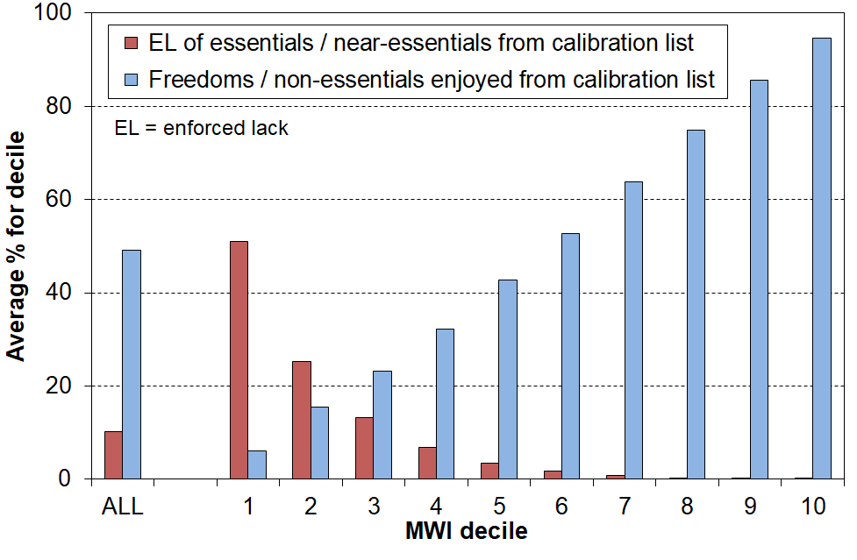
MWI-26, HILS 24-25
Table 8a shows that MWI-26 with HILS data ranks households across the NZDep SES deciles in the same way as does MWI-24 using HES data, with the same average MWI scoring in deciles. It is perhaps initially surprising that the average MWI score for NZDep decile 10 (very low SES) is so high – around 20 in Table 8a compared to the material hardship threshold of 11 (MWI-26) or 12 (MWI-24). Part of the answer is found in Table 8b which shows that only around one in five from SES decile 10 are in hardship. The 80% in decile 10 who are not in hardship would easily raise the MWI score to an average of around 20. Although there is modest correlation between SES and material wellbeing (MWB), SES is not a reliable proxy for MWB at the individual level.
Table 8a
Mean MWI score by NZDep decile - all households
MWI index | Year | NZDep decile |  |  |  |  |  |  |  |  |  | All
MWI index | Year | 1 | 2 | 3 | 4 | 5 | 6 | 7 | 8 | 9 | 10 | All
MWI-24 | 2019 | 30 | 29 | 29 | 28 | 28 | 26 | 26 | 25 | 23 | 20 | 26
MWI-24 | 2023 | 30 | 29 | 29 | 27 | 27 | 26 | 25 | 25 | 24 | 21 | 26
MWI-24 | 2024 | 29 | 29 | 28 | 28 | 27 | 26 | 25 | 24 | 23 | 21 | 26
MWI-26 | 2025 | 30 | 29 | 28 | 27 | 27 | 26 | 26 | 24 | 23 | 21 | 26
Note for table:
- NZDep decile 1 is high SES and decile 10 is low SES.

Table 8b
Material hardship rate using MWI by NZDep decile - all households
MWI index | Year | NZDep decile |  |  |  |  |  |  |  |  |  | All
MWI index | Year | 1 | 2 | 3 | 4 | 5 | 6 | 7 | 8 | 9 | 10 | All
MWI-24 12- | 2019 | 2 | 3 | 4 | 7 | 6 | 8 | 9 | 10 | 17 | 26 | 9
MWI-24 12- | 2023 | 2 | 2 | 4 | 4 | 6 | 8 | 8 | 11 | 14 | 21 | 7
MWI-24 12- | 2024 | 2 | 3 | 4 | 5 | 7 | 7 | 9 | 11 | 15 | 22 | 9
MWI-26 11- | 2025 | 2 | 4 | 5 | 4 | 5 | 8 | 7 | 12 | 15 | 21 | 8
Note for table:
- NZDep decile 1 is high SES and decile 10 is low SES.
Figure 4 shows the relationship between BHC household income and average MWI decile scores for households for MWI-24 and MWI-26. The relationships are close to identical (unsurprisingly, given the similarity of index composition and scoring).

The solid line shows the average MWI score for each BHC income decile, and the dashed lines show the average MWI scores ± one standard deviation (ie around two-thirds of the variation lies within the dashed lines). Higher household incomes are generally associated with higher levels of material wellbeing, as expected, but there is considerable variation in material wellbeing for given income levels (in deciles). While measurement error and the range of income within each income decile will explain some of the variation, the bulk is likely to reflect the impact of different levels of financial and physical assets and of the ‘other’ factors noted above and in the framework diagram in the Appendix (Figure A.1). The correlation between BHC income and MWI score is relatively modest at 0.33 (calculated on a household by household basis).

Figure 4
Average MWI scores for BHC income deciles with MWI standard deviation for each decile
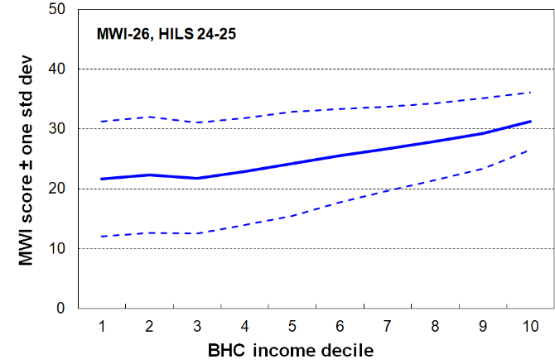
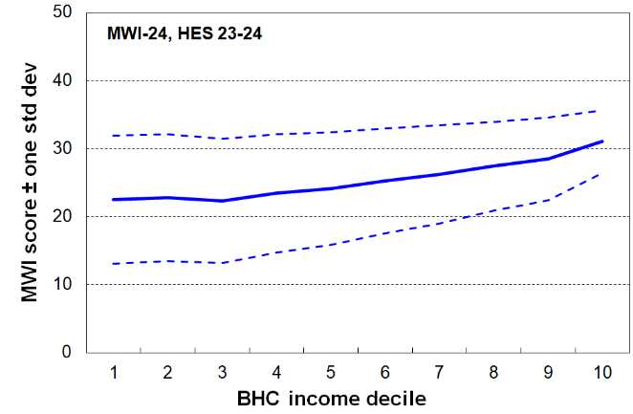
MWI-24 (HES 2023-24) and MWI-26 (HILS 2024-25)

Consistency between LIA and HES hardship rates when using MWI-26 for LIA analysis

The MWI-26 hardship rates for LIA 2023 are very close to those for the adjacent HES years using MWI-24, as shown in Tables 9a and 9b below. See Tables 3a and 3b for the discontinuity between HES and LIA (with the revised MWQs).

Table 9a
MWI-26 material hardship rates for LIA 2023 compared MWI-24 hardship rates for adjacent HES years
whole population
Whole population | HES 22-23  MWI-24 (12- & 6-) | LIA 2023  MWI-26 (11- & 5-) | HES 23-24  MWI-24 (12- & 6-)
Material hardship | 8.6 | 9.2 | 9.4
Severe material hardship | 3.1 | 3.1 | 3.2

Table 9b
MWI-26 material hardship rates for LIA 2023 compared MWI-24 hardship rates for adjacent HES years
0-17s
0-17s | HES 22-23  MWI-24 (12- & 6-) | LIA 2023  MWI-26 (11- & 5-) | HES 23-24  MWI-24 (12- & 6-)
Material hardship | 13.3 | 14.0 | 13.5
Severe material hardship | 4.8 | 5.3 | 4.6

Consistency between MWI-26 and MH-18 material hardship rates for selected demographic groups (HILS 24-25)

The following four Tables show the very good consistency between MH-18 and MWI-26 in the generation of material hardship rates for selected demographic groups, for both the whole population and for children.

There is a little more variability for the tables reporting on children, but this is to be expected given that the sample errors (uncertainties) are higher for this group than for the population as a whole.

Table 10a
Material hardship for whole population in selected sub-groups:
MWI-26 rates, numbers and composition, HILS 2024-25
 | In HHs in material hardship |  |  | All
 | Rate (%) | Numbers | Composn (%) | Composn (%)
Whole population | 9 | 478,000 | 100 | 100
Under-65s | 10 | 453,000 | 95 | 84
Age 65+ | 3 | 24,000 | 5 | 16
Household type
Single 65+ | 4 | 9,000 | 2 | 5
Couple only maxage 65+ | 1 | 5,000 | 1 | 9
Single <65 | 15 | 38,000 | 8 | 5
Couple only maxage<65 | 4 | 20,000 | 4 | 10
Two parent with any dep ch | 8 | 135,000 | 28 | 34
Sole parent with any dep ch | 35 | 122,000 | 26 | 7
Other family HHs with any dep ch | 14 | 63,000 | 13 | 9
Fam HHs no deps maxage 65+ | 6 | 13,000 | 3 | 5
Fam HHs no deps maxage <65 | 8 | 49,000 | 10 | 11
Non-fam HHs | 7 | 21,000 | 4 | 6
Main source of HH income (under-65s)
Main source market | 7 | 261,000 | 57 | 89
Main source government | 39 | 193,000 | 43 | 11
Self-employed | 3 | 10,000 | 2 | 8
Tenure of household
Owned with mortgage (incl FT) | 5 | 90,000 | 19 | 35
Owned no mortgage (incl FT) | 2 | 29,000 | 6 | 27
Private rental (no AS) | 6 | 61,000 | 13 | 18
Private rental (with AS) | 29 | 194,000 | 41 | 13
Social rental (HNZ & LA) | 40 | 90,000 | 19 | 4
Other | 9 | 14,000 | 3 | 3
Ethnicity
Māori | 19 | 171,000 | 28 | 15
Pacific | 25 | 123,000 | 20 | 8
Asian | 5 | 48,000 | 8 | 17
European | 7 | 252,000 | 41 | 58
Other | 11 | 18,000 | 3 | 3
Disability
Disabled | 18 | 136,000 | 29 | 14
Living in a ‘disabled household’ | 18 | 287,000 | 60 | 32
NZDep Quintile
Q1 | 3 | 27,000 | 6 | 19
Q2 | 4 | 43,000 | 9 | 19
Q3 | 7 | 77,000 | 16 | 20
Q4 | 10 | 106,000 | 22 | 21
Q5 | 21 | 224,000 | 47 | 21

Notes for table
- Index used is MWI-26 (11-).
- Ethnicity uses total ethnicity approach - composition is out of all person-ethnicities.

Table 10b
Material hardship for whole population in selected sub-groups:
MH-18 7+ rates, numbers and composition, HILS 2024-25
 | In HHs in material hardship |  |  | All
 | Rate (%) | Numbers | Composn (%) | Composn (%)
Whole population | 9 | 473,000 | 100 | 100
Under-65s | 10 | 448,000 | 95 | 84
Age 65+ | 3 | 26,000 | 5 | 16
Household type
Single 65+ | 4 | 10,000 | 2 | 5
Couple only maxage 65+ | 1 | 5,000 | 1 | 9
Single <65 | 16 | 41,000 | 9 | 5
Couple only maxage<65 | 4 | 20,000 | 4 | 10
Two parent with any dep ch | 8 | 136,000 | 29 | 34
Sole parent with any dep ch | 34 | 119,000 | 25 | 7
Other family HHs with any dep ch | 14 | 62,000 | 13 | 9
Fam HHs no deps maxage 65+ | 6 | 14,000 | 3 | 5
Fam HHs no deps maxage <65 | 8 | 46,000 | 10 | 11
Non-fam HHs | 7 | 19,000 | 4 | 6
Main source of HH income (under-65s)
Main source market | 6 | 250,000 | 56 | 89
Main source government | 40 | 198,000 | 44 | 11
Self-employed | 3 | 11,000 | 2 | 8
Tenure of household
Owned with mortgage (incl FT) | 4 | 79,000 | 17 | 35
Owned no mortgage (incl FT) | 2 | 28,000 | 6 | 27
Private rental (no AS) | 7 | 64,000 | 13 | 18
Private rental (with AS) | 29 | 195,000 | 41 | 13
Social rental (HNZ & LA) | 42 | 94,000 | 20 | 4
Other | 9 | 13,000 | 3 | 3
Ethnicity
Māori | 19 | 174,000 | 29 | 15
Pacific | 26 | 126,000 | 21 | 8
Asian | 5 | 47,000 | 8 | 17
European | 7 | 240,000 | 40 | 58
Other | 12 | 18,000 | 3 | 3
Disability
Disabled | 19 | 138,000 | 29 | 14
Living in a ‘disabled household’ | 18 | 289,000 | 61 | 31
NZDep Quintile
Q1 | 2 | 20,000 | 4 | 19
Q2 | 4 | 37,000 | 8 | 19
Q3 | 7 | 72,000 | 15 | 20
Q4 | 10 | 112,000 | 24 | 21
Q5 | 22 | 231,000 | 49 | 21

Notes for table
- Index used is MH-18 (7+).
- Ethnicity uses total ethnicity approach - composition is out of all person-ethnicities.

Table 11a
Material hardship for children in selected sub-groups:
MWI-26b rates, numbers and composition, HILS 2024-25
 | 0-17s in HHs in material hardship |  |  | All 0-17s
 | Rate (%) | Numbers | Composn (%) | Composn (%)
ALL 0-17s | 14 | 171,000 | 100 | 100
Household type
Two parent with any dep ch | 8 | 67,000 | 39 | 68
Sole parent with any dep ch | 37 | 77,000 | 45 | 18
Other family HHs with dep or no dep ch | 16 | 27,000 | 16 | 14
Number of children in HH
1 | 10 | 30,000 | 17 | 24
2 | 10 | 53,000 | 31 | 44
3 | 18 | 42,000 | 24 | 20
4+ | 32 | 46,000 | 27 | 12
Main source of HH income
Main source market | 8 | 84,000 | 49 | 84
Main source government | 46 | 87,000 | 51 | 16
Self-employed | 4 | 4,000 | 2 | 9
Tenure of household
Owned with mortgage (incl FT) | 6 | 29,000 | 17 | 43
Owned no mortgage (incl FT) | 3 | 5,000 | 3 | 13
Private rental (no AS) | 10 | 21,000 | 12 | 18
Private rental (with AS) | 40 | 78,000 | 46 | 16
Social rental (HNZ & LA) | 47 | 34,000 | 20 | 6
Ethnicity
Māori | 25 | 76,000 | 32 | 20
Pacific | 31 | 55,000 | 23 | 12
Asian | 6 | 15,000 | 6 | 16
European | 12 | 89,000 | 37 | 49
Other | 16 | 7,000 | 3 | 3
Disability
Disabled children | 27 | 32,000 | 19 | 10
Children in a ‘disabled household’ | 27 | 99,000 | 58 | 31
NZDep Quintile
Q1 | 4 | 10,000 | 6 | 19
Q2 | 5 | 12,000 | 7 | 19
Q3 | 12 | 28,000 | 17 | 19
Q4 | 16 | 38,000 | 22 | 20
Q5 | 31 | 83,000 | 49 | 23

Notes for table
- Index used is MWI-26 (11-).
- Ethnicity uses total ethnicity approach - composition is out of all person-ethnicities.

Table 11b
Material hardship for children in selected sub-groups:
MH-18 7+ rates, numbers and composition, HILS 2024-25
 | 0-17s in HHs in material hardship |  |  | All 0-17s
 | Rate (%) | Numbers | Composn (%) | Composn (%)
ALL 0-17s | 14 | 169,000 | 100 | 100
Household type
Two parent with any dep ch | 8 | 67,000 | 40 | 68
Sole parent with any dep ch | 36 | 76,000 | 45 | 18
Other family HHs with dep or no dep ch | 15 | 26,000 | 15 | 14
Number of children in HH
1 | 10 | 30,000 | 18 | 24
2 | 10 | 50,000 | 29 | 44
3 | 18 | 43,000 | 25 | 20
4+ | 33 | 46,000 | 27 | 12
Main source of HH income
Main source market | 8 | 82,000 | 48 | 84
Main source government | 47 | 88,000 | 52 | 16
Self-employed | 4 | 4,000 | 2 | 9
Tenure of household
Owned with mortgage (incl FT) | 5 | 25,000 | 15 | 43
Owned no mortgage (incl FT) | 4 | 6,000 | 3 | 13
Private rental (no AS) | 10 | 21,000 | 12 | 18
Private rental (with AS) | 40 | 78,000 | 46 | 16
Social rental (HNZ & LA) | 49 | 36,000 | 21 | 6
Ethnicity
Māori | 25 | 77,000 | 32 | 20
Pacific | 31 | 54,000 | 23 | 12
Asian | 6 | 15,000 | 6 | 16
European | 12 | 86,000 | 36 | 49
Other | 18 | 7,000 | 3 | 3
Disability
Disabled children | 27 | 32,000 | 19 | 10
Children in a ‘disabled household’ | 27 | 100,000 | 59 | 31
NZDep Quintile
Q1 | 4 | 9,000 | 5 | 19
Q2 | 4 | 10,000 | 6 | 19
Q3 | 12 | 27,000 | 16 | 19
Q4 | 17 | 40,000 | 24 | 20
Q5 | 31 | 83,000 | 49 | 23

Notes for table
- Index used is MH-18 (7+).
- Ethnicity uses total ethnicity approach - composition is out of all person-ethnicities.

In their Wellbeing reporting Stats NZ have to date used the MWI-24 with a 15+ threshold to identify those who have ‘good to very good’ material wellbeing.

Tables 12 and 13 show that the use of MWI-26 with a threshold of 14+ gives very good consistency with the HES-based statistics.

Table 12
Percentage of people living in households reporting good or very good material wellbeing,
by regional council area, HES 2022-23 & 2023-24, HILS 2024-25
 | HES |  | HILS
 | MWI-24 15+ |  | MWI-26 14+
 | 2023 | 2024 | 2025
ALL | 88 | 88 | 88
Northland | 86 | 88 | 84
Auckland | 88 | 86 | 87
Waikato | 87 | 86 | 87
Bay of Plenty | 89 | 89 | 88
Gisborne/Hawkes Bay | 89 | 88 | 88
Taranaki | 87 | 86 | 89
Manawatu-Wanganui | 84 | 88 | 88
Wellington | 91 | 89 | 88
Tasman/Nelson/Marlborough/West Coast | 87 | 90 | 90
Canterbury | 91 | 90 | 89
Otago | 94 | 93 | 92
Southland | 87 | 88 | 89
Note for table:
- ‘Good or very good’ material wellbeing is defined here as living in a household with a material wellbeing index score of 15+ for HES 2022-23 and 2023-24 (MWI-24) or 14+ for HILS 2024-25 (MWI-26). This indicator is used by Stats NZ in their Household Income and Housing Costs report (Table 12) and in their wellbeing indicators reporting. The Wellbeing thresholds are a few points higher than the material hardship thresholds of 12- and 11- respectively.

Table 13
Percentage of people living in households reporting good or very good material wellbeing,
for selected subgroups, HES 2022-23 & 2023-24, HILS 2024-25
 | HES |  | HILS
 | MWI-24 15+ |  | MWI-26 14+
 | 2023 | 2024 | 2025
ALL | 88 | 88 | 88
0-14 | 83 | 82 | 82
0-17 | 83 | 83 | 82
0-64 | 87 | 86 | 86
65+ | 96 | 95 | 96
Household type
Single 65+ | 96 | 94 | 94
Couple only maxage 65+ | 98 | 97 | 98
Single <65 | 81 | 80 | 82
Couple only maxage<65 | 95 | 94 | 94
2P HH with any deps | 91 | 90 | 89
2P HHs with 1 child | 93 | 92 | 91
2P HHs with 2 children | 92 | 92 | 93
2P HHs with 3+ children | 85 | 83 | 80
SP HH with any deps | 63 | 62 | 59
Tenure (65+)
Owned with mortgage 65+ | 92 | 92 | 91
Owned no mortgage 65+ | 98 | 98 | 98
Private rental 65+ | 89 | 86 | 87
Social rental 65+ | 83 | 73 | 80
Other 65+ | 95 | 93 | 96
Tenure (0-64)
Owned with mortgage 0-64 | 93 | 93 | 92
Owned no mortgage 0-64 | 97 | 97 | 96
Private rental 0-64 | 80 | 78 | 80
Social rental 0-64 | 49 | 48 | 49
Other 0-64 | 84 | 87 | 85
Disability status (break in series after 2024)
Disabled individuals - age 2+ | 77 | 76 | 77
Individuals in disabled HHs | 79 | 78 | 78
Health status (65+)
All 65+ | 96 | 95 | 96
Excellent | 98 | 99 | 99
Very good | 98 | 98 | 98
Good | 96 | 96 | 97
Fair | 92 | 90 | 91
Poor | 89 | 84 | 82
Notes for table:
- ‘Good or very good’ material wellbeing is defined here as living in a household with a material wellbeing index score of 15+ for HES 2022-23 and 2023-24 (MWI-24) or 14+ for HILS 2024-25 (MWI-26). This indicator is used by Stats NZ in their Household Income and Housing Costs report (Table 12) and in their wellbeing indicators reporting. The material hardship thresholds are 12- and 11- respectively.
- There is continuity in the time series from HES to HILS, except for disability status for which there was a change in definition from 2023-24 to 2024-25.

Appendix One

The income-wealth-consumption framework used in the MSD reports

MSD’s reports use the framework outlined in Figure 1.1 below for thinking through the relationship between material wellbeing (or living standards), household income, financial and physical assets, and other factors.
- ‘Current’ household income and financial and physical assets together largely determine the economic resources available to most households to support their consumption of goods and services and therefore their material standard of living.
- For low-income households that have very limited or no financial assets, income is the main resource available to generate their standard of living (along with the stock of physical assets such as furniture, whiteware and other consumer durables). Such households struggle in varying degrees to meet basic needs, and are also very vulnerable to the negative impacts of ‘shocks’, such as even a small drop in income or an unexpected expense.
- The framework recognises that factors other than current income and assets can also impact on material wellbeing. These factors are especially relevant for low-income / low-asset households, and can make the difference between ‘poverty/hardship’ and ‘just getting by’.
- Current physical and financial assets are a product of previous income, special demands on the household budget and budgeting decisions, gifts from outside the household, and so on; and also the history of the household itself in terms of dissolutions and re-formations involving current household members. The framework can be used in both static and dynamic contexts.

Figure 1.1
The income-wealth-consumption framework used in the MSD reports
Financial and physical assets (in part reflecting previous income)
Resources available for consumption
Household income (equiv)
Basic needs / essentials
Discretionary spend / desirable non-essentials

MWI
DEP-17 MH-18

Material wellbeing or living standards
Factors that may reduce MH for a given income and asset level
assistance from outside the household (family, friends, community, state), good stock of consumer durables

Factors that may increase MH for a given income and asset level
high housing costs, high employment-related costs (eg childcare, transport), high or unexpected health or debt servicing costs, disability that incurs extra costs

Ability to convert given resources into valued consumption

Appendix Two

Changes to questionnaire wording for items used in HILS for MWI-26 compared with what was used in HES for MWI-24 (changes in red) and the respective deprivation rates (whole population)
DK = don’t know RF = refuse to answer
ISP = individual spending HSP = household spending
Short name | Deprivation response | Changes for question wording, response options and introductory text |  | HILS module | Rate deprived for whole population
Short name | Deprivation response | HES for MWI-24 | HILS for MWI-26 | HILS module | HES  22-23 | HES  23-24 | HILS  24-25
Ownership or participation |  | I'm now going to ask you about some things you may or may not have or do…  Yes/No/DK/RF  If No: Don’t want, cost, other, DK, refuse | HSP & ISP intro- The next questions are about being forced to keep costs down…  Yes/No/DK/RF  If No: Don’t want, cost, other, DK, refuse
Shoes | Don't have - cost | Do you have at least two pairs of shoes in a good condition that are suitable for your daily activities? | Do you have at least two pairs of shoes in good condition, suitable for your daily activities? | ISP | 2.0 | 2.4 | 3.1
New clothes | Don't have - cost | Do you usually replace worn out clothes with new clothes, rather than second-hand? | Do you usually replace worn out clothes with new clothes? | ISP | 11.1 | 11.7 | 16.6
Clothes for special | Don't have - cost | Do you have suitable clothes for important or special occasions? | Do you have suitable clothes for important or special occasions? | ISP | 3.1 | 3.2 | 4.6
Contents ins | Don't have - cost | Do you have home contents insurance? | Does your household have home contents insurance? | HSP | 14.4 | 16.4 | 18.1
Protein meal | Don't have - cost | Do you have a meal with meat, fish, or chicken (or vegetarian equivalent) at least each second day? | Do you have a meal with meat, seafood, eggs, or plant-based protein at least every second day? | ISP | 1.6 | 1.9 | 3.2
Good bed | Don't have - cost | Do you have a good bed to sleep in? | Do you have a good bed to sleep in? | ISP | 2.0 | 2.3 | 4.0
Keep accomm warm | no | (not used in MWI-24) | Can your household afford to keep the dwelling adequately warm?  Yes/No/DK/RF | HOU | 6.2 | 6.9 | 9.9
 |  | Note: this question in both HES and HILS does not have the “if no why not?”
Gifts | Don't have - cost | Do you give presents to family or friends on birthdays, Christmas, or other special occasions? | Do you give presents to family or friends on birthdays, Christmas, or other special occasions? | ISP | 4.8 | 4.8 | 8.5
Local holidays | Don't have - cost | Do you usually have a holiday away from home for at least a week every year? | Do you usually have a holiday away from home for at least a week every year? | ISP | 22.7 | 23.5 | 29.1
Overseas holidays | Don't have - cost | Do you have a holiday overseas at least every three years? | Do you have a holiday overseas at least every three years? | ISP | 36.7 | 38.8 | 40.4
Vehicle access | Don't have - cost | Do you have access to a car or van for personal use? | Does your household have access to a vehicle for private use? | HSP | 2.4 | 2.6 | 1.6
Computer & internet | Don't have - cost | (not used in MWI-24) | (derived from Computer and Internet questions) | n/a | 2.5 | 2.4 | 4.6
Computer | Don't have - cost | (not used in MWI-24) | Does your household have access at home to a computer such as a PC, laptop or tablet? | HSP |  |  | 4.1
Internet | Don't have - cost | (not used in MWI-24) | Does your household have an internet connection at home? | HSP |  |  | 1.3
 |  | Note - in HILS the computer and Internet questions are separate

Economising |  | I'm now going to read out a list of things some people do to help keep costs down. This is not about choosing to spend less. It is about being forced to keep costs down to pay for other basic things that you need. Use showcard S2 to tell me if you had to do any of the following things to keep down costs in the last 12 months 'not at all', 'a little', or 'a lot':  - not at all  - a little  - a lot  DK/RF | HSP & ISP intro- The next questions are about being forced to keep costs down.  Looking at showcard P102, in the last 12 months …  yes - a little  yes - a lot  no - not at all  DK/RF
Fresh fruit & veg | a lot | ... go without fresh fruit and vegetables? | ...has the household had to go without, or cut back on, fresh fruit and vegetables? | HSP | 6.0 | 6.5 | 11.4
Cheaper / less meat | a lot | ... buy cheaper cuts of meat or buy less meat than you would like? | ...has the household had to buy cheaper cuts of meat, or buy less meat than you'd like? | HSP | 16.2 | 15.6 | 19.0
Put up with cold | a lot | ... put up with feeling cold? | ...has the household had to put up with feeling cold? | HSP | 5.9 | 6.0 | 8.1
Local trips | a lot | ... do without or cut back on trips to the shops or other local places? | ..., to keep costs down, have you ever had to do without or cut back on visits to local places, including the shops? | ISP | 12.5 | 13.4 | 16.4
Appliances | a lot | ... delay replacing or repairing broken or damaged appliances? | ...has the household had to put off replacing or repairing appliances? | HSP | 8.4 | 9.5 | 8.8
Hobbies | a lot | … spend less on hobbies or other special interests than you would like? | ..., to keep costs down, have you ever had to spend less on hobbies or other special interests than you would like? | ISP | 20.7 | 22.1 | 24.9
Doctor | a lot | … postpone or put off visits to the doctor? | ... have you ever had to put off going to the doctor? | ISP | 7.5 | 8.2 | 7.2
Dentist | a lot | ... postpone or put off visits to the dentist? | ... have you ever had to put off going to the dentist? | ISP | 23.3 | 25.9 | 25.3
Housing problems
Damp/mould problem | major problem | Does your accommodation have no problem, a minor problem, or a major problem with dampness or mould?  no problem  minor problem  major problem  DK/RF | Is there a problem with mould or damp in your dwelling?  Yes/No/DK/RF  If Yes-  Would you say it's a major problem or a minor problem?  major problem  minor problem  DK/RF | HOU | 4.6 | 4.0 | 5.5
Freedoms / restrictions
Limited by money | very limited | When buying, or thinking about buying, clothes or shoes for yourself, how much do you usually feel limited by the money available?  If no money available, select 'very limited'  not at all limited / a little limited / quite limited / very limited / DK / RF | When buying or thinking about buying clothes or shoes for yourself, how much do you feel limited by the money you have available?  If no money available, select 'very limited'.  not at all limited / a little limited / quite limited / very limited / DK / RF | ISP | 13.2 | 13.8 | 15.2
Non-essential item | very limited or couldn't buy it | Imagine that you have come across an item in a shop or on the internet that you would really like to have. It has a price tag of $300. It is not an essential item for accommodation, food, clothing, or other necessities – it’s an extra. If this happened in the next month, how limited would you feel about buying it?  not at all limited / a little limited / quite limited / very limited / couldn't buy it / DK / RF | Imagine there's something you'd really like to have which costs $400. It's not an essential item for accommodation, food, clothing, or other necessities - it's an extra. Looking at showcard P111, if this happened in the next month, how limited, if at all, would you feel about buying it?  not at all limited / a little limited / quite limited / very limited / couldn't buy it / DK / RF | ISP | 38.4 | 40.0 | 36.0
Unexpected $500 | no | If you [or your partner] had an unexpected and unavoidable expense of $500 in the next week, could you pay it within a month without borrowing?  yes/no/DK/RF | If your household had an unexpected and unavoidable expense of $500 in the next week, could you pay it within a month without borrowing?  yes/no/DK/RF | HSP | 17.0 | 17.5 | 18.0
Financial strain |  | In the last 12 months, have any of the following happened to you or your partner because of a shortage of money?  For each item use showcard S6 to tell me if it happened ‘not at all’, ‘once only’ or ‘more than once’  not at all / once only / more than once / DK / RF | Because of a shortage of money, in the last 12 months…
Late pay utilities | more than once | ... you could not pay electricity, gas, rates, or water bills on time? | … has your household ever been late paying electricity, gas, rates, or water bills?  yes/no/DK/RF  If yes,in the last 12 months how many times has your household been unable to pay electricity, gas, rates, or water bills on time - once, or more than once?  once/more than once/DK/RF | HSP | 6.1 | 6.8 | 9.6
Late pay car bills | more than once | ... you could not pay for car insurance, registration, or warrant of fitness on time? | ...has your household ever been late paying car insurance, registration, or warrant of fitness?  yes/no/DK/RF  If yes, in the last 12 months how many times has your household been unable to pay for car insurance, registration, or warrant of fitness on time - once, or more than once?  once/more than once/DK/RF | HSP | 5.2 | 5.9 | 6.7
Footnote for table:
Moving from HES to HILS there were many changes to the questionnaire for the material wellbeing questions (MWQs) that are used, among other things, to construct the Material Wellbeing Index (MWI-24). The changes included: the wording of many items; introduction to the items and the response options provided. This table gives an idea of the extent of these changes, and an indication of the size of the impact on responses for the items that make up MWI-24 (not accounting for any real world change from 23-24 to 24-25 that might influence responses). To avoid clutter the items are presented here in their deprivation (enforced lack) mode. In the index proper, some are also used in their ‘freedoms / non-essentials enjoyed’ mode.

Reporting on trends in material hardship for children is a requirement of the Child Poverty Reduction Act 2018 (CPRA or ‘The Act’). The Act gives the Government Statistician (GS) the duty and power to define material hardship (among other things) to achieve the purposes of the Act. As a contribution to their programme of work to address the discontinuity issue, Stats NZ in September 2025 commissioned MSD to prepare a detailed WP recommending a candidate revised index or indices for their consideration. This paper is available as Working Paper 01/26 at https://www.msd.govt.nz/about-msd-and-our-work/publications-resources/working-papers/index.html .
The MWI-24 has other important uses in addition to supporting a longer material hardship time series. The impact on these of the change to MWI-26 is discussed later in the paper (see p5).
See Jensen et al (2002) for the original ELSI report, and Appendix 3 in Perry (2019) for a comparison of ELSI and the MWI. https://www.msd.govt.nz/about-msd-and-our-work/publications-resources/monitoring/living-standards/
See Section E in Perry (2015) for an account of the development of the MWI-24 https://www.msd.govt.nz/about-msd-and-our-work/publications-resources/monitoring/living-standards/index.html
See p2 in Perry (2019) available at https://www.msd.govt.nz/about-msd-and-our-work/publications-resources/working-papers/index.html#WorkingPapers20095 (Working Paper 01/19).
For the respective lists see Section E of the 2019 MSD Material Wellbeing report, available at: https://www.msd.govt.nz/about-msd-and-our-work/publications-resources/monitoring/living-standards/
See Stats NZ’s account of the HES to HILS changes at https://www.stats.govt.nz/methods/about-the-transition-from-the-household-economic-survey-to-the-household-income-and-living-survey/ https://www.stats.govt.nz/methods/measuring-child-poverty-material-hardship-in-the-household-income-and-living-survey/ , and for some Living in Aotearoa tables in July 2026,at https://www.stats.govt.nz/methods/about-the-transition-from-the-household-economic-survey-to-the-household-income-and-living-survey/
See Section Two in the commissioned material hardship Working Paper available as Working Paper 01/26 at https://www.msd.govt.nz/about-msd-and-our-work/publications-resources/working-papers/index.html
The smaller standard deviation for MWI scores for higher income households does not mean that income for higher income households is a more reliable indicator of material wellbeing than it is for lower income households. It simply reflects the lower sensitivity of the MWI for discriminating between households of varying degrees of higher material living standards.
In the literature ‘current’ household income sometimes refers to income over the previous week or month. For this report (including Figure 1.1) it refers to annual income in a recent 12 month period in contrast to income in the longer-term over several years.

