

**The impact of rising housing costs on Accommodation Supplement recipients**

**Authors**

David Rea and Evan Thompson

**Acknowledgements**

We would like to thank Ross MacKay, Peter Alsop, Matt Velde, Mahathi Balajee and Mike O’Rourke for help with the preparation of data for this paper. Polly Vowles, Bryan Perry, Sandra Moore, Matthew Everett and Alex McKenzie have provided helpful suggestions and insights for the paper.

**Disclaimer**

This phase 1 report sets out analysis from a new experimental dataset. MSD has made every effort to ensure that the information in this paper is reliable, but does not guarantee its accuracy and does not accept liability for any errors. No individual accommodation supplement recipient can be separately identified in this work.  The Ministry of Social Development takes privacy, security and confidentiality seriously.

**Date**

28 June 2017

# Contents

Contents 3

Executive summary 4

Introduction 5

Data for the study 6

The wider context of housing subsidies 7

The detailed design of the Accommodation Supplement 8

Temporary Additional Support 10

Characteristics of current Accommodation Supplement recipients 12

Housing costs and subsidies for Accommodation Supplement recipients 14

Changes in housing costs and subsidies over the last decade 16

The impact of increasing housing costs on the budgets of Accommodation Supplement recipients 19

The prevalence of severe housing stress 23

Implications 26

Conclusion 27

Appendix 1: Variables in the Accommodation Supplement Dataset 28

Appendix 2: Accommodation Supplement areas 29

Appendix 3: The modified OECD equivalence scale 30

Appendix 4: The impact of the Child Material Hardship Package 31

References 32

# Executive summary

The Accommodation Supplement is a payment to low income individuals and families who have high housing costs. The payment currently subsidises the housing costs of around 11% of the total population.

The analysis presented in this paper uses a newly developed unit record dataset called the Accommodation Supplement Dataset. The new experimental dataset enables us to measure trends in the housing costs and incomes of Accommodation Supplement recipients over the last decade.

The analysis shows that the housing costs of Accommodation Supplement recipients have risen substantially in many parts of the country. By way of contrast the Accommodation Supplement and the associated housing-related hardship payments have not increased to the same extent. This has meant that on average Accommodation Supplement recipients have seen a decline in the relative value of housing subsidies. In 2016 the share of housing costs subsidized by the Accommodation Supplement and the associated housing-related hardship payments was four percentage points lower than in 2006.

As a result of this decline many groups of Accommodation Supplement recipients are facing increased pressure to afford suitable housing, and many also have less money available for spending on other necessities such as food, clothing and transport.

On average recipients are now spending 50% of their income on housing, and this is around four percentage points higher than a decade earlier.

On average real after housing cost incomes (after adjusting for differences in family size and composition) have also declined over the last decade.

These impacts have been particularly pronounced for people without children receiving an income tested main benefit.

The main reason for the overall decline in the relative value of housing subsidies for Accommodation supplement recipients is that while housing costs have been rising, the maximum rates of payment for the Accommodation Supplement have not been adjusted for over a decade, and the Temporary Additional Support payment has not on average made up the shortfall.

# Introduction

Housing is the largest single component of individual and family expenditure, and for low income families the extent to which the welfare system provides support to meet these costs is a critical determinant of living standards.

The resources individuals have to spend on housing influences their ability to access adequate housing. In addition, the resources available after paying for housing costs determines the level of purchasing power for other essentials such as food, heating, clothing and transport.

The Accommodation Supplement and the associated housing-related hardship payments represent the largest investment by central government in demand-side housing subsidies, and play an important role in protecting the living standards of a significant fraction of low income families.

This paper describes the findings of research using a new unit record dataset containing information about the housing costs and incomes of people receiving the Accommodation Supplement. Previous research has estimated these impacts based on scenarios for representative families (Johnson, 2013; Raven, 2015). The new dataset enables us to precisely measure how the actual budgets of beneficiaries have fared in the face of rising housing costs.

The rest of the paper:

* describes the new Accommodation Supplement Dataset
* provides background on the Accommodation Supplement and related payments and the wider context of different forms of housing assistance available for low income families
* sets out the eligibility rules and payment parameters for the Accommodation Supplement and the main hardship related payment called Temporary Additional Support
* describes the number and demographic characteristics of Accommodation Supplement recipients, as well as the average value of payments
* analyses how housing costs and the value of subsidies have changed over the last decade, and what this has meant for the budgets of Accommodation Supplement recipients
* describes the characteristics of Accommodation Supplement recipients who have very low after-housing-cost incomes.

# Data for the study

This study uses a newly developed unit record dataset called the Accommodation Supplement Dataset.

This new experimental research dataset is created from administrative records from the welfare payment system (SWIFTT). It contains information on over a million separate primary recipients of the Accommodation Supplement, and contains information on all spells of accommodation supplement receipt since 1 January 2006. As well as the dates during which a person received the accommodation supplement, the dataset also contains information on the demographic characteristics, family structure, declared housing costs, and income of all primary recipients while they are receiving the Accommodation Supplement.

More detail is provided in Appendix 1.

The dataset is derived from what the payment system has recorded about a primary recipient each day. Because of lags in updating of information, or alternatively backdated changes to entitlements, there will be some small variance in what was actually paid and received by individuals.

The manner in which the dataset was constructed also means that there are some minor differences from the official figures used for monitoring.

Importantly, some aspects of income (most tax credits paid by Inland Revenue for example) are currently imputed because the income data used in the paper is derived solely from Work and Income records. Some other minor elements of income (some income from boarders for example) are also not recorded. It is also likely that there is a degree of measurement error in the recording of earnings.

Matching with other administrative data will improve the measurement of a number of these income variables, and it is intended that a more comprehensive version of the Accommodation Supplement Dataset will be provided to Statistics NZ for inclusion in the Integrated Data Infrastructure (IDI).[1]

Unless otherwise stated the financial data reported in this paper are expressed in nominal dollars.

# The wider context of housing subsidies

Table 1 sets out the range of different housing subsidy programs aimed at supporting low income individuals and families in New Zealand.

The Accommodation Supplement is paid to low income individuals and families who have rent, board or ownership-related housing costs above a certain threshold. The aim of the subsidy is to ensure that housing is affordable, and the program represents an important means of protecting the living standards of low income individuals and families. There are a variety of other payments (including Temporary Additional Support) which act as add-ons to the Accommodation Supplement, and in combination this subset of payments represents around 1.8% of all core government expenditure.

An important alternative program is the Income Related Rent subsidy. This is targeted at individuals with significant housing needs, is calculated using a different formula, and is paid at a higher average rate than the Accommodation Supplement. It is only available for individuals renting from a central-government funded social housing provider. In the 2014/15 fiscal year spending on the Income Related Rent Subsidy represented around 1% of core government expenditure.

Table 1: Demand-side housing subsidies in New Zealand

|  |  |
| --- | --- |
|  | Description |
| Accommodation Supplement | Non-taxable second tier benefit that provides assistance towards a person’s accommodation costs. Approximately 290,000 recipients and a fiscal cost of $1.1 billion in 2014/15 |
| Temporary Additional Support (and Special Benefit) | Temporary Additional Support (TAS) is a non-taxable second tier supplementary benefit that can be paid for 13 weeks to help with essential living costs that cannot be met from existing income. TAS replaced Special Benefit which continues to be paid for some grandparented recipients. There are approximately 65,000 recipients in total, most of whom also receive the Accommodation Supplement. Fiscal cost of just under $0.2 billion in 2014/15 |
| Other related grants | Various recoverable and non-recoverable payments for assistance with the costs of moving, letting fees, rental advances and emergency accommodation |
| Income Related Rent Subsidy | Subsidized rent for social housing tenants with low incomes. The rate of subsidy is calculated based on income and household type. Just under 62,000 recipients and spending of over $0.7 billion in 2014/15 |
| Accommodation Benefit | Weekly payment for eligible tertiary students |
| Rates rebate | The scheme provides assistance in the form of a rebate (ie a deduction in the rates bill) to those on low incomes to assist with the cost of rates |
| Residential support subsidy/Residential care subsidy | Subsidies paid by the Ministry of Health for individuals with long term care needs |

It is important to note that there are a sizeable number of low income individuals and families who do not receive any housing subsidies. In 2016 there were around 50,000 individuals in receipt of an income-tested main benefit who were not receiving any housing subsidy. This may be because they had low accommodation costs (they owned their own home without significant mortgage costs or were living in housing provided by family, friends, local councils or NGOs), they had savings greater than the Accommodation Supplement cash asset test threshold, or they were not aware that financial assistance for accommodation costs was available.

# The detailed design of the Accommodation Supplement

The Accommodation Supplement is a non-taxable benefit paid to low income individuals and families with high housing costs.

Any resident 16 years of age or older is eligible to receive the Accommodation Supplement if they meet both a cash assets and an income test, and have accommodation costs above a certain threshold. Importantly, eligibility is not tied to being in receipt of an income tested benefit, and individuals with low earnings who are not on a benefit are also eligible.

The Accommodation Supplement can be paid to renters, boarders, or individuals who own their own home.[2]

**Figure 1: Relationship between weekly rent and Accommodation Supplement for a sole parent beneficiary with one child in West Auckland, 2016**



For a person receiving an income tested main benefit, the value of the payment is 70% of their weekly accommodation costs above an entry threshold. The amount of the entry threshold differs according to the type of benefit, the number of dependent children and the type of housing tenure. The overall amount payable cannot exceed a maximum rate which differs according to family size and also region.[3]

Figure 1 shows the value of the payment for a Sole Parent Support beneficiary who had one child and was renting in West Auckland in 2016. The figure shows how the value of the payment depends on their weekly rent. To be eligible the sole parent must be paying rent above the entry threshold of $105 per week. The payment provides a 70% subsidy for rent paid in excess of the entry threshold, up to a maximum payment of $125 per week.

Individuals not in receipt of an income tested main benefit are also eligible to receive the Accommodation Supplement as long as their assessed income remains below various income thresholds. Those on New Zealand Superannuation are eligible for the full payment unless their total income is above a cut-out point. For those with other income and who are not on an income-tested benefit or New Zealand Superannuation, the assessed payment is abated by 25 cents in the dollar for income above the income threshold.

Each year the entry thresholds are changed in line with the annual adjustment of benefits and tax credits, as it is assumed that these payments provide a contribution towards the costs of housing. By way of contrast there is no annual adjustment to the maximum rates of payment. The last time these were adjusted was 1 April 2005 (McKenzie, 2016).

Further details about the payment are available on the manuals and procedures webpages of the Work and Income website.[4]

# Temporary Additional Support

Temporary Additional Support is a non-taxable benefit that is paid as a last resort to help individuals with housing or other essential living costs (eg disability related) that cannot be met from their disposable income. It can be paid for a maximum of 13 weeks, although individuals are able to reapply if they need support over a longer period.

Temporary Additional Support functions as an add-on to the Accommodation Supplement when a person has high housing costs relative to their income and other outgoings. In virtually all cases individuals receiving Temporary Additional Support also receive the Accommodation Supplement.

To be eligible for Temporary Additional Support a person must have minimal assets, and must also be receiving all other benefits for which they are eligible.

The level of payment is determined by a formula that determines if an individual’s income is insufficient to meet their essential expenses.

The formula assesses income from all sources and then deducts ‘allowable costs’ to identify a person’s ‘disposable income’. Allowable costs include, but are not limited to, accommodation, heating, bedding, transport, childcare and costs related to disability.

Disposable income is then compared with ‘standard costs’ which are a benchmark for the minimum disposable income of different types of households. The rate of payment of Temporary Additional Support is assessed as the amount, up to a maximum rate of payment, that disposable income falls short of these standard costs.[5]

**Figure 2: Relationship between weekly rent and rate of Temporary Additional Support for a sole parent beneficiary in West Auckland, 2016**

Note: This scenario assumes $20 of other allowable costs.

Accommodation costs are a major element of allowable costs and Figure 2 sets out how rent influences the rate of the payment for a sole parent beneficiary with one child who was renting in West Auckland in 2016. In this specific instance Temporary Additional Support becomes payable at a rent of just over $190 per week ($20 of other allowable costs are assumed in this scenario). The maximum value of the payment in this instance is almost $98 per week, which is reached at rents of over $360 per week.

Further details about the payment are available on the manuals and procedures webpages of the Work and Income website.[6]

# Characteristics of current Accommodation Supplement recipients

In September 2016 there were 291,352 primary recipients receiving an Accommodation Supplement. Table 2 sets out the characteristics of these individuals. As can be seen, 44% of all primary recipients were paid the maximum rate of subsidy, and 22% also received Temporary Additional Support. Roughly two thirds of recipients were renting, 22% were boarding and 11% owned their own home.

**Table 2: Accommodation Supplement primary recipients, September 2016**

|  |  |  |
| --- | --- | --- |
|  | Number | Percentage |
| Payment less than maximum | 162,523 | 56% |
| Receiving maximum payment | 128,829 | 44% |
| Total | 291,352 | 100% |
| Not receiving Temporary Additional Support (or Special Benefit) | 226,825 | 78% |
| Receiving Temporary Additional Support (or Special Benefit) | 64,527 | 22% |
| Total | 291,352 | 100% |
| Renting | 192,962 | 66% |
| Boarding | 65,221 | 22% |
| Own home | 33,169 | 11% |
| Total | 291,352 | 100% |
| Receiving income tested main benefit | 195,848 | 67% |
| New Zealand Superannuation or Veterans Pension | 38,127 | 13% |
| Not on main benefit | 57,377 | 20% |
| Total | 291,352 | 100% |
| Area 1: Northern and central Auckland | 36,813 | 13% |
| Area 2: Other high cost urban areas | 81,363 | 28% |
| Area 3: Other urban areas | 107,002 | 37% |
| Area 4: Other parts of NZ and not specified | 66,174 | 23% |
| Total | 291,352 | 100% |
| Couple no children | 23,375 | 8% |
| Couple and one child | 9,854 | 3% |
| Couple with two or more children | 16,114 | 6% |
| Single person with no children | 161,275 | 55% |
| Sole parent with one child | 40,473 | 14% |
| Sole parent with two or more children | 40,261 | 14% |
| Total | 291,352 | 100% |
| Source: Accommodation Supplement Dataset. Note: Numbers may differ from official figures. N=291,352 | | |

Table 2 also reports the differing family circumstances of primary recipients. As can be seen, 55% of recipients were single with no partners or dependent children. In 37% of cases the Accommodation Supplement recipient had dependent children.

Table 3 reports the overall number of adults and children supported by the Accommodation Supplement. In total the payment subsidized the housing costs of 11% of the entire population and just under 19% of all children and young people.

**Table 3: Population covered by the Accommodation Supplement, September 2016**

|  |  |  |
| --- | --- | --- |
|  | Number supported by Accommodation Supplement | Percentage of total population |
| Population 17 years and over | 340,695 | 9% |
| Children and young people under 17 years | 194,430 | 19% |
| Total people | 535,125 | 11% |
| Source: Accommodation Supplement Dataset and Statistics NZ Population Estimates. N=535,125 | | |

# Housing costs and subsidies for Accommodation Supplement recipients

In September 2016 the average Accommodation Supplement recipient had $254 in weekly housing costs. On average recipients received $71 per week in Accommodation Supplement and $14 in Temporary Additional Support or Special Benefit. In total these payments represented 33% of the housing costs of recipients.

Table 4 sets out information on average housing costs and subsidies for different groups.

As can be seen, housing costs were highest for individuals who owned their own homes, who were not on a main benefit, who were living in central and northern Auckland, and for recipients with larger families.

Recipients with a larger share of their accommodation costs subsidized by Accommodation Supplement and Temporary Additional Support included those who were renting, on a main benefit, living in central and northern Auckland, and sole parents with two or more children.

**Table 4: Average weekly housing costs and subsidies for Accommodation Supplement recipients, September 2016**

|  |  |  |  |  |  |
| --- | --- | --- | --- | --- | --- |
|  | Housing costs | AS | TAS | Total housing subsidy | Percentage housing costs subsidised |
| Renting | $266 | $83 | $18 | $101 | 38% |
| Boarding | $189 | $34 | $1 | $35 | 19% |
| Own home | $309 | $74 | $17 | $91 | 30% |
| Total | $254 | $71 | $14 | $85 | 33% |
| Receiving income tested main benefit | $235 | $69 | $18 | $87 | 37% |
| New Zealand Superannuation or Veterans Pension | $232 | $60 | $10 | $69 | 30% |
| Not on main benefit | $334 | $85 | $3 | $89 | 27% |
| Total | $254 | $71 | $14 | $85 | 33% |
| Area 1: Northern and central Auckland | $324 | $114 | $14 | $128 | 39% |
| Area 2: Other high cost urban areas | $291 | $88 | $16 | $105 | 36% |
| Area 3: Other urban areas | $235 | $61 | $14 | $74 | 32% |
| Area 4: Other parts of NZ and not specified | $200 | $43 | $11 | $54 | 27% |
| Total | $254 | $71 | $14 | $85 | 33% |
| Couple no children | $305 | $79 | $16 | $95 | 31% |
| Couple and one child | $369 | $105 | $9 | $113 | 31% |
| Couple with two or more children | $385 | $105 | $8 | $112 | 29% |
| Single person with no children | $198 | $55 | $12 | $68 | 34% |
| Sole parent with one child | $290 | $73 | $20 | $93 | 32% |
| Sole parent with two or more children | $331 | $107 | $16 | $123 | 37% |
| Total | $254 | $71 | $14 | $85 | 33% |
| Source: Accommodation Supplement Dataset. N=291,352. Note 1: Numbers may differ from official figures. Note 2: TAS also includes Special Benefit payments. | | | | | |

# Changes in housing costs and subsidies over the last decade

Housing costs have increased rapidly in recent years, and for Accommodation Supplement recipients, the nominal costs of housing have increased by 31% in the ten years to September 2016. As is shown in Graph 1 below, the percentage increase in nominal housing costs has been broadly similar across all forms of tenure. Increases have occurred across many parts of the country, and not just Auckland and Canterbury (which have experienced the highest absolute increase in costs).

**Graph 1: Percentage change in nominal housing costs for Accommodation Supplement recipients, September 2006 compared to September 2016**

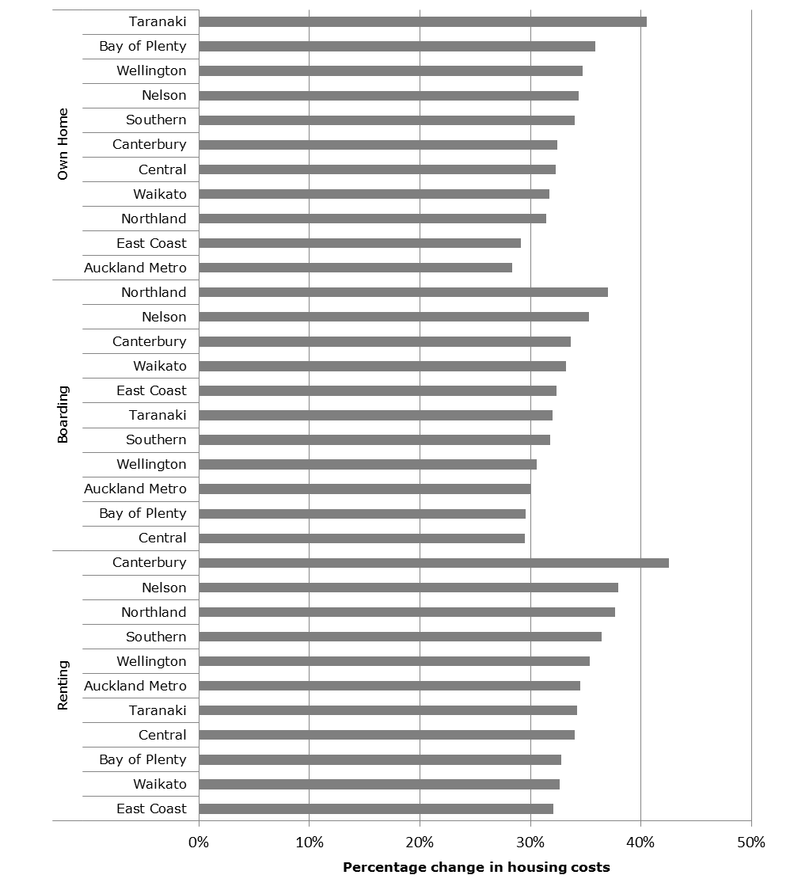Source: SWIFTT. Note: Work and Income defined regions.

While housing costs have increased by 31% over the decade, the combined value of the Accommodation Supplement/Temporary Additional Support Subsidy has only increased by 18%. As a result the proportion of housing costs that is subsidized has fallen by four percentage points from 37% in 2006 to 33% in 2016.

Table 5 shows changes in housing costs and subsidies over the past decade across different groups and areas. It shows how the share of housing costs that is subsidized has generally declined over the period, but that the extent of the decline has varied across areas and groups.

**Table 5: Changes in housing costs and subsidies over the last decade, September 2006 to September 2016**

|  |  |  |  |
| --- | --- | --- | --- |
|  | Percentage change in housing costs | Percentage change in subsidies | Percentage point change in the share of housing costs subsidised |
| Renting | 34% | 18% | -5 |
| Boarding | 30% | 32% | 0 |
| Own home | 31% | 15% | -4 |
| Total | 31% | 18% | -4 |
| Receiving income tested main benefit | 29% | 18% | -4 |
| New Zealand Superannuation or Veterans Pension | 50% | 48% | -1 |
| Not on main benefit | 30% | 18% | -3 |
| Total | 31% | 18% | -4 |
| Area 1: Northern and central Auckland | 32% | 20% | -4 |
| Area 2: Other high cost urban areas | 31% | 15% | -5 |
| Area 3: Other urban areas | 31% | 21% | -3 |
| Area 4: Other parts of NZ and not specified | 34% | 25% | -2 |
| Total | 31% | 18% | -4 |
| Couple no children | 39% | 23% | -4 |
| Couple and one child | 33% | 27% | -1 |
| Couple with two or more children | 36% | 24% | -3 |
| Single person with no children | 37% | 32% | -1 |
| Sole parent with one child | 37% | 15% | -6 |
| Sole parent with two or more children | 39% | 18% | -6 |
| Total | 31% | 18% | -4 |
| Source: Accommodation Supplement Dataset. N=546,199. Note: Numbers may differ from official figures | | | |

As accommodation costs have increased, a larger percentage of recipients have reached the maximum Accommodation Supplement payable. This has meant any further increase in housing costs has not been subsidized by the Accommodation Supplement, and recipients have had to apply and be granted Temporary Additional Support to make up any shortfall. While more recipients are now receiving Temporary Additional Support, and this payment makes up a larger share of housing subsidies, it has not fully compensated for the increase in housing costs.

**Table 6: Change in payment for Accommodation Supplement recipients, September 2006 to September 2016**

|  |  |  |  |
| --- | --- | --- | --- |
|  | September 2006 | September 2016 | Percentage point change |
| Percentage of Accommodation Supplement recipients paid at the maximum rate | 24% | 44% | 20 |
| Percentage of Accommodation Supplement recipients also in receipt of Temporary Additional Support (or Special Benefit) | 16% | 22% | 6 |
| Percentage of average housing subsidy contributed by Temporary Additional Support (or Special Benefit) | 12% | 16% | 4 |
| Source: Accommodation Supplement Dataset. N=546,199. Note: Numbers may differ from official figures | | | |

# The impact of increasing housing costs on the budgets of Accommodation Supplement recipients

Over the last decade housing costs have increased substantially faster than housing subsidies, and in this section we investigate how these changes have impacted on the budgets of Accommodation Supplement recipients.

To do this we report changes in housing costs as a percentage of income, as well as changes in real income after housing costs.[7] These measures enable an analysis of both the affordability of housing, as well as the real disposable income available for other forms of consumption.

Both measures depend not only on housing costs after taking account of subsidies, but also trends in the amount of other income such as benefits, tax credits and earnings. This is an important point because although the relative value of housing subsidies may have declined, the overall impact might be mitigated by changes in other forms of income (such as an increase in benefit rates). The overall impact on budgets therefore depends on the extent of other changes in income apart from housing subsidies.

*Housing costs as a percentage of income*

The percentage of weekly income spent on housing, usually referred to as outgoings-to-income (OTI) is a measure of the affordability of housing. Formally it can be defined as:

Housing costs as a percentage of income = (Housing costs / (Income from housing subsidies + All other net income)) * 100

*Residual income*

Residual income is a measure of the income that recipients have after paying for their housing. Residual income measures the resources a family has available for spending on all other items after taking account of housing costs. There is good evidence to show that this measure is strongly inversely correlated with direct measures of hardship (Perry, 2016). Formally residual income can be defined as:

Residual Income = (All other net income + Income from housing subsidies) – Housing Costs

In order to facilitate comparisons between households of different size and type we adjust residual incomes using the modified OECD equivalence scale, an adjustment known as equivalisation. Compared to a simple per capita measure, this adjustment gives less weight to individuals within larger families based on the assumption that there are economies of scale of consumption for larger households (for example sharing the costs of car ownership). The equivalence scale also gives less weight to children under 14 years based on the assumption that costs in other areas (such as food) are lower. Appendix 3 provides the exact weights given to each household type in the scale.

Our measure of equivalised residual income is also adjusted for inflation and reported as real 2016 dollars.

*Analysis*

Table 7 sets out measures of changes in housing costs as a percentage of income. As can be seen, overall the share of income spent on housing increased by four percentage points between 2006 and 2016.[8] The extent of these changes did however differ across groups. There were pronounced increases in housing costs as a percentage of income for beneficiaries with no dependent children, as well as for many non-beneficiaries.[9]

An important feature of Table 7 is that it also highlights those groups who in 2016 spent the largest proportion of their income on housing. Those with high housing costs as a proportion of income include those owning their own home, in receipt of an income tested main benefit (and particularly those without children), and recipients living in northern and central Auckland.

**Table 7: Housing costs as a percentage of income (OTI’s) for Accommodation Supplement recipients, September 2006 and September 2016**

|  |  |  |  |
| --- | --- | --- | --- |
|  | 2006 | 2016 | Percentage point change in OTI |
| All Accommodation Supplement recipients | | | |
| Renting | 48% | 52% | 4 |
| Boarding | 37% | 40% | 3 |
| Own home | 48% | 54% | 6 |
| Total | 45% | 50% | 4 |
| Receiving income tested main benefit | 47% | 52% | 5 |
| New Zealand Superannuation or Veterans Pension | 41% | 43% | 1 |
| Not on main benefit | 43% | 47% | 4 |
| Total | 45% | 50% | 4 |
| Area 1: Northern and central Auckland | 52% | 55% | 3 |
| Area 2: Other high cost urban areas | 48% | 52% | 4 |
| Area 3: Other urban areas | 44% | 48% | 4 |
| Area 4: Other parts of NZ | 40% | 45% | 4 |
| Total | 45% | 50% | 4 |
| Accommodation Supplement recipients receiving income tested main benefits | | | |
| Couple no children | 48% | 53% | 4 |
| Couple and one child | 46% | 49% | 2 |
| Couple with two or more children | 41% | 44% | 3 |
| Single person with no children | 49% | 54% | 6 |
| Sole parent with one child | 46% | 48% | 2 |
| Sole parent with two or more children | 43% | 46% | 3 |
| Accommodation Supplement recipients receiving NZS or Veterans Pension | | | |
| Couple no children | 41% | 42% | 1 |
| Single person with no children | 42% | 43% | 2 |
| Accommodation Supplement recipients not on main benefits | | | |
| Couple no children | 55% | 60% | 5 |
| Couple and one child | 43% | 46% | 3 |
| Couple with two or more children | 38% | 41% | 3 |
| Single person with no children | 50% | 56% | 6 |
| Sole parent with one child | 39% | 44% | 5 |
| Sole parent with two or more children | 37% | 40% | 3 |

Source: Accommodation Supplement Dataset. N=539,590. Note 1: This analysis excludes non-beneficiary recipients reporting zero earnings as there is some uncertainty about the reported results for non-beneficiaries. Note 2: Because estimates are rounded the difference in OTI’s may not always equal the percentage point change.

Table 8 sets out measures of the real average weekly equivalised residual income of different groups of beneficiaries in September 2006 and 2016. As can be seen, in 2016 the real average weekly equivalised residual income of Accommodation Supplement recipients was 2% lower than a decade earlier. Declines were particularly pronounced for people under the age of 65 years with no dependent children.

Not all groups experienced a fall in residual incomes. For example the real average equivalised residual income of individuals receiving the Accommodation Supplement and New Zealand Superannuation increased over the decade. For some Accommodation Supplement recipients with children, the recent increase in benefit rates and tax credits compensated families for increases in housing costs.[10]

**Table 8: Real average weekly equivalised residual income for Accommodation Supplement recipients, September 2006 and September 2016**

|  |  |  |  |
| --- | --- | --- | --- |
|  | 2006 | 2016 | Percentage change |
| All Accommodation Supplement recipients | | | |
| Renting | $196 | $194 | -1% |
| Boarding | $168 | $168 | 0% |
| Own home | $204 | $197 | -3% |
| Total | $192 | $189 | -2% |
| Receiving income tested main benefit | $169 | $155 | -8% |
| New Zealand Superannuation or Veterans Pension | $220 | $259 | 18% |
| Not on main benefit | $269 | $261 | -3% |
| Total | $192 | $189 | -2% |
| Area 1: Northern and central Auckland | $192 | $197 | 2% |
| Area 2: Other high cost urban areas | $192 | $189 | -2% |
| Area 3: Other urban areas | $193 | $188 | -3% |
| Area 4: Other parts of NZ | $187 | $185 | -1% |
| Total | $192 | $189 | -2% |
| Accommodation Supplement recipients receiving income tested main benefits | | | |
| Couple no children | $170 | $160 | -6% |
| Couple and one child | $172 | $173 | 1% |
| Couple with two or more children | $170 | $171 | 1% |
| Single person with no children | $145 | $131 | -10% |
| Sole parent with one child | $204 | $206 | 1% |
| Sole parent with two or more children | $191 | $195 | 2% |
| Accommodation Supplement recipients receiving NZS or Veterans Pension | | | |
| Couple no children | $237 | $273 | 15% |
| Single person with no children | $215 | $254 | 18% |
| Accommodation Supplement recipients not on main benefits | | | |
| Couple no children | $207 | $184 | -11% |
| Couple and one child | $274 | $271 | -1% |
| Couple with two or more children | $261 | $260 | -1% |
| Single person with no children | $225 | $206 | -9% |
| Sole parent with one child | $337 | $315 | -7% |
| Sole parent with two or more children | $302 | $297 | -2% |

Source: Accommodation Supplement Dataset. N=539,590. Note 1: This analysis excludes non-beneficiary recipients reporting zero earnings as there is some uncertainty about the reported results for non-beneficiaries. Note 2: The measure uses the modified OECD equivalence scale to adjust for differences in family composition. The estimates of real equivalised residual income given in the table can be interpreted as the adjusted per person disposable income available after housing costs. Note 3: The figures are real and adjusted to 2016 dollars using the all groups CPI.

An important feature of the table is that it also highlights those groups who in 2016 were most at risk of having low average weekly equivalised residual incomes. Recipients facing the greatest pressures on their budgets include boarders, and those without children on an income tested benefit. Importantly, and in contrast to the aggregated results in the table, more detailed supplementary analysis controlling for differences in benefit type and family structure shows that recipients in Accommodation Supplement areas 1 and 2 have average equalized residual incomes that are generally lower than recipients in other areas.

# The prevalence of severe housing stress

The previous section reported on the average weekly equivalised residual incomes of different groups of Accommodation Supplement recipients in 2016.

In this section we supplement this analysis by looking at the percentage of recipients who have weekly equivalised residual incomes less than a specified threshold. We use a threshold of $180 per week after paying housing costs for a single person (or the same amount in equivalised dollars for other family types).[11] We refer to individuals with incomes under this threshold as experiencing severe housing stress as it is likely that they are finding it difficult to afford their housing and pay for other necessities.

Table 9 provides a detailed breakdown of the different groups who have less than the equivalent of $180 per person per week.

**Table 9: Accommodation supplement recipients with after-housing cost equivalised incomes less than $180, September 2016**

|  |  |  |  |  |  |
| --- | --- | --- | --- | --- | --- |
| Benefit type | Family type | Area | Group as a percentage of all AS recipients | Prevalence of severe housing stress in group | Share of all those in severe housing stress |
| Income tested benefit | Couple no children | Area 1 | 0.6% | 66.1% | 0.8% |
| Area 2 | 1.1% | 68.1% | 1.5% |
| Area 3 | 1.0% | 55.9% | 1.1% |
| Area 4 | 0.7% | 50.0% | 0.7% |
| Total | 3.3% | 60.2% | 4.1% |
| Couple and one child | Area 1 | 0.1% | 75.0% | 0.2% |
| Area 2 | 0.3% | 63.0% | 0.4% |
| Area 3 | 0.3% | 50.5% | 0.4% |
| Area 4 | 0.3% | 35.9% | 0.2% |
| Total | 1.1% | 52.6% | 1.1% |
| Couple parent with two or more children | Area 1 | 0.2% | 75.7% | 0.2% |
| Area 2 | 0.4% | 72.9% | 0.6% |
| Area 3 | 0.5% | 55.8% | 0.6% |
| Area 4 | 0.5% | 41.1% | 0.4% |
| Total | 1.6% | 57.5% | 1.9% |
| Single no children | Area 1 | 4.3% | 88.1% | 7.8% |
| Area 2 | 10.2% | 87.5% | 18.2% |
| Area 3 | 16.0% | 84.2% | 27.5% |
| Area 4 | 10.7% | 83.2% | 18.1% |
| Total | 41.2% | 85.2% | 71.7% |
| Sole parent with one child | Area 1 | 0.9% | 31.2% | 0.6% |
| Area 2 | 2.9% | 27.6% | 1.7% |
| Area 3 | 4.1% | 22.7% | 1.9% |
| Area 4 | 2.7% | 16.3% | 0.9% |
| Total | 10.7% | 23.1% | 5.1% |
| Sole parent with two or more children | Area 1 | 0.7% | 40.2% | 0.6% |
| Area 2 | 2.9% | 41.2% | 2.4% |
| Area 3 | 3.9% | 30.1% | 2.4% |
| Area 4 | 2.8% | 21.1% | 1.2% |
| Total | 10.3% | 31.4% | 6.6% |
| Income tested main benefit | All family types | Total | 68.2% | 64.9% | 90.6% |
| Non beneficiary | Couple no children | Area 1 | 0.4% | 47.7% | 0.4% |
| Area 2 | 0.6% | 45.7% | 0.5% |
| Area 3 | 0.3% | 39.2% | 0.2% |
| Area 4 | 0.1% | 37.5% | 0.1% |
| Total | 1.4% | 44.3% | 1.3% |
| Couple and one child | Area 1 | 0.6% | 16.0% | 0.2% |
| Area 2 | 0.9% | 17.5% | 0.3% |
| Area 3 | 0.6% | 12.5% | 0.2% |
| Area 4 | 0.2% | 17.0% | 0.1% |
| Total | 2.3% | 15.7% | 0.7% |
| Couple parent with two or more children | Area 1 | 0.8% | 16.4% | 0.3% |
| Area 2 | 1.6% | 14.7% | 0.5% |
| Area 3 | 1.2% | 12.5% | 0.3% |
| Area 4 | 0.3% | 16.7% | 0.1% |
| Total | 3.9% | 14.6% | 1.2% |
| Single no children | Area 1 | 1.1% | 33.6% | 0.7% |
| Area 2 | 1.3% | 39.1% | 1.1% |
| Area 3 | 1.3% | 40.8% | 1.1% |
| Area 4 | 0.4% | 39.8% | 0.3% |
| Total | 4.1% | 38.3% | 3.2% |
| Sole parent with one child | Area 1 | 0.5% | 9.3% | 0.1% |
| Area 2 | 1.1% | 7.9% | 0.2% |
| Area 3 | 1.2% | 8.5% | 0.2% |
| Area 4 | 0.5% | 9.6% | 0.1% |
| Total | 3.3% | 8.6% | 0.6% |
| Sole parent with two or more children | Area 1 | 0.4% | 9.3% | 0.1% |
| Area 2 | 1.1% | 7.5% | 0.2% |
| Area 3 | 1.5% | 7.7% | 0.2% |
| Area 4 | 0.6% | 8.5% | 0.1% |
| Total | 3.6% | 8.0% | 0.6% |
| Non beneficiary | All family types | Total | 18.5% | 19.8% | 7.5% |
| NZS/VP | All family types | Area 1 | 1.8% | 8.5% | 0.3% |
| Area 2 | 3.6% | 8.4% | 0.6% |
| Area 3 | 4.8% | 6.8% | 0.7% |
| Area 4 | 3.0% | 5.4% | 0.3% |
| New Zealand Superannuation | All family types | Total | 13.3% | 7.1% | 1.9% |
| On maximum AS payment | All family types | Area 1 | 3.6% | 67.6% | 5.0% |
| Area 2 | 10.9% | 65.1% | 14.5% |
| Area 3 | 17.4% | 59.4% | 21.1% |
| Area 4 | 12.3% | 58.5% | 14.7% |
| On maximum AS payment | All family types | Total | 44.2% | 61.2% | 55.4% |
| Total | All family types | Total | 100.0% | 48.9% | 100.0% |

Source: Accommodation Supplement Dataset. Note 1: N=287,216 as the analysis excludes non-beneficiary recipients reporting zero earnings. Note 2: The measure uses the modified OECD equivalence scale to adjust for differences in family composition. The estimates of real equivalised residual income can be interpreted as the adjusted per person disposable income available after housing costs. Note 3: Numbers do not always sum due to rounding and a small number of missing values related to area. Note 4: See Appendix 2 for a map and definition of the Accommodation Supplement areas.

As can be seen, overall 49% of recipients had residual incomes less than the threshold, however there is quite a lot of variation in this incidence across different groups. The analysis shows the high rate of severe housing stress among those without children. The table also shows those living in Accommodation Supplement Areas 1 and 2 are also at higher risk of severe housing stress.

# Implications

Increasing housing costs have impacted upon the budgets of many individuals and families receiving the Accommodation Supplement.

As portrayed in Figure 3, it is highly likely that the increase in housing costs relative to income has put pressure on various aspects of housing consumption. Affordability pressures will have likely led to increased overcrowding, increased living in poor quality unsuitable housing, continued living in poor quality neighborhoods, and in extreme cases homelessness. Declining residual incomes will also likely be associated with reduced consumption in other areas of necessity, such as food, heating and education (Tunstall et al., 2013; Howden-Chapman, 2015; Perry, 2016; Waldegrave et al., 2013).

Figure 3: The impact of high housing costs on low income individuals and families

Non-housing related hardship

Overcrowding

High housing costs

Poor quality dwellings

Low quality amenities (eg transport)

Homelessness

Possible impacts on job search and mobility

For government these housing impacts will likely lead some families to seek social and emergency housing.

It is also possible that rising housing costs have reduced job search and transitions to employment. This may be because housing costs have risen most in areas where there are job opportunities and this will have blunted incentives to move. In addition, because a rising proportion of Accommodation Supplement recipients are now also in receipt of Temporary Additional Support there will be increased financial disincentives to work because of the structure of this payment.

It is important to note however that the exact nature and possible extent of these implications is somewhat uncertain, and it is an area where more empirical analysis is needed.

# Conclusion

The Accommodation Supplement and related payments are a major element of government spending aimed at protecting the living standards of low income individuals and families. Overall these programmes represent nearly 1.8% of core government expenditure and the payments subsidize the housing costs of 11% of the total population.

This study uses a new experimental dataset that measures the housing costs and incomes of Accommodation Supplement recipients.

It shows that housing costs have risen substantially over the last decade, yet housing subsidies have not increased by the same amount. Overall the proportion of housing costs covered by subsidies has fallen from 37% in 2006 to 33% in 2016.

The relative decline in housing subsidies compared to housing costs has put pressure on the weekly budgets of many low income individuals and families.

Across all Accommodation Supplement recipients the share of income devoted to housing costs is 50%, which is four percentage points higher than in 2006.

Associated with this, average real equivalised weekly residual incomes have fallen by around 2%, with large declines being experienced by main beneficiaries without dependent children. By way of contrast the residual incomes of beneficiaries with children are now on a par with a decade ago as a result of the recent increase in benefit rates as part of the Child Material Hardship package.

Finally, it is important to note that the results reported in this paper are the first phase of analysis using the new dataset, and the analysis has a number of limitations. Imputation and poor quality underlying data means there is uncertainty about the overall measurement of some aspects of incomes (particularly for non-beneficiaries). In addition, the analysis has also not fully controlled for all compositional changes or the take-up of benefits.

# Appendix 1: Variables in the Accommodation Supplement Dataset

The current version of the Accommodation Supplement Dataset contains records of all primary recipients of an Accommodation Supplement since 1 January 2006. Key variables in the dataset include:

* start date and end date of record
* birthdate
* district office
* partnership status
* number of children included
* type of main benefit received
* weekly accommodation cost
* type of accommodation
* weekly rate of Accommodation Supplement
* weekly rate of other income support payments
* tax credits
* earnings

# Appendix 2: Accommodation Supplement areas

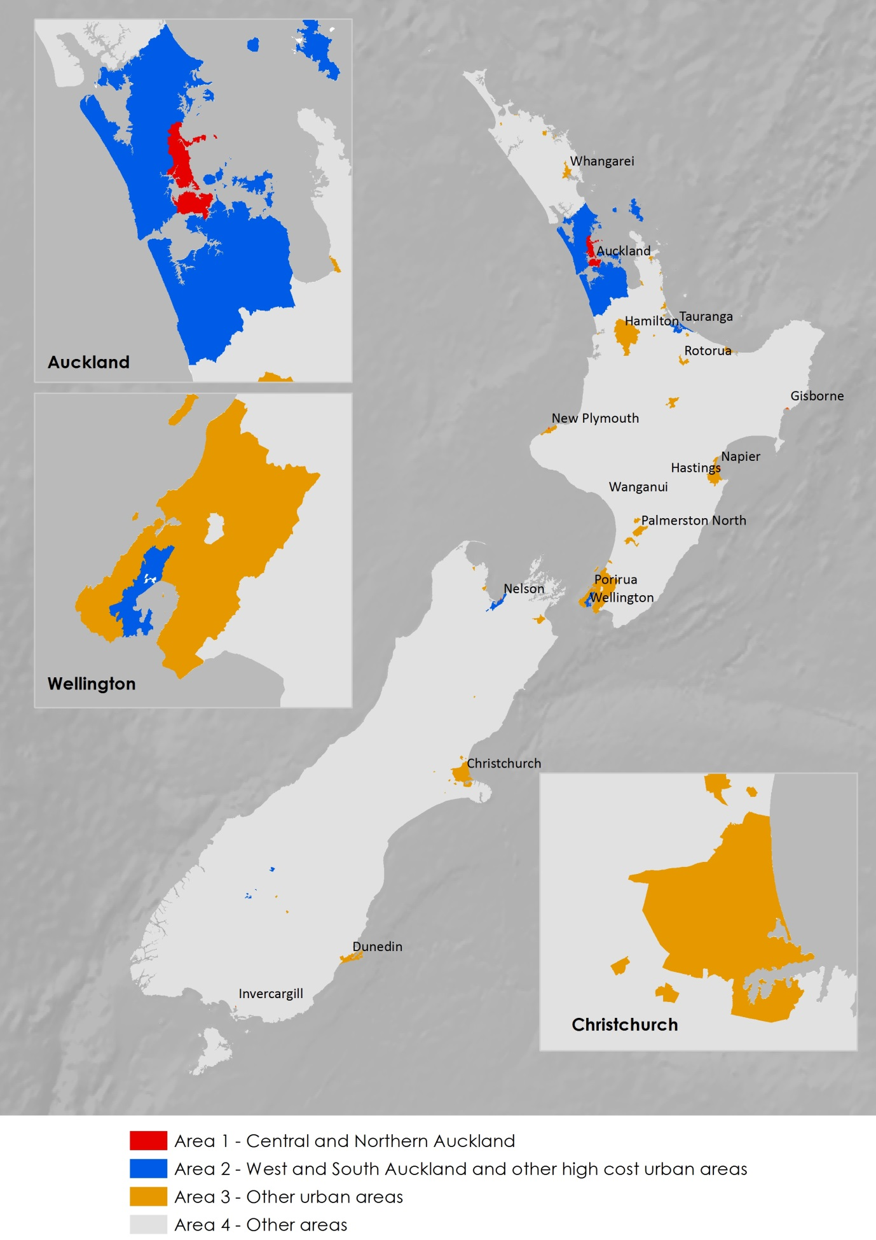

# Appendix 3: The modified OECD equivalence scale

Equivalised income can be interpreted as the per person income that is available to each individual in an income sharing unit (in this case a family), adjusted for family size and composition.

This paper uses the modified OECD equivalence scale to adjust for family size and composition (OECD, 2016). The scale provides a weight of:

* 1 for the first adult
* 0.5 for everybody else 14 years or older
* 0.3 for every child younger than 14 years of age.

Table 3.1 shows how the adjustment translates into different levels of equalized income by comparing equivalisation using the modified OECD scale and a simple per capita measure. The table shows the relative weights for a range of different family types weights, and also how a $100 converts to a per person equivalised income in each family.

**Table A1: Selected weights and impact of different forms of equivalisation**

|  |  |  |  |  |
| --- | --- | --- | --- | --- |
| Variable | Per capita weight | Per capita equivalised value of $100 actual income | Modified OECD scale weight | Modified OECD scale equivalised value of $100 actual income |
| Single adult | 1 | $100 | 1 | $100 |
| Couple no children | 2 | $50 | 1.5 | $67 |
| Couple one child under 14 years | 3 | $33 | 1.8 | $56 |
| Couple one child over 14 years | 3 | $33 | 2 | $50 |
| Couple two children under 14 years | 4 | $25 | 2.1 | $48 |
| Sole parent one child under 14 years | 2 | $50 | 1.3 | $77 |
| Sole parent one child over 14 years | 2 | $50 | 1.5 | $67 |
| Sole parent two children under 14 years | 3 | $33 | 1.6 | $63 |

# Appendix 4: The impact of the Child Material Hardship Package

Budget 2015 included a $790 million package to reduce hardship among children. As a result of this package, on 1 April 2016 there was a $25 a week increase in benefit rates for families with children, and an increase in Working for Families payments for low-income families not on a benefit

An important fraction of the children who benefited from the package were living in Families receiving the Accommodation Supplement.

On average, families with dependent children on an income tested main benefit receiving the Accommodation Supplement saw their weekly income after housing costs increase by $22. For families with children not in receipt of an income tested main benefit but receiving the Accommodation Supplement, weekly after housing costs incomes increased by $13.

These increases were slightly less when measured as equivalised income (ie measured on an adjusted per person basis) due to the fact that the average family consisted of around three people. Graph A4.1 shows the long term trends in real equivalised weekly incomes for families with children in receipt of the Accommodation Supplement.

**Graph A4.1: Impact of the Child Material Hardship package on the real equivalised weekly residual incomes of families with children in receipt of the Accommodation Supplement ($2016)**

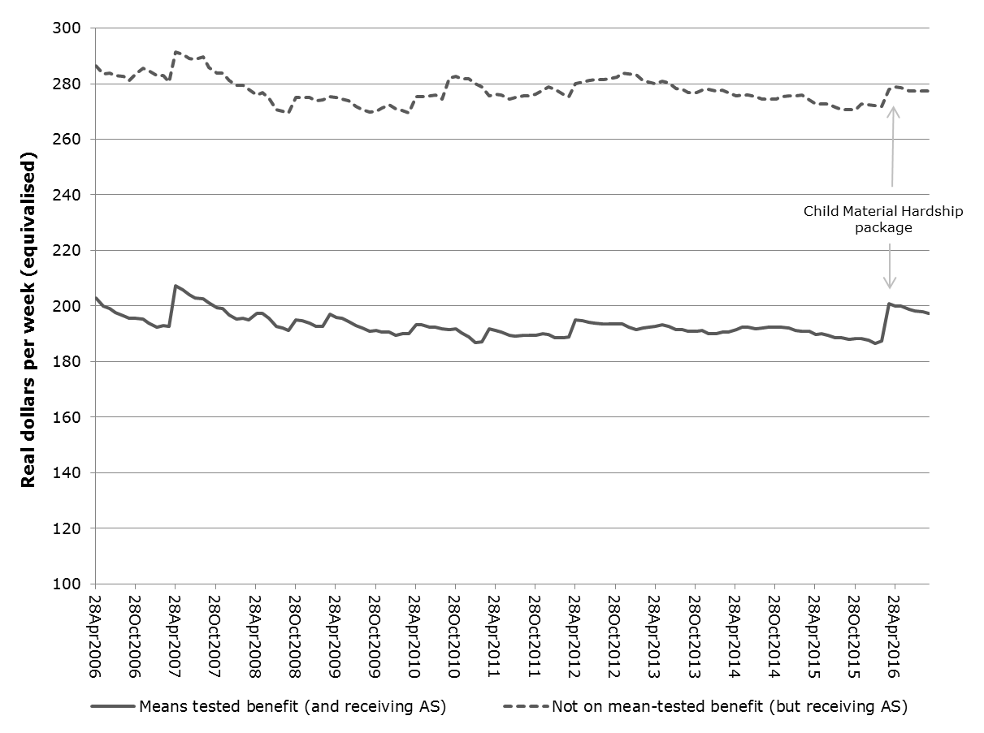

Note 1: The analysis excludes non beneficiaries with no reported other income. Note 2: Equivalisation using modified OECD scale. Note 3: Real $2016 dollars using all groups CPI.

# References

Howden-Chapman, P. (2015). *Home truths: Confronting New Zealand's housing crisis*. Wellington, New Zealand: Bridget Williams Books, 116p

Johnson, A. (2013). Give Me Shelter: An assessment of New Zealand’s Housing Assistance Policies. The Salvation Army Social Policy and Parliamentary Unit. Retrieved from <http://www.salvationarmy.org.nz/sites/default/files/uploads/GiveMeShelter2013FinalWeb.pdf>

McKenzie, A. (2016) Social Assistance Chronology – a chronology of social assistance policy and programmes in New Zealand – 1844 to present, Ministry of Social Development, <http://www.msd.govt.nz/about-msd-and-our-work/about-msd/history/social-assistance-chronology-programme-history.html>

OECD (undated) ‘What are equivalence scales’ OECD Income Distribution Database <http://www.oecd.org/els/soc/OECD-Note-EquivalenceScales.pdf>

Perry, B. (2016) Household incomes in New Zealand: Trends in indicators of inequality and hardship 1982 to 2015, Ministry of Social Development https://www.msd.govt.nz/about-msd-and-our-work/publications-resources/monitoring/household-incomes/

Raven, J. (2015) Financial Incentives to Work: The size of the margin between benefit and in-work incomes’, Policy Quarterly (11)4:26-33.

Tunstall, R., Bevan, M., Bradshaw, J., & Croucher, K. (2013). The links between housing and poverty: An evidence review. Retrieved from https://www.jrf.org.uk/report/links-between-housing-and-poverty

Waldegrave, C., Thompson, A., & Love, C. (2013). Research to Identify the Impacts and Opportunities for Māori from Recent Changes to Social Housing Provision. A Report for Te Puni Kokiri. Wellington: Family Centre Social Policy Research Unit.

1. The Statistics NZ Integrated Data Infrastructure (IDI) is a de-identified research database containing microdata about people and households. Data is from a range of government agencies, Statistics NZ surveys, and non-government organisations.
2. The definition of the housing costs for which the subsidy is payable differs according to the type of tenure of the recipient. For example, for boarders accommodation costs are calculated as 62% of their total board costs.
3. Appendix 2 provides a map of the areas for which different Accommodation Supplement maxima can be paid.
4. https://www.workandincome.govt.nz/map/income-support/extra-help/accommodation-supplement/index.html
5. The maximum weekly rate of Temporary Additional Support is set at 30% of the relevant rate of main benefit, and is adjusted annually in line with inflation. Some clients with disability-related costs may receive more than the TAS upper limit.
6. https://www.workandincome.govt.nz/map/income-support/extra-help/temporary-additional-support/index.html
7. For this analysis of housing costs we use the calculation of ‘allowable cost’ for the Accommodation Supplement. For boarders this is 62% of board costs as it is assumed that non-housing elements such as utilities are included in these costs.
8. This finding of an increase in the outgoings-to-income ratio for Accommodation Supplement recipients is consistent with what is recorded for all low income households from the Household Economic Survey (Perry, 2016)
9. The information on non-beneficiaries in this first phase of the research needs to be treated with some caution. Some income information for non-beneficiaries has been imputed (eg tax credits), there is some income information missing, and there is also some uncertainty about the recording of earnings for this group.
10. As part of the Child Material Hardship package benefit rates for families with children increased by $25 per week after tax from 1 April 2016. At the same time changes to the Working for Families Tax Credits also increased the incomes of some low income working families with dependent children not on benefit. Appendix 4 has more information.
11. The threshold is $50 less than the 50% constant value after-housing-cost measure for a single person from the Household Incomes Report (2016).

   