


ober 2026

Effectiveness of MSD employment assistance
Report for 2024/2025 financial year
October 2026
Table of Contents
Executive summary 5
Key results 5
Introduction 9
Definition of Employment Assistance 9
Assessing intervention effectiveness 10
Important aspects of the analysis 12
Structure of the report 17
Expenditure on EA interventions 18
The trend in EA expenditure over time 18
2024/2025 EA expenditure effectiveness 21
The trend in performance over time 22
Employment Assistance intervention performance in 2024/2025 23
Not evaluated interventions ($402 million) 28
EA effectiveness and spend by programme category 33
EA programme categories 33
Spend by programme category 37
Effectiveness by programme category 40
EA spend by benefit category in 2024/2025 42
Appendix 1: Effectiveness rating 45
Outcome domains 45
Effectiveness 45
Interventions where it is currently not feasible to estimate effectiveness 46
References 51

Page break

Author
Oliver Robertson, Data Scientist, Employment Insights, Evidence and Effectiveness, Insights, Strategy and Insights, Ministry of Social Development
Marc de Boer, Analytics Practice Lead, Evidence and Effectiveness, Insights, Strategy and Insights, Ministry of Social Development
Emily Greenbank, Senior Analyst Research and Evaluation, Employment Insights, Evidence and Effectiveness, Insights, Strategy and Insights, Ministry of Social Development

Acknowledgements
We would like to thank all reviewers that provided feedback and comments in preparing this and previous versions of this report: Tessa Thompson, Sydney Ball, Erin Pover, Arjun Pole, Lucy Langston, Natalie Piesse, Michelle Bly, Shane Carter, Catherine Harrow, Jeremy Plimmer, and Natasha Hopkins.
Any omissions and errors remain the responsibility of the authors.

Integrated Data Infrastructure (IDI)
Some of the information contained in this report comes from the Statistics New Zealand (Stats NZ) Integrated Data Infrastructure (IDI). Below are the standard Stats NZ, Inland Revenue Department (Inland Revenue) and the New Zealand Defence Force (NZDF) disclaimers for this information.

Statistics New Zealand IDI disclaimer
These results are not official statistics. They have been created for research purposes from the IDI and the Longitudinal Business Database (LBD) which are carefully managed by Stats NZ. For more information about the IDI and LBD please visit https://www.stats.govt.nz/integrated-data/.

Inland Revenue IDI disclaimer
The results are based in part on tax data supplied by Inland Revenue to Stats NZ under the Tax Administration Act 1994 for statistical purposes. Any discussion of data limitations or weaknesses is in the context of using the IDI for statistical purposes, and is not related to the data’s ability to support Inland Revenue’s core operational requirements.

New Zealand Defence Force IDI disclaimer
The NZDF has consented to the release of IDI results for the Limited Services Volunteer programme to Stats NZ as part of this report.

Creative Commons
This work is licensed under the Creative Commons Attribution 3.0 New Zealand licence. In essence, you are free to copy, distribute and adapt the work, as long as you attribute the work to the Crown and abide by the other licence terms. To view a copy of this licence, visit creativecommons.org/licenses/by/3.0/nz/ Please note that no departmental or governmental emblem, logo or Coat of Arms may be used in any way which infringes any provision of the Flags, Emblems, and Names Protection Act 1981. Attribution to the Crown should be in written form and not be reproduction of any such emblem, logo or Coat of Arms.

Published
Ministry of Social Development
PO Box 1556
Wellington
www.msd.govt.nz
October 2026
ISBN: 978-1-991389-49-7

Executive summary
This annual report summarises the Ministry of Social Development’s (MSD) evidence on the effectiveness of its employment assistance (EA) expenditure to the end of the 2024/2025 financial year. EA expenditure funds programmes and services designed to help people to prepare for, find, and keep employment.
The purpose of this report is to understand the impact of MSD’s EA interventions, and through that show progress towards delivering effective EA interventions. In doing so, MSD can demonstrate both its implementation of the government’s social investment approach and meet its obligations under the Public Finance Act 1989.
While informative about overall trends, this report does not contain all the necessary detail for making decisions on the future of individual EA interventions. For example, there could be a range of policy and operational responses to addressing poorly performing interventions. It is also important to note that care should be taken to avoid over-investment in interventions that are effective (i.e., exceeding the level of need) as well as compromising an intervention’s fidelity through rapid scale up.

Key results

MSD spent $839 million on EA assistance in 2024/2025
In the 2024/2025 financial year, we estimate that MSD spent a total of $839 million on EA interventions (excluding Apprenticeship Boost). This was a decrease of 2.0 percent from the previous year (decreasing by $17 million from $856 million in 2023/2024).

In 2024/2025 we could formally rate 52 percent of EA expenditure for effectiveness using quantitative impact methods
In 2024/2025 we could rate the effectiveness of $438 million (52.1 percent of total expenditure). This is a small increase from $436 million in 2023/2024 (50.9 percent). The remaining expenditure could not be evaluated because:
- evaluation was not feasible with our quantitative methods ($290 million, 34.5 percent)
- the evaluation has not yet been undertaken ($106 million, 12.6 percent)
- the evaluation has been undertaken, but insufficient time has passed for robust results to be available ($6.1 million, 0.7 percent).
Programmes can be not feasible to quantitatively evaluate for a number of reasons, including when it is difficult to identify participants, or when there is not a good comparison group. Almost 62 percent of the expenditure rated as ‘not feasible’ was on interventions related to childcare assistance ($179.0 million), where quantitative evaluation is challenging due to the lack of a suitable comparison group.
The expenditure not yet evaluated includes several large and recently introduced interventions, including Kōrero Mahi – Let’s Talk Work ($22.3 million) and Phone-Based Case Management ($16.5 million).

For rated EA interventions, around 92 percent of expenditure ($403 million) was on promising or effective interventions
In 2024/2025, $403 million of expenditure was found to be on promising or effective programmes. This is around 92 percent of EA spend that was able to be evaluated using statistical modelling techniques (such as propensity score matching) that produce formal effectiveness ratings.
Effective interventions show significant positive impacts on one or more outcome domains, and no negative effects on any other domains. Promising interventions are those that, based on current trends, are likely to be effective over the long term.

Both the amount and proportion of expenditure with an effectiveness rating increased slightly
The overall amount of expenditure with an effectiveness rating increased slightly from the previous financial year (from $436 million in 2023/2024 to $438 million). The proportion of spend rated for effectiveness also increased, from 50.9 percent to 52.1 percent.

$1.1 million was spent on interventions with a rating of ‘making no difference’
These are EA interventions for which impacts are not statistically significant and are accordingly rated as ‘making no difference’ ($1.1 million). This category includes smaller interventions such as In-Work Support Service ($1.0 million) where it is difficult to identify whether the intervention’s impacts are statistically significant or not, due to the small number of participants.

$33 million was spent on interventions with a mixed rating
In 2024/2025, 7.7 percent of evaluated EA expenditure was rated as mixed. By ‘mixed’ we mean interventions that have both positive and negative impacts.
In 2024/2025, most of this expenditure went on one programme, the Training Incentive Allowance ($16.6 million). While the Training Incentive Allowance (TIA) had positive impacts on qualifications, employment, and overall income, it also had higher income support costs whilst people were participating in TIA, resulting in the mixed rating.
The second largest programme with a mixed rating was the Business Training and Advice Grant ($2.3 million).

$388,000 was spent on interventions with a negative rating
In 2024/2025, there was a single intervention rated as negative, Work Ability Assessment ($389,000). Work Ability Assessment had a small negative impact on income, and this continued over the 3.5 years of observed data evaluated from when participants had started.

Labour Market Services, and Employment Incentives are the EA programme categories that received the most spending in 2024/2025
Labour Market Services, which includes Information Services, Seminars, Work Brokerage, and Case Management, was the largest category of EA spending in 2024/2025. The $290 million spent was a decrease of $3.2 million (-1.1 percent) from 2023/2024.
Employment Incentives, which covers incentives and services to support entry to, and maintenance of, employment was the second largest category of EA spending in 2024/2025, with $285 million in spending. It had the largest absolute decrease in spending from the previous year, falling by $25 million (-8.0 percent).

The Training programme category had the largest increase in EA spending
The Training programme category includes both Workplace Training, such as Skills for Industry, and Institutional Training, such as driver license programmes. In 2024/2025, spending on Training programmes was $135 million, an increase of $20 million (17.2 percent) from the previous financial year.

Jobseeker Work Ready (JS – WR) clients received the largest portion of the EA that can be linked to benefit type spend in the observed data
In 2024/2025, $258 million ($879 per programme participant) was invested in JS – WR clients participating in EA interventions. The second largest category was those not receiving a main benefit, though they may be receiving a supplementary benefit such as Accommodation Supplement. For this group, $163 million was invested in EA interventions ($1,842 per programme participant), primarily in programmes with high per-participant costs such as childcare subsidies, in-work training programmes, and wage subsidies.

MSD uses a range of methods to understand programme effectiveness that are not covered in this report
In addition to formal quantitative impact methods, MSD uses other forms of analysis to indicate whether a programme is likely to deliver its intended outcomes. These are also used to inform investment decisions, for example:
- programme monitoring
- outcomes based evaluations
- evidence briefs
- intervention logic models
- qualitative research
- international evidence on potential impacts.
Some employment interventions, while not formally evaluated for effectiveness, are known to be needed and useful in supporting people who are most disadvantaged. MSD continues to invest in programmes that are yet to be formally evaluated and has a continuous programme of work that aims to increase the proportion of evaluated investment.

Introduction
This annual report summarises MSD’s evidence on the effectiveness of its employment assistance (EA) expenditure to the end of the 2024/2025 financial year. The purpose of this report is to understand the impact of MSD’s EA interventions and demonstrate progress towards delivering effective EA programmes. In doing so, MSD can demonstrate both its implementation of the government’s social investment approach and meet its obligations under the Public Finance Act 1989.
The purpose of this report is to track overall progress on delivering effective EA interventions. While informative on overall trends, this report lacks the necessary detail for making decisions on the future of specific EA interventions.

Employment Assistance Evidence Catalogue
The analysis in this report is based on MSD’s Employment Assistance Evidence Catalogue (ea.analytics.msd.govt.nz). Readers wanting more detail on specific EA interventions can use the catalogue to get further information on:
- description and status of each EA intervention
- timeline of key policy and design changes
- breakdown of the cost of each EA intervention
- profile of who participates
- impact of the intervention on participants’ outcomes (if available)
- links to relevant published reports and analyses.
The catalogue is updated annually, therefore the results in the catalogue may not match those in this report.

Definition of Employment Assistance
In the literature, there are several overlapping definitions of EA interventions, also referred to as Active Labour Market Programmes (ALMPs). In this report, we define EA interventions as those designed to help people prepare, find, move into, and keep employment. This includes policies, services, and programmes either run internally by MSD staff or contracted out to external providers by MSD. Note that some interventions included in this report have additional objectives alongside employment.
In most cases, the EA interventions described in this report refer to a specific intervention with clear documentation. However, there are some interventions that refer to generic activities, such as New Initiatives or Employment Placement or Assistance Initiatives. These often refer to locally designed and delivered interventions. Because of their small scale, it has not been possible to assess their effectiveness on a case-by-case basis and instead they have been aggregated into generic intervention types.

Assessing intervention effectiveness
By effectiveness, we mean whether an EA intervention improves participants’ outcomes relative to the counterfactual (i.e., the outcomes participants would have had if they had not participated). The counterfactual can be estimated in a number of ways, but most often involves a comparison group of non-participants who are similar to the participants.
In the current analysis, we assess effectiveness against five main outcome domains where we expect EA interventions to have a positive impact (i.e., where the positive outcomes of the participants exceed those of the comparison group).
- Employment: the goal is to increase the time participants spend in employment over the long term.
- Income: the goal is to increase participants’ overall income.
- Justice: the goal is to reduce the time participants spend in corrections services.
- Education qualifications: the goal is to increase participants’ highest education attainment as measured by the New Zealand Qualifications and Credentials Framework (NZQCF).
- Welfare: the goal in most, but not all, EA interventions is to reduce the time people spend on a main benefit which is measured here through the reduction in income support assistance payments.
While these outcome domains are important, we acknowledge that they are not comprehensive. In the future, we plan to increase the number of outcome domains. For example, adding mortality and health care use.

Effectiveness rating
Based on the impact on one or more of the above outcome domains in the most recent year evaluated, we categorise EA interventions into the following groups:
- Effective: the intervention has significant positive overall impact on one or more outcome domain(s) and no negative impacts for any other domain.
- Promising: the observed trend across outcome domains indicates the intervention is expected to have a significant positive overall impact over the medium to long term. We also rate interventions as promising if we cannot evaluate the intervention directly, but where we have a similar intervention rated as effective.
- Mixed: the intervention has both positive and negative impacts on different outcome domains (e.g., a positive impact on welfare receipt, but a negative impact on overall income).
- Makes no difference: the intervention makes no significant difference on any outcome domain relative to the comparison group.
- Likely negative: the observed trend across outcome domains indicates the intervention is expected to have negative overall impact over the medium to long term.
- Negative: the intervention has a significantly negative overall impact for one or more outcome domains and no positive impacts for any other domain.
In addition to the categories above, we have three additional categories for non-rated EA interventions:
- Too soon to rate: evaluation work has been undertaken, but insufficient time has passed to assess whether the intervention is effective. Specifically, we do not rate an intervention until we have at least two years of outcome results, unless it shows unambiguously positive impacts within the two-year window.
- Not feasible: it is currently not technically possible to evaluate the effectiveness of the intervention. This occurs when issues such as difficulty finding a comparison group, or in identifying participants make comparison difficult.
- Not rated: we have not yet assessed the effectiveness of the intervention. This category often includes newer interventions where the required work to identify individual participants and the specific impact method has not been completed.
A separate technical report that provides further detail on how we estimated the impact of EA interventions and how we rated each intervention’s overall effectiveness is published alongside this report (de Boer & Robertson 2026).

Effectiveness and spend by programme category
For the 2024/2025 report, we have changed how we categorise EA programmes. The new categories group programmes with similar purposes together and also align more closely with those used by the EU and the OECD.
Grouping programmes in this way allows us to look at how MSD’s EA spending is being allocated, based on what the programme is trying to accomplish. We also present effectiveness split by these categories.
We classify programmes into the following categories:
- Labour Market Services
  - 1.1 Information Services
  - 1.2 Individual Case Management
  - 1.3 Other Services / Activities
- Training
  - 2.1 Institutional Training
  - 2.2 Workplace Training
  - 2.3 Integrated Training
  - 2.4 Special Support for Apprenticeships
- Employment Incentives
  - 3.1 Recruitment Incentives
  - 3.2 Employment Maintenance Incentives
- Disability Employment Support
  - 4.1 Disability Employment Support
  - 4.2 Vocational Rehabilitation
  - 4.3 Participation and Inclusion
- Direct Job Creation
- Start-up Incentives
- Obligations.

Important aspects of the analysis

MSD uses a range of techniques to estimate the effectiveness of EA interventions
Determining the difference that interventions make to participant outcomes is technically challenging. We use a range of rigorous impact evaluation methods, including randomised controlled trials (RCTs) and quasi-experimental approaches such as propensity score matching (PSM) and natural experiments. While these methods rely on different strategies and assumptions, all are designed to support robust causal inference. When using data that is not from an RCT, there is a risk that the reported impacts may be biased (i.e., the reported impact either over or underestimates the true impact). Having said this, the impacts presented in this report are the best estimates currently available for each EA intervention.
Where we consider there is no sufficiently robust method, we rate the intervention as ‘Not feasible to evaluate’. We acknowledge that determining whether an impact methodology is sufficiently robust involves an element of professional judgement. Within this reporting series, we have changed previously rated interventions to ‘not feasible to evaluate’. For example, in previous reports, we gave an effectiveness rating to widespread, high-frequency interventions (e.g. Jobs Search Seminar and Work and Income Seminar), but we now consider it not feasible to estimate the impact of these types of interventions due to their small impact and difficulty identifying a comparison group. These issues are discussed in more detail in Appendix 1 of this report.

Some interventions are worth funding even if we cannot assess their effectiveness
As noted above, while we strive to assess the effectiveness of all interventions, this is not always feasible. However, the absence of an effectiveness assessment through the methods described in this report does not mean an intervention lacks value or should not be funded.
Investment decisions are also informed by other forms of evidence, including programme monitoring, outcomes-based evaluations, evidence briefs, qualitative research, and international evidence. For example, there is substantial long-standing evidence that childcare assistance can help low-income parents enter and remain in employment. This evidence can support investment decisions even where an intervention has not received an effectiveness rating through the methods covered in this report.

Intervention effectiveness is measured relative to the assistance received by the comparison group
When interpreting effectiveness results, it is important to keep in mind that an intervention’s impact is estimated relative to the experience of the comparison group, specifically what employment assistance they receive. Because comparison group members can receive other forms of employment assistance, impact estimates should be interpreted as the difference between participating in the intervention relative to the assistance the comparison group received (i.e., Business as Usual).
In other words, we are rarely able to identify the impact of an intervention relative to a ‘no intervention’ counterfactual. When a high proportion of the comparison group receives alternative forms of effective employment assistance, then the observed impact of the intervention on the participant group will be lower than if the comparison group were to receive little or no employment assistance.

Each intervention is evaluated on its own – we do not attempt to estimate the impact of participants receiving multiple forms of assistance
Each intervention is evaluated as a single programme, with participants compared to a comparison group that did not participate in that intervention over the same period (but who can participate in other interventions). This means that we do not account for whether different combinations of interventions are more or less effective. Estimating the impact of different intervention combinations is technically very difficult.

The length of the outcome period is important
The impact of EA interventions on outcomes changes with the duration of the follow up period after a person starts an intervention. It is common to see that, while people are participating in an intervention, there are short-term negative impacts. Such impacts are referred to as ‘lock-in’ effects. Lock-in effects mostly occur for longer duration interventions or where the purpose of the intervention is to gain a qualification. Under these conditions, participants have less time to look for work or prefer gaining the qualification over job offers. As a result, at completion of the intervention, participants can spend longer on income support and be less likely to be in employment than if they had not participated.
On the other hand, the benefits of EA interventions often occur after completion. For some interventions, such as training programmes, these positive effects may not outweigh the early lock-in effect for some years after participants have completed their training.
Variation in the size and direction of an intervention’s impact poses a challenge when assessing effectiveness. Clearly, the observed impacts of an intervention will always capture short-term (likely negative) effects. On the other hand, evaluation projects often end before they can measure the long-term (likely positive) impacts of the intervention.
In this analysis, we address this problem in three ways:
- updating the impact results as the follow-up period increases. Currently we track outcomes of interventions for up to 24 years after participants start (e.g., 24-year impacts are for those who started in the year 2001)
- estimating the unobserved long-term impact for each intervention cohort to balance against the observed short-term impacts
- reserving judgement on whether an intervention is rated as ineffective until we have at least two years of post-participation impacts, instead giving the intervention a ‘too soon to rate’ designation.

A two-year outcome period may be too short for some interventions
For interventions such as long-term training programmes, it can take longer than two years before we see an overall positive impact. We partly address this issue by including the projection of the long-term impact of interventions in our analysis. However, it may still be the case that for these interventions, as well as for certain sub-groups (such as sole parents), we need to allow a longer period before determining whether the intervention is effective overall.

Effectiveness ratings do change over time
We continually update the analysis underpinning this report. Updates involve:
- extending our follow-up period for measuring interventions’ impacts as more data is collected
- adding new interventions
- improvements and corrections to our methodology.
These updates can result in changes in the effectiveness rating of interventions between reports in this series.
Similarly, the performance of individual interventions has changed over time. In this report series, we make separate assessments of each intervention’s effectiveness based on the participants’ start year. Therefore, changes to design, targeting, and operation of interventions will be reflected in the effectiveness ratings for each year the intervention operates.

We have not accounted for non-participant effects
The focus of this report is on interventions’ impact on participants’ outcomes. We have not accounted for potential impacts on non-participants. For EA interventions, two important non-participant effects are (i) substitution and (ii) displacement. Substitution occurs when a participant takes a vacancy that would have been filled by someone else and is most likely to occur for job placement programmes. Displacement occurs when subsidised labour reduces employment among competing firms, and is of most concern for subsidy-based interventions.

Our results have not been cross-validated with international evidence
At this stage, we have not included international evidence. Cross-validation with international experience is useful in identifying where New Zealand’s experience differs from other jurisdictions. Where the evidence is inconsistent, it is important to carefully examine the reasons for these differences.

EA interventions can have objectives outside the outcomes covered in this report
Some EA interventions are designed to achieve objectives not included in the outcomes covered in this report. We acknowledge that we may understate the full scope of these interventions’ impact.
Other interventions may seek to increase employment, but not to reduce time on main benefit (e.g., interventions designed for people with health conditions or disabilities for whom full-time work may not be an option). In the analysis, we do not penalise an intervention if it has no significant impact on one or more outcome domains. For example, an effective intervention can increase employment for participants relative to the comparison group, but have no impact on time on main benefit.
However, we argue that interventions should at minimum have no negative impacts against the above outcome domains. For example, if an intervention increases time in employment, but also increases time on income support assistance, then it is given a mixed rating.

No assessment of the relative size of effects
The effectiveness rating assessment does not account for the relative size of effects. In other words, whether the impacts are large compared to the cost of the intervention. We plan to address this issue through future social cost-benefit analysis that will enable better accounting of the size, direction, and relative value of intervention effects.

No assessment of effectiveness for sub-groups of participants
The effectiveness of interventions depends on the profile of participants and the context in which the intervention operates. It is not valid to assume that the same effectiveness results will be achieved if the intervention were targeted to groups that have not previously participated.
This report’s analysis has not looked at whether there is any variation in the effectiveness of EA interventions across participant groups. It may well be that interventions are more effective for some groups and not for others. Such findings could help with targeting of programmes and services to improve their effectiveness. We plan to include some sub-group analysis in later reports. In the meantime, readers can refer to the EA evidence catalogue for sub-group impacts for individual interventions.

Estimation of intervention cost
In this report we estimate the full cost of EA interventions, including indirect costs such as property, information and communications technology (ICT), and national office functions. For some costs, such as subsidies, there is a direct relationship between financial information and the intervention. However, for aspects such as staff time, we rely on a cost allocation model to estimate what share of these costs are allocated to each intervention (see technical report for further detail).
We make regular updates to the cost allocation model to reflect the latest information on costs and their allocation across interventions. For this reason, readers should treat the expenditure values in this report as estimates that may change between each update to this report series.

Estimation of EA spend by benefit type
To estimate spend by benefit type, we identify for each participant what benefit they were on just before starting the intervention. Information on benefit type is combined with the estimated cost of the intervention for the individual. From this data we can aggregate the total expenditure on each intervention by year.
Costs are attributed to the financial year in which a participant starts a programme. As a result, if a participant remains on the programme across multiple financial years, all associated costs are allocated to the year in which they began the programme. This differs from the main EA cost data, which looks at spend within the financial year it occurred.
Participant profile data, such as what benefit they are on, is only available where participants can be identified using a system client ID. For some programmes, individual participant information is not collected. In other cases, participant information exists but is not linked to MSD’s main person identifier. This typically happens when providers record participant details in separate systems that do not connect to MSD’s central identity register.
Due to these issues, the spend by benefit type data used in the 2024/2025 report covers around 70 percent of the full EA spend. Work is being done to improve coverage, and we expect to be able to link a higher percentage in future years.
These caveats mean that the spend split by benefit type doesn’t exactly match the other EA spending data included in this report (see the technical report for full details).

Information in this report is insufficient for making decisions on the future of individual EA interventions
As the previous comments make clear, on its own the information in this report is insufficient to make recommendations on the future of any individual intervention. Instead, the report’s findings help point to where we need to better understand the effectiveness of individual EA interventions. A more detailed investigation of the evidence could inform advice on the future of interventions covered in this report.

Structure of the report
The report is structured as follows.
First, the report summarises the evidence on expenditure and effectiveness of EA interventions. This section covers:
- Trends in overall expenditure on MSD interventions
- Breakdown of expenditure by intervention type and what benefit participants were receiving when they started the programme
- Effectiveness of interventions in the 2024/2025 financial year compared with previous financial years.
Second, we look at how spending is split between the different categories of EA programmes:
- How much was spent in each category
- How the level of spending for each category has changed from the previous financial year.
Third, we examine how EA spend is split between the different benefit types. We examine both the total spend, and the average spend for a participant of a programme.
Appendix 1 provides more detail on how we rate the effectiveness of interventions, and the reason specific interventions cannot be rated for effectiveness.
A summary of the method underpinning the analysis is in the technical report (de Boer & Robertson, 2026).

Expenditure on EA interventions
This looks at the overall trend in expenditure on EA interventions and, for the first time in this report series, breaks this down by intervention type as well as by the main benefit participants were receiving when they started an intervention.

The trend in EA expenditure over time
Figure 1 summarises the total expenditure on EA interventions over each financial year from 2013/2014 onwards. As part of the COVID-19 response, there was a substantial increase in the level of expenditure on EA interventions between 2020 and 2023, with expenditure increasing from $542 million in 2019/2020 to $926 million in 2022/2023. Since then, total expenditure has decreased, to $839 million in 2024/2025.
Figure 1: Total expenditure on EA interventions by financial year (millions)
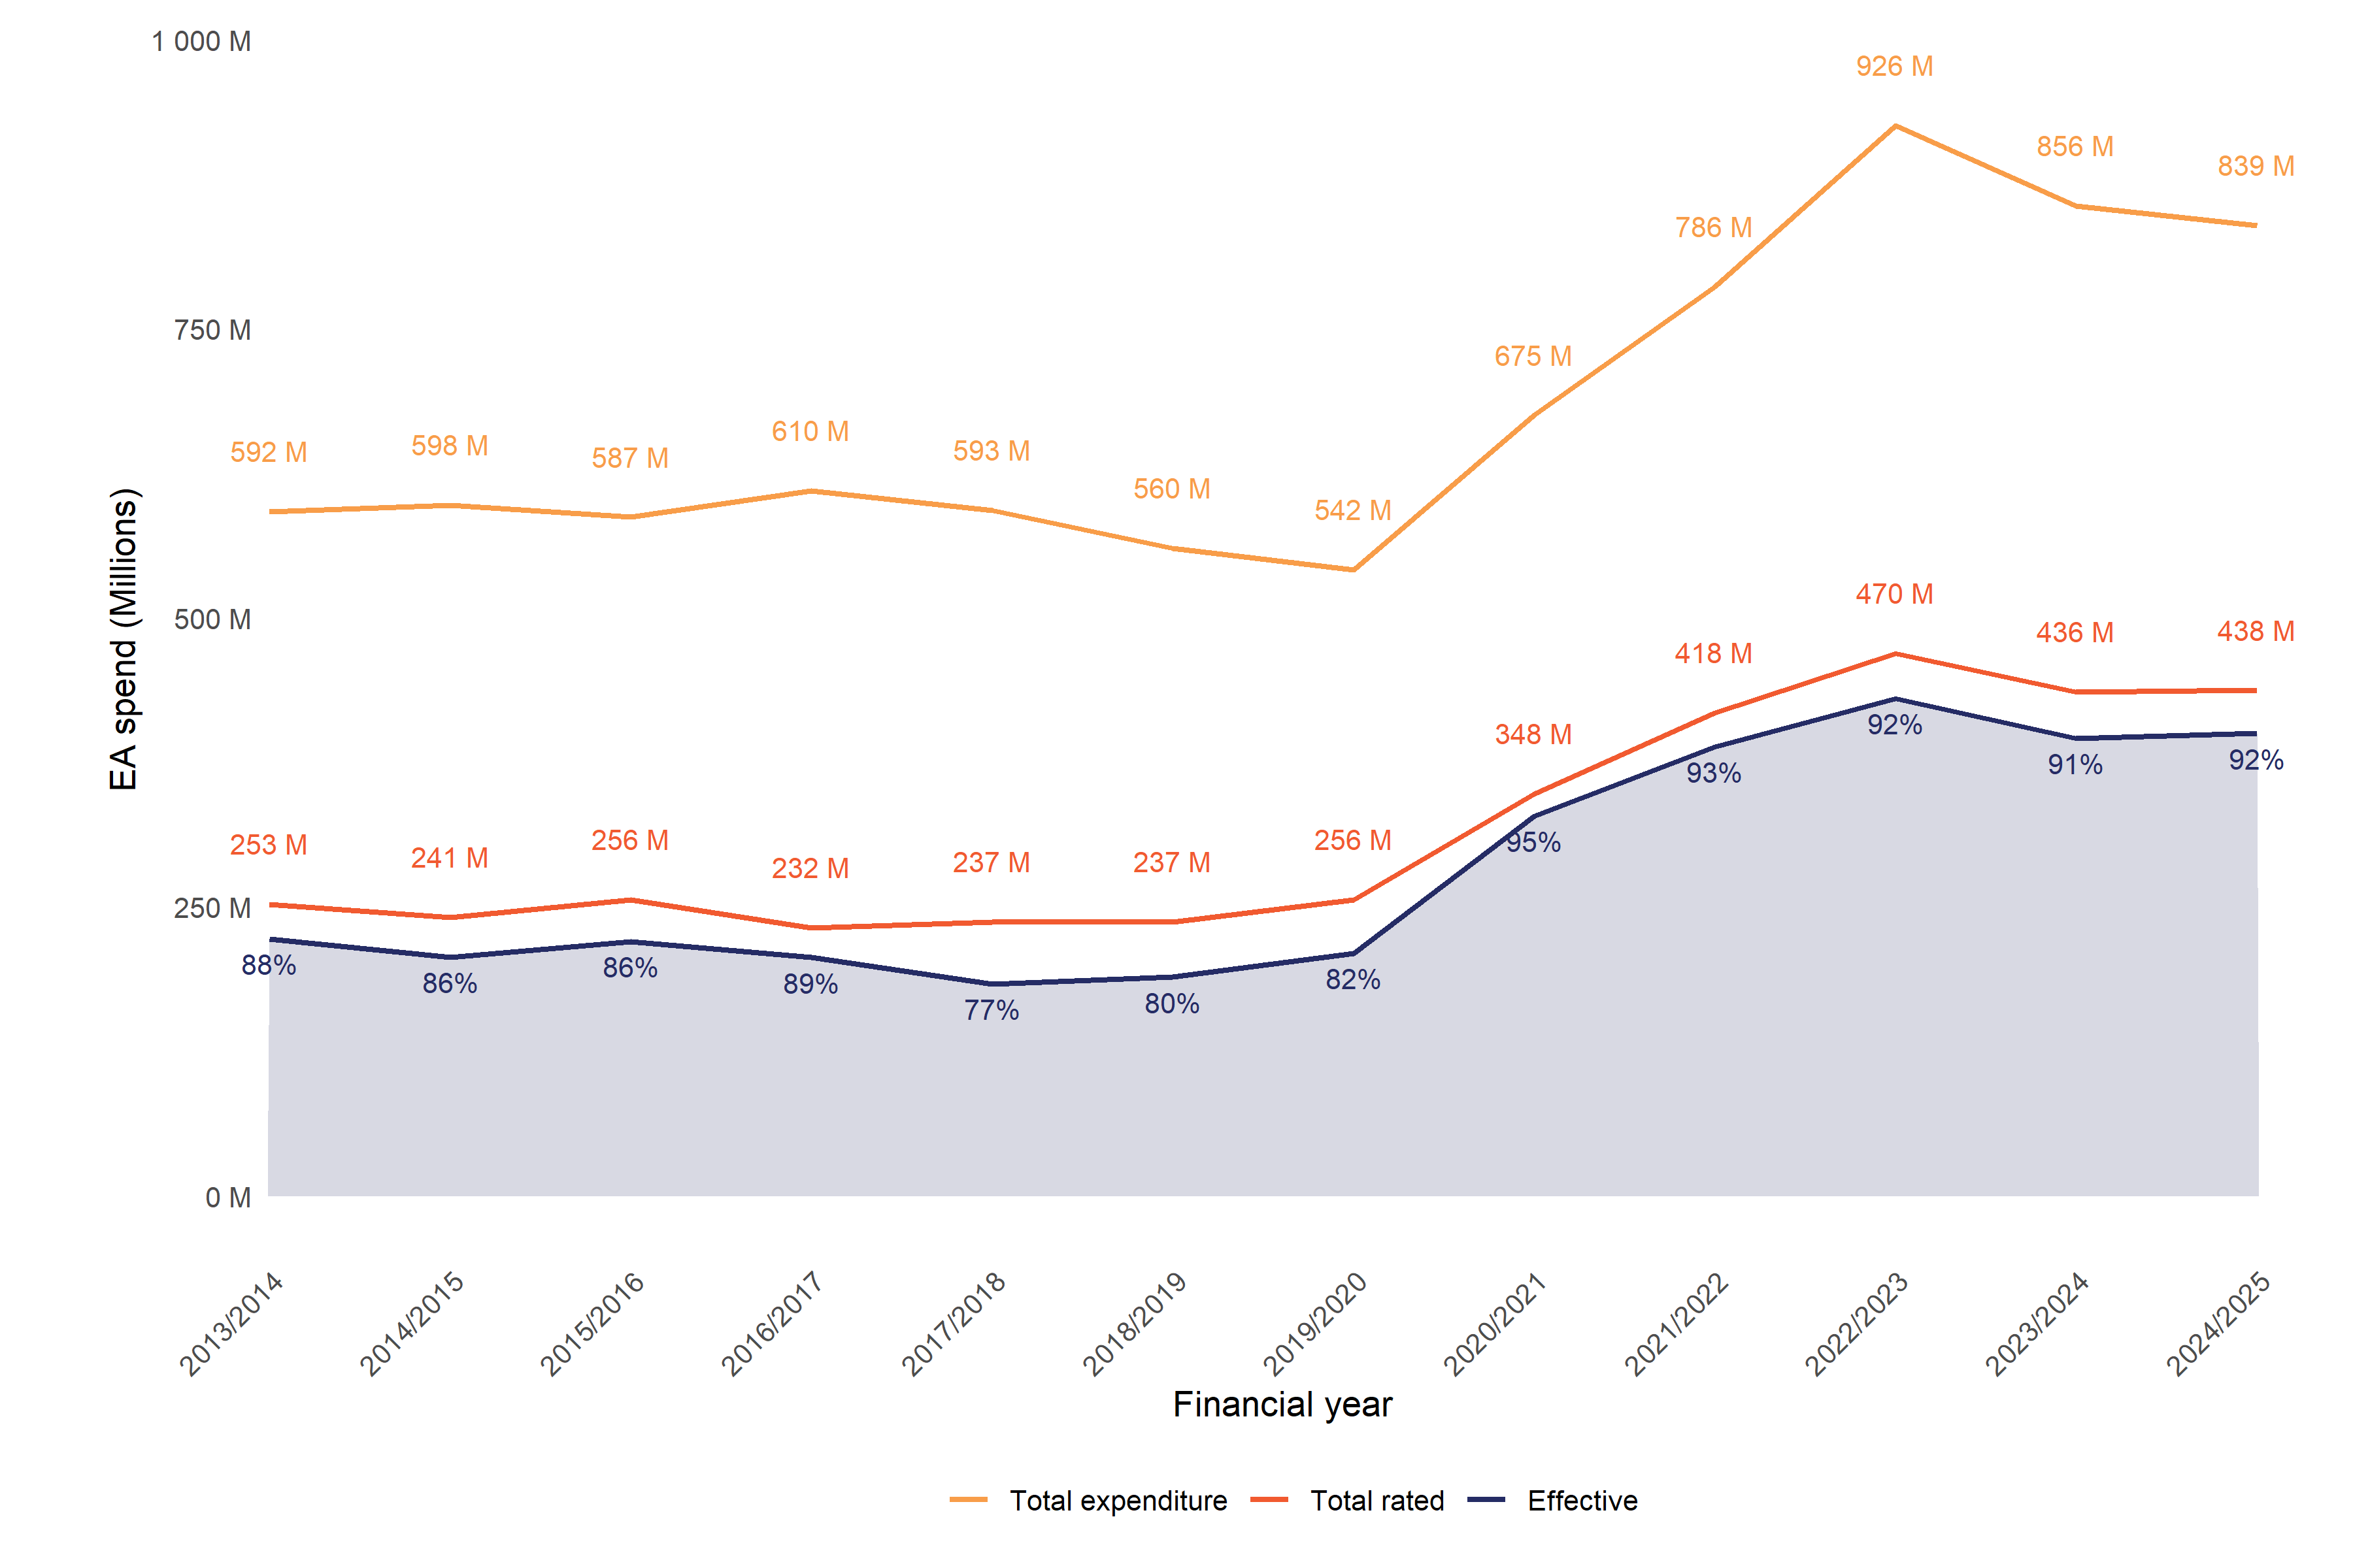

a, These results cover all EA interventions irrespective of funding source. For this reason, the expenditure here is higher than reported in MSD’s annual report EA effectiveness performance measure. That measure only includes interventions funded through the Improved Employment and Social Outcomes Support Multi-Category Appropriation (MCA).
b, Values are in millions of dollars, expressed as nominal values (not CPI-adjusted).
Source: Ministry of Social Development, July 2025.

Table 1 shows the interventions that have had the largest changes in expenditure from 2021/2022 to 2024/2025. The largest increases were among programmes that help clients develop skills that will enable them to find employment (Skills for Industry, Driver license programmes, He Poutama Rangatahi), or help those in employment to keep their job (Childcare Subsidy).
The largest decreases in expenditure were in interventions that featured employment subsidies to assist with people moving into employment (Flexi-wage, Mana in Mahi). There were also decreases in programmes that assisted individuals in relocating for employment ($5k to Work), provided case manager support to prepare for and find employment (Employment-related case management), or helped clients set up their own business (Flexi-Wage Self-Employment).
Table 1: Interventions with the largest changes in expenditure from 2021/2022 to 2024/2025
Intervention | 2021/2022 | 2022/2023 | 2023/2024 | 2024/2025 | Change in expenditure
Increased expenditure
Skills for Industry | $52.1 | $59.3 | $72.1 | $84.5 | $32.4
Driver licence programmes | $5.5 | $14.9 | $21.8 | $27.0 | $21.5
Childcare Subsidy | $93.2 | $112.4 | $115.7 | $106.9 | $13.7
He Poutama Rangatahi | $21.2 | $60.8 | $35.8 | $31.8 | $10.6
Jobseeker Support Work Ready 52-week benefit reapplication | $27.1 | $27.3 | $29.0 | $33.5 | $6.5
Decreased expenditure
Flexi-Wage Self-Employment | $12.4 | $16.1 | $11.5 | $8.7 | $-3.7
$5k to Work | $23.9 | $20.8 | $11.1 | $6.4 | $-17.5
Employment related case management | $43.2 | $34.8 | $30.2 | $25.2 | $-18.0
Mana in Mahi | $32.8 | $20.4 | $15.5 | $14.4 | $-18.4
Flexi-wage | $86.9 | $81.6 | $48.7 | $43.8 | $-43.0
Dollars are shown in millions and are nominal values (not CPI-adjusted).
Source: Ministry of Social Development, July 2025.

Table 2 lists EA interventions introduced from financial year 2022/2023 onward. These recently introduced EA programmes make up 6.4 percent of the total spend in the 2024/2025 financial year. The two largest new initiatives are Phone-based case management ($16.5 million) and Kōrero Mahi ($22.3 million). PBCM provides the same service and supports as face-to-face employment case management (ECM) but is delivered over the phone. Kōrero Mahi covers topics such as the clients’ obligations and what other support or services are available to them.
Table 2: Expenditure on EA interventions introduced from financial year 2022/2023
Intervention | 2022/2023 | 2023/2024 | 2024/2025
Kōrero Mahi - Let's talk work | - | $8.6 | $22.3
Kōrero Mahi - Work check-in | - | $0.2 | $4.3
Phone-Based Case Management | - | $0.1 | $16.5
Whakawātea te ara Poutama | $14.6 | $8.5 | $5.0
Total | $14.6 | $17.3 | $48.1
Dollars are shown in millions and are nominal values (not CPI-adjusted).
Source: Ministry of Social Development, July 2025.

2024/2025 EA expenditure effectiveness
In the 2024/2025 financial year, we estimate MSD spent a total of $839 million on employment interventions, of which we could rate the effectiveness of $438 million (52.1 percent), as shown in Figure 2.
Figure 2: Effectiveness of EA expenditure in 2024/2025
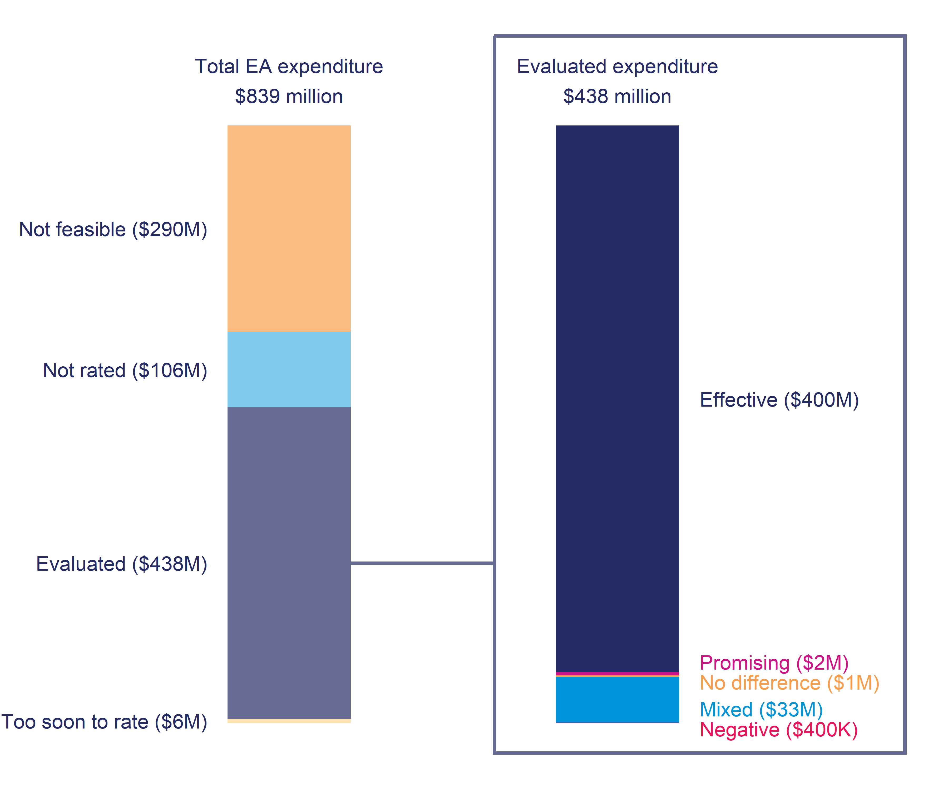
a, Total EA expenditure: Too soon to rate: less than two years of outcomes; Not rated: no impact evaluation undertaken as yet; Not feasible: intervention design or context prevents an assessment of the intervention’s effectiveness; Evaluated: intervention has an effectiveness rating.
b, Evaluated expenditure Effective: significant positive overall impact; Promising: expected to have an overall positive impact; Mixed: intervention has both positive and negative impacts; No difference: makes no significant difference; Likely negative: expected to have an overall negative impact; Negative: significantly negative overall impact.
c, These results cover all EA interventions irrespective of funding source. For this reason, the expenditure reported here is higher than reported in MSD’s annual report EA effectiveness performance measure. That covers interventions funded through the Improved Employment and Social Outcomes Support MCA.
d, Expenditure values are nominal (not CPI-adjusted). Because of rounding, sub-categories may not add up exactly to total values in the chart.
Source: Statistics New Zealand Integrated Data Infrastructure and Ministry of Social Development July 2025.

As Figure 2 shows, we could not rate interventions for three reasons:
- it was not feasible to do so ($290 million, 34.5 percent)
- the analysis has not yet been undertaken ($106 million, 12.6 percent)
- the analysis has been undertaken, but it is too soon to rate ($6.1 million, 0.7 percent).
Almost 62 percent of not feasible expenditure was on interventions related to childcare assistance, including Childcare Subsidy, Out of School Care and Recreation (OSCAR) subsidy, and OSCAR provider assistance ($179.0 million). The second largest share of this spend was on in-house employment-related case management ($25.2 million), and the third largest was the Transition to Work Grant ($24.6 million).
The not rated expenditure includes a number of new and large initiatives, including: Kōrero Mahi – let’s talk work ($22.3 million) and Phone-Based Case Management ($16.5 million).
Looking at evaluated interventions ($438 million), we can see from Figure 2 that:
- $403 million (92 percent) went on effective or promising employment assistance
- $33 million (7.7 percent) was spent on interventions that had mixed effects
- $1.1 million (0.3 percent) made no difference
- $388,000 (0.1 percent) was rated as having a negative impact.

The trend in performance over time
Figure 3 compares the effectiveness of EA expenditure over the twelve financial years to 2024/2025. The effectiveness rating refers to the experience of people who participated in that year, based on the most recent evidence available. Therefore, expenditure for a given intervention may have different effectiveness rating depending on the participation year.
Figure 3: Effectiveness rating of EA expenditure by financial year
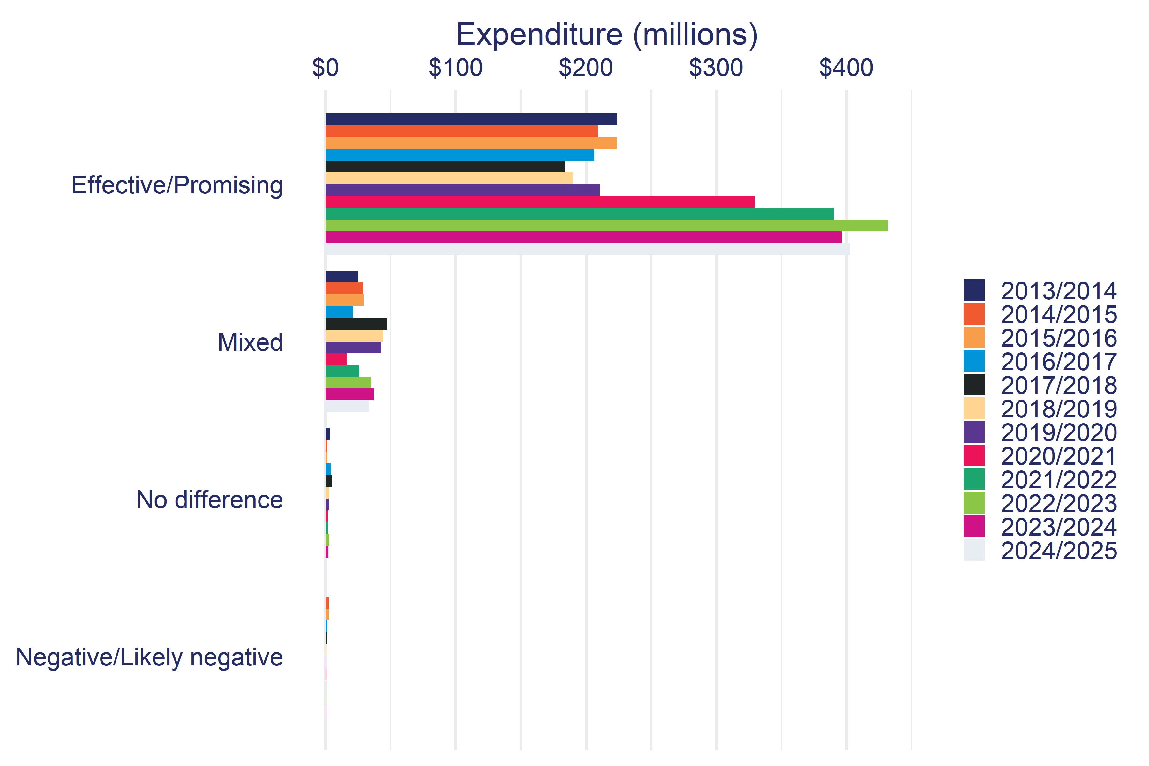
a, These results cover all EA interventions irrespective of funding source. For this reason, the expenditure here is higher than reported in MSD’s annual report EA effectiveness performance measure. That covers interventions funded through the Improved Employment and Social Outcomes Support MCA.
b, Expenditure is in nominal dollars (not CPI-adjusted).
Source: Ministry of Social Development and Statistics New Zealand Integrated Data Infrastructure, July 2025.

The main theme from Figure 3 is an increase in expenditure on interventions rated as effective or promising from 2018/2019 onwards. This increase was driven by expansion of Effective interventions such as Mana in Mahi and Flexi-wage. Expenditure in the remaining effectiveness categories has also increased since 2019/2020, but the increases were comparatively small in both absolute and relative terms.
Table 3 shows the trend in the effectiveness rating of EA interventions over the last six financial years. The top half of Table 3 shows the effectiveness rating as a proportion of total expenditure rated for effectiveness. The lower panel in Table 3 shows the proportion of expenditure on EA interventions that can be evaluated for effectiveness. The proportion of expenditure that has been evaluated for effectiveness has increased from 47.3 percent in 2019/2020, to a relatively stable level of between 50 and 53 percent for the next five financial years. The proportion of evaluated expenditure rated as either effective or promising also increased from an initial low point of 82.0 percent, and then remained above 90 percent for the next five financial years.
Table 3: Trend in effectiveness rating over the last six financial years
Rating | 2019/2020 | 2020/2021 | 2021/2022 | 2022/2023 | 2023/2024 | 2024/2025
Effectiveness
Effective | 82% | 94.6% | 93% | 91.7% | 90.8% | 91.5%
Promising | 0.2% | 0.1% | 0.4% | 0.3% | 0.1% | 0.5%
No difference | 1% | 0.5% | 0.5% | 0.6% | 0.5% | 0.3%
Mixed | 16.7% | 4.7% | 6.1% | 7.4% | 8.5% | 7.7%
Negative | 0.1% | 0.1% | 0% | 0% | 0.1% | 0.1%
Total rated | $256.5m | $347.9m | $418.2m | $469.5m | $435.9m | $437.6m
Evaluated
Evaluated | 47.3% | 51.5% | 53.2% | 50.7% | 50.9% | 52.1%
Too soon to rate | 0.2% | 0.8% | 0.5% | 0.6% | 0.7% | 0.7%
Not rated | 6.8% | 3.5% | 6.6% | 12.9% | 11.2% | 12.6%
Not feasible | 45.7% | 44.2% | 39.7% | 35.8% | 37.2% | 34.5%
Total expenditure | $541.6m | $675.5m | $786.3m | $926.0m | $856.3m | $839.5m
Source: Statistics New Zealand Integrated Data Infrastructure & Ministry of Social Development July 2025.

Employment Assistance intervention performance in 2024/2025
Table 4 shows effectiveness ratings for each EA intervention funded in the 2024/2025 financial year. For detailed results on individual interventions, refer to the Employment Assistance Evidence Catalogue (ea.analytics.msd.govt.nz).
Table 4: EA interventions by effectiveness rating in 2024/2025
Effective/Promising | Mixed/No difference/Negative
EFFECTIVE ($400.4m)  Skills for Industry ($84.5m)  Flexi-wage ($43.8m)  Employment Placement or Assistance Initiative ($35.7m)  Jobseeker Support Work Ready 52-week benefit reapplication ($33.5m)  He Poutama Rangatahi ($31.8m)  Employment Participation and Inclusion services ($31.4m)  Driver licence programmes ($27.0m)  Youth Service (YP) ($14.9m)  Mana in Mahi ($14.4m)  Vacancy Placement Full time ($12.9m)  Limited Services Volunteer ($9.6m)  Work Preparation Services ($9.6m)  Flexi-Wage Self-Employment ($8.7m)  Youth Service (YPP) ($8.4m)  New Zealand Seasonal Work Scheme ($7.0m)  Employment Service Response to COVID-19 (Regional contracts) ($6.2m)  Oranga Mahi - IPS DHBs ($3.8m)  Vacancy Placement Part time ($3.6m)  He Poutama Taitamariki ($3.3m)  Flexi-wage Project in the Community ($3.1m)  Work Confidence ($2.9m)  New Initiative ($2.6m)  Training for Work ($0.5m)  Job Search Initiatives ($0.4m)  Activity in the Community ($0.3m)  Mainstream Employment Programme ($0.3m)  Case Management Initiative ($0.2m)  PROMISING ($2.2m)  Oranga Mahi - Take Charge ($1.1m)  E Ara E - Rise Up! ($1.0m) | MIXED ($33.5m)  Training Incentive Allowance ($16.6m)  Youth Service (NEET) ($13.5m)  Business Training And Advice Grant ($2.3m)  CadetMax ($0.9m)  Prisoner Reintegration programme ($0.1m)  NO DIFFERENCE ($1.1m)  In-Work Support Service ($1.0m)  Driver licence programmes (commercial) ($0.1m)  NEGATIVE ($0.4m)  Work Ability Assessment ($0.4m)
a, Values are nominal (not CPI-adjusted). Because of rounding, sub-categories may not add up exactly to total values in the table.
b, Interventions with less than $100,000 of expenditure in the financial year are suppressed.
c, These results cover all EA interventions irrespective of funding source, for this reason, the expenditure reported here is higher than reported in MSD’s annual report EA effectiveness performance measure. That covers interventions funded through the Improved Employment and Social Outcomes Support MCA.
Sources: Ministry of Social Development & Statistics New Zealand Integrated Data Infrastructure, July 2025.

Effective/Promising ($403 million)
Effective and promising EA interventions have overall positive impacts across one or more of the five main outcome domains. Almost all of the EA categories we use have one or more effective or promising programmes. We now look at the programme categories that have effective programmes.

Labour Market Services
Effective and promising programmes in this category include Individual Case Management services like the Employment Placement or Assistance Initiative ($35.7 million), He Poutama Rangatahi ($31.8 million), and Youth Service programmes for people receiving the Youth Payment (YP) ($14.9 million) and Young Parent Payment (YPP) ($8.4 million), as well as Information Services like in-house work brokers (Vacancy Placement Full time, $12.9 million and Part-time, $3.6 million) and Work Preparation Services ($9.6 million).

Training
Training for Work ($465,000) contracts short duration training courses for people who are likely to be on a main benefit long term. Training for Work shows consistent positive impacts on both highest qualification held, as well as increasing overall time in employment and income. However, expenditure on the programme has steadily decreased over the last decade from $35.7 million in 2014/2015 to $465,000 in 2024/2025.
Support for people to gain a driver licence (Driver licence programmes, $27.0 million) also shows positive impacts, improving employment, income, and welfare outcomes.
These examples of Institutional Training contrast with earlier longer-term contracted training programmes such as Training Opportunities (ceased 2010) and Foundation Focused Training (ceased 2014) where performance was more variable.
Skills for Industry ($84.5 million) is a Workplace Training programme that provides short-term, job-focused training for people on income support who require up-skilling for specific industry requirements.
A number of EA interventions provide financial support to people to undertake study in the general education sector. While these interventions show positive impacts, we are cautious about attributing these effects primarily to the intervention. The concern is that people apply for this assistance after making the decision to take up study. Therefore, while this assistance may help reduce the cost of study and may increase the chances of completing study, it is likely that the observed impacts are largely because of prior differences between the participant and comparison groups’ intentions to take up study.
Because of this, there are no current financial supports for study programmes rated as effective. We have changed the rating of some programmes, such as Course Participation Assistance ($5.9 million), that were previously rated as effective to not feasible to evaluate.

Employment Incentives
Effective Employment Incentive programmes include those with hiring subsidies (Flexi-Wage, $43.8 million), on the job training and pastoral support (Mana in Mahi, $14.4 million), and support for seasonal work (New Zealand Seasonal Work Scheme, $7.0 million).
We need to acknowledge that while job placement interventions are effective for participants, they can have negative impacts on non-participants that we have not considered in this analysis. Further work is being undertaken to understand these potential impacts.

Disability Employment Support and Rehabilitation
Employment Participation and Inclusion services ($31.4 million), previously Vocational Services Employment, has shown improved effectiveness over time, with positive impacts on income and income support payments from 2012 onwards in addition to the long-standing positive impact on employment.

Direct Job Creation
Self-employment financial assistance (Flexi-Wage Self-Employment, $8.7 million) was found to have a positive impact on employment and income. After completing Flexi-Wage Self-Employment, only a third of participants had self-employment income at one year after starting the programme, indicating success at starting a business was low. However, this is relatively consistent with evidence of general start-up success rates.
While participants had higher employment than the comparison group over the following five years, this impact was modest. Moreover, the impact on total income was confined to the subsidy period (i.e., the subsidy is included as income for the participants), with participants having similar or lower overall income than the comparison group after this point.

Obligation-focused interventions
This includes the 52-week reapplication for JS – WR ($33.5 million). From 1 July 2025 the 52-week reapplication was replaced by the 26-week reapplication for people receiving either JS – WR or JS – HCD, but as this change falls in the 2025/2026 financial year it is not included in this report.
However, these results are based only on the impact on independence from employment and income assistance; we have not yet estimated the impact of these interventions on other outcome domains such as employment and income.

Mixed ($33 million)
Mixed interventions have both positive and negative impacts. The three largest programmes in this group were the Training Incentive Allowance, Youth Service NEET, and the Business Training and Advice Grant.
The Training Incentive Allowance ($16.6 million) provides financial assistance to support people on Sole Parent Support (SPS) and Supported Living Payment (SLP) to study up to level 7 of the NZQCF. Participants are more likely to gain qualifications, as well as higher levels of employment and income than the comparison group. But over the short term, receive higher income support (including TIA itself) than the comparison group. While over the medium term (five plus years), benefit receipt is generally lower. Finally, as noted previously, it is very likely that some of these impacts occur because participants had already decided to take up further study prior to applying for TIA and TIA was not instrumental in the decision to undertake study.
The Youth Service (NEET) ($13.5 million) is an Individual Case Management service, that targets young people transitioning out of school who are at risk of not participating in employment, education, or training. Initial analysis by The Treasury (Dixon & Crichton, 2016) found it achieved the goals of increasing education retention and increasing NZQCF level 2 qualifications gained. However, these did not translate into improvements in later outcomes. The most recently evaluated year (2020) shows a positive impact on income, but negative impacts on study and welfare receipt.
Changes made to the programme in January 2020 have not resulted in an improvement in effectiveness. However, this may be in part due to the challenges of running a face-to-face case management service over the COVID-19 lockdown periods.
The Business Training and Advice Grant ($2.3 million) is a Start-up Incentive programme that provides a grant that helps people on income support investigate whether they want to start their own business. This includes funding business skills training, developing a business plan, and soliciting advice. From 2017 onwards, the Business Training and Advice Grant shows early positive impacts on both time in employment and income support assistance (welfare). However, the impact on net-income is negative.

Negative ($388,000)
Negatively rated interventions have overall negative impacts across one or more of the five main domains, and no domains where they have a positive impact. In the 2023/2024 report, there were no programmes rated as negative. However in the 2024/2025 report, one programme is now rated as negative.

Work Ability Assessment
Work Ability Assessment ($389,000) is designed to assist case managers in identifying what assistance a person might need to progress towards employment. It is a relatively small programme, averaging 500 participants per year. The programme is currently estimated to have a negative impact on income, and no significant impact on the other domains. The estimated impact is a decrease of $38 in weekly income compared to the comparison group. However, it is possible this negative result is due to a poorly matched comparison group as there are differences in welfare history in the lead up to starting the programme. There is also no statistically significant difference in employment outcomes.

No difference ($1.1 million)
Interventions with a no difference rating are mostly small scale (i.e., with fewer than 400 participants a year). For these interventions, the small number of participants means it is difficult to identify whether the intervention has had a positive impact on outcomes.

Not evaluated interventions ($402 million)
In this section of the report, we examine the overall trend in EA expenditure by whether it has an effectiveness rating or not, as shown in Figure 4.
Figure 4: EA intervention expenditure by rating status
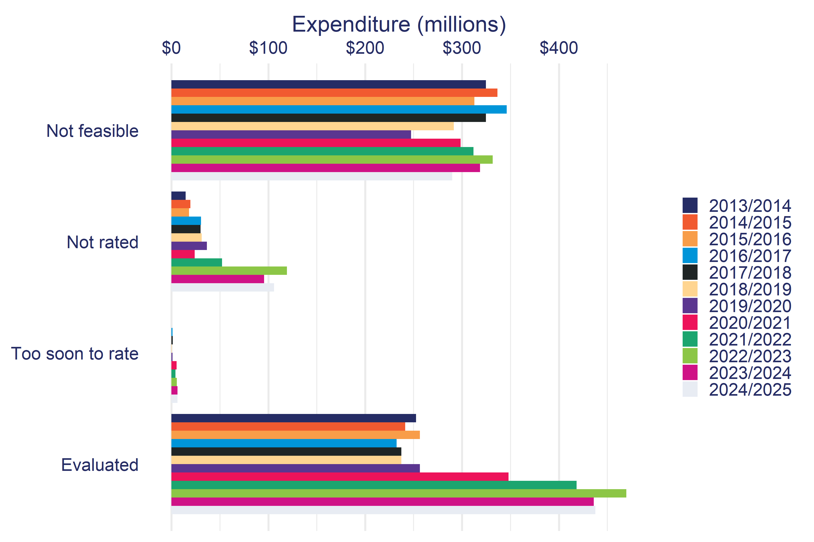
a, These results cover all EA interventions irrespective of funding source. For this reason, the expenditure here is higher than reported in MSD’s annual report EA effectiveness performance measure. That covers interventions funded through the Improved Employment and Social Outcomes Support MCA.
b, Expenditure is in nominal dollars (not CPI-adjusted).
Source: Ministry of Social Development, July 2025.

The COVID-19 response saw an expansion in funding for ‘Not rated’ and ‘Evaluated’ EA interventions from 2019/2020 onward. The increase in ‘Not rated’ reflects new programmes introduced in response to COVID-19, and the time it takes before evidence becomes available on the effectiveness of newer interventions.
Table 5 breaks down the unevaluated EA intervention expenditure by reason for the 2024/2025 financial year. There are three broad reasons for not having an effectiveness rating for an intervention:
- not feasible to evaluate,
- not rated as of 2024/2025 but may be in the future, and
- evaluation work has been done, but insufficient time has passed since the programme started for robust results to be available.
Table 5: EA interventions not evaluated for effectiveness in 2024/2025
Not feasible | Not rated
NOT FEASIBLE ($289.7m)  Childcare Subsidy ($106.9m)  OSCAR (subsidy) ($47.3m)  Employment related case management ($25.2m)  Transition to Work Grant ($24.6m)  OSCAR Provider Assistance ($21.8m)  Mayors' Taskforce for Jobs ($14.4m)  Jobs and Skills Hubs ($13.9m)  $5k to Work ($6.4m)  Course Participation Assistance ($5.9m)  Rapid Return to Work ($4.6m)  In-Work Payment ($4.3m)  Education to Employment Brokerage Service ($4.0m)  Direct Career Service ($3.1m)  Flexible Childcare Assistance ($2.9m)  Work Bonus ($2.3m)  Seasonal Work Assistance ($0.9m)  Whītiki Tauā ($0.5m)  Redundancy Support ($0.4m)  Relocate for Work Support ($0.2m)  Sustainable Employment Trial ($0.2m) | NOT RATED ($105.9m)  Kōrero Mahi - Let's talk work ($22.3m)  Māori Trades and Training Fund ($16.9m)  Phone-Based Case Management ($16.5m)  Sole Parent Support 52-week reapplication ($15.6m)  Jobseeker Support Health Condition or Disability 52-week reapplication ($11.1m)  Whakawātea te ara Poutama ($5.0m)  Kōrero Mahi - Work check-in ($4.3m)  Pathways to Employment Red Cross ($3.1m)  Pacific Employment Action Plan ($2.5m)  Community Job Coaching ($2.3m)  Supporting Offenders into Employment version 2 ($2.0m)  Employment Service in Schools Pilot ($1.5m)  Oranga Mahi - Rākau Rangatira ($0.8m)  Oranga Mahi - Puāwaitanga ($0.6m)  Kōrero Mahi - Into work ($0.5m)  Creative Careers Service ($0.3m)  Vocational Rehabilitation Services ($0.2m)  Mainstream Internship Programme ($0.2m)  Paiheretia te Muka Tāngata ($0.1m)  TOO SOON TO RATE ($6.1m)  Oranga Mahi - Here Toitū ($6.1m)
a, These results cover all EA interventions irrespective of funding source. For this reason, the expenditure here is higher than reported in MSD’s annual report EA effectiveness performance measure. That covers interventions funded through the Improved Employment and Social Outcomes Support MCA.
b, Values are nominal (not CPI-adjusted). Because of rounding, sub-categories may not add up exactly to total values in the table.
c, Interventions with less than $100,000 of expenditure in the financial year are suppressed.
Source: Ministry of Social Development, July 2025.

Not feasible ($290 million)
These are interventions implemented in such a way that it is not currently possible to estimate the difference they make. A not feasible assessment does not rule out the possibility of evaluating the impact of these interventions in the future. However, to do so would require a dedicated evaluation design. Such designs would either involve some form of randomisation or a change to the delivery of these interventions, and in both cases this would require additional resources to be allocated to the programme and its evaluation.
Below are the broad reasons why it is not currently possible to evaluate a given intervention’s effectiveness. Table 8 in Appendix 1 provides specific explanations for each intervention listed in Table 5.

Entitlement based interventions
Although most EA interventions are discretionary, there are some where entitlement is defined in law. The largest intervention in this group is Childcare Assistance (Childcare Subsidy, $106.9 million, OSCAR Provider Assistance, $21.8 million) where everyone with children is eligible to use the service. As a result, there is no similar group of non-participating parents to compare against the participants. We also do not have a historical comparison group, as childcare assistance has been available since before our administrative records began in 1993 and electronic records are not available earlier than the mid-90s.
It may be possible to examine the effectiveness of childcare assistance indirectly through an information campaign where one group is given information about their entitlement, and another is not. A study such as this would need to go through ethical review. By comparing the two groups we could see if the information (i) increases take-up and, (ii) what impact this has on subsequent outcomes.

Difficult to identify counterfactual group
Several interventions occur during a transition period (i.e., from benefit to work) or natural disasters. Here we run into the problem of identifying a potential participant population from which to draw a convincing comparison group. For example, many interventions that assist with the transition to employment (e.g. Transition to Work Grant, $24.6 million) are often provided in anticipation of an exit. Alternatively, in the case of Work Bonus ($2.3 million), the bonus is only paid if the participant achieves the contracted outcome. Under these conditions, it is difficult to identify an equivalent population that is in the same transition state but did not participate in the intervention.
Another set of interventions aim to increase the range of job opportunities available to people on income support. For example, $5k to Work ($6.4 million) enables people to relocate to take up employment outside their immediate labour market. Here, the effect of the intervention is on those eligible to receive the assistance. However, because take-up is low, it would be difficult to identify the impact of these types of interventions, even with the best available methods.

Low cost and frequent interventions
MSD’s Service Delivery group runs many short duration and frequent interventions, such as job search seminars or employment-related case management ($25.2 million). Showing the individual impact of these interventions is difficult for two reasons. First is that the individual effect of each seminar or interview attendance is expected to be small. The second reason is that, because of the wide coverage, we again run into the issue of a plausible comparison group, as non-participants are often ‘unusual’ in some way as to not have participated in this type of intervention.
The strategy to overcome this problem has been to evaluate these interventions as part of case management (CM) services (see de Boer, 2019). For example, frequent job search seminars were part of the Work Search Support (WSS) service. Here we estimated the impact of being assigned to WSS (participating in frequent seminars) to an equivalent group of people assigned to other CM services and who did not participate in these seminars. Similarly, de Boer (2019) evaluated the impact of more intensive case management services such as Work-Focused Case Management (WFCM) on participants’ time off main benefit.
However, because CM services compromise a combination of case management time and discrete EA interventions, this evidence cannot be used to identify whether employment-related case management is effective on its own. Instead, the evidence on CM services points to the effectiveness of a range of employment assistance working in combination.

Unable to identify the individuals who receive assistance
In some cases, there is insufficient information available to identify who participated in an intervention. This often occurs where the referral process is managed by contracted providers without an agreement to provide individual level participation data, or the systems to deliver the data are not sufficiently robust. Recent changes to MSD IT applications to allow providers to create and record participants has helped overcome some of these issues. As a result of these changes, programmes such as Māori Trades and Training Fund ($16.9 million) are in the process of being quantitatively evaluated.
Alongside data capture, in some cases interventions are delivered in a way that does not directly record which individuals receive the intervention. For example, programmes that provide information and advice to groups or on a casual basis, often have no information on the specific individuals involved. Examples include Education to Employment Brokerage Service ($4.0 million) and Direct Career Service ($3.1 million), or where funding is given to support providers such as OSCAR Provider Assistance ($21.8 million).

Strong selection on unobserved characteristics
The final set of interventions that are currently infeasible to rate are those where we consider there to be strong selection on unobserved characteristics (e.g., motivation, attitude, social support). Selection on unobservable characteristics means we are unsure whether any subsequent differences in outcomes between participants and a comparison group is because of the intervention or because of prior uncontrolled differences between the two groups.
For example, the Sustainable Employment Trial is for people on SLP wanting to trial working more than 15 hours a week for a six-month period. In this example, we cannot reliably identify the underlying motivation as to why an individual on SLP would decide to increase their hours of work. The only way to robustly estimate the impact of these types of interventions is to run a Randomised Control Trial.

Not rated ($106 million)
The remaining expenditure includes EA interventions that we can feasibly evaluate, but we have not done so at this time. In some cases, this is because the interventions are too small (e.g., Information Services Initiative, $74,000) or because they have only been introduced recently (e.g., Whakawātea te ara Poutama, $5.0 million).

EA effectiveness and spend by programme category
For the 2024/25 report, we have updated the way EA programmes are categorised. Each programme is now classified according to its primary purpose, using a structured hierarchy of categories and subcategories. This approach provides a clearer view of what programmes are designed to achieve and enables programmes with similar objectives to be grouped together. It also allows us to better understand how MSD's EA expenditure is distributed across different areas of activity, based on the outcomes programmes are intended to deliver.
The new categories broadly align with international standards used by the EU and OECD.

EA programme categories
Based on existing ALMP classification frameworks such as those used by the European Union and the OECD. For a full list of current programmes, and what category they have been placed in, see Table 6.
We classify programmes into the following categories.

1. Labour market services
Services that help clients and other jobseekers navigate the labour market and the available employment supports. The services range from relatively light-touch information services, seminars, and job search support, to longer-term one-on-one case management.

1.1 Information services
Services that provide individuals with information and support for career guidance, job search skills, and navigating employment options. Also includes job matching and listing platforms that allow employers to post vacancies and connect with jobseekers.

1.2 Individual case management
Services that help individuals find and secure employment through personalised, ongoing support. This may include intensive counselling, case management, coaching, and referral to other supports that suit their situation.

1.3 Other services / activities
Programmes/services included in the EA catalogue that do not readily fit in any other categories.

2. Training
Interventions aimed at improving the skills and employability of participants. Includes general education as well as job or industry specific training. Examples include short industry training courses, study support payments, and paid training like apprenticeships.

2.1 Institutional training
Formalised training, generally delivered through supervised instruction at a school, university, training centre, or via distance/e-learning. Where training occurs within a workplace, it must maintain a significant degree of formalised instruction. At least 75 percent of instruction should take place in a classroom.

2.2 Workplace training
Formalised training, generally delivered through supervised instruction in a workplace. At least 75 percent of instruction should take place in the workplace.

2.3 Integrated training
Formalised training, with an even split of time between workplace and classroom.

2.4 Special support for apprenticeships
Incentives and support for employers to recruit apprentices, or training allowances for priority groups. Apprenticeship schemes are considered part of the regular offer of education and vocational training open to all persons, and are therefore not considered a labour market programme. Only measures specifically developed to support the take-up of apprenticeship schemes by target groups are included.

3. Employment incentives
Interventions and measures that help individuals move into employment, encourage employers to hire MSD clients, and support the continued employment of individuals at risk of job loss. These interventions may focus on the employer or employee. Typically, these interventions include wage subsidies for employers, and employment-related grants or allowances for individuals, aimed at supporting entry to work, or helping maintain employment when faced with barriers such as childcare.

3.1 Recruitment incentives
Programmes that support the establishment of new employment relationships. They help individuals take up employment, and encourage employers to hire MSD clients. These programmes include payments to encourage individuals to enter the workforce, limited time paid work-experience, and subsidies to encourage employers to hire MSD clients.

3.2 Employment maintenance incentives
Programmes designed to help individuals maintain employment. These may include financial incentives for sustaining work, assisting individuals with barriers (such as subsidised childcare), and offering advice and support to help maintain employment.

4. Disability employment support and rehabilitation
Programmes or interventions designed to assist disabled people, including people with long-term health conditions or with reduced working capacity following accident or illness. The programmes or interventions aim to help people prepare for and enter the workforce, or resolve issues that might act as blockers to employment.

4.1 Disability employment support
Programmes or interventions designed to assist people who face additional barriers to employment because of their health condition or disability. These programmes or interventions aim to help these people prepare for and enter open employment positions where they will receive the market wage, or resolve issues that might act as blockers to employment.

4.2 Vocational rehabilitation
Measures that focus on the rehabilitation of individuals, whānau, and hapori with a temporary or permanent reduction in working capacity. These supports aim to help people adjust to their disability or condition and develop competencies that prepare them for work. These measures typically combine health and employment supports, offering a holistic approach to help people achieve their employment goals. This category excludes social and medical rehabilitation.

4.3 Participation and inclusion
Community participation services that can involve employment skill development, and include Disability Enterprises which have jobs designated for disabled people assessed as exempt from minimum wage requirements due to productivity limitations.

5. Direct job creation
Measures to create additional jobs to help long-term unemployed people, or those with difficulty finding work. The aim is to provide an opportunity to maintain work, develop skills, and increase employability.

5.1 Direct job creation - public, non-profit, or community jobs
Measures to create time-limited jobs in the non-profit sector or community sector. These roles provide work experience and help participants build skills to increase employability.

5.2 Direct job creation - market jobs
Measures to create time-limited jobs that could be filled in the normal employment market. These roles provide work experience and help participants build skills to increase.

6. Start-up incentives
Programmes that promote entrepreneurship by encouraging people who are unemployed or from specific target groups to start their own business or become self-employed.

7. Obligations
Programmes that place obligations or requirements, such as job search or course attendance, on clients receiving a benefit or other support.
Table 6: Current programmes by category
1. LABOUR MARKET SERVICES | 2.4 SPECIAL SUPPORT FOR APPRENTICESHIPS
1.1 INFORMATION SERVICES | 3. EMPLOYMENT INCENTIVES
Careers Guidance and Counselling | 3.1 RECRUITMENT INCENTIVES
Creative Careers Service | $5k to Work
Direct Career Service | Flexi-wage
Education to Employment Brokerage Service | Mana in Mahi
Employment Service Response to COVID-19 (Regional contracts) | New Employment Transition Grant
Employment Service in Schools Pilot | New Zealand Seasonal Work Scheme
Information Services Initiative | Relocate for Work Support
Job Search Initiatives | Sustainable Employment Trial
Job Search Seminar | Transition to Work Grant
Jobs and Skills Hubs | 3.2 EMPLOYMENT MAINTENANCE INCENTIVES
Kōrero Mahi - Into work | Childcare Subsidy
Kōrero Mahi - Let's talk work | Contracted In-Work Support
Kōrero Mahi - Work check-in | Flexible Childcare Assistance
Māori Trades and Training Fund | In-Work Payment
Pacific Employment Action Plan | In-Work Support Service
Rapid Return to Work | OSCAR (subsidy)
Vacancy Placement Full time | OSCAR Provider Assistance
Vacancy Placement Part time | Redundancy Support
Work Ability Assessment | Seasonal Work Assistance
Work Confidence | Whītiki Tauā
Work Preparation Services | Work Bonus
1.2 INDIVIDUAL CASE MANAGEMENT | 4. DISABILITY EMPLOYMENT SUPPORT AND REHABILITATION
Case Management Initiative | 4.1 DISABILITY EMPLOYMENT SUPPORT
Community Job Coaching | Employment Participation and Inclusion services
Employment Placement or Assistance Initiative | Mainstream Employment Programme
Employment related case management | Mainstream Internship Programme
He Poutama Rangatahi | Mainstream Paid Work Experience Programme
He Poutama Taitamariki | 4.2 VOCATIONAL REHABILITATION
Oranga Mahi - Here Toitū | E Ara E - Rise Up!
Paiheretia te Muka Tāngata | Oranga Mahi - IPS DHBs
Pathways to Employment Red Cross | Oranga Mahi - Puāwaitanga
Phone-Based Case Management | Oranga Mahi - Rākau Rangatira
Prisoner Reintegration programme | Oranga Mahi - Take Charge
Sole Parent Employment Service Trial | Vocational Rehabilitation Services
Supporting Offenders into Employment version 2 | 4.3 PARTICIPATION AND INCLUSION
Whakawātea te ara Poutama | 5. DIRECT JOB CREATION
Work to Wellness | 5.1 DIRECT JOB CREATION - PUBLIC, NON-PROFIT, OR COMMUNITY JOBS
Youth Service (NEET) | Activity in the Community
Youth Service (YP) | Flexi-wage Project in the Community
Youth Service (YPP) | Mayors' Taskforce for Jobs
1.3 OTHER SERVICES / ACTIVITIES | Youth Service Corp
Limited Services Volunteer | 5.2 DIRECT JOB CREATION - MARKET JOBS
New Initiative | Work Experience
2. TRAINING | 6. START-UP INCENTIVES
2.1 INSTITUTIONAL TRAINING | 6. START-UP INCENTIVES
Course Participation Assistance | Be Your Own Boss
Driver licence programmes | Business Training And Advice Grant
Driver licence programmes (commercial) | Flexi-Wage Self-Employment
Training Incentive Allowance | Self Employment Initiative
Training for Work | 7. OBLIGATIONS
2.2 WORKPLACE TRAINING | 7. OBLIGATIONS
CadetMax | Jobseeker Support Health Condition or Disability 52-week reapplication
Skills for Industry | Jobseeker Support Work Ready 52-week benefit reapplication
2.3 INTEGRATED TRAINING | Sole Parent Support 52-week reapplication
NA
This list includes all programmes with positive spend recorded in 2024/2025. Note that due to how expenditure is allocated for this year, some programmes are grouped that will not be in future years. Notably, some portions of Employment Participation and Inclusion will be split into separate programmes in future reports, and will appear in 4.3.

Spend by programme category

Employment Incentives and Labour Market Services were the two categories with the largest expenditure
Labour Market Services ($290 million) was the largest category of EA expenditure, with Individual Case Management ($168 million) being the largest component, followed by Information Services ($110 million), and Other Services/Activities ($12 million).
Employment Incentives ($285 million) was the second largest category of expenditure, split between Employment Maintenance Incentives ($188 million) and Recruitment Incentives ($97 million).
Figure 5 shows how MSD’s EA spending was distributed over these categories in the 2024/2025 Financial Year.
Figure 5: EA spend by programme category in 2024/2025
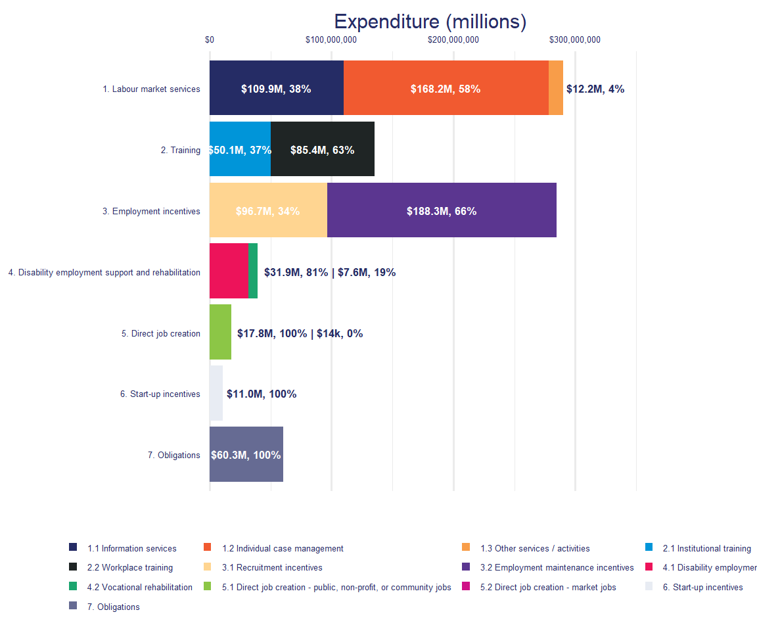
Source: Ministry of Social Development, July 2025.

Spending on Training programmes increased by 17.2 percent in 2024/2025 compared to the previous year
Figure 6 shows how the distribution of MSD’s EA spend over programme types has changed from 2023/2024 to 2024/2025. There were two categories, Training and Obligations, that had increases in expenditure in 2024/2025. Spending on Training programmes increased by $20 million (17.2 percent). This was both the largest absolute and proportional increase in spending over this period. Expenditure on programmes related to client obligations increased by a small amount ($679,000, or 1.1 percent).

The other five categories all had decreases in spending, with Employment Incentives having the largest absolute decrease ($25 million, or -8.0 percent). Start-up Incentives ($3.1 million, or -22.1 percent) and Direct Job Creation programmes ($4.5 million, or -20.2 percent) had similar falls in expenditure in 2024/2025.
Figure 6: Change in EA spending from 2023/2024 to 2024/2025 by programme category
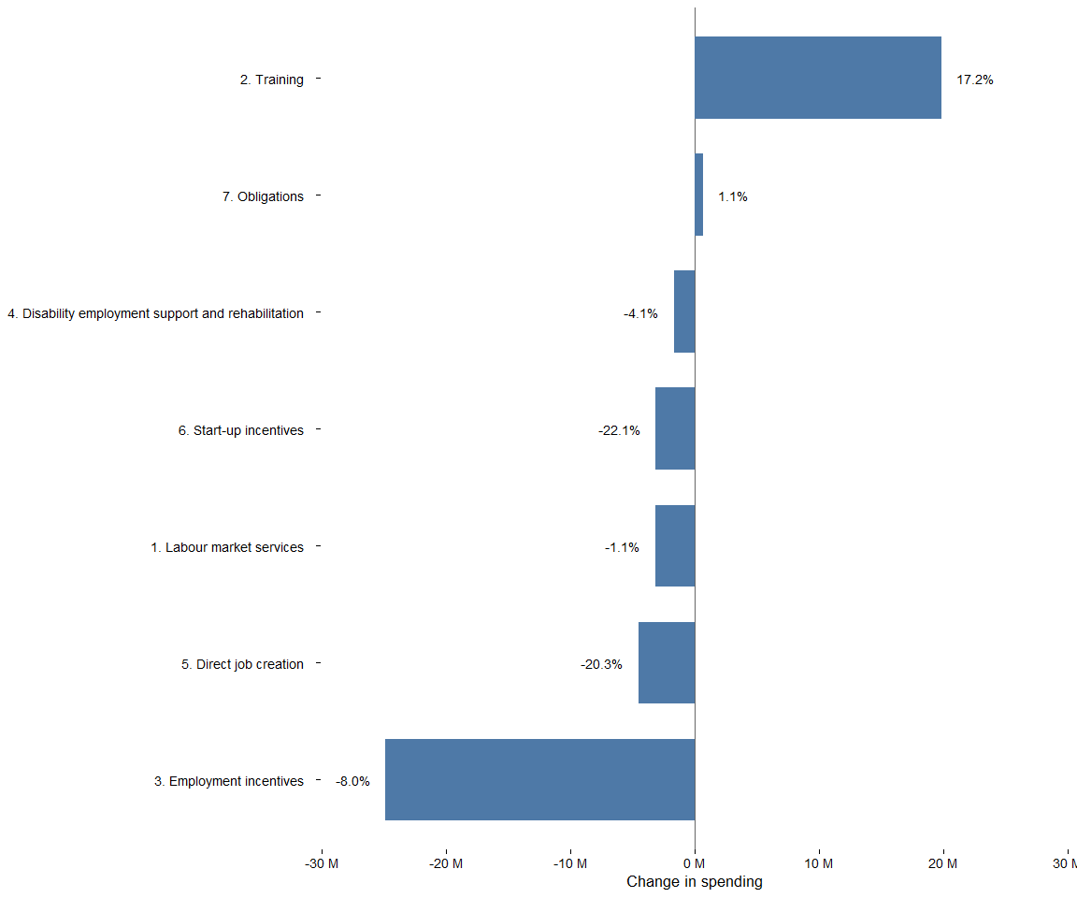
Source: Ministry of Social Development, July 2025.

Effectiveness by programme category
Here we show effectiveness rating by programme category. In this section, we broaden our scope to include all EA interventions delivered by MSD, not just those delivered in 2024/2025 (Table 7).
We have information on 313 individual EA interventions and case management services operating between 1990 and 2025. These range from large interventions, such as Training Opportunities ($80 million pa, 1991-2009) through to small local pilots running for a couple of months.
Table 7: Effectiveness of employment assistance intervention by type
Intervention type | Total | Rated | Effective/Promising | Mixed | No difference | Likely negative/Negative
1.1 Information services | 71 | 13 | 61% | 30% | - | 7%
1.2 Individual case management | 75 | 17 | 58% | 17% | 11% | 11%
1.3 Other services / activities | 6 | 2 | 50% | 50% | - | -
2.1 Institutional training | 21 | 9 | 22% | 44% | 11% | 22%
2.2 Workplace training | 13 | 7 | 71% | 14% | 14% | -
3.1 Recruitment incentives | 23 | 7 | 85% | 14% | - | -
3.2 Employment maintenance incentives | 27 | 1 | - | - | 100% | -
4.1 Disability employment support | 5 | 3 | 66% | 33% | - | -
4.2 Vocational rehabilitation | 18 | 6 | 100% | - | - | -
5.1 Direct job creation - public, non-profit, or community jobs | 24 | 8 | 50% | 25% | 12% | 12%
5.2 Direct job creation - market jobs | 8 | 4 | 25% | 75% | - | -
6. Start-up incentives | 8 | 4 | 25% | 75% | - | -
7. Obligations | 13 | 3 | 100% | - | - | -
Total | 313 | 84 | 58% | 27% | 7% | 7%
Note the percentage values are based on the number of rated interventions. Due to rounding, percentage values may not add up to 100 percent .
Sources: Ministry of Social Development & Statistics New Zealand Integrated Data Infrastructure, July 2025.
Table 7 shows that of 313 interventions for which we have information, we can rate the effectiveness of 84, or 26.8 percent. Alongside the overall low coverage, we also see substantial gaps in our knowledge of the effectiveness for some intervention types. For example, we have only one study on the effectiveness of Employment Maintenance Incentives.
Note that the percentage values for each rating in Table 7 are based on a relatively small number of observations. Small samples mean the proportional mix of intervention effectiveness may show substantial shifts in future updates to this analysis.

Workplace Training and Recruitment Incentives are generally effective
While both Workplace Training and Recruitment Incentive programmes generally have positive impacts, this must be balanced by considering the negative effects these interventions can have on non-participants through substitution or displacement effects. Our effectiveness measures do not account for these displacement and substitution effects, although further work is being done in this area to understand the magnitude of any impact that may occur.

The effectiveness of Individual Case Management varies depending on the group being worked with
Case Management Services either include staff working with specific groups of people, contracting out case management to external providers, or lowering caseloads to enable staff to have more time with individuals in their case load. People on sole parent related benefits appeared to benefit most from case management services. On the other hand, case management programmes that target young people transitioning from school to employment, education, or training frequently have negative (Youth Transitions Service) or mixed (Youth Service NEET) results.

Effectiveness ratings are variable for Institutional Training, Information Services, and Direct Job Creation interventions
The evidence on the effectiveness of Institutional Training programmes indicates that more recently contracted training programmes, such as Training for Work, are more effective than earlier versions such as Training Opportunities, Foundation Focused Training, and Skills Training. On the other hand, the effectiveness of Training Incentive Allowance appears to have decreased over the last 14 years, likely due to changes in the scope of the programme over the same period.
A reasonable proportion (61 percent) of evaluated Information Services interventions have a positive impact. However, seven percent were found to be either negative or likely negative. It is not clear what differentiates Information Services programmes that are effective from those that are not.
When we look at Direct Job Creation in detail, we find that these interventions have varying success. Work experience with private sector firms is more likely to be rated as effective. On the other hand, community or environmental placements where participants remain on benefit tend not to be effective.

Obligations’ results apply only to off main benefit outcomes
The evidence on Obligations (interventions that aim to ensure people are actively looking for work) is small relative to the number of interventions. Also, we currently only have evidence of the impact of these interventions on welfare outcomes. An important gap in our evidence is the impact of these interventions on wider outcomes such as employment and net income.

EA spend by benefit category in 2024/2025
This section reports on how MSD’s EA spend is split by the benefit participants were receiving when they start an EA assistance programme. Costs are linked to programme starts, so all costs from an individual participating in a programme are associated with the financial year they entered that programme, even if their participation takes place over more than one financial year.
In 2024/25 about 70.5 percent of EA spending could be linked to the benefit of the recipient. This means there was $247.9 million (29.5 percent) of EA spending that, while we know what programme it was spent on, we were not able to link it to an individual, and as a result it cannot be assigned to a specific benefit group. To estimate costs by benefit received, MSD relies on linking information about programme participants with their benefit status. This is only possible for programmes where participants can be identified using a system client ID.
For some programmes, individual participant information is not collected. In other cases, participant information exists but is not linked to MSD’s main person identifier. This typically happens when providers record participant details in separate systems that do not connect to the central identity register. The share of spending that can be linked to benefit types varies from year to year, limiting comparability over time.
Figure 7 shows, for expenditure that can be linked to a participant, both the total EA spend by benefit category, and the average cost per programme participant for those categories for 2024/2025.
Figure 7: Linked EA spend in 2024/2025 by benefit type
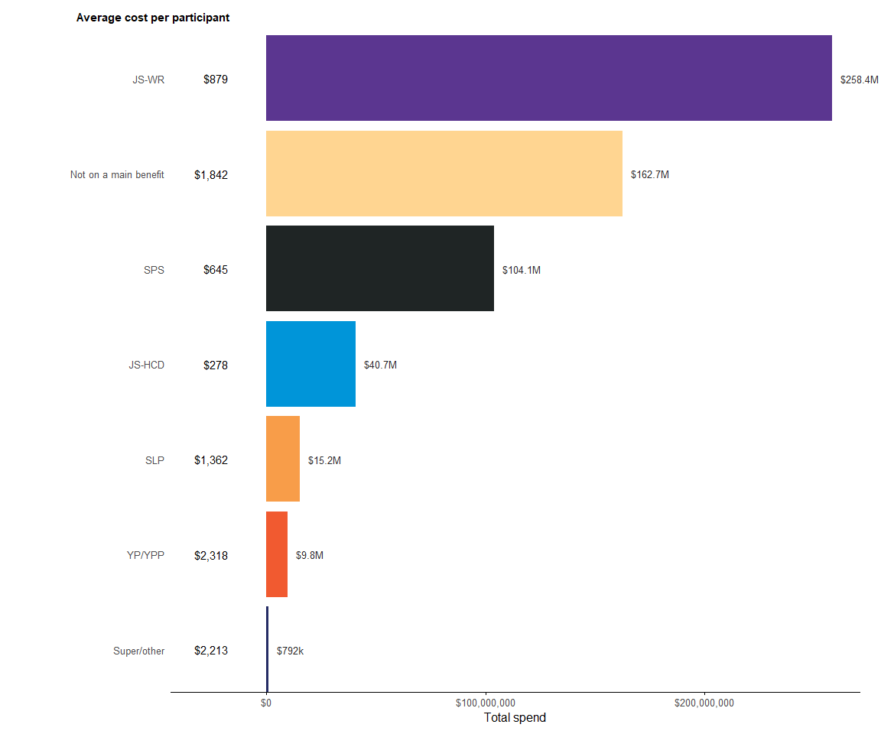
This figure covers all spending that could be linked to a programme start, about 70.5% of total EA expenditure in 2024/25
Source: Ministry of Social Development, July 2025.

Jobseeker Support – Work Ready clients receive the largest share of spending among all client groups
Overall, Jobseeker Support – Work Ready (JS – WR) clients receive the largest portion of EA spending at $258 million (44 percent of linked EA spend). This reflects the Ministry’s focus on supporting this group into employment and meeting the Jobseeker target. Most of this spending was on programmes that focus on Recruitment Incentives ($63 million on JS – WR), Workplace Training ($54 million on JS – WR), and Individual Case Management ($53 million on JS – WR).
In these categories, the programmes with the largest spend on JS – WR clients were Skills for Industry (Workplace Training, $53 million, 63 percent of programme expenditure), the Employment Placement or Assistance Initiative (Individual Case Management, $31 million, 88 percent of programme expenditure), and Flexi-Wage (Recruitment Incentives, $30 million, 68 percent of programme expenditure).

The average amount spent on a JS – WR client participating in an intervention is less than a Supported Living Payment or Youth Payment/Young Parent Payment client
While receiving the largest share of overall EA expenditure, the average spend per programme participant for JS – WR recipients ($879) is lower than for several other benefit categories. Supported Living Payment ($1,362), Youth Payment/Young Parent Payment ($2,318), and not on a main benefit ($1,842) all have larger average costs per programme participant. Of the main benefit categories, only Jobseeker Support – Health Condition and Disability (JS – HCD) ($278) and Sole Parent Support (SPS) ($645) had a lower average cost per programme participant.

There is significant spending on people that are not receiving a main benefit, with most of this expenditure on Employment Maintenance programmes
While these individuals are not receiving a main benefit, they may still be receiving supplementary benefits such as the accommodation supplement. The programmes that have the highest levels of expenditure on these individuals are usually related to Employment Maintenance Incentives, Workplace Training, and Direct Job Creation.
Just over 61 percent of EA expenditure on individuals not on a main benefit was on Employment Maintenance programmes ($100 million). This expenditure was primarily on childcare assistance (the Childcare Subsidy, OSCAR, Flexible Childcare Assistance) but also includes financial incentives (In-Work Payment, Work Bonus) and support services (In-Work Support Service).

Appendix 1: Effectiveness rating
We categorise the EA interventions based on whether the intervention had a positive impact on participants’ outcomes across five domains.

Outcome domains
Our analysis of the impact of employment interventions focuses on five outcome domains. These domains broadly reflect the intended medium and long-term objectives of employment interventions.
The outcome domains include:
- Employment: intervention is rated as effective if it increases the time spent in paid employment. This measure includes increases in employment while still on main benefit.
- Income: intervention is rated as effective if it increases net income from all sources including income support, tax credits and study assistance. Therefore, this measure accounts for both any loss of income from government assistance, as well any earning gains through movement into employment.
- Justice: intervention is rated as effective if it reduces the time participants spend in Corrections services (i.e. prison, community service, remand, home detention).
- Education qualifications: intervention is rated as effective if it increases the average of the highest qualification held. Highest qualification is based on NZQCF levels from 1 through to 9. Therefore, an impact of NZQCF 1 would mean participants had increased their highest NZQCF level by an average of 1 level (e.g. from 2.4 to 3.4).
- Welfare: intervention is rated as effective if it reduces the time participants receive a main benefit (e.g. unemployment, sole parent or health or disability benefits) and receiving employment assistance (e.g., on a wage subsidy programme).

Effectiveness
By effectiveness, we mean whether an intervention improves participant outcomes relative to the counterfactual (i.e. the outcomes participants would have had if they had not participated). In this analysis, we assess effectiveness based on the impact of the intervention on one or more outcome domains. However, we cannot assess the effectiveness of all interventions, and these are given a separate rating.
The ratings are described as follows:
- Effective: the intervention has a statistically significant positive impact on one or more primary outcome (e.g. income, employment, justice, qualifications or independence from welfare) and no evidence of a negative impact on any primary outcome.
- Promising: the trend in impacts indicates the intervention is expected to have a significant positive overall impact in the medium-to-long term. Also, we rate interventions as promising if we cannot evaluate the intervention directly, but where we have a similar intervention rated as effective.
- Mixed: the intervention has both positive and negative impacts on primary outcomes. The most common case is where an intervention increases employment but has a negative impact on welfare.
- No difference: the intervention makes no statistically significant difference for any of the primary outcomes. For smaller interventions, this may reflect insufficient statistical power to detect a meaningful impact, and these impacts may become significant when an intervention has more participants.
- Likely negative: trends indicate the intervention will have a negative impact on one or more primary outcomes and there is no evidence of a positive impact on any other primary outcome in the medium to long-term.
- Negative: the intervention has a statistically significant negative impact on one or more primary outcomes and no evidence of a positive impact on any primary outcome.
- Too soon to rate: there has not been enough time to observe the impact of the intervention. Typically, we do not rate an intervention until we have two years of outcome data available.
- Not rated: we have not rated the effectiveness of the intervention at this time.
- Not feasible: it is not considered feasible to estimate the impact of an intervention based on current data or available methods (i.e. would require some type of randomised control trial to robustly identify what impact an intervention has).

Interventions where it is currently not feasible to estimate effectiveness
Table 8 lists the EA interventions funded after the 2009/2010 financial year that were not feasible to evaluate and summarises the reason for this assessment.
Table 8: Explanation for not feasible rating by intervention
Intervention | Reason
$5k to Work | Finding the impact of $5k to Work is difficult for two reasons. The first is that all job seekers are eligible to receive it within a limited set of criteria such as being defined as at risk of long-term benefit receipt. The second is that the take up rate of the payment is low. Together this means the influence of $5k to Work on the outcomes of the target group is small. It may be possible to assess the intervention's effectiveness by randomising eligible job seekers into a treatment group who are told about $5k to Work and a control group who are not. This design would indicate the optimal take-up rate and, if this rate is high enough, it may be able to detect the impact on outcomes relative to the control group. However, this would require very large treatment and control groups (in the 10,000s) to detect the likely effect of the incentive payment.
Childcare Subsidy | The Childcare Subsidy programme is both a legal entitlement and has been available since 1983. Under these conditions, it is not possible to identify a convincing comparison group of parents who did not take up the Childcare Subsidy. It may be possible to estimate the impact of the Childcare Subsidy on non-participating parents through a Zelen RCT (i.e., an information campaign about the subsidy to a randomly selected group of non-participating eligible parents). Such a study would show the impact of the Childcare Subsidy on non-participating eligible parents only and not the average impact across all families using the subsidy.
Client Self Help | Not able to clearly define those that have and have used the service
Connected | Connected is an information and navigation programme where it is difficult to reliably identify who uses the service, as well as the difficulty of isolating the influence of this type of support on participant's later outcomes.
Contracted In-Work Support | Without some type of randomised design, it is not feasible to estimate the impact of In Work Support. This is because it is difficult to identify a convincing comparison group, at the same transition point into employment as the participants but who did not receive the intervention.
Course Participation Assistance | People usual get the Course Participation Assistance after they have decided to take up study, but before they have commenced study. For this reason it is difficult to identify a comparison group who are at the same point in their decision to take up study.
Direct Career Service | Impact evaluation of Direct Career Service is currently assessed as not feasible because it will be difficult to isolate the influence of career advice and information support on participants' outcomes from all the other factors that influence their career pathways.
Early Learning Payment | Early Learning Payment is for families enrolled in Family Start or Early Start Programmes. Currently MSD does not have access to participant level information suitable for use in an impact evaluation.
Early Response Redeployment Support | It is not feasible to estimate the impact of Early Response Redeployment Services without a randomised control treatment design (RCT). This is because it is difficult to identify people in a similar position as the participants who are at risk of losing their jobs, but are not supported by the service.
Earthquake Support Subsidy | Because the subsidy was paid during a natural disaster it is difficult to identify a suitable comparison group subject to similar conditions but who were not eligible for the subsidy. A practical issue is that the subsidy was paid to employers and we have not yet been able to identify which individual employees received the subsidy.
Education to Employment Brokerage Service | Impact evaluation of Education to Employment Brokerage Service is currently assessed as not feasible because it will be difficult to isolate the influence of career advice and information support on students' outcomes from all the other factors that influence their career pathways.
EmployAbility | Do not currently have access to which individual participants received EmployAbility to undertake an impact evaluation.
Employment Workshop | Because of their high frequency, wide coverage, and likely small impact, it was not feasible to estimate the impact of attending an individual Employment Workshop.
Employment related case management | General employment related case management is available to all individuals who are eligible to receive it. For this reason it is very difficult to identify a suitable comparison group. However, there have been evaluations of targeted case management services (e.g., Work Focused Case Management) that enable assessment of the impact of different levels of case management intensity (i.e., case management plus employment interventions).
Flexible Childcare Assistance | Flexible Childcare Assistance aims to incentivise eligible sole-parents to start employment during non-standard hours. Because the low uptake rate dilutes the effect of the programme across many non-participants, we do not consider it feasible to estimate the impact of Flexible Childcare Assistance. It may be possible to estimate the impact through an invitation to treat RCT (i.e., an information campaign to eligible sole parents) but uptake would need to be high to confidently detect any impact of Flexible Childcare Assistance through this design.
Guaranteed Childcare Assistance Payment | Guaranteed Childcare Assistance Payment is a legal entitlement. Under these conditions it is not possible to identify a convincing group of eligible parents who did not take up the Guaranteed Childcare Assistance Payment. It may be possible to estimate the impact of the Childcare Subsidy on non-participating parents through an invitation to treat RCT (i.e., an information campaign to eligible parents). A secondary reason is that we have not yet identified who received the Guaranteed Childcare Assistance Payment.
IB Employment Trial | We do not consider it possible to estimate the impact of the IB Employment Trial because it is subject to strong selection effects. In particular, the policy encourages people on long-term health condition and disability benefits to start employment. But we are not confident we have sufficient information to separate out those who are likely to move into work from those who are unable to move into employment at all. Accordingly, it is difficult to identify a suitable comparison group with the same likelihood of moving into employment as the participants.
In-Work Payment | RCT of the in-work payment was completed as part of the In-work Support Service trial.
Job and Training Support Fund | Currently we do not have information on who receives support funds. In addition, it may not be possible to identify similar individuals for a comparison group as the eligibility criteria are tight and based on a person's specific situation.
Jobs and Skills Hubs | Do not currently have access to which individual participants participated in Jobs and Skills Hubs to evaluate effectiveness.
Local Employment Coordination Groups | No identified participant group or location.
Mayors' Taskforce for Jobs | MSD does not have information on the individual participants supported through the programme. For this reason, it is not feasible to evaluate the impact of MTFJ on participants' outcomes.
Mental Health Co-ordination | Insufficient information on the design of the intervention.
Mental Health Social Bond | We do not have information on who participated in the Mental Health Social Bond programme.
Migrant Employment Assistance | Unreliable participant data.
Modification Grant | It was not feasible to estimate the impact of the Modification Grant because it is subject to strong selection effects as it targets people on long term health condition and disability where we cannot observe why a given individual feels able to take up full-time employment.
New Employment Transition Grant | Because the New Employment Transition Grant is available for people who are off main benefit and is paid out only in specific circumstances it is difficult to identify a convincing comparison group to estimate the effectiveness of this grant.
OSCAR (subsidy) | The OSCAR subsidy programme is a legal entitlement and has been available since 1996. Under these conditions it is not possible to identify a convincing group of parents who did not take up the OSCAR subsidy. It may be possible to estimate the impact of the OSCAR subsidy on non-participating parents through an invitation to treat RCT (i.e. an information campaign to eligible parents).
OSCAR Provider Assistance | OSCAR Provider Assistance works indirectly to increase the supply of OSCAR providers. Currently we do not have time series information on the level or coverage of OSCAR providers to be able to identify whether the OSCAR Provider Assistance has increased the level of OSCAR services.
Pre-Employment Drug Testing | Legislative requirements would make running an RCT ethically difficult (i.e., applying work obligations based on randomisation)
Productivity Allowance | The Productivity Allowance is administered by Workbridge. Currently MSD does not have access to participant level information suitable for use in an impact evaluation.
Project 1000 | Do not currently have access to which individual participants received Project 1000 to undertake an impact evaluation.
Project 300 Trial | Insufficient information on the design of the intervention.
Project Hua | Do not currently have access to which individual participants received Project Hua to undertake an impact evaluation.
Rapid Return to Work | Because Rapid Return to Work (RRTW) targets people applying for a main benefit, it is important to include benefit application status into the profiles used to select a matched comparison group. Currently, the data in the IDI on main benefit status does not include the application period. Without benefit application status it is currently not feasible to estimate the impact of RRTW programme. Work is underway to include this information into future supplies of income support data into the IDI.
Recruitment Seminar | Because of their high frequency and likely small impact, it was not feasible to estimate the impact of attending an individual Recruitment Seminar.
Redundancy Support | There is limited information on the individual people who are assisted by Redundancy Support services that can be linked to outcomes such as employment. In addition, identifying a suitable comparison group (who are in the processes of being laid off) is difficult with current data.
Regional Economic Development | We do not have enough information on the operation of the intervention to identify who was affected by it.
Relocate for Work Support | Finding the impact of Relocate for Work Support is difficult for two reasons. The first is that all job seekers are eligible to receive it within a limited set of criteria such as being defined as at risk of long-term benefit receipt. The second is that the take up rate of the payment is low. Together this means the influence of Relocate for Work Support on the outcomes of the target group is small. It may be possible to assess the intervention's effectiveness by randomising eligible job seekers into a treatment group who are told about Relocate for Work Support and a control group who are not. This design would indicate the optimal take-up rate and, if this rate is high enough, it may be able to detect the impact on outcomes relative to the control group. However, this would require very large treatment and control groups (in the 10,000s) to detect the likely effect of the incentive payment.
Seasonal Work Assistance | It is not currently feasible to estimate the effectiveness of this programme as it is difficult to identify the target group (people who are thinking about moving into horticultural work) to identify whether the availability of the payment has increased movement into horticultural jobs. A secondary impact that could be examined is whether the Seasonal Work Assistance reduced the probability of horticultural workers returning to main benefit in response to poor weather before and after the introduction of the programme in 2002.
Sector Workforce Engagement Programme | Do not currently have access to which individual participants participated in Sector Workforce Engagement Programme to evaluate effectiveness.
Self-Employment Start-up | Do not currently have access to which individual participants received Self-Employment Start-up to undertake an impact evaluation.
Supported Living Payment Opt-in Service | It is currently not feasible to estimate the impact of this case management service, as we are not confident we can identify a suitable comparison group based on the information that we can observe about those who are eligible to participate. To determine the effectiveness of this service would require some type of randomised controlled trial (RCT).
Sustainable Employment Trial | We do not consider it possible to estimate the impact of the Sustainable Employment Trial because it is subject to strong selection effects. In particular, the policy encourages people who have a long-term health condition and receive a disability benefit to start employment. We do not have sufficient information to separate those who are likely to move into work from those who are unable to move into employment at all. Accordingly, it is difficult to identify a suitable comparison group with the same likelihood of moving into employment as the participants.
Training Support | No information on the programme or who participates in it.
Transition to Work Grant | It is not feasible to estimate the impact of the Transition to Work Grant without a randomised design, as it is difficult to identify a convincing comparison group at the same transition point as the participants but who did not receive the grant. In addition, Transition to Work Grant can be paid in anticipation of an exit to work, further complicating the identification of a suitable comparison group.
Work Bonus | It is not feasible to estimate the impact of Work Bonus without a randomised design, as it is difficult to identify a convincing comparison group at the same transition point as the participants but who did not receive the intervention.
Work Search Assessment Seminar | This is a high frequency small impact intervention where a high proportion of eligible people participate. This makes determining impact difficult for two reasons. The first is that the individual impact of any one seminar will be small relative to all other factors that influence participants' outcomes. The second issue of high coverage means that those who do not participate are unusual in some way and this makes them a poor comparison.
Work and Income Seminar | Because of their high frequency and likely small impact, it was not feasible to estimate the impact of attending an individual Work and Income Seminar.
Youth Development Partnership | Insufficient information on the design of the intervention.
Youth Seminar | The impact of individual Youth Seminars is difficult to isolate because the attendance at any one seminar is likely to have a small effect on future outcomes. In addition, high participation rates among those eligible make it difficult to identify a suitable comparison group who did not participate.

References
Crichton, S. (2013) The Impact of Further Education on the Employment Outcomes of Beneficiaries, Ministry of Business, Innovation & Employment, Wellington (File ref:A7337408)link
Dixon, S. & Crichton, S. (2016) Evaluation of the Impact of the Youth Service: NEET programme, The Treasury, Wellington (File ref:A9299141)link
Fyfe, C., Mare D., and Taptiklis, P. (2023) COVID-19 Wage Subsidy: Outcome Evaluation - Value for Money, Motu Working Paper 23-04, Motu, Wellingtonlink
de Boer, M. & Robertson, O. (2026) Effectiveness of MSD employment assistance: Technical report for 2024/2025 financial year, Ministry of Social Development, Wellington link
MSD (2013) Impact of the 52-week Unemployment Benefit Reapplication Process Update 2: Technical Report, Ministry of Social Development, Wellington (File ref:A6516526)link
MSD (2018) In-work Support service and In-Work Payment trial, Ministry of Social Development, Wellington (File ref:A10173601)link
McLeod, K., Dixon, S. & Crichton, S. (2016) Evaluation of the Impact of the Youth Service: Youth Payment and Young Parent Payment, The Treasury, Wellington (File ref:A9299143)link
de Boer, M. & Ku, B. (2018) Effectiveness of the Limited Service Volunteer programme: Financial Year 2014/2015, Ministry of Social Development, Wellington (File ref:A8915021)link
de Boer, M. & Ku, B. (2019) Cost-effectiveness of intensive case management services (from October 2012 to July 2017): Evaluation report, Ministry of Social Development, Wellingtonlink
de Boer, M. & Ku, B., (2017) Service Delivery Cost Allocation Model for Individual Outputs: 2017 version, Ministry of Social Development, Wellington (File ref:A9317887)
de Boer, M. (2003) Impact of Jump Start seminar on uptake of the unemployment benefit, Ministry of Social Development, Wellington (File ref:A177933)

Expenditure is expressed in nominal dollars (i.e. not CPI-adjusted) and includes indirect costs. The companion technical report summarises how we calculated the cost of EA interventions.
While MSD administers the payments for Apprenticeship Boost, policy and evaluation responsibility is with the Ministry of Education.
In this report, we round expenditure values to the nearest million for values over $10 million and to the nearest $100,000 for values under $10 million.
For TIA the grant to support study is included as part of their income support payments
The spend by benefit type data does not have full coverage. In some cases, MSD does not have individual participant information, or it is not linked to MSD’s main person identifier. In these cases, spend from a programme cannot be allocated to individual clients. In this report about 70 percent of spending could be linked to individual participants. See the technical report for more information.
Public Finance Act 1989, Section 34, 2b: The chief executive of a department that administers an appropriation is responsible for advising the appropriation minister on the efficiency and effectiveness of any departmental expenses or departmental capital expenditure under that appropriation.
Currently we do not have a reliable measure of household income, so the analysis is based on individual income only and does not account for the number of dependants a person might have.
See https://op.europa.eu/en/publication-detail/-/publication/75893f87-9abf-11e8-a408-01aa75ed71a1/language-en for the EU categories, and https://web-archive.oecd.org/pdfViewer?path=/2022-09-16/120573-Coverage-and-classification-of-OECD-data.pdf for the OECD categories.
https://www.msd.govt.nz/documents/about-msd-and-our-work/publications-resources/research/effectiveness-employment-assistance/2026-msd-employment-assistance-effectiveness-technical-report-fy25.docx
Employment-related case management refers to any time that a case manager spends with a clients focused on employment, and should not be confused with the service named Employment Case Management,
The table only include new programmes with at least $1 million in annual spending in one of the years. Programmes with less than $1 million in expenditure include: Kōrero Mahi – Into work, Relocate for Work Support, and Vocational Rehabilitation Services.
We have made changes to how we categorise EA programmes this year, see Section 5.1 for details.
These are substitution (a participant takes a vacancy that would have been filled by someone else) and displacement (subsidised labour reduces employment among competing firms).
see the evaluation of the flexi-wage expansion: https://www.msd.govt.nz/about-msd-and-our-work/publications-resources/evaluation/flexi-wage-expansion/index.html
See: Mills, D. & Timmins, J. (2004) Firm Dynamics in New Zealand: A Comparative Analysis with OECD Countries. New Zealand Treasury: Working Paper 04/11. url: https://www.treasury.govt.nz/sites/default/files/2007-09/twp04-11.pdf
No longer receiving a main benefit (eg, Jobseeker Allowance, Sole Parent Support or Supported Living Payment) or receiving employment assistance, such as wage subsidies that mean people are off main benefit but still receiving assistance.
See the evaluation of Youth Service (NEET): https://www.msd.govt.nz/about-msd-and-our-work/publications-resources/evaluation/youth-service/effectiveness-of-neet-july-2025.html
This includes the OSCAR (Out of School Care and Recreation) subsidy.
WSS and WFCM services ended in July 2020.
for people with a longterm health condition or disability that prevents them from working. People on SLP can work up to 15 hours a week.
In 2010 the eligibility for TIA was reduced to courses at NZQCF Level 3 and below (high school level), and in January 2021 eligibility was increased back to NZQCF Level 7 (under-graduate courses). It is too soon to know if the expansion to include up to NZQCF 7 has had a positive impact on the programme’s performance.
Jobseeker Support – Work Ready (JS – WR), Sole Parent Support (SPS), Jobseeker Support – Health Condition and Disability (JS – HCD), Support Living Payment (SLP), Youth Payment/Young Parent Payment (YP/YPP).
Impact in this report means the change in outcomes for people receiving the intervention relative to a similar group of people who do not participate.

