



**May 2025**

**Effectiveness of MSD employment assistance**

**Report for 2023/2024 financial year**

Table of Contents

Executive summary 5

Key results 5

Introduction 9

Definition of Employment Assistance 10

Assessing intervention effectiveness 10

Important aspects of the analysis 12

Structure of the report 17

2023/2024 EA expenditure effectiveness 18

The trend in EA expenditure over time 21

The trend in performance over time 23

Employment Assistance intervention performance in 2023/2024 24

Not evaluated interventions ($422 million) 29

Effectiveness by intervention type 34

Appendix 1: Effectiveness rating 37

Outcome domains 37

Effectiveness 37

Interventions where it is currently not feasible to estimate their effectiveness 39

References 43

###### Page break

### Author

Marc de Boer, Principal Analyst, Evidence and Effectiveness, Insights, Strategy and Insights, Ministry of Social Development (MSD)

### Acknowledgements

I would like to thank the following people for their contributions and comments in preparing this and previous versions of this report: Faye Anderson, Jayne McKendry, Vidhiya Damodaran, Oliver Robertson, Emily Faith, Jelena Stojkov, Natasha Hopkins. Any omissions and errors remain the responsibility of the author.

### Integrated Data Infrastructure (IDI)

Some of the information contained in this report comes from the Statistics New Zealand (Stats NZ) Integrated Data Infrastructure (IDI). Below are the standard Stats NZ, Inland Revenue Department (Inland Revenue) and New Zealand Defence Force (NZDF) disclaimers for this information.

#### Statistics New Zealand IDI disclaimer

These results are not official statistics. They have been created for research purposes from the IDI and the Longitudinal Business Database (LBD) which are carefully managed by Stats NZ. For more information about the IDI and LBD please visit

<https://www.stats.govt.nz/integrated-data/>.

#### Inland Revenue IDI disclaimer

The results are based in part on tax data supplied by Inland Revenue to Stats NZ under the Tax Administration Act 1994 for statistical purposes. Any discussion of data limitations or weaknesses is in the context of using the IDI for statistical purposes, and is not related to the data’s ability to support Inland Revenue’s core operational requirements.

#### New Zealand Defence Force IDI disclaimer

The NZDF has consented to the release of IDI results for the Limited Services Volunteer programme to Stats NZ as part of this report.

### Creative Commons

This work is licensed under the Creative Commons Attribution 3.0 New Zealand licence. In essence, you are free to copy, distribute and adapt the work, as long as you attribute the work to the Crown and abide by the other licence terms. To view a copy of this licence, visit <https://creativecommons.org/licenses/by/3.0/nz/> Please note that no departmental or governmental emblem, logo or Coat of Arms may be used in any way which infringes any provision of the Flags, Emblems, and Names Protection Act 1981. Attribution to the Crown should be in written form and not be reproduction of any such emblem, logo or Coat of Arms.

### Published

Ministry of Social Development

PO Box 1556

Wellington 6140

New Zealand

www.msd.govt.nz

May 2025

**ISBN:** 978-1-99-110582-0

# Executive summary

This report summarises the Ministry of Social Development’s (MSD) evidence on the effectiveness of its employment assistance (EA) expenditure to the end of the 2023/2024 financial year. EA expenditure covers programmes and services designed to help people to prepare for, find, and keep employment.

The purpose of this report is to understand the impact of MSD’s EA interventions, and through that show progress towards delivering effective EA programmes. In doing so, MSD can demonstrate both its implementation of the government’s social investment approach and meet its obligations under the Public Finance Act 1989.

While informative about overall trends,this report does not contain all the necessary detail for making decisions on the future of individual EA interventions. For example, there could be a range of policy and operational responses to addressing poorly performing interventions. It is also important to note that care should be taken to avoid over-investment in interventions that are effective (ie, exceeding the level of need) as well as compromising an intervention’s fidelity through rapid scale up.

## Key results

### MSD spent $845 million on EA assistance in 2023/2024

In the 2023/2024 financial year, we estimate that MSD spent a total of $845 million[1] on EA interventions (excluding Apprenticeship Boost).[2] This was a decrease of 8.3 percent from the previous year (decreasing by $76 million from $921 million in 2022/2023) in line with the winding down of assistance from the COVID-19 response.

### In 2023/2024 we could formally rate around half of EA expenditure for effectiveness using statistical modelling techniques

In 2023/2024 we could rate the effectiveness of $423 million (50 percent of total expenditure).[3] The remaining expenditure could not be evaluated because:

* it was not feasible ($288 million, 34.1 percent)
* the analysis has not been undertaken as yet ($127 million, 15.1 percent).

Programmes can be not feasible to evaluate for a number of reasons, including when it is difficult to identify participants, or there is no identifiable comparison group. Most of the expenditure rated as ‘not feasible’ was on interventions related to childcare assistance ($192.1 million).

The expenditure not yet evaluated includes several large interventions, including: Māori Trades and Training Fund ($31.7 million),[4] Jobs and Skills Hubs ($12.8 million) and Whakawatea te ara Poutama ($8.3 million). The data for these interventions has been provided to Stats NZ and should be available in the IDI for evaluation this year.

### For rated EA interventions, around 90 percent of expenditure ($387 million) was on promising or effective interventions

In 2023/2024 $387 millionof expenditure was found to be promising or effective. This is around 91.5 percent of EA spend that was able to be evaluated using statistical modelling techniques (such as propensity score matching) that produce formal effectiveness ratings.

Effective interventions show significant positive impacts on one or more outcome domains, and no negative effects. Promising interventions are those that, based on current trends, are likely to be effective over the long term.

### The level of expenditure with an effectiveness rating remained stable

In line with reduction in overall expenditure, the amount with an effectiveness rating decreased from the previous financial year (from $461 million in 2022/2023 to $423 million). However, the proportion of spend rated for effectiveness remained the same.

### $2.0 million was spent on interventions with a rating of ‘making no difference’

These are EA interventions for which impacts are not statistically significant and are accordingly rated as ‘making no difference’ ($2.0 million). This category includes many smaller interventions such as In-Work Support Service ($1.1 million) where it is difficult to identify whether the intervention’s impacts are statistically significant or not due to the small number of participants.

### $34 million was spent on interventions with a mixed rating

In 2023/2024, 8.1 percent of evaluated EA expenditure was rated as mixed. By ‘mixed’ we mean that interventions have both positive and negative impacts. In 2023/2024, most of the expenditure went on two programmes, Youth Service Not in Education, Employment, or Training (NEET) ($17.1 million) and Training Incentive Allowance ($16.0 million).

Youth Service (NEET) increased highest qualification gained relative to the comparison group, but resulted in an increase in overall income support payments within the first 12 months after starting the programme that persisted for the observable period. Training Incentive Allowance, on the other hand, has positive impacts on qualifications, employment, and income, but had higher income support costs whilst participating in TIA.[5]

### No interventions had a negative rating

In 2023/2024, no EA intervention had a ‘likely negative’ or ‘negative’ rating.

### MSD also uses a range of other methods to understand programme effectiveness that are not covered in this report

In addition to formal effectiveness evaluations using propensity score matching or other statistical techniques, MSD uses other forms of analysis to indicate whether a programme is likely to deliver its intended outcomes. These are also used to inform investment decisions, for example:

* Outcomes based evaluations
* Evidence briefs
* Intervention logic models
* Qualitative research
* International evidence on potential impacts.

Some employment interventions, while not formally evaluated for effectiveness, are known to be needed and useful in supporting people who are most disadvantaged.

MSD continues to invest in programmes that are yet to be formally evaluated and has a continuous programme of work that looks to increase the percentage of evaluated investment.

# Introduction

This annual report summarises MSD’s evidence on the effectiveness of its employment assistance (EA) expenditure to the end of the 2023/2024 financial year. The purpose of this report is to understand the impact of MSD’s EA interventions, and through that show progress towards delivering effective EA programmes. In doing so, MSD can demonstrate both its implementation of the government’s social investment approach and meet its obligations under the Public Finance Act 1989.[6]

The purpose of this report is to track overall progress on delivering effective EA interventions. While informative on overall trends, this report lacks the necessary detail for making decisions on the future of specific EA interventions.

### Impact of COVID-19

The COVID-19 pandemic affected EA interventions and this analysis in the following ways:

* lockdowns reduced spending on some EA interventions in 2019/2020 and 2020/2021
* it led to the introduction of large initiatives designed to support the labour market during lockdown and recovery, such as COVID-19 wage subsidy programmes
* the expansion of funding to existing EA interventions such as Flexi-wage or the introduction of new initiatives such as Apprenticeship Boost Initiative to assist with post COVID-19 economic recovery.

In this report, we have excluded the COVID-19 wage subsidy programme from the analysis because of its size (over $14 billion) and one-off nature. A social cost-benefit analysis of the COVID-19 wage subsidy indicates the programme had an overall positive net-benefit (Fyfe *et al*, 2023). Also excluded is Apprenticeship Boost Initiative (the Ministry of Education will assess the benefits of that initiative as the policy lead).

### Employment Assistance Evidence Catalogue

The analysis in this report is based on MSD’s Employment Assistance Evidence Catalogue ([Employment Assistance Evidence Catalogue](https://ea.analytics.msd.govt.nz/)). Readers wanting more detail on specific EA interventions can use the catalogue to get further information on:

* description and current status of each EA intervention
* timeline of key policy and design changes
* breakdown of the cost of each EA intervention
* profile of who participates
* impact of the intervention on participants’ outcomes (if available)
* links to relevant published reports and analyses.

The catalogue is updated annually, therefore the results in the catalogue may not match those in this report.

## Definition of Employment Assistance

In the literature there are several overlapping definitions of EA interventions, also referred to as Active Labour Market Programmes (ALMPs). In this report, we define EA interventions as those designed to help people prepare, find, move into, and keep employment. Within this definition, the term EA intervention includes policies, services, and programmes either run internally by MSD staff or contracted out to external providers by MSD. Note that some interventions included in this report may have other objectives alongside employment.

In most cases, the EA interventions described in this report refer to a specific intervention with clear documentation. However, there are some interventions that refer to generic activities, such as New Initiatives or Employment Placement or Assistance Initiatives. These often refer to locally designed and delivered interventions. Because of their small scale it was not possible to assess their effectiveness on a case-by-case basis and instead they have been aggregated into generic intervention types.

## Assessing intervention effectiveness

By effectiveness, we mean whether an EA intervention improves participants’ outcomes relative to the counterfactual (ie, the outcomes participants would have had if they had not participated). The counterfactual can be estimated in a number of ways, but most often involves a comparison group of non-participants who are similar to the participants.

In the current analysis, we assess effectiveness against five main outcomes that we expect EA interventions to have a positive impact on (ie, the positive outcomes of the participants exceed those of the comparison group).

* **Employment**: the overarching goal of EA interventions is to increase the time participants spend in employment over the long term.
* **Income**: we judge interventions to have a positive impact if they increase participants’ overall income.[7]
* **Justice**: interventions have a positive impact if they reduce time in corrections services.
* **Education qualifications**: increase in participants’ highest education attainment as measured by the New Zealand Qualifications and Credentials Framework (NZQCF).
* **Welfare**: most, but not all, EA interventions aim to reduce the time people spend on a main benefit which is measured here through the reduction in income support assistance payments.

While these outcome domains are important, we acknowledge that they are not comprehensive. We plan to increase outcome domains to include those such as mortality and health care use.

### Effectiveness rating

Based on the impact on one or more of the above outcome domains, we categorise EA interventions into the following groups:

* **Effective**: the intervention has significant positive overall impact on one or more outcome domain and no negative impacts for any other domain.
* **Promising**: trend in impacts across outcome domains indicates the intervention is expected to have a significant positive overall impact over the medium to long term. Also, we rate interventions as promising if we cannot evaluate the intervention directly, but where we have a similar intervention rated as effective.
* **Mixed**: the intervention has both positive and negative impacts on different outcome domains (eg, positive impact on income support payments, but a negative impact on overall income).
* **Makes no difference**: the intervention makes no significant difference on any outcome domain relative to the comparison group.
* **Likely negative**: trend in impacts across outcome domains indicates the intervention is expected to have negative overall impact over the medium to long term.
* **Negative**: the intervention has a significantly negative overall impact for one or more outcome domains and no positive impacts for any other.

In addition to the effectiveness categories above, we have three additional categories for non-rated EA interventions.

* **Too soon to rate**: there has been insufficient time to judge whether the intervention is effective. Specifically, we do not rate an intervention until we have at least two years of outcome results, unless it shows unambiguously positive impacts within the two-year window.
* **Not feasible**: it is currently not technically possible to evaluate the effectiveness of the intervention.
* **Not rated**: we have not yet assessed the effectiveness of the intervention. This category often includes newer interventions where the required work to identify individual participants and the specific impact method has not been completed.

A separate technical report that provides further detail on how we estimated the impact of EA interventions and how we rated each intervention’s overall effectiveness is published alongside this report (de Boer, 2025).

## Important aspects of the analysis

There are several aspects of the analysis that the reader needs to keep in mind.

### Estimation of effectiveness

Determining the difference interventions make to participant outcomes is technically difficult. We use a range of methods to estimate the impact, from very robust methods, such as Randomised Control Trials (RCT), through to less robust methods, such as Propensity Score Matching (PSM) and natural experiments. For the latter group of methods, there is a risk that the reported impacts may be biased (ie, the reported impact either over or underestimates the true impact). Having said this, the impacts presented in this report are the best estimations currently available for each EA intervention.

Where we consider there is no sufficiently robust method, we give the intervention’s effectiveness rating as ‘Not feasible’. We acknowledge that it is a judgement call as to whether an impact method is sufficiently robust. Within this reporting series, we have changed previously rated interventions to be not feasible. For example, in previous reports, we gave an effectiveness rating to widespread, high-frequency job search seminars, but we now consider it not feasible to estimate the impact of these types of interventions as individual events. These issues are picked up in more detail in Appendix 1 of this report.

### Some interventions are worth funding even if we cannot assess their effectiveness

As observed in the previous paragraph, while we strive to assess the effectiveness of all interventions, this is not always possible. However, not being able to assess effectiveness should not preclude funding an intervention if, on balance, it is considered that it meets a real need and is likely to be effective, based on indirect evidence. For example, there is little debate about the need to provide childcare payments to enable low-income families to work.

Alternatively, if there is doubt about the effectiveness of an intervention, then one response would be to commission an evaluation with a robust impact method. For example, while it is not possible to assess many transition-to-work interventions using quasi-experimental methods[8], these can be assessed using a RCT methodology. However, dedicated RCT evaluations are generally more costly to implement.

### Intervention effectiveness is measured relative to the assistance received by the comparison group

It is important to keep in mind when interpreting effectiveness that an intervention’s impact is estimated relative to the experience of the comparison group, specifically what employment assistance they receive. Because comparison group members can receive other forms of employment assistance, impact estimates should be interpreted as the difference between participating in the intervention relative to the assistance the comparison group received (ie, Business as Usual).

In other words, we are rarely able to identify the impact of an intervention relative to a ‘no intervention’ counterfactual. Instead, in contexts where a high proportion of the comparison group receives alternative forms of effective employment assistance, then the observed impact of the intervention on the participant group will be lower than when the comparison group receives little employment assistance.

### Each intervention is evaluated on its own, we do not attempt to estimate the impact of participants receiving multiple forms of assistance

Each intervention is evaluated as a single programme, with participants compared to a control group that did not participate in that intervention over the same period (but who can participate in other interventions). This means that we don’t account for whether different combinations of interventions are more or less effective. Estimating the impact of different intervention combinations is technically very difficult.

### The length of the outcome period is important

The impact of EA interventions on outcomes changes with the duration of the follow up period after a person starts an intervention. It is common to see that, while people are on an intervention, there are short-term negative impacts. Such impacts are referred to as ‘lock-in’ effects. Lock-in effects mostly occur for longer duration interventions or where the purpose of the intervention is to gain a qualification. Under these conditions, participants have less time to look for work or prefer gaining the qualification over job offers. As a result, at completion of the intervention, participants can spend longer on income support and be less likely to be in employment than if they had not participated.

On the other hand, the benefits of EA interventions often occur after completion. For some interventions, such as training programmes, these positive effects may not outweigh the early lock-in effect until years after participants have completed their training.

Variation in the size and direction of an intervention’s impact poses a challenge when judging effectiveness. Clearly, the observed impacts of an intervention will always capture short term (likely negative) effects. On the other hand, evaluation projects often end before they can measure the long term (likely positive) impacts of the intervention.

In this analysis, we address this problem in three ways:

1. update the impact results as the follow-up period increases. Currently we track outcomes of interventions for up to 20 years after participants start (eg, 22 year impacts are for those who started in the year 2001)
2. estimate the unobserved long-term impact for each intervention cohort to balance against the observed short-term impacts
3. reserve judgement on whether an intervention is rated as ineffective until we have at least two years of post-participation impacts and instead give the intervention a ‘too soon to rate’ designation.

### Two-year outcome period may be too short for some interventions

For certain interventions, such as long-term training programmes, it can take longer than two years before we see an overall positive impact. We partly address this issue by including the projection of the long-term impact of interventions in our analysis. However, it may still be the case that for these interventions, as well as for certain subgroups (such as sole parents), we need to allow a longer period before determining whether the intervention is effective overall.

### Effectiveness ratings do change

We continually update the analysis underpinning this report. Updates involve:

* extending our follow-up period for measuring intervention’s impacts
* adding new interventions
* improvements and corrections to our methodology.

These updates can result in changes in the effectiveness rating of interventions between reports in this series.

Similarly, the performance of individual interventions has changed over time. In this report series, we make separate assessments of each intervention’s effectiveness based on the participants’ start year. Therefore, changes to design, targeting, and operation of interventions will be reflected in the effectiveness ratings for each year the intervention operates.

### We have not accounted for non-participant effects

The focus of this report is on interventions’ impact on participants’ outcomes. We have not accounted for impacts on non-participants. For EA interventions, two important non-participant effects are (i) substitution and (ii) displacement. Substitution occurs when a participant takes a vacancy that would have been filled by someone else and is most likely to occur for job placement programmes. Displacement occurs when subsidised labour can reduce employment among competing firms and is of most concern for subsidy-based interventions.

### No cross-validation with international evidence

At this stage, we have not included international evidence. Cross-validation with international experience is useful in identifying where New Zealand’s experience differs from other jurisdictions. In cases where there is contradictory evidence, we need to carefully examine why there is a difference.

### Assessing diverse interventions against a common standard

In some cases, EA interventions have objectives not included in the outcomes covered in this report. We acknowledge that we may understate the full scope of these interventions.

At the other end of the spectrum, some EA interventions may seek to increase employment, but not to reduce time on main benefit (eg, for people with health conditions or disabilities for whom full-time work may not be an option). In the analysis, we do not penalise an intervention if it has no significant impact on one or more outcome domains (eg, an effective intervention can increase employment for participants relative to the comparison, but not have an impact on the time on main benefit). However, we argue that interventions should at minimum have no negative impacts against the above outcome domains (eg, if an intervention increases time in employment, but also increases time on income support assistance, then it is given a mixed rating).

### No assessment of the relative size of effects

The effectiveness rating assessment does not account for the relative size of effects. In other words, are the impacts large compared to the cost of the intervention? We plan to address this issue through later cost-benefit analysis that will enable better accounting of the size, direction, and relative value of intervention effects.

### No assessment of effectiveness for sub-groups of participants

The effectiveness of interventions depends on the profile of participants and the context the intervention operates in. It is not valid to assume that the same effectiveness results will be achieved if the intervention is targeted to groups that have not previously participated.

The current analysis has not looked at whether there is any variation in the effectiveness of EA interventions across participant groups. It may well be that interventions are more effective for some groups and not for others. Such findings could help with targeting of programmes and services to improve their effectiveness. We plan to include some sub-group analysis in future editions of this report.

### Estimation of intervention cost

In this report we estimate the full cost of EA interventions, including indirect costs such as property, information and communications technology, and national office functions. For some costs, such as subsidies, there is a direct relationship between financial information and the intervention. However, for aspects such as staff time, we rely on a cost allocation model to estimate what share of these costs are allocated to each intervention.[9]

We make regular updates to the cost allocation model in response to the latest information on different costs and how they should be allocated to interventions. For this reason, readers should treat the expenditure values in this report as estimates that may change between each update to this report series.

### Information in this report is insufficient for making decisions on the future of individual EA interventions

As the previous comments make clear, the information in this report, on its own, is insufficient to make recommendations on the future of any individual intervention. Instead, the findings in the report help point to where we need to better understand the effectiveness of individual EA interventions. This more detailed investigation of the evidence could inform advice on the future of interventions covered in this report.

## Structure of the report

The report is structured as follows:

* The main body of the report summarises the evidence on the effectiveness of EA expenditure in the 2023/2024 financial year compared with previous financial years.
* Appendix 1 provides more detail on how we rate the effectiveness of interventions, and the reason specific interventions cannot be rated for effectiveness.

A summary of the method underpinning the analysis is in a separate technical report (de Boer, 2025).

# 2023/2024 EA expenditure effectiveness

In the 2023/2024 financial year, we estimate MSD spent a total of $845 million on employment interventions, of which we could rate the effectiveness of $423 million (50 percent). Figure 1 refers.

**Figure 1**: Effectiveness of EA expenditure in 2023/2024

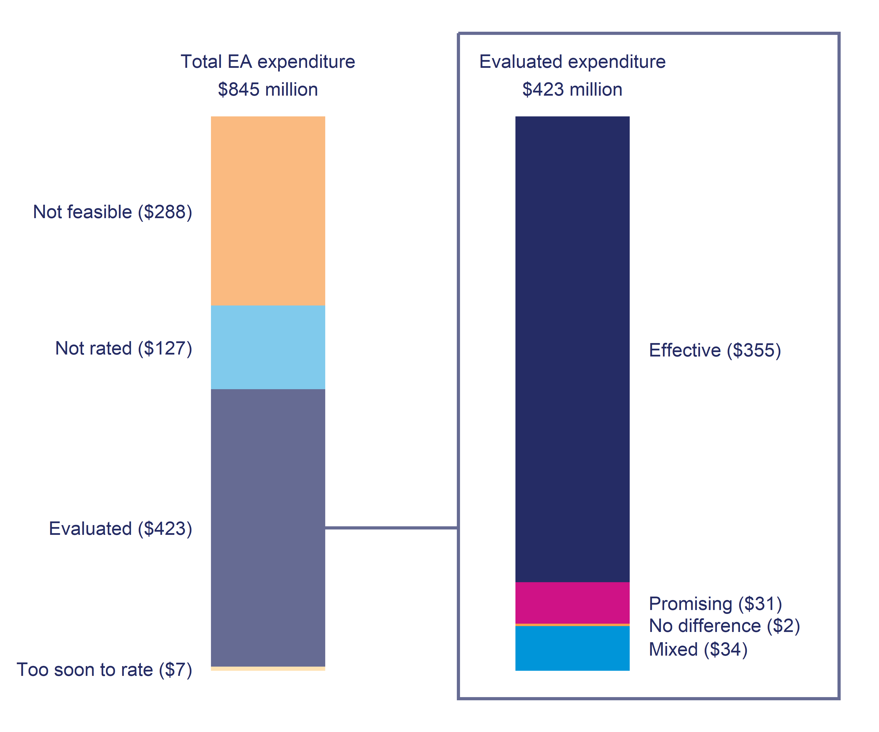

a, **Total EA expenditure**: Too soon to rate: less than two years of outcomes, Not rated: no impact evaluation undertaken as yet, Not feasible: intervention design or context prevents an assessment of the intervention’s effectiveness, Evaluated: intervention has an effectiveness rating.

b, **Evaluated expenditure** Effectiveness rating: Effective: significant positive overall impact, Promising: expected to have an overall positive impact, Mixed: intervention has both positive and negative impacts, No difference: makes no significant difference, Likely negative: expected to have an overall negative impact, Negative: significantly negative overall impact.

c, These results cover all EA interventions irrespective of funding source. For this reason, the expenditure reported here is higher than reported in MSD’s annual report EA effectiveness performance measure. That covers interventions funded through the Improved Employment and Social Outcomes Support MCA.

d, Expenditure values are nominal (not CPI-adjusted). Because of rounding, subcategories may not add up exactly to total values in the chart.

**Source**: Statistics New Zealand Integrated Data Infrastructure & Ministry of Social Development June 2024.

As Figure 1 shows, we could not rate some interventions for two reasons:

* it was not feasible ($288 million, 34.1 percent)
* the analysis has not been undertaken as yet ($127 million, 15.1 percent)
* the analysis has been completed but it is too soon to give a rating ($7 million, 0.8%).

Two thirds of not feasible expenditure was on interventions related to childcare assistance including Childcare Subsidy and Out of School Care and Recreation (OSCAR) subsidy and OSCAR provider assistance ($192.1 million). The second largest share of this spend was on in-house Employment related case management ($33.2 million).

The not rated expenditure includes a number of new and large initiatives, including: Māori Trades and Training Fund ($31.7 million),[10] Jobs and Skills Hubs ($12.8 million) and Whakawātea te ara Poutama ($8.3 million).

Looking at evaluated interventions ($423 million), we can see from Figure 1 that:

* $387 million (91.5 percent) went on effective or promising employment assistance
* $34 million (8.1 percent) was spent on interventions that had mixed effects
* $2.0 million (0.5 percent) made no difference
* no intervention was rated as either likely negative or negative.

### Trend in effectiveness rating

Table 1 shows the trend in the effectiveness rating of EA interventions over the last six years. Similar to Figure 1 the top panel shows the effectiveness rating as a proportion of total expenditure rated for effectiveness. The lower panel in Table 1 shows the proportion of overall expenditure on EA interventions covered in this report that can be evaluated for effectiveness. Over the last three financial years, the proportion of expenditure that can be evaluated for effectiveness has remained stable at around 50 percent, while the proportion of evaluated expenditure rated as either effective or promising was also stable at over 90 percent.

**Table 1**: Trend in effectiveness rating over the last six financial years[11]

| Rating | 2018/2019 | 2019/2020 | 2020/2021 | 2021/2022 | 2022/2023 | 2023/2024 |
| --- | --- | --- | --- | --- | --- | --- |
| **Effectiveness** | | | | | | |
| Effective | 79.4% | 82.9% | 87.3% | 85.7% | 85.4% | 84% |
| Promising | 10.7% | 9% | 7.7% | 7.9% | 6.8% | 7.4% |
| No difference | 1% | 0.6% | 0.5% | 0.2% | 0.4% | 0.5% |
| Mixed | 8.9% | 7.4% | 4.5% | 6.1% | 7.4% | 8.1% |
| **Total rated** | $222.5m | $256.4m | $335.5m | $407.0m | $461.3m | $422.8m |
| **Evaluated** | | | | | | |
| Evaluated | 39.6% | 47.4% | 49.6% | 51.7% | 50.1% | 50% |
| Too soon to rate | 2.8% | 0.3% | 0.8% | 0.7% | 0.7% | 0.8% |
| Not rated | 6.1% | 7.5% | 6.9% | 10.5% | 15.5% | 15.1% |
| Not feasible | 51.4% | 44.8% | 42.7% | 37.1% | 33.7% | 34.1% |
| **Total expenditure** | $561.3m | $541.4m | $676.8m | $786.9m | $921.2m | $845.2m |

**Source**: Statistics New Zealand Integrated Data Infrastructure & Ministry of Social Development June 2024.

## The trend in EA expenditure over time

Figure 2 summarises the total expenditure on EA interventions over each financial year from 2014/2015 onwards. As part of the COVID-19 response there was a substantial increase in the level of expenditure on EA interventions between 2020 to 2023, with expenditure increasing from $541 million in 2019/2020 to peaking at $921 million in 2022/2023 before falling to $845 million in 2023/2024.

**Figure 2**: Total expenditure on EA interventions by financial year (millions)

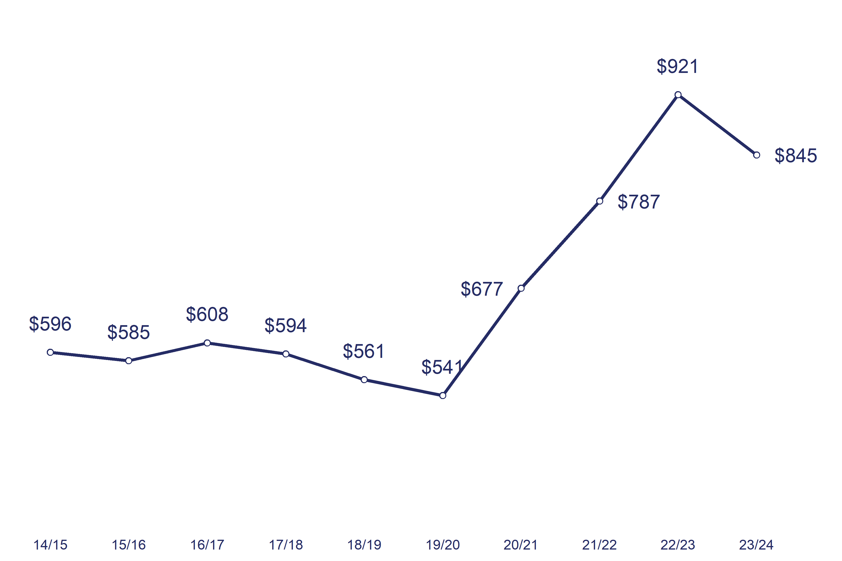

a, These results cover all EA interventions irrespective of funding source. For this reason, the expenditure here is higher than reported in MSD’s annual report EA effectiveness performance measure. That covers interventions funded through the Improved Employment and Social Outcomes Support Multi-Category Appropriation (MCA).

b, Values are in millions of dollars, expressed as nominal values (not CPI-adjusted).

**Source**: Ministry of Social Development, June 2024.

Table 2 shows those interventions that have contributed most to the increase in EA expenditure between the 2019/2020 and 2023/2024 financial years. The largest increases were among supports that feature employment subsidies to assist with people moving into employment (Flexi-wage, Mana in Mahi), training for job placement (Skills for Industry), or setting up their own business (Flexi-Wage Self-Employment). Further funding went on helping Māori entities to engage and keep Māori in employment-focused training opportunities (Māori Trades Training Fund) as well as community initiatives to support young people in general (Mayors Taskforce for Jobs and He Poutama Rangatahi).

**Table 2**: Expenditure on EA interventions in response to COVID

| Intervention | 2019/2020 | 2020/2021 | 2021/2022 | 2022/2023 | 2023/2024 |
| --- | --- | --- | --- | --- | --- |
| Flexi-wage | $27.7 | $43.7 | $86.7 | $80.3 | $47.8 |
| Flexi-Wage Self-Employment | $2.1 | $4.7 | $12.4 | $16.2 | $11.5 |
| He Poutama Rangatahi | $13.6 | $14.4 | $21.1 | $60.2 | $35.2 |
| Mana in Mahi | $5.3 | $35.7 | $33.0 | $20.4 | $15.5 |
| Māori Trades and Training Fund | $0.0 | $3.7 | $12.0 | $61.5 | $31.7 |
| Mayors Taskforce for Jobs | $0.4 | $12.2 | $14.0 | $14.7 | $13.8 |
| Skills for Industry | $44.7 | $61.4 | $51.7 | $57.0 | $67.3 |
| **Total** | **$93.7** | **$175.8** | **$230.9** | **$310.2** | **$222.7** |
| Dollars are shown in millions and are nominal values (not CPI-adjusted).  **Source**: Ministry of Social Development, June 2024. | | | | | |

## The trend in performance over time

Figure 3 compares the effectiveness of EA expenditure over the last ten financial years to 2023/2024. The effectiveness rating refers to the experience of people who participated in that year, based on the most recent evidence available. Therefore, expenditure for a given intervention may have different effectiveness rating depending on the participation year.

**Figure 3**: Effectiveness rating of EA expenditure by financial year[12]

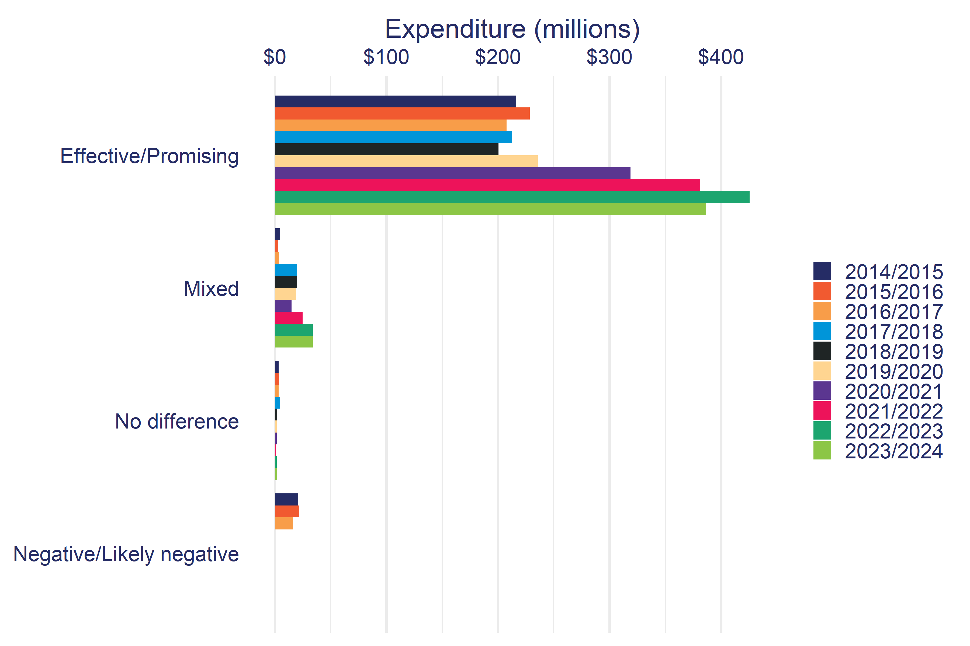 a, These results cover all EA interventions irrespective of funding source. For this reason, the expenditure here is higher than reported in MSD’s annual report EA effectiveness performance measure, which covers interventions funded through the Improved Employment and Social Outcomes Support MCA.

b, Expenditure is in nominal dollars (not CPI-adjusted).

**Source**: Ministry of Social Development and Statistics New Zealand Integrated Data Infrastructure,June 2024.

The main theme from Figure 3 is an increase in expenditure on interventions rated as effective or promising. This increase was driven by expansion of interventions such as Mana in Mahi and Flexi-wage. The increase in total expenditure since 2019/2020 has not flowed through to the other effectiveness categories, with increases being small in both absolute and relative terms.

## Employment Assistance intervention performance in 2023/2024

Table 3 shows effectiveness ratings for each EA intervention funded in the 2023/2024 financial year. For detailed results on individual interventions, refer to the Employment Assistance Evidence Catalogue (ea.analytics.msd.govt.nz).

### Effective/Promising ($387 million)

Effective and promising EA interventions have overall positive impacts across one or more of the five main outcome domains. We can categorise effective/promising EA interventions into six broad types: job placement interventions, work obligation-focused interventions, short-term training courses, financial support for study, employment support for disabled people and people with health conditions, and self-employment subsidy programmes.

#### Job placement interventions

These include in-house work brokers (Vacancy Placement Full time, $12.5 million and Part-time, $3.3 million) and contracted-out work brokerage services (Employment Placement or Assistance Initiative, $35.8 million), hiring subsidies (Flexi-Wage, $47.8 million), on the job training (Mana in Mahi, $15.5 million) and training for pre-determined employment (Skills for Industry, $67.3 million). We need to acknowledge that while job placement interventions are effective for participants, they can have negative impacts on non-participants[13] that we have not considered in this analysis.

**Table 3**: EA interventions by effectiveness rating in 2023/2024

| Effective/Promising | Mixed/No difference/Negative |
| --- | --- |
| EFFECTIVE ($355.2m) Skills for Industry ($67.3m) Flexi-wage ($47.8m) Employment Placement or Assistance Initiative ($35.8m) He Poutama Rangatahi ($35.2m) Jobseeker Support Work Ready 52-week benefit reapplication ($27.5m) Driver licence programmes ($22.4m) Mana in Mahi ($15.5m) Youth Service (YP) ($14.2m) Vacancy Placement Full time ($12.5m) Flexi-Wage Self-Employment ($11.5m) Work Preparation Services ($10.1m) Limited Services Volunteer ($9.7m) Youth Service (YPP) ($9.7m) Oranga Mahi - IPS DHBs ($6.9m) New Zealand Seasonal Work Scheme ($6.7m) Course Participation Assistance ($4.3m) Work Confidence ($3.9m) Vacancy Placement Part time ($3.3m) He Poutama Taitamariki ($3.3m) New Initiative ($3.2m) Business Training And Advice Grant ($2.6m) Work to Wellness ($1.0m) Job Search Initiatives ($0.3m) Training for Work ($0.3m) Case Management Initiative ($0.2m) Mainstream Employment Programme ($0.1m)  PROMISING ($31.5m) Employment Participation and Inclusion services ($31.5m) | MIXED ($34.1m) Youth Service (NEET) ($17.1m) Training Incentive Allowance ($16.0m) CadetMax ($0.8m) Prisoner Reintegration programme ($0.2m)  NO DIFFERENCE ($2m) In-Work Support Service ($1.1m) Activity in the Community ($0.3m) Work Ability Assessment ($0.3m) Driver licence programmes (commercial) ($0.3m) |
| a, Values are nominal (not CPI-adjusted). Because of rounding, subcategories may not add up exactly to total values in the table. b, Interventions with less than $100,000 of expenditure in the financial year are suppressed. c, These results cover all EA interventions irrespective of funding source, for this reason, the expenditure reported here is higher than reported in MSD’s annual report EA effectiveness performance measure. That covers interventions funded through the Improved Employment and Social Outcomes Support MCA.  **Sources**: Ministry of Social Development & Statistics New Zealand Integrated Data Infrastructure, June 2024. | |

#### Work obligation-focused interventions

These are interventions that use work obligation requirements to ensure that people are actively seeking employment. This group includes the 52-week reapplication for Jobseeker Support Work Ready ($27.5 million) and the pre-benefit seminar WRK4U (ended in October 2019).[14]

However, these results are based only on the impact on independence from employment and income assistance;[15] we have not yet estimated the impact of these interventions on other outcome domains such as employment and income.

#### Short-term training courses

Training for Work ($252,000) contracts short duration training courses for people who are likely to be on a main benefit long term. Training for Work shows consistent positive impacts on both highest qualification held as well as increasing overall time in employment and income. However, expenditure on the programme has steadily decreased over the last decade from $35.6 million in 2014/2015 to $252,000 in 2023/2024. Likewise, support for people to gain a driver licence (Driver licence programmes, $22.4 million) show positive impacts on employment, income, and welfare.

These examples contrast with earlier longer-term contracted training programmes such as Training Opportunities (ceased 2010) and Foundation Focused Training (ceased 2014) where performance was more variable.

#### Financial support for study

In addition to contracted training, a number of EA interventions such as Course Participation Assistance ($4.3 million) provide financial support to people to undertake study in the general education sector. While these interventions show positive impacts, we are cautious about attributing these effects primarily to the intervention. The concern is that people apply for this assistance **after** making the decision to take up study. Therefore, while this assistance may help reduce the cost of study and may increase the chances of completing study, it is likely that the observed impacts are largely because of prior differences between the participant and comparison group’s intention to take up study.

#### Employment support for disabled people and people with health conditions

Employment Participation and Inclusion services ($31.5 million), previously Vocational Services Employment, has shown improved effectiveness over time, with positive impacts on income and income support payments from 2012 onwards in addition to the long-standing positive impact on employment.

#### Self-employment subsidy programmes

Self-employment financial assistance (Flexi-Wage Self-Employment, $11.5 million) was found to have a positive impact on employment and income. However, only a third of participants had self-employment income at one year after starting the programme, indicating success at starting a business was low. However, this is relatively consistent with evidence of general start-up success rates.[16]

While participants had higher employment than the comparison group over the following five years, this impact was modest. Moreover, the impact on total income was confined to the subsidy period (ie the subsidy is included as income for the participants), with participants having similar or lower overall income than the comparison group after this point.

### Mixed ($34 million)

Mixed interventions have both positive and negative impacts. The two largest programmes in this group were Youth Service (NEET) and Training Incentive Allowance.

#### Youth Service (NEET)

The Youth Service (NEET) ($17.1 million) targets young people transitioning from school who are at risk of not participating in education, training, or employment. Initial analysis by The Treasury (Dixon & Crichton, 2016) found it did achieve the goals of increasing education retention and increasing NZQCF level 2 qualifications gained. However, these did not translate into improvements in later outcomes. The updated analysis for this report confirms these earlier findings, with Youth Service (NEET) having a positive impact on highest qualification held, but participants were more likely to receive income support than the comparison group.

The changes to the programme in January 2020 have not resulted in an improvement in effectiveness. However, this may in part be because of the difficulty of running a face to face case management service over the lockdown periods.

#### Training Incentive Allowance (TIA)

The Training Incentive Allowance ($16.0 million) provides financial assistance to support people on Sole Parent Support and Supported Living Payment to study courses up to level 7 of the NZQCF. Participants are more likely to gain qualifications as well as experience higher levels of employment and income than the comparison group, but over the short term receive higher income support (including TIA itself) than the comparison group, while over the medium term (five plus years) benefit receipt is generally lower. Finally, as noted previously, it is very likely that some of these impacts occur because participants had already decided to take up further study prior to applying for TIA and TIA was not instrumental in the decision to study or not.

### No difference ($2.0 million)

Interventions with a no difference rating are mostly small scale (ie with fewer than 400 participants a year). For these interventions, the small number of participants means it is difficult to identify whether the intervention has had a positive impact on outcomes.

## Not evaluated interventions ($422 million)

In this section of the report, we examine the overall trend in EA expenditure by whether it has an effectiveness rating or not as shown in Figure 4.

**Figure 4**: EA intervention expenditure by rating status

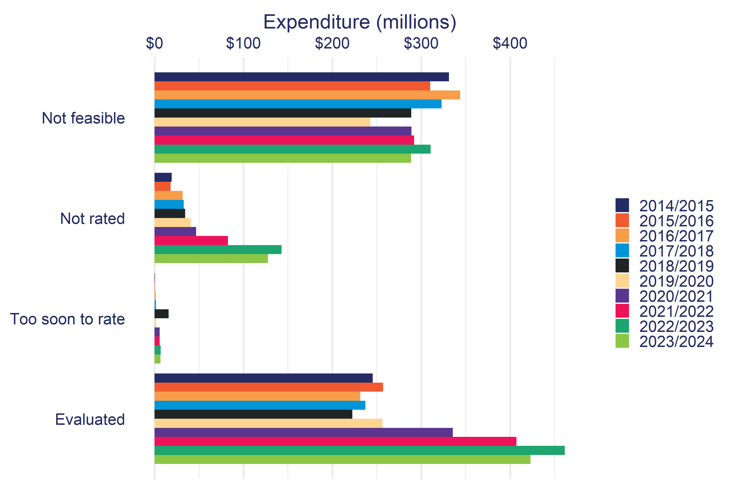

a, These results cover all EA interventions irrespective of funding source. For this reason, the expenditure here is higher than reported in MSD’s annual report EA effectiveness performance measure. That covers interventions funded through the Improved Employment and Social Outcomes Support MCA.

b, Expenditure is in nominal dollars (not CPI-adjusted).

**Source**: Ministry of Social Development, June 2024.

Of the total expenditure on EA interventions, the amount given an effectiveness rating decreased from 2010/2011 through to 2018/2019. The variation in interventions not considered feasible was largely because of the expansion in in-house case management over the 2013/2014 to 2017/2018 period. The COVID-19 response saw an expansion in funding for feasible EA interventions from 2019/2020 onward. The increase in ‘Not rated’ simply reflects the time it takes before evidence becomes available on the effectiveness of newer interventions.

Table 4 breaks down the unevaluated EA intervention expenditure by reason for the 2023/2024 financial year. There are two broad reasons for not having an effectiveness rating for an intervention: (i) not feasible and (ii) not rated.

**Table 4**: EA interventions not evaluated for effectiveness in 2023/2024

| INot feasible | Not rated |
| --- | --- |
| NOT FEASIBLE ($288.3m) Childcare Subsidy ($115.9m) OSCAR (subsidy) ($53.0m) Employment related case management ($33.2m) Transition to Work Grant ($23.3m) OSCAR Provider Assistance ($23.2m) Mayors Taskforce for Jobs ($13.8m) $5k to Work ($11.1m) Education to Employment Brokerage Service ($4.1m) Regional Economic Development ($3.2m) Work Bonus ($2.8m) Pacific Employment and Training Programme ($2.3m) Flexible Childcare Assistance ($1.2m) Seasonal Work Assistance ($0.5m) Redundancy Support ($0.4m) Sustainable Employment Trial ($0.2m) | NOT RATED ($127.2m) Māori Trades and Training Fund ($31.7m) Sole Parent Support 52-week reapplication ($19.5m) Jobs and Skills Hubs ($12.8m) Jobseeker Support Health Condition or Disability 52-week reapplication ($11.6m) Whakawātea te ara Poutama ($8.3m) Kōrero Mahi - Let's talk work ($7.9m) Rapid Return to Work ($6.8m) In-Work Payment ($5.5m) Employment Service Response to COVID-19 (Regional contracts) ($4.6m) Pathways to Employment Red Cross ($3.5m) Direct Career Service ($3.2m) Enhanced Taskforce Green ($2.4m) Supporting Offenders into Employment version 2 ($2.2m) Flexi-wage Project in the Community ($2.2m) Creative Careers Service ($1.5m) Employment Service in Schools Pilot ($1.4m) Oranga Mahi - Rākau Rangatira ($0.8m) Information Services Initiative ($0.6m) Mainstream Internship Programme ($0.4m) Mainstream Paid Work Experience Programme ($0.3m) Kōrero Mahi - Work check-in ($0.1m)  TOO SOON TO RATE ($6.5m) Oranga Mahi - Here Toitū ($6.1m) Oranga Mahi - Take Charge ($0.3m) |
| a, These results cover all EA interventions irrespective of funding source. For this reason, the expenditure here is higher than reported in MSD’s annual report EA effectiveness performance measure. That covers interventions funded through the Improved Employment and Social Outcomes Support MCA. b, Values are nominal (not CPI-adjusted). Because of rounding, subcategories may not add up exactly to total values in the table. c, Interventions with less than $100,000 of expenditure in the financial year are suppressed. Source: Ministry of Social Development, June 2024. | |

### Not feasible ($288 million)

These are interventions implemented in such a way that it is not currently possible to estimate the difference they make. A not feasible assessment does not rule out the possibility of evaluating the impact of these interventions in the future. However, to do so would require a dedicated evaluation design. Such designs would either involve some form of randomisation or a change to the delivery of these interventions, and in both cases this would require additional resources to be allocated to the programme and its evaluation.

Below are the broad reasons why it is not currently possible to evaluate a given intervention’s effectiveness. Table 6 in Appendix 1 provides specific explanations for each intervention listed in Table 4.

#### Entitlement based interventions

Although most EA interventions are discretionary, there are some where entitlement is defined in law. The largest intervention in this group is Childcare Assistance (Childcare Subsidy[17], $115.9 million, OSCAR Provider Assistance, $23.2 million) where everyone who is eligible, and would like to use Childcare Assistance, can do so. As a result, there is no similar group of non-participating parents to compare against the participants. We also do not have a historical comparison group, as childcare assistance has been available since before our administrative records began in 1993 and electronic records are not available earlier than the mid-90s.

It may be possible to examine the effectiveness of childcare assistance indirectly through an information campaign where one group is given information about their entitlement, and another is not. A study such as this would go through ethical review. By comparing the two groups, we could see if the information (i) increases take-up and, if take-up does increase, (ii) what impact this has on subsequent outcomes.

#### Difficult to identify counterfactual group

Several interventions occur during a transition period (ie from benefit to work) or natural disasters. Here we run into the problem of identifying the potential participant population to draw a convincing comparison group from. For example, many interventions that assist with the transition to employment (eg Transition to Work Grant, $23.3 million) are often provided in anticipation of an exit. Alternatively, in the case of Work Bonus ($2.8 million), the bonus is only paid if the participant achieves the contracted outcome. Under these conditions, it is difficult to identify the equivalent population that is in the same transition state but did not participate in the intervention.

Another set of interventions try to increase the range of job opportunities available to people on income support. For example, $5k to Work ($11.1 million) enables people to move locations to take up employment outside their immediate labour market. Here the effect of the intervention is on those *eligible* to receive the assistance. However, because take-up is low, it would be difficult to identify the impact of these types of interventions, even with the best available methods.

#### Low cost and frequent interventions

MSD’s Service Delivery group runs many short duration and frequent interventions, such as job search seminars or employment related case management ($33.2 million). Showing the individual impact of these interventions is difficult for two reasons. First is that the individual effect of each seminar or interview attendance is expected to be small. The second reason is that, because of the wide coverage, we again run into the issue of a plausible comparison group, as non-participants are often ‘unusual’ in some way as to not have participated in this type of intervention.

The strategy to overcome this problem has been to evaluate these interventions as part of case management (CM) services, see de Boer (2019). For example, frequent job search seminars were part of the Work Search Support (WSS) service. Here we estimated the impact of being assigned to WSS (participating in frequent seminars) to an equivalent group of people assigned to other CM services and who did not participate in these seminars. Similarly, de Boer (2019) evaluated the impact of more intensive case management services such as Work Focused Case Management (WFCM) on participants’ time off main benefit.[18]

However, because CM services compromise a combination of case management time and discrete EA interventions, this evidence cannot be used to identify whether employment related case management is effective on its own. Instead, the evidence on CM services points to the effectiveness of a range of employment assistance working in combination.

#### Unable to identify the individuals who receive assistance

In some cases there is insufficient information available to identify who participated in an intervention. This often occurs where the referral process is managed by contracted providers without an agreement to provide individual level participation data, or the systems to deliver the data are not sufficiently robust. Recent changes to MSD IT applications to allow providers to create and record participants has helped overcome some of these issues. As a result of these changes, programmes such as Māori Trades and Training Fund ($31.7 million) are in the process of being evaluated.

Alongside data capture, in some cases interventions are run in such a way that who receives the intervention is not directly recorded. For example, programmes that provide information and advice to groups or on a casual basis, often have no information on the specific individuals involved. Examples include, Education to Employment Brokerage Service ($4.1 million) and Direct Career Service ($3.2 million), or where funding is given to support providers such as OSCAR Provider Assistance ($23.2 million).

#### Strong selection on unobserved characteristics

The final set of interventions that are currently infeasible to rate are those where we consider that there is strong selection on unobserved characteristics (eg motivation, attitude, social support). Selection on unobservable characteristics means we are unsure whether any subsequent differences in outcomes between participants and a comparison group is because of the intervention or because of prior uncontrolled differences between the two groups.

For example, the Sustainable Employment Trial is for people on Supported Living Payment (SLP)[19] wanting to try working more than 15 hours a week for a six-month period. In this example, we cannot reliably identify the underlying motivation as to why an individual on SLP would decide to increase their hours of work. The only way to robustly estimate the impact of these types of interventions is to run a Randomised Control Trial.

### Not rated ($127 million)

The remaining expenditure includes EA interventions that we can feasibly evaluate, but we have not done so at this time. In some cases, this is because the interventions are too small (eg Information Services Initiative, $561,000) or because they have only been introduced recently (eg Korero Mahi - Let’s talk work, $7.9 million).

# Effectiveness by intervention type

Here we show the effectiveness rating by the type of EA intervention. In this section, we broaden our scope to include all EA interventions delivered by MSD, not just those delivered in 2023/2024 (Table 5).

We have information on 310 individual EA interventions and case management services operating between 1990 and 2024. These range from large interventions, such as Training Opportunities ($80 million pa, 1991-2009) through to small local pilots running for a couple of months. We group these interventions into broad categories reflecting how the intervention is expected to help improve participants’ outcomes. For example, training programmes aim to increase participants’ skills or qualifications to help improve their chances of gaining employment.

**Table 5**: Effectiveness of employment assistance intervention by type

| Intervention type | Total | Rated | Effective/Promising | Mixed | No difference | Likely negative/Negative |
| --- | --- | --- | --- | --- | --- | --- |
| Case Management | 75 | 17 | 64% | 5% | 11% | 17% |
| Community Development | 9 | 1 | - | - | - | 100% |
| Information Services | 16 | 1 | - | 100% | - | - |
| Health Interventions | 7 | 1 | 100% | - | - | - |
| Work Confidence | 22 | 2 | - | 100% | - | - |
| Vocational Services | 2 | 2 | 50% | 50% | - | - |
| Training | 21 | 9 | 22% | 55% | 22% | - |
| Work Obligations | 13 | 3 | 66% | - | - | 33% |
| Job Search | 22 | 4 | 75% | - | - | 25% |
| Work Experience | 28 | 11 | 45% | 45% | 9% | - |
| Job Placement | 47 | 19 | 73% | 21% | 5% | - |
| Work Transition | 20 | 1 | 100% | - | - | - |
| Work Retention | 18 | 1 | - | - | 100% | - |
| Other | 10 | 2 | 50% | 50% | - | - |
| **Total** | **310** | **74** | **55%** | **27%** | **9%** | **8%** |
| Note the percentage values are based on the number of rated interventions. Due to rounding, percentage values may not add up to 100%.  Sources: Ministry of Social Development & Statistics New Zealand Integrated Data Infrastructure, June 2024. | | | | | | |

Table 5 shows that of 310 interventions that we have information on, we can rate the effectiveness of 74 (23.9%). Alongside the overall low coverage, we also see substantial gaps in our knowledge of the effectiveness for some intervention types. For example, we have only one or two studies on the effectiveness of interventions designed to help with transitioning to and retaining employment.

Note that the percentage values for each rating in Table 5 are based on a relatively small number of observations. Small samples mean the proportional mix of intervention effectiveness may show substantial shifts in future updates to this analysis.

### Job placement and case management services are generally effective

Interventions that tend to improve participants’ outcomes are concentrated around case management and job placement. However, for job placement programmes this optimistic assessment has to be balanced by consideration of the negative effects these interventions can have on non-participants through substitution or displacement effects.

Case-management services either include staff working with specific groups of people, contracting out case management to external providers, or lowering caseloads to enable staff to have more time with individuals on their case load.

People on sole parent related benefits appeared to benefit most from case management service. On the other hand, two of the three case management services rated as negative target young people transitioning from school to education training or employment (Youth Transitions Service, Youth Service (NEET)).

### Variable effectiveness ratings for work experience, job search and information services interventions

Intervention types with a range of effectiveness ratings include work experience programmes and information services. When we look in more detail at these intervention types, we find that work experience with private sector firms is more likely to be rated as effective. On the other hand, community or environmental placements where participants remain on benefit tend not to be effective. For information services and job search type interventions, it is less clear what differentiates those that are effective from those that are not.

#### Work confidence has modest effects

Work confidence interventions (which are intended to improve a participant’s confidence and motivation) have modest impacts, with two-thirds either having mixed results or making no difference to participants’ outcomes.

#### Work obligations results apply only to off main benefit outcomes

The evidence on work obligations (interventions that ensure people are actively looking for work) is small relative to the number of interventions. Also, we currently only have evidence of the impact of these interventions on off main benefit outcomes. An important gap in our evidence is on the impact of these interventions on wider outcomes such as employment and net income.

#### Training interventions are showing better performance

The evidence on the effectiveness of training programmes[20] indicates more recently contracted training programmes, such as Training for Work, are more effective than earlier versions such as Training Opportunities, Foundation Focused Training and Skills Training. On the other hand, the effectiveness of Training Incentive Allowance appears to have decreased over the last 14 years and is likely to be linked to changes in the scope of the programme over the same period.[21]

# Appendix 1: Effectiveness rating

We categorise the EA interventions based on whether the intervention had a positive impact[22] on participants’ outcomes across five domains.

## Outcome domains

Our analysis of the impact of employment interventions focuses on five outcome domains. These domains broadly reflect the intended medium and long-term objectives of employment interventions.

The outcome domains include:

* **Employment**: intervention is rated as effective if it increases the time spent in paid employment. This measure includes increases in employment while still on main benefit.
* **Income**: intervention is rated as effective if it increases net income from all sources including income support, tax credits and study assistance. Therefore, this measure accounts for both any loss of income from government assistance, as well any earning gains through movement into employment.
* **Justice**: intervention is rated as effective if it reduces the time participants spend in Corrections services (ie prison, community service, remand, home detention).
* **Qualifications**: intervention is rated as effective if it increases the average of the highest qualification held. Highest qualification is based on NZQCF levels from 1 through to 9. Therefore, an impact of NZQCF 1 would mean participants had increased their highest NZQCF level by an average of 1 level (eg. from 2.4 to 3.4).
* **Welfare**: intervention is rated as effective if it reduces the time participants receive a main benefit (eg. unemployment, sole parent or health or disability benefits) and receiving employment assistance (eg. on a wage subsidy programme).

## Effectiveness

By effectiveness, we mean whether an intervention improves participant outcomes relative to the counterfactual (ie the outcomes participants would have had if they had not participated). In this analysis, we assess effectiveness based on the impact of the intervention on one or more outcome domains. However, we cannot assess the effectiveness of all interventions and these are given a separate rating.

The ratings are described as follows:

* **Effective**: the intervention has a statistically significant positive impact on one or more primary outcome (eg. income, employment, justice, qualifications or independence from welfare) and no evidence of a negative impact on any primary outcome.
* **Promising**: the trend in impacts indicates the intervention is expected to have a significant positive overall impact in the medium-to-long term. Also, we rate interventions as promising if we cannot evaluate the intervention directly, but where we have a similar intervention rated as effective.
* **Mixed**: the intervention has both positive and negative impacts on primary outcomes. The most common case is where an intervention increases employment but has a negative impact on welfare.
* **No difference**: the intervention makes no statistically significant difference for any of the primary outcomes. For smaller interventions, this may reflect insufficient statistical power to detect a meaningful impact and these impacts may become significant when an intervention has more participants.
* **Likely negative**: trends indicate the intervention will have a negative impact on one or more primary outcomes and there is no evidence of a positive impact on any other primary outcome in the medium to long-term .
* **Negative**: the intervention has a statistically significant negative impact on one or more primary outcomes and no evidence of a positive impact on any primary outcome.
* **Too soon to rate**: there has not been enough time to observe the impact of the intervention. Typically, we do not rate an intervention until we have two years of outcome data available.
* **Not rated**: we have not rated the effectiveness of the intervention at this time.
* **Not feasible**: it is not considered feasible to estimate the impact of an intervention based on current data or available methods (ie would require some type of randomised control trial to robustly identify what impact an intervention has).

## Interventions where it is currently not feasible to estimate their effectiveness

Table 6 lists the EA interventions funded after the 2009/2010 financial year that were not feasible to evaluate and summarises the reason for this assessment.

**Table 6**: Explanation for not feasible rating by intervention

| Intervention | Reason |
| --- | --- |
| $5k to Work | Finding the impact of $5k to Work is difficult for two reasons. The first is that all job seekers are eligible to receive it, subject to some criteria on risk of long term benefit receipt, the suitability of the job, and the distance to the job. The second is that the take up rate of the payment is low. Together this means the influence of $5k to Work on the outcomes of the target group is small. It may be possible to assess the intervention's effectiveness by randomising eligible job seekers into a treatment group who are told about $5k to Work and a control group who are not. This design would indicate the optimal take-up rate and, if this rate is high enough, it may be able to detect the impact on outcomes relative to the control group. However, this would require very large treatment and control groups (in the 10,000s) to detect the likely effect of the incentive payment. |
| Childcare Subsidy | The Childcare Subsidy programme is both a legal entitlement and has been available since 1983. Under these conditions, it is not possible to identify a convincing comparison group of parents who did not take up the Childcare Subsidy. It may be possible to estimate the impact of the Childcare Subsidy on non-participating parents through a Zelen RCT (ie an information campaign about the subsidy to a randomly selected group of non-participating eligible parents). Such a study would show the impact of the Childcare Subsidy on non-participating eligible parents only and not the average impact across all families using the subsidy. |
| Client Self Help | Not able to clearly define those that have and have used the service. |
| Connected | Connected is an information and navigation programme where it is difficult to reliably identify who uses the service, as well as the difficulty of isolating the influence of this type of support on participant's later outcomes. |
| Contracted In-Work Support | Without some type of randomised design, it is not feasible to estimate the impact of In Work Support. This is because it is difficult to identify a convincing comparison group, at the same transition point into employment as the participants but who did not receive the intervention. |
| Course Participation Assistance | People usually get Course Participation Assistance after they have decided to take up study, but before they have commenced study. For this reason it is difficult to identify a comparison group who are at the same point in their decision to take up study. |
| Direct Career Service | Impact evaluation of Direct Career Service is currently assessed as not feasible because it will be difficult to isolate the influence of career advice and information support on participants' outcomes from all the other factors that influence their career pathways. |
| Early Response Redeployment Support | It is not feasible to estimate the impact of Early Response Redeployment Services without a randomised control treatment design (RCT). This is because it is difficult to identify people in a similar position as the participants who are at risk of losing their jobs, but are not supported by the service. |
| Earthquake Support Subsidy | Because the subsidy was paid during a natural disaster it is difficult to identify a suitable comparison group subject to similar conditions but who were not eligible for the subsidy. A practical issue is that the subsidy was paid to employers and we have not yet been able to identify which individual employees received the subsidy. |
| Education to Employment Brokerage Service | Impact evaluation of Education to Employment Brokerage Service is currently assessed as not feasible because it will be difficult to isolate the influence of career advice and information support on students' outcomes from all the other factors that influence their career pathways. |
| Employment related case management | General employment related case management is available to all individuals who are eligible to receive it. For this reason it is very difficult to identify a suitable comparison group. However, there have been evaluations of targeted case management services (eg Work Focused Case Management) that enable assessment of the impact of different levels of case management intensity (ie case management plus employment interventions). |
| Employment Workshop | Because of their high frequency, wide coverage, and likely small impact, it was not feasible to estimate the impact of attending an individual Employment Workshop. |
| Flexible Childcare Assistance | Flexible Childcare Assistance aims to incentivise eligible sole-parents to start employment during non-standard hours. Because the low uptake rate dilutes the effect of the programme across many non-participants, we do not consider it feasible to estimate the impact of Flexible Childcare Assistance. It may be possible to estimate the impact through an invitation to treat RCT (ie an information campaign to eligible sole parents) but uptake would need to be high to confidently detect any impact of Flexible Childcare Assistance through this design. |
| Guaranteed Childcare Assistance Payment | Guaranteed Childcare Assistance Payment is a legal entitlement. Under these conditions it is not possible to identify a convincing group of eligible parents who did not take up the Guaranteed Childcare Assistance Payment. It may be possible to estimate the impact of the Childcare Subsidy on non-participating parents through an invitation to treat RCT (ie an information campaign to eligible parents). A secondary reason is that we have not yet identified who received the Guaranteed Childcare Assistance Payment. |
| In-Work Payment | RCT of the in-work payment was completed as part of the In-work Support Service trial. |
| Job and Training Support Fund | Currently we do not have information on who receives support funds. In addition, it may not be possible to identify similar individuals for a comparison group as the eligibility criteria are tight and based on a person's specific situation. |
| Jobs and Skills Hubs | Do not currently have access to which individual participants participated in Jobs and Skills Hubs to evaluate effectiveness. |
| Local Employment Coordination Groups | No identified participant group or location. |
| Mayors Taskforce for Jobs | MSD does not have information on the individual participants supported through the programme. For this reason, it is not feasible to evaluate the impact of MTFJ on participants' outcomes. |
| Mental Health Co-ordination | Insufficient information on the design of the intervention. |
| Mental Health Social Bond | We do not have information on who participated in the Mental Health Social Bond programme. |
| Migrant Employment Assistance | The participant data available is unreliable. |
| Modification Grant | It was not feasible to estimate the impact of the Modification Grant because it is subject to strong selection effects as it targets people with long term health conditions or disabilities, where we cannot observe why a given individual feels able to take up full time employment. |
| New Employment Transition Grant | Because the New Employment Transition Grant is available for people who are off main benefit and is paid out only in specific circumstances it is difficult to identify a convincing comparison group to estimate the effectiveness of this grant. |
| OSCAR (subsidy) | The OSCAR subsidy programme is a legal entitlement and has been available since 1996. Under these conditions it is not possible to identify a convincing group of parents who did not take up the OSCAR subsidy. It may be possible to estimate the impact of the OSCAR subsidy on non-participating parents through an invitation to treat RCT (ie an information campaign to eligible parents). |
| OSCAR Provider Assistance | OSCAR Provider Assistance works indirectly to increase the supply of OSCAR providers. Currently we do not have time series information on the level or coverage of OSCAR providers to be able to identify whether the OSCAR Provider Assistance has increased the level of OSCAR services. |
| Pre-Employment Drug Testing | Legislative requirements would make running an RCT ethically difficult (ie applying work obligations based on randomisation). |
| Project 300 Trial | Insufficient information on the design of the intervention. |
| Recruitment Seminar | Because of their high frequency and likely small impact, it was not feasible to estimate the impact of attending an individual Recruitment Seminar. |
| Redundancy Support | There is limited information on the individual people who are assisted by Redundancy Support services that can be linked to outcomes such as employment. In addition, identifying a suitable comparison group (who are in the processes of being laid off) is difficult with current data. |
| Regional Economic Development | We do not have enough information on the operation of the intervention to identify who was affected by it. |
| Seasonal Work Assistance | It is not currently feasible to estimate the effectiveness of this programme as it is difficult to identify the target group (people who are thinking about moving into horticultural work) to identify whether the availability of the payment has increased movement into horticultural jobs. A secondary impact that could be examined is whether the Seasonal Work Assistance reduced the probability of horticultural workers returning to main benefit in response to poor weather before and after the introduction of the programme in 2002. |
| Supported Living Payment Opt In Service | It is currently not feasible to estimate the impact of this case management service, as we are not confident we can identify a suitable comparison group based on the information that we can observe about those who are eligible to participate. To determine the effectiveness of this service would require some type of randomised controlled trial (RCT). |
| Sustainable Employment Trial | We do not consider it possible to estimate the impact of the Sustainable Employment Trial because it is subject to strong selection effects. In particular, the policy encourages people who have a long-term health condition and receive a disability benefit to start employment. We do not have sufficient information to separate those who are likely to move into work from those who are unable to move into employment at all. Accordingly, it is difficult to identify a suitable comparison group with the same likelihood of moving into employment as the participants. |
| Transition to Work Grant | It is not feasible to estimate the impact of the Transition to Work Grant without a randomised design, as it is difficult to identify a convincing comparison group at the same transition point as the participants but who did not receive the grant. In addition, Transition to Work Grant can be paid in anticipation of an exit to work, further complicating the identification of a suitable comparison group. |
| Work and Income Seminar | Because of their high frequency and likely small impact, it was not feasible to estimate the impact of attending an individual Work and Income Seminar. |
| Work Bonus | It is not feasible to estimate the impact of Work Bonus without a randomised design, as it is difficult to identify a convincing comparison group at the same transition point as the participants but who did not receive the intervention. |
| Work Search Assessment Seminar | This is a high frequency small impact intervention where a high proportion of eligible people participate. This makes determining impact difficult for two reasons. The first is that the individual impact of any one seminar will be small relative to all other factors that influence participants' outcomes. The second issue of high coverage means that those who do not participate are unusual in some way and this makes them a poor comparison. |
| Youth Seminar | The impact of individual Youth Seminars is difficult to isolate because the attendance at any one seminar is likely to have a small effect on future outcomes. In addition, high participation rates among those eligible make it difficult to identify a suitable comparison group who did not participate. |

# References

Crichton, S. (2013) The Impact of Further Education on the Employment Outcomes of Beneficiaries, Ministry of Business, Innovation & Employment, Wellington [link](https://thehub.sia.govt.nz/resources/the-impact-of-further-education-on-the-employment-outcomes-of-beneficiaries)

de Boer, M. & Ku, B. (2018) Effectiveness of the Limited Service Volunteer programme: Financial Year 2014/2015, Ministry of Social Development, Wellington [link](https://www.msd.govt.nz/about-msd-and-our-work/publications-resources/evaluation/lsv-effectiveness/index.html)

de Boer, M. & Ku, B. (2019) Cost-effectiveness of intensive case management services (from October 2012 to July 2017): Evaluation report, Ministry of Social Development, Wellington[link](https://www.msd.govt.nz/about-msd-and-our-work/publications-resources/evaluation/intensive-case-management-services/index.html)

de Boer, M. (2025) Effectiveness of MSD employment assistance: Technical report for 2023/2024 financial year, Ministry of Social Development, Wellington [link](https://www.msd.govt.nz/documents/about-msd-and-our-work/publications-resources/research/effectiveness-employment-assistance/2025-msd-employment-assistance-effectiveness-technical-report-fy24.docx)

de Boer, M. & Ku, B., (2017) Service Delivery Cost Allocation Model for Individual Outputs: 2017 version, Ministry of Social Development, Wellington (File ref:A9317887)

de Boer, M. (2003) Impact of Jump Start seminar on uptake of the unemployment benefit, Ministry of Social Development, Wellington (File ref:A177933)

Dixon, S. & Crichton, S. (2016) Evaluation of the Impact of the Youth Service: NEET programme, The Treasury, Wellington (File ref:A9299141)[link](https://treasury.govt.nz/publications/wp/evaluation-impact-youth-service-neet-programme-html)

Fyfe, C., Mar D., and Taptiklis, P. (2023) COVID-19 Wage Subsidy: Outcome Evaluation - Value for Money, Motu Working Paper 23-04, Motu, Wellington[link](https://www.msd.govt.nz/documents/about-msd-and-our-work/publications-resources/statistics/covid-19/wage-subsidy-evaluation-reports/wage-subsidy-scheme-value-for-money-report.pdf)

McLeod, K., Dixon, S. & Crichton, S. (2016) Evaluation of the Impact of the Youth Service: Youth Payment and Young Parent Payment, The Treasury, Wellington (File ref:A9299143)[link](https://treasury.govt.nz/publications/wp/evaluation-impact-youth-service-youth-payment-and-young-parent-payment-wp-16-07-html)

Mills, D., Timmins, J. (2004) Firm Dynamics in New Zealand: A Comparative Analysis with OECD Countries. New Zealand Treasury: Working Paper 04/11, The Treasury, Wellington [link](https://www.treasury.govt.nz/sites/default/files/2007-09/twp04-11.pdf)

MSD (2013) Impact of the 52-week Unemployment Benefit Reapplication Process Update 2: Technical Report, Ministry of Social Development, Wellington [link](http://www.msd.govt.nz/documents/about-msd-and-our-work/publications-resources/research-archive/impact-of-the-52-week-unemployment-benefit-reapplication-process-update.pdf)

MSD (2018) In-work Support service and In-Work Payment trial, Ministry of Social Development, Wellington (File ref:A10173601)

1. Expenditure is expressed in nominal dollars (ie not CPI-adjusted) and includes indirect costs. The companion technical report summarises how we calculated the cost of EA interventions, see www.msd.govt.nz/documents/about-msd-and-our-work/publications-resources/research/effectiveness-employment-assistance/2025-msd-employment-assistance-effectiveness-technical-report-fy24.pdf.
2. While MSD administers the payments for Apprenticeship Boost, policy and evaluation responsibility is with the Ministry of Education.
3. In this report, we round expenditure values to the nearest million for values over 10 million and to the nearest $100,000 for values under $10 million.
4. He Poutama Rangatahi and Māori Trades and Training Fund were transferred from MBIE to MSD in July 2021. For consistency, the expenditure on these programmes since their inception has also been included in this report.
5. For TI the grant to support study is included as part of their income support payments.
6. Public Finance Act 1989, Section 34, 2b: The chief executive of a department that administers an appropriation is responsible for advising the appropriation minister on the efficiency and effectiveness of any departmental expenses or departmental capital expenditure under that appropriation.
7. Currently we do not have a reliable measure of household income, so the analysis is based on individual income only and does not account for the number of dependants a person might have.
8. A set of methods that try to create a comparison group without using a process for randomly assigning people to a treatment or control group as is done in an RCT. Refer to the companion technical report for more detail, see www.msd.govt.nz/documents/about-msd-and-our-work/publications-resources/research/effectiveness-employment-assistance/2025-msd-employment-assistance-effectiveness-technical-report-fy24.pdf.
9. See the technical report (www.msd.govt.nz/documents/about-msd-and-our-work/publications-resources/research/effectiveness-employment-assistance/2025-msd-employment-assistance-effectiveness-technical-report-fy24.pdf).
10. The Māori Trades and Training Fund was previously not feasible to be rated. However, as the individual participant data is now captured though the Service Outcome Reporting Tool (SORT) and is in the process of being provided to the IDI, future evaluation of the programme will be possible.
11. As the cost model is updated annually when this report is created, these figures may differ from those in previous reports. See the accompanying technical report for details (www.msd.govt.nz/documents/about-msd-and-our-work/publications-resources/research/effectiveness-employment-assistance/2025-msd-employment-assistance-effectiveness-technical-report-fy24.pdf). Additionally, a programme’s rating can change as more data becomes available.
12. As the cost model is updated annually when this report is created, these figures may differ from those in previous reports. See the accompanying technical report for details (www.msd.govt.nz/documents/about-msd-and-our-work/publications-resources/research/effectiveness-employment-assistance/2025-msd-employment-assistance-effectiveness-technical-report-fy24.pdf). Additionally, a programme’s rating can change as more data becomes available.
13. These are substitution (a participant takes a vacancy that would have been filled by someone else) and displacement (subsidised labour reduces employment among competing firms).
14. The WRK4U intervention ceased operating in October 2019, while 52-week reapplications were suspended from March 2020 in response to the COVID-19 lockdown and restarted in March 2021.
15. No longer receiving a main benefit (eg, Jobseeker Allowance, Sole Parent Support or Supported Living Payment) or receiving employment assistance, such as wage subsidies that mean people are off main benefit but still receiving assistance.
16. See: Mills, D. & Timmins, J. (2004) Firm Dynamics in New Zealand: A Comparative Analysis with OECD Countries. New Zealand Treasury: Working Paper 04/11. url: <https://www.treasury.govt.nz/sites/default/files/2007-09/twp04-11.pdf>
17. includes the OSCAR (Out of School Care and Recreation) subsidy.
18. WSS and WFCM services ended in July 2020.
19. for people with a long-term health condition or disability that prevents them from working. People on SLP can work up to 15 hours a week.
20. This excludes programmes where there is a job placement component, such as S4l.
21. In 2010 the eligibility for TIA was reduced to courses at NZQCF Level 3 and below (high school level), and in July 2021 eligibility was increased back to NZQCF Level 7 (under-graduate courses). It is too soon to know if the expansion to include up to NZQCF 7 has had a positive impact on the programme’s performance.
22. Impact in this report means the change in outcomes for people receiving the intervention relative to a similar group of people who do not participate.