**Child Poverty in New Zealand:**

**The demographics of child poverty, survey-based descriptions of life ‘below the line’ including the use of child-specific indicators, trends in material hardship and income poverty rates for children, and international comparisons – with discussion of some of the challenges in measuring child poverty and interpreting child poverty statistics**

**Prepared by Bryan Perry**

**Ministry of Social Development**

**Wellington**

**October 2022**

ISBN 978-1-99-110512-7 (Print)

ISBN 978-1-99-110513-4(Online)

**Changes since last report**

* Updated with 2020-21 data.
* Time series added for material hardship rates from 2007 to 2021 and low-income rates from 1982 to 2021.
* Housing affordability for households with children – renters and owners.
* More detailed analysis and breakdown including for those in the deepest material hardship.
* Technical sections strengthened.

**Next report**

* The next report is scheduled for mid-2023. The timing is dependent on when Stats NZ publish their Child Poverty Statistics (likely to be February 2023), and on the timing of the availability of the HES data for MSD use.

**Availability on MSD website**

* This report is available on the MSD website:

[Child Poverty in New Zealand - Ministry of Social Development (msd.govt.nz)](https://www.msd.govt.nz/about-msd-and-our-work/publications-resources/research/child-poverty-in-nz/index.html)

**Updates since publication on 7 October 2022**

* Nil

**Acknowledgements**

My thanks to all those who provided comments on earlier drafts, including MSD colleagues, staff from the Treasury, Stats NZ and DPMC, and others from NGOs. Their advice, questions, challenges and smoothing out of rough patches have added considerably to the report’s robustness, readability and relevance. My thanks especially to Caroline Hodge whose expert SAS coding, preparation of publication-ready tables, ability to succinctly synthesise results from complex investigations of the data, careful review of the full text and general unwavering commitment to excellence have been crucial in the production of this report. Responsibility for all the analysis and interpretation in the report (including any errors or omissions) remains mine alone.

**MSD Child Poverty Report 2022**

**Overview and Selected Findings**

**Prepared by Bryan Perry**

**October 2022**

**Overview and selected findings**

MSD’s Child Poverty report is a comprehensive resource designed to inform policy development, research and public discussion in relation to the material wellbeing of children and the households in which they live. Most of what is reported is about material hardship, low incomes and financial stress as these are matters of considerable ongoing public policy interest, but it also reports on how well the vast majority of children and their households are doing in terms of their material wellbeing. Children are those aged under 18 years.

There is naturally some overlap with Stats NZ’s Child Poverty Statistics report (Feb 2022) – the same notion of poverty is used, the same Child Poverty Reduction Act (2018) measures, and the same basic methodology in line with international best practice – but the reports are essentially complementary, each with its own focus, purpose and selection of material. The Stats NZ report is mainly focussed on fulfilling the requirements of the CPRA and reports in detail on year-on-year and short-run changes for all children and selected sub-groups (regional council areas, ethnic groups, disability status). MSD’s report looks at the longer-term trends (15 to 50 years where possible), gives international comparisons, uses a much wider range of breakdowns (see list below), and has strong research and policy implications themes throughout.

The latest data used in both reports is from the 2020-21 Household Economic Survey (HES). The interviews for the 2021-22 HES only finished on June 30, 2022, so **the MSD report has no more up-to-date headline figures than there already are in the Stats NZ report.** The next Stats NZ report is scheduled for February 2023, with updates using HES 2021-22.

**Key themes covered in the MSD report**

* + international comparisons for children: material hardship rates, low income rates, and the proportion living in households with no adult in paid employment
  + long-run trends for low income rates (from 1982) and material hardship rates (from 2007) for all children and for selected sub-groups
  + trends in beneficiary income levels over several decades
  + detailed descriptions of life ‘under the line’ for children in various household contexts, including information on the most seriously disadvantaged
  + material hardship and low-income rates for ‘beneficiary’ and ‘working’ households
  + some comparisons with the situation for older New Zealanders and for those under 65s in households without children
  + material wellbeing for children across the full spectrum from very low to high living standards
  + the relationship between the various measures, the degree of overlap or mismatch, with discussion as to why this is the case
  + housing (un) affordability trends for households with children, especially private renters
  + discussion of some of the limitations of the HES data for reporting on poverty, and of the implications of moving to use administrative data for most income information in 2019-20
  + the rationale for the various low-income and material hardship thresholds used in MSD’s reports (and in the CPRA)
  + sensitivity testing, showing how different assumptions can impact on key findings
  + a brief outline of several common misunderstandings or misrepresentations of findings about child poverty

Sections on food security and housing quality are planned for inclusion in the 2023 edition. Good information on these themes is currently available in the Child Poverty Related Indicators report: <https://dpmc.govt.nz/publications/child-poverty-related-indicators-report-2020-21>

**Concepts, definitions and measures**

Poverty in this report and in the measures specified in the CPRA is essentially about household resources being insufficient to meet basic material needs. As in most richer countries, poverty is commonly understood as ‘*exclusion from the minimum acceptable way of life (standard of living) in one’s own society because of inadequate resources’*. This high-level definition is in line with the EU definition which was first agreed at the 1975 EU Council of Ministers, and which was inspired by the work of Peter Townsend in the UK in the 1970s.

Household income, adjusted for household size and composition, has traditionally been used as a proxy measure of household resources. While this approach produces valuable information on income inequality and on the number of households with incomes below selected low-income lines, it has several limitations as a poverty measure.

* Different households with very similar current income can have different levels of non-income resources, sometimes reflecting different income trajectories in previous years, sometimes the degree of assistance from outside the household or the level of assistance given to other households. The differing non-income resources include the levels of cash savings, and the quantity and quality of the stock of basic household items, especially durables.
* Different households with very similar current income can also have quite different basic needs. Some of these differences can be addressed: household income can be adjusted for household size and composition (‘equivalised’); the differing demands on the budget for differing housing costs can be addressed to a degree by using income after deducting housing costs (AHC income) to make comparisons more realistic. However, there are some differing demands on the household budget (ie differing needs) that cannot easily be adjusted for (eg special health costs, high debt servicing, and so on). There is also variability in the ability of households to convert a given income into valuable consumption.

As a result, when using a given low-income threshold (‘income poverty line’), it is found that some of the low-income households do not experience financial hardship, and others with incomes ‘above the line’ do. Low income on its own does not distinguish well between those with adequate resources to sustain a minimum acceptable standard of living and those without these.

This does not mean that income has little impact on the material wellbeing of individual households – for low-income households especially, any increase in income will almost always make a positive difference. It’s just that when it comes to measuring poverty (as defined above), income on its own is not a very good identifier of those who are actually struggling to achieve a minimum acceptable material standard of living.

Over the last two decades growing use has been made of non-income measures (NIMs) to more directly measure material standard of living and material hardship. These measures use survey information about what basics and near-basics households can and cannot in practice afford. By using carefully selected items from the survey information, indices can be created to rank households across a spectrum from no hardship through to severe hardship. They provide a more direct measurement of ‘minimum acceptable standard of living’ than household income does.

The EU has formally adopted a 13-item material and social deprivation index (‘EU-13’ in this report) as one of its suite of social inclusion indicators. New Zealand uses a similar 17-item index to measure hardship (DEP-17). Both these indices are designed as instruments to rank households by their differing degrees of material hardship, using a balanced set of indicators that cover a range of domains and degrees of depth of deprivation, reflect the same underlying concept (or ‘latent variable’), and which apply reasonably well to people in different age groups and household types.

Some use a combination of both low income and material hardship as a poverty measure. Ireland uses the combination method to measure what they call ‘consistent poverty’, as in their view this (overlap) group best fits the high-level definition which has both an input (resources) and outcome dimension (minimum acceptable material standard of living). MSD uses the combination method as one of the measures in its multi-measure multi-level approach. It can be seen (as in Ireland) as the preferred measure, or simply as a measure of deeper poverty. It is one of the specified measures in the CPRA suite.

**The income-wealth-consumption framework used in the MSD reports**

MSD’s reports use the framework outlinedin **Figure 1** belowfor thinking through the relationship between material wellbeing (or living standards), household income, financial and physical assets, and other factors.

* ‘Current’ household income[1] and financial and physical assets together largely determine the economic resources available to most households to support their consumption of goods and services and therefore their material standard of living.
* For low-income households that have very limited or no financial assets, income is the main resource available to generate their standard of living (along with the stock of physical assets such as furniture, consumer durables, and so on). Such households struggle in varying degrees to meet basic needs, and are also very vulnerable to the negative impacts of ‘shocks’, such as even a small drop in income or an unexpected expense.
* The framework recognises that factors other than current income and assets can also impact on material wellbeing. These factors are especially relevant for low-income / low-asset households, and can make the difference between ‘poverty/hardship’ and ‘just getting by’.

**Figure 1 (= A.1 in main report)**

**The income-wealth-consumption framework used in the MSD reports**

**Household income (equiv)**

**Basic needs / essentials**

**Discretionary spend / desirable non-essentials**

**Material wellbeing or living standards**

**Resources available for consumption**

**DEP-17**

**MWI**

**Financial and physical assets (in part reflecting previous income)**

**Other factors**

eg assistance from outside the household (family, friends, community, state), the ability to convert given resources into valuable consumption, ability to access available resources, size of housing costs and employment-related costs (eg childcare), high or unexpected health or debt servicing costs, disability that incurs extra costs or limits paid employment.

In line with the above, a key theme of this report and MSD’s main Household Incomes and Material Wellbeing reports is that *‘not all households with low incomes are in hardship, and not all in hardship have low incomes’*. The overlap between material hardship and income-based measures is limited, typically of the order of 45%, and as low as 30%, depending on the low-income measure used. Factoring this into our reading of the figures is critical for understanding and interpreting child poverty statistics.

Households in material hardship

Low-income households

Some low-income households are not in hardship

Some households in hardship do not have low incomes

The actual degree of overlap between the different measures is covered in the Selected Findings section below.

**Adjusting the low-income thresholds (poverty lines) over time: ‘fixed’ & ‘moving’ lines**

Once a low-income poverty line is established for a given survey, the question arises as to what approach to use to adjust that threshold for the next survey. There are two common ways in which this adjustment is made and they differ in how they assess whether an improvement has occurred in a household’s income circumstances:

* one approach considers that a low-income household has improved its situation when its income rises in real terms, irrespective of what is happening to the incomes of other households – the ‘fixed line’, ‘anchored’, or ‘constant-value (CV)’ approach
* the other uses the median household as the reference and an improvement is considered to have occurred when a poor household moves closer to the median – the ‘moving line’ or ‘relative (REL)’ approach.

Both approaches reflect the ‘relative disadvantage’ concept of poverty and hardship. The REL approach is self-evidently a relative approach. The CV approach has to be benchmarked against community standards in some way to start with, then after some years of being kept at the same level in real terms it has to be re-based – again relative to some estimate of community standards.

Both approaches are used in income poverty analysis in OECD-type nations. They each have a valid story to tell about the situation of people in lower-income households.

In the short to medium term at least, the fixed line (CV) measure can be seen as the more fundamental measure in the sense that it reveals whether the incomes of low-income households are rising or falling in real terms. Whatever is happening to the incomes of the ‘non-poor’, if more and more people end up falling below a CV threshold, as happened in New Zealand from the late 1980s through to the mid 1990s, then in the population at large there is likely to be wide concern about increasing poverty.

In the medium to longer-term, the REL measures become important indicators in their own right and also for social cohesion – if low incomes and middle incomes become increasingly further apart then those in low-income households are less likely to feel they belong.

**Labelling of Household Economic Survey (HES) years**

When reporting findings from the HES, ‘2017’ is short-hand for ‘2016-17’, and so on. The ‘2017’ survey ran from July 2016 to June 2017. Some of the items refer to how households were faring in the 12 months prior to the interview.

* This means that the ‘2017’ material wellbeing scores / hardship rates reflect on average how households were faring towards the end of 2016.
* The HES income information is about income in the twelve months prior to the interview. For those interviewed early in the survey (eg July 2016) the income information is for July 2015 to June 2016, and so on. This means that ‘2017’ income-based figures include information from July 2015 through to June 2017.

All this matters for the interpretation of trends in relation to assessing the impact of policy changes or major economic events.

**HES 2020-21 and the COVID impact**

The latest survey information in MSD’s 2022 Child Poverty Report is from the 2020-21 HES. The figures and trends do not therefore reflect the full net impact of COVID on the one hand and government actions to mitigate the impact on households on the other. The material hardship and low-income information in the 2021-22 HES is needed to better capture that joint impact.

**The HES gathers information on the usually resident population living in private dwellings**

The survey therefore includes those living in retirement villages, but not those in non-private dwellings such as rest homes, hotels, motels, boarding houses and hostels.[2] Other sorts of surveys are needed to obtain a picture of what life is like for those in more transient accommodation or those ‘living rough’.[3]

This does not mean that the survey does not reach households with very limited financial resources or those in more severe hardship. For example, in the 2018-19 HES: 724 of the households interviewed reported receiving help from a food bank or other community organisation more than once in the previous 12 months, 1698 households reported putting up with feeling cold ‘a lot’ in the previous 12 months because of needing to spend on other basics, and 25% came from the two most deprived NZDep13 deciles (ie the most deprived 20%).[4] The achieved response rates for the most deprived NZDep13 deciles are similar to the overall response rate – for example, 75% for 2020-21 for deciles 8, 9 and 10.

**Selected Findings**

**Material hardship comparisons with European countries**

Eurostat’s annual Survey of Incomes and Living Conditions (EU-SILC) provides the data for the EU’s social and material deprivation index (EU-13). We can produce EU-13 figures for New Zealand from HES data. The EU-13 index gives numbers that are close to those produced by the DEP-17 index that is used elsewhere in MSD reports and by Stats NZ in the CPRA reports.

The international comparisons in the main report are provided in relation to 29 European countries: most EU countries plus Norway, Switzerland and Iceland or, after January 2020, most EU countries plus Norway, Switzerland, Iceland and the UK. Bulgaria and Romania, though in the EU, are omitted as their general standard of living is much lower than New Zealand and most of the other European countries on the list. To avoid clutter in the charts, the smaller countries are omitted (Malta, Cyprus, Luxembourg and Iceland), leaving 25.

On the EU-13 measure 11% of New Zealand children lived in households that were classified as in material hardship in 2020 (latest available EU data). New Zealand’s rate was similar to that for Slovakia, Germany, Belgium and Portugal, around the middle of the European league table – lower than Ireland, France, the UK and Spain (15-18%), but higher than Finland, Norway, Poland, Sweden, the Netherlands, Switzerland (CH), Denmark, Croatia (HR) and the Czech Republic (4-7%).

In the three years since EU-SILC 2017 (≡ HES 2017-18), the median European rate decreased from 12.3% to 10.3%, and New Zealand’s rate decreased from 13.5% to 10.6%. The fall in the European median reflected the improved rates for children in several countries, who all moved from above to below the earlier European median.

The current gazetted 2027-28 CPRA target for material hardship using DEP-17 is 6%. Reaching that level would mean an EU-13 rate of around 6-7%.

**Figure 1**

**Material and social deprivation rates (% with 5+ enforced lacks), EU-13, 0-17 yrs**

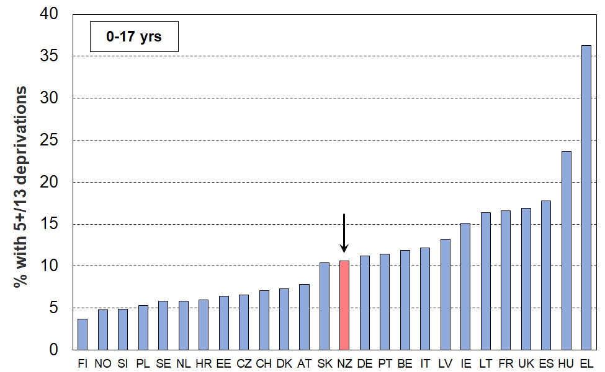**25 European countries + NZ (EU-SILC 2020, NZ HES 2020-21)**

Note for Figure 1: see Table D.1 in main report for country code abbreviations (p71).

* The 2020 EU-13 material hardship rate for New Zealand two parent households with one or two children is 7%, close to the EU median for this household type (6%). For two parent households with three or more children the New Zealand rate (17%) is above the median EU rate for this group (11%).
* For New Zealand sole parent households, the EU-13 material hardship rate is 29%, down from 34% in 2017, but still well above the European median for this household type (19%). New Zealand also has a relatively high proportion of sole parent households compared with European countries.

**Material hardship trends from 2007 to 2021**

Material hardship rates for children increased during the GFC and associated downturn, then steadily improved from 2013 to 2021 (**Figure 2**).

The downward trend can be attributed to a combination of rising employment rates, rising wages, increases to income support for families with children, increased support for housing and child-care costs, and other measures that reduce demand on the family budget (eg free doctors’ visits and the food-in-schools programme).

**Figure 2**

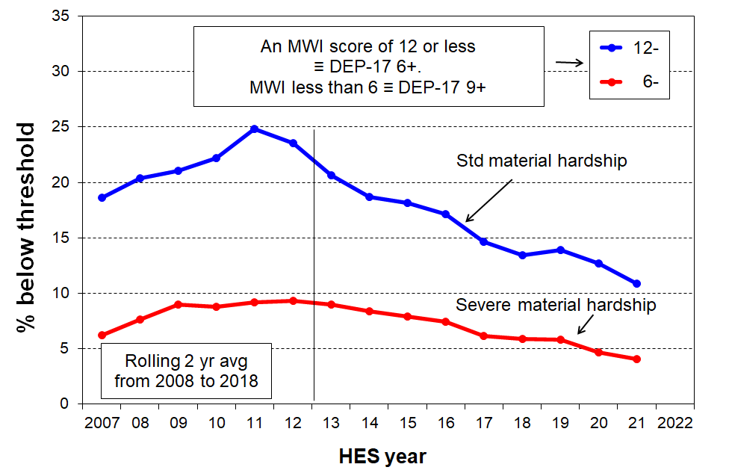**Material hardship trends for children (0-17 yrs), 2007 to 2021**

**Figure 3** shows the material hardship trends for sole-parent, two-parent and other multi-adult households with children. The hardship rate for children in sole-parent households is typically three to four times higher than for two-parent households. A major factor in the difference is the more limited potential for paid employment hours in a one-adult household, with or without children. (See the main report for more on this.)

**Figure 3**

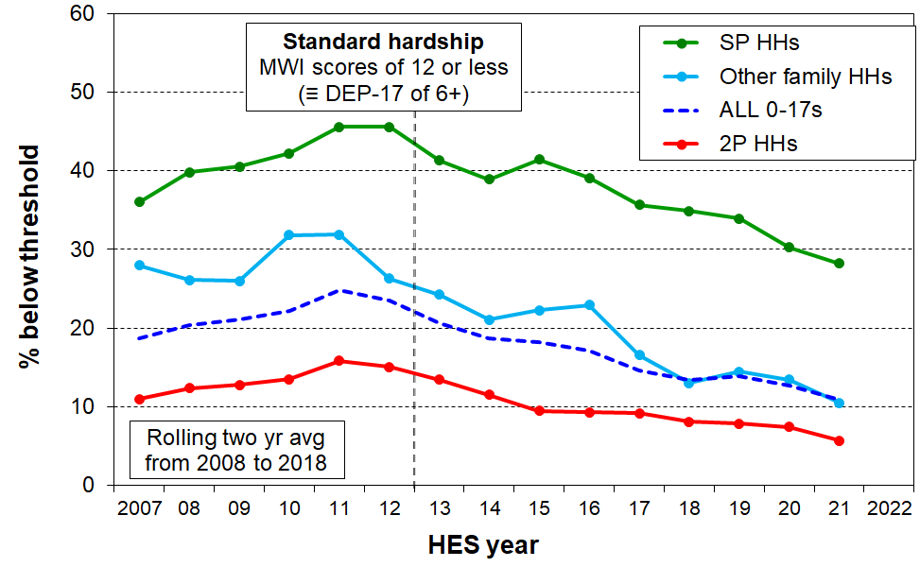 **Trends in material hardship for children (0-17 yrs), by household type**

Most children live in two-parent households (~70%), with 15% in sole-parent households and 15% in other multi-adult households.[5] This means that even though sole-parent hardship rates are much higher than for two-parent households, on average over the three most recent surveys (HES 2018-19, 2019-20, and 2020-21) around the same number of children in hardship come from each of sole-parent and two-parent households.

**Material hardship trends for ‘working’ and ‘beneficiary’ households**

In this section, ‘working’ means that most of the income for the household comes from the market, and ‘beneficiary’ means that most of the income comes from the government.[6] **Figure 4** shows the material hardship trends for the two groups of children, with beneficiary hardship rates being around four to five times higher than rates for children in working households.

**Figure 4**

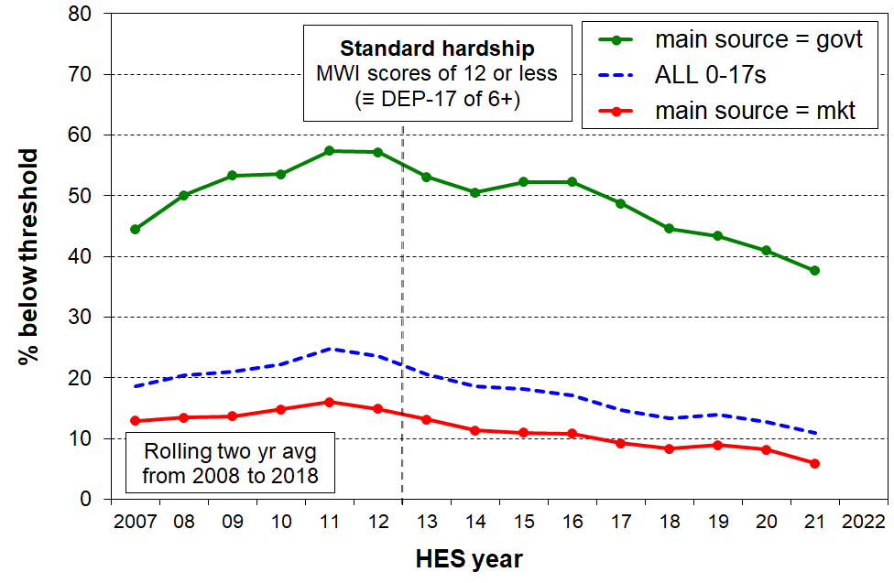 **Trends in material hardship rates for children (0-17 yrs), by main source of household income**

**Figure 5** reports on the composition of those in hardship: around the same number of children in households in hardship come from each group. Although working households have lower hardship rates, there are many more such households than beneficiary households, so the numbers even up

**Figure 5**

**Trends in the numbers of children (0-17 yrs) in households in material hardship,**

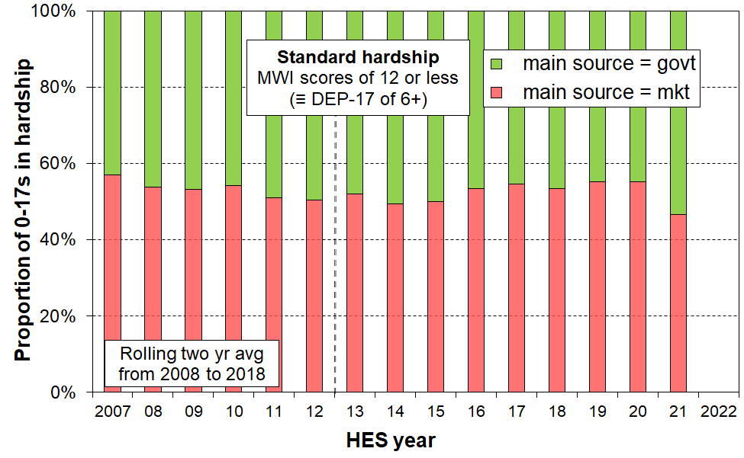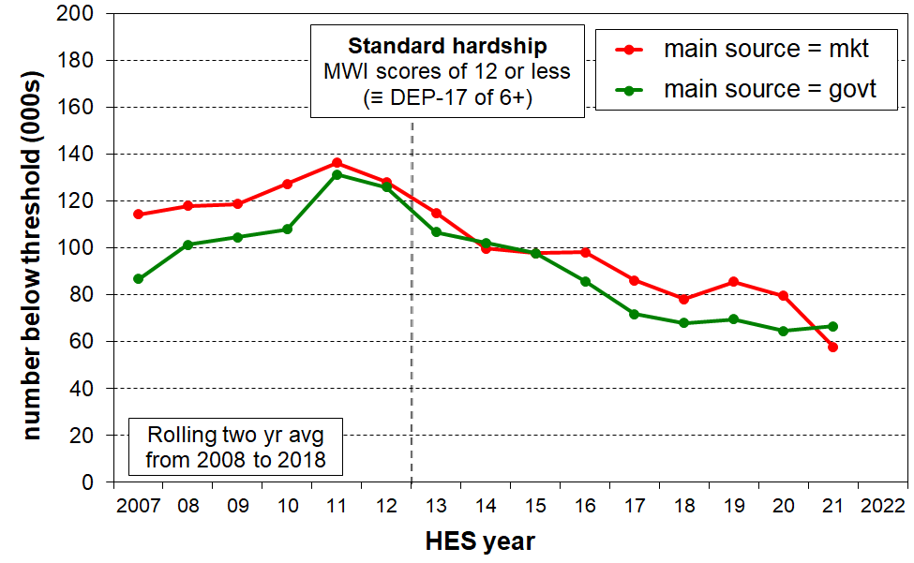**by main source of household income**

See the last page of this Overview for discussion of the often-made assertion that ‘paid work is the best way out of poverty’.

**Increasing proportion of dual-earner two-parent households**

**Figure 6** shows the trend to increasing work intensity among two-parent households with dependent children.

* The option of one partner in full-time paid employment and one not in paid employment (‘workless’) was the dominant pattern in the early 1980s. By the early 2000’s, the most common arrangement was for both parents to be employed full-time (~38%), and in 2021 the figure had reached almost one in two (49%).
* The one-FT-one-PT arrangement has been reasonably steady at 25-30%.
* Around three of every four two-parent families were dual-earner families in 2021, up from one in two in the early 1980s.
* This increasing proportion of dual-earner two-parent households is a major factor behind the longer-run consistent rise in material wellbeing for the vast majority of children, as indicated for example in **Figure 15** (a few pages below). It also points to / is consistent with the view that in general, single-earner households are now much less likely to be a viable option for providing economic security than they were 25-40 years ago.

**Figure 6**

**Increasing proportion of two-earner two-parent households (with dependent children),**

**1982 to 2021**

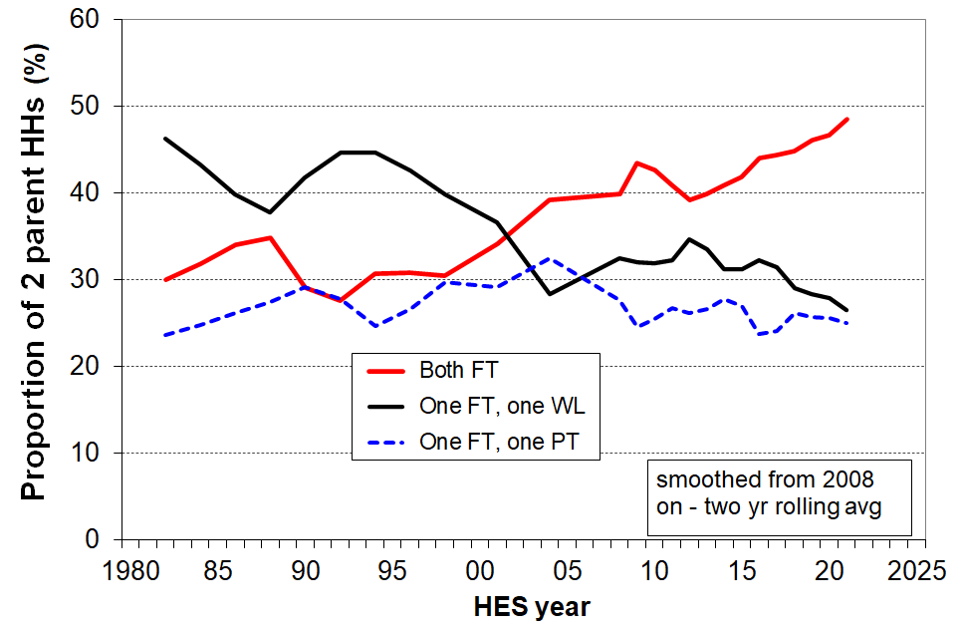

**Break in time series between HES 2017-18 and 2018-19 for income-based measures**

Up to HES 2017-18, Stats NZ merged information from the survey itself with modelled information produced by the Treasury for income items known to be inaccurately provided by many respondents. The resulting dataset is referred to as HES-TAWA. Starting with HES 2018-19 Stats NZ use and provide others with a dataset that derives most of its income information from administrative data, including tax records. This is referred to as HES-Admin.

The two datasets have some differences which mean that some income-based time series do not always mesh well between the two, especially for low incomes. This time series break is indicated in the MSD report by a vertical broken line in the charts. In some cases the trends across the discontinuity are seamless – in those cases, the MSD charts do not show the broken vertical line.

Not too much should be read into changes in trend levels between the trend lines based on the two datasets. The reader is advised to focus on the big picture. The text assists with that.

In addition, Stats NZ created a special time series for incomes back to 2007, based on the HLFS and the HES to create datasets with much larger sample sizes. They use analysis of this data in their published material. In this case there is no time series break from HES 2017-18 to 2018-19.

**Section N** in the main report has further detail on the datasets and **Section O** discusses some of the implications of moving to using administrative data for most of the income information.

**AHC low-income rates for children**

**Figure 7** shows the AHC low-income (poverty) rates for children for the four decades from 1981-82 to 2020-21, using both fully relative measures (the broken lines) and anchored or constant value measures (the solid blue lines).

The anchored line or ‘constant value (CV)’ measure sets the low-income threshold in a reference year and adjusts it forward and back using the CPI. In other words, the low-income threshold is fixed in real terms. The reported poverty rate rises if the incomes of low-income households decrease in real terms irrespective of what is happening to the incomes of the rest of the households … and vice versa. Figure 7 uses the AHC 50 CV measure, with two different reference years, 2007 and 2018.

* The solid blue CV-07 trend line reports an AHC 50 rate for children of around 18-20% in 2007 to 2012, much the same as in the 1980s. This is because the inflation-adjusted AHC incomes of low-income households with children were around the same in each time period.
* The AHC 50 CV-07 low-income rate doubled from 20% to 40% in a very short period in the late 1980s to early 1990s, reflecting rising unemployment, a falling average wage, demographic changes (more sole parent families), the 1991 benefit cuts and the introduction of market rents in (what we now refer to as) public housing.
* The rate then steadily fell through to 2008 with improving employment, a rising average wage, rising female employment, the introduction of income-related rents and Working for Families.
* The post-GFC slow-down led to a slight rise through to 2013, followed by a steady decline reflecting good economic conditions, a rising minimum wage and, more recently, higher housing support through changes to the Accommodation Supplement and increases in incomes for beneficiary families and households.

The three fully relative AHC trend lines (broken lines in Figure 7) show that low-income AHC rates for children were fairly flat over the 25 years from 1993 to 2018 on these measures, with some decrease in recent years. This indicates that low incomes were roughly keeping pace with median incomes, with no noticeable change in income inequality in the lower half of the AHC incomes distribution. In contrast, the large change in income inequality from the late 1980s to the early 1990s saw AHC low-income rates double during this period.

**Figure 7**

**Long-run trends in rates of low AHC household income for children (0-17 yrs),**

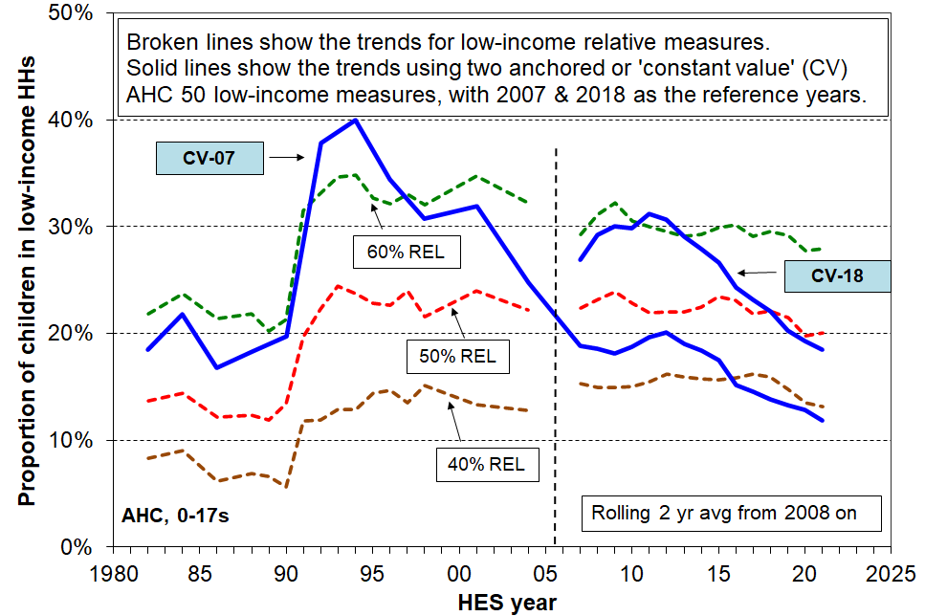**using both relative (‘moving’) thresholds and anchored (constant value) thresholds**

Notes for Figure 7:

* See box on previous page for information on the different datasets used for the time series.
* See the main report for information on the inflation adjustment approach used by MSD for the AHC CV lines.

If there is a downturn in coming years and inflation remains elevated then, all else equal, the AHC anchored poverty lines can be expected to rise. The relative lines are likely to remain flattish … or even fall, if median incomes fall more than do those of low-income households with children.

**Trends in low and middle incomes for households with children**

**Beneficiary households with children**

**Figure 8** shows the long-run trends (1947 to 2022) in inflation-adjusted (‘real’) base support for the most common beneficiary households / families:

* The incomes include benefit income and income from the Family Tax Credit and its predecessors, but exclude the Winter Energy Payment, Best Start and the Accommodation Supplement (AS).
* Incomes from the two sources noted have recently risen to be above the rates prior to the 1991 benefit cuts – for the first time since then.

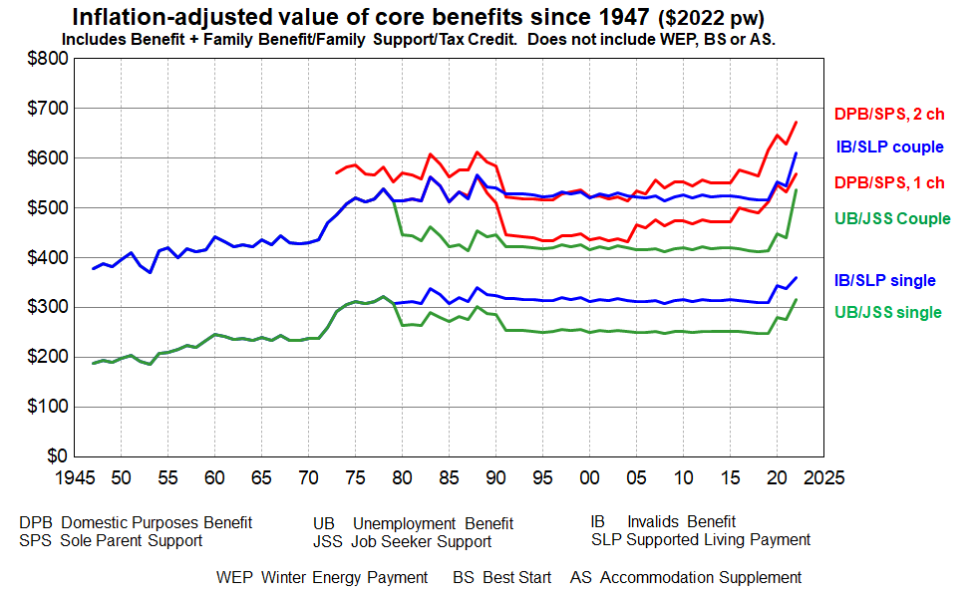**Figure 8**

**Source:** MSD collation from information from the Royal Commission on Social Security, Dept of Social Welfare Annual Reports, Income Support Service / Work and Income Fact Sheets & Budget 2022.

* While Figure 8 provides valuable information about key aspects of the trends in income of selected beneficiary recipients it does not tell the full story. In particular, it does not take account of either accommodation costs or the housing support provided through the Accommodation Supplement (AS) since 1993 or the Income-Related Rent subsidy (IRRS) for those in public housing (from 2000). The Temporary Additional Support (TAS) assistance can also have significant impact on the level of housing support for some.
* Net housing costs depend on both the level of housing costs and the entitlement to different housing subsidies. The subsidies are provided at different levels depending on geographical area, household income, and other factors. Given the wide variations in housing costs and subsidy amounts there are considerable challenges for producing a full ‘after housing costs and housing support’ time series using the example families approach as in Figure 8 above.
* Recent analysis by MSD using actual beneficiary income and housing costs data is now available in the ‘Total Incomes’ report. This information is used in **Figure 9** (next page).

**Figure 9** shows the percentage change in total income for all MSD clients (for all family types, equivalised) compared to growth in the CPI between 2006 and 2022. Income in this chart includes income from all sources including the WEP, BS and AS (see previous page for acronym glossary under Figure 8).

The blips in the trend lines reflect the WEP which applies for 22 weeks from May to September each year. Removing the blips / following the trend between blips gives an idea of the trend without the WEP.

* Total income before deducting housing costs (BHC) generally tracked a little above inflation up to around March 2018, then increased strongly to 2022. See blue lines in chart.
* Total income after deducting housing costs (AHC) generally tracked in-line with inflation (excluding housing) up to around March 2018. Since then AHC incomes have increased strongly in real terms.

**Figure 9**

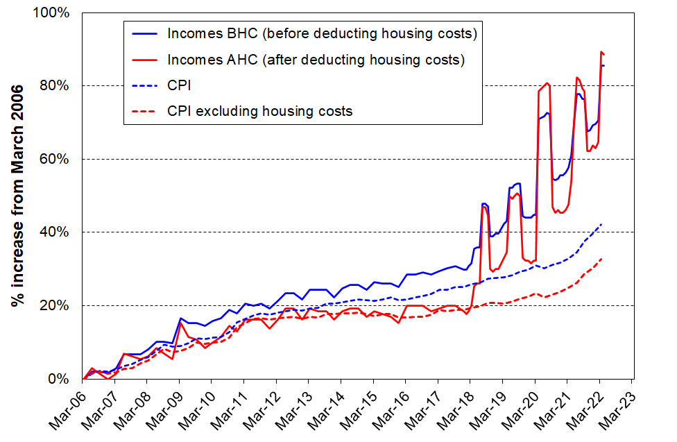**Change in total incomes (BHC and AHC) for** **beneficiary family and single-person units, 2006 to 2022**

Source: MSD Working Paper: Total incomes of MSD main benefit clients as at April 2022. [wp-total-incomes-of-msd-main-benefit-clients-as-at-april-2022.pdf](https://www.msd.govt.nz/documents/about-msd-and-our-work/publications-resources/working-papers/wp-total-incomes-of-msd-main-benefit-clients-as-at-april-2022.pdf)

* As noted in the Total Incomes document in the link below Figure G.9 this analysis has to impute housing costs for around 20% of beneficiaries whose housing costs are unknown as they do not receive AS, IRRS or TAS.

**Trends in accommodation costs relative to income for households with children**

**Figure 10** shows the trends in average housing costs as a proportion of average unequivalised income for selected income groupings (quintiles) of households with dependent children (with all adults under 65). Housing costs are:

* up from 15% in 1988 to 22% in HES 2021 for all households with children
* up from 23% to 40% for the lowest income quintile (Q1) and 19% to 30% for Q2.

**Figure 10**

**Avg housing costs relative to unequivalised income (%),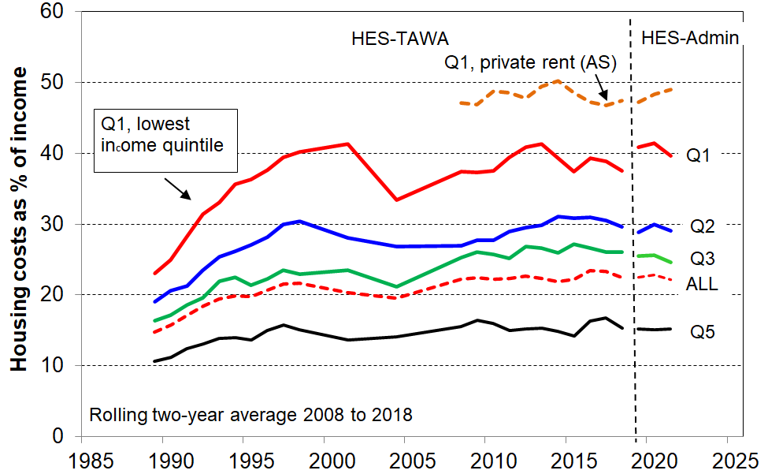 under 65 households with children, 1988 to 2021**

Note for chart.

The longer-term trend lines give robust indications of current and past levels of spending on accommodation relative to income, and of the relativities between groups (as reported in the associated text). The year-on-year fluctuations are not robust enough to support conclusions about rises or falls in these and similar short periods.

The reported Q1 proportion in Figure 10 (~40%) is dampened by the presence of households that reside in public housing for which the rent is capped at 25% of income. Most of these households are in Q1. For many in low-income households, rent makes up more than 40% of income. One such group are those that rent privately and receive the Accommodation Supplement (AS), with almost half of household income spent on accommodation on average by those in Q1 (top broken line in chart). This leaves very little for the other necessities and it is not surprising that this group has very high material hardship rates (46% for those in lowest one fifth (quintile) of this group and 32% overall).

**Figure 11** looks at housing costs relative to income a different way. It uses equivalised household income and includes all households to create the income quintile boundaries, not just households with children. For Q1 households with children that are renting and receiving the AS, 85% are spending more than 30% of their income on accommodation, 65% are spending more than 40%, and around 40-45% spend more than half their income on accommodation. Households with such high relative accommodation costs have very low residual or after-housing-costs (AHC) income.

**Figure 11**

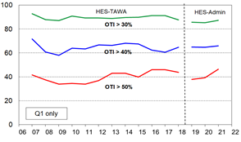**Spending on accommodation as a proportion of BHC income (%) for low-income (Q1) households with children, renting privately and receiving the Accommodation Supplment (AS), 2007 to 2021, using OTIs**

Note for chart: OTI = (housing) outgoing-to-income ratio

**Incomes for all households with children: trends by household type and ethnicity of the children[7]**

**Figure 12** shows the rising trend in ‘real’ CPI-adjusted median incomes after deducting housing costs (AHC) for households with children and for couple-only (<65) households for comparison.

* Incomes for two-parent households generally track much the same as the overall population median, other multi-adult family households with children a little lower, and sole-parent households much lower, albeit on the rise in real terms.
* AHC incomes for sole-parent households have tracked at around 50% of the median since the 1991 benefit cuts. The actual dollar gap between sole-parent household incomes and the median has increased in real terms in the period.

**Figure 12**

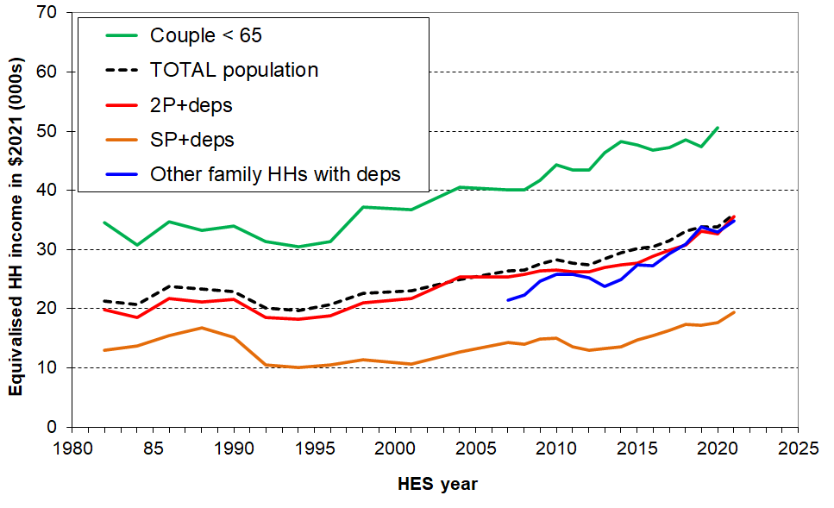**Median incomes (equivalised AHC) of selected household types in $2021**

**Figure 13** reports median AHC household income for children by ethnicity in real (CPI-adjusted) terms. There have been solid net gains in real terms since 2007 for children in each of the main ethnic groups, albeit with different trajectories through and immediately after the GFC (around a 35% real (CPI-adjusted) gain for all four groups since 2007).

**Figure 13**

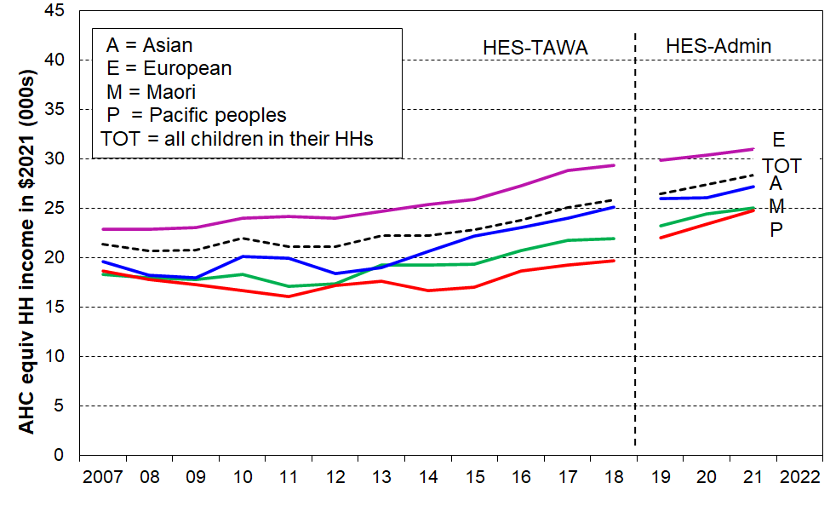 **Median AHC household incomes for children, by (total) ethnicity ($2021), HES 2007 to 2021**

The rising trends shown in the two charts above are part of the explanation as to why the vast majority of New Zealand households with children report experiencing steadily rising material living standards since the mid-1990s (see **Figures 14 and 15** on next page).

**Two other indicators of overall improvement in financial and material wellbeing for households with children**

**Falling trend for households with children reporting ‘not enough’ income for basics**

**Figure 14** shows the falling trend for households with children who respond with ‘not enough’ to the self-assessed income adequacy question about household income being enough to cover the basics of food, accommodation, clothing, electricity, and so on. There is a decline overall, as expected, but for the purposes of this report it is the decline in the rate for the lowest AHC quintile (Q1) that is of particular relevance, from 46% in HES 2013 to 28% in HES 2021.

**Figure 14**

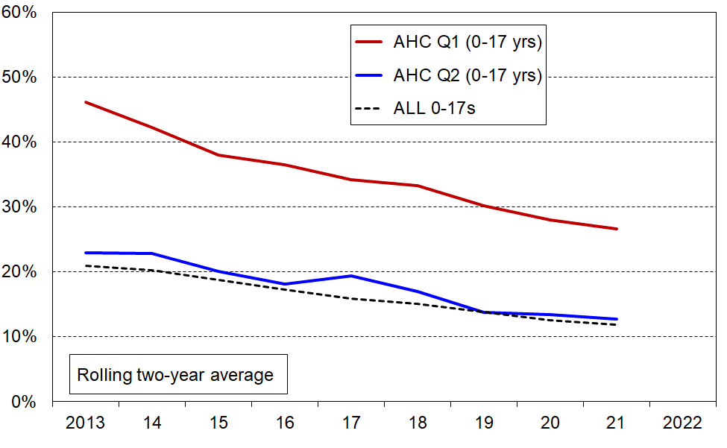**Self-assessed household income as ‘not enough’** – **falling trend for households with children**

**Improving material wellbeing overall**

Using the Material Wellbeing Index (MWI) to report on trends is similar to using an anchored line household income measure. The same fixed standard is used from one survey to the next, whereas the moving or relative line approach for incomes uses a moving standard or reference point, namely, median household income. **Figure 15** makes use of this feature, starting with a given MWI score (level of material wellbeing) in 2012-13 and showing the increasing proportions of children in households achieving that level over the period to 2020-21.

The maximum possible MWI score is 35. Material hardship rates are calculated using an MWI score of 12 or less. Figure 15 shows the trends in material wellbeing from 2013 on, with the top line representing those with a score over 14, a little above the standard hardship threshold. 78% of children were in households with these scores in 2012-13 and by 2020-21 it had reached 86%. For the lower line (representing children in households with above average / very good material living standards), 31% of children were in households with a score over 28 in 2012-13. By 2020-21 this proportion had reached 47%.

**Figure 15**

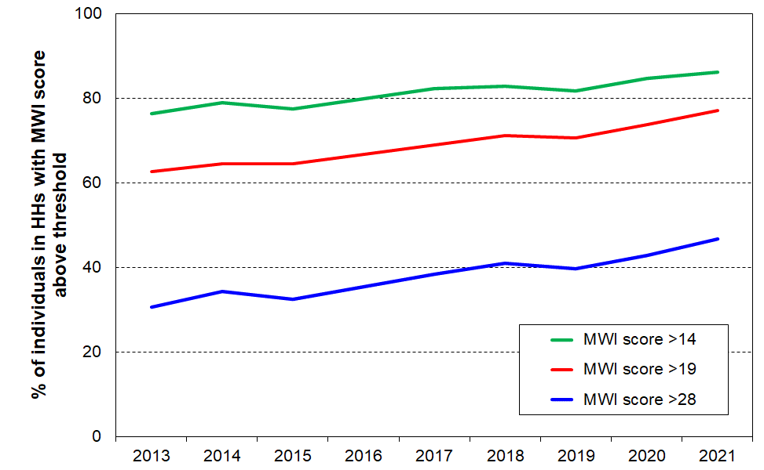 **Rising trends in material wellbeing for children (0-17 yrs), starting with selected levels in 2012-13**

**Income matters for ‘making ends meet’, but so do other factors …**

As discussed in the introduction to this Overview, a key theme of the report is that not all low-income households report being in material hardship and some households with incomes above low-income lines (poverty lines) do report hardship. The mismatch or limited overlap between income and hardship measures arises for two sorts of reasons:

* *For some low-income households* their past income could have been higher than current income and they have savings to draw on; they may have a well-established set of household goods and appliances and little or no debt servicing; they may have financial or significant in-kind support from outside the household; if household income is mainly from self-employment, legitimately declared low household income will usually bear little relationship to the resources available; and so on.
* For some *households with incomes above low-income lines (income poverty lines)* they may have above average demands on the household budget (eg significant health-related costs or high debt servicing costs); or have been on low-income over several previous years; or be trying to make do on a much lower income than previously after a relationship break-up; or for a range of reasons have great difficulty in turning income and other material resources into valuable consumption; and so on).

**Figure 16** and the associated table below shows the impact of the differing levels of liquid assets held by that for households with similar AHC incomes: higher levels of liquid financial assets mean lower levels of material hardship. This is hardly a surprising finding, but it is not often to the fore in discussion and debate, and it is rare for a single dataset to have all three pieces of information (income, liquid assets (such as savings and accessible investments) and material hardship) to enable the analysis to be done.

**Figure 16**

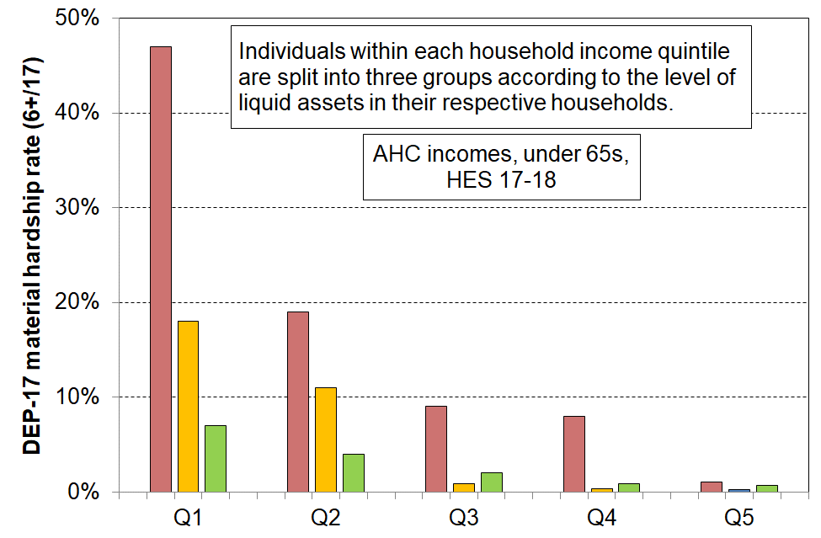 **Material hardship rates depend on the level of liquid financial assets as well as on HH income**

Reading notes for Figure A.2 and associated table below:

* The five quintiles are quintiles of AHC household income – Q1 is the lowest quintile and so on.
* Individuals within each household income quintile are ranked by their household’s level of liquid assets, then split into three equal-sized groups.

|  |  |  |  |  |  |  |  |  |  |
| --- | --- | --- | --- | --- | --- | --- | --- | --- | --- |
| **Household Economic Survey 2017-18** | **Q1** | | | **Q2** | | | **Q3** | | |
| median liquid assets ($) | 0 | 400 | 8,000 | 100 | 1,200 | 12,000 | 500 | 3,600 | 19,300 |
| can pay an unexpected + essential $500 bill within a month without borrowing (%) | 24 | 43 | 67 | 51 | 71 | 79 | 69 | 84 | 85 |
| used a foodbank more than once in previous 12 months (%) | 25 | 10 | 2 | 6 | 4 | 1 | 4 | 0 | 0 |
| put up with cold ‘a lot’ to save on costs (%) | 25 | 14 | 11 | 10 | 8 | 4 | 7 | 5 | 4 |
| borrowed from fam/friends more than once in previous 12 months to pay for basics (%) | 34 | 17 | 9 | 18 | 9 | 4 | 10 | 3 | 2 |
| self-assessed income adequacy – ‘not enough’ | 46 | 21 | 17 | 22 | 10 | 6 | 14 | 6 | 4 |
| material hardship rate (%) (6+/17, DEP-17) | 47 | 18 | 7 | 19 | 11 | 4 | 9 | 1 | 2 |
| avg AHC household income (equivalised) | 11,000 | 11,000 | 10,000 | 21,000 | 21,000 | 22,000 | 30,000 | 31,000 | 31,000 |

**Figure 17** shows how the mismatch described above works out in practice for households at different income levels. For this chart, households with children are divided into four groups according to their DEP-17 scores: the hardship group (DEP-17 = 6+); the ‘no hardship’ group (DEP-17 = 0); and two groups in between for illustrative purposes.

As expected, the lower the income, the higher is the material hardship rate (red) and the lower is the ‘no hardship’ rate (darker green). There are however some with incomes above BHC 50 and even above BHC 65 who report hardship, as well as some with low incomes who are doing reasonably well or very well (light and darker green). The orange group (DEP-17 scores of 3-5) could be described as ‘only just getting by’, and are vulnerable to shocks such as an unexpected vehicle or dentist bill or sudden loss of income through illness or reduced total paid employment hours for the household. There are a good number of such households well above the usual low-income thresholds / poverty lines.

**Figure 17**

**Material wellbeing / hardship for children in households in lower, middle and higher BHC income bands,**

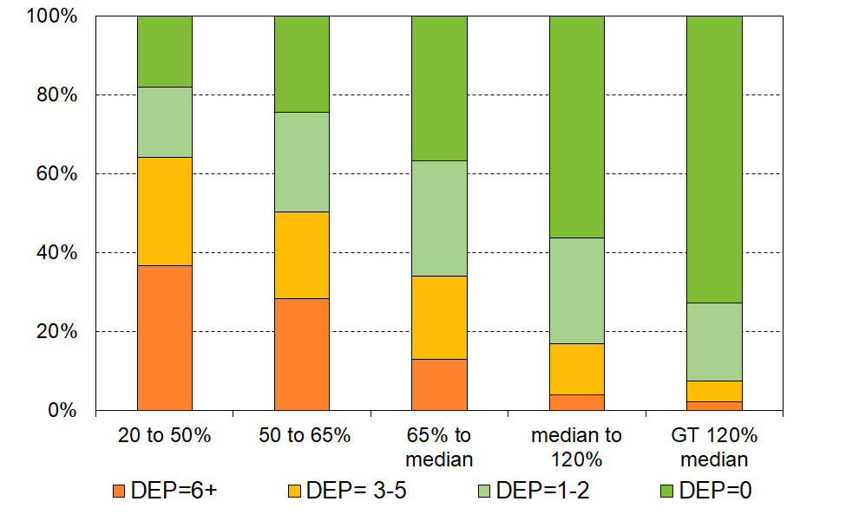 **HES 2018-19**

Figure 17 above reported on the material hardship and material wellbeing rates for different household income bands. **Figure 18** looks at it the other way: it starts with the children living in households reporting material hardship (DEP-17 scores of 6+) and reports what AHC income bands their households come from.

* around one in four (26%) come from households with incomes below 40% AHC
* only 44% come from households with incomes below 50% AHC
* almost one in three (29%) come from households with incomes above 70% AHC.

**Figure 18**

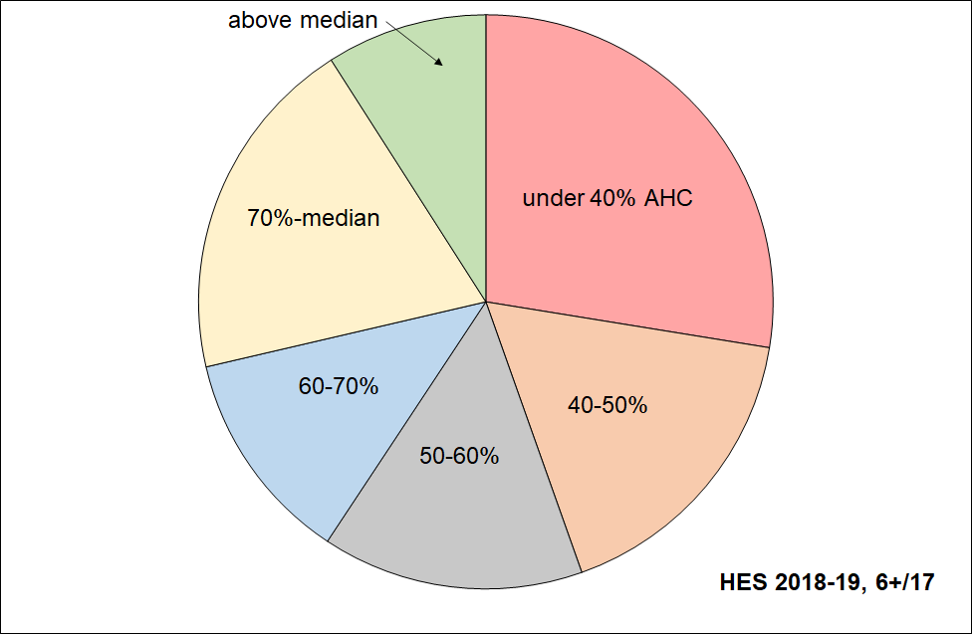**Distribution across household AHC income bands of children identified as in hardship (DEP-17, 6+)**

* **Figure 19** shows the overlaps between three measures : BHC 50, AHC 50 and material hardship (6+/17 using DEP-17 index). Note that the AHC 50 measure here is the relative version not the fixed line as used in the primary measures for CPRA purposes. The analysis uses the average of HES 2018-19, 2019-20 and 2020-21.
* Most of those in households with incomes below BHC 50 also have incomes below AHC 50 (the green-red overlap, around 85%). The rest of those with income below AHC 50 come from households with incomes above the BHC threshold, but whose housing costs are relatively large.
* Just under half (45%) of those in material hardship come from the low-income AHC group (the black-green overlap). The other half come from households with incomes higher than this.
* The fact that the overlaps are not 100% between low-income and material hardship means that policies to reduce material hardship need to consider including elements that improve the incomes and/or reduce the expenditure of those above the usual low-income poverty lines.

**Figure 19**

**3-way overlap: average of HES 2018-19, 2019-20 and 2020-21 for children (0-17 yrs)**

BHC 50% of median moving line income measure

11% (~125,000)

Material hardship

12% (~130,000)

AHC 50% of median moving line income measure

18% (~200,000)

Reading note for Figure 19:

* Both the income measures are fully relative ones (BHC 50 and AHC 50).
* The low-income rates and numbers in Figure 19 are a little lower than the official rates and numbers published by Stats NZ (~2 ppt lower). This difference arises from the treatment of the data that this report applies – households with reported incomes well below the minimum safety net levels of the social welfare system (ie typically less than BHC 20), yet also reporting that their income is enough or more than enough for the basics are not counted in the MSD report. See **Section N** in the main report for a full discussion. The overlap findings reported in the text above Figure 19 are impacted only slightly by this treatment.

**Material hardship trends for children in low-income households (‘poor children’) and for children in ‘non-poor’ and ‘near-poor’ households**

**Figure 21** shows the trends in the numbers of children in households reporting material hardship for those in both income-poor and non-income-poor households. In this chart, low-income means households with AHC incomes below 60% of the AHC median. (This higher threshold is needed to ensure that there are enough sample numbers in each sub-group to provide a robust time series including the years when the HES was a smaller survey.)

**Figure 21**

**Material hardship numbers for those in income-poor and non-income-poor households,**

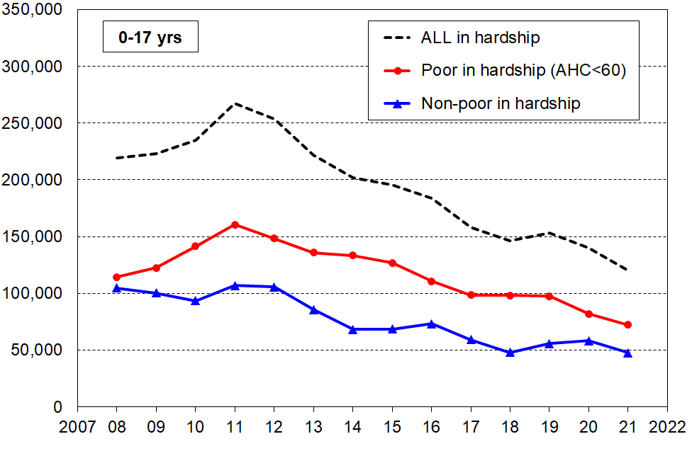**2007 to 2021, 0-17 years**

In recent years, around 35-40% of those in hardship come from households with incomes above the AHC 60 low-income threshold (blue line numbers as a proportion of broken line numbers). Around half of these come from ‘near-poor’ households, with incomes of 60 to 80% of the AHC median.

**Table 1** shows the household income levels for 60% and 80% of the median in ordinary unequivalised dollars for selected household types to give an idea of what ‘poor’ and ‘near-poor’ mean for household budgets for this analysis.

**Table 1**

**AHC 60% and 80% of median thresholds in ordinary unequivalised 2022 dollars,**

**selected household types, with children, $ per week AHC**

|  |  |  |  |  |  |  |
| --- | --- | --- | --- | --- | --- | --- |
|  | **(1,1)** | **(1,2)** | **(2,1)** | **(2,2)** | **(2,3)** | **(2,4)** |
| AHC 60% | 550 | 680 | 765 | 890 | 1,020 | 1,145 |
| AHC 80% | 735 | 905 | 1,020 | 1,190 | 1,360 | 1,530 |
| AHC median | 920 | 1,130 | 1,275 | 1,485 | 1,700 | 1,910 |

Notes:

* The figures above are calculated before any treatment is applied to the dataset
* The $2022 numbers are the actual HES 2020-21 numbers inflated by 8% (the CPI change from the 2020-21 average to June 2022)

**Material hardship, low income and foodbank usage in six Auckland regions**

When Auckland's eight former councils were merged into a single ‘Super City’ in 2010, the Auckland region was divided into 13 wards and 21 local boards. The analysis in this section uses groupings of selected wards to enable a breakdown of the Auckland region into six sub-regions, as in **Table 2.**

**Table 2**

**The six sub-regions defined by the agglomeration of selected wards**

|  |  |
| --- | --- |
| **Sub-region** | **Wards included in the sub-region** |
| Northern | North Shore, Albany and Rodney |
| Western | Waitākere (incl Massey-Henderson-Te Atatū); and Whau (incl New Lynn, Green Bay, Kelston, Avondale, Blockhouse Bay) |
| Central 1 | Albert-Eden-Puketāpapa (incl Pt Chevalier, Mt Albert, Mt Roskill, Balmoral, Mt Eden, Epsom, Royal Oak, Lynfield); and Ōrākei (incl Parnell, Newmarket, Remuera, Meadowbank, Ōrākei, Mission Bay, St Heliers, Glendowie) |
| Central 2 | Maungakiekie-Tāmaki (incl One Tree Hill, Onehunga, Te Papapa, Mt Wellington, Ellerslie, Panmure, Point England, Glen Innes, St Johns); and Waitematā-Gulf (incl Grey Lynn, Westhaven, Waiheke) |
| Southern | Manukau and Manurewa-Papakura |
| Howick-Franklin | Howick and Franklin |

Note for table:

Follow the link and scroll down for an Auckland map showing the wards: <https://www.aucklandcouncil.govt.nz/about-auckland-council/how-auckland-council-works/governing-body-wards-committees/wards/Pages/find-your-ward.aspx>

**Table 3** gives an indication of the size of each grouping of wards and of the differing levels of material and financial hardship for children across the Auckland region. The figures in the tables are the average for the three surveys 2018-19, 2019-20 and 2019-20, to ensure there are sufficient numbers in the joint sample to give robust findings on the various statistics. There is no evidence of any upward or downward trend over the three years so taking the average does not lose any information.

Four measures of material and financial hardship are reported:

* AHC 50 REL: the proportion (%) of people (children) living in households that have an after-deducting-housing costs (AHC) income of less than half the AHC median for the whole country.
* MH 6+: the standard material hardship measure used by Stats NZ and this report, households lacking 6 or more of the 17 items in the DEP-17 index.
* MH 9+: the severe hardship version of the above.
* Foodbank usage: the proportion (%) of people (children) living in households that report using a foodbank or similar at least once in the 12 months prior to interview.

**Table 3**

**Low-income (AHC 50), material hardship and foodbank usage for Auckland and six groupings of wards: children (0-17 yrs), average over 2018-19 to 2020-21 (%)**

|  |  |  |  |  |  |
| --- | --- | --- | --- | --- | --- |
| **Geographic Area** | **AHC 50** | **MH 6+** | **MH 9+** | **Total # of children** | **Foodbank %** |
| New Zealand | 18 | 12 | 5 | 1,142,000 | 10 |
| Auckland | 19 | 12 | 6 | 391,000 | 9 |
| Northern wards | 16 | 5 | 2 | 99,000 | 4 |
| Western wards | 21 | 10 | 4 | 59,000 | 10 |
| Central 1: Albert-Eden-Roskill & Ōrākei, | 14 | 4 | 2 | 53,000 | 3 |
| Central 2: Maungakiekie-Tāmaki & Waitematā-Gulf | 19 | 17 | 10 | 29,000 | 13 |
| Southern wards | 25 | 28 | 13 | 93,000 | 19 |
| Howick-Franklin wards | 18 | 7 | 3 | 57,000 | 5 |

The numbers that immediately grab one’s attention are those for the Southern wards:

* 28% of children in material hardship compared with a country-wide figure of 12% on average over the three surveys
* 13% in severe material hardship compared with 5% country-wide
* 19% of children in households using a foodbank at least once in the 12 months prior to interview, compared with 10% country-wide.

Looking at the figures another way, children (under-18s) living in the Southern wards make up:

* 24% of Auckland’s under-18 population but 53% of under-18 Aucklanders in material hardship
* 8% of the country’s under-18s, but 20% of all under-18s in material hardship.

**Those in deepest financial and material hardship – the lowest ventile (5%)**

In the findings reported so far there is a range of evidence to support the conclusion of improving material wellbeing for the bulk of New Zealand children and their households, from both longer-term and shorter-term perspectives, and of reducing material and financial hardship.

The evidence, however, only goes so far as the 2020-21 Household Economic Survey (HES) and does not therefore include the ongoing COVID-related impact and that of the high inflation rate in 2021-22. Future surveys will capture these impacts. What is clear is that in 2020-21 there were fewer children in households experiencing financial and material hardship than in 2006-07, just before the impact of the GFC- and drought-driven downturn began to be evident in the HES data.

While these are robust findings, it is important to not lose sight of the fact that the HES data also identifies the very severe hardship being experienced in any given survey by some 5% or so (~60,000 children). This estimate of severe hardship should be taken as a lower bound as the HES covers only those children in households in private dwellings, but not those in non-private dwellings such as hotels, motels, boarding houses, hostels and camping grounds and so on. Other sorts of surveys are needed to obtain a picture of what life is like for those in more transient accommodation or those ‘living rough’.[8]

**Table 4** on the next page focuses on the most materially disadvantaged children, based on the 2018-19 HES (the largest HES there is). Children are ranked by the material wellbeing index (MWI) score of their household then divided into ten equal-sized groups (deciles), and also into twenty equal-sized groups (ventiles or 5% groupings). The group of 5% in households reporting the greatest hardship is close to the same size as the DEP-17 9+ severe material hardship group (6%). The overlap between the two is around 80%.

The table show the seriously high disadvantage and lack of basics for children in the V1 group (see especially the multiple disadvantage panels giving the rates of deprivation for selected numbers of items out of the 12 and 18 listed basics).

The numbers for 2020-21 are a little better on some individual items, but have not changed for the multiple disadvantage measures reported in Table 4.

The HES is a cross-sectional survey – not a longitudinal survey in which the same individuals are followed from one interview to the next, year-on-year – so we cannot say whether the lower ventile contains the same or mostly the same children over time. It is likely though that for a good proportion of these children, the severe hardship lasts more than just one year. This assessment is supported by analysis of data from Stats NZ’s longitudinal Survey of Family, Income and Employment (SoFIE, 2003 to 2009). This shows that of the 8% of all children in households reporting the greatest hardship in a given wave, around 45% were still in this hardship band two years later. Findings from the *Growing up in Ireland* longitudinal survey also support the assessment.[9]

Even if all the 5% in Table 2 (next page) were experiencing this severe hardship for ‘only’ 12 months, then experienced good improvement, this is still a state-of-affairs that the bulk of New Zealanders would find unacceptable.

**Tables 5a and 5b** show which groups of children are in the most serious hardship. The 9+/17 columns give the numbers for those in severe material hardship using the CPRA measure (6%). **Table 5a** reports by various household characteristics and circumstances (number of children, main source of income, tenure, and so on). **Table 5b** reports by the ethnicity of the children.

Stats NZ’s new longitudinal survey, *Living in Aotearoa*, will in a few years be able to provide updated and more robust information on all of this and more. First wave interviews began in April 2022.

**Table 4**

**Children’s restrictions by the MWI score of their household (children, 6-17 yrs),**

**grouped by deciles and ventiles of children**

**HES 2018-19 (%)**

|  |  |  |  |  |  |  |  |  |  |
| --- | --- | --- | --- | --- | --- | --- | --- | --- | --- |
|  | **All** | **V1** | **V2** |  | **D1** | **D2** | **D3** | **D4** | **D5** |
| **Distribution of children (6-17yrs) across MWI deciles of children (%)** | 100 | 5 | 5 |  | 10 | 10 | 10 | 10 | 10 |
| **Don’t have** |  |  |  |  |  |  |  |  |  |
| 2 pair of shoes in good condition and suitable for daily activities for each child | 7 | 49 | 23 |  | 36 | 15 | 5 | . | . |
| 2 sets of warm winter clothes for each child | 2 | 20 | . |  | 13 | 3 | . | . | . |
| waterproof coat for each child (because of the cost) | 5 | 40 | 17 |  | 28 | 7 | 4 | . | . |
| separate bed for each child | 5 | 30 | 20 |  | 25 | 10 | 5 | 5 | . |
| fresh fruit and vegetables daily | 7 | 58 | 32 |  | 45 | 12 | 6 | 3 | . |
| meal with meat, fish or chicken (or vegetarian equiv) each day | 6 | 42 | 21 |  | 31 | 13 | 5 | 4 | . |
| good access at home to a computer and internet for homework | 6 | 40 | 14 |  | 27 | 14 | 6 | 6 | . |
| friends around to play and eat from time to time (because of the cost) | 4 | 31 | 10 |  | 21 | 7 | . | . | . |
| **Economised ‘a lot’ on children’s items to keep down costs to enable other basic things to be paid for (not just to be thrifty or to save for a trip or other non-essential)** | | | | | | | | | |
| had to go without music, dance, kapa haka, art, swimming or other special interest lessons (“a lot”) | 7 | 42 | 27 |  | 35 | 17 | 10 | 3 | . |
| unable to pay for school trip or other school event (“a lot”) | 3 | 26 | 21 |  | 24 | 6 | . | . | . |
| involvement in sport had to be limited (“a lot”) | 6 | 37 | 28 |  | 32 | 15 | 6 | . | . |
| continue to wear shoes or clothes that are worn out or the wrong size (“a lot”) | 3 | 26 | 13 |  | 19 | 7 | . | . | . |
| **Multiple restrictions of child-specific items (the 12 above)** |  |  |  |  |  |  |  |  |  |
| 2+ out of 12 | 12 | 79 | 58 |  | 68 | 28 | 12 | 5 | . |
| 3+ out of 12 | 8 | 71 | 35 |  | 53 | 17 | 6 | . | . |
| 4+ out of 12 | 6 | 61 | 25 |  | 43 | 9 | . | . | . |
| **Child-relevant general household items** |  |  |  |  |  |  |  |  |  |
| received help (food, clothes, money) from a community organisation more than once in the last 12 months | 5 | 42 | 20 |  | 31 | 9 | 5 | 3 | . |
| accommodation crowded or severely crowded (1+ extra bedrooms needed) | 13 | 34 | 27 |  | 31 | 23 | 18 | 18 | 9 |
| accommodation severely crowded (2+ extra bedrooms needed) | 3 | 7 | . |  | 6 | 6 | 4 | 5 | . |
| dampness or mould a ‘major problem’ in the accommodation | 8 | 39 | 33 |  | 36 | 20 | 10 | 7 | 4 |
| respondent reports putting up with feeling cold to keep down costs for other basics (‘a lot’) | 10 | 64 | 33 |  | 49 | 27 | 12 | 6 | 2 |
| delayed replacing or repairing broken or damaged appliances to keep down costs for other basics (‘a lot’) | 12 | 78 | 46 |  | 62 | 29 | 16 | 8 | 3 |
| household has no access to car or van for personal use | 5 | 17 | 10 |  | 14 | 7 | 9 | 3 | 4 |
| **Multiple restrictions out of 12 child-specific and 6 general child-relevant household items (18 in all) – uses severe over-crowding** | | | | | | | | | |
| 3+ out of 18 | 14 | 90 | 66 |  | 78 | 34 | 12 | 3 | . |
| 4+ out of 18 | 9 | 81 | 47 |  | 64 | 18 | 5 | . | . |
| 5+ out of 18 | 7 | 71 | 30 |  | 50 | 11 | . | . | . |
| **Postponed doctor’s visits ‘a lot’ to keep down costs to enable other basic things to be paid for (not just to be thrifty or to save for a trip or other non-essential)** | | | | | | | | | |
| For children (a lot) | 2 | 12 | . |  | 8 | 5 | . | . | . |
| For respondent (a lot) | 11 | 60 | 44 |  | 52 | 33 | 13 | 8 | 4 |
| **Respondent reports life satisfaction** |  |  |  |  |  |  |  |  |  |
| dissatisfied or very dissatisfied with life | 6 | 30 | 16 |  | 23 | 14 | 8 | 6 | 3 |
| satisfied or very satisfied with life | 79 | 35 | 50 |  | 42 | 60 | 68 | 80 | 81 |

Note: Information is suppressed in cells with fewer than 15 households in the sample.

**Table 5a (= Table B.1a)**

**Material hardship rates and composition for selected population groups (DEP-17 index, 5 thresholds),**

**Children (aged 0-17 years), HES 2018-19**

|  |  |  |  |  |  |  |  |  |  |  |  |  |
| --- | --- | --- | --- | --- | --- | --- | --- | --- | --- | --- | --- | --- |
| **HES 2018-19** | **Material hardship rates** | | | | | **Material hardship composition** | | | | | **Overall composition** | |
|  | what % of this group is in hardship, using the different thresholds? | | | | | what % of all those in hardship (using a given threshold) are in this group / cell? | | | | | **000’s** | **%** |
| **Material hardship threshold as # of items lacked out of 17** | **5+** | **6+** | **7+** | **8+** | **9+** | **5+** | **6+** | **7+** | **8+** | **9+** | **ALL** | **ALL** |
|  |  |  |  |  |  |  |  |  |  |  |  |  |
| **All children (0-17 yrs)** | 18 | 13 | 10 | 8 | 6 | 100 | 100 | 100 | 100 | 100 | 1,135 | 100 |
| **Household type** |  |  |  |  |  |  |  |  |  |  |  |  |
| 2P HH with any dependent children | 12 | 9 | 7 | 5 | 3 | 48 | 46 | 44 | 42 | 37 | 785 | 69 |
| SP HH with any dependent children | 40 | 32 | 26 | 20 | 17 | 32 | 34 | 35 | 37 | 41 | 160 | 14 |
| Other fam HHs with any dep ch | 23 | 16 | 14 | 10 | 8 | 20 | 19 | 21 | 21 | 22 | 180 | 16 |
| Other HHs (some 0-17s, no dep ch) | Cell sizes too small – rates suppressed | | | | | 1 | 1 | 0 | 1 | 0 | 10 | 1 |
| **Number of dep children in household** |  |  |  |  |  |  |  |  |  |  |  |  |
| 1 | 14 | 11 | 8 | 6 | 5 | 17 | 17 | 17 | 17 | 18 | 245 | 22 |
| 2 | 14 | 10 | 8 | 5 | 4 | 33 | 33 | 32 | 30 | 30 | 485 | 43 |
| 3 | 19 | 13 | 11 | 9 | 6 | 25 | 23 | 24 | 27 | 24 | 255 | 23 |
| 4+ | 35 | 27 | 22 | 16 | 13 | 24 | 26 | 27 | 26 | 28 | 140 | 12 |
| **Work intensity (2P & SP, adults all ages)** |  |  |  |  |  |  |  |  |  |  |  |  |
| 2P - both FT | 9 | 6 | 5 | 3 | 1 | 11 | 11 | 10 | 8 | 5 | 260 | 23 |
| 2P - FT PT | 10 | 7 | 5 | 4 | 2 | 8 | 8 | 7 | 7 | 6 | 165 | 15 |
| 2P - FT WL | 18 | 12 | 9 | 6 | 4 | 16 | 15 | 14 | 14 | 13 | 185 | 17 |
| SP - FT | 23 | 17 | 12 | 10 | 7 | 6 | 6 | 6 | 6 | 6 | 55 | 5 |
| SP - PT | 39 | 28 | 22 | 15 | 11 | 6 | 6 | 6 | 5 | 5 | 30 | 3 |
| Other | 25 | 19 | 15 | 12 | 10 | 52 | 54 | 57 | 60 | 65 | 430 | 38 |
| **Labour market status of household** |  |  |  |  |  |  |  |  |  |  |  |  |
| Self-employed | 4 | 2 | 1 | 1 | 0 | 2 | 2 | 1 | 1 | 1 | 140 | 12 |
| At least one FT worker | 14 | 10 | 7 | 5 | 3 | 57 | 54 | 52 | 48 | 44 | 820 | 72 |
| No FT worker (may have PT) | 47 | 38 | 31 | 25 | 20 | 41 | 44 | 47 | 50 | 55 | 175 | 16 |
| PT work only | 34 | 25 | 19 | 15 | 11 | 10 | 10 | 10 | 10 | 10 | 60 | 5 |
| Some work (excl SE) | 15 | 11 | 8 | 6 | 4 | 67 | 64 | 61 | 59 | 54 | 875 | 77 |
| Workless | 53 | 44 | 37 | 30 | 25 | 31 | 34 | 38 | 40 | 45 | 120 | 10 |
| **Source of HH income in the 12 months prior to interview** |  |  |  |  |  |  |  |  |  |  |  |  |
| Main source market | 12 | 9 | 6 | 4 | 3 | 60 | 56 | 52 | 48 | 45 | 975 | 86 |
| Main source government | 52 | 42 | 35 | 29 | 23 | 40 | 44 | 48 | 52 | 55 | 160 | 14 |
| **Tenure of household** |  |  |  |  |  |  |  |  |  |  |  |  |
| Owned with mortgage (incl Family Trust) | 8 | 5 | 3 | 2 | 1 | 22 | 18 | 14 | 13 | 11 | 540 | 47 |
| Owned no mortgage (incl FamilyTrust) | 5 | 3 | 3 | 3 | 2 | 3 | 3 | 3 | 4 | 4 | 120 | 10 |
| Private rental | 29 | 23 | 19 | 14 | 11 | 53 | 56 | 59 | 58 | 61 | 365 | 32 |
| Social rental | 54 | 44 | 35 | 28 | 20 | 20 | 22 | 23 | 25 | 24 | 75 | 7 |
| Other | 8 | 4 | 2 | 2 | 1 | 1 | 1 | 1 | 1 | 1 | 35 | 3 |
| **Private rental by AS receipt** |  |  |  |  |  |  |  |  |  |  |  |  |
| Private rental (no AS) | 16 | 11 | 9 | 6 | 4 | 15 | 15 | 15 | 14 | 12 | 195 | 17 |
| Private rental (with AS) | 45 | 36 | 30 | 23 | 18 | 38 | 41 | 44 | 44 | 49 | 170 | 15 |
| **Education (highest qualification in HH)** |  |  |  |  |  |  |  |  |  |  |  |  |
| Higher degree | 6 | 4 | 2 | 1 | 1 | 7 | 6 | 4 | 3 | 3 | 230 | 20 |
| Bachelors or similar | 9 | 6 | 4 | 3 | 2 | 11 | 9 | 9 | 8 | 8 | 250 | 22 |
| Post-school non-degree qual | 20 | 15 | 12 | 9 | 7 | 35 | 35 | 37 | 37 | 37 | 360 | 32 |
| School qual | 29 | 22 | 17 | 13 | 10 | 31 | 32 | 32 | 32 | 32 | 215 | 19 |
| No formal qual | 44 | 34 | 27 | 22 | 17 | 17 | 17 | 18 | 20 | 20 | 80 | 7 |
| **NZDep Quintile** |  |  |  |  |  |  |  |  |  |  |  |  |
| Q1(least deprived 20%) | 6 | 4 | 2 | 2 | 1 | 7 | 6 | 4 | 4 | 3 | 210 | 19 |
| Q2 | 9 | 6 | 4 | 3 | 2 | 10 | 9 | 7 | 7 | 7 | 230 | 20 |
| Q3 | 14 | 9 | 7 | 5 | 3 | 16 | 14 | 14 | 14 | 12 | 230 | 21 |
| Q4 | 19 | 14 | 11 | 7 | 5 | 20 | 20 | 20 | 17 | 15 | 210 | 19 |
| Q5 (most deprived 20%) | 39 | 31 | 26 | 21 | 17 | 48 | 51 | 54 | 58 | 64 | 250 | 22 |

**Table 5b** repeats the hardship rates and composition analysis for ethnicity.

Material hardship rates are much higher for Māori (23%) and Pacific children/ethnicities (28%) compared with that for European(10%) or Asian children/ethnicities (6%). For those in households reporting severe material hardship (DEP-17 score of 9+), the rates are 11-14% compared with 2-4%. These differences are much the same as in previous MSD reports which used multi-year averages to compensate for the smaller sample sizes.

The right-hand panel reports the composition of those in varying degrees of hardship. The composition of those in the 6+ and 9+ columns (CPRA material hardship and severe material hardship measures) are much the same, indicating that ethnic groupings are distributed fairly evenly in the hardship / severe hardship zone. Each of European and Māori groupings make up just over one in three of all children in households in material hardship, with similar proportions for severe material hardship. Around one in five of children in households reporting material hardship are from the Pacific peoples group.

**Table 5b (= Table B.1b)**

**Material hardship rates and composition by ethnicity (DEP-17 index, 5 thresholds),**

**Children (aged 0-17 years), HES 2018-19**

|  |  |  |  |  |  |  |  |  |  |  |  |  |
| --- | --- | --- | --- | --- | --- | --- | --- | --- | --- | --- | --- | --- |
| **HES 2018-19** | **Material hardship rates** | | | | | **Composition** | | | | | | |
|  | what % of this group is in hardship, using the different thresholds? | | | | | what % of all those in hardship (using a given threshold) are in this group / cell? | | | | | **000’s** | **%** |
| **Material hardship threshold as # of items lacked out of 17 for the household** | **5+** | **6+** | **7+** | **8+** | **9+** | **5+** | **6+** | **7+** | **8+** | **9+** | **ALL** | **ALL** |
| **Material hardship rates (%)** |  |  |  |  |  |  |  |  |  |  |  |  |
| **All children (0-17 yrs)** | 18 | 13 | 10 | 8 | 6 | 100 | 100 | 100 | 100 | 100 | 1,135 | 100 |
| **Ethnicity (total)** |  |  |  |  |  |  |  |  |  |  |  |  |
| European | 13 | 10 | 7 | 6 | 4 | 36 | 36 | 36 | 36 | 35 | 735 | 53 |
| Māori | 29 | 23 | 19 | 14 | 11 | 32 | 34 | 35 | 35 | 37 | 290 | 21 |
| Pacific peoples | 38 | 28 | 23 | 18 | 14 | 20 | 20 | 21 | 22 | 23 | 140 | 10 |
| Asian | 11 | 6 | 4 | 2 | 2 | 8 | 6 | 5 | 4 | 4 | 180 | 13 |
| Other | 24 | 18 | 10 | 7 | 5 | 4 | 4 | 3 | 3 | 2 | 45 | 3 |

Material hardship rates for all ethnicities were lower in HES 20-21 than in 2018-19, though none of the reported decreases are statistically significant.

**Three common misconceptions or misunderstandings**

***‘New Zealand has a high child poverty rate’***

* The claim is made quite frequently in New Zealand. It was evident, for example, in some of the submissions for the Child Poverty Reduction Bill, and has also been made in an opinion piece in the Guardian by a New Zealand-based commentator. The ‘high-relative-to-what-standard-or-reference-point’ information is often not stated.
* International league tables using BHC 50 low-income poverty measures are readily available from the OECD and the EU, and EU publications have BHC 60 comparisons as the default measure. For both these common measures New Zealand rates for children are a little above the median rates. Using the EU-13 material and social hardship measure, the rate for New Zealand children is 11%, just above the EU median of 10% (see Figure 1). Generalised claims about New Zealand’s child poverty rate being ‘high’ do not square with the available international information.
* A possible/likely source of the ‘high child poverty’ claim is the use of the AHC 60% measure as *the* poverty measure’, a relatively common approach for many years in New Zealand, albeit not so common now after the CPRA passed into law. This measure gives the highest rate of all common measures.[10] The matter is further compounded by the fact that there are no international AHC league tables and some have mistakenly used our AHC 60 (or 50) figures to rank us on a BHC 60 (or 50) league table. The AHC 60 rate for New Zealand children has typically been around 28-30% compared with 22-24% for BHC 60.
* In their Concluding Observations after the 2016 review of New Zealand, the United Nations Committee on the Rights of the Child (UNCRoC) noted that it is ’deeply concerned about the enduring high prevalence of poverty among children’. This assessment has helped to legitimise the ‘high child poverty rate’ narrative. The UN document itself does not identify the benchmark used and their response at the time to enquiries about the evidence for the assessment was simply that ‘the Committee takes into consideration all information available, paying attention to the State party's report as well as reports prepared by independent sources ….’. They did not provide a specific answer to the question.
* This analysis is not saying that there is not an issue to (be continuing to) address. There is - even an internationally comparable mid-table 11% material hardship rate (130,000 children) is ‘too high’ relative to an aspiration to be more like the top achievers (4-6%). The point is that for productive public and political debate and properly informed government action, clear definitions, transparent reference points and sound evidence are needed.

***“There are a quarter of a million children in New Zealand below the poverty line (one in five): they don’t have a waterproof coat, shoes in good condition for daily activities, their own bed, a warm dry home, and they have to miss out on participation in sporting and other activities, and so on”***

* The claim is grossly misleading.
  + The ‘quarter of a million’ figure is likely based on the BHC 60 measure which is taken as *‘the’* measure.
  + The claim itself works off the assumption that all ‘income poor’ children (which the claim takes to be children in households with incomes below the BHC 60 level) lack all or most of the items used in MSD’s reports to describe ‘life below the line’ (see Table 2 above for the list of items – the 12 child-specific and the 6 child-relevant household items).
* The assumption is not correct. The MSD reports show that not all low-income households are experiencing hardship: the actual proportion depends on the low-income measure used and on the sub-group being looked at, but for children in low-income households only one-in-three report being in material hardship. In addition, the proportion of low-income households lacking individual items, when taken one at a time, is even lower.
* An example using HES 2018-19 data (Figure C.9 in main report):
  + the surveys show that around 8% of all children (90,000) live in homes that report a major problem with dampness or mould
  + for children in households with incomes below the 60% BHC threshold (~250,000), ‘only’ 45,000 live in such homes (17% of the 250,000)
  + though this is 45,000 more than what most would consider acceptable, it is a much smaller group than the claimed 250,000.
* This analysis is not saying that there is not an issue to address. There is an issue to address, but exaggerations and misleading claims are not helpful for productive public and political debate.

***“Child poverty is essentially about children in beneficiary households – paid employment is (usually) the best way out of poverty.”***

* It is sometimes said that ‘work is the best way out of poverty’. This is a naïve and misleading claim, even when the focus is on those in good health. Even the more nuanced ‘work is *usually* the best way out of poverty’ is misleading.
* For the purposes of the theme being discussed here, there are three groups of interest among households in which there is at least one person in full-time paid work:

1. those for whom their market income alone is sufficient to keep them out of hardship
2. those who would be in hardship if there was no extra government support
3. those in hardship even though they are receiving government support.

* For many households, full-time paid employment **on its own** does not provide enough for the household even at a very basic level, especially where there are children (groups B above). Even with the WFF tax credits (including the in-work tax credit) and other support (eg childcare subsidies), some working households with children still struggle (group C), as shown in **Figures 4 and 5** above. Around half the children in households in material hardship come from households whose main source of income is the market (‘working households’).
* There are very good reasons – economic, social and mental health – to encourage and expect most ‘working-age’ people to be in paid employment (with varying views on when caring responsibilities should take priority). The caution here is not about these rationales and goal, but simply about a naïve and misleading narrative which hinders rather than helps understanding and decision-making. The misleading narrative is that the income from paid employment alone is (usually) enough. For many households with children, the income from paid employment plus government assistance is enough – but in this case (B above) paid employment on its own is not enough, which is the theme of this section.
* The current Social Security Act asserts that ‘work in paid employment offers the best opportunity for people to achieve social and economic wellbeing’. There is much truth in this, but in its unqualified assertion that omits any reference to government assistance for households with children in addition to what the market provides (ie the real situation is that paid work alone is not enough), and in its contradiction of the evidence as given in this and many other reports, it too is misleading and simply reinforces the more bumper-sticker versions above.
* The overstated claims are at odds with the evidence and with the real-world challenging work of deciding on how to design and implement suitable policies to fairly and sustainably provide the needed support.

**Child Poverty in New Zealand:**

**The demographics of child poverty, survey-based descriptions of life ‘below the line’ including the use of child-specific indicators, trends in material hardship and income poverty rates for children, and international comparisons – with discussion of some of the challenges in measuring child poverty and interpreting child poverty statistics**

**Prepared by Bryan Perry**

**Ministry of Social Development**

**Wellington**

**October 2022**

ISBN 978-1-99-110512-7 (Print)

ISBN 978-1-99-110513-4(Online)

**About this report**

This report is a resource to inform public discussion, policy development and research in relation to the material wellbeing of children and the households in which they live. Most of what is reported is about material hardship, low incomes and financial stress as these are matters of considerable ongoing public policy interest, but it also reports on how well the vast majority of children and their households are doing in terms of their material wellbeing. Children are those aged under 18 years.

The findings are based mainly on analysis of data from Stats NZ’s Household Economic Survey (HES) and use the child poverty measures specified in the Child Poverty Reduction Act 2018 (CPRA).[11] Some findings draw on administrative data held by the Ministry of Social Development (MSD), especially in relation to incomes of households receiving income from working-age benefits. The key tables and charts will be incorporated into the 2022 MSD Household Incomes and Material Wellbeing reports, scheduled for publication later this year or early in 2023.

MSD’s 2021 Child Poverty Report made extensive use of the 2018-19 HES whose much larger sample size supported robust detailed breakdowns and analysis.[12] This 2022 report adds some new analysis using this dataset and updates all the analysis using the 2020-21 HES.

In three new sections (Sections F, G and H), the 2022 edition also reports on trends for low-income rates over four decades and for material hardship from 2007 to 2021. A new Section I reports on housing affordability for households with children.

A second feature of the new larger datasets (2018-19 and later) that enabled new analysis in the 2021 report was the collection of child-specific material wellbeing / hardship information from parents and caregivers – examples include whether each child has two pair of shoes in good condition and suitable for daily use, two sets of warm winter clothes, a protein meal each day, is able to participate in sport and /or special interests, and so on. These items have value in themselves, but when used together with some general household items of direct relevance to children (such as the ability to keep the home warm), they can provide detailed descriptions of what ‘life below the line’ is like for children identified as ‘poor’ using the CPRA measures. The 2022 report includes further analysis using these special items.

The report is in two parts. After an Introduction covering key definitions, concepts, the data sources, and the implications of these for measurement (Section A), the rest of Part One presents and discusses a wide range of findings based on analysis of the HES and MSD administrative data. For those wishing to get straight to the findings themselves, Section B is the place to start, though some familiarity with the issues and themes discussed in Section A would be valuable for better understanding the results themselves.

The main themes covered in the Findings sections of Part One are:

* Poverty rates for different demographic groups: low-income and material hardship rates (ie ‘poverty rates’) by household type, employment status of adults in the household, main source of income for the household (government or market), highest educational qualification of adults in the household, tenure, disability status of the household, the number of children in the household, age of the children, their ethnicity, and so on.
* The within-group composition at different depths of poverty for most of the above groupings.
* Description of life ‘under the line’ and for the ‘near-poor’ who rank a little above the most generous low-income line, using child-specific deprivation items and other general child-relevant household items.
* International comparisons on a range of measures.
* The material wellbeing of children across the full spectrum, rather than just on the material hardship end – using MSD’s Material Wellbeing Index (MWI).
* Trends in low-income, material hardship and material wellbeing rates for children.
* Some limited information on low-income and material hardship persistence for children and their households drawn from Stats NZ’s 2002-03 to 2008-09 Survey of Family, Income and Employment (SoFIE), the UK’s Understanding Society longitudinal survey, the Growing up in Ireland survey and Australia’s HILDA survey.
* Housing affordability for owners and renters.

Part Two has a more technical focus: it is in the main an elaboration of the matters raised in more summary form in the Introduction (Section A), including detailed information on:

* The different versions of the HES datasets on which this report’s analysis is based.
* The measurement approaches used to produce the reported figures.
* The rationale for the various poverty thresholds, both for material hardship and low-income measures.
* Discussion of the way the report addresses some of the data and interpretation challenges that exist in the very low-income range for the HES datasets, and the implication for key statistics of these issues and of the treatment used in the report to address them.
* The application to New Zealand of European research which shows that there is a strong link between BHC cross-sectional (ie static) low-income rates and persistence rates (when using the EU definition of persistence), to provide an interim indicator of low-income persistence while Stats NZ’s new longitudinal survey (*Living in Aotearoa*) is building up waves to enable us to calculate persistence from our own data and to carry out further analysis of household income dynamics for New Zealand children.

A good list of **References** enables readers to further pursue matters of interest.

**Appendices** provide lists of the items that make up the various indices used in the report, all the non-monetary indicators collected in the HES, and tables showing the weekly dollar values of the CPRA low-income thresholds for selected household types. **Appendix 6** repeats all the HES-based tables in Sections B and C for 2020-21.

An **Overview and Selected Findings** gives a high level sweep through key definitions, concepts and measures, and provides Selected Findings that give an accessible introduction to key themes that are covered in detail in the body of the report.

A **Table of Contents** assists in locating particular areas of interest.

**Relationship of this report to the Stats NZ Child Poverty Statistics release in February 2022**

The Stats NZ release in February 2022 provides the official headline child poverty statistics in relation to the requirements of the CPRA. These statistics are the ones that are used by the government for formal reporting on progress on reducing child poverty rates as required by the Act. The baseline rates are those reported by Stats NZ for the 2017-18 HES year. The Stats NZ release also provides more detailed breakdown by ethnicity, regional council area, and for disability for 2019-20 and 2020-21.

The two reports are complementary. They naturally have some material in common, but each has its own rationale and focus which leads to two quite different types of report.

* The Stats NZ reports cover off the recent trends in the nine available CPRA measures and enables an assessment of progress towards gazetted targets. Their focus is on year-on-year changes and changes from the baseline year, in line with the requirements of the Act. They address the inevitable uncertainties that sample surveys have through the publication of detailed information on sampling errors / 95% confidence intervals for both point-in-time estimates and for the changes over time.
* The MSD report provides longer time series for low-income and material hardship rates and the focus is on the overall trends rather than year-on-year changes.[13] It addresses the uncertainties that arise when using sample surveys by providing smoothed trends, where possible using rolling two-year averages for the smaller sample-size surveys. This is appropriate for the more research-oriented MSD reports but would not meet the requirements of the Act in Stats NZ’s reporting. For reporting on smaller sub-groups the MSD reports sometimes use the average over three or more years to give a more reliable estimate, especially for the surveys with smaller sample sizes (up to and including HES 2017-18).
* Both reports give detailed breakdowns by selected groupings, some the same, but several are different in each report. For example, the MSD report includes breakdowns by household labour market status and tenure.
* Both reports use the HES data, but the MSD report also uses MSD administrative data to report on the incomes of beneficiaries and recipients of NZS.
* The MSD report:
  + has a major focus on what it means in practice day-to-day for children who are identified as ‘poor’;
  + shows how the composition of the poor changes as the threshold becomes more stringent
  + provides detailed discussion on matters relating to the interpretation of the high-level CPRA figures.
  + gives international comparisons on a range child poverty and related matters.
* The headline child poverty figures are the same or very close in both reports for 2017-18 and later (the CPRA figures), except in a few specific circumstances. Any differences are noted and explained.[14]

**No updated headline trend numbers in the MSD report**

The latest HES data used in the MSD report is the same as used in the Stats NZ report in February 2022.

There are therefore no new / updated headline trend numbers in this report - just more detailed analysis and international comparisons.

**Latest Stats NZ statistics for the 9 available CPRA measures**

The CPRA and its specified low-income and material hardship measures of child poverty provide an important context for much of what is covered in this report. For reference, the latest figures from Stats NZ are provided in the table below. The February 2022 release is available at:

<https://www.stats.govt.nz/information-releases/child-poverty-statistics-year-ended-june-2021>

The table below shows the Stats NZ rates for the nine available CPRA measures for the four surveys, HES 2017-18 to HES 2020-21, together with the numbers of children in poverty for 2020-21 (there are 1.15m children all up). These are still the latest available child poverty figures – there are no more up to date figures in this MSD report. The next CPRA child poverty statistics release by Stats NZ is scheduled for early 2023, based on HES 2021-22 and administrative data for the period.

**Rates (%) and numbers for the nine available CPRA child poverty measures**

**(Stats NZ figures for 2017-18 to 2020-21 HES)**

|  |  |  |  |  |  |  |
| --- | --- | --- | --- | --- | --- | --- |
|  | **Measure** | **% poor** | | | | **# poor** |
|  | **2017-18** | **2018-19** | **2019-20** | **2020-21** | **2020-21** |
| **P** | BHC 50% relative | 16.5 | 13.5 | 13.2 | 13.6 | 155,000 |
| S | BHC 60% relative | 25.3 | 22.1 | 21.8 | 21.7 | 250,000 |
| S | AHC 40% relative | 15.7 | 13.8 | 13.2 | 13.1 | 150,000 |
| S | AHC 50% relative | 22.8 | 20.1 | 19.5 | 20.6 | 235,000 |
| S | AHC 60% relative | 30.6 | 27.7 | 27.8 | 28.1 | 320,000 |
| **P** | AHC 50% anchored line (2017/18 ref) | 22.8 | 18.3 | 17.8 | 16.3 | 185,000 |
| **P** | Material hardship (DEP-17, 6+/17) | 13.3 | 13.2 | 11.5 | 11.0 | 125,000 |
| S | Severe material hardship (9+/17) | 5.8 | 5.7 | 4.6 | 4.9 | 55,000 |
| S | Both material hardship and low-income (less than 60% AHC) | 8.8 | 7.7 | 6.9 | 6.6 | 75,000 |

Notes for Table:

* BHC is short for ‘household income before deducting housing costs’ and AHC means ‘household income after deducting housing costs’.
* ‘AHC 40% relative’ is short for ‘40% of the median AHC income’, and so on.
* P = primary measure (required by the CPRA to have targets). S= supplementary measure (no targets required).
* Because the survey is a sample survey and not a full census, there are uncertainties in each figure. These uncertainties are often called ‘sampling errors’ but they are not mistakes - they are inevitable when using samples, even in perfectly designed and implemented surveys. The sampling errors are around 1-2 percentage points (10-20,000 children) for each of the first seven measures, with the 2018-19 figures having the smallest of the four years. The sampling errors for the bottom two measures in the table are around 1 percentage point. In general, the sampling errors are larger for finer breakdowns as the number of people in the category of interest decreases.
* The figures are given to one decimal place but this is not to be taken as implying that degree of precision (see note above on sampling errors.). Numbers are rounded to the nearest 5,000. A similar advisory applies here too.
* See the Stats NZ link above for further details on these measures, including the time series back to the 2006-07 HES.

Until its demise and functional absorption into the Child Wellbeing and Poverty Reduction Group in 2022, the Child Poverty Unit also provided a range of child poverty information on the DPMC website, including the CPRA legislation, gazetted targets, progress to meeting targets, and Child Poverty Related Indicators (CPRIs).

[Reducing Child Poverty | Child and Youth Wellbeing (childyouthwellbeing.govt.nz)](https://www.childyouthwellbeing.govt.nz/our-aspirations/context/reducing-child-poverty)

[Child Poverty measures, targets and indicators | Child and Youth Wellbeing (childyouthwellbeing.govt.nz)](https://www.childyouthwellbeing.govt.nz/our-aspirations/context/reducing-child-poverty/child-poverty-measures-targets-and-indicators)

**COVID-19 impact on survey interviewing periods for HES 2019-20, 2020-21 and 2021-22**

The 2019-20 HES stopped at the March 2020 lockdown, around three months before its scheduled end-point of 30 June. The 2020-21 HES interview period also had to be shortened. In both cases the sample was around 16,000 households rather than the expected 20,000.

The interviewing for the 2021-22 survey finished on 30 June 2022, and it too has been impacted by COVID-19 factors. The implications for data quality and reporting for this most recent survey are not known at this early stage.

**Contents**

**Glossary, Acronyms and Abbreviations** ………..……………………………………….. 12

**PART ONE Introduction and Findings**

**Section A**

**Introduction: concepts, measures, meaning … and the data used to create the numbers**

Rationale for a focus on child poverty …………………………………………………………………… 16

High level definition and approaches to measurement ……….…………………………………….… 16

Income, wealth, consumption and material wellbeing: a framework for thinking through the

relationship between income and non-income measures of material wellbeing .…………….……… 18

Four findings that reflect key aspects of the relationship above …….….…………………………… 20

Giving the numbers meaning: the need for a reference point …….….…………………………… 23

Poverty experienced …..………..…………………………………………………………………………… 24

Sen and shame …..………..…………………………………………………………………………… 24

Poverty – narrow or wide conceptualisation? ..………………………………………………………….. 25

Data sources: Stats NZ’s Household Economic Survey (HES) and associated administrative

data for income information …………………………….………………………………………………….. 26

Annex to Section A

Low-income thresholds (poverty lines for selected household types) ………………….……… 29

Material deprivation or hardship index (DEP-17) and the Material Wellbeing Index (MWI) …… 30

**Section B**

**The demographics of child poverty: rates for children in different household contexts and for ethnicity, and comparisons for selected households without children**

Children in households at different depths of material hardship, in selected household contexts

and by ethnicity: hardship rates and composition within the categories ………………………………. 32

Material hardship for children in the ‘early years’ (under 5s and under 7s) .…………………………. 36

Children in households at different levels of low-income, in selected household contexts

and by ethnicity: low-income rates and composition within the categories ………...…………………. 37

Income distribution for sole parent and two parent households …………………...…………………. 40

Children in households that are both low-income and in material hardship ………...…………………. 41

Three-way overlap: BHC low income, AHC low income and material hardship …....…………………. 43

Material hardship by disability status ………………………………………………….…………………. 45

Material hardship, low (AHC) income and foodbank usage in six Auckland sub-regions …..……… 45

Comparing poverty rates for children, one-person households (aged 18-64 yrs), and

older New Zealanders (65+ yrs) ………..………………………………………….………………………. 47

**Section C**

**Life under the line: what poverty looks like for children in households identified as poor**

The overlap / mismatch between low-income and material hardship measures of poverty

and its relevance to this section …………………………………………………………………………..... 50

The approach used in this Section: Using child-specific items and directly child-relevant household

items to provide grounded descriptions of what poverty looks like for children identified as ‘poor’ ..... 51

Children in households in material hardship ………………………….………………………………….. 54

What income bands do those in material hardship come from? ……………………………………...... 58

Children in low-income households ………..…………………………………………………………….. 59

Hardship rates for children in selected household income bands …………….……………………...... 61

What poverty looks like for children in households under the five CPRA relative thresholds … ...... 64

Children in households that are both low-income and in material hardship ………….……………….. 67

Children in working and beneficiary households ………………………………………………………. 69

**Section D**

**International comparisons**

Material hardship rates …………….……………………………………………………………………….. 71

Child-specific material deprivation items and selected child-related household items ………..….. 74

‘Poverty’ comparisons using low-income ………..…………………………………………………….. 75

Children in jobless households ………….……….…………………………………………………….. 78

**Section E**

**Children across the full material wellbeing spectrum (using the MWI)**

Dividing the full MWI spectrum into six groups ………………………………………………………….. 79

Charts and tables showing how children in selected household contexts are distributed

across the material wellbeing spectrum, from low to high ……….………………….………………. 81

**Section F**

**Trends in material hardship and material wellbeing for children: headline rates and breakdowns by selected household and individual characteristics**

Headline trends ……….…………..……………………………………………………………………….. 86

‘Working’ and ‘beneficiary’ households ………………………………………………………………….. 86

Two demographic shifts impacting on child poverty and child wellbeing numbers …………..…….…….. 88

Is paid work (usually) the best way out of poverty? …………………………………..………….…….. 89

Household type ……………………………………………………………………………………………….. 90

Ethnic groupings …………………….……………………………………………………………………….. 91

Trends in relative depth of material hardship by household type and main income source …………. 92

Tables with data for charts in this section ………………………………………………………………… 93

Persistence of material or financial hardship …………………………………………………………… 94

Two indicators of overall improvement in the financial & material wellbeing of households with children 96

Annex to Section F

Those in deepest financial and material hardship – the lowest ventile (5%) …………..….……… 97

**Section G**

**Trends in low household income for children: headline AHC rates and breakdowns**

**by selected household characteristics**

The three HES datasets used for reporting low-income rates, and the implications for constructing

valid time series information …………………………………………………………………….………….. 104

AHC low-income rates

Headline trends for AHC low-income rates for children …………………………………………….. 108

Household type ………………………………………..….…………………………………………….. 108

Household paid work intensity ……………………………………………………………………….. 111

Ethnic grouping ………………………………………………………………………………………… 112

Median AHC income trends for households with children with breakdowns by household type

and ethnicity of the children …………..……………………….…………………………………………….. 113

Incomes of households in receipt of main benefits ………….…………………………………………….. 114

Low-income persistence ………………………………………………………………………………….. 118

**Section H**

**Placeholder for future section on ‘Food Insecurity’**

Note …………………………………………………………………………………………………………….. 121

**Section I**

**Housing affordability**

The measure used in this section ……………………………………………………………………….. 124

Impact on OTIs of the presence of VLI households …………………………………………………….. 124

Applying the 30:40 indicator (as used in Australia) ……………………………………………………….. 125

Long-run trends in OTIs for households with children ………………………………………………….. 126

Trends in accommodation costs relative to income for households with children, comparisons

of averages across unequivalised quintiles ……………………………………………………………. 128

**PART TWO Selected measurement themes and issues: more detailed discussion**

**Section J**

**Material deprivation or hardship indices and MSD’s material wellbeing index**

Material hardship in New Zealand (DEP-17) ……….………………………………………………….. 133

International comparisons (EU-13) ………..……………………………………………..……………… 135

Measuring child material hardship - options …………..………..………………………………………… 136

Sensitivity of material hardship indices to changes in household circumstances …………………….. 137

Material wellbeing from low to high (the Material Wellbeing Index (MWI)) ………………….……… 137

Is a 2006-07 to 2020-21 HES-based material hardship time series feasible given the change in the

item set between the 2011-12 and 2012-13 surveys? ……..………………………………………… 138

Comparison of material hardship trends and levels for MWI and DEP-17 measures ………………. 140

**Section K**

**Setting thresholds for hardship indices**

Using calibration items ………………………………….………..……………………………………….. 143

Using international comparisons with an index similar to DEP-17 …………………………………...... 144

**Section L**

**Low-income measures**

Household income as a proxy measure of resources and its limitations as a measure of poverty

as defined in this report and as used in general conversation ……………………………………….. 145

Given the limitations, is there a place for using low household income for poverty measurement .... 150

Does the relatively low correlation between household income and reported material wellbeing mean

that there is limited value in interventions that seek to raise incomes for low- income households? 150

**Section M**

**Setting low-income thresholds**

Internationally-used thresholds ………………………………………………………………………….. 151

Reference budgets for selected household types ………..……………..……………………………. 152

Using non-monetary indicators ………..……………………..………………………………………… 154

Do these low-income thresholds seem reasonable? ………………………………………………….. 155

Updating thresholds from survey to survey: anchored and moving line thresholds ………..….…. 156

**Section N**

**The three datasets: HES-TAWA, HES-Admin and HES-HLFS-Admin**

HES-TAWA and HES-Admin ……………………………………………………………………………….. 157

HES-HLFS-Admin – StatsNZ’s bespoke back series dataset ………………………………………….. 158

VLI households in the three datasets ………………………,,………………………………………….. 160

**Section O**

**Households with very low incomes: Implications for measurement and the rationale for the treatment applied in this report**

Introduction ………..…………. ……………………….………………………………………………….. 161

Defining VLI households, and comparing their material wellbeing with that of ‘normal’ low-income

households and with that of middle-income households …………………………………………………. 163

The VLI issue in practice – why it needs addressing …………………….…………….…………….… 166

The treatment of VLI households used in this report …..……………………………………………….. 169

Examples of the impact of the treatment …………………………………………….…………….. 173

The implications of the VLI issue and of this report’s treatment decision for reporting

child poverty rates (BHC 50 and AHC 50) ……………………………………………..………………… 177

Summing up ………………………………………………………………………………………………….. 181

Annex One to Section O

Summary of the impact of the report’s treatment on the numbers of households and individuals,

with HES-TAWA 2017-18 and HES-Admin 2018-19 compared …….…………………….…………….. 182

Annex Two to Section O

Household low-income rates for children (AHC relative): trends using HES-TAWA and HES-Admin

(VLI treatment applied) compared with trends for HES-HLFS-Admin and HES-Admin (no treatment) 183

**Section P**

**Estimating low-income persistence rates from cross-sectional rates: a synthesis and application of research by Jenkins and van Kerm (2012)**

Overview of the research ………………………………………………………………………………….. 185

Application to New Zealand ……………………………………………………………………………… 186

How robust are the New Zealand persistence estimates? …..……….…………………………………. 187

Little new information? ……………………………………………………………………………………. 188

**References**  191

**Appendices**  197

Appendix 1 HES Items and the composition of indices

Appendix 2 Child-specific items (with endorsement rates)

Appendix 3Low-income thresholds (income poverty lines)

Appendix 4 Socio-economic status and material wellbeing

Appendix 5 An alternative equivalence scale for use with AHC incomes

Appendix 6 2020-21 updates of the tables in Sections B and C in the body of the report.

**Glossary, Acronyms and Abbreviations**

HES Stats NZ’s Household Economic Survey

LIA Stats NZ’s Living in Aotearoa longitudinal survey (first interviews in April 2022)

AHC After (deducting) housing costs

BHC Before (deducting) housing costs

BHC 60 Low-income threshold or income poverty line = 60% of the BHC median

VLI Very low income (see Section O for definitions for how the term is used in this report)

REL or ‘moving’ Relative-to-contemporary-median (referring to low-income thresholds or ‘poverty lines’ that are calculated as a proportion of the median for the survey year in question) = ‘moving lines’

CV or ‘anchored’ Constant value low-income thresholds hold the threshold value fixed in real (CPI-adjusted) terms, starting with a reference year. They are therefore referred to as ‘anchored’ lines. Unless otherwise stated AHC and BHC low-income statistics refer to REL lines

AS Accommodation Supplement

IRRS Income Related Rent Subsidy of 25% of income for those in public housing

WFF Working for Families

WEP Winter Energy Payment

FT Full-time (30 hours or more per week) – can also be short for Family Trust

PT Part-time (from 5 to less than 30 hours per week in paid employment)

WL Workless adult (less than 5 hours per week in paid employment)

SE Self-employed (HH) – a household for which more than half the gross income comes from self-employment

SLA an older New Zealander (65+) living in a household on their own (‘single living alone’)

HH Household

SP Sole parent

2P Two parent

NIM Non-income measure (or sometimes, a non-monetary indicator (NMI))

DEP-17 MSD’s 17-item material hardship / deprivation index – also used by Stats NZ for three CPRA measures

EU-13 The EU’s 13-item material and social deprivation index.

MWI MSD’s 24-item material wellbeing index which scores households across the full spectrum from hardship to high living standards.

EU-SILC The European Union’s Survey of Income and Living Conditions.

Equivalised income Household income adjusted for household size and composition to enable more reasonable comparisons between households when household income is used as a measure of material wellbeing

NZDep13 A socio-economic deprivation index that combines census data relating to income, home ownership, employment, qualifications, family structure, housing, access to transport and communications. NZDep13 provides a deprivation score for each meshblock in New Zealand (typically 60-110 people in each). It is not a household-based measure.

TAWA NZ Treasury’s Tax and Welfare Analysis micro-simulation model

Quintile One fifth or 20% of a ranked group of individuals or households.

Decile One tenth or 10% of a ranked group of individuals or households.

Ventile One twentieth or 5% of a ranked group of individuals or households.

CPRA Short for the Child Poverty Reduction Act (2018)

* When ‘child’ is used without qualification, it means a person aged 0-17 years (ie under 18 yrs).
* ‘Dependent children’ are all those under 18 yrs, except for those 16 and 17 year olds who are in receipt of a benefit in their own right or who are employed for 30 hrs or more a week.
* A household ‘with children’ always means a household with at least one dependent child – the household may or may not have adult children or other adults who are not the parents or caregivers.
* ‘Work’ refers to paid employment.

**PART ONE**

**Introduction and Findings**

**Section A**

**Introduction: concepts, definitions, measures … and the datasets used to create the numbers**

**Section A** covers most of the background information needed for understanding and interpreting the findings and commentary in the rest of the report. Detailed discussion of some income quality issues is left to Section J, the main low-incomes section.

The following are covered here:

* rationale for a focus on child poverty
* high level definition and approaches to measurement
* the income-wealth-consumption framework used in the MSD reports and the mismatch between income and non-income measures of poverty
* giving the numbers meaning: the need for a reference point
* poverty experienced
* poverty – narrow or wide definition
* data sources: Stats NZ’s Household Economic Survey (HES) and associated administrative data for income information.

Annex to Section A – repeated from Appendices for easy reference:

* low-income thresholds (poverty lines) for selected household types
* item list for the DEP-17 material deprivation or hardship index used in the report.

**Rationale for a focus on child poverty**

There is considerable public, media and political interest in the wellbeing of children, including their material wellbeing – how they are faring in satisfying their material needs and accessing the necessities of life. The special interest derives from two considerations:

* Children are very dependent on others for their survival, for having their material needs met and for the opportunities to grow and develop in a positive healthy way. Parents, the wider family, the community and the state all have a part to play. No one wants to see children missing out on the basics and being unable to participate in the childhood activities our society expects and values for all children.
* Living in persistent low income or hardship is not only an experience that impacts negatively on children in the here-and-now, it also increases the chances of poor outcomes later in childhood and in adulthood. While much of the observed association between persistent low income and hardship (‘poverty’) and poor outcomes can be explained by other factors that drive both the ‘poverty’ and the other poor outcomes, not all of it can. There is now good evidence that childhood experience of persistent low income or material hardship can in itself have a negative impact later on. The impact operates through pathways such as:
* the more limited (financial) resources available for investment in children and their development
* the parental stress arising from the daily pressure of not being able to pay the bills, of having to make difficult trade-off decisions where solutions to one problem create problems of their own in another area, and from a sense of shame and disappointment at not being able to provide for the children

The fact that the negative impacts show up across multiple domains contributes to a larger cumulative impact that is greater than the sum of the negative impacts taken one at a time.

In addition to the diminished life chances, the assault on dignity and self-worth and the undermining of life satisfaction, child poverty is also costly in a fiscal sense for society as a whole through higher health costs, lower employment, lower wages, lower tax revenue and lower productivity.

**Poverty: high level definition and approaches to measurement**

Poverty is essentially about household resources being insufficient to meet basic needs.

In the MSD reports, as in most richer countries, poverty is commonly understood as ‘*exclusion from the minimum acceptable way of life (standard of living) in one’s own society because of inadequate resources’*. This high-level definition is in line with the EU definition which was first agreed at the 1975 EU Council of Ministers, and which was inspired by the work of Peter Townsend in the UK in the 1970s.

Household income, adjusted for household size and composition, has traditionally been used as a proxy measure of resources. While this approach produces valuable information on income inequality and on the number of households with incomes below selected low-income lines, it has several limitations as a poverty measure.

* Different households with very similar current income can have different levels of non-income resources, sometimes reflecting different income trajectories in previous years, sometimes the degree of assistance from outside the household or the level of assistance given to other households. The differing non-income resources include the levels of cash savings, and the quantity and quality of the stock of basic household items, especially durables.
* Different households with very similar current income can have quite different basic needs. Some of these differences can be addressed: household income can be adjusted for household size and composition (‘equivalised’); the differing demands on the budget for differing housing costs can be addressed to a degree by using income after deducting housing costs (AHC income) to make comparisons more realistic. However, there are some differing demands on the household budget (ie differing needs) that cannot easily be adjusted for (eg special health costs, high debt servicing, and so on).

As a result, when using a given low-income threshold (‘income poverty line’), it is found that some of the low-income households do not experience financial hardship, and others with incomes ‘above the line’ do. Low income on its own does not distinguish well between those with adequate resources to sustain a minimum acceptable standard of living and those without these.

This does not mean that income has little impact on the material wellbeing of individual households – for low-income households especially, any increase in income is highly likely to make a positive difference. It’s just that when it comes to measuring poverty, income on its own is not a very good identifier of those who are actually struggling, for the reasons outlined above.

Over the last two decades growing use has been made of non-income measures (NIMs) to more directly measure material hardship. These measures use survey information about what basics and near-basics households can and cannot in practice afford. By using carefully selected items from the survey information, indices can be created to rank households across a spectrum from no hardship through to severe hardship. They provide a more direct measurement of ‘minimum acceptable standard of living’ than household income does.

The EU has formally adopted a 13-item material and social deprivation index (‘EU-13’ in this report) as one of its suite of social inclusion indicators. New Zealand uses a similar 17-item index to measure hardship (DEP-17). Both these indices are designed as instruments to rank households by their differing degrees of material hardship, using a balanced set of indicators that cover a range of domains and degrees of depth of deprivation, reflect the same underlying concept (or ‘latent variable’), and which apply reasonably well to people in different age groups and household types.[15]

The NIMs approach is not without its challenges too. For example, the need to be clear whether the non-possession of a basic is because of cost or simply due to personal preference, the phenomenon of ‘adaptive preferences’[16], and deciding on a method for turning the survey responses into a valid and easily understood index. These are however more tractable issues to address than the deeper conceptual and practical issues for the household income approach.

Some use a combination of both low income and material hardship as a poverty measure. Ireland uses the combination method to measure what they call ‘consistent poverty’, as in their view this (overlap) group best fits the high-level definition which has both an input (resources) and outcome dimension (minimum acceptable material standard of living). MSD uses the combination method as one of the measures in its multi-measure multi-level approach. It can be seen (as in Ireland) as the preferred measure, or simply as a measure of deeper poverty. It is one of the specified measures in the CPRA suite.

Deciding on thresholds or ‘poverty lines’

Whichever measurement approach is used – one of the household income measures or a deprivation index using NIMs – value judgments are needed to decide on what is meant in the definition by ‘minimum acceptable’ or ‘adequate’ (ie where to draw the lines). This is an inescapable aspect of poverty measurement and debate, but does not mean that any measure will do nor that all measures are equally imperfect. Some are clearly more reasonable and defensible than others.

The CPRA specifies a range of measures and thresholds to better capture the fuller picture of low-income trends and experiences of material hardship. These are listed above on page 6. This report uses these (in line too with previous MSD reports), and also discusses the rationale and suitability of the various measures and thresholds in **Sections J to M** in Part Two. The dollar values of the low-income thresholds used in this report are provided in the **Annex** to this Section.

**The income-wealth-consumption framework used in the MSD reports**

MSD reports use the framework outlinedin **Figure A.1** belowfor thinking through the relationship between material wellbeing (or living standards), household income, financial and physical assets, and the role of other factors in determining material wellbeing levels.

* ‘Current’ household income[17] and financial and physical assets together largely determine the economic resources available to most households to support their consumption of goods and services and therefore their material standard of living.
* For low-income households that have very limited or no financial assets, income is the main resource available to generate their standard of living (along with the stock of physical assets such as furniture, consumer durables, and so on). Such households struggle in varying degrees to meet basic needs, and are also very vulnerable to the negative impacts of ‘shocks’, such as even a small drop in income or an unexpected expense.
* The framework recognises that factors other than ‘current’ incomes and assets can also impact on material wellbeing.[18] These factors are especially relevant for low-income / low-asset households, and can make the difference between ‘poverty/hardship’ and ‘just getting by’.

**Figure A.1**

**The income-wealth-consumption framework used in the MSD reports**

**Household income (equivalised)**

**Basic needs / essentials**

**Discretionary spend / desirable non-essentials**

**Material wellbeing or living standards**

**Resources available for consumption**

**DEP-17**

**MWI**

**Financial and physical assets (in part reflecting previous income)**

**Other factors**

eg assistance from outside the household (family, friends, community, state), the ability to convert given resources into valuable consumption, ability to access available resources, size of housing costs and employment-related costs (eg childcare), high or unexpected health or debt servicing costs, disability that incurs extra costs or limits paid employment.

* The framework provides a high-level explanation for the observation that not all households with low incomes are in hardship, and not all in hardship have low incomes. There are many reasons for this mismatch, including differing financial and physical assets and ‘other factors’ as indicated in the lower box in Figure A.1.[19]
* This overlap or mismatch observation comes up in many contexts in this report and in MSD’s main Household Incomes and Material Wellbeing reports.[20] As illustrated in the stylised diagram below, the overlap between material hardship and income-based measures is limited, typically of the order of 45%, and as low as 30%, depending on the low-income measure used.

Households in material hardship

Low-income households

Some low-income households are not in hardship

Some households in hardship do not have low incomes

**Four findings that reflect key aspects of the relationship between household income and material wellbeing … in line with the framework outlined in Figure A.1**

*Household income and liquid financial assets[21] used together produce a more comprehensive and ‘unpacked’ picture of household material wellbeing / hardship than income alone*

As noted in the framework in Figure A.1 above, the level of financial assets held by a household is one of the other factors that impacts on the material wellbeing of a household, in addition to the impact of annual income. Liquid financial assets are particularly important as they are close to having extra income available for use in supporting higher household consumption.

**Figure A.2** and the associated table below shows that for households with similar incomes (after deducting housing costs), higher levels of liquid financial assets mean lower levels of material hardship. This is hardly a surprising finding, but it is not often to the fore in discussion and debate, and it is rare for a single dataset to have all three pieces of information (income, liquid assets (such as savings and accessible investments) and material hardship) to enable the analysis to be done.

**Figure A.2**

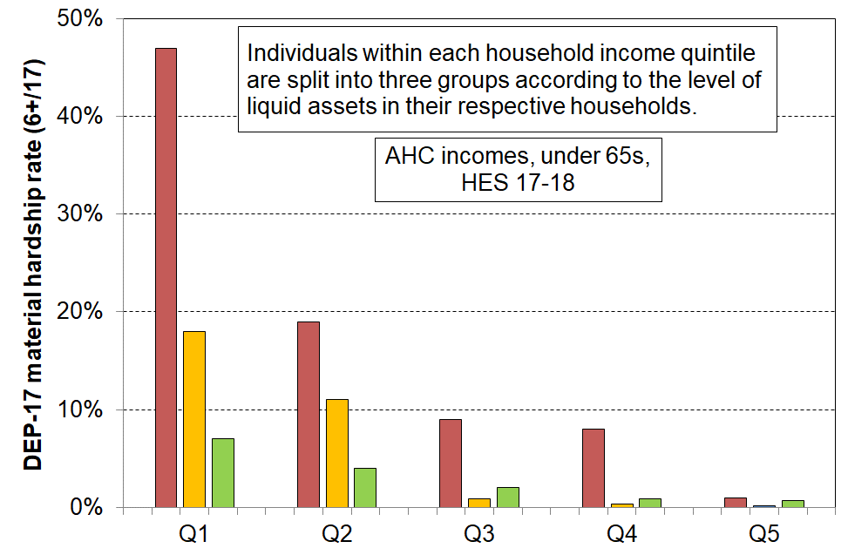**Material hardship rates depend on the level of liquid financial assets as well as on HH income**

Reading notes for Figure A.2 and associated table below:

* The five quintiles are quintiles of AHC household income – Q1 is the lowest quintile and so on.
* Individuals within each household income quintile are ranked by their household’s level of liquid assets, then split into three equal-sized groups.

|  |  |  |  |  |  |  |  |  |  |
| --- | --- | --- | --- | --- | --- | --- | --- | --- | --- |
| **Household Economic Survey 2017-18** | **Q1** | | | **Q2** | | | **Q3** | | |
| median liquid assets ($) | 0 | 400 | 8,000 | 100 | 1,200 | 12,000 | 500 | 3,600 | 19,300 |
| can pay an unexpected + essential $500 bill within a month without borrowing (%) | 24 | 43 | 67 | 51 | 71 | 79 | 69 | 84 | 85 |
| used a foodbank more than once in previous 12 months (%) | 25 | 10 | 2 | 6 | 4 | 1 | 4 | 0 | 0 |
| put up with cold ‘a lot’ to save on costs (%) | 25 | 14 | 11 | 10 | 8 | 4 | 7 | 5 | 4 |
| borrowed from fam/friends more than once in previous 12 months to pay for basics (%) | 34 | 17 | 9 | 18 | 9 | 4 | 10 | 3 | 2 |
| self-assessed income adequacy – ‘not enough’ | 46 | 21 | 17 | 22 | 10 | 6 | 14 | 6 | 4 |
| material hardship rate (%) (6+/17, DEP-17) | 47 | 18 | 7 | 19 | 11 | 4 | 9 | 1 | 2 |
| avg AHC household income (equivalised) | 11,000 | 11,000 | 10,000 | 21,000 | 21,000 | 22,000 | 30,000 | 31,000 | 31,000 |

[*As an aside, it is worth noting that in the table above the self-assessed income adequacy responses are clearly contextualised ones about the adequacy of household income given their particular household circumstances. They follow the material hardship rates reasonably closely, indicating that in their self-assessments respondents take account of the full range of household circumstances, not just income*.]

*For a given household income, there is considerable variability in reported material wellbeing*

**Figure A.3** shows the relationship between BHC household income and household MWI scores. The solid line shows the average MWI score for each BHC income decile, and the dashed lines show the average MWI scores ± one standard deviation (ie around two-thirds of the variation lies within the dashed lines). Higher household incomes are generally associated with higher levels of material wellbeing, as expected, but there is considerable variation in material wellbeing for given income levels (in deciles).[22] While measurement error and the range of income within each income decile will explain some of the variation, the bulk is likely to reflect the impact of different levels of financial and physical assets and of the ‘other’ factors noted above and in the framework diagram (Figure A.1).[23] The correlation between BHC income and MWI score is relatively modest at 0.33 (calculated on a household by household basis).

**Figure A.3**

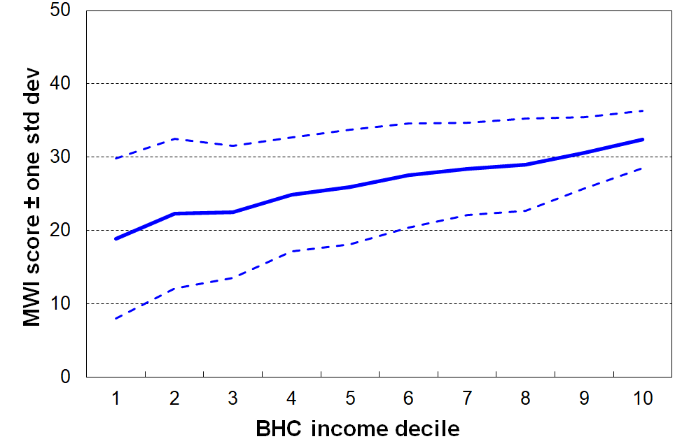**For a given household income, there is considerable variability in reported material wellbeing, though the variability diminishes with higher incomes, HES 2017-18**

*Not all below an income poverty line are in hardship and not all above it are not in hardship*

**Figure A.4** shows the material hardship rates for children in selected AHC income bands (using the DEP-17, 6+/17 measure).For example, 33% of those in households with incomes in the 40-50% AHC band are in hardship. This means that 67% of those in this band are not in hardship. Around 11% in households with incomes between 70% of the median and median are in hardship too.

**Figure A.4**

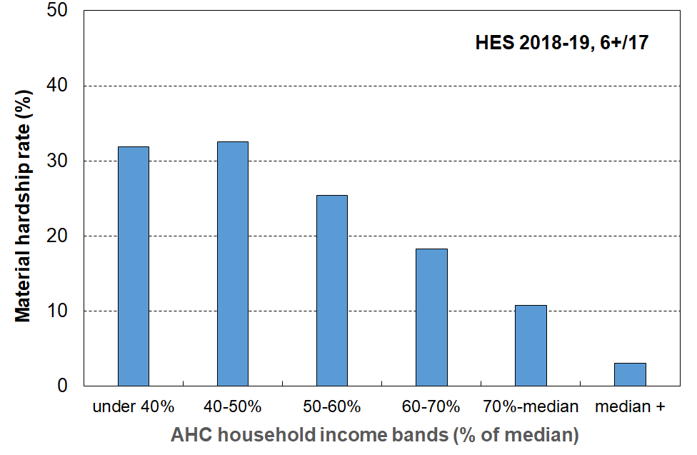**Material hardship rates (%) of children in selected AHC household income bands, HES 2018-19**

*Persistent low income leads to higher material hardship*

**Figure A.5** uses data from Stats NZ’s 2002-03 to 2008-09 longitudinal survey (SoFIE), and shows how material deprivation increases with the number of waves that households are in a low-income state. The finding is consistent with the framework described in Figure A.1 and is not surprising. It is not easy however to find empirical evidence that supports the first principles theoretical logic.[24]

After 7 years in persistent low income, the mean deprivation score had increased 6-fold from around 0.3 to 1.8 items. (Note that this is not the same as a 6-fold increase in the material hardship rate, using a given threshold such as 2 out of 8 items. That analysis is not available.)

**Figure A.5**

**Mean deprivation score (NZiDep) by number of years in low-income households:**

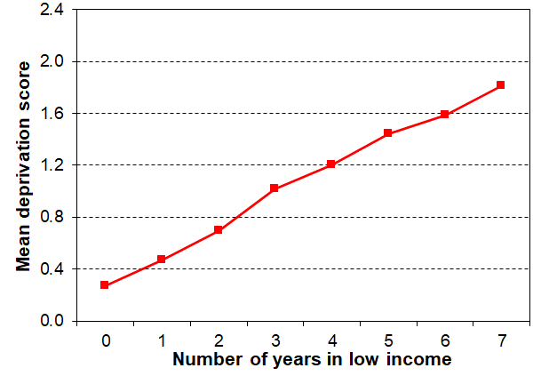**Children (0-17 yrs), SoFIE 2003 to 2009**

Source: Special 2012 run on the SoFIE data for MSD by Imlach Gunasekara & Carter (2012)

Notes for Figure:

* SoFIE is Stats NZ’s longitudinal Survey of Family, Income and Employment.
* NZiDep is an 8-item general material hardship index. The 8 items are similar to those in the DEP--17 index. See **Appendix One** for the list of items.
* The low-income measure used is 60% of median gross household income (which gives higher low-income rates than a 60% of median disposable household income measure). In other words, the low-income threshold used in the graph is a generous one,.

**Giving the numbers meaning: the need for a reference point**

Headline child poverty numbers have no practical meaning in their own right. Simple assertions that there are 80,000 … 150,000 … 250,000 … 300,000 poor children in New Zealand may be useful for advocacy purposes (with the number chosen depending on what one is advocating), but on their own they have no value for properly assessing the size of any ‘child poverty’ problem, nor for guiding policy or political responses.

MSD’s reports. including this one, provide several means for giving meaning to the poverty numbers:

* Being clear about which measure is being used at each step – this information on its own is not enough to make the use of a single measure sufficient to give a proper picture, but it is fundamental for clear communication.
* Comparing rates for other population groups using the same measure(s).
* Describing what poverty looks like in practical day-to-day terms for the different measures, using material deprivation items for which there is a broad consensus that they are ‘essentials’.
* Examining and reporting on the relationship between those identified as poor on the different measures (eg material hardship v AHC 50).
* Comparing with rates in earlier years.
* Comparing with rates in other countries when using measures that are valid for international comparisons.

**“There are no poor children, just poor families”**

It is sometimes said that the idea of ‘child poverty’ doesn’t make sense as it’s really about families / households with financial and material resources that are not adequate for meeting the basic needs of the family (ie it’s not poor children, it’s poor families / households).

In this report, when it is said, for example, that ‘the child poverty rate is 15% on a particular measure’, this is a short-hand for ‘15% of children live in families / households whose total annual household income is below the threshold used in the given measure’ … or ‘15% of children live in families / households whose material hardship score is above the threshold used’. It is too cumbersome to repeat this each time, so the shorthand version is used: ‘the child poverty rate is 15%’.

This is standard international practice and assumes reasonably equitable distribution of material wellbeing within a household. In the case of children, this is not always the case. Parents and caregivers often make sacrifices themselves that shield their children from (the worst of) the material deprivations they would otherwise experience. In a few cases it’s the other way, and children suffer badly. The HES data to date does not provide information from the children themselves (not many surveys do), but it allows us to get a more direct insight into the children’s situation through the 20 child-specific deprivation measures included in the 2018-19 HES and subsequent surveys. These items are used extensively in this MSD Child Poverty Report.

**Poverty experienced**

The understanding of poverty and the associated measurement approach used in this report (and in the full MSD reports) is narrowly focussed. It is about ‘unacceptable financial or material hardship’ and the insights about this that can be gleaned from a large-scale national survey.

This is a legitimate focus but, in pursuing it, it is important to be aware that there is much more to ‘poverty’ than what can be measured (albeit imperfectly) through analysis of data from income or deprivation surveys. These can tell us about the material core (‘unacceptable material or financial hardship’), but a different type of research is needed to give insight into how this unacceptable hardship is experienced and understood and felt.[25]

What is at issue here is the non-material as well as the material manifestations of poverty. Poverty has to be understood not just as a disadvantaged and insecure economic *condition* but also as a shameful and corrosive social *relation* … [The non-material aspects include] … lack of voice; disrespect, humiliation and assault on dignity and self-esteem; shame and stigma; powerlessness; denial of rights and diminished citizenship … They stem from people in poverty’s everyday interactions with the wider society and from the way they are talked about and treated by politicians, officials, the media and other influential bodies. Lister (2004, p7)

What people on low incomes report is a situation of great complexity in which the pressures they face are cumulative. Basics become luxuries that have to be prioritised and saved for. Solutions to one problem create problems of their own, as when saving on heating exacerbates illness and borrowing from the rent money generates arrears and threats of eviction. Poverty feels like entrapment when options are always lacking, the future is looming and unpredictable, and guilt seems ever present, arising from an inability to meet one’s children’s needs, one’s own expectations and society’s demands. Tomlinson and Walker (2009, p16)

[Poverty] is to live under the dictatorship of material necessity without choice and control in one’s daily life. That’s what poverty *is*, it’s about freedom and power and the lack thereof. Ringen (2009, p7)

**Sen and shame**

It has become popular in discussions of human wellbeing to use Amartya Sen’s dictum that the basic concern of human development or of ‘the good life’ is ‘our capability to lead the kind of lives we have reason to value’. The same language is sometimes used in relation to discussions around strategies to address poverty, with the goal of poverty alleviation intervention being characterised as helping people ‘lead the kind of lives they have reason to value’.

In using only this aspect of Sen’s thinking, it misses two key elements that Sen himself identifies in his writing on the conceptualisation of poverty. The first is the matter of the ‘irreducible absolutist core’– poverty alleviation is about having households attain a minimum acceptable standard, which may nevertheless be (well) below ‘leading the kind of lives they have reason to value’. The second is how for Sen and for ‘the poor’, shame is at the core of poverty experienced.There is a case that the bumper-sticker type of use of the notion of ‘leading the kind of lives we have reason to value’ in the context of poverty discourse both misrepresents Sen on poverty and understates the stress of life at the hard end.[26]

Whatever else poverty is understood to be it is in essence an unacceptable state-of-affairs. Properly understood, “use of the term ‘poverty’ carries with it an implication and moral imperative that something should be done about it” (Piachaud, 1987: 161).

**Poverty – narrow or wide conceptualisation?**

Poverty and hardship are multi-dimensional. Different contexts and different purposes require a focus on one or other dimension or indeed on multiple disadvantage across several dimensions. When talking about ‘poverty’ it is important to be clear about which dimension is being discussed, or if the wider notion of multiple disadvantage is in scope that that too is made clear.

‘Poverty’ is most commonly used to refer to the status of those in households that have income below a given low-income threshold, however determined.

At other times ‘poverty’ is used to describe those whose actual living conditions are very restricted and below minimum acceptable levels. This is a slightly wider perspective as these outcomes are determined by more than just income alone. The report uses ‘material hardship’ or ‘deprivation’ for this aspect. It is becoming more common to use this conceptualisation in conjunction with low-income measures.

UNICEF New Zealand go a step further and define child poverty as ‘children being deprived of the material, spiritual and emotional resources needed to survive, develop and thrive’.[27]

‘Poverty’ is also used by some almost as a catch-all term to refer to any serious disadvantage or cluster of disadvantages experienced by individuals, households or geographical areas (for example, low education, poor quality housing and local amenities, poor health, high unemployment, marginalisation through discrimination, and so on).

In other contexts, the causes, correlates and consequences of income poverty and/or material hardship are bundled together with the core notion and turned into an undifferentiated loose construct. This is understandable given the intertwining of so many threads, but it is not a helpful approach when it comes to measurement and coherent evidence-informed discussion.[28]

The focus of poverty measurement in this report is on the core material and financial hardship aspects. In this regard it is line with the CPRA. While it is not an absolute subsistence notion (‘third world starvation’), neither is it ‘just relative’. Poverty is not just about having ‘less than’, it is about ‘not having enough’. There will always be debate about where to set the threshold and even about the use of the ‘poverty’ word itself, but most would agree that there are people in New Zealand today whose actual day-to-day living standards are below a minimum acceptable level.[29] It is not just that these people have less than others who are better off, it is that they are going without things that the bulk of New Zealand society considers that all should have and none should be without.

**Data sources: Stats NZ’s Household Economic Survey (HES) and associated administrative data for income information**

The analysis in the MSD Child Poverty report is based mainly on data from Stats NZ’s Household Economic Survey (HES). As noted earlier, the increased sample size starting with the 2018-19 survey allows more detailed breakdowns for children in different contexts to be reported with greater confidence (for example, poverty rates by their household type, the tenure of their household, the labour market status of their households, their ethnicity, and so on).

The surveys gather information on the usually resident population living in private dwellings

The survey therefore includes those living in retirement villages, but not those in non-private dwellings such as rest homes, hotels, motels, boarding houses and hostels.[30] Other sorts of surveys are needed to obtain a picture of what life is like for those in more transient accommodation or those ‘living rough’.[31]

This does not mean that the survey does not reach households with very limited financial resources or those in more severe hardship. For example, in the 2018-19 HES: 724 of the households interviewed reported receiving help from a food bank or other community organisation more than once in the previous 12 months, 1698 households reported putting up with feeling cold ‘a lot’ in the previous 12 months because of needing to spend on other basics, and 25% came from the two most deprived NZDep13 deciles (ie the most deprived 20%).[32] The achieved response rates for the most deprived NZDep13 deciles are similar to the overall response rate – for example, 75% for 2020-21 for deciles 8, 9 and 10.

Findings based on sample surveys have statistical uncertainties

Some of the uncertainties arise by chance as the information is from a sample rather than the whole population. This is often referred to as ‘sample error’. Sample error is not a mistake. It exists even if a survey is perfectly designed and implemented and a 100% response rate is achieved. It is an inevitable feature of using a sample rather than counting everyone in the population of interest.

The larger HES samples that are available starting with 2018-19 reduce sample error considerably compared with the sample errors in the HES-TAWA series. The sample errors for the CPRA child poverty rates are typically 1.0 to 1.2 percentage points for HES 2018-19 (21,000 households), compared with 2 to 3 percentage points for the HES-TAWA series which have much smaller sample sizes (3000 to 5500 households). The sample sizes for 2019-20 and 2020-21 were smaller than planned due to the COVID lock-downs and related health protocols – each around 16,000 households This led to sample errors for the income-based CPRA child poverty rates increasing to around 1.3 to 1.5 percentage points.[33]

Sample surveys can also have what are loosely referred to as ‘non-sample errors’. This is a catchall term that includes any errors that are not sample errors – ie not the inevitable uncertainties associated with interviewing a sample rather than the whole population. Non-sample error can occur in any survey, whether the estimates are derived from a sample or a census. Sources of non-sample error include non-response, errors in respondents’ reporting or interviewers’ recording of answers, and errors in data processing.

Sample bias through non-response is one of the most common sources of non-sampling error. Non-response can affect the reliability of results and introduce bias if the people who do not respond systematically differ in some important characteristic from those who do respond. Careful design and application of weights can mitigate the impact of lower response rates from certain subgroups of the population (by adjusting the weights upwards). If the non-response for particular sub-groups is too great then the mitigation through weights will not eliminate the bias and its impact on population estimates.[34]

The 2015-16 HES-TAWA data shows strong evidence of sample bias and the weights available for that year do not sufficiently counter the bias. MSD reports therefore do not generally report findings based on the 2015-16 data.[35]

Administrative data has been used as the source for most of the household income information in this report, starting with HES 2018-19

Up to and including the 2017-18 HES, the data available to MSD for its reports was the ‘HES-TAWA’ data. This analytical dataset is made up of the original survey data with some of the more problematic survey-based income information that respondents may misreport (for example, benefit and Working for Families income and the Accommodation Supplement) replaced by the Treasury using their Tax and Welfare Analysis (TAWA) model or its predecessors.

For the 2018-19, 2019-20 and 2020-21 HES, Stats NZ moved to using administrative data for most of the income information. Tax data from Inland Revenue and data from MSD on benefits paid has been used to provide salary and wages and benefit income. Working for Families tax credit information comes from IR or MSD depending on which agency made the payment. Other sources of income such as self-employment income, investment income, income earned overseas and irregular income is provided by the respondent at interview time. The sample sizes are much larger, more effort was made to get a better sample / response at the bottom end, and a more comprehensive set of benchmarks was used to weight up to population estimates. These datasets (‘HES-admin’) are available to MSD for use for this and other reports.[36]

Addressing issues raised by the presence of households reporting very low incomes

The use of administrative data has in many ways further improved the income information available for HES analysis (for example, by removing measurement error when income from a respondent is misreported through recall issues or deliberately, and by avoiding the need to make assumptions about ‘take-up’ as is required for the modelled estimates of income in HES-TAWA). However, the number of very-low-income (VLI) households has increased when compared with previously published income distribution information based on HES-TAWA. The number of VLI households in HES-Admin is relatively large in itself, irrespective of any comparison with the HES-TAWA numbers. What it is that is causing this difference is not at present fully understood – there are likely to be multiple drivers. Stats NZ is carrying out further investigations.

For the purposes of this report and the other main MSD reports, households are classed as VLI if their equivalised BHC household income is under $8000 pa (in 2007 dollars). In $2022 this is close to $10,000 pa which is around 23% of the median. This is well below the BHC incomes of beneficiary households with children which are typically in the range of 60% to 75% of the median for those living in, say, South Auckland.[37]

In the HES, as in many other similar surveys in other countries, the VLI households present a challenge for the analysis in the Child Poverty report on several counts:

* the incomes are extremely low (for this report, under ~15 to 25% of the median), well below all safety net income support levels
* many of these households report a material standard of living very much higher than those in the ‘normal / less extreme’ low-income range, more like those in the middle of the income distribution
* their presence can lead to the production of misleading statistics for low-income households on a wide range of themes that matter for policy and public interest.

While the VLI group makes up only a very small proportion of the whole population (typically around 2-4%), when the population of interest is a low-income group they can make up a non-trivial portion in the new HES-Admin data series – as high as 25% in some cases. As discussed below, some treatment is needed to address the issue, for reporting time series (Sections F and G) and in particular for the 2018-19 HES, the dataset that is used for much of the analysis used in Sections B to E in the report.

Various treatments for this issue have been adopted by researchers and some government reporting agencies (both in New Zealand and internationally).

For this report, households that report zero or negative incomes and those other VLI households who report that their income is ‘enough’ or ‘more than enough’ for the basics of accommodation, food, clothing etc are removed. The treatment is designed to at least partially address the issues raised by the presence of VLI households. More detail is found in **Section J** (the low incomes section) and a full discussion including the impact on key statistics is available in **Section N** and **Section O.**

Stats NZ are aware of the VLI issue in relation to how it may possibly impact on the child poverty rates they report on in the context of the requirements of the CPRA, and also more generally for the way the presence of these extreme incomes can impact other information based on the HES. They are carrying out further investigation.[38]

**Annex to Section A**

**Low-income thresholds (‘income poverty lines’)**

**Tables 3A & 3B** (repeated here from Appendix 3 for convenience) show the income poverty thresholds in ordinary dollars pw for a range of BHC and AHC measures for selected household types.

**Table 3A**

**50% and 60% low-income thresholds or ‘poverty lines’ for various household types (BHC)**

**($2022, per week) (Using the modified OECD equivalence scale)**

|  |  |  |  |  |  |
| --- | --- | --- | --- | --- | --- |
|  |  | **REL** (‘moving’) | | **CV** (‘anchored’ /‘fixed’) | |
| Household type | Equiv ratio | 50% of 2020-21 median in $2022 | 60% of 2020-21 median in $2022 | 50% of 2006-07 median in $2022 | 60% of 2017-18 median in $2022 |
| One-person HH | 1.0 | 460 | 550 | 460 | 550 |
| SP, 1 child <14 | 1.3 | 600 | 715 | 600 | 715 |
| SP, 2 children <14 | 1.6 | 735 | 885 | 735 | 885 |
| SP, 3 children <14 | 1.9 | 875 | 1050 | 875 | 1050 |
| Couple only | 1.5 | 690 | 825 | 690 | 825 |
| 2P, 1 child <14 | 1.8 | 825 | 995 | 825 | 995 |
| 2P, 2 children <14 | 2.1 | 965 | 1160 | 965 | 1160 |
| 2P, 3 children <14 | 2.4 | 1105 | 1325 | 1105 | 1325 |
| 2P, 4 children <14 | 2.7 | 1240 | 1490 | 1240 | 1490 |
| 3 adults | 2.0 | 920 | 1105 | 920 | 1105 |

Notes:

* The figures above are calculated before any treatment is applied to the dataset
* The $2022 numbers are the actual HES 2020-21 numbers inflated by 9% (the CPI change from the 2020-21 average to June 2022)

**Table 3B**

**40%, 50% and 60% low-income thresholds or ‘poverty lines’ for various household types (AHC)**

**($2022, per week) (Using the modified OECD equivalence scale)**

|  |  |  |  |  |  |  |
| --- | --- | --- | --- | --- | --- | --- |
|  |  | **REL** (‘moving’) | | | **CV** (‘anchored’ /‘fixed’) | |
| Household type | Equiv ratio | 40% of 2020-21 median in $2022 | 50% of 2020-21 median in $2022 | 60% of 2020-21 median in $2022 | 50% of 2006-07 median in $2022 | 60% of 2017-18 median in $2022 |
| One-person HH | 1.0 | 285 | 355 | 425 | 355 | 425 |
| SP, 1 child <14 | 1.3 | 370 | 460 | 550 | 460 | 550 |
| SP, 2 children <14 | 1.6 | 455 | 565 | 680 | 565 | 680 |
| SP, 3 children <14 | 1.9 | 540 | 670 | 805 | 670 | 805 |
| Couple only | 1.5 | 425 | 530 | 635 | 530 | 635 |
| 2P, 1 child <14 | 1.8 | 510 | 635 | 765 | 635 | 765 |
| 2P, 2 children <14 | 2.1 | 595 | 745 | 890 | 745 | 890 |
| 2P, 3 children <14 | 2.4 | 680 | 850 | 1020 | 850 | 1020 |
| 2P, 4 children <14 | 2.7 | 765 | 955 | 1145 | 955 | 1145 |
| 3 adults | 2.0 | 565 | 705 | 850 | 705 | 850 |

Notes:

* The figures above are calculated before any treatment is applied to the dataset.
* The $2022 numbers are the actual HES 2020-21 numbers inflated by 8% (the after-deducting-housing costs CPI change from the 2020-21 average to June 2022).
* When Stats NZ calculate the thresholds for the 2017-18 fixed-line thresholds they adjust using the HLPI not the CPI. This has a small impact on reported numbers.

**Material deprivation or hardship index (DEP-17) and the MWI**

Material deprivation or material hardship indices are now fairly well-developed for European nations and New Zealand. These measures use survey information about what basics and near-basics households can and cannot afford in order to rank households across a spectrum from no hardship through to severe hardship.

Much of the analysis in this report uses MSD’s **DEP-17** general purpose material hardship index – this is also used by Stats NZ for its official reporting on material hardship under the CPRA. The 17 items are shown in the table below.

For each household, one adult respondent is selected at random to answer the questions, some of which are about the household (H) and some about the respondent (R). The DEP-17 score for each respondent is simply the sum of all reported enforced lacks or deprivations. This score is attributed to the household itself and to all household members and the households and the individuals in them are ranked by these scores. Thresholds can then be set, representing different depths of material hardship or deprivation (eg 6+/17, 7+/17, and so on). This is the same approach as is taken with income measures: total household income is attributed to each household member, then thresholds are set at selected income levels and income poverty rates for different depths are reported.

**Composition of DEP-17**

**and the % in households for which the respondent reported various deprivations**

**(HES 2018-19, 2019-20 and 2020-21)**

|  |  |  |  |  |  |
| --- | --- | --- | --- | --- | --- |
| **Enforced lack of essentials** (for respondent or household as a whole) | |  | **18-19** | **19-20** | **20-21** |
|  | meal with meat, fish or chicken (or vegetarian equivalent) at least each 2nd day | R | 2 | 1 | 1 |
|  | two pairs of shoes in good repair and suitable for everyday use | R | 2 | 2 | 2 |
|  | suitable clothes for important or special occasions | R | 4 | 3 | 3 |
|  | presents for family and friends on special occasions | R | 5 | 4 | 4 |
|  | home contents insurance | H | 15 | 14 | 14 |
| **Economised, cut back or delayed purchases ‘a lot’** (because money was needed for other essentials, not just to be thrifty or to save for a trip or other non-essential) | |  |  |  |  |
|  | went without or cut back on fresh fruit and vegetables | H | 4 | 3 | 3 |
|  | bought cheaper cuts of meat or bought less than wanted | H | 13 | 12 | 10 |
|  | put up with feeling cold to save on heating costs | R/H | 8 | 7 | 5 |
|  | postponed visits to the doctor | R | 8 | 7 | 6 |
|  | postponed visits to the dentist | R | 25 | 23 | 22 |
|  | did without or cut back on trips to the shops or other local places | R/H | 11 | 10 | 8 |
|  | delayed repairing or replacing broken or damaged appliances | H | 9 | 8 | 7 |
| **In arrears more than once in last 12 months** (because of shortage of cash at the time, not through forgetting) | | | |  |  |
|  | rates, electricity, water | H | 6 | 6 | 5 |
|  | vehicle registration, insurance or warrant of fitness | H | 6 | 5 | 5 |
| **Financial stress and vulnerability** | |  |  |  |  |
|  | borrowed from family or friends ‘more than once’ in the last 12 months to cover everyday living costs | H | 9 | 8 | 7 |
|  | feel ‘very limited’ by the money available when thinking about purchase of clothes or shoes for self (options were: not at all, a little, quite limited, and very limited) | R | 13 | 11 | 11 |
|  | could not pay an unexpected and unavoidable bill of $500 within a month without borrowing | H | 21 | 20 | 17 |

Reading note for table:

The figures in the right-hand three columns are based on the information provided by the household’s respondent. For example, in the fresh fruit and vegetables row for 18/19, 4% of the population were in households where the respondent said they (or their partner) went without or cut back ‘a lot’ (rather than ‘a little’ or ‘not at all’). The fourth from right column indicates whether the item is respondent-focussed (R) or household-focussed (H). Though for most items the R/H distinction is clear, a few could be either. This uncertainty is being addressed in the 2021-22 survey.

**Section J** in Part Two has more detail on the DEP-17 index, and the Material Wellbeing Index (MWI) items and scoring are listed in Table 1.3 in **Appendix 1**.

**Section B**

**The demographics of child poverty: rates for children in different household contexts and for ethnicity, and comparisons with selected households without children**

Section B reports on material hardship rates and low-income rates for children in different household contexts, and by their age (including ‘early years’), ethnicity and disability status.

The household contexts reported on are:

* household type – see Glossary and Abbreviations (page 12) for definitions
* number of children in the household
* work intensity for two parent and sole parent households at time of interview
* labour market status of the household at time of interview
* source of household income in the 12 months prior to interview (market v government)
* tenure of household
* private rental tenure by AS receipt
* highest educational qualification in the household
* disability status of the household.

In each case rates are provided at different depths of hardship and at different levels of low-income. In these cases, the differing composition at different depths is reported for each demographic grouping.

The situation for children is also compared with that for one-adult households and for older New Zealanders, using the 9 CPRA measures.

**Contents**

* Children in households at different depths of material hardship.
* Children in households at different levels of low income.
* Children in households in both low income and material hardship.
* Comparing poverty rates for children, one-person households (aged 18-64 yrs), and older New Zealanders (65+ yrs).
* Material hardship and low-income rates by disability status.
* Material and financial hardship in six sub-regions in Auckland.

**Use of 2018-19 data in some sections**

Most of the tables and charts in this Section and in Sections C and E use the data from the 2018-19 HES even though more up to date data is available. This is done mainly because of the relatively large sample size for 2018-19 which allows the detailed breakdowns to be reported with more confidence. For some statistics all three of the recent surveys are used together. **Appendix 6** has the updates of all the tables to HES 2020-21. Although there is a little difference in the numbers between 2018-19 and 2020-21, the main messages and relativities are unchanged. The later time series Sections (Sections F, G and H) all go through to 2020-21.

**Children in households at different depths of material hardship, in selected household contexts and by ethnicity: hardship rates and composition within the categories**

**Interpreting the tables that follow**

**Table B.0** below is an extract from the first of the full tables that follow, and is used to support a walk-through of the numbers to assist with interpretation for those not too familiar with ‘rates and composition’ tables.

* The 6+ material hardship columns are shaded as they give the standard material hardship information using the DEP-17 index; 9+ is the level used for severe material hardship.
* The brown shaded 5% figure is the hardship rate for children in two-parent HHs which have a hardship score of 8+/17 (much lower than the 20% rate for children in sole parent households at the same depth).
* The green shaded 41% figure says that of all the children in households in severe material hardship (9+/17), 41% are from sole parent households.
* Note that the composition columns all add to 100% (except for the two parent / sole parent work intensity panel in the full table on the next page – these add to less than 100% as all other household types and all fully workless households are not included).
* The ‘ALL’ columns show the number and % of children in each household type overall. The composition % divided by the ‘ALL’ % gives ‘the risk ratio’.[39] For children in sole parent households at the 9+ level, the risk ratio is 2.9 (41/14), whereas for children in two parent households the risk ratio is 0.54 (37/69). Whether by comparing rates directly or by comparing risk ratios, the same conclusion is reached: children in sole-parent households are five to six times more likely to be in severe material hardship than those in two-parent households.[40]

**Table B.0**

**Material hardship rates and composition for selected population groups (DEP-17 index, 5 thresholds),**

**Children (aged 0-17 years), HES 2018-19**

|  |  |  |  |  |  |  |  |  |  |  |  |  |
| --- | --- | --- | --- | --- | --- | --- | --- | --- | --- | --- | --- | --- |
| **HES 2018-19** | **Material hardship rates** | | | | | **Composition** | | | | | | |
|  | what % of this group is in hardship, using the different thresholds? | | | | | what % of all those in hardship (using a given threshold) are in this group /? | | | | | **000’s** | **%** |
| **Material hardship threshold as # of items lacked out of 17** | **5+** | **6+** | **7+** | **8+** | **9+** | **5+** | **6+** | **7+** | **8+** | **9+** | **ALL** | **ALL** |
| **Material hardship rates (%)** |  |  |  |  |  |  |  |  |  |  |  |  |
| **All children (0-17 yrs)** | 18 | 13 | 10 | 8 | 6 | 100 | 100 | 100 | 100 | 100 | 1,135 | 100 |
| **Household type** |  |  |  |  |  |  |  |  |  |  |  |  |
| 2P HH with any deps | 12 | 9 | 7 | 5 | 3 | 48 | 46 | 44 | 42 | 37 | 785 | 69 |
| SP HH with any deps | 40 | 32 | 26 | 20 | 17 | 32 | 34 | 35 | 37 | 41 | 160 | 14 |
| Other fam HHs with any deps | 23 | 16 | 14 | 10 | 8 | 20 | 19 | 21 | 21 | 22 | 180 | 16 |
| Other HHs (some 0-17s, no dep ch) | Suppressed - numbers too small | | | | | 1 | 1 | 0 | 1 | 0 | 10 | 1 |

Selected findings on material hardship, drawn from the tables that follow.

2P and SP households

* SP households have higher rates of hardship at all depths, but because there are many more 2P households, there are around the same number of children in hardship in SP and 2P households (on average over the three HES years 2018-19 to 2020-21.

Number of children in household

* Households with 1-2 children have the lowest rates, with those with 3 a little higher.
* Households with 4+ report much higher rates, almost three times that for smaller households, at both the 6+ and 9+ levels.
* The hardship composition is quite similar at different depths, around half from households with 1-2 children, and a quarter each from 3 and 4+.

Source of income

* The hardship rate for children in households with most of their income in the twelve months prior to interview coming from government sources is around 5 times the rate than for those with mainly market income (‘working households’). Nevertheless, around half of children in hardship come from ‘working households’. This reflects the fact that there are many more ‘working households’.

Ethnicity

* Material hardship rates are much higher for Māori (23%) and Pacific children/ethnicities (28%) compared with that for European (10%) or Asian children/ethnicities (6%).
* This difference is much the same as in previous MSD reports using multi-year averages with smaller sample sizes each year.

NZDep2013 quintile

* The NZDep index ranks small areas of households by their socio-economic status. The index uses eight deprivation domains including unemployment rates, low educational qualifications, low income, benefit receipt, overcrowding, no access to a car and so on.
* Half of the children in material hardship (51%) come from the most deprived NZDep quintile (20%),
* Two thirds of those in more severe hardship (64%) come from the most deprived NZDep quintile (20%).

See **Table D.6** for international comparisons of the proportions of children in jobless households.

**Table B.1a**

**Material hardship rates and composition for selected population groups (DEP-17 index, 5 thresholds),**

**Children (aged 0-17 years), HES 2018-19**

|  |  |  |  |  |  |  |  |  |  |  |  |  |
| --- | --- | --- | --- | --- | --- | --- | --- | --- | --- | --- | --- | --- |
| **HES 2018-19** | **Material hardship rates** | | | | | **Material hardship composition** | | | | | **Overall composition** | |
|  | what % of this group is in hardship, using the different thresholds? | | | | | what % of all those in hardship (using a given threshold) are in this group / cell? | | | | | **000’s** | **%** |
| **Material hardship threshold as # of items lacked out of 17** | **5+** | **6+** | **7+** | **8+** | **9+** | **5+** | **6+** | **7+** | **8+** | **9+** | **ALL** | **ALL** |
|  |  |  |  |  |  |  |  |  |  |  |  |  |
| **All children (0-17 yrs)** | 18 | 13 | 10 | 8 | 6 | 100 | 100 | 100 | 100 | 100 | 1,135 | 100 |
| **Household type** |  |  |  |  |  |  |  |  |  |  |  |  |
| 2P HH with any dependent children | 12 | 9 | 7 | 5 | 3 | 48 | 46 | 44 | 42 | 37 | 785 | 69 |
| SP HH with any dependent children | 40 | 32 | 26 | 20 | 17 | 32 | 34 | 35 | 37 | 41 | 160 | 14 |
| Other fam HHs with any dep ch | 23 | 16 | 14 | 10 | 8 | 20 | 19 | 21 | 21 | 22 | 180 | 16 |
| Other HHs (some 0-17s, no dep ch) | Cell sizes too small – rates suppressed | | | | | 1 | 1 | 0 | 1 | 0 | 10 | 1 |
| **Number of dep children in household** |  |  |  |  |  |  |  |  |  |  |  |  |
| 1 | 14 | 11 | 8 | 6 | 5 | 17 | 17 | 17 | 17 | 18 | 245 | 22 |
| 2 | 14 | 10 | 8 | 5 | 4 | 33 | 33 | 32 | 30 | 30 | 485 | 43 |
| 3 | 19 | 13 | 11 | 9 | 6 | 25 | 23 | 24 | 27 | 24 | 255 | 23 |
| 4+ | 35 | 27 | 22 | 16 | 13 | 24 | 26 | 27 | 26 | 28 | 140 | 12 |
| **Work intensity (2P & SP, adults all ages)** |  |  |  |  |  |  |  |  |  |  |  |  |
| 2P - both FT | 9 | 6 | 5 | 3 | 1 | 11 | 11 | 10 | 8 | 5 | 260 | 23 |
| 2P - FT PT | 10 | 7 | 5 | 4 | 2 | 8 | 8 | 7 | 7 | 6 | 165 | 15 |
| 2P - FT WL | 18 | 12 | 9 | 6 | 4 | 16 | 15 | 14 | 14 | 13 | 185 | 17 |
| SP - FT | 23 | 17 | 12 | 10 | 7 | 6 | 6 | 6 | 6 | 6 | 55 | 5 |
| SP - PT | 39 | 28 | 22 | 15 | 11 | 6 | 6 | 6 | 5 | 5 | 30 | 3 |
| Other | 25 | 19 | 15 | 12 | 10 | 52 | 54 | 57 | 60 | 65 | 430 | 38 |
| **Labour market status of household** |  |  |  |  |  |  |  |  |  |  |  |  |
| Self-employed | 4 | 2 | 1 | 1 | 0 | 2 | 2 | 1 | 1 | 1 | 140 | 12 |
| At least one FT worker | 14 | 10 | 7 | 5 | 3 | 57 | 54 | 52 | 48 | 44 | 820 | 72 |
| No FT worker (may have PT) | 47 | 38 | 31 | 25 | 20 | 41 | 44 | 47 | 50 | 55 | 175 | 16 |
| PT work only | 34 | 25 | 19 | 15 | 11 | 10 | 10 | 10 | 10 | 10 | 60 | 5 |
| Some work (excl SE) | 15 | 11 | 8 | 6 | 4 | 67 | 64 | 61 | 59 | 54 | 875 | 77 |
| Workless | 53 | 44 | 37 | 30 | 25 | 31 | 34 | 38 | 40 | 45 | 120 | 10 |
| **Source of HH income in the 12 months prior to interview** |  |  |  |  |  |  |  |  |  |  |  |  |
| Main source market | 12 | 9 | 6 | 4 | 3 | 60 | 56 | 52 | 48 | 45 | 975 | 86 |
| Main source government | 52 | 42 | 35 | 29 | 23 | 40 | 44 | 48 | 52 | 55 | 160 | 14 |
| **Tenure of household** |  |  |  |  |  |  |  |  |  |  |  |  |
| Owned with mortgage (incl Family Trust) | 8 | 5 | 3 | 2 | 1 | 22 | 18 | 14 | 13 | 11 | 540 | 47 |
| Owned no mortgage (incl FamilyTrust) | 5 | 3 | 3 | 3 | 2 | 3 | 3 | 3 | 4 | 4 | 120 | 10 |
| Private rental | 29 | 23 | 19 | 14 | 11 | 53 | 56 | 59 | 58 | 61 | 365 | 32 |
| Social rental | 54 | 44 | 35 | 28 | 20 | 20 | 22 | 23 | 25 | 24 | 75 | 7 |
| Other | 8 | 4 | 2 | 2 | 1 | 1 | 1 | 1 | 1 | 1 | 35 | 3 |
| **Private rental by AS receipt** |  |  |  |  |  |  |  |  |  |  |  |  |
| Private rental (no AS) | 16 | 11 | 9 | 6 | 4 | 15 | 15 | 15 | 14 | 12 | 195 | 17 |
| Private rental (with AS) | 45 | 36 | 30 | 23 | 18 | 38 | 41 | 44 | 44 | 49 | 170 | 15 |
| **Education (highest qualification in HH)** |  |  |  |  |  |  |  |  |  |  |  |  |
| Higher degree | 6 | 4 | 2 | 1 | 1 | 7 | 6 | 4 | 3 | 3 | 230 | 20 |
| Bachelors or similar | 9 | 6 | 4 | 3 | 2 | 11 | 9 | 9 | 8 | 8 | 250 | 22 |
| Post-school non-degree qual | 20 | 15 | 12 | 9 | 7 | 35 | 35 | 37 | 37 | 37 | 360 | 32 |
| School qual | 29 | 22 | 17 | 13 | 10 | 31 | 32 | 32 | 32 | 32 | 215 | 19 |
| No formal qual | 44 | 34 | 27 | 22 | 17 | 17 | 17 | 18 | 20 | 20 | 80 | 7 |
| **NZDep Quintile** |  |  |  |  |  |  |  |  |  |  |  |  |
| Q1(least deprived 20%) | 6 | 4 | 2 | 2 | 1 | 7 | 6 | 4 | 4 | 3 | 210 | 19 |
| Q2 | 9 | 6 | 4 | 3 | 2 | 10 | 9 | 7 | 7 | 7 | 230 | 20 |
| Q3 | 14 | 9 | 7 | 5 | 3 | 16 | 14 | 14 | 14 | 12 | 230 | 21 |
| Q4 | 19 | 14 | 11 | 7 | 5 | 20 | 20 | 20 | 17 | 15 | 210 | 19 |
| Q5 (most deprived 20%) | 39 | 31 | 26 | 21 | 17 | 48 | 51 | 54 | 58 | 64 | 250 | 22 |

**Table B.1b** repeats the hardship rates and composition analysis for ethnicity.

Material hardship rates are much higher for Māori and Pacific children/ethnicities (23-28%) compared with that for European or Asian children/ethnicities (6-10%). This difference is much the same as in previous MSD reports using multi-year averages.

*(See the technical note under Table B.1b for the definition and discussion of the prioritised and total approaches to reporting ethnicity.)*

**Table B.1b**

**Material hardship rates and composition by ethnicity (DEP-17 index, 5 thresholds),**

**Children (aged 0-17 years), HES 2018-19**

|  |  |  |  |  |  |  |  |  |  |  |  |  |
| --- | --- | --- | --- | --- | --- | --- | --- | --- | --- | --- | --- | --- |
| **HES 2018-19** | **Material hardship rates** | | | | | **Composition** | | | | | | |
|  | what % of this group is in hardship, using the different thresholds? | | | | | what % of all those in hardship (using a given threshold) are in this group / cell? | | | | | **000’s** | **%** |
| **Material hardship threshold as # of items lacked out of 17** | **5+** | **6+** | **7+** | **8+** | **9+** | **5+** | **6+** | **7+** | **8+** | **9+** | **ALL** | **ALL** |
| **Material hardship rates (%)** |  |  |  |  |  |  |  |  |  |  |  |  |
| **All children (0-17 yrs)** | 18 | 13 | 10 | 8 | 6 | 100 | 100 | 100 | 100 | 100 | 1,135 | 100 |
| **Ethnicity (total)** |  |  |  |  |  |  |  |  |  |  |  |  |
| European | 13 | 10 | 7 | 6 | 4 | 36 | 36 | 36 | 36 | 35 | 735 | 53 |
| Māori | 29 | 23 | 19 | 14 | 11 | 32 | 34 | 35 | 35 | 37 | 290 | 21 |
| Pacific peoples | 38 | 28 | 23 | 18 | 14 | 20 | 20 | 21 | 22 | 23 | 140 | 10 |
| Asian | 11 | 6 | 4 | 2 | 2 | 8 | 6 | 5 | 4 | 4 | 180 | 13 |
| Other | 24 | 18 | 10 | 7 | 5 | 4 | 4 | 3 | 3 | 2 | 45 | 3 |
| **Ethnicity (prioritised)** |  |  |  |  |  |  |  |  |  |  |  |  |
| European | 10 | 7 | 5 | 4 | 3 | 26 | 25 | 24 | 24 | 21 | 535 | 47 |
| Māori | 29 | 23 | 19 | 14 | 11 | 41 | 44 | 47 | 47 | 50 | 290 | 26 |
| Pacific peoples | 41 | 29 | 24 | 19 | 14 | 19 | 19 | 20 | 21 | 21 | 95 | 8 |
| Asian | 11 | 6 | 4 | 2 | 2 | 9 | 7 | 5 | 4 | 4 | 170 | 15 |
| Other | 25 | 20 | 10 | 9 | 6 | 5 | 5 | 4 | 4 | 4 | 40 | 4 |

Reading note for interpreting ‘total ethnicity’ percentages. The total ethnicities approach counts ethnicities, not children. There are around 250,000 more ethnicity responses than there are children, as many report more than one ethnicity.

* The ‘28%’ figure in the Pacific row for 6+/17 hardship rate means that out of all the ethnicities reported by children in the 6+ hardship column, 28% are Pacific (whether only Pacific or Pacific and one or more other ethnicities).
* The ‘20%’ figure in the Pacific row for 6+/17 composition means that out of all the ethnicities reported by children in the 6+ hardship column, 20% are Pacific (whether only Pacific or Pacific and one or more other ethnicities).

Starting with HES 2007, ethnicity for children is provided in the survey data, with the information coming from either the children themselves or from their parents. Individuals can specify more than one ethnicity. In Table B.1b ethnic groups are created (for the purposes of analysis) using both the total response method and the prioritised method for determining ethnicity.[41]

In the total response approach, each person’s total ethnicity response is counted. This means that individuals may be counted more than once, and the total figures will be greater than the population numbers (around 250,000 more in the case of children). The analysis is actually about the total number of ethnicities provided for the children – it is not directly about the children themselves.[42]

In the prioritised approach, if a respondent reports more than one ethnicity, the ethnicity attributed is determined according to a prioritised classification of Māori, Pacific peoples, Other and then European. This ensures that the total number of responses equals the total population being reported on. In doing so, prioritisation conceals diversity within and overlapping between ethnic groups by eliminating multiple ethnicities from the analysis. This systematic prioritisation of the data gives highest priority to Māori – meaning, for example, an individual who might self-identify as both Pacific and Māori would be counted as Māori.

**Material hardship in the ‘early years’**

There is widespread acknowledgment of the critical importance of the material, social, emotional and nurturing contexts in the early years of a child’s life for outcomes later in childhood and in adulthood. One area of public policy interest is how younger children are faring in terms of material wellbeing.

The top panel in **Table 2** reports on the material hardship rates for under 5s and under 7s using different hardship thresholds. The 6+/17 threshold is the one used by Stats NZ for the standard material hardship rate statistics in their reporting under the CPRA. For both groups (under 5s and under 7s), the same pattern is evident for each of the three material hardship levels:

* those in households with only younger children have the lowest hardship rate
* those in households that also have older siblings have the highest rate – this could be because they are in larger families which on average have higher hardship rates (eg those with 4+ children have a standard hardship rate of 27% compared with all children at 13% (see Table B.1a above for HES 2018-19)
* the overall rate for a given ‘early years’ group is in between the above two rates and is much the same as the overall hardship rate for all children aged 0-17 yrs.

There is no evidence of the ‘early years’ groups being in greater material hardship than older children.

The lower panel reports on the material hardship rates for under 5s by the number of earners / number of adults in the household:

* those in the one-earner one-adult households have a relatively high 6+/17 hardship rate of 21% – for these sole parents in paid employment roughly half are full-time and half part-time
* those in the one-earner households with two or more adults experience lower hardship rates of 13% (about average) – the bulk of these earners are full-time
* those with two or more earners in the household have on average the lowest hardship (8%).

There are no surprises in the relativities reported, but it is useful to have the size of the differences quantified.

**Table B.2**

**Material hardship for younger children:**

**three year average for HES-Admin years (2018-19 to 2020-21)**

|  |  |  |  |  |  |  |  |
| --- | --- | --- | --- | --- | --- | --- | --- |
|  | **Material Hardship (rates, %)** | | | **Material Hardship (numbers)** | | | **Total numbers** |
|  | **5+** | **6+** | **9+** | **5+** | **6+** | **9+** |
| **Age-groups** |  |  |  |  |  |  |  |
| 0-17 | 16 | 12 | 5 | 181,000 | 136,000 | 58,000 | 1,140,000 |
| 0-4 (all) | 16 | 12 | 5 | 50,000 | 37,000 | 16,000 | 304,000 |
| 0-4 (with siblings aged 5+) | 21 | 15 | 7 | 28,000 | 21,000 | 10,000 | 137,000 |
| 0-4 only (with no siblings aged 5+) | 13 | 10 | 4 | 22,000 | 16,000 | 6,000 | 168,000 |
| 0-6 (all) | 16 | 12 | 5 | 70,000 | 52,000 | 23,000 | 432,000 |
| 0-6 (with siblings aged 7+) | 20 | 15 | 7 | 33,000 | 25,000 | 11,000 | 162,000 |
| 0-6 only (with no siblings aged 7+) | 14 | 10 | 4 | 37,000 | 27,000 | 11,000 | 270,000 |
| **0-4s by # of HH earners** |  |  |  |  |  |  |  |
| No earner HH | 54 | 45 | - | 19,000 | 16,000 | - | 35,000 |
| One earner HH - 1 adult | 27 | 21 | - | 3,000 | 2,000 | - | 10,000 |
| One earner HH - 2+ adults | 18 | 13 | - | 15,000 | 11,000 | - | 85,000 |
| 2+ earner HH – 2+ adults | 8 | 5 | - | 12,000 | 7,000 | - | 139,000 |
| Self-employed HHs | 3 | 2 | - | - | - | - | 34,000 |
| TOTAL 0-4 | 16 | 12 | 5 | 50,000 | 37,000 | 16,000 | 304,000 |

Notes for table:

* The table uses the average of the three HES years 18-19, 19-20 and 20-21 to ensure that the sample numbers are large enough to deliver robust findings for the ‘0-4s by # of HH earners’ panel.
* Information is suppressed where cell sizes are too small (‘-‘).
* The DEP-17 material hardship index is used - a threshold of ‘5+’ means 5+/17.
* Self-employed HHs are defined as those for whom more than half their income is from self-employment.

**Children in households at different levels of low income, in selected household contexts and by ethnicity: low-income rates and composition within the categories**

The left-hand panel of **Table B.3a** (next page) shows the low-income rates for all children in selected household contexts and for four levels of AHC low-income (under 40% of median, 50%, 60%, 70%), and for all those at 70% or above.

The right-hand panel (composition) shows the sizes of the sub-groups within each demographic grouping. For all but two household contexts the percentages add to 100% down for each demographic group. The first exception is in the panel for work intensity for children in two parent and sole parent households – these add to less than 100% as all ‘other’ households and all fully workless households are not included. The analysis by AS is the second exception as this is just for private rentals, a subset of tenure in the panel above.

Selected findings on low-incomes, drawn from the tables that follow.

2P and SP households

* SP households have higher rates of low AHC income for all standard thresholds, but because there are many more 2P households, there are more of children in low-income 2P households than in SP households (52% and 37% respectively for AHC 50 REL).

Number of children in household

* Households with 1-2 children have the lowest rates, with those with 3 a little higher.
* Households with 4+ report much higher rates, around double that for smaller households for all standard AHC thresholds.

Source of income

* For the AHC 50 REL measure the low-income rate for children in households with most of their income in the twelve months prior to interview coming from government sources is around 6 times the rate than for those with mainly market income (‘working households’). Nevertheless, around half of children in hardship come from ‘working households’. This reflects the fact that there are many more ‘working households’ and children in ‘working households’ (87% compared with 13%).

Ethnicity

* AHC 50 REL low-income rates are higher for Māori (24%), Pacific (24%) and Asian (21%) children/ethnicities compared with that for European (12%). For children in the Asian grouping this is quite different than for their material hardship rates which are lower than European children.
* This differences are much the same as in previous MSD reports using multi-year averages with smaller sample sizes each year.

NZDep2013 quintile

* The NZDep index ranks small areas of households by their socio-economic status. The index uses eight deprivation domains including unemployment rates, low educational qualifications, low income, benefit receipt, overcrowding, no access to a car and so on.
* 58% of the children in the under AHC 50 group come from the most deprived two NZDep quintiles (40%). For material hardship, 71% come from the bottom two quintiles. This shows the much lower correlation between income and SES on the one hand, and that between material wellbeing and SES on the other (see Table B.1a).

**Table B.3a**

**Low-income rates and composition for selected population groups (AHC incomes, selected thresholds)**

**Children (aged 0-17 yrs) HES 2018-19**

|  |  |  |  |  |  |  |  |  |  |  |  |  |
| --- | --- | --- | --- | --- | --- | --- | --- | --- | --- | --- | --- | --- |
| **HES 2018-19** | **Low-income rates** | | | | | **Composition** | | | | | | |
| **AHC** | what % of this group is in a low-income household, using the different thresholds? | | | | | what % of all those in low-income households (using a given threshold) are in this group / cell? | | | | | **000’s** | **%** |
| **Low-income threshold as % of median** | **≥70** | **<70** | **<60** | **<50** | **<40** | **≥70** | **<70** | **<60** | **<50** | **<40** | **ALL** | **ALL** |
|  |  |  |  |  |  |  |  |  |  |  |  |  |
| **All children (0-17 yrs)** | 64 | 36 | 27 | 19 | 12 | 100 | 100 | 100 | 100 | 100 | 1,100 | 100 |
| **Household type** |  |  |  |  |  |  |  |  |  |  |  |  |
| 2P HH with any dependent children | 70 | 30 | 21 | 14 | 9 | 75 | 58 | 55 | 52 | 50 | 760 | 69 |
| SP HH with any dependent children | 26 | 74 | 64 | 51 | 34 | 5 | 28 | 32 | 37 | 39 | 150 | 14 |
| Other fam HHs with any dep ch | 73 | 27 | 19 | 12 | 7 | 19 | 13 | 12 | 11 | 10 | 185 | 17 |
| Other HHs (some 0-17s, no dep ch) | Cell sizes too small – rates suppressed | | | | | 1 | 1 | 1 | 1 | 1 | 10 | 1 |
| **Number of dep children in household** |  |  |  |  |  |  |  |  |  |  |  |  |
| 1 | 73 | 27 | 20 | 15 | 10 | 24 | 17 | 17 | 17 | 18 | 240 | 22 |
| 2 | 69 | 31 | 22 | 16 | 10 | 46 | 37 | 35 | 36 | 37 | 465 | 42 |
| 3 | 61 | 39 | 30 | 21 | 14 | 21 | 24 | 25 | 24 | 26 | 245 | 22 |
| 4+ | 39 | 61 | 47 | 33 | 16 | 8 | 22 | 22 | 22 | 18 | 140 | 13 |
| **Work intensity (2P & SP, adults all ages)** |  |  |  |  |  |  |  |  |  |  |  |  |
| 2P - both FT | 86 | 14 | 9 | 6 | 4 | 31 | 9 | 8 | 7 | 7 | 255 | 23 |
| 2P - FT PT | 74 | 26 | 16 | 10 | 5 | 16 | 11 | 9 | 8 | 7 | 160 | 14 |
| 2P - FT WL | 52 | 48 | 34 | 20 | 10 | 13 | 22 | 21 | 17 | 14 | 180 | 16 |
| SP - FT | 53 | 47 | 33 | 21 | 11 | 4 | 6 | 6 | 5 | 5 | 55 | 5 |
| SP - PT | 14 | 86 | 77 | 59 | 34 | 1 | 6 | 7 | 8 | 8 | 30 | 3 |
| Other | 58 | 42 | 34 | 27 | 18 | 35 | 45 | 50 | 55 | 60 | 425 | 39 |
| **Labour market status of household** |  |  |  |  |  |  |  |  |  |  |  |  |
| Self-employed | 75 | 25 | 20 | 14 | 10 | 14 | 8 | 9 | 9 | 10 | 130 | 12 |
| At least one FT worker | 73 | 27 | 18 | 11 | 6 | 82 | 56 | 49 | 42 | 36 | 800 | 72 |
| No FT worker (may have PT) | 18 | 82 | 72 | 58 | 40 | 4 | 36 | 42 | 48 | 53 | 175 | 16 |
| PT work only | 26 | 74 | 65 | 49 | 30 | 2 | 11 | 13 | 13 | 13 | 55 | 5 |
| Some work (excl SE) | 70 | 30 | 21 | 13 | 7 | 84 | 66 | 61 | 56 | 49 | 855 | 78 |
| Workless | 14 | 86 | 76 | 63 | 45 | 2 | 25 | 30 | 35 | 40 | 115 | 11 |
| **Source of HH income in the 12 months prior to interview** |  |  |  |  |  |  |  |  |  |  |  |  |
| Main source market | 73 | 27 | 18 | 11 | 6 | 98 | 66 | 59 | 51 | 46 | 955 | 87 |
| Main source government | 10 | 90 | 81 | 68 | 47 | 2 | 34 | 41 | 49 | 54 | 150 | 13 |
| **Tenure of household** |  |  |  |  |  |  |  |  |  |  |  |  |
| Owned with mortgage (incl FT) | 76 | 24 | 17 | 11 | 7 | 56 | 32 | 30 | 28 | 27 | 525 | 47 |
| Owned no mortgage (incl FT) | 81 | 19 | 12 | 8 | 6 | 13 | 6 | 5 | 5 | 5 | 115 | 11 |
| Private rental | 50 | 50 | 39 | 29 | 20 | 25 | 45 | 47 | 50 | 54 | 350 | 32 |
| Social rental | 27 | 73 | 59 | 41 | 18 | 3 | 14 | 15 | 15 | 11 | 75 | 7 |
| Other | 73 | 27 | 22 | 16 | 12 | 3 | 2 | 2 | 3 | 3 | 35 | 3 |
| **Private rental by AS receipt** |  |  |  |  |  |  |  |  |  |  |  |  |
| Private rental (no AS) | 66 | 34 | 24 | 16 | 10 | 17 | 16 | 15 | 14 | 14 | 185 | 17 |
| Private rental (with AS) | 33 | 67 | 56 | 43 | 30 | 8 | 29 | 32 | 35 | 39 | 165 | 15 |
| **Education (highest qualification in HH)** |  |  |  |  |  |  |  |  |  |  |  |  |
| Higher degree | 81 | 19 | 13 | 9 | 6 | 25 | 11 | 10 | 10 | 10 | 220 | 20 |
| Bachelors or similar | 75 | 25 | 18 | 12 | 8 | 25 | 15 | 14 | 14 | 15 | 240 | 22 |
| Post-school non-degree qual | 63 | 37 | 28 | 20 | 12 | 31 | 33 | 33 | 34 | 33 | 350 | 32 |
| School qual | 49 | 51 | 39 | 27 | 18 | 15 | 28 | 28 | 28 | 29 | 215 | 19 |
| No formal qual | 35 | 65 | 52 | 40 | 22 | 4 | 13 | 14 | 15 | 13 | 75 | 7 |
| **NZDep Quintile** |  |  |  |  |  |  |  |  |  |  |  |  |
| Q1(least deprived 20%) | 79 | 21 | 16 | 11 | 6 | 23 | 11 | 11 | 11 | 9 | 205 | 19 |
| Q2 | 75 | 25 | 18 | 12 | 9 | 23 | 14 | 13 | 13 | 15 | 220 | 20 |
| Q3 | 66 | 34 | 23 | 16 | 10 | 21 | 20 | 18 | 17 | 18 | 225 | 21 |
| Q4 | 59 | 41 | 32 | 22 | 14 | 17 | 22 | 22 | 21 | 22 | 205 | 19 |
| Q5 (most deprived 20%) | 47 | 53 | 42 | 31 | 19 | 16 | 33 | 35 | 37 | 36 | 245 | 22 |

**Table B.3b** repeats the hardship rates and composition analysis for ethnicity.

Low-income rates are much higher for Māori and Pacific children/ethnicities (21-24% for AHC 50 (REL)) compared with that for European children/ethnicities (14-16%), and a little higher than those for Asian children / ethnicities (20%). These differences are much the same as in previous MSD reports using multi-year averages.

*(See the technical note under Table B.3b for the definition and discussion of the prioritised and total approaches to reporting ethnicity.)*

**Table B.3b**

**Low-income rates and composition for selected population groups (AHC, 5 thresholds),**

**Children (aged 0-17 years), HES 2018-19**

|  |  |  |  |  |  |  |  |  |  |  |  |  |
| --- | --- | --- | --- | --- | --- | --- | --- | --- | --- | --- | --- | --- |
| **HES 2018-19** | **Low-income rates** | | | | | **Composition** | | | | | | |
| **AHC** | what % of this group is in a low-income household, using the different thresholds? | | | | | what % of all those in low-income households (using a given threshold) are in this group / cell? | | | | | **000’s** | **%** |
| **Low-income threshold as % of median** | **≥70** | **<70** | **<60** | **<50** | **<40** | **≥70** | **<70** | **<60** | **<50** | **<40** | **ALL** | **ALL** |
|  |  |  |  |  |  |  |  |  |  |  |  |  |
| **All children (0-17 yrs)** | 65 | 35 | 26 | 18 | 11 | 100 | 100 | 100 | 100 | 100 | 1,090 | 100 |
| **Ethnicity (total)** |  |  |  |  |  |  |  |  |  |  |  |  |
| European | 70 | 30 | 21 | 14 | 9 | 58 | 43 | 42 | 40 | 40 | 710 | 53 |
| NZ Māori | 55 | 45 | 33 | 24 | 14 | 18 | 27 | 27 | 28 | 27 | 290 | 21 |
| Pacific peoples | 53 | 47 | 35 | 24 | 13 | 9 | 13 | 14 | 13 | 11 | 140 | 10 |
| Asian | 63 | 37 | 28 | 21 | 14 | 12 | 13 | 13 | 14 | 16 | 170 | 13 |
| Other | 56 | 44 | 38 | 29 | 20 | 3 | 4 | 4 | 5 | 5 | 40 | 3 |
| **Ethnicity (prioritised)** |  |  |  |  |  |  |  |  |  |  |  |  |
| European | 74 | 26 | 19 | 12 | 8 | 53 | 35 | 34 | 31 | 32 | 510 | 47 |
| NZ Māori | 55 | 45 | 33 | 24 | 14 | 22 | 34 | 34 | 35 | 34 | 290 | 26 |
| Pacific peoples | 53 | 47 | 36 | 24 | 11 | 7 | 12 | 12 | 11 | 8 | 95 | 9 |
| Asian | 64 | 36 | 28 | 21 | 14 | 14 | 15 | 15 | 16 | 19 | 155 | 14 |
| Other | 55 | 45 | 40 | 30 | 20 | 3 | 5 | 6 | 6 | 7 | 40 | 4 |

Reading note for interpreting ‘total ethnicity’ percentages. The total ethnicities approach counts ethnicities, not children. There are around 250,000 more ethnicity responses than there are children, as many report more than one ethnicity.

* The ‘24%’ figure in the Pacific row for the 50% AHC low-income rate means that out of all the ethnicities reported by children in the 50% AHC column, 24% are Pacific (whether only Pacific or Pacific and one or more other ethnicities).
* The ‘11%’ figure in the Pacific row for the 50% AHC composition means that out of all the ethnicities reported by children in the 50% AHC column, 11% are Pacific (whether only Pacific or Pacific and one or more other ethnicities).

Starting with HES 2007, ethnicity for children is provided in the survey data, with the information coming from either the children themselves or from their parents. Individuals can specify more than one ethnicity. In Table B.2b ethnic groups are created (for the purposes of analysis) using both the total response method and the prioritised method for determining ethnicity.[43]

In the total response approach, each person’s total ethnicity response is counted. This means that individuals may be counted more than once, and the total figures will be greater than the population numbers (around 300,000 more in the case of children). The analysis is actually about the total number of ethnicities provided for the children – it is not directly about the children themselves.

In the prioritised approach, if a respondent reports more than one ethnicity, the ethnicity attributed is determined according to a prioritised classification of Māori, Pacific peoples, Other and then European. This ensures that the total number of responses equals the total population being reported on. In doing so, prioritisation conceals diversity within and overlapping between ethnic groups by eliminating multiple ethnicities from the analysis. This systematic prioritisation of the data gives highest priority to Māori – meaning, for example, an individual who might self-identify as both Pacific and Māori would be counted as Māori.

**Income distribution for sole parent and two parent families**

**Figure B.1** shows the distribution of BHC family incomes for sole-parent and two-parent families. Around one in three sole-parent families live in households with other adults, and two thirds in their own sole-parent headed households. For those living in wider households, the embedded sole-parent families are given the equivalised income of the whole household for the purposes of the chart.

In 2020-21, around 75% of sole-parent families had incomes below the median household income for all households, with or without children.[44] For two-parent families the proportion was 38%. The relativities between the two groups is very similar to earlier years, though the actual percentages have dropped for both (reflecting the more general higher increase in incomes for families with children than for those without, at the lower end of the distribution).

In March 2022, some 97,000 sole parents were receiving a main benefit – this is 67% of all the estimated 145,000 sole parents. Sole parent beneficiary families are clustered in the lower part of the income distribution.

The relatively low incomes of sole parent families reflects in the main three inter-related factors:

* the relatively high proportion of sole parents in receipt of a main benefit (67%), of whom 87% declare no market earnings
* the low full-time employment rate for sole parents
* there is only one potential earner in a sole parent family (though in the case of the one in three sole parent families ‘embedded’ in a wider household there is sometimes opportunity for more than one adult in the household being in paid employment).

**Figure B.1**

**Distribution of sole parent and two parent BHC family income, HES 2020-21**

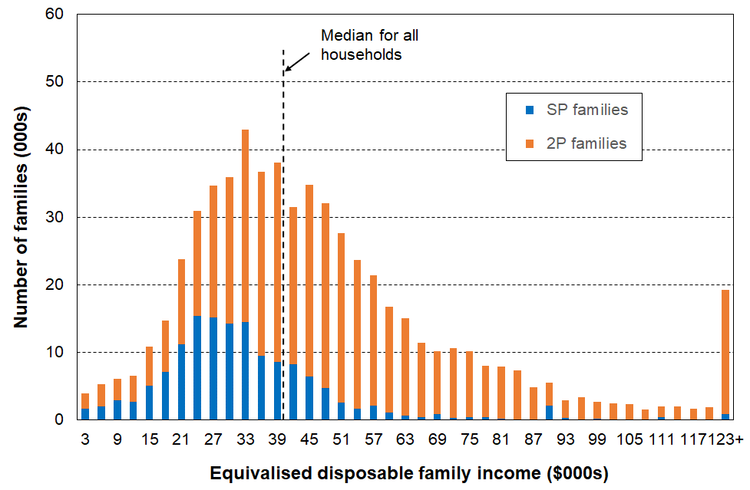

Notes: 1 Families are grouped by the income of their households in multiples of $3000 pa ($60 pw).

2 ‘Family’ here means ‘Economic Family Unit’.

It is clear from Figure B.1 that whatever standard income poverty measure is used, the proportion of those in sole parent families with incomes below the selected threshold (ie the income poverty rate for sole parent families) will be high in itself, and also higher than for those in two parent families.

**Children in households that are both low-income and in material hardship**

As shown in **Figure B.2** below, the less-than-100% overlap between the low-income and material hardship measures means that there are six groups to consider:

* the income poor (low-income households)
* the materially deprived
* the income poor who are materially deprived (the both/and group)
* the income poor who are not materially deprived (income poor only)
* the materially deprived who are not income poor (materially deprived only)
* those who are neither.

**Figure B.2**

**Six groups, from those in neither group to those in both**

In material hardship / materially deprived

Low-income / income poor

In both groups

Materially deprived only

In neither group

Income poor only

The evidence of increasing day-to-day restrictions and hardship is clear in **Table B.4a**, starting with those in neither group and moving through low income only … to both low-income and materially deprived, with the latter group clearly having the greatest restrictions on day-to-day living standards. For example, for children, the level of restrictions for the ‘both … and’ group is typically around double that for the low-income group.

**Table B.4a**

**Profile for the six groups in the low income / hardship nexus (settings as for the CPRA measure),**

**HES 2018-19**

|  |  |  |  |  |  |  |  |
| --- | --- | --- | --- | --- | --- | --- | --- |
| **HES 2018-19** | **ALL** | **neither** | **low income only** | **low income** | **deprived only** | **deprived** | **both** |
| **Children (0-17 yrs)** |  |  |  |  |  |  |  |
| size of groups (% of all children) | 100 | 68 | 18 | 26 | 5 | 13 | 8 |
| **% of all children in households reporting** |  |  |  |  |  |  |  |
| put up with cold (a lot) through shortage of money | 9 | 3 | 7 | 18 | 43 | 43 | 42 |
| use of food banks more than once in last 12 months | 5 | 1 | 4 | 12 | 18 | 26 | 32 |
| not enough income for the basics | 13 | 5 | 15 | 26 | 43 | 49 | 53 |
| borrowed from fam/friends for basics - more than once in last 12 months | 12 | 4 | 11 | 26 | 51 | 57 | 62 |
| $500 expense - cant pay | 26 | 14 | 32 | 48 | 79 | 84 | 87 |
| life satisfaction of ‘dissatisfied / very dissatisfied’ | 6 | 3 | 7 | 11 | 19 | 21 | 22 |

Notes:    - the AHC 60% of median measure is used for low income

              - the DEP-17 measure is used for material deprivation, with the threshold set at 6+/17

              - MSD treatment of the VLI households drops AHC 60 from 27.7% to 26.2%. See **Section O** for details.

Table **B.4b** repeats the analysis reported in Table B.4a, but this time using two measures that give similar-sized groups of children (19% for low-income and 23% for material hardship (albeit a non-standard 4+/17 threshold). The proportions are close to the lower quintiles on each measure. [45]

For Table B.4b the low-income measure is AHC 50 (rather than AHC 60) and material hardship measure is MWI<=16 (equivalent to 4+/17 on DEP-17).

The same pattern is evident in both tables.

**Table B.4b**

**Profile for the six groups noted above (similar sized low-income and deprived groups), HES 2018-19**

|  |  |  |  |  |  |  |  |
| --- | --- | --- | --- | --- | --- | --- | --- |
|  | **ALL** | **neither** | **low inc only** | **low inc** | **deprived only** | **deprived** | **both** |
| **Children (0-17 yrs)** |  |  |  |  |  |  |  |
| size of groups (% of all children) | 100 | 67 | 10 | 19 | 14 | 23 | 9 |
| % of all children in households reporting: |  |  |  |  |  |  |  |
| put up with cold (a lot) through shortage of money | 9 | 2 | 5 | 20 | 31 | 33 | 35 |
| use of food banks more than once in last 12 months | 5 | 1 | 3 | 14 | 14 | 19 | 26 |
| not enough income for the basics | 13 | 4 | 10 | 29 | 33 | 40 | 50 |
| borrowed from fam/friends for basics - more than once in last 12 months | 13 | 3 | 8 | 29 | 35 | 41 | 50 |
| $500 expense - cant pay | 27 | 11 | 23 | 51 | 69 | 74 | 81 |
| life satisfaction of ‘dissatisfied / very dissatisfied’ | 6 | 2 | 4 | 12 | 15 | 17 | 20 |

Notes: - the AHC 50% of median measure is used for the low-income group

- the MWI-24 measure is used for material deprivation, with the threshold set to give a material hardship rate similar to that given by the income poverty measure (AHC 50 rate = 19%, MWI<=16 gives 23%).

The combination measure (both low income and in material hardship) is used by Ireland to measure what they call ‘consistent poverty’, as in their view this (overlap) group best fits the high-level definition which has both an input (resources) and outcome dimension (minimum acceptable material standard of living).

It is one of the specified measures in the CPRA suite (see Table B.3a for this).

MSD uses the combination method as one of the measures in its multi-measure multi-level approach. It can be seen (as in Ireland) as the preferred measure, or simply as a measure of deeper poverty.

* * * * * * * * * * * * * * * * *

For each table above, the same pattern is found in the 2020-21 HES data and the actual numbers themselves are very similar. See **Appendix 6** for details.

**Three-way overlap: BHC low-income, AHC low-income and material hardship**

The previous section examined the overlap between an AHC low-income measure and a material hardship measure.

This section shows the relationship between three poverty measures: BHC 50, AHC 50 and material hardship (see **Figure B.3** belowand **Table B.5a** (next page)):

* Most of those in households with incomes below BHC 50 also have incomes below AHC 50 (the green-red overlap, around 85%). The rest of those with income below AHC 50 come from households with incomes higher than the BHC threshold, but whose housing costs are relatively large.
* Just under half (45%) of those experiencing material hardship come from the low-income AHC group (the black-green overlap). The other half come from households with incomes higher than this.
* The diagram shows how using a multi-measure approach captures a wider range of children in poverty … than using any one measure alone.
* The overlaps mean that if there is a reduction in the numbers in poverty on each of the three measures, the reduction in the total number of children experiencing poverty or hardship on any one of the three measures will be significantly more than on any one of the individual measures alone.
* The fact that the overlaps are not 100% between low-income and material hardship means that policies to reduce material hardship need to consider including elements that improve the incomes and/or reduce the expenditure of those above the usual low-income poverty lines.

**Figure B.3**

**3-way overlap: average of HES 2018-19, 2019-20 and 2020-21 for children (0-17 yrs)**

BHC 50% of median moving line income measure

11% (~125,000)

Material hardship

12% (~130,000)

AHC 50% of median moving line income measure

18% (~200,000)

Reading note for Figure 17:

* Both the income measures are fully relative ones (BHC 50 and AHC 50).
* The low-income rates and numbers in Figure 17 are a little lower than the official rates and numbers published by Stats NZ (~2 ppt lower). This difference arises from the treatment of the data that this report applies – households with reported incomes well below the minimum safety net levels of the social welfare system (ie typically less than BHC 20), yet reporting no material hardship / good material living standards are not counted in the MSD report. See **Section N** in the main report for a full discussion. The overlap findings reported in the text above Figure 17 are not impacted by this treatment.

**Table B.5a**

**Overlap of low-income and material hardship groups:**

**BHC 50, AHC 50, and DEP-17 6+, children 0-17 yrs,**

**HES 2018-19 to 2020-21**

|  |  |  |  |  |  |  |  |  |  |
| --- | --- | --- | --- | --- | --- | --- | --- | --- | --- |
| **(%)** | **Material hardship, DEP-17, 6+** | **Low income, BHC 50** | **Low income, AHC 50** | **BHC 50 and AHC 50** | **BHC 50 and MH** | **AHC 50 and MH** | **In all three** | **In any of the 3** | **None** |
| **2018-19** | 13 | 12 | 18 | 10 | 4 | 6 | 4 | - | 73 |
| **2019-20** | 12 | 11 | 18 | 9 | 3 | 5 | 3 | - | 75 |
| **2020-21** | 11 | 11 | 19 | 10 | 4 | 5 | 3 | - | 75 |
| **Avg over 3 yrs** | **12** | **11** | **18** | **10** | **4** | **5** | **3** | **-** | **74** |

|  |  |  |  |  |  |  |  |  |  |
| --- | --- | --- | --- | --- | --- | --- | --- | --- | --- |
| **(numbers)** | **Material hardship, DEP-17, 6+** | **Low income, BHC 50** | **Low income, AHC 50** | **BHC 50 and AHC 50** | **BHC 50 and MH** | **AHC 50 and MH** | **In all three** | **In any of the 3** | **None** |
| **2018-19** | 146,000 | 128,000 | 199,000 | 110,000 | 47,000 | 64,000 | 42,000 | 293,000 | 799,000 |
| **2019-20** | 127,000 | 123,000 | 196,000 | 104,000 | 36,000 | 57,000 | 32,000 | 281,000 | 820,000 |
| **2020-21** | 122,000 | 126,000 | 205,000 | 107,000 | 43,000 | 59,000 | 37,000 | 280,000 | 828,000 |
| **Avg over 3 yrs** | **132,000** | **126,000** | **200,000** | **107,000** | **42,000** | **60,000** | **37,000** | **285,000** | **816,000** |

|  |  |  |  |
| --- | --- | --- | --- |
| **(%)** | **% of BHC 50 who are in MH** | **% of AHC 50 who are in MH** | **% of BHC 50 who are in AHC 50** |
| **2018-19** | 37 | 32 | 86 |
| **2019-20** | 29 | 29 | 84 |
| **2020-21** | 34 | 29 | 85 |
| **Avg over 3 yrs** | **34** | **30** | **85** |

**Table B.5b**

**Overlap of low-income and material hardship groups:**

**BHC 50, AHC 40, and DEP-17 6+, children 0-17 yrs,**

**HES 2018-19 to 2020-21**

|  |  |  |  |  |  |  |  |  |  |  |
| --- | --- | --- | --- | --- | --- | --- | --- | --- | --- | --- |
| **(%)** | **Material hardship, DEP-17, 6+** | **Low income, BHC 50** | **Low income, AHC 40** | **BHC 50 and AHC 40** | **BHC 50 and MH** | **AHC 40 and MH** | **In all three** | **In any of the 3** |  | **None** |
| **2018-19** | 13 | 12 | 11 | 7 | 4 | 4 | 2 | - |  | 76 |
| **2019-20** | 12 | 11 | 11 | 6 | 3 | 3 | 2 | - |  | 77 |
| **2020-21** | 11 | 11 | 11 | 7 | 4 | 3 | 2 | - |  | 79 |
| **Avg over 3 yrs** | **12** | **11** | **11** | **7** | **4** | **3** | **2** | **-** |  | **77** |

|  |  |  |  |  |  |  |  |  |  |
| --- | --- | --- | --- | --- | --- | --- | --- | --- | --- |
| **(numbers)** | **Material hardship, DEP-17, 6+** | **Low income, BHC 50** | **Low income, AHC 40** | **BHC 50 and AHC 40** | **BHC 50 and MH** | **AHC 40 and MH** | **In all three** | **In any of the 3** | **None** |
| **2018-19** | 146,000 | 128,000 | 121,000 | 79,000 | 47,000 | 38,000 | 27,000 | 258,000 | 834,000 |
| **2019-20** | 127,000 | 123,000 | 118,000 | 70,000 | 36,000 | 36,000 | 23,000 | 249,000 | 852,000 |
| **2020-21** | 122,000 | 126,000 | 119,000 | 76,000 | 43,000 | 33,000 | 23,000 | 238,000 | 871,000 |
| **Avg over 3 yrs** | **132,000** | **126,000** | **119,000** | **75,000** | **42,000** | **36,000** | **24,000** | **248,000** | **852,000** |

|  |  |  |  |
| --- | --- | --- | --- |
| **(%)** | **% of BHC 50 who are in MH** | **% of AHC 40 who are in MH** | **% of BHC 50 who are in AHC 40** |
| **2018-19** | 37 | 32 | 62 |
| **2019-20** | 29 | 31 | 57 |
| **2020-21** | 34 | 28 | 60 |
| **Avg over 3 yrs** | **34** | **30** | **60** |

**Material hardship by disability status**

In HES 2019-20 and 2020-21 disability data was collected which allows reporting on disability status of individuals and their households. The following definitions are used:

* Children under 2 years old are not assessed for disability.
* People aged 2 to 4 are disabled if they have serious difficulty with at least one of the following: seeing (even with glasses), hearing (even with hearing aids), walking, manual dexterity, communicating, learning, playing or controlling their own behaviour.
* People aged 5 to 17 are disabled if they have serious difficulty with at least one of the following: seeing (even with glasses), hearing (even with hearing aids), walking, feeding or dressing themselves, communicating, learning, remembering, concentrating, accepting change, controlling their own behaviour, making friends, anxiety, or depression.
* People aged 18 or over are disabled if they have serious difficulty with at least one of the following: seeing (even with glasses), hearing (even with hearing aids), walking, remembering or concentrating, washing or dressing, communicating, upper body strength, manual dexterity, anxiety, or depression.

**Table B.6** reports the material hardship rates for children by their disability status and that of their household. The numbers are drawn directly from Stats NZ’s February 2022 Child Poverty release, with some rounding.

**Table B.6**

**DEP-17 6+/17 material hardship rates (%) for children by disability status,**

**average of HES 2019-20 and 2020-21**

|  |  |  |  |  |
| --- | --- | --- | --- | --- |
|  | **Disabled children** | **Non-disabled children** | **Children in disabled household** | **Children in non-disabled household** |
| **Numbers in hardship** | 25,000 | 90,000 | 73,000 | 56,000 |
| **% in hardship** | 21 | 10 | 21 | 7 |
| **Numbers in severe hardship** | 12,000 | 38,000 | 34,000 | 21,000 |
| **% in severe hardship** | 10 | 4 | 10 | 3 |
| **Total numbers** | 120,000 | 905,000 | 345,000 | 800,000 |
| **Total %** | 12 | 88 | 30 | 70 |

Note for table: A disabled household is one with at least one disabled person.

**Material hardship, low (AHC) income and foodbank usage in six Auckland sub-regions**

Material wellbeing and hardship are not evenly distributed across Auckland (or any major city), so looking at the average statistics for the whole region does not provide a picture that is useful for policy purposes or even for just understanding the nature of our largest city.

When Auckland's eight former councils were merged into a single ‘Super City’ in 2010, the Auckland region was divided into 13 wards and 21 local boards. The analysis in this section uses groupings of selected wards to enable a breakdown of the Auckland region into six sub-regions, as in **Table B.7.**[46]

**Table B.7**

**The six sub-regions defined by the agglomeration of selected wards**

|  |  |
| --- | --- |
| **Sub-region** | **Wards included in the sub-region** |
| Northern | North Shore, Albany and Rodney |
| Western | Waitākere (incl Massey-Henderson-Te Atatū); and Whau (incl New Lynn, Green Bay, Kelston, Avondale, Blockhouse Bay) |
| Central 1 | Albert-Eden-Puketāpapa (incl Pt Chevalier, Mt Albert, Mt Roskill, Balmoral, Mt Eden, Epsom, Royal Oak, Lynfield); and Ōrākei (incl Parnell, Newmarket, Remuera, Meadowbank, Ōrākei, Mission Bay, St Heliers, Glendowie) |
| Central 2 | Maungakiekie-Tāmaki (incl One Tree Hill, Onehunga, Te Papapa, Mt Wellington, Ellerslie, Panmure, Point England, Glen Innes, St Johns); and Waitematā-Gulf (incl Grey Lynn, Westhaven, Waiheke) |
| Southern | Manukau and Manurewa-Papakura |
| Howick-Franklin | Howick (incl Pakuranga, Botany Downs, Half-Moon Bay, Eastern Beach, East Tamaki Heights) and Franklin |

Note for table:

Follow the link and scroll down for an Auckland map showing the wards: <https://www.aucklandcouncil.govt.nz/about-auckland-council/how-auckland-council-works/governing-body-wards-committees/wards/Pages/find-your-ward.aspx>

**Table B.8** gives an indication of the size of each grouping of wards and of the differing levels of material and financial hardship across selected areas of the Auckland region, for all people and for children (0-17 years). The figures in the tables are the average for the three surveys 2018-19, 2019-20 and 2019-20, to ensure there are sufficient numbers in the joint sample to give robust findings on the various statistics. There is no evidence of any upward or downward trend over the three years so taking the average does not lose any information.

Four measures of material and financial hardship are reported:

* AHC 50 REL: the proportion (%) of people (children) living in households that have an after-deducting-housing costs (AHC) income of less than half the AHC median for the whole country.
* MH 6+: the standard material hardship measure used by Stats NZ and this report, households lacking 6 or more of the 17 items in the DEP-17 index.
* MH 9+: the severe hardship version of the above.
* Foodbank usage: the proportion (%) of people (children) living in households that report using a foodbank or similar at least once in the 12 months prior to interview.

**Table B.8a**

**Low-income (AHC 50), material hardship and foodbank usage for Auckland and six groupings of wards: all individuals, average over 2018-19 to 2020-21 (%)**

|  |  |  |  |  |  |
| --- | --- | --- | --- | --- | --- |
| **Geographic Area** | **AHC 50** | **MH 6+** | **MH 9+** | **Total # individuals** | **Foodbank %** |
| New Zealand | 14 | 8 | 3 | 4,940,000 | 6 |
| Auckland | 15 | 8 | 3 | 1,673,000 | 6 |
| Northern wards | 14 | 4 | 2 | 419,000 | 2 |
| Western wards | 16 | 7 | 2 | 255,000 | 6 |
| Central 1: Albert-Eden-Roskill & Ōrākei, | 13 | 4 | 1 | 276,000 | 3 |
| Central 2: Maungakiekie-Tāmaki & Waitematā-Gulf | 16 | 10 | 5 | 159,000 | 7 |
| Southern wards | 19 | 21 | 9 | 333,000 | 12 |
| Howick-Franklin wards | 15 | 5 | 2 | 230,000 | 3 |

**Table B.8b**

**Low-income (AHC 50), material hardship and foodbank usage for Auckland and six groupings of wards: children (0-17 yrs), average over 2018-19 to 2020-21 (%)**

|  |  |  |  |  |  |
| --- | --- | --- | --- | --- | --- |
| **Geographic Area** | **AHC 50** | **MH 6+** | **MH 9+** | **Total # children** | **Foodbank %** |
| New Zealand | 18 | 12 | 5 | 1,142,000 | 10 |
| Auckland | 19 | 12 | 6 | 391,000 | 9 |
| Northern wards | 16 | 5 | 2 | 99,000 | 4 |
| Western wards | 21 | 10 | 4 | 59,000 | 10 |
| Central 1: Albert-Eden-Roskill & Ōrākei, | 14 | 4 | 2 | 53,000 | 3 |
| Central 2: Maungakiekie-Tāmaki & Waitematā-Gulf | 19 | 17 | 10 | 29,000 | 13 |
| Southern wards | 25 | 28 | 13 | 93,000 | 19 |
| Howick-Franklin wards | 18 | 7 | 3 | 57,000 | 5 |

The numbers that immediately grab one’s attention are those for the Southern wards:

* 28% of children in material hardship compared with a country-wide figure of 12% on average over the three surveys
* 13% in severe material hardship compared with 5% country-wide
* 19% of children in households using a foodbank at least once in the 12 months prior to interview, compared with 10% country-wide.

Looking at the figures another way, children (under-18s) living in the Southern wards make up:

* 24% of Auckland’s under-18 population but 53% of under-18 Aucklanders in material hardship
* 8% of the country’s under-18s, but 20% of all under-18s in material hardship.

The other feature of the reported statistics is that the AHC 50 differences between the groupings is less pronounced than when using the more direct hardship measures. This greater sensitivity to difference or change in household circumstances is also evident more generally in time series (see p137 in Section J).

**Comparing poverty rates for children, one-person households (aged 18-64 yrs), and older New Zealanders (65+ yrs)**

This section provides HES-based evidence and commentary to assist with policy discussion in relation to two matters:

* Poverty rates for children are sometimes compared with the (lower) rates for older New Zealanders, with the conclusion reached that ‘we treat our older people better than our children’.
* One-person households do not feature as often in poverty discussions as children do. This section draws attention to the relatively high poverty rates for this group.

It also provides a good illustration as to why it is important to not rely on just one measure when assessing how different population groups are faring in their material wellbeing.

**Table B.6** compares low-income and material hardship rates for children, those in one-person households (aged 18-64 yrs), and older New Zealanders (65+ yrs), using the nine CPRA measures.

* On all measures, one-person households have higher poverty rates than children, and on all but one (BHC 60) higher than older New Zealanders.
* On all but one measure (BHC 60), older New Zealanders have the lowest poverty rates of all three groups.

**Table B.6**

**Low-income and material hardship rates (%) compared for**

**one person households (18-64 yrs), children (0-17 yrs), and older New Zealanders (65+), 2018-19**

|  |  |  |  |  |  |
| --- | --- | --- | --- | --- | --- |
| **New Zealand comparisons** | **HES 2018-19** | **One person HHs (18-64 yrs)** | **Children**  **(0-17yrs)** | **Older NZers (65+ yrs)** | **ALL** |
|  | 180,000 | 1.13m | 700,000 | 4.9m |
| BHC 50 | 31 | 13 | 9 | 10 |
| BHC 60 | 37 | 22 | 37 | 20 |
| AHC 40 | 31 | 12 | 7 | 10 |
| AHC 50 | 37 | 19 | 13 | 15 |
| AHC 60 | 44 | 27 | 26 | 22 |
| Material hardship (DEP-17, 6+/17) | 21 | 13 | 3 | 9 |
| Severe material hardship (9+/17) | 10 | 6 | 1 | 4 |
| Material hardship plus income less than AHC 60 | 19 | 8 | 2 | 5 |
| **2018-19 EU comparisons for material hardship (EU-13)** | EU-13, 5+/13 (NZ figures) | 22 | 14 | 4 | 10 |
| Median for EU + UK, NO, IS & CH | 14-15 | 11-12 | 8 | 10 |
| NZ rate relative to EU countries (plus Iceland, Norway, Switzerland and the UK) → | NZ BHC60 rate relatively high, along with Ireland, Belgium (21-23%) etc. Better only than Serbia, Latvia, Lithuania, Romania, etc. | A little above the EU median – similar to Italy, Portugal, Belgium | Among those with lowest rates such as the UK, Finland, Denmark, Switzerland, etc |  |

* + A claim sometimes made regarding the relative positions of children and older New Zealanders goes along these lines (or similar): ‘NZ Super is widely understood as an effective basic income that is highly successful in preventing poverty. Incomes for beneficiary households with children should be raised to a similar level to help address child poverty.’
    - NZS is in fact only just above the BHC 50 level, so does not ‘prevent poverty’ as measured, for example, by BHC 60 (37%, among the highest in the OECD/EU). It is NZS *plus* the very high rates of mortgage-free tenure that leads to lower hardship and lower AHC 40 rates. Older New Zealanders who rent privately have a hardship rate of 12%, a little less than children but higher than the overall 65+ rate of 3-4%.
    - For many beneficiary households with children, their total BHC household income including AS and WFF is already well above NZS levels and above the 50% BHC threshold. The issue is that these households have much higher housing costs on average compared with older New Zealanders, so their AHC incomes often fall below 50% AHC threshold, and sometimes below 40% AHC.[47]
    - The assumptions in the claim are not supported by the evidence. This is not an argument for or against doing more for children or older New Zealanders, it is just that the way the case is often presented is highly contestable.
* The lower rates for children compared with adults in one-person households reflect the cumulative impact of policy decisions over many years which have improved the incomes of households in which there are children, both beneficiary and low-income working households (in varying degrees) … with little change for one-person beneficiary households.
* The relatively high rate for older New Zealanders using the BHC 60 measure (37%) reflects two factors: (a) NZS is currently close to / just above the BHC 50 line; and (b) around 40% of those aged 65+ live in households with incomes from NZS plus less than $100 pw more from their own resources. This puts a large clump of 65+ households in the 50-60% BHC range and leads to the very high reported rate on this measure.
* Using several measures allows the overall story to be told (older New Zealanders have low material hardship rates and low AHC low-income rates), with the outlier (BHC 60) being able to be accounted for very simply and without undermining the overall picture.

**Further comparisons of material hardship rates for one-person households and children (looking at beneficiary households), and for older New Zealanders who rent.**

**Table B.7** provides some further breakdown of the material hardship figures reported in Table B.3 above.

* The material hardship rate for one-person beneficiary households is very high in itself (46-48%), and is higher than the rate for children in beneficiary households whichever of the two ways it is measured (35-42%).
* Older New Zealanders who rent have a higher material hardship rate than overall for this age group (19% compared with 3%), but their rates are still much lower than for the other two groups.

**Table B.7**

**Material hardship rates (%) for**

**one person households (18-64 yrs), children, and older New Zealanders (65+) in selected circumstances**

**HES 2018-19**

|  |  |  |  |  |  |  |  |  |
| --- | --- | --- | --- | --- | --- | --- | --- | --- |
| **One-person HHs (18-64 yrs)** | | | **Children (0-17 yrs)** | | | **Older NZers (65+ yrs)** | | **Whole population** |
| ALL | Some benefit income | Govt income as main source | ALL | In HHs with some benefit income | In HHs with govt income as main source | ALL | Renters receiving AS |
| 21 | 46 | 48 | 13 | 35 | 42 | 3 | 19 | 9 |

Note for Table B.7:

* The material hardship rates are based on the DEP-17 measure (6+/17).
* Renters with AS make up around half of all 65+ renters. When non-AS 65+ renters are included, the material hardship rate is 12%.
* The rates for beneficiary households and older New Zealanders who rent are based on relatively small sub-samples of around 700 households in each case. The sampling errors (95% CI) will be large. This means that the hardship rates for these groups should not be taken as reliable precision estimates, though they are still reliable enough to support the conclusions above. This analysis is possible now because of the much higher sample size for HES 2018-19.

**Section C**

**What does poverty look like for children in households identified as poor?**

This section uses information about aspects of the day-to-day living standards of children and the households in which they live to give a picture of what poverty looks like for children in households identified as poor using selected official CPRA measures.

Introduction:

* the overlap / mismatch between low-income and material hardship measures of poverty … and its relevance to this Section
* the approach used in this Section:
  + using child-specific items and directly child-relevant household items to help describe what poverty looks like for children in households identified as poor.

Children in households in material hardship

* + using MWI deciles and ventiles
  + under CPRA DEP-17 thresholds
  + what income bands do those in material hardship come from?

Children in low-income HHs

* + some income data challenges and conceptual/interpretation issues
  + material hardship rates for children in selected household income bands (deciles etc), and in households below CPRA low-income thresholds
  + what is life like for those under the five CPRA relative low-income bands?
  + what is life like for those in selected AHC income bands?

Children in households in both low income and material hardship

Children in working and beneficiary households

**The overlap / mismatch between low-income and material hardship measures of poverty and its relevance to this Section**

A key theme of the report is that the day-to-day picture of poverty is different depending on whether a material hardship or a low-income approach is used for measurement, even when the two groups are of similar size (eg comparing those in material hardship (13%) and those in households with incomes below 40% AHC (14%)) in HES 2018-19.[48] There are two sorts of reasons for this difference.

First, as discussed in the Section A, there are factors in addition to current household income that impact on the actual day-to-day living standards of households. As a result:

* *not all low-income households are in hardship* (eg their past income could have been higher than current income and they have savings to draw on; they may have a well-established set of household goods and appliances and little or no debt servicing; they may have financial or significant in-kind support from outside the household; if household income is mainly from self-employment, legitimately declared low household income will usually bear little relationship to the resources available; and so on)[49]
* *some households with incomes above low-income lines (income poverty lines) are in hardship* (eg they may have significant health-related costs or high debt servicing costs; or have been on low-income over several previous years; or be trying to make do on a much lower income than previously after a relationship break-up; and so on).

**Figure C.1** below illustrates this limited overlap.

**Figure C.1**

**Limited overlap between those in low-income households and those in households in material hardship**

Low-income households

Some low-income households are not in hardship

Some households in hardship do not have low incomes

Households in material hardship

Second, the sort of items used to help paint the picture of ‘life below the line’ (eg the calibration items listed in Tables C.1 and C.2 below) are likely to be reasonably correlated with the items used in the deprivation indices themselves. When these calibration items and other similar items are used to paint the picture of poverty as measured using deprivation indices, most of those lacking the ‘painting-the-picture’ items will be the same households that are defined by the indices as being in hardship.

On the other hand, in the low-income approach, household income is used as a proxy for the resources available to meet basic household material needs. As noted above, there are many other factors in addition to current income that are a part of a household’s material and financial resources. Households reporting material hardship / those in hardship using the DEP-17 6+/17 definition are therefore quite spread across the income spectrum below the median, which means that the ‘painting-the-picture’ items will also be more spread.

**The approach used in this Section:**

**Using child-specific items and directly child-relevant household items to help describe what poverty looks like for children in households identified as poor**

The 2018-19, 2019-20 and 2020-21 HES surveys gathered information on twenty child-specific items that cover a wide range of possessions and activities that most would agree every child should have and none should be deprived of in New Zealand today. These are listed in **Table C.1** below. A more detailed version is available in **Appendix 2**, including whether the reason for not having an item is because of cost or some other reason.[50]

These child-specific indicators are not suitable for use in indices such as DEP-17 or the MWI as they do not meet two of the key criteria for such measures – they are not suitable for all ages, and do not represent a good range of severity of hardship, only deeper hardship for most of the indicators. They do, however, provide valuable information on the realities of daily life for those children identified as being ‘in hardship’ by the DEP-17 or MWI index score of their household, or as being in low-income households. They can be used on their own, or combined with information on more general household conditions that are directly child-relevant (eg ability to keep home warm and dry).

When describing what poverty looks like for children in households identified as poor, this section uses a range of items that describe aspects of financial and material hardship. It often uses a special set of 18 essential items made up of 12 of the 20 child-specific items and 6 general household items that have direct relevance for children. These are listed in **Table C.2** on the next page. The chosen essentials were limited to those that would likely command a wide consensus as items that no child should have to go without and that all children should have. The report refers to these and other similar items as the calibration items, as distinct from the index items that make up DEP-17, EU-13, and so on.

**Table C.1**

**Child-specific items and the % of age 6-17s without the item or very restricted, as reported by household respondent (HES 18-19 to 20-21)**

|  |  |  |  |  |
| --- | --- | --- | --- | --- |
| **Don't have (for any reason):** | | **18-19** | **19-20** | **20-21** |
|  | Two pairs of shoes in a good condition and suitable for daily activities | 7 | 5 | 5 |
|  | Two sets of warm winter clothes | 2 | 1 | 2 |
|  | Waterproof coat | 9 | 6 | 6 |
|  | A separate bed | 5 | 4 | 4 |
|  | Fresh fruit and vegetables daily | 7 | 5 | 4 |
|  | A meal with meat, fish or chicken (or vegan equivalent) daily | 6 | 4 | 3 |
|  | Good access at home to a computer and internet for homework? | 6 | 5 | 4 |
|  | A range of books at home suitable for their ages | 5 | 4 | 4 |
|  | A suitable place at home to do school homework | 2 | 2 | 1 |
|  | Friends around to play and eat from time to time | 11 | 11 | 9 |
|  | Friends around for a birthday party | 13 | 11 | 12 |
| **Do/not do a lot in order to save money:** | |  |  |  |
|  | Postponed visits to the doctor | 2 | 1 | 1 |
|  | Postponed visits to the dentist | 1 | 1 | 1 |
|  | Did not pick up child’s prescription | 0 | 1 | 1 |
|  | Unable to pay for a child to go on a school trip or other school event | 3 | 2 | 3 |
|  | Had to limit children’s involvement in sport | 6 | 4 | 4 |
|  | Had children go without music, dance, Kapa haka, art, swimming or other special interest lessons | 7 | 5 | 5 |
|  | Children continue wearing shoes or clothes that were worn out or the wrong size | 3 | 2 | 3 |
| **Don't have (age 11+ only):** | |  |  |  |
|  | Mobile phone if aged 11+ | 18 | 14 | 13 |

**Table C.2**

**The 18 essential items used for various calibration exercises**

|  |  |
| --- | --- |
| **Selected child-specific items (12)** | **Child-relevant general household items (6)** |
| Do not have:   * two pairs good shoes for each child * two sets of warm winter clothes for each child * waterproof coat for each child (because of cost) * a separate bed for each child * fresh fruit and vegetables daily * meal with meat, fish or chicken (or vegetarian equivalent) each day * good access at home to a computer and internet for homework * friends around to play and eat from time to time (because of the cost)   Economised ‘a lot’:   * unable to pay for school trips / events for each child * had to limit children’s involvement in sport * children had to go without music, dance, kapa haka, art, swimming or other special interest lessons * continued wearing worn out / wrong size clothes or shoes | Household deprivations that have direct relevance to children:   * received help from food bank or other community group (more than once in last year) * accommodation severely crowded (2+ extra bedrooms needed) * dampness or mould in dwelling (‘major problem’) * respondent reports putting up with feeling cold to keep down costs for other basics (‘a lot’) * delayed repair or replacement of appliances (‘a lot’) * no access to car or van |

Notes for Table C.2:

* See **Appendix 1** for the full text for the child-specific items.
* The economising questions ask about economising so as to be able to pay for other basics, not just to be thrifty or save up for a special non-essential. Possible responses were ‘not at all’, ‘a little’, and ‘a lot’.

**Figure C.2** shows how these 18 calibration items are distributed across deciles of children ranked by their households’ MWI scores (left-hand chart) and by the AHC incomes of their households (right-hand chart).

**Figure C.2**

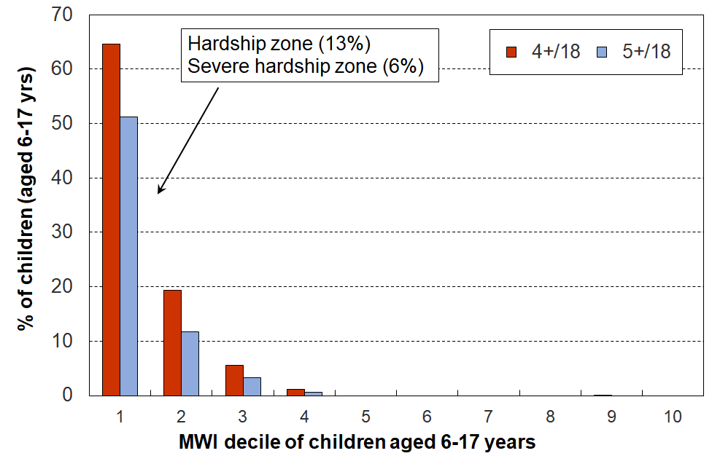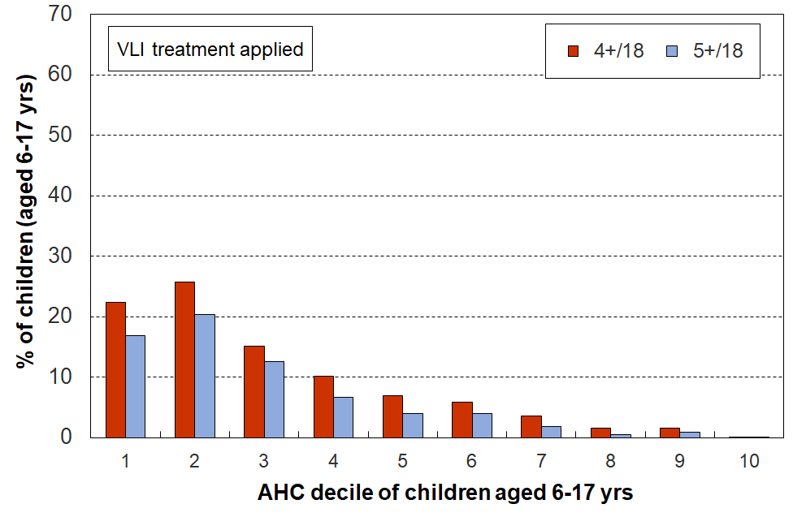 **Multiple deprivation for children using 18 essential child-specific** **and general HH items, HES 2018-19**

Note for Figure C.2

* The MWI chart above is based on the same data as the ventile version in Figure C.3 below.
* The average hardship rate for the lowest AHC decile is lower than for decile 2. This reflects a commonly-found feature of some of the households with very low income (eg those in ventile 1, the bottom 5%) – their actual day-to-day living standards are much higher than their incomes would suggest. As discussed in **Section O**, the report applies a treatment to the relevant very-low-income households that reduces but does not eliminate the anomaly.

A key takeaway from this analysis, using the 18 essential items, is how the distribution of the deprivation items is so different depending on whether the ranking of households is done by an outcome measure (MSD’s MWI) or by an input measure (AHC income).

All up, in the 2018-19 HES, around 55,000 children aged 6-17 years (~7%) experienced 4+ deprivations out of the 18 in the list in Table C.2 above.

* When households are ranked by their material wellbeing (using the MWI), 83% of these 55,000 children are found in the bottom decile (of children) and 96% are in the bottom two deciles, as shown in the left-hand chart.
* When households are ranked by their AHC incomes, the 55,000 6-17 year-olds experiencing these deprivations are spread much more widely: only 48% are in the bottom two deciles (instead of 83%), and it takes the lower eight AHC income deciles to capture the 96% captured in just the bottom two deciles on the MWI ranking.

When considering possible interventions to reduce material hardship rates for children, this finding and the associated one on the limited overlap between low-income and material hardship measures suggest two things:

* A good portion of the impact can (needs to) come from improved incomes for households with incomes above standard ‘poverty lines’ and even up to the median. While ‘spillover’ has fiscal costs that a more surgical intervention does not have, there is a likely countervailing positive impact too – some of the ‘near-poor’ will experience a reduction in financial hardship that is sufficient to take them out of the (measured) material hardship they are experiencing.
* The fact that there is a range of non-income factors that can increase or reduce hardship means that there are some policy options in addition to increased income support for assisting households to improve their position – often involving reducing demand on the household budget (see Figure A.1).

A second takeaway is how multiple material disadvantage for children clusters strongly at the hardship end of the spectrum (in addition to Figure C.2 (left-hand) see, for example, **Figure C.3** and **Tables C.3a** and **C.3b** below). The 18 items are those in **Table C.2**. The children are ranked in ventiles (5% groupings) or deciles (10% groupings) by the MWI score of their households. For the most materially deprived 5% of children, 81% experience 4 or more of the 18 deprivations, all of which are about very basic needs. Of the next 5% close to a half experience 4 or more (47%). Overall for the bottom 10%, 64% experience 4 or more of these deprivations.

While there is evidence here and elsewhere of some hardship in the next 10% (MWI decile 2, 18% with 4+), there is no gradient across all the deciles reflecting what is sometimes referred to as ‘acceptable inequality’ (as there is for many other aspects of social and material wellbeing). The analysis shows that for those children in the most materially deprived households (~5 to 8%), life is undeniably very different from that experienced by the vast majority of New Zealand children. This finding is in line with what was found using similar indicators from the 2008 Living Standards Survey. It illustrates what it means in practice to be ‘*excluded from the minimum acceptable way of life in one’s own society*’, the high-level definition of poverty commonly used for richer countries and adopted in MSD reports.

A third takeaway is the implication for interpreting findings that relate to those in households in the bottom income decile (or ventile) given the ‘households-with-very-low-income’ (VLI) issue. Without some reasonable treatment being applied to these outlier households, misleading results can be produced. Even with a reasonable treatment (as in this report), the anomalies are significantly reduced but not eliminated. See **Section O** for a detailed discussion.

* * * * * * * * * * * * * * * * * * * * * *

**The next four sub-sections** apply the approach outlined above to the four groups below, seeking in each case to answer the question – what does ‘poverty’ look like for children in households identified as ‘poor’?:

* children in households identified as in material hardship
* children in low-income households
* children in low-income households that are also in material hardship
* children in ‘working’ and ‘beneficiary’ households (using ‘main source of income in the 12 months prior to interview’ as the means of making the distinction).

**Children in households in material hardship**

**For children in households identified as ‘in hardship’, life is typically very different compared with that experienced by the vast majority of New Zealand children: there is no social gradient of ‘acceptable inequality’ across the material wellbeing spectrum when it comes to lacking common essentials – this experience is all heavily focussed in the lower 5%, perhaps a little more.**

In **Figure C.3** below, children (aged 6-17 yrs) are ranked by their households’ material wellbeing from high to low using the MWI, then grouped into ventiles (twenty equal groups of 5% each). The number of missing basics is counted out of the 18 essentials listed in Table C.2 above.

Figure C.3 shows how different life is for children in the hardship zone. This significant difference illustrates what it means in practice to be ‘*excluded from the minimum acceptable way of life in one’s own society because of inadequate resources’*, the high-level definition of poverty commonly used for richer countries, as discussed in the Introduction (Section A). There is no social gradient of ‘acceptable inequality’ across the material wellbeing spectrum when it comes to missing out on common essentials – this experience is all heavily focussed in the lower end, especially the lower 5% of children (~60,000) but also many of the next 5% are in similar severe disadvantage.

**Figure C.3**

**Multiple deprivation for children, using 18 essential child-specific and child-relevant**

**general household items, HES 2018-19**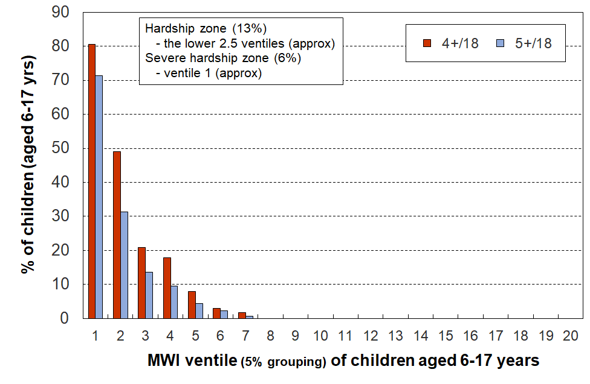

**Tables C.3a** and **C.3b** (next pages) give the detailed analysis which lies behind Figure C.3 and which underscores the considerable difference between life in the hardship zone and that for the vast majority of children.

**Table C.3a**

**Children’s restrictions by the MWI score of their household (children, 6-17 yrs),**

**grouped by quintiles of children, with the bottom quintile broken out into deciles**

**HES 2018-19 (%)**

|  |  |  |  |  |  |  |  |  |  |
| --- | --- | --- | --- | --- | --- | --- | --- | --- | --- |
|  | **All** | **D1** | **D2** |  | **Q1** | **Q2** | **Q3** | **Q4** | **Q5** |
| **Distribution of children (6-17yrs) across MWI deciles of children (%)** | 100 | 10 | 10 |  | 20 | 20 | 20 | 20 | 20 |
| **Don’t have** |  |  |  |  |  |  |  |  |  |
| 2 pair of shoes in good condition and suitable for daily activities for each child | 7 | 36 | 15 |  | 26 | 4 | . | . | . |
| 2 sets of warm winter clothes for each child | 2 | 13 | 3 |  | 8 | . | . | . | . |
| waterproof coat for each child (because of the cost) | 5 | 28 | 7 |  | 18 | 3 | . | . | . |
| separate bed for each child | 5 | 25 | 10 |  | 18 | 5 | . | . | . |
| fresh fruit and vegetables daily | 7 | 45 | 12 |  | 29 | 5 | . | . | . |
| meal with meat, fish or chicken (or vegetarian equiv) each day | 6 | 31 | 13 |  | 22 | 5 | . | . | . |
| good access at home to a computer and internet for homework | 6 | 27 | 14 |  | 21 | 6 | 2 | . | . |
| friends around to play and eat from time to time (because of the cost) | 4 | 21 | 7 |  | 14 | 3 | . | . | . |
| **Economised ‘a lot’ on children’s items to keep down costs to enable other basic things to be paid for (not just to be thrifty or to save for a trip or other non-essential)** | | | | | | | | | |
| had to go without music, dance, kapa haka, art, swimming or other special interest lessons (“a lot”) | 7 | 35 | 17 |  | 26 | 6 | . | . | . |
| unable to pay for school trip or other school event (“a lot”) | 3 | 24 | 6 |  | 15 | . | . | . | . |
| involvement in sport had to be limited (“a lot”) | 6 | 32 | 15 |  | 24 | 4 | . | . | . |
| continue to wear shoes or clothes that are worn out or the wrong size (“a lot”) | 3 | 19 | 7 |  | 13 | . | . | . | . |
| **Multiple restrictions of child-specific items (the 12 above)** |  |  |  |  |  |  |  |  |  |
| 2+ out of 12 | 12 | 68 | 28 |  | 49 | 9 | . | . | . |
| 3+ out of 12 | 8 | 53 | 17 |  | 36 | 4 | . | . | . |
| 4+ out of 12 | 6 | 43 | 9 |  | 27 | 2 | . | . | . |
| **Child-relevant general household items** |  |  |  |  |  |  |  |  |  |
| received help (food, clothes, money) from a community organisation more than once in the last 12 months | 5 | 31 | 9 |  | 20 | 4 | . | . | . |
| accommodation crowded or severely crowded (1+ extra bedrooms needed) | 13 | 31 | 23 |  | 27 | 18 | 8 | 8 | 4 |
| accommodation severely crowded (2+ extra bedrooms needed) | 3 | 6 | 6 |  | 6 | 5 | 2 | . | . |
| dampness or mould a ‘major problem’ in the accommodation | 8 | 36 | 20 |  | 28 | 8 | 3 | . | . |
| respondent reports putting up with feeling cold to keep down costs for other basics (‘a lot’) | 10 | 49 | 27 |  | 38 | 9 | 1 | . | . |
| delayed replacing or repairing broken or damaged appliances to keep down costs for other basics (‘a lot’) | 12 | 62 | 29 |  | 45 | 12 | 3 | . | . |
| household has no access to car or van for personal use | 5 | 14 | 7 |  | 10 | 6 | 3 | . | . |
| **Multiple restrictions out of 12 child-specific and 6 general child-relevant household items (18 in all)** | | | | | | | | | |
| 3+ out of 18 | 14 | 78 | 34 |  | 57 | 8 | . | . | . |
| 4+ out of 18 | 9 | 64 | 18 |  | 42 | 3 | . | . | . |
| 5+ out of 18 | 7 | 50 | 11 |  | 31 | 2 | . | . | . |
| **Postponed doctor’s visits ‘a lot’ to keep down costs to enable other basic things to be paid for (not just to be thrifty or to save for a trip or other non-essential)** | | | | | | | | | |
| For children (a lot) | 2 | 8 | 5 |  | 7 | . | . | . | . |
| For respondent (a lot) | 11 | 52 | 33 |  | 42 | 11 | 3 | . | . |
| For children (a little or a lot) | 5 | 22 | 11 |  | 17 | 6 | . | . | . |
| For respondent (a little or a lot) | 28 | 84 | 71 |  | 77 | 46 | 16 | 2 | . |
| **Respondent reports life satisfaction** |  |  |  |  |  |  |  |  |  |
| dissatisfied or very dissatisfied with life | 6 | 23 | 14 |  | 19 | 7 | 3 | 2 | . |
| satisfied or very satisfied with life | 79 | 42 | 60 |  | 51 | 74 | 84 | 92 | 95 |

Note: Information is suppressed in cells with fewer than 15 households in the sample.

**Table C.3b**

**Children’s restrictions by the MWI score of their household (children, 6-17 yrs),**

**grouped by deciles and ventiles of children**

**HES 2018-19 (%)**

|  |  |  |  |  |  |  |  |  |  |
| --- | --- | --- | --- | --- | --- | --- | --- | --- | --- |
|  | **All** | **V1** | **V2** |  | **D1** | **D2** | **D3** | **D4** | **D5** |
| **Distribution of children (6-17yrs) across MWI deciles of children (%)** | 100 | 5 | 5 |  | 10 | 10 | 10 | 10 | 10 |
| **Don’t have** |  |  |  |  |  |  |  |  |  |
| 2 pair of shoes in good condition and suitable for daily activities for each child | 7 | 49 | 23 |  | 36 | 15 | 5 | . | . |
| 2 sets of warm winter clothes for each child | 2 | 20 | . |  | 13 | 3 | . | . | . |
| waterproof coat for each child (because of the cost) | 5 | 40 | 17 |  | 28 | 7 | 4 | . | . |
| separate bed for each child | 5 | 30 | 20 |  | 25 | 10 | 5 | 5 | . |
| fresh fruit and vegetables daily | 7 | 58 | 32 |  | 45 | 12 | 6 | 3 | . |
| meal with meat, fish or chicken (or vegetarian equiv) each day | 6 | 42 | 21 |  | 31 | 13 | 5 | 4 | . |
| good access at home to a computer and internet for homework | 6 | 40 | 14 |  | 27 | 14 | 6 | 6 | . |
| friends around to play and eat from time to time (because of the cost) | 4 | 31 | 10 |  | 21 | 7 | . | . | . |
| **Economised ‘a lot’ on children’s items to keep down costs to enable other basic things to be paid for (not just to be thrifty or to save for a trip or other non-essential)** | | | | | | | | | |
| had to go without music, dance, kapa haka, art, swimming or other special interest lessons (“a lot”) | 7 | 42 | 27 |  | 35 | 17 | 10 | 3 | . |
| unable to pay for school trip or other school event (“a lot”) | 3 | 26 | 21 |  | 24 | 6 | . | . | . |
| involvement in sport had to be limited (“a lot”) | 6 | 37 | 28 |  | 32 | 15 | 6 | . | . |
| continue to wear shoes or clothes that are worn out or the wrong size (“a lot”) | 3 | 26 | 13 |  | 19 | 7 | . | . | . |
| **Multiple restrictions of child-specific items (the 12 above)** |  |  |  |  |  |  |  |  |  |
| 2+ out of 12 | 12 | 79 | 58 |  | 68 | 28 | 12 | 5 | . |
| 3+ out of 12 | 8 | 71 | 35 |  | 53 | 17 | 6 | . | . |
| 4+ out of 12 | 6 | 61 | 25 |  | 43 | 9 | . | . | . |
| **Child-relevant general household items** |  |  |  |  |  |  |  |  |  |
| received help (food, clothes, money) from a community organisation more than once in the last 12 months | 5 | 42 | 20 |  | 31 | 9 | 5 | 3 | . |
| accommodation crowded or severely crowded (1+ extra bedrooms needed) | 13 | 34 | 27 |  | 31 | 23 | 18 | 18 | 9 |
| accommodation severely crowded (2+ extra bedrooms needed) | 3 | 7 | . |  | 6 | 6 | 4 | 5 | . |
| dampness or mould a ‘major problem’ in the accommodation | 8 | 39 | 33 |  | 36 | 20 | 10 | 7 | 4 |
| respondent reports putting up with feeling cold to keep down costs for other basics (‘a lot’) | 10 | 64 | 33 |  | 49 | 27 | 12 | 6 | 2 |
| delayed replacing or repairing broken or damaged appliances to keep down costs for other basics (‘a lot’) | 12 | 78 | 46 |  | 62 | 29 | 16 | 8 | 3 |
| household has no access to car or van for personal use | 5 | 17 | 10 |  | 14 | 7 | 9 | 3 | 4 |
| **Multiple restrictions out of 12 child-specific and 6 general child-relevant household items (18 in all)** | | | | | | | | | |
| 3+ out of 18 | 14 | 90 | 66 |  | 78 | 34 | 12 | 3 | . |
| 4+ out of 18 | 9 | 81 | 47 |  | 64 | 18 | 5 | . | . |
| 5+ out of 18 | 7 | 71 | 30 |  | 50 | 11 | . | . | . |
| **Postponed doctor’s visits ‘a lot’ to keep down costs to enable other basic things to be paid for (not just to be thrifty or to save for a trip or other non-essential)** | | | | | | | | | |
| For children (a lot) | 2 | 12 | . |  | 8 | 5 | . | . | . |
| For respondent (a lot) | 11 | 60 | 44 |  | 52 | 33 | 13 | 8 | 4 |
| For children (a little or a lot) | 5 | 24 | 20 |  | 22 | 11 | 6 | 6 | . |
| For respondent (a little or a lot) | 28 | 89 | 79 |  | 84 | 71 | 54 | 38 | 21 |
| **Respondent reports life satisfaction** |  |  |  |  |  |  |  |  |  |
| dissatisfied or very dissatisfied with life | 6 | 30 | 16 |  | 23 | 14 | 8 | 6 | 3 |
| satisfied or very satisfied with life | 79 | 35 | 50 |  | 42 | 60 | 68 | 80 | 81 |

Note: Information is suppressed in cells with fewer than 15 households in the sample.

**Restrictions for children (aged 6-17 yrs) living in households in material hardship and severe material hardship (DEP-17 scores of 6+/17 and 9+/17 respectively)**

Figures C.2 and C.3 and Table C.3 above use groups of 5% and 10% of children across the MWI spectrum (ie ventiles and deciles of MWI scores). **Table C.4** below cuts the cloth a little differently – it uses the two CPRA material hardship DEP-17 measures, 6+/17 and 9+/17:

* The left-hand panel of numbers in the table (‘rates’) shows the proportion of children (6-17 yrs) who face restrictions on the basics identified in the list – for all 6-17 year olds and for those in each hardship depth.
* The right-hand panel (‘composition’) shows the proportion of all of those deprived of the item whose household has a DEP-17 score of 6+ or 9+. For example, 71% of all children whose household relied on help from a community agency or foodbank for food or cash in the 12 months prior to interview … are in households in the 6+/17 hardship zone.

**Table C.4**

**Deprivations/restrictions for children (6-17 yrs) in households in hardship (6+/17, 9+/17) HES 2018-19**

|  |  |  |  |  |  |  |  |
| --- | --- | --- | --- | --- | --- | --- | --- |
|  |  | **Rates (%)** | | |  | **Composition (%)** | |
|  |  | **Deprivation rate for item for all aged 6-17 yrs, and for those in HHs in hardship and severe hardship** | | |  | **Proportion of all deprived of the item whose household is in the specified hardship zone** | |
|  |  | **All** | **6+/17** | **9+/17** |  | **6+/17** | **9+/17** |
| **Child-relevant general household items** |  |  |  |  |  |  |  |
| Income adequacy for basics | not enough | 13 | 50 | 66 |  | 51 | 28 |
| Foodbank / other community help | more than once | 5 | 26 | 41 |  | 71 | 47 |
| Borrowed for basics from family/friends | more than once | 11 | 54 | 70 |  | 63 | 34 |
| Can pay unexpected $500 essential bill | no | 26 | 84 | 93 |  | 43 | 20 |
| Delayed replace/repair appliances | a lot | 12 | 58 | 75 |  | 63 | 34 |
| Car | don't have | 5 | 12 | 16 |  | 34 | 20 |
| Holiday away each year | don't have - cost | 29 | 74 | 78 |  | 34 | 15 |
| Holiday away each year | don't have - other | 10 | 4 | 4 |  | 5 | 2 |
| Dampness or mould | major problem | 8 | 28 | 31 |  | 46 | 21 |
| Can afford to keep home warm | no | 10 | 44 | 62 |  | 60 | 35 |
| Crowding | 1+ more rooms needed | 13 | 29 | 33 |  | 29 | 14 |
| Crowding | 2+ needed - severe | 3 | 5 | 6 |  | 23 | 11 |
| Life satisfaction | dissatis / very dissatis | 6 | 23 | 31 |  | 48 | 27 |
| **Child-specific items** |  |  |  |  |  |  |  |
| Two pair of shoes | don't have | 7 | 30 | 44 |  | 62 | 38 |
| Two sets winter clothes | don't have | 2 | 11 | 19 |  | 80 | 59 |
| Waterproof coat | don't have - cost | 4 | 24 | 34 |  | 74 | 45 |
| Waterproof coat | don't have - other | 4 | 7 | 7 |  | 24 | 10 |
| Separate bed | don't have | 5 | 20 | 26 |  | 53 | 29 |
| Fruit and veg daily | don't have | 7 | 36 | 54 |  | 68 | 43 |
| Protein meal daily | don't have | 6 | 28 | 42 |  | 62 | 40 |
| Computer / internet | don't have | 6 | 23 | 33 |  | 55 | 33 |
| Friends around to play / eat | don't have - cost | 3 | 17 | 28 |  | 68 | 46 |
| Friends around to play / eat | don't have - other | 8 | 16 | 15 |  | 28 | 11 |
| Birthday and other celebrations | don't have - cost | 5 | 24 | 32 |  | 63 | 36 |
| Birthday and other celebrations | don't have - other | 7 | 13 | 11 |  | 24 | 9 |
| Unable to fund school trips | a lot | 3 | 20 | 24 |  | 80 | 41 |
| Had to limit participation in sport | a lot | 6 | 28 | 38 |  | 69 | 39 |
| Had to go without special interests | a lot | 7 | 30 | 41 |  | 61 | 36 |
| Continued to wear worn out / wrong size shoes/clothes | a lot | 3 | 17 | 27 |  | 78 | 52 |
|  |  |  |  |  |  |  |  |

Note: See **Appendix 1** for ‘don’t have for other reasons’.

**What income bands do those in material hardship come from?**

A central theme of this report is the relatively limited overlap between low-income and material hardship measures of poverty, for poverty understood as being ‘excluded from the minimum acceptable way of life in one’s own society because of inadequate resources’.

**Figure C.4** shows the household income bands that children identified as in hardship come from (children living in households with a DEP-17 score of 6+/17). It shows that:

* around one in four (26%) come from households with incomes below 40% AHC
* only 44% come from households with incomes below 50% AHC
* almost one in three in households reporting material hardship (29%) come from households with incomes above 70% AHC.

**Figure C.4**

**Distribution across household AHC income bands of children identified as in hardship (DEP-17 of 6+/17)**

The second row in **Table C.5a** (below) gives the figures for Figure C.4.

The third row in **Table C.5a** shows the distribution across income bands for those in what the CPRA refers to as ‘*severe material hardship*’ (ie 9+/17 missing items in DEP-17 list).

* one in three (31%) of these children come from households with incomes below 40% AHC
* half (51%) come from households with incomes under 50% AHC
* one in four (26%) come from households with incomes above 70% AHC.

**Table C.5a**

**Distribution across household AHC income bands of children identified as in hardship (DEP-17, 6+/17),**

**and severe material hardship (9+/17)**

|  |  |  |  |  |  |  |  |
| --- | --- | --- | --- | --- | --- | --- | --- |
| **HES 2018-19** | **under 40%** | **40-50%** | **50-60%** | **60-70%** | **70%-median** | **above median** | **ALL, 0-17 yrs** |
| **All 0-17s** | 11 | 7 | 8 | 9 | 25 | 40 | 100 |
| **DEP-17, 6+/17** | 26 | 18 | 15 | 12 | 20 | 9 | 100 |
| **DEP-17, 9+/17** | 31 | 20 | 13 | 10 | 19 | 7 | 100 |

Reading note for Table C.5a and Figure C.4

* The numbers in the first row of this table are a little lower than the official Stats NZ numbers for 2018-19 as the treatment for VLI households with good material wellbeing has been applied. For example, for 2018-19, the AHC 60 rate from the above is 27% rather than the official 28%.

**Table C.5b** shows that the results are very similar for 2020-21.

**Table C.5b**

**Distribution across household AHC income bands of children identified as in hardship (DEP-17, 6+/17),**

**and severe material hardship (9+/17)**

|  |  |  |  |  |  |  |  |
| --- | --- | --- | --- | --- | --- | --- | --- |
| **HES 2020-21** | **under 40%** | **40-50%** | **50-60%** | **60-70%** | **70%-median** | **above median** | **ALL, 0-17 yrs** |
| **All 0-17s** | 11 | 8 | 9 | 9 | 24 | 40 | 100 |
| **DEP-17, 6+/17** | 27 | 21 | 15 | 9 | 19 | 9 | 100 |
| **DEP-17, 9+/17** | 33 | 23 | 13 | 7 | 15 | 9 | 100 |

**Children in low-income households**

This sub-section describes ‘life under the line’ for children in low-income households. It uses the same 18 calibration items as in the previous sub-section which looked at children in households experiencing material hardship.

Before coming to the detailed tables, there are two matters to highlight:

* a data issue that impacts on the picture painted of life in low-income households, and the strategy used in this report to (partially) address it
* a conceptual matter that is sometimes misunderstood and can lead to an overstatement of the number of children in low-income households experiencing serious material hardship.

**The data issue**

The Household Economic Survey, like similar ones elsewhere, includes a small group of very-low-income (VLI) households the great majority of whom report consumption / material wellbeing more like households with incomes towards the middle of the income distribution. These VLI households typically have reported incomes of less than around 10-20% of the median, well below all income support safety net levels. There are many possible sources of these implausibly low incomes: for example, some of these incomes are from self-employed households, some are from households with a temporary low income but high savings, some are recent migrants with only part-year incomes, and others arise in the creation of the dataset.

For the 2018-19 HES data, this VLI group with good material wellbeing is larger than for previous HES datasets MSD has used. As this group is in general so much better off than their counterparts with ordinary low household income, their presence can lead to misleading and incongruous findings. They make up only a very small proportion of the whole population (around 2-4%), but when the population of interest is a low-income group, they can make up a non-trivial portion as high as 25% in some cases. Their presence ‘improves’ the reported average material wellbeing of households with incomes under the CPRA poverty lines. As this section is about painting a picture of life for children in low-income households the data issue is of direct relevance.

MSD’s reports have applied various treatments in the past to seek to reduce the noise from this VLI group for selected statistics as required. The treatment used in this report is described in brief in the Section A, and is discussed in much more detail in **Section O**. In essence it deletes households with zero or negative incomes, and also those VLI households who report that they have enough or more than enough income for basics. This is a conservative and interim treatment that helps reduce the distortion, but more work is needed to address it properly, preferably at the source rather than after the fact.

Stats NZ are aware of the issue and have discussed it in the in the Technical Appendices for the 2020, 2021 and 2022 Child Poverty releases. They are investigating further.

**The conceptual / interpretation issue**

It is relatively common for media reports and other commentators to use a narrative that goes like this or similar:

1. Around one in four (five) New Zealand children are in poverty.
2. They are going without many things that most of us take for granted (they don’t have two pairs of good shoes, don’t have a good meal at least once a day, live in homes which are cold because there’s not enough money for paying the electricity bill, can’t participate in sport and special interests as there is not enough money, and so on).
3. Conclusion: This is unacceptable – much more government action is required / give to XYZ charity.

The claim about one in four (or five) being in poverty ((a) above) probably uses BHC 60 or AHC 50 low-income numbers.

The deprivations listed in the next statement (b) are all reasonable descriptions of poverty as most would understand it. However, the leap from an income-based measure to a list of serious deprivations as if the same notion of ‘poverty’ is used for both is a fallacy. Even in households with DEP-17 scores of 6+ it is not the case that all or even the majority of the children experience the deprivations listed in ‘b’ above, even less so for low-income households using the CPRA measures.

The analysis that follows provides good evidence of how life is for children in households in low-income households and shows that the narrative recounted above is a major over-statement. It could, at best, be characterised as careless enthusiasm.

**What are the hardship rates for children in selected household income bands?**

The analysis in **Figure C.4 and Table C.5** (above) started with those in households in hardship and asked what income bands they come from. Here the other question is addressed: it starts with those in selected income bands and asks what the respective hardship rates are for children in those bands.

**Figure C.5** answers this question by showing the material hardship rates for children in selected AHC income bands.For example, 33% of those in households with incomes in the 40-50% AHC band are in hardship. This means that 67% are not. **Table C.6** gives the percentages used in Figure C.5 together with the actual numbers of children in hardship in each band. For context, the table also gives the sized of the child population in the income bands - percentages and numbers.

The highest hardship rates are for children in households in the lower two AHC income bands (as expected), but the rates are well below 100% (only ~33%). In the 50-60% of median zone, only 25% are in hardship.

**Figure C.5**

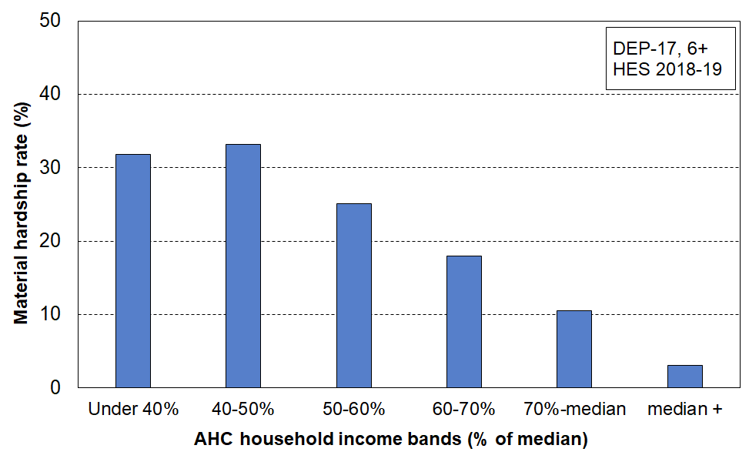**Material hardship rates (%) of children in selected AHC household income bands, HES 2018-19**

**Table C.6**

**Numbers and percentages of children in each AHC income band**

**(all children and children in households in hardship), HES 2018-19**

|  |  |  |  |  |  |  |  |  |
| --- | --- | --- | --- | --- | --- | --- | --- | --- |
|  |  | **< 40%** | **40-50%** | **50-60%** | **60-70%** | **70-100%** | **Median +** | **Sum across** |
| **Numbers (000s)** | All children (cell = # of 0-17s) | 120 | 80 | 90 | 100 | 275 | 435 | 1090 |
| # of 0-17s in the income band who are in hardship | 40 | 25 | 20 | 20 | 30 | 15 | 145 |
| **%** | % of all 0-17s who are in the income band | 11 | 7 | 8 | 9 | 25 | 40 | 100 |
| % of all 0-17s who are in hardship who come from this income band | 26 | 18 | 15 | 12 | 20 | 9 | 100 |
| % of 0-17s in the income band who are in hardship | 32 | 33 | 25 | 18 | 11 | 3 | n/a |

**Table C.7** repeats the analysis in Table C.6, this time for each CPRA relative low-income measure rather than for the selected bands as above.

**Table C.7**

**Numbers and percentages of children below each CPRA relative low-income threshold**

**(all children and children in households in hardship), HES 2018-19**

|  |  |  |  |  |  |  |
| --- | --- | --- | --- | --- | --- | --- |
|  |  | **BHC 50** | **BHC 60** | **AHC 40** | **AHC 50** | **AHC 60** |
| **Numbers (000s)** | All children (0-17 yrs) | 130 | 235 | 120 | 200 | 285 |
| Children in HHs in hardship (6+/17) | 45 | 75 | 40 | 65 | 85 |
| **Percentages** | All children (0-17 yrs) | 12 | 21 | 11 | 18 | 26 |
| Children in HHs in hardship (6+/17) | 35 | 33 | 32 | 32 | 30 |

Reading note for Table C.7:

* The numbers in the first and third rows of this table are a little lower than the official Stats NZ numbers for 2018-19 as a result of the application of the very-low-income (VLI) treatment – this deletes VLI households who self-report high income adequacy, and those reporting negative or zero BHC incomes or negative AHC incomes. See **Section O** for detail.

In Table C.3a households were ranked on their MWI scores. **Table C.8a** belowranks households using their AHC household incomes and **Table C.8b** uses BHC incomes.

A comparison between the two tables (C.3a and C.8a) shows the same sort of differences between rankings on income and ranking on the MWI as is shown in Figures C.2 above: restrictions for children are dispersed across a wider range of the household income spectrum than they are across the MWI spectrum … where the restrictions are much more tightly focussed at the lower end.

**Table C.8a**

**Children’s restrictions by AHC income of their household (children, 6-17 yrs),**

**grouped by quintiles of children, with the bottom quintile broken out into deciles, HES 2018-19 (%)**

|  |  |  |  |  |  |  |  |  |  |
| --- | --- | --- | --- | --- | --- | --- | --- | --- | --- |
|  | **All** | **D1** | **D2** |  | **Q1** | **Q2** | **Q3** | **Q4** | **Q5** |
| **Distribution of children (6-17yrs) across AHC deciles of children (%)** | 100 | 10 | 10 |  | 20 | 20 | 20 | 20 | 20 |
| **Don’t have** |  |  |  |  |  |  |  |  |  |
| 2 pair of shoes in good condition and suitable for daily activities for each child | 7 | 17 | 18 |  | 17 | 9 | 5 | . | . |
| 2 sets of warm winter clothes for each child | 2 | 4 | 5 |  | 4 | 2 | . | . | . |
| waterproof coat for each child (because of the cost) | 5 | 11 | 12 |  | 11 | 6 | 4 | . | . |
| separate bed for each child | 5 | 10 | 12 |  | 11 | 7 | 4 | 3 | . |
| fresh fruit and vegetables daily | 8 | 14 | 19 |  | 17 | 10 | 5 | 3 | . |
| meal with meat, fish or chicken (or vegetarian equiv) each day | 6 | 15 | 14 |  | 14 | 9 | 3 | 3 | . |
| good access at home to a computer and internet for homework | 6 | 11 | 16 |  | 14 | 9 | 5 | 1 | . |
| friends around to play and eat from time to time (because of the cost) | 4 | 9 | 8 |  | 8 | 5 | 3 | . | . |
| **Economised “a lot” on children’s items to keep down costs to enable other basic things to be paid for (not just to be thrifty or to save for a trip or other non-essential)** | | | | | | | | | |
| had to go without music, dance, kapa haka, art, swimming or other special interest lessons (“a lot”) | 7 | 15 | 15 |  | 15 | 10 | 6 | 2 | . |
| unable to pay for school trip or other school event (“a lot”) | 4 | 9 | 8 |  | 9 | 6 | 2 | . | . |
| involvement in sport had to be limited (“a lot”) | 6 | 15 | 12 |  | 13 | 10 | 4 | 2 | . |
| continue to wear shoes or clothes that are worn out or the wrong size (“a lot”) | 3 | 6 | 8 |  | 7 | 5 | 2 | . | . |
| **Multiple restrictions of child-specific items (the 12 above)** |  |  |  |  |  |  |  |  |  |
| 2+ out of 12 | 13 | 29 | 29 |  | 29 | 17 | 9 | 4 | . |
| 3+ out of 12 | 8 | 20 | 23 |  | 21 | 11 | 6 | 2 | . |
| 4+ out of 12 | 6 | 15 | 17 |  | 16 | 8 | 4 | 1 | . |
| **Child-relevant general household items** |  |  |  |  |  |  |  |  |  |
| received help (food, clothes, money) from a community organisation more than once in the last 12 months | 5 | 13 | 14 |  | 14 | 7 | 2 | . | . |
| accommodation crowded or severely crowded (1+ extra bedrooms needed) | 13 | 17 | 20 |  | 18 | 20 | 14 | 9 | 4 |
| accommodation severely crowded (2+ extra bedrooms needed) | 3 | 2 | 4 |  | 3 | 5 | 4 | 4 | . |
| dampness or mould a “major problem” in the accommodation | 8 | 16 | 13 |  | 15 | 12 | 8 | 5 | 2 |
| respondent reports putting up with feeling cold to keep down costs for other basics (a lot) | 10 | 17 | 23 |  | 20 | 13 | 8 | 4 | 3 |
| delayed replacing or repairing broken or damaged appliances to keep down costs for other basics (a lot) | 12 | 24 | 25 |  | 24 | 18 | 10 | 5 | 4 |
| household has no access to car or van for personal use | 5 | 8 | 11 |  | 10 | 5 | 3 | 3 | . |
| **Multiple restrictions out of 12 child-specific and 6 general child-relevant household items (18 in all)** | | | | | | | | | |
| 3+ out of 18 | 14 | 33 | 31 |  | 32 | 20 | 10 | 3 | . |
| 4+ out of 18 | 10 | 22 | 26 |  | 24 | 13 | 6 | 3 | . |
| 5+ out of 18 | 7 | 17 | 20 |  | 19 | 10 | 4 | 1 | . |
| **Postponed doctor’s visits “a lot” to keep down costs to enable other basic things to be paid for (not just to be thrifty or to save for a trip or other non-essential)** | | | | | | | | | |
| For children (a lot) | 2 | 2 | 5 |  | 3 | 2 | . | . | . |
| For respondent (a lot) | 11 | 23 | 22 |  | 23 | 17 | 9 | 5 | 3 |
| For children (a little or a lot) | 5 | 8 | 11 |  | 9 | 9 | 2 | 2 | . |
| For respondent (a little or a lot) | 29 | 49 | 46 |  | 48 | 40 | 29 | 18 | 8 |
| **Respondent reports life satisfaction** |  |  |  |  |  |  |  |  |  |
| dissatisfied or very dissatisfied with life | 6 | 12 | 13 |  | 13 | 8 | 5 | 3 | 3 |
| satisfied or very satisfied with life | 79 | 63 | 68 |  | 65 | 74 | 78 | 86 | 90 |

Note: Information is suppressed in cells with fewer than 15 households in the sample.

**Table C.8b**

**Children’s restrictions by BHC income of their household (children, 6-17 yrs),**

**grouped by quintiles of children, with the bottom quintile broken out into deciles**

**HES 2018-19 (%)**

|  |  |  |  |  |  |  |  |  |  |
| --- | --- | --- | --- | --- | --- | --- | --- | --- | --- |
|  | **All** | **D1** | **D2** |  | **Q1** | **Q2** | **Q3** | **Q4** | **Q5** |
| **Distribution of children (6-17yrs) across BHC deciles of children (%)** | 100 | 10 | 10 |  | 20 | 20 | 20 | 20 | 20 |
| **Don’t have** |  |  |  |  |  |  |  |  |  |
| 2 pair of shoes in good condition and suitable for daily activities for each child | 7 | 23 | 15 |  | 19 | 8 | 4 | . | . |
| 2 sets of warm winter clothes for each child | 2 | 6 | 4 |  | 5 | 2 | . | . | . |
| waterproof coat for each child (because of the cost) | 5 | 17 | 8 |  | 13 | 5 | 2 | . | . |
| separate bed for each child | 5 | 16 | 11 |  | 14 | 5 | 4 | 2 | . |
| fresh fruit and vegetables daily | 7 | 21 | 17 |  | 19 | 8 | 5 | 3 | . |
| meal with meat, fish or chicken (or vegetarian equiv) each day | 6 | 17 | 14 |  | 16 | 8 | 4 | 2 | . |
| good access at home to a computer and internet for homework | 6 | 15 | 16 |  | 16 | 8 | 5 | 1 | . |
| friends around to play and eat from time to time (because of the cost) | 4 | 13 | 5 |  | 9 | 6 | 2 | . | . |
| **Economised “a lot” on children’s items to keep down costs to enable other basic things to be paid for (not just to be thrifty or to save for a trip or other non-essential)** | | | | | | | | | |
| had to go without music, dance, kapa haka, art, swimming or other special interest lessons (“a lot”) | 7 | 16 | 16 |  | 16 | 11 | 4 | 2 | . |
| unable to pay for school trip or other school event (“a lot”) | 4 | 11 | 8 |  | 10 | 5 | . | . | . |
| involvement in sport had to be limited (“a lot”) | 6 | 15 | 12 |  | 14 | 10 | 3 | . | . |
| continue to wear shoes or clothes that are worn out or the wrong size (“a lot”) | 3 | 8 | 7 |  | 8 | 5 | 2 | . | . |
| **Multiple restrictions of child-specific items (the 12 above)** |  |  |  |  |  |  |  |  |  |
| 2+ out of 12 | 13 | 36 | 28 |  | 32 | 16 | 7 | 4 | . |
| 3+ out of 12 | 8 | 28 | 19 |  | 24 | 11 | 5 | 2 | . |
| 4+ out of 12 | 6 | 21 | 15 |  | 18 | 7 | 4 | . | . |
| **Child-relevant general household items** |  |  |  |  |  |  |  |  |  |
| received help (food, clothes, money) from a community organisation more than once in the last 12 months | 5 | 16 | 13 |  | 14 | 7 | 2 | . | . |
| accommodation crowded or severely crowded (1+ extra bedrooms needed) | 13 | 26 | 24 |  | 25 | 16 | 13 | 8 | 3 |
| accommodation severely crowded (2+ extra bedrooms needed) | 3 | 4 | 7 |  | 6 | 4 | 3 | 2 | . |
| dampness or mould a “major problem” in the accommodation | 8 | 18 | 15 |  | 17 | 12 | 7 | 4 | 2 |
| respondent reports putting up with feeling cold to keep down costs for other basics (a lot) | 10 | 23 | 18 |  | 21 | 14 | 8 | 4 | 2 |
| delayed replacing or repairing broken or damaged appliances to keep down costs for other basics (a lot) | 12 | 27 | 22 |  | 25 | 18 | 9 | 5 | 4 |
| household has no access to car or van for personal use | 5 | 12 | 8 |  | 10 | 5 | 4 | 2 | . |
| **Multiple restrictions out of 12 child-specific and 6 general child-relevant household items (18 in all)** | | | | | | | | | |
| 3+ out of 18 | 14 | 39 | 31 |  | 35 | 19 | 8 | 3 | . |
| 4+ out of 18 | 10 | 30 | 22 |  | 26 | 13 | 5 | 2 | . |
| 5+ out of 18 | 7 | 24 | 17 |  | 21 | 8 | 4 | . | . |
| **Postponed doctor’s visits “a lot” to keep down costs to enable other basic things to be paid for (not just to be thrifty or to save for a trip or other non-essential)** | | | | | | | | | |
| For children (a lot) | 2 | 3 | 2 |  | 3 | 3 | . | . | . |
| For respondent (a lot) | 11 | 23 | 21 |  | 22 | 18 | 10 | 4 | 3 |
| For children (a little or a lot) | 5 | 11 | 10 |  | 11 | 7 | 3 | 3 | . |
| For respondent (a little or a lot) | 28 | 50 | 45 |  | 48 | 39 | 31 | 17 | 8 |
| **Respondent reports life satisfaction** |  |  |  |  |  |  |  |  |  |
| dissatisfied or very dissatisfied with life | 6 | 12 | 13 |  | 12 | 9 | 5 | 3 | 2 |
| satisfied or very satisfied with life | 79 | 64 | 66 |  | 65 | 72 | 81 | 85 | 91 |

Note: Information is suppressed in cells with fewer than 15 households in the sample.

**What is life like for those under the five CPRA relative low-income thresholds?**

**Table C.9** shows the proportion of children in households experiencing deprivations of specific items for those with incomes under the five CPRA low-income measures. The items go a little wider than the 18 essentials listed in Table C.2.

* The child-relevant general household items are almost all ‘enforced lacks’ (ie the household does not have it because of shortage of money), or serious lacks (eg had to economise ‘a lot’ because of lack of money, ‘major problem’, and so on).
* The child-specific items are mostly simple ‘don’t haves’ as they are considered essentials that all children should have and none should be without. The ‘economise a lot’ items are very close to enforced lacks.

**Table C.9**

**Item deprivations for children aged 6-17 yrs (%),**

**in households with incomes below the CPRA BHC and AHC relative low-income thresholds,**

**HES 2018-19 (%)**

|  |  |  |  |  |  |  |  |
| --- | --- | --- | --- | --- | --- | --- | --- |
|  |  | **All (%)** | **Relative low-income thresholds / ‘income poverty lines’** | | | | |
|  |  | **BHC 50** | **BHC 60** | **AHC 40** | **AHC 50** | **AHC 60** |
| **Child-relevant general HH items** | **Response** |  |  |  |  |  |  |
| Income adequacy for basics | not enough | 13 | 35 | 30 | 34 | 31 | 27 |
| Foodbank / other community help | more than once | 5 | 15 | 14 | 14 | 14 | 12 |
| Borrowed for basics from family/friends | more than once | 11 | 27 | 25 | 29 | 27 | 24 |
| Can pay unexpected $500 essential bill | no | 26 | 53 | 50 | 53 | 50 | 48 |
| Delayed replace/repair appliances | a lot | 12 | 26 | 25 | 24 | 25 | 23 |
| Car | don't have | 4 | 11 | 9 | 8 | 9 | 9 |
| Holiday away each year | don't have - cost | 30 | 52 | 51 | 49 | 51 | 50 |
| Holiday away each year | don't have – other | 10 | 9 | 9 | 7 | 8 | 9 |
| Dampness or mould | major problem | 8 | 18 | 17 | 16 | 14 | 15 |
| Can afford to keep home warm | no | 10 | 26 | 24 | 27 | 24 | 22 |
| Crowding | 1+ more rooms needed | 13 | 27 | 24 | 17 | 19 | 18 |
| Crowding | 2+ needed - severe | 3 | 5 | 6 | 2 | 3 | 3 |
| Life satisfaction | dissatis / very dissatis | 6 | 13 | 12 | 12 | 13 | 12 |
| **Child-specific items (6-17 yrs)** |  |  |  |  |  |  |  |
| Two pair of shoes | don't have | 7 | 22 | 19 | 17 | 18 | 16 |
| Two sets winter clothes | don't have | 2 | 6 | 5 | 4 | 5 | 4 |
| Waterproof coat | don't have - cost | 5 | 16 | 12 | 11 | 11 | 10 |
| Waterproof coat | don't have - other | 4 | 7 | 7 | 9 | 7 | 7 |
| Separate bed | don't have | 5 | 15 | 13 | 10 | 12 | 11 |
| Fruit and veg daily | don't have | 7 | 22 | 18 | 15 | 17 | 16 |
| Protein meal daily | don't have | 6 | 16 | 16 | 15 | 14 | 15 |
| Computer / internet | don't have | 6 | 13 | 15 | 11 | 13 | 12 |
| Friends around to play / eat | don't have - cost | 4 | 11 | 9 | 9 | 8 | 8 |
| Friends around to play / eat | don't have - other | 8 | 12 | 14 | 17 | 14 | 13 |
| Birthday and other celebrations | don't have - cost | 5 | 16 | 14 | 13 | 13 | 11 |
| Birthday and other celebrations | don't have - other | 7 | 12 | 12 | 11 | 11 | 10 |
| Unable to fund school trips | a lot | 3 | 12 | 10 | 9 | 9 | 8 |
| Had to limit participation in sport | a lot | 6 | 14 | 14 | 14 | 14 | 12 |
| Had to go without special interests | a lot | 7 | 16 | 16 | 15 | 15 | 15 |
| Continued to wear worn out / wrong size shoes/clothes | a lot | 3 | 9 | 7 | 5 | 7 | 7 |
|  |  |  |  |  |  |  |  |
| DEP-17 material hardship, 6+/17 | | 13 | 35 | 34 | 32 | 32 | 31 |
| DEP-17 severe material hardship, 9+/17 | | 6 | 16 | 15 | 15 | 15 | 13 |

Note for Table C.8:

* For full item descriptions, see **Appendix 1**
* “Don’t have – other” includes “don’t want”.
* See Table C.10 (next page) for the numbers in each cell.

**Table C.10** is the numbers version of Table C.9. It is of value in itself, but it also enables the calculation of the proportion of all those without an item who live in households below a selected low-income line. For example:

* 44% of children in households in which the adults say that they ‘cannot afford to keep the home warm’ come from households under the AHC 50% line – 56% are in households with higher income than this (31,000 / 71,000 = 44%).
* 60% of children who don’t have two pairs of shoes come from households under the BHC 60% line – 40% are in households with higher income than this (24,000 / 40,000 = 60%).

**Table C.10**

**Item deprivations for children aged 6-17 yrs**

**in households with incomes below the CPRA BHC and AHC relative low-income thresholds,**

**HES 2018-19 (number aged 6-17 yrs, 000s)**

|  |  |  |  |  |  |  |  |
| --- | --- | --- | --- | --- | --- | --- | --- |
|  |  | **All**  **(000s)** | **Low-income thresholds / ‘income poverty lines’** | | | | |
|  |  | **BHC 50** | **BHC 60** | **AHC 40** | **AHC 50** | **AHC 60** |
| **Child-relevant general HH items** | **Response** |  |  |  |  |  |  |
| Income adequacy for basics | not enough | 95 | 30 | 47 | 26 | 40 | 52 |
| Foodbank / other community help | more than once | 36 | 13 | 22 | 10 | 18 | 23 |
| Borrowed for basics from family/friends | more than once | 84 | 24 | 39 | 22 | 35 | 46 |
| Can pay unexpected $500 essential bill | no | 192 | 47 | 77 | 40 | 65 | 91 |
| Delayed replace/repair appliances | a lot | 89 | 22 | 39 | 18 | 32 | 43 |
| Car | don't have | 33 | 10 | 15 | 6 | 12 | 17 |
| Holiday away each year | don't have - cost | 219 | 46 | 80 | 37 | 67 | 95 |
| Holiday away each year | don't have - other | 73 | 8 | 14 | 6 | 11 | 17 |
| Dampness or mould | major problem | 59 | 16 | 27 | 12 | 18 | 28 |
| Can afford to keep home warm | no | 71 | 23 | 36 | 20 | **31** | 41 |
| Crowding | 1+ more rooms needed | 96 | 24 | 38 | 13 | 25 | 35 |
| Crowding | 2+ needed - severe | 23 | 5 | 9 | 2 | 4 | 6 |
| Life satisfaction | dissatis / very dissatis | 47 | 12 | 19 | 9 | 16 | 23 |
| **Child-specific items** |  |  |  |  |  |  |  |
| Two pair of shoes | don't have | 40 | 16 | **24** | 11 | 20 | 25 |
| Two sets winter clothes | don't have | 11 | 4 | 6 | 3 | 5 | 6 |
| Waterproof coat | don't have - cost | 27 | 11 | 16 | 7 | 12 | 17 |
| Waterproof coat | don't have - other | 24 | 5 | 9 | 6 | 8 | 11 |
| Separate bed | don't have | 31 | 11 | 17 | 7 | 13 | 17 |
| Fruit and veg daily | don't have | 44 | 16 | 24 | 10 | 19 | 27 |
| Protein meal daily | don't have | 37 | 12 | 21 | 10 | 16 | 24 |
| Computer / internet | don't have | 35 | 10 | 19 | 7 | 14 | 20 |
| Friends around to play / eat | don't have - cost | 21 | 8 | 12 | 6 | 9 | 13 |
| Friends around to play / eat | don't have - other | 47 | 9 | 18 | 11 | 15 | 21 |
| Birthday and other celebrations | don't have - cost | 32 | 12 | 18 | 8 | 14 | 18 |
| Birthday and other celebrations | don't have - other | 43 | 9 | 16 | 7 | 12 | 17 |
| Unable to fund school trips | a lot | 20 | 9 | 13 | 6 | 10 | 13 |
| Had to limit participation in sport | a lot | 35 | 10 | 18 | 9 | 15 | 20 |
| Had to go without special interests | a lot | 41 | 12 | 21 | 10 | 17 | 24 |
| Continued to wear worn out / wrong size shoes/clothes | a lot | 19 | 6 | 10 | 4 | 8 | 11 |
|  |  |  |  |  |  |  |  |

Notes for Table C.9:

* For full item descriptions, see Appendix 1.
* “Don’t have – other” includes “don’t want”.

**What is life like for those in selected AHC income bands?**

**Table C.11** gives a more detailed analysis for children in households in selected AHC income bands, ranging from under 40% to 80% and higher (rather than under CPRA thresholds).

* Information on both rates and composition are included. The percentages in the composition panel all add to 100% across.
* The very bottom two rows give the material hardship and severe material hardship rates and composition for households in the selected income bands.

**Table C.11**

**Item deprivations for all children aged 6-17 yrs,**

**and those in households with incomes in selected AHC income bands, HES 2018-19**

|  |  |  |  |  |  |  |  |  |  |  |  |
| --- | --- | --- | --- | --- | --- | --- | --- | --- | --- | --- | --- |
|  |  | **Rate** | | | | | **Composition** | | | | |
|  |  | **Deprivation rate (%) for item for all aged 6-17 yrs, for those in HHs with incomes in the specified AHC income zones** | | | | | **Proportion (%) of all aged 6-17 yrs deprived of the item, for those in HHs with incomes in the specified AHC income zones** | | | | |
|  |  | **All (%)** | **< 40%** | **40-60** | **60-80** | **80+** | **< 40%** | **40-60** | **60-80** | **80+** | **ALL** |
| **All children (6-17 yrs)** |  | - | - | - | - | - | 10 | 16 | 17 | 57 | 100 |
| **Child-relevant general HH items** | **Response** |  |  |  |  |  |  |  |  |  |  |
| Income adequacy for basics | not enough | 13 | 34 | 23 | 16 | 6 | 27 | 27 | 21 | 25 | 100 |
| Foodbank / other community help | more than once | 5 | 14 | 11 | 7 | 1 | 29 | 36 | 26 | 10 | 100 |
| Borrowed for basics from fam/friends | more than once | 11 | 29 | 21 | 13 | 5 | 26 | 29 | 19 | 25 | 100 |
| Can pay unexpected $500 bill | no | 26 | 53 | 45 | 35 | 14 | 21 | 27 | 23 | 30 | 100 |
| Delayed replace/repair appliances | a lot | 12 | 24 | 21 | 17 | 6 | 20 | 28 | 25 | 27 | 100 |
| Car | don't have | 4 | - | - | - | - | - | - | - | - | - |
| Holiday away each year | don't have - cost | 30 | 49 | 50 | 40 | 18 | 17 | 26 | 23 | 33 | 100 |
| Holiday away each year | don't have - other | 10 | 7 | 10 | 11 | 10 | 8 | 16 | 20 | 57 | 100 |
| Dampness or mould | major problem | 8 | 16 | 14 | 10 | 4 | 20 | 27 | 22 | 31 | 100 |
| Can afford to keep home warm | no | 10 | 27 | 18 | 12 | 4 | 28 | 29 | 21 | 22 | 100 |
| Crowding | 1+ more bedrooms needed | 13 | 17 | 19 | 20 | 9 | 13 | 23 | 26 | 38 | 100 |
| Crowding | 2+ needed - severe | 3 | - | - | - | - | - | - | - | - | - |
| Life satisfaction | dissatis / very dissatis | 6 | 12 | 12 | 7 | 4 | 20 | 29 | 18 | 33 | 100 |
| **Child-specific items** |  |  |  |  |  |  |  |  |  |  |  |
| Two pair of shoes | don't have | 7 | 17 | 15 | 8 | 2 | 28 | 35 | 21 | 16 | 100 |
| Two sets winter clothes | don't have | 2 | - | - | - | - | - | - | - | - | - |
| Waterproof coat | don't have - cost | 5 | 11 | 10 | 5 | 1 | 27 | 35 | 21 | 18 | 100 |
| Waterproof coat | don't have - other | 4 | - | - | - | - | - | - | - | - | - |
| Separate bed | don't have | 5 | 10 | 11 | 5 | 3 | 21 | 34 | 17 | 28 | 100 |
| Fruit and veg daily | don't have | 7 | 15 | 17 | 7 | 3 | 22 | 38 | 18 | 22 | 100 |
| Protein meal daily | don't have | 6 | 15 | 15 | 5 | 2 | 27 | 38 | 16 | 20 | 100 |
| Computer / internet | don't have | 6 | 11 | 13 | 8 | 2 | 21 | 35 | 25 | 18 | 100 |
| Friends around to play / eat | don't have - cost | 4 | - | - | - | - | - | - | - | - | - |
| Friends around to play / eat | don't have - other | 8 | 17 | 11 | 10 | 5 | 23 | 22 | 22 | 33 | 100 |
| Birthday and other celebrations | don't have - cost | 5 | 13 | 10 | 9 | 2 | 26 | 30 | 29 | 15 | 100 |
| Birthday and other celebrations | don't have - other | 7 | 11 | 10 | 8 | 6 | 16 | 23 | 19 | 42 | 100 |
| Unable to fund school trips | a lot | 3 | - | - | - | - | - | - | - | - | - |
| Had to limit participation in sport | a lot | 6 | 14 | 11 | 8 | 2 | 26 | 30 | 25 | 19 | 100 |
| Had to go without special interests | a lot | 7 | 15 | 15 | 8 | 3 | 24 | 34 | 20 | 22 | 100 |
| Continued to wear worn out / wrong size shoes/clothes | a lot | 3 | - | - | - | - | - | - | - | - | - |
|  |  |  |  |  |  |  |  |  |  |  |  |
| DEP-17 material hardship, 6+/17 | | 13 | 32 | 30 | 16 | 5 | 24 | 35 | 21 | 20 | 100 |
| DEP-17 severe material hardship, 9+/17 | | 6 | 15 | 12 | 7 | 1 | 28 | 35 | 23 | 14 | 100 |

Note for Table C.11:

* For full item descriptions, see **Appendix 1**.

**Children in households that are both low-income and in material hardship**

As shown in **Figure C.6** below, the less-than-100% overlap between the low-income and material hardship measures means that there are six groups to consider:

* the income poor (low-income households)
* the materially deprived
* the income poor who are materially deprived (the both/and group)
* the income poor who are not materially deprived (income poor only)
* the materially deprived who are not income poor (materially deprived only)
* those who are neither.

**Figure C.6**

**Six groups, from those in neither group to those in both**

In material hardship / materially deprived

Low-income / income poor

In both groups

Materially deprived only

In neither group

Income poor only

The evidence of increasing day-to-day restrictions and hardship is clear in **Table C.12a**, starting with those in neither group and moving through low income only … to both low-income and materially deprived, with the latter group clearly having the greatest restrictions on day-to-day living standards. For example, for children, the level of restrictions for the ‘both … and’ group is typically around double that for the low-income group.

**Table C.12a**

**Profile for the six groups in the low income / hardship nexus (using two CPRA measures),**

**HES 2018-19**

|  |  |  |  |  |  |  |  |
| --- | --- | --- | --- | --- | --- | --- | --- |
| **HES 2018-19** | **ALL** | **neither** | **low income only** | **low income** | **deprived only** | **deprived** | **both** |
| **Whole population** |  |  |  |  |  |  |  |
| size of groups (% of whole population) | 100 | 74 | 16 | 21 | 5 | 9 | 5 |
| **% of whole population in households reporting:** |  |  |  |  |  |  |  |
| put up with cold (a lot) through shortage of money | 8 | 3 | 6 | 15 | 45 | 46 | 47 |
| use of food banks more than once in last 12 months | 3 | 1 | 3 | 9 | 17 | 23 | 29 |
| not enough income for the basics | 11 | 5 | 14 | 23 | 46 | 51 | 55 |
| borrowed from fam/friends for basics - more than once in last 12 months | 9 | 4 | 8 | 18 | 50 | 52 | 54 |
| $500 expense – can’t pay | 21 | 12 | 27 | 41 | 77 | 83 | 88 |
| life satisfaction of ‘dissatisfied / very dissatisfied’ | 6 | 3 | 6 | 11 | 25 | 27 | 28 |
| **Children (0-17 yrs)** |  |  |  |  |  |  |  |
| size of groups (% of all children) | 100 | 68 | 18 | 26 | 5 | 13 | 8 |
| **% of all children in households reporting** |  |  |  |  |  |  |  |
| put up with cold (a lot) through shortage of money | 9 | 3 | 7 | 18 | 43 | 43 | 42 |
| use of food banks more than once in last 12 months | 5 | 1 | 4 | 12 | 18 | 26 | 32 |
| not enough income for the basics | 13 | 5 | 15 | 26 | 43 | 49 | 53 |
| borrowed from fam/friends for basics - more than once in last 12 months | 12 | 4 | 11 | 26 | 51 | 57 | 62 |
| $500 expense - cant pay | 26 | 14 | 32 | 48 | 79 | 84 | 87 |
| life satisfaction of ‘dissatisfied / very dissatisfied’ | 6 | 3 | 7 | 11 | 19 | 21 | 22 |

Notes:    - the AHC 60% of median measure is used for low income

              - the DEP-17 measure is used for material deprivation, with the threshold set at 6+/17

              - MSD treatment of the VLI households drops AHC 60 from 27.7% to 26.2%. See **Section O** for details.

Table **C.12b** repeats the analysis reported in Table C.12a, but this time using two measures that give similar-sized groups of children (19% for low-income and 23% for material hardship (albeit a non-standard 4+/17 threshold). The proportions are close to the lower quintiles on each measure. [51]

For Table C.12b the low-income measure is AHC 50 (rather than AHC 60) and material hardship measure is MWI<=16 (equivalent to 4+/17 on DEP-17).

The same pattern is evident in both tables.

**Table C.12b**

**Profile for the six groups noted above (similar sized low-income and deprived groups), HES 2018-19**

|  |  |  |  |  |  |  |  |
| --- | --- | --- | --- | --- | --- | --- | --- |
|  | **ALL** | **neither** | **low inc only** | **low inc** | **deprived only** | **deprived** | **both** |
| **Whole population** |  |  |  |  |  |  |  |
| size of groups (% of whole population) | 100 | 75 | 9 | 15 | 11 | 16 | 6 |
| % of whole population in households reporting: |  |  |  |  |  |  |  |
| put up with cold (a lot) through shortage of money | 8 | 2 | 5 | 18 | 34 | 36 | 38 |
| use of food banks more than once in last 12 months | 3 | 0 | 2 | 10 | 13 | 16 | 22 |
| not enough income for the basics | 11 | 5 | 12 | 27 | 37 | 41 | 50 |
| borrowed from fam/friends for basics - more than once in last 12 months | 9 | 3 | 7 | 21 | 32 | 36 | 44 |
| $500 expense - cant pay | 21 | 10 | 23 | 45 | 69 | 73 | 81 |
| life satisfaction of ‘dissatisfied / very dissatisfied’ | 6 | 3 | 5 | 12 | 19 | 21 | 24 |
| **Children (0-17 yrs)** |  |  |  |  |  |  |  |
| size of groups (% of all children) | 100 | 67 | 10 | 19 | 14 | 23 | 9 |
| % of all children in households reporting: |  |  |  |  |  |  |  |
| put up with cold (a lot) through shortage of money | 9 | 2 | 5 | 20 | 31 | 33 | 35 |
| use of food banks more than once in last 12 months | 5 | 1 | 3 | 14 | 14 | 19 | 26 |
| not enough income for the basics | 13 | 4 | 10 | 29 | 33 | 40 | 50 |
| borrowed from fam/friends for basics - more than once in last 12 months | 13 | 3 | 8 | 29 | 35 | 41 | 50 |
| $500 expense - cant pay | 27 | 11 | 23 | 51 | 69 | 74 | 81 |
| life satisfaction of ‘dissatisfied / very dissatisfied’ | 6 | 2 | 4 | 12 | 15 | 17 | 20 |

Notes: - the AHC 50% of median measure is used for the low-income group

- the MWI-24 measure is used for material deprivation, with the threshold set to give a proportion similar to that given by the income poverty measure (MWI<=16 gives 16%).

The combination measure (both low income and in material hardship) is used by Ireland to measure what they call ‘consistent poverty’, as in their view this (overlap) group best fits the high-level definition which has both an input (resources) and outcome dimension (minimum acceptable material standard of living).

It is one of the specified measures in the CPRA suite (see Table C.12a for this).

MSD uses the combination method as one of the measures in its multi-measure multi-level approach. It can be seen (as in Ireland) as the preferred measure, or simply as a measure of deeper poverty.

* * * * * * * * * * * * * * * * *

For each table above, the same pattern is found in the 2020-21 HES data and the actual numbers themselves are very similar. See **Appendix 6** for details.

**Children in working and beneficiary households**

**Table C.13** provides a picture of what life is like for children aged 6-17 years living in ‘working’ and ‘beneficiary’ households.

The approach is much the same as earlier in this section: the hardship profiles are based on information about child-specific hardship items and general household items that are directly child-relevant (see Tables C.1 and C.2 above).

The two groups (‘working’ and ‘beneficiary’ households) are identified by their respective main sources of income over the 12 months prior to interview – market or government (includes core benefits, WFF, AS). Some of the ‘working’ households will receive WFF or AS payments, and some of the ‘beneficiary’ households will receive market income from part-time work.

Unsurprisingly, the left-hand panel of Table C.13 shows that children in ‘working’ households are on average much better off than those in ‘beneficiary’ households (fewer restrictions / deprivations). One of the main drivers of this difference is the higher income received on average by ‘working’ households ($30,400 pa compared with $13,000 for beneficiary households – note, these are equivalised dollars, not ‘ordinary’ dollars).

The right-hand panel to a considerable degree removes the income factor by looking only at households in the lower AHC income quintile (Q1). These low-income ‘working’ and ‘beneficiary’ households have more similar hardship profiles than for overall, though the children in low-income ‘working’ households are still better off (fewer restrictions / deprivations). This is possibly explained in part by their median equivalised household income ($14,400 pa) being a little higher than for ‘beneficiary’ households ($12,000 pa), but may also reflect household income trajectories over recent years as well.

The figures for children in beneficiary households also have value in themselves in that they show the degree of hardship and ‘missing out’ on basics that is experienced on average by these children.

The figures for children in all beneficiary households and those in the low income quintile (Q1) are very similar. This reflects the fact that most beneficiary households have incomes in Q1.

**Table C.13**

**Deprivations/restrictions for children (6-17 yrs) in ‘working’ & ‘beneficiary’ households HES 2018-19 (%)**

|  |  |  |  |  |  |  |  |  |  |
| --- | --- | --- | --- | --- | --- | --- | --- | --- | --- |
|  |  | **ALL aged 6-17 yrs (%)** | | | | **Q1 (AHC) aged 6-17 yrs (%)** | | | |
|  |  | **ALL** | **Main income source** | | **ALL** | | **Main income source** | |
|  |  | **Market** | **Govt** | **Market** | **Govt** |
| **Population in each group (000s)** |  | 762 | 665 | 97 | 181 | | 108 | 73 |
| **Material hardship rate (6+/17 for DEP-17)** |  | 13 | 9 | 41 | 31 | | 22 | 45 |
|  |  |  |  |  |  | |  |  |
| **Child-relevant general household items** |  |  |  |  |  | |  |  |
| Income adequacy for basics | not enough | 13 | 9 | 37 | 28 | | 20 | 39 |
| Foodbank / other community help | more than once | 5 | 2 | 23 | 12 | | 4 | 24 |
| Borrowed for basics from family/friends | more than once | 11 | 8 | 34 | 25 | | 16 | 38 |
| Can pay unexpected $500 essential bill | no | 26 | 21 | 62 | 48 | | 36 | 65 |
| Delayed replace/repair appliances | a lot | 12 | 9 | 30 | 23 | | 17 | 31 |
| Car | don't have | 5 | 3 | 14 | 9 | | 5 | 15 |
| Holiday away each year | don't have - cost | 29 | 25 | 57 | 50 | | 42 | 62 |
| Holiday away each year | don't have – other | 10 | 10 | 12 | 9 | | 9 | 10 |
| Dampness or mould | major problem | 8 | 7 | 18 | 15 | | 12 | 20 |
| Can afford to keep home warm | no | 10 | 7 | 31 | 22 | | 14 | 35 |
| Crowding | 1+ more bedrooms needed | 13 | 11 | 26 | 19 | | 15 | 24 |
| Life satisfaction | dissatis / very dissatis | 6 | 5 | 14 | 12 | | 11 | 15 |
| **Child-specific items (6-17 yrs)** |  |  |  |  |  | |  |  |
| Two pair of shoes | don't have | 7 | 4 | 25 | 16 | | 8 | 28 |
| Two sets winter clothes | don't have | 2 | 1 | 6 | 4 | | 3 | 6 |
| Waterproof coat | don't have - cost | 4 | 3 | 16 | 10 | | 6 | 18 |
| Waterproof coat | don't have - other | 4 | 4 | 6 | 7 | | 7 | 7 |
| Separate bed | don't have | 5 | 4 | 15 | 11 | | 7 | 16 |
| Fruit and veg daily | don't have | 7 | 5 | 26 | 17 | | 8 | 29 |
| Protein meal daily | don't have | 6 | 4 | 21 | 15 | | 10 | 22 |
| Computer / internet | don't have | 6 | 4 | 19 | 13 | | 8 | 19 |
| Friends around to play / eat | don't have - cost | 3 | 2 | 12 | 8 | | 3 | 15 |
| Friends around to play / eat | don't have - other | 8 | 7 | 14 | 13 | | 13 | 14 |
| Birthday and other celebrations | don't have - cost | 5 | 3 | 18 | 11 | | 5 | 21 |
| Birthday and other celebrations | don't have - other | 7 | 7 | 12 | 11 | | 10 | 11 |
| Unable to fund school trips | a lot | 3 | 2 | 14 | 8 | | 3 | 15 |
| Had to limit participation in sport | a lot | 6 | 4 | 19 | 13 | | 6 | 22 |
| Had to go without special interests | a lot | 7 | 5 | 20 | 15 | | 9 | 23 |
| Continued to wear worn out / wrong size shoes/clothes | a lot | 3 | 2 | 11 | 7 | | 4 | 12 |
| **Median AHC household income ($ equivalised)** | | 27,600 | 30,300 | 12,800 | 13,900 | | 14,700 | 12,100 |

Notes:

* In this report, all cells with original sample sizes of less than 15 are suppressed. A small number of cells come close in this table (16-18 households in sample), but none are below 15.
* For all 6-17 year olds, 13% are in ‘beneficiary’ households and 87% in ‘working’ households. The Q1 composition is 41% and 59% respectively.

The same patterns are also evident in the 2020-21 HES data. The actual numbers are very close too. See **Appendix 6** for details.

**Section D**

**International comparisons**

To assess how New Zealand children are faring in terms of poverty, a reference level or comparison standard is needed. Having agreed low-income thresholds or material hardship thresholds is one way of doing this, but there are other ways too:

* reporting time series on agreed measures: Stats NZ’s Feb 2021 report provides this information for 2007 on, and MSD’s reports give longer low-income series using slightly different datasets
* comparing rates with those in other groups on the same measure(s) – see Sections B and C above for selected comparisons.
* international comparisons with other richer nations (as in the EU or OECD).

This section is about the latter. It gives comparisons in four areas:

* material hardship rates
* child-specific and strongly child-related household material and social deprivation items
* low-income rates
* proportion of children in workless households

Particular care is needed to ensure that the comparisons are valid for the purpose stated. In this regard, international low-income league tables are problematic when they are promoted as ranking countries by poverty rates, with poverty defined as in this paper. The low-income issues are discussed in the third part of this section (‘International 3’).

The international comparisons in the tables and text in this section are mainly in relation to 29 European countries: EU plus Norway, Switzerland and Iceland or, after January 2020, EU plus Norway, Switzerland, Iceland and the UK. Bulgaria and Romania, though in the EU, are omitted as their general standard of living is much lower than New Zealand and most of the other European countries on the list. To avoid clutter in the charts, the smaller countries are also omitted (Malta, Cyprus, Luxembourg and Iceland).

**Table D.1** lists the countries and their two-letter abbreviations.

**Table D.1**

**European countries and their two-letter codes**

|  |  |  |  |
| --- | --- | --- | --- |
| AT | Austria | IS | Iceland |
| BE | Belgium | IT | Italy |
| CH | Switzerland | LT | Lithuania |
| CY | Cyprus | LU | Luxembourg |
| CZ | Czech Republic | LV | Latvia |
| DE | Germany | MT | Malta |
| DK | Denmark | NL | Netherlands |
| EE | Estonia | NO | Norway |
| EL | Greece | PL | Poland |
| ES | Spain | PT | Portugal |
| FI | Finland | SE | Sweden |
| FR | France | SI | Slovenia |
| HR | Croatia | SK | Slovakia |
| HU | Hungary | UK | United Kingdom |
| IE | Ireland |  |  |

**International 1:**

**Material hardship rates**

The EU uses a 13-item Material and Social Deprivation index as one of its official social inclusion measures, with a threshold of 5+/13 (in this report, ‘EU-13’ for short). We can replicate the index to a very good degree of certainty for New Zealand using data from the HES. See **Appendix 1** for the EU-13 item list. The EU-13 and DEP-17 indices rank households in much the same order.

Using the EU-13 index, 11% of New Zealand children lived in households that were classified as in material hardship in 2020 (latest available data). New Zealand’s rate was similar to that for Slovakia, Germany, Belgium and Portugal, around the middle of the league table – lower than Ireland, France, the UK and Spain (15-18%), but higher than Finland, Norway, Poland, Sweden, the Netherlands, Switzerland (CH), Denmark, Croatia (HR) and the Czech Republic (4-7%).

In the three years since EU-SILC 2017 (≡ HES 2017-18), the median European rate decreased from 12% to 10%, and New Zealand’s rate decreased from 13.5% to 10.6%. The fall in the European median reflected the improved rates for children in Slovakia, Croatia, Belgium and Malta, who all moved from above to below the earlier European median.

**Figure D.1**

**Material and social deprivation rates (% with 5+ enforced lacks), EU-13, 0-17 yrs**

**25 European countries + NZ (EU-SILC 2020, NZ HES 2020-21)**

**Table D.2**

**Material and social deprivation rates (% with 5+ enforced lacks, EU-13), 0-17 yrs**

**29 European countries + NZ**

**EU-SILC 2020, NZ HES 2020/21**

|  |  |  |  |  |  |
| --- | --- | --- | --- | --- | --- |
| Iceland | IS | 3 | Slovakia | SK | 10 |
| Finland | FI | 4 | **New Zealand** | **NZ** | 11 |
| Norway | NO | 5 | Germany | DE | 11 |
| Slovenia | SI | 5 | Portugal | PT | 11 |
| Poland | PL | 5 | Belgium | BE | 12 |
| Luxembourg | LU | 6 | Italy | IT | 12 |
| Netherlands | NL | 6 | Latvia | LV | 13 |
| Sweden | SE | 6 | Ireland | IE | 15 |
| Croatia | HR | 6 | Lithuania | LT | 16 |
| Estonia | EE | 6 | France | FR | 17 |
| Czech Republic | CZ | 7 | Cyprus | CY | 17 |
| Switzerland | CH | 7 | United Kingdom | UK | 17 |
| Denmark | DK | 7 | Spain | ES | 18 |
| Austria | AT | 8 | Hungary | HU | 24 |
| Malta | MT | 10 | Greece | EL | 36 |

Source for European data: <https://ec.europa.eu/eurostat/web/main/data/database> - accessed on 20 June 2022.

* The 2020 EU-13 material hardship rate for New Zealand two parent households with one or two children is 7%, close to the EU median for this household type (6%). For two parent households with three or more children the New Zealand rate (17%) is above the median EU rate for this group (11%).
* For New Zealand sole parent households, the EU-13 material hardship rate is 29%, down from 34% in 2017, but still well above the European median for this household type (19%). New Zealand also has a relatively high proportion of sole parent households.
* The material hardship rate for older New Zealanders (65+) is among the best in Europe (~4%). The scatterplot in **Figure D.2** below for 2018 uses material hardship rates both for children (horizontal axis) and for those aged 65+ (vertical axis), with the chart divided into quadrants using the respective median hardship rates as the boundaries. New Zealand, along with the UK, Ireland and Belgium were in the SE quadrant (2018) – relatively low material hardship for older citizens and above median rates for children. In contrast, in the SW quadrant are countries with relatively low rates for both groups (eg Norway, Finland, Sweden, and so on).

**New Zealand’s 2027-28 CPRA material hardship target**

The 2027-28 target for child material hardship is currently 6% using the DEP-17 measure. Given that EU-13 5+ rates and DEP-17 6+ rates are similar (see **Table K.3**) the EU-13 target can be taken as something close to 6% as well. Using a stylised ‘day after’ approach, reaching the ten-year 6% child material hardship target would shift New Zealand as shown by the arrow in **Figure D.2**. The depiction assumes that the rates for all other countries remain frozen. This assumption is likely to not fully hold over the next decade, but the chart nevertheless gives an idea of the magnitude of the proposed change, progress to date, and of the different company New Zealand would be keeping if the target were achieved.

**Figure D.2**

**Material hardship rates for children (0-17 yrs) and those aged 65+:**

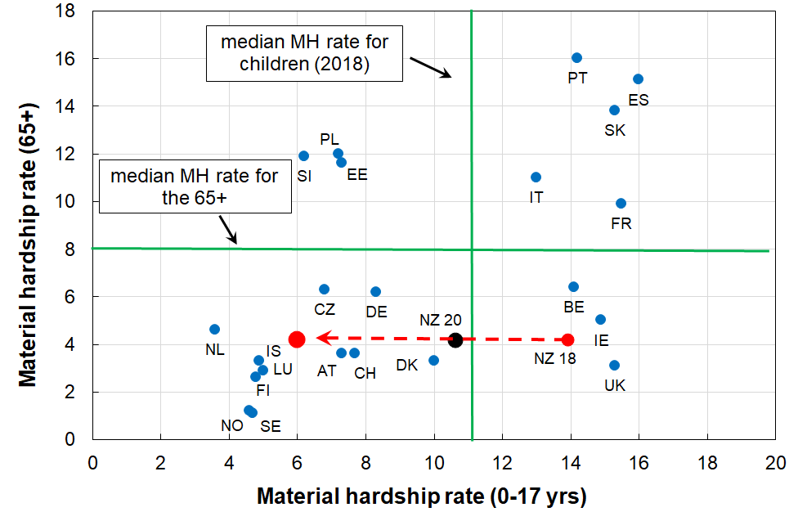**comparisons with selected European countries (2018)**

Notes for Figure D.2:

* Countries with even higher material hardship rates for either children or those aged 65+ (or both) are omitted from the chart to better enable NZ to be rated against the countries we usually make comparisons with. The omitted countries are Greece, Hungary, Latvia and Lithuania. They are however included for calculating the medians.
* The medians are for all the EU countries plus Norway, Switzerland and Iceland.

The assumption of ‘nothing else changing’ is not as far-fetched as it may initially sound. There are not that many countries with large changes in the last decade or so (ie from pre-GFC to now): for the 65+ group, only Poland, the Czech Republic and Estonia changed greatly (decreases); and for children, these three plus Slovakia, Lithuania and Portugal decreased considerably and Greece increased. The median for child material hardship for the full EU decreased from around 15% to 11% in the last decade or so. When Norway, Iceland and Switzerland are added to the EU list, the drop in the median hardship rate for children is less as these countries have lowish rates and did not change very much. The analysis in this paragraph is based on Eurostat data for EU-9, the predecessor of EU-13.

**International 2:**

**Child-specific material and social deprivation items and selected child-related household items**

**Table D.3** shows where New Zealand children rank for 7 child-specific essentials and 3 child-related household items.

* The country abbreviations are as in Table D.1 above.
* The full text for the child-specific items is available in **Appendix 2**

Deprivation rates for New Zealand children using the single-item indicators in Table D.3 are typically ‘mid-table’ or lower (ie higher rates). The ‘high performance’ for NZ children for access to a private vehicle could possibly reflect the relative qualities across countries of public transport as much as anything.

**Table D.3**

**Enforced lacks of 7 child-specific items and 3 child-related general household items (%):**

**New Zealand compared with 24 EU countries and Switzerland (EU-SILC 2014, HES 2018-19)**

|  |  |  |  |  |  |  |  |  |  |  |  |  |  |  |  |  |  |  |  |
| --- | --- | --- | --- | --- | --- | --- | --- | --- | --- | --- | --- | --- | --- | --- | --- | --- | --- | --- | --- |
| **Child-specific items** | | | | | | | | | | | | | | **Child-related HH items** | | | | | |
| **Shoes** | | **Fruit & veg** | | **Proteins** | | **Celebration** | | **School trips** | | **Internet** | | **Friends** | | **Car** | | **Home warm** | | **Holidays** | |
| SE | 0 | SE | 0 | SE | 0 | FI | 0 | DE | 1 | NL | 0 | FI | 0 | **NZ** | **2** | FI | 1 | CH | 5 |
| CH | 0 | FI | 0 | FI | 0 | DK | 1 | FI | 1 | SE | 0 | CH | 0 | LU | 2 | SE | 1 | SE | 5 |
| LT | 0 | DK | 0 | DK | 1 | SE | 1 | SE | 1 | FI | 0 | SE | 1 | IT | 2 | LU | 1 | FI | 7 |
| EL | 1 | CH | 1 | LU | 1 | CH | 1 | CH | 1 | DK | 1 | NL | 1 | FR | 3 | CH | 1 | SI | 7 |
| FI | 1 | AT | 1 | PT | 1 | DE | 1 | DK | 1 | DE | 1 | DK | 1 | SE | 3 | EE | 1 | CZ | 9 |
| LU | 1 | NL | 1 | CH | 1 | AT | 2 | NL | 1 | EE | 1 | DE | 2 | SI | 3 | DK | 2 | DK | 9 |
| AT | 1 | LU | 1 | SI | 1 | LU | 2 | SI | 2 | CH | 1 | LU | 2 | FI | 4 | NL | 3 | LU | 9 |
| SI | 1 | SI | 1 | AT | 2 | NL | 2 | AT | 2 | AT | 1 | CZ | 2 | DE | 4 | SI | 4 | EE | 10 |
| PO | 1 | ES | 2 | FR | 2 | UK | 2 | EE | 3 | SI | 1 | FR | 2 | CH | 4 | AT | 4 | FR | 12 |
| EE | 2 | DE | 2 | NL | 2 | SI | 2 | UK | 3 | LU | 1 | IE | 3 | DK | 5 | BE | 5 | SK | 16 |
| UK | 2 | BE | 2 | BE | 3 | IE | 3 | IE | 3 | FR | 2 | SI | 3 | NL | 6 | FR | 5 | NL | 16 |
| DE | 2 | IT | 3 | ES | 3 | EE | 3 | LU | 4 | PO | 3 | AT | 4 | IE | 7 | DE | 5 | DE | 17 |
| DK | 2 | IE | 3 | PO | 3 | CZ | 4 | BE | 4 | BE | 4 | **NZ** | **4** | ES | 7 | CZ | 6 | AT | 18 |
| IT | 3 | FR | 3 | UK | 3 | LT | 5 | FR | 5 | CZ | 4 | EE | 5 | HR | 7 | SK | 8 | LT | 19 |
| CZ | 3 | PT | 3 | IE | 3 | FR | 5 | CZ | 5 | **NZ** | **4** | BE | 6 | AT | 7 | PO | 8 | BE | 19 |
| ES | 3 | CZ | 3 | DE | 4 | **NZ** | **6** | **NZ** | **5** | UK | 5 | UK | 7 | BE | 7 | HR | 9 | PO | 26 |
| HR | 3 | PO | 3 | **NZ** | **4** | HR | 6 | LT | 6 | IE | 5 | HR | 7 | PO | 8 | UK | 9 | LV | 28 |
| PT | 4 | UK | 4 | CZ | 5 | BE | 6 | LV | 8 | HR | 5 | IT | 7 | EL | 9 | IE | 9 | HR | 29 |
| NL | 4 | HR | 5 | IT | 6 | IT | 7 | HR | 8 | LT | 5 | PO | 9 | EE | 10 | **NZ** | **10** | IT | 29 |
| BE | 4 | EL | 5 | EE | 6 | PT | 8 | PO | 9 | LV | 8 | LT | 10 | PT | 10 | ES | 12 | **NZ** | **30** |
| FR | 5 | **NZ** | **6** | HR | 6 | PO | 10 | SK | 9 | EL | 9 | LV | 11 | UK | 11 | LV | 18 | ES | 35 |
| **NZ** | **5** | EE | 7 | LT | 6 | LV | 10 | PT | 9 | SK | 9 | ES | 13 | CZ | 12 | IT | 18 | UK | 35 |
| IE | 6 | LT | 8 | LV | 8 | ES | 11 | IT | 10 | IT | 11 | PT | 14 | LT | 12 | PT | 25 | PT | 37 |
| SK | 7 | SK | 10 | EL | 9 | SK | 12 | ES | 11 | PT | 11 | EL | 14 | SK | 14 | LT | 26 | EL | 41 |
| LV | 12 | LV | 10 | SK | 13 | EL | 19 | EL | 21 | ES | 14 | SK | 15 | LV | 23 | EL | 31 | IE | 53 |
|  | 5 | EU | 4 |  | 5 |  | 7 |  | 8 |  | 7 |  | 8 |  | 9 |  | 10 |  | 27 |

Source: Selection from Table 6 in Guio et al (2018) using EU-SILC 2014, plus MSD analysis of HES 2018-19.

Notes for Table D.3:

* The EU analysis is for children aged from 1-15 yrs, whereas the NZ data is for 6-17 years This is unlikely to impact on the high level findings above.
* The bulk of the EU items above are in the ‘enforced lack’ modality – that is, “don’t have or do” because of shortage of money / cost, not some other reason. The NZ data aligns with that.
* The ‘school trips’ item is an enforced lack for the EU, and an ‘economised-a-lot-because-of-shortage-of-money’ item for NZ. The NZ equivalent figure could be anything between 3.5% and 6.5%, so it was recorded as 5%. The overall conclusion about the ranking picture is not changed by this uncertainty.
* These items are now being collected in each HES, so New Zealand trends should be evident after a few more years of survey data are available. The EU-SILC is now collecting these items each three years starting with 2021. Access to the 2021 data should be available by the end of 2022.

**International 3:**

**‘Poverty’ comparisons using low income**

International league tables which rank countries by their income poverty (low-income) rates are now commonly created and published. This report takes the view that such tables are highly misleading when they are promoted as ranking countries by their poverty rates, with poverty understood as ‘being excluded from a minimum acceptable standard of living in one’s own country because of inadequate resources’. At best they are rankings of countries by their income inequality in the lower half of the household income distribution. This is a useful international comparison, but that is not how the league tables are generally described or promoted.

The following theoretical-conceptual and empirical considerations support the view taken in the report:

* The income-wealth-material wellbeing framework outlined in Figure A.1 above draws attention to the fact that there are several key factors other than income that determine a household’s material wellbeing or living standards. For example, income does not cover all the relevant ‘resources’ available to households to generate consumption, and there are non-standard extra ‘needs’ such as those relating to high health costs and debt servicing. Low income on its own does not do a very good job of identifying those in poverty (when using the common high-level definition noted above). It is not surprising therefore that there is a significant mismatch between those identified as ‘poor’ using low income and those identified as ‘poor’ using a material deprivation index which is based on information about the actual day-to-day living conditions.
* Household income can therefore at best only be a rough proxy for material wellbeing. This is one of the reasons why the EU’s official descriptor for their BHC 60 low-income headline measure is the ‘at-risk-of-poverty’ indicator.[52] This matter is further discussed in **Section L**. This is, in the first instance, an issue for within-country conceptualisation and measurement of poverty using low household incomes. There are additional issues when it comes to using low incomes for international comparisons.
* When relative low-income measures are used in international comparisons they are best understood as measures of inequality in the lower half of the distribution rather than as measures of relative poverty. They provide a useful way of comparing how dispersed or compressed the income distribution is below the median on a country-by-country basis.

When they are used as ‘poverty’ measures for international league tables they are giving a comparison of the proportion of people from households that have incomes more than a defined distance from middle incomes for each country. This is consistent with a relative disadvantage notion of poverty and can be useful when looking at trends and relativities within a country. They are, however, misleading for international league tables purporting to measure ‘poverty’.

* The difficulty arises because people often (understandably) take the low-income league tables to be about ‘poverty’ understood as experiencing poor material living conditions assessed against some common international standard. This is still a relative perspective, but the reference is no longer the middle incomes of a particular country, but some notion of minimum acceptable living conditions that is the same for all the (richer) countries being compared. There is good evidence that for those living in the richer nations there is a reasonably common and coherent view as to what are ‘necessities’ and what constitutes a minimum acceptable material standard of living (eg Dickes et al (2010) for the EU as a whole). This is hardly surprising given the inter-connectedness of the 21st century world and the awareness of how other countries live as a result of readily available international communications and widespread inter-country travel (pre-COVID).
* The issue described above is well illustrated in **Figure D.3** (next page) which shows for OECD countries the very low correlation (around 0.4) between 50% BHC low-income (‘poverty’) rates and how households assess their ability to live on their current income. The self-assessment information comes from a 2010 Gallup survey and was reported in the OECD’s 2011 *Society at a Glance*.

**Figure D.3**

**Very weak relationship between ‘income poverty’ (BHC 50) and reported income difficulties:**

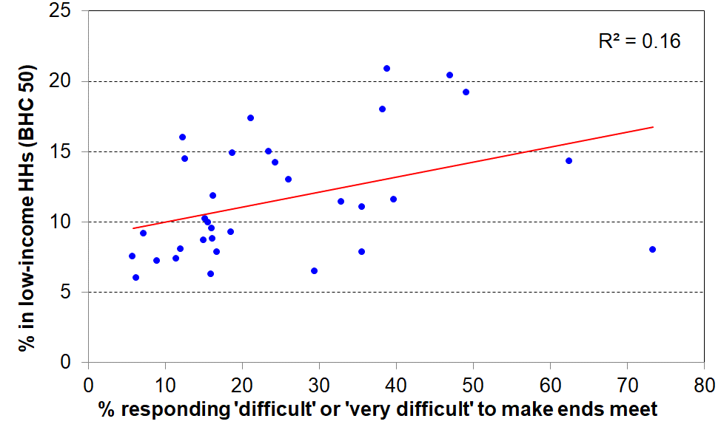**34 OECD countries c 2010**

* Finally, the income approach can produce incongruous results for the comparison of ‘poverty’ rates in richer countries. **Figure D.4** below uses 2018 Eurostat data and shows that countries with very similar ‘poverty’ (low-income) rates can have quite different material deprivation or hardship rates. For example, Netherlands and Hungary both have 13% low-income (poverty) rates, but very different deprivation rates (5% and 20% respectively).

**Figure D.4**

**Correlation between low-income rates (BHC 60%) and material hardship rates (EU-13, 5+)**

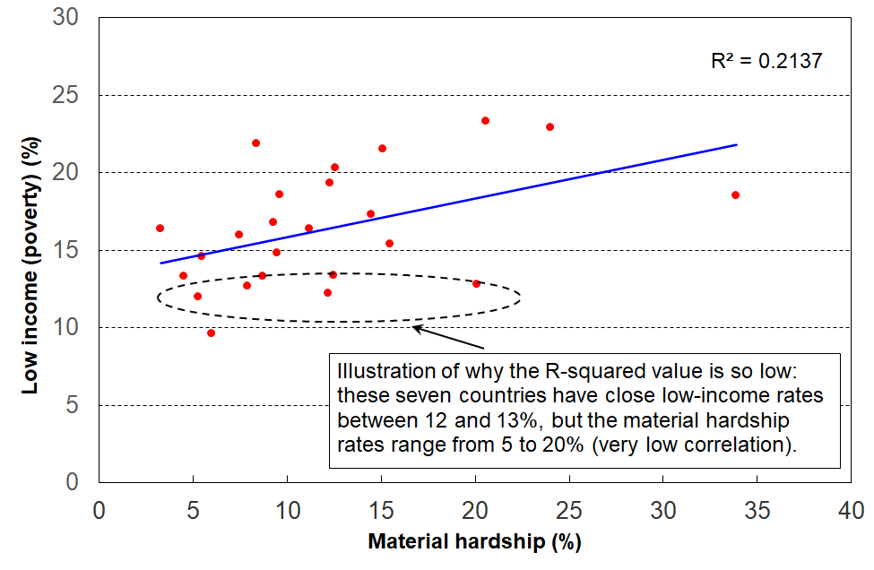**for 25 European countries (EU-SILC 2018)**

The concerns raised in this report about the use of low-income for international comparisons of poverty are not new.[53] A recent example is Goedemé et al (2019), who use reference budgets for selected European countries to show how the 60% BHC thresholds bear little relation to what is actually needed in many poorer European countries to reach even survival level.

For completeness, low-income rates for New Zealand children are reported in **Table D.4** in relation to the EU median rate. Based on the above analysis, this report’s view is that the comparisons do not tell us anything about how New Zealand children are faring in their material wellbeing relative to their European counterparts. That is better assessed using material hardship indices and deprivation items as in the first two sub-sections, International 1 and 2 above. The comparisons in Table D.4 indicate that on these BHC measures, income inequality in the lower half of the income distribution for New Zealand households with children is a little above the European country median.

**Table D.4**

**Low-income rates (BHC) for New Zealand children (0-17 yrs)**

**compared with the European country median**

**HES 2020-21, EU-SILC 2020**

|  |  |  |
| --- | --- | --- |
|  | **New Zealand** | **EU** |
| **BHC 60** | 22 | 16 |
| **BHC 50** | 14 | 10 |

Note: European figures include all EU countries (except Romania and Bulgaria) plus non-EU countries Norway, Switzerland, Iceland and the UK (UK left the EU in January 2020).

**International 4:**

**Children in jobless households**

**Table D.6** compares New Zealand with EU countries on the proportion of children in jobless households. In HES 2012, at the height of the GFC impact, New Zealand was at the high end of the table with a rate of 18%, similar to Hungary, the United Kingdom and Ireland (16-20%). By HES 2019-20, the rate had fallen to 10%, then it rose a little to 12% in the 2020-21 HES.

**Table D.6**

**International comparisons of the proportion of children living in jobless households (%):**

**2008 to 2020 (calendar years)**

|  |  |  |  |  |  |  |  |  |  |  |  |
| --- | --- | --- | --- | --- | --- | --- | --- | --- | --- | --- | --- |
|  | **2008** | **2012** | **2017** | **2019** | **2020** |  | **2008** | **2012** | **2017** | **2019** | **2020** |
| Sweden | 8 | 7 | 6 | 11 | 15 | Latvia | 8 | 11 | 8 | 8 | 8 |
| Belgium | 11 | 12 | 12 | 11 | 13 | Estonia | 7 | 9 | 6 | 7 | 8 |
| France | 8 | 10 | 12 | 12 | 12 | Romania | 10 | 12 | 9 | 7 | 8 |
| Ireland | 13 | 20 | 12 | 11 | 11 | **EU-27 median** | **8** | **10** | **9** | **7** | **8** |
| Italy | 7 | 9 | 10 | 9 | 11 | Austria | 6 | 6 | 7 | 6 | 7 |
| **New Zealand** | **17** | **18** | **11** | **11** | **11** | Malta | 9 | 8 | 8 | 7 | 6 |
| United Kingdom | 17 | 17 | 12 | 11 | 10 | Hungary | 15 | 16 | 8 | 6 | 6 |
| Bulgaria | 11 | 17 | 12 | 9 | 10 | Cyprus | 4 | 7 | 10 | 6 | 6 |
| Germany | 10 | 9 | 9 | 8 | 9 | Luxembourg | 4 | 4 | 8 | 6 | 5 |
| Spain | 7 | 14 | 10 | 8 | 9 | Czechia | 7 | 8 | 6 | 6 | 5 |
| Slovakia | 9 | 10 | 8 | 8 | 8 | Portugal | 5 | 9 | 6 | 5 | 5 |
| Lithuania | 11 | 12 | 10 | 9 | 8 | Netherlands | 5 | 6 | 6 | 5 | 5 |
| Greece | 4 | 13 | 9 | 8 | 8 | Finland | 4 | 4 | 5 | 5 | 5 |
| Denmark | 3 | 8 | 9 | 8 | 8 | Croatia | 7 | 11 | 8 | 6 | 4 |
| Poland | 8 | 9 | 8 | 8 | 8 | Slovenia | 3 | 4 | 3 | 3 | 3 |

* EU Source is: <http://appsso.eurostat.ec.europa.eu/nui/show.do?dataset=lfsi_jhh_a&lang=en> - accessed 21 Mar 2022.
* The reported EU proportions are for the calendar years specified. The HES cuts across adjacent calendar years. For EU 2020 comparisons, the NZ figure is the average of the HES 2019-20 and 2020-21 figures, and so on.
* The figures for New Zealand to 2017 are derived using the sample weights developed by the New Zealand Treasury for use with the HES, as these are constructed using benefit numbers as one of the benchmarks. 2019 and later figures use the (new) Stats NZ weights which use benefit numbers as one of the benchmarks.

**Children in jobless households, in households with no full-time paid worker and in families in receipt of a main benefit**

Leading up to the GFC and in the downturn associated with it (2008 to 2012), around one in four New Zealand children lived in households where there was no adult in full-time employment. This dropped to around one in six in the 2016-17 HES and has been steady since then (**Table D.6**). This figure, like 2020-21 jobless figure (12%), is nevertheless high by OECD and EU standards.

**Table D.7**

**Proportion of children in ‘workless’ households (% of all children)**

|  |  |  |  |  |  |  |  |
| --- | --- | --- | --- | --- | --- | --- | --- |
| **HES survey year** | **2007-08** | **2011-12** | **2016-17** | **2017-18** | **2018-19** | **2019-20** | **2020-21** |
| **In jobless HHs** | 17 | 19 | 11 | 11 | 11 | 10 | 12 |
| **In HHs with no FT worker** | 24 | 25 | 16 | 17 | 16 | 16 | 17 |
| **In beneficiary families** | 19 | 21 | 16 | 15 | 15 | 16 | 18 |

See notes below Table D.6.

The proportion of children in beneficiary families is unlikely to ever match either of the other two lines for several reasons:

* a beneficiary family may live in a household where an adult is in FT work (eg a sole parent family living with the mother’s parents or other relatives)
* some beneficiary families receive income from part-time employment
* the beneficiary information is a snapshot at 31 March (from 2013 on), whereas the HES-based figures are an average over the full survey year.

**Section E**

**Children across the full material wellbeing spectrum**

The focus so far has been on material hardship, low incomes and financial stress (‘child poverty’), all of which are matters of considerable ongoing public policy interest. This justifiable focus can sometimes mean that it is easy to forget that the vast majority of New Zealand children are living in households in which their basic material needs are consistently met, and most in fact experience a good to very good material standard of living.

MSD’s Material Wellbeing Index (MWI) ranks households across the full material wellbeing spectrum from low to high, rather than just being focussed on the low end as the DEP-17 and EU-13 indices are.[54] Applying the MWI to the 2018-19 HES data enables the creation of a fuller picture of how all children are faring.

The analysis in this section divides the full spectrum into six groups for illustrative purposes:

* The boundary for the lowest group was selected to make the MWI hardship rate correspond as closely as possible to the 6+/17 DEP-17 hardship rate (13% in 2018-19), the one used by Stats NZ in the CPRA child poverty statistics.
* Group 2 could be labelled ‘just getting by’ (the next 12% of children).
* The lower boundary for the highest group was selected so that this group had none of the basics missing and had virtually all the ‘freedoms’ (see text and **Table E.1** below).
* The boundaries for the remaining three groups were more arbitrary, but the decisions reflected the fact that the MWI’s discriminatory power diminishes the higher the MWI scores. Group 5 was therefore made larger than Groups 3 and 4, and clearly includes households not in the same league as those in Group 6, but much better off on average than Group 4.

**Table E.1** shows the distribution of the whole population and of children across the six groupings, and then uses selected survey items to give an idea of the standard of living for households with children in each grouping or band. This indicative calibration exercise uses items covering both the basics that all should have and none should go without, and some non-basics that most aspire to (‘freedoms’ for short).

**Table E.1**

**Using household or respondent items to give an indication of the standard of living in each MWI band:**

**children in their households, HES 2018-19**

|  |  |  |  |  |  |  |  |
| --- | --- | --- | --- | --- | --- | --- | --- |
| Group # | **1** | **2** | **3** | **4** | **5** | **6** | **ALL** |
| MWI score bands | 0-12 | 13-18 | 19-24 | 25-29 | 30-33 | 34-35 |  |
| Whole population - across 6 groups (%) | 10 | 10 | 15 | 21 | 25 | 19 | 100 |
| Children (0-17 yrs) – across 6 groups (%) | 14 | 12 | 18 | 20 | 22 | 14 | 100 |
| **% of children in households which report these deprivations** |  |  |  |  |  |  |  |
| No access to car | 11 | 9 | 5 | 3 | 0 | 0 | 5 |
| Help from foodbank more than once in last 12 months | 25 | 8 | 2 | 0 | 0 | 0 | 5 |
| Cut back / went without fresh fruit and veg ‘a lot’ | 25 | 3 | 0 | 0 | 0 | 0 | 4 |
| Cannot keep home warm | 43 | 18 | 5 | 0 | 0 | 0 | 10 |
| Not enough income for basics | 48 | 21 | 9 | 4 | 2 | 0 | 13 |
| **% of children in households which report these ‘freedoms’** |  |  |  |  |  |  |  |
| Holidays away from home at least once each year (have) | 19 | 35 | 55 | 69 | 81 | 90 | 61 |
| $300 spot purchase – not at all restricted | 0 | 0 | 3 | 7 | 23 | 86 | 19 |
| Clothes/shoes for self - not limited by money | 0 | 2 | 4 | 10 | 27 | 88 | 21 |
| Hobbies and special interests – economised ‘not at all’ | 4 | 10 | 17 | 38 | 75 | 98 | 42 |
| Local trips – economised ‘ not at all’ because of money | 5 | 14 | 34 | 60 | 92 | 99 | 54 |
| Dentist – postponed ‘not at all’ because of money | 8 | 17 | 34 | 57 | 87 | 99 | 53 |
| Broken appliances – delayed repairing or replacing ‘not at all’ | 16 | 32 | 50 | 72 | 94 | 100 | 64 |
| Satisfied / very satisfied with life | 47 | 64 | 80 | 86 | 93 | 95 | 80 |

Note for Table E.1: any cells ≤ 1.5% are recorded as ‘0’.

**Table E.2** repeats the analysis above using a wider range of items, both child-relevant household items and child-specific items.

**Table E.2**

**Using child-relevant household items and child-specific items**

**to give an indication of the standard of living experienced by children in each MWI band.**

**HES 2018-19**

|  |  |  |  |  |  |  |  |  |
| --- | --- | --- | --- | --- | --- | --- | --- | --- |
| Group # |  | **1** | **2** | **3** | **4** | **5** | **6** | **ALL** |
| MWI score bands |  | 0-12 | 13-18 | 19-24 | 25-29 | 30-33 | 34-35 |  |
| Whole population - across 6 groups (%) |  | 10 | 10 | 15 | 21 | 25 | 19 | 100 |
| Children (6-17 yrs) – across 6 groups (%) |  | 14 | 12 | 18 | 20 | 22 | 14 | 100 |
| **Child-relevant general HH items** | **Response** |  |  |  |  |  |  |  |
| Income adequacy for basics | not enough | 49 | 21 | 9 | 5 | 2 | 0 | 13 |
| Foodbank / other community help | more than once | 24 | 7 | 2 | 0 | 0 | 0 | 5 |
| Borrowed for basics from fam/friends | more than once | 47 | 18 | 8 | 3 | 0 | 0 | 11 |
| Can pay unexpected $500 bill | no | 83 | 52 | 26 | 12 | 4 | 0 | 26 |
| Delayed replace/repair appliances | a lot | 53 | 20 | 9 | 2 | 0 | 0 | 12 |
| Car | don't have | 11 | 8 | 4 | 3 | 0 | 2 | 5 |
| Holiday away each year | don't have - cost | 78 | 59 | 35 | 17 | 6 | 0 | 29 |
| Holiday away each year | don't have - other | 4 | 8 | 11 | 14 | 12 | 10 | 10 |
| Dampness or mould | major problem | 32 | 14 | 7 | 2 | 0 | 0 | 8 |
| Can afford to keep home warm | no | 44 | 17 | 5 | 0 | 0 | 0 | 10 |
| Crowding | 1+ more rooms needed | 29 | 19 | 16 | 7 | 8 | 4 | 13 |
| Crowding | 2+ needed - severe | 6 | 5 | 4 | 0 | 2 | 0 | 3 |
| Life satisfaction | dissatis / very dissatis | 20 | 11 | 5 | 3 | 2 | 0 | 6 |
| **Child-specific items** |  |  |  |  |  |  |  |  |
| Two pair of shoes | don't have | 30 | 9 | 3 | 0 | 0 | 0 | 7 |
| Two sets winter clothes | don't have | 10 | 2 | 0 | 0 | 0 | 0 | 2 |
| Waterproof coat | don't have - cost | 22 | 5 | 2 | 0 | 0 | 0 | 4 |
| Waterproof coat | don't have - other | 7 | 8 | 5 | 3 | 2 | 0 | 4 |
| Separate bed | don't have | 20 | 9 | 4 | 0 | 0 | 0 | 5 |
| Fruit and veg daily | don't have | 35 | 10 | 3 | 0 | 0 | 0 | 7 |
| Protein meal daily | don't have | 12 | 2 | 0 | 0 | 0 | 0 | 3 |
| Computer / internet | don't have | 22 | 9 | 5 | 2 | 0 | 0 | 6 |
| Friends around to play / eat | don't have - cost | 17 | 5 | 0 | 0 | 0 | 0 | 3 |
| Friends around to play / eat | don't have - other | 17 | 15 | 9 | 5 | 3 | 0 | 8 |
| Birthday and other celebrations | don't have - cost | 24 | 8 | 2 | 0 | 0 | 0 | 5 |
| Birthday and other celebrations | don't have - other | 12 | 13 | 8 | 6 | 4 | 3 | 7 |
| Unable to fund school trips | a lot | 18 | 4 | 0 | 0 | 0 | 0 | 3 |
| Had to limit participation in sport | a lot | 26 | 10 | 2 | 0 | 0 | 0 | 6 |
| Had to go without special interests | a lot | 29 | 13 | 2 | 0 | 0 | 0 | 7 |
| Continued to wear worn out / wrong size shoes/clothes | a lot | 17 | 3 | 0 | 0 | 0 | 0 | 3 |
|  |  |  |  |  |  |  |  |  |
| DEP-17 material hardship, 6+/17 | | 82 | 12 | 0 | 0 | 0 | 0 | 13 |
| DEP-17 severe material hardship, 9+/17 | | 38 | 0 | 0 | 0 | 0 | 0 | 5 |

Note for Table E.2: any cells ≤ 1.5% are recorded as ‘0’.

The charts in **Figure E.1** below show how children in selected household contexts are distributed across the material wellbeing spectrum (HES 2018-19).

* The six groupings range from material hardship (red) through to very well off (dark green on the right).
* Each cluster of six adds to 100%.
* The right-hand cluster in the household type chart (left-hand chart immediately below) shows how all children are distributed across the material well-being spectrum.
* **Table E.3** gives the data behind the charts.

**Figure E.1**

**The material wellbeing of children in selected household contexts (6 groupings using MWI scores)**

**HES 2018-19**

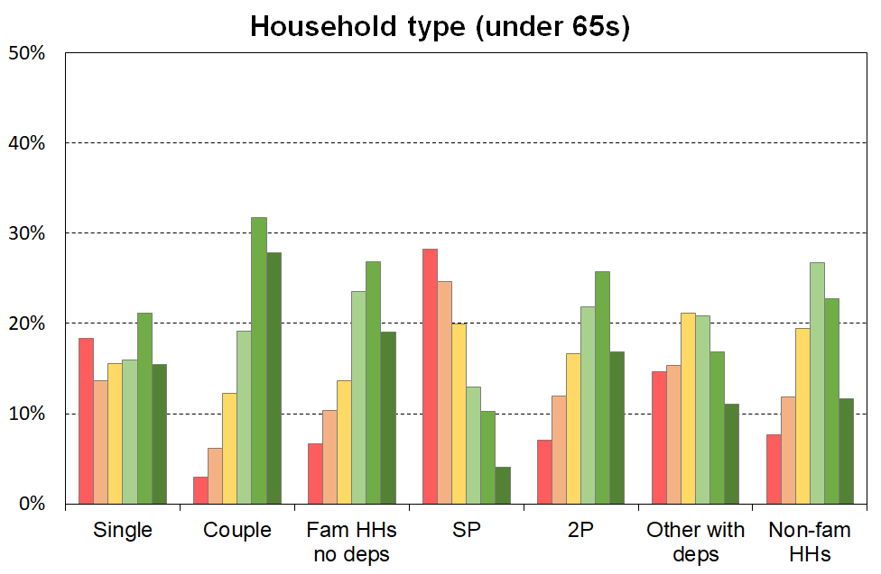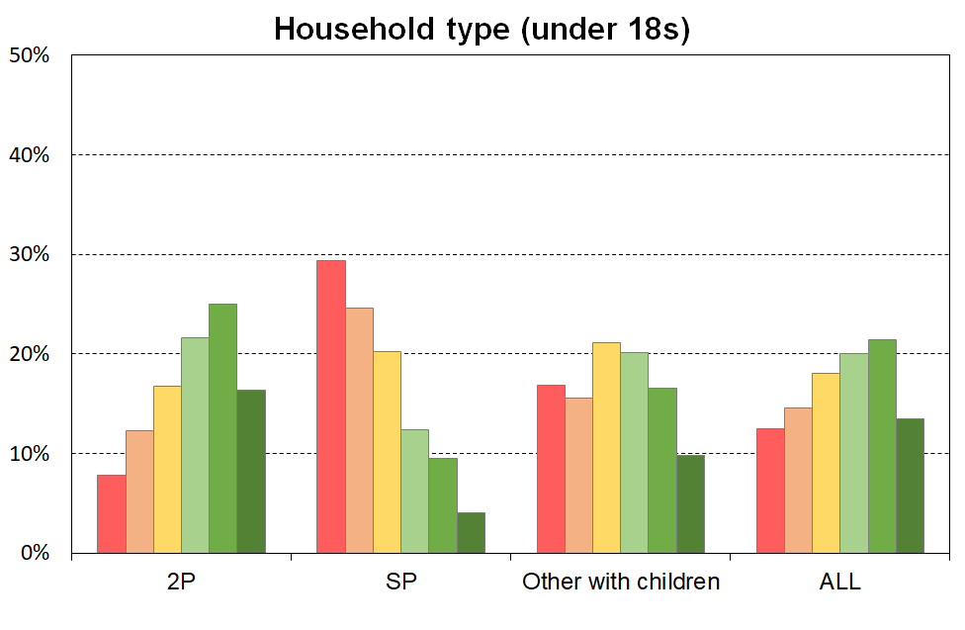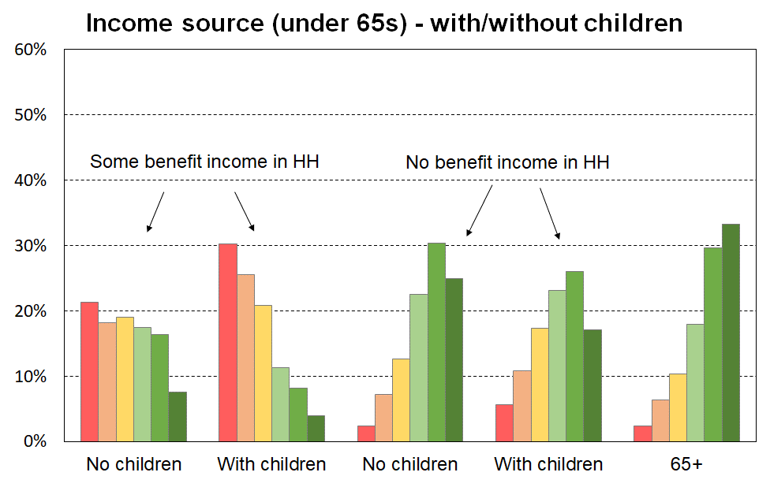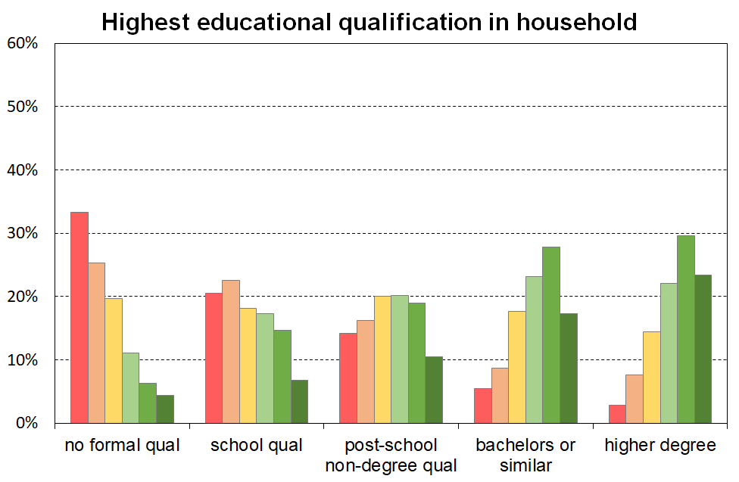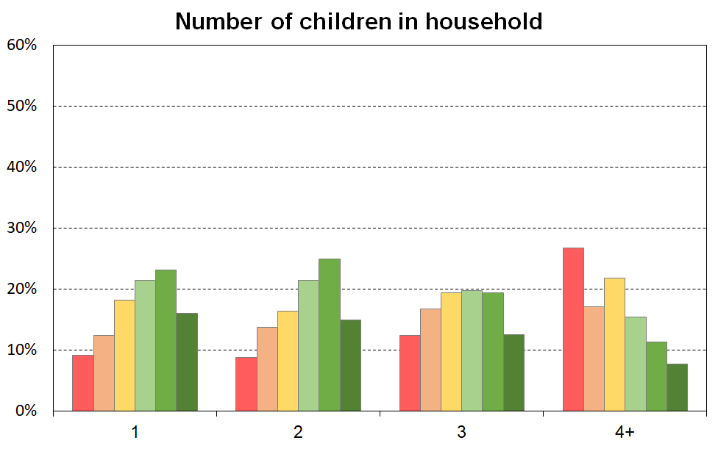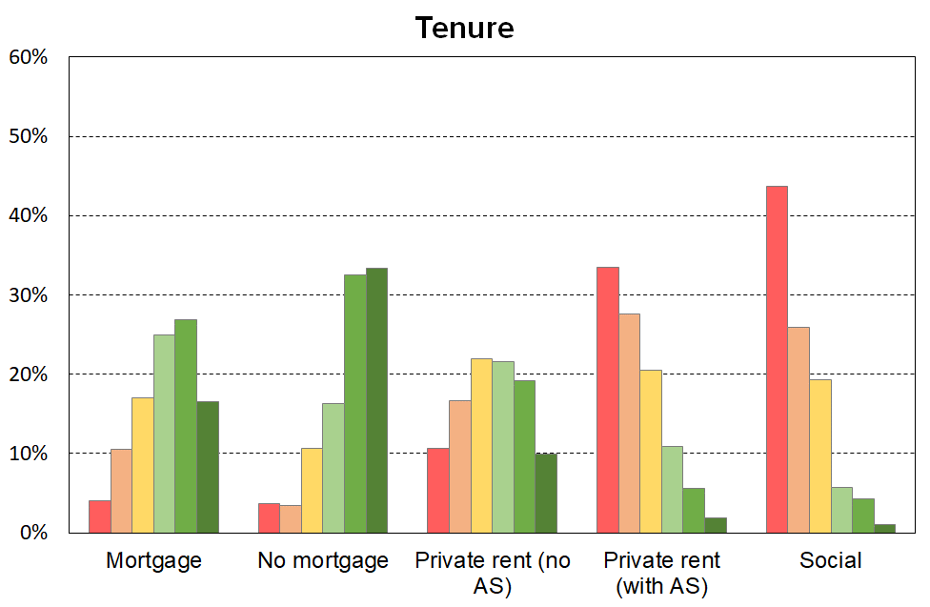

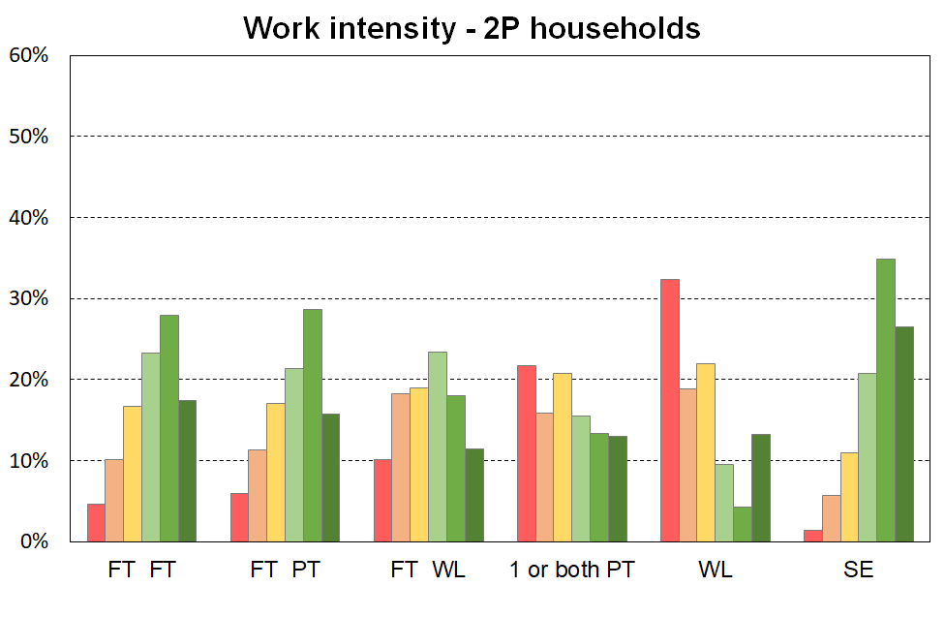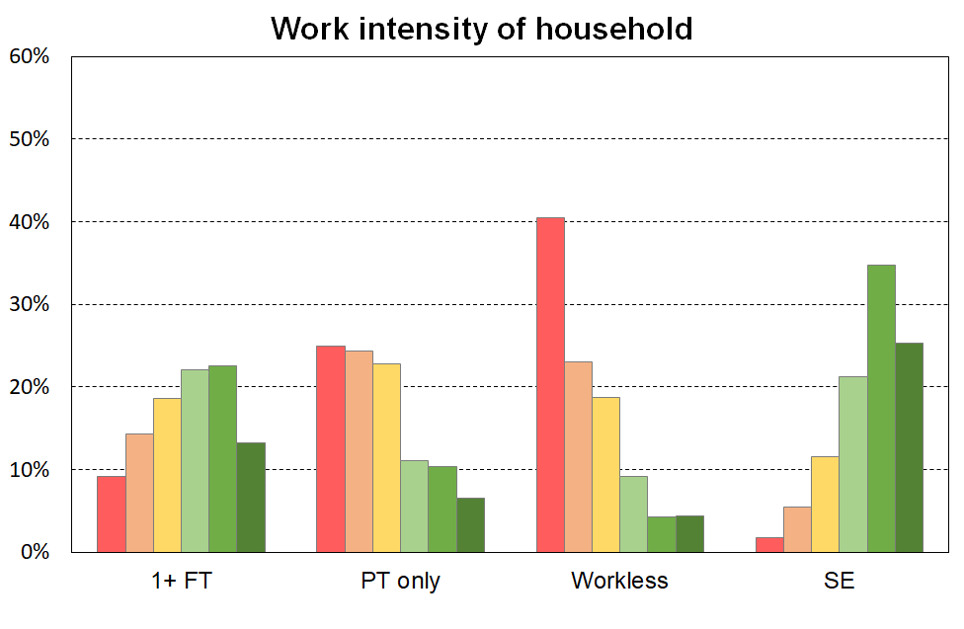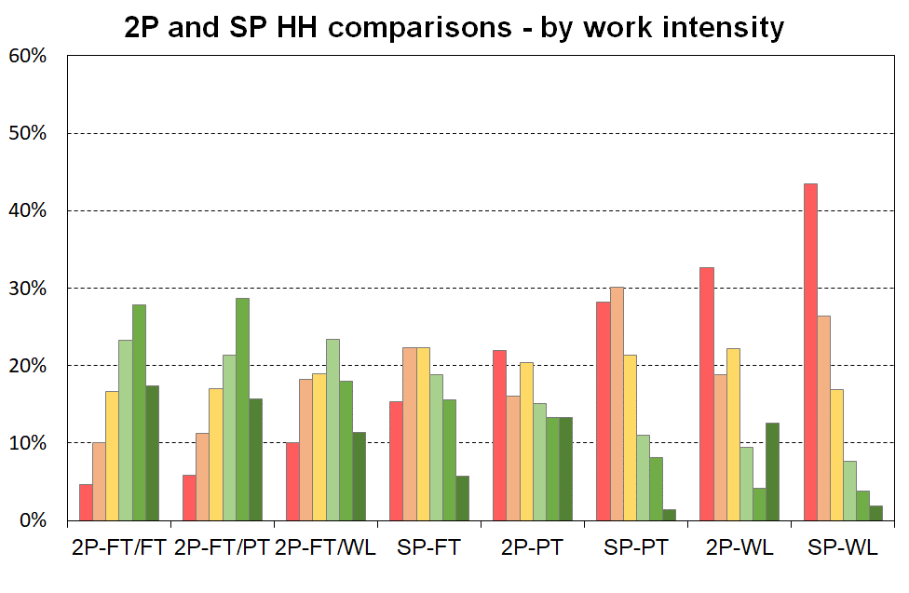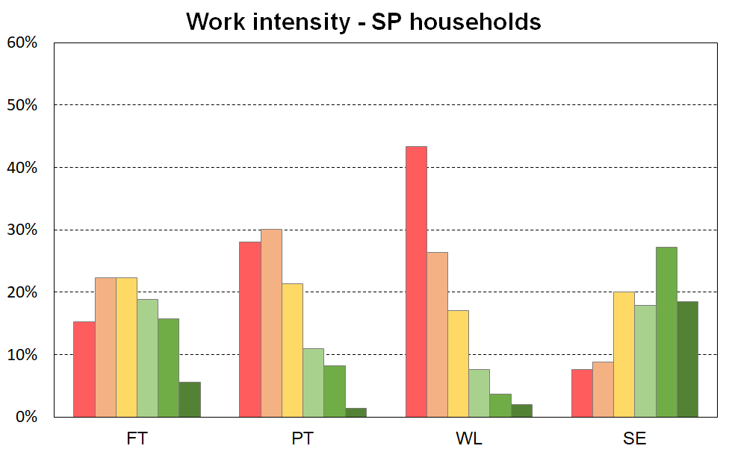

The left-hand chart in **Figure E.2** shows how children are distributed across the material wellbeing spectrum by their ethnicity (‘total’ definition).

When interpreting the chart, it is important to note that the information is descriptive only and should not be used as if ethnicity is being portrayed as causal in relation to MWI scores (material wellbeing). To support a causality narrative or conclusion, a starting point would be regression analysis in which other relevant variables are included to control for differences in education, household type, household employment hours, and so on. Even then, further investigation would be needed to understand whether any in the set of control variables themselves have any significant dependency on ethnicity.

The right-hand chart in Figure E.2 looks at the group of children who live in households in which the highest educational qualification is a tertiary degree. This in effect introduces a simple control for educational qualification (at the degree level). There is a greater similarity for the material wellbeing profiles for these children across the ethnic groupings than there is when all children are looked at, though some differences are still evident.

**Figure E.2**

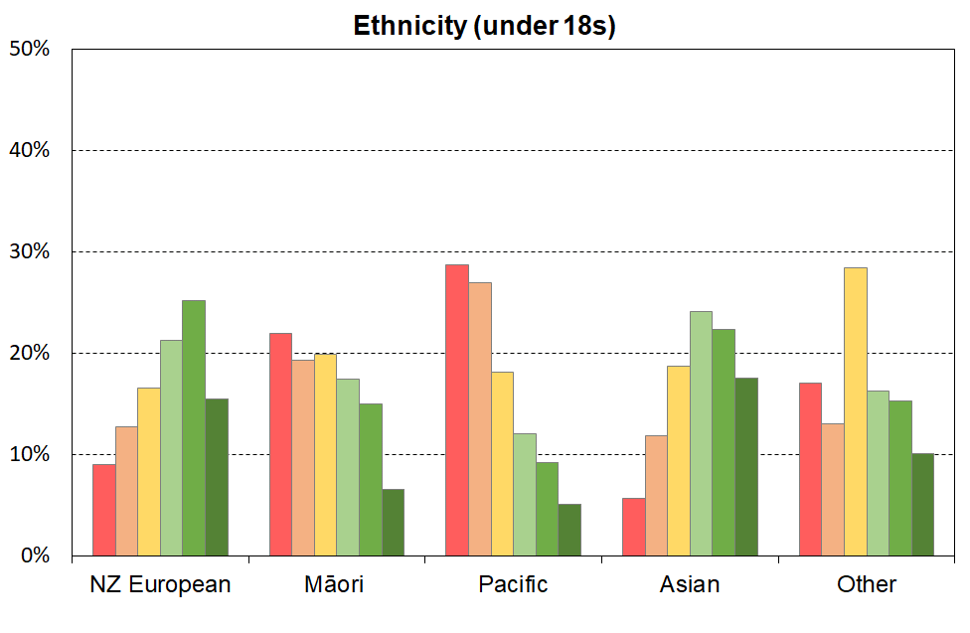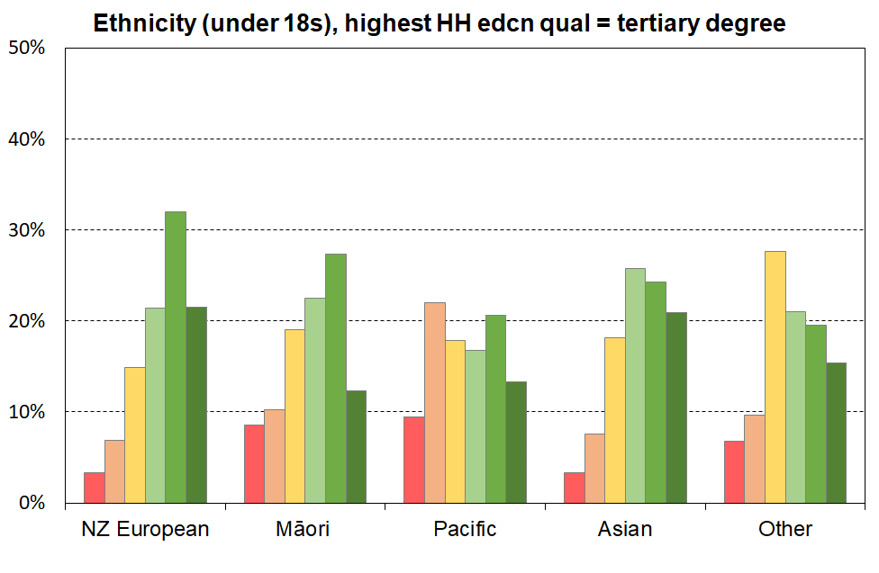**The material wellbeing of children by their ethnicity (6 groupings using MWI scores)**

**Table E.3**

**The material wellbeing of children in selected household contexts (6 groupings using MWI scores),**

**HES 2018-19**

|  |  |  |  |  |  |  |  |  |
| --- | --- | --- | --- | --- | --- | --- | --- | --- |
| MWI level (6=highest material wellbeing) **→** | **1** | **2** | **3** | **4** | **5** | **6** | **Size of group** | |
|  | 0-12 | 13-18 | 19-24 | 25-29 | 30-33 | 34-35 | 000s | % |
| **All children (0-17 yrs)** | 14 | 12 | 18 | 20 | 22 | 14 | 1,135 | 100 |
|  |  |  |  |  |  |  |  |  |
| **Household type** |  |  |  |  |  |  |  |  |
| Two parent | 10 | 11 | 17 | 22 | 25 | 16 | 785 | 69 |
| Sole parent | 33 | 21 | 20 | 12 | 9 | 4 | 160 | 14 |
| Other under 65 households | 19 | 13 | 21 | 20 | 17 | 10 | 180 | 16 |
| All children (0-17 yrs)_ | 14 | 12 | 18 | 20 | 22 | 14 | 1,135 | 100 |
| **Number of children in households** |  |  |  |  |  |  |  |  |
| 1 | 11 | 11 | 18 | 21 | 23 | 16 | 245 | 22 |
| 2 | 11 | 12 | 16 | 21 | 25 | 15 | 485 | 43 |
| 3 | 16 | 14 | 19 | 20 | 19 | 12 | 255 | 23 |
| 4+ | 31 | 14 | 21 | 15 | 11 | 7 | 140 | 12 |
| **Highest educational qualification in HH** |  |  |  |  |  |  |  |  |
| no formal qualification | 36 | 22 | 19 | 11 | 6 | 5 | 80 | 7 |
| school qualification | 23 | 19 | 18 | 18 | 15 | 7 | 215 | 19 |
| post-school non-degree qualification | 16 | 14 | 20 | 20 | 19 | 11 | 360 | 32 |
| bachelors or similar | 7 | 8 | 17 | 23 | 28 | 17 | 250 | 22 |
| higher degree | 4 | 6 | 14 | 22 | 30 | 23 | 230 | 20 |
| **Tenure of household** |  |  |  |  |  |  |  |  |
| Owned with mortgage (incl FT) | 5 | 9 | 17 | 25 | 27 | 16 | 540 | 47 |
| Owned no mortgage (incl FT) | 5 | 3 | 11 | 16 | 32 | 33 | 120 | 10 |
| Private rental (no AS) | 13 | 14 | 22 | 21 | 19 | 10 | 195 | 17 |
| Private rental (with AS) | 38 | 23 | 20 | 11 | 6 | 2 | 170 | 15 |
| Social rental (HNZ & LA) | 49 | 22 | 19 | 5 | 4 | 1 | 75 | 7 |
| **Income source (and 65+)** |  |  |  |  |  |  |  |  |
| Some benefit income, no dep children | 21 | 8 | 32 | 27 | 10 | 2 | 5 | 0 |
| Some benefit income, with dep children | 37 | 21 | 20 | 10 | 7 | 4 | 250 | 22 |
| No benefit income, no dep children | 6 | 12 | 12 | 20 | 27 | 21 | 5 | 0 |
| No benefit income, with dep children | 8 | 10 | 17 | 23 | 26 | 16 | 875 | 77 |
| 65+ | 3 | 6 | 11 | 18 | 30 | 33 | 710 | 63 |
| **Household work intensity – sole parent HHs** |  |  |  |  |  |  |  |  |
| FT | 17 | 20 | 23 | 19 | 16 | 6 | 55 | 34 |
| PT | 32 | 26 | 22 | 11 | 9 | 1 | 30 | 19 |
| WL | 49 | 21 | 16 | 8 | 4 | 2 | 65 | 42 |
| SE | 6 | 7 | 24 | 17 | 24 | 22 | 5 | 4 |
| **HH work intensity – 2 parent HHs** |  |  |  |  |  |  |  |  |
| FT FT | 7 | 9 | 16 | 23 | 27 | 17 | 260 | 33 |
| FT PT | 8 | 10 | 17 | 21 | 29 | 15 | 165 | 21 |
| FT WL | 14 | 16 | 20 | 23 | 16 | 11 | 185 | 24 |
| 1 or both PT (no FT) | 27 | 11 | 18 | 13 | 13 | 18 | 20 | 2 |
| WL | 38 | 13 | 24 | 9 | 3 | 13 | 30 | 4 |
| SE | 2 | 5 | 11 | 21 | 36 | 26 | 120 | 15 |
| **HH work intensity – other HHs with deps** |  |  |  |  |  |  |  |  |
| 1+ FT | 17 | 13 | 22 | 21 | 17 | 10 | 140 | 79 |
| WL | 43 | 16 | 16 | 14 | 11 | 1 | 20 | 11 |
| SE | 2 | 1 | 11 | 29 | 31 | 26 | 10 | 6 |
| Other | 15 | 26 | 36 | 4 | 9 | 10 | 10 | 4 |
| **HH work** intensity – all HHs with dep ch |  |  |  |  |  |  |  |  |
| 1+ FT | 11 | 12 | 19 | 22 | 22 | 13 | 815 | 72 |
| PT only | 28 | 21 | 22 | 11 | 11 | 8 | 60 | 5 |
| WL | 45 | 18 | 18 | 9 | 5 | 5 | 120 | 10 |
| SE | 3 | 5 | 11 | 21 | 35 | 26 | 140 | 12 |

**Table E.3 (cont’d)**

**The material wellbeing of children by their ethnicity (6 groupings using MWI scores),**

**HES 2018-19**

|  |  |  |  |  |  |  |  |  |
| --- | --- | --- | --- | --- | --- | --- | --- | --- |
| MWI level (6=highest MWB) **→** | **1** | **2** | **3** | **4** | **5** | **6** | **Size of group** | |
|  | 0-12 | 13-18 | 19-24 | 25-29 | 30-33 | 34-35 | 000s | % |
| **Ethnicity of child (all children)** |  |  |  |  |  |  |  |  |
| European | 10 | 11 | 16 | 21 | 25 | 16 | 735 | 53 |
| NZ Māori | 24 | 17 | 20 | 18 | 15 | 7 | 290 | 21 |
| Pacific peoples | 32 | 23 | 18 | 12 | 9 | 5 | 140 | 10 |
| Asian | 7 | 10 | 19 | 24 | 22 | 18 | 180 | 13 |
| Other | 21 | 8 | 28 | 17 | 16 | 10 | 45 | 3 |
| **Ethnicity of child (children in HHs with university degree as highest educational qualification)** |  |  |  |  |  |  |  |  |
| European | 4 | 6 | 15 | 22 | 32 | 21 | 325 | 57 |
| NZ Māori | 9 | 9 | 19 | 23 | 27 | 12 | 70 | 12 |
| Pacific peoples | 13 | 18 | 18 | 17 | 21 | 14 | 30 | 5 |
| Asian | 5 | 6 | 18 | 26 | 24 | 21 | 125 | 22 |
| Other | 10 | 6 | 27 | 21 | 20 | 16 | 25 | 4 |

Note: the ‘total ethnicity’ approach is used – see Section B for definition.

**Section F**

**Trends in material hardship and material wellbeing for children: headline rates and breakdowns by selected household and child characteristics**

This section reports the trends in material hardship for children from HES 2007 to HES 2021:

* for all children
* by main source of income of the household (market or government)
* by household type
* by ethnic group of the children

It provides comparisons with the population as a whole and older New Zealanders (aged 65+).

There is a short section on persistent material hardship, and another on the improving material and financial wellbeing for New Zealand children overall.

In the **Annex** to Section F there is detailed information about those in households in the deepest financial and material hardship – the lowest ventile (5%).

* * * * * * * * * * * * * * * * *

The main analysis is based on MSD’s Material Wellbeing Index (MWI) from 2013 to 2021 and its predecessor, the Economic Living Standards Index (ELSI), from 2007 to 2012. **Section J** provides the analysis that supports the splicing of the ELSI and MWI series into one for reporting for working-age households.

The MWI trend from 2013 to 2021 is very close to that produced by DEP-17, MSD’s material deprivation measure that is used by Stats NZ for official CPRA Child Poverty Statistics. **Section J** provides the detail on this.

Most of the charts and tables report at both the ‘standard’ material hardship level and also for more severe hardship. The MWI thresholds are set at levels to mimic the DEP-17 6+/17 and 9+/17 measures used in the official CPRA reporting by Stats NZ.

**Appendix 1** lists the items and specifies the scoring methods used for the DEP-17 and MWI indices.

**Headline trends for material hardship for children**

Material hardship rates for children increased during the GFC and associated downturn, then steadily improved from 2013 to 2021 (falling to 11% or 125,000) (**Figure F.1**).

The downward trend can be attributed to a combination of rising employment rates, rising real wages, increases to income support for families with children, increased support for housing and child-care costs, and other measures that reduce demand on the family budget (eg free doctors’ visits and the food-in-schools programme).

**Figure F.1**

**Material hardship trends for children (0-17 yrs), 2007 to 2021**

Note for Figure F.1: The vertical line between 2011-12 and 2012-13 HES years is a reminder that the chart splices the numbers from two indices, one up to 2011-12 and the other from 2012-13. See **Section J** for details and the justification for the splicing.

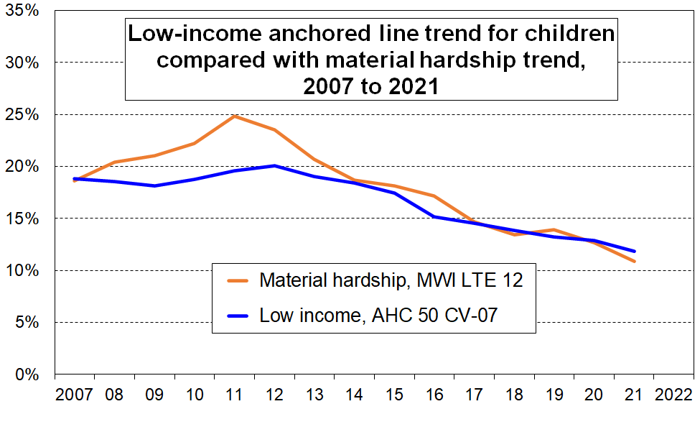The child poverty rate using the low-income anchored line measure for AHC 50 also rose and fell over the same period, but the changes were much more muted in percentage terms, 18% to 20% then down to 12%, compared with the 18% to 25% to 11% trajectory for material hardship rates. This does not mean that in and after the GFC material hardship in New Zealand ‘got a lot worse’, whereas anchored-line AHC income poverty became only ‘a little worse’. It simply reflects two features of the use of material deprivation indices when used for time series:

* by their construction they are more sensitive than income measures to changing household circumstances – the items are all essentials or close to that
* many households live in an ‘only-just-getting-by’ mode and even a small loss (gain) in income can easily lead to them moving below (above) a hardship threshold. See **Section J** for more on this, including international comparisons.

In contrast to the ‘standard’ hardship rate, the severe material hardship rate is only a little lower in 2021 than in 2008 (though much better than at its peak following the GFC impact). This reflects the greater challenges that both these very disadvantaged households themselves and government assistance have in improving their material wellbeing. See the **Annex** to this section for detailed survey-based description of the severe deprivation experienced by the most disadvantaged 5% of children (~60,000).

See **Table F.2** (page 93) for the numbers for Figures F.1, F.2 and F.6.

**Material hardship trends for ‘working’ and ‘beneficiary’ households**

In this section, ‘working’ means that most of the income for the household comes from the market, and ‘beneficiary’ means that most of the income comes from the government.[55] **Figure F.2** shows the material hardship trends for the two groups of children, with beneficiary hardship rates being around four to five times higher than rates for children in working households.

**Figure F.2**

 **Trends in material hardship rates for children (0-17 yrs), by main source of household income**

**Figure F.3** reports on the composition of those in hardship: around the same number of children in households in hardship come from each group (60,000 to 65,000 in 2021). Although working households have lower hardship rates, there are many more such households than beneficiary households, so the numbers even up.

**Figure F.3**

**Trends in the numbers of children (0-17 yrs) in households in material hardship,**

**by main source of household income**

**Sole parent declared earnings (March quarter 2022)**

Most sole parents in receipt of a main benefit do not have any declared income from paid work (87%). Around 4% declare earnings up to $150 pw, another 4% between $150 and $300 pw and 6% above $300. Sole-parent recipients of main benefits are currently able to earn up to $160 pw gross from paid work before their benefit is abated (since April 2021).

**Two demographic shifts that impact on the child poverty and child material wellbeing numbers**

Around half of the children in households reporting material hardship come from households for whom the main source of income is government transfers (see **Figure F.3** above). **Figure F.4** shows the trend in the proportion of children living in families receiving a main benefit. In March 2022 the figure was around 18% (206,000), up from the low point in 2018 and 2019 of 15% (170,000) and well down on the post-GFC high in 2010 to 2012 of 22% (230,000).

**Figure F.4**

**Trends in the proportion of children living in a family receiving a main benefit,**

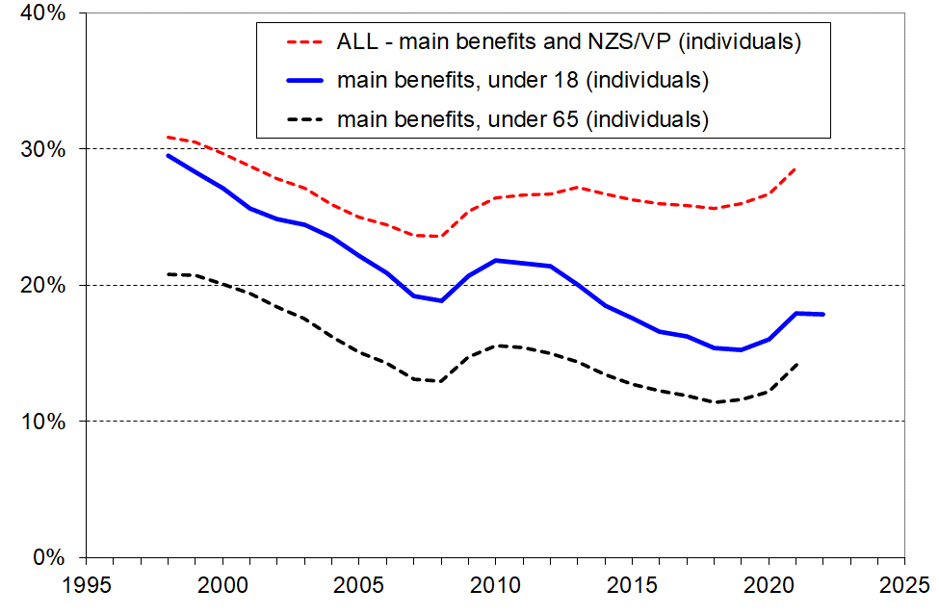**with comparisons under 65s and the whole population receiving a main benefit or NZS/VP**

Around 70% of all children live in two-parent households. Median household income is strongly impacted by the incomes of these households. **Figure F.5** shows the trend to increasing work intensity among two-parent households with dependent children.

* The option of one partner in full-time paid employment and one not in paid employment (‘workless’) was the dominant pattern in the early 1980s. By the early 2000’s, the most common arrangement was for both parents to be employed full-time (~38%), and in 2021 the figure had reached almost one in two (49%).
* The one-FT-one-PT arrangement has been reasonably steady at 25-30%.
* Around three of every four two-parent families were dual-earner families in 2021, up from one in two in the early 1980s.
* This increasing proportion of dual-earner two-parent households is a major factor behind the longer-run steady rise in material wellbeing for the vast majority of children, as indicated for example in **Figure F.10** below. It also points to / is consistent with the view that in general, single-earner households are now much less likely to be a viable option for providing economic security than they were 30 to 40 years ago.

**Figure F.5**

**Increasing proportion of two-earner two-parent households (with dependent children),**

**1982 to 2021**

**Paid work the best way out of poverty?**

It is sometimes said that ‘work is the best way out of poverty’. This is a naïve and misleading claim, even when the focus is on those in good health. Even the more nuanced ‘work is *usually* the best way out of poverty’ is misleading.

For the purposes of the theme being discussed in this box, there are three groups of interest among households in which there is at least one person in full-time paid work:

1. those for whom their market income alone is sufficient to keep them out of hardship
2. those who would be in hardship if there was no extra government support
3. those in hardship even though they are receiving government support.

For many households, **full-time paid employment on its own** does not provide enough for the household even at a very basic level, especially where there are children (groups ‘B’ above). Even with the WFF tax credits (including the in-work tax credit) and other support (eg childcare subsidies) some working households with children still struggle (group ‘C’), as shown in **Figures F.2 and F.3** above.)

There are very good reasons – economic, social and mental health – to encourage and expect most ‘working-age’ people to be in paid employment (with varying views on when caring responsibilities should take priority). The caution here is not about these rationales and goal, but simply about a naïve and misleading narrative which hinders rather than helps understanding and decision-making. The misleading narrative is that the income from paid employment alone is (usually) enough. For many households with children, the income from paid employment plus government assistance is enough – but in this case, by definition, paid employment on its own is not enough, which is the theme of this section.

The current Social Security Act asserts that ‘*work in paid employment offers the best opportunity for people to achieve social and economic wellbeing’*. There is much truth in this, but in its unqualified assertion that omits any reference to government assistance for households with children in addition to what the market provides (ie the real situation is that paid work alone is not enough), and in its contradiction of the evidence as given in this and many other reports, it too is misleading and simply reinforces the more bumper-sticker versions above.

The situation is much the same as for the claims made about a Living Wage, as discussed in Perry (2019c), Section J:

*[When calculating a Living Wage rate…] government subsidies and tax credits are taken into account. While this is reasonable to do for [deciding on] the wage needed to meet basic costs given that such support exists, the Living Wage rate that is produced is not by itself able to meet the basic costs required, contrary to how the proposal is marketed and understood by many when adopting it for their employees …*

*There is a case for viewing the Living Wage movement as essentially an effort by some citizens to raise the minimum wage, with the extra (first-round) costs paid for by the employer, and with the gains shared between the worker and the government (more tax, lower tax credits etc). This is not just an issue of semantics. There are, for example, many instances in media reports of employers and commentators talking as if the Living Wage is in itself a real living wage when for most it is not. There is a significant gap between the marketing claims and the technical-conceptual reality.*

*This analysis is not an argument for or against the Living Wage movement and its objectives. It is simply a call for a more coherent and realistic understanding and dialogue, lest we come to believe that the Living Wage is in fact ‘the hourly wage a worker needs to pay for the necessities of life and participate as an active citizen in the community’. It is much more complex than that.*

The point is this: both the simplistic assertion that ‘work is (usually) the best way out of poverty’ and the Living Wage narrative conceal the core truth that, at least for households with children, government assistance is needed by many to ‘make work pay’. The overstated claims are at odds with the evidence and with the real-world challenging work of deciding on how to design and implement suitable policies to fairly and sustainably provide the additional support needed over and above that provided by the market through paid employment on its own.

**Material hardship trends for children by their household type**

**Figure F.6** shows the material hardship and severe hardship trends for sole-parent, two-parent and other multi-adult households with children. The hardship rate for sole-parent households is typically three to four times higher than for two-parent households. A major factor in the difference is the more limited potential for paid employment hours in a one-adult household, with or without children.

**Figure F.6**

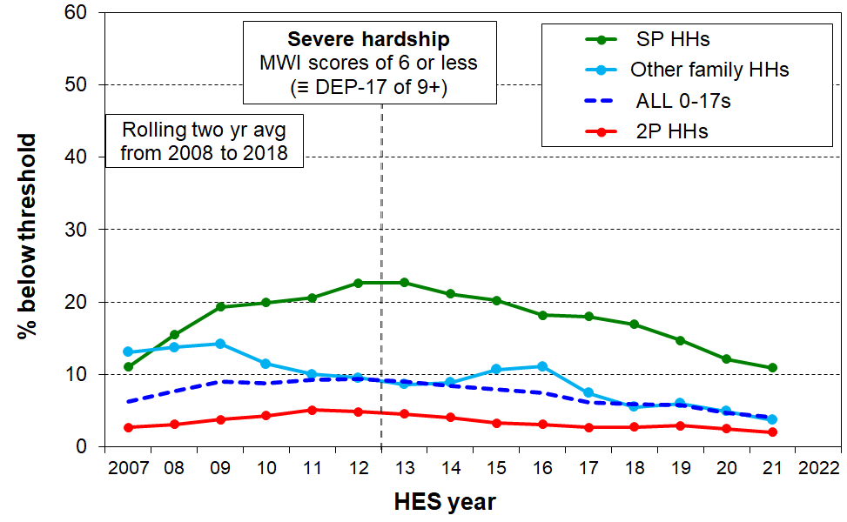 **Trends in material hardship and severe material hardship for children (0-17 yrs), by household type**

Most children live in two-parent households (~70%), with 15% in sole-parent households and 15% in other multi-adult households.[56] This means that when looking at the composition of children in hardship by household type that the two-parent v sole-parent numbers are much closer than the very different rates might suggest. On average over the three most recent surveys (HES 2018-19, 2019-20, and 2020-21), of all children in households in hardship, 42% come from two-parent households, 39% from sole-parent households and 18% from other family households. For children in households in severe hardship, the proportions are similar (see Table FA.2a for 2019).

Sole-parent families are mainly female-headed (around 83%). Material hardship rates for female-headed and male-headed sole parent families are very similar.

**Material hardship rates for children and older New Zealanders compared**

**Figure F.7** shows the relatively high rates of material hardship for New Zealand children relative to the rate for older New Zealanders. The gap is closing but is still large (11% v 3% in 2020-21).

**Figure F.7**

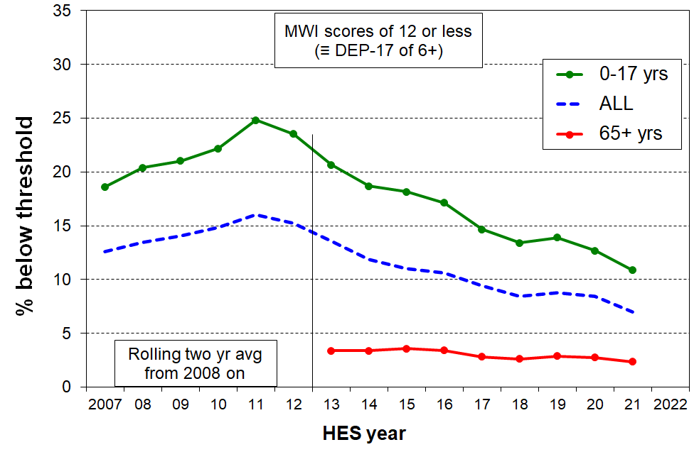**Trends in material hardship for children (0-17 yrs), the whole population and older New Zealanders (65+)**

Compared with most European countries, the ratio of the child material hardship rate to that for the population as a whole is high for New Zealand, in part reflecting the fact that the very low hardship rate for older New Zealanders pulls down the population rate more than for other countries. (See Perry (2019d), Figure C.5) and Figure D.2 above in this report.)

**Material hardship rates by ethnic grouping**

For most of the HES years prior to 2018-19 the sample size is too small to provide robust estimates for smaller sub-groups. Even in the largest sample (2018-19) the sample error is 2.3 ppt for the material hardship numbers for children in the Māori ethnic grouping, 4.2 ppt for Pacific and 1.7ppt for Asian. (This means that an estimate of 22.6% material hardship for Māori children in 2018-19 has a 95% confidence interval of around 20% to 25%, and much more than that for earlier years).

To partially address the issues arising from the relatively small sample sizes the trend lines in **Figure F.8** below are smoothed lines based on rolling two-year averages up to and including 2017-18. This allows the trend for children in the Māori ethnic grouping to be reported.

**Figure F.8**

**Material hardship rates for all children / ethnicities and children in the Māori ethnic grouping (%),**

**using spliced ELSI / MWI series as in Figure F.1 etc, 2007 to 2021,**

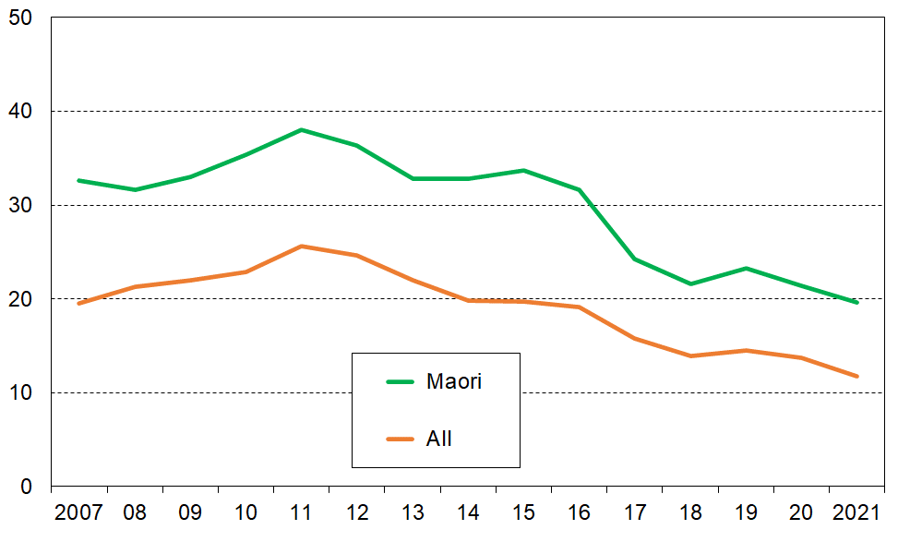**(total ethnicity approach)**

The Pacific peoples and Asian groupings are too small to allow construction of robust trend lines. **Table F.1** groups three surveys together and shows the trend in the average of these clumped figures for the earlier years, then each year for the larger HES-Admin survey years.

There has been a strong improvement in the material hardship rates for each ethnic group from the pre-GFC rates in 2007 to 2009. Each group saw an increase through the GFC then a fall through to 2021, though the peak lasted longer for the Pacific peoples group.

**Table F.1**

**Material hardship rates for children by ethnic grouping (total ethnicity approach), 2007 to 2021,**

**using the same ELSI / MWI spliced series as in Figure F.1 to F.4**

**(three-year groupings to 2017-18)**

|  |  |  |  |  |  |  |  |  |
| --- | --- | --- | --- | --- | --- | --- | --- | --- |
|  | **Material hardship rates (%)** | | | | | | | **Total Numbers** |
|  | **2007-2009** | **2010-2012** | **2013-2015** | **2016-2018** | **2019** | **2020** | **2021** | **2021** |
| **Māori** | 33 | 36 | 34 | 24 | 24 | 19 | 20 | 300,000 |
| **Pacific peoples** | 44 | 47 | 47 | 34 | 32 | 29 | 24 | 140,000 |
| **European** | 14 | 18 | 13 | 10 | 10 | 8 | 8 | 750,000 |
| **Asian** | 19 | 16 | 8 | 6 | 7 | 5 | 4 | 210,000 |
| **ALL** | 21 | 25 | 20 | 15 | 15 | 12 | 11 | 1,450,000 |

Notes for Table F.1:

* There are 40,000 in the ‘Other’ category – this row is suppressed as the numbers are too small to reliably report on low-income rates. For 2021, the sampling error for this group was of the order of 10 ppt on a point estimate of around 20% for material hardship.
* See Section B (p35 under TableB.1b) for discussion of the counting approach used for ‘total ethnicity’.
* In the corresponding income table (Table G.1), there are 1,400,000 ethnicities counted. The difference arises because of the treatment of VLIs implemented by the report. Around 50,000 are removed by that process.

**Relative depth of material hardship by household type and main source of income**

**Figure F.9** gives an indication of the relative depth of material hardship for children in sole parent and two-parent households, and for households with children by main source of income. The depth rates are calculated by dividing the severe hardship rate by the hardship rate which gives the proportion of those in hardship who are in severe hardship in the various household types.

The notion of hardship depth is related to but is not the same as severe material hardship: the former is a ratio, the latter is a proportion with the number of deprivations above a specified threshold. If the material hardship rate remained unchanged (at say 10%), but the severe hardship rate fell to zero, then this is an improvement compared with the situation where the hardship rate remained at 10% and there was no change or even an increase in the proportion in severe hardship. The trend of the material hardship depth indicator can pick up this change whereas the standard material hardship measure alone cannot.

The depth of material hardship rose for both sole-parent and two-parent households during the GFC and its aftermath. Hardship depth (as defined above) has been declining for sole-parent households from around 2014 on whereas there has been little net change for children in two-parent households. Depth has also decreased for children in beneficiary households since 2017-18, likely reflecting the increases in income support for this group in that period. For children overall, depth has also decreased since around 2017-18 after a post-GFC plateau starting in around 2013-14.

**Figure F.9**

**Trends in depth of material hardship for children (0-17 yrs),**

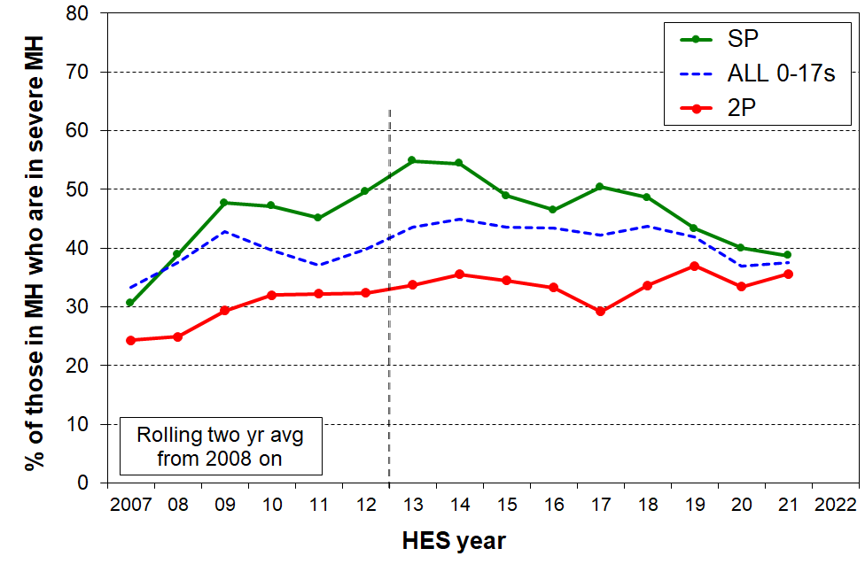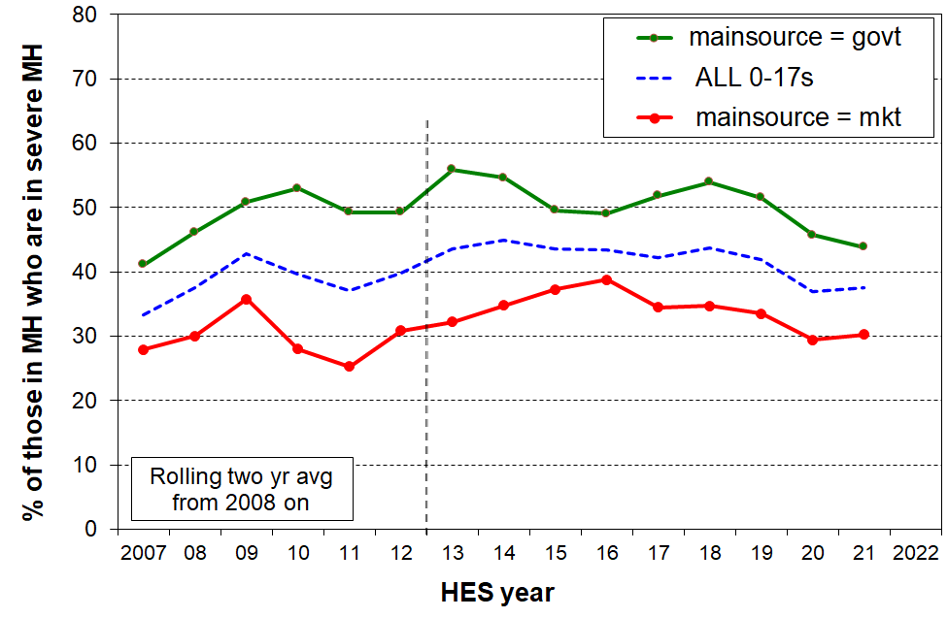 **by household type (left) and by main source of household income (right)**

Note for charts:

See the text above the charts for the definition of ‘hardship depth’ used in the charts – it is not the same as the notion of ‘severe material hardship’.

**Table F.2**

**Material hardship rates for children (%) in the selected charts as noted:**

**Smoothed figures using a rolling two-year average up to and including 2017-18**

|  |  |  |  |  |  |  |  |  |  |  |
| --- | --- | --- | --- | --- | --- | --- | --- | --- | --- | --- |
|  | **Figure F.1** | | **Figure F.2** | | **Figure F.6** | | | **Figure F.6** | | |
|  | **All children** | | **Govt** | **Mkt** | **SP** | **2P** | **Other** | **SP** | **2P** | **Other** |
|  | **Std 12-** | **Severe 6-** | **Std 12-** | **Std 12-** | **Std 12-** | **Std 12-** | **Std 12-** | **Severe 6-** | **Severe 6-** | **Severe 6-** |
| **2007** | 18.6 | 6.2 | 44.5 | 12.9 | 36.0 | 11.0 | 28.0 | 11.0 | 2.7 | 13.1 |
| **2008** | 20.4 | 7.6 | 50.10 | 13.5 | 39.8 | 12.3 | 26.1 | 15.5 | 3.1 | 13.8 |
| **2009** | 21.0 | 9.0 | 53.3 | 13.7 | 40.5 | 12.8 | 26.0 | 19.3 | 3.8 | 14.2 |
| **2010** | 22.2 | 8.8 | 53.5 | 14.8 | 42.2 | 13.5 | 31.8 | 19.9 | 4.3 | 11.5 |
| **2011** | 24.8 | 9.2 | 57.4 | 16.0 | 45.5 | 15.8 | 31.9 | 20.6 | 5.1 | 10.0 |
| **2012** | 23.5 | 9.4 | 57.2 | 14.9 | 45.6 | 15.0 | 26.3 | 22.6 | 4.9 | 9.6 |
| **2013** | 20.7 | 9.0 | 53.1 | 13.2 | 41.3 | 13.4 | 24.3 | 22.7 | 4.5 | 8.7 |
| **2014** | 18.7 | 8.4 | 50.6 | 11.4 | 38.9 | 11.5 | 21.1 | 21.1 | 4.1 | 8.9 |
| **2015** | 18.2 | 7.9 | 52.3 | 11.0 | 41.4 | 9.5 | 22.3 | 20.2 | 3.3 | 10.7 |
| **2016** | 17.1 | 7.4 | 52.3 | 10.8 | 39.1 | 9.3 | 22.9 | 18.2 | 3.1 | 11.1 |
| **2017** | 14.7 | 6.2 | 48.8 | 9.3 | 35.6 | 9.1 | 16.6 | 18.0 | 2.7 | 7.4 |
| **2018** | 13.4 | 5.9 | 44.6 | 8.4 | 34.9 | 8.1 | 13.0 | 16.9 | 2.7 | 5.5 |
| **2019** | 13.9 | 5.8 | 43.4 | 9.0 | 33.9 | 7.9 | 14.5 | 14.7 | 2.9 | 6.0 |
| **2020** | 12.7 | 4.7 | 41.0 | 8.2 | 30.3 | 7.4 | 13.5 | 12.1 | 2.5 | 4.9 |
| **2021** | 10.9 | 4.1 | 37.7 | 6.0 | 28.2 | 5.7 | 10.5 | 10.9 | 2.0 | 3.7 |

Abbreviations in table

* Govt = main source of household income is the government (‘beneficiary households’) (under 65)
* Mkt = main source of household income is the market (‘working households’) (under 65)
* SP = sole parent households with any dependent children
* 2P = two parent households with any dependent children
* Other = other family households with any dependent children

Notes for table:

* Figure F.1 and F.2 rates are for children (0-17 yrs). Figure F.6 rates are for all those in the respective households, adults included.
* The indices used are the MWI and its predecessor ELSI – see first page of Section F.
* A rolling two-year average is used for smoothing up to and including 2017-18.
* The report usually gives the above rates only to the nearest whole number to avoid giving an impression of precision which the sample errors show is not warranted. They are given here to one decimal place to assist with creating charts.
* In contrast to the time series for low-income rates, there is no break in the material hardship time series – see further on this in the opening pages of Section G.

**Persistence of material hardship**

The HES is a cross-sectional survey – not a longitudinal survey in which the same individuals are followed from one interview to the next, year-on-year – so we cannot tell from the HES data how much of the reported material hardship in one year continues to the next or beyond for those in hardship in ‘year one’.

While the international literature has a good number of studies of low-income persistence and income dynamics based on high quality longitudinal data, there is relatively little material available that covers the persistence of material hardship or financial stress, and especially so for children.

Stats NZ’s new longitudinal survey, *Living in Aotearoa*, will in a few years be able to provide good information on the persistence of material hardship and financial stress for children and their households. First wave interviews began in April 2022.

This short subsection is a placeholder in the meantime, providing some examples from New Zealand (in the 2000s), Ireland and Australia. See Section G (p118) for information on low-income persistence.

Stats NZ’s longitudinal Survey of Family, Income and Employment (SoFIE, 2003 to 2009)

The SoFIE includes the 8 items for the NZiDEP index (see **Appendix 1** for the list.) Using a 3+ threshold for the NZiDEP measure, 8% of children were in households reporting material hardship in the early SoFIE waves. Of these 8%, around 45% were still in this hardship band two years later. Of the 15% in material hardship using the less stringent 2+/8 threshold, almost 60% were still in this hardship band two years later. This is evidence of quite significant persistence.[57]

The longitudinal *Growing up in Ireland* surveys of two cohorts of children (1998+ and 2008+)

For the 1998 cohort, the interviews were done at ages 9, 13 and 17, and material hardship persistence is reported for ‘always’ and ‘any 2 of the 3’.

For the 2008 cohort there are four waves: at infancy, and ages 3, 5 and 9. The material hardship rates are reported for ‘always’ and ‘2 consecutive waves’.

The analysis uses an ‘economic vulnerability’ concept (EV) which draws on three dimensions and which is quantified using a statistical technique called Latent Class Analysis (LCA)[58]. The three dimensions are:

* living in a household with a low income (bottom 20 per cent)
  + experiencing difficulty/great difficulty in making ends meet
* experiencing material deprivation (the inability to afford basic goods and services), using the Irish 11 item index.

Maître et al (2021) report that the same 5% of children remained in EV for all waves in each cohort. This is a long period of hardship and deprivation. Using a less stringent notion of persistence (in EV in 2 out of 3 consecutive waves rather than in each wave), around 15% were identified as EV for two adjacent years – in addition to the 5% always in EV.

The longitudinal Household, Income & Labour Dynamics in Australia (HILDA) surveys (2001 to 2019)

In each wave, the HILDA self-completion questionnaire contains the following question:

* *Since January [survey year] did any of the following happen to you because of a shortage of money?*

a. Could not pay electricity, gas or telephone bills on time

b. Could not pay the mortgage or rent on time

c. Pawned or sold something

d. Went without meals

e. Was unable to heat home

f. Asked for financial help from friends or family

g. Asked for help from welfare/community organisations

The HILDA team use a 2+ threshold in their analysis and refer to such households as being in ’financial stress’ for short, while recognising that that description may not capture all that the measure embraces.

The 2020-21 report (Table 3.9) indicates that of those reporting 2+/7 in one wave, 55% of two parent households and 65% of sole parent households reported 2+/7 in the next.

The *Growing Up in New Zealand* study has data on material hardship (including MWI and DEP-17 items) which allows for reporting on persistent material hardship. Current projects are underway which will provide longitudinal reports of material hardship from when the participating children were nine months old, up until the age of twelve.

**Two indicators of overall improvement in the financial and material wellbeing of households with children**

**Improving material wellbeing overall**

Using the Material Wellbeing Index (MWI) to report on trends is similar to using a fixed line household income measure. The same fixed standard is used from one survey to the next, whereas the moving or relative line approach for incomes uses a moving standard, namely, median household income. **Figure F.10** makes use of this feature, starting with a given MWI score (level of material wellbeing) in 2012-13 and showing the increasing proportions of children in households achieving that level over the period to 2020-21.

The maximum possible MWI score is 35. Material hardship rates are calculated using an MWI score of 12 or less. Figure F.9 shows the trends in material wellbeing from 2013 on, with the top line representing those with a score over 14, a little above the standard hardship threshold. 78% of children were in households with these scores in 2012-13 and by 2020-21 it had reached 86%. For the lower line (representing children in households with above average / very good material living standards), 31% of children were in households with a score over 28 in 2012-13. By 2020-21 this proportion had reached 47%.

**Figure F.10**

 **Rising trends in material wellbeing for children (0-17 yrs), starting with selected levels in 2012-13**

**Falling trend for households with children reporting ‘not enough’ income to over basics**

**Figure F.11** shows the falling trend for households with children who respond with ‘not enough’ to the self-assessed income adequacy question about whether household income is enough to cover the basics of food, accommodation, clothing, electricity, and so on. There is a decline overall, as expected, but for the purposes of this report it is the decline in the rate for the lowest AHC quintile (Q1) that is of particular relevance, from 46% in HES 2013 to 27% in HES 2021.

**Figure F.11**

**Self-assessed household income as ‘not enough’ for basics** – **falling trend for households with children**

For 2007 to 2011, just under 40% of households with children said they had enough or more than enough income for basics. This proportion steadily rose after that and reached 61% in 2021 (with 28% saying ‘only just enough’ and 12% ‘not enough’).

**Annex to Section F**

**Those in deepest financial and material hardship – the lowest ventile (5%)**

In the findings in Section F there is a range of evidence to support the conclusion of improving material wellbeing for the bulk of New Zealand children and their households, from both longer-term and shorter-term perspectives, and of reducing material and financial hardship. Many of the findings reported in the next section (Section G) on trends in low incomes for households with children, plus some supplementary information on trends in median incomes for different groups, also support the same high-level conclusion.

The evidence, however, only goes so far as the 2020-21 Household Economic Survey (HES) and does not therefore include the ongoing COVID-related impact and that of the high inflation rate in 2021-22. Future surveys will capture these impacts. What is clear is that in 2020-21 there were fewer children in households experiencing financial and material hardship than in 2007-08, just before the impact of the GFC- and drought-driven downturn began to be evident in the HES data.

While these are robust findings, it is important to not lose sight of the fact that the HES data also identifies the very severe hardship being experienced by some 5% or so (~60,000 children).

**Table FA.1** on the next page repeats Table C.3b here for convenience. It focuses on the most materially disadvantaged children, based on the 2018-19 HES (the largest HES there is). Children are ranked by the material wellbeing index (MWI) score of their household then divided into ten equal-sized groups (deciles), and also into twenty equal-sized groups (ventiles or 5% groupings). The group of 5% in households reporting the greatest hardship is close to the same size as the DEP-17 9+ severe material hardship group (6%) as used in the official CPRA measurement regime. The overlap between the two groups is around 80%.[59]

The V1 column in the table shows the seriously high disadvantage and lack of basics for children in the V1 group:

* note the very high rates for the lack of child-specific items for which there would be a strong consensus that no child should go without and all should have
* see especially the multiple disadvantage panels giving the rates of deprivation for selected numbers of items out of the 12 and 18 listed basics.

The numbers for 2020-21 are a little better on some individual items, but have not changed for the multiple disadvantage measures reported in Table FA.1.

The HES is a cross-sectional survey – not a longitudinal survey in which the same individuals are followed from one interview to the next, year-on-year – so we cannot tell from the HES whether the lower ventile (5%) contains the same or mostly the same children over time. It is likely though that for a good proportion of these children, the severe hardship lasts more than just one year. This assessment is supported by analysis of data from Stats NZ’s longitudinal Survey of Family, Income and Employment (SoFIE, 2003 to 2009). Of the 8% of all children in households reporting the greatest hardship in a given wave, around 45% were still in this hardship band two years later.[60] Findings from the *Growing up in Ireland* longitudinal survey also support the assessment (see above on page 94). [61]

Even if all the 5% in Table FA.1 (next page) were experiencing this severe hardship for ‘only’ 12 months then experienced good improvement, this is still a state-of-affairs that the bulk of New Zealanders would find unacceptable.

Stats NZ’s new longitudinal survey, *Living in Aotearoa*, will in a few years be able to provide updated and more robust information on all of this and more. First wave interviews began in April 2022.

**Table FA.1 (=Table C.3b)**

**Children’s restrictions by the MWI score of their household (children, 6-17 yrs),**

**grouped by deciles and ventiles of children**

**HES 2018-19 (%)**

|  |  |  |  |  |  |  |  |  |  |
| --- | --- | --- | --- | --- | --- | --- | --- | --- | --- |
|  | **All** | **V1** | **V2** |  | **D1** | **D2** | **D3** | **D4** | **D5** |
| **Distribution of children (6-17yrs) across MWI deciles of children (%)** | 100 | 5 | 5 |  | 10 | 10 | 10 | 10 | 10 |
| **Don’t have** |  |  |  |  |  |  |  |  |  |
| 2 pair of shoes in good condition and suitable for daily activities for each child | 7 | 49 | 23 |  | 36 | 15 | 5 | . | . |
| 2 sets of warm winter clothes for each child | 2 | 20 | . |  | 13 | 3 | . | . | . |
| waterproof coat for each child (because of the cost) | 5 | 40 | 17 |  | 28 | 7 | 4 | . | . |
| separate bed for each child | 5 | 30 | 20 |  | 25 | 10 | 5 | 5 | . |
| fresh fruit and vegetables daily | 7 | 58 | 32 |  | 45 | 12 | 6 | 3 | . |
| meal with meat, fish or chicken (or vegetarian equiv) each day | 6 | 42 | 21 |  | 31 | 13 | 5 | 4 | . |
| good access at home to a computer and internet for homework | 6 | 40 | 14 |  | 27 | 14 | 6 | 6 | . |
| friends around to play and eat from time to time (because of the cost) | 4 | 31 | 10 |  | 21 | 7 | . | . | . |
| **Economised ‘a lot’ on children’s items to keep down costs to enable other basic things to be paid for (not just to be thrifty or to save for a trip or other non-essential)** | | | | | | | | | |
| had to go without music, dance, kapa haka, art, swimming or other special interest lessons (“a lot”) | 7 | 42 | 27 |  | 35 | 17 | 10 | 3 | . |
| unable to pay for school trip or other school event (“a lot”) | 3 | 26 | 21 |  | 24 | 6 | . | . | . |
| involvement in sport had to be limited (“a lot”) | 6 | 37 | 28 |  | 32 | 15 | 6 | . | . |
| continue to wear shoes or clothes that are worn out or the wrong size (“a lot”) | 3 | 26 | 13 |  | 19 | 7 | . | . | . |
| **Multiple restrictions of child-specific items (the 12 above)** |  |  |  |  |  |  |  |  |  |
| 2+ out of 12 | 12 | 79 | 58 |  | 68 | 28 | 12 | 5 | . |
| 3+ out of 12 | 8 | 71 | 35 |  | 53 | 17 | 6 | . | . |
| 4+ out of 12 | 6 | 61 | 25 |  | 43 | 9 | . | . | . |
| **Child-relevant general household items** |  |  |  |  |  |  |  |  |  |
| received help (food, clothes, money) from a community organisation more than once in the last 12 months | 5 | 42 | 20 |  | 31 | 9 | 5 | 3 | . |
| accommodation crowded or severely crowded (1+ extra bedrooms needed) | 13 | 34 | 27 |  | 31 | 23 | 18 | 18 | 9 |
| accommodation severely crowded (2+ extra bedrooms needed) | 3 | 7 | . |  | 6 | 6 | 4 | 5 | . |
| dampness or mould a ‘major problem’ in the accommodation | 8 | 39 | 33 |  | 36 | 20 | 10 | 7 | 4 |
| respondent reports putting up with feeling cold to keep down costs for other basics (‘a lot’) | 10 | 64 | 33 |  | 49 | 27 | 12 | 6 | 2 |
| delayed replacing or repairing broken or damaged appliances to keep down costs for other basics (‘a lot’) | 12 | 78 | 46 |  | 62 | 29 | 16 | 8 | 3 |
| household has no access to car or van for personal use | 5 | 17 | 10 |  | 14 | 7 | 9 | 3 | 4 |
| **Multiple restrictions out of 12 child-specific and 6 general child-relevant household items (18 in all) – uses severe over-crowding** | | | | | | | | | |
| 3+ out of 18 | 14 | 90 | 66 |  | 78 | 34 | 12 | 3 | . |
| 4+ out of 18 | 9 | 81 | 47 |  | 64 | 18 | 5 | . | . |
| 5+ out of 18 | 7 | 71 | 30 |  | 50 | 11 | . | . | . |
| **Postponed doctor’s visits ‘a lot’ to keep down costs to enable other basic things to be paid for (not just to be thrifty or to save for a trip or other non-essential)** | | | | | | | | | |
| For children (a lot) | 2 | 12 | . |  | 8 | 5 | . | . | . |
| For respondent (a lot) | 11 | 60 | 44 |  | 52 | 33 | 13 | 8 | 4 |
| **Respondent reports life satisfaction** |  |  |  |  |  |  |  |  |  |
| dissatisfied or very dissatisfied with life | 6 | 30 | 16 |  | 23 | 14 | 8 | 6 | 3 |
| satisfied or very satisfied with life | 79 | 35 | 50 |  | 42 | 60 | 68 | 80 | 81 |

Note: Information is suppressed in cells with fewer than 15 households in the sample.

**Tables FA.2a and FA.2b** repeat Tables B.1a and B.1b here for convenience and show which groups of children are in the most serious hardship. The 9+/17 composition column shows how those in severe material hardship are distributed across the various sub-groups. **Table FA.2a** reports by various household characteristics and circumstances (number of children in household, main source of income, tenure, and so on). **Table FA.2b** reports by the ethnicity of the children.

Looking at the composition of the most disadvantaged 5-6%:

* Around 60% live in private rental accommodation (mostly with AS).
* Two in three are in households living in the most deprived NZDep quintile
* Severe hardship rates are higher for children in Māori and Pacific ethnic groupings, but the numbers of Pacific, Māori and European children in severe material hardship are reasonably similar (as there are more children in the European grouping overall). For children in the Asian grouping, both their rate and the composition proportion are very low.
* The severe hardship rates are much higher for sole parent than two parent households and for beneficiary households compared with those in paid employment … but because of the much higher numbers in each of the second groups in the pairs, roughly the same number of children are in each group within the pairs (eg children in households receiving most of their income from the market make up around half of all the children in households in severe material hardship).
* The severe hardship rate for children in larger families (4+ children) is much higher than for smaller families (2 to 3 times the smaller family rates), but around the same number of children in households in severe material hardship are from households with 2, 3 or 4+ children (only 18% in severe hardship are from one-child households.

**Table FA.2a (= Table B.1a)**

**Material hardship rates and composition for selected population groups (DEP-17 index, 5 thresholds),**

**Children (aged 0-17 years), HES 2018-19**

|  |  |  |  |  |  |  |  |  |  |  |  |  |
| --- | --- | --- | --- | --- | --- | --- | --- | --- | --- | --- | --- | --- |
| **HES 2018-19** | **Material hardship rates** | | | | | **Composition** | | | | | | |
|  | what % of this group is in hardship, using the different thresholds? | | | | | what % of all those in hardship (using a given threshold) are in this group / cell? | | | | | **000’s** | **%** |
| **Material hardship threshold as # of items lacked out of 17** | **5+** | **6+** | **7+** | **8+** | **9+** | **5+** | **6+** | **7+** | **8+** | **9+** | **ALL** | **ALL** |
|  |  |  |  |  |  |  |  |  |  |  |  |  |
| **All children (0-17 yrs)** | 18 | 13 | 10 | 8 | 6 | 100 | 100 | 100 | 100 | 100 | 1,135 | 100 |
| **Household type** |  |  |  |  |  |  |  |  |  |  |  |  |
| 2P HH with any dependent children | 12 | 9 | 7 | 5 | 3 | 48 | 46 | 44 | 42 | 37 | 785 | 69 |
| SP HH with any dependent children | 40 | 32 | 26 | 20 | 17 | 32 | 34 | 35 | 37 | 41 | 160 | 14 |
| Other fam HHs with any dep ch | 23 | 16 | 14 | 10 | 8 | 20 | 19 | 21 | 21 | 22 | 180 | 16 |
| Other HHs (some 0-17s, no dep ch) | Cell sizes too small – rates suppressed | | | | | 1 | 1 | 0 | 1 | 0 | 10 | 1 |
| **Number of dep children in household** |  |  |  |  |  |  |  |  |  |  |  |  |
| 1 | 14 | 11 | 8 | 6 | 5 | 17 | 17 | 17 | 17 | 18 | 245 | 22 |
| 2 | 14 | 10 | 8 | 5 | 4 | 33 | 33 | 32 | 30 | 30 | 485 | 43 |
| 3 | 19 | 13 | 11 | 9 | 6 | 25 | 23 | 24 | 27 | 24 | 255 | 23 |
| 4+ | 35 | 27 | 22 | 16 | 13 | 24 | 26 | 27 | 26 | 28 | 140 | 12 |
| **Work intensity (2P & SP, adults all ages)** |  |  |  |  |  |  |  |  |  |  |  |  |
| 2P - both FT | 9 | 6 | 5 | 3 | 1 | 11 | 11 | 10 | 8 | 5 | 260 | 23 |
| 2P - FT PT | 10 | 7 | 5 | 4 | 2 | 8 | 8 | 7 | 7 | 6 | 165 | 15 |
| 2P - FT WL | 18 | 12 | 9 | 6 | 4 | 16 | 15 | 14 | 14 | 13 | 185 | 17 |
| SP - FT | 23 | 17 | 12 | 10 | 7 | 6 | 6 | 6 | 6 | 6 | 55 | 5 |
| SP - PT | 39 | 28 | 22 | 15 | 11 | 6 | 6 | 6 | 5 | 5 | 30 | 3 |
| Other | 25 | 19 | 15 | 12 | 10 | 52 | 54 | 57 | 60 | 65 | 430 | 38 |
| **Labour market status of household** |  |  |  |  |  |  |  |  |  |  |  |  |
| Self-employed | 4 | 2 | 1 | 1 | 0 | 2 | 2 | 1 | 1 | 1 | 140 | 12 |
| At least one FT worker | 14 | 10 | 7 | 5 | 3 | 57 | 54 | 52 | 48 | 44 | 820 | 72 |
| No FT worker (may have PT) | 47 | 38 | 31 | 25 | 20 | 41 | 44 | 47 | 50 | 55 | 175 | 16 |
| PT work only | 34 | 25 | 19 | 15 | 11 | 10 | 10 | 10 | 10 | 10 | 60 | 5 |
| Some work (excl SE) | 15 | 11 | 8 | 6 | 4 | 67 | 64 | 61 | 59 | 54 | 875 | 77 |
| Workless | 53 | 44 | 37 | 30 | 25 | 31 | 34 | 38 | 40 | 45 | 120 | 10 |
| **Source of HH income in the 12 months prior to interview** |  |  |  |  |  |  |  |  |  |  |  |  |
| Main source market | 12 | 9 | 6 | 4 | 3 | 60 | 56 | 52 | 48 | 45 | 975 | 86 |
| Main source government | 52 | 42 | 35 | 29 | 23 | 40 | 44 | 48 | 52 | 55 | 160 | 14 |
| **Tenure of household** |  |  |  |  |  |  |  |  |  |  |  |  |
| Owned with mortgage (incl Family Trust) | 8 | 5 | 3 | 2 | 1 | 22 | 18 | 14 | 13 | 11 | 540 | 47 |
| Owned no mortgage (incl FamilyTrust) | 5 | 3 | 3 | 3 | 2 | 3 | 3 | 3 | 4 | 4 | 120 | 10 |
| Private rental | 29 | 23 | 19 | 14 | 11 | 53 | 56 | 59 | 58 | 61 | 365 | 32 |
| Social rental | 54 | 44 | 35 | 28 | 20 | 20 | 22 | 23 | 25 | 24 | 75 | 7 |
| Other | 8 | 4 | 2 | 2 | 1 | 1 | 1 | 1 | 1 | 1 | 35 | 3 |
| **Private rental by AS receipt** |  |  |  |  |  |  |  |  |  |  |  |  |
| Private rental (no AS) | 16 | 11 | 9 | 6 | 4 | 15 | 15 | 15 | 14 | 12 | 195 | 17 |
| Private rental (with AS) | 45 | 36 | 30 | 23 | 18 | 38 | 41 | 44 | 44 | 49 | 170 | 15 |
| **Education (highest qualification in HH)** |  |  |  |  |  |  |  |  |  |  |  |  |
| Higher degree | 6 | 4 | 2 | 1 | 1 | 7 | 6 | 4 | 3 | 3 | 230 | 20 |
| Bachelors or similar | 9 | 6 | 4 | 3 | 2 | 11 | 9 | 9 | 8 | 8 | 250 | 22 |
| Post-school non-degree qual | 20 | 15 | 12 | 9 | 7 | 35 | 35 | 37 | 37 | 37 | 360 | 32 |
| School qual | 29 | 22 | 17 | 13 | 10 | 31 | 32 | 32 | 32 | 32 | 215 | 19 |
| No formal qual | 44 | 34 | 27 | 22 | 17 | 17 | 17 | 18 | 20 | 20 | 80 | 7 |
| **NZDep Quintile** |  |  |  |  |  |  |  |  |  |  |  |  |
| Q1(least deprived 20%) | 6 | 4 | 2 | 2 | 1 | 7 | 6 | 4 | 4 | 3 | 210 | 19 |
| Q2 | 9 | 6 | 4 | 3 | 2 | 10 | 9 | 7 | 7 | 7 | 230 | 20 |
| Q3 | 14 | 9 | 7 | 5 | 3 | 16 | 14 | 14 | 14 | 12 | 230 | 21 |
| Q4 | 19 | 14 | 11 | 7 | 5 | 20 | 20 | 20 | 17 | 15 | 210 | 19 |
| Q5 (most deprived 20%) | 39 | 31 | 26 | 21 | 17 | 48 | 51 | 54 | 58 | 64 | 250 | 22 |

**Table FA.2b** repeats the hardship rates and composition analysis for ethnicity.

Material hardship rates are much higher for Māori and Pacific children/ethnicities (23-28%) compared with that for European or Asian children/ethnicities (6-10%). For those in households reporting severe material hardship (DEP-17 score of 9+), the rates are 11-14% compared with 2-4%. These differences are much the same as in previous MSD reports which used multi-year averages to compensate for the smaller sample sizes.

The right-hand panel reports the composition of those in varying degrees of hardship. The composition of those in the 6+ and 9+ columns (CPRA material hardship and severe material hardship measures) are much the same, indicating that ethnic groupings are distributed fairly evenly in the hardship / severe hardship zone. Each of European and Māori groupings make up just over one in three of all children in households in material hardship, with similar proportions for severe material hardship. Around one in five of children in households reporting material hardship are from the Pacific peoples group.

**Table FA.2b (= Table B.1b)**

**Material hardship rates and composition by ethnicity (DEP-17 index, 5 thresholds),**

**Children (aged 0-17 years), HES 2018-19**

|  |  |  |  |  |  |  |  |  |  |  |  |  |
| --- | --- | --- | --- | --- | --- | --- | --- | --- | --- | --- | --- | --- |
| **HES 2018-19** | **Material hardship rates** | | | | | **Composition** | | | | | | |
|  | what % of this group is in hardship, using the different thresholds? | | | | | what % of all those in hardship (using a given threshold) are in this group / cell? | | | | | **000’s** | **%** |
| **Material hardship threshold as # of items lacked out of 17 for the household** | **5+** | **6+** | **7+** | **8+** | **9+** | **5+** | **6+** | **7+** | **8+** | **9+** | **ALL** | **ALL** |
| **Material hardship rates (%)** |  |  |  |  |  |  |  |  |  |  |  |  |
| **All children (0-17 yrs)** | 18 | 13 | 10 | 8 | 6 | 100 | 100 | 100 | 100 | 100 | 1,135 | 100 |
| **Ethnicity (total)** |  |  |  |  |  |  |  |  |  |  |  |  |
| European | 13 | 10 | 7 | 6 | 4 | 36 | 36 | 36 | 36 | 35 | 735 | 53 |
| Māori | 29 | 23 | 19 | 14 | 11 | 32 | 34 | 35 | 35 | 37 | 290 | 21 |
| Pacific peoples | 38 | 28 | 23 | 18 | 14 | 20 | 20 | 21 | 22 | 23 | 140 | 10 |
| Asian | 11 | 6 | 4 | 2 | 2 | 8 | 6 | 5 | 4 | 4 | 180 | 13 |
| Other | 24 | 18 | 10 | 7 | 5 | 4 | 4 | 3 | 3 | 2 | 45 | 3 |

**Section G**

**Trends in low household income rates for children: headline AHC rates and rates for selected groups, and income trends for children in beneficiary families**

There are several data matters that impact on HES-based income and income-related statistics and their interpretation. These are discussed in detail in **Section N** and **Section O** later in this report and are summarised at the start of this Section to assist with understanding and interpreting some of the charts and information that follow.

Following this data section, the following trends for children are reported:

* low-income AHC measures:
  + three relative lines: 40%, 50% and 60% of median
  + two 50% AHC anchored lines using 2007 and 2018 respectively as the reference years
* comparison between BHC and AHC anchored line trajectories in the long-run from 1982
* AHC 50 by the number of earners and adults in the household
* AHC 50 by household type
* AHC 50 by ethnic group (using averages for groupings of years where sample sizes are small)
* AHC medians by household type
* AHC medians by ethnic group
* beneficiary incomes from 1947 to 2022, using example families and entitlements from core benefits and family support / WFF where relevant
* beneficiary incomes from 2006 to 2022 using MSD administrative data and counting all income sources (including the Accommodation Supplement, Winter Energy Payment and so on, not just core benefits and WFF).

There is a short section on persistence of low income.

**The three HES datasets used for reporting low-income rates, and the implications for constructing valid time series information**

**HES-TAWA and HES-Admin**

TAWA is the Treasury’s microsimulation model of the New Zealand personal tax and transfer system and relies on input data from Stats NZ’s Household Economic Survey (HES). Its main purpose is to provide indicative comparisons of the impacts of selected changes to policy settings on the personal / family / household income distributions.

TAWA and its predecessors have also been used to produce the after-tax-and-transfer income estimates for individuals in the households interviewed in the HES (ie their disposable income).

It is well-established that some of the components of income gathered in sample surveys are not reliable. In particular, the income received from government transfers is often inaccurately reported. The TAWA model improves on the accuracy of the income data gathered in the HES survey by modelling first-tier income support payments (JSS, SPS, SLP and NZS), and the second tier AS, and WFF tax credits available to families with dependent children, then calculating personal income tax. (More recently TAWA has been further developed to model the Best Start support for families with very young children and the Winter Energy Payment.)

Up to 2017-18 Stats NZ merged this disposable income information (and other variables) from TAWA into their HES survey dataset, and this composite dataset was used by Stats NZ, MSD and others to produce reports on trends in median household incomes, low-income rates, income inequality, housing affordability through outgoing-to-income ratios, and so on. The composite dataset is known as the HES-TAWA dataset.

Since 2017-18, the TAWA model has been further improved by integrating administrative sources of income (for example, first-tier income support receipt, wage and salary, self-employment) from Stats NZ’s Integrated Data Infrastructure. Where administrative data is not available for an individual, the survey response has been used as a proxy though this proxy information is no longer collected for some income sources from HES 2019-20 onwards. This ‘augmented’ HES-TAWA dataset is used for Treasury advice, but is not used in this report.

For the 2018-19 HES Stats NZ moved to using administrative data for most of the income information, and calculated disposable income[62] themselves rather than relying on Treasury to do so via TAWA. Tax data from Inland Revenue and data from MSD on benefits paid has been used to provide salary and wages and benefit income. Working for Families tax credit information comes from IR or MSD depending on which agency made the payment. Other sources of income such as self-employment income, investment income, income earned overseas and irregular income is provided by the respondent at interview time. The sample sizes are much larger, more effort was made to get a better sample / response at the bottom end, and a more comprehensive set of benchmarks was used to weight up to population estimates. From 2018-19 on, these datasets (‘HES-Admin’) are available to MSD for use for this and other reports.

**HES-HLFS-Admin – Stats NZ’s bespoke back series dataset**

Stats NZ faced a considerable challenge for the 2 April 2019 Child Poverty release: they had to use existing data sources to produce 2017-18 baseline rates that were robust enough to use in the context of the target-setting, monitoring and accountability requirements of the CPRA. The HES (HES-TAWA) on its own had several limitations including relatively small samples with sampling errors too large for the purposes of the Act and a set of weights in need of upgrading.

Stats NZ’s approach to improving the robustness of the 2017-18 baseline estimates involved three elements:

* increasing the sample size by pooling the Household Labour Force Survey (HLFS) information with the HES – to reduce sample error
* using a revised set of benchmarks for calculating weights for converting sample numbers into population estimates – to better help in addressing sample bias issues at the lower end of the income distribution
* using administrative data from IRD and MSD for income information rather than relying on survey information – to improve the accuracy of household income estimates.

Not all elements were able to be applied to each type of measure:

* The full treatment was able to be applied only to BHC income measures.
* For AHC incomes:
* admin data was used for the BHC income component of the AHC income, but as there is no housing cost information in the HLFS, the sample size was limited to that of the HES (5,500 in 2017/18)
* revised weights helped somewhat in addressing under-representation due to sample bias.
* For material hardship estimates:
* the HLFS does not have material hardship information, so the sample was limited to that of the HES (5,500 in 2017/18)
* only the revised weights element could be applied to the material hardship estimates.

**The VLI (‘very low income’) issue and this report’s interim treatment for it**

The use of administrative data has in many ways further improved the income information available for HES analysis (for example, by removing measurement error when income from a respondent is misreported through recall issues or deliberately, and by avoiding the need to make assumptions about ‘take-up’ as is required for the modelled estimates of income in HES-TAWA).[63]

However, the number of very-low-income (VLI) households (those with incomes well below all safety net income support levels) has increased considerably in HES-Admin when compared with previously published income distribution information based on HES-TAWA, especially for households with children. The number is also high in its own right.

* There will always be VLI households in any dataset like the HES (eg recent migrants, new households formed in the survey year, households with self-employment income legitimately declaring low income while maintaining good material living standards, and so on), but the numbers in HES-admin are too high for producing robust statistics involving low-income households.
* The number of children in VLI households in 2018-19 is almost 3x the number in 2017-18.
* For 2018-19, children in VLI households make up around 24% of all children under the BHC 50 low-income threshold, compared with 9% for 2017-18.

In summary, VLI households (and especially their increased presence in the HES-admin data) present a challenge on several counts for the analysis in this Child Poverty Report and other MSD reports:

* The incomes are extremely low (well below all safety net income support levels and under ~15 to 25% of the median household income, using this report’s VLI definition).
* In the HES-Admin data the bulk of these households report a material standard of living very much higher than those in the ‘normal / less extreme’ low-income range, more like those in the middle of the income distribution[64].
* Their presence can lead to the production of misleading statistics for low-income households on a wide range of themes that matter for policy and public interest. For example:
  + Low-income poverty rates are inflated, though the degree to which that happens depends on the treatment applied and especially the impact of that treatment on the median (see **Section O**, especially Tables O.7 and O.8).
  + When using material deprivation and financial stress indicators to describe what life is like for those in low-income households, the presence of so many VLI households with reasonable to very good material wellbeing leads to a very optimistic and misleading picture. This analysis and related ‘overlap’ analysis is a major aspect of MSD reports.
  + Indicators of housing stress such as the standard OTIs (housing outgoings-to-income ratios) are greatly overstated for low-income households because the housing costs of VLI households are much the same as those for ‘middle income’ households but their incomes are not in that range (see **Table I.2** and **Table O.3a**).

The HES-TAWA datasets, as supplied by Stats NZ up to and including HES 2017-18, are much less impacted by the VLI issue. This in itself does not mean that the HES-TAWA datasets are ‘better’. There are many criteria to consider in assessing dataset quality. There are however two key questions that need addressing:

* What is driving the relatively high numbers of VLI households in HES-Admin, especially for households with children? What can be done to address this issue?
* Why is there such a difference between the VLI numbers in HES-TAWA and those in HES-Admin? Finding an answer to this requires detailed knowledge of both datasets and an assessment of the strengths and limitations of each. This work would assist in producing a brief account as to why we have a discontinuity in time series from HES-TAWA to HES-Admin.

Stats NZ are aware of the VLI issue in relation to how it may possibly impact on the child poverty rates they report on in the context of the requirements of the CPRA, and also more generally for the way the presence of these extreme incomes can impact other information based on the HES. They are carrying out further investigations. The issue is discussed further in **Section O**.

The treatment applied to the data to go some way to addressing the VLI issue and mitigating its impact on the reported findings

For the purposes of this report and the other main MSD reports, households are classed as VLI if their equivalised BHC household income is under $8,000 pa (in 2007 dollars). In $2022 this is close to $10,000 pa which is around 23% of the median. This is well below the BHC incomes of beneficiary households with children which are typically in the range of 60% to 75% of the median for those living in, say, South Auckland.[65]

While the VLI group makes up only a very small proportion of the whole population (typically around 2-4%), when the population of interest is a low-income group they can make up a non-trivial portion in the new HES-Admin data series. For example, as noted on the previous page, around one in four of the children in the BHC 50 low-income group come from VLI households.

Some treatment of the data is therefore needed to at least partially address the issue and reduce the chances of reporting misleading findings.[66] For this report, households are removed from the datasets according to the rules outlined below:

* Delete all households with zero or negative BHC income.
* Delete all BHC VLI households with zero or negative AHC income (ie those low-income households whose housing costs are greater than or equal to their BHC income).
* Delete BHC (or AHC) VLI households who report enough or more than enough income for basics.
* No treatment is needed for material hardship reporting except where both income and material hardship are used together, in which case the relevant income deletions are applied.

The three income-based deletion sets overlap – they are not mutually exclusive. For example, for HES 2018-19:

* 50,000 of the 61,000 households removed by applying the BHC treatment are also removed using the AHC treatment
* 27,000 more with very low AHC incomes are removed by the AHC treatment on its own.

The above is intended to give enough information for readers looking at Sections B to J. More detail and full discussion (including the impact on key statistics) is found in **Section N** andespecially in **Section O.**

**Breaks in time series for income-based measures**

Given the three datasets that are used for the HES-based reporting, as described on the first two pages of this Section G, there are three potential time series breaks. Stats NZ treat the HES-HLFS-Admin and HES-Admin data as a continuous series (and MSD does not have access to the HES-HLFS-Admin data), so there are two for consideration:

* HES 2003-04 to 2006-07 between HES-TAWA and HES-HLFS-Admin, when MSD is reporting a longer time series and uses Stats NZ child poverty (low income) figures for 2006-07 to 2020-21.
* HES 2017-18 to 2018-19 between HES-TAWA and HES-Admin, when MSD is reporting time series for child poverty or other statistics (eg housing affordability, median incomes) using HES-TAWA then HES-Admin with or without the treatment described on the previous page.

The time series breaks are indicated in the MSD reports by a vertical broken line in the charts. In some cases the trends across the discontinuity are seamless – in those cases, the MSD charts do not always show the broken vertical line.

Not too much should be read into changes in trend levels between the trend lines based on the dataset pairs. The reader is advised to focus on the big picture and key relativities between trend lines for different sub-groups. The relativities are not impacted by the differences between the three datasets described above. The text assists with that.

**Section N** in the main report has further detail on the datasets and **Section O** discusses some of the implications of moving to using administrative data for most of the income information.

,

**AHC low-income rates for children**

**Figure G.1** shows the AHC low-income (poverty) rates for children for the four decades from 1981-82 to 2020-21, using both fully relative measures (the broken lines) and anchored or constant value measures (the solid blue lines).[67]

**Figure G.1**

**Long-run trends in rates of low AHC household income for children (0-17 yrs),**

**using both relative (‘moving’) thresholds and anchored (constant value) thresholds**

Notes for Figure G.1:

* For the relative low-income lines, HES-TAWA data is used up to HES 2003-04, HES-HLFS-Admin from 2006-07 to 2017-18, and HES-Admin from 2018-19 on (the numbers from 2006-07 on are the official Stats NZ numbers).
* For the anchored low-income lines, HES-TAWA is used up to HES 2017-18 and HES-Admin after that. There is an imperfect meshing of REL and CV in the chart. For example, the AHC 50 CV-07 line should cross the REL AHC 50 line at 2007. It doesn’t, as the REL lines use a different version of the HES data and different weights – see text below. The big picture story is still robust.

The anchored line or ‘constant value (CV)’ measure sets the low-income threshold in a reference year and adjusts it forward and back using the CPI. In other words, the low-income threshold is fixed in real terms. The reported poverty rate rises if the incomes of low-income households decrease in real terms irrespective of what is happening to the incomes of the rest of the households … and vice versa. Figure G.1 uses the AHC 50 CV measure, with two different reference years, 2007 and 2018.

* The solid blue CV-07 trend line reports an AHC 50 rate for children of around 18-20% in 2007 to 2012, much the same as in the 1980s. This is because the inflation-adjusted AHC incomes of low-income households with children were around the same in each of those time periods.
* The AHC 50 CV-07 low-income rate doubled from 20% to 40% in a very short period in the late 1980s to early 1990s, reflecting rising unemployment, a falling average wage, demographic changes (more sole parent families), the 1991 benefit cuts and the introduction of market rents in (what we now refer to as) public housing.
* The rate then steadily fell through to 2008 with improving employment, a rising average wage, rising female employment, the introduction of income-related rents and Working for Families.
* The post-GFC slow-down led to a slight rise through to 2013, followed by a steady decline reflecting good economic conditions, a rising minimum wage and, more recently, higher housing support through changes to the Accommodation Supplement, and increases in incomes for beneficiary families and households, the Winter Energy Payment, and so on.

The three fully relative AHC trend lines (broken lines in Figure G.1) show that low-income AHC rates for children were fairly flat over the 25 years to 2018 on these measures, with some decrease in recent years reflecting the impact of the Families Package. The general flatness of the trendlines indicates that low incomes were roughly keeping pace with median incomes, with no noticeable change in income inequality in the lower half of the AHC incomes distribution until recently. In contrast, from the late 1980s to the early 1990s there was a very large increase in AHC relative low-income rates, in line with the large rise in income inequality in the period.

**Ongoing use of CV-07?**

The CV-07 anchored line measures are valuable for many reasons, but a special feature flows from the fact that low AHC household incomes were around the same in real (CPI-adjusted) terms in 2000 to 2012 as they were in the 1980s. This allows it to be used for a meaningful long-run time series which shows the significant changes in low household income over 4 decades.

From 2007 to 2021, the AHC equivalised household income median rose 36% in real terms. The AHC 50 CV-07 threshold (set in 2007 and adjusted by the CPI each year) is around 37% of the 2021 median. So AHC 50 CV-07 has become the equivalent of AHC 37 in 2021. This is a very low threshold.

If there is a downturn in the economy in coming years and inflation remains elevated then, all else equal, the AHC CV-07 thresholds can be expected to rise and the low-income rates they measure would rise too. The relative lines are likely to remain flattish … or even fall, if median incomes fall more than or if they rise less than those of low-income households with children.

If there is no significant downturn and the CV-07 threshold remains below AHC 40, then the series is highly likely to be stopped. The CV-18 series still has plenty of room to continue giving usable anchored line information.

**Different trajectories for AHC and BHC low-income rates using anchored line approach.**

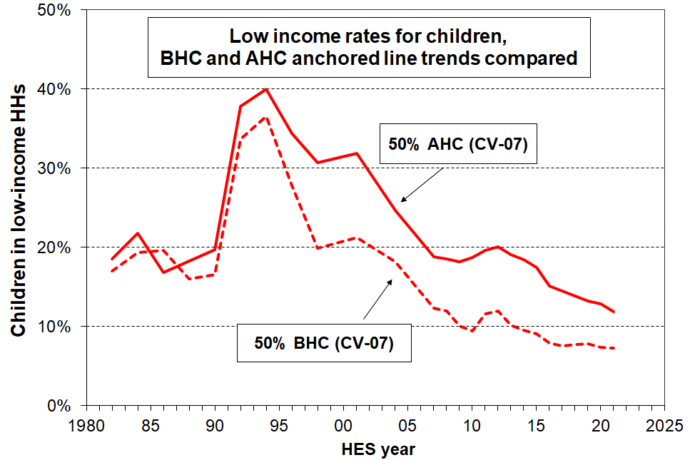The doubling of the 50% AHC CV-07 poverty rate from the late 1980s to the early 1990s reflects the large decrease in AHC incomes of low-income households with children in that period, as discussed above. By around 2007 the AHC low-income rates were similar to those in the 1980s which indicates that in 2007 the AHC incomes of low-income households with children were around the same in real inflation-adjusted terms as in the 1980s, and higher than in the early 1990s. The further net decline in rates to 2021 indicates that the AHC incomes of low-income households with children were higher in real inflation-adjusted terms at that time than they were in 2007.

The BHC CV-07 trend also shows a large fall from the early 1990s peak through to 2021, but with lower rates throughout.

The difference in trajectory for AHC and BHC low-income anchored-line rates for children reflects the fact that since the early 1990s housing costs have taken a much larger proportion of household income than in the 1980s for low-income households, typically 40-50% rather than 20-25% (see **Section I**). BHC household incomes for low-income households were higher in real terms than in the 1980s from around 2004 through to 2021, but the higher proportion of the household income taken up on housing costs means that AHC incomes for low-income households did not go above 1980s levels until around 2015, despite the real increase in BHC incomes.

**Low-income rates by household type**

**Figures G.2** and **G.3** show theAHC low-income (poverty) rates for children for the four decades from 1981-82 to 2020-21 using an anchored or constant value measure (AHC 50, with 2007 as the reference year) and the AHC 50 fully relative or ‘moving line’ measures respectively. See pages 108-109 above and page 155 in Section M for more information on the two approaches.

The low-income rates for sole-parent households are generally much higher than for two-parent households, though from around 2018 the gap has been closing on the anchored line approach.

**Figure G.2**

**AHC 50 CV-07 anchored line low-income rates for households with children, 1982 to 2021**

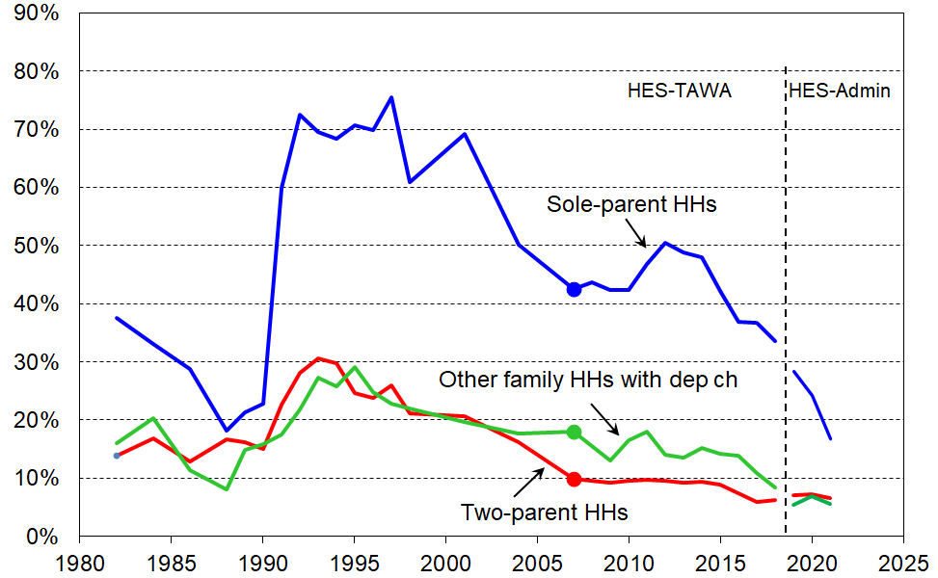**(reference year is 2007)**

**Figure G.3**

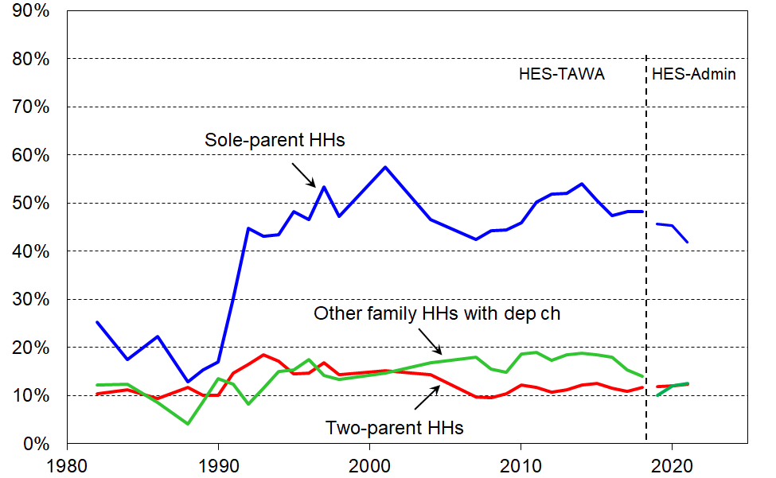**AHC 50 relative / moving line low-income rates for households with children, 1982 to 2021**

Most children live in two-parent households (~70%), with 15% in sole-parent households and 15% in other multi-adult households.[68] This means that when looking at the composition of children in low-income households the two-parent v sole-parent numbers are much closer than the very different rates might suggest. On average over the three most recent surveys (HES 2018-19, 2019-20, and 2020-21), of all children in low-income households (using AHC 50), 50% come from two-parent households, 38% from sole-parent households and 11% from other family households. (See also Table B.3a.)

**Low-income rates by household work intensity**

**Figure G.4** shows the smoothed trend in low-income AHC 60 rates for children in households with different paid work intensity and numbers of adults. The Working for Families reforms lowered the low-income rates markedly for one earner households but their low-income rates have risen since as their incomes did not rise as quickly as the median. On the other hand the households with two or more earners did have their incomes rise quickly enough to keep up with the median growth and the trend for their low-income rate remained flat (blue line).

**Figure G.4**

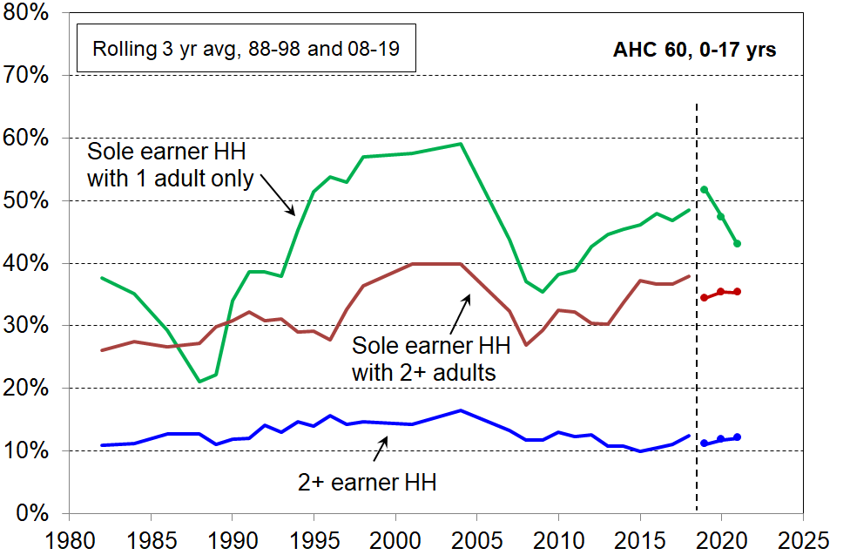**Low-income trends for 0-17s in sole-earner and two-earner households, AHC 60 relative**

Note for table: the AHC 60 low-income measure is used to ensure there are enough numbers in the relatively small sole earner one adult households.

[*The following text and chart are repeated from Section F as they are relevant to this section too.*]

Around 70% of all children live in two-parent households. Median household income is strongly impacted by the incomes of these households. **Figure G.5** shows the trend to increasing work intensity among two-parent households with dependent children.

* The option of one partner in full-time paid employment and one not in paid employment (‘workless’) was the dominant pattern in the early 1980s. By the early 2000’s, the most common arrangement was for both parents to be employed full-time (~38%), and in 2021 the figure for this arrangement had reached almost one in two (49%).
* Around three of every four two-parent families were dual-earner families in 2021, up from one in two in the early 1980s.
* This increasing proportion of dual-earner two-parent households is a major factor behind the longer-run steady rise in material wellbeing for the vast majority of children, as indicated for example in **Figure F.10** and **F.11.** It also points to / is consistent with the view that in general, single-earner households are now much less likely to be a viable option for providing economic security than they were 30 to 40 years ago.

**Figure G.5**

**Increasing proportion of two-earner two-parent households, 1982 to 2021**

**Low-income rates by ethnic grouping**

For most of the HES years prior to 2018-19 the sample size is too small to provide robust estimates for smaller ethnic groupings. Even in the largest sample (2018-19) the sample error is 2.1 ppt for the AHC 50 numbers for children in the Māori ethnic grouping, and 3.4 ppt for Pacific and Asian. (This means that an estimate of 24% AHC 50 for Māori in 2018-19 has a 95% confidence interval (CI) of around 22% to 26%, and a much larger CI than that for earlier years). To partially address the issues arising from the relatively small sample sizes for the ethnic groupings other than European, **Figure G.6** plots the smoothed trend lines using rolling two-year averages up to and including 2017-18. This allows the trend for Māori to be reported. The chartshows the AHC 50 low-income trends for all children and for children in the Māori ethnic grouping, using both relative and anchored line measures with the anchor or reference year being 2007.

**Figure G.6**

**Low-income rates for all children / ethnicities and children in the Māori ethnic grouping (%),**

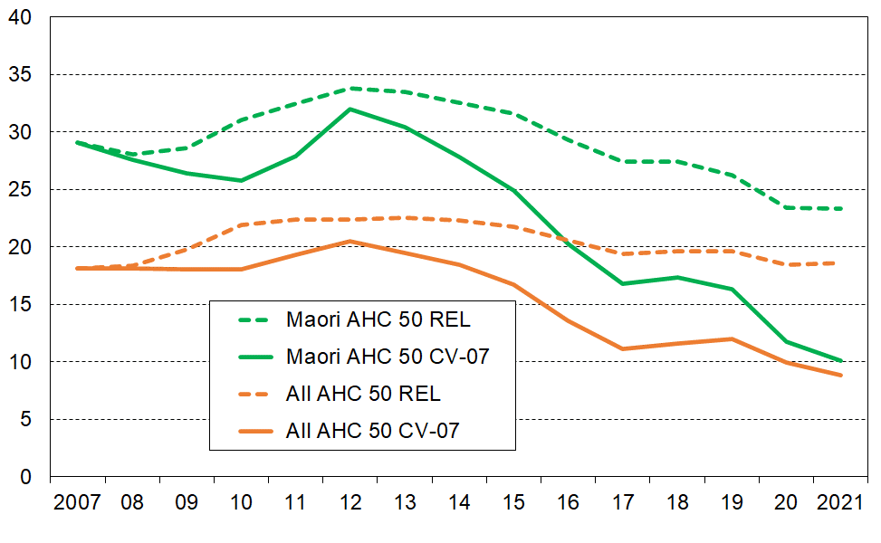**AHC 50 relative and anchored lines, 2007 to 2021, (total ethnicity approach)**

The Pacific and Asian groupings are too small to allow construction of robust trend lines. **Table G.1** groups three surveys together and shows the trend in the average of these clumped figures for the earlier years, then each year for the larger HES-Admin survey years. There has been a strong improvement in the low-income anchored line rates (AHC CV-07) for each ethnic group from the pre-GFC rates in 2007 to 2009, just as there was for material hardship rates (see Table F.1). Each group saw an increase through the GFC then a fall through to 2021 on this anchored line measure. This reflects the fact that real incomes at the lower end improved in real CPI-adjusted terms.

On the AHC 50 REL or moving line measure, the net improvements from the pre-GFC period have been more muted except for the Asian group which saw a reduction from 29% to 20%. This reflects the fact that low incomes generally maintained reasonable relativity with the median.

**Table G.1**

**Low-income rates for children by ethnic grouping (total ethnicity approach),**

**AHC 50 relative and anchored lines, 2007 to 2021 (three-year groupings to 2017-18)**

|  |  |  |  |  |  |  |  |  |  |
| --- | --- | --- | --- | --- | --- | --- | --- | --- | --- |
|  |  | **Low-income rates (%)** | | | | | | | **Total Numbers** |
|  |  | **2007-2009** | **2010-2012** | **2013-2015** | **2016-2018** | **2019** | **2020** | **2021** | **2021** |
| **AHC 50 REL** | **Māori** | 29 | 33 | 32 | 27 | 24 | 23 | 24 | 290,000 |
| **Pacific** | 25 | 35 | 33 | 31 | 24 | 24 | 22 | 140,000 |
| **European** | 14 | 16 | 16 | 14 | 14 | 14 | 16 | 730,000 |
| **Asian** | 29 | 23 | 24 | 20 | 21 | 23 | 20 | 200,000 |
| **ALL** | 19 | 23 | 22 | 19 | 19 | 18 | 19 | 1,400,000 |
| **AHC 50 CV-07** | **Māori** | 27 | 30 | 26 | 17 | 13 | 10 | 10 | 290,000 |
| **Pacific** | 23 | 27 | 25 | 16 | 11 | 10 | 8 | 140,000 |
| **European** | 13 | 14 | 12 | 9 | 8 | 7 | 7 | 730,000 |
| **Asian** | 27 | 20 | 19 | 11 | 14 | 14 | 11 | 200,000 |
| **ALL** | 18 | 20 | 17 | 11 | 11 | 9 | 8 | 1,400,000 |

Notes for Table G.1:

* There are 40,000 in the ‘Other’ category – this row is suppressed as the numbers are too small to reliably report on low-income rates. For 2021, the sampling error for this group was of the order of 11 ppt on a low-income AHC 50 REL point estimate of around 50%.
* See Section B (p35 under TableB.1b) for discussion of the counting approach used for ‘total ethnicity’

**Median AHC incomes for households with children, by household type and children’s ethnicity**

**Figure G.7** shows the rising trend in ‘real’ CPI-adjusted median incomes after deducting housing costs (AHC) for households with children and for couple-only (<65) households for comparison.

* Incomes for two-parent households generally track much the same as the overall population median, other multi-adult family households with children a little lower, and sole-parent households much lower, albeit on the rise in real terms.
* AHC incomes for sole-parent households have tracked at around 50% of the median since the 1991 benefit cuts. The actual dollar gap between sole-parent household incomes and the median has increased in real terms in the period.

**Figure G.7**

**Median incomes (equivalised AHC) of selected household types ($2021), 1982 to 2021**

**Figure G.8** reports median AHC household income for children by ethnicity in real (CPI-adjusted) terms. There have been solid net gains in real terms since 2007 for children in each of the main ethnic groups, albeit with different trajectories through and immediately after the GFC (around a 35% real (CPI-adjusted) gain for all four groups since 2007).

**Figure G.8**

 **Median AHC household incomes for children, by (total) ethnicity ($2021), HES 2007 to 2021**

The rising trends shown in the two charts above are part of the explanation as to why the vast majority of New Zealand households with children report experiencing steadily rising material living standards since the mid-1990s (see **Figures F.10** and **F.11** above).

**Income of households in receipt of main benefits**

Children in beneficiary households typically make up around half of children in low-income households (using the CPRA low-income measures) and around half those in households reporting material hardship. Trends in the incomes of beneficiary households with children are therefore highly relevant for understanding the New Zealand child poverty story.

**Figures G.9 and G.10** below show the long-run trends in (core) beneficiary household income from two perspectives for selected benefit types:

* in real inflation-adjusted terms
* relative to the after-tax average wage.

In this analysis, beneficiary income includes core benefits plus Family Tax Credit and its predecessors (Family Benefit / Support). The income is net income (ie after tax). It does not include the Winter Energy Payment, Best Start or the Accommodation Supplement.

The time series goes from 1 April 1947 to 1 April 2022, and includes the changes announced in Budget 21. In 2022, this core beneficiary income for sole parent households with children (<12) is higher in real terms for the first time since the 1991 benefit cuts.

The information shown in the charts that follow has sometimes been used to support views about the adequacy or inadequacy of beneficiary incomes. There are several factors to bear in mind when making such an assessment based only on the chart information:

* Some of the non-included payments noted above have played an increasing role in the income support system.
* Even though 2021 or 2022 levels are back above the pre-1991-benefit-cut levels for beneficiary households with children, this in itself supports an ‘adequacy’ assessment for before-deducting-housing-costs (BHC) incomes only if the pre-cut incomes were considered adequate.
* The increases in housing costs as a proportion of income for low-income households in recent years means that ‘residual’ or ‘after-housing-costs-are-deducted’ (AHC) income has not in recent years risen as much as (BHC) income, and in some particular cases may have fallen.
* Any assessment of adequacy, whether for beneficiary or working households, needs to be clear about what assumptions are being made about housing costs, health / medical / disability-related costs, debt servicing costs and the stock of household appliances and furniture. What can be reasonably claimed as adequate income for households whose housing costs are ‘average’ and the other costs are ‘low’ is unlikely to be adequate when these assumptions are not met.
* The inflation-adjustment used in Figure G.9 is the all-groups CPI. The cost of living changes for beneficiaries are not necessarily well-represented by the CPI as beneficiary households and low-income households in general typically have a different expenditure bundle than the average household. Stats NZ has developed an inflation adjuster for different groups (the household living-costs price index (HLPI)), one of which is for low-income households. This HLPI goes back only to 2008. For the longer-term series in Figure G.7 the CPI therefore had to be used. It is a reasonable first order approximation, but it doesn’t support precise comparisons especially over the long haul, say, the 1960s to 2021.

**Figure G.9** shows the long-run trends (1947 to 2022) in inflation-adjusted (‘real’) base support for the most common beneficiary households / families:

* The incomes include benefit income and income from the Family Tax Credit and its predecessors, but exclude the Winter Energy Payment, Best Start and the Accommodation Supplement (AS).
* Incomes from the two sources noted have recently risen to be above the rates prior to the 1991 benefit cuts – for the first time since then.

**Figure G.9**

**Source:** MSD collation from information from the Royal Commission on Social Security, Department of Social Welfare Annual Reports, Income Support Service / Work and Income Fact Sheets and Budget 2022.

**Some key dates**

1946 Universal Family Benefit

1972 Royal Commission on Social Security

1991 Benefit cuts

2004-05 Working for Families

2016 Child Material Hardship Package

2018 Families Package

2020 $25 increase (April)

2020 Indexation to average wage commences (Apr)

2021 $20 pw increase (July)

2022 WEAG plus $15 pw for families with children (Apr)

**Figure G.10** compares core beneficiary income and NZ Superannuation (NZS) rates with the average wage (after tax).

* The DPB/SPS trends include the WFF income. From the late 1980s through to 2019 there was a steady decline in their core incomes compared with the average wage, albeit with a short-run reversal for sole parents when WFF was introduced in 2004-05. From 2020 to 2022 beneficiary incomes for sole parent households improved relative to the average wage.
* The NZS ‘married couple’ rate has for some time been at 66% of the net average wage, and the ‘single-living-alone (SLA)’ rate at 43% (65% of the ‘married couple’ rate). This compares with around 50% for a UB/JSS couple and 30% for a UB/JSS single in 2022.

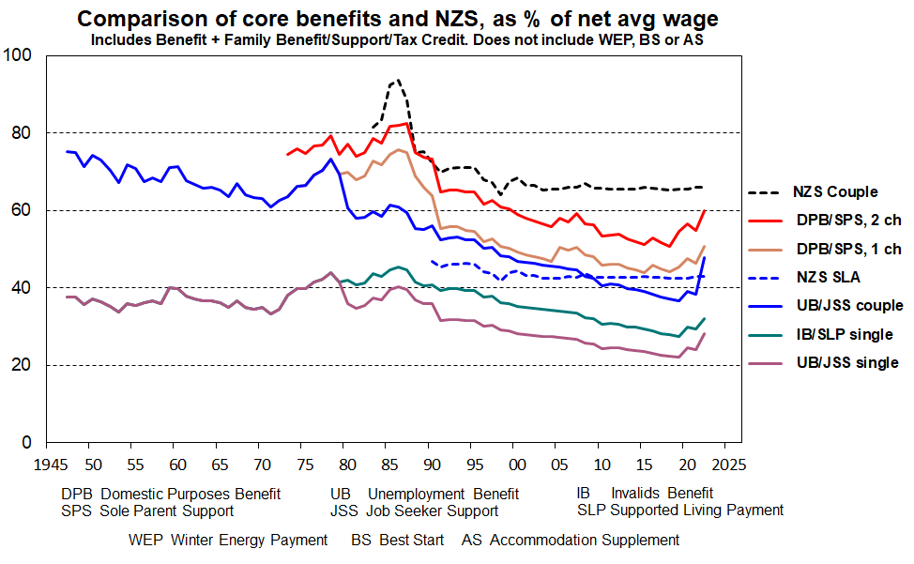**Figure G.10**

**Source:** MSD collation from information from the Royal Commission on Social Security, Department of Social Welfare Annual Reports, Income Support Service / Work and Income Fact Sheets and Budget 2021.

**Some key dates**

1946 Universal Family Benefit

1972 Royal Commission on Social Security

1991 Benefit cuts

2004-05 Working for Families

2016 Child Material Hardship Package

2018 Families Package

2020 $25 increase (April)

2020 Indexation to average wage commences (Apr)

2021 $20 pw increase (July)

2022 WEAG plus $15 pw for families with children (Apr)

**Figures G.9 and G.10 provide valuable information but do not / cannot tell the full story**

* While Figures G.9 and G.10 provide valuable information about key aspects of the trends in income of selected beneficiary recipients they do not tell the full story. In particular, they do not take account of either accommodation costs or the housing support provided through the Accommodation Supplement (AS) since 1993 or the Income-Related Rent subsidy (IRRS) for those in public housing (from 2000). The Temporary Additional Support (TAS) assistance can also have significant impact on the level of housing support for some.
* Net housing costs depend on both the level of housing costs and the entitlement to different housing subsidies. The subsidies are provided at different levels depending on geographical area, household income, and other factors. Given the wide variations in housing costs and subsidy amounts there are considerable challenges for producing a full ‘after housing costs and housing support’ time series using the example families approach as in Figures G.9 and G.10 above.
* Recent analysis by MSD using actual beneficiary income and housing costs data is now available in the Total Incomes Report. This information is used in **Figure G.11** (next page).

**Figure G.11** shows the percentage change in total income for all MSD clients (for all family types, equivalised) compared to growth in the CPI between 2006 and 2022. Income in this chart includes income from all sources including the WEP, BS and AS (see previous page for acronym glossary under Figure G.10).

The blips in the trend lines reflect the WEP which applies for 22 weeks from May to September each year. Removing the blips / following the trend between blips gives an idea of the trend without the WEP.

* Total income before deducting housing costs (BHC) generally tracked a little above inflation up to around March 2018, then increased strongly to 2022. See blue lines in chart.
* Total income after deducting housing costs (AHC) generally tracked in-line with inflation (excluding housing) up to around March 2018. Since then AHC incomes have increased strongly in real terms.

**Figure G.11**

**Change in total incomes (BHC and AHC) for beneficiary units, 2006 to 2022**

Source: MSD Working Paper: Total incomes of MSD main benefit clients as at April 2022. [wp-total-incomes-of-msd-main-benefit-clients-as-at-april-2022.pdf](https://www.msd.govt.nz/documents/about-msd-and-our-work/publications-resources/working-papers/wp-total-incomes-of-msd-main-benefit-clients-as-at-april-2022.pdf)

* As noted in the Total Incomes Report in the link below the chart, this analysis has to impute housing costs for around 20% of beneficiaries whose housing costs are unknown as they do not receive AS, IRRS or TAS.

**Low-income persistence**

It is well-established that it is the experience of living in a household with persistently low income (rather than ‘just’ very short-term low income) that increases the chances of poor outcomes for children in their childhood and in later adult life. Information about the degree of low-income persistence, the patterns of movement into and out of low income, and of income mobility more generally across the full income spectrum is important for a fuller understanding of the nature and extent of poverty among children.

The bulk of the findings in this report are based on the cross-sectional information available in Stats NZ’s Household Economic Survey (HES) – for each survey a different sample of households is selected and different individuals are interviewed each time. Longitudinal data is needed to produce information about low-income persistence and income dynamics / mobility – here, the same individuals are followed from one wave of the survey to the next.

Stats NZ’s Survey of Family, Income and Employment (SoFIE) which ran from 2002-03 to 2008-09 is the latest national longitudinal survey that New Zealand has. Interviews for the first wave of Stats NZ’s new longitudinal survey, *Living in Aotearoa*, began in April 2022. This short sub-section is a placeholder on persistence in the interim while the waves build up.[69]

**Three approaches to conceptualising and measuring low-income persistence**

* Looking at the whole population of interest and reporting the proportions in poverty in selected numbers of waves in a given window.
* Looking only at those in poverty in a given wave and reporting the proportions of this group who were in a selected number of immediately previous or future waves.
* Chronic low-income as a measure of persistence: on this approach, being in persistent low income means living in a household whose average income over N years is lower than the average of the poverty threshold over the same period. One of the advantages of this approach is that it addresses the issue of households that have incomes that fluctuate in a band just below and just above the poverty line being used – such minor fluctuations are counted as ‘mobility’ or ‘moving in or out of poverty’ and this can create an overly optimistic view of the ability of mobility to resolve low-income issues.

**Figure G.12** shows the trend in persistent low income in the UK over the period from 2020-11 to 2017-18 using the first approach. Persistence is defined as being in poverty in three or four of the last four interviews (including the current one). The low-income measure is BHC 60 and the data is from the very large longitudinal *Understanding Society* survey run by the Institute for Social and Economic Research at the University of Essex (40,000 households in wave one). The somewhat startling finding is the flatness of the trend which indicates essentially ‘no change’ in persistence in the period.

**Figure G.12**

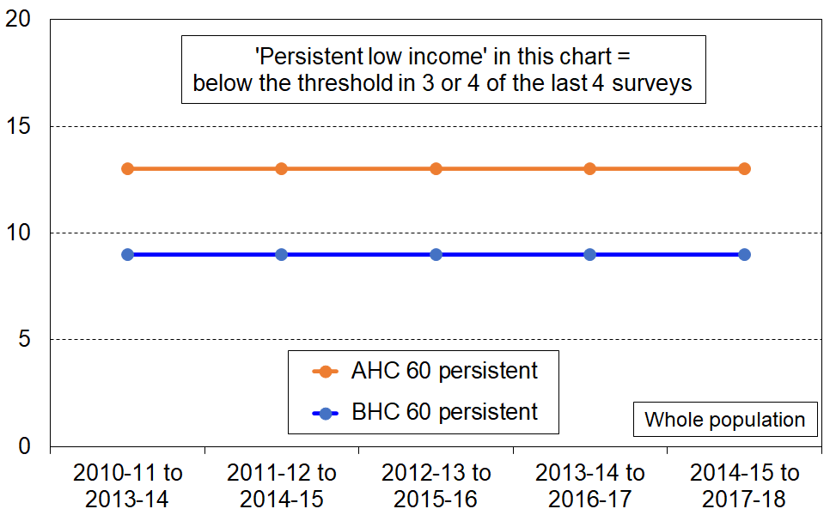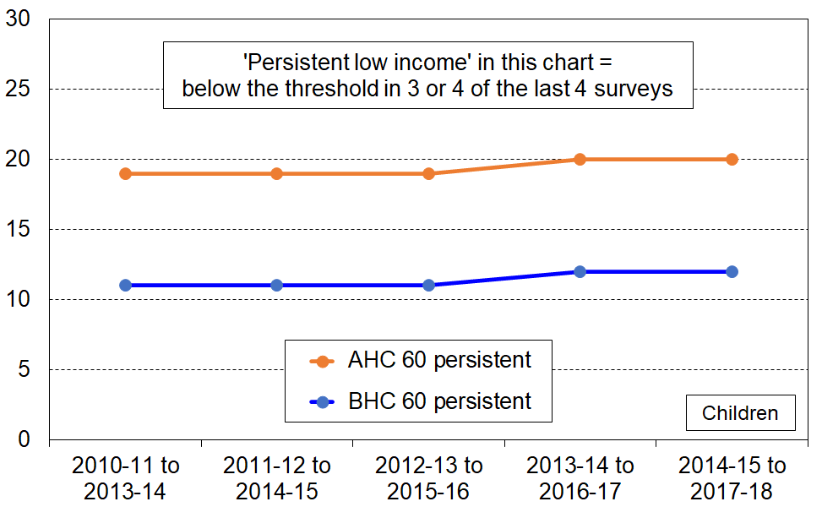**UK trends in persistent low income (BHC 60) for the whole population (LH chart) and children (RH chart)**

Source: UK Department for Work and Pensions (2020), available at [Income Dynamics: Income movements and the persistence of low incomes, 2010 to 2018 (revised sept 2020) (publishing.service.gov.uk)](https://assets.publishing.service.gov.uk/government/uploads/system/uploads/attachment_data/file/917304/income-dynamics-income-movements-and-persistence-of-low-incomes-2010-18-revised-sept-2020.pdf)

**Figure G.13** uses the second approach in which the starting point is the group currently in poverty. Those in persistent poverty are those in poverty in the current interview who were also in poverty in two or three of the immediately preceding three surveys. The low-income measure is BHC 60 and the data is from Eurostat’s EU-SILC survey. The chart is only for the whole population as the samples are generally too small to give a robust trend for children.

Compared with the first approach (Figure G.12 above), the second more focussed approach shows some changes in the persistence rate over time, but these changes year-on-year are likely to be less than the sample error on the change, even for the whole population.

A feature of this definition of persistence (which is the official EU definition) is that across EU countries there is a reasonably linear relationship between BHC 60 low-income rates and BHC 60 persistent low income rates in a given year, with the persistence rates mostly falling within 60 to 70% of the cross-sectional rate. Countries rank in a very similar way on both cross-sectional and persistence measures of low-income (ie high correlation). This phenomenon is discussed in detail in **Section P** of this report. For Belgium the persistence rate is 64% of the cross-sectional rate on average over the 8 years, and 67% for Ireland, with the proportion for any given year staying within the 60-70% band.

**Figure G.13**

**Trends in low income and persistent low income (BHC 60) for the whole population**

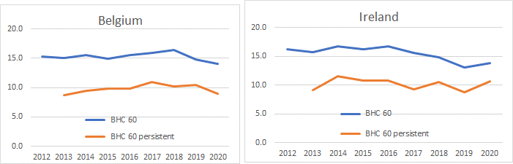**for Belgium and Ireland, 2012 to 2020, EU-SILC and Eurostat definition of persistence**

An example of the chronic poverty approach is reported in Section L of the 2019 Household Incomes Report, based on analysis of SoFIE data. Key points from that analysis are:

* The chronic poverty rate is around 80% of the current rate in a given wave.
* Those in chronic poverty do not however form a subset of those in current poverty in a given wave. For children, out of every 100 in current poverty at any time:
  + 60 are also in chronic poverty, and in addition another 20 not in current poverty are in chronic poverty.
  + The 40 who are in current poverty but not chronic poverty form part of the group with more transient experiences of poverty.

**Section H**

**Placeholder for a section on ‘Food insecurity’ in next edition**

**Section I**

**Housing affordability for children and their households – renters and owners**

This Section on housing affordability focuses on those already in their own homes or renting. It does not look at affordability from the perspective of those in the market seeking to purchase a property.

High outgoings for housing costs relative to income are often associated with financial stress for low- to middle-income households. Low-income households especially can be left with insufficient income to meet other basic needs such as food, clothing, basic household operations, transport, medical care and education for household members.

There is no internationally agreed measure of housing (un)affordability but the general idea of a ratio of housing costs outgoings to income is widely used. The ratio is called OTI for short (outgoings-to-income ratio).**[70]** There are two main sets of decisions to make when deciding on and implementing an OTI measure:

* What to include in the measurement of housing costs and whether to use gross housing costs or net housing costs after offsetting gross with any housing support
* Which low-to-middle-income households? What OTI threshold?

**Table I.1** shows the different definitions of housing costs and treatment of housing support used by selected sources in New Zealand and internationally.

**Table I.1**

**Components of housing costs included in affordability analysis by selected sources**

|  |  |  |  |  |  |  |  |
| --- | --- | --- | --- | --- | --- | --- | --- |
|  | **Housing cost components (primary dwelling only or others too?)** | | | | | | **Treatment of housing support** |
|  | **Rent** | **Mortgage Principal** | **Mortgage Interest** | **Rates** | **Building Insurance** | **Utilities for water, electricity, gas, etc** |
| **Eurostat** | ✓ | - | ✓ | ✓ | ✓ | ✓ | Deducted from HC |
| **OECD ‘short’** | ✓ | ✓ | ✓ | - | - | - | Included in income |
| **OECD ‘total’** | ✓ | ✓ | ✓ | ✓ | ✓ | ✓ | Included in income |
| **HBAI (UK)** | ✓ | - | ✓ | ✓ | ✓ | ✓ | Included in income |
| **Australia (ABS)** | ✓ | ✓ | ✓ | ✓ | ✓ | - | Included in income |
| **Stats NZ from 2007** | ✓ | ✓ | ✓ | ✓ | ✓ | - | Included in income |
| **MSD reports** | ✓ | ✓ | ✓ | ✓ | ✓ | - | Included in income |

An OTI threshold of 30% is commonly used, though some use 40%. Whatever OTI threshold is used the issue of housing affordability is clearly more demanding for low-to-middle income households than for higher-income households. Using, say, a 30% or 40% threshold and applying it to households of all incomes gives a misleading indication of the size of any unaffordable housing issue: it inflates the assessment by including households clearly not in housing stress. It is also disrespectful to those in real housing affordability stress to be grouped with higher income households who have plenty left after paying for their accommodation.[71]

Australia use the 30:40 indicator for measuring housing affordability stress:

*‘The 30:40 indicator identifies households as being in housing affordability stress when the household has an income level in the bottom 40 per cent of Australia's income distribution and is paying more than 30 per cent of its income in housing costs. The underlying assumption is that*[*those on higher incomes who pay more than 30 percent of their income for housing do so as a choice*](http://ec2-13-238-222-5.ap-southeast-2.compute.amazonaws.com/research/final-reports/105)*and that such housing costs have little or no impact on the household's ability to buy life's necessities (such as food, health care, education etc.).*’ [72]

The EU’s Housing Cost Overburden measure uses a 40% threshold. As shown in Table I.1 above they have a wider definition of housing costs than Australia and New Zealand use, and also use net housing costs in the numerator of the ratio. See Perry (2021c) for New Zealand comparisons using the EU definition.

**The measure used in this section**

This section uses a simple OTI ratio of gross housing costs to household disposable income, the same measure used by Stats NZ.[73] Housing costs are taken as rates, dwelling insurance, mortgage payments (principal and interest) and rent. Housing support is included in income.[74] Trends are reported using OTI thresholds of 30%, 40% and 50%, especially for low-income households (the lower two quintiles, Q1 and Q2). There is a special focus on households in private rental accommodation.

The figures and trends are national average figures for households with children. Sometimes the households are counted and sometimes the children are counted. **Table I.3** on the next page provides the detail of how many children are in each quintile for the different ways of creating quintiles (ranking households or ranking individuals using their household income).

The OTI measure has its limitations. For example, a household may have a low OTI simply because it is in poor quality (‘cheap’) or overcrowded accommodation. A low OTI on its own does not always signal that the household is in ‘good’ housing. There may also be (potential) housing stress which remains unseen – for example, adult children living with parents not by choice but by necessity. It nevertheless is a useful metric as part of a suite of ‘decent housing’ measures.

**Impact on OTIs of the presence of very-low-income (VLI) households and of the treatment used in the report**

OTI housing unaffordability figures are sensitive to the presence of the relatively high number of very-low-income households (VLIs) in the HES-Admin data, as shown in **Table I.2** below.[75]

The Current CPRIs row is from the 2022 Child Poverty Related Indicators publication,[76] with the figures provided by Stats NZ with no special treatment for VLIs.[77] The MSD row applies the treatment described in this report. The VLI matter is of no great consequence when looking at all children, but those numbers are not suitable for a housing stress measure, as discussed above. Looking at low-income households with children (Q1), the VLI issue has a significant inflationary impact on the estimation of the proportion of children in households experiencing housing stress. VLI households are by definition at the very low end of Q1, and as they have ‘normal’ housing costs they will inevitably have very high OTIs.[78]

**Table I.2**

**Housing cost OTIs for all children in their households and for two low-income groups (Q1 and Q1+Q2): Comparison of DPMC/Stats NZ and MSD rates for 2020-21 (%)**

|  |  |  |  |  |  |  |  |  |  |
| --- | --- | --- | --- | --- | --- | --- | --- | --- | --- |
|  | **All** | | | **Q1** | | | **Q1+Q2** | | |
|  | **> 30%** | **> 40%** | **> 50%** | **> 30%** | **> 40%** | **> 50%** | **> 30%** | **> 40%** | **> 50%** |
| **Current CPRIs (DPMC / Stats NZ)** | 34 | 18 | 10 | 60 | 48 | 35 | - | - | - |
| **MSD, with treatment for very-low-income HHs (VLIs)** | 33 | 17 | 9 | 48 | 36 | 24 | 45 | 27 | 15 |

Note for table:

The income quintiles are whole population quintiles, based on the ranking of all individuals by their households’ disposable incomes (incomes from all sources, after taxes and transfers, and including the AS). See **Table I.3** for the distribution of children and households with children across population quintiles.

**Applying the 30:40 indicator (as used in Australia)**

The MSD row inTable I.2 reports a housing unaffordability rate of 45% for children in low-income households (Q1+Q2) when using a 30% OTI threshold. **Table I.3a** shows that 48% of children are in households in the lower two population income quintiles when ranking is done on individuals, as it is in Table I.2. That means that around 22% of all children (0.45 x 48%) are in unaffordable housing on this measure.

If low-income is limited to the lowest income quintile (Q1) rather than Q1+Q2, then around 11% of children would be considered to be in unaffordable housing (0.48 x 22%).

**Table I.3a**

**Distribution of individuals by the BHC equivalised income of their households (quintiles on individuals):**

**Whole population and children, % across, HES 2018-19 to 2020-21**

|  |  |  |  |  |  |  |  |
| --- | --- | --- | --- | --- | --- | --- | --- |
|  | **Q1 (low)** | **Q2** | **Q3** | **Q4** | **Q5** | **ALL** | **#s** |
| **All individuals** | 20 | 20 | 20 | 20 | 20 | 100 | 4,814,000 |
| **(All households)** | 24 | 18 | 18 | 20 | 20 | 100 | 1,762,000 |
| **Children (0-17 yrs)** | 22 | 26 | 22 | 16 | 14 | 100 | 1,111,000 |
| **(All households with children)** | 19 | 24 | 23 | 19 | 16 | 100 | 596,000 |

**Table I.3b**

**Distribution of households by their BHC equivalised income (quintiles on households):**

**All households and households with children by selected tenures, % across, HES 2018-19 to 2020-21**

|  |  |  |  |  |  |  |  |
| --- | --- | --- | --- | --- | --- | --- | --- |
|  | **Q1 (low)** | **Q2** | **Q3** | **Q4** | **Q5** | **ALL** | **#s** |
| **All households** | 20 | 20 | 20 | 20 | 20 | 100 | 1,762,000 |
| **Households with children** | 16 | 24 | 25 | 19 | 15 | 100 | 596,000 |
| **Households with children - private rent (no AS)** | 12 | 26 | 32 | 20 | 9 | 100 | 102,000 |
| **Households with children - private rent (with AS)** | 27 | 42 | 22 | 7 | - | 100 | 91,000 |
| **Households with children - public** | 58 | 28 | 12 | - | - | 100 | 33,000 |

Note: cells <=1.5% are masked

**Table I.4** shows the number and proportions of children and households with children by tenure on average over the latest three HES years, 2018-19, 2019-20 and 2020-21. The bulk are in owner-occupier homes (just under 60%); those in private rentals are divided fairly evenly between those receiving AS support and those not doing so.

**Table I.4**

**Numbers and proportions (%) of children and households with children by tenure:**

**Average across HES 2018-19 to 2020-21**

|  |  |  |  |  |  |  |
| --- | --- | --- | --- | --- | --- | --- |
|  | **Owned incl Family Trust** | **Rent (private) no AS** | **Rent (private) with AS** | **Rent (public)** | **Other** | **ALL** |
| **Households with children (numbers)** | 357,000 | 106,000 | 91,000 | 31,000 | 19,000 | 605,000 |
| **Children (numbers)** | 659,000 | 191,000 | 182,000 | 75,000 | 35,000 | 1,142,000 |
| **Households with children (% across)** | 59 | 18 | 15 | 5 | 3 | 100 |
| **Children (% across)** | 58 | 17 | 16 | 7 | 3 | 100 |

**Long-run trends in OTIs for households with children (all and those in Q1)**

**Figure I.1** reports on trends for all households with children in all tenures. While this information does not help with assessing the proportion of children in unaffordable housing it is nevertheless of value in monitoring trends overall and noting significant changes.

**Figure I.1**

**Spending on accommodation as a proportion of income (%) for**

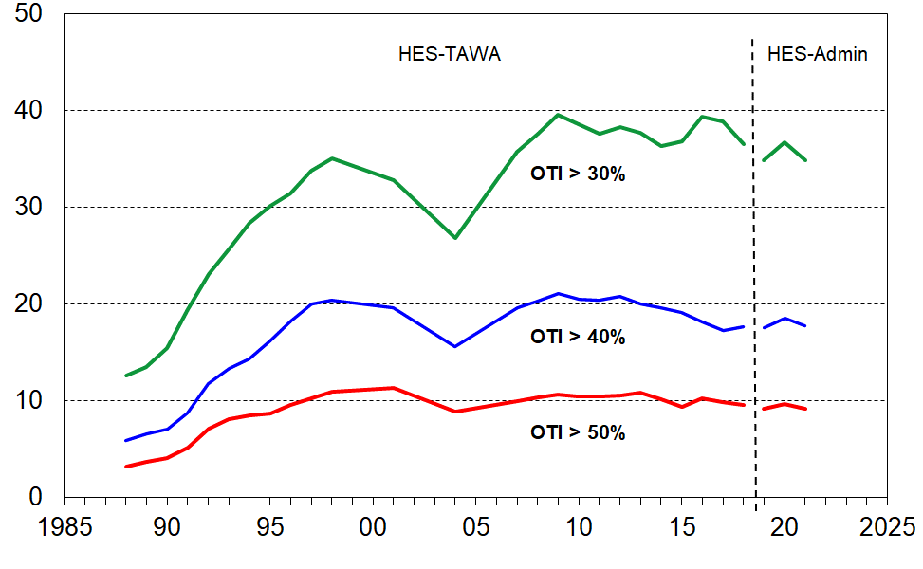 **all households with children, using OTIs, 1988 to 2021**

**Figure I.2** focuses on the housing unaffordability trends for low-income households with children (Q1). Just over half (52%) spend more than 30% of their income on accommodation costs, 40% spend more than 40%, and close on one in three spend more than half their income on accommodation costs.

The numbers here are for households with children and are a little different from those in Table I.2 above which count the children themselves. Table I.6 at the end of this Section provides comprehensive OTI information for all income quintiles and for the Q1+Q2 low-income group.

**Figure I.2**

**Spending on accommodation as a proportion of income (%) for**

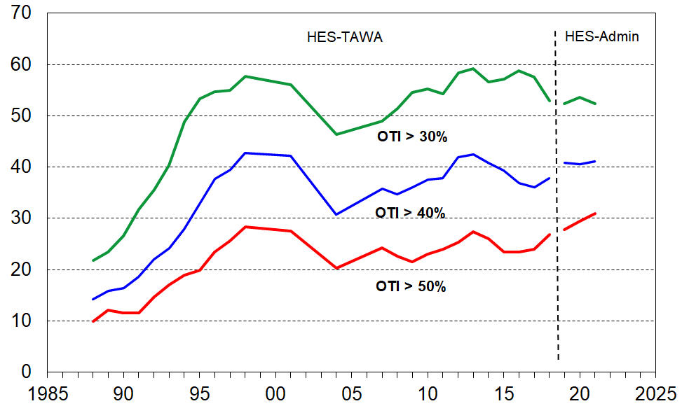**low-income (Q1) households with children, using OTIs, 1988 to 2021**

**Spending on accommodation for households with children living in private rentals, with and without AS support**

There is particular public policy interest in households with children living in private rental accommodation, especially those in receipt of housing support through the Accommodation Supplement (AS). Around one in three children live in these households, split fairly evenly between those receiving the AS and those not (see Table I.4 above). The material hardship rate for children in households renting privately and receiving AS support is high (28% compared with 11% for all children in the 2020-21 HES) [79] and the bulk have BHC household incomes in the lower two population quintiles (Q1 and Q2).

**Figure I.4** shows that in recent years around 40% of households with children (with AS support) were spending more than 40% of their income on accommodation. This is back to where it was as the GFC impact was beginning in 2008 and 2009, and down from the higher levels in the post-GFC downturn (close to 50%). These high levels of housing unaffordability for this group go a long way to explaining their high material hardship levels.

Those in private rentals but not receiving the AS had lower greater-than-40% OTIs (19% on average over 2018-19 to 2020-21), bringing the overall greater-than-40% figure down to just under 30% for households with children in private rentals.

**Figure I.4**

**Spending on accommodation as a proportion of income (%) for**

**households with children renting privately, using the OTI > 40% threshold, 2007 to 2021:**

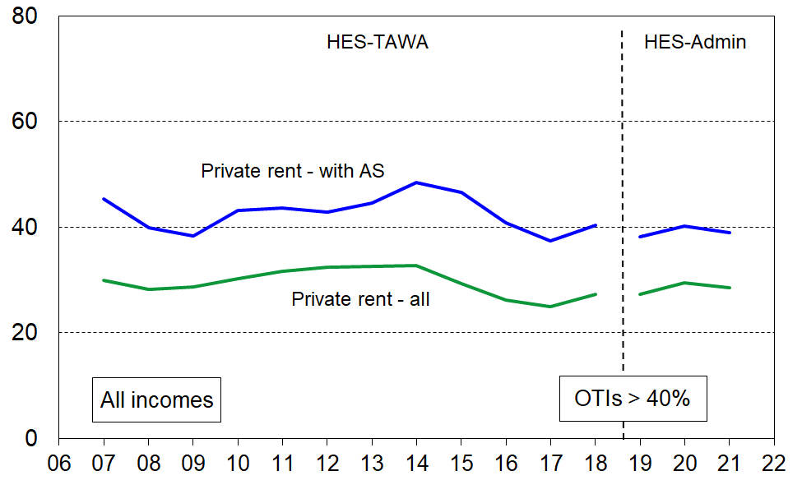**all these households and those receiving AS support**

Even though the bulk of households with children in private rentals (with AS) are in the lower two income quintiles (Q1 and Q2), not all are. **Fig I.5** focuses on those in the lower income quintiles, removing the diluting impact of the higher-income households.

**Figure I.5**

**Spending on accommodation as a proportion of income (%) for low-income**

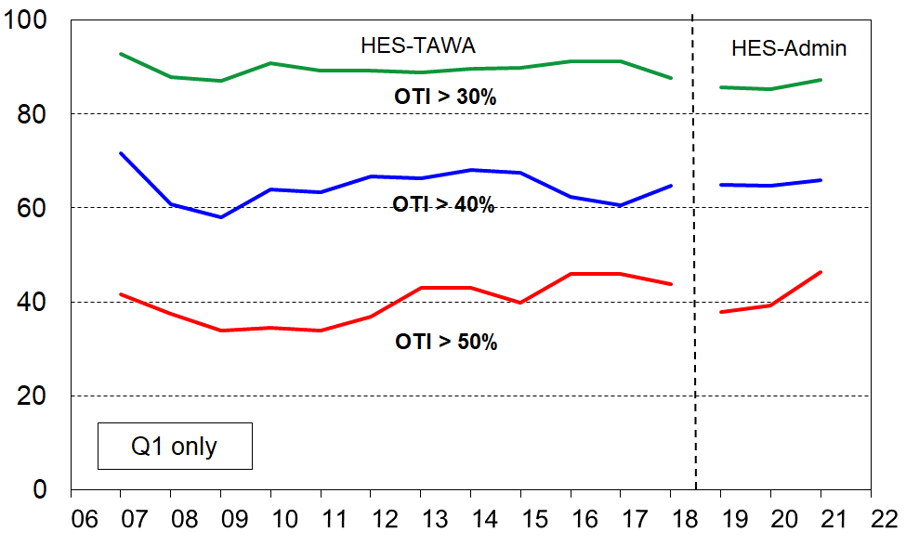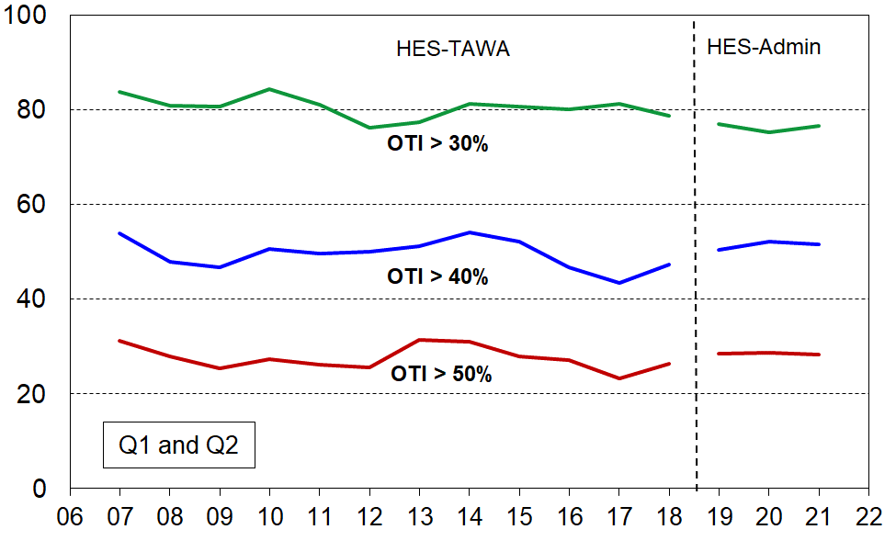 **households with children (Q1 and Q1+Q2), renting privately and receiving the AS, 2007 to 2021**

Note: AS = Accommodation Supplement and OTI = (housing costs) outgoings-to-income ratio

* For Q1 households with children that are renting and receiving the AS, 85% are spending more than 30% of their income on accommodation, 65% are spending more than 40%, and around 40-45% spend more than half their income on accommodation.
* Looking at the wider group of low-income households (Q1 and Q2 together), three in four (76%) are spending more than 30% of their income on accommodation, half (51%) more than 40% and 28% more than half their income.
* Households with such high relative accommodation costs have very low residual or after-housing-costs (AHC). It is therefore no surprise that their material hardship rates are so high.

**Trends in accommodation costs relative to income for households with children, comparisons of averages across unequivalised quintiles**

This section uses a different approach. Instead of counting those with OTIs above a threshold, **Figure I.6** shows the trends in the average housing costs as a proportion of average unequivalised income for households with dependent children (with all adults under 65). The quintiles are quintiles of households with children. The proportions spent on accommodation:

* increased from 15% in 1988 to 22% in HES 2021 for all households with children
* increased from 23% to 40% for the lowest income quintile (Q1) and 19% to 30% for Q2.

**Figure I.6**

**Average housing costs relative to unequivalised income (%),**

**under 65 households with children, 1988 to 2021**

Note for chart.

The longer-term trend lines give robust indications of current and past levels of spending on accommodation relative to income, and of the relativities between groups (as reported in the associated text). The year-on-year fluctuations are not robust enough to support conclusions about rises or falls in these and similar short periods.

The reported Q1 proportion in Figure I.6 (~40% in HES 2020-21) is an average – this means that there are some low-income households with children (Q1) for whom accommodation costs make up more than 40% of their income. In addition, the 40% figure itself is dampened by the presence of households that reside in public housing for which the rent is capped at 25% of income. Almost all of these households are in Q1. One group from Q1 that has a higher-than-average proportion of income spent on housing costs are those households with children who rent privately and receive the AS (see section on previous page). The top broken line in Figure I.6 shows that this group on average spends around half their household income on accommodation. Low-income households that spend so much of their income on accommodation are highly likely to be unable to afford the other basics of life. This is reflected in the high material hardship rates for this group, as shown in **Table I.5**. Note that only this sub-group is reported on in the table: being in Q5 here means being in the highest income zone for this sub-group only, not the highest for all children. The separate row under the note for the table shows where the incomes of the private renting (with AS) group fit relative to those for all children.

**Table I.5**

**Household income and material hardship rates for children living in private rentals (receiving the AS),**

**by unequivalised household income quintiles of these children only, average of HES 2018-19 to 2020-21**

|  |  |  |  |  |  |  |
| --- | --- | --- | --- | --- | --- | --- |
|  | **Q1 (low)** | **Q2** | **Q3** | **Q4** | **Q5** | **ALL** |
| **Median household income ($) of all in the quintile (unequiv)** | 38,000 | 50,000 | 64,000 | 85,000 | 122,000 | 64,000 |
| **Material hardship (%), DEP-17, 6+** | 46 | 40 | 29 | 23 | 21 | 32 |
| **Severe material hardship (%), DEP-17. 9+** | 24 | 17 | 16 | 9 | 7 | 15 |

Note for table: There are around 180,000 children (90,000 households with children) in private rentals and receiving AS support – see Table I.4 for further detail on tenure.

|  |  |  |  |  |  |  |
| --- | --- | --- | --- | --- | --- | --- |
| **Distribution of children (%) in private rentals (with AS) across quintiles of all children, ranked by their HHs’ unequiv income** | 42 | 25 | 15 | 12 | 7 | 100 |

**Table I.6** provides all the information shown in the OTI charts above (and more), covering OTI thresholds of 30%, 40% and 50%. The quintiles are population household income quintiles, counting households.

**Table I.6a**

**Proportion of all households with children with housing cost OTIs > 30%, by income quintile (%)**

|  |  |  |  |  |  |  |  |
| --- | --- | --- | --- | --- | --- | --- | --- |
| **HES year** | **Q1** | **Q2** | **Q3** | **Q4** | **Q5** | **ALL** | **Q1+Q2** |
| I.6 tables. | 22 | 14 | 10 | 7 | 7 | 13 | 17 |
| 1990 | 28 | 20 | 13 | 8 | 11 | 17 | 24 |
| 1992 | 36 | 30 | 16 | 13 | 15 | 24 | 34 |
| 1994 | 53 | 31 | 17 | 15 | 10 | 29 | 45 |
| 1996 | 56 | 38 | 24 | 15 | 8 | 32 | 47 |
| 1998 | 61 | 42 | 23 | 19 | 9 | 34 | 51 |
| 2001 | 56 | 44 | 23 | 14 | 19 | 33 | 50 |
| 2004 | 46 | 38 | 20 | 14 | 10 | 27 | 42 |
| 2007 | 49 | 42 | 28 | 33 | 24 | 36 | 44 |
| 2008 | 51 | 44 | 32 | 33 | 21 | 38 | 47 |
| 2009 | 55 | 48 | 36 | 32 | 17 | 40 | 50 |
| 2010 | 55 | 46 | 36 | 30 | 13 | 39 | 50 |
| 2011 | 54 | 45 | 36 | 27 | 15 | 38 | 49 |
| 2012 | 58 | 46 | 35 | 24 | 15 | 38 | 51 |
| 2013 | 59 | 45 | 34 | 23 | 13 | 38 | 51 |
| 2014 | 57 | 45 | 34 | 20 | 11 | 36 | 50 |
| 2015 | 57 | 45 | 36 | 21 | 12 | 37 | 50 |
| 2016 | 55 | 45 | 36 | 23 | 15 | 37 | 49 |
| 2017 | 54 | 46 | 34 | 24 | 16 | 37 | 49 |
| 2018 | 53 | 46 | 33 | 25 | 14 | 37 | 49 |
| 2019 | 52 | 47 | 32 | 26 | 15 | 35 | 49 |
| 2020 | 54 | 50 | 34 | 25 | 16 | 37 | 51 |
| 2021 | 52 | 47 | 33 | 23 | 14 | 35 | 49 |

Note: From HES 2008 to 2018, the table shows the smoothed trends using a rolling two-year average. The source for 2019 to 2021 is HES-admin. See the introduction to Section G for a description of the different datasets that are used in the I.6 tables.

**Table I.6b**

**Proportion of all households with children with housing cost OTIs > 40%, by income quintile (%)**

|  |  |  |  |  |  |  |  |
| --- | --- | --- | --- | --- | --- | --- | --- |
| **HES year** | **Q1** | **Q2** | **Q3** | **Q4** | **Q5** | **ALL** | **Q1+Q2** |
| 1988 | 14 | 6 | 4 | 1 | 3 | 6 | 9 |
| 1990 | 15 | 8 | 3 | 3 | 3 | 7 | 11 |
| 1992 | 22 | 14 | 7 | 10 | 5 | 13 | 19 |
| 1994 | 30 | 16 | 6 | 8 | 3 | 15 | 25 |
| 1996 | 39 | 23 | 12 | 2 | 6 | 19 | 31 |
| 1998 | 46 | 21 | 9 | 9 | 5 | 20 | 33 |
| 2001 | 42 | 25 | 12 | 6 | 5 | 20 | 34 |
| 2004 | 31 | 23 | 11 | 7 | 3 | 16 | 27 |
| 2007 | 36 | 22 | 13 | 18 | 8 | 20 | 27 |
| 2008 | 35 | 23 | 16 | 17 | 8 | 20 | 28 |
| 2009 | 36 | 25 | 18 | 15 | 8 | 21 | 29 |
| 2010 | 38 | 23 | 17 | 12 | 7 | 21 | 29 |
| 2011 | 38 | 23 | 18 | 11 | 6 | 20 | 29 |
| 2012 | 42 | 24 | 16 | 11 | 4 | 21 | 32 |
| 2013 | 43 | 24 | 14 | 8 | 4 | 20 | 32 |
| 2014 | 41 | 23 | 16 | 6 | 4 | 20 | 30 |
| 2015 | 39 | 22 | 17 | 7 | 3 | 19 | 29 |
| 2016 | 37 | 21 | 15 | 8 | 3 | 18 | 27 |
| 2017 | 36 | 20 | 14 | 8 | 4 | 17 | 26 |
| 2018 | 38 | 20 | 13 | 9 | 5 | 18 | 27 |
| 2019 | 41 | 24 | 13 | 8 | 4 | 18 | 31 |
| 2020 | 41 | 28 | 12 | 7 | 6 | 19 | 33 |
| 2021 | 41 | 26 | 12 | 5 | 5 | 18 | 32 |

**Table I.6c**

**Proportion of all households with children with housing cost OTIs > 50%, by income quintile (%)**

|  |  |  |  |  |  |  |  |
| --- | --- | --- | --- | --- | --- | --- | --- |
| **HES year** | **Q1** | **Q2** | **Q3** | **Q4** | **Q5** | **ALL** | **Q1+Q2** |
| 1988 | 10 | 2 | 2 | 0 | 1 | 3 | 5 |
| 1990 | 9 | 5 | 1 | 2 | 2 | 4 | 7 |
| 1992 | 15 | 7 | 5 | 3 | 2 | 8 | 12 |
| 1994 | 19 | 6 | 4 | 4 | 2 | 8 | 14 |
| 1996 | 26 | 8 | 4 | 2 | 3 | 10 | 18 |
| 1998 | 31 | 10 | 4 | 4 | 4 | 12 | 20 |
| 2001 | 28 | 12 | 7 | 3 | 2 | 11 | 20 |
| 2004 | 20 | 10 | 6 | 4 | 2 | 9 | 15 |
| 2007 | 24 | 12 | 5 | 5 | 4 | 10 | 17 |
| 2008 | 23 | 12 | 6 | 6 | 3 | 10 | 16 |
| 2009 | 22 | 13 | 8 | 5 | 4 | 11 | 16 |
| 2010 | 23 | 12 | 8 | 3 | 4 | 10 | 16 |
| 2011 | 24 | 11 | 8 | 4 | 3 | 10 | 16 |
| 2012 | 25 | 11 | 6 | 6 | 1 | 11 | 17 |
| 2013 | 27 | 13 | 5 | 4 | 1 | 11 | 19 |
| 2014 | 26 | 11 | 6 | 3 | 1 | 10 | 17 |
| 2015 | 23 | 10 | 6 | 4 | 1 | 9 | 15 |
| 2016 | 23 | 11 | 5 | 4 | 1 | 9 | 16 |
| 2017 | 24 | 8 | 7 | 5 | 2 | 9 | 14 |
| 2018 | 27 | 8 | 7 | 5 | 3 | 10 | 15 |
| 2019 | 28 | 12 | 5 | 3 | 1 | 9 | 18 |
| 2020 | 29 | 14 | 4 | 2 | 1 | 10 | 20 |
| 2021 | 31 | 10 | 4 | 2 | 1 | 9 | 19 |

Note: From HES 2008 to 2018, the table shows the smoothed trends using a rolling two-year average. The source for 2019 to 2021 is HES-admin. See the introduction to Section G for a description of the different datasets that are used in the I.6 tables.

**PART TWO**

**Selected measurement themes and issues:**

**more detailed discussion**

**Section J**

**Material deprivation or hardship indices, and MSD’s material wellbeing index**

Material deprivation or material hardship indices are now fairly well-developed for European nations and New Zealand. These measures use survey information about what basics and near-basics households can and cannot afford in order to rank households across a spectrum from no hardship through to severe hardship.

**DEP-17**

Much of the analysis in this report uses MSD’s **DEP-17** general purpose material hardship index – this is also used by Stats NZ for its official reporting on material hardship under the CPRA. The 17 items are shown in the table below.

For each household, one adult respondent is selected at random to answer the questions, some of which are about the household (H) and some about the respondent (R). The DEP-17 score for each respondent is simply the sum of all reported enforced lacks or deprivations. This score is attributed to the household itself and to all household members and the households and the individuals in them are ranked by these scores. Thresholds can then be set, representing different depths of material hardship or deprivation (eg 6+/17, 7+/17, and so on). This is the same approach as is taken with income measures: total household income is attributed to each household member, then thresholds are set at selected income levels and income poverty rates for different depths are reported.

**Table J.1**

**Composition of DEP-17**

**and the % in households for which the respondent reported various deprivations**

**(HES 2018-19, 2019-20 and 2020-21)**

|  |  |  |  |  |  |
| --- | --- | --- | --- | --- | --- |
| **Enforced lack of essentials** (for respondent or household as a whole) | |  | **18-19** | **19-20** | **20-21** |
|  | meal with meat, fish or chicken (or vegetarian equivalent) at least each 2nd day | R | 2 | 1 | 1 |
|  | two pairs of shoes in good repair and suitable for everyday use | R | 2 | 2 | 2 |
|  | suitable clothes for important or special occasions | R | 4 | 3 | 3 |
|  | presents for family and friends on special occasions | R | 5 | 4 | 4 |
|  | home contents insurance | H | 15 | 14 | 14 |
| **Economised, cut back or delayed purchases ‘a lot’** (because money was needed for other essentials, not just to be thrifty or to save for a trip or other non-essential) | |  |  |  |  |
|  | went without or cut back on fresh fruit and vegetables | H | 4 | 3 | 3 |
|  | bought cheaper cuts of meat or bought less than wanted | H | 13 | 12 | 10 |
|  | put up with feeling cold to save on heating costs | R/H | 8 | 7 | 5 |
|  | postponed visits to the doctor | R | 8 | 7 | 6 |
|  | postponed visits to the dentist | R | 25 | 23 | 22 |
|  | did without or cut back on trips to the shops or other local places | R/H | 11 | 10 | 8 |
|  | delayed repairing or replacing broken or damaged appliances | H | 9 | 8 | 7 |
| **In arrears more than once in last 12 months** (because of shortage of cash at the time, not through forgetting) | | | |  |  |
|  | rates, electricity, water | H | 6 | 6 | 5 |
|  | vehicle registration, insurance or warrant of fitness | H | 6 | 5 | 5 |
| **Financial stress and vulnerability** | |  |  |  |  |
|  | borrowed from family or friends ‘more than once’ in the last 12 months to cover everyday living costs | H | 9 | 8 | 7 |
|  | feel ‘very limited’ by the money available when thinking about purchase of clothes or shoes for self (options were: not at all, a little, quite limited, and very limited) | R | 13 | 11 | 11 |
|  | could not pay an unexpected and unavoidable bill of $500 within a month without borrowing | H | 21 | 20 | 17 |

Reading note for table:

The figures in the right-hand three columns are based on the information provided by the household’s respondent. For example, in the fresh fruit and vegetables row for 18/19, 4% of the population were in households where the respondent said they (or their partner) went without or cut back ‘a lot’ (rather than ‘a little’ or ‘not at all’). The fourth from right column indicates whether the item is respondent-focussed (R) or household-focussed (H). Though for most items the R/H distinction is clear, a few could be either. This uncertainty is being addressed in the 2021-22 LIA survey.

**Table J.2** shows how the DEP-17 scores are distributed for the population as a whole, children aged under 18, and children aged 6-17 years. The latter group is included as for reporting on child-specific deprivation items the report uses this age-group. The distribution is almost identical to that for all children.

The material hardship threshold used by the MSD reports and by Stats NZ for the CPRA statistics is 6+/17, and the severe hardship threshold is 9+/17. These are shaded in the table.

**Table J.2a**

**Cumulative distribution of the DEP-17 scores (% individuals), HES 2018-19**

|  |  |  |  |  |  |  |  |  |  |  |  |  |
| --- | --- | --- | --- | --- | --- | --- | --- | --- | --- | --- | --- | --- |
| **Score** | **0+** | **1+** | **2+** | **3+** | **4+** | **5+** | **6+** | **7+** | **8+** | **9+** | **10+** | **11+** |
| **ALL (%)** | 100 | 46 | 30 | 22 | 17 | 13 | 9 | 7 | 5 | 4 | 3 | 2 |
| **0-17 yrs (%)** | 100 | 54 | 38 | 29 | 23 | 18 | 13 | 10 | 8 | 6 | 4 | 3 |
| **6-17 yrs (%)** | 100 | 53 | 38 | 29 | 23 | 18 | 13 | 10 | 8 | 5 | 4 | 3 |

**Table J.2b**

**Cumulative distribution of the DEP-17 scores (% individuals), HES 2020-21**

|  |  |  |  |  |  |  |  |  |  |  |  |  |
| --- | --- | --- | --- | --- | --- | --- | --- | --- | --- | --- | --- | --- |
| **Score** | **0+** | **1+** | **2+** | **3+** | **4+** | **5+** | **6+** | **7+** | **8+** | **9+** | **10+** | **11+** |
| **ALL (%)** | 100 | 41 | 26 | 18 | 13 | 9 | 7 | 5 | 4 | 3 | 2 | 1 |
| **0-17 yrs (%)** | 100 | 48 | 31 | 23 | 18 | 14 | 11 | 8 | 6 | 5 | 3 | 2 |
| **6-17 yrs (%)** | 100 | 47 | 32 | 23 | 18 | 14 | 11 | 8 | 6 | 5 | 3 | 2 |

**Figure J.1** shows the cumulative distribution of DEP-17 scores (% individuals) over three surveys: HES 2014-15, HES 2018-19 and HES 2020-21. The reduction in material hardship is shown by the lower percentages at each DEP-17 level. Those in households reporting zero hardship items increased from 41% to 52% in the period covered.

**Figure J.1**

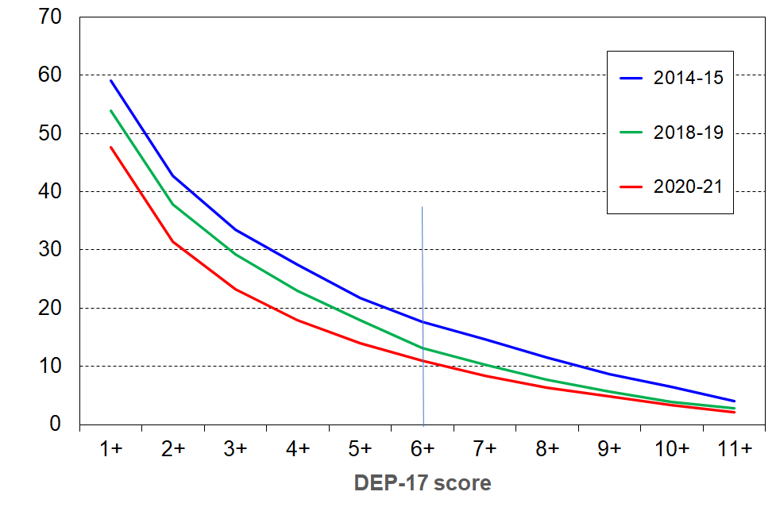**Cumulative distribution of the DEP-17 scores (%), HES 2014-15 to 2020-21, 0-17 yrs**

The lines for 2017-18 and 2019-20 are suppressed to avoid clutter. The 2017-18 line is fairly similar to the 2018-19 (green) line and the 2019-20 line falls between its adjacent surveys (green and red).

**International comparisons (EU-13)**

For the international comparisons in Section D this report uses the EU’s 13-item Index of Material and Social Deprivation (‘**EU-13**’ for short).[80] The 2018-19, 2019-20 and 2020-21 HES have most of the EU-13 items in it and the remainder can be reasonably approximated. The 13 items are listed in **Appendix 1** (and in **Section J)**.

The correlation between the DEP-17 and EU-13 indices in the 2018-19 HES was 0.86 for the whole population and 0.87 for children, and is much the same in the 2017-18 and 2019-20 data. As illustrated in the selection in **Table J.3** below, the EU-13 and DEP-17 measures give very similar hardship rates for different population sub-groups. [81]

**Table J.3**

**Comparisons of DEP-17 and EU-13 hardship rates for children in selected groupings**

**for HES 2017-18, 2018-19 and 2020-21**

|  |  |  |  |  |  |  |
| --- | --- | --- | --- | --- | --- | --- |
|  | **HES 2017-18** | | **HES 2018-19** | | **HES 2020-21** | |
|  | **EU-13 (5+)** | **DEP-17 (6+)** | **EU-13 (5+)** | **DEP-17 (6+)** | **EU-13 (5+)** | **DEP-17 (6+)** |
| **All children (0-17 yrs)** | 13 | 13 | 14 | 13 | 11 | 11 |
| **Household type** |  |  |  |  |  |  |
| 2P HH with any deps | 9 | 8 | 10 | 9 | 6 | 6 |
| SP HH with any deps | 34 | 38 | 32 | 32 | 28 | 31 |
| Other fam HHs with any deps | 16 | 15 | 16 | 16 | 13 | 12 |
| Other HHs | 7 | 11 | 15 | 11 | 13 | 11 |
| **Number of children in household** |  |  |  |  |  |  |
| 1 | 8 | 9 | 11 | 11 | 8 | 8 |
| 2 | 10 | 10 | 10 | 10 | 7 | 8 |
| 3 | 17 | 16 | 16 | 13 | 11 | 11 |
| 4+ | 27 | 26 | 28 | 27 | 27 | 27 |
| **Labour market status of household** |  |  |  |  |  |  |
| Self-employed | 3 | 3 | 3 | 2 | 2 | 2 |
| At least one FT worker | 10 | 9 | 11 | 10 | 7 | 7 |
| No FT worker (may have PT) | 39 | 42 | 38 | 38 | 32 | 36 |
| PT work only | 26 | 32 | 29 | 25 | 19 | 20 |
| Some work (excl SE) | 11 | 11 | 12 | 11 | 8 | 7 |
| Workless | 45 | 46 | 42 | 44 | 39 | 43 |

When using deprivation indices such as DEP-17 (and EU-13) it is important to recognise what they are and what they are not:

* They do not purport to use the 17 (or 13) most important or most serious deprivations – the selection process for such an approach would be fraught and would not be likely to command widespread support.
* Rather they are designed as instruments to rank households by their differing degrees of material hardship, using a balanced set of indicators that cover a range of domains and degrees of depth of deprivation, reflect the same underlying concept (or ‘latent variable’), and which apply reasonably well to people in different age groups and household types.
* Not every conceivable deprivation item has to be used to create a valid and useful index. What is needed is a judiciously selected set of items which tap into the same underlying latent variable. Those lacking these basics and near-basics are more often than not without other potential index items. That is why EU-13 and DEP-17 give similar results. There is good evidence of a relatively widespread consensus on what basic and near-basic needs are.[82]

**Measuring child material hardship**

In broad terms, there are three types of indices that can be used to produce child material hardship statistics:

Those that use only child-specific items (often based on information from the household respondent). An example of this is the 14-item index used in UNICEF’s 2012 Report Card #10 and the 2013 Report Card #11.[83] A limitation of this approach is that it does not take account of a wide range of general household items that are very relevant to the material wellbeing of children in the household (eg keeping home warm, no dampness or mould, access to private vehicle, getting appliances repaired or replaced, and so on). It also cannot be used to compare children with other age-groups and household types.

Those that use both child-specific and child-relevant general household items. An example of this is the new Child Material and Social Deprivation Index recently developed by European researchers and formally adopted for EU usage in March 2018.[84] The UK government also uses a mixed-item index for measuring child material hardship.[85] This approach addresses the first issue noted above (some general household items are very relevant to the material wellbeing of children in the household), but still cannot be used to compare children with others.

Those that use only general household items and items that relate to the adult respondent. This approach addresses both the issues above, but leaves hanging the question as to whether a general household index reasonably reflects the situation of the children in the household. For the purposes of ranking countries on their child material hardship rates in league tables, the second and third approaches give very similar results.

The MSD report uses the third approach as cross-group comparisons are priority outputs. It uses the second approach to assist with painting a grounded picture of ‘life under the line’ (Section C), and for scale calibration (Sections K and M). The report does not use the first one at all, but reports on individual child-specific items and how their lack is distributed across household income or material well-being deciles.[86]

**Sensitivity of material hardship indices to changes in household circumstances**

A feature of material hardship trends is that they are often quite sensitive to changing household circumstances and can show much higher percentage point changes for rates compared with the corresponding changes in income poverty rates.

This can be seen for New Zealand children in **Figure F.1** in Part One. This does not mean that in the GFC material hardship in New Zealand ‘got a lot worse’, whereas income poverty became only ‘a little worse’. It simply reflects two features of the use of material deprivation indices for time series: (a) by their construction they are more sensitive than income measures to changing household circumstances, when looking at percentage point changes, and (b) many households live in an “only-just-getting-by” mode and even a small loss (gain) in income can easily lead to them moving below (above) a hardship threshold.

This feature is not unique to New Zealand data as the charts below for Ireland show. The right-hand chart uses an index approach with all three measures set to 100 in 2004. Their hardship measure shows the greatest sensitivity.



**The Material Wellbeing Index (MWI)**

DEP-17 and EU-13 are material hardship indices, focussing on the lower end of the material wellbeing spectrum. MSD has also developed a **Material Wellbeing Index (MWI)** which ranks households across the full material wellbeing spectrum from low to high. The MWI ranks households very much the same at the lower end as does DEP-17. The 24 MWI items are listed in **Appendix 1**.[87]

**Is a 2006-07 to 2020-21 HES-based material hardship time series feasible given the change in the item set between the 2011-12 and 2012-13 surveys?**

The time series reported in Section F use the Economic Living Standards Index (ELSI) up to and including 2012, and after that the Material Wellbeing Index (MWI). The MWI is the revised version of the ELSI prototype. These indices are constructed using non-incomes data from Stats NZ’s Household Economic Surveys (HES), from 2007 to 2020:

* twenty-five items were collected from 2007 to 2012 (the ELSI items)
* in the 2013 HES, 13 of the 25 ELSI items were dropped and 17 new items were added
* from 2013 to 2015 the survey collected 29 items from which the MWI and DEP-17 are constructed
* from HES 2016 on, six more items were added, and the previous 29 were retained.
* from HES 2019 on, three new items were added, with all but one of the previous 35 retained. The ‘continue to wear worn-out clothes’ economising item (not at all, a little, a lot) was dropped and replaced with an enforced lack item about whether the respondent can ‘usually replace worn-out clothes by some new (not second-hand ) clothes’.[88]

The major change to the item set between 2011-12 and 2012-13 means that there can be no on-going ELSI time series and, similarly, the new MWI series can run only from 2013. This means a break between 2012 to 2013 with ELSI before the break and MWI after, which potentially thwarts efforts for a time series across the whole period. This section shows that such a time series is feasible. It uses the fact that 9 of the 12 items that are common to both the earlier and later datasets are suitable to be used to create a good-enough index (DEP-COMMON) that shows the shape of the trend lines across the full period, 2007 to 2018, for three thresholds. This information provides a solid guide for how to splice the ELSI and MWI time series between HES 2012 and HES 2013, the period in which the item sets changed.

The 9 common items are listed below. They are of two types:

**Enforced lacks**

* two pair shoes for daily activities (R)
* suitable clothes for special occasions (R)
* presents for families/friends (R)
* home contents insurance (H)
* holiday away from home for at least a week each year (R)

**Economising ‘a lot’ to keep costs down so as able to afford other basic items**

* go without fresh fruit and vegetables (H)
* continue wearing worn out clothing (R)
* postpone or put off visits to the doctor (R)
* do without or cut back on trips to the shops or other local places (H)

Note: R= for respondent, and H = for household as a whole.

The 3 items that are in both datasets but which are not used in DEP-COMMON are about hobbies and overseas holidays (not suitable for tracking hardship) and income adequacy. The index score is created simply by adding the number of items that indicate hardship (either an enforced lack or economising ‘a lot’).

DEP-COMMON has a very good reliability score, with a Cronbach’s alpha of 0.76. The items cover a reasonable range of domains. When it is used to identify the groups with the highest and lowest deprivation rates it gives results similar to DEP-17 and EU-13 (see **Table J.4** below). Its main limitation is that with only 9 items there are relatively large gaps between rates for different thresholds in the typical hardship zones. In other words, DEP-COMMON has a clunky cumulative distribution curve. There are only three thresholds of any great use (3+, 4+, and 5+), and for the whole population the rates in 2017-18 are 9%, 7% and 3% respectively.

**Table J.4**

**Comparisons of hardship rates for different sub-groups**

**using different indices (EU-13, DEP-17 and DEP-COMMON), HES 2017-18**

|  |  |  |  |
| --- | --- | --- | --- |
| HES 2017-18 | **EU-13 (5+)** | **DEP-17 (6+)** | **DEP-COMMON (3+)** |
| ALL | 9 | 8 | 9 |
| 0-17 | 15 | 13 | 15 |
| 65+ | 4 | 3 | 4 |
| 2P <65 | 9 | 7 | 9 |
| SP <65 | 36 | 37 | 36 |
| Couple <65 | 4 | 2 | 5 |
| European (total) | 6 | 6 | 7 |
| Maori (total) | 20 | 18 | 21 |
| Children (main source = market) | 9 | 8 | 9 |
| Children (main source = govt) | 47 | 43 | 45 |

Reading note: The thresholds used for the indices produce hardship rates which are close enough (8-9%) for the purposes of the comparisons in this table.

**Figure J.2** below uses the 9-item DEP-COMMON to create a time series from 2008 to 2018. DEP-COMMON has good enough credentials to be used to show the shape of the trend lines for three thresholds across the full period, HES 2007 to HES 2018.[89] This provides a solid guide for how to splice the ELSI - MWI time series between HES 2012 and 2013, when the item sets changed.

**Figure J.2a**

Constructing a material hardship time series, 2007 to 2018:

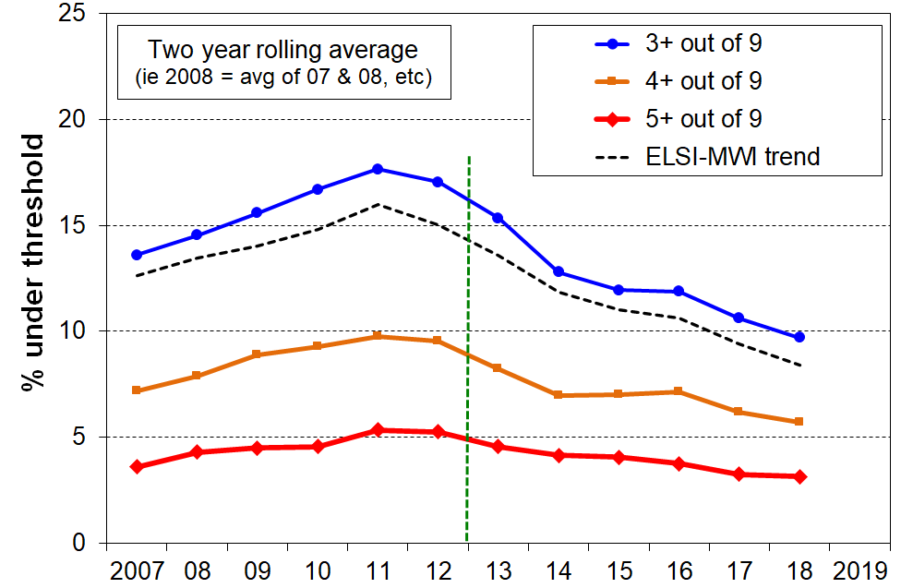DEP-COMMON (9 items) compared with ELSI-MWI, whole population

**Figure J.2b**

Constructing a material hardship time series, 2007 to 2018:

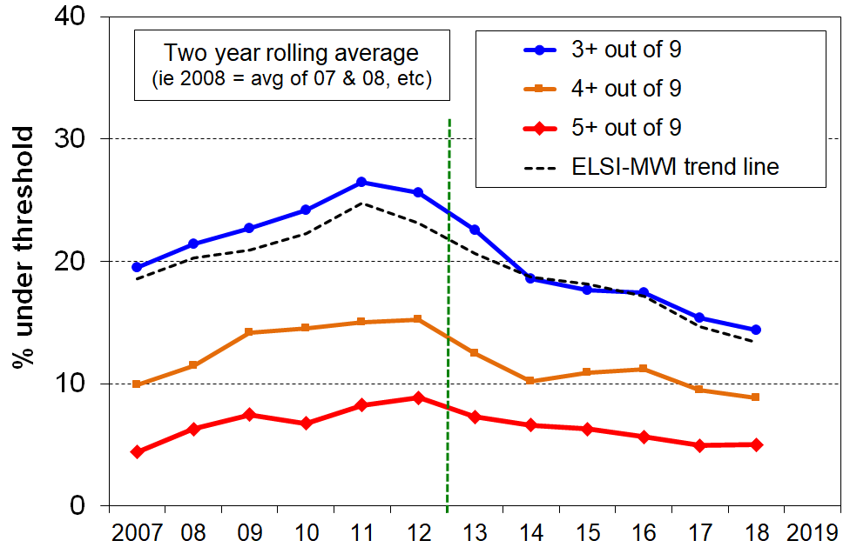DEP-COMMON (9 items) compared with ELSI-MWI, children (0-17 yrs)

There is one group for whom the splicing is not robust – older New Zealanders, aged 65+.

The limitation can be seen in the discontinuity between the ELSI hardship levels (up to and including 2021), and those produced by the MWI for this group from 2013 on (**Figure J.3**).

**Figure J.3**

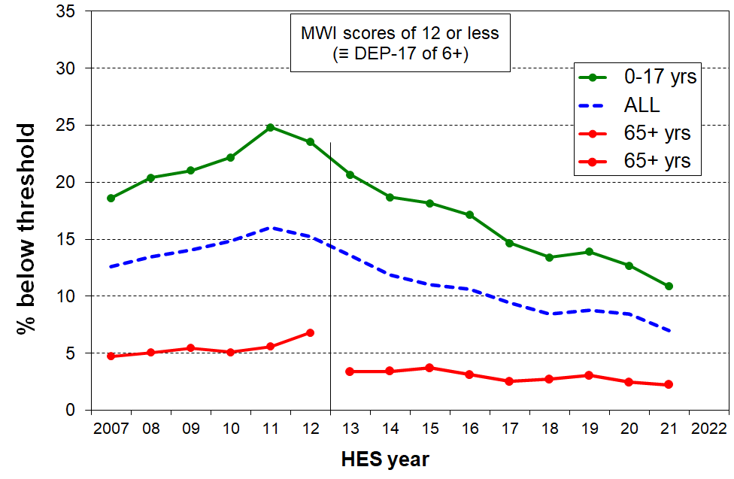**Discontinuity bwtreen ELSI and MWI trends for older New Zealanders, 65+**

The discontinuity is likely to be explained by the fact that ELSI uses self-rated satisfaction and self-rated living standards in constructing the index, and these contribute a considerable portion of the ELSI score. The MWI does not have any items like that in it.

For a given hardship score, using DEP-17 / MWI type items, older people generally self-rate lower than other New Zealanders on the two self-rating items, perhaps reflecting a ‘disappointment’ factor – having hoped to be better off by their age. This increases the measured hardship levels using ELSI, but not for MWI which does not use the two self-rating items. See also Adaptive Preferences box on next page.

**Comparison of material hardship levels and trends for MWI and DEP-17 measures**

**Figure J.4** shows that for children (aged 0-17 years) the DEP-17 and MWI hardship trends are close from 2013 on, the period in which they can both be constructed from the HES. This finding holds for both the standard and the severe hardship levels.

**Figure J.4**

**Comparison of trends in material hardship rates using MWI and DEP-17, HES 2013 to 2020:**

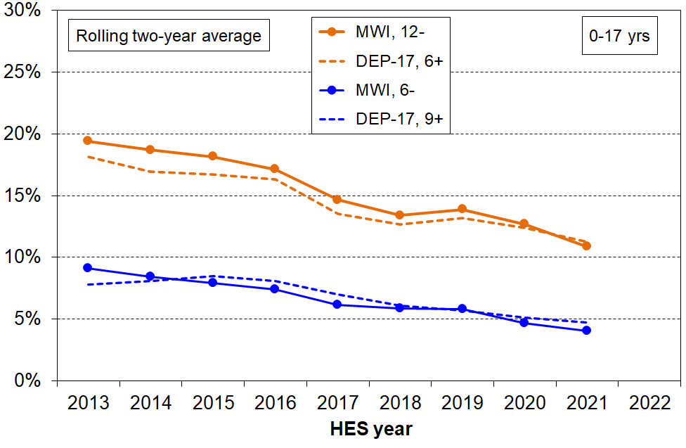 **children (0-17 yrs)**

**Adaptive Preferences**

In his pioneering work on income poverty and its relationship with deprivation, Townsend (1979) defined deprivation as ‘a state of observable and demonstrable disadvantage relative to the local community or wider society or nation to which an individual, family or group belongs’ (Nolan and Whelan (2011, p31). This conceptualisation was criticised on the grounds that deprivation, as commonly understood, involves the notion of being denied the opportunity to have or do something. The question arises regarding ‘non-possession’ as to whether this is by choice or because of constraint. Mack and Lansley (1985) responded to this criticism by asking whether the respondent is doing without the item or activity because they cannot afford it or just do not want it.

This approach has been widely copied, and there is evidence that it does assist with capturing resource constraints rather than choice (eg see Nolan and Whelan, 1996). However, in partially resolving one issue it created another potential issue.

There is good evidence that disadvantaged individuals compare themselves with others who are in the same precarious situation or even worse off and, as a result, lower their expectations and adapt their aspirations and preferences to their material and financial constraints. This can lead to “don’t want” responses rather “can’t afford” responses, resulting in a downward bias in deprivation rates. Older people who are experiencing a lower living standard than they had hoped for may also respond with “don’t want” rather than “can’t afford” as a strategy to maintain a sense of dignity and still being in control of their own lives. See **Figure J.3** above and the related text for a New Zealand example.

This report generally uses the ‘enforced lack’ approach (though not for some of the child-specific items) and at least in part addresses the ‘adaptive preferences’ issue through careful selection of items for which the issue is likely to be less significant, including the use of the ‘economising’ mode for several of the items used. The careful item selection strategy is well illustrated by the issues raised in relation to Figure J.3 above.

See McKay (2004), Halleröd (2006), and Berthoud et al (2006) for recent discussions on the issue of adaptive preferences and whether the ‘enforced lack’ approach for hardship measurement introduces a systematic bias depending on how far preferences adapt to circumstances. See also Crettaz and Suter (2013) who show that the adaptive preference issue impacts different types of items differently.

**Section K**

**Setting thresholds for hardship indices**

DEP-17 is a good ranking instrument for households at the lower end of the material wellbeing spectrum, but there is no straightforward way of just looking at the DEP-17 item list and concluding that a household is experiencing material hardship (ie ‘unacceptably low living standards’) if it has, say, 4+ or 8+ or some other count of the 17 deprivation items. This is in part because DEP-17 includes a few items that some would say are not ‘absolute essentials’ for a minimum acceptable standard of living in New Zealand – more like ‘near essentials’. This makes it difficult to use the internal logic of the index by itself to set a range of defensible thresholds that would command widespread support.

To assist the judgement call that is inherent in setting a threshold, additional information from outside the 17 index items is needed. MSD’s reports use two external reference points for this purpose:

* A suite of 18 items for which there is a strong case for considering them all as essentials for New Zealand children, items that no child should go without.
* The level set by the Eurostat when using their EU-13 index.

The 18 essential items are listed in **Table K.1** below and used in **Figure K.1** below (next page). The list is made up of 12 child-specific items and 6 general household items that are directly child-related and essential for them.[90]

**Table K.1**

**The 18 essential items used for the calibration in Figure K.1**

|  |  |
| --- | --- |
| **Selected child-specific items (12)** | **General child-relevant household items (6)** |
| Do not have:   * two pairs of shoes in a good condition and suitable for daily activities for each child * two sets of warm winter clothes for each child * waterproof coat for each child (because of cost) * a separate bed for each child * fresh fruit and vegetables daily * meal with meat, fish or chicken (or vegetarian equivalent) each day * good access at home to a computer and internet for homework * friends around to play and eat from time to time (because of the cost)   Economised ‘a lot’:   * unable to pay for school trips / events for each child * had to limit children’s involvement in sport * children had to go without music, dance, kapa haka, art, swimming or other special interest lessons * continued wearing worn out / wrong size clothes and shoes | Household deprivations that have direct relevance to children:   * received help from food bank or other community group (more than once in last year) * accommodation severely crowded (2+ extra bedrooms needed) * dampness or mould in dwelling (‘major problem’) * respondent reports putting up with feeling cold to keep down costs for other basics (‘a lot’) * delayed repair or replacement of appliances (‘a lot’) * no access to car or van |

Note for Table J.1:

* The economising questions ask about economising so as to be able to pay for other basics, not just to be thrifty or save up for a special non-essential. Possible responses were ‘not at all’, ‘a little’, and ‘a lot’.
* In the MSD analysis, the child-specific items are applied to 6-17 year olds as some are not relevant to younger children (eg school trips, involvement in sport).

**Figure K.1** ranks children by their MWI ventile (5% grouping), and shows the rapidly increasing chance of missing out on several of the 18 essentials for the lower ventiles, especially the lower two (ie lower 10% of children aged 6-17 years).

**Figure K.1**

**Multiple deprivation for children, using 18 essential child-specific and child-relevant**

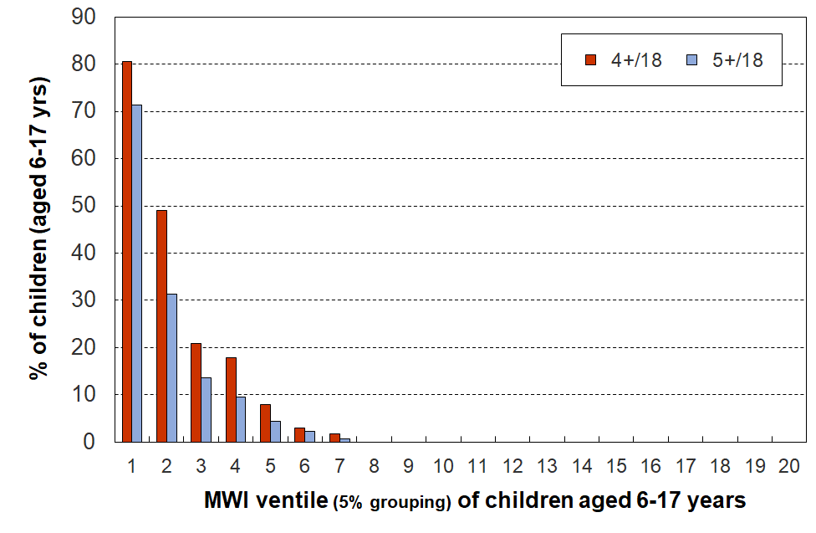**general household items, HES 2018-19**

This analysis narrows the range of plausible thresholds, supporting a threshold in the range of 6+/17 to 8+/17 (see **Table K.2** below which shows a child material hardship rate of 8-13% in this range of thresholds).[91]

**Table K.2**

**Cumulative distribution of the DEP-17 scores (% individuals), HES 2018-19**

|  |  |  |  |  |  |  |  |  |  |  |  |  |
| --- | --- | --- | --- | --- | --- | --- | --- | --- | --- | --- | --- | --- |
| **Score** | **0+** | **1+** | **2+** | **3+** | **4+** | **5+** | **6+** | **7+** | **8+** | **9+** | **10+** | **11+** |
| **ALL (%)** | 100 | 46 | 30 | 22 | 17 | 13 | 9 | 7 | 5 | 4 | 3 | 2 |
| **0-17 yrs (%)** | 100 | 54 | 38 | 29 | 23 | 18 | 13 | 10 | 8 | 6 | 4 | 3 |
| **6-17 yrs (%)** | 100 | 53 | 38 | 29 | 23 | 18 | 13 | 10 | 8 | 5 | 4 | 3 |

One of the values of the material hardship approach is that it allows fairly straightforward international comparisons of how children are faring in terms of material wellbeing. We are able to compare New Zealand hardship rates with those from European countries using Eurostat’s EU-13 measure. Setting a DEP-17 threshold that gives hardship numbers that are in line with those produced using EU-13 is a second external reference point that can be used. Eurostat uses a 5+/13 threshold for EU-13.

**Table K.3** below compares DEP-17 rates for different age-groups using thresholds of 6+/17, 7+/17 and 8+/17 with the EU-13 rates for a threshold of 5+/13. The DEP-17 6+/17 threshold gives very similar figures to the 5+/13 threshold for EU-13. See also **Table J.3** above for further comparisons.

**Table K.3**

**Comparisons of hardship rates using EU-13 (5+/13) and selected DEP-17 thresholds:**

**selected age groups for HES 2018/19**

|  |  |  |  |  |
| --- | --- | --- | --- | --- |
|  | **EU-13** | **DEP-17** | | |
|  | **5+** | **6+** | **7+** | **8+** |
| **Population** | 11 | 9 | 7 | 5 |
| 0-17 | 14 | 13 | 10 | 8 |
| 18-24 | 10 | 10 | 7 | 5 |
| 25-44 | 10 | 10 | 7 | 5 |
| 45-64 | 10 | 8 | 6 | 5 |
| 65+ | 4 | 3 | 2 | 2 |

MSD reports now use the 6+/17 threshold for DEP-17. Stats NZ does the same for their official CPRA reporting on child poverty rates, with 9+/17 for severe material hardship.[92]

**Section L**

**Low-income measures**

**Household income as a proxy measure of resources and its limitations as a measure of poverty as defined in this report and as used in general conversation**

In relation to the high level definition of poverty used in most of the richer nations –‘*exclusion from the minimum acceptable way of life (standard of living) in one’s own society because of inadequate resources’* – household income, adjusted for household size and composition, has traditionally been used as a proxy measure of resources for the purposes of poverty measurement.

While this approach produces valuable information on income inequality and on the number of households with incomes below selected low-income lines, it has several serious limitations as a poverty measure. In particular, different households with very similar current income can have different levels of non-income resources, sometimes reflecting higher income in previous years (eg some cash savings, a good stock of basic household items, help in cash and kind from outside the household, and so on), and different demands on the household budget (eg from differing housing costs, special health costs, debt servicing, and so on).

* This means that low income on its own does not distinguish well between those with adequate resources to sustain a minimum acceptable standard of living and those without these. Using household income after housing costs (AHC income) helps but it is not a complete answer. In other words, household income does not perform well as a poverty measure.
* This does not mean that income has little impact on the material wellbeing of individual households – for low-income households especially, any increase in income makes a positive difference. It’s just that when it comes to measuring poverty, income on its own is not a very good identifier of those who are actually struggling, for the reasons outlined above.

What follows elaborates further on this theme (household income not performing well in identifying those who are actually struggling financially):

* three examples using data from the 2017/18 and 2018-19 HES
* one from Stats NZ’s SoFIE longitudinal survey
* examples from the international literature
* recognition of the issue by Eurostat.

Many of the issues are discussed in **Section A** and there is some repetition here to help create a consolidated resource in the one place.

**Figure L.1** shows the relationship between BHC household income and household MWI score. The solid line shows the average MWI score for each BHC income decile, and the dashed lines show the average MWI scores ± one standard deviation. Higher household incomes are generally associated with higher levels of material wellbeing, as expected. There is, however, considerable variation in material wellbeing for given income levels (in deciles), though this variation diminishes for higher household incomes. In addition, the correlation between BHC income and MWI score is relatively modest at 0.33 (calculated on a household by household basis).

While measurement error and the range of income within each income decile will explain some of the variation, the bulk is likely to reflect the impact of different levels of financial and physical assets and of the ‘other’ factors noted above and in the framework diagram (Figure A.1).

**Figure L.1**

**Average MWI scores for BHC income deciles with MWI standard deviation for each decile,**

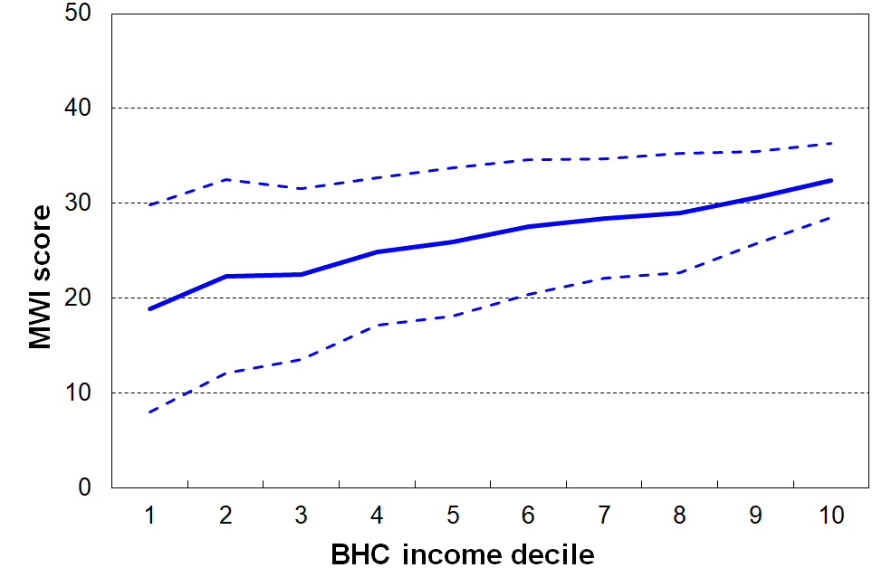**HES 2017/18**

Note for Table:

The smaller standard deviation for MWI scores for higher income households does not mean that income for higher income households is a more reliable indicator of material wellbeing than it is for lower income households. It simply reflects the lower sensitivity of the MWI for discriminating between households of varying degrees of higher material living standards. The key point is that across the whole spectrum, and especially at the lower end where the greatest policy interest lies, there is variation of material well-being / hardship within each income decile.

**Figure L.2** and the associated table below shows that for households with similar incomes (after deducting housing costs), higher levels of liquid financial assets[93] mean lower levels of material hardship. This is hardly a surprising finding, but it is not often to the fore in discussion and debate, and it is rare for a single dataset to have all three pieces of information (income, liquid assets (such as savings and accessible investments) and material hardship) to enable the analysis to be done.

**Figure L.2**

**Material hardship rates depend on the level of liquid financial assets as well as on HH income**

Reading notes for Figure A.2 and associated table below:

* The five quintiles are quintiles of AHC household income – Q1 is the lowest quintile and so on.
* Individuals within each household income quintile are ranked by their household’s level of liquid assets, then split into three equal-sized groups.

|  |  |  |  |  |  |  |  |  |  |
| --- | --- | --- | --- | --- | --- | --- | --- | --- | --- |
| **Household Economic Survey 2017-18** | **Q1** | | | **Q2** | | | **Q3** | | |
| median liquid assets ($) | 0 | 400 | 8,000 | 100 | 1,200 | 12,000 | 500 | 3,600 | 19,300 |
| can pay an unexpected + essential $500 bill within a month without borrowing (%) | 24 | 43 | 67 | 51 | 71 | 79 | 69 | 84 | 85 |
| used a foodbank more than once in previous 12 months (%) | 25 | 10 | 2 | 6 | 4 | 1 | 4 | 0 | 0 |
| put up with cold ‘a lot’ to save on costs (%) | 25 | 14 | 11 | 10 | 8 | 4 | 7 | 5 | 4 |
| borrowed from fam/friends more than once in previous 12 months to pay for basics (%) | 34 | 17 | 9 | 18 | 9 | 4 | 10 | 3 | 2 |
| self-assessed income adequacy – ‘not enough’ | 46 | 21 | 17 | 22 | 10 | 6 | 14 | 6 | 4 |
| material hardship rate (%) (6+/17, DEP-17) | 47 | 18 | 7 | 19 | 11 | 4 | 9 | 1 | 2 |
| avg AHC household income (equivalised) | 11,000 | 11,000 | 10,000 | 21,000 | 21,000 | 22,000 | 30,000 | 31,000 | 31,000 |

.

The bottom three rows of the table are of particular relevance to the matter of the reliability and suitability of household income as a measure of poverty as defined above.

There is explicit evidence here that households with close to the same income give quite different responses to an income adequacy question, depending on their liquid assets. The responses are contextualised ones about the adequacy of household income *given their particular circumstances*. MWI and DEP-17 scores reflect the impact on living standards of these other circumstances as well as that of household income, whereas household income is a more indirect measure of material wellbeing, a proxy that cannot take account of other key factors.

The third illustration is given in **Figure L.3** which shows the household income bands for the households in which children identified as in hardship live (children living in households with a DEP-17 score of 6+/17). It shows that:

* (only) around one in four (28%) come from households with incomes below 40% AHC
* almost two in three (60%) come from households with incomes below 60% AHC
* just under one in three (29%) come from households with incomes above 70% AHC.

**Figure L.3**

**Distribution across household AHC income bands of children identified as in hardship (DEP-17 of 6+/17)**

Note: Figure L.3 repeats Figure C.4 – see the latter for more detail.

The fourth illustration is given in **Figure L.4** which shows how material deprivation increases with the length of time that households are in a low-income state (ie looking at current annual income cannot tell the whole story). The finding is consistent with the framework described in Figure A.1 and is not surprising. It is not easy however to find empirical evidence that supports the first principles theoretical logic.

After 7 years in persistent low income, the mean deprivation score had increased 6-fold from around 0.3 to 1.8 items. (Note that this is not the same as a 6-fold increase in the material hardship rate, using a given threshold such as 2 out of 8 items. That analysis is not available.)

**Figure L.4 (=A.5)**

**Mean deprivation score (NZiDep) by number of years in low-income households:**

**Children (0-17 yrs), SoFIE 2003 to 2009**

Source: Special 2012 run on the SoFIE data for MSD by Imlach Gunasekara & Carter (2012)

Notes for Table:

* SoFIE is Stats NZ’s longitudinal Survey of Family, Income and Employment.
* NZiDep is an 8-item general material hardship index.The 8 items are similar to those in the DEP--17 index.
* The low-income measure used is 60% of median gross household income (which gives higher low-income rates than a 60% of median disposable household income measure). In other words, the low-income threshold used in the graph is a generous one,.

The concerns raised in this report about the use of income on its own for identifying the poor / measuring poverty are not new. Ringen (1988) made a persuasive case that household income was both an indirect and unreliable measure of poverty, to the extent that the statistics produced are ‘invalid’. The issue is well summed up by Nolan and Whelan in their 1996 publication on *Resources, Deprivation and Poverty* (p219):

*‘[There are inherent difficulties in measuring income accurately …. but] the fundamental issue about reliance on income in measuring poverty is not simply one of measurement: it is whether income, properly measured, in fact tells us what we want to know when we set out to measure poverty’* (p219).

More recently, Guio et al (2020:8) sum up:

*Although current (disposable) household income is usually used as a proxy for “command over resources”, the association between current income and deprivation is far from perfect. This imperfect link is documented extensively in the literature (see among others Whelan et al, 2001; Whelan and Maître, 2006; 2007; Berthoud and Bryan, 2011; Fusco et al, 2011; Nolan and Whelan,2011; Verbunt and Guio, 2019)*.

The development of the EU-13 material and social deprivation measure was motivated in part by the the limitations of household income measures of poverty. Notten et al (2017) have recently developed a deprivation index using Canadian data, with similar motivation.[94]

The EU itself explicitly recognised the issue in 2002 through its naming of their official headline low-income rate (BHC 60%) as the ‘at-risk-of-poverty rate’ (Atkinson et al, 2002). Nolan and Whelan (2011) note that *‘this reflects an acceptance that low income on its own may not always be a reliable indicator of poverty and social exclusion’* (p42). The Eurostat glossary notes that ‘*this indicator does not measure wealth or poverty, but low income in comparison to other residents in that country, which does not necessarily imply a low standard of living’*.[95]

In practice, however, the ‘at-risk-of’ qualifier is very often dropped and the discourse reverts to ‘19% of children in country X live in poverty’ or similar, even at the official level. Examples abound.

The formal media release in January 2021 from the UN’s special rapporteur on extreme poverty and human rights after his ‘mission’ to the EU in late 2020 / early 2021 talks in many places about ‘poverty reduction’ and ‘almost 100 million living in poverty’, and so on, while only once or twice does the full ‘at-risk-of-poverty’ language get used. The impression left is that the EU is in dire straits.

Use of ‘poverty’ language for household income measures is given further legitimacy by the OECD’s use of the 50% BHC measure as its preferred one – without even the EU caveat.

Most UNICEF Report Cards on children in richer countries include a poverty league table using BHC 50 or BHC 60 measures, without any qualification or caveat.[96] All of this tends to legitimise the use of relative low-income measures as poverty measures, despite the well-founded cautions of academics and the built-in caveat in Eurostat’s at-risk-of-poverty language.

A recent UK publication on the working poor (McNeil and Parkes, 2021) notes that “The relative poverty line is computed as 60 per cent of the median equivalised household income, with any household under this amount being described as ‘in poverty’.” The quote marks around ‘in poverty’ raise an unarticulated question but it is never discussed.

**Given the limitations, is there a place for using low household income in poverty measurement?**

While household income has some serious limitations as a precise indicator of poverty as defined above (‘resources not adequate to support a minimum acceptable material standard of living’), there is a good case for using it as part of a suite of measures that together provide a reasonable picture of how material and financial disadvantage is distributed and how it is changing over time.

The re-distribution of income is a fundamental lever that governments have control over. There is an obligation on governments (including from international commitments) and a public policy interest from citizens to have publicly available information on how income is distributed across households and how trends in rates change over time for selected groups. Income support is the main lever available to a government for poverty alleviation. The impact of the use of re-distribution needs to be monitored and its impact observed, alongside the impact of other interventions, even if household income is not a reliable measure of a household’s ‘command over resources’.

The use of expenditure is not generally accepted as an alternative, in part because it also is not a good proxy for reporting consumption possibilities, but also because the quality of the expenditure data is often patchy.

While the use of non-income measures and material deprivation indices has developed strongly in the last two decades, and they have the advantage of reflecting the impact not only of income but of many other factors (see Figure A.1), they are not sufficient on their own and also have their own challenges as noted earlier.

**Does the relatively loose relationship overall between household income and reported material wellbeing (correlation of around 0.35) mean that there is limited value in interventions which seek to raise household incomes for low to middle income households?**

Households with similar incomes (even when equivalised) have a range of reported material wellbeing scores (see Figure A.3), reflecting the impact of factors in addition to income on material wellbeing, as discussed in Section A. The relatively loose relationship is about the relationship on average, given these variations.

For a given household with income in the low to middle range, an increase in income will almost always lead to an increase in material wellbeing / reduction in material hardship for that household (unless the extra is used for debt repayment or savings). This is especially the case for households with incomes below the standard CPRA thresholds.

The observations about the average strength of the relationship do not tell us about the impact on individual households.

**Section M**

**Setting low-income thresholds**

Just as in the case of material hardship indices, judgment calls are needed for setting low-income thresholds or ‘poverty lines’.

This report uses the suite of relative low-income measures that are specified in the CPRA. In one sense, therefore, the decisions are already made, but there is value in discussing and documenting what justifications there are for the traditional selections.

This report (and MSD’s Household Incomes Report) use four approaches for assisting the judgement calls:

* + the thresholds commonly used internationally
  + thresholds that are arrived at by the use of reference budgets for selected household types
  + evidence of where on the household income spectrum there is a clear increase (if any) in reported hardship at low-income levels, using more direct non-monetary indicators
  + sense check by readers when given the weekly dollar values of various thresholds for selected household types.

When applying these approaches and using the selected low-income thresholds the report does not (expect to be able to) reach a definitive conclusion about a sharp cut-off with those below being ‘poor’ and those above ‘not poor’ – for all the reasons outlined in **Section L** and elsewhere. The report takes the view that any low-income threshold, even those with the strongest support from evidence of the type listed above, can only ever be either:

* a rough-and-ready proxy for resources, or command over resources.
* a ‘rights-based’ minimum income required to reach and maintain a minimum acceptable standard of living, given a set of assumptions about:
* the defining characteristics of the minimum acceptable standard (eg don’t need to use foodbanks)
* the household having a good enough base stock of furniture, whiteware, clothing and so on
* there being no special high demands on the budget for health or disability issues, addressing debt and so on
* the household having reasonable ability to turn a given income into useful consumption
* an accepted set of equivalence ratios to enable reasonably fair comparisons across different household types.[97]

**Internationally used low-income measures and thresholds**

BHC 50 and BHC 60 measures are widely used, especially by the OECD and the EU respectively.

AHC 60 is used by Scotland in their official measures of poverty, and the HBAI reports for the UK as a whole use the AHC 40, 50 and 60 measures as well as BHC measures.

There is very little formal use of AHC measures in the richer nations although in the last year or so Eurostat have begun reporting on these.

**Reference budgets for selected household types**

The most up-to-date reference budgets for New Zealand are reported in the *Example Families and Budgets* background paper prepared for the 2019 Welfare Expert Advisory Group.[98] [99]

The research provides estimated budgets for six example families with adults of working age and on low incomes: three are single people without children, and three are families with children (two sole parents, one couple).

The main focus of the research is on the adequacy of the income support system. For the purposes of this section of the Child Poverty report, the relevant findings are the budget costs reported as a proportion of the median household income at the time.

Budgets Costs are calculated for two levels of expenditure:

* a level sufficient to cover ‘core’ (or basic) costs (for example, rent, food, power, clothes, medical costs, transport, school costs, etc), and
* a level to cover both core and ‘participation’ costs (for example, including a small personal allowance, low-cost activities, cheap presents for family, etc) – these costs reflect modest needs and a relatively minimal interpretation of participation and include no spending on alcohol or tobacco and no debt repayments.

Key assumptions include:

* the families are based in Manurewa (South Auckland) – though other locations are considered later in the paper
* no cash assets (savings)
* no debt.

The research finds that in order to meet core expenditure needs:

* BHC incomes need to be in the range of 63% to 75% of the BHC median for Manurewa, and a wider range when other areas with different housing costs are considered.
* AHC incomes need to be in the range of 45% to 50% of the AHC median for Manurewa, and are much the same when other areas with different housing costs are considered.

New Zealand Poverty Measurement Project focus groups from the 1990s.

The research carried out by the New Zealand Poverty Measurement Project (NZPMP) in the 1990s used focus groups of low-income householders to provide some grounded indication of what a poverty line would look like for New Zealand, a ‘realistic poverty line for use in social and economic policy.[100] Each group was asked to reach reasonable agreement on a minimum adequate budget for a household comprising two adults and three children (aged 7-11). This weekly budget was then expressed as a proportion (%) of the median household income from Stats NZ’s Household Economic Survey (HES) and these results were used to reach a ‘60%’ conclusion for a New Zealand BHC poverty line at the time. Many have gone on to mistakenly use this to support an AHC 60% conclusion.

The household budget template set out 15 categories of spending and each group had to decide on a dollar amount for each line in the budget. The purchasing power of the budget was to be ‘strictly minimal’, but such that the household could live independently, without resorting to a food bank, for example. The households were assumed to have basic furnishings and household appliances, no significant costs for sickness or disability, stable financial circumstances and very good financial management abilities.

The focus groups were carried out in Lower Hutt and Wainuiomata in 1993, in some Lower North Island towns in 1995, and then in Auckland and Wellington in 1996. Further focus groups were run in the 2000s but the results are not yet published.

The main focus was on just one household type: two adults and three children. The 1993 Lower Hutt focus groups also provided a budget for a household with a sole parent and two children.

The original focus group information was re-analysed by MSD in 2018.[101] This work concluded that:

* The research in the 1990s does not unambiguously and clearly support a 60% BHC threshold – it points to a range of 55 to 80%, depending on location (and housing costs especially).
* It supports an AHC threshold of 50 to 55% of the median.

Summary of findings from New Zealand reference budget research

The two pieces of research point in the same direction for estimates of low-income thresholds or poverty lines:

* For BHC incomes, a wide range is indicated (55% to 80% of the BHC median), strongly reflecting differing housing costs in different areas.[102] This finding illustrates two key themes outlined earlier in this section and illustrated in the framework in Figure A.1:
  + Factors other than current household income have a major impact on material living standards - housing costs are one of the main factors.
  + Household income is best seen as a rough-and-ready proxy for resources, rather than as a reliable and precise indicator of material wellbeing.
* For AHC incomes, a much tighter range is indicated – 45% to 55% of the median.

**Using non-monetary indicators**

Is there any evidence that somewhere towards the low end of the household income spectrum there is a clear increase in reported hardship? [103]

The analysis below is based on 2015 and 2017 HES data. The income bands are all AHC income bands expressed as a proportion of the AHC median.

Surviving without outside help?

A reasonable minimum requirement of an above-poverty-line budget is that it allows a household to be able to live independently, without for example having to rely on a food bank.

The two charts below show that:

* There are much higher rates of dependence on outside assistance (whether food banks or friends/family) for those with incomes in the below 40% AHC and in the 40-50% AHC bands, compared with those with incomes in bands above this.
* 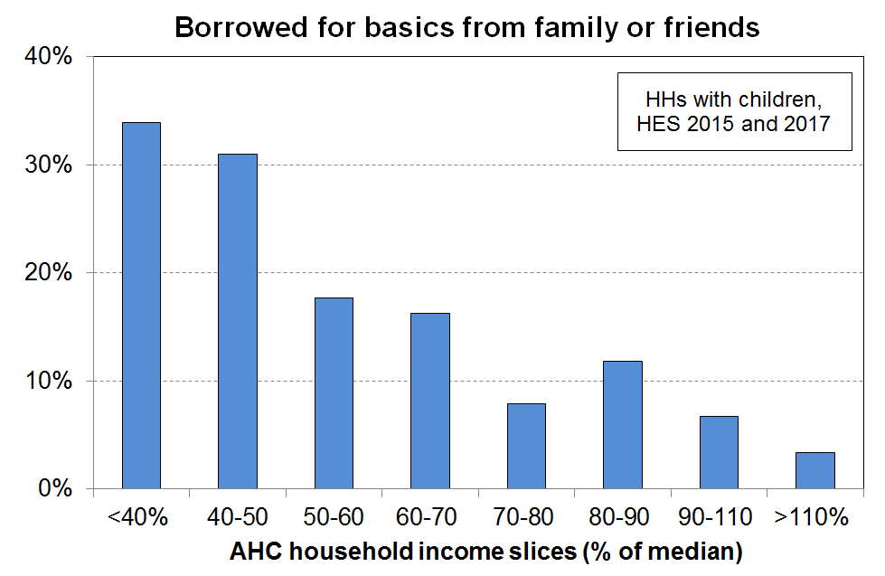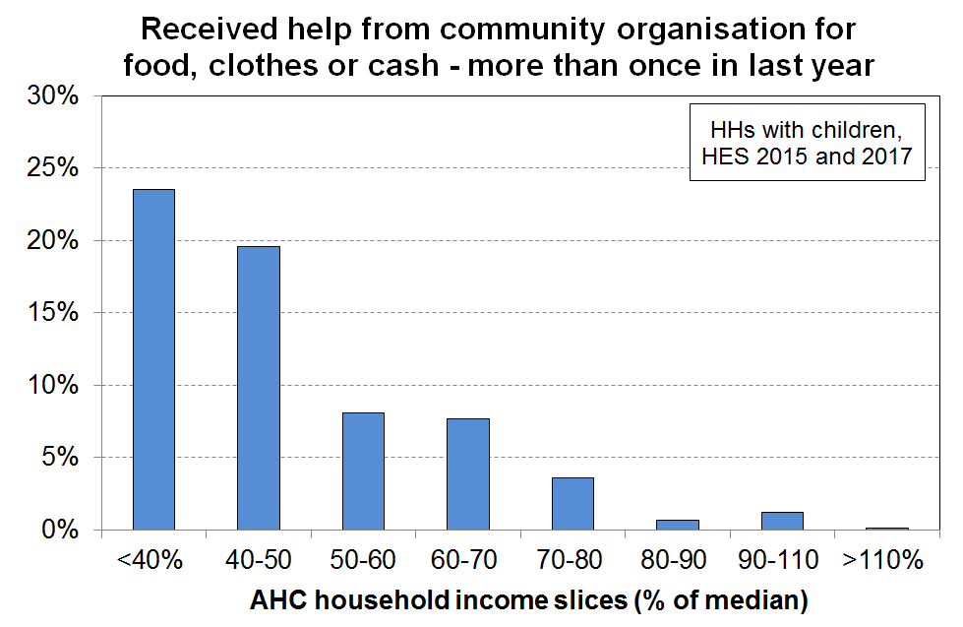Even in the 50% to 70% bands there are still 15% of households with children needing to borrow for basics. This is in line with a view which sees any ‘poverty line’ as simply a rough-and-ready guide rather than a precise cut-off.

Two very basic items: fruit/veges and shoes for the respondent

In households with children, the deprivation of fresh/fruit and vegetables (‘a lot’[104]) is clearly much higher for the under 40% AHC households, and the inability to have two pair of reasonable shoes is much higher for the respondents in under 50% AHC households than for households with incomes above this.

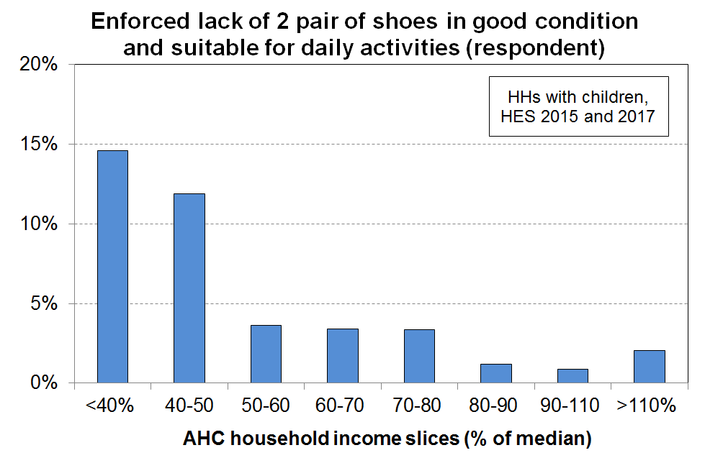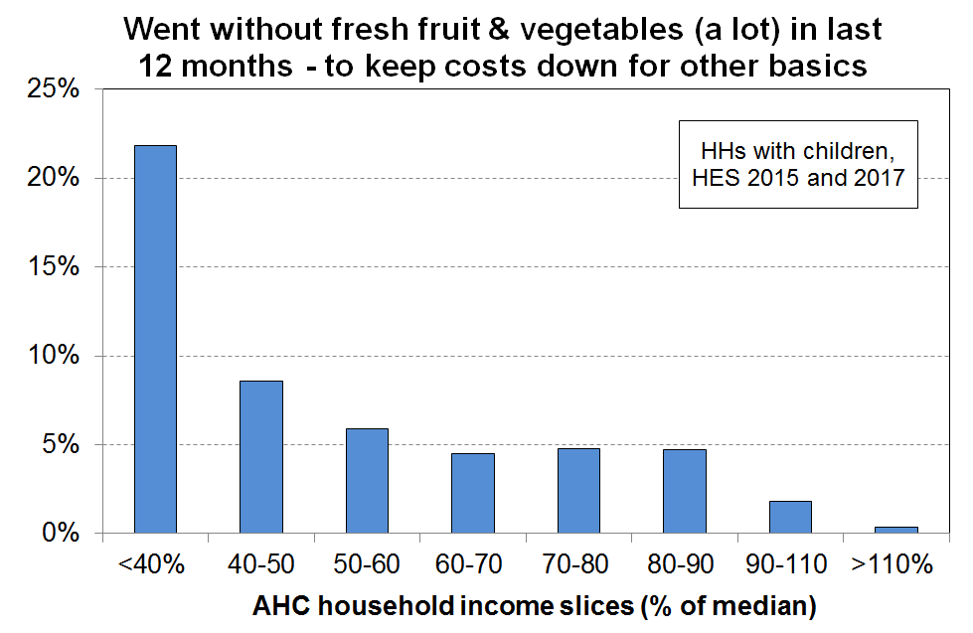

The results are not definitive but are reasonably consistent with those from the reference budgets.

**Do these weekly dollar values seem reasonable?**

The dollar value of the low-income thresholds used in the Household Incomes Report are provided in **Appendix 3** for a range of household types, and are repeated here for convenience. Most householders have a fair idea as to what the minimum AHC income is needed to barely survive, or (a little better) to just get by.

**Table 3A (from Appendix 3)**

**50% and 60% low-income thresholds or ‘poverty lines’ for various household types (BHC)**

**($2022, per week) (Using the modified OECD equivalence scale)**

|  |  |  |  |  |  |
| --- | --- | --- | --- | --- | --- |
|  |  | **REL** (‘moving’) | | **CV** (‘anchored’ /‘fixed’) | |
| Household type | Equiv ratio | 50% of 2020-21 median in $2022 | 60% of 2020-21 median in $2022 | 50% of 2006-07 median in $2022 | 60% of 2017-18 median in $2022 |
| One-person HH | 1.0 | 460 | 550 | 460 | 550 |
| SP, 1 child <14 | 1.3 | 600 | 715 | 600 | 715 |
| SP, 2 children <14 | 1.6 | 735 | 885 | 735 | 885 |
| SP, 3 children <14 | 1.9 | 875 | 1050 | 875 | 1050 |
| Couple only | 1.5 | 690 | 825 | 690 | 825 |
| 2P, 1 child <14 | 1.8 | 825 | 995 | 825 | 995 |
| 2P, 2 children <14 | 2.1 | 965 | 1160 | 965 | 1160 |
| 2P, 3 children <14 | 2.4 | 1105 | 1325 | 1105 | 1325 |
| 2P, 4 children <14 | 2.7 | 1240 | 1490 | 1240 | 1490 |
| 3 adults | 2.0 | 920 | 1105 | 920 | 1105 |

Notes:

* The figures above are calculated before any treatment is applied to the dataset
* The $2022 numbers are the actual HES 2020-21 numbers inflated by 9% (the CPI change from the 2020-21 average to June 2022)

**Table 3B (from Appendix 3)**

**40%, 50% and 60% low-income thresholds or ‘poverty lines’ for various household types (AHC)**

**($2022, per week) (Using the modified OECD equivalence scale)**

|  |  |  |  |  |  |  |
| --- | --- | --- | --- | --- | --- | --- |
|  |  | **REL** (‘moving’) | | | **CV** (‘anchored’ /‘fixed’) | |
| Household type | Equiv ratio | 40% of 2020-21 median in $2022 | 50% of 2020-21 median in $2022 | 60% of 2020-21 median in $2022 | 50% of 2006-07 median in $2022 | 60% of 2017-18 median in $2022 |
| One-person HH | 1.0 | 285 | 355 | 425 | 355 | 425 |
| SP, 1 child <14 | 1.3 | 370 | 460 | 550 | 460 | 550 |
| SP, 2 children <14 | 1.6 | 455 | 565 | 680 | 565 | 680 |
| SP, 3 children <14 | 1.9 | 540 | 670 | 805 | 670 | 805 |
| Couple only | 1.5 | 425 | 530 | 635 | 530 | 635 |
| 2P, 1 child <14 | 1.8 | 510 | 635 | 765 | 635 | 765 |
| 2P, 2 children <14 | 2.1 | 595 | 745 | 890 | 745 | 890 |
| 2P, 3 children <14 | 2.4 | 680 | 850 | 1020 | 850 | 1020 |
| 2P, 4 children <14 | 2.7 | 765 | 955 | 1145 | 955 | 1145 |
| 3 adults | 2.0 | 565 | 705 | 850 | 705 | 850 |

Notes:

* The figures above are calculated before any treatment is applied to the dataset
* The $2022 numbers are the actual HES 2020-21 numbers inflated by 8% (the CPI change from the 2020-21 average to June 2022)

**Summing up for low-income thresholds**

BHC 50 and 60 are commonly used internationally and are within the range identified by NZ research. As poverty lines, they are however very dependent on housing costs variation for reliably indicating financial stress.

AHC measures are not common internationally though UK report in HBAI and Scotland have it in legislation and the EU has recently started reporting. Unfortunately they all use 60% AHC on the basis that they use 60% BHC for official measures. 60% AHC and 60% BHC are very different measures and support quite different standards of living (all else equal). This is because at median BHC income housing costs are around 20% of income, but in the lower deciles housing costs are much more than 20% - more like 30-40% on average. This makes AHC 60 a much more generous threshold than BHC 60, reflected in the higher reported poverty rates. Reference budgets (both recent WEAG and NZPMP in the 1990s) point to thresholds in the 45% to 55% range for AHC.

Note that AHC 50 rates are close to BHC 60 rates and AHC 40 rates are close to BHC 50 rates, consistent with the logic outlined above.

**Updating the low-income thresholds (‘poverty lines’) from survey to survey: anchored and moving line thresholds**

* There are two common approaches to updating the low-income thresholds (‘poverty lines’) from survey to survey:
* select a threshold in a reference year and update it each survey using an appropriate inflation index (an anchored, fixed line or constant-value approach)
* use thresholds that are a fixed percentage of the median (a fully relative approach).
* The two approaches correspond to two different conceptualisations of what an ‘improvement’ means for low-income households:
  + on the first approach (anchored line), the situation of a low-income household is said to have improved if its income rises in real terms, irrespective of whether its rising income makes it any closer or further away from middle-income households
  + on the second approach (moving line or fully relative approach), the situation of a low-income household is said to have improved if its income gets closer to that of the median household, irrespective of whether it is better or worse off in real terms.
* The Household Incomes Report uses both approaches but takes the view that the anchored line is the more fundamental in the short to medium term, in the sense that it reveals whether the incomes of low-income households are rising or falling in real terms. Whatever is happening to the incomes of the ‘non-poor’, if more and more people end up falling below an anchored-line threshold, as happened in New Zealand from the late 1980s through to the mid 1990s, then in the population at large there is likely to be growing concern about increasing poverty.
* The anchor or reference year needs to be re-set from time to time if household incomes continue to rise in real terms. The Household Incomes Report initially used 1998 as the reference year, then in 2008 changed to 2007.[105] The report also reports a time series starting in 2017 using 2018 as the reference year which aligns with the reporting requirements in the Child Poverty Reduction Act (2018).[106]

**Section N**

**The three datasets:**

**‘HES-TAWA’, ‘HES-Admin’ and ‘HES-HLFS-Admin’**

**HES-TAWA and HES-Admin**

TAWA is the Treasury’s microsimulation model of the New Zealand personal tax and transfer system (‘Tax and Welfare Analysis’) and relies on input data from Stats NZ’s Household Economic Survey (HES). Its main purpose is to provide indicative comparisons of the impacts of selected changes to policy settings on the personal / family / household income distributions.

TAWA and its predecessors have also been used to produce the after-tax-and-transfer income estimates for individuals in the households interviewed in the HES (ie their disposable income).

It is well-established that some of the components of income gathered in sample surveys are not reliable. In particular, the income received from government transfers is often inaccurately reported. The TAWA model improves on the accuracy of the income data gathered in the HES survey by modelling first-tier income support payments (JSS, SPS, SLP and NZS), and the second tier AS, and WFF tax credits available to families with dependent children, then calculating personal income tax. (More recently TAWA has been further developed to model the Best Start support for families with very young children and the Winter Energy Payment.)

Up to 2017-18 Stats NZ merged this disposable income information (and other variables) from TAWA into their HES survey dataset, and this composite dataset was used by Stats NZ, MSD and others to produce reports on trends in median household incomes, low-income rates, income inequality, housing affordability through outgoing-to-income ratios, and so on. The composite dataset is known as the HES-TAWA dataset.

Reported income from self-employment and income from investment are also known to have inaccuracies but these are not modelled by TAWA for the HES-TAWA dataset. The reported survey values are used. Similarly, the income from wages and salaries as reported by respondents was used in the HES-TAWA dataset for these components of income.

Since 2017-18, the TAWA model has been further improved by integrating administrative sources of income (for example, first-tier income support receipt, wage and salary, self-employment) from Stats NZ’s Integrated Data Infrastructure. Where administrative data is not available for an individual, the survey response has been used as a proxy though this proxy information is no longer collected for some income sources from HES 2019-20 onwards. This ‘augmented’ HES-TAWA dataset is used for Treasury advice, but is not used in this report.

For the 2018-19 HES, Stats NZ moved to using administrative data for most of the income information, and calculated disposable income[107] themselves rather than relying on Treasury to do so via TAWA. Tax data from Inland Revenue and data from MSD on benefits paid has been used to provide salary and wages and benefit income. Working for Families tax credit information comes from IR or MSD depending on which agency made the payment. Other sources of income such as self-employment income, investment income, income earned overseas and irregular income is provided by the respondent at interview time. The sample sizes are much larger, more effort was made to get a better sample / response at the bottom end, and a more comprehensive set of benchmarks was used to weight up to population estimates. From 2018-19 on, these datasets (‘HES-Admin’) are available to MSD for use for this and other reports.

The use of administrative data has in many ways further improved the income information available for HES analysis (for example, by removing measurement error when income from a respondent is misreported through recall issues or deliberately, and by avoiding the need to make assumptions about ‘take-up’ as is required for the modelled estimates of income in HES-TAWA).[108] However, the number of very-low-income (VLI) households has increased considerably when compared with previously published income distribution information based on HES-TAWA, especially for households with children. The number of VLI households is large in itself in HES-Admin, irrespective of any comparison with the HES-TAWA numbers. In this report VLI households are those with equivalised disposable BHC incomes below $10,000 pa in 2018-19 (ie below around 24% of the median, and well below the lowest income support safety levels): 38,000 children are in VLI households in 2018-19 (3.3% of all children) compared with 14,000 in 17-18 (1.2%). **Section O** has detailed discussion.

Stats NZ are aware of the VLI issue in relation to how it may possibly impact the child poverty rates they report on in the context of the requirements of the CPRA, and also more generally for the way the presence of these extreme incomes can impact other information based on the HES.

They are carrying out further investigation, especially for HES 2018-19 and later. In the Technical Appendix for the February 2022 release of Child Poverty Statistics[109] they report on some of the results of their investigation to date, noting that for the VLI households with children some 80% have at least one person employed (including self-employed), yet a good number have no source of income in the data while at the same time reporting adequate income for basic needs.[110]

“This [analysis] suggests there may be a problem with the wages and salaries data for these households. Either we haven’t correctly linked to their income data, their wages and salaries are not in the tax system, or their employment status has been misclassified (for example, as employees when they are self-employed).

We have decided at present that we will not apply any treatment when producing poverty rates to try and correct for this group of people with very low income. However, users of the data should be aware of this issue when analysing this end of the distribution and may want to apply their own treatment depending on the purpose of their analysis. We will continue to investigate what is driving what we observed and to further improve the dataset.”

**Section O** in this report provides a detailed discussion of the VLI issue, describes the treatment that is used in this report to reduce the distortion in key statistics, gives an account of the rationale for the treatment decision, and reports the impact of the treatment on selected statistics.

As one step in the process of producing the ‘augmented’ HES-TAWA for 2018-19, Treasury created old-style HES-TAWA income data as described above. Stats NZ did the merger with their HES data and provided MSD with a 2018-19 HES-TAWA for research purposes. The weights provided are Treasury weights not Stats NZ weights, but experience with both sets of weights in recent years gives reasonable confidence that the grossed up numbers for each are very similar. The analytical dataset was created without Stats NZ doing the editing of wage, salary and benefit information they did for past HES-TAWA datasets. MSD is satisfied that the HES-TAWA 2018-19 data is good enough for the purposes of this report for comparisons with the figures produced by the 2018-19 HES-Admin data, including the impact of the treatment.

**HES-HLFS-Admin – Stats NZ’s bespoke back series dataset**

Stats NZ faced a considerable challenge for the 2 April 2019 Child Poverty release: they had to use existing data sources to produce 2017-18 baseline rates that were robust enough to use in the context of the target-setting, monitoring and accountability requirements of the CPRA. The HES (HES-TAWA) on its own had several limitations including relatively small samples with sampling errors too large for the purposes of the Act and a set of weights in need of upgrading.

The Act specifies three types of measures for measuring child poverty:

* low incomes before deducting housing costs (BHC incomes)
* low incomes after deducting housing costs (AHC incomes)
* material hardship (MH).

Stats NZ’s approach to improving the robustness of the 2017-18 baseline estimates involved three elements:

* increasing the sample size by pooling the Household Labour Force Survey (HLFS) information with the HES – to reduce sample error
* using a revised set of benchmarks for calculating weights for converting sample numbers into population estimates – to better help in addressing sample bias issues at the lower end
* using admin data from IRD and MSD for income information rather than rely on survey information – to improve the accuracy of household income estimates.

Not all elements were able to be applied to each type of measure:

* The full treatment was able to be applied only to BHC income measures:
* the pooled HLFS-HES dataset created a sample of close to 20,000 and this reduced sample error from around 2.5% to 1.1% for 50% BHC rates, a significant improvement
* admin data was used as the source of most income information.
* For AHC incomes:
* admin data was used for the BHC income component of the AHC income, but as there is no housing cost information in the HLFS, the sample size was limited to that of the HES (5,500 in 2017/18)
* revised weights helped somewhat in addressing under-representation due to sample bias.
* For material hardship estimates:
* the HLFS does not have material hardship information, so the sample was limited to that of the HES (5,500 in 2017/18)
* only the revised weights element could be applied to the material hardship estimates.

The new methodology resulted in BHC relative (‘moving line’) child poverty estimates that were generally a little higher than those based on HES-TAWA and previously published by MSD. The larger samples reduced the variability in year-on-year changes. The trends remained much the same in the period (ie fairly flat).

The relative AHC child poverty measures also showed similar trends to their MSD HES-TAWA counterparts from 2009-10 on, though in this case AHC 60 levels were a little lower than for HES-TAWA, AHC 50 levels were much the same and AHC 40 levels were a little higher than in HES-TAWA (1-2 ppt). The estimates for 2006-07 to 2008-09 using the new weights were higher, but much the same as for HES-TAWA 2008-09 to 2017-18.[111]

**VLI households in the three datasets**

The 2006-07 to 2017-18 HES-HLFS-Admin back series, like its 2018-19 to 2020-21 HES-Admin counterparts, has a high level of VLI households, both relative to the earlier HES-TAWA datasets, and in their own right (see below). **Figure N.1** shows this by comparing the number of children in households with incomes under 20% of the BHC median with the numbers below 50% of the median (BHC 50).[112] The HES-TAWA ratios are included for comparison, including HES-TAWA 2018-19.

BHC 20 was chosen as the VLI threshold for Figure N.1 as it is well below the BHC incomes of beneficiary households with children which are typically in the range of 60% to 75% of the median for those living in, say, South Auckland.[113] It also provides a straightforward alternative perspective to that produced by the $8000 pa (in $2007) threshold used in the main analysis (see **Table N.1**).

**Figure N.1**

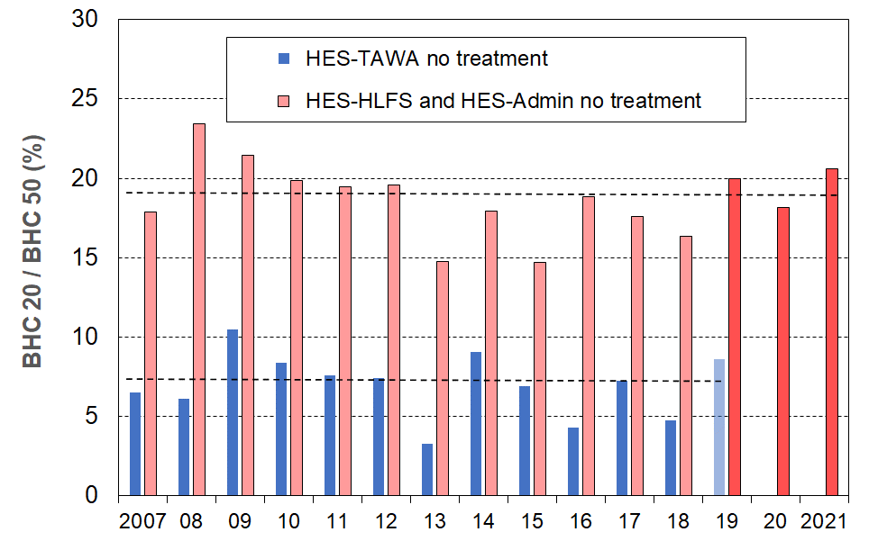**BHC 20 to BHC 50 ratios (as a %) for children in their households**

Note for chart: The horizontal dashed lines are drawn at the average of each of the two sets of rates to give an idea of the difference between them.

**Table N.1** applies the BHC VLI threshold used in the main analysis in the report – $8000 pa in constant $2007 over the whole period 2007 to 2021. This equates to close to $10,000 pa in nominal terms for HES 2018-19. It is included here for reference and to give context for Figure N.1.

**Table N.1**

**BHC equivalised disposable household income medians and VLI thresholds,**

**HES 2006-07 to 2020-21**

|  |  |  |  |  |  |  |  |  |
| --- | --- | --- | --- | --- | --- | --- | --- | --- |
|  | **2007** | **08** | **09** | **10** | **11** | **12** | **13** | **14** |
| BHC median ($nominal) | 26,548 | 28,158 | 29,908 | 30,286 | 30,931 | 31,597 | 32,409 | 34,477 |
| 20% of BHC median | 5,310 | 5,632 | 5,982 | 6,057 | 6,186 | 6,319 | 6,482 | 6,895 |
| 50% of BHC median | 13,274 | 14,079 | 14,954 | 15,143 | 15,465 | 15,798 | 16,205 | 17,239 |
| $8,000 ($07) in nominal $ | 8,000 | 8,251 | 8,521 | 8,679 | 9,009 | 9,207 | 9,279 | 9,425 |
| $8,000 ($07) as % of median | 30 | 29 | 28 | 29 | 29 | 29 | 29 | 27 |

|  |  |  |  |  |  |  |  |  |
| --- | --- | --- | --- | --- | --- | --- | --- | --- |
|  | **14** | **15** | **16** | **17** | **18** | **19** | **20** | **2021** |
| BHC median ($nominal) | 34,477 | 35,978 | 35,729 | 38,176 | 39,913 | 40,698 | 41,595 | 43,903 |
| 20% of BHC median | 6,895 | 7,196 | 7,146 | 7,635 | 7,983 | 8,140 | 8,319 | 8,781 |
| 50% of BHC median | 17,239 | 17,989 | 17,865 | 19,088 | 19,956 | 20,349 | 20,797 | 21,951 |
| $8,000 ($07) in nominal $ | 9,425 | 9,484 | 9,517 | 9,649 | 9,794 | 9,965 | 10,150 | 10,341 |
| $8,000 ($07) as % of median | 27 | 26 | 27 | 25 | 25 | 24 | 24 | 24 |

See **Section O** for a detailed discussion of the VLI issue.

**Section O**

**Households with very low incomes: Implications for measurement and the rationale for the treatment applied in this report**

This report uses household income, adjusted for household size and composition, as a proxy measure of household financial resources, with low household income used as a measure of (income) poverty. This is a standard approach used by OECD and EU nations. While there are some well-known challenges and limitations for this approach as outlined in Section A and discussed in more detail in Section M, it performs well enough for many purposes when it is understood as a rough and ready guide to a household’s consumption possibilities. For example, even though there is variation in measured material wellbeing at any given income level, looking across the income spectrum the lower the household income the lower on average are the material living standards of these households. [114]

There is however a small group of households at the lower end of the distribution[115] for most of whom there is a strong divergence from the usual average relationship between household income and consumption / material wellbeing. This divergence can be shown in a number of ways. **Figure O.1** shows two of these, using HES 2018-19 data:

* total household expenditure (as a proxy for consumption) for unequivalised household income ventiles for the whole population
* material wellbeing for equivalised household income ventiles for under 65s[116] (material wellbeing measured using the average Material Wellbeing Index scores in each ventile).

**Figure O.1**

**Household spending for all ages and MWI scores for under 65s across the household income spectrum:**

**Evidence of significant divergence for a small group of households with very low incomes (HES 2018-19)**

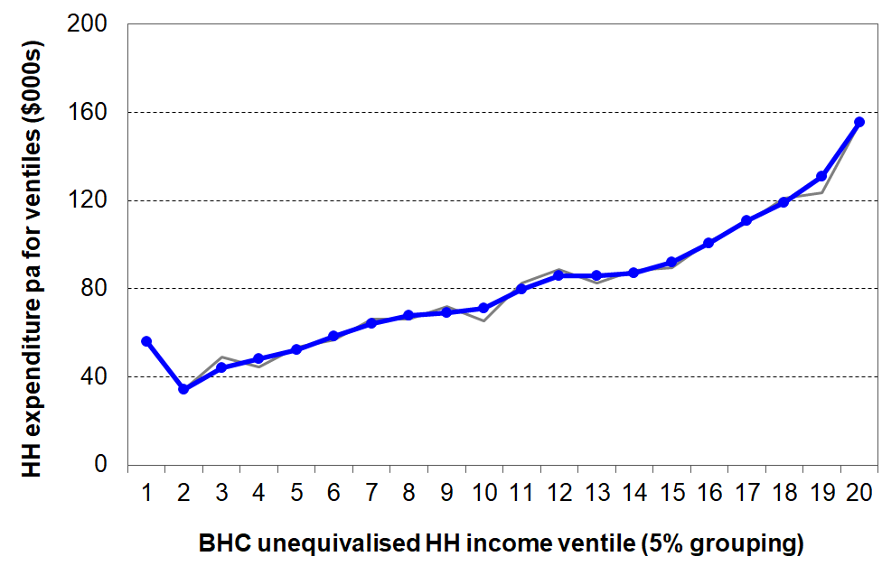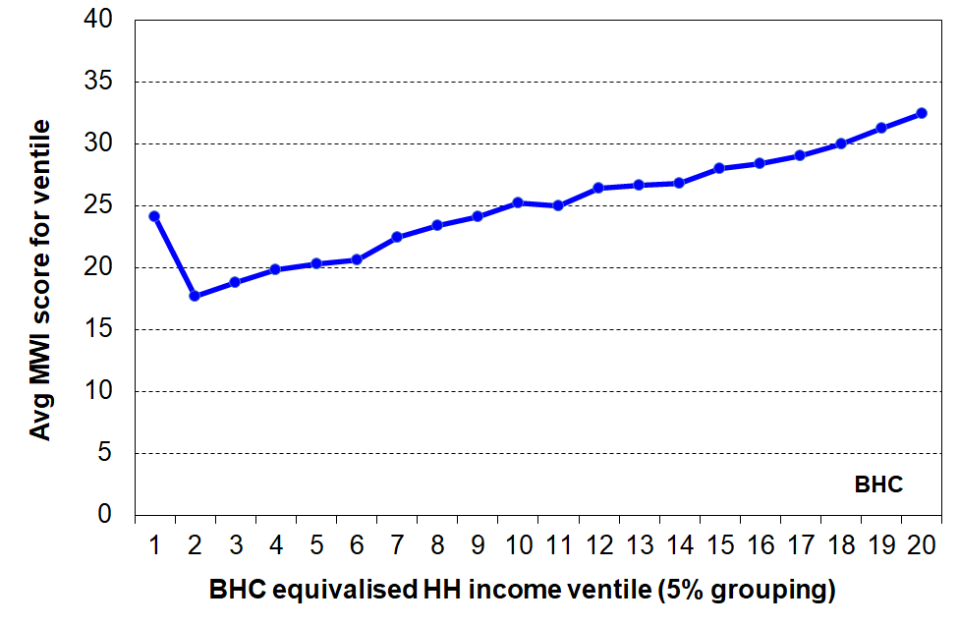 **Expenditure (all ages) MWI (under 65s)**

The incomes of the households in the divergence zone are extremely low (mostly well under 20% of the median, and well below all safety net income support levels), yet they have reported expenditure more like those in the 3rd and 4th deciles and material wellbeing scores that are more like the average for those with incomes around the median.

The existence of the ‘tick’ at the lower end of the household income distribution when reporting on the material wellbeing of these households is not unique to New Zealand data. For example, Brewer et al (2017) provide a comprehensive analysis of UK data in relation to the divergence, reporting the same ‘tick’ relationship as in Figure O.1.

Nor is it a new phenomenon for HES data. Using the HES-TAWA data up to HES 2017-18, earlier MSD reports have noted the ‘tick’ over many years and incorporated it into discussion of ‘noise at the very low end of the income distribution’, and as a motivation to design and apply various treatments to the data to reduce distortion and the risk of publishing misleading findings.[117] What is new is that the size of the group in the divergence zone is much larger in the HES-Admin datasets which rely in the main on administrative data for income information. The increased proportion is especially noticeable for households with children. The divergence is no longer just a nuisance which can be addressed in a low-key way: it is now a significant distortionary issue that when untreated can easily lead to misleading findings for several key statistics.

The two charts below (**Figs O.2** and **O.3**) illustrate the increase in size and impact of this very-low-income (VLI) group starting in HES 2018-19.

When compared with the previous HES-TAWA data, the 2018-19 HES-Admin data has a much larger proportion (%) of decile one households with reported spending more than 3x their income. The proportion has almost trebled, from around 15% on average for HES-TAWA to close to 40% for HES-admin.

**Figure O.2**

**Proportion (%) of decile one households with reported spending more than 3x their income**

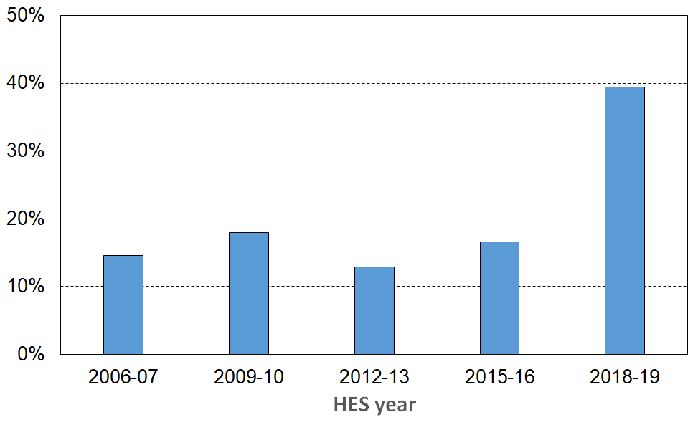 **is much higher in HES 2018-19**

**Figure O.3** compares the number of children under a BHC 20 low-income line with the number under the BHC 50 line for HES-TAWA data and for HES-Admin data (2018-19 and later). The BHC 20 threshold is well below income support levels. The proportion in these VLI households in the HES-Admin data is very high in itself (~19%) and is almost three times those in the HES-TAWA data.[118]

**Figure O.3**

**The number of children in households with incomes below BHC 20**

**as a proportion (%) of all children in households with incomes below BHC 50**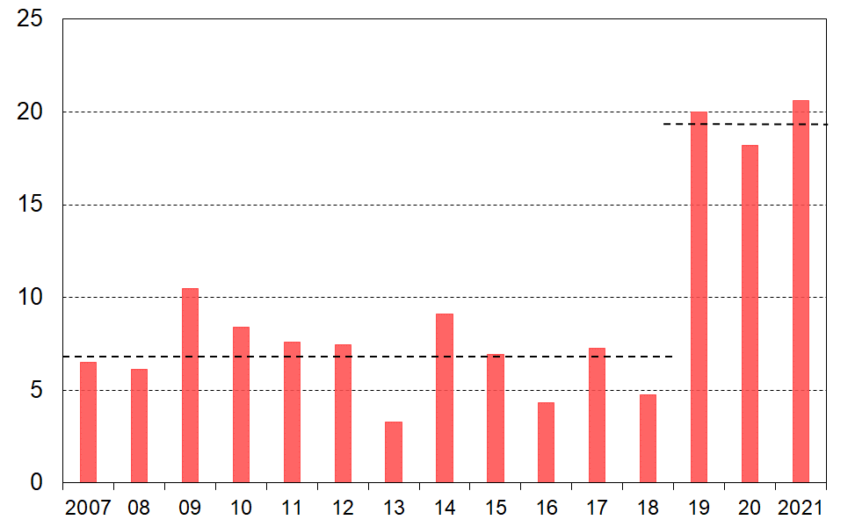

**Defining VLI households, and comparing their material wellbeing with that of ‘normal’ low-income households and with that of middle-income households**

For the purposes of the formal analysis for this report, households are classed as VLI (BHC) if their equivalised BHC household income is under $8000 pa (in 2007 dollars), and VLI (AHC) if their equivalised AHC income is under $4000 pa (in 2007 dollars). The VLI threshold for BHC incomes (~24% of the median in the HES-Admin years) is well below the incomes of beneficiary households with children which are typically in the range of 50% to 75% of the median depending on where the household lives and what Accommodation Supplement support they are entitled to.

The VLI thresholds for two example households with children are given below in ordinary (non-equivalised) dollars to provide an indication of the (seriously low) level of the VLI threshold. The example households are: one parent plus one dependent child under 15 and two-parent plus two dependent children under 15.

BHC $8k ($07) equivalised is around $10k in $2022:

for a (1,1) HH, this is around $13k pa ($250pw)

for a (2,2) HH around $21k pa ($400 pw).

* These are well below BHC incomes from core benefits plus WFF and AS, which are around $42k and $56k pa respectively for the example families above, if living in South Auckland.
* AHC $4k ($07) equivalised is just under $5k in $2022:
  + for a (1,1) HH, this is around $6k pa ($125pw)
  + for a (2,2) HH around $10k pa ($200 pw).

**Tables O.1a** and **O.1b** show the size of the VLI groups (as defined above) for both BHC and AHC incomes for HES 2017-18 and HES 2018-19.

**Table O.1a**

**Size of the VLI group, numbers and proportions of individuals, HES 2017-18**

|  |  |  |  |  |
| --- | --- | --- | --- | --- |
|  | **BHC** | | **AHC** | |
|  | numbers | % of all | numbers | % of all |
| All Individuals | 81,000 | 1.7 | 170,000 | 3.6 |
| Children (age 0-17) | 14,000 | 1.2 | 37,000 | 3.3 |

**Table O.1b**

**Size of the VLI group, numbers and proportions of individuals, HES 2018-19**

|  |  |  |  |  |
| --- | --- | --- | --- | --- |
|  | **BHC** | | **AHC** | |
|  | numbers | % of all | numbers | % of all |
| All Individuals | 155,000 | 3.2 | 255,000 | 5.3 |
| Children (age 0-17) | 38,000 | 3.3 | 61,000 | 5.4 |

Note: see text above the tables for VLI thresholds used in this report

**VLI BHC threshold: BHC 20 or $8000 (in 2007 dollars)?**

$8000 (in 2007 dollars) is the main BHC VLI threshold used. The BHC 20 threshold is used in a couple of places in the report as it provides an alternative easy-to-understand perspective that is close to that produced by the $8000 pa (in $2007). BHC 20 is used for **Figures N.1** and **O.3** above and they show that just under 20% of children in households below the BHC 50 threshold are in BHC 20 VLI households in 2018-19. **Table O.3** shows 24% for this statistic when using the $8k (in $2007) VLI threshold which is around 24% of the median in 2018-19. Both thresholds are well below the BHC incomes of beneficiary households with children which are typically in the range of 50% to 75% of the median. The general findings in Sections N and O are the same whichever threshold is used.

VLI households differ from ‘normal’ low-income households on two counts:

* The incomes are extremely low, well below all safety net income support levels – for this report, under ~20% of the BHC median.
* The bulk of these VLI households report a good to very good material standard of living, much better than those in the ‘normal / less extreme’ low-income range, and more like those in the middle of the income distribution.

**Figure O.4**

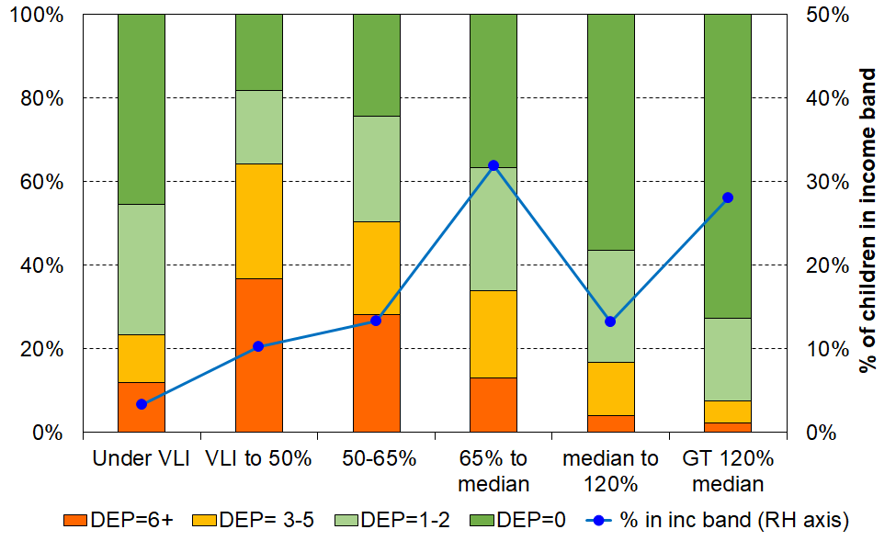**Material wellbeing / hardship for children in the VLI group compared with those in other income bands, HES 2018-19**

**Table O.2** gives the numbers used to create Figure O.4 above, with a comparison of VLI numbers for HES 2017-18:

* The number of children in VLI households in 2018-19 is almost 3x the number in 2017-18
* For 2018-19, children in VLI households make up around 24% of all under BHC 50, compared with 9% for 2017-18.
* The numbers of children in hardship in the VLI group (DEP=6+/17, shaded cells) are much the same for the two years, but the number in better-off households is much larger for the 2018-19 HES.

**Table O.2**

**Material wellbeing / hardship numbers for children in the VLI group compared with those in other income bands for 2018-19 HES, with a comparison of VLI numbers for 2017-18**

|  |  |  |  |  |  |  |  |
| --- | --- | --- | --- | --- | --- | --- | --- |
|  | **HES-TAWA 2017-18** | **HES-Admin 2018-19** | | | | | |
|  | **< VLI** | **< VLI** | **VLI to BHC 50** | **BHC 50 to 65%** | **65% to median** | **median to 120%** | **>120% median** |
| **DEP = 0** | 6,200 | 17,000 | 21,100 | 36,600 | 132,400 | 84,000 | 231,300 |
| **DEP = 1-2** | 2,200 | 11,800 | 20,500 | 38,100 | 106,200 | 40.000 | 62,400 |
| **DEP = 3-5** | 1,400 | 4,300 | 32,000 | 33,400 | 75,700 | 19.300 | 17,100 |
| **DEP = 6+** | **3,900** | **4,500** | 42500 | 42,500 | 47,100 | 5,800 | 7,000 |
| **Total** | 14,000 | 38,000 | 116,000 | 150,700 | 361,400 | 149,100 | 318.000 |

**Table O.3** elaborates on the material wellbeing / hardship comparisons summarised in Figure O.4. They show in more detail the relatively good material living standards of the VLI group compared with those with more ‘normal’ low-incomes in bands up to the median.

For example:

* only 12% of children in VLI households are in hardship, a much lower hardship rate than those in the VLI to BHC 50 zone (37%)
* 54% of VLI households with children say they have enough or more than enough money for the basics – this is higher than for those with incomes around the median.

**Table O.3a**

**Selected characteristics of the very-low-income group (for all individuals in their households)**

**compared with other low-income and low-to-middle income households and the population overall**

**HES 2018-19 (%)**

|  |  |  |  |  |  |
| --- | --- | --- | --- | --- | --- |
| **HES 2018-19 (no treatment)** | **<8k ($07)** | **8k to 50% BHC** | **50% BHC to 65%** | **65% BHC to median** | **Total popln** |
| % in each income group (individuals in their households) | 3 | 8 | 13 | 26 | 100 |
| % in each income group (households) | 4 | 9 | 16 | 23 | 100 |
| % of all individuals in households below the BHC50 low-income line who are in VLI households | 29 | n/a | n/a | n/a | n/a |
| DEP-17 = 6+/17 | 9 | 28 | 17 | 11 | 9 |
| Used foodbanks (at least once in 12 months prior to interview) | 4 | 19 | 11 | 5 | 5 |
| Income adequacy (enough or more than enough) | 58 | 34 | 45 | 52 | 62 |
| DEP 17 = 0 | 53 | 28 | 40 | 42 | 54 |
| Can pay unexpected unavoidable $1500 bill within a month without borrowing | 62 | 32 | 45 | 47 | 57 |
| Median housing costs | $17,000 | $8,000 | $8,000 | $18,000 | $18,000 |

Notes: The income bands are based on the count of individuals in their households as is standard practice for low-income (poverty ) measurement. The analysis unit is also the individual. Using the household as the analysis unit makes very little difference to the numbers.

$8k in $2007 is around $10k in $2022.

**Table O.3b**

**Selected characteristics of the very-low-income group (for 0-17s in their households)**

**compared with other low-income and low-to-middle income households and the population overall**

**HES 2018-19 (%)**

|  |  |  |  |  |  |
| --- | --- | --- | --- | --- | --- |
| **HES 2018-19 (no treatment)** | **<8k ($07)** | **8k to 50% BHC** | **50% BHC to 65%** | **65% BHC to median** | **Total popln** |
| % in each income group (0-17s in their households) | 3 | 10 | 13 | 32 | 100 |
| % in each income group (households with 0-17s) | 3 | 8 | 11 | 31 | 100 |
| % of all children (0-17 yrs) in households below the BHC50 low-income line who are in VLI households | 24 | n/a | n/a | n/a | n/a |
| DEP-17 = 6+/17 | 12 | 37 | 28 | 13 | 13 |
| Used foodbanks (at least once in 12 months prior to interview) | 8 | 28 | 19 | 6 | 8 |
| Income adequacy (enough or more than enough) | 54 | 28 | 36 | 48 | 56 |
| DEP 17 = 0 | 45 | 18 | 24 | 37 | 46 |
| Can pay unexpected unavoidable $1500 bill within a month without borrowing | 55 | 21 | 28 | 40 | 50 |
| Median housing costs | $22,000 | $13,000 | $17,000 | $21,000 | $21,000 |

Notes: As per Table O.3.

**The VLI issue in practice – why it needs addressing**

Left untreated or unresolved at the source, the datasets with high proportions of VLI households risk producing misleading findings in relation to (income) poverty levels, poverty depth, descriptions of ‘life below the poverty line’, housing outgoings-to-income ratios (OTIs), and so on. Some examples of these issues are given below. More examples are provided later in this section (Section O) when the treated and untreated results are reported together for various statistics.

**Figure O.5** shows that the average hardship rate for children in households below the 40% AHC threshold is lower than for those in ‘higher’ low-income households, 40-50% AHC.[119] This is not only incongruous in itself (it is at odds with the declared use of household income as a proxy for household consumption possibilities and material living standards), but it also impacts on the descriptions of what life is like for children in households with incomes ‘below the line’, a central theme of this report.

**Figure O.5**

**Material hardship rates (%) of children in selected AHC household income bands:**

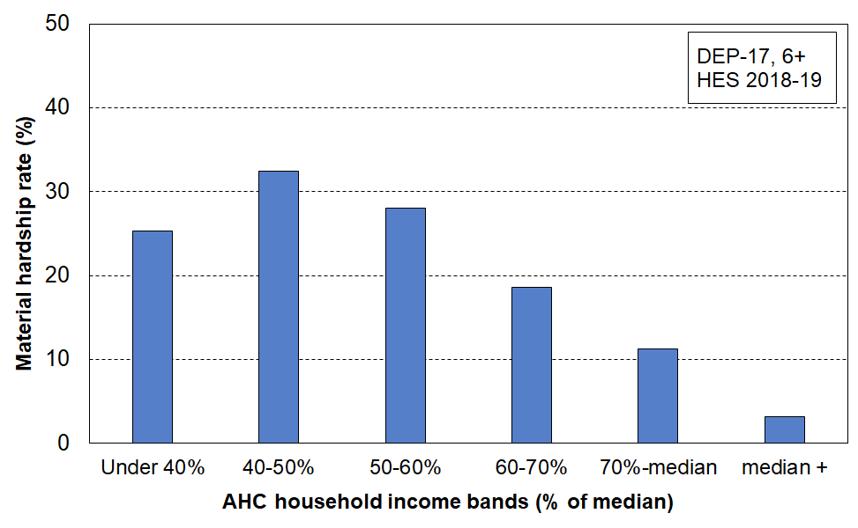**HES 2018-19**

**Figure O.6** uses a suite of 18 essential child-specific and general household items to show what life is like for children in different parts of the AHC household income (see **Table C.2** for the list of items used). The untreated data makes it look as if the lower 10% of households with children have hardship rates more like those just below the median, and certainly they have much better living standards on average than those in the second decile. Even when ventiles (5% groupings) are used (not shown), both the lower two ventiles are reported as better off than those in households with higher income. This is not usable information.

**Figure O.6**

**Multiple deprivation for children using 18 essential child-specific and general household items,**

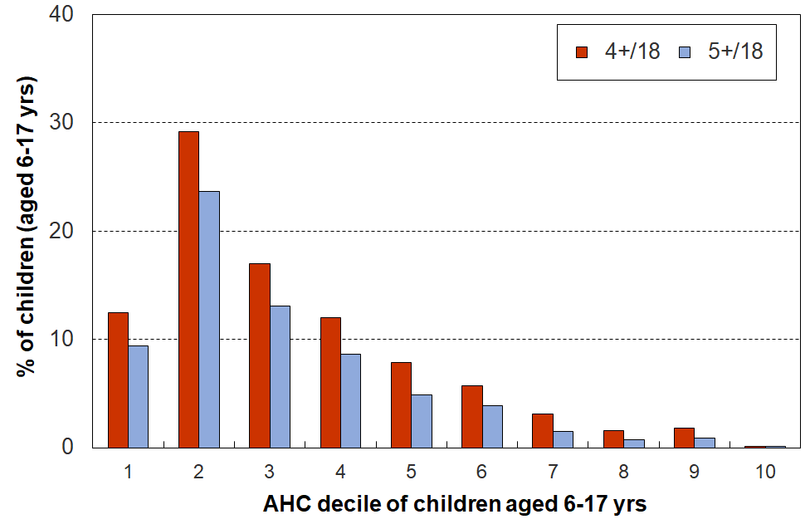**HES 2018-19**

**Figure O.7** shows the trend in housing affordability pressure for low-income (Q1) households with children, using a housing-outgoing-to-income ratio (OTI) of greater than 50% (ie those spending more than half their income on housing). Left untreated, the figures are likely to be interpreted as showing a very large increase in housing stress for low-income (Q1) households with children, and the stress is continuing to rise strongly above previous levels. If correct, this has significant policy implications.

From the analysis already reported we know that the HES-Admin data has significantly more VLI households than the HES-TAWA data. This, rather than a real-world change, is likely to have driven the reported increase. It is possible that the HES-TAWA data understates the OTIs, but even if this were shown to be the case, the proportion of VLIs in the HES-Admin data creates too much noise in itself to support the use of those datasets for producing believable and valid OTIs in their own right, especially for low-income households – which is precisely where the policy focus and public interest lies.

Later in this section, this chart is repeated with the report’s treatment applied (see **Figure O.11**)

**Figure O.6**

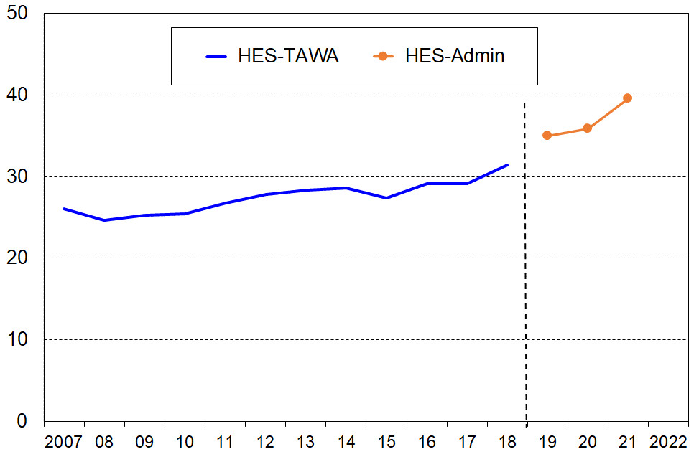**Proportion (%) of low-income (Q1) households with children with OTIs greater than 50%**

Notes for graph:

Households with zero or negative incomes are excluded as an infinite or negative OTI ratio has no practical meaning. This conservative treatment is applied to both HES-TAWA and HES-Admin data.

The 2009 to 2018 trend line is smoothed using a rolling three-year average.

A fourth example is poverty depth. A common measure of (income) poverty depth is the difference between the poverty line and the median income of those below that line expressed as a proportion (%) of the income at the poverty line (eg BHC 50, BHC 60). A median poverty depth of 20% when using BHC 50 means that the median income of those below the poverty line is 20% less than the poverty line itself. The higher the percentage the larger the poverty depth. This measure is quite sensitive to the degree of noise at the lower end of the distribution, and there is therefore some hesitance about using it. It is nevertheless used by the EU in its formal monitoring regime and in international league tables by agencies such as UNICEF.

For poverty depth analysis it is common to apply at least some light treatment such as the exclusion of all households with negative or zero income. For the five years from 2013-14 to 2017-18, using this light touch treatment drops the average HES-TAWA median poverty depth for BHC 50 by around 0.5 percent points to 18.8%. The three-year average for HES-Admin 2018-19 to 2020-21 drops by around 1.5 ppt to 21.7%.

When the report’s full treatment is applied the median poverty depth ratio for the five HES-TAWA years for BHC 50 drops (a further) 1.5 ppt to 17.4%. For 2018-19 to 2020-21 (HES-Admin) the full treatment shifts the reported median depth ratio down by around a further 4.5 ppt, with the treated average being 17.4%, close to the same as for the last five HES-TAWA years.

[The BHC 50 mean poverty depth ratio is even more substantially reduced by the report’s treatment for the HES-admin years, from 40% with no treatment at all, to 30% when deleting negatives and zeroes to 20% with the full treatment applied.]

Using the average for the not-fully-treated HES-Admin data (21.7%) makes New Zealand’s international ranking above the EU/OECD median (ie more inequality at the very bottom), rather than below it at 17.4% after full treatment.[120]

UNICEF’s Report Card #10 has results for around 2012. If the same range of depth ratios still holds internationally, then using the untreated HES-Admin numbers (at least 21.7%) puts New Zealand above the EU/OECD median (ie more unequal at very low incomes), whereas for the treated version (17.4%), well below. The main point is that a 4.5 or 6.0 ppt difference (depending on starting point) is a very large difference and leads to quite different storylines about New Zealand’s poorest children relative to those in other similar countries.

A fifth example relates to the validity and credibility of the low-income rates produced from current HES-Admin data, when there is no treatment of the VLI issue. As shown in **Figure O.3** above, around one in five children (19%) who were identified as in households below the BHC 50 line are actually below BHC 20.[121] Some are expected in that very low income region (eg some self-employed, some whose household has changed over the 12 months before the interview, some recent immigrants with part-year income), but one in five is too high to be acceptable. The HES-TAWA series typically reported around one in 14 (7-8%) in the VLI zone. Irrespective of whether the HES-TAWA or HES-Admin data is assessed as ‘better’, what is clear is that the HES-Admin data has too high a proportion of VLI households to allow reliable and valid reporting when the focus is on low-income analysis such as BHC 50, AHC 40, housing affordability for low-income households and so on.

Stats NZ are aware of the VLI issue in relation to how it may possibly impact on the child poverty rates they report on in the context of the requirements of the CPRA, and also more generally for the way the presence of these extreme incomes can impact other information based on the HES. They are carrying out further investigation, especially for HES 2018-19 and later.

In the Technical Appendix for the February 2022 release of Child Poverty Statistics[122] they report on some of the results of their investigation to date, noting that for the VLI households with children some 80% have at least one person employed (including self-employed), yet many have no source of income in the data while reporting adequate income for basic needs.[123]

“This [analysis] suggests there may be a problem with the wages and salaries data for these households. Either we haven’t correctly linked[124] to their income data, their wages and salaries are not in the tax system, or their employment status has been misclassified (for example, as employees when they are self-employed).

We have decided at present that we will not apply any treatment when producing poverty rates to try and correct for this group of people with very low income. However, users of the data should be aware of this issue when analysing this end of the distribution and may want to apply their own treatment depending on the purpose of their analysis. We will continue to investigate what is driving what we observed and to further improve the dataset.”

**The treatment of VLI households used in this report**

MSD’s reports have applied various treatments for the VLI issue in the past to seek to reduce the distortion for particular statistics such as decile shares and other income inequality measures, measures of poverty depth, measures of housing affordability using outgoing-to-income measures, and when examining the overlap between income and non-income measures of poverty (a major theme of this report).

One treatment involved using reported household spending to impute a more realistic income for the VLI households, and another simply deleted households with incomes under a selected very low level of a few thousand dollars per annum. The expenditure treatment is available only every third year (starting with 2006-07) so has limitations for time series. Deletions based purely on income (eg ‘remove the bottom N%) can open the analysis to the charge that it potentially eliminates from the dataset some households that are genuinely in poverty, thus under-estimating the level of need.

The VLI issue is widely recognised, and various treatments have been adopted by researchers and some government reporting agencies (both in New Zealand and internationally). Some examples are outlined in the box on page 172 below.

The four starting points for designing the treatment for this report were that:

* Household income is being used as a proxy for the household financial and physical resources that generate the household’s material living standards, and households with extremely low incomes clearly breach this underlying assumption – others may do too, but the goal is significant noise reduction at the very low end, not complete noise elimination which is not possible.
  + Households with zero or negative household incomes clearly breach the assumption.
  + VLI households that report reasonable living standards or better also breach the assumption above.
* The relatively large proportion of VLI households in the HES-Admin series (see Figure O.3 and Table O.1 above) increases the chance of producing incongruous findings when using non-monetary indicators to describe ‘life below the line’ (a major aspect of the early sections of this report). Treatment is not a ‘nice-to-have’, it’s an essential if the reporting is to have credibility and congruence.
* The profile of the VLI households in HES-Admin:
  + a greater proportion of households with children compared with HES-TAWA, and a considerable number of children *per se* when compared with the total number under BHC 50 (a primary CPRA measure)
  + a greater proportion of VLI households with at least one full-time worker in HES-Admin than in HES-TAWA, and the number *per se* is unexpectedly high (ie it’s not ‘just’ or mainly a ‘self-employed’ issue).[125]
* In addition, a usable treatment for this report needs to be applicable to the HES-TAWA datasets that MSD holds, so that for time series and reporting and other comparisons involving both datasets it’s closer to an apples-with-apples comparison between the two, even if a break in the time series has to be declared. The treatment should be able to be applied back to 2006-07, and longer if possible.

For this report, households are removed according to the following rules. The treatments are designed to at least partially address the distortions produced by the presence of VLI households:

* for BHC income analysis (61,000 HHs (3.4%) removed in 18-19):
  + households with negative or zero BHC income
  + households with equivalised BHC incomes less $8k ($2007) reporting housing costs greater than or equal to their BHC income (ie low BHC income with negative or zero AHC incomes)
  + households with equivalised BHC incomes less than $8k ($2007) and who report ‘enough or more than enough’ income for basics.
* for AHC analysis (78,000 HHs (4.4%) removed in 18-19)
  + households with negative or zero BHC income
  + households with equivalised BHC incomes less $8k ($2007) reporting housing costs greater than or equal to their BHC income (ie low BHC income with negative or zero AHC incomes)
  + households with equivalised AHC incomes less than $4k ($2007) and who report ‘enough or more than enough’ income for basics.
* No removals are needed for material hardship reporting except where both income and material hardship are used together, in which case the relevant income deletions are applied.

The treatment applied should be considered interim and better than not doing it at all for the purposes of this report. MSD’s view is that it is not however adequate for CPRA purposes but is a contribution to the further work being done on that. Using a medical analogy, the current treatment dulls the pain to some degree, but not fully, and ideally a better understanding of the cause or causes of the pain should be established and addressed as well as possible, even if some relief of residual symptoms is still required.

**In summary, the report’s treatment for household incomes analysis is as follows:**

* Delete all households with zero or negative BHC income
* Delete all BHC VLI households with zero or negative AHC income (ie those low-income households whose housing costs are greater than or equal to their BHC income)
* Delete BHC (or AHC) VLI households who report enough or more than enough income for basics

The three deletion sets overlap – they are not mutually exclusive. For example:

* 50,000 of the 61,000 removed by applying the BHC treatment are also removed using the AHC treatment
* 27,000 more with very low AHC incomes are removed by the AHC treatment on its own.

**Table O.4a** gives the numbers of BHC and AHC households and individuals removed by the treatment. **Table O.4b** gives an idea of the size of the removals relative to the population as a whole and to the bottom deciles (BHC and AHC), and **Table O.4c** shows the size of the removals as a proportion (%) of the bottom income decile and of all those in the VLI category.

**Table O.4a**

**Numbers of VLI households and individuals removed by the treatment,**

**HES 2018-19**

|  |  |  |  |  |  |  |
| --- | --- | --- | --- | --- | --- | --- |
|  | **BHC** | | | **AHC** | | |
|  | Before | After | Removed | Before | After | Removed |
| All households | 68,000 | 7,000 | 61,000 | 109,000 | 31,000 | 78,000 |
| Households with children | 18,000 | 2,000 | 16,000 | 32,000 | 11,000 | 21,000 |
| All individuals | 155,000 | 18,000 | 137,000 | 255,000 | 76,000 | 179,000 |
| Children (0-17 yrs) | 38,000 | 5,000 | 33,000 | 61,000 | 20,000 | 41,000 |

**Table O.4b**

**Numbers of VLI households and individuals removed by the treatment,**

**compared with total population and with bottom income deciles,**

**HES 2018-19**

|  |  |  |  |  |  |  |
| --- | --- | --- | --- | --- | --- | --- |
|  | **BHC** | | | **AHC** | | |
| (numbers) | All before removal | Bottom decile before removal | # Removed | All before removal | Bottom decile before removal | # Removed |
| All households | 1,755,000 | 175,500 | 61,000 | 1,755,000 | 175,500 | 78,000 |
| Households with children | 604,000 | 48,500 | 16,000 | 604,000 | 50,000 | 21,000 |
| All individuals | 4,855,000 | 485,500 | 137,000 | 4,855,000 | 485,500 | 179,000 |
| Children (0-17 yrs) | 1,133,000 | 133,500 | 33,000 | 1,133,000 | 124,500 | 41,000 |

Note: For the whole population, whether households or individuals, the bottom income decile has 10% of the population numbers in it. For households with children, the numbers in the bottom decile are a little less than 10% and for children themselves the bottom decile has a little more than 10% of children in it. This suggests that VLI households with children have on average more than the average number of children.

**Table O.4c**

**Proportion (%) of households and individuals removed by the treatment,**

**compared with bottom income deciles and with total VLI numbers,**

**HES 2018-19**

|  |  |  |  |  |
| --- | --- | --- | --- | --- |
|  | **BHC** | | **AHC** | |
| (percentages) | VLI numbers as % of bottom decile numbers | Removed as % of VLI | VLI numbers as % of bottom decile numbers | Removed as % of VLI |
| All households | 35 | 90 | 44 | 71 |
| Households with children | 33 | 88 | 41 | 65 |
| All individuals | 28 | 88 | 37 | 70 |
| Children (0-17 yrs) | 25 | 87 | 33 | 67 |

**Examples of treatments used by others**

Reports and studies that (include a) focus on the low-income zone of the distribution show a range of responses to the extremely-low-income issue. Some simply ignore it or accept it as unfortunate noise. Others conclude that it is mainly an issue about the reporting of income for the self-employed: this is certainly a factor, but is only a part of the story.

The Australian Bureau of Statistics (ABS) has recognised the issue for many years in its Household Incomes Reports, and has recently changed from its earlier approach of using only deciles 2 and 3 to describe ‘low income’ (a very blunt treatment) to now using an adjusted low-income quintile which excludes households with incomes in the lowest 2%. The ABS does not however use this modified dataset to report on low-income rates (‘income poverty’). Davidson et al (2020), in a joint Australian Council of Social Services / University of New South Wales report provide low-income rates for Australia using ABS data. They exclude from the survey sample households reporting zero or negative incomes and self-employed households, ‘since their reported incomes are not good indicators of their living standards’.

The UK recognises the issue, and in their main Household Below Average Income reports they italicise the BHC 50 rates to remind readers of the extra uncertainty when using this low-income threshold. They also note that ‘[h]ouseholds reporting the lowest incomes may not have the lowest living standards. The bottom 10 per cent of the income distribution should not, therefore, be interpreted as having the bottom 10 per cent of living standards’. While this is undoubtedly true, it doesn’t say what to do about the matter when using low-income thresholds such as BHC 50 and so on.

In the 1990s, the New Zealand Poverty Measurement Project (NZPMP) recognised the problem, and sought to address it by deleting from the dataset those self-employed who declared losses and those whose expenditure was more than three times their income. The effect of this adjustment to the dataset was to reduce reported poverty rates. In 1991, the deletions reduced the size of the database by 4.4 percentage points, and lowered the overall poverty incidence by three percentage points. See Waldegrave et al (1996).

Recent European research used deletions of all with negative or zero income and all with incomes below BHC 10 for sensitivity testing (Kyzyma, (2020)).

In the context of EU-SILC and comparisons for European countries, Van Kerm (2007) has shown that, depending on the treatment of extreme income values, different poverty estimates are achieved, although the overall ordering of the countries is normally not affected. It is possible that for a given country that while treatment changes the level, the general trend is not affected.

MSD has discussed the issue in Appendix 8 of the Household Incomes Report, and created a plausible interim treatment involving expenditure which it has applied to selected statistics. The result of the treatment is reported in Appendix 9 of the Incomes Report. Since the 2006-07 HES, expenditure has been available only every third year so the treatment has not been able to be used for a full annual time series. For all housing affordability reporting using OTIs, MSD has in the past deleted all households with zero or negative income.

**Impact of the treatment**

**Table O.5** repeats the analysis reported in **Table O.3a** and shows the impact of the treatment on all individuals in the VLI group (see the <8k ($07) column). Table O.1 is repeated here for convenience.

Once the treatment is applied, the material hardship rates, foodbank usage, median housing costs and so on are all in the ‘plausible’ range relative to those in the more normal low-income bands.[126]

**Table O.5**

**(compare with Table O.3a below, repeated here for convenience)**

**Selected characteristics of the very-low-income group (for all individuals in their households)**

**compared with other low-income and low-to-middle income households and the population overall**

**HES 2018-19 (%)**

|  |  |  |  |  |  |
| --- | --- | --- | --- | --- | --- |
| **HES 2018-19 (with treatment)** | **<8k ($07)** | **8k to 50% BHC** | **50% BHC to 65%** | **65% BHC to median** | **Total popln** |
| % in each income group (individuals in their households) | <1 | 9 | 14 | 27 | 100 |
| % in each income group (households) | <1 | 10 | 17 | 24 | 100 |
| % of all individuals in households below the BHC50 low-income line who are in VLI households | 4 | n/a | n/a | n/a | n/a |
| DEP-17 = 6+/17 | 30 | 27 | 17 | 11 | 9 |
| Used foodbanks (at least once in 12 months prior to interview) | 11 | 18 | 11 | 5 | 5 |
| Income adequacy (enough or more than enough) | 0 | 35 | 44 | 53 | 62 |
| DEP 17 = 0 | 18 | 29 | 39 | 43 | 54 |
| Can pay unexpected unavoidable $1500 bill within a month without borrowing | 25 | 33 | 45 | 47 | 57 |
| Median housing costs | $5,000 | $8,000 | $8,000 | $19,000 | $18,000 |

Notes: The income bands are based on the count of individuals in their households as is standard practice for low-income (poverty) measurement. The analysis unit is also the individual. Using the household as the analysis unit makes very little difference to the numbers.

Note that $8k in $07 is around $10k in $2022

The figure in row three of the <8k column (~4%) is calculated using the new median after the treatment is applied.

Because of the targeted deletions in the treatment process, the <8k column has even fewer in it than in the original Table O.1. The numbers should be taken as indicative only rather than as precise estimates. They all move in the right direction vis-à-vis those in Table O.1.

**Table O.3a**

**(repeated here for convenience)**

**Selected characteristics of the very-low-income group (for all individuals in their households)**

**compared with other low-income and low-to-middle income households and the population overall**

**HES 2018-19 (%)**

|  |  |  |  |  |  |
| --- | --- | --- | --- | --- | --- |
| **HES 2018-19 (no treatment)** | **<8k ($07)** | **8k to 50% BHC** | **50% BHC to 65%** | **65% BHC to median** | **Total popln** |
| % in each income group (individuals in their households) | 3 | 8 | 13 | 26 | 100 |
| % in each income group (households) | 4 | 9 | 16 | 23 | 100 |
| % of all individuals in households below the BHC50 low-income line who are in VLI households | 29 | n/a | n/a | n/a | n/a |
| DEP-17 = 6+/17 | 9 | 28 | 17 | 11 | 9 |
| Used foodbanks (at least once in 12 months prior to interview) | 4 | 19 | 11 | 5 | 5 |
| Income adequacy (enough or more than enough) | 58 | 34 | 45 | 52 | 62 |
| DEP 17 = 0 | 53 | 28 | 40 | 42 | 54 |
| Can pay unexpected unavoidable $1500 bill within a month without borrowing | 62 | 32 | 45 | 47 | 57 |
| Median housing costs | $17,000 | $8,000 | $8,000 | $18,000 | $18,000 |

Notes: The income bands are based on the count of individuals in their households as is standard practice for low-income (poverty ) measurement. The analysis unit is also the individual. Using the household as the analysis unit makes very little difference to the numbers.

**Table O.6** (next page) shows the impact on children in VLI households.

**Table O.6**

**(compare with Table O.2 below, repeated here for convenience)**

**Selected characteristics of the very-low-income group (for 0-17s in their households)**

**compared with other low-income and low-to-middle income households and the population overall**

**HES 2018-19 (%)**

|  |  |  |  |  |  |
| --- | --- | --- | --- | --- | --- |
| **HES 2018-19 (with treatment)** | **<8k ($07)** | **8k to 50% BHC** | **50% BHC to 65%** | **65% BHC to median** | **Total popln** |
| % in each income group (0-17s in their households) | <1 | 11 | 14 | 33 | 100 |
| % in each income group (households with 0-17s) | <1 | 9 | 12 | 32 | 100 |
| % of all children (0-17 yrs) in households below the BHC50 low-income line who are in VLI households | 4 | n/a | n/a | n/a | n/a |
| DEP-17 = 6+/17 | 32 | 36 | 28 | 12 | 13 |
| Used foodbanks (at least once in 12 months prior to interview) | 22 | 27 | 19 | 6 | 8 |
| Income adequacy (enough or more than enough) | 0 | 29 | 35 | 50 | 56 |
| DEP 17 = 0 | 8 | 19 | 24 | 38 | 46 |
| Can pay unexpected unavoidable $1500 bill within a month without borrowing | 18 | 22 | 28 | 42 | 49 |
| Median housing costs | $5,000 | $13,000 | $17,000 | $21,000 | $21,000 |

Notes: As per Table O.5

**Table O.2**

**(repeated here for convenience)**

**Selected characteristics of the very-low-income group (for 0-17s in their households)**

**compared with other low-income and low-to-middle income households and the population overall**

**HES 2018-19 (%)**

|  |  |  |  |  |  |
| --- | --- | --- | --- | --- | --- |
| **HES 2018-19 (no treatment)** | **<8k ($07)** | **8k to 50% BHC** | **50% BHC to 65%** | **65% BHC to median** | **Total popln** |
| % in each income group (0-17s in their households) | 3 | 10 | 13 | 32 | 100 |
| % in each income group (households with 0-17s) | 3 | 8 | 11 | 31 | 100 |
| % of all children (0-17 yrs) in households below the BHC50 low-income line who are in VLI households | 24 | n/a | n/a | n/a | n/a |
| DEP-17 = 6+/17 | 12 | 37 | 28 | 13 | 13 |
| Used foodbanks (at least once in 12 months prior to interview) | 8 | 28 | 19 | 6 | 8 |
| Income adequacy (enough or more than enough) | 54 | 28 | 36 | 48 | 56 |
| DEP 17 = 0 | 45 | 18 | 24 | 37 | 46 |
| Can pay unexpected unavoidable $1500 bill within a month without borrowing | 55 | 21 | 28 | 40 | 50 |
| Median housing costs | $22,000 | $13,000 | $17,000 | $21,000 | $21,000 |

Notes: As per Table O.1.

The charts that follow repeat some of the earlier charts that used untreated data to illustrate the VLI issue, this time with the treatment applied.

**Figure O.7** shows the impact of applying the treatment to the ‘tick’ chart reported above in Figure O.1. The relationship between average material wellbeing for AHC income ventiles and the average income in the ventiles falls better into line with the central assumption in this report (and in similar research) that, on average, household income is a good-enough rough-and-ready proxy for material wellbeing.

**Figure O.7**

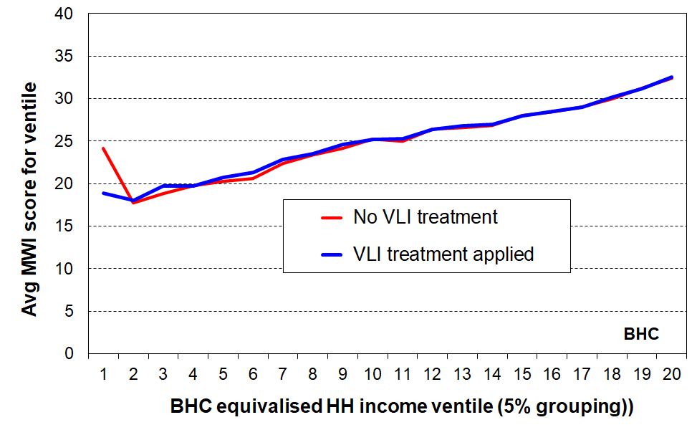**Impact of applying the treatment to the ‘tick’ chart which shows the relationship between household income levels and average MWI scores for under 65s, HES 2018-19**

**Figure O.8** shows the impact of applying the report’s treatment to the BHC 20 to BHC 50 ratio reported above in Figure O.3. The ratios are much more consistent between 2007 to 2018 on the one hand (HES-TAWA) and 2019 to 2021 on the other (HES-Admin) than when left untreated, as well as being much lower and less intrusive for the HES-Admin years.

**Figure O.8**

**The number of children in households with incomes below BHC 20**

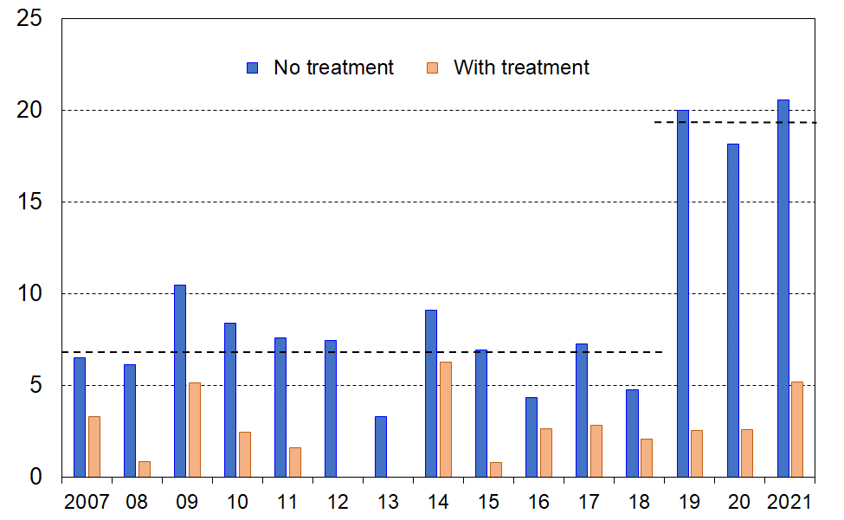**as a proportion (%) of all children in households with incomes below BHC 50: before and after treatment**

**Figure O.9** shows the improvement to reporting on the material hardship rates for selected AHC income bands. In the treated data, households in the ‘under 40% AHC’ zone have material hardship rates similar to those in the 40-50% range. A treated rate of more like 35%+ would have been ideal, .

But at least the material hardship rates of the low-income group is not as low as it was.

**Figure O.9**

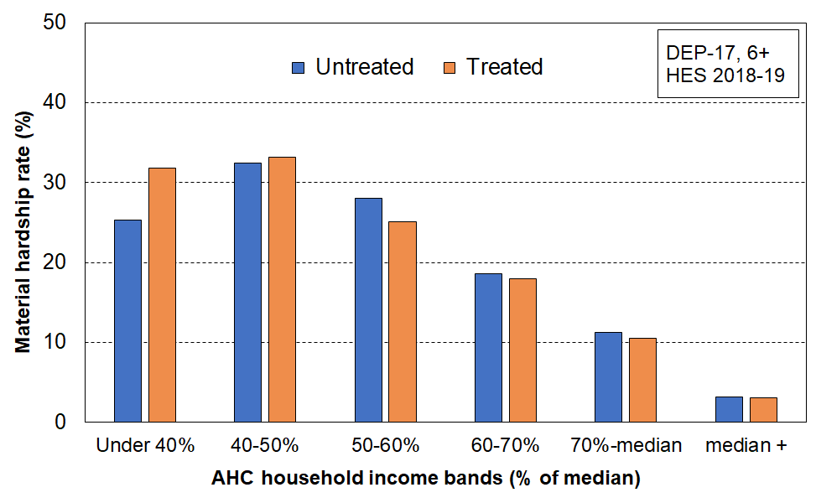**Material hardship rates (%) of children in selected AHC household income bands, HES 2018-19**

**Figure O.10 r**epeats Figure O.5, but with treatment applied. As in Figure O.9, the relationship between AHC income band and material hardship rates is greatly improved, albeit not fully resolved.

**Figure O.10**

**Multiple deprivation for children using 18 essential child-specific and general household items,**

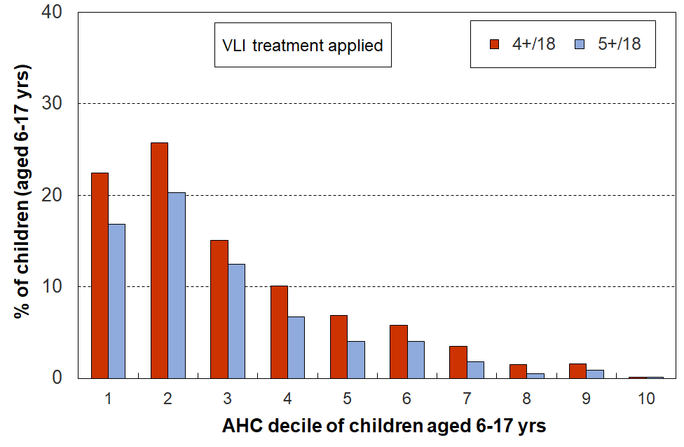**HES 2018-19**

**Figure O.11** shows the trend in housing affordability pressure for households with children, using a housing-outgoing-to-income ratio (OTI) of greater than 50% (ie those spending more than half their income on housing). It repeats the information from Figure O.6 (dashed lines) and adds the trends using the report’s full treatment. As expected from earlier analysis (see, for example, Figures O.3 and O.8), the impact of the treatment is greater on the HES-Admin line than on HES-TAWA line. The treated figures still show a rise (in line with expectations given recent rises in rent), but at a level more in line with previous levels. If the HES-Admin untreated dashed line properly represents reality, it points to the unaffordability situation being even worse than previous information had suggested. The policy implications of the two HES-Admin lines are quite different.

Until the VLI matter is resolved, this report strongly suggests that low-income OTI figures based on untreated HES-Admin data should not be used for policy purposes.

**Figure O.11**

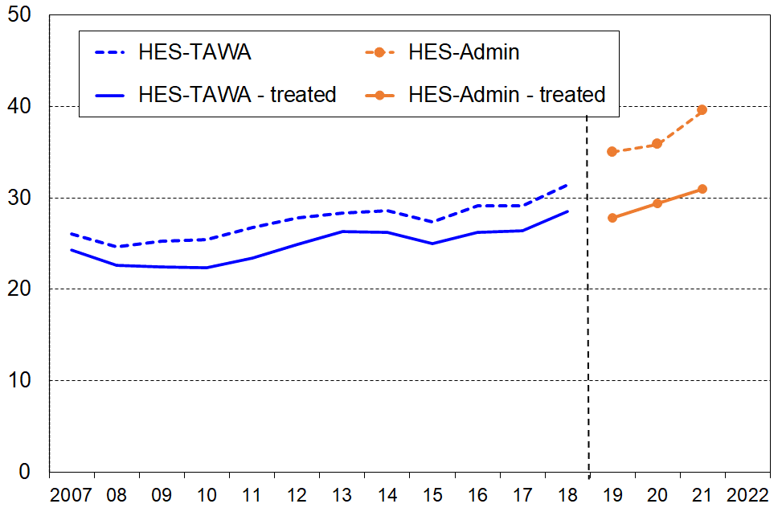 **Proportion (%) of households with children with OTIs greater than 50%**

Notes for graph: .

The dashed lines use datasets with negative and zero incomes deleted as negative or infinite OTIs have no practical meaning.

The solid lines use datasets with the report’s full treatment applied.

The 2009 to 2018 trend line is smoothed using a rolling three-year average.

One of the most important impacts of the treatment relates to estimates of the proportion of children in households under the BHC 50 poverty line, one of the primary measures used in the CPRA suite (ie a measure for which gazetted targets are required to be set). This issue is discussed in the separate sub-section that follows.

**The implications of the VLI issue and of this report’s treatment decision for reporting child poverty rates (BHC 50 and AHC 50)**

**Table O.7** reports the impact on reported child poverty rates of a selection of treatments (BHC 50). Other age-groups are included for comparison of impact.[127]

The treatment in column #2 is the one described above and used in this report. Treatments #3 and #4 are variations on the deletion theme, with #3 being the same as #2 except that the median is held fixed. As discussed above, Treatment #2 is not open to the common criticism of a deletion approach, namely that it might have removed households that are in genuine need. It is in fact conservative and could be questioned on that ground. Treatment #4 (delete bottom 2%) is likely to be seen as too blunt to be useful for child poverty measurement but is useful for illustrative purposes here.

The main alternative to deletion as a treatment approach is to impute. As a part of the investigation into possible treatments MSD increased the equivalised disposable income of the VLI households by $25,000, taking their incomes above the BHC 60 poverty line but still remaining below the median. This is the region on the income distribution where the analysis reported in Figures O.1 and O.4 indicated that there were similarities with the VLI households average expenditure and material wellbeing scores. This approach does not change the median or the BHC 50 threshold, nor does it change the total number of people in the dataset. The drop in reported poverty rates compared with the ‘no treatment’ option arises solely from the reshuffling upwards of the (initially-)VLI households who also report good material wellbeing. It too is included here for illustrative purposes only.

**Table O.7**

**BHC 50 low-income rates by age-group (%), using different treatments to address the issue of**

**very-low-income households with good to very good material wellbeing**

**HES 2018-19**

|  |  |  |  |  |  |
| --- | --- | --- | --- | --- | --- |
|  | **1**  **(no treatment)** | **2**  **(delete using MSD treatment, then recalculate median)** | **3**  **(delete using MSD treatment and hold median the same)** | **4**  **(delete bottom 2% then recalculate the median)** | **5**  **(create modified dataset through an imputation which leaves median unchanged – no deletions)** |
| **0-17 yrs** | 13.5 | 11.8 | 11.0 | 12.5 | 10.7 |
| **18-24** | 11.3 | 9.1 | 8.7 | 10.6 | 8.4 |
| **25-44** | 8.8 | 7.1 | 6.5 | 7.6 | 6.4 |
| **45-64** | 12.4 | 10.1 | 9.5 | 10.8 | 9.2 |
| **65+** | 9.6 | 8.3 | 7.2 | 8.5 | 7.0 |
| **ALL** | 11.2 | 9.3 | 8.6 | 10.0 | 8.4 |

Treatment descriptions for Table O.7:

1. No treatment (negatives are re-set to zero, but this has no impact on low-income rates).
2. After the treatment is applied, the median is recalculated (it increases a little), and the new BHC 50 threshold is applied. This is the main treatment approach used in this report. No re-weighting.
3. As in #2, except that the median and therefore the BHC 50 threshold are held the same as in #1. No re-weighting.
4. All households with incomes in the lower 2 percent of the BHC distribution are deleted. No re-weighting.
5. This is the imputation approach described in the text above the table.

How realistic is a $25k imputation (as above)?

For HES 2018-19, MSD has access to both HES-TAWA (with Treasury weights) and to HES-Admin (with Stats NZ weights). A comparison of the incomes of HES-Admin VLI households with the incomes of these same households in the HES-TAWA data shows that around two-thirds had HES-TAWA incomes more than $10,000 higher than the income in the HES-admin data. Half had incomes more than $20,000 higher. For their 2020 Technical Appendix, Stats NZ looked at households with AHC incomes of less than $4000 in the 2017-18 HES-HLFS dataset and compared survey income with the final admin data. They found that around two-thirds had survey incomes more than $10,000 higher than the admin incomes. [128] This analysis suggests that the $25,000 imputation described for Table O.7 (and Table O.8 below) is not quite as far-fetched as it might seem at first sight.

**Table O.8** reports the impact of the same selection of treatments on reported child poverty rates for the AHC 50 measure. Other age-groups are included for comparison of impact.[129]

**Table O.8**

**AHC 50 low-income rates by age-group (%), using different treatments to address the issue of**

**very-low-income households with good to very good material wellbeing**

**HES 2018-19**

|  |  |  |  |  |  |
| --- | --- | --- | --- | --- | --- |
|  | **1**  **(no treatment)** | **2**  **(delete using MSD treatment, then recalculate median)** | **3**  **(delete using MSD treatment and hold median the same)** | **4**  **(delete bottom 2% then recalculate the median)** | **5**  **(create modified dataset through an imputation which leaves median unchanged – no deletions)** |
| **0-17 yrs** | 20.1 | 18.1 | 17.2 | 19.0 | 16.5 |
| **18-24** | 18.2 | 14.8 | 14.0 | 16.1 | 13.3 |
| **25-44** | 14.6 | 12.3 | 11.7 | 13.0 | 11.3 |
| **45-64** | 16.4 | 13.2 | 12.9 | 14.5 | 12.3 |
| **65+** | 14.1 | 12.3 | 11.5 | 13.6 | 11.2 |
| **ALL** | 16.6 | 14.1 | 13.5 | 15.1 | 13.0 |

Treatment descriptions for Table O.8:

1. No treatment (negatives are re-set to zero, but this has no impact on low-income rates).
2. After the treatment is applied, the median is recalculated (it increases a little), and the new BHC 50 threshold is applied. This is the main treatment approach used in this report. No re-weighting.
3. As in #2, except that the median and therefore the AHC 50 threshold are held the same as in #1. No re-weighting.
4. All households with incomes in the lower 2 percent of the BHC distribution are deleted. No re-weighting.
5. This is the imputation approach described in the text above Table O.7.

**Figure O.12** shows the impact of the report’s treatment decision on the BHC 50 HES-TAWA / HES-Admin time series. There is almost no impact for the HES-TAWA time series (2006-07 to 2018-19), but a substantial downward impact for HES-admin, of the order of 1.5 to 2.0 percentage points. This is consistent with the VLI analysis reported in this Section – in particular, it is consistent with the observations that:

* the proportion of VLI households is higher in HES-Admin (2018-19 to 2020-21) than in recent HES-TAWA years, and that this is especially the case for households with children
* the proportion of VLI households in the bespoke HES-HLFS back series dataset created by Stats NZ (and using administrative data for the bulk of income information) is around the same as for HES-Admin (2018-19 to 2020-21) – see **Figure N.1** which is repeated on the next page for convenience.

**Figure O.12**

**Impact on BHC 50 low-income rates for children (0-17 years) of the treatment used in this report to address the issue of very-low-income households who report good to very good material wellbeing**

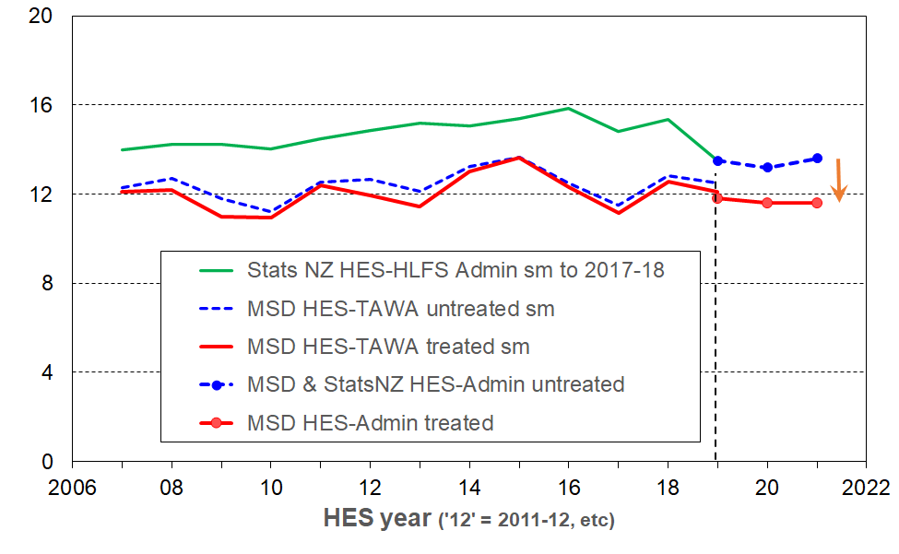**HES 2006-07 to 2020-21**

Notes: ‘sm’ = ‘smoothed’ – in this case, by reporting rolling two-year averages

The vertical broken line indicates that there is a break in the time series from HES-TAWA to HES-Admin (treated or untreated).

See **Section N** for information on the different datasets used in the chart.

The HES-HLFS and untreated HES-Admin lines (green line and blue broken line with year markers) are the official Stats NZ lines, with time series continuity (and smoothed to 2017-18). The analysis in this section suggests that there is a case for a treatment of the data that generates these lines, and that such a treatment would lower the levels each year by 1.5 to 2.0 ppt as it does in 2018-19 to 2020-21. If the treatment were applied across the whole period 2006-07 to 2020-21 the analysis presented in this report (eg Figure N.1) suggests that it is unlikely that the general trend would be changed. [130]

The HES-TAWA data is likely to underestimate low-income rates for at least two reasons (though by how much is not easy to assess):

* the Stats NZ weighting regime that is provided with the HES-TAWA data is known to produce fewer children in beneficiary households than the MSD official counts (this is addressed in the new weighting regime used in HES-HLFS and HES-admin datasets)
* in the estimation of income from Working for Families the TAWA model assumes 100% take-up. This was reasonable given the evidence available at the time, but new recent analysis shows that this is too optimistic for WFF. [131]

Neither of these matters relate to the VLI issue *per se*, but are relevant to the process of working towards a more robust and settled view of trends and levels for low-income rates.

If the proportion of children in VLI households remains the same (currently around 2.5% of all children for each of 18-19, 19-20, and 20-21) then when/if the CPRA ten-year BHC target of 5% is reached, around half would be in VLI households. This presents a real validity / credibility issue. The chance of the size remaining about the same in the future is fairly high. For all of 2007 to 2018, in the special HLFS-HES datasets that Stats NZ constructed to assist with establishing baseline rates for the CPRA target-setting requirement, the proportion of children below BHC 20 was reasonably steady at 2.2 to 2.6%, and the proportion of those under BHC 20 compared to those under BHC 50 was generally reasonably steady around the 19% average as shown in the chart below. Figures N.1 and O.8 have provided support for this assessment, and are repeated here for convenience (Figure O.8 is (re-named here as Figure O.13). [132]

**Figure N.1** (repeated here for convenience)

**BHC 20 to BHC 50 ratios (as a %) for children in their households**

Note for chart: The horizontal dashed lines are drawn at the average of each of the two sets of rates to give an idea of the difference between them.

**Figure O.13** (=Figure O.8 above)

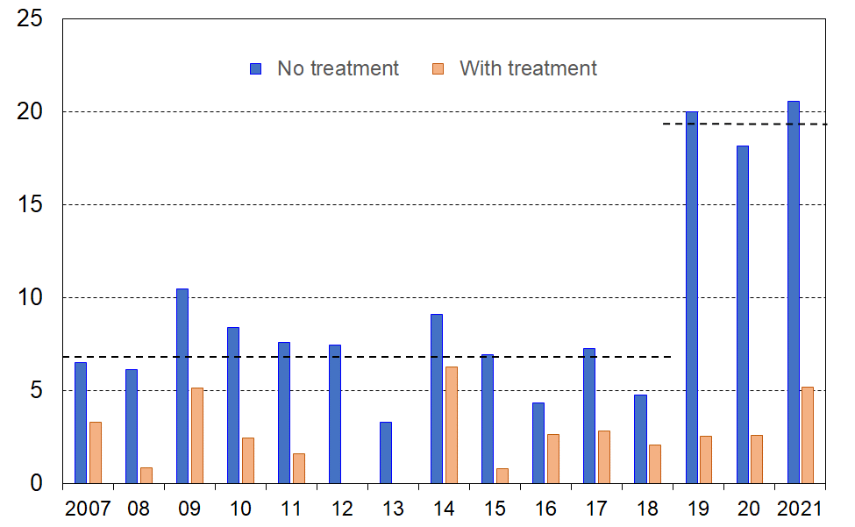 **BHC 20 to BHC 50 ratios (as a %) for households with children with and without VLI treatment**

Reducing measured poverty using relative low-income measures is challenging in itself – it requires the incomes of those in low-income households to rise more quickly than those around the median, and this needs to occur for a sustained period.

The VLI issue increases this challenge substantially, as the VLI group (with incomes well below income support levels) is not likely to be impacted by policy changes or changes in the wider economy. This is not because they are ‘hard-to-reach’ or ‘on the margins of society’. Some are there because of the way self-employment income is conceptualised and reported for tax purposes, some are there because of their changing household arrangements over the reference period. There are however others who are there because of unresolved issues in properly identifying the income of household members from administrative data.

The situation is similar to the situation of households trying to reduce their electricity bill – they can make changes to impact the variable costs, but the size of the fixed costs component limits the overall impact of their efforts.[133]

**Summing up**

The number of VLI households in the HES-Admin datasets is too high to ignore. Their presence leads to a wide range of statistics being misleading or incongruous when reporting on low-income rates, housing affordability, the description of ‘life under the poverty line’ using non-monetary indicators, and so on. There will always be VLI households – for example, some self-employed households will (legitimately) report very low income; for some individuals their current household will be very different from earlier in the reference period and this can lead to some appearing to have implausibly low incomes based on current household arrangements; some recent immigrants may have only a few months income before the interview date – but the numbers of VLI households in HES-Admin are too large and undermine confidence in some of the statistics produced.

The HES-TAWA datasets, as supplied by Stats NZ up to and including HES 2017-18, are much less impacted by the VLI issue. This in itself does not mean that the HES-TAWA datasets are ‘better’. There are many criteria to consider in assessing dataset quality. There are however two key questions that need addressing:

* What is driving the relatively high numbers of VLI households in HES-Admin, especially for households with children? What can be done to address this issue?
* Why is there such a difference between the VLI numbers in HES-TAWA and those in HES-Admin? Finding an answer to this requires detailed knowledge of both datasets and an assessment of the strengths and limitations of each. This work would assist in producing a brief account as to why we have a discontinuity in time series from HES-TAWA to HES-Admin.

The VLI treatment used in this report has a clear rationale, is fairly straightforward to apply and is not too data intensive (it just needs the self-assessed income adequacy item in the dataset along with income information). It produces plausible numbers, and reduces the risk of promulgation of misleading findings.

It should however be considered interim and better than not doing it at all for the purposes of this report. MSD’s view is that it is not however adequate for CPRA purposes but is a contribution to the further work being done on that. Using a medical analogy, the current treatment dulls the pain to some degree, but not fully, and ideally a better understanding of the cause or causes of the pain should be established and addressed as well as possible, even if some relief of residual symptoms is still required.

**Annex One to Section O**

**Summary of the impact of the report’s treatment on numbers of households and individuals, with HES-TAWA 2017-18 and HES-Admin 2018-19 compared**

Most of these numbers are in Tables in the body of Section O. They are drawn together here for ease of reference.

**Table O.A1.1a**

**Size of the VLI group, numbers and proportions of households, HES 2017-18**

|  |  |  |  |  |
| --- | --- | --- | --- | --- |
| **Households – HES 2017-18** | **BHC** | | **AHC** | |
| numbers | % of all | numbers | % of all |
| All households | 41,000 | 2.4 | 77,000 | 4.4 |
| Households with dependent children | 8,500 | 1.5 | 23,000 | 3.7 |
| All households – after treatment | 10,000 | <1 | 34,000 | 2.0 |
| Households with dep ch – after treatment | 3,800 | <1 | 13,000 | 2.2 |

**Table O.A1.1b**

**Size of the VLI group, numbers and proportions of individuals, HES 2017-18**

|  |  |  |  |  |
| --- | --- | --- | --- | --- |
| **Individuals – HES 2017-18** | **BHC** | | **AHC** | |
| numbers | % of all | numbers | % of all |
| All individuals | 81,000 | 1.7 | 170,000 | 3.6 |
| Children | 14,000 | 1.2 | 37,000 | 3.3 |
| All individuals – after treatment | 25,000 | <1 | 85,000 | 1.8 |
| Children – after treatment | 7,000 | <1 | 24,000 | 2.1 |

**Table O.A1.1c**

**Size of the VLI group, numbers and proportions of households, HES 2018-19**

|  |  |  |  |  |
| --- | --- | --- | --- | --- |
| **Households – HES 2018-19** | BHC | | AHC | |
| numbers | % of all | numbers | % of all |
| All households | 68,000 | 3.8 | 109,000 | 6.2 |
| Households with dependent children | 18,000 | 3.0 | 32,000 | 5.3 |
| All households – after treatment | 7,000 | <1 | 31,000 | 1.8 |
| Households with dep ch – after treatment | 2,000 | <1 | 11,000 | 1.9 |

**Table O.A1.1d**

**Size of the VLI group, numbers and proportions of individuals, HES 2018-19**

|  |  |  |  |  |
| --- | --- | --- | --- | --- |
| **Individuals – HES 2018-19** | **BHC** | | **AHC** | |
| numbers | % of all | numbers | % of all |
| All individuals | 155,000 | 3.2 | 255,000 | 5.3 |
| Children | 38,000 | 3.3 | 61,000 | 5.4 |
| All individuals – after treatment | 18,000 | <1 | 76,000 | 1.6 |
| Children – after treatment | 5,000 | <1 | 20000 | 1.9 |

Note: see text above the tables for VLI thresholds used in this report

**Annex Two to Section O**

**Household low-income rates for children (AHC, relative): trends using HES-TAWA and HES-Admin (VLI treatment applied) compared with trends for HES-Admin (no treatment)**

**Section N** describes and discusses the HES datasets used by MSD and Stats NZ when reporting on AHC low-income rates. In summary:

* MSD uses the HES-TAWA dataset through to 2017-18. This enables reporting over the period from 1981-82 to 2017-18. For 2018-19 to 2020-21 MSD uses the HES-Admin dataset.
* Stats NZ uses a bespoke HES-Admin dataset for 2006-07 to 2017-18. This dataset also has a different set of weights than they provided for HES-TAWA data. For 2018-19 to 2020-21 Stats NZ uses the same HES-Admin dataset as MSD.

A further difference between the data used by MSD and that by Stats NZ is that MSD applies the report’s treatment to the Very-Low-Income (VLI) households, which are deleted from the dataset according to the rules outlined in **Section O**. Stats NZ do not apply any treatment.

**Figure O.A2.1** shows the impact of these differences for reporting on trends in AHC low-income rates for children.

* MSD can report a much longer time series, going back to 1981-82.
* There is a discontinuity in the MSD time series going from HES-TAWA (treated) to HES-Admin (treated). This is shown on the chart.
* Stats NZ have not declared any discontinuity between 2017-18 and 2018-19 as they use administrative data for most of the income information in both periods, and the same benchmarks for calculating weights.
* The AHC 50 and AHC 60 trend lines produced by the respective reporting regimes are fairly close from 2008-09 to 2017-18, but the AHC 40 rates are noticeably higher for Stats NZ’s reporting. The AHC 40 measure is the one most impacted by the presence of VLI households which Section O argues leads to an overstatement of low-income rates for a very low threshold such as AHC 40 (and BHC 50).
* There is technically a discontinuity in the MSD time series between the 2003-04 and 2006-07 datapoints because the treatment can only be applied from 2006-07 on. As the treatment has very limited impact on HES-TAWA rates (especially when compared with the impact on HES-Admin rates), Figure O.A2.1 does not show any discontinuity between those data points.
* The analysis in Figure O.A2.1 better shows the impact of the WFF initiative through to 2006-07 than the alternative in Figure G.1 as there is no change in dataset from 2003-04 to 2006-07 as there is in Figure G.1.

**Figure O.A2.1**

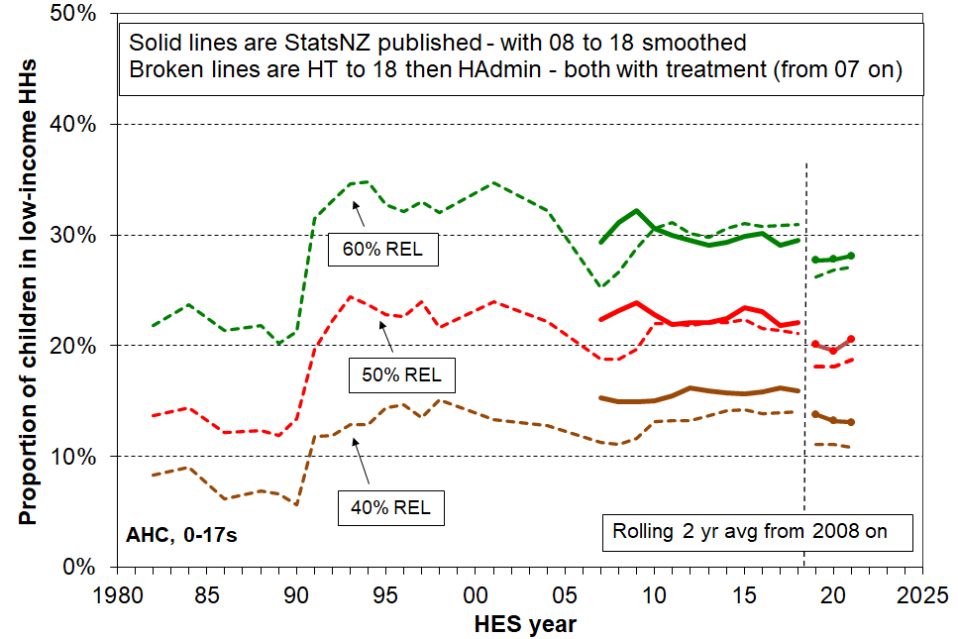**AHC low-income rates for children (0-17 years): trends using different datasets (see text above)**

Note: see Appendix 2 of Stats NZ’s 2022 Child Poverty Technical Appendix for a similar chart. <https://www.stats.govt.nz/methods/child-poverty-statistics-year-ended-june-2021-technical-appendix#quality>

**Section P – Estimating low-income persistence rates from cross-sectional rates: a synthesis and application of research by Jenkins and van Kerm (2012)**

New Zealand does not have any current longitudinal data to allow population-wide analysis of income dynamics – mobility, persistence and so on.[134] The Survey of Family, Income and Employment (SoFIE) is the latest source for such longitudinal data and ran from 2002 to 2009.[135]

Stats NZ has developed a new longitudinal survey with a view to having persistence statistics available for children (and others) for the 2025-26 year in line with the requirements of the CPRA.[136] Their current proposal is to use the EU definition as the main one *(‘in poverty in the current year, and in poverty at least two out of three from the previous three years’*), but the data will enable a range of persistence measures to be produced. International comparisons for New Zealand, using the EU definition, will not be available from the new longitudinal study until 2027, although Stats NZ plan on having some persistence analysis available in 2026.

There is however some recent European research (Jenkins and Van Kerm, 2012) that points to a way of making reasonable estimates of low-income persistence rates for children in the interim. A central theme of the research is that *when using the EU definition of low-income persistence* there is a near- linear relationship between current and persistent low-income rates. This section provides a summary of the research and applies it to New Zealand.

**Overview of the research**

The research shows theoretically from first principles that this relationship could be expected, building a predictive model based on some simplifying assumptions around exit and entry rates[137]. The model shows a linear relationship between current and persistence rates. The only inputs needed for the model to be able to predict persistence rates are the entry and exit rates and the cross-sectional low-income rates (from the EU-SILC data).

When they applied the predictive model using EU-SILC data for transition rates and cross-sectional rates for each country, they found that the predicted persistence rates were reasonably accurate vis-à-vis the survey-based persistence rates.

They also show that the relationship holds in practice using both EU-SILC data for 2007 and earlier data from the European Community Household Panel. For the current and persistent low-income rates from the 2007 EU-SILC data, the Pearson correlation coefficient was 0.91 when looking at the whole population in each country. The relationship was not quite as strong for sub-groups, but was still very good for children, the best of the sub-groups.

**Table P.1** shows that the strong relationship is still evident in the data when updated to 2017, for both the whole population and for children (0-17 years).

**Table P.1**

**Correlation between current and persistent low-income rates, 32 European countries (2017) [138]**

|  |  |  |
| --- | --- | --- |
|  | **Whole population** | **Children (0-17 yrs)** |
| **BHC 60** | 0.94 | 0.91 |
| **BHC 50** | 0.95 | 0.93 |

Source: MSD analysis of Eurostat low-income current and persistent low-income rates.

The strong relationship between current and persistent low-income rates *when using the EU definition of persistence* means that if we know the current rate, then a reasonable estimate of the persistence rate can be made.

**Application to New Zealand**

The scatterplot in **Figure P.1** below shows the relationship between current low-income rates and persistent low-income rates for 32 European countries using 2017 EU-SILC data (BHC 50% and 60%). New Zealand’s cross-sectional rates are known for 2017 (from the 2017-18 HES), which allows estimates of the New Zealand persistence rates to be made, as per the dashed red lines. These are around 13% for BHC 60 and 5% for BHC 50.

**Figure P.1**

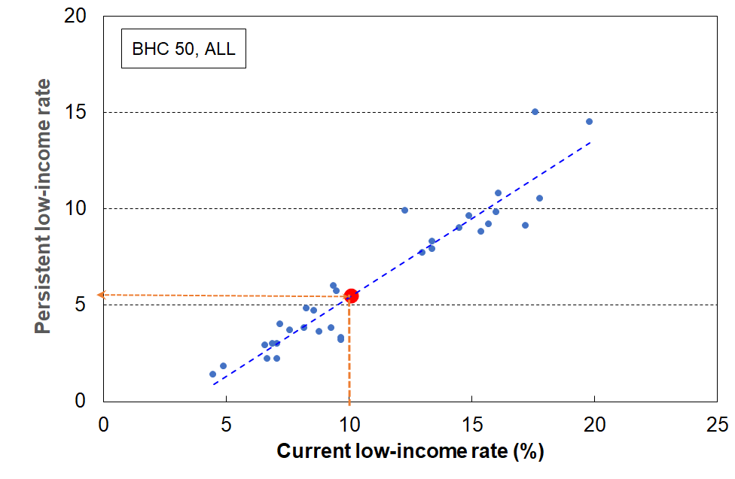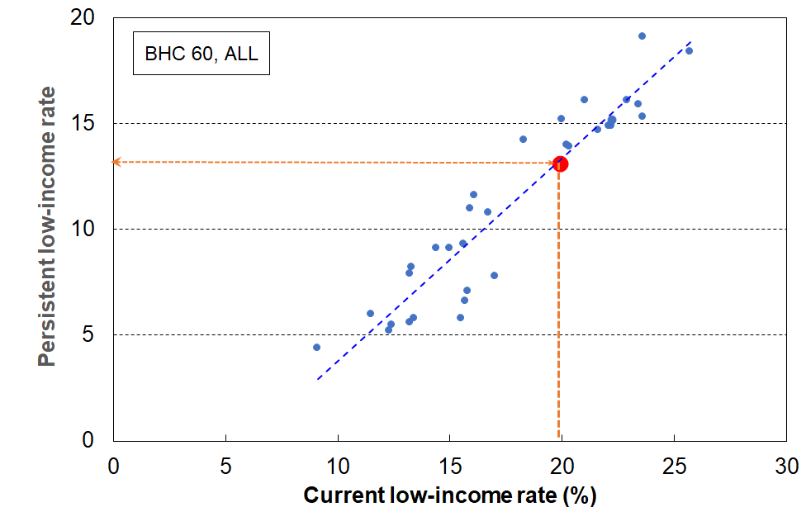**Estimating NZ’s low-income persistence rates for the whole population, based on the strong relationship between current rates and persistence rates when using the EU definition of persistence (2017)**

.

**Figure P.2** repeats the analysis for children (aged under 18 years). New Zealand’s cross-sectional rates for children are known for 2017 for BHC 60 and BHC 50 (24% and 15%) which allows estimates of the New Zealand persistence rates to be made, as per the dashed red lines.[139] These are around 16% for BHC 60 and 9% for BHC 50.

**Figure P.2**

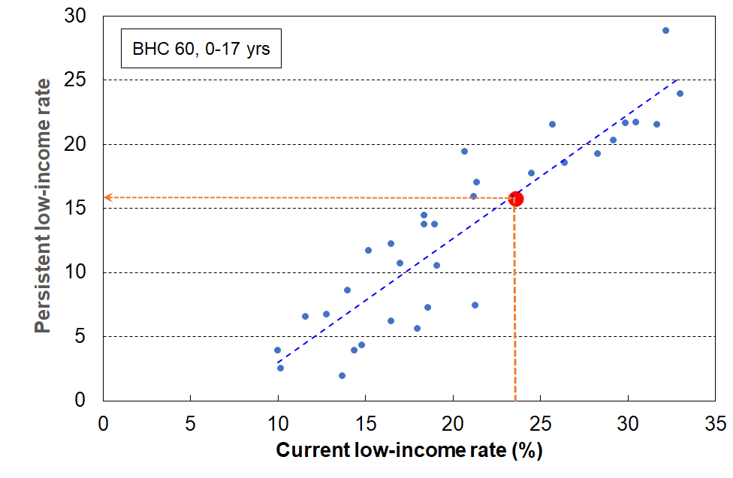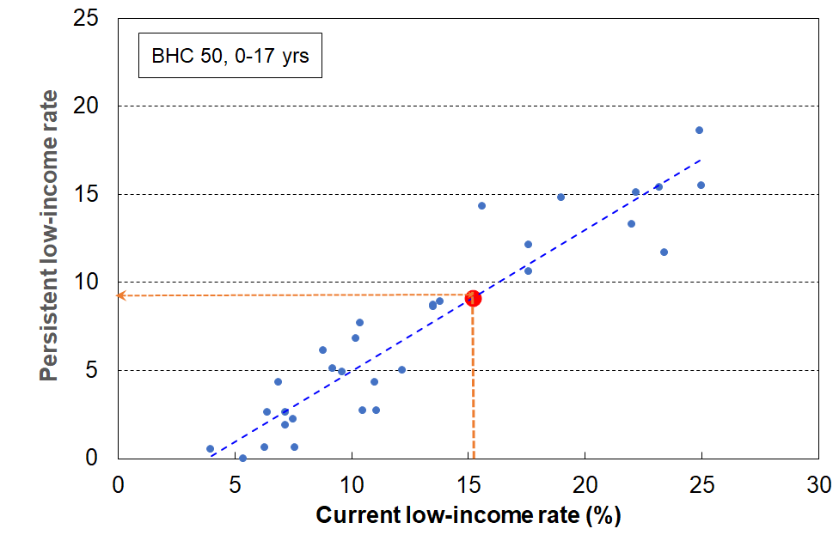**Estimating NZ’s low-income persistence rates for children, based on the strong relationship between current rates and persistence rates when using the EU definition of persistence (2017)**

The 32 European countries in Figures P.1 and P.2 and the associated analysis include several that are not usually used in international comparisons in MSD’s reports – Romania, Bulgaria, Hungary, Turkey, Montenegro, Serbia and North Macedonia. When the analysis is repeated using just the remaining 25 European countries with whom New Zealand is more commonly compared:

* the correlation coefficients are virtually unchanged
* the New Zealand low-income persistence estimates remain unchanged, for both the whole population and for children (ie the slopes of the dashed lines above remain much the same)
* median rates remain very similar as there is a bunching of countries near the median, and rates for some of the deleted 7 countries are below the median
* New Zealand rates remain a few percentage points above the median (see the previous section on current low-income rates for detail)[140]
* what does change is New Zealand’s position on the league tables for children, from around 10th to12th highest for the 32 as in Figure P.2, to around 5th to 6th highest for the 25.

**How robust are the New Zealand persistence estimates?**

Looking only at the charts, a reasonable conclusion would be that the New Zealand estimates would need to be reported as ‘X±2%’ to fit within the observed variability around the linear relationship. There is however a further finding in the research that points to being able to have greater confidence in the New Zealand estimates.

As noted above, a key assumption of the model developed by Jenkins and Van Kerm is that poverty entry and exit rates remain steady for each country over the four-year period for which the persistence rate is measured. When they applied their model using EU-SILC data, they found for almost all countries that they could quite reasonably predict the persistence rate (albeit slightly under-estimated), based on the current low-income rate and just that one year’s transition rates.

Given the importance in the model of the steady-state assumption regarding transition rates, and the observed variability of these rates in the EU-SILC data from year to year even when there was no major (macro-) economic change or re-distributional policy change, they repeated the predictive analysis using the average of the last two years of transition information instead of just the latest year’s. The correlation coefficient between actual and predicted persistence improved markedly to around 0.9.[141]

In relation to Figures P.1 and P.2, this finding means that a good portion of the deviation from the linear relationship for the European countries can be put down to ‘noise’ (the variability in transition rates derived from the EU-SILC samples as a result of the usual uncertainties in all sample surveys (sampling and non-sampling errors)). The New Zealand estimates can be taken as much more secure than what is suggested looking only at the charts.

**Little new information?**

Jenkins and Van Kerm note that an important implication of the strong relationship between current and persistent low-income rates *when using the Eurostat definition of persistence* is that the independent production of persistence rates from longitudinal data ‘adds relatively little information to that which is revealed by the “headline” current poverty rate’ (ibid, p21). In applying this finding in their European context they put the case that the EU might want to consider using a different longitudinal measure for its official persistence reporting so as to deliver ‘new information’. They make it clear that it is not an argument against the collection of longitudinal low-income data – they are very supportive of the value of such data.

As with Jenkins and Van Kerm in the European context, applying the research finding in a New Zealand context is not about questioning the value of collecting longitudinal data for child poverty persistence monitoring. There are many good reasons for doing so. For example, even if the Jenkins / Van Kerm estimation is valid for New Zealand as a whole and for children when using the EU definition, and is good enough for a high-level finding:

* The estimation is unlikely to be precise enough to be able to be used for target-setting and accountability under the CPRA for a primary measure. In addition to the usual uncertainties when using sample surveys, there is also another layer of uncertainty added as the relationship is just ‘near-linear’, even though from a research perspective it is a very strong relationship.
* The current New Zealand commitment to (more than) halve the BHC 50 low-income rate for children by 2028 requires considerable redistributive effort. This means that entry and exit rates are unlikely to be steady over the period (they will need to fall and rise respectively), which is likely to invalidate the steady state transition assumption that is required for a robust estimate based on the Jenkins and van Kerm model.
* Understanding the persistence of household income for different sub-groups requires a longitudinal data set (estimates from cross-sectional rates would be too uncertain).
* Monitoring and understanding changes in entry and exit rates is an important exercise in itself that requires separate longitudinal data.
* Monitoring persistent material hardship requires survey information.[142]

The question the ‘little new information’ finding raises is about the choice of a persistence measure or suite of measures. This relates both to decisions for official statistics that will meet the requirements of the CPRA (2018), and also for decisions for what measures MSD might report on post-2026.

The advantage of using the EU definition is that it is well-established and allows international comparisons. There are however other definitions of persistence that can be used and which add value, albeit without the international comparisons. For example:

* + Look at all households over an N-year period, and define persistence as having an average income that is less than an average low-income threshold. This ‘chronic’ approach avoids counting those whose incomes move from a little above the threshold to a little below between surveys (and vice versa) as transitions into or out of poverty, while their actual standard of living doesn’t change. MSD’s Household Incomes Report reports on this measure, based on analysis of Stats NZ’s Survey of Family, Income and Employment (2002 to 2009) by Carter and Imlach Gunasekara (2012). See also the end of Section G in this report.
  + Look at all households in the current year (not just those with low incomes) and those in the previous 2 years and count those ‘under the line’ in 2 out 3 years (or previous 3 years, counting those under the line for 3 out of 4 years).

**References**

Abe, A.K. (2019), ‘Developing Deprivation Index for Children Taking into Account of Adaptive Preferences.’ *Child Ind Res* **12**, 647–665 .

Affordable Housing Commission (2019), ‘Defining and Measuring Housing Affordability – an Alternative Approach’. AHC, UK. Retrieved from <https://nationwidefoundation.org.uk/wp-content/uploads/2019/06/Definingandmeasuringhousingaffordability.pdf>

Amore, K. (2016). Severe housing deprivation in Aotearoa/New Zealand. Housing and Health Research Programme (University of Otago). Dunedin: University of Otago. Retrieved from <https://www.healthyhousing.org.nz/wp-content/uploads/2016/08/Severe-housing-deprivationin-Aotearoa-2001-2013-1.pdf>

Amore, K., Viggers, H., & Howden Chapman, P. (2020). Severe housing deprivation in Aotearoa New Zealand, 2018. Housing and Health Research Programme (University of Otago). Dunedin: University of Otago. Retrieved from <https://www.hud.govt.nz/assets/News-andResources/Statistics-and-Research/2018-Severe-housing-deprivation-estimate/Severe-HousingDeprivation-2018-Estimate-Report.pdf>

Atkinson, A. B., Cantillon, B., Marlier, E., & Nolan, B. (2002). *Social Indicators: The EU and Social Inclusion*. Oxford: Oxford University Press.

Atkinson, J., Salmond, C., & Crampton, P. (2014). ‘NZDep2013 Index of Deprivation’. Wellington: Department of Public Health, University of Otago, Wellington.

Available online:  <http://www.otago.ac.nz/wellington/research/hirp/otago020194.html>

Auckland City Mission (2014a). ‘Speaking for Ourselves: The Truth about what keeps people in poverty from those who live it.’ Summary of findings from the Family 100 project. Auckland City Mission.

Auckland City Mission (2014b). ‘Demonstrating the complexities of being poor’. An empathy tool for the Family 100 project. Auckland City Mission.

Both the above are available at <https://www.aucklandcitymission.org.nz/latest-news/resources/>

Berthoud, R. & Bryan, M. (2011). ‘Income, deprivation and poverty: a longitudinal analysis’. *Journal of Social Policy*, *40*(01), 135-156.

Bradshaw, J., & Finch, N. (2003). ‘Overlaps in Dimensions of Poverty’. *Journal of Social Policy (32)*, 513-525.

Brewer, M., Etheridge, B. & O’Dea C. (2017). ‘[Why are Households that Report the Lowest Incomes So Well‐off?](https://ideas.repec.org/a/wly/econjl/v127y2017i605pf24-f49.html)’, *[Economic Journal](https://ideas.repec.org/s/wly/econjl.html), Royal Economic Society, vol. 127*(605), pages 24-49, October.

Carter, K., Mok, P. & Le, T (2014). ‘Income Mobility in New Zealand: A Descriptive Analysis’. New Zealand Treasury Working Paper 14/15.

Carter, K. & Imlach Gunasekara, F. (2012). ‘Dynamics of Income and Deprivation in New Zealand, 2002-2009. A descriptive analysis of the Survey of Family, Income and Employment (SoFIE).’ Public Health Monograph Series No. 24. Wellington: Department of Public health, University of Otago, Wellington.

Crettaz, E.& Suter, C. (2013), ‘The Impact of Adaptive Preferences on Subjective Indicators: An Analysis of Poverty Indicators’, *Social Indicators Research*, *114*(1), 139-152.

Davidson, P., Saunders, P., Bradbury, B. & Wong, M. (2020), ‘Poverty in Australia 2020: Part 1, Overview’. ACOSS/UNSW Poverty and Inequality Partnership Report No. 3, Sydney: ACOSS.

de Neubourg, C., Bradshaw J., Chzhen, Y., Main, G., Martorano, B. & and Menchini, L. (2012). ‘Child deprivation, multidimensional poverty and monetary poverty in Europe’. *Innocenti Working Paper* 2012-02, UNICEF Innocenti Research Centre, Florence.

Dickes, P., Fusco, A., & Marlier, E. (2010), 'Structure of national perceptions of social needs across EU countries', *Social Indicators Research*, *95*(1), 143-167.

Fahey, T. (2007), ‘The case for an EU-wide measure of poverty’, *European Sociological Review*, 23(1), 35-47

Fusco, A., Marlier, E., & Guio, A.-C. (2010) Income poverty and material deprivation in European countries. Eurostat Methodologies and Working Papers, OPOCE: Luxembourg.

Fusco, A. Guio, A.-C. & Marlier, E. (2011). Characterising the income poor and the materially deprived in European countries. In: Atkinson A.B. and Marlier E. (eds.), *Income and living conditions in Europe*, Publications Office of the European Union, Luxembourg, pp.132-153.

Fusco (2015). ‘The relationship between income and housing deprivation: A longitudinal analysis.’ *Economic Modelling 49* (2015) 137–143.

Goedemé, T. & Rottiers, S. (2011). ‘Poverty in the Enlarged European Union: A Discussion about Definitions and Reference Groups.’ Herman Deleeck Centre for Social Policy, University of Antwerp.

Goedemé, T. et al (2019). ‘What Does It Mean to Live on the Poverty Threshold? Lessons From Reference Budgets.’ Chapter 1 in Cantillon, B., Goedemé, T. and Hills, J. (2019), *Decent incomes for all: Improving poverty reduction in Europe*, Oxford: Oxford University Press.

Guio, A.-C., Gordon, D., & Marlier, E.(2012). ‘Measuring material deprivation in the EU: Indicators for the whole population and child-specific indicators’, Eurostat Methodologies and Working Papers, OPOCE: Luxembourg.

Guio, A.-C., Gordon, D., & Marlier, E.(2017a). ‘Measuring child material deprivation in the EU’, Chapter 11 in Atkinson, Guio and Marlier (Eds) ‘*Monitoring Social Inclusion in Europe’*. Luxembourg: Eurostat.

Guio, A.-C., Gordon, D., Marlier, E., Naiera, H. & Pomati, M. (2018). ‘Towards an EU measure of child deprivation’, *Child Indicators Research 11*: 835-860.

Guio, A.-C., Gordon, D., Najera, H. & Pomati, M. (2017b). ‘Revising the EU material deprivation variables (analysis of the final 2014 EU-SILC data)’, Eurostat Methodologies and Working Papers, Luxembourg: Publications Office of the European Union.

Guio, A.-C., Marlier, E. & Pomati, M. (2017c). ‘Evolution of material deprivation over time’, Chapter 20 in Atkinson, Guio and Marlier (Eds) ‘*Monitoring Social Inclusion in Europe’*. Luxembourg: Eurostat.

Guio, A.-C., Marlier, E., Nolan, B. (eds) (2021), *Improving the understanding of poverty and social exclusion in Europe*, Publications Office of the European Union, Luxembourg.

Guio, A.-C., Marlier, E., Vandenbrouke, F. & Verbunt, P. (2020). ‘Micro-and macro-drivers of child deprivation in 31 European countries’, Eurostat Statistical Working Papers, Luxembourg: Publications Office of the European Union.

Halleröd, B. (2006). ‘Sour Grapes: Relative Deprivation, Adaptive Preferences and the Measurement of Poverty’. *Journal of Social Policy 35 (03*):371-390.

Imlach Gunasekara, F. & Carter, K. (2012). ‘Dynamics of Income in Children in New Zealand, 2002-2009. A descriptive analysis of the Survey of Family, Income and Employment (SoFIE).’ Public Health Monograph Series No. 28. Wellington: Department of Public Health, University of Otago.

Jäntti, M., Törmälehto, V., & Marlier, E. (2013). *The use of registers in the context of EU-SILC: challenges and opportunities.* Publications Office of the European Union.

Jenkins, S. & Van Kerm (2014). ‘[The Relationship Between EU Indicators of Persistent and Current Poverty](https://ideas.repec.org/a/spr/soinre/v116y2014i2p611-638.html)’, [*Social Indicators Research Vol*](https://ideas.repec.org/s/spr/soinre.html) 116(2): 611-638.

“The current poverty rate and the persistent poverty rate are both included in the European Union’s (EU's) portfolio of primary indicators of social inclusion. We show that there is a near-linear relationship between these two indicators across EU countries drawing on empirical analysis of EU-SILC and ECHP data. Using a prototypical model of poverty dynamics, we explain how the near-linear relationship arises and show how the model can be used to predict persistent poverty rates from current poverty information. In the light of the results, we discuss whether the EU's persistent poverty measure and the design of EU-SILC longitudinal data collection require modification.”

Jenkins, S. (2018). ‘Perspectives on Poverty in Europe’. IZA Discussion Paper No. 12014.

Kyzyma, I. (2020) ‘How poor are the poor? Looking beyond the binary measure of income poverty.’ *Journal of Economic Inequality* *18*:525–549

Lister, R. (2004), *Poverty*, Cambridge: Polity Press.

Lohmann, H, (2011). ‘Comparability of EU-SILC survey and register data: The relationship among employment, earnings and poverty’. *Journal of European Social Policy Vol. 21*(1): 37-54.

McNeil, C. & Parkes, H. (2021) ‘No longer managing: The rise of working poverty and fixing Britain's broken social settlement’, IPPR. <http://www.ippr.org/research/publications/no-longer-managing>

Maître, B., Smith Russell (2021)*. The Dynamics of child poverty in Ireland: Evidence from the Growing up in Ireland survey*. Dublin: Office of the Minister for Children.

Meyer, B., Mok, W. & Sullivan, J. (2015). *’*Household Surveys in Crisis’*. Journal of Economic Perspectives Vol. 29 (4):* 199-226.

Ministry of Social Development (2022). ‘Total incomes of MSD main benefit clients as at April 2022.’ MSD Working Paper available at: [wp-total-incomes-of-msd-main-benefit-clients-as-at-april-2022.pdf](https://www.msd.govt.nz/documents/about-msd-and-our-work/publications-resources/working-papers/wp-total-incomes-of-msd-main-benefit-clients-as-at-april-2022.pdf)

Mitchell, L., Baylis, P. & Randolph, S. (2021). ‘Monitoring the enjoyment of the rights to adequate housing and health care and protection in Aotearoa New Zealand’. Motu Working Paper 21-12, Wellington. New Zealand. <https://www.motu.nz/our-research/human-rights/monitoring-enjoyment-rights-housing-health-care-protection-nz/>

Morton, S. et al (2020). *Growing Up in New Zealand: A longitudinal study of New Zealand children and their families. Now We Are Eight.* Auckland: Growing Up in New Zealand.

Nolan, B., & Whelan, C. T. (1996). *Resources, Deprivation and Poverty*. Oxford: Clarendon Press.

Nolan, B., & Whelan, C. T. (2011). *Poverty and Deprivation in Europe*. Oxford: Oxford University Press.

Notten, G. (2015). ‘Child Poverty in Ontario: The Value Added of Material Deprivation Indicators for Comparative Policy Analysis in North America.’ *Journal of Comparative Policy Analysis: Research and Practice (17*:5): 533-551.

Notten, G., Charest, J. & Heisz,, A. (2017). ‘Material Deprivation in Canada.’ Working Paper 1715E, Department of Economics, University of Ottawa.

Notten, G., and Kaplan, J. (2021). ‘Material Deprivation: Measuring Poverty by Counting Necessities Households Cannot Afford.’ *Canadian Public Policy* 1–17.

Notten, G. & Kaplan, J. (2022). ‘[An Empirical Validation Method for Narrowing the Range of Poverty Thresholds](https://ideas.repec.org/a/spr/soinre/v161y2022i1d10.1007_s11205-021-02817-1.html)’, [*Social Indicators Research*](https://ideas.repec.org/s/spr/soinre.html) *161(1)*: 251-271.

Office of the Children’s Commissioner and Oranga Tamariki (2019), ‘What makes a good life? Children and young people’s views on wellbeing’. Wellington: Office of the Children’s Commissioner.

Office of National Statistics (2019). ‘2017 Comparisons of persistent poverty between UK and other EU countries.’ Article, ONS. <https://www.ons.gov.uk/peoplepopulationandcommunity/personalandhouseholdfinances/incomeandwealth/articles/persistentpovertyintheukandeu/2017>

Penne, T., Cussó Parcerisas, I., Mäkinen, L., Storms, B., Goedemé, T. (2016), ‘Can reference budgets be used as a poverty line’, ImPRovE Working Paper N°16/05. Antwerp: Herman Deleeck Centre for Social Policy – University of Antwerp.

Perry, B. (2007). ‘The Economic Living Standards Index (ELSI): Another look at the underlying construct and some of the headline findings in *‘New Zealand Living Standards 2004’.* MSD Working Paper 01/07.

Perry, B. (2015). ‘Measuring and monitoring material hardship for New Zealand children: MSD research and analysis used in advice for the Budget 2015 child hardship package’. Unpublished report. Wellington: Ministry of Social Development. (Available from author.)

Perry, B. (2018). *Household Incomes in New Zealand: Trends in Indicators of Inequality and Hardship,* 1982 to 2017. Wellington: Ministry of Social Development.

Perry, B. (2019a). ‘Material hardship measures for the Child Poverty Reduction Act (2018)’. MSD Working Paper 01/19, available at: <https://www.msd.govt.nz/about-msd-and-our-work/publications-resources/working-papers/index.html#WorkingPapers20191>

Perry, B. (2019b). ‘Stats NZ Child Poverty Statistics release, 2 April 2019: MSD Background and Overview’. MSD Working Paper 02/19, available at: <https://www.msd.govt.nz/about-msd-and-our-work/publications-resources/working-papers/index.html#WorkingPapers20191>

Perry, B. (2019c). *Household Incomes in New Zealand: Trends in Indicators of Inequality and Hardship,* 1982 to 2018. Wellington: Ministry of Social Development.

Perry, B. (2019d). *The Material Wellbeing of New Zealand Households: Trends and Relativities using Non-income Measures, with International Comparisons.* Wellington: Ministry of Social Development.

Perry, B. (2021a). *Child Poverty in New Zealand.* Wellington: Ministry of Social Development. Available at: <https://www.msd.govt.nz/about-msd-and-our-work/publications-resources/research/child-poverty-in-nz/index.html>

Perry, B. (2021b). *The Material Wellbeing of New Zealand Households: Trends and Relativities using Non-income Measures, with International Comparisons.* Wellington: Ministry of Social Development. Available at: <https://www.msd.govt.nz/about-msd-and-our-work/publications-resources/monitoring/living-standards/index.html>

Perry, B. (2021c). *Housing Affordability for Renters and Owners: International Comparisons.* Wellington: Ministry of Social Development. Available at: <https://www.msd.govt.nz/about-msd-and-our-work/publications-resources/monitoring/household-incomes/>

Perry, B. (forthcoming). *Household Incomes in New Zealand: Trends in Indicators of Inequality and Hardship,* 1982 to 2021. Wellington: Ministry of Social Development.

Piachaud, D. (1987), ‘Problems in the definition and measurement of poverty’, *Journal of Social Policy, 16* (2), 147-164.

Rea, D., Anastasiadis, S., Benny, V., Chokkanathapuram, A., Lee, W., Smith, C., and Vandenbroucke, B. (2019). ‘Measuring the living standards of people receiving income-tested main benefits.’ Working paper, Wellington: Social Investment Agency and Ministry of Social Development.

Ringen, S. (1988). ‘Direct and indirect measures of poverty’, *Journal of Social Policy, 17(3)*: 351- 365

Ringen, S. (2009). ‘Poverty – The Rowntree Project Revisited’, paper delivered at the Kennedy School of Government, Harvard University, 1 June 2009.

Salmond, C., Crampton, P., King, P., & Waldegrave, C. (2006). ‘NZiDep: a New Zealand index of socioeconomic deprivation for individuals.’ Social Science and Medicine 62(6): 1474-85.

Saunders, P., Wong, M., Bradbury, B. (2016). ‘Poverty in Australia since the financial crisis: the role of housing costs, income growth and unemployment.’ *Journal of Poverty and Social Justice 24(2)*: 97–112.

Serafino, P. & Tonkin, R. (2017). ‘Comparing poverty estimates using income, expenditure and material deprivation, Chapter 13 in Atkinson, Guio and Marlier (Eds) ‘*Monitoring Social Inclusion in Europe’*. Luxembourg: Eurostat.

Sheehy-Skeffington, J & Rea, J. (2017). *‘How poverty affects peoples decision-making processes.’* London: Joseph Rowntree Foundation.

Statistics New Zealand (2019). ‘*Measuring child poverty: Material hardship’*. Available from <https://www.stats.govt.nz/methods/measuring-child-poverty-material-hardship>

Stephens, R. & Waldegrave C (2001) ‘The effectiveness of the transfer and tax system in reducing poverty in 1998’, *Social Policy Journal of New Zealand*, Issue 16.

Stephens, R., Waldegrave, C., & Frater, P. (1995), 'Measuring poverty in New Zealand', *Social Policy Journal of New Zealand*, (5), 88-112.

Tomlinson, M. & Walker, R. (2009), *‘Coping with Complexity: Child and Adult Poverty.’* London: Child Poverty Action Group.

Townsend, P.(1979). ‘Poverty in the United Kingdom’. Harmondsworth, Penguin Books Ltd.

UNICEF Innocenti (2012), ‘Measuring Child Poverty: New league tables of child poverty in the world’s rich countries’, Innocenti Report Card 10, UNICEF Office of Research – Innocenti, Florence.

UNICEF Innocenti (2020), ‘Worlds of Influence: Understanding what shapes child well-being in rich countries’, Innocenti Report Card 16, UNICEF Office of Research – Innocenti, Florence.

Van Kerm, P. (2007). ‘Extreme incomes and the estimation of poverty and inequality indicators from EU-SILC’. In: Comparative EU statistics on income and living conditions: Issues and challenges. Proceedings of the EU-SILC conference (Helsinki, 6-8 November 2006). Office for Official Publications of the European Communities, Luxembourg.

Verbunt, P. & Guio, A-C. (2019). ‘Explaining Differences Within and Between Countries in the Risk of Income Poverty and Severe Material Deprivation: Comparing Single and Multilevel Analyses.’ *Social Indicators Research*,*144:* 827-868.

Welfare Expert Advisory Group Secretariat (2019), *‘Example Families and Budgets: Investigating the Adequacy of Incomes (Background Paper for the WEAG).’* Wellington: Welfare Expert Advisory Group

Waldegrave, C., Stephens, R., & King, P. (2003), 'Assessing the progress on poverty reduction', *Social Policy Journal of New Zealand*, (23), 197-222.

Waldegrave, C., Stuart, S., & Stephens, R. (1996), 'Participation in poverty research: drawing on the knowledge of low-income householders to establish an appropriate measure for monitoring social policy impacts', *Social Policy Journal of New Zealand*, (7), 191-206.

Whiteford, P. &  Adema, W. (2007), "What Works Best in Reducing Child Poverty: A Benefit or Work Strategy?", *OECD Social, Employment and Migration Working Papers*, No. 51, OECD Publishing, Paris.

**Appendices**

**Appendix 1** Indices and HES items

**Appendix 2** List of HES child-specific hardship items, with endorsement rates

**Appendix 3** Low-income thresholds (income poverty lines)

**Appendix 4** Socio-economic status and material wellbeing

**Appendix 5** An alternative equivalence scale for use with AHC incomes

**Appendix 6** Sections B and C tables repeated for HES 2020-21.

**Appendix 1 – indices and HES items including child-specific material deprivation items**

**Composition of indices (DEP-17, EU-13, MWI) and list of child specific items**

**Table 1.1**

**Composition of DEP-17**

|  |  |
| --- | --- |
| **Enforced lack of essentials** (for respondent or household as a whole) | |
|  | meal with meat, fish or chicken (or vegetarian equivalent) at least each 2nd day |
|  | two pairs of shoes in good repair and suitable for everyday use |
|  | suitable clothes for important or special occasions |
|  | presents for family and friends on special occasions |
|  | home contents insurance |
| **Economised, cut back or delayed purchases ‘a lot’** because money was needed for other essentials (not just to be thrifty or to save for a trip or other non-essential) | |
|  | went without or cut back on fresh fruit and vegetables |
|  | bought cheaper cuts of meat or bought less than wanted |
|  | put up with feeling cold to save on heating costs |
|  | postponed visits to the doctor |
|  | postponed visits to the dentist |
|  | did without or cut back on trips to the shops or other local places |
|  | delayed repairing or replacing broken or damaged appliances |
| **In arrears more than once in last 12 months** (because of shortage of cash at the time, not through forgetting) | |
|  | rates, electricity, water |
|  | vehicle registration, insurance or warrant of fitness |
| **Financial stress and vulnerability** | |
|  | borrowed money from family or friends more than once in the last 12 months to cover everyday living costs |
|  | feel ‘very limited’ by the money available when thinking about purchase of clothes or shoes for self (options were: not at all, a little, quite limited, and very limited) |
|  | could not pay an unexpected and unavoidable bill of $500 within a month without borrowing |

Note: an enforced lack is an item that is wanted but not possessed because of the cost.

**Table 1.2**

**Composition of EU-13[143]**

|  |
| --- |
| **Seven household deprivations (enforced lacks)** |
| ability to face unexpected expenses of NZD1500[144] |
| have one week’s annual holiday away from home |
| avoid arrears in mortgage or rent, utility bills or HP instalments |
| have a meal with meat, fish or chicken every second day |
| keep the home adequately warm |
| have access to a car / van for personal use |
| replace worn-out furniture |
| **Six personal deprivations (enforced lacks)** |
| replace worn-out clothes by some new ones |
| have two pairs of properly fitting shoes |
| spend a small amount of money each week on oneself |
| have regular leisure activities |
| have a get together with friends/family for a drink/meal at least monthly |
| have both a computer and an internet connection |

**Table 1.3**

**The 37 items in HES 2018-19 and 2019-20, and how the relevant items are scored for the three indices (MWI, DEP-17 and EU-13)**

|  |  |  |  |  |
| --- | --- | --- | --- | --- |
| **Item description** | | **MWI** | **DEP-17** | **EU-13** |
| **Ownership or participation** (have/do, don’t have/do and enforced lack (EL))  *For DEP-17 and EU-13, score an EL as 1, otherwise 0*  *For MWI, score an EL as a 0, otherwise 1* | |  |  |  |
| 1 | Two pairs of shoes in a good condition and suitable for daily activities | ✓ | ✓ | ✓ |
| 2** | Replace worn-out clothes by some new (not second-hand) ones | ✓ | - | ✓ |
| 3 | Suitable clothes for important or special occasions | ✓ | ✓ | - |
| 4 | Contents insurance | ✓ | ✓ | - |
| 5 | A meal with meat, fish or chicken (or vegetarian equivalent) at least each 2nd day | ✓ | ✓ | ✓ |
| 6 | A good bed | ✓ | - | - |
| 7** | Keep home adequately warm | - | - | ✓ |
| 8 | Presents for family/friends on special occasions | ✓ | ✓ | - |
| 9 | Holiday away from home at least once every year | ✓ | - | ✓ |
| 10 | Overseas holiday at least once every three years | ✓ | - |  |
| 11* | Access to car or van for personal use | - | - | ✓ |
| 12* | Access to both a computer and internet connection at home | - | - | ✓ |
| 13* | Have a get together with friends or extended family for a drink or meal at least once a month | - | - | ✓ |
| **Economising** (not at all, a little, a lot) – to keep down costs to help in paying for (other) basic items (not just to be thrifty or to save for a trip or other non-essential)  *For DEP-17 and EU-13, score ‘a lot’ as 1, otherwise 0*  *For MWI, score ‘not at all as 2, ‘a little’ as 1, and ‘a lot’ as 0* | | | | |
| 14 | Gone without or cut back on fresh fruit and vegetables | ✓ | ✓ | - |
| 15 | Buy cheaper cuts of meat or bought less meat than you would like | ✓ | ✓ | - |
|  | Continued wearing worn out clothes (*to 2018 only*) | ✓ | - | - |
| 16 | Put up with feeling cold | ✓ | ✓ | - |
| 17 | Do without or cut back on trips to the shops or other local places | ✓ | ✓ | - |
| 18 | Delay replacing or repairing broken or damaged appliances | ✓ | ✓ | - |
| 19* | Delay replacing or repairing broken or worn out furniture | - | - | ✓ |
| 20 | Spent less on hobbies or other special interests than you would like | ✓ | - | ✓ |
| 21 | Postponed visits to the doctor | ✓ | ✓ | - |
| 22 | Postponed visits to the dentist | ✓ | ✓ | - |
| **Housing problems** (no problem, minor problem, major problem … in the last 12 months)  *For MWI, score as 2, 1 and 0 respectively.* | |  |  |  |
| 23 | Dampness or mould | ✓ | - | - |
| 24 | Heating or keeping it warm in winter | ✓ | - | - |
|  | Crowding (*derived variable = Canadian Index*) | - | - | - |
| **Freedoms/Restrictions** | |  |  |  |
| 25 | About how much money, on average, do you have each week for spending on things for yourself without consulting anyone else? (under $10, 10-25, 26-50, >50)  *For EU-13, score ‘under$10’ as 1, and anything else as 0* | - | - | ✓ |
| 26 | When buying, or thinking about buying, clothes or shoes for yourself, how much do you usually feel limited by the money available? (4 point response options: ‘not at all limited, a little limited, quite limited, very limited)  *For DEP-17, score ‘very limited’ as 1, otherwise 0.*  *For MWI, score as 3, 2, 1 and 0 respectively.* | ✓ | ✓ | - |
| 27 | $300 spot purchase for an ’extra’, not a necessity – how limited do you feel about buying it? (5 point response options: not at all limited, a little limited, quite limited, very limited, couldn’t buy it)  *For MWI, score as 4, 3, 2, 1 and 0 respectively.* | ✓ | - | - |
| 28 | $500 unexpected unavoidable expense on an essential – can you pay in a month without borrowing? (yes/no)  *For DEP-17, score ‘no’ as 1, and ‘yes’ as 0*  *For MWI, score ‘yes’ as 2 and ‘no’ as 0* | ✓ | ✓ | - |
| 29* | $1500 unexpected unavoidable expense on an essential – can you pay in a month without borrowing? (yes/no)  *For EU-13, score ‘no’ as 1, and ‘yes’ as 0* | - | - | ✓ |

|  |  |  |  |  |
| --- | --- | --- | --- | --- |
| **Item description** | | **MWI** | **DEP-17** | **EU-13** |
| **Financial strain** (in last 12 months) (not at all, once, more than once)  *For DEP-17 and EU-13, score ‘more than once’ as 1, otherwise 0*  *For MWI, score ‘not at all’ as 2, ‘once’ as 1, ‘more than once’ as 0* | |  |  |  |
| 30 | Behind on rates or utilities | ✓ | ✓ | ✓  (any one, more than once) |
| 31** | Behind on HP and other loan payments |  |  |
| 32 | Behind on rent or mortgage | - | - |
| 33 | Behind on car registration, wof or insurance | ✓ | ✓ | - |
| 34 | Borrowed from family or friends to meet everyday living costs | - | ✓ | - |
| 35 | Received help in the form of food, clothes or money from a welfare or community organisation such as a church or food bank | - | - | - |
| **Global self-ratings** | |  |  |  |
| 36 | Adequacy of income to cover basics of accommodation, food, clothing, etc (*not enough, only just enough, enough, more than enough*) | - | - | - |
| 37 | Satisfaction with life (*very satisfied, satisfied, neither, dissatisfied, very dissatisfied*) | - | - | - |

* introduced in 2018 HES

** introduced in 2019 HES

No asterisk = available from 2013

The MWI scoring recipe above is for HES 2019 and later. It is slightly different for earlier years as the ‘worn out clothes’ item shifted from the ‘economising’ category to the ‘ownership / participation’ category.

**Table 1.4**

**The 20 child-specific items in the 2018-19 HES**

|  |
| --- |
| **Have/do, don’t have/do for each of your children (**Respondents are asked whether any have/do lacks are because of cost or for some other reason.) |
| two pairs of shoes in a good condition that are suitable for daily activities |
| two sets of warm winter clothes |
| waterproof coat |
| all the uniform required by their schools |
| a separate bed |
| fresh fruit and vegetables daily |
| a meal with meat, fish or chicken (or vegetarian equivalent) each day |
| a range of books at home suitable for their ages |
| a suitable place at home to do school homework |
| their friends around to play and eat from time to time |
| their friends around for a birthday party |
| good access at home to a computer and the internet for homework |
| a mobile phone if aged 11 or older |
| **Economising** (not at all, a little, a lot) – to keep down costs to help in paying for (other) basic items (not just to be thrifty or to save for a trip or other non-essential). In this report, economising ‘a lot’ is taken as equivalent to an enforced lack. |
| postponed a child's visit to the doctor |
| postponed a child's visit to the dentist |
| did not pick up a child's prescription |
| been unable to pay for a child to go on a school trip or other school event |
| had to limit children’s involvement in sport |
| had your children go without music, dance, kapa haka, art, swimming or other special interest lessons |
| had your children continue wearing shoes or clothes that were worn out or the wrong size |

Note: None of these items are included in DEP-17 or EU-13 which are general purpose indices that are deigned to apply to all ages and household types and so on.

See **Appendix 2** for more detail.

**Table 1.5**

**EU’s Child Material and Social Deprivation Index[145]**

The list of items for the measurement of child deprivation consists of 12 ‘children’ and 5 ‘household’ items, which cover both material and social aspects of deprivation:

**Children items:**

1. Some new (not second-hand) clothes

2. Two pairs of properly fitting shoes

3. Fresh fruit and vegetables daily

4. Meat, chicken, fish or vegetarian equivalent daily

5. Books at home suitable for the children’s age

6. Outdoor leisure equipment

7. Indoor games

8. Regular leisure activities

9. Celebrations on special occasions

10. Invitation of friends to play and eat from time to time

11. Participation in school trips and school events

12. Holiday

**Household items:**

13. Replace worn-out furniture

14. Arrears

15. Access to Internet

16. Home adequately warm

17. Access to a car for private use

We can almost replicate the index for New Zealand – we do not have items 6, 7 and 8.

See **Appendix 2** for the child-specific items collected in New Zealand.

**Table 1.6**

**NZiDEP**

See Salmond et al (2006).

A suggested lead-in to these questions is: “The following few questions are designed to identify people who have had special financial needs in the last 12 months. Although these questions may not apply directly to you, for completeness we need to ask them of everyone.”

1. [Buying cheap food]

In the last 12 months have you personally been forced to buy cheaper food so that you could pay for other things you needed? (yes/no)

1. [Unemployment] NOTE: defined as no for those 65 and over, and for full-time care-givers/home-makers; otherwise:

In the last 12 months, have you been out of paid work at any time for more than one month? (yes/no)

1. [Being on a means-tested benefit]

In the 12 months ending today did you yourself receive payments from any of these three benefits: Jobseeker Support, Sole Parent Support or Supported Living Payment? (yes/no)

1. [Feeling cold to save on heating costs]

In the last 12 months have you personally put up with feeling cold to save heating costs? (yes/no)

1. [Help obtaining food]

In the last 12 months have you personally made use of special food grants or food banks because you did not have enough money for food? (yes/no)

1. [Wearing worn-out shoes]

In the last 12 months have you personally continued wearing shoes with holes because you could not afford replacement? (yes/no)

1. [Going without fresh fruit and vegetables]

In the last 12 months have you personally gone without fresh fruit and vegetables, often, so that you could pay for other things you needed? (yes/no)

1. [Help from community organisations]

In the last 12 months have you personally received help in the form of clothes or money from a community organisation (like the Salvation Army)? (yes/no)

**Appendix 2**

**Child specific items in 2018-19, 2019-20 and 2020-21**

The 2018-19, 2019-20 and 2020-21 HES gathered information on twenty child-specific items that cover a wide range of possessions and activities that most would agree every child should have and none should be deprived of in New Zealand today. These are listed in **Table 2.1** below.[146] A more detailed version is provided in **Table 2.2** including whether the reason for not having an item is because of cost or some other reason.

These child-specific indicators are not suitable for use in indices such as DEP-17 or the MWI as they do not meet two of the key criteria for such measures – they are not suitable for all ages, and do not represent a good range of severity of hardship, only deeper hardship for most of the indicators. They do, however, provide valuable information on the realities of daily life for those children identified as being ‘in hardship’ by the DEP-17 or MWI index score of their household, or as being in low-income households. They can be used on their own, or combined with information on more general household conditions that are child-relevant.

**Table 2.1**

**Child-specific items:**

**the % of age 6-17s without the item or who are very restricted in the specified activity,**

**as reported by household respondent (HES 18/19 and 19/20)**

|  |  |  |  |  |  |
| --- | --- | --- | --- | --- | --- |
| **Don't have (for any reason):** | | **18/19** | **19/20** | **20/21** | **Abbreviation sometimes used** |
|  | Two pairs of shoes in a good condition and suitable for daily activities | 7 | 5 | 5 | Shoes |
|  | Two sets of warm winter clothes | 2 | 1 | 2 | - |
|  | Waterproof coat | 9 | 6 | 6 | - |
|  | A separate bed | 5 | 4 | 4 | - |
|  | Fresh fruit and vegetables daily | 7 | 5 | 4 | Fruit & veg |
|  | A meal with meat, fish or chicken (or vegetarian equivalent) daily | 6 | 4 | 3 | Proteins |
|  | Good access at home to a computer and internet for homework? | 6 | 5 | 4 | Internet |
|  | A range of books at home suitable for their ages | 5 | 4 | 4 | - |
|  | A suitable place at home to do school homework | 2 | 2 | 1 | - |
|  | Friends around to play and eat from time to time | 11 | 11 | 9 | Friends |
|  | Friends around for a birthday party | 13 | 11 | 12 | Celebration |
| **Do/not do a lot in order to save money:** | |  |  |  |  |
|  | Postponed visits to the doctor | 2 | 1 | 1 | - |
|  | Postponed visits to the dentist | 1 | 1 | 1 | - |
|  | Did not pick up child’s prescription | 0 | 1 | 1 | - |
|  | Unable to pay for a child to go on a school trip or other school event | 3 | 2 | 3 | School trips |
|  | Had to limit children’s involvement in sport | 6 | 4 | 4 | - |
|  | Had children go without music, dance, kapa haka, art, swimming or other special interest lessons | 7 | 5 | 5 | - |
|  | Children continue wearing shoes or clothes that were worn out or the wrong size | 3 | 2 | 3 | - |
| **Don't have (age 11+ only):** | |  |  |  |  |
|  | Mobile phone if aged 11+ | 18 | 14 | 13 | - |

**Table 2.2**

**Child-specific items – more detail**

**% of age 6-17s without the item or who are very restricted in the specified activity,**

**as reported by household respondent (HES 18/19 and 19/20)**

|  |  |  |  |  |  |
| --- | --- | --- | --- | --- | --- |
| **Child Item** | | **Response** | **18/19** | **19/20** | **20/21** |
|  | Two pairs of shoes in a good condition and suitable for daily activities | Have | 93 | 95 | 95 |
| Don't have - cost | 5 | 3 | 3 |
| Don't have - other | 2 | 2 | 2 |
|  | Two sets of warm winter clothes | Have | 98 | 98 | 98 |
| Don't have - cost | 2 | 1 | 1 |
| Don't have - other | 0 | 0 | 0 |
|  | Waterproof coat | Have | 91 | 94 | 94 |
| Don't have - cost | 4 | 3 | 3 |
| Don't have - other | 4 | 3 | 3 |
|  | All the uniform required by their schools | Have | 90 | 90 | 90 |
| Don't have - cost | 3 | 2 | 2 |
| Don't have - other | 1 | 1 | 1 |
| Not applicable | 6 | 8 | 7 |
|  | A separate bed | Have | 94 | 96 | 96 |
| Don't have - cost | 3 | 2 | 2 |
| Don't have - other | 3 | 2 | 2 |
|  | Fresh fruit and vegetables daily | Have | 93 | 95 | 96 |
| Don't have - cost | 6 | 3 | 3 |
| Don't have - other | 2 | 1 | 1 |
|  | A meal with meat, fish or chicken (or vegan equivalent) at least each 2nd day | Have | 93 | 95 | 97 |
| Don't have - cost | 4 | 2 | 2 |
| Don't have - other | 2 | 2 | 1 |
|  | Good access at home to a computer and internet for homework? | Have | 91 | 92 | 94 |
| Don't have - cost | 4 | 3 | 2 |
| Don't have - other | 2 | 2 | 1 |
|  | A range of books at home suitable for their ages | Have | 95 | 95 | 95 |
| Don't have - cost | 2 | 2 | 1 |
| Don't have - other | 2 | 3 | 3 |
|  | A suitable place at home to do school homework | Have | 97 | 97 | 97 |
| Don't have - cost | 1 | 1 | 0 |
| Don't have - other | 1 | 1 | 1 |
|  | Friends around to play and eat from time to time | Have | 88 | 89 | 90 |
| Don't have - cost | 3 | 3 | 2 |
| Don't have - other | 8 | 8 | 7 |
|  | Friends around for a birthday party | Have | 86 | 87 | 87 |
| Don't have - cost | 5 | 4 | 4 |
| Don't have - other | 7 | 8 | 8 |
|  | Postponed visits to the doctor | Not at all | 93 | 95 | 96 |
| A little | 3 | 3 | 2 |
| A lot | 2 | 1 | 1 |
|  | Postponed visits to the dentist | Not at all | 95 | 96 | 96 |
| A little | 3 | 2 | 3 |
| A lot | 1 | 1 | 1 |
|  | Did not pick up childs prescription | Not at all | 96 | 96 | 97 |
| A little | 3 | 2 | 2 |
| A lot | 0 | 1 | 1 |
|  | Unable to pay for a child to go on a school trip or other school event | Not at all | 87 | 91 | 91 |
| A little | 8 | 5 | 5 |
| A lot | 3 | 2 | 3 |
|  | Had to limit children’s involvement in sport | Not at all | 81 | 86 | 86 |
| A little | 12 | 8 | 8 |
| A lot | 6 | 4 | 4 |

**Table 2.2 (cont’d)**

**Child-specific items – more detail**

|  |  |  |  |  |  |
| --- | --- | --- | --- | --- | --- |
|  | **Child Item** | **Response** | **18/19** | **19/20** | **20/21** |
|  | Had children go without music, dance, kapa haka, art, swimming or other special interest lessons | Not at all | 82 | 85 | 87 |
| A little | 10 | 8 | 8 |
| .A lot | 7 | 5 | 5 |
|  | Children continue wearing shoes or clothes that were worn out or the wrong size | Not at all | 86 | 90 | 89 |
| A little | 11 | 8 | 8 |
| .A lot | 3 | 2 | 3 |
|  | Mobile phone if aged 11+* | Have | 77 | 81 | 83 |
| Don't have - cost | 5 | 3 | 3 |
| Don't have - other | 13 | 11 | 10 |
| Not applicable | 5 | 5 | 4 |

**Appendix 3**

**Low-income thresholds**

**Table 3A**

**50% and 60% low-income thresholds or ‘poverty lines’ for various household types (BHC)**

**($2022, per week) (Using the modified OECD equivalence scale)**

|  |  |  |  |  |  |
| --- | --- | --- | --- | --- | --- |
|  |  | **REL** (‘moving’) | | **CV** (‘anchored’ /‘fixed’) | |
| Household type | Equiv ratio | 50% of 2020-21 median in $2022 | 60% of 2020-21 median in $2022 | 50% of 2006-07 median in $2022 | 60% of 2017-18 median in $2022 |
| One-person HH | 1.0 | 460 | 550 | 460 | 550 |
| SP, 1 child <14 | 1.3 | 600 | 715 | 600 | 715 |
| SP, 2 children <14 | 1.6 | 735 | 885 | 735 | 885 |
| SP, 3 children <14 | 1.9 | 875 | 1050 | 875 | 1050 |
| Couple only | 1.5 | 690 | 825 | 690 | 825 |
| 2P, 1 child <14 | 1.8 | 825 | 995 | 825 | 995 |
| 2P, 2 children <14 | 2.1 | 965 | 1160 | 965 | 1160 |
| 2P, 3 children <14 | 2.4 | 1105 | 1325 | 1105 | 1325 |
| 2P, 4 children <14 | 2.7 | 1240 | 1490 | 1240 | 1490 |
| 3 adults | 2.0 | 920 | 1105 | 920 | 1105 |

Notes:

* The figures above are calculated before any treatment is applied to the dataset
* The $2022 numbers are the actual HES 2020-21 numbers inflated by 9% (the CPI change from the 2020-21 average to June 2022)

**Table 3B**

**40%, 50% and 60% low-income thresholds or ‘poverty lines’ for various household types (AHC)**

**($2022, per week) (Using the modified OECD equivalence scale)**

|  |  |  |  |  |  |  |
| --- | --- | --- | --- | --- | --- | --- |
|  |  | **REL** (‘moving’) | | | **CV** (‘anchored’ /‘fixed’) | |
| Household type | Equiv ratio | 40% of 2020-21 median in $2022 | 50% of 2020-21 median in $2022 | 60% of 2020-21 median in $2022 | 50% of 2006-07 median in $2022 | 60% of 2017-18 median in $2022 |
| One-person HH | 1.0 | 285 | 355 | 425 | 355 | 425 |
| SP, 1 child <14 | 1.3 | 370 | 460 | 550 | 460 | 550 |
| SP, 2 children <14 | 1.6 | 455 | 565 | 680 | 565 | 680 |
| SP, 3 children <14 | 1.9 | 540 | 670 | 805 | 670 | 805 |
| Couple only | 1.5 | 425 | 530 | 635 | 530 | 635 |
| 2P, 1 child <14 | 1.8 | 510 | 635 | 765 | 635 | 765 |
| 2P, 2 children <14 | 2.1 | 595 | 745 | 890 | 745 | 890 |
| 2P, 3 children <14 | 2.4 | 680 | 850 | 1020 | 850 | 1020 |
| 2P, 4 children <14 | 2.7 | 765 | 955 | 1145 | 955 | 1145 |
| 3 adults | 2.0 | 565 | 705 | 850 | 705 | 850 |

Notes:

* The figures above are calculated before any treatment is applied to the dataset
* The $2022 numbers are the actual HES 2020-21 numbers inflated by 8% (the CPI change from the 2020-21 average to June 2022)

**Appendix 4**

**Socio-economic status (SES), household income and material living standards (NZDep and the MWI-24)**

The NZDep is an area-based measure of socio-economic deprivation in New Zealand. It measures the level of deprivation for people in each small area. It is based on nine Census variables. NZDep is displayed as deciles. Each NZDep decile contains about 10% of small areas in New Zealand. See, for example, Atkinson et al (2014).

Some reports use the social gradient across NZDep quintiles (or deciles) to support the claim that those in poverty experience much poorer outcomes than those with higher living standards. The ‘poor’ are identified as those in Quintile 5 (the 20% with highest SES deprivation using NZDep). While this is a reasonable approximation for many purposes, it is important to be clear that poverty is not the same as low SES.

**Tables 4.1** and **4.2** show the low-income and material hardship Risk Ratios by NZDep decile for under 65s and under 18s respectively, with the material hardship gradient being much steeper than the low-income gradient. There are many low-income households in NZDep quintiles 1-4.

**Table 4.1**

**Socio-economic status (NZDep13 decile), material hardship and low income (AHC 50):**

**Average of HES 2018-19, 2019-2020 and 2020-21, 0-64 years**

|  |  |  |  |  |
| --- | --- | --- | --- | --- |
|  | **%** | | **Risk Ratio** | |
| **NZDep13 decile** | **Material hardship**  **MWI-24 ≤12 ≡ DEP-17 6+** | **Low income**  **AHC 50** | **Material hardship**  **MWI-24 ≤12 ≡ DEP-17 6+** | **Low income**  **AHC 50** |
| **1 (least deprived 10%)** | 1.5 | 8.3 | 0.2 | 0.6 |
| **2** | 2.6 | 9.7 | 0.3 | 0.7 |
| **3** | 3.5 | 10.4 | 0.4 | 0.7 |
| **4** | 5.7 | 11.3 | 0.6 | 0.8 |
| **5** | 6.4 | 13.8 | 0.7 | 0.9 |
| **6** | 7.4 | 13.0 | 0.8 | 0.9 |
| **7** | 9.2 | 15.0 | 1.1 | 1.0 |
| **8** | 10.6 | 18.6 | 1.2 | 1.3 |
| **9** | 16.6 | 21.2 | 1.9 | 1.4 |
| **10 (most deprived 10%)** | 25.5 | 25.0 | 2.9 | 1.7 |
| **ALL** | **8.8** | **14.6** | **1.0** | **1.0** |

**Table 4.2**

**Socio-economic status (NZDep13 decile), material hardship and low income (AHC 50):**

**Average of HES 2018-19, 2019-2020 and 2020-21, 0-17 years**

|  |  |  |  |  |
| --- | --- | --- | --- | --- |
|  | **%** | | **Risk Ratio** | |
| **NZDep13 decile** | **Material hardship**  **MWI-24 ≤12 ≡ DEP-17 6+** | **Low income**  **AHC 50** | **Material hardship**  **MWI-24 ≤12 ≡ DEP-17 6+** | **Low income**  **AHC 50** |
| **1 (least deprived 10%)** | 2.3 | 9.9 | 0.2 | 0.5 |
| **2** | 3.8 | 11.2 | 0.3 | 0.6 |
| **3** | 4.5 | 12.5 | 0.4 | 0.7 |
| **4** | 6.8 | 13.7 | 0.6 | 0.7 |
| **5** | 9.0 | 17.3 | 0.8 | 0.9 |
| **6** | 9.4 | 17.3 | 0.8 | 0.9 |
| **7** | 13.0 | 19.1 | 1.1 | 1.0 |
| **8** | 14.8 | 22.0 | 1.2 | 1.2 |
| **9** | 22.6 | 25.7 | 1.9 | 1.4 |
| **10 (most deprived 10%)** | 31.4 | 31.3 | 2.6 | 1.7 |
| **ALL** | **12.0** | **18.3** | **1.0** | **1.0** |

**Figure 4.1** shows the relationship between the area-based NZDep SES ranking (quintiles on the horizontal axis) and the household-based material wellbeing rates (MWI, 6 groups from low material wellbeing (red) to high material wellbeing (dark green). The correlation between MWI deciles and NZDep deciles is 0.33 (for individuals).

**Figure 4.1**

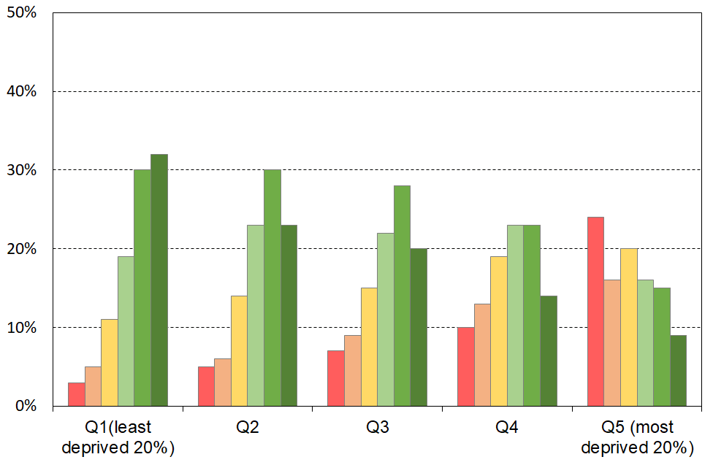**Material wellbeing for children in their households, by NZDep13 quintiles**

MSD’s Material Wellbeing Index (MWI) ranks households across the full material wellbeing spectrum from low to high, rather than just being focussed on the low end as the DEP-17 and EU-13 indices are.[147]

The analysis in Section E and in Figure 4.1 divides the full spectrum into six groups for illustrative purposes:

* The boundary for the lowest group was selected to make the MWI hardship rate correspond as closely as possible to the 6+/17 DEP-17 hardship rate (13% in 2018-19), the one used by Stats NZ in the CPRA child poverty statistics.
* Group 2 could be labelled ‘just getting by’ (the next 12% of children).
* The lower boundary for the highest group was selected so that this group had none of the basics missing and had virtually all the ‘freedoms’ (see **Table E.1** and related text).
* The boundaries for the remaining three groups were more arbitrary, but the decisions reflected the fact that the MWI’s discriminatory power diminishes the higher the MWI scores. Group 5 was therefore made larger than Groups 3 and 4, and clearly includes households not in the same league as those in Group 6, but much better off on average than Group 4.

See **Section E** for more on the MWI groupings.

**Appendix 5**

**An alternative equivalence scale for use with AHC incomes**

**Choice of scale for AHC incomes analysis**

This report uses the same equivalence scale for both BHC and AHC incomes, in line with the Stats NZ approach to the Child Poverty Statistics they publish for the CPRA measures (the modified OECD scale). There is a case for using a different set for AHC analysis as once accommodation costs are paid there is more limited opportunity for economies of scale for the household budget. In other words, the AHC equivalence ratios should reflect the more limited scope for economies of scale when looking only at residual income after housing costs have been deducted (AHC).

The UK’s *Households Below Average Income* reports use what they call their ‘companion’ scale for AHC analysis. Instead of attributing an extra 0.50 for second and subsequent household members aged 14+ as the modified OECD scale does for the BHC case, it uses 0.72. This reflects the more limited scope for economies of scale for adults for non-accommodation costs. The child factor increases only slightly from 0.30 to 0.34. (See (DWP, 2005 and 2013)).[148]

**Table 5.1** below compares the Jensen, modified OECD and HBAI scales that the UK now uses, using the single person household as the reference. The children are assumed to be around 9-12 yrs old. The lower economies of scale for a second household member are evident in the HBAI ratios.

**Table 5.1**

**Equivalence scales used in the UK for AHC analysis ((1,0) as reference household),**

**compared with the modified OECD scale used for BHC analysis and with the Revised Jensen Scale**

**(for children under 14 yrs)**

|  |  |  |  |
| --- | --- | --- | --- |
| HH type | **RJS 1988** | **‘Modified OECD’ scale for BHC analysis** | **HBAI ‘Companion’ scale for AHC analysis** |
| (1,0) | 1.00 | 1.00 | 1.00 |
| (1,1) | 1.40 | 1.30 | 1.34 |
| (1,2) | 1.75 | 1.60 | 1.68 |
| (2,0) | 1.54 | 1.50 | 1.72 |
| (2,1) | 1.86 | 1.80 | 2.06 |
| (2,2) | 2.17 | 2.10 | 2.40 |
| (2,3) | 2.43 | 2.40 | 2.74 |
| (3,0) | 1.98 | 2.00 | 2.44 |

When the UK’s ‘companion scale’ for AHC analysis is applied, three sets of relativities can be expected to change compared with staying with ‘modified OECD’ scale for AHC analysis too:

* those between singles and couples – the unequivalised income needed by a single-person household to reach the same potential living standards as a couple is lower when using the HBAI scale – this recognises that apart from housing costs there is limited opportunity for economies of scale when a second person joins the household;
* those between sole parent and two parent households - the unequivalised income needed by a sole parent household to reach the same potential living standards as a two parent household is lower when using the HBAI scale (same reason as above);
* those between a two adult household and a household with 3+ adults – the unequivalised income needed by the latter to reach the same potential living standards is higher when using the HBAI scale than with the modified OECD scale.

The consequence of this is that estimated poverty rates for single-person households and sole parent households could be expected to be a little lower relative to those for couples and two parent households respectively, when using the companion scale, all else equal. For households with 3+ adults the rates can generally be expected to be a little higher relative to those for two adult households. The household type section in **Table 5.2** confirms this. The tables also show that poverty structure remains much the same in that the those sub-groups with higher rates remain relatively high and those with lower rates remain relatively low.

**Table 5.2**

**AHC 50 REL low-income rates using two equivalence scales, HES 2020-21**

|  |  |  |
| --- | --- | --- |
|  | **‘Modified OECD’** | **HBAI ‘companion’ scale for AHC analysis** |
| **Total population** | 14 | 13 |
| **By Age group** |  |  |
| 0-17 | 19 | 17 |
| 18-24 | 18 | 19 |
| 25-44 | 13 | 12 |
| 35-64 | 13 | 12 |
| 65+ | 11 | 8 |
| 0-64 | 15 | 14 |
| **By household type** |  |  |
| Single 65+ | 21 | 10 |
| Couple 65+ | 8 | 8 |
| Single < 65 | 31 | 24 |
| Couple < 65 | 9 | 9 |
| SP with children | 43 | 36 |
| 2P with children | 13 | 12 |
| Other family HHs with children | 12 | 12 |
| Other family HHs, adults only | 8 | 9 |
| Non-family HHs | 21 | 22 |
| **By tenure (0-64 yrs)** |  |  |
| Owned, no mortgage | 9 | 9 |
| Owned, with mortgage | 9 | 9 |
| Rented, private no AS | 15 | 15 |
| Rented, private with AS | 34 | 32 |
| Rented, public | 30 | 26 |

(See the 2019 Household Incomes Report, Appendix 3, which shows that trends in child AHC low-income rates are not impacted by the change in equivalence scale (Perry, 2019)).

**Appendix 6 – 20-21 Tables**

Just add a ‘6’ in front of table title. Eg Table 6.B.1a, etc

**Table 6 - B.0**

**Material hardship rates and composition for selected population groups (DEP-17 index, 5 thresholds),**

**Children (aged 0-17 years), HES 2020-21**

|  |  |  |  |  |  |  |  |  |  |  |  |  |
| --- | --- | --- | --- | --- | --- | --- | --- | --- | --- | --- | --- | --- |
| **HES 2020-21** | **Material hardship rates** | | | | | **Composition** | | | | | | |
|  | what % of this group is in hardship, using the different thresholds? | | | | | what % of all those in hardship (using a given threshold) are in this group / cell? | | | | | **000’s** | **%** |
| **Material hardship threshold as # of items lacked out of 17** | **5+** | **6+** | **7+** | **8+** | **9+** | **5+** | **6+** | **7+** | **8+** | **9+** | **ALL** | **ALL** |
|  |  |  |  |  |  |  |  |  |  |  |  |  |
| **All children (0-17 yrs)** | 14 | 11 | 8 | 6 | 5 | 100 | 100 | 100 | 100 | 100 | 1,145 | 100 |
| **Household type** |  |  |  |  |  |  |  |  |  |  |  |  |
| 2P HH with any dependent children | 8 | 6 | 5 | 3 | 3 | 39 | 38 | 37 | 35 | 37 | 790 | 69 |
| SP HH with any dependent children | 39 | 31 | 24 | 19 | 14 | 43 | 45 | 45 | 46 | 45 | 180 | 16 |
| Other fam HHs with any dep ch | 16 | 12 | 9 | 8 | 6 | 18 | 17 | 17 | 18 | 18 | 170 | 15 |
| Other HHs (some 0-17s, no dep ch) | Suppressed – numbers too small | | | | | 1 | 1 | 1 | 1 | 0 | 10 | 1 |

**Table 6 - B.1a**

**Material hardship rates and composition for selected population groups (DEP-17 index, 5 thresholds),**

**Children (aged 0-17 years), HES 2020-21**

|  |  |  |  |  |  |  |  |  |  |  |  |  |
| --- | --- | --- | --- | --- | --- | --- | --- | --- | --- | --- | --- | --- |
| **HES 2020-21** | **Material hardship rates** | | | | | **Composition** | | | | | | |
|  | what % of this group is in hardship, using the different thresholds? | | | | | what % of all those in hardship (using a given threshold) are in this group / cell? | | | | | **000’s** | **%** |
| **Material hardship threshold as # of items lacked out of 17** | **5+** | **6+** | **7+** | **8+** | **9+** | **5+** | **6+** | **7+** | **8+** | **9+** | **ALL** | **ALL** |
|  |  |  |  |  |  |  |  |  |  |  |  |  |
| **All children (0-17 yrs)** | 14 | 11 | 8 | 6 | 5 | 100 | 100 | 100 | 100 | 100 | 1,145 | 100 |
| **Household type** |  |  |  |  |  |  |  |  |  |  |  |  |
| 2P HH with any dependent children | 8 | 6 | 5 | 3 | 3 | 39 | 38 | 37 | 35 | 37 | 790 | 69 |
| SP HH with any dependent children | 39 | 31 | 24 | 19 | 14 | 43 | 45 | 45 | 46 | 45 | 180 | 16 |
| Other fam HHs with any dep ch | 16 | 12 | 9 | 8 | 6 | 18 | 17 | 17 | 18 | 18 | 170 | 15 |
| Other HHs (some 0-17s, no dep ch) | Suppressed – numbers too small | | | | | 1 | 1 | 1 | 1 | 0 | 10 | 1 |
| **Number of dep children in household** |  |  |  |  |  |  |  |  |  |  |  |  |
| 1 | 11 | 8 | 5 | 4 | 3 | 17 | 17 | 14 | 13 | 12 | 250 | 22 |
| 2 | 10 | 8 | 6 | 4 | 3 | 31 | 29 | 29 | 28 | 29 | 485 | 42 |
| 3 | 14 | 11 | 9 | 7 | 6 | 23 | 23 | 23 | 24 | 26 | 260 | 23 |
| 4+ | 31 | 27 | 22 | 17 | 13 | 28 | 30 | 33 | 34 | 34 | 145 | 13 |
| **Work intensity (2P & SP, adults all ages)** |  |  |  |  |  |  |  |  |  |  |  |  |
| 2P - both FT | 4 | 3 | 2 | 1 | 1 | 6 | 6 | 6 | 5 | 5 | 290 | 25 |
| 2P - FT PT | 6 | 4 | 3 | 2 | 2 | 6 | 5 | 4 | 4 | 4 | 155 | 14 |
| 2P - FT WL | 14 | 10 | 8 | 5 | 4 | 14 | 14 | 13 | 11 | 10 | 165 | 14 |
| SP - FT | 20 | 14 | 13 | 10 | 6 | 8 | 7 | 8 | 8 | 6 | 60 | 5 |
| SP - PT | 35 | 28 | 25 | 15 | 13 | 6 | 6 | 7 | 6 | 6 | 30 | 2 |
| Other | 22 | 18 | 13 | 11 | 9 | 60 | 62 | 61 | 65 | 68 | 445 | 39 |
| **Labour market status of household** |  |  |  |  |  |  |  |  |  |  |  |  |
| Self-employed | 3 | 2 | 1 | 1 | 1 | 3 | 2 | 2 | 2 | 2 | 140 | 12 |
| At least one FT worker | 9 | 7 | 5 | 4 | 3 | 45 | 42 | 43 | 41 | 37 | 815 | 71 |
| No FT worker (may have PT) | 43 | 36 | 27 | 22 | 18 | 52 | 55 | 55 | 57 | 61 | 190 | 17 |
| PT work only | 25 | 20 | 17 | 11 | 9 | 10 | 10 | 11 | 9 | 10 | 60 | 5 |
| Some work (excl SE) | 10 | 7 | 6 | 4 | 3 | 55 | 52 | 54 | 51 | 47 | 875 | 76 |
| Workless | 52 | 43 | 32 | 26 | 22 | 42 | 46 | 44 | 47 | 51 | 130 | 12 |
| **Source of HH income in the 12 months prior to interview** |  |  |  |  |  |  |  |  |  |  |  |  |
| Main source market | 7 | 5 | 4 | 3 | 2 | 44 | 40 | 40 | 37 | 34 | 955 | 83 |
| Main source government | 47 | 39 | 30 | 24 | 20 | 56 | 60 | 60 | 63 | 66 | 190 | 17 |
| **Tenure of household** |  |  |  |  |  |  |  |  |  |  |  |  |
| Owned with mortgage (incl FT) | 5 | 3 | 2 | 1 | 1 | 15 | 13 | 11 | 10 | 7 | 535 | 47 |
| Owned no mortgage (incl FT) | 5 | 4 | 3 | 2 | 2 | 4 | 4 | 4 | 4 | 4 | 130 | 11 |
| Private rental | 23 | 18 | 14 | 10 | 8 | 53 | 53 | 53 | 50 | 52 | 365 | 32 |
| Social rental | 51 | 42 | 35 | 30 | 24 | 24 | 25 | 27 | 31 | 32 | 75 | 7 |
| Other | 18 | 14 | 13 | 8 | 7 | 4 | 4 | 5 | 4 | 5 | 40 | 3 |
| **Private rental by AS receipt** |  |  |  |  |  |  |  |  |  |  |  |  |
| Private rental (no AS) | 11 | 8 | 6 | 4 | 3 | 13 | 11 | 12 | 11 | 11 | 180 | 16 |
| Private rental (with AS) | 35 | 28 | 21 | 15 | 12 | 40 | 42 | 41 | 39 | 41 | 185 | 16 |
| **Education (highest qualification in HH)** |  |  |  |  |  |  |  |  |  |  |  |  |
| Higher degree | 2 | 1 | 1 | 0 | 0 | 4 | 3 | 2 | 2 | 1 | 275 | 24 |
| Bachelors or similar | 6 | 4 | 2 | 1 | 1 | 10 | 7 | 6 | 4 | 4 | 250 | 22 |
| Post-school non-degree qual | 16 | 12 | 10 | 8 | 6 | 32 | 33 | 34 | 37 | 38 | 330 | 29 |
| School qual | 26 | 21 | 16 | 12 | 8 | 33 | 35 | 34 | 33 | 31 | 205 | 18 |
| No formal qual | 40 | 32 | 25 | 20 | 17 | 21 | 22 | 23 | 24 | 26 | 85 | 8 |
| **NZDep Quintile** |  |  |  |  |  |  |  |  |  |  |  |  |
| Q1(least deprived 20%) | 3 | 2 | 1 | 1 | 1 | 3 | 3 | 3 | 2 | 2 | 210 | 18 |
| Q2 | 7 | 5 | 3 | 2 | 2 | 10 | 9 | 8 | 7 | 8 | 235 | 20 |
| Q3 | 13 | 10 | 8 | 7 | 5 | 18 | 17 | 18 | 21 | 21 | 225 | 20 |
| Q4 | 17 | 13 | 10 | 8 | 6 | 24 | 24 | 24 | 25 | 25 | 230 | 20 |
| Q5 (most deprived 20%) | 29 | 24 | 18 | 13 | 10 | 45 | 46 | 47 | 45 | 44 | 245 | 21 |

**Table 6 - B.1b**

**Material hardship rates and composition by ethnic group (DEP-17 index, 5 thresholds),**

**Children (aged 0-17 years), HES 2020-21**

|  |  |  |  |  |  |  |  |  |  |  |  |  |
| --- | --- | --- | --- | --- | --- | --- | --- | --- | --- | --- | --- | --- |
| **HES 2020-21** | **Material hardship rates** | | | | | **Composition** | | | | | | |
|  | what % of this group is in hardship, using the different thresholds? | | | | | what % of all those in hardship (using a given threshold) are in this group / cell? | | | | | **000’s** | **%** |
| **Material hardship threshold as # of items lacked out of 17** | **5+** | **6+** | **7+** | **8+** | **9+** | **5+** | **6+** | **7+** | **8+** | **9+** | **ALL** | **ALL** |
| **Material hardship rates (%)** |  |  |  |  |  |  |  |  |  |  |  |  |
| **All children (0-17 yrs)** | 14 | 11 | 8 | 6 | 5 | 100 | 100 | 100 | 100 | 100 | 1,145 | 100 |
| **Ethnicity (total)** |  |  |  |  |  |  |  |  |  |  |  |  |
| European | 10 | 8 | 6 | 4 | 3 | 37 | 35 | 34 | 33 | 34 | 750 | 52 |
| Māori | 25 | 20 | 16 | 13 | 10 | 35 | 36 | 38 | 39 | 39 | 300 | 21 |
| Pacific peoples | 30 | 24 | 18 | 14 | 11 | 20 | 20 | 20 | 20 | 20 | 140 | 10 |
| Asian | 6 | 5 | 4 | 3 | 2 | 6 | 6 | 6 | 6 | 5 | 215 | 15 |
| Other | 9 | 7 | 5 | 4 | 3 | 2 | 2 | 2 | 2 | 1 | 45 | 3 |
| **Ethnicity (prioritised)** |  |  |  |  |  |  |  |  |  |  |  |  |
| European | 8 | 6 | 4 | 3 | 2 | 27 | 25 | 23 | 22 | 23 | 530 | 46 |
| Māori | 25 | 20 | 16 | 13 | 10 | 47 | 48 | 50 | 52 | 51 | 300 | 26 |
| Pacific peoples | 30 | 24 | 18 | 14 | 11 | 18 | 19 | 19 | 19 | 20 | 100 | 9 |
| Asian | 5 | 4 | 3 | 2 | 2 | 7 | 7 | 6 | 6 | 6 | 200 | 17 |
| Other | 12 | 9 | 6 | 3 | 3 | 1 | 1 | 1 | 1 | 1 | 20 | 2 |

Reading note for interpreting ‘total ethnicity’ percentages. The total ethnicities approach counts ethnicities, not children. There are around 300,000 more ethnicity responses than there are children, as many report more than one ethnicity.

* The ‘24%’ figure in the Pacific row for 6+/17 hardship rate means that out of all the ethnicities reported by children in the 6+ hardship column, 28% are Pacific (whether only Pacific or Pacific and one or more other ethnicities).
* The ‘20%’ figure in the Pacific row for 6+/17 composition means that out of all the ethnicities reported by children in the 6+ hardship column, 20% are Pacific (whether only Pacific or Pacific and one or more other ethnicities).

**Table 6 - B.2a**

**Low-income rates and composition for selected population groups (AHC incomes, selected thresholds)**

**Children (aged 0-17 yrs) HES 2020-21**

|  |  |  |  |  |  |  |  |  |  |  |  |  |
| --- | --- | --- | --- | --- | --- | --- | --- | --- | --- | --- | --- | --- |
| **HES 2020-21** | **Low-income rates** | | | | | **Composition** | | | | | | |
| **AHC** | what % of this group is in a low-income household, using the different thresholds? | | | | | what % of all those in low-income households (using a given threshold) are in this group / cell? | | | | | **000’s** | **%** |
| **Low-income threshold as % of median** | **≥70** | **<70** | **<60** | **<50** | **<40** | **≥70** | **<70** | **<60** | **<50** | **<40** | **ALL** | **ALL** |
|  |  |  |  |  |  |  |  |  |  |  |  |  |
| **All children (0-17 yrs)** | 64 | 36 | 27 | 19 | 11 | 100 | 100 | 100 | 100 | 100 | 1,110 | 100 |
| **Household type** |  |  |  |  |  |  |  |  |  |  |  |  |
| 2P HH with any dependent children | 70 | 30 | 21 | 14 | 8 | 75 | 56 | 54 | 50 | 52 | 755 | 68 |
| SP HH with any dependent children | 28 | 72 | 61 | 46 | 26 | 7 | 30 | 34 | 38 | 36 | 170 | 15 |
| Other fam HHs with any dep ch | 71 | 29 | 20 | 14 | 8 | 18 | 13 | 11 | 12 | 11 | 175 | 16 |
| Other HHs (some 0-17s, no dep ch) | Cell sizes too small – rates suppressed | | | | | 1 | 1 | 1 | 1 | 1 | 10 | 1 |
| **Number of dep children in household** |  |  |  |  |  |  |  |  |  |  |  |  |
| 1 | 72 | 28 | 22 | 16 | 10 | 24 | 17 | 18 | 18 | 20 | 240 | 22 |
| 2 | 68 | 32 | 23 | 16 | 9 | 45 | 38 | 36 | 35 | 37 | 470 | 43 |
| 3 | 61 | 39 | 30 | 21 | 12 | 21 | 25 | 25 | 26 | 25 | 250 | 23 |
| 4+ | 42 | 58 | 43 | 30 | 15 | 8 | 21 | 20 | 20 | 17 | 140 | 13 |
| **Work intensity (2P & SP, adults all ages)** |  |  |  |  |  |  |  |  |  |  |  |  |
| 2P - both FT | 85 | 15 | 10 | 7 | 5 | 33 | 10 | 9 | 10 | 11 | 280 | 25 |
| 2P - FT PT | 76 | 24 | 14 | 9 | 5 | 16 | 9 | 7 | 6 | 6 | 150 | 13 |
| 2P - FT WL | 49 | 51 | 35 | 19 | 10 | 11 | 20 | 19 | 15 | 13 | 160 | 14 |
| SP - FT | 52 | 48 | 30 | 16 | 7 | 4 | 7 | 6 | 4 | 4 | 60 | 5 |
| SP - PT | 17 | 83 | 70 | 54 | 26 | 1 | 5 | 6 | 6 | 5 | 25 | 2 |
| Other | 56 | 44 | 36 | 28 | 16 | 35 | 49 | 53 | 59 | 60 | 440 | 40 |
| **Labour market status of household** |  |  |  |  |  |  |  |  |  |  |  |  |
| Self-employed | 74 | 26 | 21 | 13 | 9 | 14 | 9 | 10 | 8 | 10 | 135 | 12 |
| At least one FT worker | 72 | 28 | 19 | 11 | 7 | 80 | 54 | 49 | 43 | 43 | 785 | 71 |
| No FT worker (may have PT) | 21 | 79 | 67 | 54 | 30 | 6 | 37 | 42 | 49 | 46 | 190 | 17 |
| PT work only | 30 | 70 | 54 | 42 | 20 | 2 | 10 | 10 | 11 | 9 | 55 | 5 |
| Some work (excl SE) | 70 | 30 | 21 | 13 | 7 | 82 | 64 | 59 | 54 | 52 | 840 | 76 |
| Workless | 18 | 82 | 72 | 59 | 34 | 3 | 27 | 32 | 38 | 37 | 130 | 12 |
| **Source of HH income in the 12 months prior to interview** |  |  |  |  |  |  |  |  |  |  |  |  |
| Main source market | 73 | 27 | 19 | 11 | 6 | 95 | 63 | 57 | 49 | 48 | 930 | 84 |
| Main source government | 19 | 81 | 71 | 58 | 34 | 5 | 37 | 43 | 51 | 52 | 180 | 16 |
| **Tenure of household** |  |  |  |  |  |  |  |  |  |  |  |  |
| Owned with mortgage (incl FT) | 74 | 26 | 17 | 11 | 7 | 54 | 33 | 30 | 28 | 29 | 520 | 47 |
| Owned no mortgage (incl FT) | 81 | 19 | 13 | 9 | 5 | 14 | 6 | 6 | 5 | 6 | 130 | 12 |
| Private rental | 49 | 51 | 41 | 30 | 18 | 24 | 44 | 47 | 50 | 52 | 350 | 31 |
| Social rental | 34 | 66 | 53 | 36 | 15 | 4 | 13 | 14 | 14 | 9 | 75 | 7 |
| Other | 61 | 39 | 29 | 19 | 10 | 3 | 4 | 4 | 3 | 3 | 40 | 3 |
| **Private rental by AS receipt** |  |  |  |  |  |  |  |  |  |  |  |  |
| Private rental (no AS) | 66 | 34 | 25 | 15 | 9 | 15 | 14 | 14 | 12 | 13 | 165 | 15 |
| Private rental (with AS) | 34 | 66 | 55 | 44 | 26 | 9 | 30 | 33 | 38 | 39 | 180 | 16 |
| **Education (highest qualification in HH)** |  |  |  |  |  |  |  |  |  |  |  |  |
| Higher degree | 79 | 21 | 15 | 11 | 7 | 29 | 14 | 13 | 14 | 15 | 260 | 23 |
| Bachelors or similar | 75 | 25 | 17 | 9 | 6 | 26 | 15 | 14 | 11 | 11 | 240 | 22 |
| Post-school non-degree qual | 60 | 40 | 29 | 19 | 11 | 27 | 32 | 30 | 29 | 30 | 315 | 28 |
| School qual | 51 | 49 | 39 | 27 | 15 | 15 | 25 | 26 | 27 | 25 | 205 | 18 |
| No formal qual | 34 | 66 | 55 | 44 | 24 | 4 | 14 | 16 | 19 | 18 | 85 | 8 |
| **NZDep Quintile** |  |  |  |  |  |  |  |  |  |  |  |  |
| Q1(least deprived 20%) | 80 | 20 | 15 | 9 | 6 | 23 | 10 | 10 | 9 | 9 | 200 | 18 |
| Q2 | 72 | 28 | 20 | 15 | 10 | 22 | 16 | 15 | 16 | 18 | 225 | 20 |
| Q3 | 63 | 37 | 28 | 20 | 13 | 20 | 20 | 20 | 21 | 24 | 220 | 20 |
| Q4 | 56 | 44 | 34 | 22 | 13 | 18 | 24 | 25 | 24 | 23 | 225 | 20 |
| Q5 (most deprived 20%) | 52 | 48 | 38 | 26 | 13 | 18 | 29 | 30 | 31 | 26 | 240 | 22 |
|  |  |  |  |  |  |  |  |  |  |  |  |  |

**Table 6 - B2.b**

**Low-income rates and composition for selected population groups (AHC, 5 thresholds),**

**Children (aged 0-17 years), HES 2018-19**

|  |  |  |  |  |  |  |  |  |  |  |  |  |
| --- | --- | --- | --- | --- | --- | --- | --- | --- | --- | --- | --- | --- |
| **HES 2018-19** | **Low-income rates** | | | | | **Composition** | | | | | | |
| **AHC** | what % of this group is in a low-income household, using the different thresholds? | | | | | what % of all those in low-income households (using a given threshold) are in this group / cell? | | | | | **000’s** | **%** |
| **Low-income threshold as % of median** | **≥70** | **<70** | **<60** | **<50** | **<40** | **≥70** | **<70** | **<60** | **<50** | **<40** | **ALL** | **ALL** |
|  |  |  |  |  |  |  |  |  |  |  |  |  |
| **All children (0-17 yrs)** | 64 | 36 | 27 | 19 | 12 | 100 | 100 | 100 | 100 | 100 | 1,100 | 100 |
| **Ethnicity (total)** |  |  |  |  |  |  |  |  |  |  |  |  |
| European | 70 | 30 | 22 | 15 | 9 | 58 | 44 | 43 | 41 | 41 | 53 | 53 |
| NZ Māori | 55 | 45 | 33 | 25 | 15 | 19 | 27 | 26 | 28 | 27 | 21 | 21 |
| Pacific peoples | 53 | 47 | 35 | 24 | 13 | 9 | 13 | 13 | 13 | 11 | 10 | 10 |
| Asian | 63 | 37 | 28 | 21 | 15 | 12 | 13 | 13 | 14 | 16 | 13 | 13 |
| Other | 56 | 44 | 38 | 30 | 20 | 3 | 4 | 4 | 5 | 5 | 3 | 3 |
| **Ethnicity (prioritised)** |  |  |  |  |  |  |  |  |  |  |  |  |
| European | 73 | 27 | 19 | 13 | 8 | 53 | 35 | 34 | 32 | 33 | 515 | 47 |
| NZ Māori | 55 | 45 | 33 | 25 | 15 | 23 | 34 | 33 | 35 | 34 | 290 | 26 |
| Pacific peoples | 52 | 48 | 36 | 24 | 12 | 7 | 12 | 12 | 11 | 9 | 95 | 9 |
| Asian | 64 | 36 | 28 | 21 | 15 | 14 | 15 | 15 | 16 | 19 | 160 | 14 |
| Other | 55 | 45 | 41 | 31 | 21 | 3 | 5 | 6 | 6 | 6 | 40 | 4 |

Reading note for interpreting ‘total ethnicity’ percentages. The total ethnicities approach counts ethnicities, not children. There are around 250,000 more ethnicity responses than there are children, as many report more than one ethnicity.

* The ‘24%’ figure in the Pacific row for the 50% AHC low-income rate means that out of all the ethnicities reported by children in the 50% AHC column, 24% are Pacific (whether only Pacific or Pacific and one or more other ethnicities).
* The ‘13%’ figure in the Pacific row for the 50% AHC composition means that out of all the ethnicities reported by children in the 50% AHC column, 13% are Pacific (whether only Pacific or Pacific and one or more other ethnicities).

**Table 6 - C.3a**

**Children’s restrictions by the MWI score of their household (children, 6-17 yrs),**

**grouped by quintiles of children, with the bottom quintile broken out into deciles**

**HES 2020-21 (%)**

|  |  |  |  |  |  |  |  |  |  |
| --- | --- | --- | --- | --- | --- | --- | --- | --- | --- |
|  | **All** | **D1** | **D2** |  | **Q1** | **Q2** | **Q3** | **Q4** | **Q5** |
| **Distribution of children (6-17yrs) across MWI deciles of children (%)** | 100 | 10 | 10 |  | 20 | 20 | 20 | 20 | 20 |
| **Don’t have** |  |  |  |  |  |  |  |  |  |
| 2 pair of shoes in good condition and suitable for daily activities for each child | 5 | 29 | 7 |  | 18 | 3 | . | . | . |
| 2 sets of warm winter clothes for each child | 2 | 14 | . |  | 8 | . | . | . | . |
| waterproof coat for each child (because of the cost) | 3 | 26 | 5 |  | 15 | . | . | . | . |
| separate bed for each child | 4 | 18 | 6 |  | 12 | 3 | 2 | . | . |
| fresh fruit and vegetables daily | 4 | 29 | 6 |  | 18 | 2 | . | . | . |
| meal with meat, fish or chicken (or vegetarian equiv) each day | 3 | 17 | 5 |  | 11 | . | . | . | . |
| good access at home to a computer and internet for homework | 4 | 19 | 7 |  | 13 | 3 | . | . | . |
| friends around to play and eat from time to time (because of the cost) | 2 | 14 | 6 |  | 10 | . | . | . | . |
| **Economised ‘a lot’ on children’s items to keep down costs to enable other basic things to be paid for (not just to be thrifty or to save for a trip or other non-essential)** | | | | | | | | | |
| had to go without music, dance, kapa haka, art, swimming or other special interest lessons (“a lot”) | 5 | 33 | 11 |  | 22 | 3 | . | . | . |
| unable to pay for school trip or other school event (“a lot”) | 3 | 20 | 3 |  | 11 | . | . | . | . |
| involvement in sport had to be limited (“a lot”) | 4 | 31 | 9 |  | 20 | 3 | . | . | . |
| continue to wear shoes or clothes that are worn out or the wrong size (“a lot”) | 3 | 21 | 4 |  | 13 | . | . | . | . |
| **Multiple restrictions of child-specific items (the 12 above)** |  |  |  |  |  |  |  |  |  |
| 2+ out of 12 | 9 | 60 | 18 |  | 39 | 5 | . | . | . |
| 3+ out of 12 | 6 | 45 | 7 |  | 26 | . | . | . | . |
| 4+ out of 12 | 3 | 27 | . |  | 14 | . | . | . | . |
| **Child-relevant general household items** |  |  |  |  |  |  |  |  |  |
| received help (food, clothes, money) from a community organisation more than once in the last 12 months | 7 | 44 | 15 |  | 29 | 5 | . | . | . |
| accommodation crowded or severely crowded (1+ extra bedrooms needed) | 14 | 30 | 27 |  | 28 | 19 | 11 | 9 | 4 |
| accommodation severely crowded (2+ extra bedrooms needed) | 4 | 10 | 5 |  | 8 | 5 | 3 | . | . |
| dampness or mould a ‘major problem’ in the accommodation | 6 | 31 | 14 |  | 22 | 4 | . | . | . |
| respondent reports putting up with feeling cold to keep down costs for other basics (‘a lot’) | 7 | 42 | 16 |  | 29 | 3 | . | . | . |
| delayed replacing or repairing broken or damaged appliances to keep down costs for other basics (‘a lot’) | 10 | 61 | 26 |  | 44 | 7 | . | . | . |
| household has no access to car or van for personal use | 4 | 10 | 10 |  | 10 | 5 | 2 | . | . |
| **Multiple restrictions out of 12 child-specific and 6 general child-relevant household items (18 in all)** | | | | | | | | | |
| 3+ out of 18 | 10 | 73 | 21 |  | 47 | 4 | 1 | 0 | 0 |
| 4+ out of 18 | 7 | 58 | 9 |  | 34 | 1 | 0 | 0 | 0 |
| 5+ out of 18 | 5 | 44 | . |  | 24 | 1 | 0 | 0 | 0 |
| **Postponed doctor’s visits ‘a lot’ to keep down costs to enable other basic things to be paid for (not just to be thrifty or to save for a trip or other non-essential)** | | | | | | | | | |
| For children (a lot) | 1 | 7 | . |  | 5 | . | . | . | . |
| For respondent (a lot) | 9 | 55 | 19 |  | 37 | 7 | . | . | . |
| For children (a little or a lot) | 4 | 17 | 9 |  | 13 | 4 | . | . | . |
| For respondent (a little or a lot) | 22 | 81 | 54 |  | 67 | 31 | 11 | 2 | . |
| **Respondent reports life satisfaction** |  |  |  |  |  |  |  |  |  |
| dissatisfied or very dissatisfied with life | 5 | 23 | 8 |  | 15 | 4 | 3 | . | . |
| satisfied or very satisfied with life | 81 | 42 | 64 |  | 53 | 78 | 87 | 91 | 96 |

Note: Information is suppressed in cells with fewer than 15 households in the sample.

**Table 6 - C.3b**

**Children’s restrictions by the MWI score of their household (children, 6-17 yrs),**

**grouped by deciles and ventiles of children**

**HES 2020-21 (%)**

|  |  |  |  |  |  |  |  |  |  |
| --- | --- | --- | --- | --- | --- | --- | --- | --- | --- |
|  | **All** | **V1** | **V2** |  | **D1** | **D2** | **D3** | **D4** | **D5** |
| **Distribution of children (6-17yrs) across MWI deciles of children (%)** | 100 | 5 | 5 |  | 10 | 10 | 10 | 10 | 10 |
| **Don’t have** |  |  |  |  |  |  |  |  |  |
| 2 pair of shoes in good condition and suitable for daily activities for each child | 5 | 37 | 20 |  | 29 | 7 | 5 | . | . |
| 2 sets of warm winter clothes for each child | 2 | 20 | . |  | 14 | . | . | . | . |
| waterproof coat for each child (because of the cost) | 3 | 37 | 14 |  | 26 | 5 | 3 | . | . |
| separate bed for each child | 4 | 17 | 19 |  | 18 | 6 | . | . | . |
| fresh fruit and vegetables daily | 4 | 43 | 16 |  | 29 | 6 | . | . | . |
| meal with meat, fish or chicken (or vegetarian equiv) each day | 3 | 25 | 8 |  | 17 | 5 | . | . | . |
| good access at home to a computer and internet for homework | 4 | 22 | 16 |  | 19 | 7 | 4 | . | . |
| friends around to play and eat from time to time (because of the cost) | 2 | 18 | 10 |  | 14 | 6 | . | . | . |
| **Economised ‘a lot’ on children’s items to keep down costs to enable other basic things to be paid for (not just to be thrifty or to save for a trip or other non-essential)** | | | | | | | | | |
| had to go without music, dance, kapa haka, art, swimming or other special interest lessons (“a lot”) | 5 | 42 | 24 |  | 33 | 11 | 4 | . | . |
| unable to pay for school trip or other school event (“a lot”) | 3 | 27 | 13 |  | 20 | 3 | . | . | . |
| involvement in sport had to be limited (“a lot”) | 4 | 39 | 22 |  | 31 | 9 | . | . | . |
| continue to wear shoes or clothes that are worn out or the wrong size (“a lot”) | 3 | 33 | 9 |  | 21 | 4 | . | . | . |
| **Multiple restrictions of child-specific items (the 12 above)** |  |  |  |  |  |  |  |  |  |
| 2+ out of 12 | 9 | 78 | 42 |  | 60 | 18 | 7 | . | . |
| 3+ out of 12 | 6 | 62 | 28 |  | 45 | 7 | . | . | . |
| 4+ out of 12 | 3 | 38 | 16 |  | 27 | 2 | . | . | . |
| **Child-relevant general household items** |  |  |  |  |  |  |  |  |  |
| received help (food, clothes, money) from a community organisation more than once in the last 12 months | 7 | 50 | 38 |  | 44 | 15 | 6 | . | . |
| accommodation crowded or severely crowded (1+ extra bedrooms needed) | 14 | 30 | 30 |  | 30 | 27 | 21 | 18 | 12 |
| accommodation severely crowded (2+ extra bedrooms needed) | 4 | 10 | . |  | 10 | 5 | . | 5 | . |
| dampness or mould a ‘major problem’ in the accommodation | 6 | 40 | 22 |  | 31 | 14 | 5 | . | . |
| respondent reports putting up with feeling cold to keep down costs for other basics (‘a lot’) | 7 | 59 | 26 |  | 42 | 16 | 3 | . | . |
| delayed replacing or repairing broken or damaged appliances to keep down costs for other basics (‘a lot’) | 10 | 83 | 40 |  | 61 | 26 | 9 | 6 | . |
| household has no access to car or van for personal use | 4 | 11 | 10 |  | 10 | 10 | 6 | 4 | . |
| **Multiple restrictions out of 12 child-specific and 6 general child-relevant household items (18 in all)** | | | | | | | | | |
| 3+ out of 18 | 10 | 92 | 53 |  | 73 | 21 | 6 | . | . |
| 4+ out of 18 | 7 | 80 | 37 |  | 58 | 9 | . | . | . |
| 5+ out of 18 | 5 | 66 | 22 |  | 44 | . | . | . | . |
| **Postponed doctor’s visits ‘a lot’ to keep down costs to enable other basic things to be paid for (not just to be thrifty or to save for a trip or other non-essential)** | | | | | | | | | |
| For children (a lot) | 1 | 11 | . |  | 7 | . | . | . | . |
| For respondent (a lot) | 9 | 72 | 37 |  | 55 | 19 | 8 | 5 | . |
| For children (a little or a lot) | 4 | 20 | 15 |  | 17 | 9 | 4 | . | . |
| For respondent (a little or a lot) | 22 | 91 | 72 |  | 81 | 54 | 39 | 22 | 14 |
| **Respondent reports life satisfaction** |  |  |  |  |  |  |  |  |  |
| dissatisfied or very dissatisfied with life | 5 | 24 | 22 |  | 23 | 8 | 6 | . | . |
| satisfied or very satisfied with life | 81 | 37 | 48 |  | 42 | 64 | 73 | 84 | 85 |

Note: Information is suppressed in cells with fewer than 15 households in the sample.

**Table 6 - C.4**

**Deprivations/restrictions for children (6-17 yrs) in households in hardship (6+/17, 9+/17) HES 2020-21**

|  |  |  |  |  |  |  |  |
| --- | --- | --- | --- | --- | --- | --- | --- |
|  |  | **Rates (%)** | | |  | **Composition (%)** | |
|  |  | **Deprivation rate for item for all aged 6-17 yrs, and for those in HHs in hardship and severe hardship** | | |  | **Proportion of all deprived of the item whose household is in the specified hardship zone** | |
|  |  | **All** | **6+/17** | **9+/17** |  | **6+/17** | **9+/17** |
| **Child-relevant general household items** |  |  |  |  |  |  |  |
| Income adequacy for basics | not enough | 11 | 51 | 60 |  | 49 | 25 |
| Foodbank / other community help | more than once | 7 | 41 | 53 |  | 61 | 35 |
| Borrowed for basics from family/friends | more than once | 10 | 55 | 71 |  | 60 | 34 |
| Can pay unexpected $500 essential bill | no | 22 | 84 | 92 |  | 41 | 20 |
| Delayed replace/repair appliances | a lot | 10 | 62 | 79 |  | 65 | 37 |
| Car | don't have | 4 | 11 | 10 |  | 31 | 13 |
| Holiday away each year | don't have - cost | 24 | 73 | 79 |  | 33 | 16 |
| Holiday away each year | don't have - other | 12 | 5 | 3 |  | 4 | 1 |
| Dampness or mould | major problem | 6 | 26 | 30 |  | 50 | 26 |
| Can afford to keep home warm | no | 8 | 45 | 55 |  | 60 | 32 |
| Crowding | 1+ more rooms needed | 14 | 28 | 31 |  | 21 | 11 |
| Crowding | 2+ needed - severe | 4 | 9 | 9 |  | 27 | 13 |
| Life satisfaction | dissatis / very dissatis | 5 | 20 | 25 |  | 43 | 24 |
| **Child-specific items** |  |  |  |  |  |  |  |
| Two pair of shoes | don't have | 5 | 26 | 35 |  | 61 | 36 |
| Two sets winter clothes | don't have | 2 | 12 | 16 |  | 79 | 48 |
| Waterproof coat | don't have - cost | 3 | 22 | 32 |  | 74 | 48 |
| Waterproof coat | don't have - other | 3 | 6 | 9 |  | 24 | 15 |
| Separate bed | don't have | 4 | 16 | 15 |  | 45 | 20 |
| Fruit and veg daily | don't have | 4 | 27 | 39 |  | 74 | 48 |
| Protein meal daily | don't have | 3 | 16 | 26 |  | 61 | 46 |
| Computer / internet | don't have | 4 | 16 | 21 |  | 51 | 29 |
| Friends around to play / eat | don't have - cost | 2 | 13 | 14 |  | 63 | 32 |
| Friends around to play / eat | don't have - other | 7 | 15 | 13 |  | 24 | 10 |
| Birthday and other celebrations | don't have - cost | 4 | 23 | 31 |  | 63 | 37 |
| Birthday and other celebrations | don't have - other | 8 | 17 | 16 |  | 25 | 10 |
| Unable to fund school trips | a lot | 3 | 18 | 24 |  | 78 | 49 |
| Had to limit participation in sport | a lot | 4 | 28 | 35 |  | 71 | 41 |
| Had to go without special interests | a lot | 5 | 30 | 38 |  | 68 | 38 |
| Continued to wear worn out / wrong size shoes/clothes | a lot | 3 | 19 | 30 |  | 76 | 56 |

**Table 6 - C.5b**

**Distribution across household AHC income bands of children identified as in hardship (DEP-17, 6+/17),**

**and severe material hardship (9+/17)**

|  |  |  |  |  |  |  |  |
| --- | --- | --- | --- | --- | --- | --- | --- |
| **HES 2020-21** | **under 40%** | **40-50%** | **50-60%** | **60-70%** | **70%-median** | **above median** | **ALL, 0-17 yrs** |
| **All 0-17s** | 11 | 8 | 9 | 9 | 24 | 40 | 100 |
| **DEP-17, 6+/17** | 27 | 21 | 15 | 9 | 19 | 9 | 100 |
| **DEP-17, 9+/17** | 33 | 23 | 13 | 7 | 15 | 9 | 100 |

**Table 6 - C.6**

**Numbers and percentages of children in each AHC income band**

**(all children and children in households in hardship)**

**HES 2020-21**

|  |  |  |  |  |  |  |  |  |
| --- | --- | --- | --- | --- | --- | --- | --- | --- |
|  |  | **< 40%** | **40-50%** | **50-60%** | **60-70%** | **70-100%** | **Median +** | **Sum across** |
| **Numbers (000s)** | All children (cell = # of 0-17s) | 120 | 85 | 95 | 100 | 270 | 440 | 1110 |
| # of 0-17s in the income band who are in hardship | 35 | 25 | 20 | 10 | 25 | 10 | 120 |
| **%** | % of all 0-17s who are in the income band | 11 | 8 | 9 | 9 | 24 | 40 | 100 |
| % of all 0-17s who are in hardship who come from this income band | 27 | 21 | 15 | 9 | 19 | 9 | 100 |
| % of 0-17s in the income band who are in hardship | 28 | 29 | 19 | 11 | 9 | 2 | n/a |

**Table C.7** repeats the analysis in Table C.6 for each CPRA relative low-income measure rather than for selected bands.

**Table 6 - C.7**

**Numbers and percentages of children below each CPRA relative low-income threshold**

**(all children and children in households in hardship)**

**HES 2020-21**

|  |  |  |  |  |  |  |
| --- | --- | --- | --- | --- | --- | --- |
|  |  | **BHC 50** | **BHC 60** | **AHC 40** | **AHC 50** | **AHC 60** |
| **Numbers (000s)** | All children (0-17 yrs) | 130 | 225 | 120 | 205 | 300 |
| Children in HHs in hardship (6+/17) | 40 | 60 | 35 | 60 | 75 |
| **Percentages** | All children (0-17 yrs) | 11 | 20 | 11 | 19 | 27 |
| Children in HHs in hardship (6+/17) | 33 | 27 | 28 | 29 | 25 |

Reading note for Table C.7:

The numbers in this table are a little lower than the official Stats NZ numbers for 2018-19 as the treatment for VLI households with good material wellbeing has been applied. See **Appendix 5** for further information, and **Section O** in the main report for detail,

**Table 6 - C.8a**

**Children’s restrictions by AHC income of their household (children, 6-17 yrs),**

**grouped by quintiles of children, with the bottom quintile broken out into deciles, HES 2018-19 (%)**

|  |  |  |  |  |  |  |  |  |  |
| --- | --- | --- | --- | --- | --- | --- | --- | --- | --- |
|  | **All** | **D1** | **D2** |  | **Q1** | **Q2** | **Q3** | **Q4** | **Q5** |
| **Distribution of children (6-17yrs) across MWI deciles of children (%)** | 100 | 10 | 10 |  | 20 | 20 | 20 | 20 | 20 |
| **Don’t have** |  |  |  |  |  |  |  |  |  |
| 2 pair of shoes in good condition and suitable for daily activities for each child | 7 | 17 | 18 |  | 17 | 9 | 5 | . | . |
| 2 sets of warm winter clothes for each child | 2 | 4 | 5 |  | 4 | 2 | . | . | . |
| waterproof coat for each child (because of the cost) | 5 | 11 | 12 |  | 11 | 6 | 4 | . | . |
| separate bed for each child | 5 | 10 | 12 |  | 11 | 7 | 4 | 3 | . |
| fresh fruit and vegetables daily | 8 | 14 | 19 |  | 17 | 10 | 5 | 3 | . |
| meal with meat, fish or chicken (or vegetarian equiv) each day | 6 | 15 | 14 |  | 14 | 9 | 3 | 3 | . |
| good access at home to a computer and internet for homework | 6 | 11 | 16 |  | 14 | 9 | 5 | 1 | . |
| friends around to play and eat from time to time (because of the cost) | 4 | 9 | 8 |  | 8 | 5 | 3 | . | . |
| **Economised “a lot” on children’s items to keep down costs to enable other basic things to be paid for (not just to be thrifty or to save for a trip or other non-essential)** | | | | | | | | | |
| had to go without music, dance, kapa haka, art, swimming or other special interest lessons (“a lot”) | 7 | 15 | 15 |  | 15 | 10 | 6 | 2 | . |
| unable to pay for school trip or other school event (“a lot”) | 4 | 9 | 8 |  | 9 | 6 | 2 | . | . |
| involvement in sport had to be limited (“a lot”) | 6 | 15 | 12 |  | 13 | 10 | 4 | 2 | . |
| continue to wear shoes or clothes that are worn out or the wrong size (“a lot”) | 3 | 6 | 8 |  | 7 | 5 | 2 | . | . |
| **Multiple restrictions of child-specific items (the 12 above)** |  |  |  |  |  |  |  |  |  |
| 2+ out of 12 | 13 | 29 | 29 |  | 29 | 17 | 9 | 4 | . |
| 3+ out of 12 | 8 | 20 | 23 |  | 21 | 11 | 6 | 2 | . |
| 4+ out of 12 | 6 | 15 | 17 |  | 16 | 8 | 4 | 1 | . |
| **Child-relevant general household items** |  |  |  |  |  |  |  |  |  |
| received help (food, clothes, money) from a community organisation more than once in the last 12 months | 5 | 13 | 14 |  | 14 | 7 | 2 | . | . |
| accommodation crowded or severely crowded (1+ extra bedrooms needed) | 13 | 17 | 20 |  | 18 | 20 | 14 | 9 | 4 |
| accommodation severely crowded (2+ extra bedrooms needed) | 3 | 2 | 4 |  | 3 | 5 | 4 | 4 | . |
| dampness or mould a “major problem” in the accommodation | 8 | 16 | 13 |  | 15 | 12 | 8 | 5 | 2 |
| respondent reports putting up with feeling cold to keep down costs for other basics (a lot) | 10 | 17 | 23 |  | 20 | 13 | 8 | 4 | 3 |
| delayed replacing or repairing broken or damaged appliances to keep down costs for other basics (a lot) | 12 | 24 | 25 |  | 24 | 18 | 10 | 5 | 4 |
| household has no access to car or van for personal use | 5 | 8 | 11 |  | 10 | 5 | 3 | 3 | . |
| **Multiple restrictions out of 12 child-specific and 6 general child-relevant household items (18 in all)** | | | | | | | | | |
| 3+ out of 18 | 14 | 33 | 31 |  | 32 | 20 | 10 | 3 | . |
| 4+ out of 18 | 10 | 22 | 26 |  | 24 | 13 | 6 | 3 | . |
| 5+ out of 18 | 7 | 17 | 20 |  | 19 | 10 | 4 | 1 | . |
| **Postponed doctor’s visits “a lot” to keep down costs to enable other basic things to be paid for (not just to be thrifty or to save for a trip or other non-essential)** | | | | | | | | | |
| For children (a lot) | 2 | 2 | 5 |  | 3 | 2 | . | . | . |
| For respondent (a lot) | 11 | 23 | 22 |  | 23 | 17 | 9 | 5 | 3 |
| For children (a little or a lot) | 5 | 8 | 11 |  | 9 | 9 | 2 | 2 | . |
| For respondent (a little or a lot) | 29 | 49 | 46 |  | 48 | 40 | 29 | 18 | 8 |
| **Respondent reports life satisfaction** |  |  |  |  |  |  |  |  |  |
| dissatisfied or very dissatisfied with life | 6 | 12 | 13 |  | 13 | 8 | 5 | 3 | 3 |
| satisfied or very satisfied with life | 79 | 63 | 68 |  | 65 | 74 | 78 | 86 | 90 |

Note: Information is suppressed in cells with fewer than 15 households in the sample.

**Table 6 - C.8b**

**Children’s restrictions by BHC income of their household (children, 6-17 yrs),**

**grouped by quintiles of children, with the bottom quintile broken out into deciles**

**HES 2018-19 (%)**

|  |  |  |  |  |  |  |  |  |  |
| --- | --- | --- | --- | --- | --- | --- | --- | --- | --- |
|  | **All** | **D1** | **D2** |  | **Q1** | **Q2** | **Q3** | **Q4** | **Q5** |
| **Distribution of children (6-17yrs) across MWI deciles of children (%)** | 100 | 10 | 10 |  | 20 | 20 | 20 | 20 | 20 |
| **Don’t have** |  |  |  |  |  |  |  |  |  |
| 2 pair of shoes in good condition and suitable for daily activities for each child | 7 | 23 | 15 |  | 19 | 8 | 4 | . | . |
| 2 sets of warm winter clothes for each child | 2 | 6 | 4 |  | 5 | 2 | . | . | . |
| waterproof coat for each child (because of the cost) | 5 | 17 | 8 |  | 13 | 5 | 2 | . | . |
| separate bed for each child | 5 | 16 | 11 |  | 14 | 5 | 4 | 2 | . |
| fresh fruit and vegetables daily | 7 | 21 | 17 |  | 19 | 8 | 5 | 3 | . |
| meal with meat, fish or chicken (or vegetarian equiv) each day | 6 | 17 | 14 |  | 16 | 8 | 4 | 2 | . |
| good access at home to a computer and internet for homework | 6 | 15 | 16 |  | 16 | 8 | 5 | 1 | . |
| friends around to play and eat from time to time (because of the cost) | 4 | 13 | 5 |  | 9 | 6 | 2 | . | . |
| **Economised “a lot” on children’s items to keep down costs to enable other basic things to be paid for (not just to be thrifty or to save for a trip or other non-essential)** | | | | | | | | | |
| had to go without music, dance, kapa haka, art, swimming or other special interest lessons (“a lot”) | 7 | 16 | 16 |  | 16 | 11 | 4 | 2 | . |
| unable to pay for school trip or other school event (“a lot”) | 4 | 11 | 8 |  | 10 | 5 | . | . | . |
| involvement in sport had to be limited (“a lot”) | 6 | 15 | 12 |  | 14 | 10 | 3 | . | . |
| continue to wear shoes or clothes that are worn out or the wrong size (“a lot”) | 3 | 8 | 7 |  | 8 | 5 | 2 | . | . |
| **Multiple restrictions of child-specific items (the 12 above)** |  |  |  |  |  |  |  |  |  |
| 2+ out of 12 | 13 | 36 | 28 |  | 32 | 16 | 7 | 4 | . |
| 3+ out of 12 | 8 | 28 | 19 |  | 24 | 11 | 5 | 2 | . |
| 4+ out of 12 | 6 | 21 | 15 |  | 18 | 7 | 4 | . | . |
| **Child-relevant general household items** |  |  |  |  |  |  |  |  |  |
| received help (food, clothes, money) from a community organisation more than once in the last 12 months | 5 | 16 | 13 |  | 14 | 7 | 2 | . | . |
| accommodation crowded or severely crowded (1+ extra bedrooms needed) | 13 | 26 | 24 |  | 25 | 16 | 13 | 8 | 3 |
| accommodation severely crowded (2+ extra bedrooms needed) | 3 | 4 | 7 |  | 6 | 4 | 3 | 2 | . |
| dampness or mould a “major problem” in the accommodation | 8 | 18 | 15 |  | 17 | 12 | 7 | 4 | 2 |
| respondent reports putting up with feeling cold to keep down costs for other basics (a lot) | 10 | 23 | 18 |  | 21 | 14 | 8 | 4 | 2 |
| delayed replacing or repairing broken or damaged appliances to keep down costs for other basics (a lot) | 12 | 27 | 22 |  | 25 | 18 | 9 | 5 | 4 |
| household has no access to car or van for personal use | 5 | 12 | 8 |  | 10 | 5 | 4 | 2 | . |
| **Multiple restrictions out of 12 child-specific and 6 general child-relevant household items (18 in all)** | | | | | | | | | |
| 3+ out of 18 | 14 | 39 | 31 |  | 35 | 19 | 8 | 3 | . |
| 4+ out of 18 | 10 | 30 | 22 |  | 26 | 13 | 5 | 2 | . |
| 5+ out of 18 | 7 | 24 | 17 |  | 21 | 8 | 4 | . | . |
| **Postponed doctor’s visits “a lot” to keep down costs to enable other basic things to be paid for (not just to be thrifty or to save for a trip or other non-essential)** | | | | | | | | | |
| For children (a lot) | 2 | 3 | 2 |  | 3 | 3 | . | . | . |
| For respondent (a lot) | 11 | 23 | 21 |  | 22 | 18 | 10 | 4 | 3 |
| For children (a little or a lot) | 5 | 11 | 10 |  | 11 | 7 | 3 | 3 | . |
| For respondent (a little or a lot) | 28 | 50 | 45 |  | 48 | 39 | 31 | 17 | 8 |
| **Respondent reports life satisfaction** |  |  |  |  |  |  |  |  |  |
| dissatisfied or very dissatisfied with life | 6 | 12 | 13 |  | 12 | 9 | 5 | 3 | 2 |
| satisfied or very satisfied with life | 79 | 64 | 66 |  | 65 | 72 | 81 | 85 | 91 |

Note: Information is suppressed in cells with fewer than 15 households in the sample.

**Table 6 - C.9**

**Item deprivations for children aged 6-17 yrs (%),**

**in households with incomes below selected BHC and AHC relative low-income thresholds,**

**HES 2020-21 (%)**

|  |  |  |  |  |  |  |  |
| --- | --- | --- | --- | --- | --- | --- | --- |
|  |  | **All (%)** | **Relative low-income thresholds / ‘income poverty lines’** | | | | |
|  |  | **BHC 50** | **BHC 60** | **AHC 40** | **AHC 50** | **AHC 60** |
| **Child-relevant general HH items** | **Response** |  |  |  |  |  |  |
| Income adequacy for basics | not enough | 11 | 30 | 25 | 26 | 28 | 24 |
| Foodbank / other community help | more than once | 7 | 24 | 20 | 20 | 20 | 18 |
| Borrowed for basics from family/friends | more than once | 10 | 26 | 22 | 20 | 22 | 22 |
| Can pay unexpected $500 essential bill | no | 22 | 45 | 42 | 43 | 44 | 42 |
| Delayed replace/repair appliances | a lot | 10 | 24 | 21 | 21 | 23 | 20 |
| Car | don't have | 4 | 8 | 8 | 6 | 8 | 7 |
| Holiday away each year | don't have - cost | 24 | 47 | 44 | 44 | 44 | 43 |
| Holiday away each year | don't have – other | 12 | 11 | 14 | 9 | 12 | 13 |
| Dampness or mould | major problem | 6 | 13 | 10 | 9 | 9 | 9 |
| Can afford to keep home warm | no | 8 | 21 | 19 | 16 | 18 | 18 |
| Crowding | 1+ more rooms needed | 14 | 26 | 23 | 16 | 19 | 19 |
| Crowding | 2+ needed - severe | 4 | 6 | 6 | 1 | 5 | 4 |
| Life satisfaction | dissatis / very dissatis | 5 | 10 | 9 | 8 | 9 | 9 |
| **Child-specific items (6-17 yrs)** |  |  |  |  |  |  |  |
| Two pair of shoes | don't have | 5 | 14 | 14 | 11 | 13 | 11 |
| Two sets winter clothes | don't have | 2 | 6 | 4 | 4 | 5 | 4 |
| Waterproof coat | don't have - cost | 3 | 13 | 10 | 10 | 10 | 8 |
| Waterproof coat | don't have - other | 3 | 5 | 5 | 4 | 5 | 4 |
| Separate bed | don't have | 4 | 10 | 9 | 6 | 8 | 7 |
| Fruit and veg daily | don't have | 4 | 12 | 10 | 10 | 11 | 9 |
| Protein meal daily | don't have | 3 | 8 | 8 | 9 | 8 | 7 |
| Computer / internet | don't have | 4 | 12 | 10 | 8 | 9 | 8 |
| Friends around to play / eat | don't have - cost | 2 | 6 | 6 | 6 | 6 | 6 |
| Friends around to play / eat | don't have - other | 7 | 10 | 11 | 8 | 9 | 11 |
| Birthday and other celebrations | don't have - cost | 4 | 12 | 10 | 10 | 10 | 9 |
| Birthday and other celebrations | don't have - other | 8 | 14 | 12 | 10 | 11 | 13 |
| Unable to fund school trips | a lot | 3 | 10 | 8 | 7 | 8 | 7 |
| Had to limit participation in sport | a lot | 4 | 12 | 11 | 9 | 10 | 10 |
| Had to go without special interests | a lot | 5 | 15 | 13 | 10 | 12 | 11 |
| Continued to wear worn out / wrong size shoes/clothes | a lot | 3 | 8 | 7 | 6 | 7 | 6 |
|  |  |  |  |  |  |  |  |
| DEP-17 material hardship, 6+/17 | | 11 | 32 | 26 | 27 | 28 | 26 |
| DEP-17 severe material hardship, 9+/17 | | 5 | 19 | 14 | 15 | 14 | 12 |

Note for Table C.8:

* For full item descriptions, see **Appendix 1**
* “Don’t have – other” includes “don’t want”.
* See Table C.9 for the numbers in each cell.

**Table 6 - C.10**

**Item deprivations for children aged 6-17 yrs**

**in households with incomes below selected BHC and AHC relative low-income thresholds,**

**HES 2020-21 (number aged 6-17 yrs, 000s)**

|  |  |  |  |  |  |  |  |
| --- | --- | --- | --- | --- | --- | --- | --- |
|  |  | **All**  **(000s)** | **Low-income thresholds / ‘income poverty lines’** | | | | |
|  |  | **BHC 50** | **BHC 60** | **AHC 40** | **AHC 50** | **AHC 60** |
| **Child-relevant general HH items** | **Response** |  |  |  |  |  |  |
| Income adequacy for basics | not enough | 84 | 27 | 38 | 20 | 37 | 47 |
| Foodbank / other community help | more than once | 56 | 21 | 31 | 15 | 27 | 36 |
| Borrowed for basics from family/friends | more than once | 76 | 23 | 34 | 15 | 30 | 42 |
| Can pay unexpected $500 essential bill | no | 167 | 40 | 64 | 34 | 59 | 82 |
| Delayed replace/repair appliances | a lot | 78 | 22 | 33 | 16 | 31 | 38 |
| Car | don't have | 29 | 7 | 13 | 5 | 11 | 14 |
| Holiday away each year | don't have - cost | 181 | 43 | 67 | 35 | 59 | 83 |
| Holiday away each year | don't have - other | 91 | 10 | 21 | 7 | 17 | 26 |
| Dampness or mould | major problem | 43 | 11 | 16 | 7 | 13 | 19 |
| Can afford to keep home warm | no | 62 | 19 | 28 | 12 | 24 | 35 |
| Crowding | 1+ more rooms needed | 108 | 23 | 36 | 12 | 26 | 38 |
| Crowding | 2+ needed - severe | 28 | 5 | 10 | 1 | 6 | 9 |
| Life satisfaction | dissatis / very dissatis | 38 | 9 | 14 | 6 | 12 | 18 |
| **Child-specific items** |  |  |  |  |  |  |  |
| Two pair of shoes | don't have | 33 | 11 | 19 | 8 | 16 | 21 |
| Two sets winter clothes | don't have | 12 | 5 | 6 | 3 | 6 | 7 |
| Waterproof coat | don't have - cost | 23 | 11 | 14 | 7 | 12 | 15 |
| Waterproof coat | don't have - other | 20 | 4 | 7 | 3 | 7 | 8 |
| Separate bed | don't have | 26 | 8 | 12 | 4 | 10 | 13 |
| Fruit and veg daily | don't have | 29 | 10 | 14 | 8 | 13 | 17 |
| Protein meal daily | don't have | 20 | 6 | 10 | 7 | 10 | 13 |
| Computer / internet | don't have | 24 | 9 | 13 | 6 | 11 | 14 |
| Friends around to play / eat | don't have - cost | 16 | 5 | 8 | 4 | 7 | 10 |
| Friends around to play / eat | don't have - other | 47 | 8 | 15 | 6 | 11 | 19 |
| Birthday and other celebrations | don't have - cost | 29 | 10 | 14 | 7 | 12 | 16 |
| Birthday and other celebrations | don't have - other | 52 | 11 | 17 | 8 | 14 | 23 |
| Unable to fund school trips | a lot | 18 | 8 | 11 | 5 | 10 | 12 |
| Had to limit participation in sport | a lot | 30 | 10 | 14 | 6 | 13 | 18 |
| Had to go without special interests | a lot | 34 | 12 | 18 | 7 | 15 | 20 |
| Continued to wear worn out / wrong size shoes/clothes | a lot | 19 | 6 | 9 | 5 | 8 | 11 |

Notes for Table C.9:

* For full item descriptions, see Appendix 1.
* “Don’t have – other” includes “don’t want”.

**Table 6 - C.11**

**Item deprivations for all children aged 6-17 yrs,**

**and those in households with incomes in selected AHC income bands, HES 2020-21**

|  |  |  |  |  |  |  |  |  |  |  |  |
| --- | --- | --- | --- | --- | --- | --- | --- | --- | --- | --- | --- |
|  |  | **Rate** | | | | | **Composition** | | | | |
|  |  | **Deprivation rate (%) for item for all aged 6-17 yrs, for those in HHs with incomes in the specified AHC income zones** | | | | | **Proportion (%) of all aged 6-17 yrs deprived of the item, for those in HHs with incomes in the specified AHC income zones** | | | | |
|  |  | **All (%)** | **< 40%** | **40-60** | **60-80** | **80+** | **< 40%** | **40-60** | **60-80** | **80+** | **ALL** |
| **All children (6-17 yrs)** |  | - | - | - | - | - | 10 | 16 | 18 | 56 | 100 |
| **Child-relevant general HH items** | **Response** |  |  |  |  |  |  |  |  |  |  |
| Income adequacy for basics | not enough | 11 | 26 | 22 | 13 | 5 | 24 | 31 | 21 | 23 | 100 |
| Foodbank / other community help | more than once | 7 | 20 | 17 | 10 | 2 | 28 | 36 | 23 | 13 | 100 |
| Borrowed for basics from fam/friends | more than once | 10 | 20 | 23 | 11 | 4 | 20 | 36 | 20 | 24 | 100 |
| Can pay unexpected $500 bill | no | 22 | 43 | 41 | 27 | 12 | 20 | 29 | 22 | 29 | 100 |
| Delayed replace/repair appliances | a lot | 10 | 21 | 19 | 13 | 5 | 21 | 28 | 22 | 29 | 100 |
| Car | don't have | 4 | - | - | - | - | - | - | - | - | - |
| Holiday away each year | don't have - cost | 24 | 44 | 41 | 30 | 14 | 19 | 27 | 22 | 32 | 100 |
| Holiday away each year | don't have - other | 12 | 9 | 17 | 13 | 11 | 8 | 22 | 19 | 52 | 100 |
| Dampness or mould | major problem | 6 | 9 | 10 | 7 | 3 | 16 | 27 | 23 | 33 | 100 |
| Can afford to keep home warm | no | 8 | 16 | 19 | 11 | 3 | 20 | 36 | 24 | 20 | 100 |
| Crowding | 1+ more bedrooms needed | 14 | 16 | 22 | 19 | 10 | 12 | 24 | 25 | 40 | 100 |
| Crowding | 2+ needed - severe | 4 | - | - | - | - | - | - | - | - | - |
| Life satisfaction | dissatis / very dissatis | 5 | 8 | 10 | 6 | 3 | 17 | 30 | 23 | 30 | 100 |
| **Child-specific items** |  |  |  |  |  |  |  |  |  |  |  |
| Two pair of shoes | don't have | 5 | 11 | 12 | 5 | 2 | 25 | 38 | 20 | 17 | 100 |
| Two sets winter clothes | don't have | 2 | - | - | - | - | - | - | - | - | - |
| Waterproof coat | don't have - cost | 3 | - | - | - | - | - | - | - | - | - |
| Waterproof coat | don't have - other | 3 | - | - | - | - | - | - | - | - | - |
| Separate bed | don't have | 4 | - | - | - | - | - | - | - | - | - |
| Fruit and veg daily | don't have | 4 | - | - | - | - | - | - | - | - | - |
| Protein meal daily | don't have | 3 | - | - | - | - | - | - | - | - | - |
| Computer / internet | don't have | 4 | - | - | - | - | - | - | - | - | - |
| Friends around to play / eat | don't have - cost | 2 | - | - | - | - | - | - | - | - | - |
| Friends around to play / eat | don't have - other | 7 | 8 | 12 | 9 | 5 | 13 | 28 | 23 | 36 | 100 |
| Birthday and other celebrations | don't have - cost | 4 | - | - | - | - | - | - | - | - | - |
| Birthday and other celebrations | don't have - other | 8 | 10 | 15 | 8 | 5 | 15 | 30 | 18 | 38 | 100 |
| Unable to fund school trips | a lot | 3 | - | - | - | - | - | - | - | - | - |
| Had to limit participation in sport | a lot | 4 | - | - | - | - | - | - | - | - | - |
| Had to go without special interests | a lot | 5 | 10 | 12 | 6 | 2 | 22 | 38 | 21 | 19 | 100 |
| Continued to wear worn out / wrong size shoes/clothes | a lot | 3 | - | - | - | - | - | - | - | - | - |
|  |  |  |  |  |  |  |  |  |  |  |  |
| DEP-17 material hardship, 6+/17 | | 11 | 27 | 25 | 11 | 4 | 26 | 36 | 19 | 19 | 100 |
| DEP-17 severe material hardship, 9+/17 | | 5 | 15 | 11 | 4 | 2 | 32 | 35 | 14 | 18 | 100 |

Note for Table C.11:

* For full item descriptions, see **Appendix 1**.

**Table 6 - C.12a**

**Profile for the six groups in the low income / hardship nexus (settings as for the CPRA measure),**

**HES 2020-21**

|  |  |  |  |  |  |  |  |
| --- | --- | --- | --- | --- | --- | --- | --- |
| **HES 2020-21** | **ALL** | **neither** | **low income only** | **low income** | **deprived only** | **deprived** | **both** |
| **Whole population** |  |  |  |  |  |  |  |
| size of groups (% of whole population) | 100 | 75 | 18 | 22 | 3 | 7 | 4 |
| **% of whole population in households reporting:** |  |  |  |  |  |  |  |
| put up with cold (a lot) through shortage of money | 5 | 2 | 4 | 10 | 43 | 40 | 37 |
| use of food banks more than once in last 12 months | 4 | 1 | 5 | 11 | 30 | 35 | 40 |
| not enough income for the basics | 9 | 4 | 12 | 20 | 41 | 50 | 57 |
| borrowed from fam/friends for basics - more than once in last 12 months | 7 | 3 | 7 | 15 | 51 | 52 | 52 |
| $500 expense – can’t pay | 17 | 10 | 20 | 32 | 76 | 82 | 88 |
| life satisfaction of ‘dissatisfied / very dissatisfied’ | 5 | 3 | 5 | 8 | 23 | 23 | 22 |
| **Children (0-17 yrs)** |  |  |  |  |  |  |  |
| size of groups (% of all children) | 100 | 69 | 20 | 27 | 4 | 11 | 7 |
| **% of all children in households reporting** |  |  |  |  |  |  |  |
| put up with cold (a lot) through shortage of money | 6 | 2 | 3 | 11 | 46 | 39 | 35 |
| use of food banks more than once in last 12 months | 8 | 2 | 9 | 18 | 33 | 41 | 45 |
| not enough income for the basics | 11 | 4 | 13 | 23 | 43 | 50 | 54 |
| borrowed from fam/friends for basics - more than once in last 12 months | 11 | 3 | 10 | 22 | 55 | 57 | 58 |
| $500 expense - cant pay | 22 | 12 | 25 | 41 | 79 | 84 | 87 |
| life satisfaction of ‘dissatisfied / very dissatisfied’ | 5 | 2 | 4 | 8 | 18 | 19 | 20 |

Notes:    - the AHC 60% of median measure is used for low income

              - the DEP-17 measure is used for material deprivation, with the threshold set at 6+/17

              - MSD treatment of the VLI households drops AHC 60 from 28% to 27%. See **Section O** for details.

**Table 6 - C.12b**

**Profile for the six groups noted above (similar sized low-income and deprived groups), HES 2020-21**

|  |  |  |  |  |  |  |  |
| --- | --- | --- | --- | --- | --- | --- | --- |
|  | **ALL** | **neither** | **low inc only** | **low inc** | **deprived only** | **deprived** | **both** |
| **Whole population** |  |  |  |  |  |  |  |
| size of groups (% of whole population) | 100 | 77 | 10 | 14 | 9 | 13 | 4 |
| % of whole population in households reporting: |  |  |  |  |  |  |  |
| put up with cold (a lot) through shortage of money | 5 | 1 | 3 | 11 | 30 | 29 | 28 |
| use of food banks more than once in last 12 months | 4 | 1 | 4 | 12 | 22 | 25 | 31 |
| not enough income for the basics | 9 | 4 | 11 | 23 | 33 | 38 | 48 |
| borrowed from fam/friends for basics - more than once in last 12 months | 7 | 3 | 7 | 17 | 35 | 37 | 40 |
| $500 expense - cant pay | 17 | 8 | 17 | 36 | 68 | 71 | 76 |
| life satisfaction of ‘dissatisfied / very dissatisfied’ | 5 | 3 | 3 | 9 | 18 | 18 | 20 |
| **Children (0-17 yrs)** |  |  |  |  |  |  |  |
| size of groups (% of all children) | 100 | 71 | 11 | 19 | 11 | 19 | 8 |
| % of all children in households reporting: |  |  |  |  |  |  |  |
| put up with cold (a lot) through shortage of money | 6 | 1 | 2 | 13 | 30 | 29 | 28 |
| use of food banks more than once in last 12 months | 8 | 1 | 8 | 21 | 28 | 32 | 39 |
| not enough income for the basics | 11 | 4 | 11 | 27 | 33 | 39 | 48 |
| borrowed from fam/friends for basics - more than once in last 12 months | 11 | 3 | 9 | 24 | 41 | 43 | 45 |
| $500 expense - cant pay | 22 | 9 | 19 | 44 | 70 | 73 | 78 |
| life satisfaction of ‘dissatisfied / very dissatisfied’ | 5 | 2 | 2 | 8 | 15 | 16 | 17 |

Notes: - the AHC 50% of median measure is used for the low-income group

- the MWI-24 measure is used for material deprivation, with the threshold set to give a proportion similar to that given by the income poverty measure (MWI<=17 gives 13%).

**Table 6 - C.13**

**Deprivations/restrictions for children (6-17 yrs) in ‘working’ & ‘beneficiary’ households HES 2020-21 (%)**

|  |  |  |  |  |  |  |  |  |  |
| --- | --- | --- | --- | --- | --- | --- | --- | --- | --- |
|  |  | **ALL aged 6-17 yrs (%)** | | | | **Q1 (AHC) aged 6-17 yrs (%)** | | | |
|  |  | **ALL** | **Main income source** | | **ALL** | | **Main income source** | |
|  |  | **Market** | **Govt** | **Market** | **Govt** |
| **Population in each group (000s)** |  | 783 | 660 | 123 | 184 | | 105 | 80 |
| **Material hardship rate (6+/17 for DEP-17)** |  | 11 | 5 | 40 | 26 | | 10 | 47 |
|  |  |  |  |  |  | |  |  |
| **Child-relevant general household items** |  |  |  |  |  | |  |  |
| Income adequacy for basics | not enough | 11 | 7 | 34 | 25 | | 13 | 40 |
| Foodbank / other community help | more than once | 7 | 3 | 33 | 18 | | 5 | 37 |
| Borrowed for basics from family/friends | more than once | 10 | 6 | 33 | 22 | | 10 | 37 |
| Can pay unexpected $500 essential bill | no | 22 | 15 | 61 | 42 | | 21 | 68 |
| Delayed replace/repair appliances | a lot | 10 | 7 | 30 | 20 | | 11 | 33 |
| Car | don't have | 4 | 2 | 12 | 8 | | 3 | 14 |
| Holiday away each year | don't have - cost | 24 | 18 | 54 | 43 | | 31 | 60 |
| Holiday away each year | don't have – other | 12 | 11 | 13 | 13 | | 14 | 12 |
| Dampness or mould | major problem | 6 | 4 | 15 | 10 | | 5 | 15 |
| Can afford to keep home warm | no | 8 | 5 | 27 | 18 | | 8 | 30 |
| Crowding | 1+ more bedrooms needed | 14 | 11 | 30 | 19 | | 15 | 25 |
| Life satisfaction | dissatis / very dissatis | 5 | 3 | 13 | 9 | | 5 | 14 |
| **Child-specific items (6-17 yrs)** |  |  |  |  |  | |  |  |
| Two pair of shoes | don't have | 5 | 2 | 18 | 12 | | 4 | 21 |
| Two sets winter clothes | don't have | 2 | 1 | 5 | 4 | | 3 | 6 |
| Waterproof coat | don't have - cost | 3 | 2 | 13 | 9 | | 4 | 15 |
| Waterproof coat | don't have - other | 3 | 2 | 6 | 5 | | 3 | 7 |
| Separate bed | don't have | 4 | 3 | 11 | 7 | | 3 | 13 |
| Fruit and veg daily | don't have | 4 | 2 | 15 | 10 | | 4 | 17 |
| Protein meal daily | don't have | 3 | 1 | 11 | 7 | | 3 | 13 |
| Computer / internet | don't have | 4 | 2 | 12 | 8 | | 3 | 15 |
| Friends around to play / eat | don't have - cost | 2 | 1 | 7 | 6 | | 4 | 8 |
| Friends around to play / eat | don't have - other | 7 | 6 | 12 | 10 | | 9 | 12 |
| Birthday and other celebrations | don't have - cost | 4 | 3 | 12 | 9 | | 5 | 15 |
| Birthday and other celebrations | don't have - other | 8 | 7 | 14 | 13 | | 10 | 15 |
| Unable to fund school trips | a lot | 3 | 1 | 10 | 7 | | 2 | 13 |
| Had to limit participation in sport | a lot | 4 | 3 | 14 | 10 | | 4 | 18 |
| Had to go without special interests | a lot | 5 | 3 | 15 | 12 | | 7 | 19 |
| Continued to wear worn out / wrong size shoes/clothes | a lot | 3 | 2 | 9 | 6 | | 3 | 11 |
| **Median AHC household income ($ equivalised)** | | 30,000 | 33,100 | 15,800 | 15,000 | | 15,700 | 14,300 |

Notes:

* In this report, all cells with original sample sizes of less than 15 are suppressed. A small number of cells come close in this table (15-18 households in sample), but none are below 15.
* For all 6-17 year olds, 16% are in ‘beneficiary’ households and 84% in ‘working’ households. The Q1 composition is 43% and 57% respectively.

**Table 6 - E.1**

**Using household or respondent items to give an indication of the standard of living in each MWI band:**

**children in their households, HES 2020-21**

|  |  |  |  |  |  |  |  |
| --- | --- | --- | --- | --- | --- | --- | --- |
| Group # | **1** | **2** | **3** | **4** | **5** | **6** | **ALL** |
| MWI score bands | 0-12 | 13-18 | 19-24 | 25-29 | 30-33 | 34-35 |  |
| Whole population - across 6 groups (%) | 7 | 8 | 14 | 21 | 27 | 23 | 100 |
| Children (0-17 yrs) – across 6 groups (%) | 11 | 10 | 16 | 21 | 25 | 17 | 100 |
| **% of children in households which report these deprivations** |  |  |  |  |  |  |  |
| No access to car | 11 | 9 | 5 | 3 | 0 | 0 | 4 |
| Help from foodbank more than once in last 12 months | 42 | 17 | 6 | 3 | 0 | 0 | 8 |
| Cut back / went without fresh fruit and veg ‘a lot’ | 26 | 4 | 2 | 0 | 0 | 0 | 4 |
| Cannot keep home warm | 46 | 17 | 4 | 2 | 0 | 0 | 8 |
| Not enough income for basics | 51 | 24 | 11 | 5 | 2 | 0 | 11 |
| **% of children in households which report these ‘freedoms’** |  |  |  |  |  |  |  |
| Holidays away from home at least once each year (have) | 19 | 32 | 55 | 66 | 81 | 90 | 64 |
| $300 spot purchase – not at all restricted | 0 | 0 | 4 | 7 | 29 | 86 | 24 |
| Clothes/shoes for self - not limited by money | 0 | 0 | 4 | 11 | 33 | 84 | 26 |
| Hobbies and special interests – economised ‘not at all’ | 5 | 13 | 20 | 37 | 74 | 98 | 48 |
| Local trips – economised ‘not at all’ because of money | 6 | 20 | 40 | 62 | 90 | 100 | 62 |
| Dentist – postponed ‘not at all’ because of money | 8 | 21 | 33 | 59 | 83 | 99 | 59 |
| Broken appliances – delayed repairing or replacing ‘not at all’ | 12 | 31 | 47 | 74 | 92 | 100 | 68 |
| Satisfied / very satisfied with life | 45 | 64 | 78 | 88 | 92 | 97 | 82 |

Note for Table E.1: any cells ≤ 1.5% are recorded as ‘0’.

**Table6 - E.2**

**Using child-relevant household items and child-specific items**

**to give an indication of the standard of living experienced by children in each MWI band.**

**HES 2020-21**

|  |  |  |  |  |  |  |  |  |
| --- | --- | --- | --- | --- | --- | --- | --- | --- |
| Group # |  | **1** | **2** | **3** | **4** | **5** | **6** | **ALL** |
| MWI score bands |  | 0-12 | 13-18 | 19-24 | 25-29 | 30-33 | 34-35 |  |
| Whole population - across 6 groups (%) |  | 7 | 8 | 14 | 21 | 27 | 23 | 100 |
| Children (6-17 yrs) – across 6 groups (%) |  | 11 | 10 | 16 | 21 | 25 | 18 | 100 |
| **Child-relevant general HH items** | **Response** |  |  |  |  |  |  |  |
| Income adequacy for basics | not enough | 51 | 24 | 12 | 5 | 2 | 0 | 11 |
| Foodbank / other community help | more than once | 42 | 14 | 5 | 3 | 0 | 0 | 7 |
| Borrowed for basics from fam/friends | more than once | 54 | 21 | 7 | 4 | 0 | 0 | 10 |
| Can pay unexpected $500 bill | no | 85 | 55 | 30 | 10 | 4 | 0 | 22 |
| Delayed replace/repair appliances | a lot | 60 | 23 | 8 | 2 | 0 | 0 | 10 |
| Car | don't have | 10 | 10 | 5 | 3 | 0 | 0 | 4 |
| Holiday away each year | don't have - cost | 76 | 61 | 32 | 18 | 4 | 0 | 24 |
| Holiday away each year | don't have - other | 4 | 9 | 13 | 17 | 13 | 10 | 12 |
| Dampness or mould | major problem | 29 | 14 | 3 | 2 | 0 | 0 | 6 |
| Can afford to keep home warm | no | 48 | 18 | 5 | 0 | 0 | 0 | 8 |
| Crowding | 1+ more rooms needed | 28 | 27 | 21 | 12 | 9 | 3 | 14 |
| Crowding | 2+ needed - severe | 9 | 5 | 5 | 3 | 2 | 0 | 4 |
| Life satisfaction | dissatis / very dissatis | 22 | 7 | 4 | 3 | 2 | 0 | 5 |
| **Child-specific items** |  |  |  |  |  |  |  |  |
| Two pair of shoes | don't have | 28 | 6 | 3 | 0 | 0 | 0 | 5 |
| Two sets winter clothes | don't have | 14 | 0 | 0 | 0 | 0 | 0 | 2 |
| Waterproof coat | don't have - cost | 24 | 4 | 2 | 0 | 0 | 0 | 3 |
| Waterproof coat | don't have - other | 6 | 6 | 5 | 2 | 2 | 0 | 3 |
| Separate bed | don't have | 17 | 5 | 3 | 2 | 0 | 0 | 4 |
| Fruit and veg daily | don't have | 28 | 5 | 2 | 0 | 0 | 0 | 4 |
| Protein meal daily | don't have | 9 | 0 | 0 | 0 | 0 | 0 | 1 |
| Computer / internet | don't have | 18 | 6 | 3 | 2 | 0 | 0 | 4 |
| Friends around to play / eat | don't have - cost | 13 | 5 | 0 | 0 | 0 | 0 | 2 |
| Friends around to play / eat | don't have - other | 14 | 14 | 10 | 6 | 3 | 3 | 7 |
| Birthday and other celebrations | don't have - cost | 22 | 10 | 3 | 0 | 0 | 0 | 4 |
| Birthday and other celebrations | don't have - other | 18 | 11 | 12 | 6 | 5 | 3 | 8 |
| Unable to fund school trips | a lot | 18 | 3 | 0 | 0 | 0 | 0 | 3 |
| Had to limit participation in sport | a lot | 29 | 7 | 3 | 0 | 0 | 0 | 4 |
| Had to go without special interests | a lot | 31 | 9 | 3 | 0 | 0 | 0 | 5 |
| Continued to wear worn out / wrong size shoes/clothes | a lot | 20 | 4 | 0 | 0 | 0 | 0 | 3 |
|  |  |  |  |  |  |  |  |  |
| DEP-17 material hardship, 6+/17 | | 85 | 17 | 0 | 0 | 0 | 0 | 11 |
| DEP-17 severe material hardship, 9+/17 | | 44 | 0 | 0 | 0 | 0 | 0 | 5 |

Note for Table E.2: any cells ≤ 1.5% are recorded as ‘0’.

**Table 6 - E.3**

**The material wellbeing of children in selected household contexts (6 groupings using MWI scores),**

**HES 2020-21**

|  |  |  |  |  |  |  |  |  |
| --- | --- | --- | --- | --- | --- | --- | --- | --- |
| MWI level (6=highest material wellbeing) **→** | **1** | **2** | **3** | **4** | **5** | **6** | **Size of group** | |
|  | 0-12 | 13-18 | 19-24 | 25-29 | 30-33 | 34-35 | 000s | % |
| **All children (0-17 yrs)** | 11 | 10 | 16 | 21 | 25 | 17 | 1,145 | 100 |
|  |  |  |  |  |  |  |  |  |
| **Household type** |  |  |  |  |  |  |  |  |
| Two parent | 6 | 7 | 15 | 23 | 28 | 21 | 790 | 69 |
| Sole parent | 30 | 20 | 19 | 13 | 13 | 5 | 180 | 16 |
| Other under 65 households | 13 | 13 | 19 | 22 | 22 | 10 | 170 | 15 |
| All children (0-17 yrs)_ | 11 | 10 | 16 | 21 | 25 | 17 | 1,145 | 100 |
| **Number of children in households** |  |  |  |  |  |  |  |  |
| 1 | 7 | 10 | 16 | 22 | 27 | 18 | 250 | 22 |
| 2 | 8 | 9 | 15 | 22 | 28 | 19 | 485 | 42 |
| 3 | 11 | 10 | 17 | 22 | 24 | 16 | 260 | 23 |
| 4+ | 28 | 14 | 17 | 17 | 13 | 11 | 145 | 13 |
| **Highest educational qualification in HH** |  |  |  |  |  |  |  |  |
| no formal qualification | 32 | 20 | 20 | 13 | 11 | 4 | 85 | 8 |
| school qualification | 19 | 17 | 19 | 20 | 16 | 8 | 205 | 18 |
| post-school non-degree qualification | 12 | 11 | 18 | 23 | 22 | 15 | 330 | 29 |
| bachelors or similar | 4 | 7 | 14 | 24 | 31 | 20 | 250 | 22 |
| higher degree | 1 | 3 | 12 | 21 | 34 | 28 | 275 | 24 |
| **Tenure of household** |  |  |  |  |  |  |  |  |
| Owned with mortgage (incl FT) | 3 | 5 | 13 | 25 | 32 | 22 | 535 | 47 |
| Owned no mortgage (incl FT) | 4 | 3 | 10 | 15 | 31 | 38 | 130 | 11 |
| Private rental (no AS) | 8 | 9 | 21 | 25 | 26 | 11 | 180 | 16 |
| Private rental (with AS) | 27 | 22 | 23 | 16 | 9 | 2 | 185 | 16 |
| Social rental (HNZ & LA) | 41 | 25 | 19 | 10 | 4 | 1 | 75 | 7 |
| **Income source (and 65+)** |  |  |  |  |  |  |  |  |
| Some benefit income, no dep children | 12 | 20 | 3 | 20 | 11 | 35 | 0 | 0 |
| Some benefit income, with dep children | 29 | 20 | 20 | 15 | 11 | 5 | 285 | 25 |
| No benefit income, no dep children | 2 | 13 | 20 | 22 | 29 | 13 | 5 | 0 |
| No benefit income, with dep children | 5 | 7 | 15 | 23 | 30 | 21 | 855 | 75 |
| 65+ | 2 | 5 | 9 | 15 | 29 | 41 | 765 | 67 |
| **Household work intensity – sole parent HHs** |  |  |  |  |  |  |  |  |
| FT | 15 | 14 | 23 | 18 | 21 | 10 | 60 | 34 |
| PT | 30 | 19 | 24 | 14 | 12 | 2 | 30 | 16 |
| WL | 43 | 26 | 15 | 10 | 5 | 1 | 85 | 47 |
| SE | . | 6 | 3 | 17 | 33 | 41 | 5 | 4 |
| **HH work intensity – 2 parent HHs** |  |  |  |  |  |  |  |  |
| FT FT | 3 | 5 | 14 | 26 | 29 | 22 | 290 | 37 |
| FT PT | 3 | 6 | 15 | 22 | 37 | 18 | 155 | 20 |
| FT WL | 10 | 10 | 18 | 25 | 23 | 13 | 165 | 21 |
| 1 or both PT (no FT) | 12 | 13 | 25 | 23 | 15 | 12 | 20 | 3 |
| WL | 40 | 13 | 20 | 10 | 2 | 15 | 30 | 4 |
| SE | 2 | 3 | 8 | 18 | 31 | 37 | 125 | 16 |
| **HH work intensity – other HHs with deps** |  |  |  |  |  |  |  |  |
| 1+ FT | 11 | 13 | 19 | 24 | 23 | 11 | 135 | 78 |
| WL | 30 | 21 | 26 | 7 | 11 | 4 | 20 | 11 |
| SE | 3 | . | 10 | 32 | 31 | 24 | 5 | 4 |
| Other | 14 | 21 | 18 | 21 | 23 | 3 | 10 | 7 |
| **HH work** intensity – all HHs with dep ch |  |  |  |  |  |  |  |  |
| 1+ FT | 7 | 8 | 17 | 24 | 28 | 16 | 815 | 71 |
| PT only | 21 | 17 | 23 | 19 | 15 | 5 | 60 | 5 |
| WL | 40 | 22 | 18 | 10 | 5 | 5 | 130 | 12 |
| SE | 2 | 3 | 8 | 19 | 31 | 37 | 140 | 12 |

**Table 6 - E.3 (cont’d)**

**The material wellbeing of children by their ethnicity (6 groupings using MWI scores),**

**HES 2020-21**

|  |  |  |  |  |  |  |  |  |
| --- | --- | --- | --- | --- | --- | --- | --- | --- |
| MWI level (6=highest MWB) **→** | **1** | **2** | **3** | **4** | **5** | **6** | **Size of group** | |
|  | 0-12 | 13-18 | 19-24 | 25-29 | 30-33 | 34-35 | 000s | % |
| **Ethnicity of child (all children)** |  |  |  |  |  |  |  |  |
| European | 8 | 8 | 14 | 22 | 28 | 20 | 750 | 52 |
| NZ Māori | 20 | 14 | 19 | 19 | 17 | 11 | 300 | 21 |
| Pacific peoples | 24 | 17 | 22 | 19 | 13 | 6 | 140 | 10 |
| Asian | 4 | 7 | 17 | 25 | 28 | 18 | 215 | 15 |
| Other | 7 | 13 | 18 | 23 | 25 | 16 | 45 | 3 |
| **Ethnicity of child (children in HHs with university degree as highest educational qualification)** |  |  |  |  |  |  |  |  |
| European | 2 | 4 | 10 | 21 | 35 | 27 | 355 | 55 |
| NZ Māori | 7 | 8 | 17 | 23 | 27 | 19 | 80 | 12 |
| Pacific peoples | 5 | 10 | 25 | 28 | 26 | 6 | 35 | 6 |
| Asian | 2 | 5 | 15 | 26 | 31 | 21 | 150 | 23 |
| Other | 2 | 10 | 13 | 25 | 32 | 19 | 25 | 4 |

Note: the ‘total ethnicity’ approach is used – see Section B for definition.

1. In the literature ‘current’ household income sometimes refers to income over the previous week or month. For this report (including Figure 1) it refers to annual income in a recent 12 month period in contrast to income in the longer-term over several years.
2. For example, the HES does not include the families in Emergency Housing which includes around 3800 children (Source: MSD Monthly Housing Update for July 2022).
3. The Ministry of Housing and Urban Development (HUD) contracted the University of Otago to produce an estimate of New Zealand’s homeless population, using 2018 Census data. This estimated there were around 3500 people living without shelter, and 7500 people in emergency housing, campgrounds, motels, and other temporary accommodation.  [2018 Severe Housing Deprivation Estimate - Te Tūāpapa Kura Kāinga - Ministry of Housing and Urban Development (hud.govt.nz)](https://www.hud.govt.nz/stats-and-insight/2018-severe-housing-deprivation-estimate/)
4. Once the population weights were applied to gross up the sample numbers to population estimates the number of individuals in the lower two NZDep deciles was 19.4%.
5. Sole-parent families are found in both sole parent households and multi-adult households: a sole parent HH is a sole parent family not living in a household with others. Two thirds of SP families are found in SP HHs and one third in multi-adult HHs.
6. The focus in this report is on paid work. The value of unpaid work is immense, especially in relation to parenting and other caring responsibilities, but is not looked at in this report.
7. Disability statistics are available from the HES only in 2019-20 and 2020-21 so there is no trend information. See this report (Section B) or Stats NZ’s February 2022 report <https://www.stats.govt.nz/information-releases/child-poverty-statistics-year-ended-june-2021/>
8. Discussed on page 7.
9. See the main report for further details and references.
10. See Appendix 6 in MSD’s 2019 Household Incomes Report for a re-evaluation of the (focus group) evidence used to support the claim of the AHC 60 measure as being *the* measure,
11. Access to the HES data was provided by Statistics New Zealand under conditions designed to meet the confidentiality provisions of the Statistics Act 1975. The results presented in this analysis are the work of the Ministry of Social Development except where otherwise stated.
12. The achieved sample for the 2018-19 HES was 21,000 households compared with previous HES samples of 3500 to 5500. Importantly for this report, the 2018-19 HES sample has around 7300 households with children, compared with the previous 1100 to 1800. The 2019-20 and 2020-21 HES samples are a little smaller than the 2018-19 HES as in each case the surveying was unable to be carried out over the full 12 months because of COVID-related restrictions (~16,000 households, 5600 with children).
13. As this Child Poverty Report does, so also the MSD Incomes Report provides low-income trend information on several measures that start in the mid-1980s (Stats NZ income time series generally go back only to HES 2006-07) and the Material Wellbeing Report provides material hardship information from 2006-07 on (Stats NZ material hardship time series starts in 2012-13). These MSD reports are scheduled for release later in 2022 or early 2023.
14. See, for example, the note under Table C.7 and Table C.12a. The last few pages of **Section O** are relevant here too.
15. See **Appendix 1** for the lists of items for DEP-17, EU-13 and for the MWI (MSD’s full spectrum material wellbeing index).
16. See **Section J** for discussion of the potential impact of ‘adaptive preferences’ on measurement using material deprivation indices, especially p141.
17. In the literature ‘current’ household income sometimes refers to income over the previous week or month. For this report (including Figure A.1) it refers to annual income in a recent 12 month period. Even this longer period stands in contrast to income in the longer term over several years which better indicates the resources available for consumption.
18. In addition to the DEP-17 and EU-13 material hardship or deprivation indices the report also uses MSD’s Material Wellbeing Index (MWI) which ranks households across the full material wellbeing spectrum from low to high. In addition to the NMIs covering basics and near-basics, the MWI includes items that cover consumption of commonly-aspired-to discretionary items.
19. In addition to the resource and demand factors noted in the box in Figure A.1, household dynamics over the 12 months prior to interview can also have an impact – the household that individuals are members of at the time of interview may not always have been their household over the previous 12 months, the reference period for calculating the household income. For example, a recently separated non-employed spouse now in a new one-person household, or a new migrant can look as if they have had little or no income in the reference period.
20. This mismatch is well-established in the international literature – see, for example, Ringen (1988), Perry (2002), Bradshaw and Finch (2003), Nolan and Whelan (2011), Brewer et al (2017), Verbunt and Guio (2019).
21. Liquid assets represent the total across the following asset classes: Foreign and NZ currency greater than $1000, Bank deposits, Bonds and other debt, Managed funds and other investment funds, Shares in listed corporations, Other non-pension financial assets.
22. The smaller standard deviation for MWI scores for higher income households does not mean that income for higher income households is a more reliable indicator of material wellbeing than it is for lower income households. It simply reflects the lower sensitivity of the MWI for discriminating between households of varying degrees of higher material living standards.
23. Nolan and Whelan (1996) note on p219: ‘[There is measurement error, but …] the fundamental issue about reliance on income in measuring poverty is not simply one of measurement: it is whether income, properly measured, in fact tells us what we want to know when we set out to measure poverty.’
24. See ONS (2019) Figure 8, and Nolan and Whelan (2011), especially Chapter 6.
25. See, for example, Auckland City Mission (2014a, 2014b) for information coming out of their Family 100 project.
26. In his efforts to reconcile the relative and absolute notions of poverty, Sen distinguished between ‘capabilities’ and ‘functionings’. Capabilities are the potential that people have to lead fulfilled and engaging lives and are absolute and everywhere the same. Functionings, on the other hand, are the facilities and resources required to enable people to achieve their capabilities and are determined by cultural expectations and resource constraints. Sen’s view is that ‘the ability to go about without shame’, like a capability, is at the ‘irreducible absolutist core in the idea of poverty’.
27. See <https://www.unicef.org.nz/in-new-zealand/fair-childhood>
28. Recall the failed attempt to muddle everything in together in the UK measurement regime in the mid-2000s.
29. Although there would be a difference of views on just what that minimum acceptable level would be, albeit most judgement calls would lie within a relatively narrow range .
30. For example, the HES does not include the families in Emergency Housing which includes around 3800 children (Source: MSD Monthly Housing Update for July 2022).
31. The Ministry of Housing and Urban Development (HUD) contracted the University of Otago to produce an estimate of New Zealand’s homeless population, using 2018 Census data. This estimated there were around 3500 people living without shelter, and 7500 people in emergency housing, campgrounds, motels, and other temporary accommodation.  [2018 Severe Housing Deprivation Estimate - Te Tūāpapa Kura Kāinga - Ministry of Housing and Urban Development (hud.govt.nz)](https://www.hud.govt.nz/stats-and-insight/2018-severe-housing-deprivation-estimate/)
32. Once the population weights were applied to gross up the sample numbers to population estimates the number of individuals in the lower two NZDep deciles was 19.4%.
33. As discussed earlier, this is one of the reasons behind the decision to mainly report using HES 2018-19. Note that the results for 2020-21 are reported in **Appendix 6**.
34. See Stats NZ’s Technical Appendix for their Child Poverty Statistics release for an account of the strategies and procedures used to reduce non-sample error including the chances of sample bias.

    <https://www.stats.govt.nz/methods/child-poverty-statistics-year-ended-june-2021-technical-appendix#sample>
35. See Perry (2018, 2019b) for a detailed amount of the rationale for this decision. The Stats NZ weights used in their new back series based on HES-HLFS-Admin data better address the sample bias in the 2015-16 data, but this dataset is not available for other users. See **Section J** and **Section N** for further detail on the datasets.
36. Stats NZ created special combined HES-HLFS datasets for producing a 2007 to 2018 BHC low-income back series to assist with estimating the 2017-18 BHC baseline low-income rates for the CPRA. These datasets were larger than the HES datasets themselves and thus the sample error was reduced. The back series for AHC incomes and material hardship measures use the HES-TAWA data, but with upgraded weights. See **Section J** and **Section N** for more detail.
37. Area of residence matters as that impacts housing costs and the maximum Accommodation Supplement (AS) that is available. Households in areas with relatively cheap rentals have lower BHC incomes than the South Auckland examples as their AS support is lower. This makes them look worse off whereas in fact on an AHC measure they may be better off in residual (AHC) income terms than their South Auckland counterparts. This incongruence is one of the limitations of using BHC income as a measure of poverty.
38. See Stats NZ’s Technical Appendix for their Child Poverty Statistics release for an account of their investigations to date.

    <https://www.stats.govt.nz/methods/child-poverty-statistics-year-ended-june-2021-technical-appendix#sample>
39. The risk ratio is a very useful statistic that can be used to succinctly summarise the over- or under-representation of a population subgroup (in this case) in a hardship category, with ratios greater than 1 indicating over-representation
40. To state the obvious, one of the main reasons for the difference in hardship rates for these two household types is that there is much less potential for paid employment hours in sole parent households compared with two parent (and other multi-adult) households with children. This is often not part of the conversation about the difference.
41. A third way is the single/combination classification which counts people in mutually exclusive categories. People are counted just once in the relevant single or combination group.
42. The application of the ‘total ethnicity’ approach in this report is a little different from the way Stats NZ implement it, but the relativities are unchanged.
43. A third way is the single/combination classification which counts people in mutually exclusive categories. People are counted just once in the relevant single or combination group.
44. This is for family or household income adjusted for family size and composition (equivalised family income). Using unadjusted family income makes little difference to this finding.
45. The stylised diagram (Figure B.1) has the same percentages in each of the two sets. When the sizes of the two sets are different the reported size of the overlap depends on which is used as the denominator. For example, if there is 20% in one, 8% in the other and 5% in both, the overlap group is 25% of one and 63% of the other. When the two sets are of different size, careful communication is required. For example, if the 20% in the example is low income and the 8% is material hardship, one conclusion could be that most (75%) in low income are not in hardship. To give context, it would be useful to select the low-income and material hardship thresholds to give similar numbers in each, then look at the overlap, and report on that as well. Table B.2b does that.
46. It is intended to expand the ward-based analysis to other cities, ready for publication in MSD’s 2023 Material Wellbeing Report.
47. WEAG Secretariat (2019), p22..
48. See Section B (p38ff) for more detailed information on this.
49. In addition to these issues, which are essentially related to the fact that household income is at best only a rough-and-ready proxy for resources available to support consumption, there are also measurement challenges, especially in the low-income zone. There are, for example, a number of non-SE households with very low reported incomes (VLIs) (well below minimum income support levels provided by the state) who also report good to very good material living standards. This is discussed in detail in **Section O** in Part 2.
50. Several of the child-specific items apply only to school-age children (eg ‘school trip’, ‘involvement in sport’). The analysis in this section is therefore limited to 6-17year olds.
51. The stylised diagram (Figure C.6) has the same percentages in each of the two sets. When the sizes of the two sets are different the reported size of the overlap depends on which is used as the denominator. For example, if there is 20% in one, 8% in the other and 5% in both, the overlap group is 25% of one and 63% of the other. When the two sets are of different size, careful communication is required. For example, if the 20% in the example is low income and the 8% is material hardship, one conclusion could be that most (75%) in low income are not in hardship. To give context, it would be useful to select the low-income and material hardship thresholds to give similar numbers in each, then look at the overlap, and report on that as well. Table C.12b does that.
52. Though in practice, the language often gets abbreviated to ‘the poverty rate for X is 12%, and so on. See **Section L** for further detail.
53. See, for example, Atkinson et al (2002), Fahey (2007), Fusco et al (2010), Nolan and Whelan (2011), Goedemé and Rottiers (2011) and Jenkins (2018).
54. In this report, **Section J** and **Appendix 1** give basic information on the MWI. See Section E in Perry (2019d) for more detailed information on the index.
55. The focus in this report is on paid work. The value of unpaid work is immense, especially in relation to parenting and other caring responsibilities, but is not looked at in this report.
56. Sole-parent families are found in both sole parent households and multi-adult households: a sole parent HH is a sole parent family not living in a household with others. Two thirds of SP families are found in SP HHs and one third in multi-adult HHs.
57. The findings in this paragraph are based on the author’s secondary analysis of Table 24 in Imlach Gunesekara and Carter (2012). It should be taken as a first order high level estimate not a precise statistic, noting that the SoFIE data used is unweighted (there were no weights developed in the source document). The numbers are nevertheless robust enough for the use to which they are put in the above.
58. The technique identifies those who have a high probability of experiencing a distinctive risk profile in relation to multiple dimensions of poverty (in this case, the three noted above), without necessarily experiencing all dimensions at a particular point in time. See Maître et al (2021) for further detail.
59. See the trend line for severe material hardship in **Figure F.1** and the associated commentary.
60. The finding in this paragraph is based on the author’s secondary analysis of Table 24 in Imlach Gunesekara and Carter (2012). It should be taken as a first order high level estimate not a precise statistic, noting that the SoFIE data used is unweighted (there were no weights developed in the source document). The numbers are nevertheless robust enough for the use to which they are put in the above.
61. The *Growing Up in New Zealand* study has work-in-progress to deliver persistent material hardship information. 
62. Disposable income = income from all sources including all government transfers (including core working-age benefits, working-for-families tax credits, the Accommodation Supplement and NZ Superannuation) … *less* income tax.
63. See Meyer et al (2015) for a thorough discussion of the current challenges for surveys, the need for administrative data and the challenges that this source can have.
64. Apart from anything else, this is strongly at odds with the use of household income as a reasonably reliable indicator of household material wellbeing, a core assumption of all income-based poverty measures.
65. These BHC incomes may at first sight seem high for beneficiary households. This is because the incomes include the Accommodation Supplement support for those in private rentals. On an after-housing-costs (AHC) basis, the incomes of these households are around 40% of the AHC median which makes for a very stringent household budget. See **Section M** for more detail on ‘Reference Budgets’ as a strategy for setting low-income thresholds.
66. Various treatments have been adopted by researchers and some government reporting agencies (both in New Zealand and internationally). These are noted in **Section O** where the VLI issue is discussed more fully.
67. See **Annex Two** in **Section O**, for Figure G.1 repeated using HES-TAWA through to 2017-18, and with this report’s VLI data treatment applied in all years from 2006-07 to 2020-21.
68. Sole-parent families are found in both sole parent households and multi-adult households: a sole parent HH is a sole parent family not living in a household with others. Two thirds of SP families are found in SP HHs and one third in multi-adult HHs.
69. Section K in the 2019 Household Incomes report has more information on low-income persistence and income mobility, drawing on SoFIE and selected reports from other countries.
70. Another approach is to use a minimum level of ‘residual income’ as an indicator of housing stress. ‘Residual income’ is income left over after paying for accommodation. This method is covered off in the use of AHC low-income measures earlier in the report.
71. See Affordable Housing Commission (2019) for a good discussion of the issues around setting a threshold and defining ‘unaffordability’.
72. <https://www.ahuri.edu.au/research/brief/understanding-3040-indicator-housing-affordability-stress>
73. See <https://www.stats.govt.nz/information-releases/household-income-and-housing-cost-statistics-year-ended-june-2021/>
74. Both the Accommodation Supplement and the Income Related Rent Subsidy for public housing tenants are included in the BHC income measure.
75. See the summary of the VLI issue and the treatment used in this report at the start of Section G above, pp103ff. Sections N and O provide a more detailed discussion.
76. <https://dpmc.govt.nz/publications/child-poverty-related-indicators-report-2020-21>
77. Households with zero income are given a zero OTI.
78. See Tables O.3a and O.3b for the housing costs of VLI households.
79. Down from 36% and 13% respectively in the 2018-19 HES, reflecting the extra support from the AS changes introduced in 2018, increases to income support for families with children, and other measures that reduce demand on the family budget (eg free doctors’ visits and the food-in-schools programme).
80. See Guio et al (2012, 2017b) for detail on the criteria and process followed for item selection for the EU-13 measure and on the validity and reliability of the index itself.
81. One of the criteria used in selecting a DEP-17 threshold of 6+/17 was that the DEP-17 material hardship rate for children should be similar to that produced by the EU-13 5+/13 measure in 2017-18. (They were 13.2% and 13.5% respectively).
82. See Dickes et al (2010) for the EU as a whole; Gordon et al (2013), and Mack and Lansley (2015) for the UK.
83. de Neubourg et al (2012).
84. Guio et al (2018). The items are listed at the end of **Appendix 1**.
85. See, for example, Section 12 in the House of Commons Library’s Briefing Paper #7096 available at: <https://dera.ioe.ac.uk/id/eprint/34239>
86. No HES items are available that have information based on the responses of children themselves. For recent New Zealand research which does, see Office of the Children’s Commissioner and Oranga Tamariki (2019) for their research on ‘What makes a good life? Children and young people’s views on wellbeing’.
87. See Perry (2019d) for more detailed information about the MWI.
88. See **Appendix 1** for a list of the items collected in the HES.
89. One of the nine items changed after 2017-18 so DEP-COMMON can’t be continued beyond HES 2017-18.
90. The same approach is used in Section C for painting a picture of ‘life below the line’.
91. See Notten & Kaplan (2022) for another ‘narrowing the range’ approach using Canadian data.
92. See Statistics New Zealand (2019) and Perry (2019a) for further detail.
93. Liquid assets represent the total across the following asset classes: Foreign and NZ currency greater than $1000, Bank deposits, Bonds and other debt, Managed funds and other investment funds, Shares in listed corporations, Other non-pension financial assets.
94. The question of the validity of using low-income measures to rank countries in poverty league tables as is done by the EU, the OECD, UNICEF, and so on, is a related but different question. The question in this section (Section L) is – ‘does low-income reliably identify those in serious financial difficulty in a given country?’. The international question includes that issue, but also asks ‘does a low-income measure (% of country median) reasonably rank countries in a poverty table when there is great variation in GDP per capita between the countries?’. This report addresses the international question in **Section D**.
95. <https://ec.europa.eu/eurostat/statistics-explained/index.php?title=Glossary:At-risk-of-poverty_rate>
96. A notable exception is UNICEF’s Report Card #10 which has a full discussion about the limitations of using household income, especially in international comparisons (UNICEF (2012)).. See also de Neubourg et al (2012) for a Working Paper supporting the approach in RC #10.
97. The rights-based approach does not therefore resolve the limitations of the household incomes approach, but it does set them in a clear context.
98. See [www.weag.govt.nz/weag-report/background-papers](http://www.weag.govt.nz/weag-report/background-papers/). MSD is currently updating this analysis.
99. The Fairer Future advocacy group published an update of some of the WEAG work on Example Families in March 2022. See <https://fairerfuture.org.nz/liveable-incomes-2022>
100. Waldegrave, Stephens and King (2003:198), ‘Assessing the progress on poverty reduction’. For more detail about the research, and for the source of the tables used in this section, see Waldegrave, Stuart and Stephens (1996), ‘Participation in poverty research: Drawing on the knowledge of low-income householders to establish an appropriate measure for monitoring social policy impacts’.
101. See Appendix 6 in Perry (2018).
102. This finding is consistent with the Canadian approach to measuring poverty which sets different low-income thresholds in different regions, mainly as a reflection of differing housing costs. A standard basket of goods is costed for around 50 different regions / communities across Canada for a reference household of two adults and two children. The largest component of the variability comes from housing costs – the costlier regions / communities have housing costs around 60% higher than the cheaper regions / communities.
103. Cf ‘Townsend’s Elbow’.
104. The survey gives options of ‘not at all’, ‘a little’, or ‘a lot’
105. See Section G for more on the future of the CV-07 measures.
106. MSD’s narrative about trends in poverty uses a tiered approach in which the first tier is material hardship and anchored line low-income measures, and the second tier is the fully relative low-income measures. It does this on the basis that rises or falls in the first tier measures unambiguously indicate whether the size of the struggling group is getting larger or smaller, whether we as a nation are slipping or improving in our efforts to reduce poverty. On the other hand, fully relative measures cannot speak with that clarity, as they depend on the movement in the median. A falling median can lead to a fall in measured relative income poverty, even if nothing changes in the incomes of low-income households. The MSD approach is a little different from the approach in the CPRA which identifies a second tier measure (BHC 50) as one of the primary measures for which targets must be set. The CPRA primary measures are a balanced set, covering relative and fixed line approaches.
107. Disposable income = income from all sources including all government transfers (including core working-age benefits, working-for-families tax credits, the Accommodation Supplement and NZ Superannuation) … *less* income tax.
108. See Meyer et al (2015) for a thorough discussion of the current challenges for surveys, the need for administrative data and the challenges that this source can have.
109. <https://www.stats.govt.nz/methods/child-poverty-statistics-year-ended-june-2021-technical-appendix#quality>
110. Stats NZ use a VLI threshold of $6000 pa (equivalised) in their investigation which is what MSD used in the 2021 Child Poverty Report. In this 2022 report the threshold is more like $10,000 pa. This impacts some of the numbers but not the main story.
111. See **Annex Two in Section O** in this report for the relevant charts, or see Appendix 2 of Stats NZ’s 2022 Child Poverty Technical Appendix. <https://www.stats.govt.nz/methods/child-poverty-statistics-year-ended-june-2021-technical-appendix#quality>
112. Our thanks to Stats NZ for providing the information for the HES-HLFS-Admin back series numbers.
113. Area of residence matters as that impacts Housing Costs and the maximum Accommodation Supplement (AS) that is available. Households in areas with relatively cheap rentals have lower BHC incomes than the South Auckland examples as their AS support is lower.
114. For the 2018-19 HES, the correlation between households’ BHC equivalised income and their MWI score is 0.36 for under 65 households and 0.32 overall (much the same as other countries which publish this statistic). See also **Figure A.2** for evidence of variation in material wellbeing for a given income level.
115. The strong divergence is observed in the lowest 5% grouping (ventile) and typically features around 2-4% of the population as a whole.
116. Under 65s are used, as the high mortgage-free status of the 65+ group leads to a non-monotonic relationship in BHC ventiles 3 to 6 (or thereabouts) – MWI scores for 65+ households in this zone are much higher than expected based on their BHC income alone.
117. See for example Appendices 8 and 9 in the 2019 Household Incomes Report.
118. Stats NZ’s special BHC back series to 2006-07 (using administrative data for income and a joint HES-HLFS dataset to increase sample size) also has high BHC 20 to BHC 50 ratios, of a similar size to those shown in Figure O.2 for HES-Admin (2018-19 on). See **Figure N.1** above. (Source: special run by Stats NZ for this report).
119. See also **Figure O.4** above for a more detailed analysis of different levels of material hardship / wellbeing across selected income bands, including the VLI group.
120. A full analysis would require some detailed knowledge of the size of the VLI issue in other countries. If, for most, the size of the issue is similar to that for New Zealand, then rankings would not be changed by treatment. If they vary greatly across countries there would be implications. MSD is seeking information from Eurostat.
121. Around one in four (24%) when applying the standard VLI threshold of $8000 pa (in 2007 dollars), which is around $10,000 pa in 2018-19 (equivalised dollars). See **Table N.1.**
122. <https://www.stats.govt.nz/methods/child-poverty-statistics-year-ended-june-2021-technical-appendix#quality>
123. Stats NZ use a VLI BHC threshold of $6k pa (equivalised) in their investigation which is what MSD used in 2021 Child Poverty Report. In this 2022 Report the threshold is more like $10,000 pa. This impacts some of the numbers but not the main story.
124. The use of administrative data in the HES requires linking individuals in the HES to the Integrated Data Infrastructure (IDI) spine, a dataset to which all datasets in the IDI are linked. This link uses address, address history, name, and date of birth. The ‘link rate’ refers to the proportion of individuals in the HES sample that is successfully linked to the IDI. A high link rate ensures high quality data. The link rate of the overall HES sample in September 2021 to the IDI was 95 percent (with a false positive rate of 1.8 percent). Linking to the IDI enables Stats NZ to assign admin income data (salaries and wages, and benefits) to all in-scope and eligible individuals aged 15+ from responding households, even if they themselves did not respond to the survey. This increases the number of usable responses in the dataset. Records unable to be linked to the IDI had wage and salary and benefit income imputed to reduce potential bias.
125. See Perry (2021a) Section O, and Stats NZ’s Technical Appendix for the 2022 Child Poverty release.
126. The treatment raises the 2018-19 BHC median from $40,700 to $41,600, and the AHC median from $31,200 to $32,000. See **Table O.7** below for more on this.
127. As noted above, no re-weighting is carried out after the deletion treatments are applied. Re-weighting is unlikely to change the structure and relativities of the findings in Table O.7, though some of the detail may be a little different.
128. See <https://www.stats.govt.nz/methods/child-poverty-statistics-technical-appendix-2018-19> (pp8-9).
129. As noted above, no re-weighting is carried out after the deletion treatments are applied. Re-weighting is unlikely to change the structure and relativities of the findings in Table O.8, though some of the detail may be a little different.
130. In the context of EU-SILC and comparisons for European countries, Van Kerm (2007) has shown that, depending on the treatment of extreme income values, different poverty estimates are achieved, although the overall ordering of the countries is normally not affected. For a given country, while treatment changes the level, the general trend is not greatly affected though the detail of the trend may well be impacted in places. This is well illustrated in Figure O.12..
131. Since 2017, the TAWA model has not assumed 100% take-up for the AS for its costings, but the probabilistic method applied for modelling was not suitable for application to the data provided to Stats NZ for the ‘HES-TAWA’ dataset.
132. Our thanks to Stats NZ who produced the HES-HLFS figures for this chart in a special run for this report.
133. The AHC 40 has similar challenges. There are even challenges for the AHC 50 fixed line measure, as the VLI group will create a fixed base there too, albeit well below the lowest threshold that a fixed-line threshold will be allowed to fall before being re-based.
134. *Growing Up in New Zealand* is a cohort study – still in early years and not able to give population estimates of persistence.
135. See Carter and Imlach Gunasekara (2012), Carter et al (2014) and Section L in Perry (2019c).
136. The first interviews for the Living in Aotearoa survey took place in April 2022.
137. The model is based on: (a) the EU definition of persistence; and (b) two key assumptions about exit and entry rates (transition rates). The latter are that: (i) average transition rates are steady over time for each country; and (ii) exit and entry rates are the same for all individuals in a given country. The core equation in the model is of the form Persistence rate = K x current cross-sectional rate, where K is a function only of entry and exit rates for the particular country (K is always less than 1 (ie a country’s persistence rate is lower than its current cross-sectional rate)).
138. The 32 European countries include 26 of the EU-28 countries (no data for Slovakia, and Luxembourg is excluded as an outlier), plus Norway, Switzerland, Turkey, Montenegro, Serbia and North Macedonia. When Romania, Bulgaria, Hungary and the latter four are excluded (25 left), the correlations are almost identical to those for the 32.
139. Figures from Stats NZ’s child poverty statistics for HES 2017-18.
140. Given the very high correlation between current and persistent low-income rates, the rankings are much the same for both current and persistence measures.
141. ‘The Pearson correlation between predicted and observed rates is now 0.96 (compared with 0.85) for old member states, and 0.86 (compared with 0.71) for new member states’ (ibid, p20).
142. Eurostat does not publish persistent material hardship information. However, Guio et al (2017c) show that ‘as in Jenkins and Van Kerm (2014) for income poverty, we find a quasi-linear relationship between the persistent MD indicator and the current MD indicator’. (MD= material deprivation). The Guio et al finding is for the population as a whole. It is hoped that for the next version of this MSD report the analysis will be available for children.
143. Also, see Perry (2021, forthcoming) for detail on how well HES items match for constructing EU-13.
144. For each country, the amount is set at a suitable value close to (±5%) the per month national income poverty line (60% of median) for the one person household. There is no adjustment for household size or composition.
145. See Guio et al (2018) for further information.
146. The child-specific items do not in the main apply to pre-school children so, when using the child-specific items, the analysis here and elsewhere is limited to 6-17 year olds (in 2018-19, around 760,000 out of the 1.13m children aged under 18 years (67%)).
147. In this report, **Section J** and **Appendix 1** give basic information on the MWI. See Section E in Perry (2019d) for more detailed information on the index.
148. The new poverty measure developed by the Social Metrics Commission for the UK (an AHC income measure) also uses the HBAI companion scale. In reaching this decision the SMC considered the modified OECD scale but decided against it. However, their report indicates that they are not yet settled on the HBAI scale and will do more work on this before finalising (Social Metrics Commission, 2018).