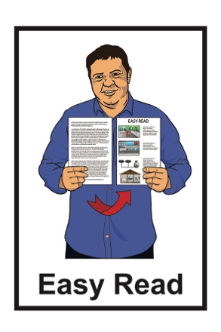
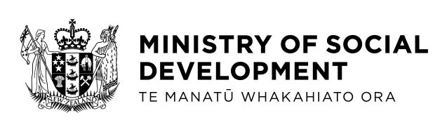

A new agreement on the
Convention on the Rights of the Child
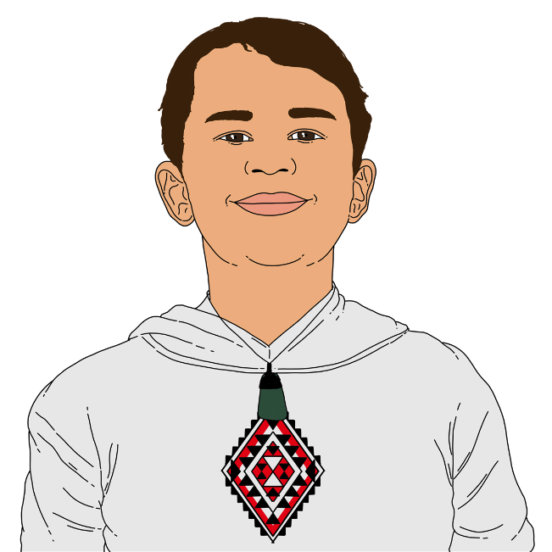
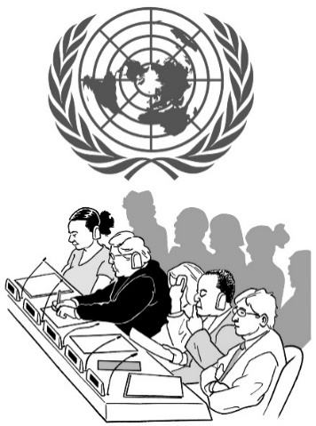

Published in Easy Read: April 2023
What this document is about

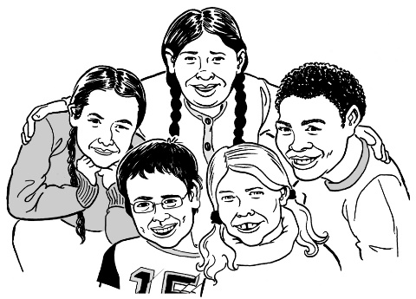
This document is about a new agreement to do with the United Nations Convention on the Rights of the Child.

An agreement is something people / groups have all said yes to.

The United Nations is a group of most of the countries in the world working together.

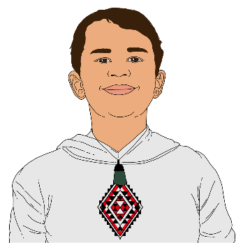
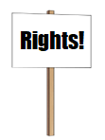
The Convention on the Rights of the Child says all the rights children everywhere should have.

In this document we will call it the Convention for short.
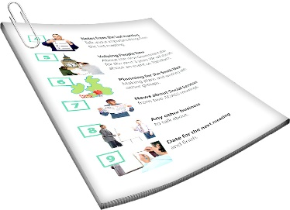
There are 3 extra agreements that go with the Convention.

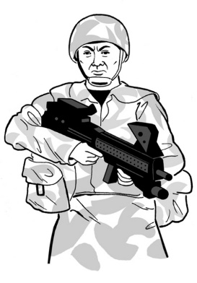
New Zealand has already agreed to the first 2 which are about:
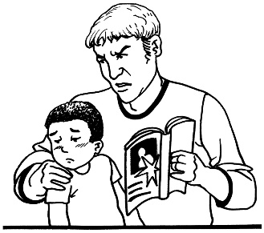
- children fighting in wars
- children being made to do sexual things for adults.

The new agreement is called the Optional Protocol to the Convention on the Rights of the Child on a Communications Procedure.

We will call it OPCP for short.

The OPCP agreement means people can make a complaint to the United Nations if children have not been getting their rights in:
- the Convention
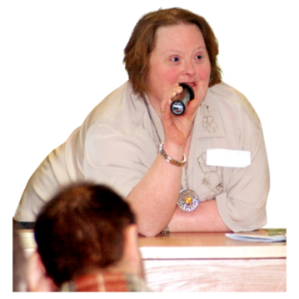
- any of the extra agreements.

Telling the United Nations about this is called making a claim.

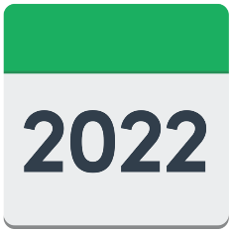
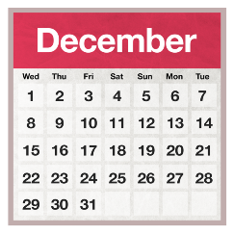
The OPCP agreement started in New Zealand on 23 December 2022.

What the OPCP agreement says about the Convention on the Rights of the Child

There are a lot of different kinds of rights in:
- the Convention
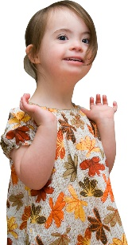
- the extra agreements.

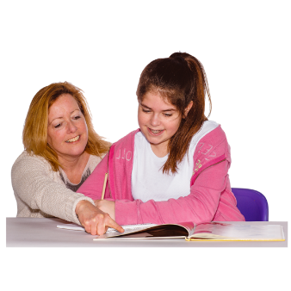
Some of these rights are the right to:
- have a name
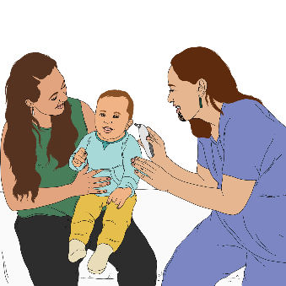
- education like going to school
- health
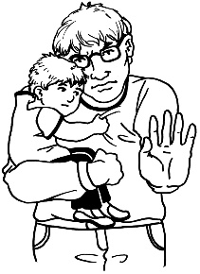
- be kept safe from harm
- say what you think about different things.
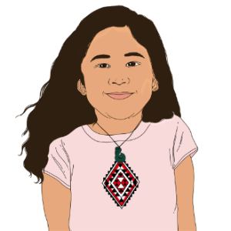
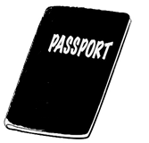
Some more of these rights are the right to:
- be alive
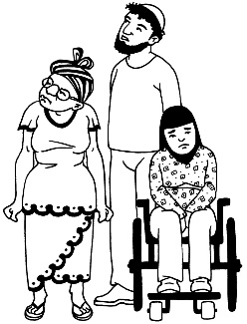
- have a nationality
- not be discriminated against.

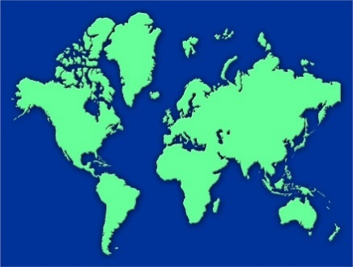
A nationality is a country you:
- are from
- have the right to stay in.

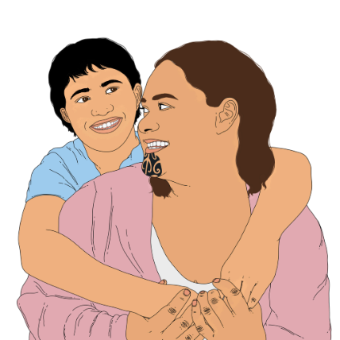
Being discriminated against means being treated unfairly for something like being:

- Māori
- a girl / woman.
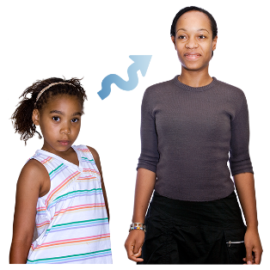
Some more of these rights are the right to:
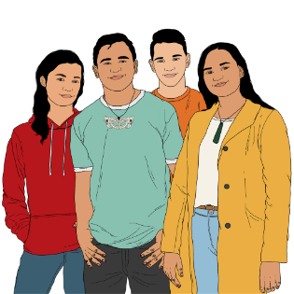
- grow up
- change as you grow
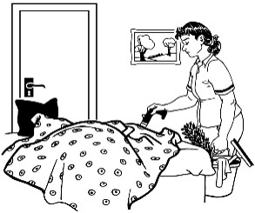
- have your own opinions
- not be made to do lots of work to make money for other people
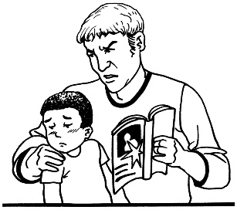
- not be made to do sexual things
- have a good way of living like:
  - a safe home
  - enough food.

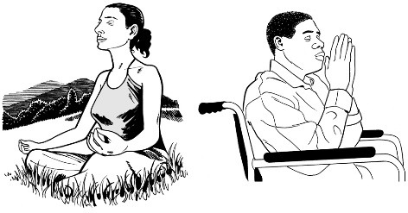
Another of these rights is the right to have a religion.

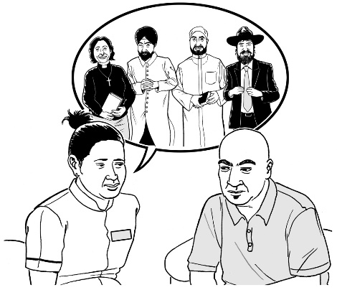
A religion is a group of people who believe similar things about ideas like:

- if there is a god / gods
- what happens after we die.

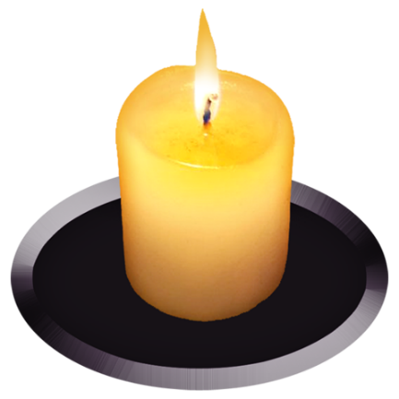
Some examples of religions are:

- Christian
- Hindu
- Muslim.

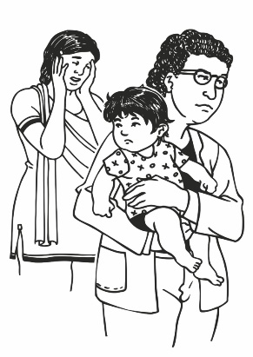
There are also rights for children who may need to be better looked after like:

- children who cannot live with their families
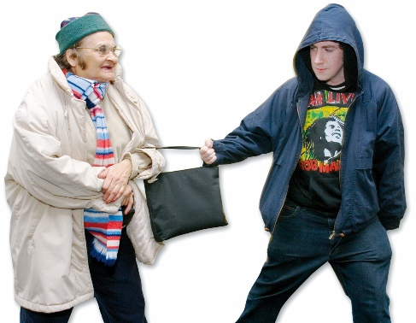
- children who have broken the law
- children who the police think may have broken the law.

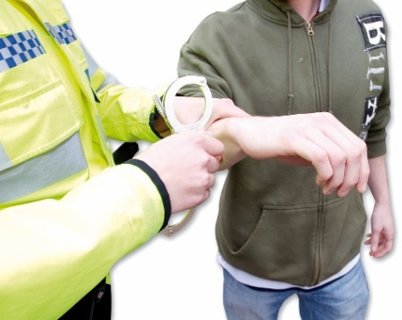
Someone who has broken the law has done a crime like:
- stealing
- hitting someone.

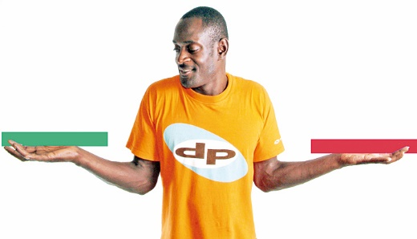
The Convention also says that when making decisions about a child people should think about what is best for the child.
Children also cannot choose to join the military until they are 16.

The military means the armed forces who are groups of people who fight in wars like the:
- army
- navy
- air force.

You must be 18 before you can:
- be conscripted
- fight in a war.

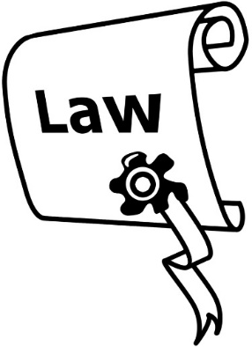
Some countries have laws that say you must join the military even if you do not want to.

This is called being conscripted.

How does making a claim work?

Claims can only be made about things that happened after
22 December 2022.

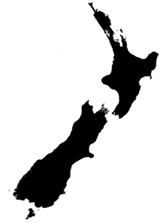
People wanting to make a claim to the United Nations need to try and sort it out in New Zealand first.

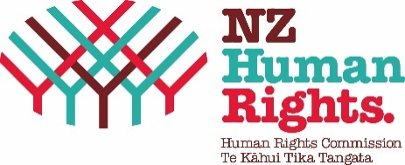
Some of the places to complain to in New Zealand are:
- Human Rights Commission / Human Rights Review Tribunal
- Office of the Ombudsman
- Privacy Commissioner.

There are other places that only look at some kinds of rights.
None of these places can deal with complaints about all the kinds of rights included in the Convention.
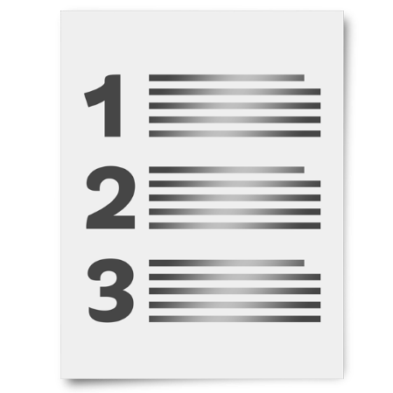

You can find a longer list of places to complain to in New Zealand in the full version of this document.

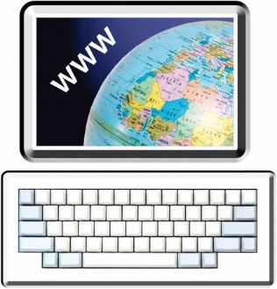
The full version of this document is at:
https://www.msd.govt.nz/opcp

Where can I find more information?

You can find more information about the OPCP at:
https://www.msd.govt.nz/opcp
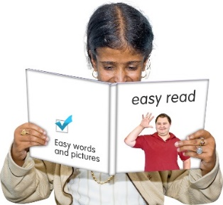

This information is not in Easy Read.

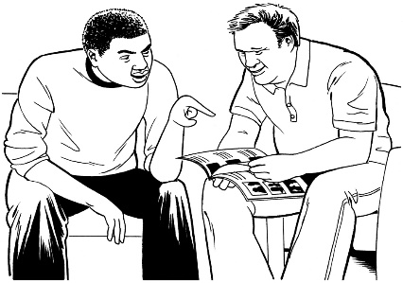
You may want to ask someone to support you while you read it.

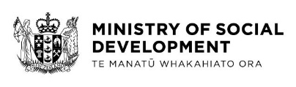
This document has been written by the Ministry of Social Development.

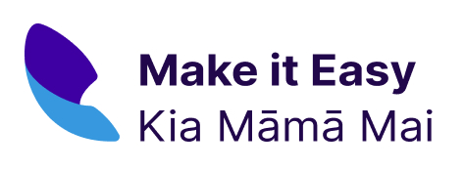
It has been translated into Easy Read by the Make it Easy Kia Māmā Mai service of People First New Zealand Ngā Tāngata Tuatahi.

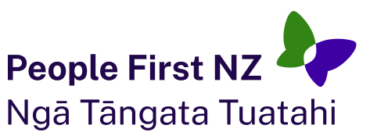
The ideas in this document are not the ideas of People First New Zealand Ngā Tāngata Tuatahi.
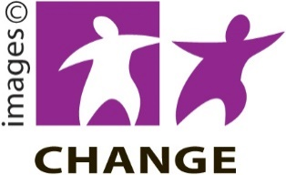
Make it Easy uses images from:

- Changepeople.org

- Photosymbols.com

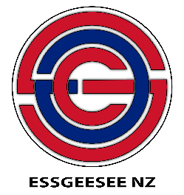
- SGC Image Works

- Huriana Kopeke-Te Aho.

All images used in this Easy Read document are subject to copyright rules and cannot be used without permission.

