The material wellbeing of NZ households:

Overview and Key Findings

from

- the 2016 Household Incomes Report
- and the companion report using non-income measures (2016 NIMs Report):

Prepared by Bryan Perry

Ministry of Social Development
Wellington

August 2016

The Overview brings together in the one place the key definitions and concepts, and the key findings and overall story from both reports – all the figures, tables and charts used in the Overview are in the two fuller reports.

What the reports are about

The Household Incomes Report and its companion report using non-income measures (NIMs Report) provide information on the material wellbeing of New Zealand households from two perspectives:
- household incomes: the reports use disposable household income (total after-tax income from all sources for all members of the household), adjusted for household size and composition
- non-income measures (NIMs): this approach more directly measures the material wellbeing of households in terms of having:
- the basics such as adequate food, clothes, accommodation, electricity, transport, keeping warm, maintaining household appliances in working order, and so on, and
- freedoms to purchase and consume non-essentials that are commonly aspired to.

The reports are published as part of the Ministry of Social Development’s work on monitoring social and economic wellbeing. They are a resource for use by a wide range of individuals and groups – policy advisors, researchers, students, academics, community groups, commentators and citizens more generally – to inform policy development and public debate around poverty alleviation and redistribution policies.

Data sources and time periods covered

The current releases update earlier reports with data from Statistics New Zealand’s 2014-15 Household Economic Survey (2015 HES), the latest available. A larger than usual sample was gathered for the 2015 HES – 5600, some 65% to 75% larger than usual.

The Incomes Report covers the period from 1982 to 2015. The HES data is supplemented by MSD administrative data and data from Statistics New Zealand’s Income Survey and their longitudinal Survey of Family, Income and Employment (SoFIE) which ran from 2002 to 2009.

The interviews for the 2015 HES took place from July 2014 to June 2015. The incomes question asked about incomes “in the last 12 months”. The latest income figures (2015 HES) therefore reflect on average what household incomes were in calendar 2014, rather than “today”.

The NIMs report draws on HES data from 2007 to 2015, and from data gathered in MSD’s 2008 Living Standards Survey.

Though most of the survey data is from Statistics New Zealand, the analysis and findings are the work and responsibility of the Ministry of Social Development, except where noted otherwise.

What to expect in this update

Each new update builds on the analysis and findings of previous issues.

Unless there is a major shock to the economy such as the recent global financial crisis (GFC), or a policy change that directly impacts in a significant way on the labour market or incomes, findings using the latest available survey data can be expected to be in line with previously identified levels and trends in all the main areas monitored by the reports. They can also be expected to reveal the same relativities between different groups. In addition to confirming existing knowledge, one of the main values of the updates is that uncertainties can be removed in situations where recent trends have been volatile.

There were no major shocks to the economy or major changes in government policy that could impact on the 2014-15 data (2015 HES). The updated figures are generally in line with previous trends and relativities. In a few cases previous ambiguities or uncertainties are now clear. These are noted in the Key Findings below.

Each update also includes new analysis and information.

Glossary and Abbreviations

HES Household Economic Survey
HES 2010 HES 2009-10 – the income data mainly reflects incomes in calendar 2009
SoFIE Survey of Family, Income and Employment
IS Income Survey
BHC Before (deducting) housing costs
AHC After (deducting) housing costs
NIMs Non-income measures (sometimes called non-monetary indicators)
ELSI Economic Living Standards Index
MWI Material Wellbeing Index (ELSI, mark 2)
DEP-17 17-item deprivation index (MSD)
EU-13 13-item deprivation index (Eurostat)
NAOTWE net (after tax) average ordinary time weekly earnings
median income the middle income, with the same number of people above as below
mean income arithmetic average of all incomes
quintile when individuals are ranked by some characteristic and divided into 5 equal groups, each group is called a quintile (each group is 20% of the whole)
Q1 a shorthand for the bottom quintile
decile when individuals are ranked by some characteristic and divided into 10 equal groups, each group is called a decile (each group is 10% of the whole)
D2 a shorthand for the second decile (ie second up from the bottom)
vingtile when individuals are ranked by some characteristic and divided into 20 equal groups, each group is called a vingtile (each group is 5% of the whole)
percentile when individuals are ranked by some characteristic and divided into 100 equal groups, each group is called a percentile.
P10 10th percentile – this is at the top of the bottom decile, 10% up from the bottom
P50 50th percentile (ie the median)
90:10 ratio the ratio of the income at P90 to that at P10
OTI (Housing) outgoings to income ratio
AS Accommodation Supplement
NZS New Zealand Superannuation
WFF Working for Families
GFC Global Financial Crisis

‘anchored line’ low income (poverty) measure:
- this is the line set at a chosen level in a reference year (now 2007), and held fixed in real terms (CPI adjusted)
- sometimes referred to as the constant value line (CV-07 for short)
- the concept of ‘poverty’ here is – have the incomes of low-income households gone up or down in real terms compared with what they were previously?

‘moving line’ low income (poverty) measure:
- this is the fully relative line that moves when the median moves (eg if median rises, the poverty line rises and reported poverty rates increase even if low incomes stay the same)
- sometimes referred to as the REL line for short
- the concept of ‘poverty’ here is – have the incomes of low-income households moved closer or further away from the median?
The Introduction: .………………………………………………………………………………………….. 4
- discusses the income-wealth-consumption-material-wellbeing framework used in the reports, including how the framework helps both the high-level measurement story and a high-level narrative for approaches to address material disadvantage
- outlines the way the reports define and measure material wellbeing, and illustrates the differences that different measures can make to the overall picture produced
- identifies some of the challenges involved in analysing sample surveys such as the HES,
and in interpreting the findings, with special reference to issues with the reliability of the
survey data for very low and very high incomes.

The Key Findings section covers:
- household incomes: ……………………………………………………………………………. 11
  - trends from 1982 to 2015
  - trends in very high incomes
- income inequality, 1982 to 2015: ……………………………………………………………… 14
  - trends for 1982 to 2015 using percentile ratios and the Gini
  - income redistribution, and
  - Inclusive Growth
- housing costs relative to income, especially for low-income households: ………………… 19
- housing quality: …………………………………………………………………………………. 20
  - dampness and mould
  - difficulty keeping it warm in winter
  - crowding
- low income (income poverty) and material hardship trends, including relativities between
different groups by family type, work status, age, ethnicity, and tenure:
  - guidelines and principles for interpreting findings .…………………………………… 22
  - the whole population …………………………………………………………………….. 24
  - children (0-17yrs) ..………………………………………………………………………. 27
  - older New Zealanders (65+ yrs) ..…………………………………………………….. 32
- income mobility and low-income persistence …………………………………………………… 34
- international comparisons: …….………………………………………………………………….. 35
  - low incomes
  - material hardship
  - very high incomes
  - income inequality
  - wealth inequality

Two Appendices have tables and charts which enable the reader to work out where their
household is ranked on both the incomes and MWI spectrums ……………………………………….. 36

Appendix Three gives a picture of the different living standards profiles at different MWI levels …… 40

Appendix Four has summary tables for child poverty and material hardship: rates, numbers and composition using a range of measures …………………………………………………………………. 41

Appendix Five outlines the different approaches used internationally for reporting on “poverty and material hardship” for children …………………………………………………………………………….. 44

Appendix Six provides a high-level schema that outlines the range of causes of material hardship
for children, to assist with discussions on policy options ………………………………….……………. 45

Introduction

The income-wealth-consumption-material-wellbeing framework

The income-wealth-consumption-material wellbeing framework used in the reports is shown below:
- Household income and financial and physical assets together largely determine the economic resources available to most households to support their consumption of goods and services and therefore their material standard of living.
- Households with resources that are not adequate for supporting consumption that meets basic needs (those experiencing poverty or material hardship) are of special public policy interest.
- For low-income households that have very limited or no financial assets their income is the main in-house resource available to generate their standard of living. Such households not only struggle in varying degrees to meet basic needs, but are also very vulnerable to the negative impacts of “shocks” such as even a small drop in income or an unexpected expense.
- The framework recognises that factors other than incomes and assets can also impact on material wellbeing. These factors are especially relevant for low-income / low-asset households, and can make the difference between “poverty/hardship” and “just getting by”.

Basic needs / essentials
Discretionary spend / desirable non-essentials
Resources available for consumption
Household income
DEP-17

MWI
Financial and physical assets

Other factors
eg assistance from outside the household (family, community, state), housing costs, high or unexpected health or debt servicing costs, lifestyle choices, ability to access available resources

Material wellbeing or living standards

- To measure material wellbeing more directly the NIMs report uses both MSD’s material wellbeing index (MWI) which covers the whole spectrum from low to high material living standards, and its deprivation index (DEP-17) which focuses on the low living standards end of the spectrum. The MWI and DEP-17 rank households in almost exactly the same order for the lower 20% of the population.
- The framework shows how it can be that not all households with low incomes are in hardship, and not all in hardship have low incomes. The overlap between similar-sized groups of those identified as in material hardship and those with low incomes is typically only 40 to 50%, not 100%, as there are many factors in addition to income that determine a household’s level of material wellbeing (living standards).

The framework and government policy to address poverty and material hardship

The income-wealth-consumption-material-wellbeing framework together with its elaboration in Appendix Five in relation to child poverty and hardship provide a high-level check-list for discussion, debate and policy development for addressing poverty and hardship.

For example, thinking about poverty alleviation from the perspective of the household, and how that intersects with government policy, the framework points to the following, as the pathways for addressing or alleviating poverty:
- increasing household income (whether it be from higher total earnings or increased government cash assistance or reduced tax)
- having the demands on the core household budget reduced (for example, through government services and government subsidies such as those for free doctor’s visits for under 13s, reduced fees for Community Services Card holders, child care subsidies)
- getting better at using a given income to meet basic needs (through improved budgeting, healthy family functioning (tension and chaos reduce efficiency), improving life skills, better access to government and community services, and so on).

The framework makes it clear that improving the day-to-day living standards of households is about more than income, though income remains a very important factor.

When the focus is on raising incomes for households with children the framework points to three factors that impact on child poverty rates and on the proportion of poor children who come from various subgroups (that is, on the composition of the poor):
- the economy and the labour market (impacting for example on employment and unemployment rates, wage rates, benefit numbers (including numbers of sole-parent families), and interest rates)
- demographic shifts and changing cultural norms (eg the number of sole-parent families, whether sole-parent families live in households on their own or with other adults, the proportion of dual-earner two-parent households)
- policy changes that have a direct impact on income (eg policy changes around benefit rates, income-related rents, the Accommodation Supplement and Working for Families settings all have clear impacts on the child poverty rates for children from working and workless households, and on the relativities between the two groups).

[See the June 2016 report to the Ministerial Committee on Poverty which sets out the Government’s ongoing approach to alleviating poverty in New Zealand, available at:
http://www.dpmc.govt.nz/sites/all/files/publications/3862574-mcop-govt-actions-on-poverty-2016.pdf ]

Three ways of measuring material wellbeing and ranking households

The reports use three different measures of material wellbeing to rank households from high to low. Both income measures adjust for household size and composition to enable more realistic comparisons between different household types.
- BHC income (income before deducting housing costs):
Household income from all household members from all sources after paying income tax gives an indication of the different levels of financial resources available to different households, all else being equal.
But all else is not equal, as the diagram on the previous page makes clear. There are many factors other than current income that make a difference to the actual day-to-day living standards of households. For example, the largest item on the household budget for many households is accommodation costs, and yet for others in mortgage-free homes these costs are much lower. Accommodation costs cannot usually be changed in the short-term. To better compare the material wellbeing of households when using incomes the Incomes Report also uses household income after deducting housing costs (AHC incomes), especially for “poverty” measurement.
- AHC income (income after deducting housing costs):
AHC income (ie BHC income after deducting housing costs) is a very useful measure for understanding the real-life differences in consumption possibilities for households when looking at income alone. AHC income is sometimes called “residual income”.
There are other factors (in addition to income and housing costs) that also contribute to a household’s material wellbeing. The combined impact of all these factors on a household’s material wellbeing can be captured by examining more directly the actual living conditions and consumption possibilities that households experience. The MWI does this.
- MWI (Material Wellbeing Index)
The MWI is made up of 24 items that give direct information on the day-to-day actual living conditions that households experience. They are about the basics such as food, clothes, accommodation, electricity, transport, keeping warm, maintaining household appliances in working order, and so on, and also about the freedoms households report to purchase and consume non-essentials that are commonly aspired to. See Appendix Two for a list of the MWI items.
Differences in MWI scores reflect the differing impact on living standards of the income, assets and other factors in the framework on page 4. The MWI rankings reflect the different levels of consumption for different households in a way that gets around the need to carry out the very demanding analysis required to create a dollar value for each household’s consumption. The tables in Appendix 3 give a picture of the different living standards profiles at different MWI levels, using both MWI items and several not in the MWI.
MSD also uses two deprivation / material hardship indices which focus only on the low end of the spectrum:
- DEP-17: this gives the same results as the MWI when looking at the bottom quintile (20%), but the scoring is more intuitive (eg a score of 7+/17 simply means “missing 7 or more basics from the list of 17”)
- EU-13: this 13-item index is used in Europe and we use it monitor how New Zealand ranks internationally – it ranks households much the same as DEP-17 does.

Where do you and your household rank?

- Appendix One has tables to enable the reader to find out which BHC income decile their household fits in.

- Appendix Two shows how to calculate your household’s MWI score and then how that score translates to a ranking relative to the whole population.
The different measures can show different pictures of who is in the higher and lower material wellbeing levels

Different pictures can emerge depending on which measure of material wellbeing is used. This is most clearly illustrated when looking at how different age groups rate relative to each other on the three measures.
- The charts below show how the bottom quintile (bottom 20%) becomes “younger” when the ranking measure changes from BHC to AHC to the MWI: the proportion of older New Zealanders in the bottom quintile decreases (25% to 9% to 5%) and the proportion of children increases (28% to 34% to 38%).
- The differences arise in part because mortgage-free home ownership is very high among older New Zealanders (ie housing costs are very low for most), so when moving from BHC to AHC incomes a large re-ranking happens with many older New Zealanders moving up and many families with children moving down relative to each other. The table shows the result of the movement from Q1 (BHC) to Q2 (AHC) for many older New Zealanders.

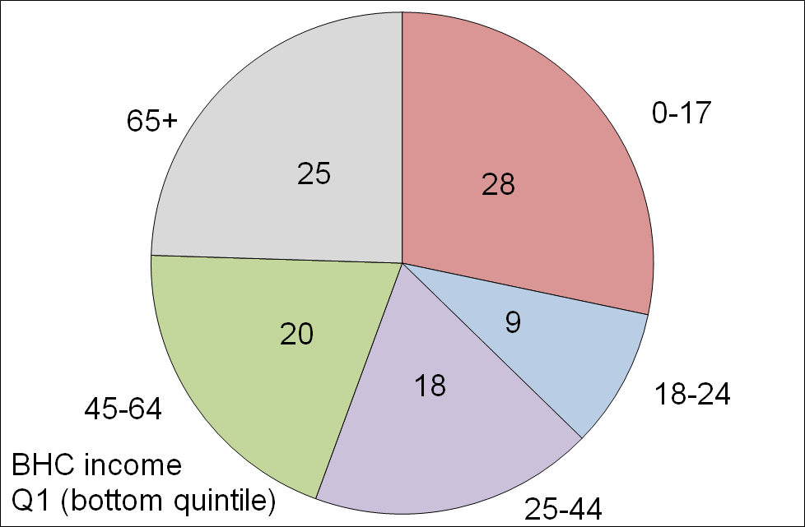
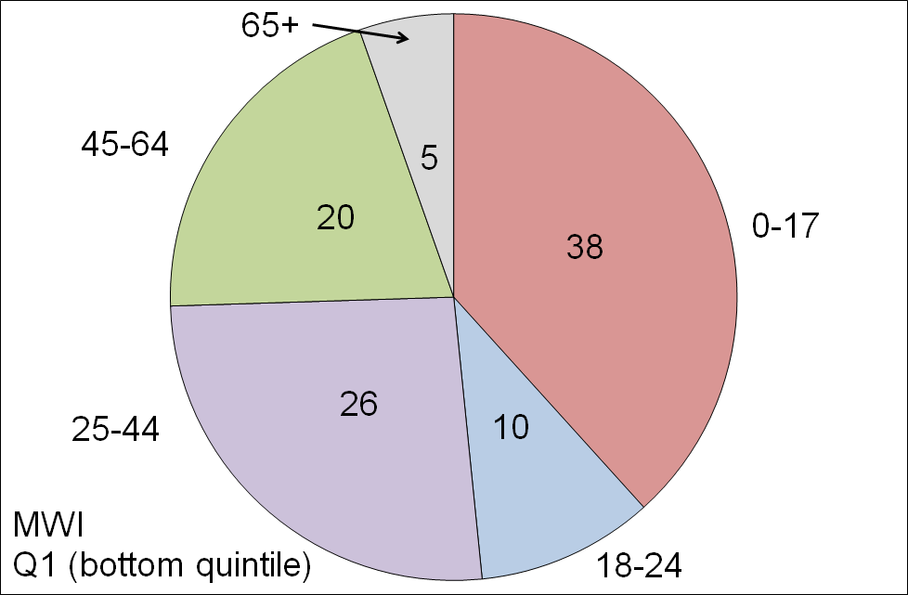
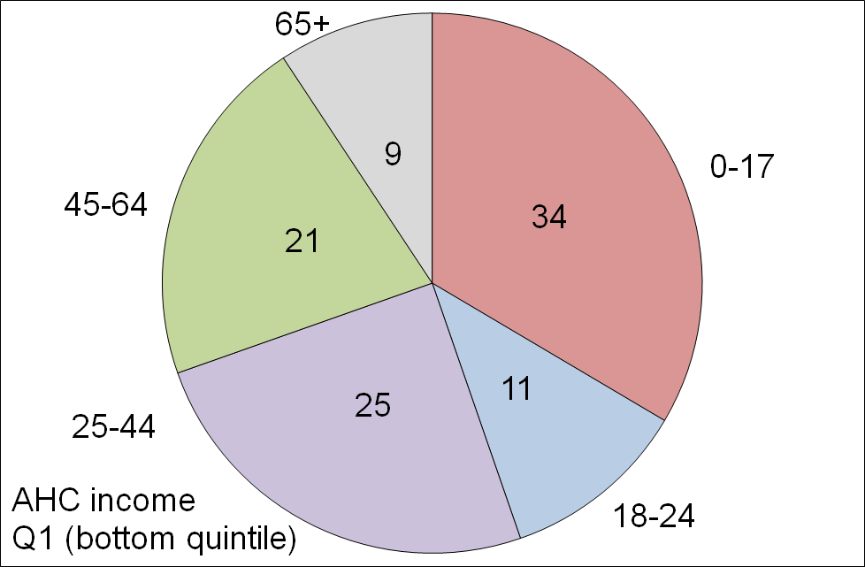
The make-up of the bottom quintile (20%) for the three measures, by age groups (HES 2015)

- The differences in the make-up of the bottom quintile on the three measures are also a reflection of the life-cycle fact that in addition to a mortgage-free home many aged 65+ have all the household appliances and furniture they need and many have other financial reserves they can call on. This explains the large change for older New Zealanders when comparing their numbers in Q5 (see table below which covers all five quintiles): using the MWI, 44% of older New Zealanders are in this higher living standards group, whereas for AHC only 20% are.
- The table also shows that around one in three older New Zealanders (35%) have BHC incomes that place them in the bottom BHC income quintile, but only one in fourteen (7%) are in the lowest MWI quintile.

Where older New Zealanders are found across all quintiles (%), three measures (HES 2015)
 | Q1 | Q2 | Q3 | Q4 | Q5 | TOTAL
BHC | 35 | 18 | 16 | 14 | 16 | 100
AHC | 13 | 32 | 18 | 16 | 20 | 100
MWI | 7 | 10 | 15 | 24 | 44 | 100

Even when the income and MWI pictures look similar, as they often do for AHC low income (poverty) and MWI material hardship numbers, the actual overlap between the households in the two groups is usually fairly modest (45-50% for the bottom quintiles)

- Analysis using AHC incomes identifies the same groups as more likely to be at the lower end as analysis using the MWI (sole parent households; older New Zealanders renting and with only NZS as income; and so on).

- However the overlap between those in households with low AHC incomes and those in households with low MWI scores is only modest. For example, the overlap between the lower 20% of each ranking is typically around 45% to 50%, reflecting the impact of the factors other than income on the actual living standards of the households.

- This does not mean that household income is not a very important driver of living standards. For low-income households an income increase will almost always raise their material wellbeing. What the finding means is that when comparing the material wellbeing of households, income alone is often not a reliable indicator as the “other factors” vary greatly from household to household.

When people are asked if their household’s income is adequate to cover the basics of food, clothing, accommodation and other necessities, there is good evidence that their responses take account not only of their income but also of all the other factors that make demands on or contribute to the household budget.

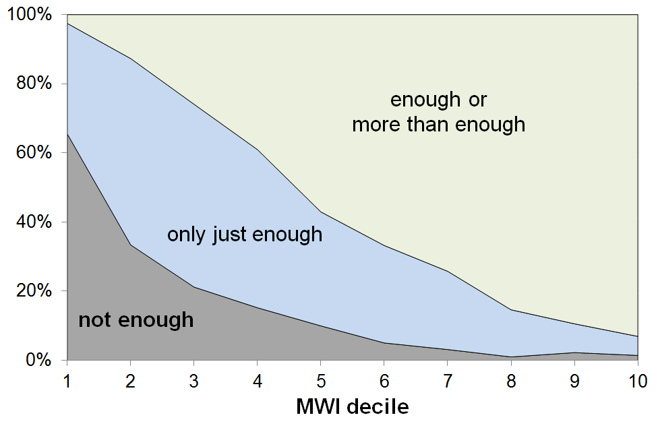
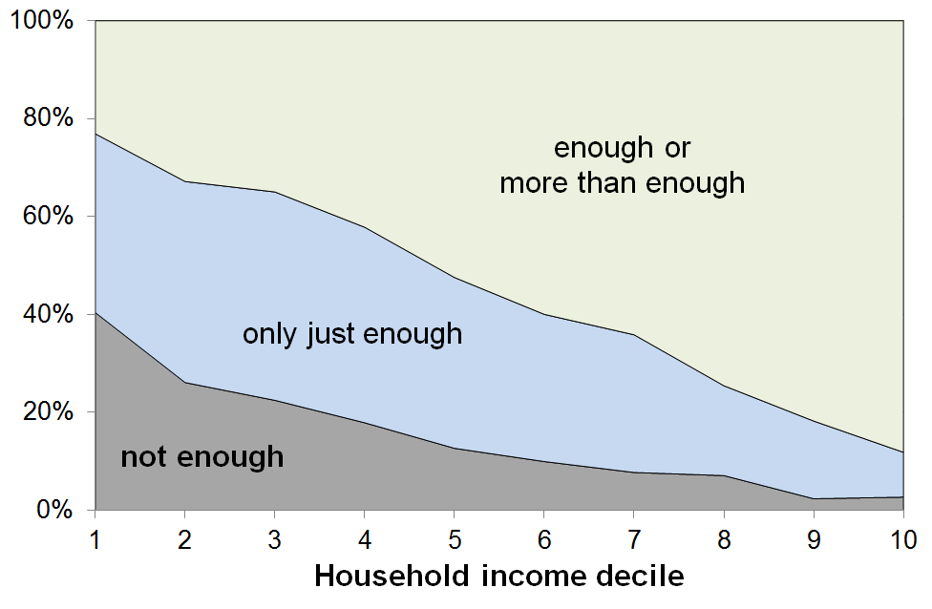
- The graphs below show the responses to the income adequacy question asked in the HES, by household BHC income decile and by decile of MWI score. The graphs use a three-way split for grouping the responses: not enough; only just enough; and enough or more than enough.

- The expected gradients from lower to higher material wellbeing are clear on both measures. The “not enough” distribution is however much more tightly bunched at the lower end when the MWI is used for ranking households rather than when household income is used.

- In line with the framework outlined on page 4 above, this more bunched low end when using MWI rankings is highly likely to reflect the fact that respondents are taking as a given both their stock of household goods and appliances, and also the “other” factors that assist or place extra demand on the household budget. In other words, the responses are intelligent ones about the adequacy of household income, given their particular circumstances. MWI scores reflect the impact on living standards of these other factors as well as that of the household income, whereas household income is a more indirect measure of material wellbeing, a proxy that cannot take account of other key factors.

- Looking at the data from the other perspective (how many say “enough” or “more than enough”?), 23% of those in the lowest income decile report having “enough” or “more than enough” income to meet basic needs, but only 3% of those in the lowest MWI decile report that their income is “enough” or “more than enough”.

- These findings:
- illustrate the value and importance of the income-wealth-consumption-material wellbeing framework used in the reports
- give some encouraging evidence of the robustness of the responses given to this more subjective self-assessment question
- warn against using the responses to this common question as if they give reliable information on income adequacy per se, leaving other factors aside.

Using and interpreting the findings in the two main reports and in this Overview

Findings based on sample surveys have statistical uncertainties

- The findings in the reports are based on data from sample surveys, so there are always statistical uncertainties. The uncertainties are greater for smaller groups than for larger ones, and are greater for high and low incomes than they are for the rest.
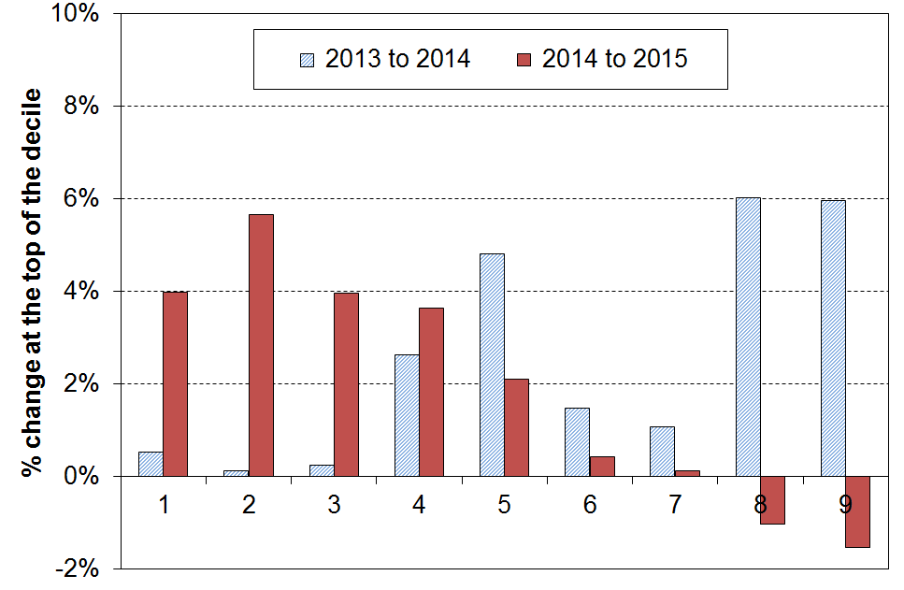
- For example, while reported changes from one survey to the next for the median and nearby are reliable for giving the actual direction of the change and its rough size, those for high or low incomes are often not. This is illustrated in the graph on the right which shows year-on-year changes for incomes at the top of each decile for HES 2013 to 2014, and for HES 2014 to 2015. A tempting summary or headline finding for the latest data could be “higher incomes fell and lower incomes rose from 2014 to 2015”. This would be misleading as it puts too much reliance on year-to-year changes for high and low incomes where the uncertainties are at their greatest. As the graph shows, the changes from 2013 to 2014 go the other way and would be equally misleading to rely on on their own.

- The findings about differences or changes are at their strongest when looking at clear trends or changes over several surveys or longer, when comparing rankings using different measures, and when identifying which groups are faring well and which not so well.

There are particular issues at the bottom and top of the income distribution

- While the incomes of most of the households in the bottom decile seem plausible (for example, they are in line with main income support levels or the incomes received by households with workers on the minimum wage), there are always some that report implausibly low incomes, lower than beneficiary incomes or much less then declared spending, or both. A few self-employed report negative incomes. The bottom decile is unique in this regard. For example, while there are households in each income decile that report expenditure more than three times their income (around 2-3% of all households), around 80% of these are found in the bottom income decile.

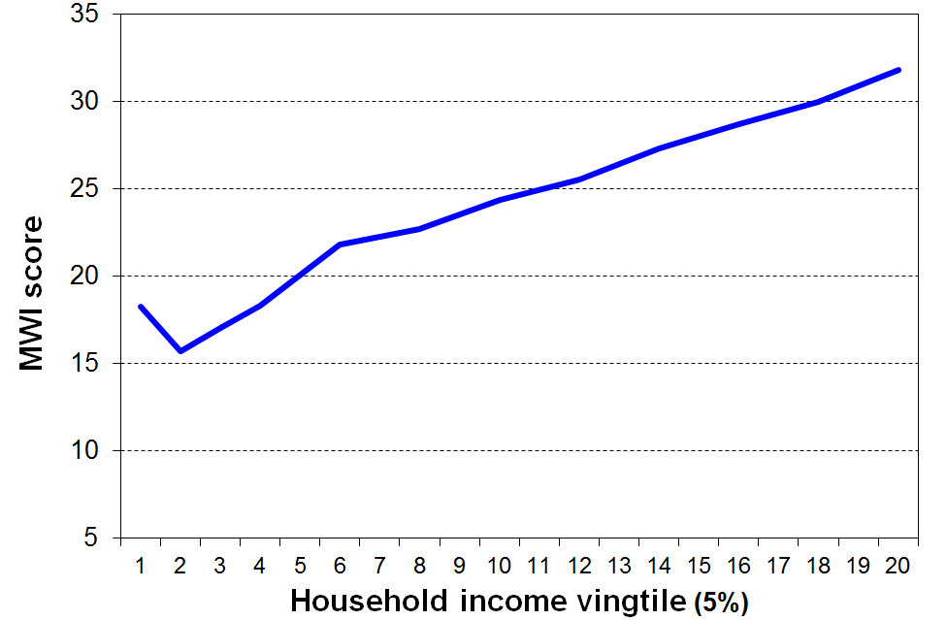
- This means that the average income of the bottom decile cannot be taken as a reasonable estimate of this group’s (relative) material wellbeing. This is supported by the analysis in the graph which shows how the MWI score decreases as expected when coming down the income spectrum, except for the bottom income vingtile (5%) whose average MWI score is more like those in the second income decile. This shows that the incomes of those reporting implausibly low incomes are in general not a reliable indicator of the resources available to those households.

- It also means that it is unwise to use very low BHC income thresholds to monitor “severe” poverty as too great a proportion of the households under such thresholds are those with implausibly low reported incomes. The Incomes Report does not go below a 50% of median threshold for BHC incomes.

- When the low-income-high-expenditure households are removed from the data, the reported low income (poverty) rates are around 1 percentage point lower (using a 50% of median measure), but the overall directions of the trends do not change.

- At the very high end, there are two issues:
- First, very high income households are under-represented in most sample surveys. We know this through comparisons with tax records. This a well-known issue across all countries.
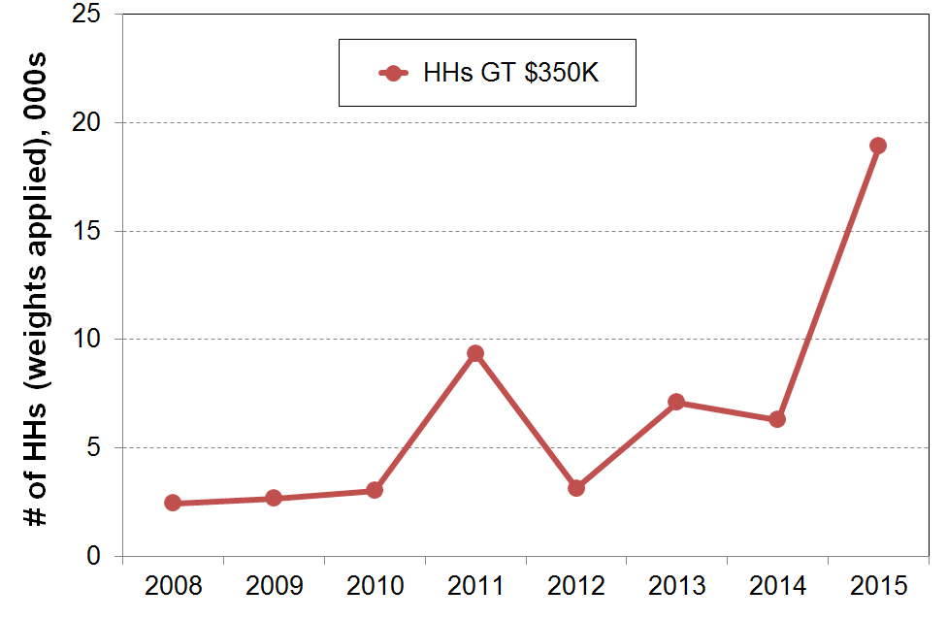
- Second, from survey to survey the number of very high income households and the size of their reported incomes can vary considerably. The graph shows this phenomenon occurring in HES 2011 and again in HES 2015. This factor can have a very large and misleading impact on the reported trends in top decile shares of total household income and in inequality measures which take account of all incomes in the sample (eg the Gini coefficient). The resulting fluctuations simply reflect the challenges of consistently achieving a representative sample of very high income households, rather than any real-world changes.

The surveys gather information on the usually resident population living in private dwellings

- The survey therefore includes those living in retirement villages, but not those in non-private dwellings such as “rest homes”, hotels, motels, boarding houses and hostels.

- The survey does not capture those “living rough” as they are not members of a household in a private dwelling.

- Low income (poverty) and material hardship rates based on the HES and surveys like it are about trends and relativities for the population in private dwellings. Other sorts of surveys are needed to obtain a picture of what life is like for those “living rough” or in boarding houses, hostels and so on.

The surveys are snapshots of different samples each survey, not a movie following the same people

- Most of the findings are based on the HES which surveys a different group each time (ie repeat cross-sectional surveys). To gain a fuller picture of the material wellbeing of individuals we need information on the same group of people over many years (longitudinal surveys). These can tell us about: total income received over several years which is a better indicator of material wellbeing than income over just one year; low-income and material hardship persistence; income mobility; and changing household circumstances.

- Up to date New Zealand longitudinal data with household income information is not available at present (2002-2009 only), though what we have is very useful in that it shows (a) the relationship between repeat cross-sectional low income rates and low income rates from the longitudinal data, and (b) that we are similar to other countries which have longer-running surveys. In addition, the material hardship measures from the HES go some way to capture the impacts of income history beyond the current year’s.

The reports use a clear set of guidelines and principles for their choice of primary measures for monitoring trends, and for interpreting the findings

- See the table on page 23 for details.

Incomes and income inequality

Household incomes

- Household income in this section is total after-tax income from all sources for all members of the household, adjusted for household size and composition. This is sometimes called equivalised disposable household income.

- Household income is not the same as household or individual earnings as it includes not only wages and salaries but also government transfers such as NZS, income-tested benefits, and tax credits.

- The trends and findings for incomes before deducting housing costs (BHC incomes) and those for incomes after deducting housing costs (AHC incomes) can be quite different. This is so for two reasons: households with similar BHC incomes can have quite different AHC incomes, and housing costs have increased over the years as a proportion of the budgets for most households, and especially for low income (BHC) households. Information is provided for both BHC and AHC incomes.

- From HES 2014 to HES 2015 median household income (BHC) rose 2% in real terms (2% above the CPI inflation rate), following a reported 5% rise from HES 2013 to HES 2014. As noted in the Introduction, changes from one survey to the next need to be treated with caution, even for basic figures such as the median, though it is less susceptible to statistical blips than most other income statistics.

- Looking over the five surveys from HES 2011 to HES 2015 (the recovery phase after the GFC) gives more robust trend figures then looking at year-on-year change:
- the BHC median grew on average at just under 3% pa in real terms
- the proportionate gains from the recovery were shared reasonably evenly across all income groups, with slightly larger gains on average for lower income households (11-12%) and slightly smaller gains for higher income households (7-8%).

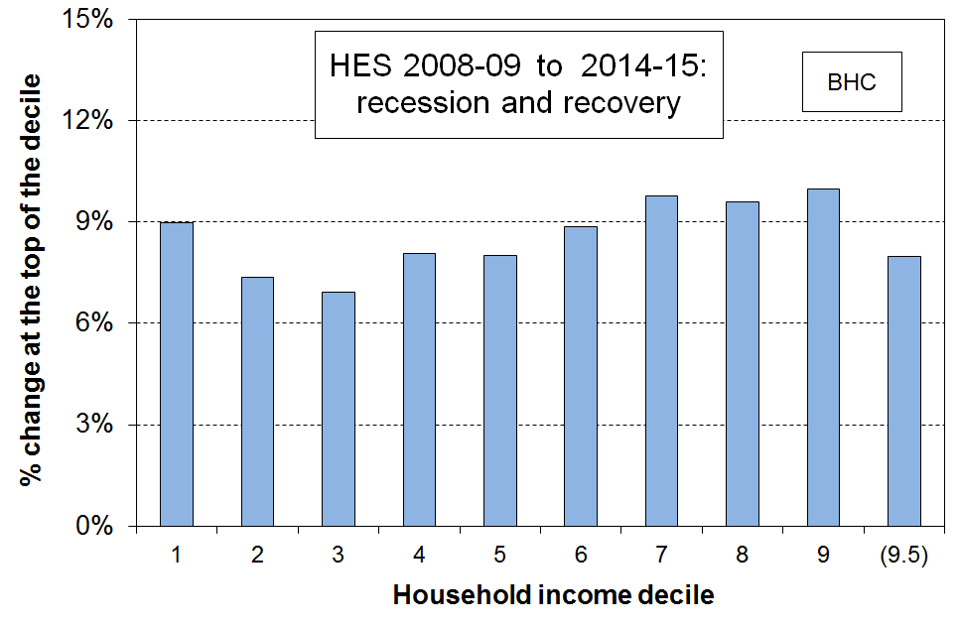
- The graph shows the net improvement at the top of each income decile from HES 2009 to HES 2015. This is from just before the GFC (calendar 2008 on average), through the recession, and then the recovery. The increases were reasonably even across the spectrum at around 8-10% in real terms (8-10% above inflation). The negative impact of the GFC and the associated recession was generally a little greater for lower income households, but the slightly greater gains since for lower income households offset that.

- The rise in BHC incomes at P10 (ie at the top of the bottom decile (decile 1)) from HES 2009 to HES 2015 mainly reflects rises in real terms for NZS. Those whose incomes are almost entirely from NZS are at the top of the lower decile and the bottom of the second decile. Incomes for beneficiaries and those reliant only on minimum wage employment (plus WFF if eligible) remained steady in real terms so did not contribute to the rise at P10.

- New Zealand’s net gains from HES 2009 to HES 2015 are better overall than for many OECD countries – the negative impact was more muted here and the recovery has been stronger than for many:
  - the UK median fell through the GFC and has only just returned to its pre-GFC level
  - Italy, Spain, France and Germany were flat through the GFC and have remained so since
  - the US median in 2014 was much the same as in 2008 before the GFC, and was 4% lower than in 2000
  - in Australia incomes above the median have shown very little net growth since just before the GFC
  - New Zealand’s post-GFC gain of 12% at the median is more like that of the top performers such as Finland and Sweden (10-12%), though they did not have the fall in median during the GFC that New Zealand did (-3%).
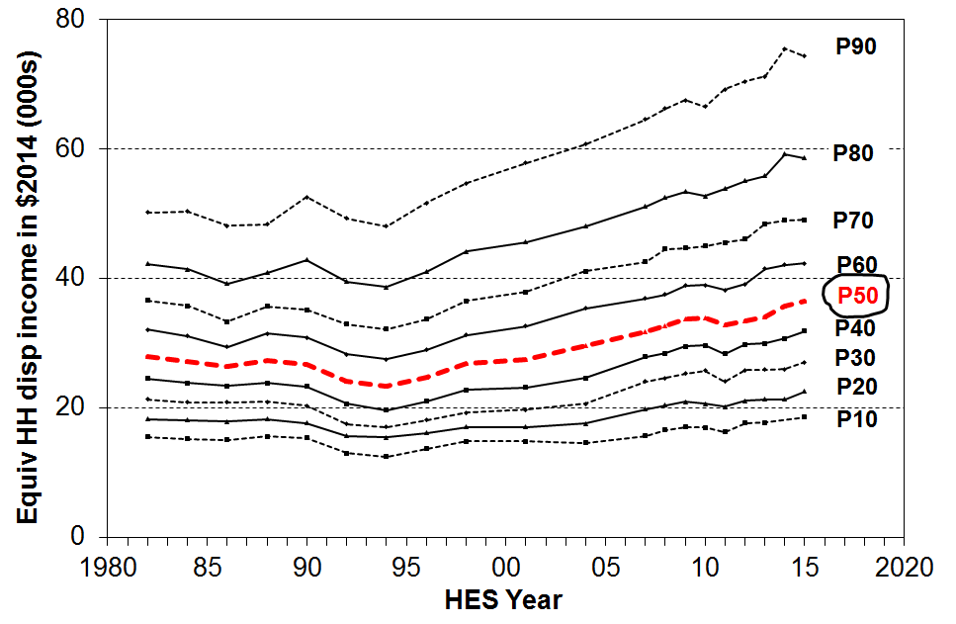
- The graph shows the trends for different parts of the BHC income distribution for the last three decades. It shows the fall in the median from 1982 to 1994, the steady rise to 2008-09, the fall in the recent recession and the subsequent rise through to the 2015 HES.

- Incomes at the top of the bottom decile (P10) only returned to their 1980s level in 2006-07.

- Increasing gaps between the different lines on the graph can be caused by two quite different factors. When interpreting the graph, both need to be kept in mind:
- First, the widening gaps can reflect increasing inequality. For example, from 1982 to 1994, the gap between the P90 and P50 (median) lines widened and the P90:P50 ratio increased.
- Second, the gaps can widen even when there is no increase in inequality. For example, from 1994 to 2015 incomes at both the median and at P90 increased by 56% in real terms. This means that P90 incomes remained at around double the P50 level, even though the actual gap between them increased in dollar terms. In this period, it is the increase in the dollar gap that increases the dispersion between the lines, not any increase in inequality as usually measured.

Median household income in ordinary (unequivalised) dollars

- Median household income (BHC and not adjusted for household size and composition) was $73,500 in the 2014-15 HES, up 10% in real terms from HES 2008-09, pre-GFC ($66,900), up 26% from 2003-04 ($58,500) and 57% from 1993-94 ($46,900).

- In 1993-94 the median was in fact lower than in 1981-82 ($59,800) when it was similar in real terms to what it was in 2003-04. The net gain in real terms over the whole 33 years from HES 1982 to HES 2015 was 23% at the median.

Very high incomes

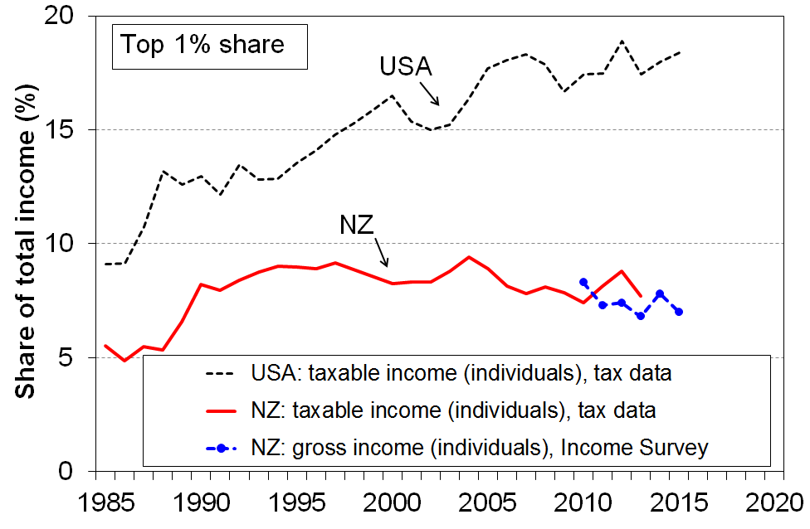
- There is considerable media and general public interest in the very high incomes that some individuals receive, and in the perceptions that the gap between these and the rest is increasing, and that this group is receiving an increasing share of total income.

- One way of looking at the issue is to examine the trends in the income share received by the top 1%. The most reliable information on these very high incomes is from tax records.

- The graph shows that, for New Zealand, the share received by the top 1% increased from 5% in the mid 1980s to around 9% in the mid 1990s, and was steady or slightly falling through to 2013, in the 7-9% range. Information from the New Zealand Income Survey (using a sample of around 30,000 individuals) shows that there is no evidence of any rise over the years from 2010 to 2015.

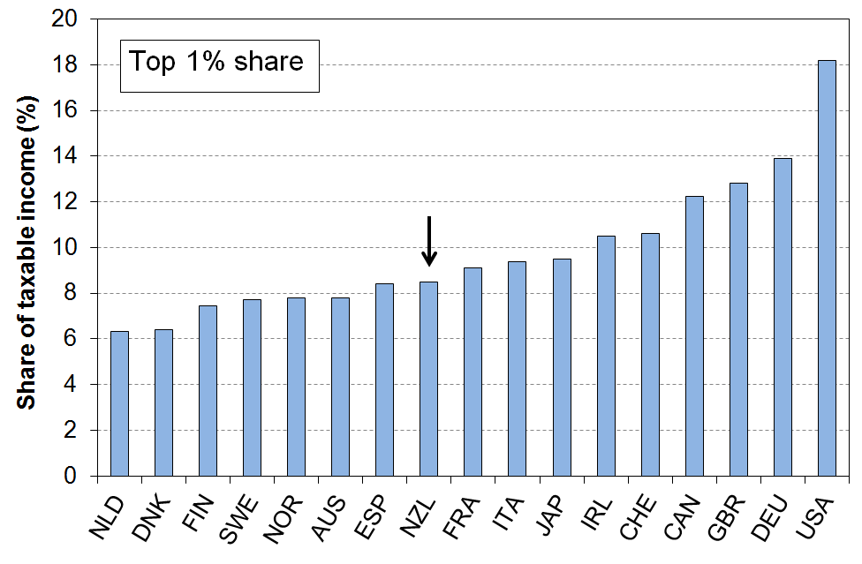
- New Zealand’s top 1% share is in the low to mid range for OECD countries with whom we traditionally compare ourselves. See graph at right.

- Narrowing the focus even further to look at just the top 0.5% of individuals, the same picture emerges for New Zealand: from 2000 to 2013, the share of income received by the top 0.5% was steady at 5-6%.
- One of the reasons for the interest in what is happening with very high incomes is the fact that in the USA there has been considerable growth in the share of total income received by high income earners (see graph on previous page), while at the same time there has been little or no income rise for the bulk of the “middle class”. Neither of these factors apply in New Zealand: the trends for the top 1% and 0.5% shares are flat for New Zealand, and “middle class” income growth has been solid over the 20 years to 2015.

AHC incomes
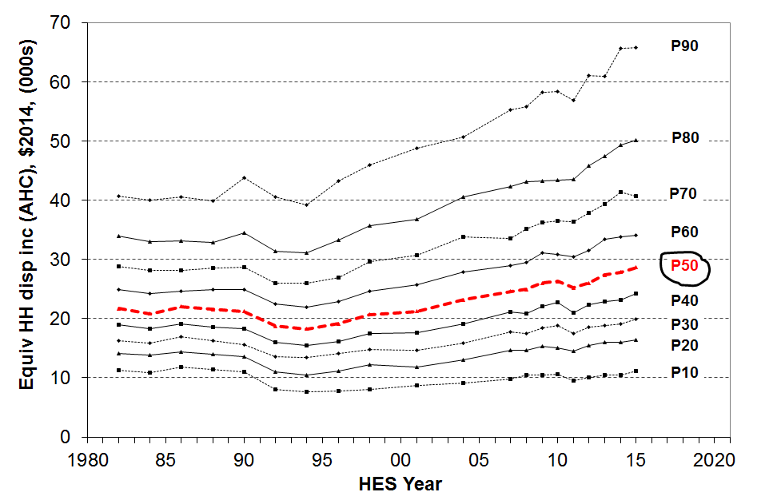
- Trends in household incomes after deducting housing costs (AHC incomes) tell a somewhat different story than do BHC incomes, especially for low-income households:
- incomes at P10 (top of the bottom decile) have still not returned to their level in the 1980s in real terms
- P20 incomes returned just before GFC.
- the median returned to 1980s level in the early 2000s, and is now around 30% higher than in 1988.

- The difference between BHC and AHC trends arises because housing costs now take a greater proportion of the household income especially for low-income households:
- the share is up from 14% in the late 1980s to 20% in 2013 overall for under 65s
- up from 29% to 49% on average for the bottom quintile, and
- up from 19% to 32% for Q2 (second from bottom quintile).
More detailed information on trends in housing outgoings to income ratios (OTIs) is given in the housing section below (see p 19).

- AHC income inequality rates are higher than BHC rates at all times. AHC low-income rates (poverty rates) are higher now than in the 1980s on every measure used in the Incomes Report.
- Information on these trends is given below in the Inequality and Poverty and Hardship sections (p14 and p22 respectively)

Income inequality

- There are many types of inequality that are of relevance to public policy formulation and debate, including inequalities in educational outcomes and access to health care, wage inequality, inequality in community outcomes, and so on. The focus in this section is on inequality of household incomes.

- Household income inequality is about the gap between the better off and those not so well off: it is about having “less than” or “more than” others, and about how much incomes are spread out or dispersed. This is different from (income) poverty which is about household resources being too low to meet basic needs – about “not having enough” when assessed against a benchmark of “minimum acceptable standards”.

- Several approaches are used to summarise in a single number the amount of income dispersion or inequality. No one statistic has emerged as the preferred or “best” one, mainly because each one captures a different aspect of the way the dispersion of incomes changes over time, and each one has its own value and limitations. It is now common to report on more than one indicator and to compare and discuss the trends produced by each.

- The most straightforward is the percentile ratio, usually either the 80:20 or 90:10.

- The 90:10 ratio covers a greater portion of the population than does the 80:20 (80% compared with 60%). The graph shows the 90:10 trend from 1982 to 2015.

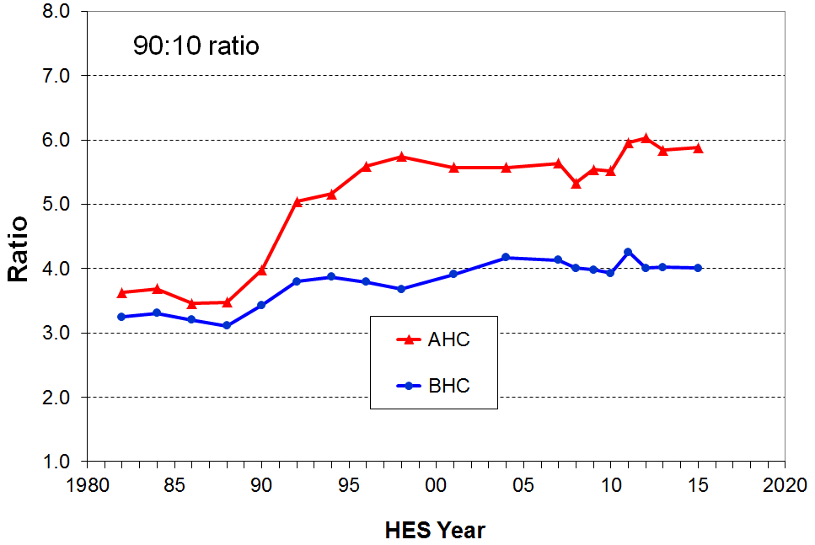
- BHC household incomes at the 90th percentile are around 4 times the level of incomes of households at the 10th percentile. Apart from a blip in HES 2011, the 90:10 ratio was flat from 2004 to 2015. There is no evidence of any sustained medium-term or post-GFC rise in inequality on this measure for BHC incomes.

- The main rise in the 90:10 ratio occurred from the late 1980s to the early 1990s, with a further but smaller rise through to the mid 2000s.

- AHC incomes are more dispersed than BHC incomes as housing costs make up a higher proportion of the household budget for lower income households than they do for higher income households. The rise in AHC inequality from the late 1980s to the mid 1990s was a much larger than the BHC rise, and in contrast to the fairly flat BHC trend in the last ten years the AHC trend was consistently higher from 2011 to 2015 than it was in the mid 2000s.

- The Gini coefficient is a commonly used measure of inequality. In contrast to the percentile ratios which look at the gap between two points on the income spectrum, the Gini takes into account the incomes of all households, giving a summary of the income differences between each household in the sample and every other household in the sample.

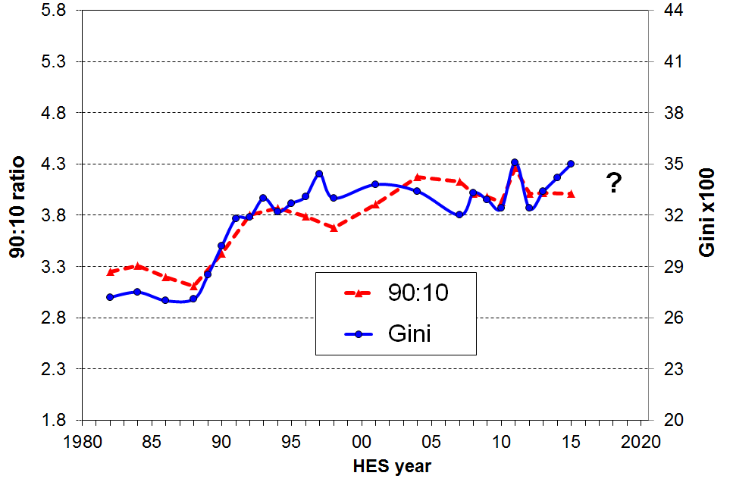
- The graph shows the Gini and 90:10 together for BHC incomes. Four main features stand out:
- both measures show the rapid and large rise in income inequality from the late 1980s to the mid 1990s
- they had different trajectories from the mid 1990s through to the mid 2000s but ended up in similar places again by the late 2000s
- both measures show a one-off spike for the 2010-11 survey
- the 90:10 ratio is flat from 2012 to 2015, whereas the Gini consistently increased each survey in that period.

- Some year-on-year volatility could be expected during and following the GFC, but the very different trends in the two measures from 2012 to 2015 suggest that some other factor is in play.

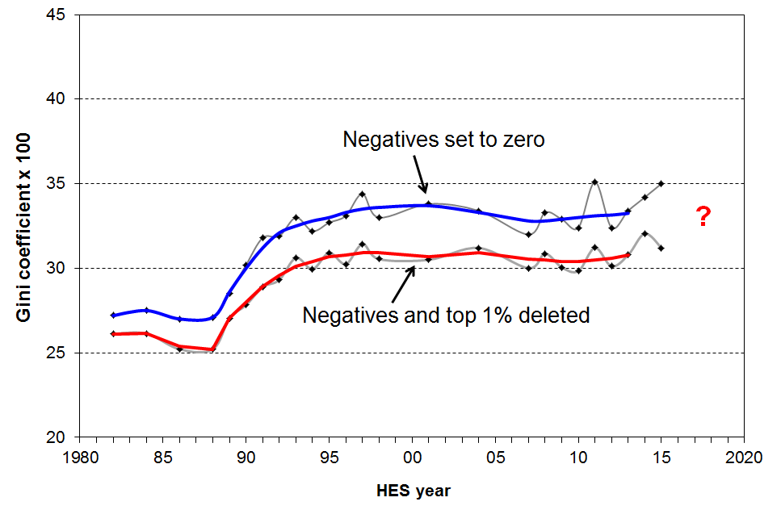
- One of the main differences between the 90:10 and the Gini is that the Gini uses all incomes, including those at the very top and at the very bottom. As outlined in the Introduction, there are challenges with the reliability of the data at the very top and bottom. The graph at the right shows the number of households with very high incomes, based on the HES for 2008 to 2015. These sampling fluctuations have a significant impact on the Gini value. Both 2011 and 2015 have unusually large numbers of households with very high incomes. These are also the years with historically high Gini numbers. Similarly, the number and size of the negative incomes reported can have an impact on the Gini, but in practice this is a much smaller impact. Neither of these issues impact on the 90:10 figures as the issues occur either above P90 or below P10.

- The top line in the graph shows the Gini for all in the sample as in previous reports (with negatives set to zero, as is standard practice). The lower line is for the Gini with both the top 1% and negatives deleted. The fluctuations for this line are more muted and the 2015 figure shows a decline relative to 2014 rather than a rise. Trend lines for both go only to 2013 in recognition of the sampling uncertainties.
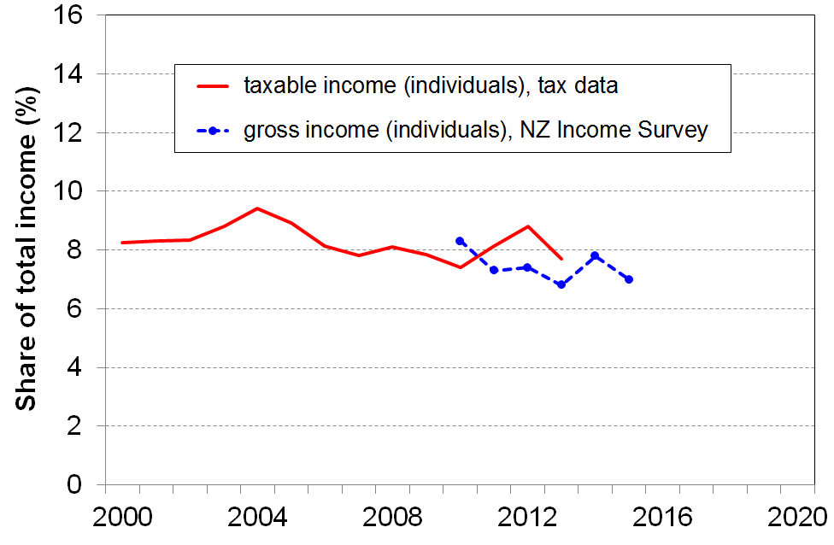
- The final graph on this page provides an independent check that the fluctuations in very high incomes captured in the HES are random and not a reflection of what is actually happening with very high incomes. The trend using tax data is reasonably flat from 2000 to 2013 (latest available), and the more recent trend using the Income Survey is also flat. See above on p12 for a longer term plot of the top 1% share.

- The Incomes Report will from now on report on high HES incomes, the Gini, and the top 1% share as in the charts on this page to better report and explain the fluctuations and trends in the Gini measure of inequality.

- For AHC incomes, the Gini (with both the top 1% and negatives deleted) shows a modest rising trend from HES 2007 to 2015.

Summing up

- There is no evidence of any sustained rise or fall in BHC household income inequality in the last 10-15 years (90:10 ratio) or the last 20 years (Gini for 99% plus top 1% share) or the last 25 years (top 1% share from tax records).
- AHC incomes are much more dispersed than BHC incomes and there is evidence of higher AHC income inequality in the last few years as compared with the mid 2000s and earlier.
Income redistribution

- New Zealand, like all OECD countries, has a tax and transfer system that significantly redistributes market income (wages, salaries, investments, self-employment) and reduces the inequality and hardship that would otherwise exist. In interpreting the findings in this section it is important to note that market income is not the counterfactual or “natural state” that would exist if there was no government intervention. The existence of taxes, government expenditure and the apparatus of the welfare state influences citizens’ behaviour in relation to labour market participation, living arrangements, and so on. The analysis can be taken as an indication of the extent of redistribution given that we live in a redistributive welfare state.
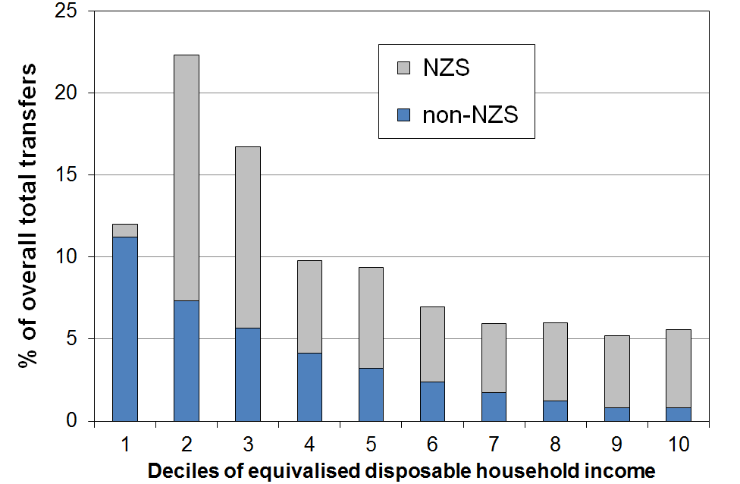
- “Government transfers” include working-age welfare benefits, New Zealand Superannuation (NZS), the Accommodation Supplement, Working for Families tax credits, special needs grants, and so on. The top chart shows the distribution of these transfers across household income deciles, with NZS separated out. For example, decile 2 households receive 22% of all transfers and two thirds of that is NZS.

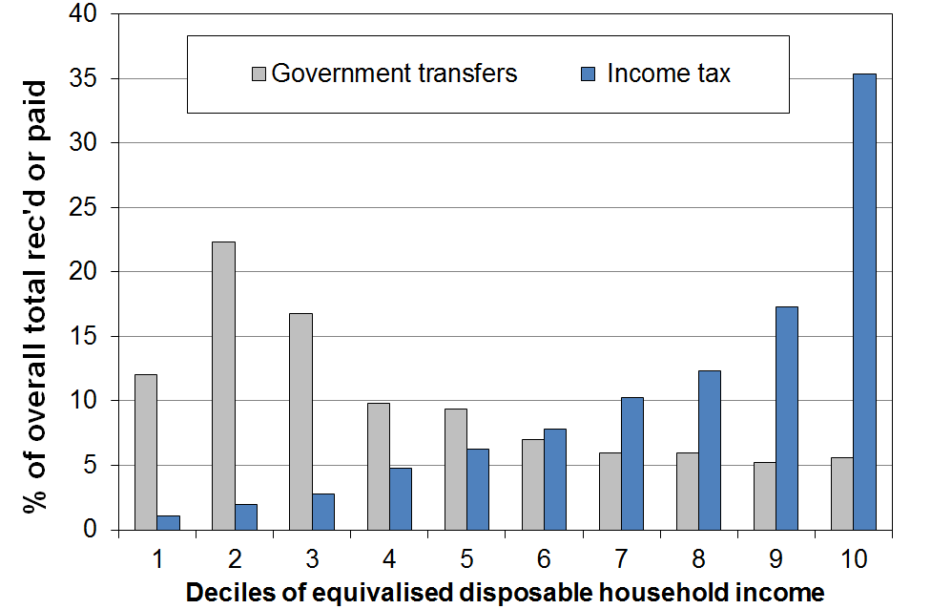
- The middle chart shows how the proportion of total income tax paid and transfers received varies across the different deciles. For example, households in the top decile pay one third (35%) of all income tax collected, and receive 5% of all transfers. The transfers received by the top decile are almost entirely from NZS. The rest is from low-income ‘independent’ adults living in high-income households while (legitimately) receiving a core income-tested benefit such as Sole Parent Support.

- Another useful way of looking at the extent of redistribution is to look at the difference between income taxes paid and transfers received for households in different income deciles. For many households, the amount they receive in transfers is greater than what they pay in income tax. They have a negative net tax liability.

- One group with negative net tax liability is low- to middle-income households with dependent children. For example, single-earner families with two children can earn up to around $60,000 pa before they pay any net tax. Around half of all households with children receive more in welfare benefits and tax credits than they pay in income tax. The vast majority of older New Zealanders (aged 65+) live in households where there is a negative net tax liability – the income tax they pay is less than the value of the NZS they receive. “Working-age” working households without dependent children have a positive income tax liability whatever their income.

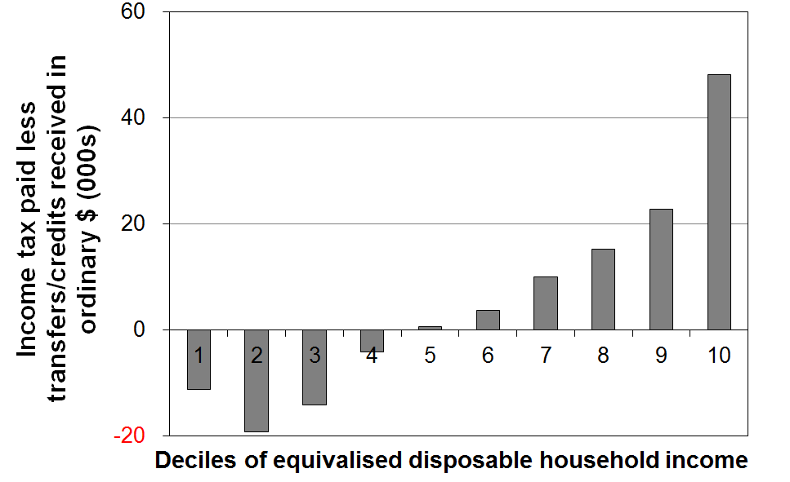
- The bottom chart shows that when all households are counted (working age with children, working age without children, and 65+ households), and looking at households grouped in deciles rather than looking at individual households, the total income tax paid by each of the bottom four deciles is less than the total transfers received (tax credits, welfare benefits, NZS and so on). For the fifth decile, payments and receipts are on average equal. It is only for each of the top five deciles that total income tax paid is greater than transfers received.
Inclusive Growth

- The idea of “Inclusive Growth” (IG) has gained traction in recent years, especially post GFC. At the heart of the IG notion is the goal of simultaneously promoting economic growth and reducing (or at least not increasing) various inequalities. It is about policy approaches that simultaneously drive growth and inclusiveness.

- For example, the OECD launched its IG initiative in 2012 in association with the Ford Foundation, and defines IG as “economic growth that creates opportunity for all segments of the population and distributes the dividends of increased prosperity, both in monetary and non-monetary terms, fairly across society”.

- By definition, the notion of inclusiveness requires a focus on individuals and households, not just on the system as a whole and “averages”. IG is also multi-dimensional, covering not only income and wealth, but also jobs, education, health and access to healthcare. Some include many other dimensions too in a broader notion of “living standards”.

- One of the motivations for the IG approach is the observation that for many countries in the years leading up to the GFC, the dividends of economic growth were not fairly shared across the whole income distribution. In particular in the US and the UK a small group of very high income earners vacuumed up the bulk of the new income coming from economic growth, leaving little or none for the rest to share.

- The graphs below show one aspect of New Zealand’s IG experience from the mid 1990s to 2015 – the growth in real terms of household incomes (not equivalised) and Gross National Disposable Income per capita (GNDI pc). They show that:
- median disposable household income tracked very closely with GNDI pc, showing “inclusive growth” (left hand graph)
- the P20 and P90 incomes tracked close to the median (P50), thus showing that the “inclusive growth” extended to higher and lower incomes (right hand graph)
- average wages (after tax) fell behind GNDI pc growth, consistent with lowish productivity growth or higher returns to capital than to labour, or both (and see the point made below the graphs)
- in the post GFC years, average wage growth (after tax) has been only a little less than the growth in median household incomes and GNDI per capita.
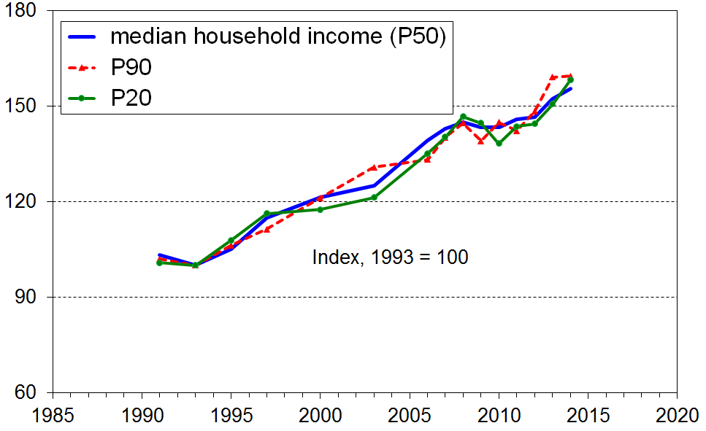
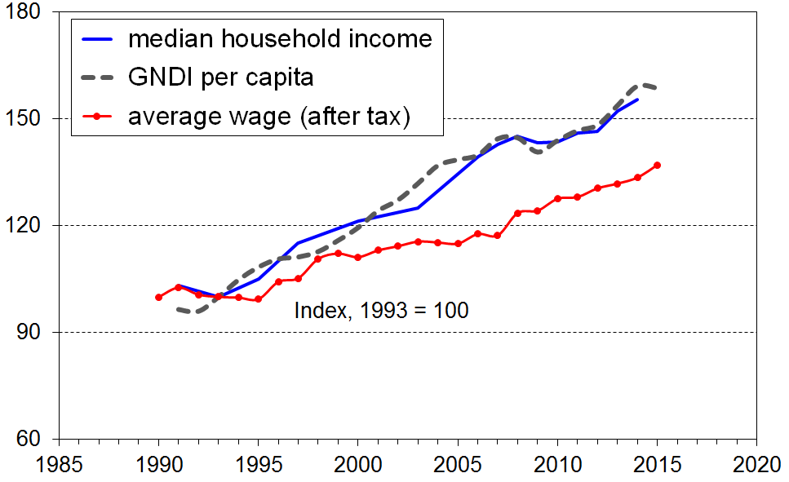
- One of the reasons for the higher growth rate for household incomes compared with wages is the increase in total hours in paid employment per household for many multi-adult households. In general this reflects the increased female labour force participation in the period. For example:
  - out of all two parent families that had at least one parent in FT employment, the proportion with 2 earners increased from 58% in 1994 to 67% in 2008 (69% in 2015)
  - one consequence of this is that the ratio of median two parent income to median sole parent income has increased from 1.57 in 1994 to 1.66 in 2008 (1.67 in 2015).

- The growth in household incomes at P10 (ie at the top of the bottom decile) has been variable across the period 1994 to 2015. Part of that variability will be due to sampling error, though from P10 up this is not so much of an issue as it is below P10. The net gain at P10 is less than for the median or P20. The fact that there was any real income growth at all at P10 mainly reflects rises in real terms for NZS. Those whose incomes are almost entirely from NZS are at the top of the lower decile and the bottom of the second decile. Incomes for beneficiaries and those reliant only on minimum wage employment (plus WFF if eligible) remained steady in real terms so did not contribute to the rise at P10.

- For assessing the degree of Inclusive Growth in New Zealand’s experience, the above is just a small contribution. For example, the largely positive analysis of IG for household incomes does not address the question as to whether the current range of incomes is “optimal” or considered “fair and reasonable” by the population, nor whether those households with low incomes have enough to live on at an acceptable minimum standard.

UN’s Sustainable Development Goals: Inequality Goal #10.1

- On September 2015 all 193 UN member states formally adopted the 2030 Agenda for Sustainable Development which includes a new set of global goals (the Sustainable Development Goals (SDGs)) which replace the Millenium Development Goals (MDGs). One of the differences between the SDGs and MDGs is that the SDGs are universal rather than just focussing on “developing countries”.

- SDG #10 is about reducing inequality within and between countries, and covers a wide range of inequalities. It has an Inclusive Growth approach. One of the targets for Goal #10 is that member states “by 2030, progressively achieve and sustain income growth of the bottom 40% of the population at a rate higher than the national average” (Goal 10.1). This refers to BHC income.

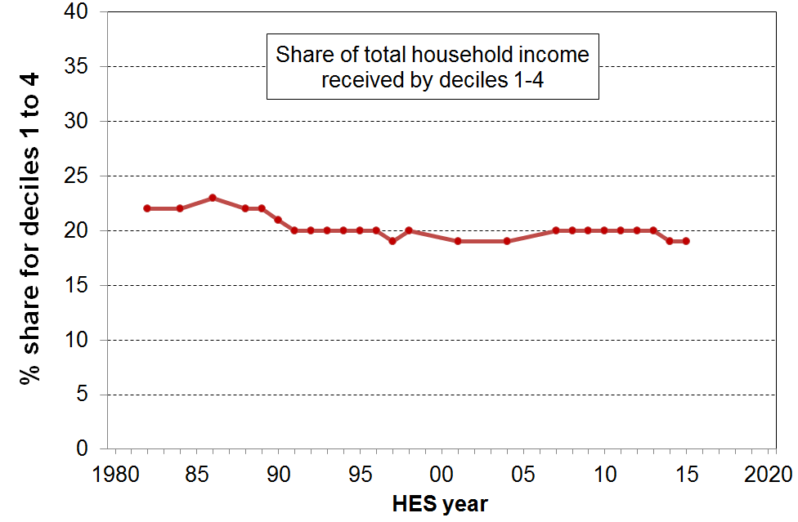
- The graph shows the share of total household income (BHC) for the bottom 40% for New Zealand, 1982 to 2015. If the growth for the bottom 40% is greater than that for average incomes, the trend line will slope up, showing that the bottom 40% is taking a larger slice of the pie (ie is growing faster than the national average). The generally flat trend from the early 1990s through to 2015 shows that the income growth of the bottom 40% has been much the same as that for the national average in that period.

- A limitation of this UN target is that it simply commits individual countries to improve on their base position, but there are as yet no guidelines or expectations about what an “acceptable” target range is for the ratio by 2030.

Housing costs and housing quality

Ongoing housing costs relative to income

- High outgoings for housing costs relative to income (high OTIs) are often associated with financial stress for low- to middle-income households. Low-income households especially can be left with insufficient income to meet other basic needs such as food, clothing, basic household operations, transport, medical care and education for household members.

- Housing affordability can be measured in a number of ways. From the perspective of potential homeowners the simplest measure is the ratio of average house price to annual household disposable income, which in effect gives the number of years needed to cover the purchase price of a house (on average). Other more sophisticated measures incorporate the cost of financing as well (eg Massey University’s Home Affordability Index).

- This section on housing affordability takes the perspective of households already in their own homes or renting and uses a measure which is relevant to both homeowners and renters. The ratio used is that of gross housing costs (rates, mortgage, rent) to household disposable income, in much the same way that home-loan lenders do for assessing risk.

Proportion of households with high OTIs
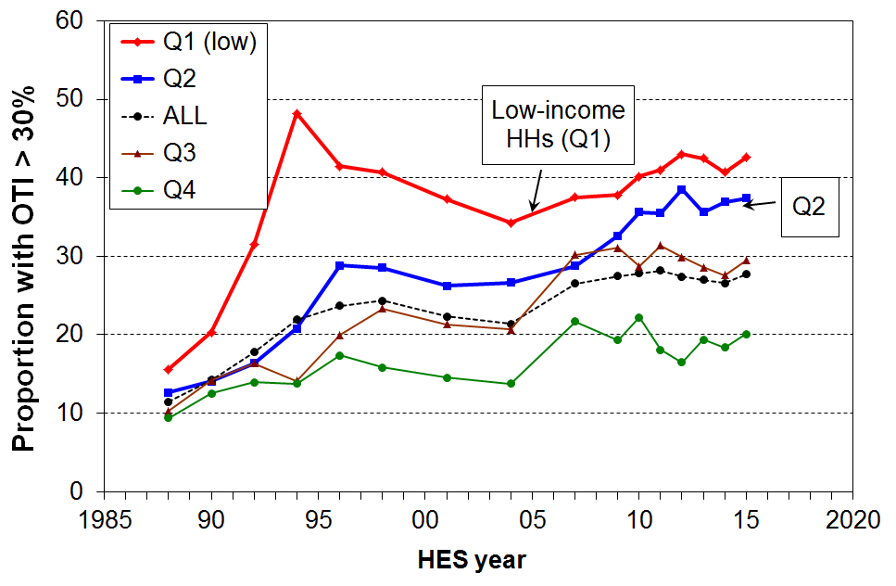
- In HES 2015 around 28% of households had high OTIs – that is, housing costs of more than 30% of their disposable (after tax) income. There has been little change in this rate since HES 2009.

- For the bottom two income quintiles (Q1 and Q2), the proportions were 43% and 37% respectively in HES 2015. While these are considerably higher than a decade earlier (34% and 27% respectively), these rates appear to have stopped rising.

- From 2007 to 2015, around 15% of all households had an even higher OTI (greater than 40%), up from 5% in the late 1980s. For those in the bottom income quintile, around one in three (32%) households spend more than 40% of their income on housing.

- The figures above are national averages. There are regional differences that a relatively small sample survey like the HES cannot reliably report on when breaking down by both region and income quintile.

Average housing costs as a proportion of average income for different income quintiles

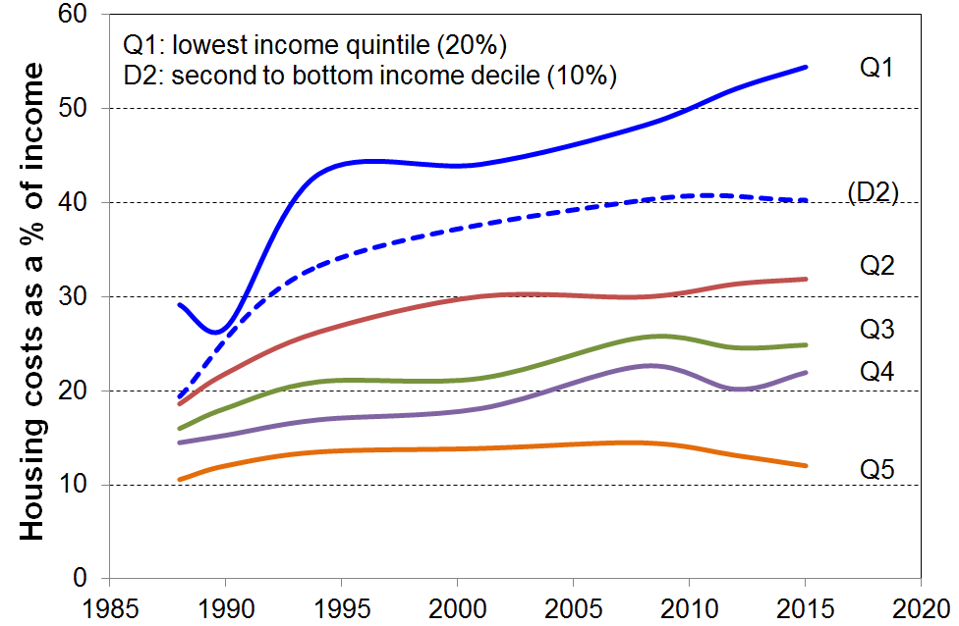
- Housing costs now take a greater proportion of household income especially for low-income households:
  - up from 14% in the late 1980s to 20% in 2015 overall for under 65s
  - up from 29% to 54% on average for the bottom quintile, and 19% to 32% for Q2.

Using MSD administrative data

- In February 2016, 44% of AS recipients were receiving the maximum payment, up from 25% in February 2007.
- In June 2016, almost all renters receiving the AS spent more than 30% of their income on housing costs, three in four spent more than 40% and half spent more than 50% (see Table below).

- These figures were all up on what they were in June 2007 (90%, 67%, 40% respectively).

Housing stress for AS recipients using three OTI thresholds (30%, 40% and 50%)
Group | This group as a proportion of all who receive AS |  | housing costs as a proportion of income
Group |  |  | >30% |  | >40% |  | >50%
Group | 2007 | 2016 | 2007 | 2016 | 2007 | 2016 | 2007 | 2016
All | 100 | 100 | 87 | 92 | 59 | 69 | 34 | 44
Renters | 63 | 66 | 90 | 94 | 67 | 76 | 40 | 52
Single adult | 45 | 55 | 90 | 94 | 65 | 73 | 40 | 50
2 parent with dependent children | 11 | 9 | 74 | 89 | 40 | 56 | 21 | 29
One parent with one child | 19 | 14 | 86 | 89 | 60 | 67 | 33 | 42
One parent with 2+ children | 17 | 14 | 84 | 88 | 55 | 64 | 23 | 34
NZS/VP | 9 | 13 | 81 | 86 | 48 | 54 | 23 | 27
Source: MSD Information Analysis Platform, iMSD

Housing quality

- Major problems with dampness and mould, difficulty with keeping the house warm, and overcrowding are all issues with housing quality that have impacts on health and wellbeing, especially for children.

Dampness and heating issues for private dwellings

- In the HES surveys, starting with 2012-13, respondents are asked whether their accommodation had no problem, a minor problem or a major problem with (i) dampness or mould, and (ii) keeping it warm / heating it in winter.
- On average over the three surveys from 2012-13 to 2014-15:
- 7% reported a major problem with dampness or mould
- 9% reported a major problem with heating it / keeping it warm in winter
- for children (aged 0-17 yrs), the figures for their households were:
    - 10% for a major problem with dampness and mould (~110,000 children)
    - 13% for a major problem with heating / keeping it warm in winter (~140,000)
    - 7% reporting both issues (~75,000) .

- The issues are much more prevalent in lower-income households than in middle and higher income households, and are especially concentrated in households with low MWI scores (bottom quintile) – these are households experiencing multiple deprivation across a range of basics:
- a third of these bottom MWI quintile households report “a major problem”
- around 65-70% of those reporting “major problems” are in this lowest material wellbeing quintile, 75-80% for children (0-17 years).

- The issues are much more prevalent in rental accommodation than in owner-occupied dwellings:
- 70% of those reporting a major problem with either issue were in rental accommodation, 45% in private rental and 25% in HNZC homes
- in HNZC homes one in three are reported to be hard to heat or keep warm in winter.

- In a related question, respondents were asked to what degree they had put up with feeling cold in the last 12 months as a result of being forced to keep costs down to pay for other basics. The options were “not at all”, “a little”, or “a lot”.
- Overall, 7% reported a serious problem on this issue.
- The rates were particularly high for sole parent and beneficiary-with-children homes (22% and 30% respectively), 10% for children in all households, and 4% those aged 65+
- The rate for working families with children overall was only 6%, but controlling for income by looking only at the bottom income quintile (Q1), the rate is 15% for this group.
  - As there are many more low-income working families than there are beneficiary families (overall and in Q1), the numbers reporting having to put up with the cold “a lot” are fairly similar for each group. This touches on a finding that comes up several times in the reports: there is good evidence of a group of “working poor” that is about the same size as the “beneficiary poor” group.

Crowding

- Living in a crowded house greatly increases the risk of transmission and experience of communicable diseases and respiratory infection. It also means severely reduced personal space and privacy, inadequate space for children to do homework or study, and increases the chances of relational stress.

- There is no internationally agreed on measure of household crowding, but the Canadian index is used widely in New Zealand. This index uses a set of rules for determining who should and should not share a bedroom, with a crowded household being one that requires one or more extra bedrooms. A severe crowding measure uses a threshold of two or more extra bedrooms needed.

- The Census data shows a decline in household crowding overall from 13% in 1986 to 10% in 2001. The rate has plateaued at this level since in the Censuses for 2006 and 2013.

- For children (0-14 yrs) the rate in the 2013 Census was 16% (~130,000). It was 5% (~40,000) using the more severe measure, for which households need 2+ extra bedrooms. Crowding is in the main a children’s issue:
- 80% of those in crowded households are in households with children
- 38% of children in HNZC homes live in crowded accommodation (1+ needed).

- Those of Pacific ethnicity report the highest crowding rate in 2013 (39%) though this was down from 50% in 1986. The rate for Maori declined from 35% to 19% in the same period.

- The 2008 Living Standards Survey showed that:
  - 5% of children did not have separate beds
  - 8% did not have separate bedrooms for children of the opposite sex (10+ yrs)

Room for the children to study and play?

- The 2008 LSS responses show that:
- 8% of all children and 30% of those in the bottom MWI decile have a serious restriction regarding space for study and play, and
- 63% of all children facing this space restriction live in households in the bottom MWI decile – this is another instance of cumulative disadvantage.

Poverty and material hardship

What the reports mean by poverty and material hardship

- Poverty is essentially about household resources being insufficient to meet basic needs. In the richer countries poverty is commonly defined as exclusion from a minimum acceptable standard of living because of inadequate household financial and material resources.

- In practice, household incomes have traditionally been used to measure resources, with low incomes used as a measure of income poverty. The limitations of this approach are well-known and are briefly discussed in the opening section of this Overview (p4). Monitoring trends in low incomes is nevertheless an important exercise as many low-income households have very limited or no financial or other assets, and their income is therefore the main in-house resource available for survival.

- Over the last two decades growing use has been made of non-income measures to more directly measure material standard of living, and material hardship.

- Value judgments are needed to decide on what is “minimum acceptable” or “adequate” (ie where to draw the lines). This is an inescapable aspect of poverty measurement and debate, but does not mean however that any measure will do nor that all are equally suspect. Some are clearly more reasonable and defensible than others. The NIMs report, for example, has a section producing evidence to support its choice of more and less severe thresholds. The Incomes Report uses a range of fairly standard measures used in richer countries. Both reports use several thresholds so that the fuller story can be told about trends at various depths.

- “Poverty” is an awkward word, but its widespread use means that there is little chance of any other word gaining acceptance. The approach in the reports is to use the word, but to be very clear what is meant by it and what is not meant by it, and what measure is being used.

- The causes, correlates and consequences of poverty and material hardship are all critical matters to understand and all need to be considered in addressing poverty and hardship, especially for children. Apart from a high-level reference to causes in the Framework (p4) and in the more elaborated version in Appendix Six, these matters lie beyond the scope of the reports. Their focus is on the description of the core experience.

- For monitoring and interpreting the trends and other figures relating to poverty and hardship, the reports use the guidelines and principles outlined in the table on the next page. In particular:
  - note the use of anchored line low income rates and of material hardship rates as the primary measures, and the rationale for this
  - note that fully relative income measures are not used to monitor short to medium term trends in income poverty, but to look at longer run changes in income inequality in the bottom half of the income distribution.

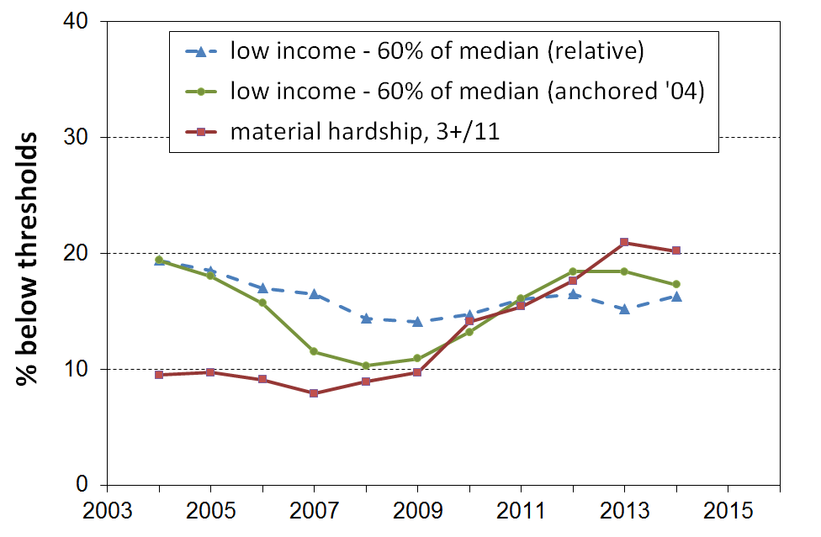
- The reports strongly advocate a multi-level multi-measure approach, with a supporting narrative to integrate the information into a coherent story. The value of a multi-measure approach is shown here for Ireland. The chart shows the differing trends for Ireland in recent years using moving and anchored line income poverty measures and a material hardship measure (based on non-monetary indicators). The fully relative income poverty measure barely picked up the impact of the GFC downturn because the median was falling, masking the increasing numbers whose real incomes were falling. This latter was picked up by the anchored line income poverty measure. The material hardship measures also picked up the impact on households of the downturn.

Principle or position taken in the reports | Practical consequences for measurement and for interpreting the numbers and trends
- Material disadvantage has several important dimensions. | - a multi-measure approach is used to give insight into these different aspects
- Income poverty (low income) and material hardship each exist on a continuum from less to more severe. | - for each measure more than one threshold is used, and the difference or similarity in the trends at different depths becomes a part of the core story about material disadvantage  - there is no single headline measure that is able to definitively and robustly identify how many are “in poverty” … while the rest are not
- There are two common approaches to updating the “poverty lines” from survey to survey. | - select a reference year and update using the CPI  - keep the thresholds as a fixed percentage of the median (a fully relative approach)
- When used over time, fully relative income poverty measures give information about trends in income inequality in the bottom half of the income distribution. They do not give any information about changes in the incomes of low-income households per se, only in relation to the median which itself can move up or down. | - For monitoring trends over time the Incomes Report treats the relative measures as secondary measures.  - They have value especially when considering performance in the longer term within an “Inclusive Growth” framework.
- Housing costs make up a very large part of the total household budget for many households, especially those with low to middle incomes. For others (eg mortgage-free home-owners) direct housing costs are very low. Different households can also pay quite different housing costs for very similar houses in different areas.  Ranking households on BHC incomes has significant limitations for assessing which households are struggling financially. | - Income after deducting housing costs (AHC income or residual income) is used in the Incomes Report to better compare the material wellbeing of those households with similar incomes but very different housing costs.  - Conceptually, it can be seen as an approximation to the rankings achieved by adding imputed rents to BHC incomes for home-owners.
- The findings are based on data from sample surveys | - There will therefore always be statistical uncertainties in every figure. The uncertainties are greater for smaller groups than for larger ones, and are greater for high and low incomes than they are for the rest.  - Year-on-year changes can rarely be relied on for indicating the trend. The findings about differences and changes are at their strongest when looking at clear trends or changes over several surveys or longer, when comparing rankings using different measures, and when identifying which groups are faring well and which not so well.
- The use of relative low-income measures for creating international league tables for “poverty” in the richer nations is a misleading approach as it does not compare the actual living conditions of households, just the income inequality in the lower half of the distribution. | - For meaningful international comparisons of poverty in the richer nations, a material hardship or deprivation measure is needed.
- At the very least, the incomes of the least well off should not decline in real (CPI-adjusted) terms over time, and their material wellbeing should not decline in relation to the basics. Successive governments in the last 25 years have espoused this view, most recently through maintaining core income support levels through the GFC. | - For reporting on trends and assessing progress (especially in the short to medium term), the primary measures used in the reports are:  - anchored line AHC income poverty / low income rates  - material hardship rates

Population as a whole

Low income (income poverty)

- For monitoring trends in income poverty (low incomes), the report uses the AHC (after deducting housing costs) “anchored” line measure as its primary indicator. The thresholds are set at 50% and 60% of the reference year median (2007), and adjusted by the CPI for inflation for other years. The thresholds are therefore held at a constant value (CV) in real terms from survey to survey. For short, the measures are sometimes referred to as AHC 50% CV-07 and so on. The 50% CV-07 measure is also used create a longer time series starting in 1982.
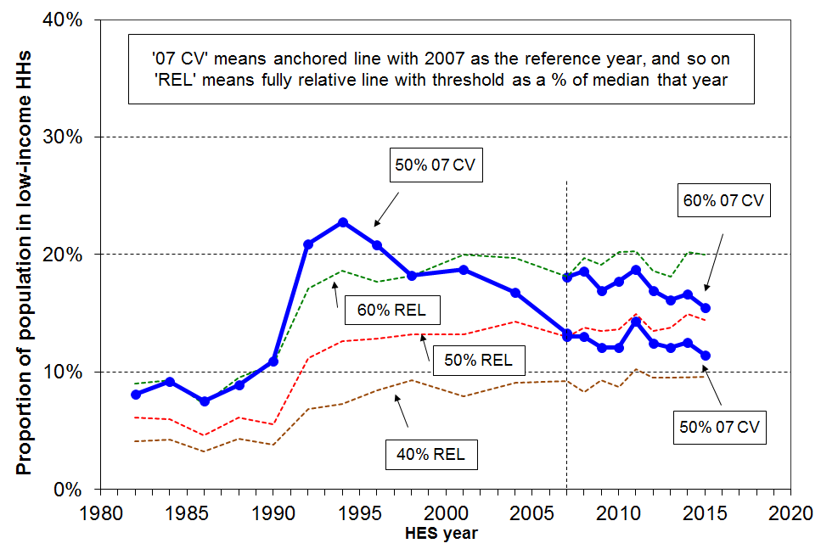
- There is no evidence of any rise in recent years in income poverty trends using anchored line measures, either BHC or AHC. The trends are either flat or declining, depending on the start point or measure used.

- For the AHC 50% CV-07 anchored line measure the trend from before the GFC to 2015 was flat (around 12%), apart from a spike in one recession year.

- For the AHC 60% CV-07 anchored line measure the low income rate fell from its peak of 19% in the recession to 16% in HES 2015, a little below the pre-GFC rate of 17% in HES 2009.

- Looking at the longer-term picture from 1982 the AHC population poverty rate more than doubled in a very short period from the late 1980s to early 1990s, reflecting rising unemployment, a falling average wage, demographic changes (more sole parent families) and the 1991 benefit cuts. It then steadily fell through to 2007 with improving employment, a rising average wage, rising female employment, the introduction of income-related rents and Working for Families. This fall in rate indicates that the AHC incomes of many low-income households were higher than in the mid 1990s. Since 2007, the trend line for the AHC 50% CV-07 has been relatively flat, as gains in BHC incomes at these low levels have generally been offset by increases in housing costs.

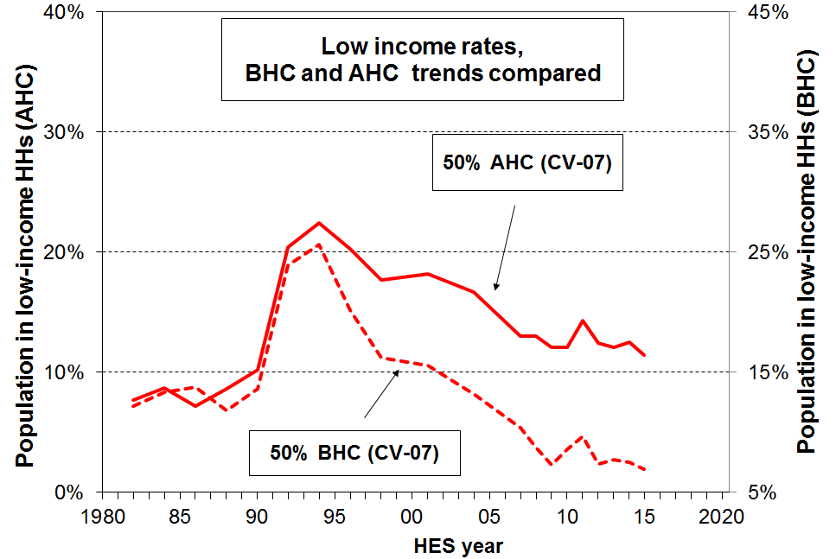
- The different trajectories for BHC and AHC incomes show up as different trends for BHC and AHC poverty rates using anchored line measures. Household incomes (BHC) for low-income households were higher in real terms from 2004 to 2015 than in the mid 1980s. This shows up in the dashed line in the graph in which BHC anchored line “poverty” rates from 2004 on are lower than in the 1980s. In recent years the rate has been ~7% compared with 12-14% in the 1980s. On the other hand, AHC “poverty” rates using the same measure are higher in recent years than in the mid 1980s (~13% compared with 8-9%). This reflects the fact that AHC incomes for low-income households are still lower now in real (inflation-adjusted) terms than in the 1980s, despite the real increase in BHC incomes. This is mainly because housing costs are now much higher relative to BHC incomes, especially for low-income households (see p19 above).

- The three fully relative trend lines show that whatever threshold is chosen, low-income rates at the different depths have tracked in reasonably similar ways over the last thirty years. The increases from HES 2012-13 to 2013-14 reflected in the main the large rise in the median between surveys. This raised the dollar value of the relative poverty lines and the low-income (poverty) rates therefore rose. There was no measurable change from 2013-14 to 2014-15.

- There is no evidence of any increasing depth of relative income poverty over the last two decades. Increasing depth means that for a given threshold, a greater proportion are further below the threshold than before. One way that increasing depth would show up is that the 40% relative line would move closer to the 50% relative line, showing an increasing number in very low income households (under 40%) compared with the numbers between the 40% and 50% lines.

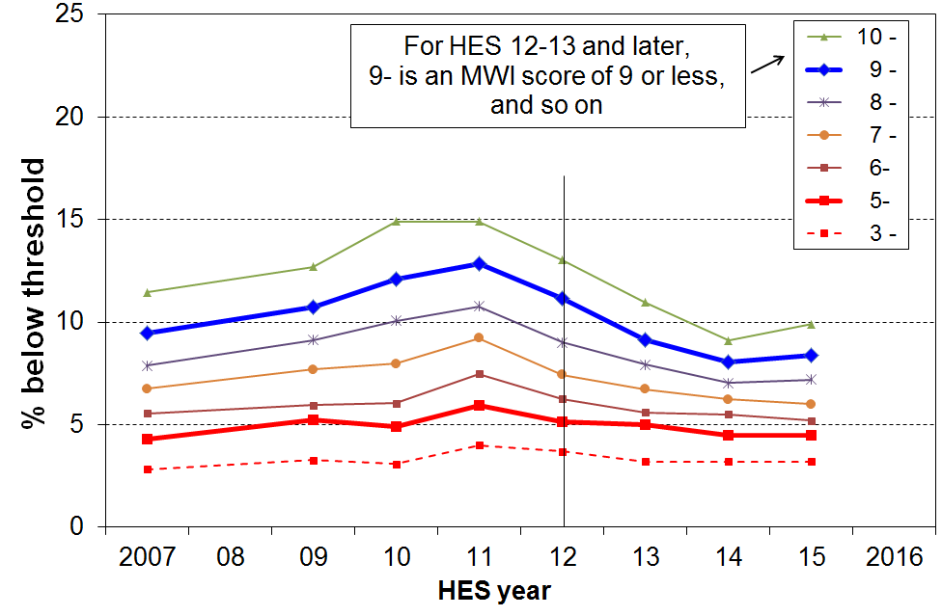
Material hardship

- Trends in material hardship rates are now available for HES 2006-07 to 2014-15. Up to and including HES 2011-12, the analysis used MSD’s ELSI measure, then from 2012-13 on it uses the material wellbeing index (MWI), the revised version of ELSI. See the NIMs report for detailed discussion and evidence in support of using an unbroken series.

- The MWI gives the same figures and trends as MSD’s deprivation index (DEP-17) but it can also give more detailed information at the lower end. A description of the items used in these indices is given in Appendix Two.

- Trends are shown in the chart for the whole population using a range of thresholds. The two thicker lines (for MWI scores of 9 or less and 5 or less respectively) correspond fairly closely to the rates produced by the EU’s standard and severe hardship thresholds respectively.

- For the more severe hardship measure the rate tracked at around 5% through the whole period that we can measure, with only a slight rise through the GFC.

- For the standard or less severe hardship measure, the impacts of the GFC and the recovery are very clear, with the rate first rising to 13% in HES 2010-11 then falling to 8% by HES 2014 and much the same in HES 2015. The general state of the economy (wages and employment especially) has a rapid and noticeable impact on those in lesser hardship and those ”just getting by”. For those in deeper hardship, these impacts are less noticeable. Most in deeper hardship are working-age beneficiaries or low-waged workers with persistent low income. For some of these and others, there are factors either in addition to low income or contributing to their low income (or both) that lead to their being in deeper hardship (see the framework on page 4).

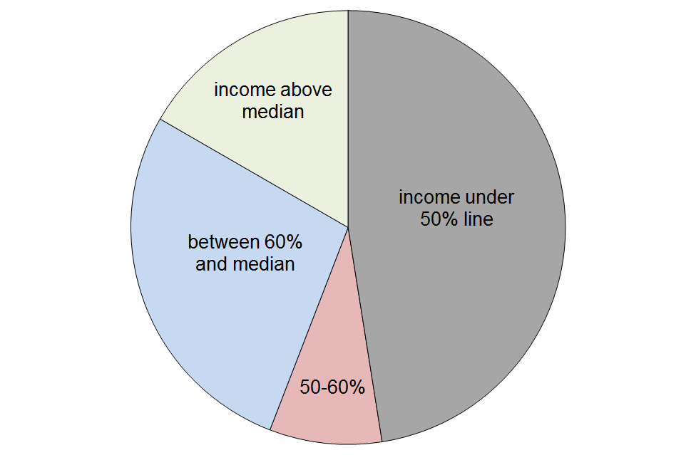
The incomes of those in hardship

- The pie chart below shows the AHC household income bands for the 8% of the population who are identified as being in hardship using the less severe threshold (MWI score of 9 or less, DEP-17 score of 7+), using HES 2014-15 data.

- Just under half (48%) have incomes below the 50% of median AHC line, and a further 8% are in the 50%-60% band. 17% have incomes above the median.

- This wide range of household incomes for those identified as “in hardship” illustrates the point made in the framework used for the reports that differences in actual living standards among households reflect not only the impact of differences in household income but also differences in financial assets and other economic resources, differences in special demands on the household budget (such as those arising from high debt servicing costs, high health-related costs, commitments to family and others outside the immediate household), and differences in abilities to use a given income to meet basic needs or to maximise the value of discretionary spending.

Hardship rates for the non-poor
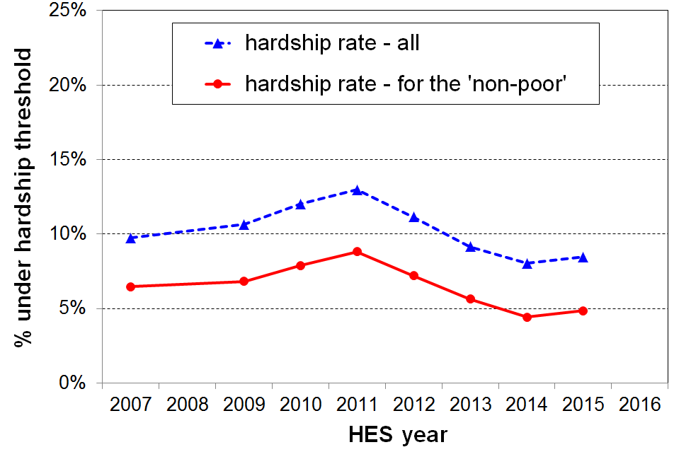
- The graph show the trend in the hardship rate (less severe threshold) for the “non-poor” and for the whole population. The low-income measure used is the AHC 60% relative measure.

- It is a reminder that there are households in hardship whose incomes are above the threshold of even the most generous AHC measure reported on. While not “in poverty”, the finances of these households are precarious. Relatively small drops in income or unexpected bills can make a significant difference to their actual day-to-day living conditions.

Low income rates and composition of the poor for selected groups

- The table below shows the low income rates and composition of those in low income by ethnicity, main source of household income for under 65s, and by tenure for under 65s:
  - there is very little difference in the composition of the poor whether the 60% or 50% thresholds are used
  - around half of all under 65s who are counted as poor live in households where market income is the main source of income
  - just on two thirds of under 65s who are counted as poor live in rental accommodation, whether private of HNZC
 | What % of this population group are poor? |  | What % of the poor are in this population group?
Population group | Poverty rate |  | Composition of the poor
Threshold used ==> | 60% | 50% | 60% | 50%
Ethnicity
Maori | 26 | 19 | 24 | 23
Pacific | 25 | 18 | 9 | 9
Euro/Pakeha | 12 | 9 | 47 | 47
Other | 26 | 20 | 21 | 21
Main source of income < 65
Benefit | 80 | 67 | 48 | 54
Market | 10 | 6 | 52 | 46
Tenure <65
HNZC | 43 | 32 | 14 | 14
Private rental | 26 | 20 | 52 | 53
Own home – with mortgage | 11 | 8 | 28 | 27
Own home – no mortgage | 7 | 5 | 7 | 7
Population overall | 16 | 11 | 100 | 100
Population – under 65s | 17 | 12 | 100 | 100
Notes: 1 The analysis unit is the individual. For tenure, there is an argument for using households as the unit of analysis. Using households makes only a minor difference to the numbers and relativities.
2 The income measure used is the anchored line AHC measure with 2007 as the reference year. Two thresholds are used, 50% and 60% of median.
Children

- There is high public, media and political interest in the wellbeing of children, including how they are faring in accessing their material needs and the necessities of life. This section therefore gives more detail than in the population section above.

- Appendix Four has detailed tables for child poverty and hardship rates, and for the composition of poor children by their ethnicity and selected household characteristics.

“There are no poor children, just poor families”
It is sometimes said that the idea of “child poverty” doesn’t make sense as it’s really about families with financial and material resources that are not adequate for meeting the basic needs of the family (ie it’s not poor children, it’s poor families).
In this report, when it is said that “the child poverty rate on a given measure is 18%”, this is a short-hand for “18% of children live in families whose total income is below the threshold used in the given measure”. It is too cumbersome to repeat this each time, so the shorthand version is used: “the child poverty rate is 18%”.

Low income (income poverty)

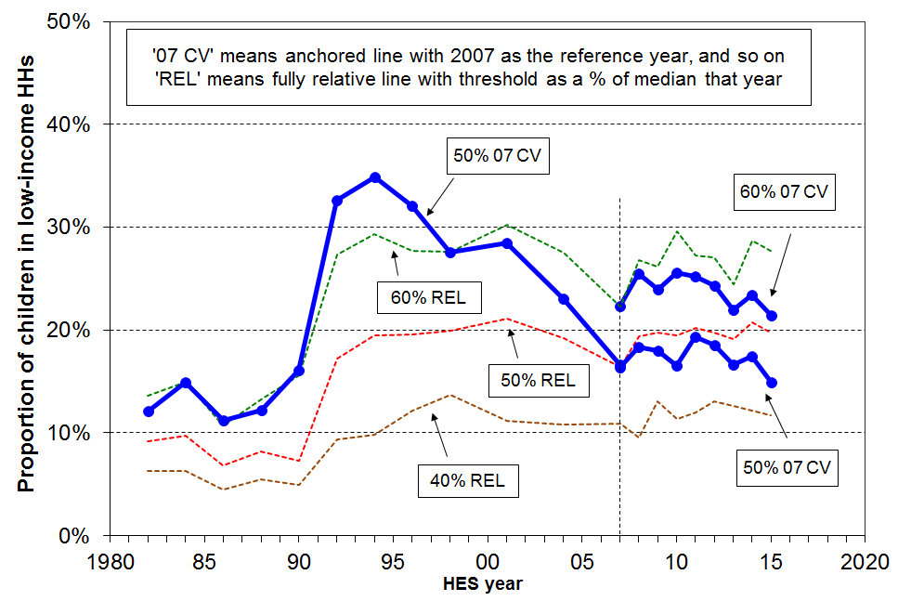
- There is no evidence of any rising child poverty trend in recent years using the anchored line AHC measures. Trends are either flat or falling depending on the starting point or measure used.

- For the AHC 50% CV-07 measure the 2014 rate was close to the pre-GFC rate (~18%). The dip in 2015 is promising but the next survey will tell us whether it is part of a downward trend or merely a statistical blip.

- For the AHC 60% CV-07 measure the low income rate for children fell from its pre-recession rate of 24% to 21% in 2015.

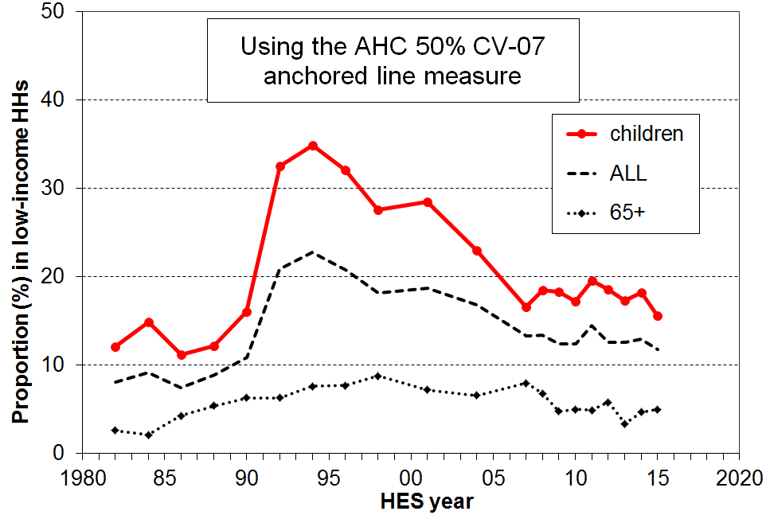
- On the AHC moving line measures, child poverty rates in HES 2015 are around double what they were in the 1980s, indicating higher inequality in the lower half of the AHC incomes distribution from the 1990s to 2015.

- Low income (poverty) rates for children are always higher than for the population overall, in part because of the relatively low rates for older New Zealanders. This is illustrated in the AHC 50% CV-07 graph.

- For the BHC 60% CV-07 anchored line measure (not shown) there is a clear downward trend from around 20% pre-GFC (2008) to 16% on average in 2014 and 2015.

- Looking at the longer-term picture from 1982 the AHC child poverty rate almost tripled in a very short period from the late 1980s to early 1990s, reflecting rising unemployment, a falling average wage, demographic changes (more sole parent families) and the 1991 benefit cuts. It then steadily fell through to 2007 with improving employment, a rising average wage, rising female employment, the introduction of income-related rents and Working for Families. This fall in poverty rate indicates that the AHC incomes of many low-income households with children were higher in 2007 than in the mid 1990s. Since 2007, the trend line for the AHC 50% CV-07 has been relatively flat, as gains in BHC incomes at these low levels have generally been offset by increases in housing costs.

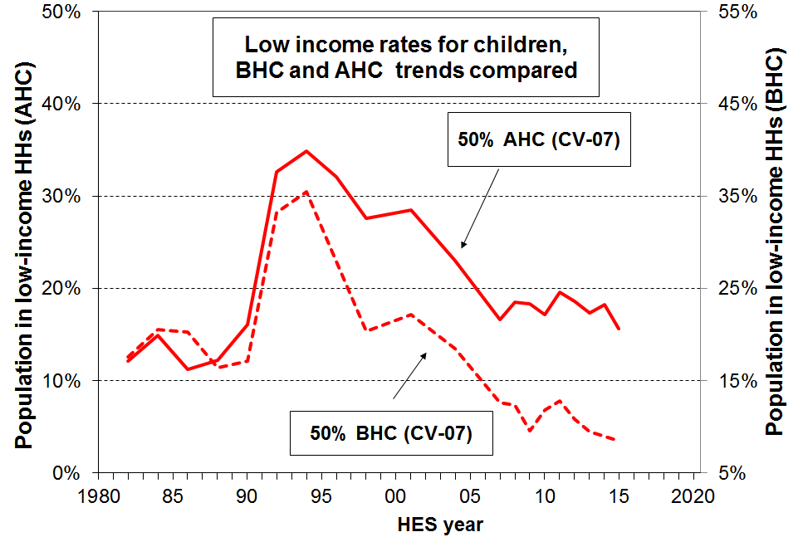
- The different trajectories for BHC and AHC incomes show up as different trends for BHC and AHC child poverty rates using anchored line measures. Household incomes (BHC) for low-income households were higher in real terms from 2004 to 2015 than in the mid 1980s. This shows up in the dashed line in the graph in which BHC anchored line “poverty” rates from around 2004 on are lower than in the 1980s. In recent years the rate has been ~10% compared with 12-14% in the 1980s. On the other hand, AHC “poverty” rates using the same measure are higher in recent years than in the mid 1980s (~17% compared with 11-12%). This reflects the fact that AHC incomes for low-income households are still lower now in real (inflation-adjusted) terms than in the 1980s, despite the real increase in BHC incomes. This is mainly because housing costs are now much higher relative to BHC incomes, especially for low-income households (see p19 above).

- The three fully relative trend lines show that whatever threshold is chosen, low-income rates at the different depths have tracked in reasonably similar ways over the last thirty years, though the 60% measure dipped in 2007 as WFF changes tipped a good number of working families over the line (just). The increases from HES 2012-13 to 2013-14 reflected in the main the large rise in the median between surveys. This raised the dollar value of the relative poverty lines and the low-income (poverty) rates therefore rose. There was a small fall from 2013-14 to 2014-15, but neither the rise nor the fall tell us anything about what is happening to low incomes per se. The 28% 2015 rate is the same as the levels in 2001 to 2004.

- There is no evidence of any increasing depth of relative income poverty over the last two decades. One way that increasing depth would show up is that the 40% relative line would move closer to the 50% relative line, showing an increasing proportion in very low income households (under 40%) compared with the numbers between the 40% and 50% lines.

Material hardship

- Trends in child material hardship rates are now available for HES 2006-07 to 2014-15. Up to and including HES 2011-12, the analysis used MSD’s ELSI measure, then from 2012-13 on it uses the material wellbeing index (MWI), the revised version of ELSI. See the NIMs report for detailed discussion and evidence in support of using an unbroken series.

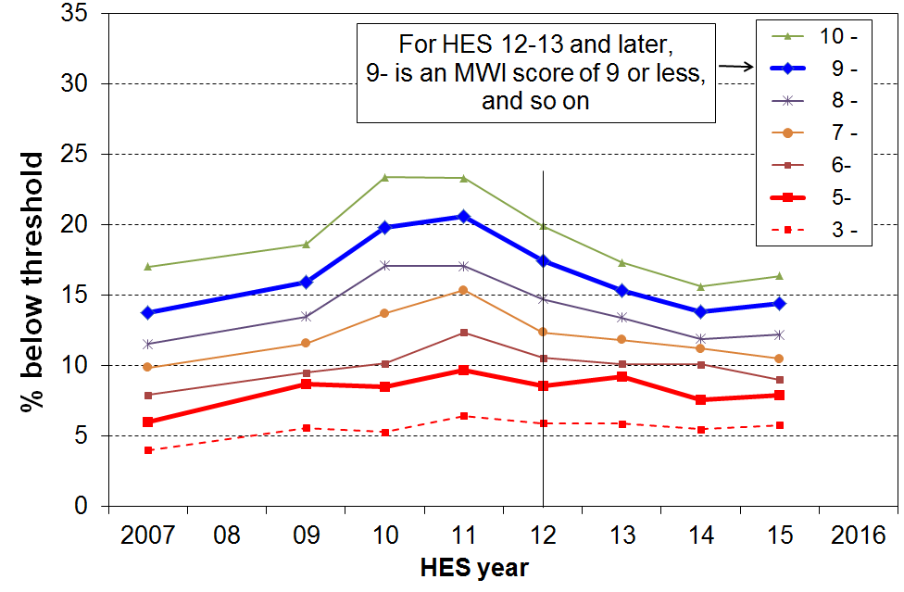
- The MWI gives the same figures and trends as MSD’s deprivation index (DEP-17) but it can also give more detailed information at the lower end. A description of the items used in these indices is given in Appendix Two.

- The chart shows trends in child hardship rates using a range of thresholds. The two thicker lines (for MWI scores of 9 or less and 5 or less respectively) correspond fairly closely to the rates produced by the EU’s standard and severe hardship thresholds respectively.

- Using the more severe threshold, there was a slight rise through the GFC to 10% and a small fall to 8%, the pre-GFC level.

- As for the population as a whole, the trend using the less severe measure rose significantly during the GFC to a maximum of 21%, then fell to 14% in 2014 and was much the same in 2015.
Hardship rates for the “non-poor” children
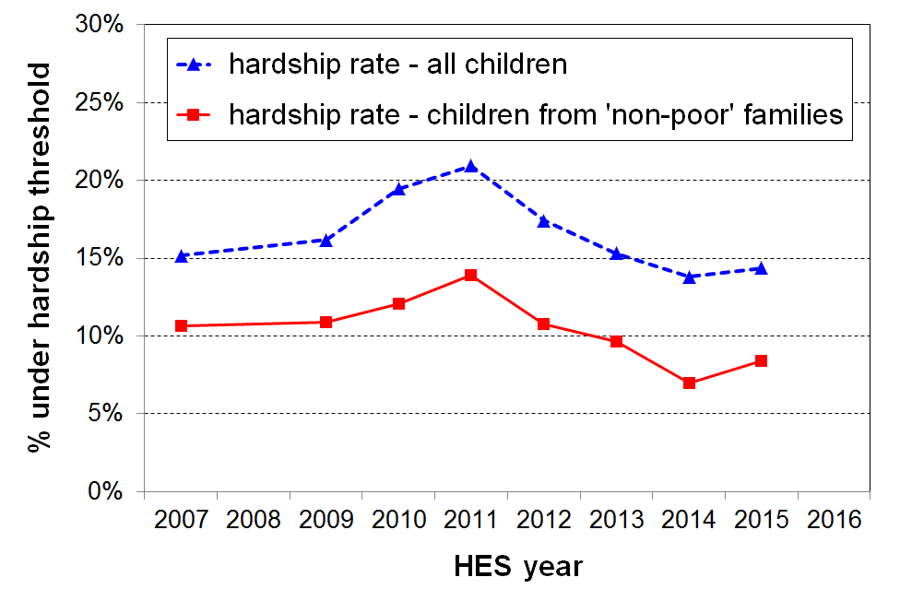
- The graph show the trend in the hardship rate (less severe threshold) for “non-poor” children and for all children. The low-income measure used is the AHC 60% relative measure.

- It is a reminder that there are households with children who are experiencing hardship but whose incomes are above the threshold of even the most generous AHC measure reported on. While not “in poverty”, the finances of these households are precarious. Relatively small drops in income or unexpected bills can make a significant difference to their actual day-to-day living conditions.

Those in “deeper poverty” or “more severe hardship”

- One of the features of the approach used in the Incomes and Non-incomes reports is to accept that there is no line that can definitively divide the population into the “poor” and the “non-poor”. The reports use and advocate an approach that accepts that poverty and material hardship (will always be considered to) exist on a continuum from less to more severe. They use thresholds within a plausible and defensible range to give a comprehensive account of what is happening at the different depths.

- There are three different conceptualisations of “deeper poverty” or “more severe hardship” used in the reports:
- those in households with very low AHC incomes (say, less than 40% of median AHC incomes)
- those in households with high deprivation scores (eg MWI ≤ 5 (≡ DEP-17 of 9+/17))
- those in households with both low income and experiencing material hardship.

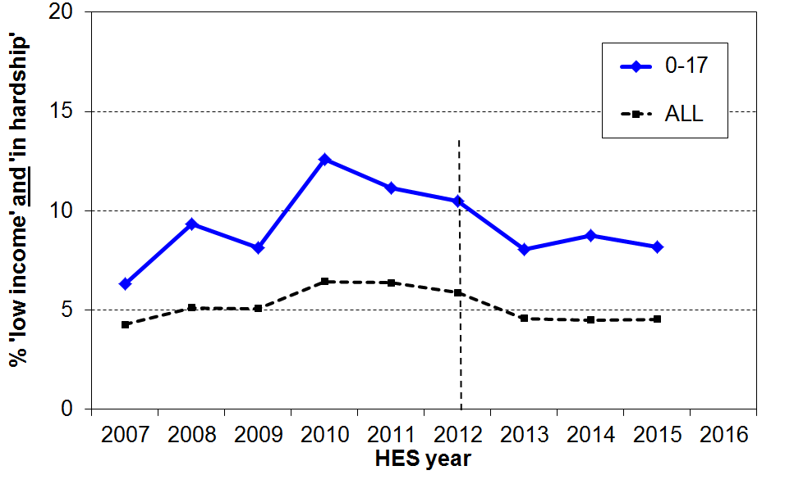
- The third conceptualisation (the overlap group) is used for the graph. Around 8% of children (85,000) live in households whose incomes are below the 60% of median AHC line and who are in hardship using the standard or less severe threshold (ie MWI ≤ 9, DEP-17 ≡ 7+/17).

- For those in hardship but with incomes reasonably above a low-income line there are grounds for expecting living standards to improve over time provided their incomes do not decline and that there are no on-going special demands on the budget (eg from high health costs, high debt servicing, and so on). However for those in hardship who also continue to have fairly low incomes, there is very little chance of improvement of living standards until incomes rise and stay up.

- See also the housing quality section on pages 20-21 above.

Not all poor children experience material hardship, and not all children experiencing material hardship come from “poor” families

- The overlap between those identified as income poor and those identified as experiencing material hardship is nowhere near 100% - more like 40% overall for children when the low-income and high hardship groups are of similar size, though much higher for sole-parent families.
- Measurement error will contribute to some of this non-overlap, but there are strong conceptual grounds for not expecting 100%, as indicated in the Framework on p4. There are factors other than income that impact on the levels of day-to-day living standards
p + h
poor but not in hardship
in hardship, but not poor
- This limited overlap means that not all poor children experience material hardship, and not all children experiencing material hardship come from “poor” families.
- Using the 50% AHC anchored line measure and the more severe material hardship measure (DEP-17 score of 9+/17 ≡ MWI ≤ 5):
  - there are 160,000 children in the low income group, 85,000 in the more severe hardship group and 37,000 in the overlap group
  - in other words, only 23% of those in the low income group are in severe hardship, and 43% of those in hardship have incomes below the 50% threshold used
  - when the less severe hardship threshold is used, 39% of this low income group are in hardship

Common misunderstanding

- There is a common misunderstanding in relation to the way some of the poverty and hardship figures from the report are used that it warrants specific attention.
- When discussing child poverty and hardship in New Zealand, the following narrative is sometimes promoted:
  - there are 160,000 children in income poverty in New Zealand (or 300,000 on the AHC 60% relative measure)
  - these poor children do not have basic items such as two pair of shoes in good condition for daily activities, a raincoat, their own bed, a warm dry home, and so on, and are severely restricted by money from participation in sports and other activities.
- The second step above (b) works off the assumption that all “poor” children lack all or most of the items used in the hardship indices or in the calibration exercise to select usable thresholds (see the NIMs report). This is not the case, as indicated already in the figures in the top half of the page.
- An example using a specific item illustrates the fallacy:
  - around 10% of all children (110,000) live in homes that report a major problem with dampness and mould
  - for children in households in the bottom AHC income quintile (around 27% of all children), “only” 17% live in such homes (around 50,000)
  - though this is 17% more than what most would consider acceptable, it is well off 100%
  - when households are ranked by their MWI or DEP-17 scores, the households with these sort of issues get better identified and cluster more at the bottom, and 28% of children in this low MWI quintile are identified as living in a home that reports a major problem with dampness and mould (80,000) – still well off 100%, though 28% more than most would consider acceptable.

Poverty and hardship composition for children (which children are poor or in hardship?)

(This section uses the 60% of median AHC anchored line measure (60% AHC CV-07). There is very little difference when the 50% measure is used.)

- half of poor children are Maori/Pacific (34% of all children are Maori/Pacific).

- half of poor children are from sole parent families and half from two parent (24% of all children are from sole parent families).

- half of poor children are from households where the highest educational qualification for parent(s) is school or less (31% of all children are in these families).

- seven out of ten poor children live in rental accommodation (20% HNZC, 50% in private rental).

- a sizeable proportion of children identified as poor or in hardship come from working families (around 40%):
- AHC income poverty rates for children in working families are on average much lower than for those in beneficiary families (12% and 75% respectively), but 40% of poor children come from families where at least one adult is in full-time work or is self-employed as there are many more such working families
- this difference between rates (the proportion of children below a selected line) and composition (the proportion of children below the line who come from different groups) for these two groups arises because there are many times more working families than there are beneficiary families
- using material hardship measures gives a similar picture: around 50% of the children in hardship using the standard EU threshold are from working families, and around 33% using the more severe threshold
- the numbers of children in households reporting having to put up with feeling cold “a lot” because of money being needed for other basics are split fairly evenly between low-income beneficiary and low-income working families (see p21)
- whichever figure is used (33%, 40% or 50%), the issue of the working poor is evident – this is an OECD-wide issue and all countries now use an In-work Tax Credit or similar top-up to help address poverty and material hardship in low-income working families.

- see Appendix Four (p43) for more detail on composition.

Older New Zealanders (aged 65+)

- Older New Zealanders (aged 65+) currently make up 14% of the population (650,000). By 2028 this proportion is expected to be close to 20% (1.04m).

Incomes

- The great majority of those aged 65+ are very dependent on NZS for their survival. For example:
  - 40% of singles have virtually no other income source, 60% report less than $100 pw from non-government sources, and 75% have more than half their income from NZS (ie only 25% have other income that is greater than the gross single living alone NZS rate of $431 pw (2015).
  - The per capita income of couples is on average much higher than for singles – for example only 30% of couples report less than $100 per capita pw from non-government sources – but most couples are nevertheless still highly dependent on NZS, with 55% having more than half their income from NZS.

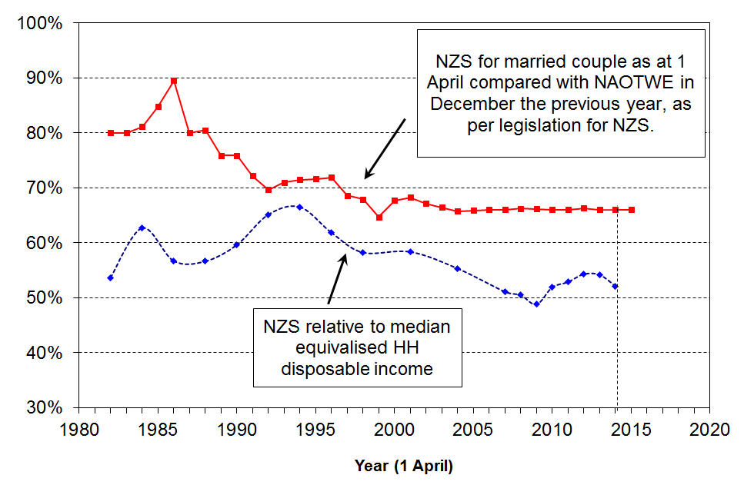
- In 2015, the NZS married couple rate was close to the 66% floor relative to average earnings, as shown in the upper line in the graph.
  - NZS has declined in value relative to median household incomes since the mid 1990s. This is because median household income has risen steadily in real terms, while the real value of NZS did not change greatly in real terms from the mid 1990s through to 2007.
  - Rapidly rising household median income saw NZS briefly fall below 50% of the median before the income tax changes in 2008 and 2010 and rising after-tax wages pushed the ratio back up to 54% in 2013 (52% in 2015).

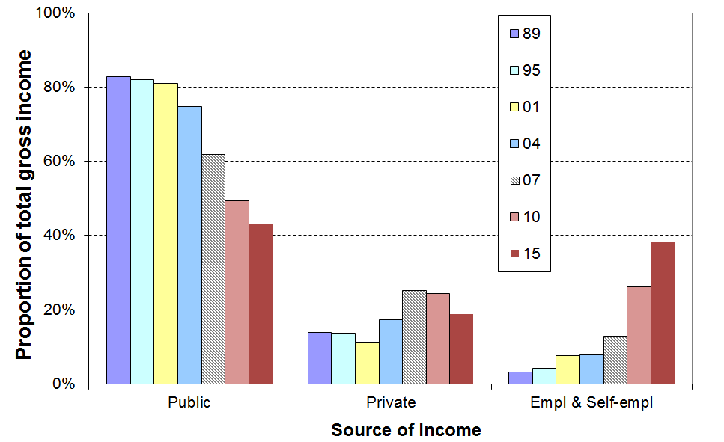
- An emerging feature of the incomes of the 65+ cohort is the strong rise in incomes from employment and self-employment for the “younger” group (aged 65-70), especially couples, starting from the early 2000s:
  - The graph illustrates this change with the trend for couples in the middle couples’ quintile. Employment income in 2015 made up almost the same proportion of their total income as did government sources (~40%).
  - For decile 7-9 couples, half their income is now from employment and a quarter from each of NZS and private investment income.
  - There is some increase in employment income for singles but not for as many, and with lower pa rates.
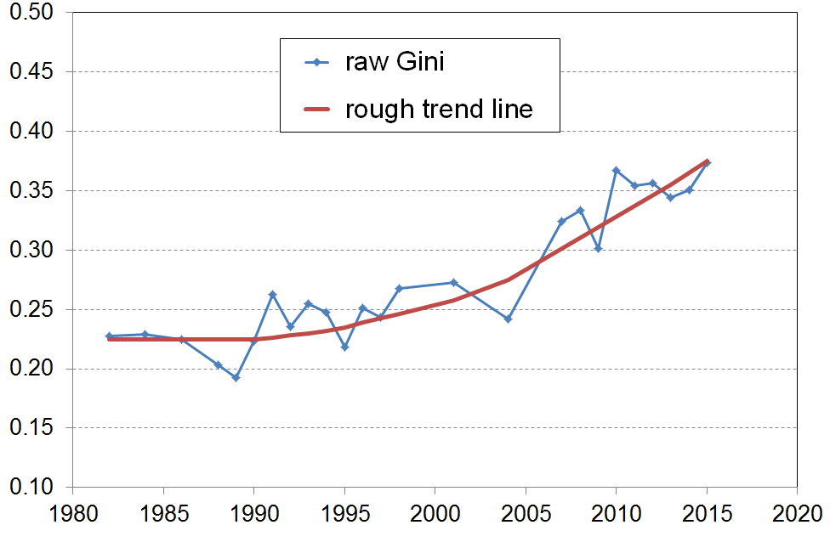
- This increased employment income for some means increased inequality among older New Zealanders, as shown by the Gini trend-line.

Income poverty and material hardship among older New Zealanders

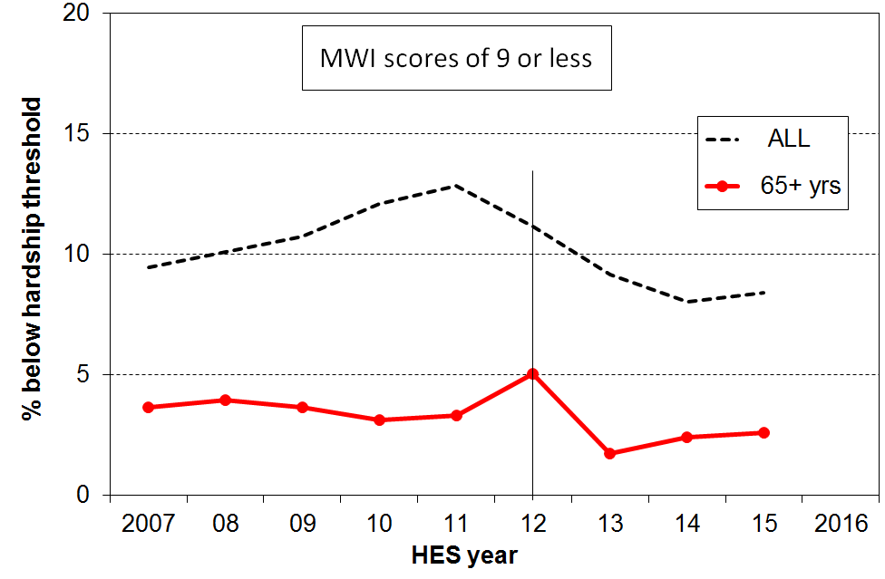
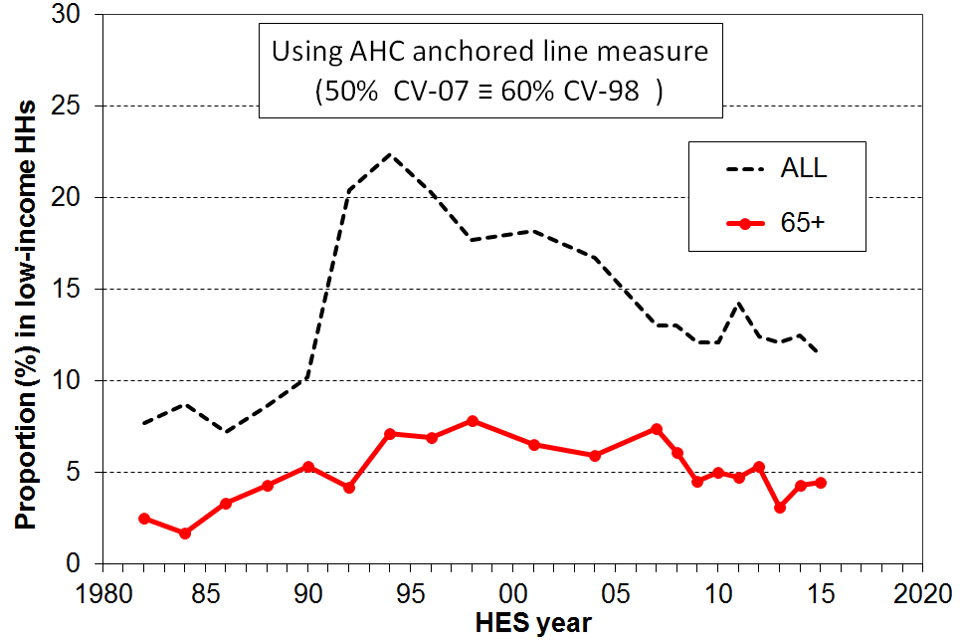
- Income poverty rates for older New Zealanders remain lower than those for other age groups when using AHC income measures. Hardship rates using non-income measures show the same pattern. The graphs and table show the details.
Income poverty and hardship rates for age groups (%): HES 2015
Age group ==> | 0-17 | 18-24 | 25-44 | 45-64 | 65+ | ALL
Income poverty (low income)
- AHC 60% anchored (CV-07) | 21 | 20 | 15 | 14 | 8 | 16
- AHC 50% anchored (CV-07) | 15 | 17 | 10 | 11 | 4 | 11
Material hardship
- MWI ≤11 (higher than usual threshold, but gives a population rate the same as for AHC 50 above) | 18 | 11 | 11 | 8 | 4 | 11
- MWI ≤ 9 (standard) ≡ DEP-17 7+/17 | 14 | 8 | 9 | 6 | 3 | 8
- MWI ≤ 5 (more severe) ≡ DEP-17 9+/17 | 8 | 3 | 5 | 3 | 1 | 4

- The lower AHC income poverty and low material hardship rates for older New Zealanders reflect the mix of universal public provision (mainly NZS) and the private provision built up by most of the current cohort over their lifetime. A key component of this private provision is mortgage-free home ownership which is relatively high among the current cohort.

- Older New Zealanders score well overall on individual hardship items, though there is a small group that is struggling. For example, 4% report having to put up with feeling cold “a lot” because of costs, compared with 10% for households with children and 7% overall.

- On self-assessed satisfaction with life, 87% say they are satisfied or very satisfied, compared with 82% overall, while for those in the bottom decile of material wellbeing, 32% say they are dissatisfied or very dissatisfied, compared with 22% overall for this decile.

- Most of those older New Zealanders with the low AHC incomes and high material hardship rates are, unsurprisingly, those who rent and who have NZS and little or no more to live off.

- Declining mortgage-free home ownership for the cohorts coming through to “retirement” suggest that the low poverty and hardship rates may soon start to rise, unless this impact is mitigated by asset accumulation over the life course by means other than home ownership (eg KiwiSaver).

- The increasing proportion of older New Zealanders in paid employment also has the potential to mitigate the impact of declining mortgage-free home ownership provided these are the same people who need the extra income to pay the mortgage or the rent. The chances are though that in the main they will in the main be non-manual white-collar workers who are more likely to be better off anyway.

- The AHC income poverty rate for older working-age adults living on their own (45-64 years) trebled from 1984 to 2007 and has remained high since (36% on average for 2014 and 2015 compared with 16% for the population overall, and second highest after sole-parents (55%), using the same AHC anchored line measure). This also points to an increasing number of vulnerable older New Zealanders in the future as these figures indicate that many in this age-group have little freeboard to save.
Income mobility and poverty persistence

- The HES gives a repeat cross-sectional picture – different people are interviewed each survey. To understand how much income mobility there is, and how long-lasting or brief the poverty spells are, the same people need to be followed each survey. The longitudinal data from Statistics New Zealand’s SoFIE survey provides this information (2002 to 2009).

- The analysis showed that there is a good deal of movement but that much of it is short-range:
  - 53% are in the same decile or the one next to it after 7 years, the same as in the UK
  - over seven years there is a mix of mobility and immobility – for example, out of those who start in one of the lower three household income deciles in the first year:
    - half are still there after seven years
    - a quarter have moved up to around the middle
    - and another quarter have moved to have incomes above the middle.

- It is important to look at cross-sectional low-income or poverty rates with “longitudinal eyes”, especially now that the SoFIE has finished. One way to do this is through the use of the idea of chronic poverty – this is about having an average household income over several years that is below the average poverty threshold over those years. A useful rule-of-thumb that came out of the SoFIE research was that for every 100 children in poverty in a HES survey (cross-sectional) we know that:
  - around 60 are in chronic poverty
  - and there are another 20 not in current poverty but who are in chronic poverty (ie their household’s current income is “above the line” but on average over several years their average income is below the line).

- Another way of looking at poverty persistence is to count the number of years or surveys (waves) in which people are in low-income households in a given period. This is straightforward, but is potentially misleading as it cannot take into account movements from below to not far above whatever poverty line is selected, and vice versa. Many have this experience. The SoFIE research showed that only 5% of children were in poverty for all or all but one of the seven SoFIE waves, a finding in line with overseas studies. This paints a quite different and much more optimistic picture of the multi-year poverty experience for children than does the chronic poverty approach. The chronic poverty approach is much more robust for this purpose as it takes into account the movements above and below the selected poverty line, and does not just give a blunt “in” or “out” count.

The longer that households are in low income the greater is their risk of (higher) material deprivation.

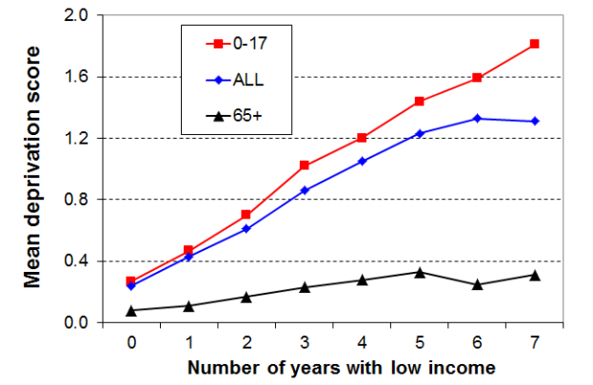
- The analysis for the graph draws on longitudinal data from SoFIE. The high-level finding that the longer that households are in low income the higher is their average deprivation score is not surprising. It is nevertheless one that is not always to the fore in discussions around poverty and hardship figures.
- The relatively flat line for older households reflects the fact that such households often have resources other than current income with which to support consumption for basic needs. This is in line with the income-wealth-consumption-material-wellbeing framework outlined in the introduction.

- The low-income threshold used in the analysis above produced poverty rates above the usual cross-sectional ones – that is, it was a relatively generous threshold. When a lower threshold is used, more in line with the 60% BHC cross-sectional threshold, the cumulative impact of ongoing lower low income leads to higher reported deprivation, as expected.
International comparisons

Household income trends
- In the seven years from just before the GFC impact (HES 2009), to HES 2015, household income growth was relatively even across the income spectrum at 8-10% in real terms, from the top of the bottom decile (P10) through to high incomes in the top decile.
- New Zealand’s net gains in this period are better overall than for many OECD countries – the negative impact was more muted and the recovery has been stronger. For example:
  - the UK median fell through the GFC and has only just returned to its pre-GFC level
  - Italy, Spain, France and Germany were flat through the GFC and have remained so since
  - the US median and other middle incomes have been flat for many years.

Income inequality
- The share of income received by the top 1% of tax payers has been reasonably steady in a 7-9% range since the early 1990s, up from 5% in the 1980s:
  - New Zealand ranks in the lower middle of the OECD for this statistic, similar to Australia, Spain and France
  - the US (19%), Germany (14%), the UK (13%), and Canada (12%) all currently have much higher rates for the top 1% share and have experienced much greater rises than New Zealand since the 1980s.
- Using measures like the 90:10 ratio and the Gini trend line, New Zealand’s income inequality is a little higher than the OECD average, around the same as Australia.

Wealth inequality

- Wealth inequality is usually around double the level of income inequality. The most wealthy 10% of New Zealand households hold around 50% of all household wealth, whereas the top 10% of households receive a 25% share of all income.
- NZ’s wealth inequality is about average for the OECD, similar to Canada, Norway and France.

Poverty and material hardship

- The OECD and EU publish international league tables that rank countries on their income poverty rates using 50% and 60% of median poverty lines respectively (BHC).
- On the latest available figures (c 2012 for OECD and 2015 for the EU), New Zealand is in the middle of the rankings for both population poverty rates and child poverty rates.
 | OECD 50% |  | EU 60%
 | All | 0-17 | All | 0-17
NZ | 10 | 13 | 18 | 20
OECD / EU | 10 | 13 | 17 | 21
- These figures are really about income inequality in the lower half of the income distribution. They do not tell us anything about how actual living conditions differ from country to country as median incomes differ so much, depending largely on differences in GDP per capita. To properly compare countries for actual living conditions, non-income measures are needed.
- Using an EU deprivation index (EU-13) with data from 2008 (NZ) and 2009 (EU), NZ ranks very well for older people (65+) but not so well for children – a finding consistent with the relativities produced within New Zealand using MWI and DEP-17 measures. We cannot exactly replicate the EU index for NZ again in 2015, but based on the hardship trends reported above using our own indices NZ figures on the EU index are likely to be much the same in 2015 as in 2008, perhaps a little lower. The EU medians have also returned to much the same as before the GFC. For 2008 and 2009:
  - the population hardship rate was 11%, a little better than the EU median (13%)
  - the hardship rate for children was 18%, just above the EU median (17%), but ranking NZ below most of the richer western European nations with whom we have traditionally compared ourselves
  - the hardship rate for those aged (65+) was 3%, ranking New Zealand near the top among EU nations – in the top five along with Norway, Sweden and Denmark.
Appendix One

Where does your household fit on the income distribution?

The Incomes Report often ranks individuals by their household’s equivalised BHC disposable income (ie by their household income, after adjusting for household size and composition). The tables below give the annual (unequivalised) disposable income levels (BHC) of different household types in each (equivalised) income decile. From these tables, most people will be able to locate where they and their households fit on the income distribution.

To use these tables, select the column heading that best describes your household or family situation. Go down the column until you find your household’s disposable income range (ie annual after-tax income, including all social assistance from the state). The row gives the equivalised income decile for your household income. For example, a household comprising a sole parent with two children with a disposable income of $51,000 pa is in decile 4.

Table 1A

Where does your household fit in the overall household income distribution (BHC)?
HES 2015
Equivalised income decile | Ordinary dollars (ie not equivalised)
Equivalised income decile | One person,  no children  (reference HH) | Sole parent, one child | Sole parent, two children | Sole parent, three children | Sole parent, four children
Bottom decile | < $18,600 | < $26,000 | < $32,600 | < $38,300 | < $43,400
Decile 2 | 18,600 - 22,600 | 26,000 - 31,600 | 32,600 - 39,600 | 38,300 - 46,600 | 43,400 - 52,700
Decile 3 | 22,600 - 27,100 | 31,600 - 38,000 | 39,600 - 47,500 | 46,600 - 55,900 | 52,700 - 63,200
Decile 4 | 27,100 - 32,000 | 38,000 - 44,800 | 47,500 - 56,000 | 55,900 - 65,900 | 63,200 - 74,500
Decile 5 | 32,000 - 36,600 | 44,800 - 51,300 | 56,000 - 64,100 | 65,900 - 75,400 | 74,500 - 85,300
Decile 6 | 36,600 - 42,500 | 51,300 - 59,500 | 64,100 - 74,400 | 75,400 - 87,600 | 85,300 – 99,000
Decile 7 | 42,500 - 49,300 | 59,500 - 69,000 | 74,400 - 86,300 | 87,600 - 101,600 | 99,000 - 114,900
Decile 8 | 49,300 - 58,900 | 69,000 - 82,400 | 86,300 - 103,000 | 101,600 - 121,300 | 114,900 - 137,200
Decile 9 | 58,900 - 74,700 | 82,400 - 104,600 | 103,000 - 130,700 | 121,300 - 153,900 | 137,200 - 174,100
Top decile | > $74,700 | > $104,600 | > $130,700 | > $153,900 | > $174,100

Note: use disposable household income when using this table – that is, household income from all sources after paying personal income tax and after receiving all tax credits (from Working for Families) and other state transfers (eg NZS, AS, main benefits)
Table 1B

Where does your household fit in the overall household income distribution (BHC)?
HES 2015
Equivalised income decile | Ordinary dollars (ie not equivalised)
Equivalised income decile | Couple or 2 adults sharing | Couple,  one child | Couple,  two children | Couple,  three children | Couple, four children | Three adults, one child
Bottom decile | < $28,700 | < $34,600 | < $40,400 | <$ 45,200 | < $50,100 | < $42,100
Decile 2 | 28,700 - 34,800 | 34,600 - 42,000 | 40,400 - 49,100 | 45,200 - 54,900 | 50,100 - 60,800 | 42,100 - 51,100
Decile 3 | 34,800 - 41,800 | 42,000 - 50,500 | 49,100 - 58,900 | 54,900 - 66,000 | 60,800 - 73,000 | 51,100 - 61,300
Decile 4 | 41,800 - 49,300 | 50,500 - 59,500 | 58,900 - 69,400 | 66,000 - 77,700 | 73,000 - 86,100 | 61,300 - 72,300
Decile 5 | 49300 - 56,400 | 59,500 - 68,100 | 69,400 - 79,500 | 77,700 - 89,000 | 86,100 - 98,500 | 72,300 - 82,800
Decile 6 | 56,400 - 65,500 | 68,100 - 79,100 | 79,500 - 92,200 | 89,000 - 103,300 | 98,500 - 114,300 | 82,800 - 96,100
Decile 7 | 65,500 - 75,900 | 79,100 - 91,700 | 92,200 - 107,000 | 103,300 - 119,800 | 114,300 - 132,600 | 96,100 - 111,400
Decile 8 | 75,900 - 90,700 | 91,700 - 109,500 | 107,000 - 128,000 | 119,800 - 143,100 | 132,600 - 158,400 | 111,400 - 133,100
Decile 9 | 90,700 - 115,000 | 102,500 - 139,000 | 128,000 - 162,000 | 143,100 - 181,500 | 158,400 - 201,000 | 133,100 - 168,800
Top decile | > $115,000 | > $139,000 | > $162,000 | > $181,500 | > $201,000 | > $168,800

Note: use disposable household income when using this table – that is, household income from all sources after paying personal income tax and after receiving all tax credits (from Working for Families) and other state transfers (eg NZS, AS, main benefits)
Appendix Two

Lists of items in the MWI and DEP-17, and how to calculate your household’s MWI score and find your ranking

The table on the next page identifies the items in the MWI and in DEP-17. A tick () in the column means that this item is in the index.

It also indicates the scoring for each item used in each index.

The raw MWI scores range from 0 to 43, with higher scores meaning higher material living standards. For convenience, the actual MWI scores are converted to a 0 to 35 range, with any raw scores of 8 or less being classed as “0”. This does not lead to any loss of usable information as there are typically only 1-2% in this latter category. For the rest, 8 is deducted from the raw score to give the actual MWI score.

The graph below shows where a given score ranks a household on the MWI distribution. For example, a score of 25 ranks the household at the 42nd percentile (that is, the household is above 42% of other households).

The MWI can discriminate between households better in the lower half than in the upper half of the distribution. The reports clump the top 25% or so together (scores of 33-35) as a “high living standards” group and do not attempt to break it down further.

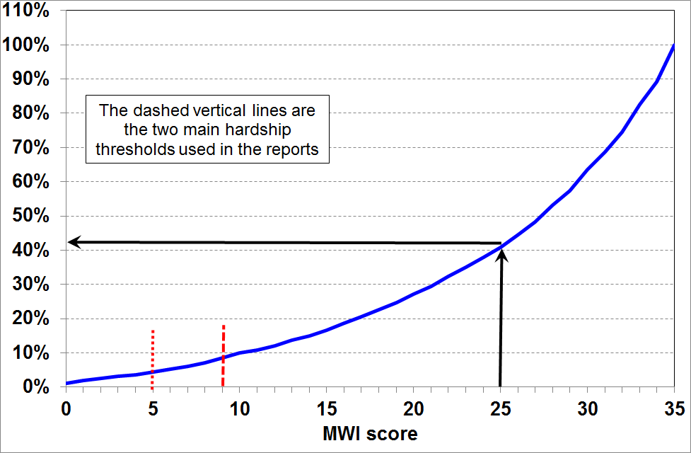

Method 1: go through the 24 MWI items on the previous page and calculate your / your household’s raw score, deduct 8, then use the chart above for a ranking.

Method 2: if you think you are probably in a household with fairly high living standards, it is quicker to go through the 24 items above and note which ones you score less than the full amount on, then deduct these amounts from 35.

The 29 non-income items in the HES (from 2012-13 on), the composition of the MWI and DEP-17,
and how each item is scored for the two indices
Item description |  | MWI | DEP-17 | Your MWI scores
Ownership or participation (have/do, don’t have/do and enforced lack (EL))
For DEP-17, score an EL as 1, otherwise 0
For MWI, score an EL as a 0, otherwise 1
1 | Two pairs of shoes in a good condition and suitable for daily activities | ✓ | ✓
2 | Suitable clothes for important or special occasions | ✓ | ✓
3 | Contents insurance | ✓ | ✓
4 | A meal with meat, fish or chicken (or vegetarian equivalent) at least each 2nd day | ✓ | ✓
5 | A good bed | ✓ | -
6 | Presents for family/friends on special occasions | ✓ | ✓
7 | Holiday away from home at least once every year | ✓ | -
8 | Overseas holiday at least once every three years | ✓ | -
Economising (not at all, a little, a lot) – to keep down costs to help in paying for (other) basic items
For DEP-17, score ‘a lot’ as 1, otherwise 0
For MWI, score ‘not at all as 2, ‘a little’ as 1, and ‘a lot’ as 0
9 | Gone without or cut back on fresh fruit and vegetables | ✓ | ✓
10 | Buy cheaper cuts of meat or bought less meat than you would like | ✓ | ✓
11 | Continued wearing worn out clothes | ✓ | -
12 | Put up with feeling cold | ✓ | ✓
13 | Do without or cut back on trips to the shops or other local places | ✓ | ✓
14 | Delay replacing or repairing broken or damaged appliances | ✓ | ✓
15 | Spent less on hobbies or other special interests than you would like | ✓ | -
16 | Postponed visits to the doctor | ✓ | ✓
17 | Postponed visits to the dentist | ✓ | ✓
Housing problems (no problem, minor problem, major problem)
For MWI, score as 2, 1 and 0 respectively.
18 | Dampness or mould | ✓ | -
19 | Heating or keeping it warm in winter | ✓ | -
Freedoms/Restrictions
20 | When buying, or thinking about buying, clothes or shoes for yourself, how much do you usually feel limited by the money available? (4 point response options: ‘not at all limited, a little limited, quite limited, very limited)  For DEP-17, score ‘very limited’ as 1, otherwise 0.  For MWI, score as 3, 2, 1 and 0 respectively. | ✓ | ✓
21 | $300 spot purchase for an ’extra’, not a necessity – how limited do you feel about buying it? (5 point response options: not at all limited, a little limited, quite limited, very limited, couldn’t buy it)  For MWI, score as 4, 3, 2, 1 and 0 respectively. | ✓ | -
22 | $500 unexpected unavoidable expense on an essential – can you pay in a month without borrowing? (yes/no)  For DEP-17, score no’ as 1, and ‘yes’ as 0  For MWI, score ‘yes’ as 2 and ‘no’ as 0 | ✓ | ✓
Financial strain (in last 12 months) (not at all, once, more than once)
For DEP-17, score ‘more than once’ as 1, otherwise 0
For MWI, score ‘not at all’ as 2, ‘once’ as 1, ‘more than once’ as 0
23 | Behind on rates or utilities | ✓ | ✓
24 | Behind on car registration, wof or insurance | ✓ | ✓
25 | Behind on rent or mortgage | - | - | n/a
26 | Borrowed from family or friends to meet everyday living costs | - | ✓ | n/a
27 | Received help in the form of food, clothes or money from a welfare or community organisation such as a church or food bank | - | - | n/a
Global self-ratings
28 | Adequacy of income to cover basics of accommodation, food, clothing, etc | - | - | n/a
29 | Satisfaction with life | - | - | n/a
Note: An EL is an enforced lack – an item that is wanted but not possessed because of the cost

Appendix Three

Non-MWI Items with a positive association with MWI scores (LSS 2008),
plus the distribution across MWI deciles for three “freedom” items used in the index (%)
MWI decile ➔ | 1 | 2 | 3 | 4 | 5 | 6 | 7 | 8 | 9 | 10 | ALL
Items not in the MWI
have private health insurance | 14 | 18 | 27 | 40 | 44 | 48 | 51 | 52 | 52 | 62 | 41
quality of car / motor vehicle for <65 [‘top of the range’ or ‘good quality’ on a 4 point scale with other options being ‘mid-range’ or ‘budget or lower’] | 19 | 29 | 31 | 36 | 40 | 46 | 53 | 49 | 63 | 69 | 42
quality of kitchen appliances, layout, storage etc [‘top of the range’ or ‘good quality’ on a 4 point scale with other options being ‘mid-range’ or ‘budget or lower’] | 11 | 23 | 31 | 31 | 34 | 46 | 46 | 53 | 61 | 70 | 41
overall physical condition of accommodation [‘very good’ on a 5 point scale through to ‘very poor’] | 9 | 17 | 23 | 24 | 30 | 38 | 41 | 44 | 51 | 64 | 34
could pay unexpected expense of $2000 within a month without borrowing | 14 | 35 | 44 | 63 | 72 | 83 | 87 | 88 | 97 | 98 | 68
enough or more than enough money to meet essentials of food, accommodation, and so on | 4 | 10 | 18 | 36 | 42 | 53 | 64 | 75 | 82 | 91 | 48
money for self each week [more than $50] | 7 | 8 | 14 | 23 | 32 | 42 | 48 | 62 | 66 | 80 | 38
very satisfied with life [average of HES 12/13 & 13/14] | 3 | 9 | 16 | 20 | 23 | 28 | 33 | 40 | 46 | 55 | 28
Items in the MWI
put off going to dentist [not at all] | 14 | 20 | 28 | 34 | 48 | 57 | 71 | 82 | 91 | 99 | 54
delayed replacing or repairing appliances that were not working [not at all] | 9 | 30 | 46 | 56 | 65 | 72 | 81 | 93 | 98 | 100 | 65
have a holiday overseas at least once every 3 yrs (<65) | 5 | 17 | 25 | 35 | 44 | 51 | 60 | 67 | 69 | 80 | 43

Non-MWI Items with a negative association with MWI scores (LSS 2008),
plus the distribution across MWI deciles for three “enforced lack” items used in the index (%)
MWI decile ➔ | 1 | 2 | 3 | 4 | 5 | 6 | 7 | 8 | 9 | 10 | ALL
Items not in the MWI
used food bank or other community assistance (more than once in previous 12 months) | 24 | 12 | 4 | 3 | 0 | 0 | 0 | 0 | 0 | 0 | 4
pawned goods to get cash for necessities (more than once in previous 12 months) | 28 | 14 | 7 | 3 | 2 | 2 | 1 | 0 | 0 | 0 | 6
keep main rooms warm [EL] | 35 | 14 | 7 | 4 | 2 | 1 | 1 | 0 | 0 | 0 | 7
house too small [major problem] | 29 | 17 | 11 | 7 | 8 | 3 | 3 | 1 | 2 | 0 | 8
overall physical condition of accommodation [poor or very poor on 5 point scale] | 25 | 9 | 7 | 4 | 3 | 1 | 1 | 0 | 0 | 0 | 5
crime or vandalism in the area [major problem] | 24 | 15 | 11 | 7 | 7 | 6 | 5 | 4 | 4 | 2 | 8
hairdresser once every three months [EL] | 51 | 29 | 18 | 8 | 5 | 2 | 2 | 1 | 0 | 0 | 12
a night out at least once a fortnight [EL] | 56 | 41 | 31 | 21 | 15 | 10 | 5 | 2 | 1 | 0 | 18
self-rated health, poor or fair (<65) | 50 | 30 | 19 | 11 | 13 | 10 | 10 | 6 | 7 | 10 | 17
borrowed from family or friends to meet everyday living costs [more than once in last 12 months] | 54 | 29 | 21 | 10 | 9 | 4 | 2 | 2 | 0 | 0 | 13
Items in the MWI
clothes for special or important occasions [EL] | 41 | 13 | 5 | 2 | 2 | 1 | 1 | 0 | 0 | 0 | 7
put up with feeling cold [a lot] | 56 | 22 | 13 | 5 | 4 | 1 | 1 | 0 | 0 | 0 | 10

EL = ‘enforced lack’
Appendix Four

Key figures for child poverty and hardship: rates and composition

The tables below are from Section G in the Non-Incomes Report and Section F in the Incomes Report.

Note that the reports:
- use a multi-measure multi-level approach to better capture the trends in different aspects of material disadvantage
- use the material hardship measures and the anchored line AHC income measures as the primary indicators for monitoring trends
- use the fully relative “moving line” measures as indicators of changing inequality in the lower half of the income distributions over the longer term
- warn against drawing definitive conclusions based on year-on-year changes – trends over several years and longer are what give robust information.

For more detailed information on interpreting the figures and on the rationale for the approaches used in the reports, the reader is referred to the table on p23 in this Overview, the Annex to Section H in the Incomes Report and to the Guidelines document on the MSD website:
http://www.msd.govt.nz/about-msd-and-our-work/publications-resources/monitoring/household-incomes/index.html

How many children are there in households experiencing material hardship?
(ie How many children live in households with deprivation scores below selected thresholds?)

Material hardship rates (%) and numbers for children
HES year | MSD less severe threshold ≡ EU ‘standard’ threshold |  | MSD more severe threshold ≡ EU ‘severe’ threshold
 | rate (%) | numbers | rate (%) | numbers
2007 | 14 | 145,000 | 6 | 65,000
2009 | 16 | 170,000 | 9 | 95,000
2010 | 20 | 210,000 | 9 | 90,000
2011 | 21 | 220,000 | 10 | 105,000
2012 | 17 | 180,000 | 9 | 90,000
2013 | 15 | 165,000 | 9 | 100,000
2014 | 14 | 145,000 | 8 | 80,000
2015 | 14 | 155,000 | 8 | 85,000

- The less severe threshold uses an MWI score of 9 or less (≡ DEP-17 score of 7+/17). The more severe threshold uses an MWI score of 5 or less, (≡ 9+/17 for DEP-17).

- Note that for the MWI a lower score means lower living standards (higher deprivation), whereas for DEP-17 a higher score means higher deprivation.
How many poor children are there in New Zealand?
(ie How many children live in households with incomes below selected thresholds?)

Low income (poverty) rates for children in New Zealand
(ie the number of children in households with incomes below the selected thresholds)
 | BHC |  |  | AHC
 | BHC ‘anchored line (2007)’ | BHC ‘moving line’ |  | AHC ‘moving line’ |  |  | AHC ‘anchored line (2007)’
HES year | 50% (07 ref) | 50% | 60% | 40% | 50% | 60% | 50% (07 ref) | 60% (07 ref)
2001 | 22 | 12 | 24 | 11 | 21 | 30 | 28 | 37
2004 | 17 | 14 | 26 | 11 | 19 | 28 | 23 | 31
2007 | 13 | 13 | 20 | 11 | 16 | 22 | 16 | 22
2009 | 9 | 12 | 21 | 13 | 20 | 26 | 18 | 24
2010 | 11 | 14 | 23 | 11 | 20 | 30 | 17 | 26
2011 | 12 | 13 | 22 | 12 | 20 | 27 | 19 | 25
2012 | 10 | 12 | 21 | 13 | 20 | 27 | 19 | 24
2013 | 9 | 11 | 20 | 13 | 19 | 24 | 17 | 22
2014 | - | 14 | 24 | - | 21 | 29 | 17 | 23
2015 | 8 | 13 | 21 | 12 | 20 | 28 | 15 | 21

Numbers of poor children in New Zealand
(ie the number of children in households with incomes below the selected thresholds)
 | BHC |  |  | AHC
 | BHC ‘anchored line (2007)’ | BHC ‘moving line’ |  | AHC ‘moving line’ |  |  | AHC ‘anchored line (2007)’
HES year | 50% (07 ref) | 50% | 60% | 40% | 50% | 60% | 50% (07 ref) | 60% (07 ref)
2001 | 225,000 | 120,000 | 250,000 | 115,000 | 215,000 | 310,000 | 285,000 | 380,000
2004 | 175,000 | 150,000 | 265,000 | 115,000 | 200,000 | 285,000 | 240,000 | 320,000
2007 | 135,000 | 135,000 | 210,000 | 115,000 | 175,000 | 240,000 | 175,000 | 240,000
2009 | 100,000 | 125,000 | 230,000 | 140,000 | 210,000 | 280,000 | 195,000 | 255,000
2010 | 110,000 | 150,000 | 250,000 | 120,000 | 210,000 | 315,000 | 175,000 | 275,000
2011 | 125,000 | 145,000 | 235,000 | 130,000 | 210,000 | 290,000 | 205,000 | 270,000
2012 | 110,000 | 130,000 | 225,000 | 135,000 | 215,000 | 285,000 | 195,000 | 255,000
2013 | 95,000 | 120,000 | 215,000 | 135,000 | 205,000 | 260,000 | 175,000 | 235,000
2014 | - | 150,000 | 250,000 | - | 220,000 | 305,000 | 185,000 | 245,000
2015 | 85,000 | 140,000 | 220,000 | 125,000 | 210,000 | 295,000 | 160,000 | 230,000
* 40% of median AHC income poverty figures and 50% of median BHC figures are not reported for HES 2014 because of data issues for some beneficiary incomes – see main report.

AHC = after deducting housing costs
BHC = before deducting housing costs

Children from income-poor households: composition by their ethnicity and by selected household characteristics

The shaded column shows the proportion of poor children in the various sub-groups. Some sub-groups have high poverty rates but if there is a relatively small proportion of children in that sub-group overall, then the proportion of poor children coming from that sub-group is much lower than their poverty rate would suggest (and vice versa). For example:
- the poverty rate for children in sole-parent families living on their own is high at 69%, but only 45% of all poor children come from such families
- on the other hand, the poverty rate for children in two-parent families is much lower at 15%, yet 47% of poor children come from these families
- this difference arises from the fact that there are many more children in two-parent families than in sole-parent families living on their own (76% and 16% respectively).

Poverty rates and composition for children by their ethnicity and by characteristics of their households, based on the 60% of median anchored line AHC measure (CV-07):
average over three surveys, HES 2011 to HES 2013
Dependent children (0-17 yrs):  1,060,000 | Children in income-poor households |  | All children
Dependent children (0-17 yrs):  1,060,000 | What % of this category are poor? | What % of poor children are in this category? | What % of all children are in this category?
 | Poverty rate (%) | Composition of the poor (%) | Approximate composition for all children (%)
Household type
Sole parent HH | 64 | 47 | 18
Two parent HH | 15 | 44 | 69
Multi-adult family HH | 16 | 8 | 12
Family type
Sole parent families | 53 | 53 | 24
- in SP family on own | 69 | 45 | 16
- within a wider HH | 23 | 8 | 8
Two parent families | 15 | 47 | 76
# of children in the household
1 or 2 | 21 | 55 | 63
3+ | 29 | 45 | 37
Ethnicity
Maori | 34 | 34 | 24
Pacific | 34 | 13 | 10
Other | 27 | 14 | 12
Euro/Pakeha | 17 | 38 | 54
Highest household educational qualification
No formal qualification | 55 | 15 | 7
School qualification only | 35 | 38 | 25
Post-school non-degree | 21 | 33 | 38
Degree or post-graduate | 12 | 14 | 30
Main source of income for HH
Benefit | 75 | 63 | 22
Market | 12 | 37 | 78
Tenure
HNZC | 54 | 19 | 9
Private rental | 38 | 53 | 33
Own home | 12 | 28 | 59
Children overall | 23 | 100 | 100

Appendix Five

Measures used internationally for reporting on “poverty and material hardship”, especially for children – to assist in comparing apples with apples

OECD
Low incomes
- 50% BHC relative (mainly)
- 60% BHC relative (this information is collected from members but is used less than the 50%)
- sometimes they use an anchored line approach, but rarely
- the OECD never uses AHC, mainly because many OECD countries do not collect housing costs in the same survey as they collect the income data so cannot do what we do
Material hardship
- no hardship measures available from the OECD, partly because not enough member countries collect the relevant data
New Zealand children
- using the 50% BHC relative measure, the low-income rate for NZ children is 13% (140,000 children), and the OECD median is 11% (HES 2013, latest available comparison)

EU (and Eurostat)
Low incomes
- 60% BHC relative
- the EU never uses AHC, mainly because many EU countries do not collect housing costs in the same survey as they collect the income data so cannot do what we do
Material hardship
- the relevant data is collected by all EU countries – the EU currently uses a 9-item index, and are about to approve a much improved 13-item index which is similar to our DEP-17
- each index uses two thresholds (eg “standard” hardship 5+/13, “severe hardship” 7+/13)
- we can replicate both indices using NZ data for 2008, and from the next HES will have updates
New Zealand children
- using the 60% BHC relative measure, the low-income rate for NZ children is 22% (240,000 children), and the EU median is 21% (HES 2015, latest available comparison)
- using the EU 13-item index, the 2008 rate for NZ children was18% (190,000) on the standard measure and 8% (85,000) on the severe measure – the EU medians were 16% and 7%

UNICEF (International Research Centre in Florence)
Low incomes
- they use a range of approaches, depending on the purpose of the publication, but they have never used AHC, because there is no source for international comparisons using AHC incomes (see above on the OECD and the EU)
- in Report Card 11 (2013) – 50% of median BHC relative plus a material hardship index
- in Report Card 12 (2014) – 60% of median BHC anchored plus a material hardship index
- in Report Card 13 (2016) – 50% of median BHC relative
Material hardship
- UNICEF (Research Centre) recognises the value of this approach and would like to use it more, but only the EU countries and NZ can provide the analysis for international comparisons

UK – we can do AHC comparisons
- the UK reports on a wide range of measures – BHC and AHC moving and anchored lines for low incomes, and also their own material hardship measures (in addition to the EU measures)
- the New Zealand and UK figures using the AHC relative (or moving line) low income measures are almost identical for children:
  - AHC 60% relative for children (UK = 29%, NZ = 28%(around 300,000))
  - AHC 50% relative for children (UK = 19%, NZ = 20% (around 210,000)).
Appendix Six
Low incomes BHC and AHC
Material hardship
Core benefits
FTC or similar
IWTC or similar
Income tax
Gross accommodation costs
Housing subsidies (AS, IRR)
Household size and composition
- who we live with makes a difference
- difficulty accessing available subsidies and services
- high (net) health and disability costs
- high debt servicing
- high transport costs
- support for others outside the household
- limited life-skills
- poor lifestyle choices
(-)
(+)
- economic growth
- productivity
- suitable range of jobs
- jobs with opportunity for progression
- globalisation
- returns on capital and labour
- relative bargaining powers of employers and employees

- discrimination
- public perceptions of “poverty” and its causes
- cultural norms and values, especially in relation to “individual responsibility” and “social solidarity”

- work tests
- targeted financial incentives
- other expectations and institutional arrangements
- degree of targeting of financial assistance

Some of the causes/drivers of poverty also impact directly on other dimensions of wellbeing
- compulsive and addictive behaviours of parents
- education and skill levels of parent(s) in the household
- physical and mental health of parents
- other personal qualities and lifestyle choices of parents
Material hardship for children: causes/drivers and consequences
- neighbourhood and community social capital – this can impact especially on some of the individual factors
Other outcomes
- other aspects of current wellbeing
- outcomes over the life course / life chances
Labour market
- HH hours worked
- wage rates
- minimum wage

- financial & physical assets (including basic household goods and appliances)
- local amenities and public transport
- support from outside the household from family, friends and NGOs
- government services and subsidies (eg ECE, GP visits, insulation, food-in-schools)
- hardship assistance (eg SNGs)
- personal skills and abilities, including home production, budgeting and ‘stretching the budget’
(Net) child-care costs
A major demand on the budget that can either be a barrier to taking up employment or can lead to in-work material hardship
Interventions to directly address poor outcomes and/or to mitigate poor outcomes that are consequences of poverty
PPL & PTC
The framework can be used for looking at poverty and hardship, independent of the threshold selected, including:
- poverty and hardship ‘now’, a relatively static perspective (but impacted by dynamic factors)
- poverty and hardship dynamics, including the persistence of low income and material hardship
- life chances – linking poverty and hardship in childhood to other outcomes in childhood and as an adult

Statistics New Zealand discusses the issue in the data quality section of its November HES releases. This can be found at: http://www.stats.govt.nz/browse_for_stats/people_and_communities/Households/HouseholdEconomicSurvey_HOTPYeJun15/Data%20Quality.aspx
Source: the World Incomes and Wealth Database (formerly the World Top Incomes Database ) at the Paris School of Economics (Alvaredo and colleagues, 2016). This database is the recognised source for international comparisons for very high income shares.
The share was 11% in the 1920s and 1930s , and around 8% in the 1950s. For most richer countries, the top 1% shares were the lowest in the last 100 years in the 1970s and 1980s.
The share for the top 0.1% in the USA increased even more dramatically than did the top 1% share, from 2% in the 1970s to 8% just before the GFC.
The Income Survey has a sample of around 15,000 households (28,000 adults), much larger than the HES (5600 households in 2014-15, but usually around 3500).
For each graph on this page the deciles are deciles of individuals ranked according to the equivalised disposable income of their respective households. The total income tax paid and government cash transfers received reported for each decile is calculated in ordinary dollars for the households to which the individuals belong.
GDP is a measure of the production of final goods and services in the domestic economy. The income available to the nation for consumption or investment is wider than GDP and includes net income flows with the rest of the world. GNDI measures this wider concept. It is a measure of the volume of goods and services New Zealand residents have command over.
Statistics New Zealand reports that housing costs took up 16% of household income on average in the 2015 HES. The difference in the numbers occurs because (i) Statistics New Zealand uses gross (before tax ) income whereas the Incomes Report uses after-tax income, and (ii) the Statistics New Zealand figure is for all ages, rather than the under 65s as above.
The previously-used 60% CV-98 and the current 50% CV-07 threshold are close to identical in dollar terms (adjusted for inflation). This means that the 60% CV-98 and 50% CV-07 trend lines are indistinguishable from each other.
Hardship rates using an MWI score of 9 or less are the same as when using a DEP-17 score of 7+/17. For an MWI score of 5 or less, the equivalent is 9+/17 for DEP-17. Note that for the MWI a lower score means lower living standards (higher deprivation), whereas for DEP-17 a higher score means higher deprivation.
Hardship rates using an MWI score of 9 or less are the same as when using a DEP-17 score of 7+/17. For an MWI score of 5 or less, the equivalent is 9+/17 for DEP-17. Note that for the MWI a lower score means lower living standards (higher deprivation), whereas for DEP-17 a higher score means higher deprivation.
The calculations in the table assume that any children are aged around 8 to 10 years, but the figures are close enough if the children are younger or older.
Hardship rates using an MWI score of 9 or less are the same as when using a DEP-17 score of 7+/17. For an MWI score of 5 or less, the equivalent is 9+/17 for DEP-17. Note that for the MWI a lower score means lower living standards (higher deprivation), whereas for DEP-17 a higher score means higher deprivation.

