Sample Committee Fee Member Payslip’

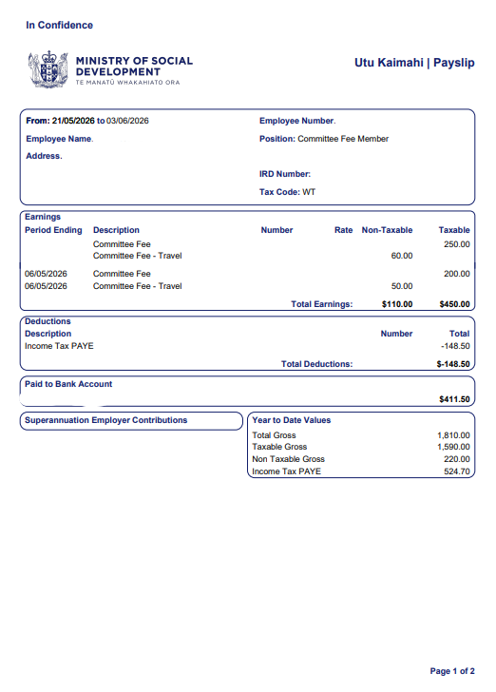
All gross earnings for the current pay, (includes any retro/previous meeting claims)

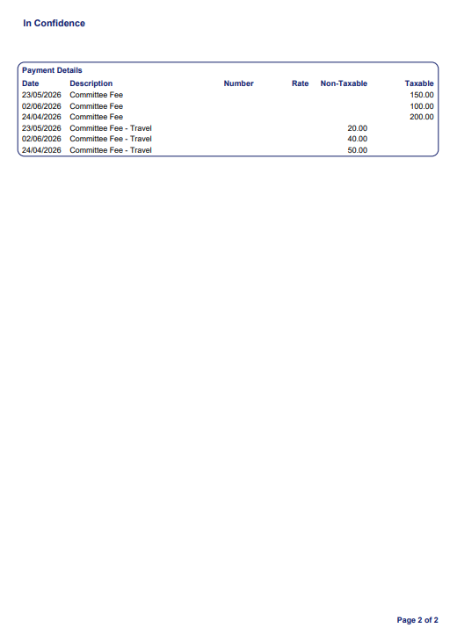
Page 2 provides a breakdown of each meeting date provided in the Invoice

