Coversheet |  | 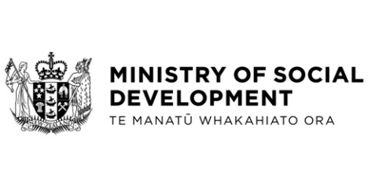

Social Security (Cash Assets and Income Exemptions—Kāinga Ora Energy Subsidy) Amendment Regulations 2023 and Student Allowances (Income Exemptions—Kāinga Ora Energy Subsidy) Amendment Regulations 2023
Hon Carmel Sepuloni, Minister for Social Development and Employment
These documents have been proactively released.

4 May 2023, Cabinet paper - Social Security (Cash Assets and Income Exemptions—Kāinga Ora Energy Subsidy) Amendment Regulations 2023 and Student Allowances (Income Exemptions—Kāinga Ora Energy Subsidy) Amendment Regulations 2023
4 May 2023, Cabinet Legislation Committee Minute LEG-23-MIN-0037, Cabinet Office.

This paper seeks authorisation for submission to the Executive Council of the Social Security (Cash Assets and Income Exemptions—Kāinga Ora Energy Subsidy) Amendment Regulations 2023 and the Student Allowances (Income Exemptions—Kāinga Ora Energy Subsidy) to ensure that subsidies provided as part of Kāinga Ora’s Pilot Winter Energy Study (the pilot) are excluded as income for the purposes of the Social Security Act 2018, the Public and Community Housing Management Act 1992, and the Student Allowance Regulations 1998.

© Crown Copyright, Creative Commons Attribution 4.0 International (CC BY 4.0)
Search Tags: Kāinga Ora, Pilot Winter Energy Study.

