Coversheet |  | 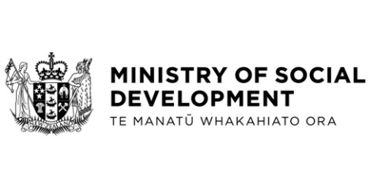

Kāinga Ora Pilot Winter Energy Study: Exemption from income definition under the Social Security Act 2018
Hon Carmel Sepuloni, Minister for Social Development and Employment
These documents have been proactively released.
15 March 2023, Paper -Kāinga Ora Pilot Winter Energy Study: Exemption from Income Definition under the Social Security Act 2018
15 March 2023, Cabinet Social Wellbeing Committee, Minute of Decision SWC-23-MIN-0014, Cabinet Office.

Amendments to the Social Security Regulations 2018 and the Student Allowance Regulations 1998 to ensure that subsidies provided as part of Kāinga Ora’s Pilot Winter Energy Study are excluded as income for the purposes of the Social Security Act 2018, the Public and Community Housing Management Act 1992, and the Student Allowance Regulations.
Some parts of this information release would not be appropriate to release and, if requested, would be withheld under the Official Information Act 1982 (the Act). Where this is the case, the relevant sections of the Act that would apply have been identified. Where information has been withheld, no public interest has been identified that would outweigh the reasons for withholding it. This is the key to the redaction code used for this release:
- Section 9(2)(b)(ii) - to protect the commercial position of the supplier of the information.

Please note – the Cabinet paper had a typographical error in Recommendation 5: the amendments are to give effect to the decision in recommendations 3 and 4 above, not 4 and 5 above. This does not have a substantive change on the assessed impact and cost of the policy.
© Crown Copyright, Creative Commons Attribution 4.0 International (CC BY 4.0)
Search Tags: Kāinga Ora, Pilot Winter Energy Study.

