Coversheet |  | 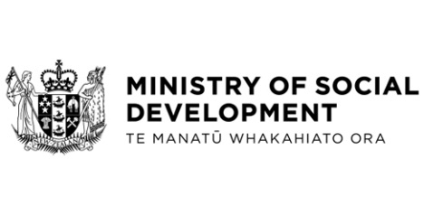

Social Security (Mandatory Reviews) Amendment Regulations 2025
Hon Louise Upston, Minister for Social Development and Employment
These documents have been proactively released.
6 November 2025, Cabinet paper - Social Security (Mandatory Reviews) Amendment Regulations 2025
6 November 2025, Cabinet Legislation Committee Minute LEG-25-MIN-0216, Cabinet Office.

These papers relate to the Social Security (Mandatory Reviews) Amendment Act that was passed in June 2025 which amends the Social Security Act 2018. This Act introduces a requirement that MSD must review a specified benefit at least once every 52 weeks. The Social Security (Mandatory Reviews) Amendment Regulations amend the Social Security Regulations 2018 to specify benefits subject to mandatory reviews and prescribes circumstances for exception from mandatory reviews.
Some parts of this information release would not be appropriate to release and, if requested, would be withheld under the Official Information Act 1982 (the Act). Where this is the case, the relevant sections of the Act that would apply have been identified. Where information has been withheld, no public interest has been identified that would outweigh the reasons for withholding it. This is the key to the redaction code used for this release:
- Section 9(2)(h) - this information is legally privileged.

Please note there is an error on page 3, para 11.6 which refers to “the prescribed circumstances outlined in paragraphs 7 above” – this should refer to paragraph 8.

The following documents that accompanied the Cabinet paper are already public:
- Social Security (Mandatory Reviews) Amendment Bill: Approval for Introduction and LEG-25-MIN-0085. www.msd.govt.nz/about-msd-and-our-work/publications-resources/information-releases/cabinet-papers/2025/social-assistance-legislation.html

© Crown Copyright, Creative Commons Attribution 4.0 International (CC BY 4.0)
Search Tags: Mandatory reviews, automated decision-making, ADM

