Coversheet |  | 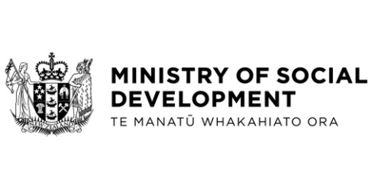
Social Security (Cash Assets and Income Exemptions—Lake Alice Compensation or Ex Gratia Payments) and Residential Care and Disability Support Services (Exempt Assets—Lake Alice Compensation or Ex Gratia Payments) Amendment Regulations 2025
Hon Louise Upston, Minister for Social Development and Employment
These documents have been proactively released:
- 24 July 2025, Cabinet paper - Social Security (Cash Assets and Income Exemptions—Lake Alice Compensation or Ex Gratia Payments) and Residential Care and Disability Support Services (Exempt Assets—Lake Alice Compensation or Ex Gratia Payments) Amendment Regulations 2025

- 24 July 2025, Cabinet Legislation Committee Minute LEG-25-MIN-0140, Cabinet Office.

Amendments to the Social Security Act 2018 and Residential Care and Disability Support Services Act 2018 are required to ensure that Lake Alice redress payments are permanently excluded from being considered as income or cash assets for assistance administered by the Ministry of Social Development.

© Crown Copyright, Creative Commons Attribution 4.0 International (CC BY 4.0)
Search Tags: Lake Alice, compensation, ex gratia, income, cash assets, Ministry of Social Development, benefit system, residential care

