Coversheet |  | 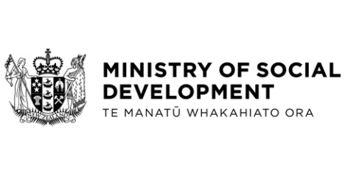

Changes in Vote Social Development to fund Welfare that Works and Community Participation Services

Hon Louise Upston, Minister for Social Development and Employment
These documents have been proactively released full.
- 19 June 2024, Cabinet paper - Changes in Vote Social Development to fund Welfare that Works and Community Participation Services

- 19 June 2024, Cabinet Social Outcomes Committee Minute SOU-24-MIN-0059, Cabinet Office.

The paper ‘Changes in Vote Social Development to fund Welfare that Works and Community Participation Services’ seeks an approval to transfer $27.860 million of an $29.889 million underspends from 2023/2024 within Vote Social Development to fund:
- The first phase of Welfare that Works over the 2024/25 financial year, which focuses on getting young people aged 18 to 24 years old off the Jobseeker Support benefit and into work, and
- Community participation services, allowing more disabled people to be supported to participate in the community and in employment.

© Crown Copyright, Creative Commons Attribution 4.0 International (CC BY 4.0)
Search Tags: Welfare that Works, Community Participation Services, Young Jobseekers.

