Coversheet |  | 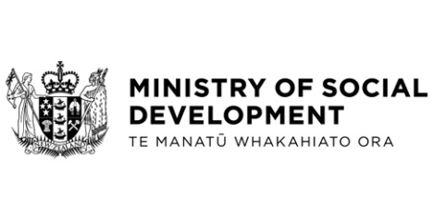

Te Haoroa Programme: Ministry of Social Development Data Warehouse Replacement Report Back
Hon Louise Upston, Minister for Social Development and Employment
These documents have been proactively released.
8 May 2024, Cabinet paper – Te Haoroa Programme: Ministry of Social Development Data Warehouse Replacement Report Back
8 May 2024, Cabinet Social Outcomes Committee Minute SOU-24-MIN-0035, Cabinet Office.

The purpose of this paper is to provide a report back on the progress of the Ministry of Social Development’s (MSD’s) implementation of the Te Haoroa Data Warehouse Replacement Programme (Te Haoroa).
Some parts of this information release would not be appropriate to release and, if requested, would be withheld under the Official Information Act 1982 (the Act). Where this is the case, the relevant sections of the Act that would apply have been identified. Where information has been withheld, no public interest has been identified that would outweigh the reasons for withholding it. This is the key to the redaction code used for this release:
- Section 9(2)(b)(ii) – to protect the commercial position of the supplier of the information.

© Crown Copyright, Creative Commons Attribution 4.0 International (CC BY 4.0)
Search Tags: Te Haoroa, Data Warehouse Replacement, Programme, MSD, Ministry of Social Development

