Coversheet |  | 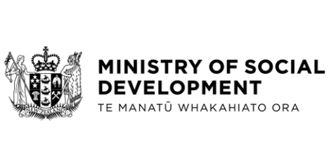

Student Allowances Amendment Regulations (No 2) 2024
Hon Louise Upston, Minister for Social Development and Employment
These documents have been proactively released.
20 June 2024, Cabinet paper – Student Allowances Amendment Regulations (No 2) 2024
20 June 2024, Cabinet Legislation Committee Minute LEG-24-MIN-0118, Cabinet Office.

The Cabinet paper ‘Student Allowances Amendment Regulations (No 2) 2024’ seeks approval to submit the Student Allowances Amendment Regulations (No 2) 2024 to the Executive Council, which will maintain the current abatement regime for Student Allowance payments for students under 24 years of age once personal income tax thresholds are increased on 31 July 2024.
© Crown Copyright, Creative Commons Attribution 4.0 International (CC BY 4.0)
Search Tags: Student Allowances, Amendment, Regulations, 2024, Personal Income Tax, Abatement, Threshold.

