Coversheet |  | 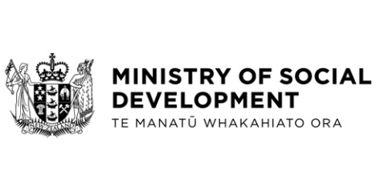

Social Security (Temporary Additional Support-Severe Weather Events TAA Programme) Amendment Regulation 2024
Hon Louse Upston, Minister for Social Development and Employment
These documents have been proactively released in full.
21 March 2024, Social Security (Temporary Additional Support – Severe weather events TAA Programme) Amendment Regulation 2024, Cabinet Office
21 March 2024, Cabinet Legislation Committee Minute LEG-24-MIN-0033, Cabinet Office.

Amendments to the Social Security Regulations are required to ensure that the increased scope of TAA recipients would not have their existing financial assistance impacted by TAA payments.
Please note – the Cabinet paper Social Security (Temporary Additional Support – Severe weather events TAA Programme) Amendment Regulation 2024 had a typographical error on page 4, paragraph 18: the date of the announcement was written as 18 March 2024, but should have been written as 21 March 2024 (announcement can be found here: www.beehive.govt.nz/release/help-homeowners-impacted-severe-weather).

© Crown Copyright, Creative Commons Attribution 4.0 International (CC BY 4.0)
Search Tags: TAA, Homeowners, Accommodation, Severe Weather, Cyclone,

