Coversheet |  | 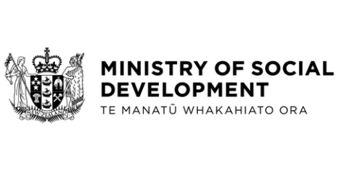

Government Response to the Report of the Petitions Committee on the Petition of Andrew Wilson: Rezone Accommodation Supplement Eligibility for Queenstown Residents
Hon Louise Upston, Minister for Social Development and Employment
These documents have been proactively released.
21 March 2024, Government Response to the Report of the Petitions Committee on the Petition of Andrew Wilson: Rezone Accommodation Supplement Eligibility for Queenstown Residents
21 March 2024, Cabinet Legislation Committee Minute LEG-24-MIN-0034, Cabinet Office.
The Government is required to respond to the report of the Petitions Committee on the Petition of Andrew Wilson: Rezone Accommodation Supplement Eligibility for Queenstown Residents.
Some parts of this information release would not be appropriate to release and, if requested, would be withheld under the Official Information Act 1982 (the Act). Where this is the case, the relevant sections of the Act that would apply have been identified. Where information has been withheld, no public interest has been identified that would outweigh the reasons for withholding it. This is the key to the redaction code used for this release:
- Section 9(2)(f)(iv) - the confidentiality of advice under active consideration

The following document that accompanied the Cabinet paper is already public:
- Government Response to the Report of the Petitions Committee on Petition of Andrew Wilson, Rezone Accommodation Supplement Eligibility for Queenstown Residents, which was presented to the House of Representatives on 25 March 2024. https://selectcommittees.parliament.nz/v/Paper/ad450b29-ed52-475e-1e27-08dc4c68423f
© Crown Copyright, Creative Commons Attribution 4.0 International (CC BY 4.0)
Search Tags: Accommodation Supplement, Petitions Committee, Queenstown

