Coversheet |  | 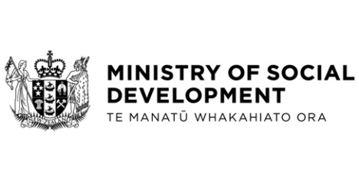

Te Pae Tawhiti Programme: Detailed Business Case for Horizon One – Investing in the Ministry of Social Development’s future
Hon Carmel Sepuloni, Minister for Social Development and Employment
These documents have been proactively released.
8 June 2023, Cabinet paper – Te Pae Tawhiti Programme: Detailed Business Case for Horizon One – Investing in the Ministry of Social Development’s future
31 May 2023, Appendix One – Te Pae Tawhiti Programme Overview
31 May 2023, Appendix Two – Te Pae Tawhiti Programme Horizon One Detailed Business Case
8 June 2023, Cabinet Government Administration and Expenditure Review Committee Minute GOV-23-MIN-0016, Cabinet Office.

These papers are the Horizon One Detailed Business Case for the Ministry of Social Development’s (MSD) Te Pae Tawhiti Transformation Programme, which will make it easier for New Zealanders to get the support they need from MSD and its partners.
Some parts of this information release would not be appropriate to release and, if requested, would be withheld under the Official Information Act 1982 (the Act). Where this is the case, the relevant sections of the Act that would apply have been identified. Where information has been withheld, no public interest has been identified that would outweigh the reasons for withholding it. This is the key to the redaction codes used for this release:
- Section 9(2)(b)(ii) - the commercial position of the supplier of the information
- Section 9(2)(f)(iv) - the confidentiality of advice under active consideration
- Section 9(2)(g)(i) - to maintain the effective conduct of public affairs through the free and frank expression of opinion.

© Crown Copyright, Creative Commons Attribution 4.0 International (CC BY 4.0)
Search Tags: Te Pae Tawhiti, Horizon One, Detailed Business Case

