Coversheet |  | 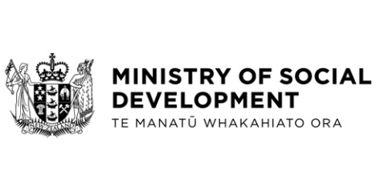
Social Security (Temporary Additional Support—Severe Weather Events TAA Programme) Amendment Regulations 2023

Hon Carmel Sepuloni, Minister for Social Development and Employment
These documents have been proactively released.
18 September 2023, Cabinet Legislation Committee paper: Social Security (Temporary Additional Support—Severe Weather Events TAA Programme) Amendment Regulations 2023
18 September 2023, Cabinet Legislation Committee Minute LEG-23-MIN-0192, Cabinet Office.

The paper seeks authorisation to submit the Social Security (Temporary Additional Support—Severe Weather Events TAA Programme) Amendment Regulations 2023 to the Executive Council.
The following document that accompanied the Cabinet paper is already public:
- Social Security (Temporary Additional Support—Severe Weather Events TAA Programme) Amendment Regulations 2023, which amends the Social Security Regulations 2018 to provide that the Severe Weather Events – Temporary Accommodation Assistance (SWE TAA) is not chargeable income for Temporary Additional Support and that people who receive the SWE TAA cannot also claim their temporary accommodation costs as an allowable cost for Temporary Additional Support.
Social Security (Temporary Additional Support—Severe Weather Events TAA Programme) Amendment Regulations 2023 (SL 2023/255) – New Zealand Legislation

© Crown Copyright, Creative Commons Attribution 4.0 International (CC BY 4.0)
Search Tags: NIWE TAA, North Island Weather Events, Temporary Accommodation Assistance, Temporary Accommodation Service, SWE TAA, Severe Weather Events

