Coversheet |  | 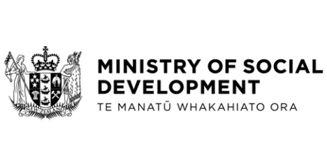
Passing on child support to sole parent beneficiaries: phased implementation
Hon Carmel Sepuloni, Minister for Social Development and Employment
Hon David Parker, Minister of Revenue
These documents have been proactively released.
23 November 2022, Cabinet paper - Passing on child support to sole parent beneficiaries: phased implementation
23 November 2022, Appendix to Cabinet paper - Appendix one – child support pass-on policy decisions and phase to be implemented in
23 November 2022, Regulatory Impact Statement - Child support pass-on - RIS Update
23 November 2022, Cabinet Social Wellbeing Committee Minute SWC-22-MIN-0222, Cabinet Office.
Following additional policy design decisions subsequent to Cabinet’s earlier agreement to pass on child support payments paid via Inland Revenue to sole parent beneficiaries, it is no longer possible to deliver the full policy design by 1 July 2023.
Instead, a phased approach is proposed that would pass on child support to sole parent beneficiaries and charge cash payments of child support relating to periods from 1 July 2023 as income for financial assistance purposes.
The second phase would address more complex income charging rules required to implement the full policy design and would be implemented from mid-2025 at the earliest.
Some parts of this information release would not be appropriate to release and, if requested, would be withheld under the Official Information Act 1982 (the Act). Where this is the case, the relevant sections of the Act that would apply have been identified. Where information has been withheld, no public interest has been identified that would outweigh the reasons for withholding it. This is the key to the redaction codes used for this release:
- Section 9(2)(f)(iv) - the confidentiality of advice under active consideration
- Section 9(2)(g)(i) – to maintain the effective conduct of public affairs through the free and frank expression of opinion
- Section 9(2)(h) - this information is legally privileged.

Also note that the child poverty projection figures on pages 8 and 30 are incorrect. The correct figures are 10,000 (+/-4000) according to the BHC50 measure and 6,000 (+/-3000) on the AHC50 measure.
Shading on the Regulatory Impact Statement identifies content that is new to the Regulatory Impact Statement update of November 2022.

© Crown Copyright, Creative Commons Attribution 4.0 International (CC BY 4.0)

