Coversheet |  | 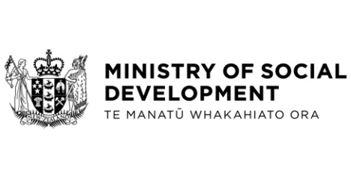
North Island Weather Events: Interim support for displaced homeowners with private rental arrangements
Hon Carmel Sepuloni, Minister for Social Development and Employment
Hon Dr Megan Woods, Minister of Housing
These documents have been proactively released.
17 July 2023, Cabinet paper - North Island Weather Events: Interim Support for Displaced Homeowners with Private Rental Arrangements
17 July 2023, Cabinet Minute CAB-23-MIN-0312, Cabinet Office.

This paper sets out decisions to establish the North Island Weather Events - Temporary Accommodation Assistance (NIWE TAA) for displaced homeowners with private rental arrangements.
Some parts of this information release would not be appropriate to release and, if requested, would be withheld under the Official Information Act 1982 (the Act). Where this is the case, the relevant sections of the Act that would apply have been identified. Where information has been withheld, no public interest has been identified that would outweigh the reasons for withholding it. This is the key to the redaction codes used for this release:
- Section 9(2)(f)(iv) - the confidentiality of advice under active consideration
- Section 9(2)(g)(i) – to maintain the effective conduct of public affairs through the free and frank expression of opinion

© Crown Copyright, Creative Commons Attribution 4.0 International (CC BY 4.0)
Search Tags: NIWE TAA, Temporary Accommodation Assistance, Temporary Accommodation Service

