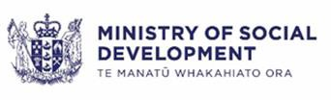

Ministry of Social Development Corporate Platform
Detailed Business Case (DBC)

Prepared for: | Nadine Kilmister
Date: | Wednesday, 19 October  2022
Version: | 1.0
Status: | FINAL
Template Version: | April 2021

Detailed Business Case Document Control Document Information
Role | Name | Review Status
Chief Financial Officer | Lara Ariell | Endorsed
Group General Manager People | Cain McLeod | Endorsed
Group General Manager Commercial Operations | Karen Dawson | Endorsed
Transformation Investment Committee |  | Noted and Delegated sign off to DCE People and Capability
Document Sign-off
Role | Name | Sign-off Date
Senior Responsible Owner | Nadine Kilmister | 19 October 2022
2022-11-23 10:45:36

Document ID | A12955807
Document owner | Karen Dawson - Corporate Portfolio Owner
Issue date | 17 October 2022
Filename | Budget 22 Corproate Platform Business Case FINAL.docx
Document History

Version | Issue date | Changes
0.30 | 08/11/2021 | Alignment with Te Pae Tawhiti Transformation Programme, including a re-alignment with the latest Treasury template.
0.40 | 17/11/2021 | Draft for internal review.
0.50 | 01/12/2021 | Draft incorporating feedback and financials.
0.60 | 17/12/2021 | Alignment to B23 Budget Bid wording
0.70 | 25/01/2022 | Alignment to Treasury feedback on funding received
0.80 | 26/01/2022 | Updated economic costing numbers and review comments
0.90 | 04/02/2022 | Draft incorporating feedback and changes in financials due to guidance.
0.10 | 20/09/2022 | Edits to align with Cabinet Paper and updates for Whaikaha, Te Pae Tawhiti, Treasury feedback and Finance review
1.0 | 17/10/2022 | Baseline version
Document Review

Contents

Executive Summary 5
The Strategic Case – the Case for Change 10
Organisational Overview 10
Our Corporate Platform 14
Corporate Platform current state 16
Scope of this business case 18
Investment Objectives 19
Benefits we will achieve from the investment 21
Key Risks 23
Key constraints, dependencies, and assumptions 24
The Economic Case – Identifying the preferred option 27
Key strategic choices already made 27
Key decisions already made 28
We only have one option 28
Indicative costs and benefits 30
Scaling Options Assessment 31
Overview of Scaling Options 31
Confirming the Preferred Option 35
Commercial Case 43
Procurement Background 43
Contractual arrangements at the time of procurement 45
New contracts are being negotiated 46
Probity 46
Financial Case 48
Funding sources 50
Overall affordability 50
Management Case 51
Organisational change management 68
Benefits management planning 71
Risk management planning 75
Corporate Platform and business assurance arrangements 76
Annexes 80
Annex 1 - SRO Letter 80
Annex 2 – Benefit Map 81
Annex 3 – Procurement 82
Annex 4 - Corporate Platform Renewal Implementation Plan 83
Annex 5 - Corporate Platform – Agile Practice and Ceremonies 84
Annex 6 – Risks register 85
Annex 7 – Change Management 85
Annex 8 - Detailed Results of scaling options 86

Executive Summary

Te Pae Tawhiti requires the Ministry of Social Development (MSD) to have a robust, fit-for-purpose corporate platform to support and provide better outcomes for our staff, partners, and clients

In 2018 we introduced a new strategic direction, Te Pae Tawhiti – Our Future, setting out the three key shifts we needed to make to achieve better outcomes for New Zealanders.
We need fit-for-purpose systems, business processes, people capability, and
information to achieve our ambition and deliver on government’s expectations. A robust and fit for purpose corporate platform will provide the corporate information we will need to manage in a more complex environment. It will collect, collate, and provide the information we need to support decision-making and provide better outcomes for our clients, staff, and partners – both at the front line and back office.
In May 2022, Cabinet considered a programme business case and agreed that an MSD transformation is the preferred way forward [GOV-22-MIN-001] The
programme will transform MSD’s future service model to enable MSD to respond to a changing social landscape and be equipped to deliver effective, timely, and mana-enhancing support and services.
The Corporate Platform is a key enabler for MSD’s Te Pae Tawhiti Transformation Programme1 (the Programme). The Programme will transform MSD’s service model to enable them to respond to a changing social landscape and be equipped to deliver effective, timely, and mana-enhancing support and services In May 2022, Cabinet considered a programme business case and agreed that an MSD transformation is the preferred way forward [GOV-22-MIN-001]. The Corporate Platform has been separated from the Programme because it is an integral
enabler to the design of MSD’s Future Service Model. This capability is seen as a pre-requisite to the Programme in order to support all phases of the Programme whilst stabilising business as usual technologies that support financial, procurement and people capabilities.
The Programme is also dependent on discovery and design work detailed within the scope of this updated business case to scope the replacement of the
Ministry’s aging and high-risk Social Sector contract management systems to be investment ready and able to deliver on strategic partnering initiatives.
In addition to Te Pae Tawhiti, on 1 July 2022 Government launched New Zealand’s first Whaikaha - Ministry of Disabled People (Whaikaha) to create a more inclusive society for approximately 1.1 million disabled people. MSD
already provides corporate services to Oranga Tamarki, and the Social Wellbeing Agency and will need to expand these corporate services to support the needs of Whaikaha.

- Cabinet considered a Programme Business Case in May 2022 and agreed transformation is the preferred way forward [CAB-22-MIN-001 refers].

A robust, fit for purpose corporate platform will give the Ministry the:

  - finance capability that helps us to manage our core accountabilities under the Public Finance Act on over $33 billion of expenditure per annum

  - procurement and contract management capability to support the procurement, contract management, and delivery of over $1 billion of payments per annum

  - processes, and systems that enable Social Sector Procurement capability and support the development of long-term strategic partnership arrangements and management of over 2,000 current partner arrangements

  - payroll capability to ensure that our 14,500 staff across MSD, Oranga Tamariki, Whaikaha and the Social Wellbeing Agency are paid accurately, on time and in line with legislative requirements

  - human resources capability to support the development of our staff to ensure MSD have the people capability needed now and into the future.

A corporate platform will ensure we are able to operate in a way that is consistent with all-of-government (AoG) Common Process Model (CPM) standards and will increase our people capability to ensure we are operating effectively and focusing on value for money – moving us from a transactional to strategic focus.
Because of the growing importance of social sector partners, including those who will support Whaikaha, we need to have the foundations to enable future investment in social sector commissioning capability and supporting systems.
This will make it easier for partners to work with us and deliver services on our behalf to improve services to our clients, their whānau and communities.

MSD faces major challenges in delivering core capabilities to achieve the desired future state
Our corporate platform has the following immediate issues:
- immediate systems risk to the core finance system, KEA, as no longer has vendor support from 2022
- immediate systems risk to the tool used to integrate the payroll and HR system because of the age of the system
- systems risk associated with the aging and complex Chris21 payroll.

Many of the corporate (back office) business processes are no longer fit-for- purpose and use workarounds to address gaps in core systems functionality.

Rebuilding the corporate platform will address the immediate risk of failure and support Te Pae Tawhiti and the future transformation of MSD services
We are using the CPM and expanding it in areas where we can add value.
A strong finance capability through a modern financial management system (FMIS) will ensure that we meet our finance responsibilities.
The procurement, contract management, and partnering capability we will deliver will help us better work with, support and manage our suppliers and partners

and improve the visibility and transparency of contracted/funded engagements. It will lay the foundations for future investment by leveraging FMIS capabilities to support our partners and community providers who deliver services to our clients and their whānau, including those in the disabilities sector.
We need high performing human resources (HR) and payroll capability to ensure that our staff are well equipped and supported to undertake their roles.
We need information to support decision-making with our clients, staff, and partners – both at the front line and back office. We need the information to help inform policy and support our Ministers and other government stakeholders.

We have three core investment objectives
We have identified three core objectives:
  - Implement modern systems
    - Implement modern finance, procurement and contract management, payroll, and HR systems to effectively fulfil obligations to clients, partners, staff, and government goals
  - Implement modern business processes
    - Implement modern finance, procurement and contract management, payroll, and HR processes to effectively fulfil obligations to clients, partners, staff, and government goals
  - Establish fit-for-purpose people capability
    - Increase people capability so that the corporate (back office) staff can provide value-adding and strategic advice.

Achieving these objectives will deliver significant benefits
Implementing the new corporate platform will remediate the risk attributable to the use of unsupported software for our mission-critical functions.
Implementation will deliver a modern, fit-for-purpose finance and procurement system with associated business processes. These processes and systems will ensure we meet our accountabilities under the Public Finance Act and NZ Government Procurement rules. We will also grow the people capability we need to operate effectively. The new procurement platform will support us to manage a large volume of contracted engagements that contribute to achievement of broader outcomes, the New Zealand economy and as an enabler for social sector contracting. We will deliver a fit-for-purpose payroll system that ensures our workforce, and the agencies we support are paid accurately, on time and in line with legislative requirements. The platform will provide better corporate information, supporting our decision-making with clients, staff, partners, and government.

MSD has already made key decisions
We are currently focusing on replacing the core finance system (KEA), the Chris 21 payroll and the interface between the payroll and HR systems.
We have initially focused on the areas of greatest risk and where we will deliver the most significant early value:
  - We have chosen Oracle as the FMIS platform and Accenture as our implementation partner.
  - We have chosen SAP as the payroll platform and Accenture as our implementation partner.

  - We will continue to use our current SAP HR platform.

We have made a strategic commitment. Funding was provided as part of Budget 20 and Budget 21 to start implementing and integrating these new platforms.
Cabinet noted that a further bid was expected in Budget 2022. We are well into our journey of replacing FMIS and the payroll platform. Given the progress made, the option to not complete the replacement platform investment would be unacceptable as a change in approach would take value away from progress made to date and result in an increased risk in the event that we would need to start again.

The preferred way forward will deliver easy to access, accurate and timely corporate services to those who need it – supported by easy to understand, relevant, and useful information.
We are seeking additional funding via the contingency funding set aside in Budget 22 process. We need $28.518 million to complete the replacement of the FMIS and payroll systems and allow us to fund Software as a Service (SaaS) and Platform as a Service (PaaS) fees for the implemented software and platforms.
The amount includes funding to scope up the replacement of our aging and high- risk Social Sector contract management systems (FAC and Conquest) and work with the sector to investigate how the all-of-government (AoG) Common Process Model (CPM) and the Oracle implementation could be used as the foundation for this work. Te Pae Tawhiti is dependent on the discovery and design of this phase to be investment ready and deliver on strategic partnering initiatives.

Our risks will increase without this funding
Without further funding, our system risk profile will not improve. Due to the in- flight nature of the programme and the complexity associated with managing interfaces between new and heritage systems, the risk of system failure and errors is higher until the heritage systems can be retired.
FMIS Release 1 provides a minimum viable transaction engine that interfaces back into existing systems using short-term workarounds that we will resolve as part of FMIS Release 2. Without additional funding, these workarounds will remain in place, increasing risk and requiring extra people to ensure that our financial information and reporting is timely and accurate. Release 2 will provide the tools and capability to resolve the direct criticism from Audit New Zealand regarding MSD’s lack of procurement and contract management systems.
The payroll solution has been procured, but implementation cannot be completed without extra funding.
Not implementing FMIS Release 2 will likely lead to a delay in our ability to deliver the strategic partnering initiatives of Te Pae Tawhiti programme. It will also impact provision of the shared services (finance, contract management and HR / payroll) required to support Whaikaha. The additional scope of work and associated changes needed to support Whaikaha will increase the risk of failure to our existing finance and payroll systems.

We have confidence in our ability to deliver
We have successfully used Agile to deliver since 2016, including through our response to COVID-19.

Agile governance is transparent and allows timely and effective escalation. Governance for the corporate portfolio of work has been established and is operational.
Our approach to delivery is based on risk mitigation.
  - We are utilising the AoG CPM and working across the public service to expand the model in areas where we can add value.
  - Robust procurement to select experienced implementation partners who bring expertise in specific processes and systems where it doesn’t make sense to retain full time in the Ministry.
  - We are implementing configurable SaaS and PaaS in line with all-of- government strategic technology direction.
  - Change management is an area of focus through the entire Corporate Platform implementation as we are changing processes and the underlying technology and building new capability.

Our assurance is aligned to the GCDO Digital Public Services branch three lines of defence model.
We have maintained delivery momentum under the resource and skills pressure caused by the pandemic. We have demonstrated our ability to deliver as most technical elements of the FMIS Release 1 programme have been configured and tested. Release 1 was successfully delivered in April 2022.

The Strategic Case – the Case for Change

Organisational Overview
Manaaki tangata, Manaaki whānau – we help New Zealanders to be safe, strong and independent.

Our role in supporting New Zealanders

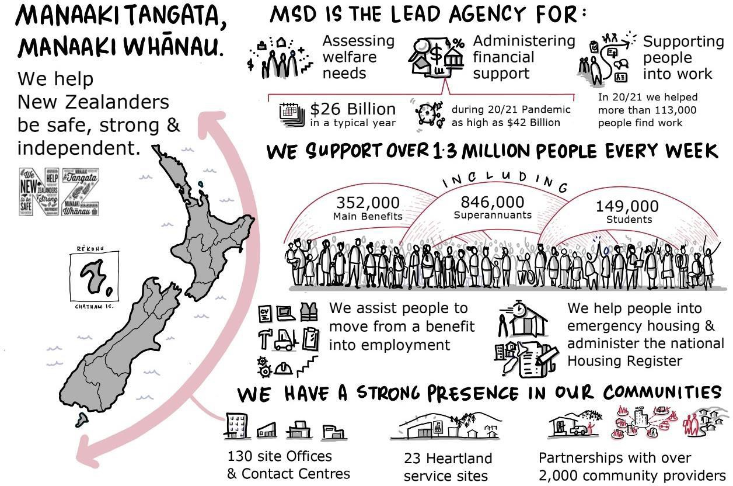

Figure 1 - Who we are

We understand the future we want
The Government's vision for the welfare system is to ensure people have an adequate income and standard of living, are treated with, and can live in dignity, and can participate meaningfully in their communities2. The Government has developed a comprehensive work programme to build a welfare system consistent with the vision of enabling 'whakamana tāngata' – restoring people's dignity.
Delivering these services will require the Ministry of Social Development (MSD) to access and use rich corporate information to ensure we direct our resources in

- See CAB-19-MIN-0578 / SWC-19-MIN-0168 (11 November 2019), para 16.

the best way to support our clients and whānau. This means we need a robust, fit-for-purpose corporate platform.

Te Pae Tawhiti – Our Future gives us a clear strategic direction
Our aim is to become a trusted and proactive organisation, connecting clients to all the support and services that are right for them, to improve the social and economic wellbeing of New Zealanders

Te Pae Tawhiti – Our Future, will guide us to achieve this aim, we are focusing on three key shifts:
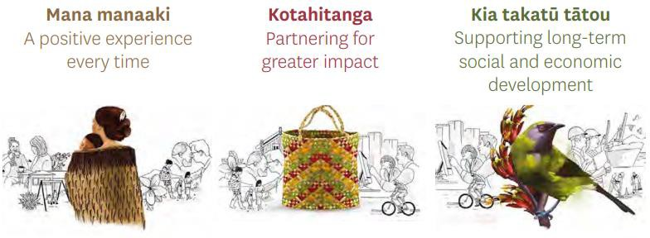
Te Pae Tawhiti – Our Future is supported by Te Pae Tata and Pacific Prosperity, which embrace the three shifts and describes how they will be realised for Māori and Pacific peoples.
Te Pae Tata: Te Rautaki Māori me te Mahere Mahi, aims to embed a Māori world view into our organisation that will honour our commitment as a Tiriti o Waitangi partner and prioritise the needs of whānau.
Pacific Prosperity: Our People, Our Solutions, Our Future, aims to rejuvenate the Ministry's delivery and engagement of services for Pacific peoples, families, and communities, so they are safe, thrive and flourish in New Zealand.

We face longstanding issues that affect how well we can respond to changing client needs and implement Government priorities
We must revise our operating model to be more responsive to our clients' needs. We need to modernise our technology and provide systems that meet New Zealanders' digital expectations, are cost-effective to manage, and are agile to allow us to respond to change.
The challenges associated with our ageing technology have previously been highlighted, through the Baseline Review (2018) and the Strategic Planning Pilot (2019), as well as in Accenture’s IT Asset Condition Review (2020). Currently, we cannot effectively use the valuable data and information we hold, as it is locked up in our technology systems. This prevents us from using information and intelligence to better meet client needs and enable easier access to services and information for clients, whānau, partners, staff, and government.
The corporate platform is a collective term for the back-office service model, processes, and systems our people use to deliver to the needs and expectations of New Zealanders. Without these foundations in place, we cannot achieve the outcomes that government requires. To continue to improve client outcomes and

respond to government requirements, we are seeking further investment to complete the implementation of a new service model, technology, and business processes and deal with risks raised by Audit NZ.

Te Pae Tawhiti – Our Future requires us to have a robust, fit-for-purpose corporate platform to support and provide better outcomes for our staff, partners, and clients
We must be prepared and ready to deliver high quality welfare services in a changing landscape. A robust corporate platform will provide the corporate information we will need to manage, in a more complex future.
A robust, fit-for-purpose corporate platform will give us the:
- finance capability that helps us to manage our core accountabilities under the Public Finance Act on over $33 billion of expenditure per annum

- procurement and contract management capability to support the procurement, contract management, and delivery of over $1 billion of payments per annum

- processes, and systems that enable Social Sector Procurement capability and support the development of long-term strategic partnership arrangements and management of over 2,000 current partner arrangements

- payroll capability to ensure that our 14,500 staff across MSD, Oranga Tamariki, Whaikaha and the Social Wellbeing Agency are paid accurately, on time and in line with legislative requirements

- human resources capability to support the development of our staff to ensure MSD have the people capability needed now and into the future.

We need strong partnering platforms and capability
Improving social sector commissioning is part of the Government’s continuing commitment to wellbeing. Trying to address social issues in isolation is expensive and resource intensive. Iwi, hapū, whānau, communities, funders and providers cannot solve these issues alone. It requires strong Social Sector Procurement capability, processes, and systems that can support managing long term strategic partnerships.
There is the opportunity to leverage the Corporate Platform investment to provide capability to enable better long-term outcomes for whānau, hapū, iwi and communities through social procurement and contract management.
Te Pae Tawhiti programme will deliver a transformation of MSD through an
overhaul of the organisation’s operating model. The Corporate Portfolio and the replacement of our corporate platform is a key enabler for Te Pae Tawhiti as it will lift MSD’s corporate capabilities to the levels required to support transformation. As a key enabler, the Corporate Platform work is integrated with the wider Te Pae Tawhiti work programme to ensure alignment. The implementation of our new Corporate Platform takes us beyond risk mitigation and provides the foundations for organisational transformation.

Common Process Model (CPM)
Cabinet has directed all agencies who plan to invest in their ‘back-office
functions’ (corporate support functions) to make more efficient investments. To do so involves applying a set of principles developed by the Government Chief Digital Officer (GCDO) and Government Chief Data Steward (GCDS) in consultation with the Treasury and other Agencies.
The Minister of Finance has highlighted his expectation that all agencies will adopt the all-of-government CPM3. CPM was built as the basis of Inland Revenue’s enterprise support services transformation. It is a model that Inland Revenue adapted for the New Zealand government context and is now a government-wide, business process-based standard.

- See, Common Process Model | NZ Digital government

Our Corporate Platform
Our existing corporate systems do not meet the demands and pressures placed on us. They currently do not allow us to transform the way we work. Investment is required to ensure they are fit for purpose.

Scope of the corporate platform
The scope of the Corporate Platform encompasses the operating model, systems, policies and processes, information, and people capability for:
  - Finance.
  - Corporate procurement and contract management.
  - Human resources.
  - Payroll.
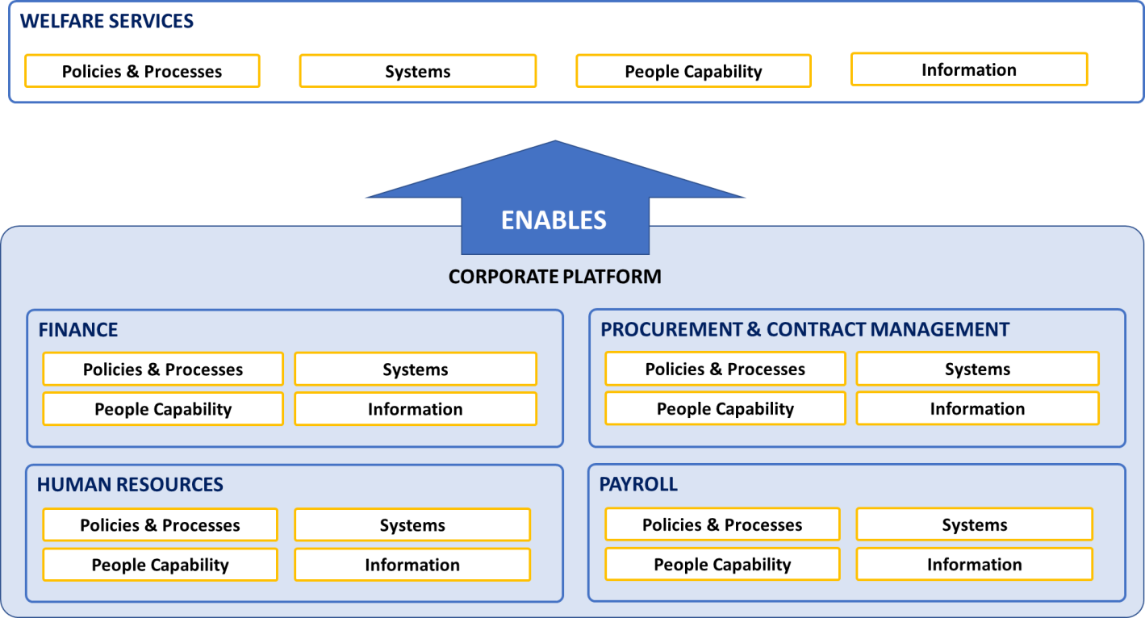
Figure 2 - Corporate Platform Overview

Other agencies use of our Corporate Platform
There are currently shared services arrangement in place between MSD and three agencies: Social Wellbeing Agency, Whaikaha and Oranga Tamariki. MSD provides corporate services, including finance, payroll, and HR information systems under this shared service arrangement.
Oranga Tamariki’s operating environments and strategic imperatives have diverged from ours. These changes impact the ability for both Ministries to continue to share the same systems.
A process is now in place to progressively separate the corporate services currently being provided to Oranga Tamariki by us. This separation process was agreed after a review in 2018, with formal agreement of both Chief Executives.

We are working closely with Oranga Tamariki on the separation and transition from the existing finance and procurement and human resources management

information system (HRMIS) and payroll systems, to ensure that this happens in a way that maintains the current service levels and results in a cost-effective implementation of new systems for both Ministries. The separation of services is scheduled to be complete by April 2023.
Whaikaha will share our Corporate Platform systems and services (finance, contract management and HR / payroll). It will allow us to leverage our technology systems and processes to achieve efficiencies and effectiveness between the ministries.
Whaikaha will require significant additional capabilities for an expected $1.8 bn related to procurement and contract management. Our current corporate platform does not have the core systems, business processes, and capability to effectively support social sector procurement. This is becoming a critical requirement for us to fulfil our role as lead agency in the Welfare System and major funder of social services delivered through partners – at $400m each year with 2,000 partners.

Finance
A fit-for-purpose financial management information system (FMIS) is needed to ensure that we manage our finances effectively and have the core information needed to inform how we best use our resources to achieve the Government’s vision. We need a modern, functional, fit-for-purpose finance system that replaces the existing KEA system.
As part of our finance transformation, we will redefine the role of our National Accounting Centre (NAC) because of changing systems, the implementation of CPM business processes, and the separation of MSD and Oranga Tamariki.
We have chosen Oracle as our solution partner for the new FMIS system.

Procurement and contract management
We will build the procurement platform we need to support us to meet our accountabilities for the significant departmental services and goods we procure. This capability will help us manage and deliver our responsibilities for broader outcomes and improve transparency of contracted spend. We will have the systems and processes in place to support full procure to pay requirements. We will implement CPM procure to pay processes.
We have chosen Oracle as our solution partner for procurement and contract management.

Human resources
A robust HRMIS is needed to ensure that we can build and support the workforce needed to deliver the services required to clients and whānau. We will modernise our HR policies, processes, and capabilities to support this.

We will continue to use the SAP Success Factors HR system and will implement additional modules to better support our staff and their managers.

Payroll
A fit-for-purpose payroll platform is required to ensure our staff are paid accurately and on-time. The information gathered and stored in the payroll platform is critical for workforce planning and budgeting.
We have chosen the SAP Success Factors Employee Central Payroll system.

Corporate Platform current state

We face major challenges in delivering core capabilities to achieve this desired future state

Our corporate platform is facing the following immediate issues:
- There is immediate systems risk to the core finance system, Key Environmental Accounting (KEA), as it no longer has vendor support since 2021.
- There is immediate systems risk to the tool used to integrate the payroll and HR system, YURI, because of the age of the system and the complex nature of interfaces between new and heritage systems.
- We also face significant systems risk to the aging and complex Chris21 payroll.

We also need to increase our people capability to use our new tool sets to ensure we can move from a transactional to a strategic focus.

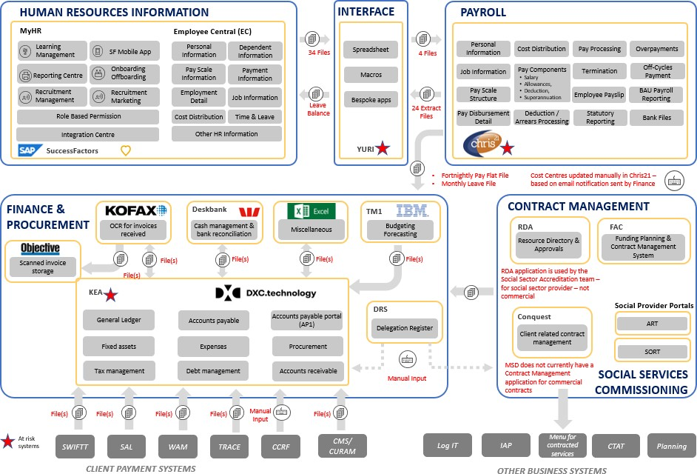

Figure 3 - Current State of Corporate Platform

Finance, procurement, and contract management
The finance and procurement applications are our key tools for processing over $1 billion per annum of payments, ordering necessary goods and services to deliver to our clients, and ensuring compliance with key legislation such as the Income Tax Act 2007. If these systems fail, our ability to make the payments and order the goods and services that we need to serve our clients is compromised.
Our core finance system – KEA was implemented in 1995. A minimal level of capital and operating funding has been invested in KEA since the initial release of the system in 1995. The current upgrade is the last, and KEA application will be unsupported from 2022.
KEA and its surrounding applications are not able to support the provision of timely and useful information to decision makers. These applications also limit the value we can generate from suppliers and partners through the procurement and contract management processes. KEA is also unable to meet Government requirements for the use of NZBN and e-invoicing.
We have received advice from PwC, Audit New Zealand, and KPMG that we need to improve our procurement and contract management system capabilities. Our current systems do not support effective management contracted spend, or report on key government priorities e.g. broader outcomes, progressive procurement targets. We have continuing challenges with our procurement capability and the need to raise our Procurement Capability Index (PCI).
- Conquest, the system MSD uses to manage contracts with suppliers and to manage partnerships with community providers was rated “red” in an asset condition assessment completed in 2020.⁴
- FAC, our existing funding and contracting application, also urgently needs replacement as it is considered at high risk of failure.
- An Audit New Zealand report⁵ noted the higher level of inherent risk for procurement and contract management carried by MSD and identified priorities for strengthening our control over procurement and contract management. We need to address our systems, our business processes, and our people capability in finance and procurement to make these well documented improvements and act on the recommendations we have accepted.

We have already started implementing the first components of a new FMIS solution, and the first release was delivered in April 2022.

Payroll
The Chris21 payroll makes over 31,000 payments to over 14,500 staff across Ministry of Social Development, Oranga Tamariki and the Social Wellbeing Agency (SWA) each month. Whaikaha will also use the aging Chris21 payroll system when it is established on 1 July 2022. The system manages between 30,000 and 44,000 data transactions each month received from myHR (SAP SuccessFactors).
We physically host the Chris21 payroll package in-house. While Chris21 reliably pays staff, it is no longer a modern payroll with the flexibility we require. The configuration is complex, limiting the speed at which we can respond to change and cater to the disparate needs of our workforce.

- Accenture, IT Asset Condition Review, 2020.
- Audit New Zealand, 2019.

The age and complexity of the payroll and our reliance on an aging bespoke integration tool mean that there is a significant risk of systems failure. Such a failure could result in failing to pay MSD’s, Whaikaha, Oranga Tamariki’s and SWA staff and the staff of shared service partners. We have received a report from PwC⁶ that highlights the risk of service failure.
While the immediate issue relates to the integration tool and payroll systems, we also need to improve our business processes. The current state of our systems and the necessary workarounds make significant business process improvement difficult.
Upgrading our systems and business processes will also require a corresponding capability lift for our staff.

In December 2021, we completed the procurement of a new payroll system, choosing SAP Success Factors Employee Central Payroll as the new technology, and Accenture as the implementation partner.

Social Sector Procurement and Contract Management
Our key current procurement and contract management systems, FAC and Conquest, do not have the core system functionality, business processes, and capability to effectively support Social Sector Procurement and contract management. Furthermore, FAC and Conquest are not aligned with AoG CPM. These systems are ageing and are at high risk.
Whaikaha will require significant additional capabilities for an expected $1.8 bn related to procurement and contract management.
This is becoming a critical requirement for us to fulfil our role as lead agency in the Welfare System and major funder of social services delivered through partners – at $400m each year with 2,000 partners.

Scope of this business case
A Corporate Platform strategy was developed and was agreed by MSD’s Leadership Team in 2020. The strategy articulates the change roadmap for this business case over several years with natural decision points at the end of each release.
The business case is focused on the renewal of Corporate Platform (‘Corporate Platform Renewal’) and implementing the changes to modernise capability, processes, and systems to manage risk, ensure processes are effective and efficient, and to put in place the people capability we need. Corporate Platform Renewal is already underway, with Release 1 for the FMIS on schedule for delivery in April 2022.
The Corporate Platform renewal was partially funded through Budgets 20 and 21 but we have insufficient funding to complete the implementation of both FMIS and payroll.
The Corporate Platform Renewal scope will mitigate risks that relate to:
- Finance systems – The core system (KEA) will be no longer supported from 2021.

- PwC, Future state of MSD HR systems architecture (PwC, July 2019)

  - Payroll to HR integration tool (YURI) – this tool is end-of-life and failure- prone.
  - Payroll – Chris21 is increasingly difficult to manage and no longer fit-for- purpose.
It will also allow us to update many of our processes, so they align with the AoG CPM. Our staff will have training to move from the transactional and often manual processes they currently use with the old systems and adopt the new systems and processes.
Furthermore, a discovery and design phase to scope up the replacement of our aging and high-risk Social Sector contract management systems (FAC and Conquest) and work with the sector to investigate how AoG Common Processes and the Oracle implementation could be used as the foundation for this work. In parallel, we will also be looking at how this foundation capability can be used as the basis of an integrated procurement and contract management system for Whaikaha.
While the functionality and specific usage of the capability for partnering will be defined and implemented as part of the Te Pae Tawhiti transformation Programme this will prepare for further investment.

The scope of delivery
The scope of this business case completes the remaining risk mitigation for our finance systems, including:
  - the base functionality for departmental procurement and contract management which is an enabler of social sector procurement and support for Whaikaha.
  - budgeting and forecasting functionality (annual and multi-year).
  - internal and external reporting, including reporting required for audit and appropriation management.
  - modern legacy system interfaces.
  - a platform to respond to future social sector commissioning requirements.

The scope of this bid will also de-risk reduce the risk posed by the current payroll issues and improve our current human resource information system (HRIS), by delivering a modern payroll solution that will ensure we can:
  - pay staff accurately and on time.
  - improve our HRIS by adding and integrating new system functionality including workforce analytics, management of performance and goals, compensation management, and HR service centre.

Investment Objectives
The investment objectives are summarised in the following table. These investment objectives have been agreed by our leadership team as part of the strategy for the Corporate Platform.

Investment Objective One | Implement modern systems  Implement modern finance, procurement and contract management, payroll, and HR systems so that MSD can effectively fulfil its obligations to its clients, partners, staff, and government goals.
Existing Arrangeme nts | - Except for our recently updated base HR system we have aging, unreliable systems that are no longer supported.  - Systems do not provide all the required functionality (e.g., in partners and communities).  - Core finance functionality are 25 years old.  - Systems require manual workarounds and additional staff to operate and manage them.  - Information requires significant manual massaging to make it useful.
Business Needs | - Modern, flexible, reliable, supported cloud-based Corporate Platform systems that provide accurate, timely, accessible, and useful information.  - Use of the standard all-of-government Common Process Model to configure sustainable software as a service technology solution with modern and consistently updated support arrangements.
Investment Objective Two | Implement modern business processes  Implement modern finance, procurement and contract management, payroll, and HR processes so that MSD can effectively fulfil its obligations to its clients, partners, staff, and government goals.
Existing Arrangeme nts | - Currently reliant on many manual processes.  - Variability in how processes operate and perform.
Business Needs | - Use of the standard all-of-government Common Process Model to ensure MSD is able to leverage investment in consistently updated business processes for NZ government agencies.
Investment Objective Three | Establish fit-for-purpose people capability  Increase the corporate platform people capability so that the corporate platform staff can be true business partners providing value-add and strategic advice.
Existing Arrangeme nts | - Because of heavy reliance on manual process, staff are focused on transactional, lower value work.
Business Needs | - Systems and processes that eliminate low value transactional activity and enable staff to focus on higher value-add strategic focus work, ensuring the effective operation of the Ministry.

Table 1 –Investment Objectives

Benefits we will achieve from the investment

The key benefits from the implementation of the new Corporate Platform are as follows:

Area | Benefit | Level
Risk | Reduced risk of operational failure – as the systems continue to age, there is increasing risk that the core FMIS platform and interface between payroll and HR will fail (as measured by Corporate Platform availability and time to resolve issues). | HIGH
Informatio n | Improved data and information that will inform better decision-making and more accurate, timely, and useful information for budget-holders and people leaders (as measured by quality of information, time to make available, ability to access anytime, anywhere and on any device). | MEDIU M
Business Process | Improved accuracy, usability, and timeliness of core processing through improved systems and use of all- of-government common processes (as measured by  accuracy of Corporate Platform core data, time to make available, ability to access anytime, anywhere and on any device).  MSD has more accurate, efficient and (where appropriate) automated business processes with very limited requirement for manual transaction processing (as measured by accuracy and timeliness of payments and other transactions). | MEDIU M

Area | Benefit | Level
People | We will have the people capability we need to operate effectively, including increased strategic and analytical capability, with less time spent on transaction processing and workarounds to manage aging systems (as measured by quality, timeliness, accuracy, availability of information to budget holders).  Ability to deploy staff currently focused on transactional work and workarounds into true value- add activities (as measured by number of staff to be redirected into other work).  An effective HR platform will help us ensure we recruit the right staff and develop them for the roles required. It will help us train them to undertake their roles, including our Te Tiriti obligations. It will help train our staff to better understand and meet the complex needs of our clients. It will also help us to train our staff to work more effectively with community providers and partners. | MEDIU M
Procureme nt | Improved contract and procurement outcomes (as measured by cost of procurement transactions, discounts achieved on procurement, and improvement in our Procurement Capability Index (PCI) outcomes). | MEDIU M
Governmen t | Improved information sharing and continuous improvement through working with other government agencies using all-of-government CPM (as measured by quality of information shared, availability of information, currency of business process and benchmarking).  Improved ability to meet wider government process commitments, including paying suppliers within 10 days, use of the NZBN and implementation of e- invoicing (measured by our ability to meet government standards). | MEDIU M

Table 2 - Benefits sought

Further details on the benefit map can be found in annex 2.

Supporting the Living Standards Framework
In addition to these benefits, there are secondary qualitative benefits supporting the Living Standards Framework. These are summarised in the following table.

Jobs and earnings | - Improved corporate information to support government and MSD in achieving expanded employment services.  - Improved ability to deliver effective employment services through our partners to those clients who will most benefit from  them.
Safety | - A reliable platform to process and make payments accurately and on time to suppliers and staff.
Income | - Improved corporate information to support improved delivery of income services.  - Improved relationships with partners to support improved delivery of employment services.
Knowledge & skills | - Reliable information supporting improved critical decision making across MSD.  - Useful sharing of information with other government agencies and our partners to increase capability across government and our partners.
Cultural Identity | - An effective HR platform will ensure that we recruit the right staff and develop them for the roles required. It will help us train them to undertake their roles, including ensuring that they fulfil our Te Tiriti o Waitangi obligations.  - Better trained staff and more effective community engagement and partnerships to increase access to local, Māori, Pasifika, and regional businesses.  - Improved targeting of services to respond to the needs or aspirations of Māori.  - Improved effectiveness of funding of Iwi providers.
Environment | - Raising our people capability so that we can more effectively support government’s social, economic, and environmental outcomes, including supporting the transition to net zero emissions and reduced waste.
Table 3 - Living Standards Benefit Summary

Key Risks
There are several risks to consider with this project, including capacity and capability of resources available across agencies, vendors, and the market as well as the competing priorities or dependencies with business as usual and other projects.
The detailed risks, mitigations and current ratings can be found in the Annex 6 – Risk Register.

 | Risks | Notes & Management Strategies
R1 | Resource contention due to other priorities | Putting in place contingency and supplementary resource options, including the use of overseas domain expertise, system access for test  environments and senior manager support and

 | Risks | Notes & Management Strategies
 |  | representation at MSD internal Program Increment prioritisation process.
R2 | Delay in securing sufficient Corporate Platform funding | Looking at options for sequencing that mitigate the greatest risk to critical functions to understand absolute priority for any funding received. These options are presented in the economic case.
R3 | Access to offshore development resources | Appropriate exemptions to MSD Remote Access and Jurisdiction standards, vendor controls and data protection policies and cost comparisons for Australian, Philippine, and Indian resources.
R4 | Capacity & Capability in Payroll Vendor Market Place | Procurement has been successfully completed with Accenture (ZAG) appointed as the Payroll / HR implementation partner and SAP Payroll selected as the Payroll product. Currently working to validate individuals to support implementation planning from both MSD & Accenture.
R5 | MSD & Oranga Tamariki funding and dependencies | Coordinating aligned budgets, papers, funding, and governance structures for 20/21/22 budgets and bids where relevant.
R6 | Concurrent Oranga Tamariki and MSD FMIS projects affect | Established Governance groups at all levels and sharing lessons, progress, and artefacts to reduce the risk to delivery.
R7 | Business as usual pressure | Confirmed executive support, organising robust contingency, and improving flexibility of access to testing systems.
R8 | Synergising MSD Agile & Vendor Delivery Methodologies | Engaging MSD Agile resources and established practices, ensuring delivery partners and vendors are aligned to MSD working methodology where relevant through procurement for delivery implementations.
R9 | Extent of legacy application changes | Continue as-is architecture and begin MVP scope and enhancement discovery for future work.
Table 4 - Risk Analysis Table

Key constraints, dependencies, and assumptions
The proposal is subject to the following constraints, dependencies, and assumptions.
Management strategies and registers have been developed to and they will be carefully monitored and managed during the programme.

 | Constraints | Notes

C1 | Technical resourcing for interfaces | MSD has finite resource able to work on the technical interfaces between Corporate Platform and other systems.
C2 | Epic priority is set in quarterly PI Planning Process | MSD agile planning is undertaken on a quarterly basis to secure shared services resources required to deliver projects. The individual epics within the Corporate Platform receive priority via the PI Planning process.
C3 | Funding injection required from Government | MSD does not have the capital or operational funding to deliver the corporate platform without the injection of new capital funding from The Treasury.
 | Dependencies | Notes & Management strategies
D1 | Timing of implementation of Oranga Tamariki payroll | Oranga Tamariki will require assistance from MSD to support their payroll implementation – planning currently depends upon Oranga Tamariki implementing their new payroll before MSD starts implementation of its own payroll.  Working closely with Oranga Tamariki Programme Director, weekly sync in place, to identify and manage dependencies.
D2 | Timing of implementation of Oranga Tamariki finance and procurement | Oranga Tamariki and MSD will need to work together to sequence and time finance system implementations and separation of financial support arrangements. Working closely with Oranga Tamariki Programme Director, weekly sync in place, to identify and manage dependencies.
D3 | Support of Oranga Tamariki implementations | MSD will need to support Oranga Tamariki as it transitions away from the MSD legacy platforms.  Working closely with Oranga Tamariki Programme Director, weekly sync in place, to identify and manage dependencies.
D4 | Shared Services disengagement | Oranga Tamariki needs to be ready from process, organisation, technology, financial and information perspectives before shared services currently provided from MSD can end.
 | Assumptions | Notes & Management strategies
A1 | Cloud implementation model | MSD will be able to work in a way that supports the cloud implementation model. This involves MSD taking new approaches to the way and resources involved in the delivery and support of new services and technologies.  The Corporate Platform is actively engaged across MSD to work through some of the challenges this new model presents.
A2 | Finance, Procurement & HR cost pressure | The implementation of people, process, technology, and information capabilities associated with the FMIS, Payroll  (and HRIS configuration changes) and operating funding

 |  | in this business case will remove the MSD cost pressure from existing shared services for Finance, Procurement and HR.
A3 | Learning and reusing | Utilising IRs ESS programme learnings, collateral, Common Process Model, and the Accenture Golden Client will reduce risk for FMIS implementation.
A4 | Financial | Financial assumptions are documented in the Financial Case of this business case.
A5 | Oracle will be a fit-for purpose replacement for FAC and Conquest | Oracle will meet the social procurement and contract management business needs which will allow decommissioning of existing systems. Note that the Conquest system has the functionality to hold an individual record of a client, which Oracle does not have.
Table 5 - Key Constraints, Dependencies and Assumptions

The Economic Case – Identifying the preferred option
Our programme is already underway, and we have already made key procurement decisions. The Economic Case aims to state the previously presented preferred option and consider scaling investment option(s). The analysis included the following steps:
- Key strategic choices and decisions already made to state our preferred option.
- Defining evaluation criteria for scaling options – confirming the investment objectives, critical success factors and benefits to be used to help assess the scaling options identified.
- Undertaking the programme scaling options assessment.
- Process, that:
  - identifies the different scaling options for the programme.
  - assesses each of the scaling options against the investment objectives, critical success factors and benefits to identify whether that option is discounted, possible, or preferred.
- Assessing the relative costs, benefits, and risks of the shortlist scaling options through Multi-Criteria Decision Analysis (MCDA) to confirm the scaling options to the preferred option.

The process included a set of workshops with senior programme stakeholders. The outcomes were then formulated appropriately before being taken to the Transformation Investment Committee for endorsement.

Key strategic choices already made
Based upon the guidance described above received from the Minister of Finance and the Government Chief Digital Officer, we have made the following key strategic choices for the Corporate Platform.
- We will continue splitting systems and services with Oranga Tamariki – this has already been agreed and provides maximum flexibility for each agency to pursue its own imperatives.
- We will use the all-of-government CPM – MSD will contribute back to AoG CPM where processes are not included the current CPM.
- We will use a cloud system that enables the CPM for our Corporate Platform – The Government Digital Strategy has directed a strong preference for a commercial off-the-shelf cloud system.
- Whaikaha– the Ministry, was established on 1 July 2022, shares our systems and services. It allows us to leverage our technology systems and processes to achieve efficiencies and effectiveness between the Ministries.
- We will seek to use a single integrated system where this makes sense – a single SAP payroll and HR system will address the key interface risk (YURI) as we already use SAP SuccessFactors; a single system from SAP may provide additional value over that exceeds the risk from vendor lock-in; this decision will be made as part of the procurement process. SAP and Oracle were the only vendors who responded to the original ROI.

Key decisions already made
We are focused on replacing core legacy corporate systems:
- Key Environmental Accounting (KEA) for Finance.
- Chris21 for Payroll.
- The system interface, YURI, between payroll (Chris21) and HR (SAP SuccessFactors).

Due to their age and complexity, continuing with these systems provides the greatest risk of failure. Changing them offers us the potential to provide the greatest benefits. Faced with these issues:
- We have chosen to take this opportunity to consider finance, procurement, contract management, HR, and payroll as a single corporate platform – seeking to use a single integrated system where this makes sense – rather than many systems connected by many interfaces. We can maximise investment value and combine all key entities we manage on a single information base.
- We have chosen Oracle as the finance and procurement platform and Accenture as the implementation partner. This occurred through a robust procurement process.
  - Standard AoG CPM and FMIS systems provide procurement functionality that could be used to manage our delivery partners.
  - While we want to use a single integrated system where this makes sense, the choice of Oracle does not preclude future procurement decisions around other products being assessed as providing additional value over a single integrated system. These decisions will be made within Te Pae Tawhiti scope as part of future planning and procurement processes.
- We will continue to use its current SAP HR platform – SuccessFactors. It is a state-of-the-art platform that will meet our requirements in the future.
- We have chosen SAP as the Payroll platform and Accenture as the implementation partner for Payroll and Human Resources Information System (HRIS). This occurred through a robust procurement process.

We only have one option
Based on its strategic and qualitative choices and the work in flight with Corporate Platform Renewal, we only have a single viable option available to pursue (without significant risk of failure by maintaining the current state):
- Implement Oracle finance as confirmed through procurement processes and leverage for social sector contracts.
- Continue using SAP HR (SuccessFactors) cloud solution.
- Implement the SAP Success Factors Employee Central Payroll as confirmed through procurement processes.

To be better prepared and investment ready, the choice will allow us to undertake discovery and design phase for Social Sector Procurement and contract management, client payments and debt management activities using the Corporate Platform. The implementation of any later phases of this work will form part of the scope of Te Pae Tawhiti programme.

This option supports manaakitanga for clients and will be easier for staff, purchasers, suppliers, and partners to understand and navigate. It will deliver accessible, accurate, and timely services to those who need it, supported by understandable, relevant, useful information.

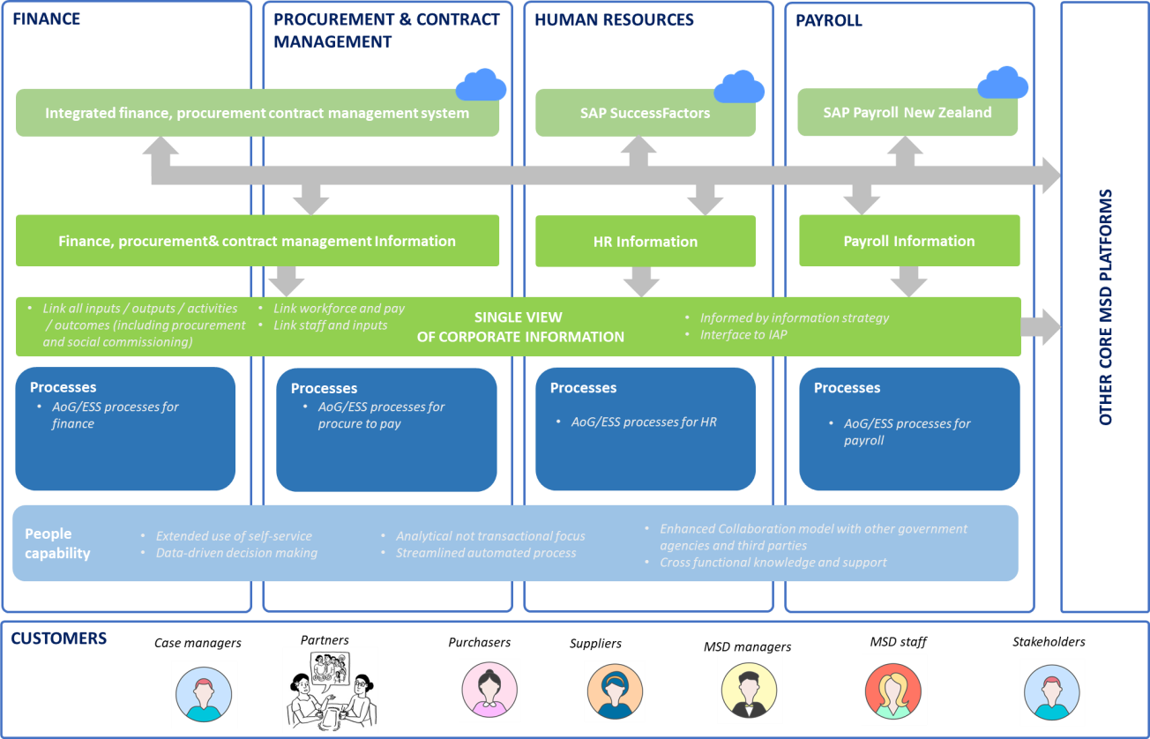
Figure 4 - The Future Corporate Platform

The Critical Success Factors are still valid
The following Critical Success Factors (CSF) were identified for the successful delivery of the future Corporate Platform.

Key Critical Success Factors | Description  How well the option: | How addressed in the preferred option
Strategic fit and business needs | - Meets the agreed investment objectives, related business needs and requirements, and  - Fits with other strategies, programmes, and projects. | We have developed a strategy for the Corporate Platform. The Executive Leadership Team has agreed this strategy.  The preferred option aligns with this strategy.
Potential value for money | - Optimises value for money (i.e., the optimal mix of potential benefits, costs, and risks). | The use of off-the-shelf cloud solutions and the all-of-

Key Critical Success Factors | Description  How well the option: | How addressed in the preferred option
 |  | government processes minimises customisations, maximises use of existing IP, and therefore supports value for money.
Supplier capacity and capability | - Matches the ability of potential suppliers to deliver the required services, and  - It is likely to result in a sustainable arrangement that optimises value for money over  the term of the contract. | The key components required are available from and supported by major suppliers (e.g., Oracle and SAP).
Potential affordability | - Can be met from likely available funding, and  - Matches other funding constraints. | This business case is seeking the necessary funding for the preferred option.
Potential achievability | - It is likely to be delivered given the organisation’s ability to respond to the changes required, and  - Matches the level of available skills required for successful delivery. | We will work with implementation partners. Accenture is the implementation partner for the core financial and procurement, and payroll.
Table 6 - Critical Success Factors

Indicative costs and benefits
We have estimated the total cost (net of amounts approved in Budget 2020 and internal funding) over eight years from 2020/21 for the replacement of FMIS and HRIS/Payroll systems, discovery and design phase to identify Social Sector Procurement options and cost pressures associated with the cessation of HR / Payroll, Finance and Procurement Shared services.
The proposed whole of life cost of the Corporate Platform is $126.273 m over the eight years of the expected lifetime of the programme.

Further Funding Principles
We will use the following funding principles to manage the funding envelope.
- Those pieces of work that will create the greatest value for money will be funded and implemented first. The value will be measured in terms of both risks mitigated and quantitative and qualitative benefits that will be achieved.
- The programme will deliver across epics and then enhance these based on the best value for money.
- Funding will be sought through the budget process.
- The Corporate Platform will be extended into other parts of our operation to gain value further.
The Senior Responsible Owner has signified her agreement to the proposal’s indicative cost and benefit estimates.

Scaling Options Assessment
The purpose of the scaling option assessment process was to generate and consider a wide range of choices if funding for the preferred option is not received. The scaling option choices were developed by considering scope and scale elements to identify options to the preferred option that could potentially solve the investment objectives and meet the critical success factors and benefits. We then iterated and refined these options with senior programme stakeholders and assessed them against the evaluation criteria.
When undertaking this assessment, scaling options that did not meet a critical success factor were immediately ruled out from any further analysis as per Better Business Case guidance. This method enabled a more detailed focus to be applied to those scaling options that did meet the critical success factors specific to their alignment with the Investment Objectives and Benefits.
We have arrived at four scaling options with a shortlist of two. The output of the assessment is provided in Annex 8.

Overview of Scaling Options
We have developed four scaling options, including the identified preferred option. These options form a continuum of the “Do minimum” option to full risk mitigation of the Corporate Platform programme and funding for discovery work associated with Social Sector Procurement. The preferred option is option four.

The summary assessment of each of the shortlist options is included below:

OPTION 1:  Do Minimum  (DISCOUNTED) | Complete FMIS risk reduction, no Payroll
Description | Focus on completing the implementation of our FMIS solution and ensure that we fully realise the benefits in this area and mitigate all of the risks we hold in our existing finance system, KEA. As per our planning, this would include FMIS releases 1 and 2.
Advantages | The main advantages are:  - The investment is focused on mitigating risk and making the minimum changes required that we hold in our current finance system KEA.  - No additional funding from the Crown would be required for this option.
Disadvantages | The main disadvantages are:  - Due to its age, our provider for CHRIS21 (the payroll) is likely to stop supporting this version in the next year. We have been struggling to gain a significant patch from Frontier for over eight months, and the solution resides on out of support infrastructure that we cannot upgrade until this patch is provided.  - Raise critical risks that we hold in our existing payroll system, Chris21 and integration infrastructure YURI which will continue to worsen over the scheduled 2 years it will take to implement.  - To defer another year will raise the risk of payroll failure to over 10,000 staff (including agencies with which we host/provide a shared service). We have had three system failures over the last year, and we anticipate that this will increase.  - If the Payroll function fails, we cannot restore, and we will be forced to use the contingency of re-running the bank payment file from the last successful pay run, which will not include any new employees. This introduces 12 months of manual updates per re-run of backfile to ‘undo’ issues this creates.  - We expect that changes to the Holidays Act and the Public Services Act will come into effect over the coming year. We will use best endeavours to make these changes, but without investment, we will do this using a manual workaround to an already complex and fragile system.  - We will also be unable to deliver on any transformative initiatives in the HR landscape, which will mean enabling elements of our People Strategy, Te Pae Tata and Te Pai Tawhiti will not be available.  - We will not be able to meet the payroll needs of Whaikaha People on our current systems and processes.
Costs | LOW
Benefits | LOW
Risks | HIGH

Conclusion | To be discounted.

OPTION 2: (DISCOUNTED) | Complete Payroll only
Description | This option would pause the FMIS work to date, at the end of Release 1 in April 2022, and focus our effort on implementing the Payroll solution.
Advantages | The main advantages are:  - This option will mitigate the significant organisational risk we carry in our current payroll technology, Chris21, and the YURI interface between our HRMIS system and payroll.  - No additional funding from the Crown would be required for this option
Disadvantages | The main disadvantages are:  - While this is a viable Payroll option, we will still have significant issues to manage over the interim until we secure funding to complete our new FMIS solution  - Not completing FMIS will still carry risks in procurement and contracting. We used unsuitable tools and manually managed the workload highlighted in an audit report, leaving this significant risk unresolved.  - The FMIS solution we have procured includes a set of tactical processes until the whole solution is complete. These will add to our system risk profile and require an increase in personnel to manage until the total FMIS solution is complete.  - Delaying the FMIS solution will cost us more. We will be paying our technology provider Oracle for a solution that is not fully implemented based on the licencing cost set up. Delays in a competitive market may see a loss of IP if staff decide to move on and increase cost and time when we pick the project back up.  - We will not be able to meet the full financial management needs of Whaikaha on our current systems and processes.
Costs | LOW
Benefits | LOW
Risks | HIGH
Conclusion | To be discounted

OPTION 3: | Mitigate our risks, complete FMIS and payroll
Description | In this option, the Ministry requests funding for the Corporate Platform in Budget 2022. This option will ensure that all the original risks we intended to mitigate with the in-flight FMIS, and Payroll process and system replacements are mitigated.
Advantages | The main advantages are:  - We are achieving the goal of mitigating our high level of technology system risk by replacing our aged technology  platforms.

- There is a wide range of benefits of making information more easily available for decision-making, modernising our processes, and aligning them with all-of-government process models.
- Delivery on all our programme benefits
Disadvantages | The main disadvantages are:  - Te Pae Tawhiti – Our Future focuses on our ability to work better with welfare sector partners to help us deliver services to our clients. Without the discovery and design work proposed, we will not deliver the strong foundations that our strategic direction requires to enable Social Sector Procurement.  - As there will be no focus on contract management and procurement capabilities, we will not meet the needs Whaikaha, who require these capabilities.
Costs | HIGH
Benefits | MEDIUM/HIGH
Risks | LOW
Conclusion | To be taken forward as a scaling option

OPTION 4:  (Preferred) | Mitigate our risks, discovery and design funding for Social Sector Procurement
Description | This option will ensure that all of the original risks we intended to mitigate with the FMIS and Payroll system replacements are mitigated. We will also scope up the replacement of our aging and high risk Social Sector contract management systems (FAC and Conquest) and work with the sector to investigate how AoG Common Processes and the Oracle implementation could be used as the foundation for this work. It will be to ensure that we are investment ready in developing a further business case.
Advantages | The main advantages are:  - We are achieving the goal of mitigating our high level of technology system risk by replacing our aged technology platforms.  - Delivery on all of our programme benefits and an enabler to MSD wider strategic intentions and key Government priorities.  - Te Pae Tawhiti – Our Future focuses on our ability to work better with welfare sector partners to help us deliver services to our clients. The additional discovery and design phase is vital in ensuring that we do not lose time and will assist Te Pae Tawhiti in being investment ready in meeting the strategic shift in improving our relationships with partners. The implementation will be managed as part of Te Pae Tawhiti.  - This option will assess how the foundation contract and procurement management capability can be used as the basis of an integrated procurement and contract management system for Whaikaha who require these  capabilities.
Disadvantages | The main disadvantages are:

 | - The funding requirement to be met in Budget 22 is the most expensive of the scaling options.
Costs | HIGH
Benefits | MEDIUM/HIGH
Risks | LOW
Conclusion | Preferred Option
Table 7 - Scaling Options Overview

Confirming the Preferred Option

Costs
A cost model has been developed to measure capital and operating costs for each of the four scaling options over an 8-year timeframe. The model has been populated with inputs and assumptions with rigour suitable for the Detailed Business Case.

The inputs and model calculations were derived from a mix of:
- Cost estimates from similar initiatives
- Project team estimates of relative costs across options and project phasing across the 8-year timeframe for the calculations.
- Licensing and ongoing support estimated costs from SAP, Oracle, and SaaS.
- FMIS Actual costs up until 30 Sept 2021 and comparison to estimated costs.
- Statement of Work (SoW) and Request for Proposal (RFP) provided by implementation partner Accenture for FMIS and Payroll, respectively.

The costs presented in the Detailed Business Case represent the project team’s estimate of the investment choices that might need to be made in each of the options.

The indicative costs for each of the scaling options, for the first 8 years (undiscounted) as Capital Expenditure and Operating Expenditure across the different cost dimensions, have been explored. Further detail on these cost dimensions can be found in the Financial Case.

8 Year Costs Ranges ($m) | Option 1: Complete FMIS risk reduction, no Payroll | Option 2: Complete Payroll only | Option 3: Mitigate our risks, complete FMIS and Payroll | Option 4: Mitigate our risks, discovery and design funding for Social Sector Procurement
Capital Total | - | - | - | -
Project costs associated with configuration and implementation to deliver | 41.021 | 44.845 | 67.973 | 70.225
Licenses, system support, staff overheads, contingency | 22.650 | 30.813 | 30.813 | 30.813
HMIS - Compensation, performance & goals, workforce analytics, service centre | - | 2.000 | 2.000 | 2.000
Organisational Transformation and cost pressures | 17.063 | 23.235 | 23.235 | 23.235
TOTAL 8-year costs | 80.733 | 100.892 | 124.021 | 126.273
Table 8 – High-Level Cost Summary (undiscounted)

Benefits
For each benefit identified in the Strategic Case, several potential result areas were identified for detailed assessment.

The Corporate Platform needs to be viewed as the underlying piece of technology to enable and support our people and processes in delivering change, and therefore, the realisation of benefits may not occur until years after implementation. The quantification of benefits is done only where the benefits could be justified through robust evidence and in a conservative manner. There is insufficient evidence to quantify the expected realisation of benefits appropriately.

Investment Objectives | Benefits | Description of Benefit | Result Area
Implement modern systems  Implement modern finance, | Risk reduction | Reduced risk of operational failure – increasing risk that the core FMIS  platform and | - Corporate Platform availability and time to resolve issues.

Investment Objectives | Benefits | Description of Benefit | Result Area
procurement and contract management, payroll, and HR systems to effectively fulfil obligations to clients, partners, staff, and government goals. |  | interface between payroll and HR will fail.
 | Improved data and information | Improved data and information that will inform better decision-making and more accurate, timely, and useful information for budget-holders and people leaders. | - Quality of information, time to make available, time to access, ability to access anytime, anywhere and on any device.  - The percentage of spend generated by purchase order.  - Ability to self-service and view reports.
 | Improved contract and procurement outcomes | Improved contract and procurement outcomes. | - Cost of procurement transactions.  - Discounts achieved on procurement.  - Our Procurement Capability Index (PCI) outcomes).  - Single source of commercial supplier  information.
Implement modern business processes  Implement modern finance, procurement and contract management, payroll, and HR processes to effectively fulfil obligations to clients, partners, staff, and government goals. | Improved Business Processes | Improved accuracy, usability, and timeliness of core processing through improved systems and use of all-of- government common processes. | - Accuracy of Corporate Platform core data, time to make available, time to make available, ability to access anytime, anywhere and on any device.
 |  | MSD has more accurate and efficient automated business processes with very limited requirement for manual transaction processing requirements. | - Accuracy and timeliness of payments and other transactions.
 | Increase ease to share information with wider government | Improved information sharing and continuous improvement through working with other government agencies using all- of-government CPM. | - Quality of information shared.  - Availability of information.  - Currency of business process and benchmarking.
 |  | Improved ability to  meet wider | - Performance against government standards i.e., including paying

Investment Objectives | Benefits | Description of Benefit | Result Area
 |  | government process commitments. | suppliers within 10 days and use of the NZBN and implementation of e- invoicing.
Establish fit-for- purpose people capability Increase the Corporate Platform people capability so that the Corporate Platform staff can be true business partners providing value- add and strategic advice. | Our people operating effectively with an increase in capability | We will have the people capability we need to operate effectively, including increased strategic and analytical capability. | - Less time spent on transaction processing and workarounds to manage aging systems  - Quality, timeliness, accuracy, availability of information to budget holders.  - Ability to deploy current staff focused on transactional work and workarounds into true value-add activities as measured by number of staff to be redirected into other work.
 |  | We will effective HR platform which will ensure that we recruit the right staff and develop them for the roles required. | - Effectively train our people to undertake their roles, to:  - Fulfil MSD Te Tiriti obligations.  - Better meet the complex needs of our clients.  - Work better with community providers and partners.
Table 9 - High Level Benefits

Assessment of the Scaling Options
The options were assessed by considering the information on costs and benefits above, undertaking further qualitative analysis, and carrying out a Multi-Criteria Decision Analysis (MCDA). A qualitative summary of the key points of difference between the options driving the MCDA assessment is set out in the following table .

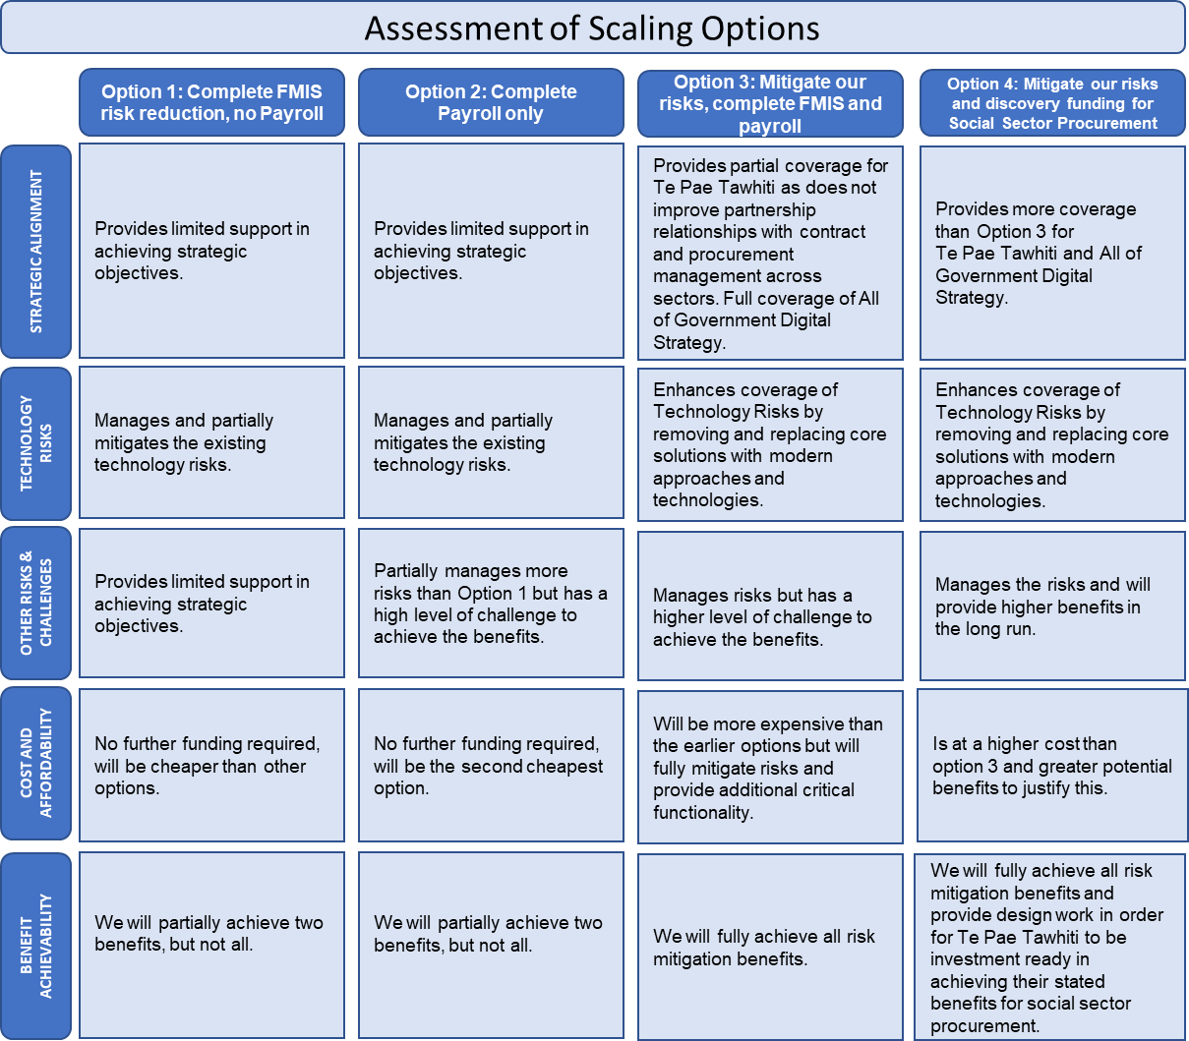

Table 10 - Qualitative comparison of Scaling Options

The Assessment process considered multiple factors across the scaling options to provide a view on the preferred way forward. This included:
- Investment Objectives and Critical Success Factors.
- The programme team prepared a quantified assessment of costs.
- A qualified assessment of benefits prepared by the programme team. The key outputs from the MCDA are provided below, indicating a ranking of the options based on these inputs.
Assessment of scaling options  ($m) | Option 1: Complete FMIS risk reduction, no Payroll | Option 2: Complete Payroll only | Option 3: Mitigate our risks, complete FMIS and payroll | Option 4: Mitigate our risks, discovery and design funding for Social Sector Procurement
Analysis period | 8 years | 8years | 8 years | 8 years
Total Cost (undiscounted) | $80.733 | $100.892 | $124.021 | $126.273

Assessment of scaling options  ($m) | Option 1: Complete FMIS risk reduction, no Payroll | Option 2: Complete Payroll only | Option 3: Mitigate our risks, complete FMIS and payroll | Option 4: Mitigate our risks, discovery and design funding for Social Sector Procurement
Main Benefits (by Domain Indicator)
Increase resilience of core corporate systems  Reduction is critical system risk  – FMIS  - Payroll | HIGH  NEUTRAL | NEUTRAL  HIGH | HIGH  HIGH | HIGH  HIGH
Easier to access real time information | MEDIUM | MEDIUM | HIGH | HIGH
Benefit Rank | 4th | 3rd | 1st | 1st
Multi Criteria Dimensional Analysis
Strategic Alignment | 4 | 3 | 2 | 1
Technical Risk | 4 | 3 | 1 | 1
Other Risk | 4 | 4 | 2 | 1
Cost / Affordability | 1 | 2 | 3 | 4
Benefit Achievability | 4 | 3 | 1 | 1
MCDA Rank | 4th | 3rd | 2nd | 1st
OVERALL RANK | 4th | 3rd | 2nd | 1st
Table 13 – Assessment of scaling options

Assumptions
For the cost analysis, the following assumptions have been made:
- Costings are based on: Market engagement and expert advice on the resources required to implement FMIS and payroll systems and processes in MSD.

When assessing scaling options, further assumptions relating to the split of operating expenses are:
- We have excluded $2 million of compensation, performance & goals, workforce analytics, a service centre related to Payroll implementation.
- We have excluded $1 million of Payroll Operations and $1.5 million of HR Uplift, all related to Payroll implementation as initially assumed.

- It includes $2 million of Finance Uplift and $2million of NAC related to FMIS Release 1.
- It includes $1.5 million of Procurement Capability Uplift related to FMIS Release 2.
- The cost pressure relating to the split of systems and processes with OT will impact MSD regardless of any module included or excluded. Therefore, Finance Cost pressure of $2.7 million and Payroll & HR Cost Pressure of
$900k has been shown separately (Cost Pressures).

Assessment period
The start date for valuation purposes is assumed to be 1 July 2020.

The life of the programme is assumed to be eight years; this is the period over which costs and benefits are assessed.

Estimated costs
Depreciation, capital charges, interest and other financing costs are excluded from the analysis.

The following costs were estimated by:
- Configuration and implementation project costs – the project costs associated with configuring and implementing FMIS and Payroll systems in order to deliver and to go live
- Licensing, Subscription and Support Costs – ongoing operating expense relating to product provider licensing costs and other support costs.
- Organisational change (communications, training, capability uplift etc.) – Project costs associated with structure, roles and culture that has been broken down to finance uplift, payroll operation, procurement capability uplift, HR uplift and National Accounting Centre.
- Human Resources backlog – Project costs associated with compensation, performance & goals, workforce analytics and service centre.
- Assurance – Probity Assurance, Gateway Review, IQA and Agile Assurance activities are planned through implementing the Corporate Platform.
- Cost pressures – Oranga Tamariki will have independent FMIS system Payroll & HR systems by 2023. At this point, MSD will face cost pressures due to the split and inefficiencies; the costs associated with this pressure will decrease over time.

Taxation
All dollar figures are GST exclusive.

Overall, the assessment of the scaling options has revealed that Option 4: Mitigate our risks, discovery and design funding for Social Sector Procurement is the preferred option. This conclusion is based upon the following aspects:
- The cost and benefit profile for Option 4 – Mitigate our risks, discovery and design funding for Social Sector Procurement is substantially better than other options that were considered.
- The alignment of the option to GCDO and our overall strategy and direction is significantly better compared to other options.
- The additional discovery and design phase to scope the replacement of Social Sector Contract management systems (FAC and Conquest) ensure that we are investment ready for business case development as part of Te Pae Tawhiti.
- The assessment of other qualitative items reveals that the Mitigate our risks, discovery and design funding for Social Sector Procurement option ranks higher than the alternatives considered.
- Without further funding:
  - the Ministry will have a half-finished FMIS implementation, and we will need to continue to use an out of support core financial accounting system that interfaces to a modern SaaS solution. This system co-existence (a hybrid of new and legacy systems and processes) increases the risk of operational failure and potentially negates the benefits expected from replacing the FMIS transactional engine.
  - There will continue to be an increased risk of systems failure that fails to pay over 15,600 staff across multiple agencies without significant mitigation efforts.
- If full funding for the Corporate Platform is not received, we intend to seek funding in the following budgets to complete the work underway.

Commercial Case
The Commercial Case describes the procurement route taken for the preferred option that underpin the Corporate Platform programme and deliver to the strategic benefits.
The commercial decisions made to date have been guided by the Corporate Platform Strategy and our procurement framework. Procurement has been realised through two different plans, which are available for reference in Annex 3 - Procurement.

Procurement Background
Several investment objectives and strategic choices were in place before the procurement of a new Corporate Platform began as referenced in the Strategic Case.

Key strategic choices already made
Refer to the Economic Case for the key strategic decisions made. These were underlined by supporting principles the programme established to guide the decision-making process:

Supporting principles in place
- We will use its agile framework for implementation – this will involve agile creation of features in value for money order with live cutover of major groups of features where these cannot be incrementally implemented – e.g., in the case of payroll and core financials.
- We will use experienced partners for advice and implementation support – We do not have the expertise required to manage implementation and change of this complexity and cannot be funded to have this expertise in the steady state; it will use experienced partners.
- We will align with all-of-government strategy – this includes the strategy for a digital public service.

Other requirements
Commercially, we have several requirements to consider, including:
  - Selecting partners and providers who could deliver the required combination of fit-for-purpose, quality, price, and delivery on time in expectation of the full preferred option being funded.
  - A need for third-party consultants, specialist advisers, fixed term employees and contract staff for successful implementation, beyond what the primary implementation vendors and software suppliers can provide.
  - A need to acquire advisory and assurance services including security, privacy, penetration, and quality assurance through all-of-government consulting panels. Post-project evaluation has however been considered, and details have been included in the Management Case, including review dates and purpose.

The only strategic choice remaining by the time we entered the procurement phase was whether we should procure a single corporate system or two – one for payroll/HR and one for finance/procurement:
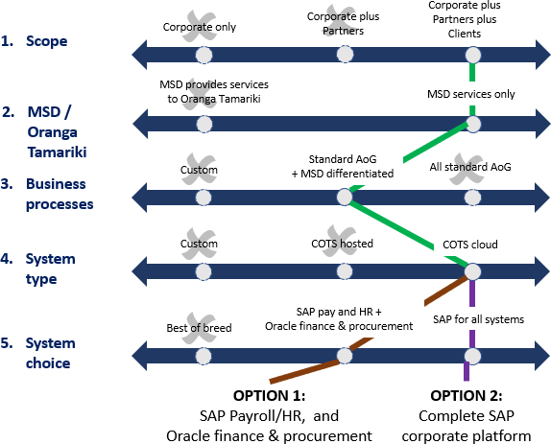
Figure 5 - Strategic Decision Making

Procurement milestones
A decision7 was made to align delivery schedules as appropriate to suit Oranga Tamariki’s implementation and transition to its own payroll solution and any delays that came with it. As such the FMIS procurement was completed in 2020, with the payroll procurement completed in late 2021.

With contracts awarded for the payroll solution in December 2021, the last of the planned milestones for this process have now been met.

FMIS Procurement | Dates
Pre-procurement | 2018-2020
ROI
RFP Stage 1
RFP Stage 2
Post RFP

Payroll Procurement | Dates
Pre-procurement | Feb - Dec 2021
Tender
Evaluation – Phase One
Evaluation - Phase Two
Post-evaluation

- See, https://www.parliament.nz/resource/en-
NZ/53SCSS_EVI_104508_SS1005/c9283dd60c981b317cf34f8e83fb2b638c5ec395 - p. 15

Contracts start: 24 Nov 2020  Implementation Partner  04 Dec  Solution Provider - SaaS & PaaS 2020 |  | Contracts start:  20 Dec  Implementation Partner  2021  Solution Provider - SaaS & PaaS
Table 11 - Procurement Milestones

Contractual arrangements at the time of procurement
At the time of procurement, the contract types awarded to be considered were to be outcomes-based Software as a Service Agreement, using either:
  - An all-of-government Contract or Agreement (if one has been established) for the licensing.
  - Our Master Service Agreement, with some amendment where required for implementation support.

The key performance indicators for measuring supplier performance were to be negotiated based upon what is proposed by the suppliers for each solution, with outcomes likely to be agreed including:
  - implementation and integration plan and timelines.
  - the quality standards / key performance indicators for measuring the supplier’s performance.
  - the timeframes for delivery.

And it was expected that payment will be for:
  - implementation, which will be based upon completion of deliverables as agreed in each Sprint schedule.
  - on-going support, which will be an annual cost, plus license renewals.
Contract provisions
The contract procurements and key procurement milestones were to be determined for each procurement required. The overarching programme approach was:

Contract lengths:
  - SaaS products (FMIS & Payroll) contracts will be entered into on a multi- year basis to enable an aggressive negotiation to secure a long term locked in price.
  - Implementation Partners will be contracted under MSA agreements to provide implementation and in the case of FMIS ongoing support services. Individual statements of work will be entered into for specific outcomes.
Contract management
The responsibility for managing the commercial contracts and the overall supplier relationship management will sit with the Commercial Operations Group (COG) on the signing of the contract. COG will work alongside our Corporate Platform Programme Manager, People Group and Finance Information and Systems to develop respective commercial contracts and relationship management plans in consultation with the successful suppliers.

Completion of the FMIS contract also outlined that:
  - Within 6-months of the completion of transition we will agree a 24-month disengagement plan for EcoSysD.
  - At the expiry or upon termination of the Agreement by us, we will formally notify the supplier of the enactment of the:
    - disengagement transition term and,
    - disengagement plan - stating which plan(s).

Procurement outcomes

Our solution has been confirmed
This choice was made through the procurement process to go with Option 1 – We would acquire an integrated SAP Payroll/HRIS and Oracle FMIS & Procurement solution.

Partners and providers have been selected
We have also selected the partners and providers we will work with to realise the Corporate Platform changes:
  - Accenture NZ has been selected as the Strategic Partner to cover implementation and support services for both the FMIS and Payroll solutions. A Master Services Agreement has been contractually agreed and Statements of Work (SoW) are being agreed to support the project outcomes. The SoW for Accenture to provide Release 1 implementation services was signed in early December 2020. A further SOW will be agreed for Release 2.
  - Oracle NZ has been selected as the Platform as a Service (PaaS) and Software as a Service (SaaS) provider utilising the all-of-government Oracle SFA as the contractual mechanism.
  - SAP Payroll solution has been selected as the Platform as a Service (PaaS) and Software as a Service (SaaS) Enterprise payroll solution with supporting contracts in place.

New contracts are being negotiated
Now that our providers have been selected, and contracts awarded at different times to Accenture NZ, these contracts, including contract provisions and management through to completion are being amended and negotiated to accurately reflect the outcome of procurement for the entire Corporate Platform.

This is also to ensure we have a Contract for Service that accurately reflects the nature of the relationship with Accenture NZ and covers the SaaS approach being proposed and will align with contractual arrangements, where relevant, in alignment with Te Pae Tawhiti.

Probity
Updated probity deeds are being drafted to further acknowledge these selection choices covering the Service Providers selected for the Corporate Platform and consolidate where we started with two separate procurement plans being executed and contracts awarded at different times since this process first began.

These deeds set out our expectations for our service providers, who because of their work for us may obtain information that could unfairly benefit them in responding to our procurements, they must conduct themselves to respond to potentially impacted procurements. We commit to apply such Probity Deed obligations consistently to all relevant MSD service providers.

Accountancy treatment
In accordance with the guidance released by the Treasury regarding Accounting for Software as a Service (SaaS), we are assuming that all costs relating to the build and configuration of SaaS are an operating expense.

Payment Mechanisms
Payment for leading SaaS services is on an annual basis with payment made in advance.
Payment for PaaS services is on an annual basis with payment made in advance. For PaaS services Oracle offers a universal credit for annually committed PaaS volumes and we will annually review and amend this commitment.

Payment for Oracle Guided learning is on an annual basis with payment made in advance. We have entered the full managed service for Guided Learning for a 24-month period and will reassess the ongoing viability of the full managed service post the major implementations.

Payment for implementation partners is made on a time and materials basis.

Financial Case
The purpose of the Financial Case is to determine the funding requirements of the preferred option and to demonstrate that the recommended deal is affordable.

Financial costing approach
We developed our costing model in concert with our delivery partner, Accenture. Together, we worked through the details of the agile teams required to deliver and cost them based on MSA and our internal resource chargeback rates. We identified down to an individual role level who is needed and built up the model.

Impact on the financial statements
Based on current estimates, the anticipated cash flows for the investment proposal over its intended life span are set out in the table below.

$millions
 | 2020/  21 | 2021/  22 | 2022/  23 | 2023/  24 | 2024/  25 | 2025/  26 |  | 2026/  27 | 2027/  28 | Total
Preferred Way Forward:
Capital | $- | $- | $- | $- | $- |  | $- | $- | $- | $-
Operating | $0.638 | $36.699 | $47.761 | $13.473 | $7.474 | $6.743 |  | $6.743 | $6.743 | $126.273
Total | $0.638 | $36.69  9 | $47.76  1 | $13.47  3 | $7.474 | $6.743 |  | $6.743 | $6.743 | $126.273
Funded by:
Existing Revenue | $0.638 | $9.557 | $19.242 | $15.057 | $14.407 | $14.407 |  | $14.407 | $14.407 | $102.124
Existing Capital | $12.580 | $34.835 | $- | $- | $- | $- |  | $- | $- | $47.415
Proposed Expense Transfer | $- | $- | $- | $- | $- | $- |  | $- | $- | $-
Extra Revenue | $- | $27.142 | $28.518 | $(1.584  ) | $(6.933  ) | $(7.665  ) |  | $(7.665  ) | $(7.665  ) | $24.149
Extra Capital | $(12.58  0) | $(34.83  5) | $- | $- | $- | $- |  | $- | $- | $(47.415)
Total | $0.638 | $36.69  9 | $47.76  1 | $13.47  3 | $7.474 | $6.743 |  | $6.743 | $6.743 | $126.273
Table 12 - Anticipated Cash Flows

Assumptions
The following assumptions have been made in determining estimates:
  - Resources have been costed at time and materials.

  - All FMIS costs up to 30th September 2021 are actuals.
  - FMIS MSD staff (internals and externals) costs from 1 Oct ‘21 is based on estimated FTE’s required, which was worked through with the Programme Manager, Product Owner and IT. The calculation is as follows: FTE * Percentage Required * Number of working days in the month * average daily rate of $1,000 per day for IT and $640 per day for business resources.
  - Accenture costs to the end of Release 1 are based on an SOW provided by Accenture. Costs for Release 2 are based on a combination of what was provided in the RFP’s and what Accenture expected would be consumed. It was also reviewed and scrutinised by the Programme Manager, Product Lead, and IT.
  - Software Licences for Payroll have been based on the SAP Cloud Framework Agreement, and it is assumed that MSD will sign up for this.
  - FMIS Release 2, Payroll and discovery and design include a contingency of 15% due to higher confidence of certainty of costs.
  - Overheads have been calculated on MSD resources as standard practice, but we have used a reduced daily rate of $39pp per day instead of $78.
  - The FMIS licences and support and maintenance costs came from the Oracle contract. From July ’22 we increased the costs for licences because the original costs were based on 8,500 users but increasing MSD headcount will raise the number of users to 10,000.
  - The rationale above has been applied to Payroll licence costs.
  - There will be no expenditure incurred in 20/21 for Payroll, and that it will now start in 21/22 and finish in 22/23.
  - FMIS release 1 started in 20/21 and is expected to be completed by April 2022. Payroll and FMIS Release 2 is scheduled to begin the second half of 21/22.
  - There is a Contingency of 15% on MSD costs and Accenture costs. There is no contingency on the cost pressures (i.e., Organisational Change and Split with OT).
  - There is $8m included in the periods 20/21 to 22/23 for one-off Organisational Changes. There is no funding for ongoing new roles.
  - Finance will have a $2.7m cost pressure due to the split with OT (will lose some economies of scale). There will be a 100% cost pressure in years 1 and 2. 75% cost pressure in year 3, and 50% cost pressure in year 4 onwards. It is assumed that OT will have their FMIS ready as of 1 April 2023.
  - Payroll and HR will have a $0.9m cost pressure due to the split with OT (will lose some economies of scale). 100% cost pressure in years 1 and 2. 75% cost pressure in year 3, and 50% cost pressure in year 4 onwards. It is assumed that OT will have their Payroll ready as of 1 October 2022.

Accounting for Software as a Service (SaaS)

  - In accordance with the guidance released by the Treasury regarding Accounting for Software as a Service (SaaS), we are assuming that all costs relating to the build and configuration of SaaS are an operating expense.
  - Before this guidance was released, we were treating costs relating to the configuration of SaaS as a capital cost. We had received both Capital and Operating funding for the Corporate Platform through Budget 20 and

Budget 21. As outlined in table 14, this means that our proposed funding profile does not match the funding received.
  - We have expensed all the work to date in the 2021/22 financial year.

  - Our anticipated cash flows in table 14, details the total cost of what is required, and subtracts the funding already received, showing the difference as extra revenue. Some of the funding we have already received is for depreciation and capital charge which will no longer be required. We are assuming this can be used to offset operating costs in the first instance. If this is not the case we will require more funding than we have included in our Budget submission.

Funding sources
It is proposed that the additional funding required for 2022/23 is sought/provided via the Budget 22 bid process.

Overall affordability
The proposed whole of life cost of the Corporate Platform is $126.273million8 over the eight years of the expected lifetime of the programme.

The Senior Responsible Owner (SRO) has signified her agreement to the required level of funding required. The SRO’s letter is attached (Annex 1).

Our current operating baselines are insufficient to cover the 2022/23 shortfall identified in Table 14.

- Whole of Life costs excludes depreciation and capital charge, in line with Treasury guidance

Management Case
The Management Case confirms that the Corporate Platform programme is achievable and details the arrangements needed to ensure successful delivery and manage project risks while focusing on delivering benefits.

History of delivering change
MSD has a track record of delivering complex change while continuing to deliver services for New Zealanders. Our capability has been built up over many decades of social policy implementation, machinery of government changes, organisation structure changes, formal partnerships and working relationships, IT systems upgrades, incremental improvement initiatives and large programmes. Our policy and welfare settings have been subject to regular change.

The Ministry already operates in an environment where we are responsible for integrating delivery of numerous projects and programmes to respond to the needs of our clients.

Our approach supports the early and regular delivery of value and will help ensure responsiveness and adaptability
We will use a variety of methodologies to deliver the Corporate Platform, including agile. This enables us to deliver continuous and early value over a series of releases for our clients, the government, staff, and partners. It allows us to prioritise as necessary including the ability to respond to adverse events and government priorities.

Agile approaches are embedded into everyday work at MSD
MSD continues to develop and embed its agile ways of working across the organisation. This approach is becoming more natural and normal. While it is not the only way that MSD delivers change, it is becoming the primary way.
In alignment with GCDO direction9, we started using this approach to support change implementation in 2016 in the technology area. It involved the adoption of incremental planning and implementation, multi-disciplinary teams, and continuous improvement to how we planned and prioritised work.
During 2019 we phased in the new way of working to non–technology business groups at MSD, in the Employment and Income Support areas. This helped when, in 2020, we had to deliver new services at pace as part of the government's support package for COVID-19. This approach propelled the establishment of 11 Portfolios to provide better alignment between strategy and delivery.
Agile has been used in the Corporate Platform programme journey to date. We continue to engage with other large organisations in the public and private sectors on their agile approach to gain insights to inform our approach and continue to grow our agile capability.

- https://www.digital.govt.nz/standards-and-guidance/governance/system-assurance/all-of-government-portfolio- programme-and-project-assurance-framework/

Our agile framework and implementation partner methodologies
The Corporate Platform operates within the SAFe framework. By its nature, the ceremonies and techniques that have been adopted allow for more accurate management of internal resource allocation and work and currency of information and escalation to decision-makers.
Accenture NZ has been named the trusted implementation partner for delivering FMIS & Procurement and Payroll projects. Through a master statement of work covering their respective procurement bids for each solution, they will also bring their own implementation methodology to be successfully partnered with our agile framework.

Accenture NZ’s methodology also forms the basis of the detailed planning of programme activities that will be executed, i.e., backlog tasks, specific deliverables to be produced and associated resource demands for the quarterly program increment planning activity.

A clear understanding of the Minimum Viable Product based on utilising industry leading SaaS supported by the adoption of the all-of-government Common Processes ensures scope and the backlog can be well-managed, and the change impacts are understood and managed appropriately. We will have clear roles and responsibilities within each epic to enable best practice product ownership and management.

Robust project disciplines are enforced by having a Release Train Engineer and Scrum Lead embedded within the epics. Annex 5 provides an overview of the PI planning process and the associated ceremonies.

Based on the implementation partners statement of work, formal reporting is completed, and forms part of the overall pack reviewed by the Product Management Group. The group is more aligned to a traditional steering committee than our agile practices to provide extra oversight of project status and progress.

Agile coaches will provide agile assurance and coaching on an ongoing basis once the epics are up and running. We will review and agree on our agile assurance approach for a specific epic within 60 days of the statement of work being agreed with Accenture NZ.

MSD operates an integrated programme of work across core portfolios – into which the Corporate Platform is integrated
The Integrated Work Programme (IWP) is currently made up of 11 established portfolios (the number of portfolios may evolve over time). A portfolio is a team of people delivering a change work programme that aligns to MSD’s Strategy. It helps ensure we are working on the right things in the right order to support the Ministry’s outcomes.

Portfolios are organised around a collection of value streams and delivery teams to deliver value to MSD staff and our clients.
There are two types of portfolio at MSD:
- Service Portfolios – these align with the mahi that we do with our frontline teams, our clients, and our communities.
- Enabling Portfolios - these focus on the mahi required to support the service portfolios and to keep the Ministry safe.

The relationship between the enabling and service portfolios is illustrated in the following diagram.

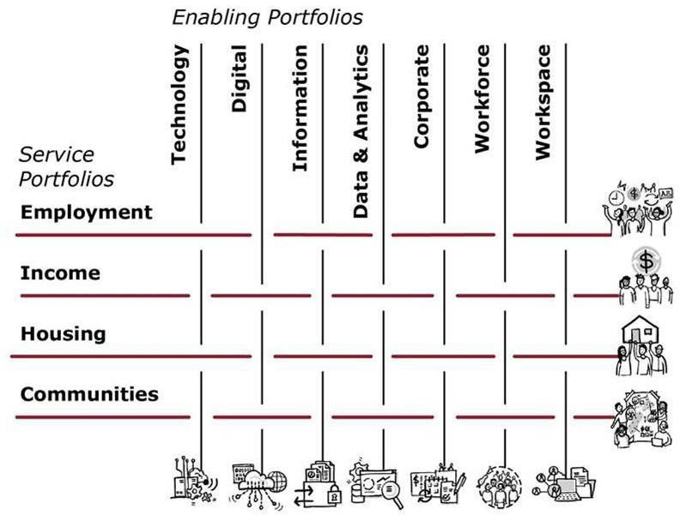

The Corporate Platform programme sits within the Corporate Portfolio.
Each Portfolio will have a Portfolio roadmap to align to strategy, policy, and operational work programme. The collective Portfolio roadmaps make up the IWP which LT has oversight to ensure confidence in capacity and capability to deliver value and achieve the results expected. This structure helps align the Corporate Portfolio to the delivery of work, by prioritising of the right things at the right time to support our outcomes.

Portfolio Management
The Portfolio has an owner and a resource pool. The Portfolio leads the development of products and services for our clients, partners, staff, and stakeholders.

Each Portfolio develops a Portfolio Roadmap of the epics to be delivered in short to medium term. The roadmaps set out the work aligned to our strategy, policy work, programme and the capability and the funding required to deliver.

The work of the portfolios is governed and managed by the Business Owner, typically supported by a Portfolio Manager and the Portfolio teams. Within each Portfolio, teams of people work together to deliver outcomes aligned with organisational, strategic, and portfolio priorities.
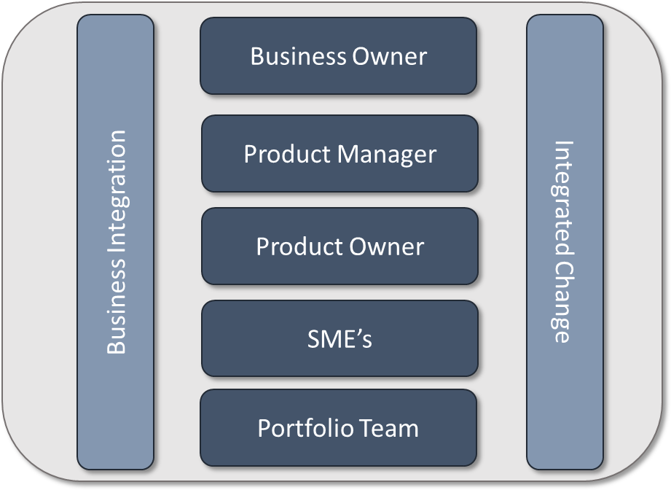

Term | Description
Portfolio Owner | Accountable for the successful delivery of the initiative directs allocated resources to achieve agreed value within agreed budget and time, manages portfolio changes in response to external or internal circumstances and events and manages governance and compliance.  The Portfolio Owner will evaluate fitness for use and actively participate in all Programme and Product Management Group events listed in the Agile Practice and Ceremonies section.
Business Owner | The Business Owner is ultimately responsible for the value streams within the portfolio. This role has oversight of all work in the portfolio and manages relationships with key senior stakeholders.  The key stakeholder who holds the primary business responsibility from the relevant area that might be affected by the introduction of the Corporate Platform changes. The Business Owner will work closely with the Portfolio Owner and Product Manager to create alignment between Product vision / Roadmap and business objective, provide input to the business change impact and assist the programme team  in removing blockers or impediments.

Term | Description
Product Manager | The Product Manager supports the Product Owner with integrated planning, runs portfolio stand-ups, and is part of the Product Manager sync up. Have content authority for the Programme Backlog. They are responsible for identifying Customer needs, prioritizing Features, guiding the work through the Programme Kanban, and developing the programme Vision and Roadmap.
Product Owner | Are members of the Agile Team responsible for defining Stories and prioritizing the Team Backlog to streamline the execution of programme priorities while maintaining the conceptual and technical integrity of the Features or  components for the team.
Figure 6 - Portfolio Structure
Programme Increment (PI) planning
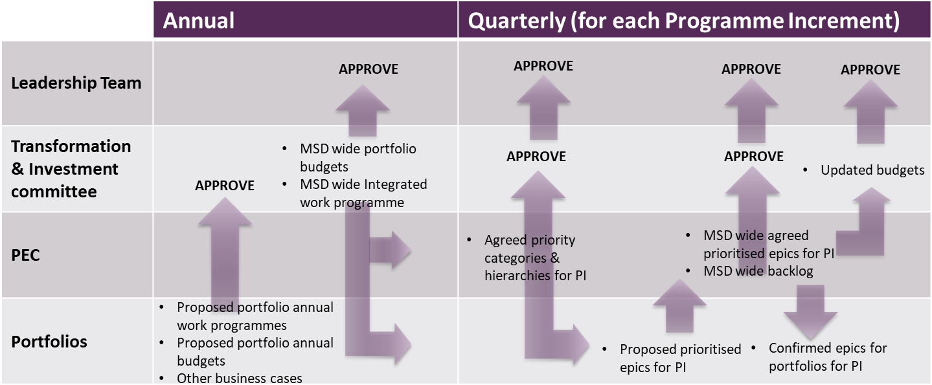
MSD establishes an integrated work programme and budget every 12 months and then reviews and revises on a PI-by-PI basis based on value priorities.
Figure 7 - Programme Increment Planning Process Summary
Each quarter, priorities for each PI are re-evaluated, and an organisation-wide prioritised set of “epics” agreed. In Agile parlance, an epic is a large chunk of work with a common objective that can be completed within a programme increment. Therefore, it is the level at which change work is prioritised across the Ministry.

The prioritisation and planning for each PI start with PEC confirming the priorities for choosing which epics will be agreed for the PI. Each portfolio confirms its list of epics for the programme increment and priorities. PEC then meets (multiple times) to agree and challenge the overall ranking of all the epics against the agreed priorities.
Regular reprioritisation supports continued organisation agility
This approach of regular, transparent reprioritisation enables us to be especially agile in its response to the changing environment and responding to new

government priorities. It helps ensure that we take a joined-up approach to change across the organisation and reduces duplication of effort.
Two cross-portfolio functions support portfolio management
The Business Integration function is responsible for:
- Leading the formation and providing visibility of our integrated work programme. Ensuring that there is an integrated work programme roadmap to guide the overall work programme.
- Ensuring there is a clear vision and design for our future services model.
There is an Integrated Change Management team that provides change management support across the portfolios and is responsible for:
- The overall change management methodology.
- Change management advice to portfolios.
- The maintenance of a cross-portfolio change calendar to support cross- portfolio change.

Governance of the Corporate Platform starts with the Leadership Team
The work that is delivered by the portfolios is governed through an integrated governance framework that ensures strategic integration of the change work taking place across the whole of MSD while continuing to have a view of business-as-usual activities. The governance structure is centred around our Leadership Team as the primary governance group.
To enable the Leadership Team to focus on overarching and strategic issues and support quality decision-making, the Leadership Team has governance committees with authority to make decisions on behalf of the organisation. The committees are responsible for assisting Leadership Team to achieve the strategic direction through governing matters relating to their area of responsibility.

Ensuring the proper representation within the governance structures will help to ensure that the Corporate Platform is well aligned and is committed to delivering on our investment objectives. Alignment with other key governance structures that are in place within MSD has been considered to help drive consistency and obtain the greatest value from the information available.

Governance and Leadership Structure
The diagram below shows the governance framework for MSD portfolios (which includes the Corporate Portfolio), and the relationships and touchpoints of the various parts of the system:

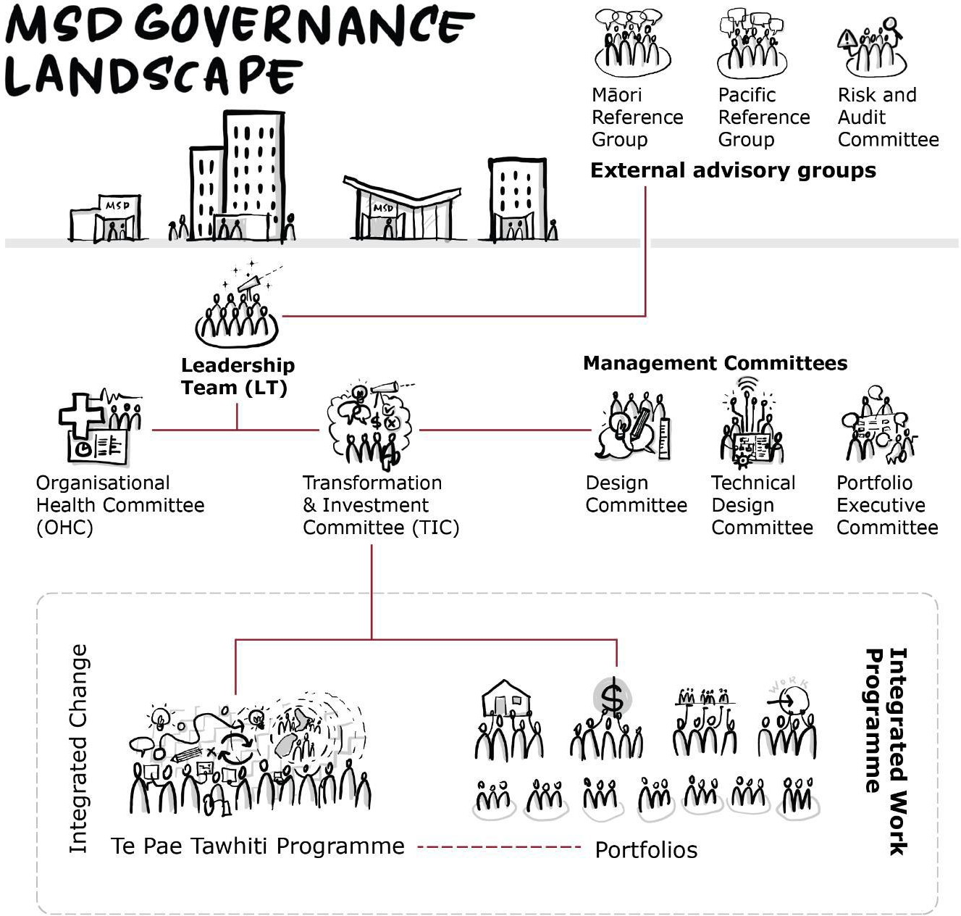

Figure 8 - Governance Landscape

The table below outlines the core responsibilities of the Leadership Team and governance committees: *

Note, further details on the roles and responsibilities of these groups are contained in their respective Terms of Reference.

Group | Role in relation to the Programme
Leadership team (LT) | Overall governance (meets weekly):  - Makes organisation-level significant strategic/design/prioritisation decisions  - Determines funding/budget for the programme  - Signs off significant programme artefacts (e.g., DBCs)  - Monitors overall programme status and any action required through quarterly reporting  - Commissioning and approving the external and internal Budget approach and package  - Approving external accountability documents  - Approving industrial relations principles and agreements  - Officers under the Health and Safety at Work Act 2015
Organisational Health Committee (OHC) | OHC is next-level governance from LT (meets quarterly):  - Manage the impacts of Corporate Platform on our people and resources  - Support the transition and plans to manage identified change impacts (particularly for frontline staff and clients)  - Monitors that our priorities are identified and delivered on and any action required  - Providing assurance to LT and the Risk and Audit Committee on organisational risks.  Accountable to LT.

Transformation & Investment Committee (TIC) | TIC is next-level governance from LT (meets fortnightly:  - LT’s main governance subcommittee and makes next- level significant strategic/design/prioritisation decisions.  - Monitors funding/budget for the programme  - Organisational transformation and performance support delivery of our strategic objectives, purpose, and outcomes.  - Steers/shapes significant programme artefacts (e.g., DBCs)  - Approves portfolio strategies, roadmaps, and funding  - Driving investment and performance maturity and capability.  - Ensuring alignment of the programme with MSD’s organisational strategies  - Monitors programme status and any action required through monthly reporting.  Accountable to LT.
Senior Responsible Owner (SRO) | The Senior Responsible Owner (SRO) has overall accountability for Corporate Platform. They ensure it meets its objectives, delivers the desired outcomes, and delivers value that will enable benefits to be realised.  The SRO is the visible owner of the overall business change and will make sure the delivery team is focused on achieving its objectives. They provide confidence to the Chief Executive that the investment will deliver the expected outcomes and benefits. The SRO will be recognised throughout MSD as the key leadership figure in driving the change forward.  Delegated responsibility from LT for the management of the programme. Is a member of TIC.  Accountable to LT and the Chief Executive.
Table 13 - Core Responsibilities of Governance and Leadership

Delivery advisory committees and functions provide key decision-making and advisory support in specialised areas. The relevant groups that operate in an advisory role to Corporate Platform are detailed below:

Group | Advisory role in relation to the Programme
Māori Reference Group | Provide a strategic reference point and give advice on the design and implementation of social strategies and policies that impact Māori.  In relation to Corporate Platform, the Reference Group advises the Leadership Team on matters relating to positively transforming outcomes for Māori and the  implementation of our policies, services and initiatives that impact Māori.  Advises LT.
Pacific Reference Group | Ensure the actions and initiatives that come out of the Pacific Prosperity Strategy and Action Plan are effective for Pacific peoples.  In relation to Corporate Platform, the Reference Group advises the Leadership Team on the actions and initiatives that come out of Pacific Prosperity Strategy and Action Plan are effective for Pacific.  Advises LT.
Risk and Audit Committee (RAC) | Provide independent advice to the Chief Executive on the Ministry’s risk management processes including  - oversight and monitoring of significant risk management issues, including remediation actions required,  - the resolution of significant issues and monitoring, control functions performance.  - reporting the outcome of any independent reviews of the risk management process.  In relation to Corporate Platform, the RAC are part of the MSD lines of defence model.  Accountable to the Chief Executive.
Design Committee (DC) and Technical Design Committee (TDC) | DC and TDC are advisory bodies that provide assurance to TIC that Project components are aligned to desired organisational design and technical design principles.  In addition, TDC ensure our technical solutions align with our Technology and Data Information Strategies.  Advisor to TIC.
Chief Privacy Officer (CPO) | Decision making authority for privacy considerations.  Advisor to TIC.
Chief Information Security Officer (CISO) | Decision making authority for security (IT and Information) consideration.  Advisor to TIC.
Procurement Group | Procurement decision making for procurement over $100k.  Advisor to TIC.

Portfolio Executive Committee (PEC) | Under the strategic direction of TIC, PEC provides  prioritisation and optimisation of MSD’s resources related to portfolio investments to support Corporate Platform.  Advisor to TIC.
Table 14 - Advisory Committee Functions

Programme roles and responsibilities
We have designed a management structure to support agile development and implementation of the Corporate Platform. The current key roles are shown below: [Redacted content].

Figure 9 - Corporate Platform Management Arrangements

FINAL – BUDGET SENSITIVE

The key roles and responsibilities are summarised below:
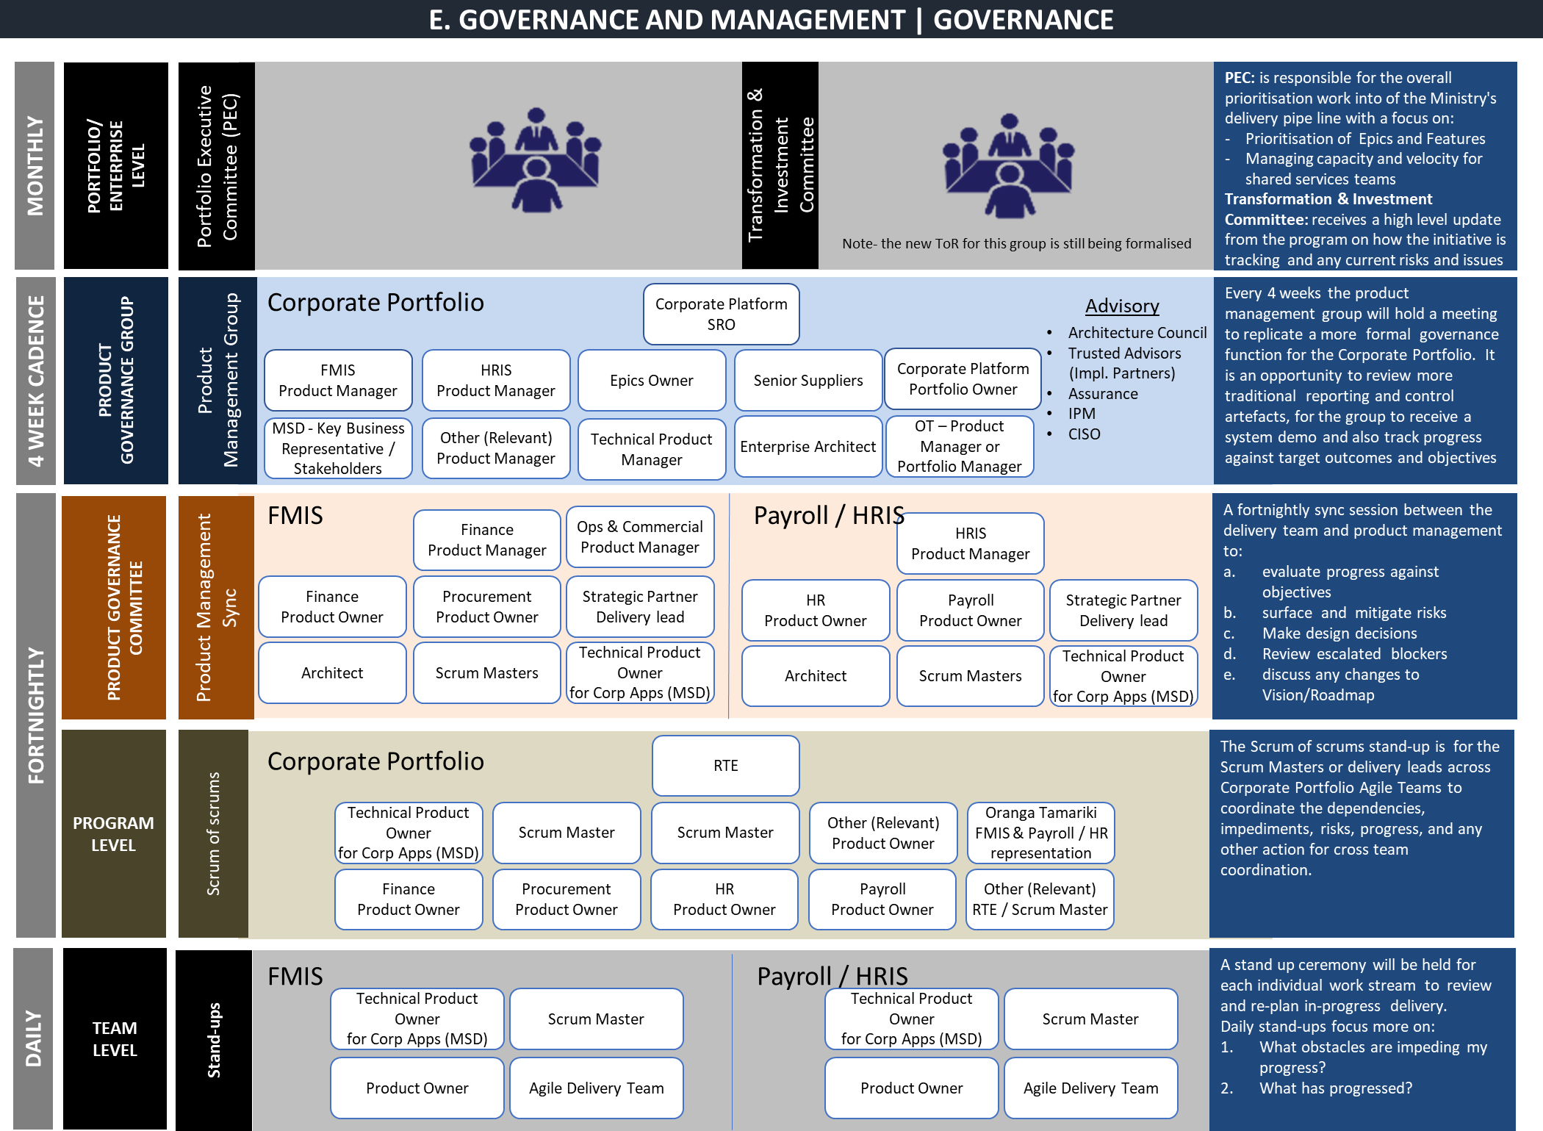

Figure 10 - Corporate Platform Structure

Product Management Group membership
The following are members of the Product Management Group:

Role in Programme | Person | Role in MSD
SRO | Nadine Kilmister | A/Deputy Chief Executive People & Capability
Corporate Platform Portfolio Owner | Karen Dawson | Group GM Commercial Operations
Business Owner Finance | Lara Ariell | Group GM Finance and Chief Financial Officer
Business Owner Human Resource and Payroll | Cain McLeod | Group GM People
Business Owner Procurement | Karen Dawson | Group GM Commercial Operations
Implementation Partner | Suraj Sowki | Accenture Account Lead
Solution Provider | Hugh McParland | Public Sector Customer Success Executive (Oracle)
Business Owner Technology | Tracy Voice | Group GM Improvement System & Technology
Secretariat | Rebecca Platts | Portfolio Coordinator
Table 15 - Product Management Group Membership
Programme reporting arrangements
The proposed internal and external governance reporting are as follows:

Recipient | Reporting Need | Primary Report
GCDO | Visibility that the programme is on time, within budget and managing its risks. | Corporate Platform Programme monthly dashboard
Treasury | Visibility that the programme is on time, within budget and managing its risks. | Corporate Platform Programme monthly dashboard
Transformation & Investment Committee | Provides overall governance for the portfolio  - Tests and approves strategy for corporate platform.  - Tests and approves budgets and associated plans to deliver agreed value against these budgets.  - Monitors and tests progress against budget, time, and value delivered.  - Tests and approves changes to the value, plans, budgets. | Summarised Programme Status Report

Recipient | Reporting Need | Primary Report
Risk and Assurance | Evidence that the Programme is operating effectively, delivering within the agreed tolerances, Programme impacts and risk profile. | Corporate Platform Programme monthly dashboard, External and Internal assurance reporting
Integrated Portfolio Management (IPM) | Visibility that the Programme is tracking towards benefit realisation, delivery performance i.e., on time, within budget and managing its risks. | Corporate Platform Programme Fortnightly Product Sync update (email) and monthly dashboard  Quarterly benefits reports
Portfolio Owner | Evidence that the Programme is operating effectively, delivering within the agreed tolerances. | Corporate Platform Programme Fortnightly Product Sync update (email) and monthly dashboard  Business Representatives on programme, External and Internal assurance providers
Product Management Committee | Evidence that the Programme is operating effectively, delivering within the agreed tolerances. | Corporate Platform Programme Weekly Product Sync update (email) and monthly dashboard  Business Representatives on programme, External and Internal assurance providers
Product Management Group | Evidence that the Programme is operating effectively, delivering within the agreed tolerances. | Corporate Platform Programme Monthly Product Management Group meeting & report
Table 16 - Programme Reporting Arrangements

Use of special advisors
The Corporate Platform will need to draw on a wide range of internal and external specialist capabilities to design, integrate and deliver the Corporate Platform outcomes.

Product Owners and Subject Matter Experts (SMEs) have been appointed to support the Corporate Platform renewal. We have established communities of practice and organised groups of people with a common interest in a specific technical or business domain. They regularly collaborate to share information and improve their skills.

We will engage with IR to validate our design, integration, and delivery by using IR ECHO materials instead of going through the process of building our own.

It will help to reduce the delivery risk as we use partners and products we know have worked before. We will further draw upon previously used training materials as much as possible.

The use of special advisors will be throughout the life of the Corporate Platform to support the successful delivery and achievement of the benefits. The following special advisors have already been engaged:
- Accenture is the implementation partner for FMIS and Payroll. Accenture has also reviewed the design decisions for Release 1 and assured us that the long-term outcomes of the Portfolio have not been compromised.
- IQA NZ performs reviews to provide independent external assurance.

Personnel implications
Subject Matter Experts (SMEs) and any additional costs that may arise are paid by Corporate Platform, which also factors in a higher duties allowance if appropriate. If business as usual (BAU) needs to get a contractor to replace SME, the Corporate Platform will pay the difference to BAU.

Corporate Platform Outline Programme Plan
As per the preferred option, the Corporate Platform programme is estimated to be complete in approximately two years' time and to complete and release the following Corporate Platform epics:

FMIS &  Procuremen t Release 1 | Finance  Financials Management Expenses  Project Accounting | Procurement Requisitions/PO’s Supplier Portal  Procurement Contracts | Reporting  Base Product
Payroll | Employee Central Payroll  MSD Pay Processing Off-cycles payment Termination | Integration  New FMIS  IRD Reporting Bank Files | Reporting  Payroll Reconciliation
FMIS &  Procuremen t Release 2 | Finance Budgeting and Planning Capital & Project Planning  Allocations/Reporting | Procurement  Sourcing  Contract Management  Procurement Analytics | Reporting & Analytics  CEIS/FCC and output reporting
HRIS | Succession & Development IPS  Workforce Analytics Performance & Goals Compensation  Service Centre

Table 17 - High-Level Corporate Platform Renewal epics

We are funded to deliver until the end of PI 23 (end of September 2022) at which time several of the Programme Milestones will have been completed or will be in progress:

Milestone | Project | Phase | Start | End | Status
Procurement & Project Setup | FMIS & Procurement | Horizon One | PI 15 | PI 16 | Complete
FMIS & Procurement Release 1 | FMIS & Procurement | Horizon One | PI 17 | PI 22 | In Progress
Integrations | FMIS & Procurement | Horizon One | PI 17 | PI 20 | Complete
Procurement & Project Setup | Payroll & HRIS | Horizon One | PI 18 | PI 20 | Complete
Migrate OT off MSD Platform | External | Horizon One | PI 19 | PI 23 | In Progress
Funding of the preferred option is required to complete several milestones in progress and start any more beyond PI 23.
Payroll | Payroll & HRIS | Horizon One | PI 21 | PI 27 | In Progress
FMIS & Procurement Release 2 | FMIS & Procurement | Horizon One | PI 21 | PI 26 | In Progress
End HRIS & Payroll (OT) Shared Service | External | Horizon One | PI 23 | PI 25 | In Progress
Retire Kea (MSD) | Payroll & HRIS | Horizon One | PI 25 | PI 25 | Not Started
HRIS | Payroll & HRIS | Horizon One | PI 27 | PI 30 | Not Started
Retire Chris21 + Yuri (MSD) | Payroll & HRIS | Horizon One | PI 29 | PI 30 | Not Started
Table 18 – High-Level Programme Schedule

Not continuing this path would undermine Corporate Platform benefits, raise several new risks associated with the project resourcing and off-ramping undelivered scope back onto the business, and require significant project and change management replanning.

Further details on the Corporate Platform Roadmap can be found in Annexes 4.

Organisational change management
Corporate Platform and Portfolio delivery, and continuous improvement, are significantly influenced by the effectiveness of change management. We will update our change management approach where necessary throughout the life of the Corporate Platform, to support changing organisational needs.

We have a comprehensive Change Management Framework that sets out key elements of the change implementation approach and supporting principles.

Our change approach, in its simplest form, is broken into three key stages:
- Plan (warm-up).
- Implement (launch).
- Sustain (follow up).

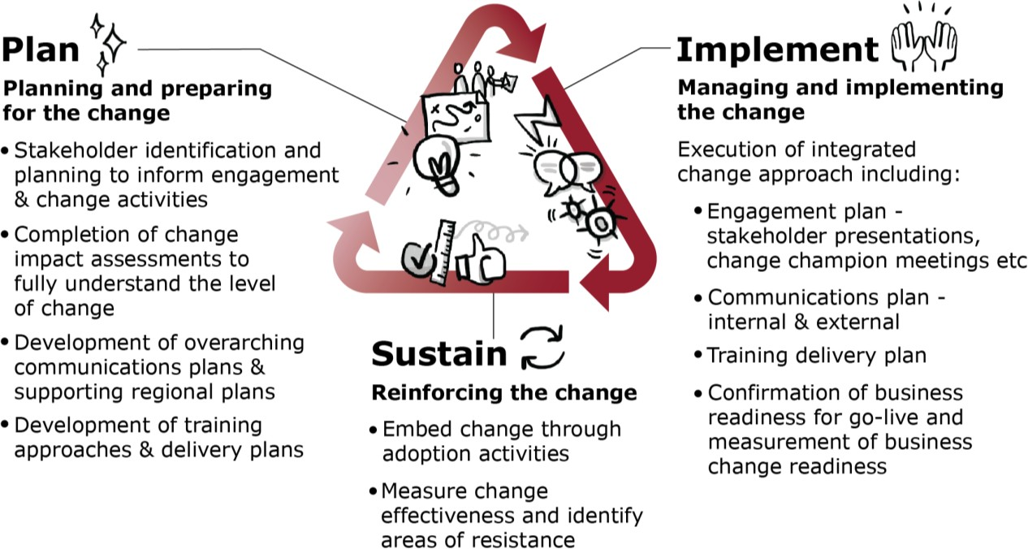

Figure 11 - Change management approach

Change management is driven by clear principles centred around delivering value to our clients and whānau
Our guiding set of change principles provides insight into the human side of change. It guides our behaviours when managing and leading change. The set of principles recognises who we are as an organisation, how we work and what we have learnt to date about implementing change at MSD.
- People and whānau focused – People and whānau are at the centre of the design, development, and delivery of everything that we do. This is so we can support them along their journeys and be responsive to their needs – thus enhancing the wellbeing of New Zealanders.
- Future focus - We remain committed to our vision and purpose, and engagement activity retains constancy and understanding of the story.

- Change is leader-led – Our leaders are aligned and enabled to effectively 'tell the story' and understand how we will deliver.
- Targeted and transparent –Our communication clearly articulates the 'why' and is tailored to our stakeholder groups. Client and staff stories are utilised where possible to illustrate change outcomes.
- We work collaboratively - Change programmes and activities are developed by working with representatives across MSD, so staff are meaningfully engaged throughout the Programme. We engage early and ensure change is embedded.
- Measure and adjust – We understand and communicate our outcomes, celebrate achievements, and look to improve continuously.

Change is integrated across portfolios through common methods and a single change calendar
To ensure that change is integrated, we:
- Are growing our change management capability to ensure the change is coordinated, integrated, and embedded in all portfolios.
- Have built a consolidated, integrated view of change impacts on the frontline. The change calendar sets out the change sequence and helps inform deliberate choices around change deployment approaches.
- Identify any risks regarding the pace and the amount of planned change activity.
- Review the data and trends of change impacts (linking with other initiative data such as benefits).
- Have a consolidated change management plan agreed by senior governance and endorsed by Portfolio Owner.
We expect our change management approach to mature and refine as Corporate Platform complexity is further understood through detailed planning and engagement with stakeholders.

Change Management for FMIS Release 1
Change plans for Release 1 of the FMIS solution articulate the impacts to people, the methodology being applied, and the levers already required to prepare and support people through the organisational impacts across several profiles or personas:

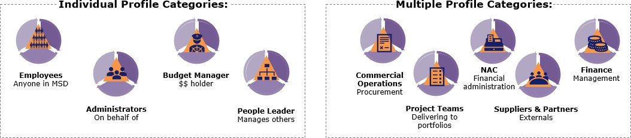
Figure 13 - Profile Categories

These plans also provide an overview of the effort required by the Corporate Platform to manage the change and of the business to adopt a new FMIS solution successfully. High-level changes for all stakeholders include:
- Changes to Finance activities – improvements to core, project, and budget management tasks.
- Changes to the way we buy – simplified processes, approvals, electronic expenses, and receipting.
- Changes to the way we engage externally – introducing a supplier portal and punch-out functionality.

As the Corporate Platform continues to deliver as planned, ongoing change management planning and iteration will be required to successfully execute all change initiatives and eventually sustain the new ways of working beyond the programme's life. While there are higher impacts for the back-office teams, project teams or externals who manage or heavily rely on these corporate services, the Corporate Platform will impact us.

A change enablement plan is established for May-December 2021 the duration of FMIS Release 1 with which stakeholders have been engaged. There are three focus areas for the change enablement plan, including impacts, communications and engagement, and training. A detailed summary of the change enablement plan for each focus area is in Annex 7. The change enablement plan will be updated to align and reflect each FMIS and Payroll Release.

Stakeholder engagement
Constructive engagement with our stakeholders is critical in supporting successful change, building trust, and supporting people to work or interact with us differently. We are well-placed with existing solid relationships with stakeholders, including clients and whānau and a range of well-established channels to use to connect with them.

We have learned from other Government agencies undertaking transformations; early engagement leads to better outcomes. All our engagement activities will be guided by a commitment to engaging early and proactively with stakeholders to build genuine and meaningful partnerships that will allow us to deliver change and achieve the best possible outcomes for clients and whānau.

Our detailed stakeholder mapping process and engagement plan ensures we connect with the right people at the right time throughout the lifespan of the Corporate Platform. It will be a living document, reviewed and updated regularly to reflect each Release. It is supported by an engagement plan setting out internal and external communications plans to ensure our message is clear, consistent, timely and uses the range of channels available to us in the most effective manner.

Benefits management planning
The Corporate Portfolio has a Benefits Register and a Benefits Realisation Plan that articulates the value being delivered by the Corporate Platform.

We are developing a Value Management Framework which will ensure that there is a link between the delivery of value to the achievement of outcomes from the portfolio roadmaps.

Effective benefit management and realisation planning will:
- indicate the extent to which benefits are being realised
- focus on high impact and high priority benefits to maximise use of resources
- give early warning of potential problems and create the opportunity to adapt the benefits or changes to enable the overall objectives
- ensure that achieved benefits are measured, reported, and communicated.

Value Reporting
Reporting and monitoring of value delivered is an integral part of Corporate Platform. We will measure and report the value expected and realised for each epic on a quarterly basis. Regular monitoring of value delivered will enable us to identify any issues and adjust quickly to ensure we remain on track for key value realisation points, as set out in the Corporate Platform Renewal Horizon roadmap and Benefit Realisation Plan.

The Corporate Platform will:
- Report back to Cabinet within 12 months after the in-service date on the actual level of benefits achieved compared with those approved in this DBC.
- Provide information to Treasury at agreed intervals on the actual level of benefits achieved compared with those identified in this DBC.

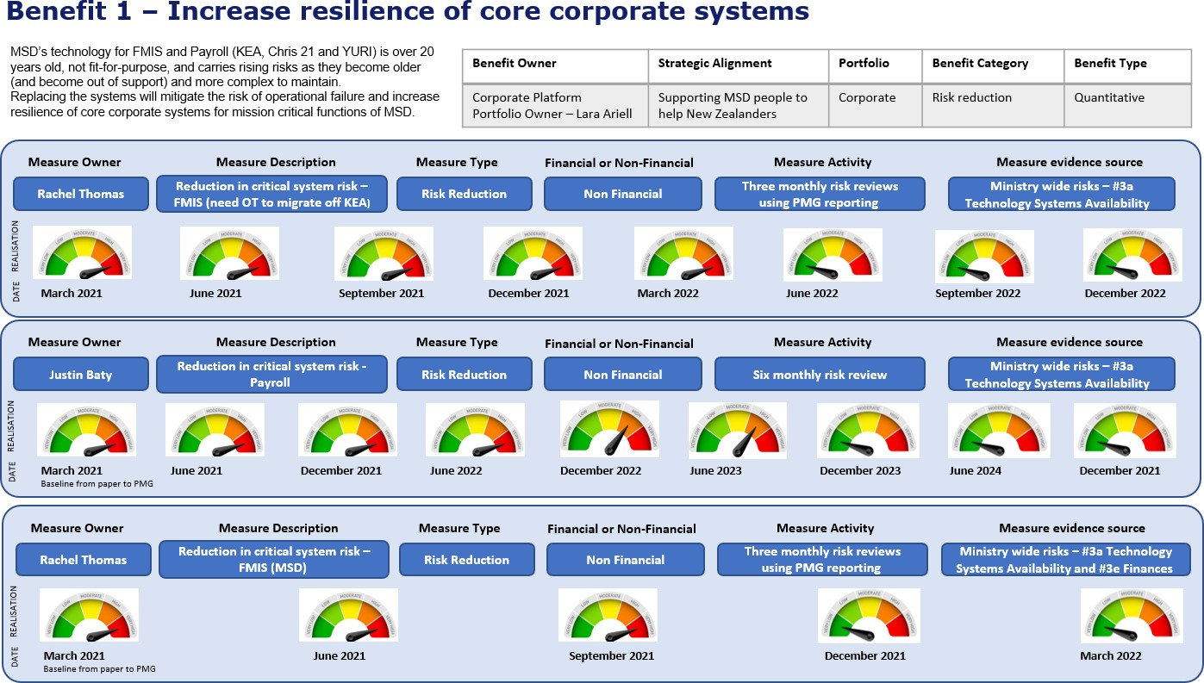

Figure 12 - Benefit One Summary

FINAL – BUDGET SENSITIVE

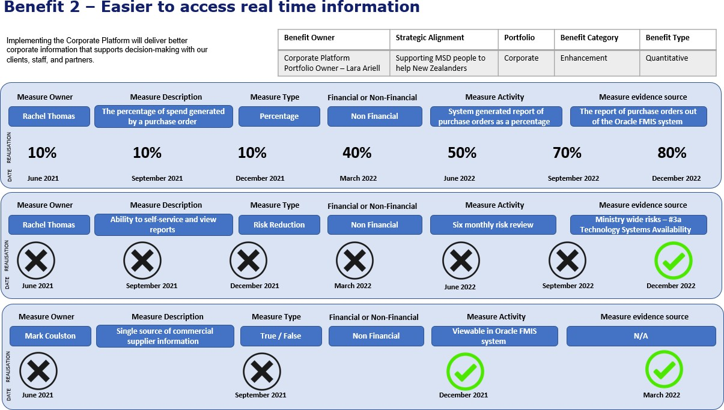

10
Figure 13 - Benefit Two Summary

- Corporate benefit Profile 2 September 2021

Risk management planning
Risk management is used to ensure a proactive approach across the Ministry to support the achievement of investment objectives.
Risk management
The Portfolio Manager holds a Risk and Issue Management Strategy and a Risk Register and is being actively managed and tracked. There is an intensive focus currently on nine identified high risks. With appropriate mitigations agreed or already in progress, eight of these can be reduced to medium risks. The risk analysis is detailed in Annex 6.

Ongoing risk management will be in place to ensure the needs of the Corporate Platform are prioritised, and senior stakeholders are engaged readily and frequently on the progress and issues faced through implementation.

A risk register is managed for each epic and is regularly and frequently reviewed and updated throughout the course of the Corporate Platform.

Risk Identification:
The Corporate Platform risks are identified, assessed, and recorded on the Corporate Portfolio risk register and reviewed regularly. These risks are used to provide an integrated portfolio view in regular reporting.

In alignment with agile, value stream level risks are discussed and progressed at weekly meetings. Team level and workstream delivery risks are identified, categorised, and managed at the stand-up team meetings and the information maintained in their Portfolio risk register.

At a minimum, reviews of all risks occur at each program increment planning and sprint, identifying and assessing the risks and determining controls and planned mitigations. Each backlog identifies and includes a risk and impact assessment in delaying or stopping a piece of work. We undertake regular reporting and governance touchpoints to ensure best practice management of risk and risk oversight for the SRO, LT, and TIC.

Risk Assessment
Once a risk has been identified, it is assessed using ROAM as one of the following:
- Resolved – The risk has been assessed and is no longer a concern.
- Owned – An appropriate risk owner with the delegation required to manage the risk has been identified, and they have accepted accountability for the management decisions in relation to the risk. All risks identified should be "owned" within a reasonable period.

- Accepted – The risk owner has accepted the risk with no further controls or mitigations required at this time; however, the risk will be reviewed and monitored until it is resolved.
- Mitigated –Additional controls and/or mitigations and their owners have been identified. Controls are in place and monitored, and any additional mitigations, that may be necessary are put in place to ensure the risk is managed to an acceptable level.

Risk responsibility
Any staff member can identify risks; they should be actively assessed as soon as possible, and their management agreed by the risk owner, who is the person with the appropriate delegation to manage them.

If a risk cannot be owned or managed at the team level, it is escalated to the release train or portfolio level for further direction. Risk reporting occurs within and across all levels of the Corporate Portfolio.

Corporate Platform and business assurance arrangements
This investment proposal has been self-assessed as medium risk using the
Treasury’s Risk Profile Assessment11 tool. After review by the system leads via the moderation process, the rating was changed to high risk on the 21st December 2020.

The Corporate Platform is subject to ongoing Gateway Reviews. A Gateway Review 0: Strategic Assessment was undertaken in May 2021, and the Corporate Platform was given an Amber rating. The reviewers provided some feedback, which has been implemented and incorporated in developing this detailed business case. A subsequent Gateway Review is scheduled for mid-2022.

In an agile environment, assurance is part of the delivery process and is embedded into day-to-day operations and governance arrangements. We are currently finalising our assurance plan. The plan will include our approach to mitigating data migration and quality risks and data interfaces.

The Corporate Platform programme will conduct independent external assurance to control bias and the perception thereof within the programme. It aligns with GCDO’s “third line of defence”, the independent assurance obtained from internal and third-party assurance providers. IQA NZ has been engaged to provide independent extremal assurance. The Terms of Reference for the first IQA has been agreed with the review scheduled for February 2022.

- https://treasury.govt.nz/information-and-services/state-sector-leadership/investment-management/think- investment-possibilities/risk-profile-assessment

Assurance is delivered through our lines of defence
Within our organisation, assurance is embedded throughout, and we understand how assurance contributes to the successful achievement of our outcomes, and therefore, deliver on our objectives. Our approach is aligned with the GCDO’s principles of good assurance and guidance for Agile delivery. 12 GCDO states that assurance is most effective when it is integrated across three lines of defence.
Our model consists of five lines of defence which is aligned to GCDO’s three lines of defence, as this enables us to more clearly articulate roles and functions at multiple levels in the Corporate Platform.

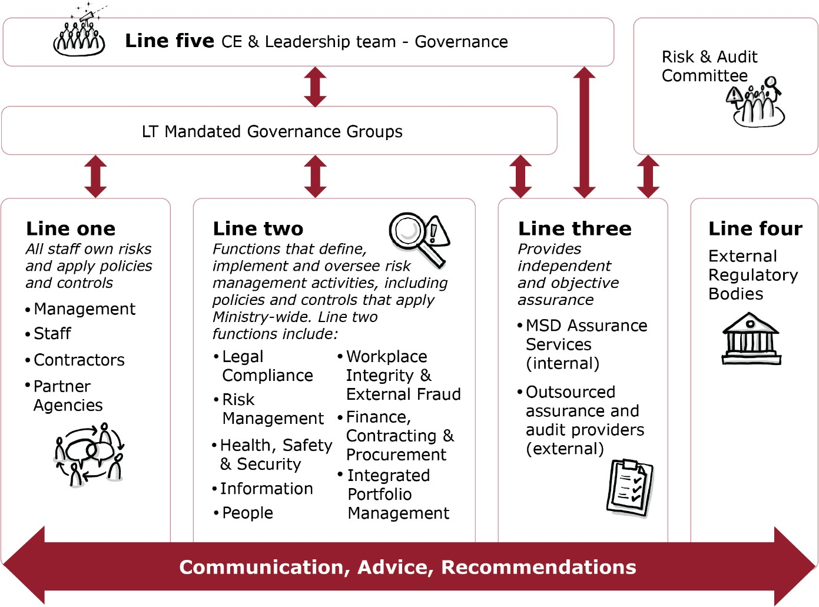

Figure 14 - Assurance approach

Assurance over the IWP is intended to give confidence to the Governance and Leadership groups that the IWP is well-managed and is:
- Has effective identification and management of risk
- Informs decision makers accurately, comprehensively and in a timely manner
- Delivers value that meet the expectations of our clients and stakeholders
- Delivers value within the expected and budgeted costs

- See Government Chief Digital Officer System Assurance Team, Principles of good assurance and lessons learned for digital investments (NZ Government, not dated) https://www.digital.govt.nz/assets/Standards-guidance/Governance/Pocket-guide- Principles-of-good-assurance-and-lessons-learned-for-digital-investments.pdf [Accessed 9 November 2020]

- Meets the desired timelines as far as possible.

To provide assurance, quality management activities are built into delivery using Sprint Reviews, Retrospectives and Portfolio Inspect and Adapt events. Agile delivery encourages continuous identification and implementation of improvements.

In addition, we have internal assurance activities
- that the process is fit for purpose
- health checks on specific epics to ensure the process is being followed.

Post-Project Evaluation Planning
Below is the schedule of planned project evaluation reviews, which detail the purpose and date of each review:

Review | Date | Assurance Type | Review Detail
FMIS | Mar-20 | Probity Assurance | Procurement Probity
Corporate Platform | Mar-21 | Gateway Review | Gate 0
Payroll | Oct-21 | Probity Assurance | Procurement Probity
FMIS R1 | Jan-22 | SPHRaE | Security, privacy, human rights and ethics review
FMIS R1 | Feb-22 | IQA | Implementation Readiness
Corporate Platform | May-22 | Gateway Review | Gate 1
FMIS R2 | May-23 | IQA | TQA / Implementation Readiness
Payroll | Mar-23 | Legislative Compliance | Legislative Compliance
Corporate Platform | Mar-23 | IQA | Portfolio Assurance
Corporate Platform | May-23 | Gateway Review | Gate TBC
Payroll | Apr-23 | IQA | TQA
Payroll | Nov-23 | IQA | PIR
Corporate Platform | Mar-24 | IQA | Portfolio Assurance
Corporate Platform | May-24 | Gateway Review | Gate TBC
Corporate Platform | Jun-24 | IQA | Portfolio PIR

Annexes

Annex 1 - SRO Letter

18 January 2021

To whom it may concern
Corporate Platform Detailed Business Case

The Ministry of Social Development is proposing a major strategic initiative to meet future organisational requirements for its Corporate Platform.
This Programme Business Case is a significant deliverable for this initiative. It investigates to investigate value for money options to deliver this initiative and proposes a plan for its delivery.
I confirm that:
- I have been actively involved in the development of the attached investment proposal through its various stages
- I accept the strategic aims and investment objectives of the investment proposal, its functional content, size, and services
- the indicative cost estimates of the proposal are sound and based on best available information, and
- suitable contingency arrangements are in place to address any current or unforeseen affordability pressures.
This letter fulfils the requirements of the current Better Business Cases guidance. Should either these requirements or the key assumptions on which this case is based change significantly, revalidation of this letter of support will be sought.
Yours sincerely

Nadine Kilmister
DCE People & Capability Ministry of Social Development

FINAL – BUDGET SENSITIVE

Annex 2 – Benefit Map
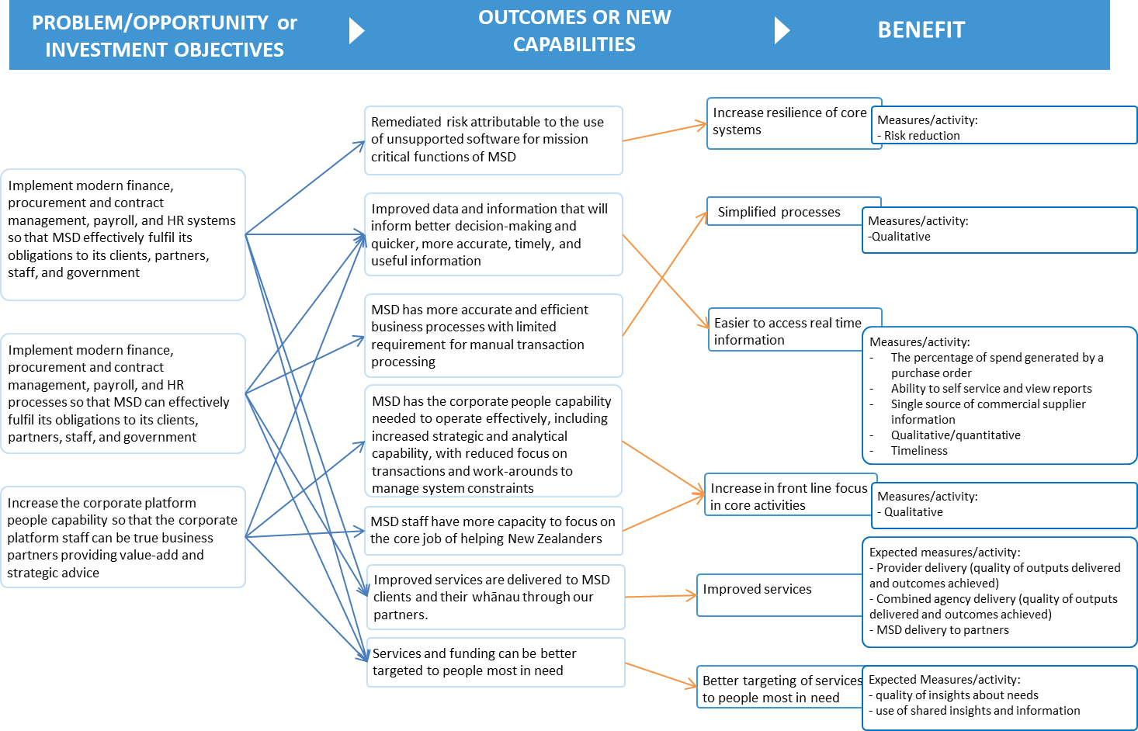
Figure 18 Benefits Map

Annex 3 – Procurement

MSD Procurement Policy
MSD Procurement Policy.

Corporate Platform planning phase
- Project Initiation Document (PID)
- CSOC FMIS & Payroll sourcing approach
- Corporate Platform Ecosystem Procurement Plan

FMIS procurement phase:
FMIS Stage 1 (ROI phase):
- Stage 1 RFP folder
- ROI Document
- ROI Evaluation report

FMIS Stage 2 (Strategic Partner selection)
- Stage2 RFP folder
- RFP Evaluation report

FMIS Stage 3 (Product selection)
- Stage 3 Procurement Plan
- RFP Timeline
- RFP Document (released version)
- Programme Sponsor briefings:
  - RFP Evaluation summary
  - TCO briefing
- Stage 3 Evaluation Report
- Oracle SFA affiliate form (signed copy)
- Oracle Ordering Documents – SaaS, PaaS, and Guided Learning tool (signed copies)
- MSD Legal Memo – FMIS Ordering Documents (signed copy)

FMIS Contractual Documentation
- Folder to FMIS Contractual Documentation

Payroll Procurement
- Payroll Procurement Plan – Product & Partner
- DCE memo on Payroll procurement approach for Product & Partner
- Payroll Procurement Timeline – Product & Partner

Annex 4 - Corporate Platform Renewal Implementation Plan
The following diagrams summarises the current high-level plan for the Corporate Platform Renewal Roadmap.
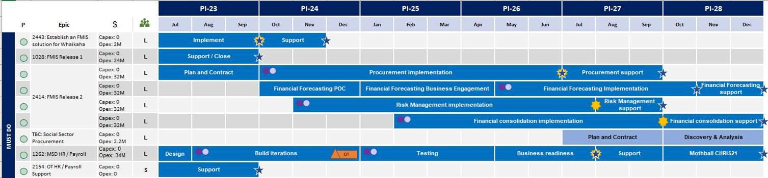

Better Business Cases: Guide to Developing the Project Detailed Business Case (DBC) | 83

Annex 5 - Corporate Platform – Agile Practice and Ceremonies
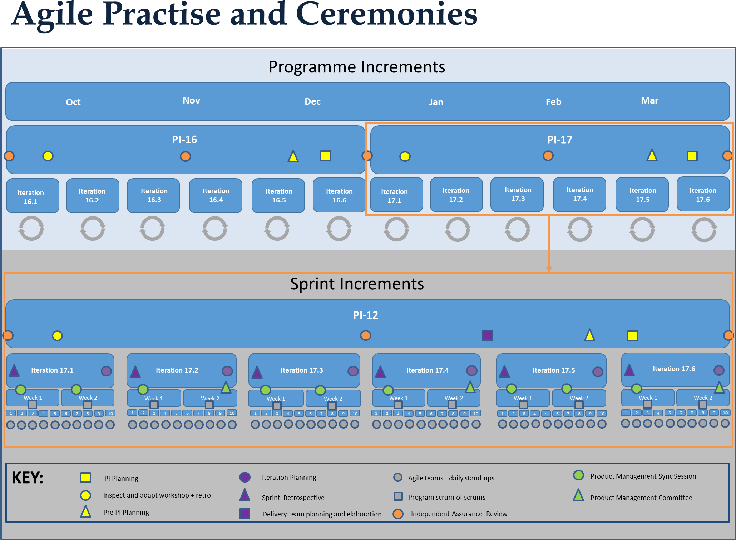
Figure 20 Agile Practice and Ceremonies

Annex 6 – Risks register
Below is the link to the continuously updated Corporate Platform Risk register. Corporate Platform RAID Register

Annex 7 – Change Management
FMIS Change Update June 2021

Programme Business Case | 85

Annex 8 - Detailed Results of scaling options

 | Option 1:  Complete FMIS r isk reduction, no Payroll | Option 2:  Complete Payroll only | Option 3:  Mitigate our r isks,  complete FMIS and Payroll | Option 4:  Mitigate our r isks, and discovery funding for Social Services
Critical Success Factors
Strategic Fit | No | No | Partial | Partial
Value for Money | No | No | Yes | Yes
Supplier Capacity & Capability | No | No | Yes | Yes
Potential Affordability | Yes | Yes | Partial | Partial
Potential Achievability | Yes | Yes | Yes | Yes
Investment Objectives
Implement modern systems | Partial | Partial | Yes | Yes
Implement modern business  processes | Partial | Partial | Yes | Yes
Establish fit-for-purpose people  capability | Partial | Partial | Yes | Yes
Main Benefits
(Assessment of Value by Domain Indicator) - High, Medium, Low, Neutral
 | Option 1:  Complete FMIS r isk reduction, no Payroll | Option 2:  Complete Payroll only | Option 3:  Mitigate our r isks,  complete FMIS and Payroll | Option 4:  Mitigate our r isks, and discovery funding for Social Services  Procurement
Benefit 1:
Increase resilience of core corporate systems
Reduction is critical system risk - FMIS | HIGH | LOW | HIGH | HIGH
Reduction in critical system risk - Payroll | NEUTRAL | HIGH | HIGH | HIGH
Benefit 2:  Easier to access real time information | MEDIUM | MEDIUM | HIGH | HIGH
 | Multi Criteria Dimensional Analysis (MCDA) - Ranking (1-4)
 | Option 1:  Complete FMIS r isk reduction, no Payroll | Option 2:  Complete Payroll only | Option 3:  Mitigate our r isks,  complete FMIS and Payroll | Option 4:  Mitigate our r isks, and discovery funding for Social Services  Procurement
Strategic Alignment | 4 | 3 | 2 | 1
Technical Risk | 4 | 3 | 1 | 1
Other Risk | 4 | 3 | 2 | 1
Cost/Affordability | 1 | 2 | 3 | 4
Benefit Achievability | 4 | 3 | 1 | 1
MCDA Rank | 4 | 3 | 2 | 1
Summary | Discounted | Discounted | Viable | Preferred way forward

