Coversheet |  | 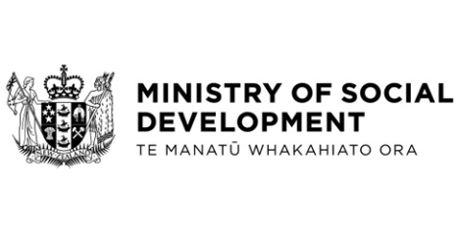

Ministry of Social Development updated Corporate Platform Business Case
Hon Carmel Sepuloni, Minister for Social Development and Employment

These documents have been proactively released.
17 November 2022 - Cabinet paper - Ministry of Social Development updated Corporate Platform Business Case
19 October 2022, Ministry of Social Development updated Corporate Platform - Detailed Business Case
23 November 2022, Cabinet Government Administration and Expenditure Review Committee Minute GOV-22-MIN-0049, Cabinet Office.

These papers seek approval for the final drawdown of contingency funding set aside for the replacement of the Ministry of Social Development’s core finance and payroll systems as part of the Corporate Platform programme of work.
Some parts of this information release would not be appropriate to release and, if requested, would be withheld under the Official Information Act 1982 (the Act). Where this is the case, the relevant sections of the Act that would apply have been identified. Where information has been withheld, no public interest has been identified that would outweigh the reasons for withholding it. This is the key to the redaction code used for this release:
- Section 9(2)(a) – to protect the privacy of natural persons.

© Crown Copyright, Creative Commons Attribution 4.0 International (CC BY 4.0)
Search Tags: Ministry of Social Development, Updated Corporate Platform Business Case, Funding drawdown approval

