Coversheet |  | 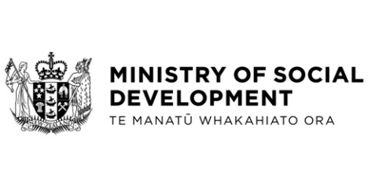
Amendments to the Approved Information Sharing Agreement between Inland Revenue and the Ministry of Social Development to facilitate Child Support Pass-on
Hon Carmel Sepuloni, Minister for Social Development and Employment
These documents have been proactively released.
11 May 2023, Cabinet paper - Amendments to the Approved Information Sharing Agreement between Inland Revenue and the Ministry of Social Development to facilitate Child Support Pass-on
11 May 2023, attachment to Cabinet paper - Amendment Relating to the Approved Information Sharing Agreement Between Inland Revenue and the Ministry of Social Development
11 May 2023, Cabinet Legislation Committee Minute LEG-23-MIN-0049, Cabinet Office.
These papers propose that the Cabinet Legislation Committee authorise the submission of the Privacy (Information Sharing Agreement between Inland Revenue and Ministry of Social Development) Amendment Order 2023 to Cabinet and the Executive Council.
This Order amends the existing Privacy (Information Sharing Agreement between Inland Revenue and Ministry of Social Development) Order 2017 to remove the required 10 working days’ notice period for adverse actions when the Ministry of Social Development automatically charges child support as income as a result of an information share with Inland Revenue. It also updates this Order to reflect minor changes agreed between the agencies from September 2021.
© Crown Copyright, Creative Commons Attribution 4.0 International (CC BY 4.0)
Search Tags: child support pass-on, information sharing, approved information sharing agreement, inland revenue

