SENSITIVE - BUDGET
Office of the Minister for Social Development and Employment
Social Wellbeing Committee

Peke Waihanga Artificial Limb Service: contribution to address cost pressures

Proposal
- This paper seeks Cabinet’s out of cycle approval to allocate $5.095 million to the Peke Waihanga Artificial Limb Service, enabling unforeseen and urgent critical cost pressures to be addressed.

Relation to government priorities
- The decisions in this paper support the Government’s manifesto commitments:
- to support disabled persons and the realisation of their full rights and opportunities through disability-focused policy, funding, and services; and
- to build a stronger health and disability system that delivers for all, drawing on the recommendations of the Health and Disability System Review.

Executive Summary
- In the normal course of business, cost pressure for departments and Crown entities would be addressed via the annual budget process. This paper is being submitted to Cabinet outside of the Budget process to address urgent matters with funding implications. It provides relevant supporting information and demonstrates that the proposal cannot be:
- funded through reprioritisation of lower-value activities from within existing baselines;
- funded through increasing fees for service in the short term; or
- deferred until the next Budget.
- The Peke Waihanga Artificial Limb Service (Peke Waihanga) is an autonomous Crown entity. Its functions, set out in the Artificial Limb Service Act 2018, include the manufacture, repair and maintenance of prosthetic and orthotic devices, as well as providing rehabilitative services. In the normal course of business, Peke Waihanga delivers a financially sustainable service on commercial terms, without the need of a Crown appropriation.
- Peke Waihanga is currently beset by a range of unforeseen critical cost pressures that are affecting the operations, asset base and financial resilience of the service, exacerbated by lost revenue during the COVID-19 lockdown.
- These are extraordinary circumstances for Peke Waihanga. The Crown’s support will help the service to recover from these short-term financial challenges and continue delivering a financially sustainable and resilient service to disabled New Zealanders.
- Therefore, I am seeking Cabinet’s approval to $5.095 million of new funding, split roughly 50:50 between capital and operating expenditure. Two new appropriations within Vote Social Development will need to be established, while the cost will be managed against the between-Budget contingency (opex) and the multi-year capital allowance (capex).

Background
- Prior to its formal establishment in 1990, Peke Waihanga was part of the former Social Security Department (later the Department of Social Welfare), and had been focussed on delivering the rehabilitation support required by returning servicemen.
- Prosthetic and orthotic devices are critical mobility aids, preventing deterioration of chronic disease and disabilities and allowing users to live independent and productive lives. Following a major review of its role and operation in 2015, Peke Waihanga adopted a more client-centred approach emphasising the development and delivery of wrap-around, individualised services, co-ordination of care, and technology to achieve better outcomes for their clients.
- Over the last eight years Peke Waihanga’s turnover has trebled in response to increased demand. Peke Waihanga holds national service delivery contracts with the Accident Compensation Corporation (ACC) and Te Whatu Ora Health New Zealand (Te Whatu Ora) to provide prosthetic and rehabilitation services to approximately 4,400 amputees. Peke Waihanga is also contracted by Te Whatu Ora for orthotics services, covering the Auckland, Bay of Plenty, Counties Manukau, Hauora Tairāwhiti, Waikato, Waitemata and West Coast districts. In the last 12 months, over 7,200 clients from across Aotearoa have accessed Peke Waihanga Orthotic Services.
- Over the last three years, Peke Waihanga has also developed a world leading peer support evidence-based program for amputees - an important early intervention for the mental well-being of their clients.
- Peke Waihanga services are highly valued by their clients, established through independent third-party assessment as set out in table 1.

Table 1: Key satisfaction measures
Key service user satisfaction measures | Māori | All
How well did we set you up to be independent and productive in your local community and at home? | 92%  (n=165) | 92% (n=1,322)
Rate the overall service you received for the job we have undertaken for you? | 94%  (n=180) | 95% (n=1,461)
Rate how much trust and confidence you have in the staff providing your care? | 97%  (n=195) | 97% (n=1,567)
- In the normal course of business, Peke Waihanga delivers a financially sustainable service on commercial terms, covering the cost of their operations from service delivery contracts held with Te Whatu Ora and ACC.

Analysis
- Recently, Peke Waihanga has been beset by a range of unexpected short-term critical cost pressures largely attributable to the impact of COVID-19, which have increased costs, decreased commercial revenue during lockdown and affected short-term organisational viability.

Short-term critical cost pressures

Inability to absorb construction cost increases
- Peke Waihanga does not have sufficient capital to advance limb centre refurbishment projects, which have been severely impacted by construction cost increases.
- Over the last few years, Peke Waihanga has been working with the Ministry of Social Development (the Ministry) to remediate building issues at their limb centres. While the location of these buildings near transport and other health services is ideal for clients and staff, structural issues have been creating significant health and safety risks.
- The refurbishment of the Christchurch and Auckland Limb Centres is a substantial capital expenditure for Peke Waihanga. In Budget 2021, Peke Waihanga received capital funding of $5.000 million to:
- replace the dilapidated Christchurch Limb Centre ($4.300 million); and
- re-roof the Auckland Limb Centre ($0.635 million).
- These estimates were prepared on or around November 2020, with planning assumptions and contingencies reflective of relatively stable construction costs over the preceding year.
- The Christchurch refurbishment was impacted by the discovery and removal of disused sewer pipes under the site. The subsequent impact of COVID-19 then resulted in building staff shortages and delays in obtaining key building products. The contracts underpinning these projects currently commit contractors to completion of the Christchurch build by February 2023 and the Auckland re-roof by mid to end 2023.
- The impact of COVID-19 has seen construction costs increase significantly over the last 18 months, due to higher demand for building activity, continuing supply-chain issues, and higher labour costs. This is illustrated by the accelerating quarterly increase in the NZ Producers Price Index (PPI) as set out below in Graph 1 (updated 31 June 2022).
Graph 1: Quarterly NZ PPI - construction industry; Statistics New Zealand
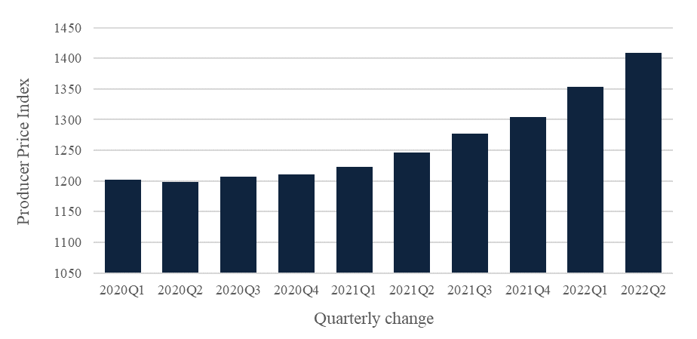
- The refurbishment projects cannot be funded through reprioritisation of lower-value activities from within existing baselines. Peke Waihanga have not owned the limb centres for long enough to build up sufficient capital reserves (e.g. through accumulated depreciation) to offset the initial construction costs, let alone these unexpected cost increases.
- [Redacted content].
- The refurbishment projects cannot be deferred until the next Budget. If additional capital were not received until June 2023, contractors and suppliers would be unpaid and contracted deliverables would not be achieved on time. Health and safety risks for clients and staff would endure, with Peke Waihanga needing to continue operating from temporary premises, compromising the wellbeing of staff and clients.
- Rather than defer these costs, it is in the Crown’s fiscal interest to address them quickly, and reduce the opportunity for further increases. Given the accelerating PPI as of 30 June 2022, further quarterly increases are likely if this cost pressure is deferred, along with increased cost to the Crown.
- Given that these costs cannot be met through reprioritisation or deferred until Budget 23 without significant disruption and further cost increases, out of cycle funding is required.

Inability to offset increased inventory costs
- Amputation procedures reported to the Ministry of Health where the patient is known to have diabetes have increased by 50% over the last 10 years. In addition to generating demand for prosthetics, this also generates demand for orthotic services to support and fund amputation prevention strategies.
- To meet increased demand, service delivery for prosthetic and orthotic services is commissioned by Te Whatu Ora and ACC. In the last 4 years this has been characterised by the need to improve service coverage in underserved districts. However, during the same period, service establishment costs have also dramatically increased.
- Peke Waihanga draws from cash reserves to fund upfront service establishment costs, which are eventually recovered through fee-for-service revenue. While these costs include training, client support and minor building modifications, they are largely comprised of the cost to establish initial inventory.
- Peke Waihanga has some in-house capability to manufacture prosthetic and orthotic components for inventory, however they are also reliant on European-based contractors for the supply and manufacture of more specialised components.
- Establishing and maintaining an appropriate inventory of these components allows Peke Waihanga to obtain economies of scale from their procurement. As part of their client-centric approach, it allows faster responses to the needs of their clients and significant reductions in patient waiting list times; for example, the Orthotics service was able to rapidly resolve orthotic waitlists of 274, 450, 244 and 168 respectively for clients in the Auckland, Bay of Plenty, Counties Manukau and Waitemata districts. Technological advances are also helping to keep waiting lists low by delivering better outcomes and increased independence – for example, the Peke Waihanga microprocessor knee programme improved patient functional outcomes by 108%.
- [Redacted content]
- [Redacted content]. The National Prosthetic Service Agreement (NPSA), which establishes the pricing for service delivery contracts with Te Whatu Ora, has not been reviewed for more than two decades. The current agreement is reflective of the technologies and pricing available in its era, and not of the increased range and cost of technologies that have emerged since then; least of all the significant developments in the last four years. [Redacted content]
- [Redacted content]
- The cost to maintain an adequate inventory cannot be funded through reprioritisation of lower-value activities from within existing baselines. Peke Waihanga do not have discretion about the activities they can undertake, as they are contracted to deliver orthotic and prosthetic services and support to anyone who is referred to them for support.
- While Peke Waihanga have discretion about the service delivery contracts they express interest in, they have not had an opportunity to renegotiate cost-reflective prices in their existing contracts, an issue that has become more pressing in the last four years, and especially since the height of the COVID-19 pandemic.
- Addressing inventory cost pressure at Peke Waihanga also cannot be deferred until the next Budget. [Redacted content]
- Peke Waihanga requires approximately $2.100 million in opex funding to offset their service establishment costs, particularly their inventory costs. This will enable prompt service delivery and prompt payment for suppliers until break-even is reached towards the end of 2022.

[Redacted content]
- [Redacted content]
- [Redacted content]
- [Redacted content]
- The consequence for the Crown of partially addressing this cost pressure would be increased likelihood of subsequent Crown support.

Financial implications
- $2.995 million in capital funding is required to complete the refurbishment of Peke Waihanga’s Christchurch and Auckland Limb Centres, as set out below in Table 2:
Table 2: Total capital requirements
Description | Funds required ($m)
Increased building costs - Christchurch | $1.800
Increased building costs - Auckland | $1.195
Total capital funding | $2.995
- $2.100 million in opex funding is required to address inventory cost pressure, as set out below in Table 3:
Table 3: Total opex funding requirements
Description | Funds required ($m)
To offset increased inventory costs | $2.100
Total opex funding | $2.100
- The total combined cost to fully fund these cost pressures in 2022/23 is $5.095 million, as set out below in Table 4:
Table 4: Total funding requirement
Description | Funds required ($m)
Total capital requirement | $2.995
Total opex funding requirement | $2.100
Total funding requirement | $5.095
- I propose that two new appropriations be established within Vote Social Development (for the capital and operating funding, respectively). The operating balance impact will be charged against the between-Budget contingency, while the capital cost will be charged as a pre-commitment against the multi-year capital allowance.

Regulatory Impact Statement
- A Regulatory Impact Assessment (RIA) has not been undertaken for this paper because the proposals do not have immediate legislative or regulatory implications.

Climate Implications of Policy Assessment
- The Climate Implications of Policy Assessment (CIPA) requirements do not apply to this paper as the initiatives either do not have a direct emissions impact, do not meet the emissions abatement threshold to require a CIPA, or do not have enough certainty to be accurately quantified.

Population Implications
- This proposal will fund programmes designed to support 4,400 amputees and 16,500 orthotic users. Demographic information about Peke Waihanga service users is set out below:
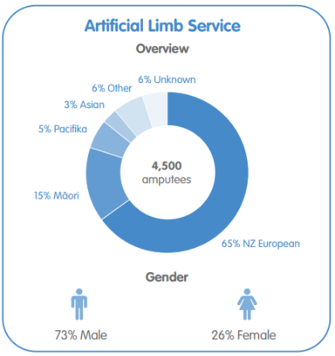
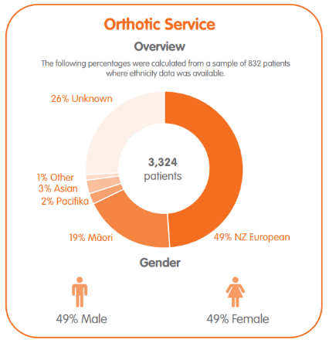
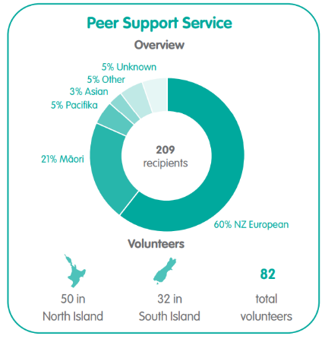

Human Rights
- The proposals in this paper are consistent with the New Zealand Bill of Rights Act 1990 and the Human Rights Act 1993.

Consultation
- The following government departments and agencies have been consulted on this Cabinet paper: Peke Waihanga; the Treasury; Manatū Hauora Ministry of Health; ACC; Whaikaha Ministry of Disabled People.

Communications
- Officials will liaise with my office to coordinate a communications plan once funding is agreed.

Proactive Release
- This paper will be proactively released within Cabinet Office guidelines and published on the Ministry of Social Development’s website, with redactions as appropriate under the Official Information Act 1982.

Recommendations
The Minister for Social Development and Employment recommends that the Committee:
- note that in the normal course of business, Peke Waihanga delivers an effective and financially sustainable service on commercial terms, with no need of ongoing Crown funding;
- note that by Peke Waihanga currently faces short-term critical cost pressures, including:
  - capital cost pressures, specifically a $2.995 million increase in the cost of refurbishing the Christchurch and Auckland Limb Centres; and
  - operating cost pressures of $2.100 million, due to increased inventory costs arising from service expansion, advanced technology, and the impact of COVID-19 on global supply chains;
- note that these cost pressures are unable to be;
  - funded from cash reserves, due to the compounding effect of other cost pressures
  - funded through reprioritisation of lower-value activities from within existing baselines;
  - funded through increasing fees for service in the short term; or
  - deferred until the next Budget;
- [Redacted content];
- agree to increase spending by $5.095 million in total to address the critical cost pressures experienced by Peke Waihanga, with the following impacts on the operating balance and net debt;
Table 5: Operating Balance and Net Debt impacts
Impacts | Increase / (decrease) per financial year ($m)
 | 2022/23 | 2023/24 | 2024/25 | 2025/26 | 2026/27
Operating Balance and Net Debt | 2.100 | - | - | - | -
Operating Balance only | - | - | - | - | -
Net Debt Impact only | 2.995 | - | - | - | -
No impact | - | - | - | - | -
Total impact | 5.095 | - | - | - | -

- agree to establish within Vote Social Development the following new appropriations, for which the Appropriation Minister will be the Minister for Social Development and Employment, and the Appropriation Administrator will be the Ministry of Social Development;
Table 6: New appropriations to be established
Ref # | Title | Type | Scope
6.1 | Peke Waihanga –New Zealand Artificial Limb Service | Non-Departmental Output Expenses | This appropriation is limited to supporting Peke Waihanga – New Zealand Artificial Limb Service to deliver services under the Artificial Limb Service Act 2018.
6.2 | Peke Waihanga – New Zealand Artificial Limb Service Capital Injections | Non-Departmental Capital Expenditure | This appropriation is limited to capital injections to Peke Waihanga – New Zealand Artificial Limb Service for their capital programme.
- approve the following changes to Vote Social Development appropriations to give effect to the decision at recommendation 5 above;
Table 7: Appropriation changes to be made
Appropriation type and title | Increase / (decrease) per financial year ($m)
 | 2022/23 | 2023/24 | 2024/25 | 2025/26 | 2026/27
Non-Departmental Output Expenses:  Peke Waihanga –New Zealand Artificial Limb Service | 2.100 | - | - | - | -
Non-Departmental Capital Expenditure:  Peke Waihanga –New Zealand Artificial Limb Service Capital Injections | 2.995 | - | - | - | -
Total Operating | 2.100 | - | - | - | -
Total Capital | 2.995 | - | - | - | -
- agree that the proposed change to appropriations for 2022/23 under recommendation 7 above be included in the 2022/23 Supplementary Estimates and that, in the interim, the increase be met from Imprest Supply;
- agree that:
  - the operating expenses incurred under recommendation 5 above will be charged against the between-Budget contingency established as part of Budget 2022; and
  - the capital expenditure incurred under recommendation 5 above will be charged against the multi-year capital allowance.

Authorised for lodgement
Hon Carmel Sepuloni
Minister for Social Development and Employment

Appendix A: Additional financial information

[Redacted content]

Refer Process for submitting funding proposals to Cabinet outside of the Budget process, CO (18) 2: Proposals with Financial Implications and Financial Authorities. Cabinet Office, 30 July 2018.
An artificial device which helps restore the normal functions of a missing body part
A support, brace, or splint which helps restore the body’s movement
For the period 01/01/2019 to 31/08/2022. Assessed on a scale of 0 Worst and 10 Best possible score. The % is calculated by counting those with a 5 or high score, divided by total responses.
Refer Briefing for Incoming Minister, Peke Waihanga Artificial Limb Service, November 2020.
Peke Waihanga does not require additional support from the Crown to meet the increased depreciation expense arising from these refurbishment projects.
Retrieved from Peke Waihanga Annual Report 2020/2021

