Coversheet |  | 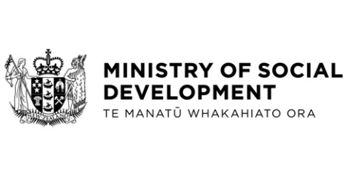
Consultation with the Deaf community on potential amendments to the New Zealand Sign Language Act 2006
Hon Poto Williams, Minister for Disability Issues
These documents have been proactively released.
23 August 2022, Cabinet paper - Consultation with the Deaf community on potential amendments to the New Zealand Sign Language Act 2006
31 August 2022, Cabinet Social Wellbeing Committee, Minute of Decision
SWC-22-MIN-0158.

This paper seeks Cabinet agreement for the Minister for Disability Issues to consult with the Deaf community on three potential amendments to the New Zealand Sign Language Act 2006 (the NZSL Act), before final proposals are developed for your Cabinet’s consideration in December 2022.
The following documents that accompanied the Cabinet paper are already public:
- Appendix: Discussion Document: Potential amendments for consultation is available here www.odi.govt.nz/nzsl/nzsl-act-consultation-2022
© Crown Copyright, Creative Commons Attribution 4.0 International (CC BY 4.0)
Search Tags: New Zealand Sign Language Act 2006

