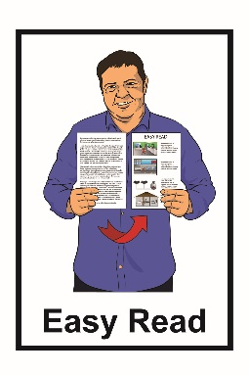

Update from the

Minister for Disability Issues:

What is happening to make

New Zealand more accessible for disabled people
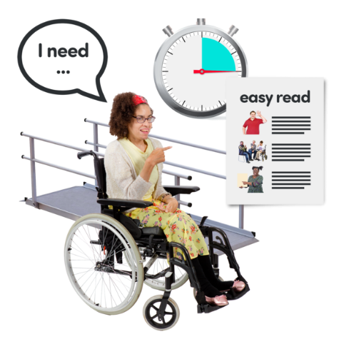

May 2021

What is this document about?

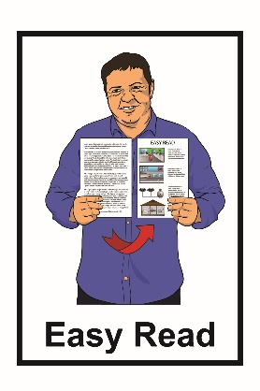
This is an Easy Read document.

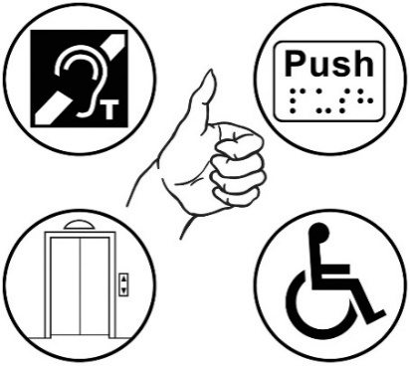
This document is about what the government is doing to make New Zealand better for disabled people.

The information in this document is from the Minister for Disability Issues.
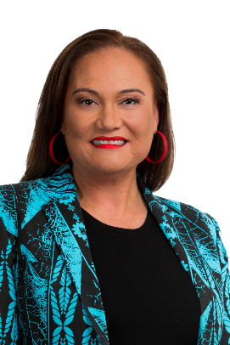

The Minister for Disability Issues is Carmel Sepuloni.

What you will find in here

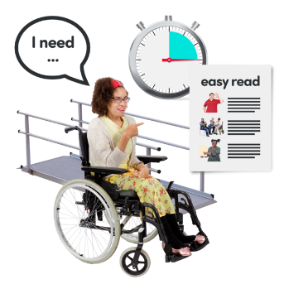
Page number:

New Zealand needs to be more accessible for disabled people 3
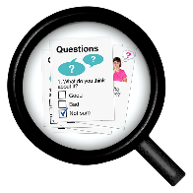

What is happening now 4
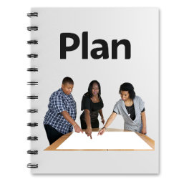

What the government planned
to do 6
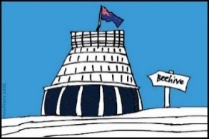

What the government has done 8
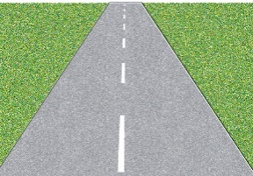

The next steps 10
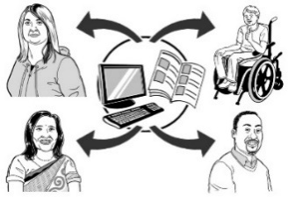

Where to find more information 13

New Zealand needs to be more

accessible for disabled people
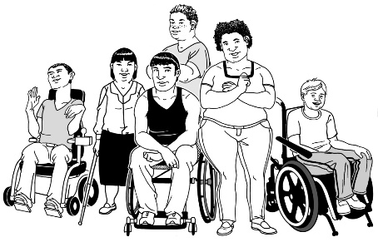

1 in 4 people in New Zealand are disabled.

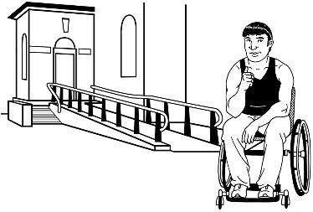
New Zealand being accessible means that disabled people can:

- get into buildings

- use public services like swimming pools

- use transport like buses
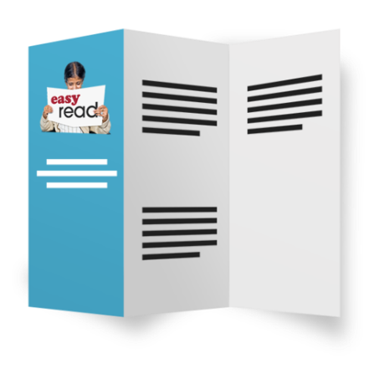
- have a job

- get information in ways that can be understood.

What is happening now

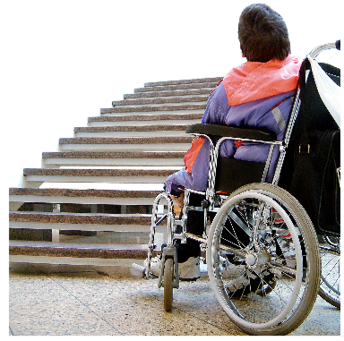
The government has found some problems making New Zealand more accessible for disabled people.

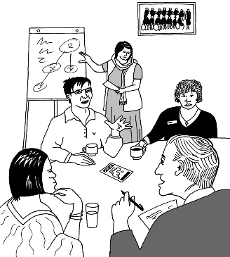
Here are some of the things that New Zealand does not have right now:

- 1 organisation in charge of leading everyone else to make things better for disabled people

- lots of people who understand accessibility working in the places we need them
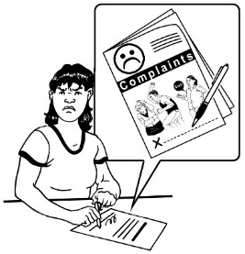
- 1 place where disabled people can go to report problems.

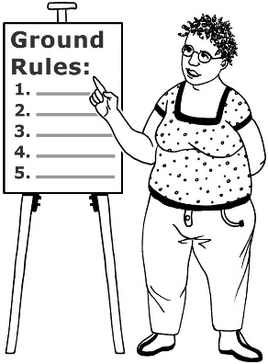
Here are some more things that New Zealand doesn’t have:

- a good system to make sure that people follow the rules to include disabled people
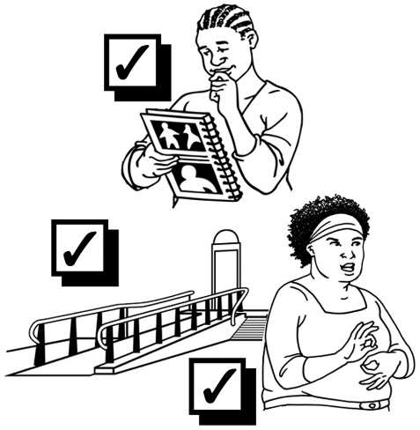
- people who think about what disabled people need when they make decisions about things like:

  - rules

  - plans

  - services

  - buildings.

What the government planned to do

In June 2020 the Minister for Disability Issues presented a Cabinet Paper called Framework to accelerate progress towards accessibility in Aotearoa New Zealand.
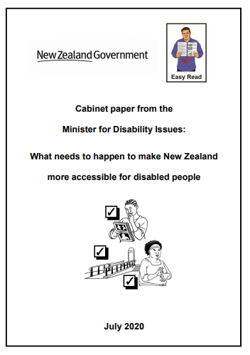

There is an Easy Read translation of this paper called:

What needs to happen to make New Zealand more accessible for disabled people.
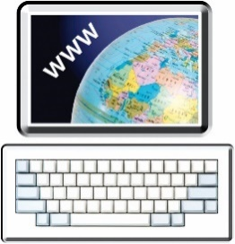

You can read it on the Ministry of Social Development Website:

https://www.msd.govt.nz/about-msd-and-our-work/publications-resources/information-releases/accelerate-accessibility/index.html

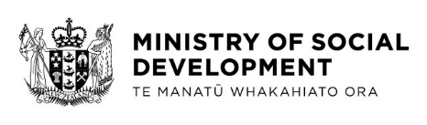
You can also contact the Ministry of Social Development .
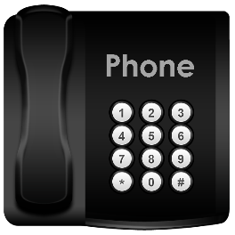

Phone:

04 916 3300

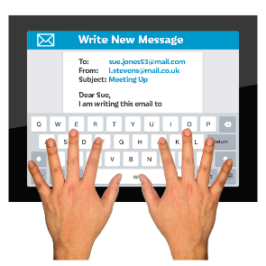
Email:

info@msd.govt.nz

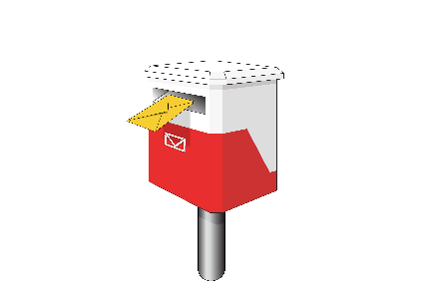
You can ask them to post you a copy of the document.

What the government has done

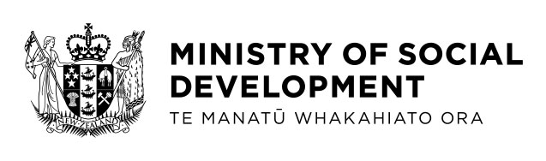
The Ministry of Social Development is working with the Access Alliance to make accessibility better in New Zealand.

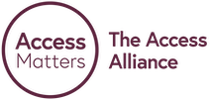
The Access Alliance is made of people and groups including:
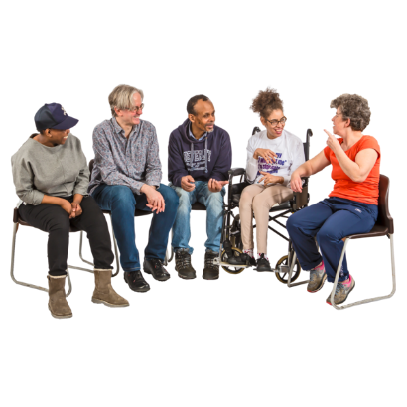
- Disabled People's Organisations

- disability service providers

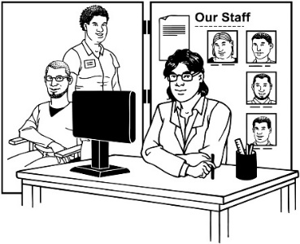
- community organisations

- disability advocates.

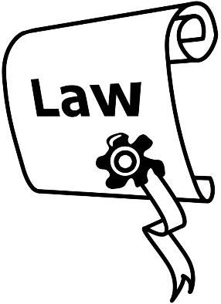
Together they have been making a plan about a new law to make things better for disabled people.

The new law would need to allow for:

- new ideas

- different ways of doing things
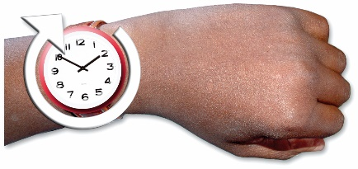
- taking time to get things right.

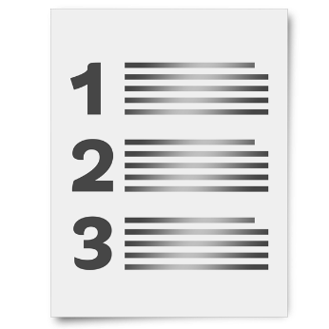
The new law would also need to:

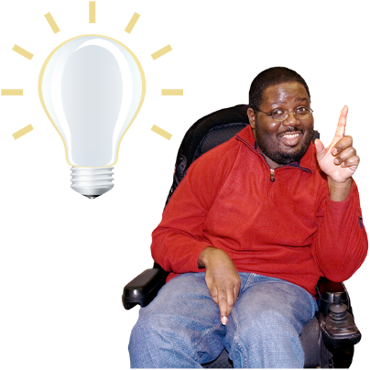
- make it clear what needs to be done

- make everyone understand they must include disabled people.

The next steps

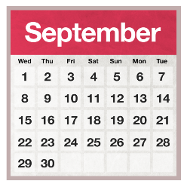
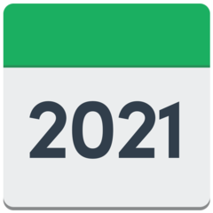
In September 2021 the Minister for Disability Issues will bring the whole plan to Cabinet.

Cabinet makes decisions for New Zealand.

Cabinet is:
- the Prime Minister
- some other MPs who are part of the government.

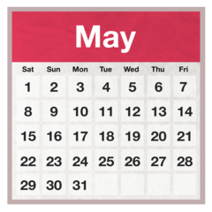
The Minister wanted to write the plan in May 2021.

Making a law is a big change so the Minister wants to make sure to get it right.

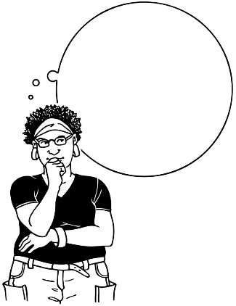
That is why the Minister has decided to take some more time before she talks to Cabinet about what she says should happen.

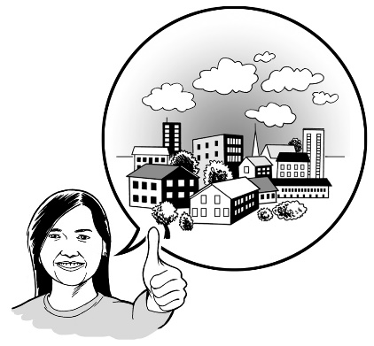
More time is needed to talk to different groups about the changes like:

- government agencies
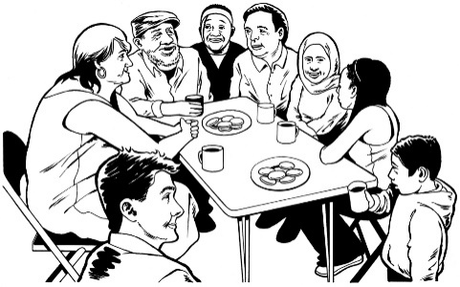
- businesses

- community.

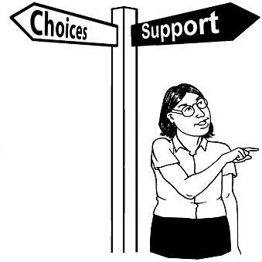
Talking about the plan in September 2021 means that it can be part of the bigger changes to the Disability Support System.

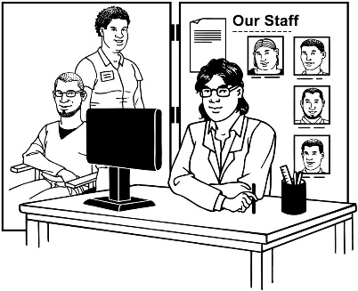

The Disability Support System means the services that government pays to support disabled people like support workers.

Where to find more information

The full version of this document is called:

Update on Accelerating Accessibility - 19 May 2021.

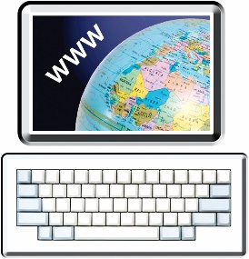
You can find the full version of the Cabinet Paper at the Ministry of Social Development website:

https://www.msd.govt.nz/about-msd-and-our-work/publications-resources/information-releases/accelerate-accessibility/index.html

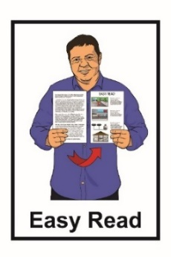
The full version of the document is not in Easy Read.

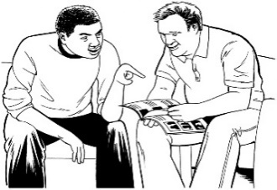
You may want to ask someone to assist you to read it.
You can also contact the Ministry of Social Development.

Phone:

04 916 3300

Email:

info@msd.govt.nz

You can ask them to post you a a copy of the document.
This information has been written by the Ministry of Social Development.
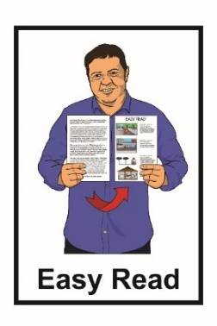
It has been translated into Easy Read by the Make It Easy service of People First New Zealand Inc. Ngā Tāngata Tuatahi.
The ideas in this document are not the ideas of People First New Zealand Inc. Ngā Tāngata Tuatahi.
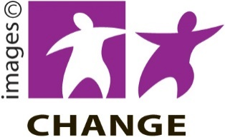
Make It Easy uses images from:

- Changepeople.org

- Photosymbols.com

- Sam Corliss

All images used in this Easy Read document are subject to copyright rules and cannot be used without permission.

