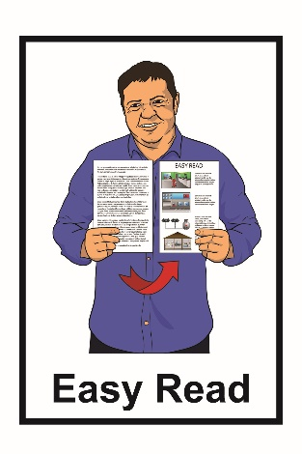

Regulatory Impact Statement:
Accelerating Accessibility in New Zealand
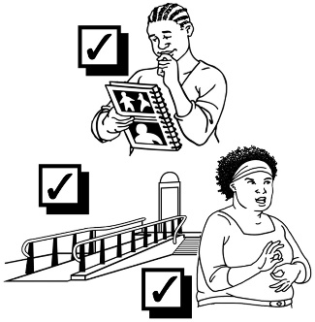

October 2021

Before you start

This is a long document.

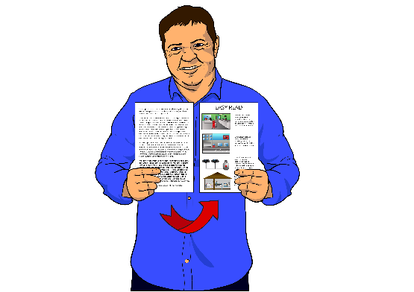
While it is written in Easy Read it can be hard for some people to read a document this long.

Some things you can do to make it easier are:
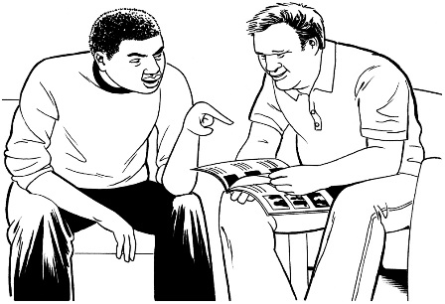
- read it a few pages at a time

- have someone help you to understand it.

What you will find in here:

Page number:
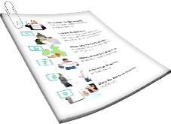

What is this document about?............3
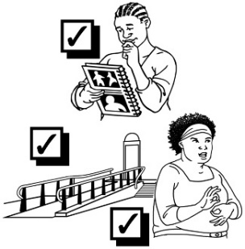

What does Accelerating
Accessibility mean?...................…….4

What is a Regulatory Impact Statement?.........................................7

The 4 options to accelerate accessibility in New Zealand ………..9

Which is the best option?….............14

Where to find more information……16

What is this document about?

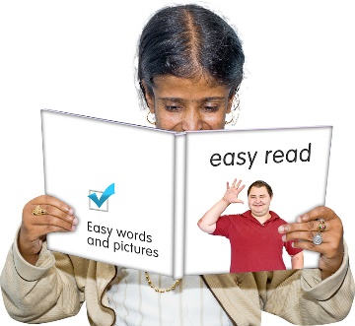
This is an Easy Read summary of some of the things in the Regulatory Impact Statement: Accelerating Accessibility.

A summary:
- is shorter
- tells you the main ideas.

In the document we will look at what:
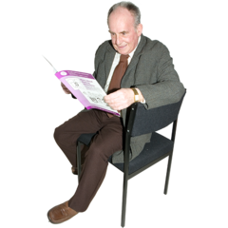
- Accelerating Accessibility means

- a Regulatory Impact Statement is

- some of the things in the Regulatory Impact Statement are.
What does Accelerating Accessibility mean?

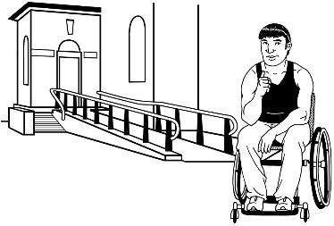
The Government wants to make New Zealand a more accessible place for disabled people to live.

Accessible means that disabled people can:
- get into / move around in buildings

- use services easily

- get around in their community

- understand what is being said
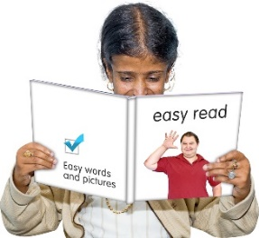

          - get information in ways that they can understand.
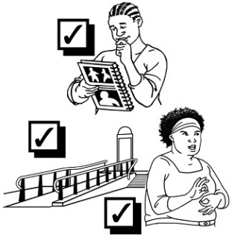
Accessibility can mean many different things for people.

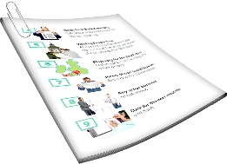
The Minister for Disability Issues has written a new Cabinet Paper about Accelerating Accessibility.

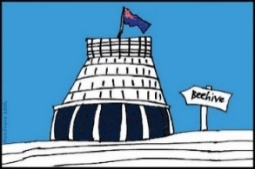
Cabinet papers are documents given to Cabinet to read.

Cabinet is a group of New Zealand government ministers.

Cabinet meets most weeks to talk about important things.

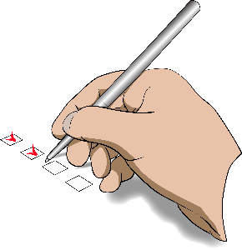
Accelerating means to make things happen faster.

Accelerating Accessibility means looking at what needs to be done to make New Zealand accessible for disabled people faster.

You can find an Easy Read translation of the new Cabinet Paper: Accelerating Accessibility in New Zealand at this website:

www.msd.govt.nz/about-msd-and-our-work/publications-resources/information-releases/cabinet-papers/2021/ accelerating-accessibility.html

What is a Regulatory Impact Statement?

A Regulatory Impact Statement is a Government document that everyone can have access to.

It is also called a RIS.

A RIS outlines the advice given by a government agency to its Minister.

The RIS looks at:

          - the problem that needs to be sorted

          - the ways the problem could be sorted

          - who the government agency spoke to about the problem.

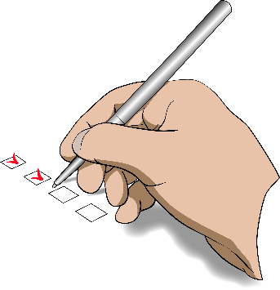
A RIS also looks at how the solution will be:

          - put in place

          - checked to make sure it is working.

The Ministry of Social Development wrote the RIS about Accelerating Accessibility in New Zealand.

The 4 options to
accelerate accessibility in New Zealand

To sort out the problem of New Zealand not being accessible enough for disabled people the Ministry of Social Development looked at 4 options.

Options are when there is more than 1 thing that needs to be thought about.

From the options 1 or more things may be chosen.

Option 1: Leave things the same.

This would mean no changes to the laws we have now to make things more accessible for disabled people.

Option 2: Cabinet would decide what work needed to be done to improve accessibility.

Cabinet is a group of New Zealand Government ministers who meet to make decisions about what the Government will do.

There would still be no changes to the laws we have now to make things more accessible for disabled people.

Option 3: A new legislative framework that will improve accessibility for disabled people.

A legislative framework is like a set of laws and other rules that must be followed.

The legislative framework would set out:

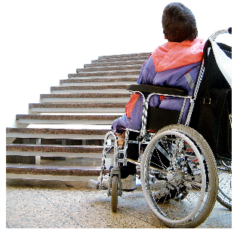
- who would lead the changes needed for there to be better accessibility in New Zealand

- what barriers need to be taken away.

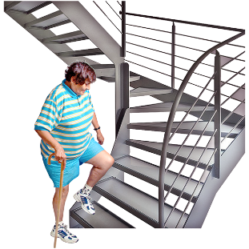
Barriers are things that stop disabled people from:

- being able to get into buildings
- having a job

- getting an education

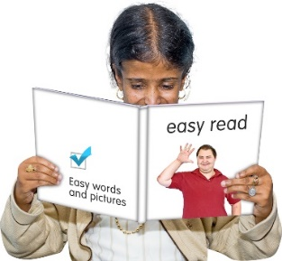
- understanding information

- having the right technology like mobile phones.

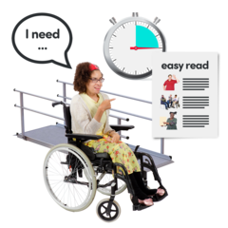
The legislative framework would also set out:

- the things that need to be put in place to make things more accessible

- how we make sure this work is done.
Option 4: Have a new law that works to make accessibility better for disabled people.

This would be a separate law with rules about how to make New Zealand accessible for disabled people.

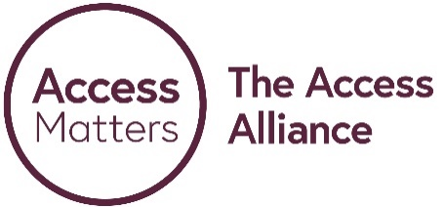
The Access Alliance:

- likes this option the best

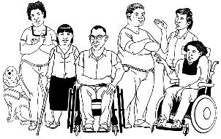
- would like the new law to be called the Accessibility for New Zealanders Act.

You can find more information about the Access Alliance on their website:

www.accessalliance.org.nz

Which is the best option?

The Ministry of Social Development likes Option 3 most.

Option 3 is about having a legislative framework with rules that will improve accessibility.

The Ministry of Social Development likes Option 3 because it:

- works better across all government agencies

- mean we have a way of:

  - finding out about the barriers

  - taking away the barriers.
The Ministry of Social Development also thinks Option 3 will make it easier to:

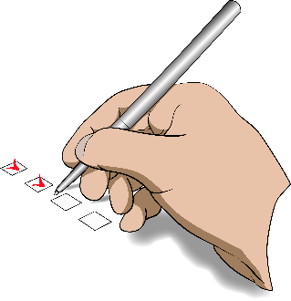
- work with disabled people to plan for better accessibility

- change things faster so that there is better accessibility for disabled people.

The Ministry of Social Development thinks that Option 4 would:

- not work well across all government agencies
- not take away of some the barriers that disabled people have.
Where to find more information

You can find the full Regulatory Impact Statement: Accelerating Accessibility at this website:

www.msd.govt.nz/about-msd-and-our-work/publications-resources/regulatory-impact-statements/accelerating-accessibility/index.html
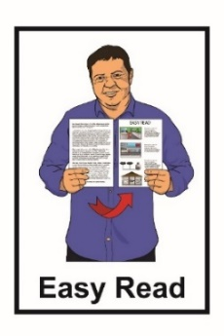

The full version of the RIS is not in Easy Read.

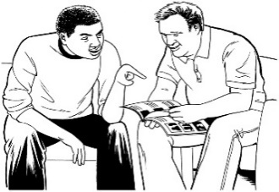
You may want to ask someone to assist you to read it.

You can also contact the Ministry of Social Development.

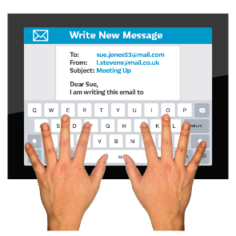
Phone: 04 916 3300

Email: info@msd.govt.nz
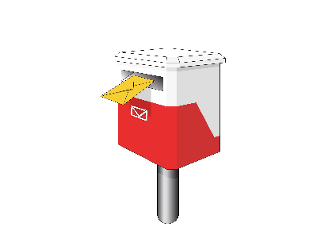

You can ask them to post you a copy of the RIS document.

This information has been written by the Ministry of Social Development.
.
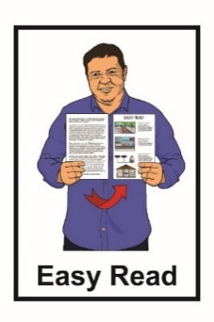
It has been translated into Easy Read by the Make It Easy service of People First New Zealand Inc. Ngā Tāngata Tuatahi.

The ideas in this document are not the ideas of People First New Zealand Inc. Ngā Tāngata Tuatahi.
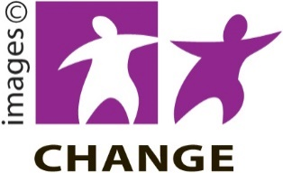
Make It Easy uses images from:

- Changepeople.org

- Photosymbols.com
- Sam Corliss

All images in this Easy Read document are subject to copyright rules and cannot be used without permission.

