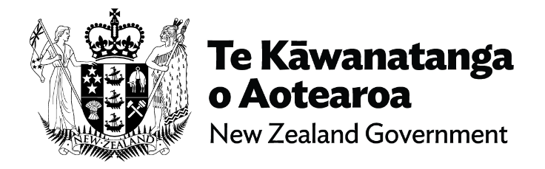
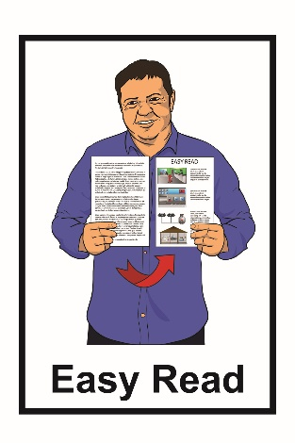

Cabinet paper from the
Minister for Disability Issues:
Accelerating Accessibility in
New Zealand
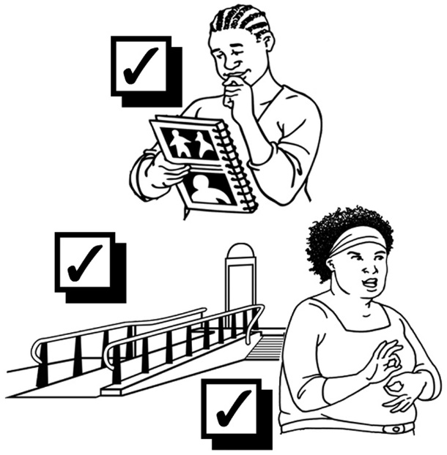

October 2021

Before you start

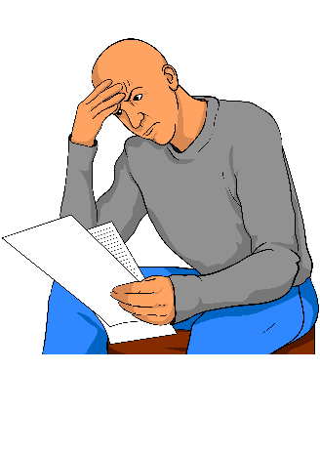

This is a long document.

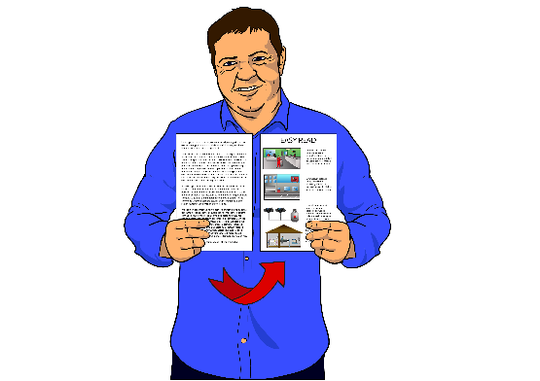
While it is written in Easy Read it can be hard for some people to read a document this long.

Some things you can do to make it easier are:
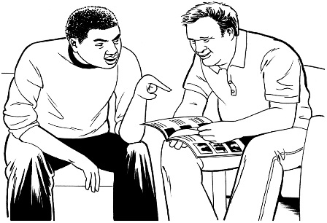
- read it a few pages at a time

- have someone help you to understand it.

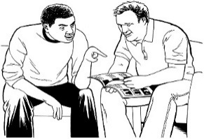
What you will find in here

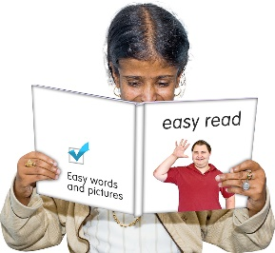
Page number:

What is this document about?..........3

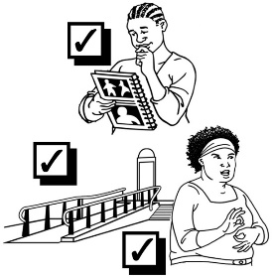
What is the Cabinet paper
about?...............................................6

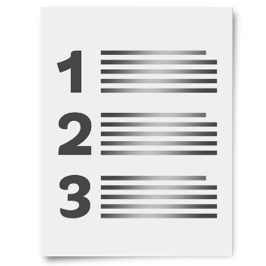
- Proposal……………………………8

- Executive Summary……………..11
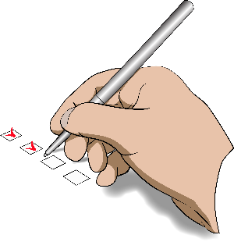

- Recommendations………………17

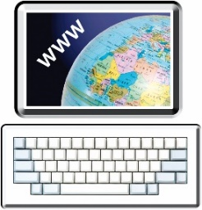
Where to find more
information .24

What is this document about?

This Easy Read document is about a Cabinet paper to do with Accelerating Accessibility in New Zealand.

A Cabinet paper has information in it that Cabinet needs to:

- know

- make a decision about.

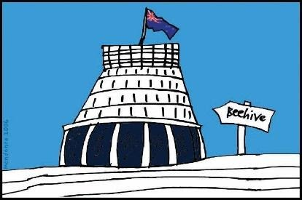
Cabinet is a group of senior government ministers.

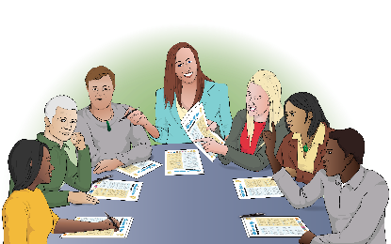
Cabinet meets to make important decisions.

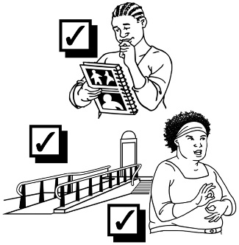
Accelerating Accessibility means looking at what needs to be done to make New Zealand accessible for disabled people faster.

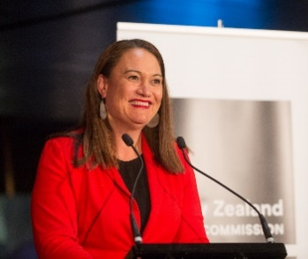
The Cabinet paper is from the Minister for Disability Issues.

The Minister for Disability Issues is Carmel Sepuloni.

The Cabinet paper is for the Cabinet Social Wellbeing Committee.

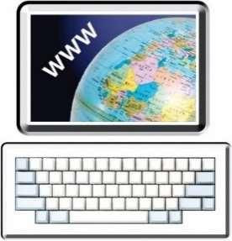
You can find a list of the government ministers who are on the Cabinet Social Wellbeing Committee at this website:

https://dpmc.govt.nz/cabinet-committees/
swc-cabinet-social-wellbeing-committee

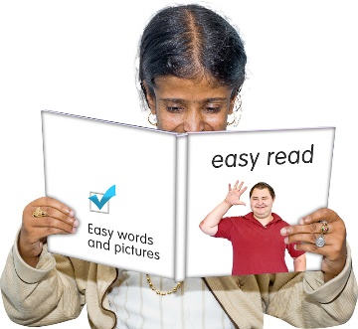
This document is an Easy Read summary of some of the things in the Cabinet paper.

A summary:
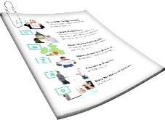
- is shorter
- tells you the main ideas.

What is the Cabinet paper about?

The Cabinet paper is to do with making sure that New Zealand is accessible for disabled people.

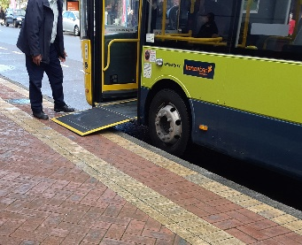
Accessible can mean many different things for people.

Accessible means that disabled people can:

- get into / move around in buildings

- use services easily

- get around in their community

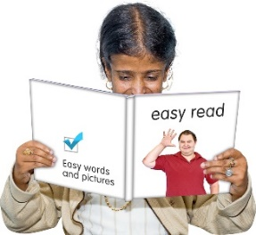
- understand what is being said

          - get information in ways that they can understand.
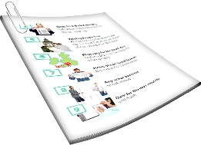
This Easy Read translation looks at 3 parts of the Cabinet paper:

- Proposal
- Executive Summary

- Recommendations.

Proposal is the idea the Minister is asking the Cabinet to think about.

Executive Summary looks at the important main messages in the Cabinet paper.

Recommendations are things that should be done.

- Proposal

The proposal in the paper asks the Cabinet to say yes to 2 things.

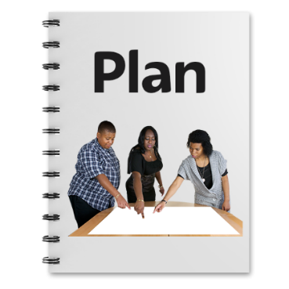
- Make a plan so that New Zealand can be more accessible for:

- disabled people
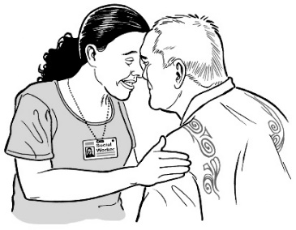
- tāngata whaikaha Māori

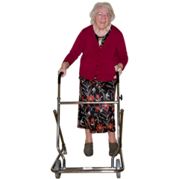
- other people with access needs who might include:

            - older people

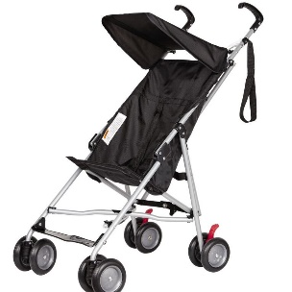
            - families with small children.

The proposal also asks Cabinet to say yes to:

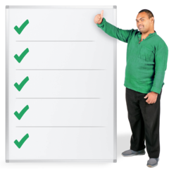
- A new legislative framework that will improve accessibility for disabled people.

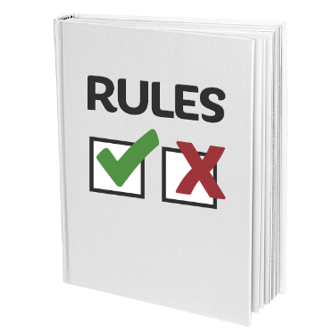
A legislative framework is like a set of laws and other rules that must be followed.

Having this legislative framework will:

  - support New Zealand to be more accessible

  - make a new Accessibility Governance Board.
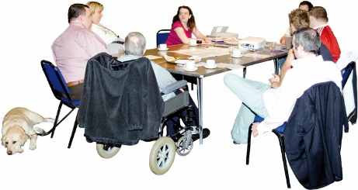
A Governance Board is a group of people who:

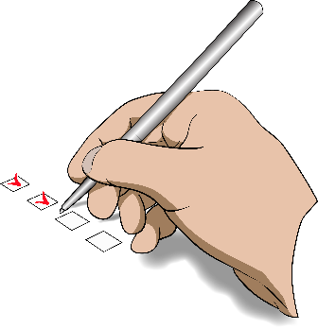
- decide what should be done

- check the right things are being done.

- Executive Summary

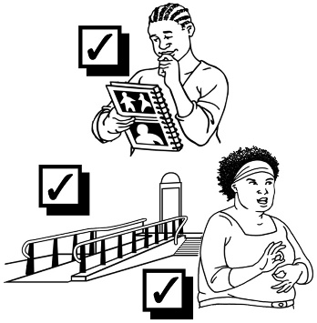
Accessibility is important because it means that disabled people:

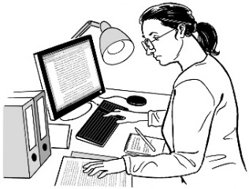
- are able to be part of their community

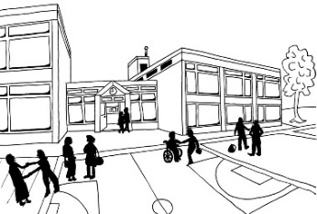
- have the same access as everyone else to doing things like:

  - having work

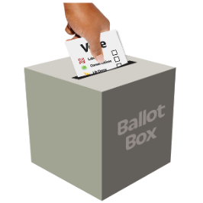
  - getting an education

  - being able to vote in elections.

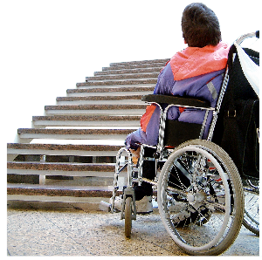
We need to remove the barriers that make accessiblity hard for disabled people.

Barriers are things that make it hard for disabled people to live their lives.

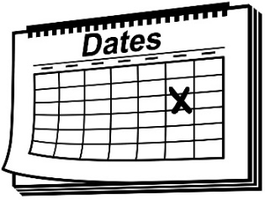
It is taking a long time to remove many of these barriers.

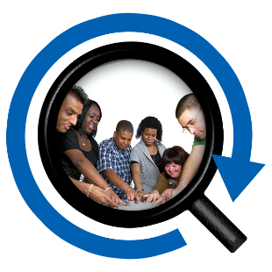
There is no easy way of checking which of the barriers have been fixed.

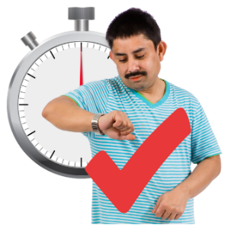
The Government wants to make accessibility happen more quickly.

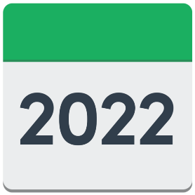
In 2022 the Minister plans to have a new legislative framework.

The legislative framework will do 3 things:

- create an Accessibility Governance Board to involve disabled people
- support government ministers to make better decisions about accessibility

- make sure there are people to lead the work on accessibility in the public service.

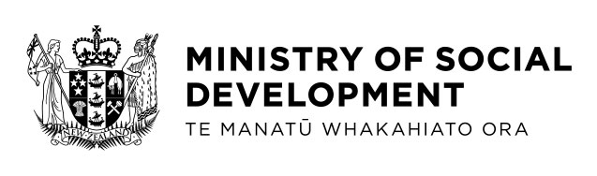
The public service means organisations that the Government runs like the Ministry of Social Development.
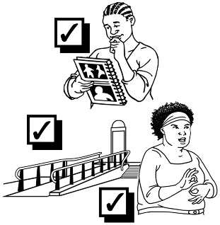
The changes will help New Zealand to be more accessible.

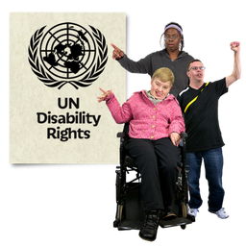
The changes will also support the Government to follow:

- the New Zealand Disability Strategy 2016 – 2026

- the United Nations Convention on the Rights of Persons.
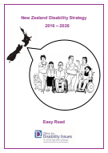

The New Zealand Disability Strategy works to make sure disabled people:

- are treated fairly

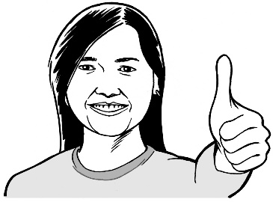
- get what they need to have a good life

- are part of the community

- can make their own decisions.

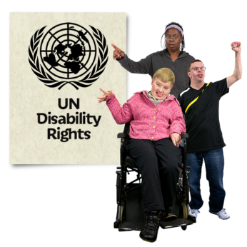
The United Nations Convention on the Rights of Persons with Disabilities is also called the UNCRPD.

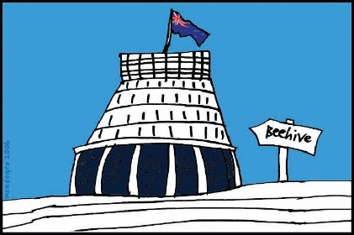
The UNCRPD is a law lots of countries have agreed to.

In 2008 the New Zealand Government said that we agree with the UNCRPD.
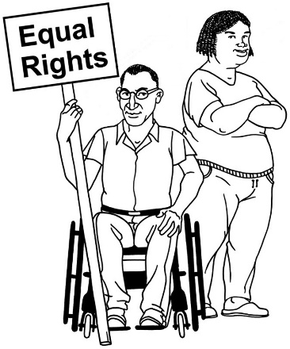

It says what governments must do to make sure disabled people get the same rights as everybody else.

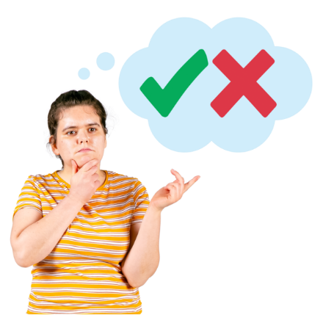
The Government will need to make choices about how to make accessibility happen.

To decide the Government will ask lots of different stakeholders.

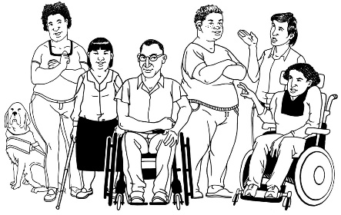
Stakeholders include:

- disabled people
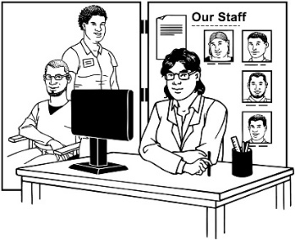
- family / whānau of disabled people

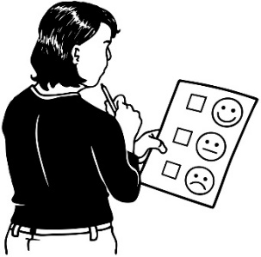
- disability service providers

- people who run businesses.

- Recommendations

Minister Sepuloni makes some recommendations in this Cabinet paper.

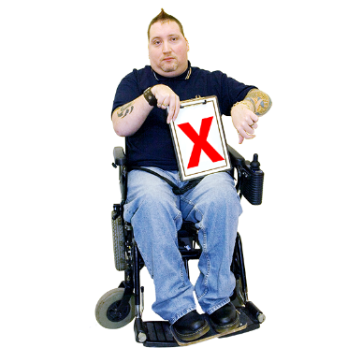
Minister Sepuloni recommends:

- the Committee understands that the way things work now does not make things accessible enough.
- it would be better to have a new way to make things accessible.

The Minister also recommends that the new way of doing things should have:

  - good leaders

  - different ways of making things accessible for disabled people

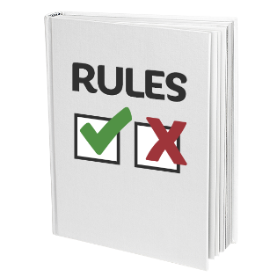
  - really clear rules

  - ways of checking if the laws we have now work well for disabled people.

The Minister also recommends that the new way of doing things should follow the principles of Te Tiriti o Waitangi.
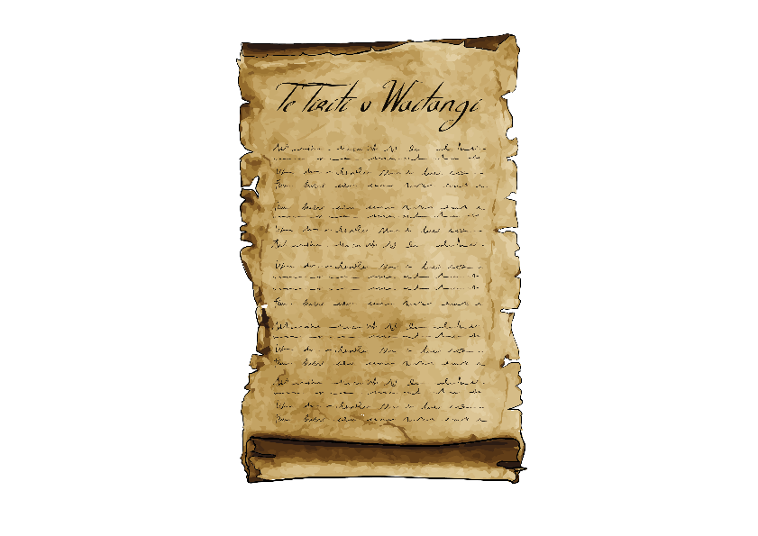

The Treaty of Waitangi / Te Tiriti o Waitangi is a legal document that was signed in 1840.

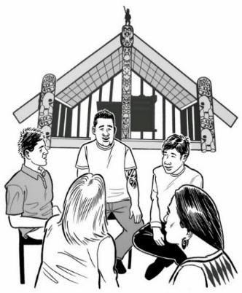
The Treaty / Te Tiriti is important to New Zealand.

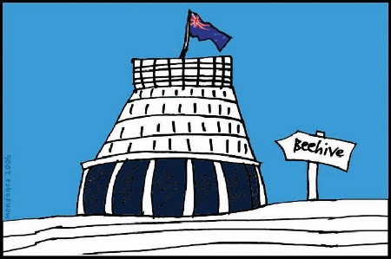
It is about Māori and the New Zealand Government:
- making decisions together
- protecting things that are important to Māori.

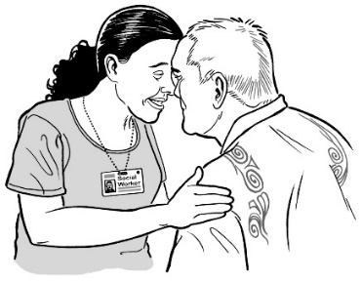
Following Te Tiriti o Waitangi means making sure that tāngata whaikaha / disabled Māori are fully involved including:
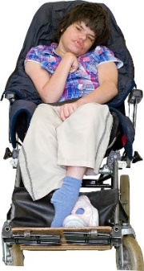
  - disabled rangitahi / young people

  - tamariki / children
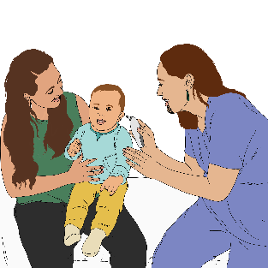
  - whānau / family.

The Minister also recommends that the Cabinet understands that the new way of working has been developed with the Access Alliance.

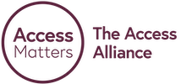
The Access Alliance is made up of:
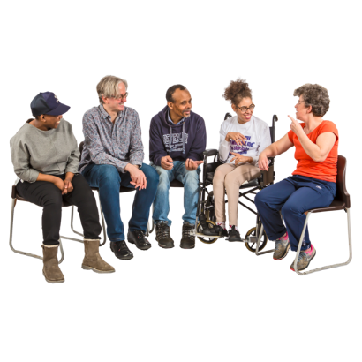
- disabled people

- disabled people's organisations

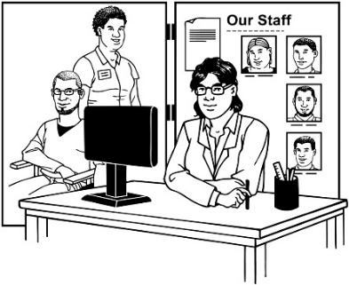
- disability service providers

- community organisations

- disability advocates.

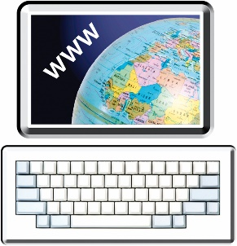
You can find out more about the Access Alliance on their website:

https://www.accessalliance.org.nz

The Minister recommends that the Cabinet agrees the new legislative framework will also say:

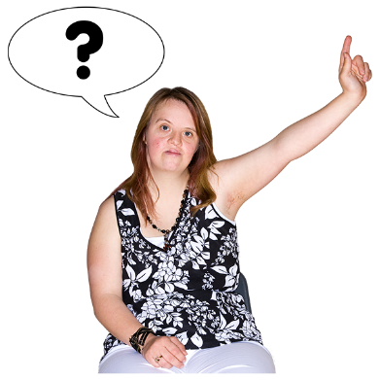
- how people will will have a chance to say what they think including:

  - disabled people

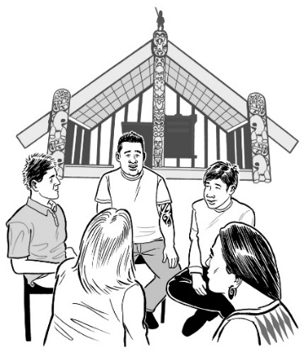
  - tāngata whaikaha Māori

  - individual people

  - groups of people.

The Minister also recommends that the Cabinet agrees the new legislative framework will say:

- how the new way of doing things should work

- what the new Accessibility Governance Board will do
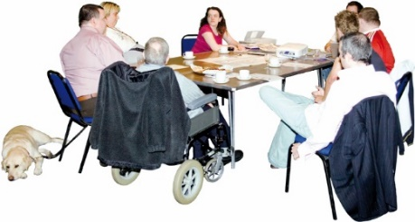
- how people are chosen to go on the Board.

Where to find more information

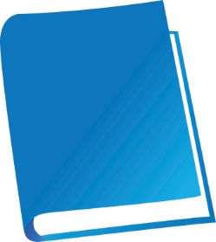
The full version of the Cabinet paper is called:

Accelerating Accessibility in New Zealand
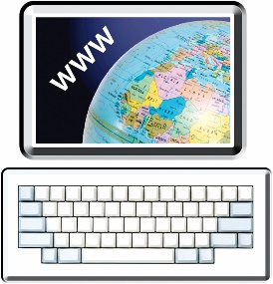

You can find the full version of the Cabinet paper at the Ministry of Social Development website:

www.msd.govt.nz/about-msd-and-our-work/publications-resources/information-releases/cabinet-papers/2021/ accelerating-accessibility.html
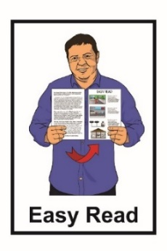

The full version of the Cabinet paper is not in Easy Read.

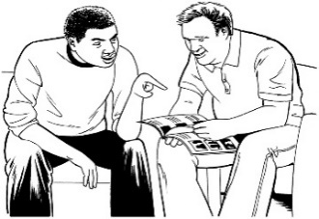
You may want to ask someone to assist you to read it.
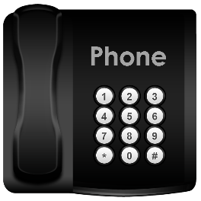
You can also contact the Ministry of Social Development.

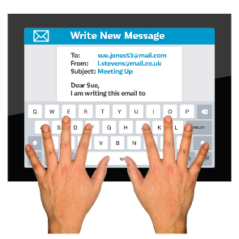
Phone: 04 916 3300

Email: info@msd.govt.nz
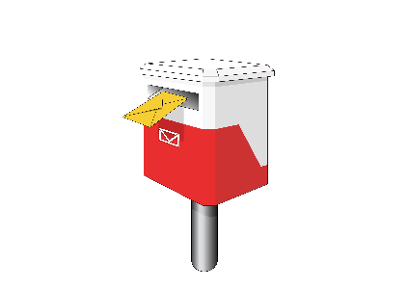

You can ask them to post you a copy of the Cabinet paper.

This information has been written by the Ministry of Social Development.

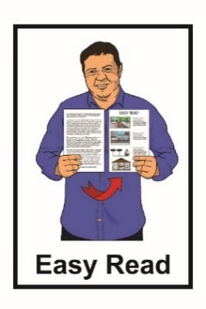
It has been translated into Easy Read by the Make It Easy service of People First New Zealand Inc. Ngā Tāngata Tuatahi.

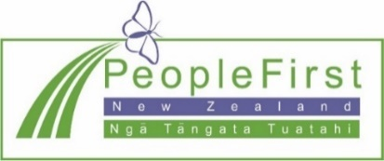
The ideas in this document are not the ideas of People First New Zealand Inc. Ngā Tāngata Tuatahi.
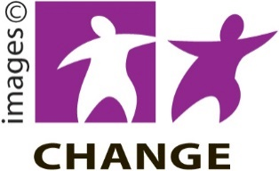
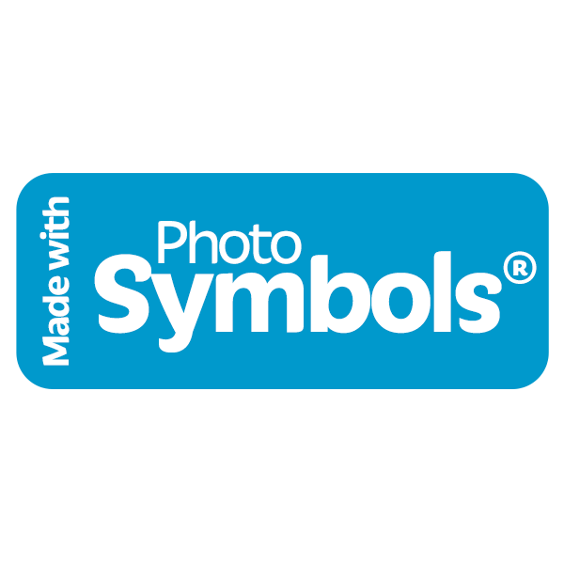
Make It Easy uses images from:

- Changepeople.org

- Photosymbols.com
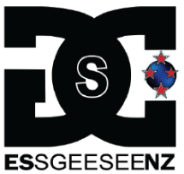
- Sam Corliss

- Huriana Kopeke-Te Aho

All images in this Easy Read document are subject to copyright rules and cannot be used without permission.

