Help with essential costs

Work and Income may be able to help if you’re on a low income or not working.
If you’ve lost your job or can’t work at the moment you may be able to get a benefit or some other financial help from us. We can also help you look for work.
You might have been affected by COVID-19, drought, floods or other events outside your control.
If you’re struggling to meet your living costs or had an unexpected bill we might be able to help you, even if you’re working.
We can help with urgent costs like:
- food
- accommodation costs (rent, mortgage, board)
- power, gas and water bills or heating
- medical and dental costs
We have different types of support and payments available depending on your situation.

Find out more
Even if you don’t think you qualify, call us to talk about your situation.
You can also visit workandincome.govt.nz and click on Check what you might get.

For more information
- Go to workandincome.govt.nz
- Call us on 0800 559 009, 7am to 6pm Monday to Friday and 8am to 1pm, Saturday.

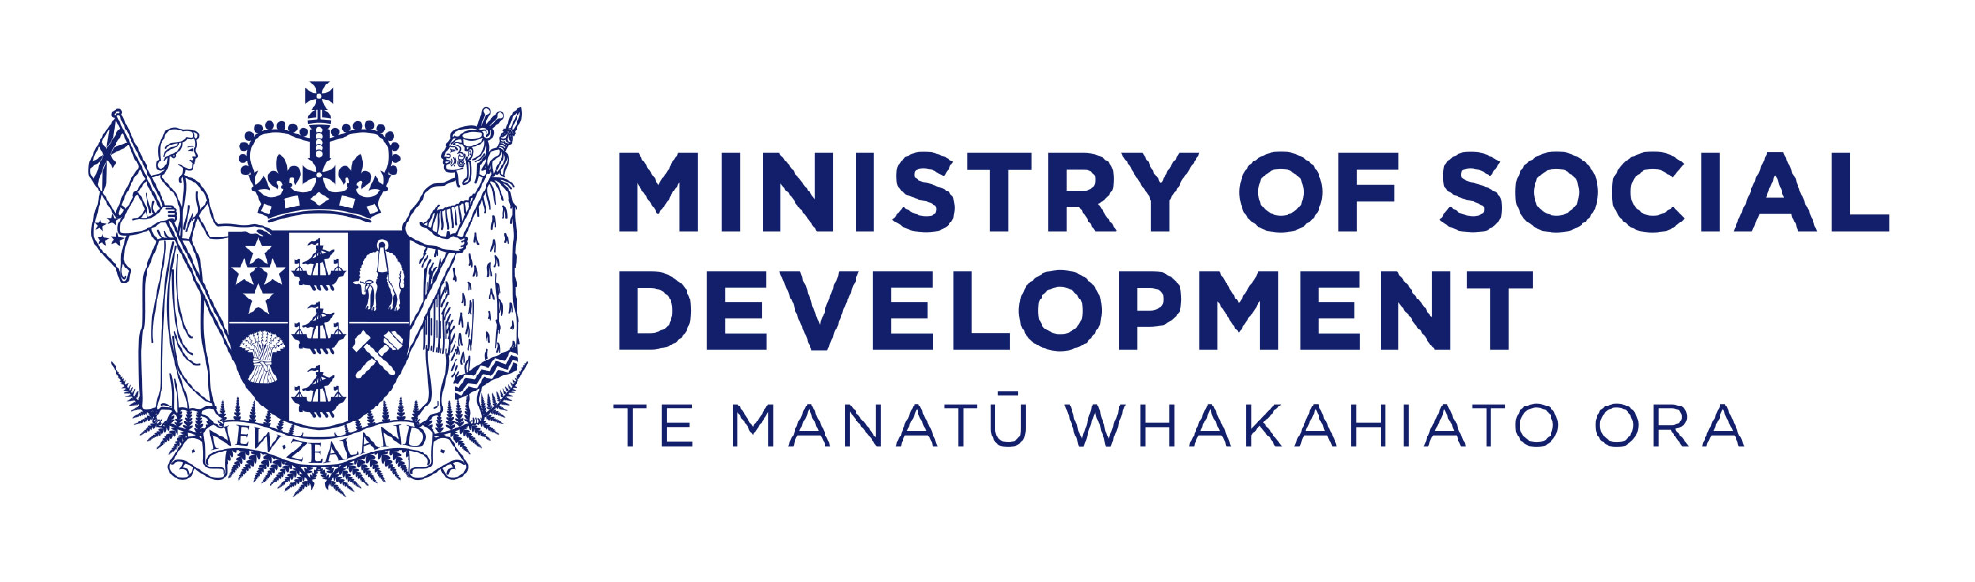
March 2020

