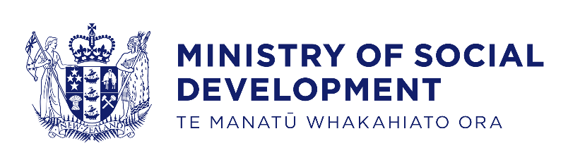

# Abuse in Care Royal Commission of Inquiry – Apology from the Ministry of Social Development

Tēnā koutou katoa. Ngā mihi nui ki a koutou katoa.

Ko Debbie Power tēnei e mihi ana.

My name is Debbie Power, and I am the Chief Executive of the Ministry of Social Development.

It is both a humbling and immense privilege to be able to speak to you today.

Let me begin by speaking to all of you who were abused while you in were in the care of the state.

I wish to sincerely apologise for what happened to you on our watch. It was our responsibility to provide care.

We should have looked after you and kept you safe as a young person in our care.

We may have thought we were removing you from harm, but often times we put you in harm’s way. We did not always protect you.

For that, I am deeply sorry.

When you courageously shared your stories of abuse, we did not always listen or take immediate action, and I am truly sorry for that.

I am sorry for the way some of you have been treated through the redress process with MSD. Our redress system has not always got things right. I accept the Royal Commission’s finding that for some of you, it has been slow, retraumatising and litigious. None of us wanted that and I apologise.

Based on your feedback we have made changes to the redress system over the years and, following the Royal Commission’s recommendation, we have introduced rapid payments. We will continue to make the redress process better.

To those of you who are part of our disabled community - I want to acknowledge the harm done to you. We failed to appreciate the impact of institutionalisation and segregation on disabled people, Deaf and people experiencing mental distress. We were too slow to take action. As the Chief Executive now responsible for the delivery of Disability Support Services, I want to make sure that we have the systems in place to ensure this doesn’t happen again.

We also failed to provide care that was culturally appropriate. For Māori, we failed to ensure te reo Māori, connection to whakapapa, tikanga and mātauranga were present in the places where you were in care.

For Pacific people, you were separated from your Kainga, your communities, and your culture.

These failures have caused ongoing pain to you, your whānau, and your communities.

I know no apology can make up for the lost years and hurt the abuse has brought to you, as a child and into adulthood.

I also want to acknowledge the family and whānau who have accompanied you through your journey. The impact on them cannot be understated, and that often has been passed to the next generation.

I do hope that hearing these words today, can go some way towards bringing you the closure you deserve.

Thank you for your courage in revisiting your experiences for the Royal Commission. I saw how hard it was for you and your family to relive your past.

What happened to you was not your fault. None of the blame can be attributed to you, or anything you did.

It should never have happened. We should have had better systems in place to protect you.

It doesn’t end here. More needs to be done: to make it easier for people in need to use our services; to restore the trust and confidence of those who we have let down; and to better support people to make decisions that help them live the lives they want.

We have heard your voices and listened to your accounts.

We are determined to work together with other agencies to ensure the past is never repeated.

We remain committed to improving the work we do to better support the care system.

We continue to strengthen the accreditation system for providers of care services through Te Kāhui Kāhu (Social Services Accreditation).

We continue to support the Government around changes to Oranga Tamariki Oversight – changes that will make the Monitor more independent and enhance the Children’s Commissioner’s advocacy role.

Thank you for being here. Thank you for holding us to account, and for challenging us to do much, much better.

We cannot change the past, but thank you for the courage and perseverance you and your families have demonstrated which has led to today.

End of information: **Abuse in Care Royal Commission of Inquiry | Apology from the Ministry of Social Development**

This Large Print document is adapted by Blind Citizens NZ from the standard document provided by the Ministry of Social Development