Te Huringa ō Te Ao - Supporting Men Behaviour Change

Te Huringa ō Te Ao Compass, Alignment Tool
Purpose: The aim of The Compass is to encourage and review alignment to the underpinning principles and service aspirations of Te Huringa ō Te Ao.
When to use: This tool is not mandatory. It can be used throughout service development, where useful, to support you on your alignment to the Te Huringa ō Te Ao Framework. For example, when defining your service development aspirations, reflecting on your progress throughout service development, or testing your service concept. Annual or bi-annual reflections are encouraged where possible.
How to use: This tool can be used for self or group reflection, alongside MSD or privately.

What is Te Huringa ō Te Ao
Te Huringa ō Te Ao is a new family violence service that supports sustainable behaviour change for men to restore whānau wellbeing.
This service is for tāne and men harming and hurting their partners and children, who realise it is time for change.
Te Huringa ō Te Ao is for all tāne and men across New Zealand and offers a wide variety of flexible, proactive, and culturally responsive support that encourages men to reconnect with themselves, whānau, and community. This support is tailored to meet the holistic needs of tāne, men and whānau, while continually challenging men to own their behaviour, to be safe and to keep safe. This represents a shift away from short-term, prescribed programmes, and towards a system that puts the responsibility on men to be safe and keep safe.
Te Huringa ō Te Ao aims to create opportunities for local communities to reimagine support for men harming others by centering whānau voice. Together, we aim to think differently in how we support men on their journeys of change to break the cycles of violence, and to create and sustain intergenerational change.
The project framework has 7 Service Aspirations and 10 Underpinning Principles. All services developed for Te Huringa ō Te Ao are aligned to this framework.

You can find out more about the project framework on the MSD website.

Tool Guidance
The Te Huringa ō Te Ao framework reflects essential information from a literature review, the voices of men using violence, and sector engagement. This includes Service Aspirations and Underpinning Principles. All service development, service delivery, and project stewardship must align to these key elements.
This tool contains two compasses, one for Service Aspirations and one for Underpinning Principles, to make it easy for individuals and organisations to reflect on their alignment.
Use this tool to reflect on which service development stage (refer to key) best suits where you are for each element. For example, when looking at the key, you may feel you are currently at 1 (Aspirational) in some elements and score at a 4 (Transformative) in others. Plot these reflections on the compasses and jot down any supporting notes if useful. You may repeat this over time to show growth or areas of focus. As noted, annual or bi-annual reflections are encouraged where possible.

For example, it may look something like this for Underpinning Principles: 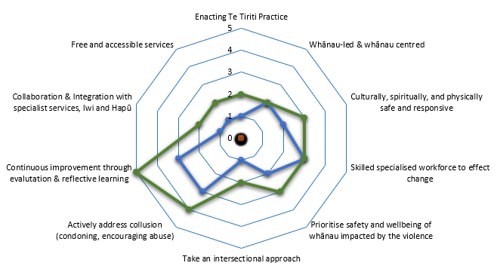

Te Huringa ō Te Ao Compass - for your use (printable page)
Key: service development stages
- Aspirational – want to be able to do well
- Emerging – we’re developing but we need more capability
- Consolidating – we do this well but we’re looking to improve
- Transformative – We do this really well and are open to sharing
- Implementation – we are ready to implement this in our service
Add your service development stage to each relevant arm of the compasses as follows:
Underpinning Principles
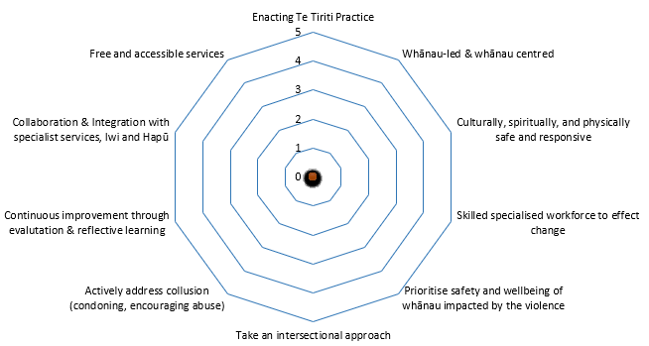
Service Aspirations
