Child Poverty in New Zealand:
The demographics of child poverty, survey-based descriptions of life ‘below the line’ including the use of child-specific indicators, trends in material hardship and income poverty rates for children, and international comparisons – with discussion of some of the challenges in measuring child poverty and interpreting child poverty statistics

Prepared by Bryan Perry

Ministry of Social Development
Wellington

October 2022

ISBN 978-1-99-110512-7 (Print)

ISBN 978-1-99-110513-4 (Online)

(Overview and Selected Findings)

Changes since last report

- Updated with 2020-21 data.

- Time series added for material hardship rates from 2007 to 2021 and low-income rates from 1982 to 2021.

- Housing affordability for households with children – renters and owners.

- More detailed analysis and breakdown including for those in the deepest material hardship.

- Technical sections strengthened.

Next report

- The next report is scheduled for mid-2023. The timing is dependent on when Stats NZ publish their Child Poverty Statistics (likely to be February 2023), and on the timing of the availability of the HES data for MSD use.

Availability on MSD website

- This report is available on the MSD website:
Child Poverty in New Zealand - Ministry of Social Development (msd.govt.nz)

Updates since publication on 7 October 2022

- Nil

Acknowledgements

My thanks to all those who provided comments on earlier drafts, including MSD colleagues, staff from the Treasury, Stats NZ and DPMC, and others from NGOs. Their advice, questions, challenges and smoothing out of rough patches have added considerably to the report’s robustness, readability and relevance. My thanks especially to Caroline Hodge whose expert SAS coding, preparation of publication-ready tables, ability to succinctly synthesise results from complex investigations of the data, careful review of the full text and general unwavering commitment to excellence have been crucial in the production of this report. Responsibility for all the analysis and interpretation in the report (including any errors or omissions) remains mine alone.

MSD Child Poverty Report 2022

Overview and Selected Findings

Prepared by Bryan Perry
October 2022

Overview and selected findings

MSD’s Child Poverty report is a comprehensive resource designed to inform policy development, research and public discussion in relation to the material wellbeing of children and the households in which they live. Most of what is reported is about material hardship, low incomes and financial stress as these are matters of considerable ongoing public policy interest, but it also reports on how well the vast majority of children and their households are doing in terms of their material wellbeing. Children are those aged under 18 years.

There is naturally some overlap with Stats NZ’s Child Poverty Statistics report (Feb 2022) – the same notion of poverty is used, the same Child Poverty Reduction Act (2018) measures, and the same basic methodology in line with international best practice – but the reports are essentially complementary, each with its own focus, purpose and selection of material. The Stats NZ report is mainly focussed on fulfilling the requirements of the CPRA and reports in detail on year-on-year and short-run changes for all children and selected sub-groups (regional council areas, ethnic groups, disability status). MSD’s report looks at the longer-term trends (15 to 50 years where possible), gives international comparisons, uses a much wider range of breakdowns (see list below), and has strong research and policy implications themes throughout.

The latest data used in both reports is from the 2020-21 Household Economic Survey (HES). The interviews for the 2021-22 HES only finished on June 30, 2022, so the MSD report has no more up-to-date headline figures than there already are in the Stats NZ report. The next Stats NZ report is scheduled for February 2023, with updates using HES 2021-22.

Key themes covered in the MSD report

  - international comparisons for children: material hardship rates, low income rates, and the proportion living in households with no adult in paid employment
  - long-run trends for low income rates (from 1982) and material hardship rates (from 2007) for all children and for selected sub-groups
  - trends in beneficiary income levels over several decades
  - detailed descriptions of life ‘under the line’ for children in various household contexts, including information on the most seriously disadvantaged
  - material hardship and low-income rates for ‘beneficiary’ and ‘working’ households
  - some comparisons with the situation for older New Zealanders and for those under 65s in households without children
  - material wellbeing for children across the full spectrum from very low to high living standards
  - the relationship between the various measures, the degree of overlap or mismatch, with discussion as to why this is the case
  - housing (un) affordability trends for households with children, especially private renters
  - discussion of some of the limitations of the HES data for reporting on poverty, and of the implications of moving to use administrative data for most income information in 2019-20
  - the rationale for the various low-income and material hardship thresholds used in MSD’s reports (and in the CPRA)
  - sensitivity testing, showing how different assumptions can impact on key findings
  - a brief outline of several common misunderstandings or misrepresentations of findings about child poverty

Sections on food security and housing quality are planned for inclusion in the 2023 edition. Good information on these themes is currently available in the Child Poverty Related Indicators report: https://dpmc.govt.nz/publications/child-poverty-related-indicators-report-2020-21

Concepts, definitions and measures

Poverty in this report and in the measures specified in the CPRA is essentially about household resources being insufficient to meet basic material needs. As in most richer countries, poverty is commonly understood as ‘exclusion from the minimum acceptable way of life (standard of living) in one’s own society because of inadequate resources’. This high-level definition is in line with the EU definition which was first agreed at the 1975 EU Council of Ministers, and which was inspired by the work of Peter Townsend in the UK in the 1970s.

Household income, adjusted for household size and composition, has traditionally been used as a proxy measure of household resources. While this approach produces valuable information on income inequality and on the number of households with incomes below selected low-income lines, it has several limitations as a poverty measure.
- Different households with very similar current income can have different levels of non-income resources, sometimes reflecting different income trajectories in previous years, sometimes the degree of assistance from outside the household or the level of assistance given to other households. The differing non-income resources include the levels of cash savings, and the quantity and quality of the stock of basic household items, especially durables.
- Different households with very similar current income can also have quite different basic needs. Some of these differences can be addressed: household income can be adjusted for household size and composition (‘equivalised’); the differing demands on the budget for differing housing costs can be addressed to a degree by using income after deducting housing costs (AHC income) to make comparisons more realistic. However, there are some differing demands on the household budget (ie differing needs) that cannot easily be adjusted for (eg special health costs, high debt servicing, and so on). There is also variability in the ability of households to convert a given income into valuable consumption.

As a result, when using a given low-income threshold (‘income poverty line’), it is found that some of the low-income households do not experience financial hardship, and others with incomes ‘above the line’ do. Low income on its own does not distinguish well between those with adequate resources to sustain a minimum acceptable standard of living and those without these.

This does not mean that income has little impact on the material wellbeing of individual households – for low-income households especially, any increase in income will almost always make a positive difference. It’s just that when it comes to measuring poverty (as defined above), income on its own is not a very good identifier of those who are actually struggling to achieve a minimum acceptable material standard of living.

Over the last two decades growing use has been made of non-income measures (NIMs) to more directly measure material standard of living and material hardship. These measures use survey information about what basics and near-basics households can and cannot in practice afford. By using carefully selected items from the survey information, indices can be created to rank households across a spectrum from no hardship through to severe hardship. They provide a more direct measurement of ‘minimum acceptable standard of living’ than household income does.

The EU has formally adopted a 13-item material and social deprivation index (‘EU-13’ in this report) as one of its suite of social inclusion indicators. New Zealand uses a similar 17-item index to measure hardship (DEP-17). Both these indices are designed as instruments to rank households by their differing degrees of material hardship, using a balanced set of indicators that cover a range of domains and degrees of depth of deprivation, reflect the same underlying concept (or ‘latent variable’), and which apply reasonably well to people in different age groups and household types.

Some use a combination of both low income and material hardship as a poverty measure. Ireland uses the combination method to measure what they call ‘consistent poverty’, as in their view this (overlap) group best fits the high-level definition which has both an input (resources) and outcome dimension (minimum acceptable material standard of living). MSD uses the combination method as one of the measures in its multi-measure multi-level approach. It can be seen (as in Ireland) as the preferred measure, or simply as a measure of deeper poverty. It is one of the specified measures in the CPRA suite.
The income-wealth-consumption framework used in the MSD reports

MSD’s reports use the framework outlined in Figure 1 below for thinking through the relationship between material wellbeing (or living standards), household income, financial and physical assets, and other factors.
- ‘Current’ household income and financial and physical assets together largely determine the economic resources available to most households to support their consumption of goods and services and therefore their material standard of living.
- For low-income households that have very limited or no financial assets, income is the main resource available to generate their standard of living (along with the stock of physical assets such as furniture, consumer durables, and so on). Such households struggle in varying degrees to meet basic needs, and are also very vulnerable to the negative impacts of ‘shocks’, such as even a small drop in income or an unexpected expense.
- The framework recognises that factors other than current income and assets can also impact on material wellbeing. These factors are especially relevant for low-income / low-asset households, and can make the difference between ‘poverty/hardship’ and ‘just getting by’.

Figure 1 (= A.1 in main report)
The income-wealth-consumption framework used in the MSD reports
Household income (equiv)
Basic needs / essentials
Discretionary spend / desirable non-essentials
Material wellbeing or living standards
Resources available for consumption
DEP-17
MWI

Financial and physical assets (in part reflecting previous income)

Other factors
eg assistance from outside the household (family, friends, community, state), the ability to convert given resources into valuable consumption, ability to access available resources, size of housing costs and employment-related costs (eg childcare), high or unexpected health or debt servicing costs, disability that incurs extra costs or limits paid employment.

In line with the above, a key theme of this report and MSD’s main Household Incomes and Material Wellbeing reports is that ‘not all households with low incomes are in hardship, and not all in hardship have low incomes’. The overlap between material hardship and income-based measures is limited, typically of the order of 45%, and as low as 30%, depending on the low-income measure used. Factoring this into our reading of the figures is critical for understanding and interpreting child poverty statistics.
Households in material hardship
Low-income households

Some low-income households are not in hardship
Some households in hardship do not have low incomes

The actual degree of overlap between the different measures is covered in the Selected Findings section below.
Adjusting the low-income thresholds (poverty lines) over time: ‘fixed’ & ‘moving’ lines

Once a low-income poverty line is established for a given survey, the question arises as to what approach to use to adjust that threshold for the next survey. There are two common ways in which this adjustment is made and they differ in how they assess whether an improvement has occurred in a household’s income circumstances:
- one approach considers that a low-income household has improved its situation when its income rises in real terms, irrespective of what is happening to the incomes of other households – the ‘fixed line’, ‘anchored’, or ‘constant-value (CV)’ approach
- the other uses the median household as the reference and an improvement is considered to have occurred when a poor household moves closer to the median – the ‘moving line’ or ‘relative (REL)’ approach.

Both approaches reflect the ‘relative disadvantage’ concept of poverty and hardship. The REL approach is self-evidently a relative approach. The CV approach has to be benchmarked against community standards in some way to start with, then after some years of being kept at the same level in real terms it has to be re-based – again relative to some estimate of community standards.

Both approaches are used in income poverty analysis in OECD-type nations. They each have a valid story to tell about the situation of people in lower-income households.

In the short to medium term at least, the fixed line (CV) measure can be seen as the more fundamental measure in the sense that it reveals whether the incomes of low-income households are rising or falling in real terms. Whatever is happening to the incomes of the ‘non-poor’, if more and more people end up falling below a CV threshold, as happened in New Zealand from the late 1980s through to the mid 1990s, then in the population at large there is likely to be wide concern about increasing poverty.

In the medium to longer-term, the REL measures become important indicators in their own right and also for social cohesion – if low incomes and middle incomes become increasingly further apart then those in low-income households are less likely to feel they belong.

Labelling of Household Economic Survey (HES) years

When reporting findings from the HES, ‘2017’ is short-hand for ‘2016-17’, and so on. The ‘2017’ survey ran from July 2016 to June 2017. Some of the items refer to how households were faring in the 12 months prior to the interview.
- This means that the ‘2017’ material wellbeing scores / hardship rates reflect on average how households were faring towards the end of 2016.
- The HES income information is about income in the twelve months prior to the interview. For those interviewed early in the survey (eg July 2016) the income information is for July 2015 to June 2016, and so on. This means that ‘2017’ income-based figures include information from July 2015 through to June 2017.

All this matters for the interpretation of trends in relation to assessing the impact of policy changes or major economic events.

HES 2020-21 and the COVID impact
The latest survey information in MSD’s 2022 Child Poverty Report is from the 2020-21 HES. The figures and trends do not therefore reflect the full net impact of COVID on the one hand and government actions to mitigate the impact on households on the other. The material hardship and low-income information in the 2021-22 HES is needed to better capture that joint impact.

The HES gathers information on the usually resident population living in private dwellings

The survey therefore includes those living in retirement villages, but not those in non-private dwellings such as rest homes, hotels, motels, boarding houses and hostels. Other sorts of surveys are needed to obtain a picture of what life is like for those in more transient accommodation or those ‘living rough’.

This does not mean that the survey does not reach households with very limited financial resources or those in more severe hardship. For example, in the 2018-19 HES: 724 of the households interviewed reported receiving help from a food bank or other community organisation more than once in the previous 12 months, 1698 households reported putting up with feeling cold ‘a lot’ in the previous 12 months because of needing to spend on other basics, and 25% came from the two most deprived NZDep13 deciles (ie the most deprived 20%). The achieved response rates for the most deprived NZDep13 deciles are similar to the overall response rate – for example, 75% for 2020-21 for deciles 8, 9 and 10.

Selected Findings

Material hardship comparisons with European countries

Eurostat’s annual Survey of Incomes and Living Conditions (EU-SILC) provides the data for the EU’s social and material deprivation index (EU-13). We can produce EU-13 figures for New Zealand from HES data. The EU-13 index gives numbers that are close to those produced by the DEP-17 index that is used elsewhere in MSD reports and by Stats NZ in the CPRA reports.

The international comparisons in the main report are provided in relation to 29 European countries: most EU countries plus Norway, Switzerland and Iceland or, after January 2020, most EU countries plus Norway, Switzerland, Iceland and the UK. Bulgaria and Romania, though in the EU, are omitted as their general standard of living is much lower than New Zealand and most of the other European countries on the list. To avoid clutter in the charts, the smaller countries are omitted (Malta, Cyprus, Luxembourg and Iceland), leaving 25.

On the EU-13 measure 11% of New Zealand children lived in households that were classified as in material hardship in 2020 (latest available EU data). New Zealand’s rate was similar to that for Slovakia, Germany, Belgium and Portugal, around the middle of the European league table – lower than Ireland, France, the UK and Spain (15-18%), but higher than Finland, Norway, Poland, Sweden, the Netherlands, Switzerland (CH), Denmark, Croatia (HR) and the Czech Republic (4-7%).

In the three years since EU-SILC 2017 (≡ HES 2017-18), the median European rate decreased from 12.3% to 10.3%, and New Zealand’s rate decreased from 13.5% to 10.6%. The fall in the European median reflected the improved rates for children in several countries, who all moved from above to below the earlier European median.

The current gazetted 2027-28 CPRA target for material hardship using DEP-17 is 6%. Reaching that level would mean an EU-13 rate of around 6-7%.

Figure 1
Material and social deprivation rates (% with 5+ enforced lacks), EU-13, 0-17 yrs
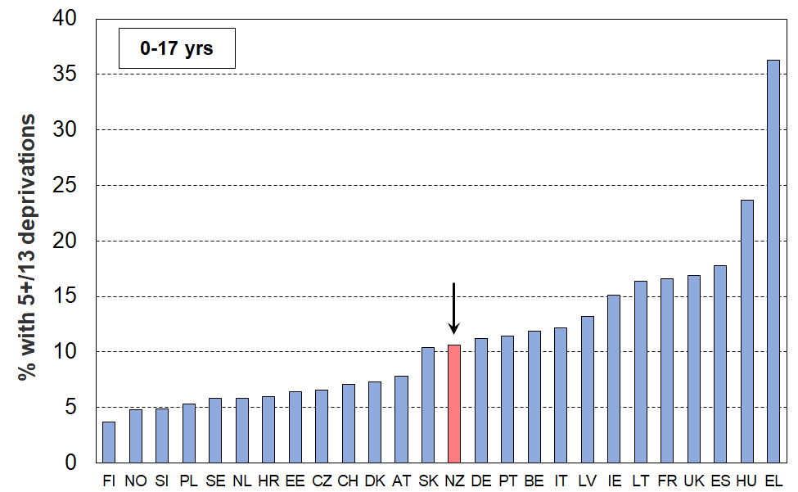
25 European countries + NZ (EU-SILC 2020, NZ HES 2020-21)
Note for Figure 1: see Table D.1 in main report for country code abbreviations (p71).

- The 2020 EU-13 material hardship rate for New Zealand two parent households with one or two children is 7%, close to the EU median for this household type (6%). For two parent households with three or more children the New Zealand rate (17%) is above the median EU rate for this group (11%).

- For New Zealand sole parent households, the EU-13 material hardship rate is 29%, down from 34% in 2017, but still well above the European median for this household type (19%). New Zealand also has a relatively high proportion of sole parent households compared with European countries.

Material hardship trends from 2007 to 2021

Material hardship rates for children increased during the GFC and associated downturn, then steadily improved from 2013 to 2021 (Figure 2).

The downward trend can be attributed to a combination of rising employment rates, rising wages, increases to income support for families with children, increased support for housing and child-care costs, and other measures that reduce demand on the family budget (eg free doctors’ visits and the food-in-schools programme).

Figure 2
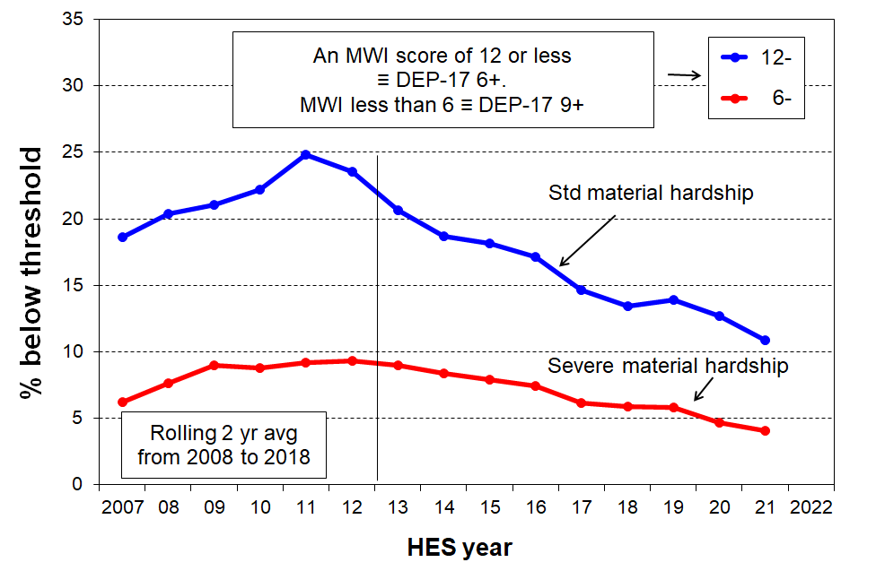
Material hardship trends for children (0-17 yrs), 2007 to 2021

Figure 3 shows the material hardship trends for sole-parent, two-parent and other multi-adult households with children. The hardship rate for children in sole-parent households is typically three to four times higher than for two-parent households. A major factor in the difference is the more limited potential for paid employment hours in a one-adult household, with or without children. (See the main report for more on this.)
Figure 3
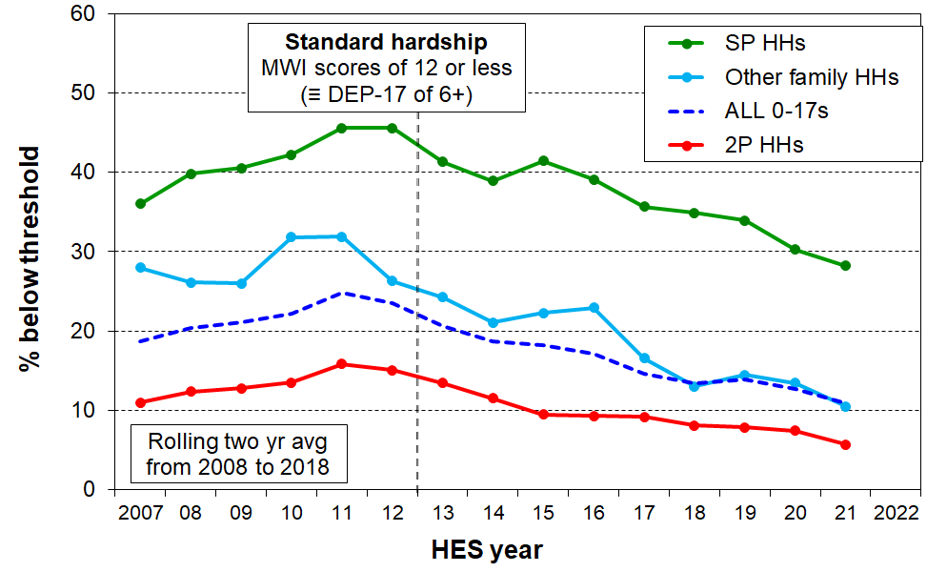
Trends in material hardship for children (0-17 yrs), by household type
Most children live in two-parent households (~70%), with 15% in sole-parent households and 15% in other multi-adult households. This means that even though sole-parent hardship rates are much higher than for two-parent households, on average over the three most recent surveys (HES 2018-19, 2019-20, and 2020-21) around the same number of children in hardship come from each of sole-parent and two-parent households.

Material hardship trends for ‘working’ and ‘beneficiary’ households

In this section, ‘working’ means that most of the income for the household comes from the market, and ‘beneficiary’ means that most of the income comes from the government. Figure 4 shows the material hardship trends for the two groups of children, with beneficiary hardship rates being around four to five times higher than rates for children in working households.

Figure 4
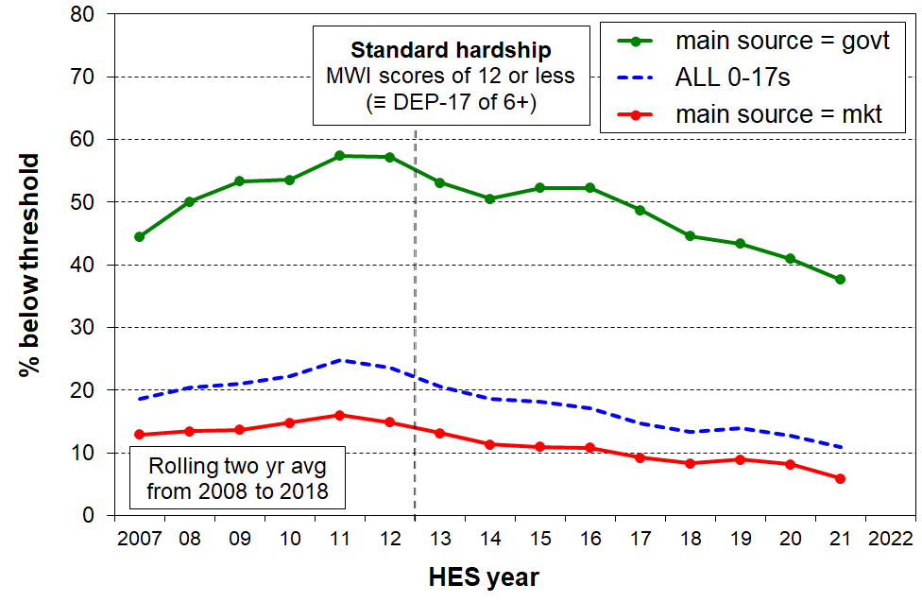
Trends in material hardship rates for children (0-17 yrs), by main source of household income

Figure 5 reports on the composition of those in hardship: around the same number of children in households in hardship come from each group. Although working households have lower hardship rates, there are many more such households than beneficiary households, so the numbers even up

Figure 5
Trends in the numbers of children (0-17 yrs) in households in material hardship,
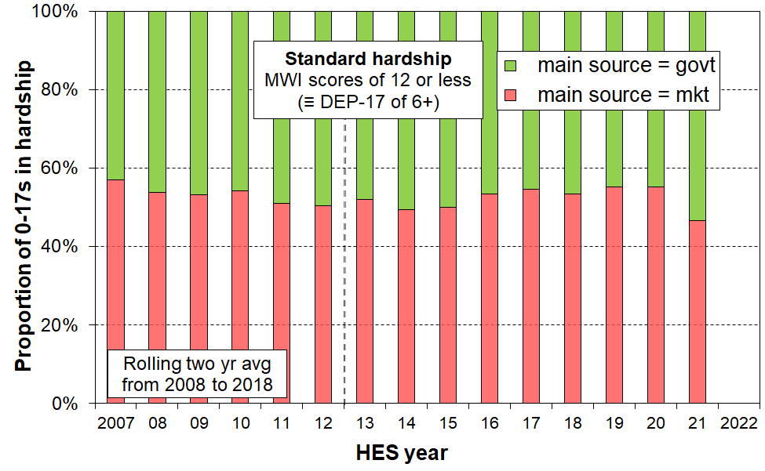
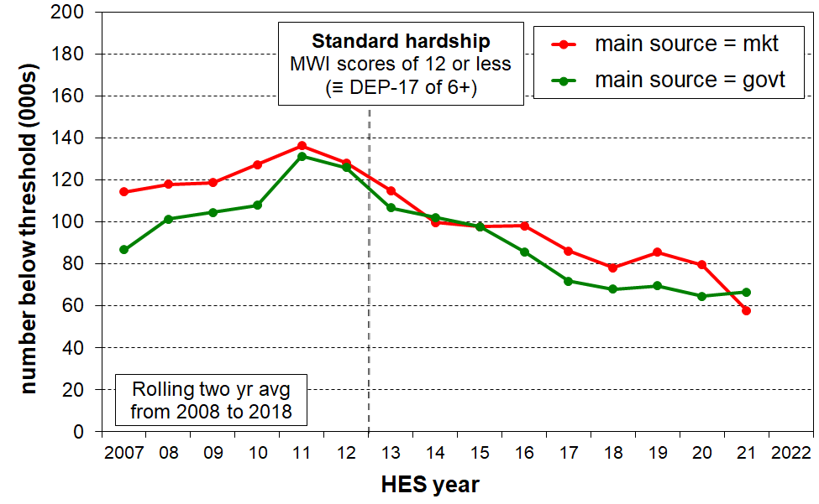
by main source of household income

See the last page of this Overview for discussion of the often-made assertion that ‘paid work is the best way out of poverty’.
Increasing proportion of dual-earner two-parent households

Figure 6 shows the trend to increasing work intensity among two-parent households with dependent children.
- The option of one partner in full-time paid employment and one not in paid employment (‘workless’) was the dominant pattern in the early 1980s. By the early 2000’s, the most common arrangement was for both parents to be employed full-time (~38%), and in 2021 the figure had reached almost one in two (49%).
- The one-FT-one-PT arrangement has been reasonably steady at 25-30%.
- Around three of every four two-parent families were dual-earner families in 2021, up from one in two in the early 1980s.
- This increasing proportion of dual-earner two-parent households is a major factor behind the longer-run consistent rise in material wellbeing for the vast majority of children, as indicated for example in Figure 15 (a few pages below). It also points to / is consistent with the view that in general, single-earner households are now much less likely to be a viable option for providing economic security than they were 25-40 years ago.

Figure 6
Increasing proportion of two-earner two-parent households (with dependent children),
1982 to 2021
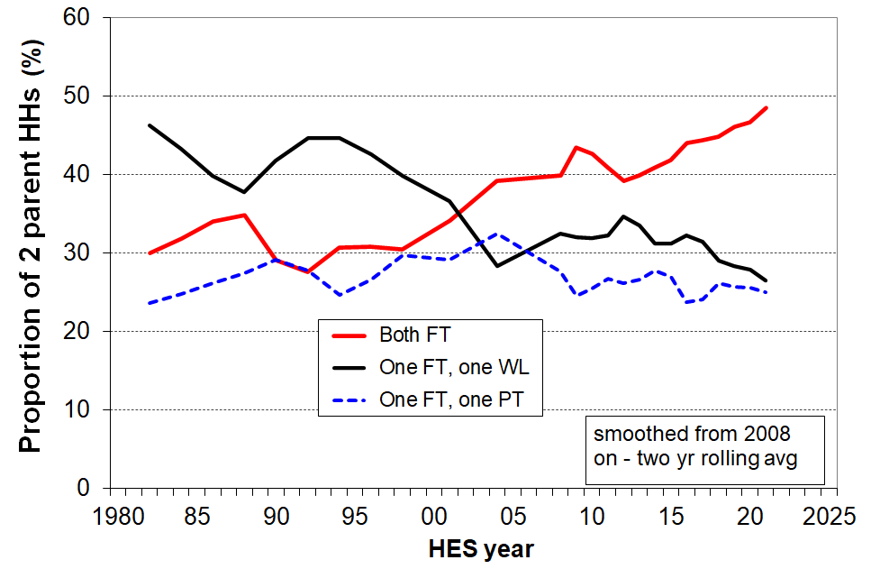

Break in time series between HES 2017-18 and 2018-19 for income-based measures

Up to HES 2017-18, Stats NZ merged information from the survey itself with modelled information produced by the Treasury for income items known to be inaccurately provided by many respondents. The resulting dataset is referred to as HES-TAWA. Starting with HES 2018-19 Stats NZ use and provide others with a dataset that derives most of its income information from administrative data, including tax records. This is referred to as HES-Admin.

The two datasets have some differences which mean that some income-based time series do not always mesh well between the two, especially for low incomes. This time series break is indicated in the MSD report by a vertical broken line in the charts. In some cases the trends across the discontinuity are seamless – in those cases, the MSD charts do not show the broken vertical line.

Not too much should be read into changes in trend levels between the trend lines based on the two datasets. The reader is advised to focus on the big picture. The text assists with that.

In addition, Stats NZ created a special time series for incomes back to 2007, based on the HLFS and the HES to create datasets with much larger sample sizes. They use analysis of this data in their published material. In this case there is no time series break from HES 2017-18 to 2018-19.

Section N in the main report has further detail on the datasets and Section O discusses some of the implications of moving to using administrative data for most of the income information.

AHC low-income rates for children

Figure 7 shows the AHC low-income (poverty) rates for children for the four decades from 1981-82 to 2020-21, using both fully relative measures (the broken lines) and anchored or constant value measures (the solid blue lines).

The anchored line or ‘constant value (CV)’ measure sets the low-income threshold in a reference year and adjusts it forward and back using the CPI. In other words, the low-income threshold is fixed in real terms. The reported poverty rate rises if the incomes of low-income households decrease in real terms irrespective of what is happening to the incomes of the rest of the households … and vice versa. Figure 7 uses the AHC 50 CV measure, with two different reference years, 2007 and 2018.
- The solid blue CV-07 trend line reports an AHC 50 rate for children of around 18-20% in 2007 to 2012, much the same as in the 1980s. This is because the inflation-adjusted AHC incomes of low-income households with children were around the same in each time period.
- The AHC 50 CV-07 low-income rate doubled from 20% to 40% in a very short period in the late 1980s to early 1990s, reflecting rising unemployment, a falling average wage, demographic changes (more sole parent families), the 1991 benefit cuts and the introduction of market rents in (what we now refer to as) public housing.
- The rate then steadily fell through to 2008 with improving employment, a rising average wage, rising female employment, the introduction of income-related rents and Working for Families.
- The post-GFC slow-down led to a slight rise through to 2013, followed by a steady decline reflecting good economic conditions, a rising minimum wage and, more recently, higher housing support through changes to the Accommodation Supplement and increases in incomes for beneficiary families and households.

The three fully relative AHC trend lines (broken lines in Figure 7) show that low-income AHC rates for children were fairly flat over the 25 years from 1993 to 2018 on these measures, with some decrease in recent years. This indicates that low incomes were roughly keeping pace with median incomes, with no noticeable change in income inequality in the lower half of the AHC incomes distribution. In contrast, the large change in income inequality from the late 1980s to the early 1990s saw AHC low-income rates double during this period.

Figure 7
Long-run trends in rates of low AHC household income for children (0-17 yrs),
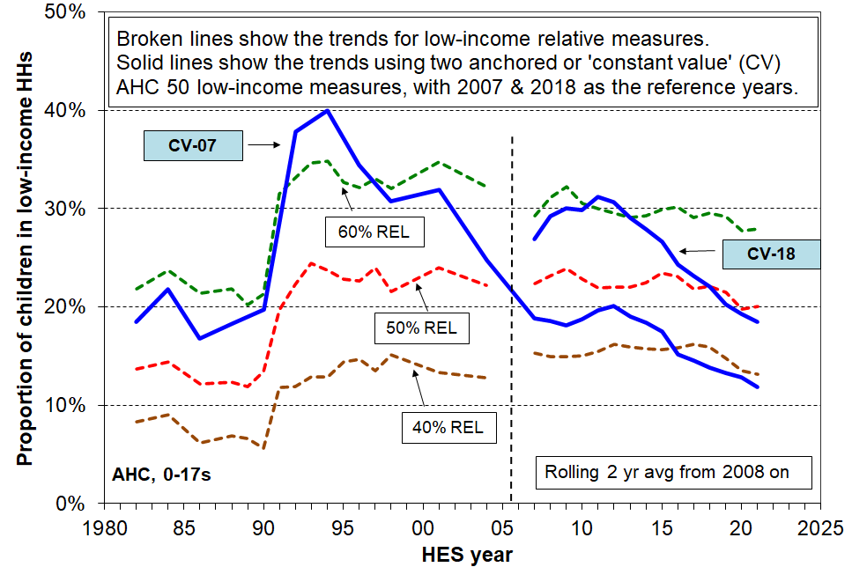
using both relative (‘moving’) thresholds and anchored (constant value) thresholds
Notes for Figure 7:
- See box on previous page for information on the different datasets used for the time series.
- See the main report for information on the inflation adjustment approach used by MSD for the AHC CV lines.

If there is a downturn in coming years and inflation remains elevated then, all else equal, the AHC anchored poverty lines can be expected to rise. The relative lines are likely to remain flattish … or even fall, if median incomes fall more than do those of low-income households with children.
Trends in low and middle incomes for households with children

Beneficiary households with children

Figure 8 shows the long-run trends (1947 to 2022) in inflation-adjusted (‘real’) base support for the most common beneficiary households / families:
- The incomes include benefit income and income from the Family Tax Credit and its predecessors, but exclude the Winter Energy Payment, Best Start and the Accommodation Supplement (AS).
- Incomes from the two sources noted have recently risen to be above the rates prior to the 1991 benefit cuts – for the first time since then.

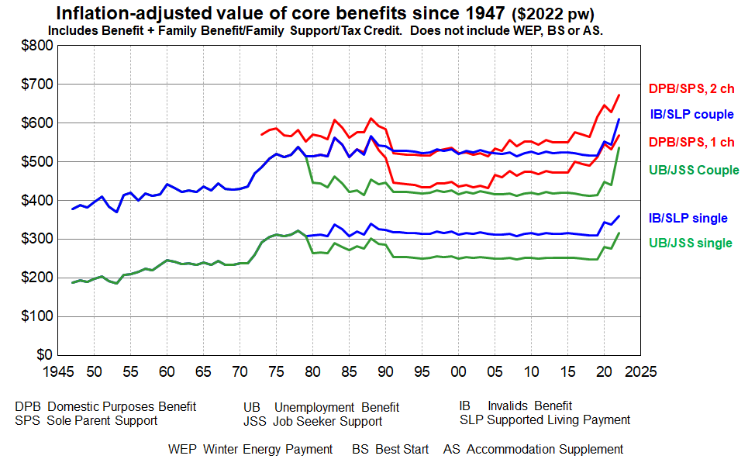
Figure 8
Source: MSD collation from information from the Royal Commission on Social Security, Dept of Social Welfare Annual Reports, Income Support Service / Work and Income Fact Sheets & Budget 2022.

- While Figure 8 provides valuable information about key aspects of the trends in income of selected beneficiary recipients it does not tell the full story. In particular, it does not take account of either accommodation costs or the housing support provided through the Accommodation Supplement (AS) since 1993 or the Income-Related Rent subsidy (IRRS) for those in public housing (from 2000). The Temporary Additional Support (TAS) assistance can also have significant impact on the level of housing support for some.

- Net housing costs depend on both the level of housing costs and the entitlement to different housing subsidies. The subsidies are provided at different levels depending on geographical area, household income, and other factors. Given the wide variations in housing costs and subsidy amounts there are considerable challenges for producing a full ‘after housing costs and housing support’ time series using the example families approach as in Figure 8 above.

- Recent analysis by MSD using actual beneficiary income and housing costs data is now available in the ‘Total Incomes’ report. This information is used in Figure 9 (next page).

Figure 9 shows the percentage change in total income for all MSD clients (for all family types, equivalised) compared to growth in the CPI between 2006 and 2022. Income in this chart includes income from all sources including the WEP, BS and AS (see previous page for acronym glossary under Figure 8).

The blips in the trend lines reflect the WEP which applies for 22 weeks from May to September each year. Removing the blips / following the trend between blips gives an idea of the trend without the WEP.
- Total income before deducting housing costs (BHC) generally tracked a little above inflation up to around March 2018, then increased strongly to 2022. See blue lines in chart.
- Total income after deducting housing costs (AHC) generally tracked in-line with inflation (excluding housing) up to around March 2018. Since then AHC incomes have increased strongly in real terms.

Figure 9
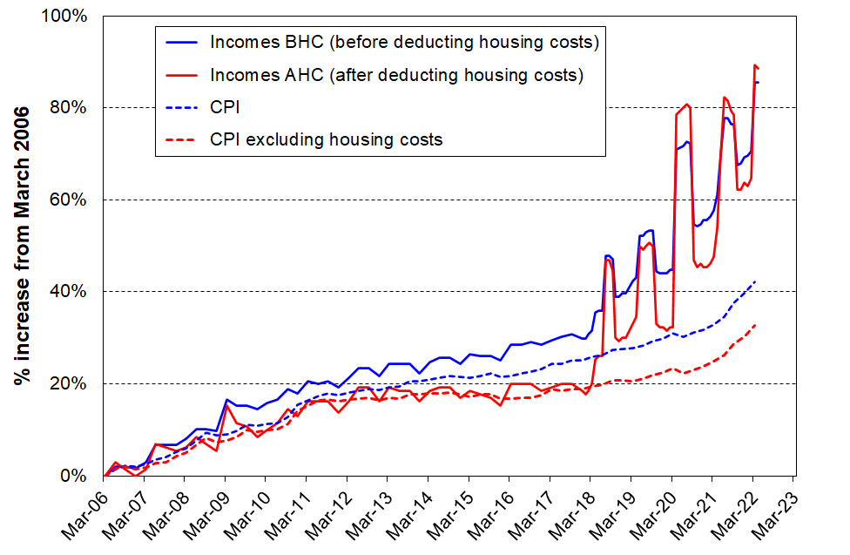
Change in total incomes (BHC and AHC) for beneficiary family and single-person units, 2006 to 2022
Source: MSD Working Paper: Total incomes of MSD main benefit clients as at April 2022. wp-total-incomes-of-msd-main-benefit-clients-as-at-april-2022.pdf

- As noted in the Total Incomes document in the link below Figure G.9 this analysis has to impute housing costs for around 20% of beneficiaries whose housing costs are unknown as they do not receive AS, IRRS or TAS.

Trends in accommodation costs relative to income for households with children

Figure 10 shows the trends in average housing costs as a proportion of average unequivalised income for selected income groupings (quintiles) of households with dependent children (with all adults under 65). Housing costs are:
- up from 15% in 1988 to 22% in HES 2021 for all households with children
- up from 23% to 40% for the lowest income quintile (Q1) and 19% to 30% for Q2.
Figure 10
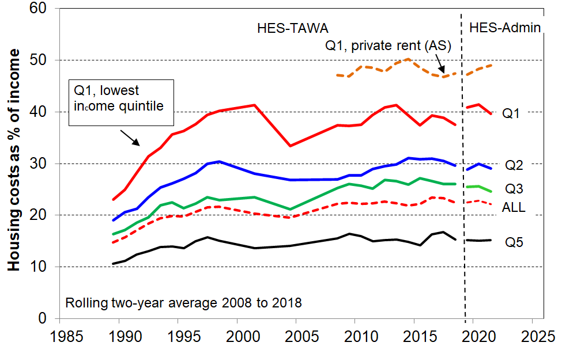
Avg housing costs relative to unequivalised income (%), under 65 households with children, 1988 to 2021
Note for chart.
The longer-term trend lines give robust indications of current and past levels of spending on accommodation relative to income, and of the relativities between groups (as reported in the associated text). The year-on-year fluctuations are not robust enough to support conclusions about rises or falls in these and similar short periods.

The reported Q1 proportion in Figure 10 (~40%) is dampened by the presence of households that reside in public housing for which the rent is capped at 25% of income. Most of these households are in Q1. For many in low-income households, rent makes up more than 40% of income. One such group are those that rent privately and receive the Accommodation Supplement (AS), with almost half of household income spent on accommodation on average by those in Q1 (top broken line in chart). This leaves very little for the other necessities and it is not surprising that this group has very high material hardship rates (46% for those in lowest one fifth (quintile) of this group and 32% overall).

Figure 11 looks at housing costs relative to income a different way. It uses equivalised household income and includes all households to create the income quintile boundaries, not just households with children. For Q1 households with children that are renting and receiving the AS, 85% are spending more than 30% of their income on accommodation, 65% are spending more than 40%, and around 40-45% spend more than half their income on accommodation. Households with such high relative accommodation costs have very low residual or after-housing-costs (AHC) income.
Figure 11
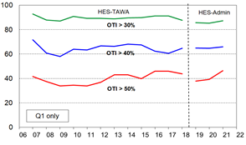
Spending on accommodation as a proportion of BHC income (%) for low-income (Q1) households with children, renting privately and receiving the Accommodation Supplment (AS), 2007 to 2021, using OTIs
Note for chart: OTI = (housing) outgoing-to-income ratio

Incomes for all households with children: trends by household type and ethnicity of the children

Figure 12 shows the rising trend in ‘real’ CPI-adjusted median incomes after deducting housing costs (AHC) for households with children and for couple-only (<65) households for comparison.
- Incomes for two-parent households generally track much the same as the overall population median, other multi-adult family households with children a little lower, and sole-parent households much lower, albeit on the rise in real terms.
- AHC incomes for sole-parent households have tracked at around 50% of the median since the 1991 benefit cuts. The actual dollar gap between sole-parent household incomes and the median has increased in real terms in the period.

Figure 12
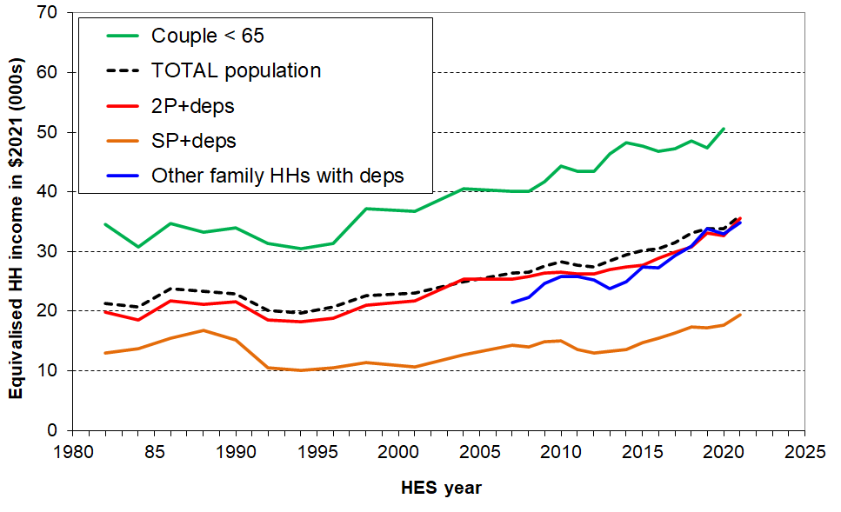
Median incomes (equivalised AHC) of selected household types in $2021

Figure 13 reports median AHC household income for children by ethnicity in real (CPI-adjusted) terms. There have been solid net gains in real terms since 2007 for children in each of the main ethnic groups, albeit with different trajectories through and immediately after the GFC (around a 35% real (CPI-adjusted) gain for all four groups since 2007).

Figure 13
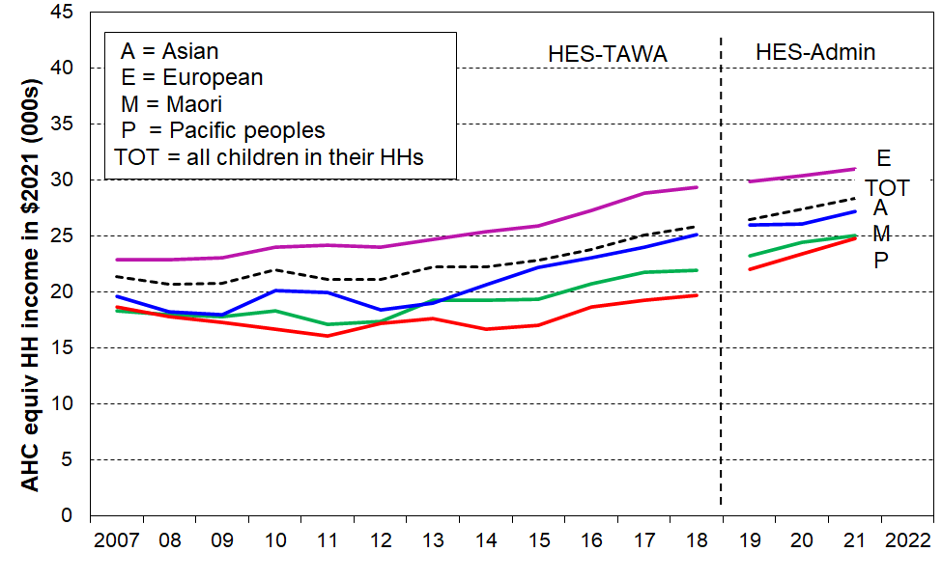
Median AHC household incomes for children, by (total) ethnicity ($2021), HES 2007 to 2021

The rising trends shown in the two charts above are part of the explanation as to why the vast majority of New Zealand households with children report experiencing steadily rising material living standards since the mid-1990s (see Figures 14 and 15 on next page).

Two other indicators of overall improvement in financial and material wellbeing for households with children

Falling trend for households with children reporting ‘not enough’ income for basics

Figure 14 shows the falling trend for households with children who respond with ‘not enough’ to the self-assessed income adequacy question about household income being enough to cover the basics of food, accommodation, clothing, electricity, and so on. There is a decline overall, as expected, but for the purposes of this report it is the decline in the rate for the lowest AHC quintile (Q1) that is of particular relevance, from 46% in HES 2013 to 28% in HES 2021.

Figure 14
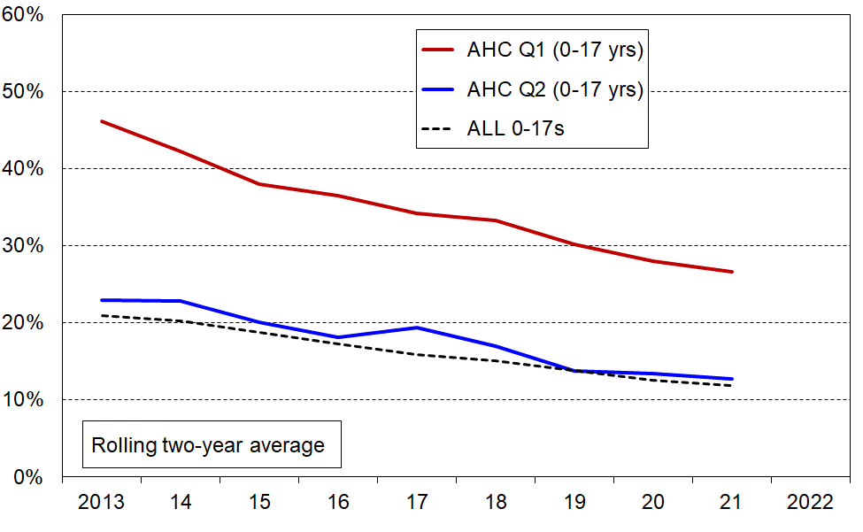
Self-assessed household income as ‘not enough’ – falling trend for households with children

Improving material wellbeing overall

Using the Material Wellbeing Index (MWI) to report on trends is similar to using an anchored line household income measure. The same fixed standard is used from one survey to the next, whereas the moving or relative line approach for incomes uses a moving standard or reference point, namely, median household income. Figure 15 makes use of this feature, starting with a given MWI score (level of material wellbeing) in 2012-13 and showing the increasing proportions of children in households achieving that level over the period to 2020-21.

The maximum possible MWI score is 35. Material hardship rates are calculated using an MWI score of 12 or less. Figure 15 shows the trends in material wellbeing from 2013 on, with the top line representing those with a score over 14, a little above the standard hardship threshold. 78% of children were in households with these scores in 2012-13 and by 2020-21 it had reached 86%. For the lower line (representing children in households with above average / very good material living standards), 31% of children were in households with a score over 28 in 2012-13. By 2020-21 this proportion had reached 47%.
Figure 15
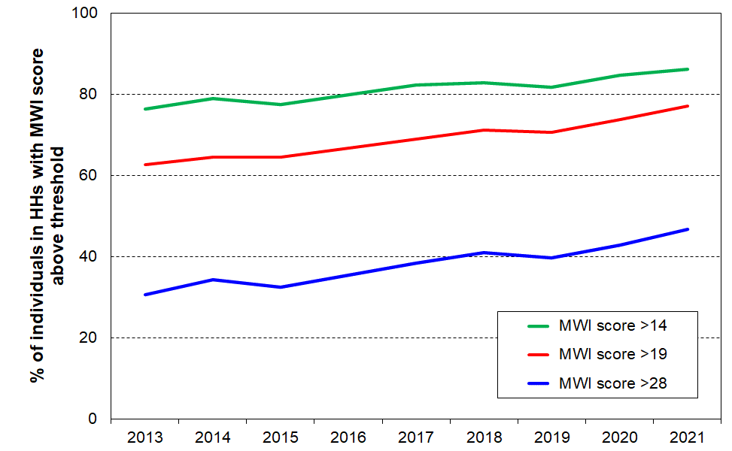
Rising trends in material wellbeing for children (0-17 yrs), starting with selected levels in 2012-13

Income matters for ‘making ends meet’, but so do other factors …

As discussed in the introduction to this Overview, a key theme of the report is that not all low-income households report being in material hardship and some households with incomes above low-income lines (poverty lines) do report hardship. The mismatch or limited overlap between income and hardship measures arises for two sorts of reasons:
- For some low-income households their past income could have been higher than current income and they have savings to draw on; they may have a well-established set of household goods and appliances and little or no debt servicing; they may have financial or significant in-kind support from outside the household; if household income is mainly from self-employment, legitimately declared low household income will usually bear little relationship to the resources available; and so on.
- For some households with incomes above low-income lines (income poverty lines) they may have above average demands on the household budget (eg significant health-related costs or high debt servicing costs); or have been on low-income over several previous years; or be trying to make do on a much lower income than previously after a relationship break-up; or for a range of reasons have great difficulty in turning income and other material resources into valuable consumption; and so on).

Figure 16 and the associated table below shows the impact of the differing levels of liquid assets held by that for households with similar AHC incomes: higher levels of liquid financial assets mean lower levels of material hardship. This is hardly a surprising finding, but it is not often to the fore in discussion and debate, and it is rare for a single dataset to have all three pieces of information (income, liquid assets (such as savings and accessible investments) and material hardship) to enable the analysis to be done.
Figure 16
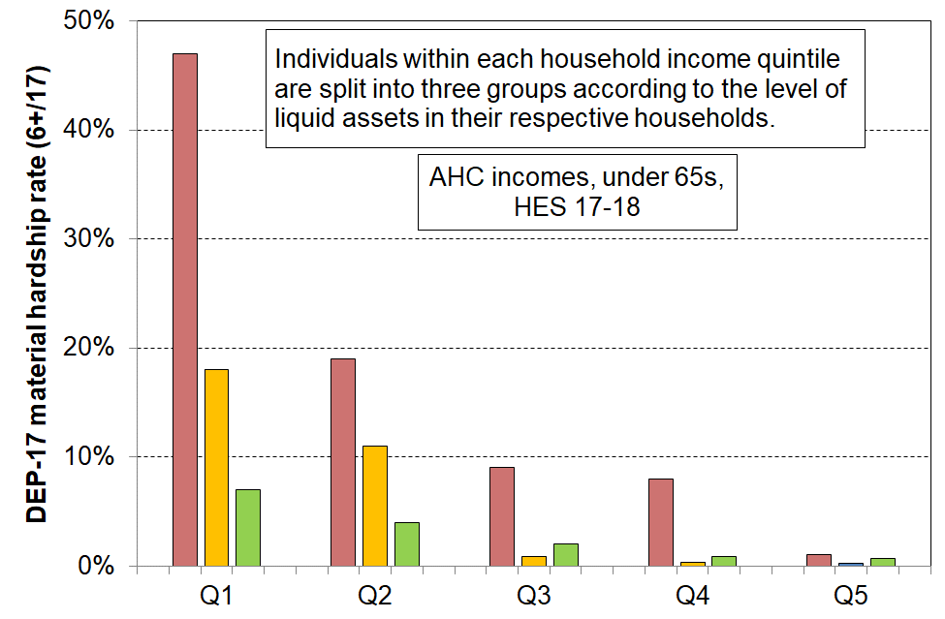
Material hardship rates depend on the level of liquid financial assets as well as on HH income
Reading notes for Figure A.2 and associated table below:
- The five quintiles are quintiles of AHC household income – Q1 is the lowest quintile and so on.
- Individuals within each household income quintile are ranked by their household’s level of liquid assets, then split into three equal-sized groups.

Household Economic Survey 2017-18 | Q1 |  |  | Q2 |  |  | Q3
median liquid assets ($) | 0 | 400 | 8,000 | 100 | 1,200 | 12,000 | 500 | 3,600 | 19,300
can pay an unexpected + essential $500 bill within a month without borrowing (%) | 24 | 43 | 67 | 51 | 71 | 79 | 69 | 84 | 85
used a foodbank more than once in previous 12 months (%) | 25 | 10 | 2 | 6 | 4 | 1 | 4 | 0 | 0
put up with cold ‘a lot’ to save on costs (%) | 25 | 14 | 11 | 10 | 8 | 4 | 7 | 5 | 4
borrowed from fam/friends more than once in previous 12 months to pay for basics (%) | 34 | 17 | 9 | 18 | 9 | 4 | 10 | 3 | 2
self-assessed income adequacy – ‘not enough’ | 46 | 21 | 17 | 22 | 10 | 6 | 14 | 6 | 4
material hardship rate (%) (6+/17, DEP-17) | 47 | 18 | 7 | 19 | 11 | 4 | 9 | 1 | 2
avg AHC household income (equivalised) | 11,000 | 11,000 | 10,000 | 21,000 | 21,000 | 22,000 | 30,000 | 31,000 | 31,000

Figure 17 shows how the mismatch described above works out in practice for households at different income levels. For this chart, households with children are divided into four groups according to their DEP-17 scores: the hardship group (DEP-17 = 6+); the ‘no hardship’ group (DEP-17 = 0); and two groups in between for illustrative purposes.

As expected, the lower the income, the higher is the material hardship rate (red) and the lower is the ‘no hardship’ rate (darker green). There are however some with incomes above BHC 50 and even above BHC 65 who report hardship, as well as some with low incomes who are doing reasonably well or very well (light and darker green). The orange group (DEP-17 scores of 3-5) could be described as ‘only just getting by’, and are vulnerable to shocks such as an unexpected vehicle or dentist bill or sudden loss of income through illness or reduced total paid employment hours for the household. There are a good number of such households well above the usual low-income thresholds / poverty lines.
Figure 17
Material wellbeing / hardship for children in households in lower, middle and higher BHC income bands,
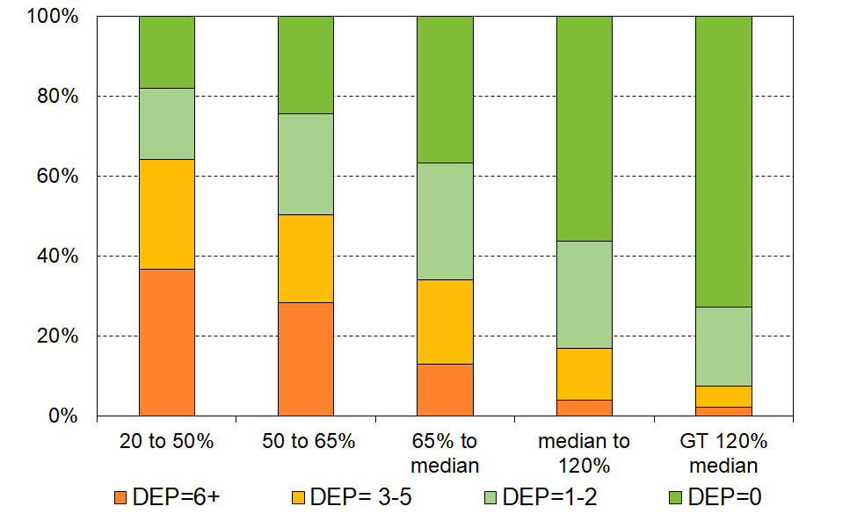
HES 2018-19

Figure 17 above reported on the material hardship and material wellbeing rates for different household income bands. Figure 18 looks at it the other way: it starts with the children living in households reporting material hardship (DEP-17 scores of 6+) and reports what AHC income bands their households come from.
- around one in four (26%) come from households with incomes below 40% AHC
- only 44% come from households with incomes below 50% AHC
- almost one in three (29%) come from households with incomes above 70% AHC.

Figure 18
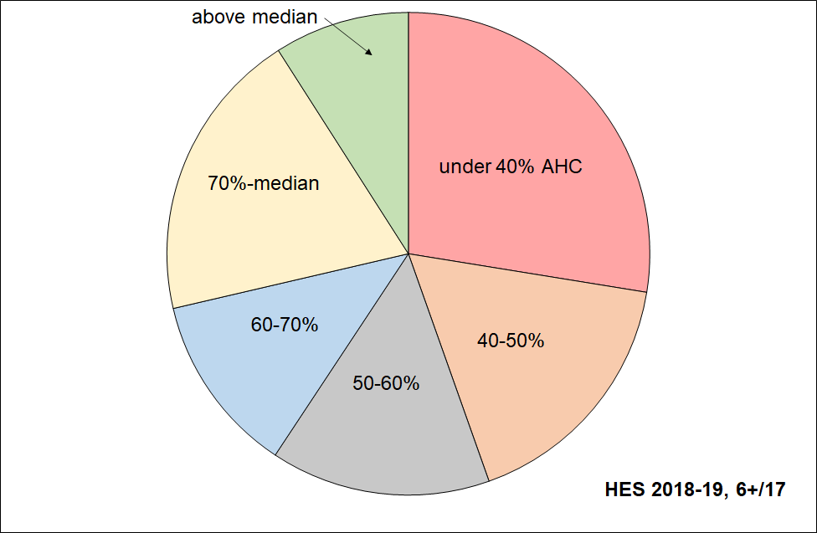
Distribution across household AHC income bands of children identified as in hardship (DEP-17, 6+)

- Figure 19 shows the overlaps between three measures : BHC 50, AHC 50 and material hardship (6+/17 using DEP-17 index). Note that the AHC 50 measure here is the relative version not the fixed line as used in the primary measures for CPRA purposes. The analysis uses the average of HES 2018-19, 2019-20 and 2020-21.
- Most of those in households with incomes below BHC 50 also have incomes below AHC 50 (the green-red overlap, around 85%). The rest of those with income below AHC 50 come from households with incomes above the BHC threshold, but whose housing costs are relatively large.
- Just under half (45%) of those in material hardship come from the low-income AHC group (the black-green overlap). The other half come from households with incomes higher than this.
- The fact that the overlaps are not 100% between low-income and material hardship means that policies to reduce material hardship need to consider including elements that improve the incomes and/or reduce the expenditure of those above the usual low-income poverty lines.

Figure 19
3-way overlap: average of HES 2018-19, 2019-20 and 2020-21 for children (0-17 yrs)
BHC 50% of median moving line income measure
11% (~125,000)
Material hardship
12% (~130,000)
AHC 50% of median moving line income measure
18% (~200,000)

Reading note for Figure 19:
- Both the income measures are fully relative ones (BHC 50 and AHC 50).
- The low-income rates and numbers in Figure 19 are a little lower than the official rates and numbers published by Stats NZ (~2 ppt lower). This difference arises from the treatment of the data that this report applies – households with reported incomes well below the minimum safety net levels of the social welfare system (ie typically less than BHC 20), yet also reporting that their income is enough or more than enough for the basics are not counted in the MSD report. See Section N in the main report for a full discussion. The overlap findings reported in the text above Figure 19 are impacted only slightly by this treatment.

Material hardship trends for children in low-income households (‘poor children’) and for children in ‘non-poor’ and ‘near-poor’ households

Figure 21 shows the trends in the numbers of children in households reporting material hardship for those in both income-poor and non-income-poor households. In this chart, low-income means households with AHC incomes below 60% of the AHC median. (This higher threshold is needed to ensure that there are enough sample numbers in each sub-group to provide a robust time series including the years when the HES was a smaller survey.)

Figure 21
Material hardship numbers for those in income-poor and non-income-poor households,
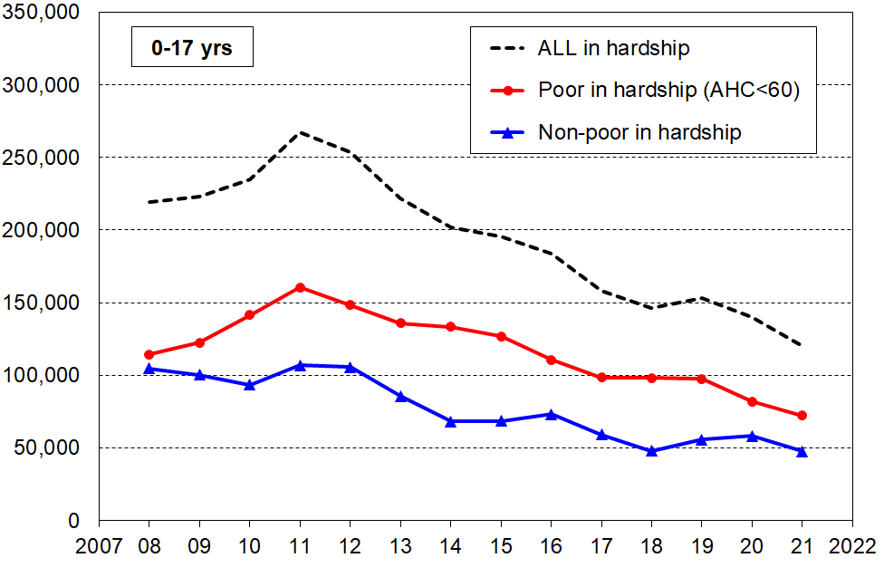
2007 to 2021, 0-17 years

In recent years, around 35-40% of those in hardship come from households with incomes above the AHC 60 low-income threshold (blue line numbers as a proportion of broken line numbers). Around half of these come from ‘near-poor’ households, with incomes of 60 to 80% of the AHC median.

Table 1 shows the household income levels for 60% and 80% of the median in ordinary unequivalised dollars for selected household types to give an idea of what ‘poor’ and ‘near-poor’ mean for household budgets for this analysis.

Table 1
AHC 60% and 80% of median thresholds in ordinary unequivalised 2022 dollars,
selected household types, with children, $ per week AHC
 | (1,1) | (1,2) | (2,1) | (2,2) | (2,3) | (2,4)
AHC 60% | 550 | 680 | 765 | 890 | 1,020 | 1,145
AHC 80% | 735 | 905 | 1,020 | 1,190 | 1,360 | 1,530
AHC median | 920 | 1,130 | 1,275 | 1,485 | 1,700 | 1,910
Notes:
- The figures above are calculated before any treatment is applied to the dataset
- The $2022 numbers are the actual HES 2020-21 numbers inflated by 8% (the CPI change from the 2020-21 average to June 2022)

Material hardship, low income and foodbank usage in six Auckland regions

When Auckland's eight former councils were merged into a single ‘Super City’ in 2010, the Auckland region was divided into 13 wards and 21 local boards. The analysis in this section uses groupings of selected wards to enable a breakdown of the Auckland region into six sub-regions, as in Table 2.

Table 2
The six sub-regions defined by the agglomeration of selected wards
Sub-region | Wards included in the sub-region
Northern | North Shore, Albany and Rodney
Western | Waitākere (incl Massey-Henderson-Te Atatū); and Whau (incl New Lynn, Green Bay, Kelston, Avondale, Blockhouse Bay)
Central 1 | Albert-Eden-Puketāpapa (incl Pt Chevalier, Mt Albert, Mt Roskill, Balmoral, Mt Eden, Epsom, Royal Oak, Lynfield); and Ōrākei (incl Parnell, Newmarket, Remuera, Meadowbank, Ōrākei, Mission Bay, St Heliers, Glendowie)
Central 2 | Maungakiekie-Tāmaki (incl One Tree Hill, Onehunga, Te Papapa, Mt Wellington, Ellerslie, Panmure, Point England, Glen Innes, St Johns); and Waitematā-Gulf (incl Grey Lynn, Westhaven, Waiheke)
Southern | Manukau and Manurewa-Papakura
Howick-Franklin | Howick and Franklin
Note for table:
Follow the link and scroll down for an Auckland map showing the wards: https://www.aucklandcouncil.govt.nz/about-auckland-council/how-auckland-council-works/governing-body-wards-committees/wards/Pages/find-your-ward.aspx

Table 3 gives an indication of the size of each grouping of wards and of the differing levels of material and financial hardship for children across the Auckland region. The figures in the tables are the average for the three surveys 2018-19, 2019-20 and 2019-20, to ensure there are sufficient numbers in the joint sample to give robust findings on the various statistics. There is no evidence of any upward or downward trend over the three years so taking the average does not lose any information.

Four measures of material and financial hardship are reported:
- AHC 50 REL: the proportion (%) of people (children) living in households that have an after-deducting-housing costs (AHC) income of less than half the AHC median for the whole country.
- MH 6+: the standard material hardship measure used by Stats NZ and this report, households lacking 6 or more of the 17 items in the DEP-17 index.
- MH 9+: the severe hardship version of the above.
- Foodbank usage: the proportion (%) of people (children) living in households that report using a foodbank or similar at least once in the 12 months prior to interview.

Table 3
Low-income (AHC 50), material hardship and foodbank usage for Auckland and six groupings of wards: children (0-17 yrs), average over 2018-19 to 2020-21 (%)
Geographic Area | AHC 50 | MH 6+ | MH 9+ | Total # of children | Foodbank %
New Zealand | 18 | 12 | 5 | 1,142,000 | 10
Auckland | 19 | 12 | 6 | 391,000 | 9
Northern wards | 16 | 5 | 2 | 99,000 | 4
Western wards | 21 | 10 | 4 | 59,000 | 10
Central 1: Albert-Eden-Roskill & Ōrākei, | 14 | 4 | 2 | 53,000 | 3
Central 2: Maungakiekie-Tāmaki & Waitematā-Gulf | 19 | 17 | 10 | 29,000 | 13
Southern wards | 25 | 28 | 13 | 93,000 | 19
Howick-Franklin wards | 18 | 7 | 3 | 57,000 | 5

The numbers that immediately grab one’s attention are those for the Southern wards:
- 28% of children in material hardship compared with a country-wide figure of 12% on average over the three surveys
- 13% in severe material hardship compared with 5% country-wide
- 19% of children in households using a foodbank at least once in the 12 months prior to interview, compared with 10% country-wide.

Looking at the figures another way, children (under-18s) living in the Southern wards make up:
- 24% of Auckland’s under-18 population but 53% of under-18 Aucklanders in material hardship
- 8% of the country’s under-18s, but 20% of all under-18s in material hardship.
Those in deepest financial and material hardship – the lowest ventile (5%)

In the findings reported so far there is a range of evidence to support the conclusion of improving material wellbeing for the bulk of New Zealand children and their households, from both longer-term and shorter-term perspectives, and of reducing material and financial hardship.

The evidence, however, only goes so far as the 2020-21 Household Economic Survey (HES) and does not therefore include the ongoing COVID-related impact and that of the high inflation rate in 2021-22. Future surveys will capture these impacts. What is clear is that in 2020-21 there were fewer children in households experiencing financial and material hardship than in 2006-07, just before the impact of the GFC- and drought-driven downturn began to be evident in the HES data.

While these are robust findings, it is important to not lose sight of the fact that the HES data also identifies the very severe hardship being experienced in any given survey by some 5% or so (~60,000 children). This estimate of severe hardship should be taken as a lower bound as the HES covers only those children in households in private dwellings, but not those in non-private dwellings such as hotels, motels, boarding houses, hostels and camping grounds and so on. Other sorts of surveys are needed to obtain a picture of what life is like for those in more transient accommodation or those ‘living rough’.

Table 4 on the next page focuses on the most materially disadvantaged children, based on the 2018-19 HES (the largest HES there is). Children are ranked by the material wellbeing index (MWI) score of their household then divided into ten equal-sized groups (deciles), and also into twenty equal-sized groups (ventiles or 5% groupings). The group of 5% in households reporting the greatest hardship is close to the same size as the DEP-17 9+ severe material hardship group (6%). The overlap between the two is around 80%.

The table show the seriously high disadvantage and lack of basics for children in the V1 group (see especially the multiple disadvantage panels giving the rates of deprivation for selected numbers of items out of the 12 and 18 listed basics).

The numbers for 2020-21 are a little better on some individual items, but have not changed for the multiple disadvantage measures reported in Table 4.

The HES is a cross-sectional survey – not a longitudinal survey in which the same individuals are followed from one interview to the next, year-on-year – so we cannot say whether the lower ventile contains the same or mostly the same children over time. It is likely though that for a good proportion of these children, the severe hardship lasts more than just one year. This assessment is supported by analysis of data from Stats NZ’s longitudinal Survey of Family, Income and Employment (SoFIE, 2003 to 2009). This shows that of the 8% of all children in households reporting the greatest hardship in a given wave, around 45% were still in this hardship band two years later. Findings from the Growing up in Ireland longitudinal survey also support the assessment.

Even if all the 5% in Table 2 (next page) were experiencing this severe hardship for ‘only’ 12 months, then experienced good improvement, this is still a state-of-affairs that the bulk of New Zealanders would find unacceptable.

Tables 5a and 5b show which groups of children are in the most serious hardship. The 9+/17 columns give the numbers for those in severe material hardship using the CPRA measure (6%). Table 5a reports by various household characteristics and circumstances (number of children, main source of income, tenure, and so on). Table 5b reports by the ethnicity of the children.

Stats NZ’s new longitudinal survey, Living in Aotearoa, will in a few years be able to provide updated and more robust information on all of this and more. First wave interviews began in April 2022.

Table 4
Children’s restrictions by the MWI score of their household (children, 6-17 yrs),
grouped by deciles and ventiles of children
HES 2018-19 (%)
 | All | V1 | V2 |  | D1 | D2 | D3 | D4 | D5
Distribution of children (6-17yrs) across MWI deciles of children (%) | 100 | 5 | 5 |  | 10 | 10 | 10 | 10 | 10
Don’t have
2 pair of shoes in good condition and suitable for daily activities for each child | 7 | 49 | 23 |  | 36 | 15 | 5 | . | .
2 sets of warm winter clothes for each child | 2 | 20 | . |  | 13 | 3 | . | . | .
waterproof coat for each child (because of the cost) | 5 | 40 | 17 |  | 28 | 7 | 4 | . | .
separate bed for each child | 5 | 30 | 20 |  | 25 | 10 | 5 | 5 | .
fresh fruit and vegetables daily | 7 | 58 | 32 |  | 45 | 12 | 6 | 3 | .
meal with meat, fish or chicken (or vegetarian equiv) each day | 6 | 42 | 21 |  | 31 | 13 | 5 | 4 | .
good access at home to a computer and internet for homework | 6 | 40 | 14 |  | 27 | 14 | 6 | 6 | .
friends around to play and eat from time to time (because of the cost) | 4 | 31 | 10 |  | 21 | 7 | . | . | .
Economised ‘a lot’ on children’s items to keep down costs to enable other basic things to be paid for (not just to be thrifty or to save for a trip or other non-essential)
had to go without music, dance, kapa haka, art, swimming or other special interest lessons (“a lot”) | 7 | 42 | 27 |  | 35 | 17 | 10 | 3 | .
unable to pay for school trip or other school event (“a lot”) | 3 | 26 | 21 |  | 24 | 6 | . | . | .
involvement in sport had to be limited (“a lot”) | 6 | 37 | 28 |  | 32 | 15 | 6 | . | .
continue to wear shoes or clothes that are worn out or the wrong size (“a lot”) | 3 | 26 | 13 |  | 19 | 7 | . | . | .
Multiple restrictions of child-specific items (the 12 above)
2+ out of 12 | 12 | 79 | 58 |  | 68 | 28 | 12 | 5 | .
3+ out of 12 | 8 | 71 | 35 |  | 53 | 17 | 6 | . | .
4+ out of 12 | 6 | 61 | 25 |  | 43 | 9 | . | . | .
Child-relevant general household items
received help (food, clothes, money) from a community organisation more than once in the last 12 months | 5 | 42 | 20 |  | 31 | 9 | 5 | 3 | .
accommodation crowded or severely crowded (1+ extra bedrooms needed) | 13 | 34 | 27 |  | 31 | 23 | 18 | 18 | 9
accommodation severely crowded (2+ extra bedrooms needed) | 3 | 7 | . |  | 6 | 6 | 4 | 5 | .
dampness or mould a ‘major problem’ in the accommodation | 8 | 39 | 33 |  | 36 | 20 | 10 | 7 | 4
respondent reports putting up with feeling cold to keep down costs for other basics (‘a lot’) | 10 | 64 | 33 |  | 49 | 27 | 12 | 6 | 2
delayed replacing or repairing broken or damaged appliances to keep down costs for other basics (‘a lot’) | 12 | 78 | 46 |  | 62 | 29 | 16 | 8 | 3
household has no access to car or van for personal use | 5 | 17 | 10 |  | 14 | 7 | 9 | 3 | 4
Multiple restrictions out of 12 child-specific and 6 general child-relevant household items (18 in all) – uses severe over-crowding
3+ out of 18 | 14 | 90 | 66 |  | 78 | 34 | 12 | 3 | .
4+ out of 18 | 9 | 81 | 47 |  | 64 | 18 | 5 | . | .
5+ out of 18 | 7 | 71 | 30 |  | 50 | 11 | . | . | .
Postponed doctor’s visits ‘a lot’ to keep down costs to enable other basic things to be paid for (not just to be thrifty or to save for a trip or other non-essential)
For children (a lot) | 2 | 12 | . |  | 8 | 5 | . | . | .
For respondent (a lot) | 11 | 60 | 44 |  | 52 | 33 | 13 | 8 | 4
Respondent reports life satisfaction
dissatisfied or very dissatisfied with life | 6 | 30 | 16 |  | 23 | 14 | 8 | 6 | 3
satisfied or very satisfied with life | 79 | 35 | 50 |  | 42 | 60 | 68 | 80 | 81
Note: Information is suppressed in cells with fewer than 15 households in the sample.

Table 5a (= Table B.1a)
Material hardship rates and composition for selected population groups (DEP-17 index, 5 thresholds),
Children (aged 0-17 years), HES 2018-19
HES 2018-19 | Material hardship rates |  |  |  |  | Composition
 | what % of this group is in hardship, using the different thresholds? |  |  |  |  | what % of all those in hardship (using a given threshold) are in this group / cell? |  |  |  |  | 000’s | %
Material hardship threshold as # of items lacked out of 17 | 5+ | 6+ | 7+ | 8+ | 9+ | 5+ | 6+ | 7+ | 8+ | 9+ | ALL | ALL
All children (0-17 yrs) | 18 | 13 | 10 | 8 | 6 | 100 | 100 | 100 | 100 | 100 | 1,135 | 100
Household type
2P HH with any dependent children | 12 | 9 | 7 | 5 | 3 | 48 | 46 | 44 | 42 | 37 | 785 | 69
SP HH with any dependent children | 40 | 32 | 26 | 20 | 17 | 32 | 34 | 35 | 37 | 41 | 160 | 14
Other fam HHs with any dep ch | 23 | 16 | 14 | 10 | 8 | 20 | 19 | 21 | 21 | 22 | 180 | 16
Other HHs (some 0-17s, no dep ch) | Cell sizes too small – rates suppressed |  |  |  |  | 1 | 1 | 0 | 1 | 0 | 10 | 1
Number of dep children in household
1 | 14 | 11 | 8 | 6 | 5 | 17 | 17 | 17 | 17 | 18 | 245 | 22
2 | 14 | 10 | 8 | 5 | 4 | 33 | 33 | 32 | 30 | 30 | 485 | 43
3 | 19 | 13 | 11 | 9 | 6 | 25 | 23 | 24 | 27 | 24 | 255 | 23
4+ | 35 | 27 | 22 | 16 | 13 | 24 | 26 | 27 | 26 | 28 | 140 | 12
Work intensity (2P & SP, adults all ages)
2P - both FT | 9 | 6 | 5 | 3 | 1 | 11 | 11 | 10 | 8 | 5 | 260 | 23
2P - FT PT | 10 | 7 | 5 | 4 | 2 | 8 | 8 | 7 | 7 | 6 | 165 | 15
2P - FT WL | 18 | 12 | 9 | 6 | 4 | 16 | 15 | 14 | 14 | 13 | 185 | 17
SP - FT | 23 | 17 | 12 | 10 | 7 | 6 | 6 | 6 | 6 | 6 | 55 | 5
SP - PT | 39 | 28 | 22 | 15 | 11 | 6 | 6 | 6 | 5 | 5 | 30 | 3
Other | 25 | 19 | 15 | 12 | 10 | 52 | 54 | 57 | 60 | 65 | 430 | 38
Labour market status of household
Self-employed | 4 | 2 | 1 | 1 | 0 | 2 | 2 | 1 | 1 | 1 | 140 | 12
At least one FT worker | 14 | 10 | 7 | 5 | 3 | 57 | 54 | 52 | 48 | 44 | 820 | 72
No FT worker (may have PT) | 47 | 38 | 31 | 25 | 20 | 41 | 44 | 47 | 50 | 55 | 175 | 16
PT work only | 34 | 25 | 19 | 15 | 11 | 10 | 10 | 10 | 10 | 10 | 60 | 5
Some work (excl SE) | 15 | 11 | 8 | 6 | 4 | 67 | 64 | 61 | 59 | 54 | 875 | 77
Workless | 53 | 44 | 37 | 30 | 25 | 31 | 34 | 38 | 40 | 45 | 120 | 10
Source of HH income in the 12 months prior to interview
Main source market | 12 | 9 | 6 | 4 | 3 | 60 | 56 | 52 | 48 | 45 | 975 | 86
Main source government | 52 | 42 | 35 | 29 | 23 | 40 | 44 | 48 | 52 | 55 | 160 | 14
Tenure of household
Owned with mortgage (incl Family Trust) | 8 | 5 | 3 | 2 | 1 | 22 | 18 | 14 | 13 | 11 | 540 | 47
Owned no mortgage (incl FamilyTrust) | 5 | 3 | 3 | 3 | 2 | 3 | 3 | 3 | 4 | 4 | 120 | 10
Private rental | 29 | 23 | 19 | 14 | 11 | 53 | 56 | 59 | 58 | 61 | 365 | 32
Social rental | 54 | 44 | 35 | 28 | 20 | 20 | 22 | 23 | 25 | 24 | 75 | 7
Other | 8 | 4 | 2 | 2 | 1 | 1 | 1 | 1 | 1 | 1 | 35 | 3
Private rental by AS receipt
Private rental (no AS) | 16 | 11 | 9 | 6 | 4 | 15 | 15 | 15 | 14 | 12 | 195 | 17
Private rental (with AS) | 45 | 36 | 30 | 23 | 18 | 38 | 41 | 44 | 44 | 49 | 170 | 15
Education (highest qualification in HH)
Higher degree | 6 | 4 | 2 | 1 | 1 | 7 | 6 | 4 | 3 | 3 | 230 | 20
Bachelors or similar | 9 | 6 | 4 | 3 | 2 | 11 | 9 | 9 | 8 | 8 | 250 | 22
Post-school non-degree qual | 20 | 15 | 12 | 9 | 7 | 35 | 35 | 37 | 37 | 37 | 360 | 32
School qual | 29 | 22 | 17 | 13 | 10 | 31 | 32 | 32 | 32 | 32 | 215 | 19
No formal qual | 44 | 34 | 27 | 22 | 17 | 17 | 17 | 18 | 20 | 20 | 80 | 7
NZDep Quintile
Q1(least deprived 20%) | 6 | 4 | 2 | 2 | 1 | 7 | 6 | 4 | 4 | 3 | 210 | 19
Q2 | 9 | 6 | 4 | 3 | 2 | 10 | 9 | 7 | 7 | 7 | 230 | 20
Q3 | 14 | 9 | 7 | 5 | 3 | 16 | 14 | 14 | 14 | 12 | 230 | 21
Q4 | 19 | 14 | 11 | 7 | 5 | 20 | 20 | 20 | 17 | 15 | 210 | 19
Q5 (most deprived 20%) | 39 | 31 | 26 | 21 | 17 | 48 | 51 | 54 | 58 | 64 | 250 | 22
Table 5b repeats the hardship rates and composition analysis for ethnicity.

Material hardship rates are much higher for Māori (23%) and Pacific children/ethnicities (28%) compared with that for European(10%) or Asian children/ethnicities (6%). For those in households reporting severe material hardship (DEP-17 score of 9+), the rates are 11-14% compared with 2-4%. These differences are much the same as in previous MSD reports which used multi-year averages to compensate for the smaller sample sizes.

The right-hand panel reports the composition of those in varying degrees of hardship. The composition of those in the 6+ and 9+ columns (CPRA material hardship and severe material hardship measures) are much the same, indicating that ethnic groupings are distributed fairly evenly in the hardship / severe hardship zone. Each of European and Māori groupings make up just over one in three of all children in households in material hardship, with similar proportions for severe material hardship. Around one in five of children in households reporting material hardship are from the Pacific peoples group.
Table 5b (= Table B.1b)
Material hardship rates and composition by ethnicity (DEP-17 index, 5 thresholds),
Children (aged 0-17 years), HES 2018-19
HES 2018-19 | Material hardship rates |  |  |  |  | Composition
 | what % of this group is in hardship, using the different thresholds? |  |  |  |  | what % of all those in hardship (using a given threshold) are in this group / cell? |  |  |  |  | 000’s | %
Material hardship threshold as # of items lacked out of 17 for the household | 5+ | 6+ | 7+ | 8+ | 9+ | 5+ | 6+ | 7+ | 8+ | 9+ | ALL | ALL
Material hardship rates (%)
All children (0-17 yrs) | 18 | 13 | 10 | 8 | 6 | 100 | 100 | 100 | 100 | 100 | 1,135 | 100
Ethnicity (total)
European | 13 | 10 | 7 | 6 | 4 | 36 | 36 | 36 | 36 | 35 | 735 | 53
Māori | 29 | 23 | 19 | 14 | 11 | 32 | 34 | 35 | 35 | 37 | 290 | 21
Pacific peoples | 38 | 28 | 23 | 18 | 14 | 20 | 20 | 21 | 22 | 23 | 140 | 10
Asian | 11 | 6 | 4 | 2 | 2 | 8 | 6 | 5 | 4 | 4 | 180 | 13
Other | 24 | 18 | 10 | 7 | 5 | 4 | 4 | 3 | 3 | 2 | 45 | 3

Material hardship rates for all ethnicities were lower in HES 20-21 than in 2018-19, though none of the reported decreases are statistically significant.

Three common misconceptions or misunderstandings

‘New Zealand has a high child poverty rate’

- The claim is made quite frequently in New Zealand. It was evident, for example, in some of the submissions for the Child Poverty Reduction Bill, and has also been made in an opinion piece in the Guardian by a New Zealand-based commentator. The ‘high-relative-to-what-standard-or-reference-point’ information is often not stated.

- International league tables using BHC 50 low-income poverty measures are readily available from the OECD and the EU, and EU publications have BHC 60 comparisons as the default measure. For both these common measures New Zealand rates for children are a little above the median rates. Using the EU-13 material and social hardship measure, the rate for New Zealand children is 11%, just above the EU median of 10% (see Figure 1). Generalised claims about New Zealand’s child poverty rate being ‘high’ do not square with the available international information.

- A possible/likely source of the ‘high child poverty’ claim is the use of the AHC 60% measure as the poverty measure’, a relatively common approach for many years in New Zealand, albeit not so common now after the CPRA passed into law. This measure gives the highest rate of all common measures. The matter is further compounded by the fact that there are no international AHC league tables and some have mistakenly used our AHC 60 (or 50) figures to rank us on a BHC 60 (or 50) league table. The AHC 60 rate for New Zealand children has typically been around 28-30% compared with 22-24% for BHC 60.

- In their Concluding Observations after the 2016 review of New Zealand, the United Nations Committee on the Rights of the Child (UNCRoC) noted that it is ’deeply concerned about the enduring high prevalence of poverty among children’. This assessment has helped to legitimise the ‘high child poverty rate’ narrative. The UN document itself does not identify the benchmark used and their response at the time to enquiries about the evidence for the assessment was simply that ‘the Committee takes into consideration all information available, paying attention to the State party's report as well as reports prepared by independent sources ….’. They did not provide a specific answer to the question.

- This analysis is not saying that there is not an issue to (be continuing to) address. There is - even an internationally comparable mid-table 11% material hardship rate (130,000 children) is ‘too high’ relative to an aspiration to be more like the top achievers (4-6%). The point is that for productive public and political debate and properly informed government action, clear definitions, transparent reference points and sound evidence are needed.

“There are a quarter of a million children in New Zealand below the poverty line (one in five): they don’t have a waterproof coat, shoes in good condition for daily activities, their own bed, a warm dry home, and they have to miss out on participation in sporting and other activities, and so on”

- The claim is grossly misleading.
  - The ‘quarter of a million’ figure is likely based on the BHC 60 measure which is taken as ‘the’ measure.
  - The claim itself works off the assumption that all ‘income poor’ children (which the claim takes to be children in households with incomes below the BHC 60 level) lack all or most of the items used in MSD’s reports to describe ‘life below the line’ (see Table 2 above for the list of items – the 12 child-specific and the 6 child-relevant household items).

- The assumption is not correct. The MSD reports show that not all low-income households are experiencing hardship: the actual proportion depends on the low-income measure used and on the sub-group being looked at, but for children in low-income households only one-in-three report being in material hardship. In addition, the proportion of low-income households lacking individual items, when taken one at a time, is even lower.

- An example using HES 2018-19 data (Figure C.9 in main report):
  - the surveys show that around 8% of all children (90,000) live in homes that report a major problem with dampness or mould
  - for children in households with incomes below the 60% BHC threshold (~250,000), ‘only’ 45,000 live in such homes (17% of the 250,000)
  - though this is 45,000 more than what most would consider acceptable, it is a much smaller group than the claimed 250,000.
- This analysis is not saying that there is not an issue to address. There is an issue to address, but exaggerations and misleading claims are not helpful for productive public and political debate.

“Child poverty is essentially about children in beneficiary households – paid employment is (usually) the best way out of poverty.”

- It is sometimes said that ‘work is the best way out of poverty’. This is a naïve and misleading claim, even when the focus is on those in good health. Even the more nuanced ‘work is usually the best way out of poverty’ is misleading.

- For the purposes of the theme being discussed here, there are three groups of interest among households in which there is at least one person in full-time paid work:
- those for whom their market income alone is sufficient to keep them out of hardship
- those who would be in hardship if there was no extra government support
- those in hardship even though they are receiving government support.

- For many households, full-time paid employment on its own does not provide enough for the household even at a very basic level, especially where there are children (groups B and C above). Even with the WFF tax credits (including the in-work tax credit) and other support (eg childcare subsidies), some working households with children still struggle (group C), as shown in Figures 4 and 5 above. Around half the children in households in material hardship come from households whose main source of income is the market (‘working households’).

- There are very good reasons – economic, social and mental health – to encourage and expect most ‘working-age’ people to be in paid employment (with varying views on when caring responsibilities should take priority). The caution here is not about these rationales and goal, but simply about a naïve and misleading narrative which hinders rather than helps understanding and decision-making.

- The current Social Security Act asserts that ‘work in paid employment offers the best opportunity for people to achieve social and economic wellbeing’. There is much truth in this, but in its unqualified assertion that omits any reference to government assistance for households with children in addition to what the market provides (ie the real situation is that paid work alone is not enough), and in its contradiction of the evidence as given in this and many other reports, it too is misleading and simply reinforces the more bumper-sticker versions above.

In the literature ‘current’ household income sometimes refers to income over the previous week or month. For this report (including Figure 1) it refers to annual income in a recent 12 month period in contrast to income in the longer-term over several years.
For example, the HES does not include the families in Emergency Housing which includes around 3800 children (Source: MSD Monthly Housing Update for July 2022).
The Ministry of Housing and Urban Development (HUD) contracted the University of Otago to produce an estimate of New Zealand’s homeless population, using 2018 Census data. This estimated there were around 3500 people living without shelter, and 7500 people in emergency housing, campgrounds, motels, and other temporary accommodation. 2018 Severe Housing Deprivation Estimate - Te Tūāpapa Kura Kāinga - Ministry of Housing and Urban Development (hud.govt.nz)
Once the population weights were applied to gross up the sample numbers to population estimates the number of individuals in the lower two NZDep deciles was 19.4%.
Sole-parent families are found in both sole parent households and multi-adult households: a sole parent HH is a sole parent family not living in a household with others. Two thirds of SP families are found in SP HHs and one third in multi-adult HHs.
The focus in this report is on paid work. The value of unpaid work is immense, especially in relation to parenting and other caring responsibilities, but is not looked at in this report.
Disability statistics are available from the HES only in 2019-20 and 2020-21 so there is no trend information. See this report (Section B) or Stats NZ’s February 2022 report https://www.stats.govt.nz/information-releases/child-poverty-statistics-year-ended-june-2021/
Discussed on page 7.
See the main report for further details and references.
See Appendix 6 in MSD’s 2019 Household Incomes Report for a re-evaluation of the (focus group) evidence used to support the claim of the AHC 60 measure as being the measure,

