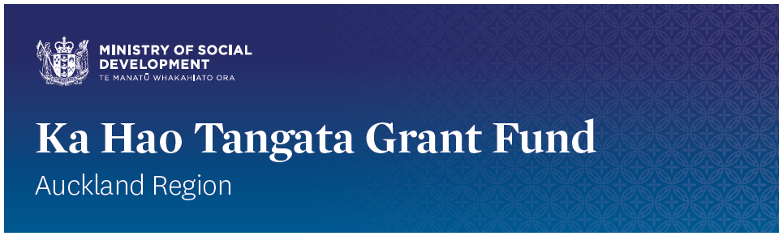
Successful applications for the Ka Hao Tangata Grant Fund

Funding for the Ka Hao Tangata Grant is now closed.
Applications for the Ka Hao Tangata Grant Fund opened on 20 August 2018 and closed once the fund was allocated.

The Fund was only available in the Auckland area and up to $0.5 million was available for allocation for the 2018/2019 financial year.

Sixteen applications were received totalling $1,302,231.00 in requests for funding. All applications were assessed by a panel. The panel made recommendations based on the published criteria and the panel recommendations were moderated to ensure a fair and transparent process.

Through the Ka Hao Tangata Grant Fund MSD has been able to support nine applications with partial funding offers to a combined total value of $490,448.00. These are listed below.

Provider Name | Project Name | Grant Value
Te Whānau o Waipareira Trust | Wai Angitu – Employment Pathways | $65,000.00
Mangere East Family Service Centre | ME Family Services | $53,560.00
Te Whangai Trust Board | Te Whangai Tautoko mahi | $69,800.00
Huakina Development Trust | Timata Hou | $60,000.00
Transformation Academy Trust | Transformation Academy Y_NEET | $31,200.00
MUMA Whānau Services | MUMA Mahi | $65,000.00
Tongan Health Society Incorporated | Pou – Stand Tall | $45,000.00
Franklin Family Support Trust Board | Parent Passport – Return to Work | $30,888.00
Silver Fern Motorsport Charitable Trust | Getting Started | $70,000.00
 | Total | $490,448.00

