Jobseeker Support – March 2015 Quarter

Jobseeker Support (JS) is for people who can usually look or prepare for work. It also includes people who can only work part-time or cannot look for work at the moment, for example because they have a health condition, injury or disability.

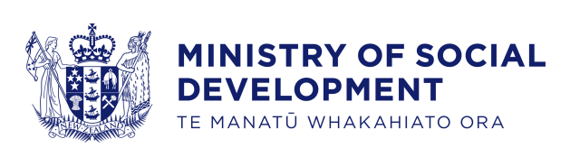
Key Facts
At the end of March 2015:
- 116,893 working-age* people were receiving Jobseeker Support
- four percent of the working-age population of New Zealand** were receiving Jobseeker Support
- fifty-five percent of Jobseeker Support recipients were male
- fifty-six percent of Jobseeker Support recipients had been receiving a benefit continuously for more than one year.
Comparing March 2015 with March 2014:
- the number of recipients of Jobseeker Support decreased by 5,060, or four percent
- there were decreases in Jobseeker Support numbers across all age groups. The 40-54 year age group had the largest percentage decrease
- there were decreases in Jobseeker Support numbers across all ethnic groups
- the proportion of the working-age population in New Zealand receiving Jobseeker Support remained stable.
Characteristics of working-age recipients of Jobseeker Support
at the end of March 2010, 2014 and 2015
 | Mar-2010 | Mar-2014 | Mar-2015 | Annual change
Benefit subgroup
Jobseeker Support – Work Ready | 84,926 | 65,908 | 63,063 | -2,845 | -4%
Jobseeker Support – Health Condition or Disability (HCD) | 55,776 | 56,045 | 53,830 | -2,215 | -4%
Gender
Male | 81,307 | 66,961 | 64,494 | -2,467 | -4%
Female | 59,395 | 54,992 | 52,399 | -2,593 | -5%
Ethnic group
NZ European | 61,689 | 51,052 | 47,902 | -3,150 | -6%
Māori | 42,466 | 41,118 | 40,628 | -490 | -1%
Pacific peoples | 12,391 | 9,310 | 8,754 | -556 | -6%
All other ethnicities*** | 19,940 | 17,866 | 17,169 | -697 | -4%
Unspecified ethnicity | 4,216 | 2,607 | 2,440 | -167 | -6%
Age group
18-24 years | 31,439 | 24,562 | 23,753 | -809 | -3%
25-39 years | 38,957 | 30,737 | 30,106 | -631 | -2%
40-54 years | 44,701 | 40,384 | 37,734 | -2,650 | -7%
55-64 years | 25,605 | 26,270 | 25,300 | -970 | -4%
Continuous duration on any benefit
One year or less | 70,300 | 53,021 | 52,006 | -1,015 | -2%
More than one year | 70,402 | 68,932 | 64,887 | -4,045 | -6%
Incapacity groups for HCD clients
Psychological or psychiatric condition | 22,658 | 23,545 | 22,862 | -683 | -3%
Musculo-skeletal system disorders | 8,159 | 9,211 | 8,833 | -378 | -4%
Accidents | 4,383 | 4,273 | 3,988 | -285 | -7%
Cardio-vascular disorders | 3,102 | 2,746 | 2,647 | -99 | -4%
Pregnancy-related conditions | 1,250 | 894 | 776 | -118 | -13%
Other disorders and conditions | 16,224 | 15,376 | 14,724 | -652 | -4%
Total number of recipients of Jobseeker Support | 140,702 | 121,953 | 116,893 | -5,060 | -4%
Percentage of working-age main benefit population receiving Jobseeker Support | 43% | 41% | 41%
Percentage of working-age population receiving Jobseeker Support | 5% | 4% | 4%
*Working-age clients are aged 18-64 years. This definition reflects the minimum age of eligibility for most main benefits and the age of qualification for New Zealand Superannuation.
**Based on Statistics NZ National Population Estimate year ended June 2014.
***Includes Other Europeans, Asian peoples and Middle Eastern/Latin American/African people.

Five-year trend
The number of clients receiving Jobseeker Support at the end of March increased slightly between 2010 and 2011 before decreasing over the last four years.
Changes between 2010 and 2015 which have affected the number of clients receiving Jobseeker Support include changes in economic conditions. The decrease in Jobseeker Support numbers over the last four years reflects a slowly recovering employment situation and an increased focus by Work and Income on moving job seekers into paid work.
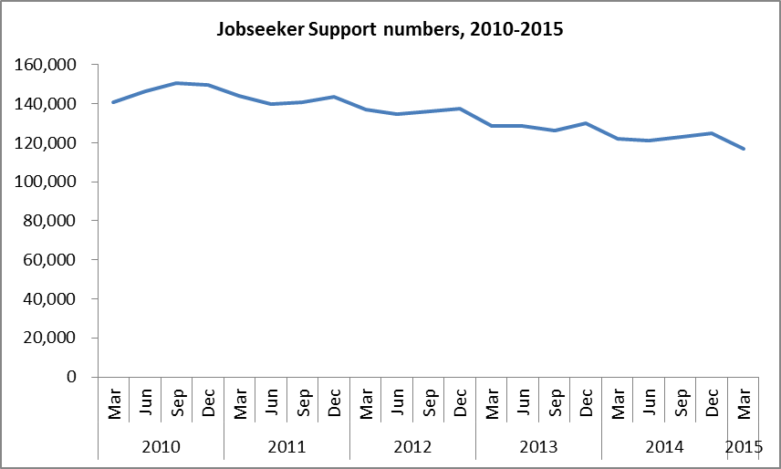

The proportion of the working-age population who were receiving Jobseeker Support at the end of March remained relatively unchanged between 2010 and 2011 before decreasing over the last four years.
