


c

Lifecourse factors associated with time spent receiving main benefits in young adulthood:
Full report on early findings

Prepared by
David Welch
Dunedin Multidisciplinary Health and Development Study
Otago University

Moira Wilson
Centre for Social Research and Evaluation
Te Pokapū Rangahau Arotake Hapori

Prepared for
Social Services Policy
Ministry of Social Development

July 2010

ISBN 978-0-478-32362-7 (online)

Acknowledgements
This research was based on the experiences of members of the Dunedin Multidisciplinary Health and Development Study (the Dunedin Study) who participated in the Dunedin Study age 32 assessment and at that assessment consented to the integration of the Ministry of Social Development’s data on their benefit histories. Funding for the Dunedin Study from the Health Research Council of New Zealand and the contribution of study members is gratefully acknowledged. Daniel Campbell, Professor Richie Poulton, John Jensen, Dr Debbie McLeod and Ross MacKay made helpful comments on earlier drafts. We are grateful to Chungui Qiao for carefully checking tables and figures.

Disclaimer
Any errors or omissions remain the responsibility of the authors. The views expressed do not necessarily reflect the views of the Ministry of Social Development or the Dunedin Study.

Contents
Executive summary 4
1 Introduction 8
2 The integrated data 10
3 Comparison of benefit receipt for the Dunedin and national cohorts 12
4 Early lifecourse factors associated with time spent receiving benefit 22
5 Age 32 outcomes associated with time spent receiving benefit 50
6 Relevance of these findings to other groups 60
7 Directions for further research 63
References 65
Appendix 1 Summary of associations 67
Appendix 2 Timeline 71
Appendix 3 Memorandum of Understanding 72

Executive summary
This report describes early findings from a research collaboration between the Ministry of Social Development (MSD) and the Dunedin Multidisciplinary Health and Development Research Unit (DMHDRU).

The collaboration explores the MSD’s benefit administration data which has been integrated into the Dunedin Multidisciplinary Health and Development Study (DMHDS or the Dunedin Study), a longitudinal investigation of a cohort born in Dunedin between April 1972 and March 1973.

The integrated data provides an opportunity for research about early lifecourse precursors of benefit receipt, the wider life experiences that accompany benefit receipt, and outcomes for people who have spent time receiving benefit.

The purpose of this initial report is to provide basic findings about associations between lifecourse factors and the length of time spent receiving benefit, with the hope of stimulating and informing further, hypothesis-driven, research.

Simple data analysis approaches have been used to produce a series of bi-variate associations (summarised in Appendix 1); no attempt has been made to control for potential confounding factors. The associations presented should therefore be interpreted with care.
Patterns of benefit receipt
We examined patterns of benefit receipt between 1 January 1993 (when most study members were aged 20) and the DMHDRU age 32 assessment.

The benefit receipt histories of the Dunedin Study members over this period were broadly similar to those of the national cohort born in the same year, in spite of the lower than average representation of Mäori and Pacific young people in the Dunedin cohort.

In both the Dunedin Study and nationally:

- approximately half the cohort received some income from a main benefit in the 11–12 year period, and a large proportion of those who received benefits did so for only a short time (just under three-quarters spent either no time or less than a tenth of their time receiving benefit in the period)
- a small proportion with the longest benefit durations accounted for the majority of the total weeks that cohort members spent receiving benefit (for example the 10 percent of the cohort who spent the largest share of their time receiving benefit accounted for around 60 percent of all the weeks cohort members spent receiving benefit in the 11–12 year period)
- women were more likely than men to spend longer periods receiving benefit
- on average, for most of the time that men received benefits they were in receipt of unemployment and training related benefits, and the average share of time spent on incapacity benefits increased for men with longer benefit durations
- on average, for just over half the time that women received benefits they were in receipt of Domestic Purposes Benefit as a sole parent, and the average share of time spent on Domestic Purposes Benefit increased for women with longer benefit durations.
Associations between the length of time spent receiving benefit and early lifecourse experiences
The time study members spent receiving benefit in young adulthood had statistically significant associations with social, economic, and health factors from their childhood and adolescence. These factors include:

- measures of upbringing (lower family occupational status, having a mother who was young when she first became a parent, low parental education, time in a sole-parent family, multiple caregiver or residential changes, low family cohesion and high conflict, harsh discipline, physical abuse and sexual abuse were associated with longer periods receiving benefit)
- individual characteristics (socialised aggression, inattention, hyperactivity, conduct disorder, anxiety, psychoticism, neuroticism, antisocial behaviour, lower IQ, mental health problems, and lower self-esteem were associated with longer periods receiving benefit)
- transition to adulthood (longer periods of youth unemployment and becoming a parent early were associated with longer periods receiving benefit).

While high levels of the risk factors examined were associated with longer-term benefit receipt, on average, short-term benefit recipients tended to have experienced less childhood adversity adulthood than either those who did not receive benefits or those who received benefits for longer periods.

In other words, these factors were not risk factors for benefit receipt, but for longer-term benefit receipt of two years or more.
Associations between the length of time spent receiving benefit and other outcomes in young adulthood
The time study members spent receiving benefit in young adulthood was also associated with a range of age 32 outcomes. Longer periods of benefit receipt were associated with lower occupational status, lower income, lower qualifications, poorer mental health, and higher rates of substance abuse and smoking.

From the simple bi-variate associations presented, we are unable to say whether associations between longer-term benefit receipt and poor outcomes are caused by longer-term benefit receipt itself.

Longer-term benefit receipt is associated with a range of prior adverse family and individual circumstances. The associations found in this initial examination of the data may therefore simply reflect systematic, pre-existing differences between the people who spent longer and shorter periods receiving benefit.

Several measures of physical health (body mass index (BMI), waist-to-hip ratio, body fat percentage, fitness (VO2max), and physical exercise) showed no association with time receiving benefit. Lower systolic blood pressure was associated with more time receiving benefit.
Relevance to more recent birth cohorts
The proportion of the New Zealand working-age population receiving benefit was very high when the Dunedin Study members were in their 20s:

- Unemployment rates peaked in the early 1990s following major economic restructuring and recession. They were especially high for this cohort due to their relative youth and consequent lack of an established position in the labour market.
- This group was also affected by the rapid growth in the rate of sole parenthood in the 1990s. Growth in the rate of sole parenthood may have partly reflected the effects of the difficult economic circumstances of that time on patterns of family formation and dissolution.

Up until 2007, rates of benefit receipt were lower for younger cohorts entering adulthood than they were for the Dunedin cohort. Falling unemployment led to much lower rates of receipt for young men especially. In addition, women in younger cohorts tended to have their children later, appeared to be less likely to parent alone and, where they did parent alone, were more likely to work full-time.

While the prevalence of benefit receipt may vary, it is reasonable to suppose that the factors identified by this report would tend to predict who is most at risk of longer periods of benefit receipt in any socio-economic context. For example, for the cohorts who entered the labour market in the recessionary conditions prevailing in 2009, these early findings may indicate who is most at risk of longer-term benefit receipt.

What is less clear is how the prevalence of the various risk factors has changed, and whether those factors operate in the same way for ethnic groups with a lower than average representation in the Dunedin Study.
Possible directions for further research
The research collaboration between the MSD and DMHDRU has the potential to provide new knowledge about the causal paths that underlie the associations in this report. This first report is intended to inform the development of a series of further, hypothesis-driven, studies.

The findings highlight the role that the benefit system performs in providing a short-term safety net for young people from more advantaged backgrounds. Not all people who receive benefit need intensive assistance.

The associations highlighted here could be investigated further to provide information that might help in directing more services early in a person’s benefit history only to those most at risk of longer-term benefit receipt.

This report shows that longer-term benefit receipt can be predicted early in the lifecourse. Early intervention that is successful in reducing childhood risk factors, or modifying their effects, and boosting protective factors may reduce the time people spend in benefit in adulthood. The investigation of potential intervention points could be the subject of future research.

The findings confirm that there are associations between longer-term benefit receipt and adverse outcomes in young adulthood, including poor mental and physical health and economic adversity.

Further investigation of how the accumulation of risk over the lifetime combines to increase the likelihood of multiple problems may strengthen the evidence base for integrated interventions that aim to improve outcomes for longer-term benefit recipients and their children.

Because most longer-term benefit recipients in the Dunedin cohort were parents by age 32, their experiences are now shaping the lives of their children. Some of their circumstances that have been highlighted in this initial research suggest that their children, in turn, will be among those in younger cohorts with an elevated risk of poor outcomes in adulthood.

This highlights the potential for gains in reducing the intergenerational transmission of disadvantage that can be made from working effectively with those at risk of longer-term benefit receipt.

1 Introduction
The purpose of this report is to provide a starting point for a programme of research into lifecourse factors associated with benefit receipt.

The Dunedin Study is a longitudinal study of a birth cohort of over 1,000 people born in Dunedin in 1972/1973.

At their age 32 assessment, 97 percent of those assessed consented to the MSD’s data on their receipt of main benefits being integrated into the study database (main benefits are defined in the shaded box below, and referred to as ’benefits‘ in this report).

While the MSD maintains some information on people while they receive benefits, little is known about early lifecourse precursors of benefit receipt of different durations, the wider life experiences that accompany benefit receipt, or outcomes after the cessation of benefits. The integrated data provides an opportunity for new knowledge in this area.

The purpose of this initial report is to provide basic findings about associations between lifecourse factors and the length of time spent receiving benefit, in order to stimulate and inform further, hypothesis-driven, research.

Simple data analysis approaches have been used to produce a series of bi-variate associations (summarised in Appendix 1); no attempt has been made to control for potential confounding factors. The findings of the report should therefore be interpreted with care.

The report describes:

- the integrated data (section 2)
- the benefit receipt histories of the sample in comparison with the national population in the same birth cohort over the same time period (section 3)
- associations between childhood and adolescent experiences and time spent receiving benefit (section 4)
- associations between adult outcomes and time spent receiving benefit (section 5)
- the relevance of the findings to other groups (section 6)
- possible directions for future research (section 7).

Main benefits
New Zealand social assistance is made up of several distinct tiers of provision: main benefits; supplementary assistance payments and tax credits.

Main benefits most commonly received by people in young adulthood over the period of the study were:

- unemployment and training related benefits (paid where a person was seeking full-time work or in approved training aimed at helping the person to find work)
- Unemployment Benefit–Student Hardship (paid in vacation periods when a person was seeking full-time work and planning to return to study)
- Domestic Purposes Benefit for sole parents
- Sickness Benefit (paid to people who cannot work or work reduced hours due to sickness injury, disability or pregnancy)
- Invalid’s Benefit (paid to people with a long-term and severe incapacity).

Other main benefits received less frequently include Emergency Benefit, Domestic Purposes Benefit for carers and women alone and Widow’s Benefit.

All main benefits are subject to a test of the joint income of the beneficiary and their partner; the benefit reduces as joint private income increases. There is generally no test of assets, with the exception of benefits such as Emergency Benefit which are paid on the grounds of hardship.

Main benefits can be paid together with:

- supplementary benefits (payable to people on low and middle incomes, including people not receiving main benefits, to help with a specific need or specific cost)
- family tax credits (payable to low and middle income families with dependent children, including families not receiving main benefits).

This report is concerned only with the receipt of main benefits.

2 The integrated data
The Dunedin Study is a longitudinal investigation of health and behaviour in a birth cohort. The study members were born in Dunedin, New Zealand, between April 1972 and March 1973.

Of these individuals, 1,037 children (91 percent of eligible births) participated in the first follow-up assessment at age 3, which constituted the base sample for the remainder of the study. Follow-ups were done at ages 5, 7, 9, 11, 13, 15, 18, 21, 26, and most recently at age 32 years when 972 (96 percent) of the 1,015 study members still alive were assessed.

The idea of integrating benefit administration data into the study was first mooted at the Ministry of Social Policy’s Long Road to Knowledge seminar in April 2001. Approval in principle was received from the Otago Ethics Committee in August 2003 and final approval was received in September 2004.

Study members were asked for their consent to the integration as part of their age 32 assessments which took place between 3 November 2003 and 30 June 2005.

A Memorandum of Understanding was developed to govern the process of integrating the MSD data into the Dunedin Study in order to ensure that the privacy of both the consenting DMHDRU study members and the MSD data relating to people not in the study was protected.

Details of the data integration process are outlined in the shaded box below.

Integration process
- DMHDS name, sex, and date of birth data for consenting study members (N=947/972 (97%)) was brought to MSD’s National Office in Wellington where they were matched against MSD records. MSD benefit and address histories for all matches on names and aliases with the correct sex and date of birth were downloaded and taken to the DMHDRU (N=522). No DMHDS data was left on MSD computers.

- To confirm that the benefit details supplied did in fact relate to the matched study member, addresses from the DMHDS computer address databases from ages 21, 26, and 32 were compared with addresses from the MSD data. Those with any matching address were regarded as having been identified as the same people (N=358). There was one clear mismatch on the basis of different contemporaneous addresses, and one case with two MSD social welfare numbers.

- Where no match or mismatch was found with the addresses in DMHDS computer records (N=162), comparison was made with all DMHDS printed records of the addresses of study members, and of the addresses of others that they had supplied as informants (eg parents, partners, relatives etc). 148 more matches were made.

- The final group had names and dates of birth which matched, but no address matches were found (N=14). Of these, 4 had no MSD record of benefit spells, and could thus be accepted as true non-benefit recipients. Records from the DMHDS Life History Calendars were consulted to see if the remaining 10 study members had reported receiving benefits at the same times recorded by MSD. Three further cases were identified based on correspondence between Life History Calendar records and MSD records.

- The remaining seven cases were excluded from the analyses as it could not be confirmed that the benefit details supplied did in fact relate to the matched study member: five of these had received benefits for up to two months, one for about a year, and one for about five years. Thus, we ended up with a total of 940 study members who are the subject of the present report.

3 Comparison of benefit receipt for the Dunedin and national cohorts
The MSD data integrated into the Dunedin Study gives start and end dates for spells of benefit receipt, and the type of benefit received. It also indicates whether the person was the ’primary‘ recipient of the benefit or the ’partner‘ of the primary benefit recipient. These measures were drawn from the MSD’s Benefit Dynamics Data Set, a longitudinal research data set assembled by sorting through and cleaning source benefit administration records.

The integrated data allows us to trace the benefit receipt histories of study members from 1 January 1993 (when most were aged 20 and some aged 19) until the date of their age 32 assessment.

This section compares the Dunedin Study cohort’s benefit receipt histories with those of the national population in the same birth cohort.

We anticipated a lower rate of benefit uptake in the Dunedin Study cohort for three main reasons:

- Emigration: The Dunedin Study cohort includes some people who spent some or all of their time overseas and were ineligible for New Zealand benefits in those periods of absence.
- Immigration: The national cohort includes immigrants, who may be over-represented in benefit uptake, whereas the Dunedin Study members are all New Zealand born.
- Lower than average representation of Māori and Pacific people in the Dunedin Study: These population groups experienced higher rates of unemployment and higher rates of benefit receipt than average through the period of the study.

Despite these sources of difference, patterns of benefit receipt for members of the Dunedin Study and the national cohort were broadly similar.
Point prevalence of benefit receipt for the national cohort
In the early 1990s, rates of benefit receipt in New Zealand were very high. Figures 1 and 2 show the estimated proportion of people in the national cohort born in the year to March 1973 receiving each of the main benefits at different points in time, broken down by sex.

Figure 1 shows that more than one in five men in the national cohort received benefit in the early 1990s, usually an unemployment or training related benefit (UB TB related), with rates above this level in the summer months as students took up Unemployment Benefit–Student Hardship (UB-SH). As men in the national cohort turned 32, the proportion receiving benefit had fallen to around one in 10, and receipt was increasingly associated with Sickness Benefit (SB) or Invalid’s Benefits (IB)

Figure 1: Estimated percentage of males in the national cohort born in the year to March 1973 receiving benefit at month ends, by benefit type
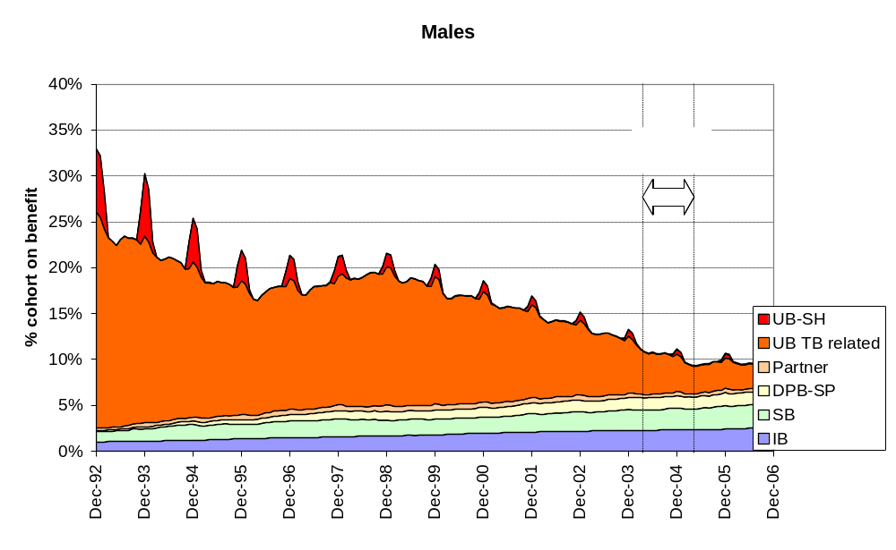
Key: UB-SH is Unemployment Benefit–Student Hardship
UB TB related includes unemployment and training related benefits
Partner refers to receipt of any main benefit as a partner of the primary benefit recipient
DPB-SP includes Domestic Purposes Benefit–Sole Parent and Emergency Maintenance Allowance
SB includes Sickness Benefit and Sickness Benefit–Hardship
IB is Invalid’s Benefit.
Note: Population estimates are used to obtain an estimate of the resident population in the cohort as at March each year. Linear interpolation is used to obtain estimates for the intervening months.
Sources: MSD’s Benefit Dynamics Data Set; Statistics New Zealand, Estimated Resident Population by Age

Figure 2 shows the proportion of women in the national cohort receiving benefit was around 25 percent for much of the 1990s, and receipt was increasingly associated with receipt of Domestic Purposes Benefit–Sole Parent (DPB-SP). Receipt fell between 1998 and 2007. Around 18 percent of women in the national cohort received a main benefit as they turned 32.

Figure 2: Estimated percentage of females in the national cohort born in the year to March 1973 receiving benefit at month ends, by benefit type
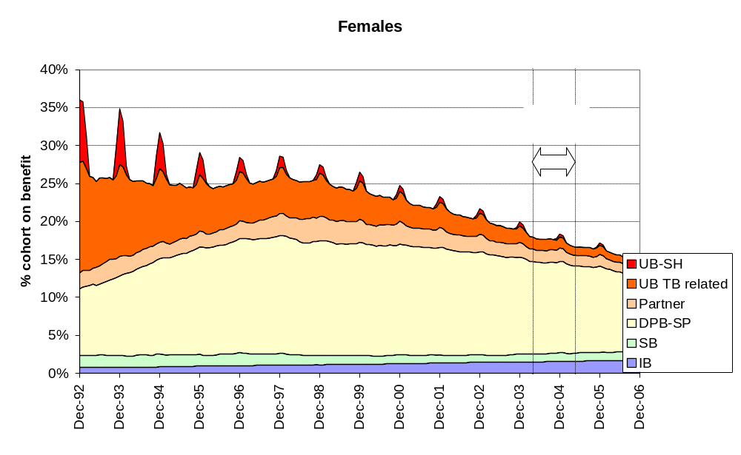
Key: UB-SH is Unemployment Benefit–Student Hardship
UB TB related includes unemployment and training related benefits
Partner refers to receipt of any main benefit as a partner of the primary benefit recipient
DPB-SP includes Domestic Purposes Benefit–Sole Parent and Emergency Maintenance Allowance
SB includes Sickness Benefit and Sickness Benefit–Hardship
IB is Invalid’s Benefit.
Note: Population estimates are used to obtain an estimate of the resident population in the cohort as at March each year. Linear interpolation is used to obtain estimates for the intervening months.
Sources: MSD’s Benefit Dynamics Data Set; Statistics New Zealand, Estimated Resident Population by Age
Period prevalence of benefit receipt for the national and Dunedin cohorts
Table 1 compares estimates of the proportion of the Dunedin Study members and the proportion of the national cohort born in the same year who received a main benefit at any time between the beginning of 1993 and their 32nd birthday.

For both groups, the comparison relies on an estimation of the number of individuals who were ever resident in New Zealand over the period and could therefore potentially have had some receipt of New Zealand benefits:

- For study members, two estimates are presented in the table. One assumes that all study members were New Zealand resident and able to receive main benefits for at least some time in the period. The other arbitrarily assumes that only 95 percent were New Zealand resident at some time in the period. At the time of writing, the true proportion ever resident was unknown.
- For the national cohort born in the same year, the MSD’s Benefit Dynamics Data Set provided the number who received benefits between 1 January 1993 and their 32nd birthday. However, there is no data source for the number of different national cohort members ever resident in New Zealand during the period. We estimated this figure using population estimates and migration data. (The shaded box below sets out the calculations made, the data used and the potential sources of over- and under-estimation.)

Table 1: Estimated percentage who received main benefits at some time between 1 January 1993 and age 32
 | Dunedin Study members |  | National cohort born year to March 1973 (%)
 | assuming all NZ resident at some time (%) | assuming 95% NZ resident at some time (%) | National cohort born year to March 1973 (%)
Male | 49 | 51 | 55
Female | 45 | 48 | 56
Total | 47 | 49 | 55
Sources: DMHDRU; MSD’s Benefit Dynamics Data Set; Statistics New Zealand, Estimated Resident Population by Age
Note: See shaded box below for the estimation of the national population potentially able to receive benefits in the period.

Estimation of the number of different individuals in the national cohort born in the same year as Dunedin Study members potentially able to receive main benefits
A: Estimated number born in the year to March 1973 resident in New Zealand at the beginning of 1993:
Female | 29,930
Male | 29,760
Total | 59,690
(Number of 20 year olds as at March 1993. Source: Statistics New Zealand, Estimated Resident Population by Age.)

Plus B: Estimated number born in the year to March 1973 not resident in New Zealand at the beginning of 1993 becoming resident in New Zealand at some time between the beginning of 1993 and their 32nd birthday:
Female | 13,595
Male | 11,853
Total | 25,448
(Obtained by summing 21year old permanent and long-term migrants in the year ended March 1994 … 31year old permanent and long-term migrants in the year ended March 2004. Source: Statistics New Zealand, Permanent and Long-term Arrivals by Age.)

Equals C: Estimated number in the national cohort born in the year to March 1973 potentially able to receive main benefits at some stage between the beginning of 1993 and their 32nd birthday:
Female | 43,525
Male | 41,613
Total | 85,138

This estimation approach will overstate the number potentially able to receive main benefits where:

- individuals in the population resident in New Zealand at the beginning of 1993 later arrived in New Zealand as permanent or long-term migrants
- individuals arrived in New Zealand as permanent or long-term migrants to New Zealand more than once in the period
- individuals who arrived in New Zealand as permanent or long-term migrants left New Zealand before they achieved sufficient residency for main benefits. (People must generally be resident in New Zealand for at least two years before they are able to claim main benefits. However, people may qualify sooner on the grounds of hardship.)

The approach will understate the number potentially able to receive main benefits where:

- population estimates understate the population resident in New Zealand at the beginning of 1993
- individuals who arrived in New Zealand as short-term or temporary migrants later became resident in New Zealand (the Work to Residence policy introduced in 2002 made changing residency status once in New Zealand a more common route to permanent residence).

Time spent receiving benefit for the national and Dunedin cohorts
Figures 3 and 4 compare the distributions of time receiving main benefits. The plots assume all Dunedin Study members were New Zealand resident and able to receive benefits at some time, and use the estimate of the national population potentially able to receive benefits described in the shaded box above.

Compared with the national cohort, a slightly higher proportion of study members had no benefit receipt, and a slightly lower proportion spent up to 10 percent of their time on benefit. These differences may reflect the differences in residency and migrant status described above.

In both the Dunedin Study and nationally, a large proportion of people in the cohort who received benefits did so for relatively short periods.

Figure 3: Estimated distribution of shares of time spent receiving benefit, for males, 1 January 1993–age 32
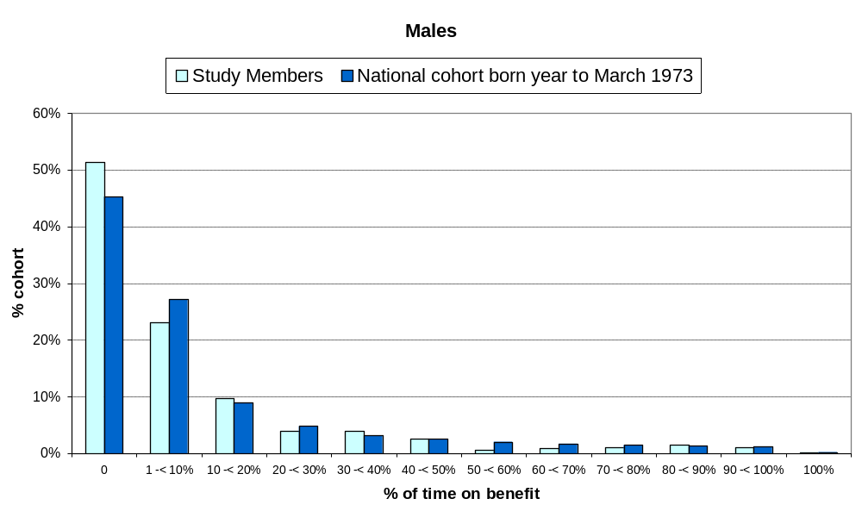
Sources: DMHDRU; MSD’s Benefit Dynamics Data Set; Statistics New Zealand, Estimated Resident Population by Age, Permanent and Long-Term Arrivals by Age
Note: See shaded box above for the estimation of the national population potentially able to receive benefits in the period.

Figure 4: Estimated distribution of shares of time spent receiving benefit, for females, 1 January 1993–age 32
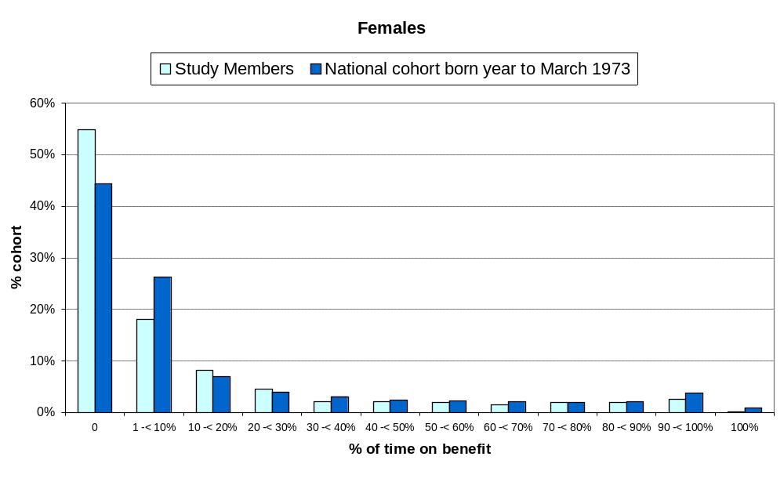
Sources: DMHDRU; MSD’s Benefit Dynamics Data Set; Statistics New Zealand, Estimated Resident Population by Age, Permanent and Long-Term Arrivals by Age
Note: See shaded box above for the estimation of the national population potentially able to receive benefits in the period.
Benefit weeks accounted for by short- and longer-term recipients for the national and Dunedin cohorts
While few in the Dunedin and national cohorts spent 20 percent or more of their time receiving main benefits (only 17 percent of the Dunedin cohort and 21 percent of the national cohort), these groups accounted for around 80 percent of the weeks cohort members overall spent receiving benefit (Table 2).

In the Dunedin cohort, only 10 percent of the cohort spent 40 percent or more of their time receiving benefit and this group accounted for around 62 percent of the total benefit weeks.

Table 2: Estimated share of all weeks spent receiving benefit between 1 January 1993 and age 32, accounted for by cohort members spending different shares of time receiving benefit
Share of time spent receiving benefit 1993 – age 32 | Dunedin Study members |  | National cohort
Share of time spent receiving benefit 1993 – age 32 | % cohort | % of all weeks spent receiving benefit by cohort | % cohort | % of all weeks spent receiving benefit by cohort
0% | 53 | 0 | 45 | 0
More than 0% | 47 | 100 | 55 | 100
10% or more | 26 | 93 | 28 | 93
20% or more | 17 | 81 | 21 | 84
30% or more | 13 | 72 | 16 | 76
40% or more | 10 | 62 | 13 | 68
50% or more | 8 | 52 | 11 | 60
60% or more | 6 | 46 | 8 | 51
70% or more | 5 | 39 | 6 | 42
80% or more | 4 | 29 | 5 | 33
90% or more | 2 | 16 | 3 | 22
100% | 0 | 1 | 1 | 4
Sources: DMHDRU; MSD’s Benefit Dynamics Data Set; Statistics New Zealand, Estimated Resident Population by Age
Note: See shaded box above for the estimation of the national population potentially able to receive benefits in the period.
Share of time spent on different types of benefit for the national and Dunedin cohorts
Figures 5 and 6 show that the average share of time spent on different benefit types was broadly similar for the two groups.

Figure 5 shows that, on average, for most of the time that men received benefits they were in receipt of unemployment and training related benefits. For those with longer benefit durations, the average share of time spent on incapacity benefits was higher.

Figure 5: Mean share of time spent on different benefit types by those males who received benefit
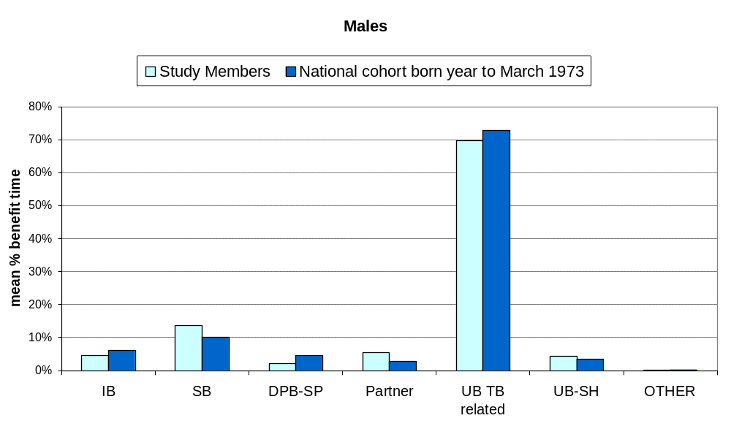
Key: UB-SH is Unemployment Benefit–Student Hardship
UB TB related includes unemployment and training related benefits
Partner refers to receipt of any main benefit as a partner of the primary benefit recipient
DPB-SP includes Domestic Purposes Benefit–Sole Parent and Emergency Maintenance Allowance
SB includes Sickness Benefit and Sickness Benefit–Hardship
IB is Invalid’s Benefit
OTHER includes Emergency Benefit, Domestic Purposes Benefit for carers and women alone and Widow’s Benefit
Sources: DMHDRU; MSD’s Benefit Dynamics Data Set

Figure 6 shows that, on average, for just over half the time that women received benefits they were in receipt of Domestic Purposes Benefit as a sole parent. For those with longer benefit durations, the average share of time spent on Domestic Purposes Benefit was higher.

Figure 6: Mean share of time spent on different benefit types by those females who received benefit
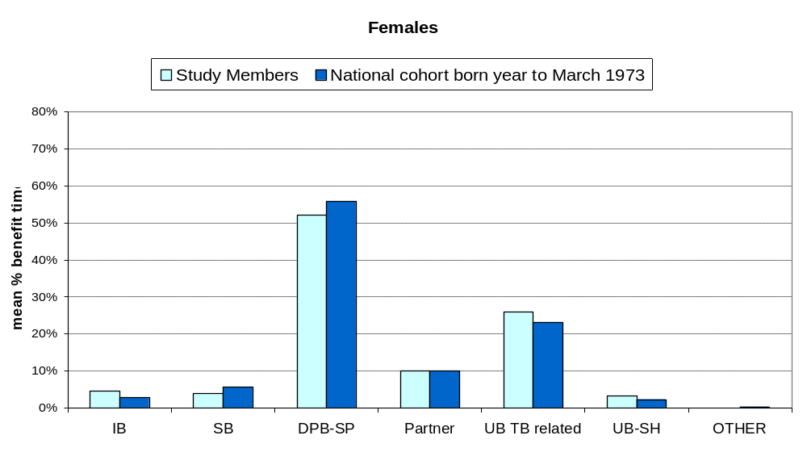
Key: UB-SH is Unemployment Benefit–Student Hardship
UB TB related includes unemployment and training related benefits
Partner refers to receipt of any main benefit as a partner of the primary benefit recipient
DPB-SP includes Domestic Purposes Benefit–Sole Parent and Emergency Maintenance Allowance
SB includes Sickness Benefit and Sickness Benefit–Hardship
IB is Invalid’s Benefit
OTHER includes Emergency Benefit, Domestic Purposes Benefit for carers and women alone and Widow’s Benefit
Sources: DMHDRU; MSD’s Benefit Dynamics Data Set

4 Early lifecourse factors associated with time spent receiving benefit
This section examines associations between the length of time spent receiving benefits in young adulthood and early lifecourse factors. Analyses have been conducted only in terms of the amount of time spent on all benefits received. Future studies could investigate the factors predicting the uptake of specific benefits.

The selection of factors was informed by the literature on outcomes for children, and by the availability of measures from the Dunedin Study.

Our analysis is limited to family and individual factors as these are the measures of individuals’ life experiences taken by the Dunedin Study. We acknowledge that a range of wider social, economic and institutional factors can also contribute to outcomes.

The factors examined here are not an exhaustive list, but are intended to provide an introduction to some of the measures available from the Dunedin Study and their associations with benefit receipt.

The time study members spent receiving benefit in young adulthood is found to have statistically significant associations with a range of social, economic and health factors from their childhood and adolescence.

High levels of the risk factors identified were associated with longer-term benefit receipt. But short-term benefit recipients tended to have experienced less childhood adversity and better outcomes in adulthood than either those who did not receive benefits or those who received benefits for longer periods.
Analytic approach
Simple bi-variate analyses were conducted using linear regression with the proportion of total time spent receiving benefit as the outcome variable. The effects measured in each analysis are presented as the standardised regression coefficient (β) and an accompanying p-value.

The standardised regression coefficient is equivalent to reporting correlation between the two variables, and is a useful metric for comparing effect sizes since it is measurement scale-independent.

For each outcome, two models were generated, in which those who received no benefit were, and were not, included. The two β-coefficients generated are referred to as β_{all} and β_{ben} respectively.

For display purposes, time spent receiving benefit was converted to six categories defined by a consideration of both the data distribution and intuitively interesting time periods (Table 3).

Women were over-represented in the long-term group accounting for 55 of the 89 who received benefit for more than five years. Almost all of these women had received DPB as a sole parent.

Table 3: Number and proportion with time spent receiving benefit in different categories
Category | Number | Percent
No benefit | 499 | 53.1
Up to 6 months | 113 | 12.0
6 months to a year | 70 | 7.4
1 to 2 years | 80 | 8.5
2 to 5 years | 89 | 9.5
More than 5 years | 89 | 9.5
Total | 940 | 100.0
Note: Categories are up to and including the exact numbers of years or months indicated, ie the 2 to 5 years category covers those with duration more than exactly 2.0 years and less than or equal to 5.0 years.

The means of each category were graphed with error bars representing one standard error of the mean. Categories were spaced according to the median time period spent receiving benefit in each category to allow effects to be estimated by eye.

Analyses testing for sex-by-predictor interactions were conducted for each model. Where sex interaction terms were significant (p=0.05) (ie the association between the predictor variable and time spent receiving benefit was significantly different for men and women), separate analyses were conducted by sex, and separate graphs constructed.

The findings should be interpreted with care. No attempt has been made to establish whether the associations are causal in nature, or to control for potential confounding factors.
Socio-economic background
Family socio-economic status of children has been shown to be influential on health outcomes in adulthood (Poulton et al, 2002).
Family occupational status
Family occupational status was measured with a six-point scale that places each occupation into one of six categories based on the educational level and income associated with that occupation in data from the New Zealand census (Elley and Irving, 1972, 1976).

The scale ranges from 1 (unskilled labourer) to 6 (professional).

The variable used in our analyses was calculated by first taking the highest occupational status level of the parents at each assessment, and then taking means of these values across assessments at birth, ages 3, 5, 7, 9, 11, 13, and 15 years.

Family occupational status predicted benefit receipt (β_{all}=-0.144, p<0.001 and β_{ben}=-0.212, p<0.001). The graph shows that short-term benefit recipients tended to come from higher occupational status backgrounds than those with no benefit receipt, while longer-term benefit recipients tended to come from lower occupational status backgrounds than shorter-term benefit recipients.

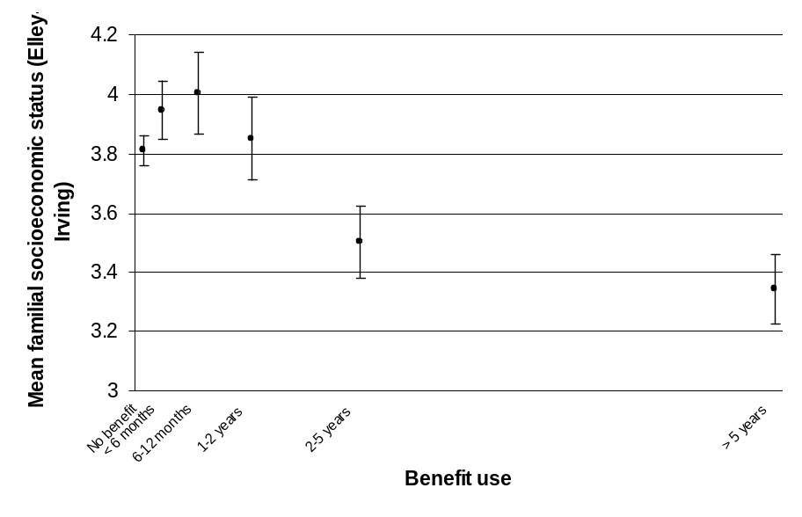
This (inverted) J-shaped function was observed in many of the factors investigated. There are a number of possible explanations for it:

- The effect of the joint income test: In order for a person who is married or in a relationship in the nature of marriage to qualify for a main benefit, the joint income of the couple must not exceed a fairly modest given limit.
The effect of this is to exclude from benefit entitlement some people who would otherwise qualify, thereby introducing some people with risk factors into the ‘no-benefit’ group.
- The effect of the stand-down policies: In response to high unemployment, reforms introduced in 1991 introduced a redundancy stand-down with a non-entitlement period of up to 26 weeks depending on prior income. A 26-week stand-down could also apply where a person left employment voluntarily.
The effect of these provisions may have been to exclude some disadvantaged people who experienced unemployment over the period from receiving main benefits.
- A socio-economic gradient to transitional unemployment associated with study and overseas travel: Groups who participate in university education have more advantaged backgrounds than others (Fergusson and Woodward, 2000). We also expect that people from more advantaged backgrounds were more likely to spend part of their 20s and early 30s overseas.
Both these activities are often associated with short-term unemployment, and benefit receipt for people unemployed after leaving university or returning to the country would often have been unaffected by the stand-down policies described above.
We find that those who received benefits for up to 12 months were significantly more likely to be degree-qualified than both those who received benefits for no time and those who received benefits for more than 12 months.
Mother’s age at first birth
Study members whose mothers bore children younger tended to spend more time receiving benefit (β_{all}=-0.114, p=0.001 and β_{ben}=-0.161, p=0.001).
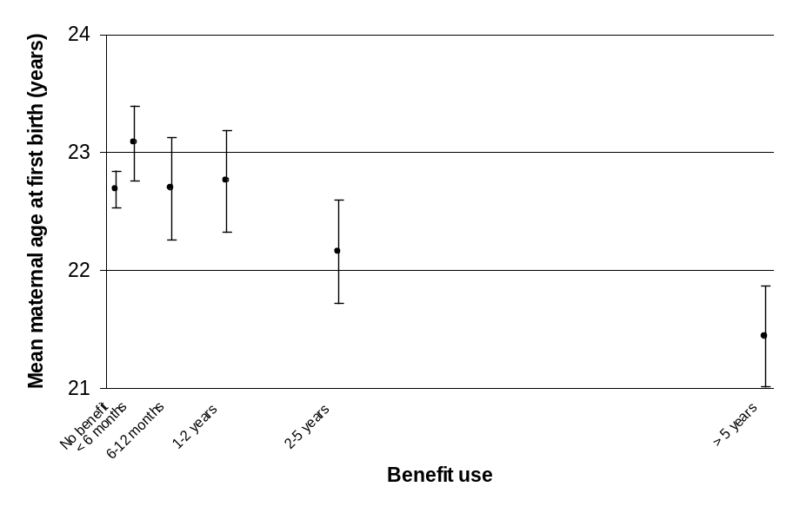
Maternal paid work
Mothers’ hours of paid work per week were determined by interview at ages 3, 5, 7, 9, 11, and 13. The mean number of hours across these ages was calculated to represent each mother’s overall involvement in paid work during the study member’s childhood.

There were marginal effects of maternal involvement in paid work on later benefit receipt, in that study members with mothers who worked more tended to spend less time receiving benefit (β_{all}=-0.056, p=0.085 and β_{ben}=-0.065, p=0.172).
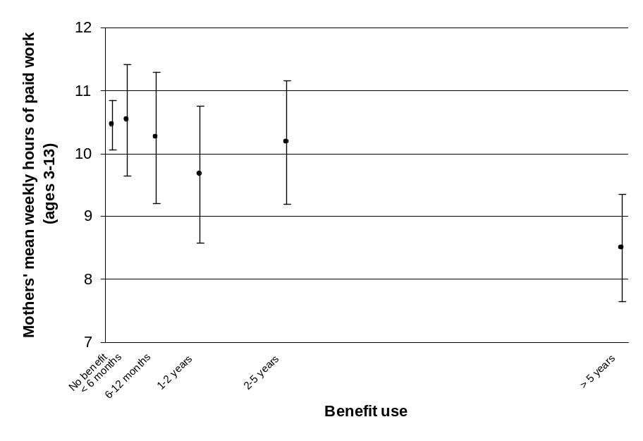

Parental education
Low parental education was identified as parents not having School Certificate when the study member was aged 3. It was defined separately for each parent.

Low paternal education was not associated with benefit receipt (β_{all} =-0.025, p=0.448 and β_{ben} =-0.055, p=0.264).

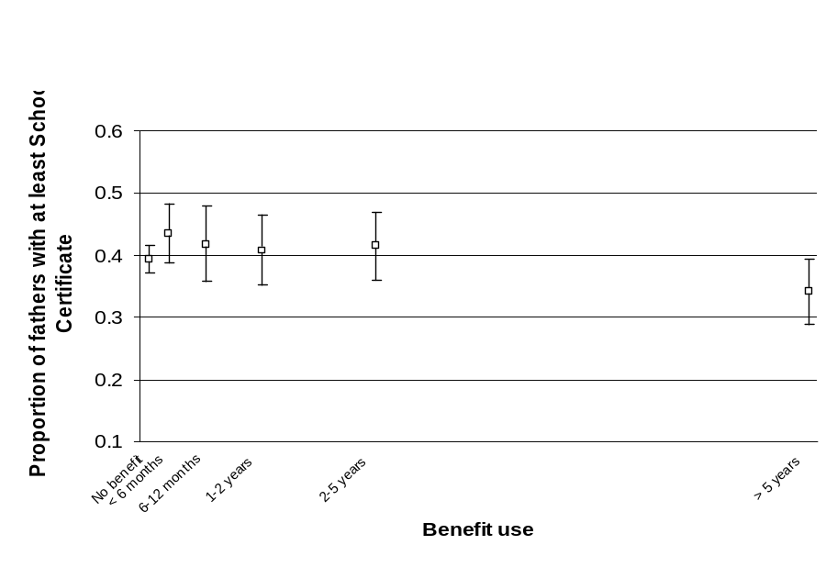
Low maternal education was associated with longer benefit receipt (β_{all}=-0.144, p<0.001 and β_{ben}=-0.188, p<0.001).

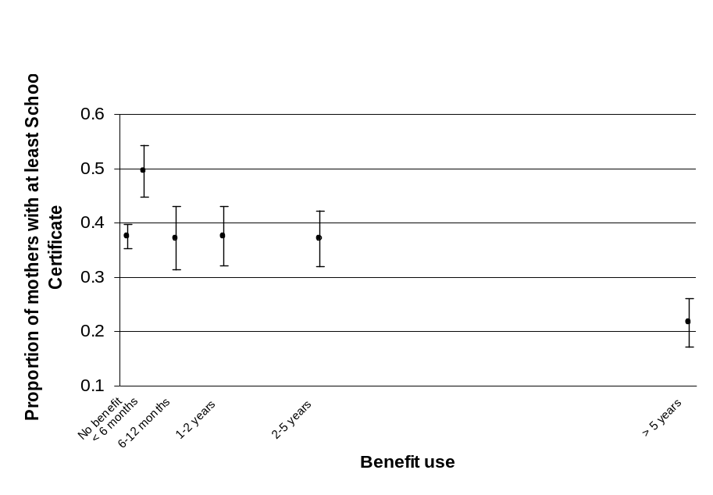
Family structure and stability
Time in a sole-parent family
Sole parenting was assessed as the number of years that the study member spent with one parent up to the age of 11 years.

Those who spent more time with a sole parent during childhood tended to spend more time receiving benefit (β_{all}=0.168, p<0.001 and β_{ben}=0.170, p<0.001).
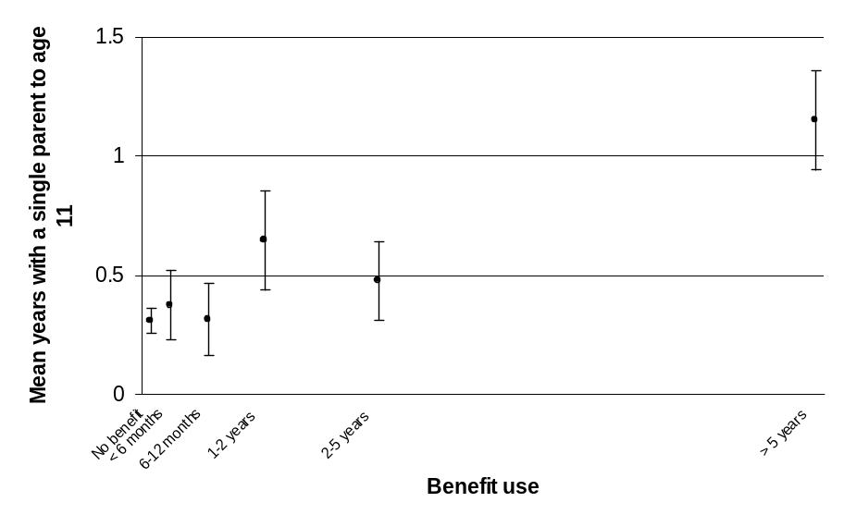
Caregiver changes
More caregiver changes were associated with more time spent with benefits (β_{all}=0.274, p<0.001 and β_{ben}=-0.323, p<0.001).
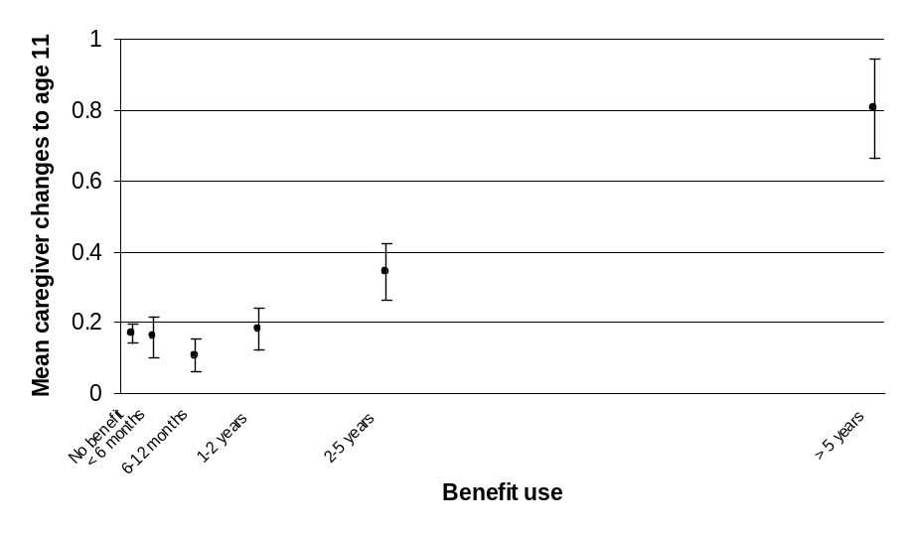
Residential changes
More childhood residential changes predicted more time spent receiving benefit (β_{all}=0.124, p<0.001 and β_{ben}=0.116, p=0.015).
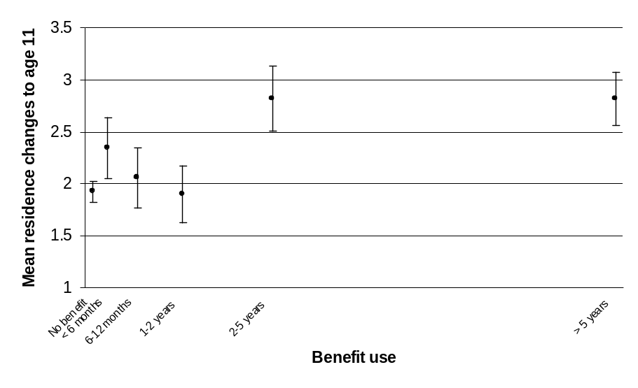
Religiosity
At age 11, study members were asked about religious activities, eg participation at Sunday school, attendance at church and at any church youth group.

There was no effect of religiosity on later benefit receipt (β_{all}=0.049, p=0.155 and β_{ben}=0.080, p=0.107).
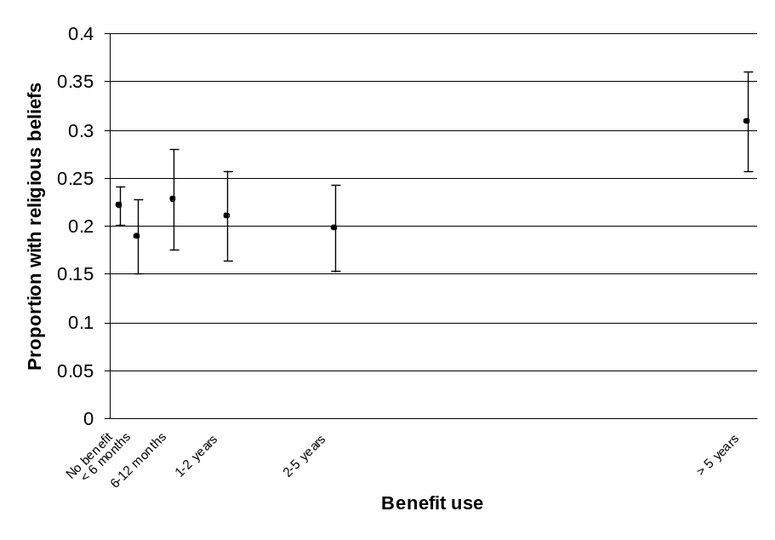
Family environment
Maternal malaise
Maternal malaise was determined by questioning of the study members’ mothers when the study members were aged 5, 7, and 9.

The Malaise Inventory was used, which consists of a series of 24 yes/no questions about emotional problems and associated somatic symptoms (Rutter et al, 1970). Standardised values were computed for each age, and the mean score across the three standardised values was computed.

There was an association of maternal malaise with later benefit receipt (β_{all}=0.126, p<0.001 and β_{ben}=0.155, p=0.001), in that more malaise was associated with more time spent receiving benefit.
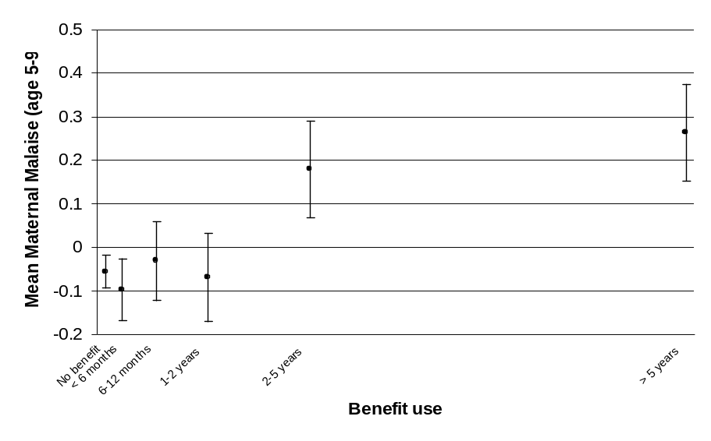
Family cohesion
The Moos Family Environment Scale (Moos and Moos, 1981) Cohesion subscale reflects the degree of commitment, help and support family members provide for each other.

Cohesion predicted time receiving benefit (β_{all}=-0.118, p<0.001 and β_{ben}=-0.141, p=0.004) in that those from more cohesive families tended to spend less time receiving benefit.
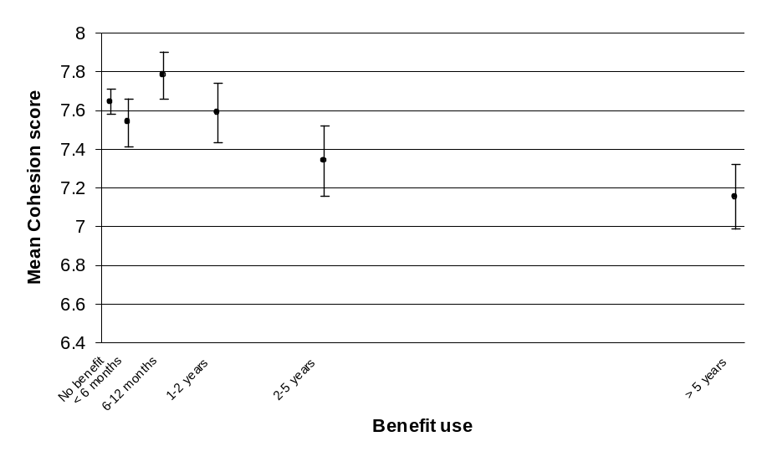
Family expressiveness
The Moos Family Environment Scale (Moos and Moos, 1981) Expressiveness subscale measures family encouragement to express feelings openly.

It did not predict time receiving benefit (β_{all}=-0.031, p=0.357 and β_{ben}=-0.033, p=0.499).
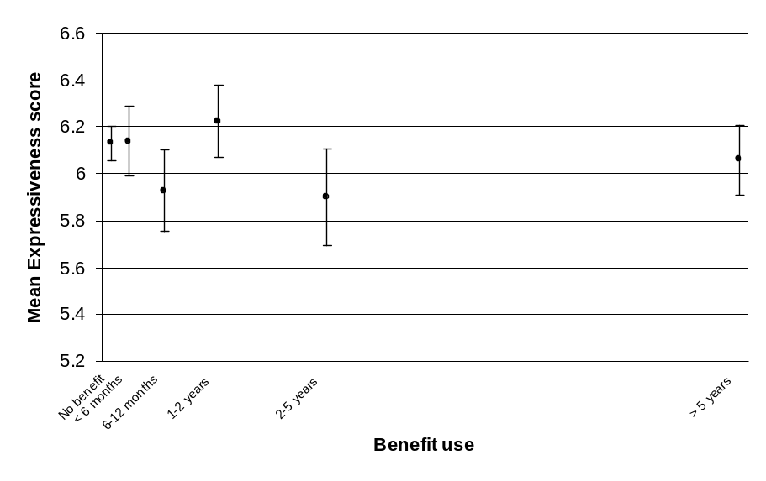
Family conflict
The Moos Family Environment Scale (Moos and Moos, 1981) Conflict subscale measures family aggression and conflict.

Conflict predicted time receiving benefit (β_{all}=0.087, p=0.010 and β_{ben}=0.146, p=0.003) in that those from families with more conflict tended to spend more time receiving benefit.
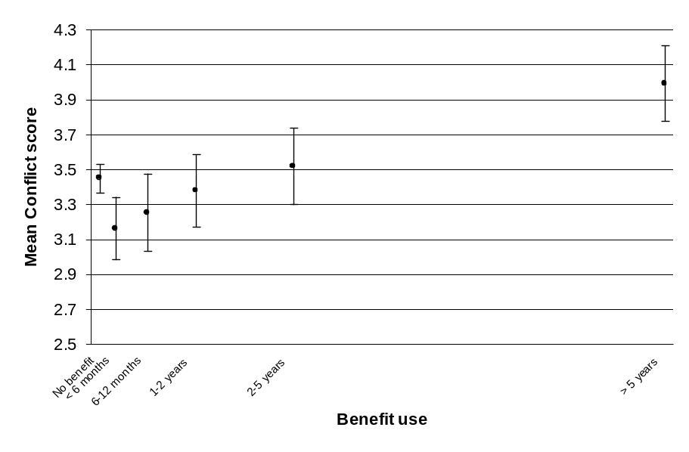
Harsh discipline
Harsh Discipline was measured at ages 7 and 9 using a checklist of disciplinary behaviours.

Parents were asked to indicate if they engaged in 10 behaviours, such as “smack (your child) or hit him/her with something”, “try to frighten (your child) with someone like his/her father or a policeman” and “threaten to smack or deprive (your child) of something”. These items were averaged across ages 7 and 9 years.

There was no detectable overall effect (β_{all}=0.036, p=0.282), and nor was there an overall effect detected among benefit recipients (β_{ben}=0.030, p=0.530).

However, there was an interaction with sex in the association with harsh punishment for benefit recipients (p=0.015). Exploration of this interaction by modelling males and females separately showed that while there was no relationship for females (β_{ben}=-0.079, p=0.261), increasing use of benefits by male study members was predicted by the amount of harsh discipline they experienced in childhood (β_{ben}=0.163, p=0.015).

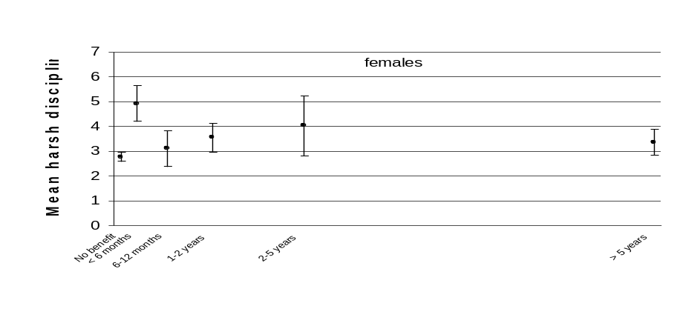
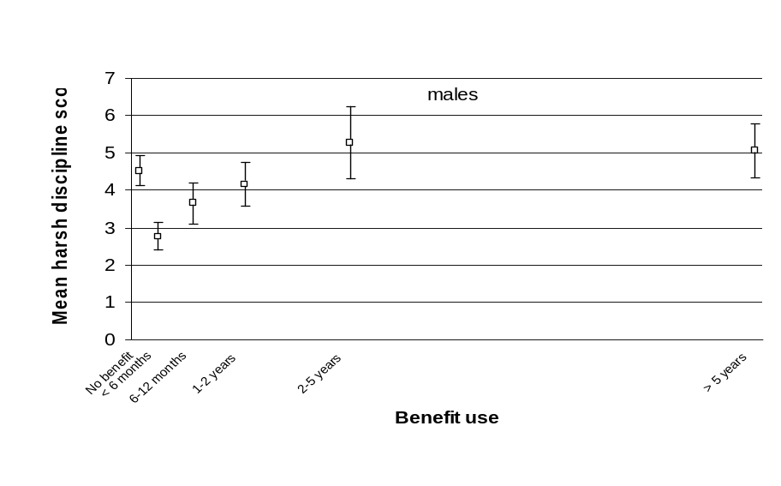
Child abuse
Physical abuse
Extreme physical abuse up to age 11 was defined as the study member having suffered from lasting bruising or welts, or being attacked in a more violent way than smacking or being hit with a strap or wooden spoon.

There was an increased rate of this in those who would use more benefits (β_{all}=0.149, p<0.001), and this was associated with a sex interaction (p<0.001), whereby effects were detectable in males (β_{all}=0.295, p<0.001) but not females (β_{all}=0.046, p=0.328).

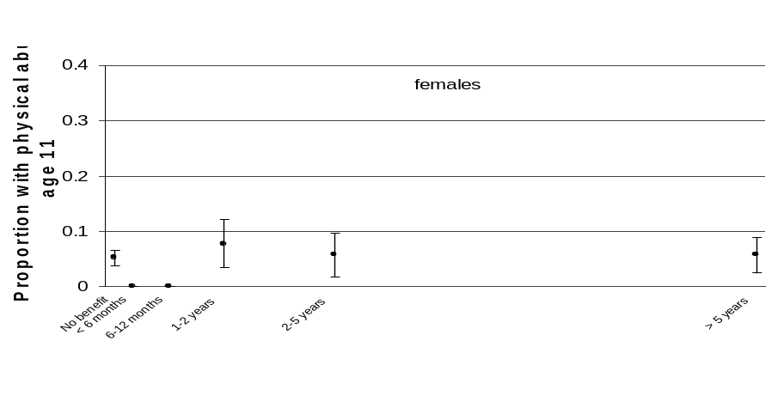
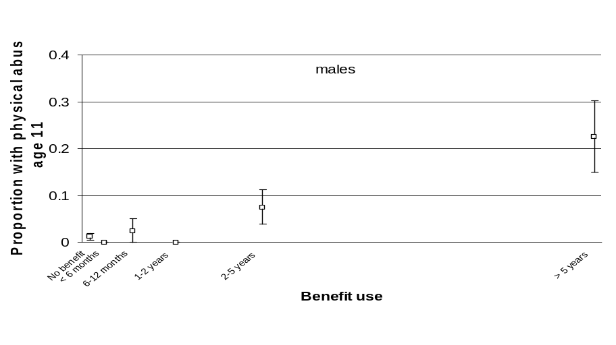
Sexual abuse
Childhood sexual abuse was defined as any type of sexual physical contact up to age 11 years.

Sexual abuse predicted time receiving benefit (β_{all}=0.084, p=0.010 and β_{ben}=0.101, p=0.036) in that those who would spend more time receiving benefit were more likely to have been sexually abused as children.

There was no difference between men and women in the association between childhood sexual abuse and time receiving benefit.
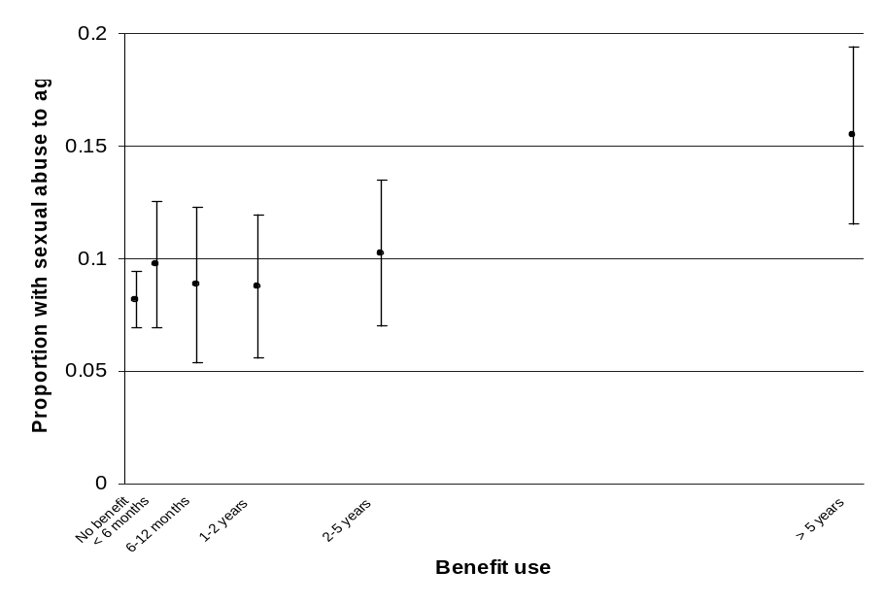
Mental health and behavioural problems in childhood
The Rutter Behaviour Questionnaire (Rutter et al, 1970) was completed by parents and teachers at ages 5, 7, 9, and 11. The Rutter questionnaire has three sub-scales: hyperactivity, neuroticism, and antisocial behaviour.

Examples of items are ”Often running about or jumping up and down”, ”Hardly ever still” (hyperactivity), ”Often worried, worries about many things” (neuroticism) and ”Frequently fights with other children” (antisocial behaviour).
Childhood hyperactivity
Greater hyperactivity scores predicted more benefit receipt (β_{all}=0.153, p<0.001 and β_{ben}=0.227, p<0.001).
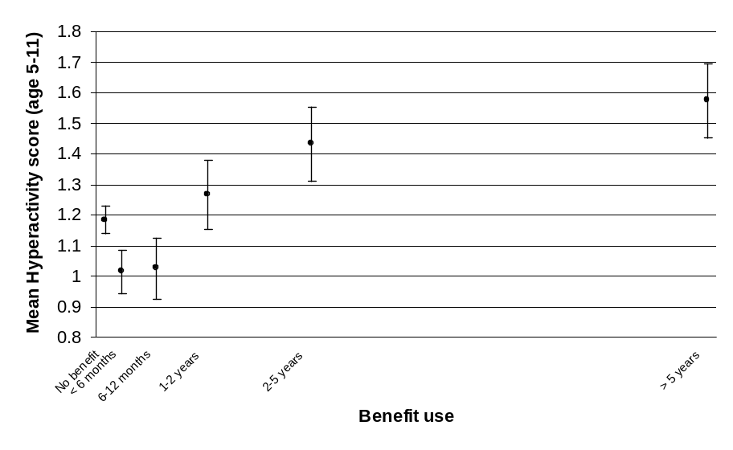
Childhood neuroticism
There was an interaction with sex in the association with neuroticism (p=0.047). Males who were more neurotic during childhood tended to use benefits for longer periods (β_{all}=0.102, p=0.026 and β_{ben}=0.133, p=0.044), but this was not the case for females (β_{all}=-0.035, p=0.452 and β_{ben}=-0.072, p=0.299).

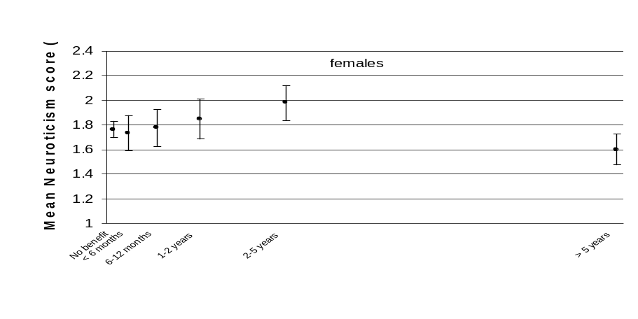
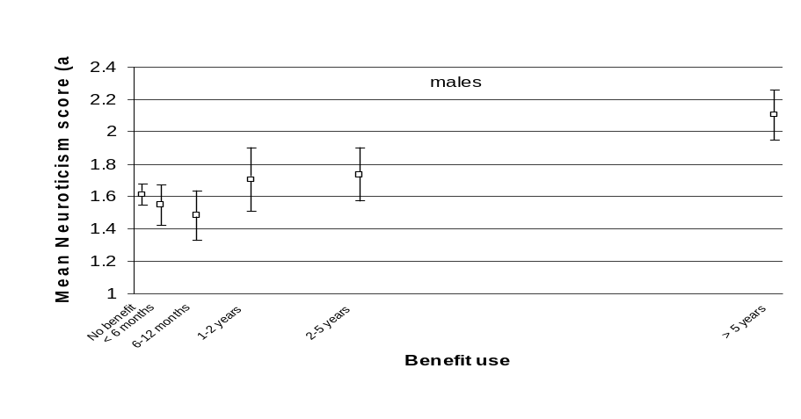
Childhood antisocial behaviour
Childhood antisocial behaviour predicted increased benefit receipt (β_{all}=0.153, p<0.001 and β_{ben}=0.216, p<0.001).
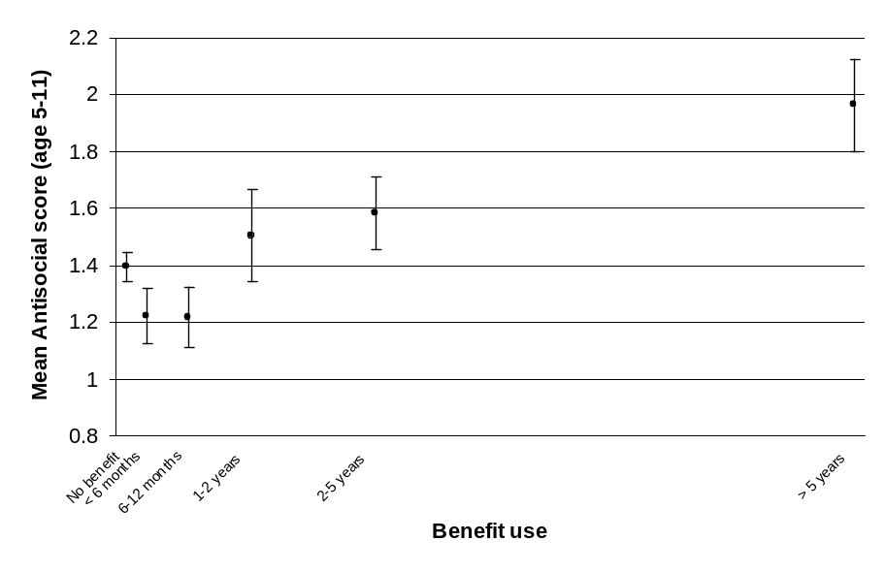
Mental health and behavioural problems in early adolescence
Behavioural problems were assessed by parents at ages 13 and 15 using the Revised Behaviour Problem Checklist (RBPC) (Quay and Peterson, 1987).

This checklist presents statements about behaviour which comprise six sub-scales:

- Socialised aggression (the tendency to misbehave conjointly with others),
eg ”steals in company with others”
- Inattention, eg ”inattentive to what others say’”
- Hyperactivity, eg ”restless, unable to sit still”
- Conduct disorder, eg ”fights“
- Psychotic behaviour, eg ”expresses strange, far-fetched ideas”
- Anxiety, eg ”afraid to try new things for fear of failure”.

Scores were standardised at each age, and the mean across both ages was used in analyses.
Socialised aggression
Higher levels of age 13–15 socialised aggression predicted more benefit receipt (β_{all}=0.320, p<0.001 and β_{ben}=0.385, p<0.001).

The β_{all} was associated with a sex interaction (p=0.004) as depicted in the graphs; the effects were detectable in males (β_{all}=0.300, p<0.001) and similarly females (β_{all}=0.357, p<0.001), though the pattern of effects differed slightly.
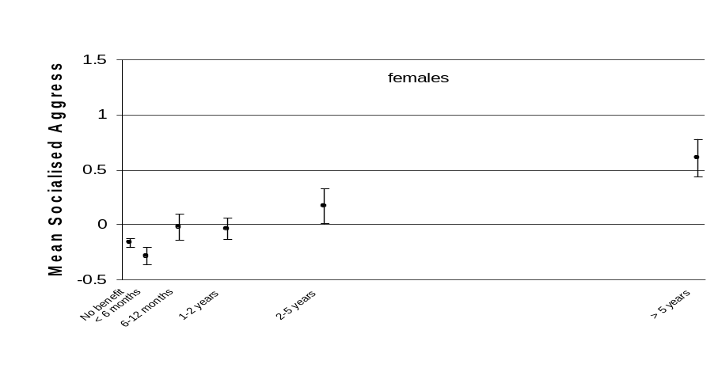
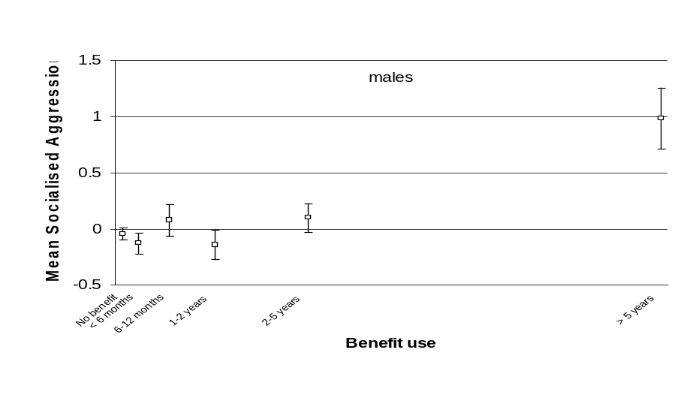
Inattention
Higher levels of attention problems at age 13–15 predicted spending longer receiving benefit (β_{all}=0.150, p<0.001 and β_{ben}=0.216, p<0.001).
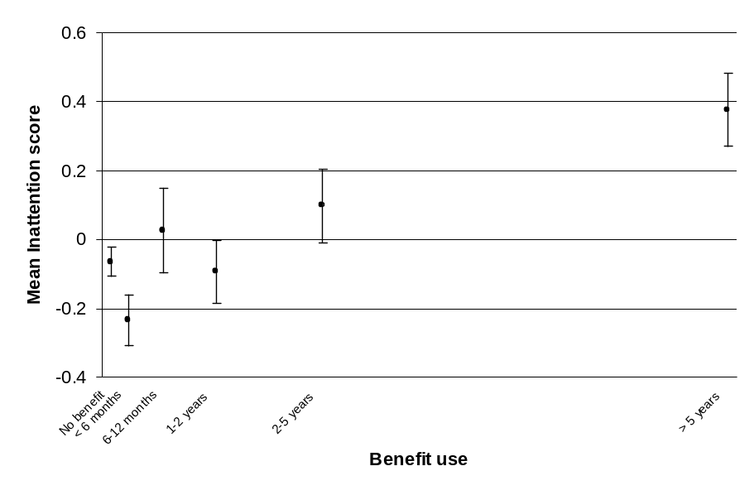
Hyperactivity
Higher levels of age 13–15 hyperactivity were marginally associated with more benefit receipt in adulthood (β_{all}=0.091, p=0.006 and β_{ben}=0.095, p=0.051).
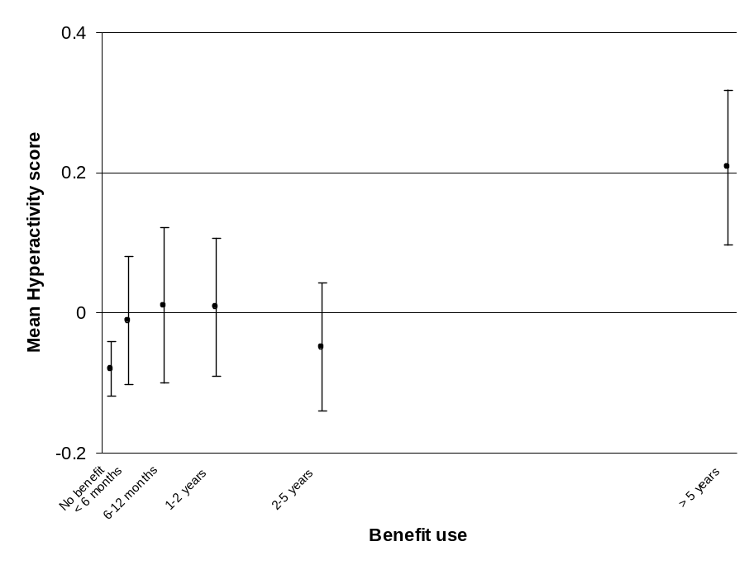
Conduct disorder
Those with higher levels of conduct disorder at age 13–15 tended to spend more time receiving benefit (β_{all}=0.182, p<0.001 and β_{ben}=0.231, p<0.001).
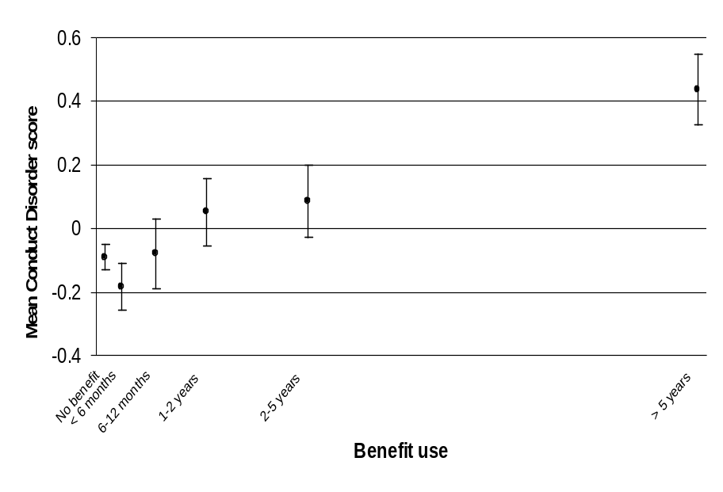
Psychoticism
Age 13–15 psychosis score predicted benefit receipt (β_{all}=0.142, p<0.001 and β_{ben}=0.177, p<0.001) in that those with more psychotic behaviour tended to use more benefits.
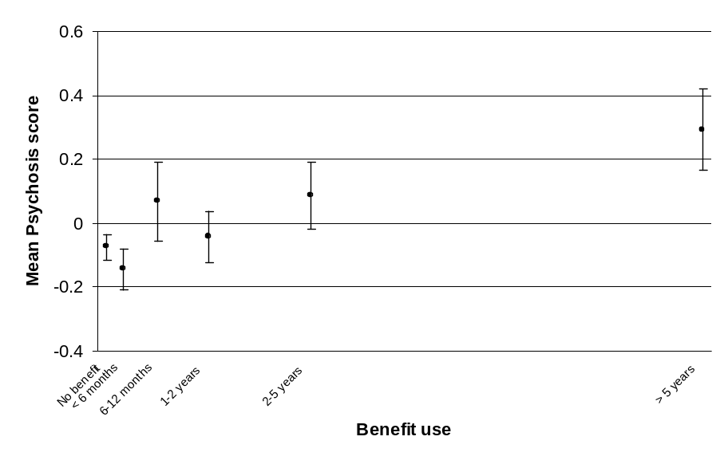
Anxiety
There was an interaction with sex in the association with age 13–15 anxiety interaction (p=0.017).

Among males, those who were more anxious tended to spend longer receiving benefit (β_{all}=0.150, p=0.001 and β_{ben}=0.205, p=0.002), but this was not so for females (β_{all}=0.034, p=0.476 and β_{ben}=-0.045, p=0.520).
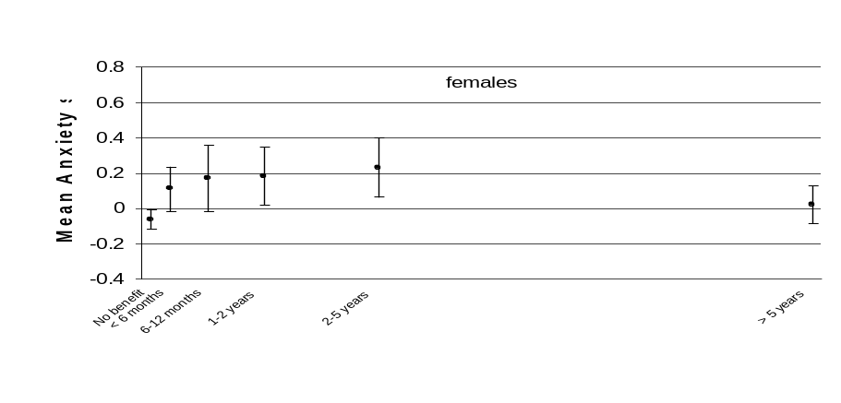

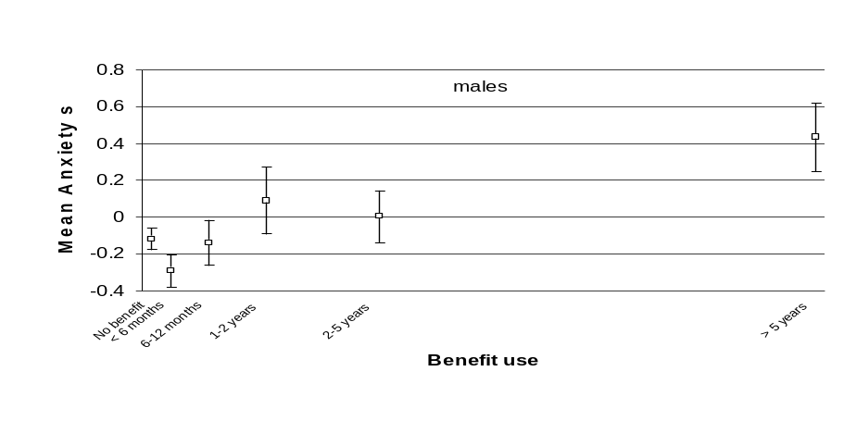

Mental health and behavioural problems at age 15
At the age 15 assessment, the Diagnostic Interview Schedule for Children (DISC) structured interview was administered (Costello et al, 1982).

This was used to diagnose depression, anxiety, conduct disorder, and attention deficit disorder according to the criteria of the Diagnostic and Statistical Manual of Mental Disorders, third edition (DSM-III) (American Psychiatric Association, 1980).
Any diagnosis
The proportions meeting any of the DSM-III diagnostic criteria tended to be more likely to spend more time receiving benefit (β_{all}=0.212, p<0.001 and β_{ben}=0.309, p<0.001).
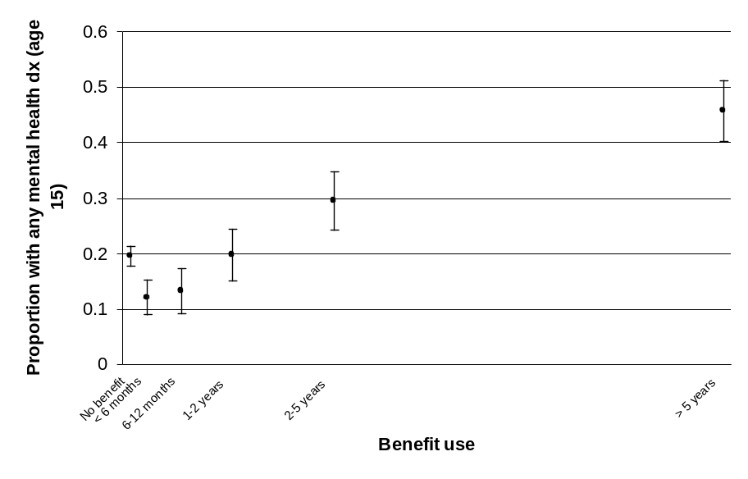
Depression
The total meeting criteria for diagnosis of depression was 32, which provides little power for detecting effects.

Age 15 depression did not predict later benefit receipt (β_{all}=0.048, p=0.158 and β_{ben}=0.057, p=0.249).
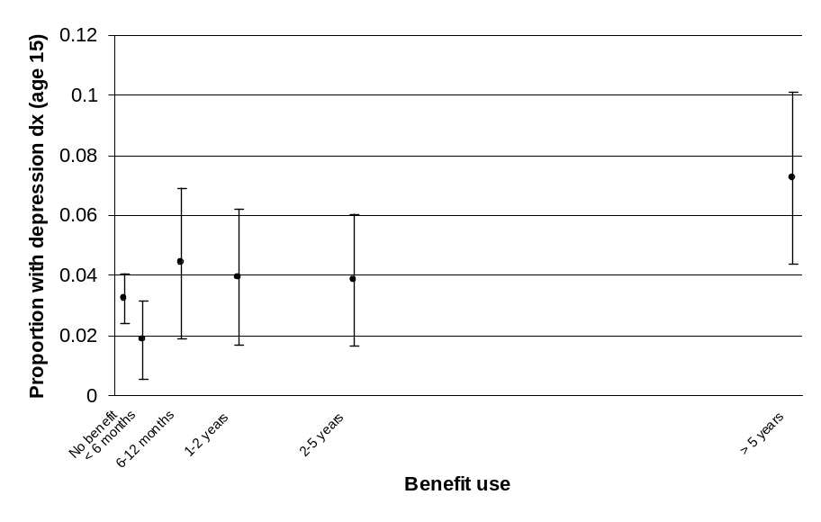
Anxiety
Those meeting anxiety diagnostic criteria were more likely to spend more time receiving benefit (β_{all}=0.084, p=0.012 and β_{ben}=0.127, p=0.010).
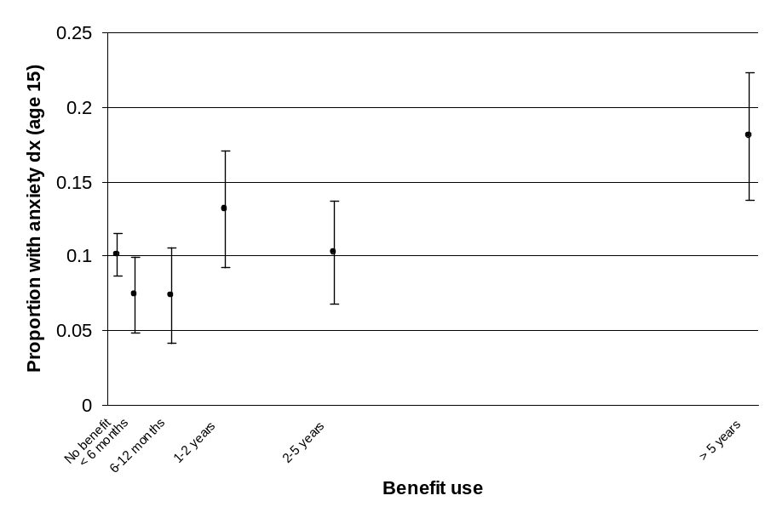
Conduct disorder
Those with conduct disorder were more likely to spend more time receiving benefit (β_{all}=0.223, p<0.001 and β_{ben}=0.294, p<0.001).
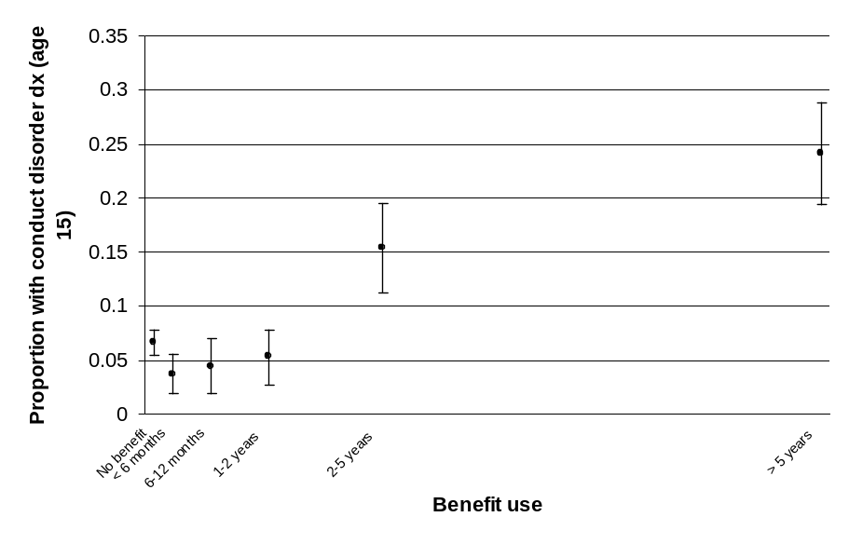
Attention deficit disorder
Only 17 people met the criteria for diagnosis of attention deficit disorder, but they were more likely to spend more time receiving benefit (β_{all}=0.077, p=0.022 and β_{ben}=0.111, p=0.024).
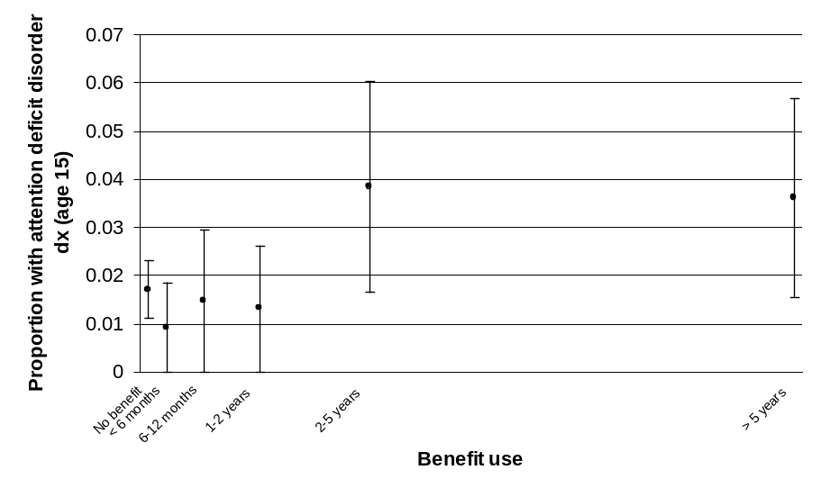
Individual characteristics that can be protective
The literature highlights a range of characteristics that can be protective against poor outcomes. IQ and self-esteem are analysed here.

Others that could be considered in future analyses include low novelty seeking and positive peer affiliations in adolescence, self-efficacy, length of schooling and school attainment (Fergusson and Horwood, 2003).
Intelligence quotient
Weschler IQ was measured at ages 7, 9, 11, and 13 (Wechsler, 1974). Scores were standardised and the mean computed across the four ages.

Higher IQ predicted less benefit receipt (β_{all}=-0.200, p<0.001 and β_{ben}=-0.294, p<0.001).
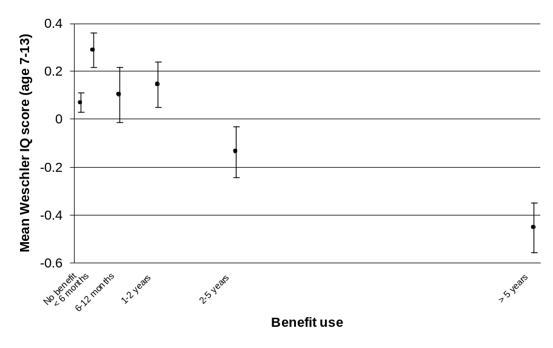
Self-esteem
Self-esteem was assessed at ages 11 and 13 using the Rosenberg Self-esteem Scale (Rosenberg, 1965). The respondents answered statements which are alternately positive (eg “On the whole I am happy with myself”) and negative (eg “At times I think I am no good at all”).

Those with lower self-esteem were more likely to spend more time receiving benefit (β_{all}=-0.164, p<0.001 and β_{ben}=-0.257, p<0.001).
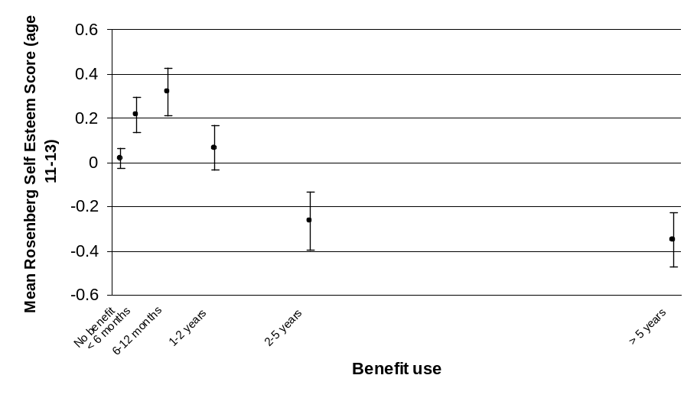
Transition to adulthood
Time unemployed
The duration of unemployment during the period between leaving school and age 21 predicted later benefit receipt (β_{all}=0.332, p<0.001 and β_{ben}=0.311, p<0.001).
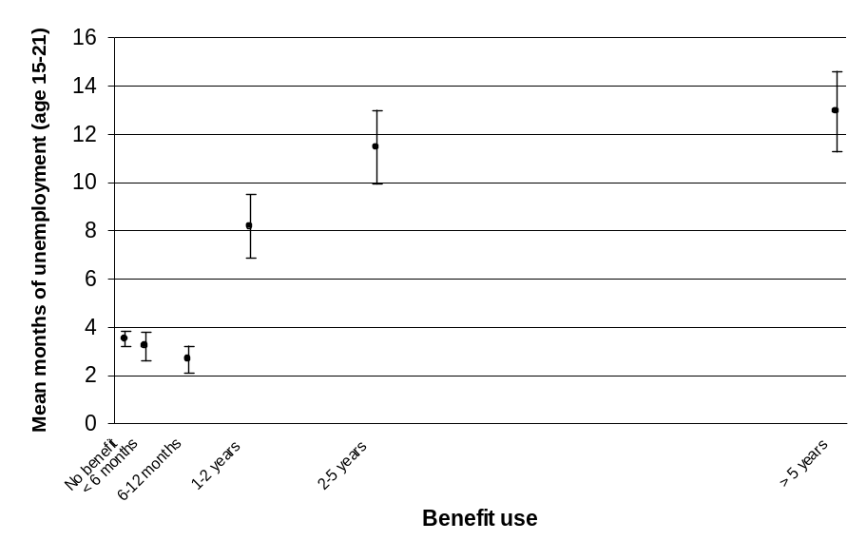
Early entry into parenthood
Having offspring born before age 21 predicted later benefit receipt (β_{all}=0.325, p<0.001 and β_{ben}=0.396, p<0.001).

It is worth mentioning here (even though we have always tested for sex interactions and have normally only mentioned them where effects were significant) that there was no difference between men and women in terms of the influence of having early offspring on the amount of time spent receiving benefit.

Because more women than men reported early parenthood, the rates for women would be higher than those indicated by the graph for both sexes shown here.
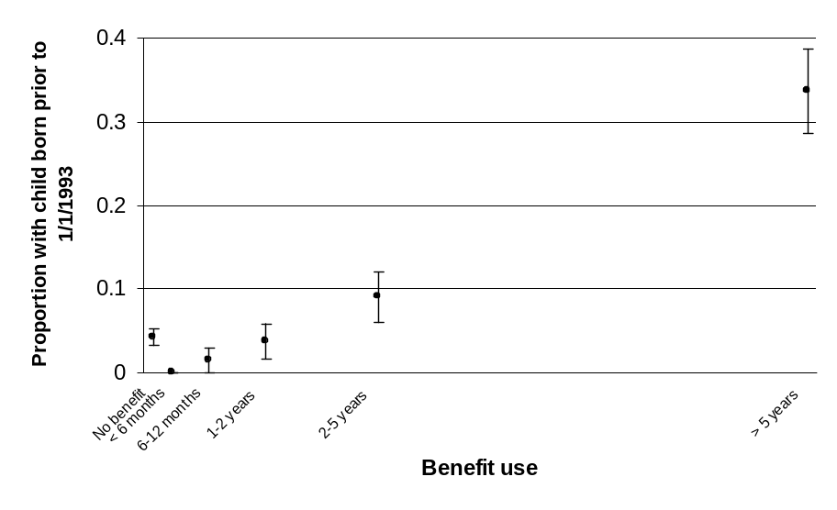
age 21
Other experiences in the transition to adulthood that are likely to be associated with later benefit receipt but are not examined here include youth offending, school retention and attainment and post secondary participation in education and training (McLaren, 2003).
age 21
Combination of factors
Individually, each of the predictors identified is fairly weak; the strongest having β-values of approximately 0.3, and thus R² values about 0.1, or accounting for 10 percent of variance. This is a common finding in the literature.

The effects of individual risk and protective factors in isolation on children’s outcomes are often modest, and what tends to distinguish children who have a high risk of poor outcomes is an accumulation of disadvantages (Fergusson and Horwood, 2003; Fergusson et al, 2003; Melchior et al, 2007).

For example, most of the excess risk of poor health at age 32 experienced by Dunedin Study members from low socio-economic status families appears to be due to their high levels of exposure to multiple types of adversity, including their parents’ liability to mental and physical disorders, their own poor childhood and adolescent health, low childhood IQ, exposure to childhood maltreatment, and their own low socio-economic status as adults. No single factor emerges as a leading explanation (Melchior et al, 2007).

It is possible to model benefit usage based on combinations of predictors, rejecting those which do not add to the total amount of variance explained based on a stepwise adding/removal of predictors from the model.

The problem with this approach is that where predictors are intercorrelated, the ones that end up in the final model may be arbitrary. This is because if two variables, say parental education and IQ, account for much the same portion of the variance in benefit receipt, only one will end up in the model, even though both have predictive power.

This problem cautions against dismissing predictors from one’s thinking simply because they do not occur in the final model, and emphasises the need for further hypothesis-driven analysis to better understand the processes that underlie the associations found.

Two stepwise multiple linear regression models were generated including all of the predictor variables identified as having significant effects in the preceding bi-variate models. The first (in Table 4) included all data, and the second (in Table 5) was based only on those who had received some benefits. The entry and exit criteria for the stepwise process were 0.05 and 0.1 respectively.

Table 4: Predictors of time spent receiving benefit in early adulthood after stepwise multiple linear regression modelling, overall R²=0.292
Predictor | β-value | p-value
Time unemployed ages 15–21 | 0.250 | <0.001
Early entry into parenthood | 0.239 | <0.001
RBPC socialised aggression | 0.200 | <0.001
Number of caregiver changes | 0.160 | <0.001
Any mental health diagnosis at 15 | 0.128 | 0.001
Physical abuse | 0.092 | 0.011
Rutter antisocial behaviour | -0.088 | 0.025

Table 5: Predictors of time spent receiving benefit in early adulthood after stepwise multiple linear regression modelling, excluding those who were never in receipt of benefit, overall R2=0.352
Predictor | β-value | p-value
Early entry into parenthood | 0.306 | <0.001
Time unemployed ages 15–21 | 0.230 | <0.001
RBPC socialised aggression | 0.205 | <0.001
Number of caregiver changes | 0.166 | 0.001
Any mental health diagnosis at 15 | 0.134 | 0.012

The main predictor variables selected under both cuts of the data were the same. As anticipated, due to the tendency of the bi-variate relationships to be J-shaped, the model fit was improved when applied to just those who received benefits.

An ability to account for about a third of variance in benefit receipt is encouragingly high given the large number of factors that may be expected to influence this outcome.

It should be borne in mind that the variables which remain in the model all intercorrelate with other predictors and each other, so they cannot be thought of in isolation. However, these all clearly have an independent influence on time spent receiving benefit.

5 Age 32 outcomes associated with time spent receiving benefit
This section examines associations between the length of time spent receiving benefits in young adulthood and a small selection of measures recorded at study members’ age 32 assessment.

The findings confirm that longer periods of benefit receipt between 1993 and the age 32 assessment were associated with lower occupational status, lower income, lower qualifications, poorer mental health, and higher rates of substance abuse and smoking at age 32.

Several measures of physical health (body mass index (BMI), waist-to-hip ratio, body fat percentage, fitness (VO2max), and physical exercise) show no association with time receiving benefit. Lower systolic blood pressure was associated with more benefit receipt.

Based on these initial findings, we are unable to say whether associations between longer-term benefit receipt and poor outcomes are caused by longer-term benefit receipt itself.
Analytic approach
Simple analyses similar to those for childhood predictors were conducted.

The situation for outcomes is made slightly complex by the fact that there are two frames of reference for thinking about the possible effects of benefits on peoples’ lives:

- A ‘dosage’ effect: Time spent receiving benefit may have repercussions due to factors such as poverty, loss of a desire to work, alienation from the mainstream society, discrimination or despondency.
- A ‘recovery’ effect: The impact of a person’s experiences while receiving benefits may reduce with time after coming off benefits.

We examine models that include both time spent receiving benefit and time since receiving benefit. Because the two variables were correlated (r=-0.624), we also consider each separately in case the effect attributable to one was masked by the other (collinearity). Time since receiving benefit could only be considered for those who had received some benefit.

From the simple bi-variate associations presented here, we are unable to say whether dosage and recovery effects play any causal role.

We have seen that longer-term benefit receipt is associated with a range of prior adverse family and individual circumstances. The associations found in this initial examination of the data may therefore simply reflect systematic, pre-existing differences between the people who spent longer and shorter periods receiving benefit.

Analyses testing for sex-by-benefit receipt interactions were conducted for each model. Where sex interaction terms were significant (p=0.05), separate analyses were conducted by sex, and separate graphs constructed.
Age 32 socio-economic outcomes
Occupational status
Occupational status at age 32 was assessed according to the Elley Irving SES rating. Occupational status was higher in those with shorter benefit receipt between 1993 and their age 32 assessment (β_{all}=-0.255, p<0.001).

Considering just those with some benefit receipt, there were bi-variate associations with both benefit receipt (β_{ben}=-0.321, p<0.001) and recovery (β_{ben}=0.309, p<0.001).

Multivariate analysis including both variables suggested that they had independent associations with occupational status (benefit receipt (β_{ben}=-0.212, p<0.001) and recovery (β_{ben}=0.181, p=0.002)).
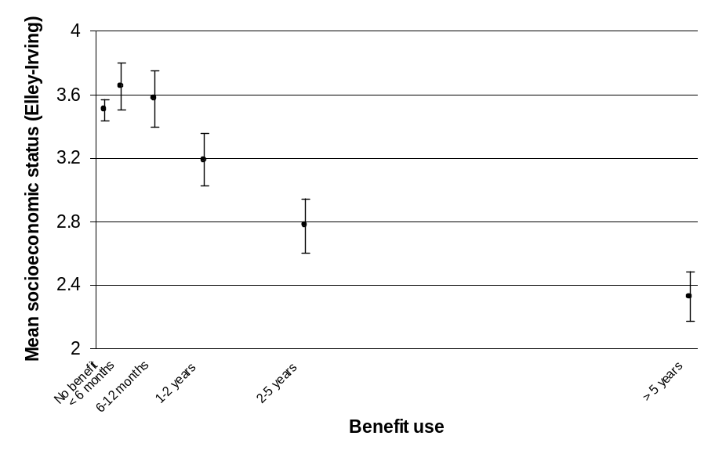
Income
Income at age 32 was higher in those with shorter benefit receipt (β=-0.255, p<0.001). Considering just those with some benefit receipt, there were bi-variate associations with both benefit receipt (β_{ben}=-0.364, p<0.001) and recovery (β_{ben}=0.414, p<0.001).

Multivariate analysis including both variables suggested that they had independent associations with income (benefit receipt (β_{ben}=-0.173, p=0.002) and recovery (β_{ben}=0.306, p<0.001)).

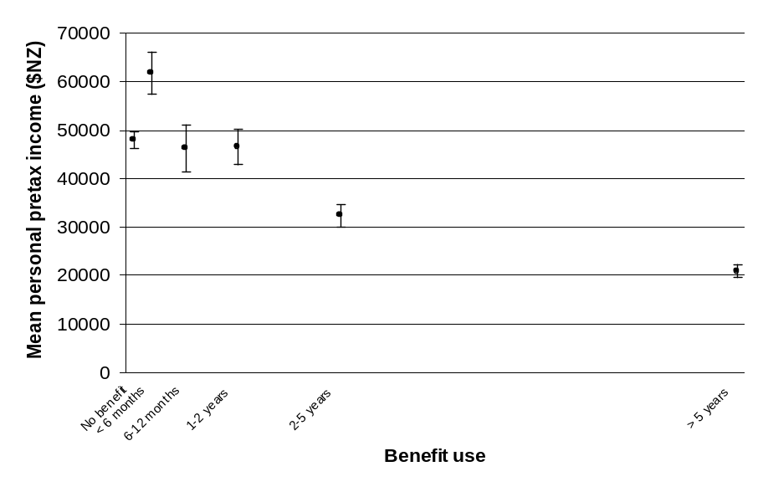
Degree qualification
Having a degree qualification by age 32 was associated with shorter benefit receipt (β_{all}=-0.154, p<0.001). There was no interaction with sex.

Considering just those with some benefit receipt, there were bi-variate associations with both benefit receipt (β_{ben}=-0.288, p<0.001) and recovery (β_{ben}=0.247, p<0.001).

Multivariate analysis including both variables suggested that they had independent associations with degree qualification (benefit receipt (β_{ben}=-0.219, p<0.001) and recovery (β_{ben}=0.111, p=0.057)).
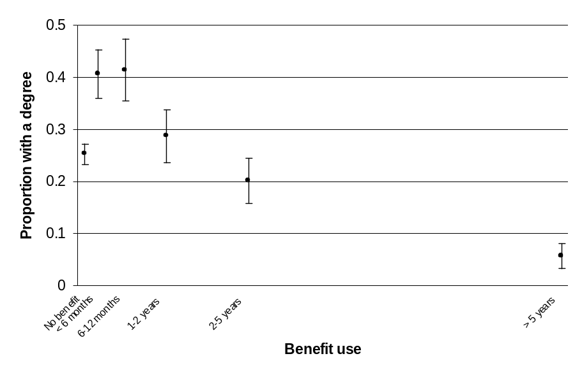
Age 32 mental health
Any diagnosis
Thirty-seven percent or 351 of the 939 who underwent mental health interviews at age 32 had some diagnosis of a mental health condition in the prior 12 months according to DSM-IV criteria. Having a mental health diagnosis was associated with more benefit receipt (β_{all}=0.174, p<0.001). There was no interaction with sex.

Considering just those with some benefit receipt, there were bi-variate associations with both benefit receipt (β_{ben}=0.168, p<0.001) and recovery (β_{ben}=-0.134, p=0.005).

Multivariate analysis including both variables suggested that they did not have independent associations with mental health (benefit receipt (β_{ben}=0.138, p=0.022) and recovery (β_{ben}=-0.048, p=0.426)). That is, the associations were perfectly collinear so that independent associations could not be identified.
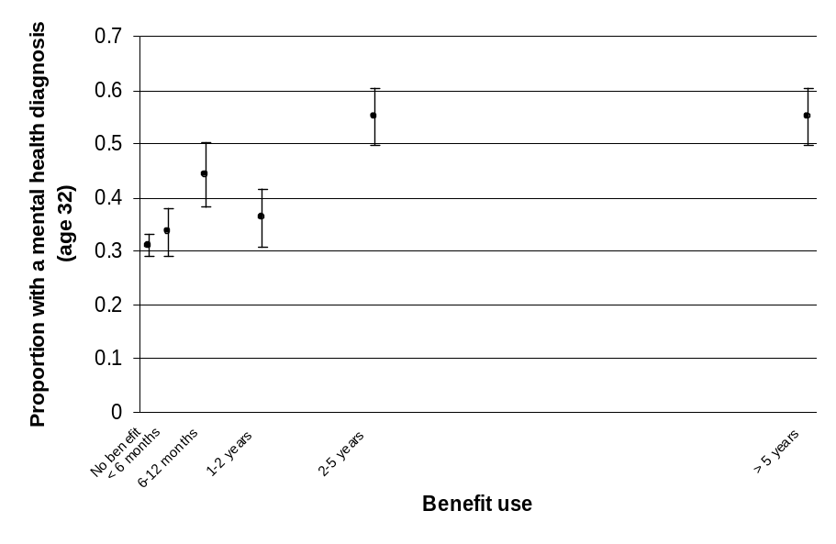
Anxiety disorder
Twenty-two percent or 209 of the 939 who underwent mental health interviews at age 32 had some diagnosis of an anxiety disorder according to DSM-IV criteria in the prior 12 months. Having an anxiety disorder was associated with more benefit receipt (β_{all}=0.145, p<0.001). There was no interaction with sex.

Considering just those with some benefit receipt, there were bi-variate associations with both benefit receipt (β_{ben}=0.182, p<0.001) and recovery (β_{ben}=-0.141, p=0.003).

Multivariate analysis including both variables suggested that they did not have independent associations with anxiety disorders (benefit receipt (β_{ben}=0.154, p=0.011) and recovery (β_{ben}=-0.045, p=0.458)).
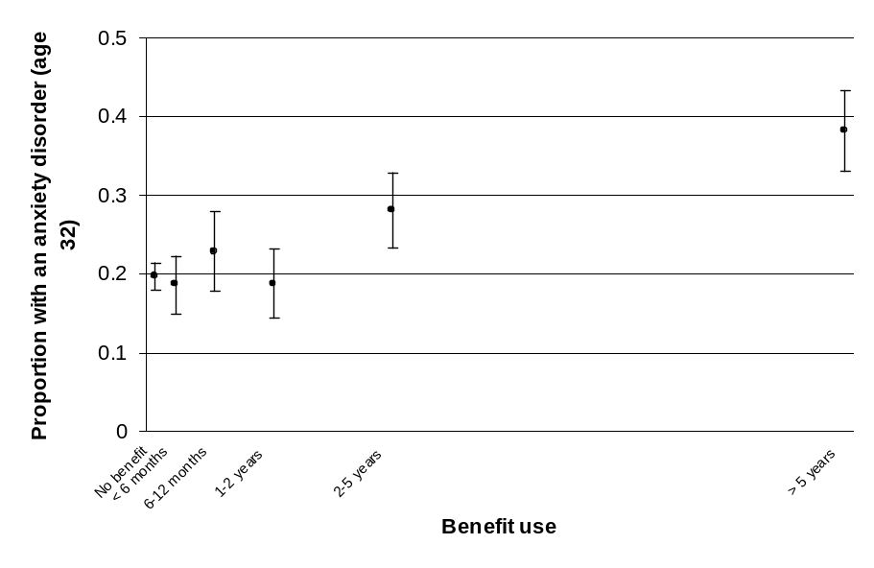
Substance disorders
Thirteen percent or 121 of the 939 who underwent mental health interviews at age 32 had some diagnosis of a substance disorder according to DSM-IV criteria in the prior 12 months. Having a substance disorder was associated with more benefit receipt (β_{all}=0.190, p<0.001). There was no interaction with sex.

Considering just those with some benefit receipt, there were bi-variate associations with both benefit receipt (β_{ben}=0.185, p<0.001) and recovery (β_{ben}=-0.160, p=0.001).

Multivariate analysis including both variables suggested that they did not have independent associations with substance disorders (benefit receipt (β_{ben}=0.138, p=0.022) and recovery (β_{ben}=-0.074, p=0.218)).
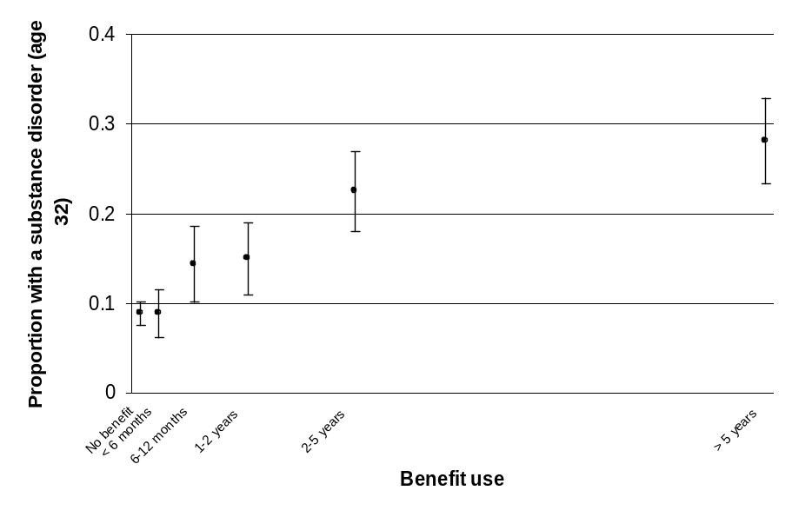
Age 32 physical health
There were no associations between time receiving benefit or recovery time with body mass index (BMI), waist-to-hip ratio, body fat percentage, fitness (VO2max), or physical exercise.
Blood pressure
Lower systolic blood pressure was associated with more benefit receipt (β_{all}=-0.098, p=0.003). There was no interaction with sex.

Considering just those with some benefit receipt, there were bi-variate associations with both benefit receipt (β_{ben}=-0.172, p<0.001) and recovery (β_{ben}=0.159, p<0.001).

Multivariate analysis including both variables suggested that they did not have independent associations (benefit receipt (β_{ben}=-0.119, p=0.051) and recovery (β_{ben}=0.085, p=0.163)).

No effect was found for diastolic blood pressure.

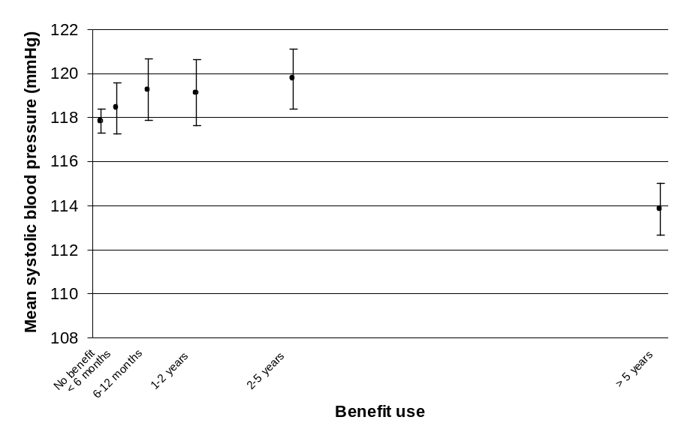
Smoking
Thirty-four percent or 315 of the 940 study members had smoked daily for a month or more in the prior 12 months. Smoking was associated with more benefit receipt (β_{all}=0.336, p<0.001). There was no interaction with sex.

Considering just those with some benefit receipt, there were bi-variate associations with both benefit receipt (β_{ben}=0.433, p<0.001) and recovery (β_{ben}=-0.273, p<0.001).

Multivariate analysis including both variables suggested that they did not have independent associations with smoking (benefit receipt (β_{ben}=0.430, p<0.001) and recovery (β_{ben}=-0.005, p=0.930)).
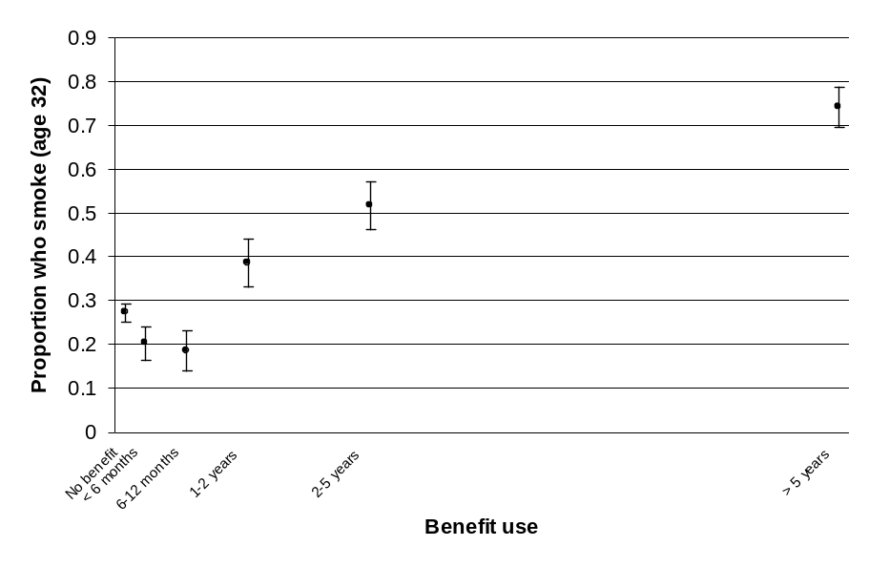
Tinnitus
Forty-five percent or 425 of the 940 study members reported having experienced some tinnitus in the prior 12 months. Tinnitus was associated with more benefit receipt (β_{all}=0.094, p=0.004). There was no interaction with sex.

Considering just those with some benefit receipt, there were bi-variate associations with both benefit receipt (β_{ben}=0.169, p<0.001) and recovery (β_{ben}=-0.157, p=0.001).

Multivariate analysis including both variables suggested that they did not have independent associations with tinnitus (benefit receipt (β_{ben}=0.116, p=0.053) and recovery (β_{ben}=-0.084, p=0.162)).
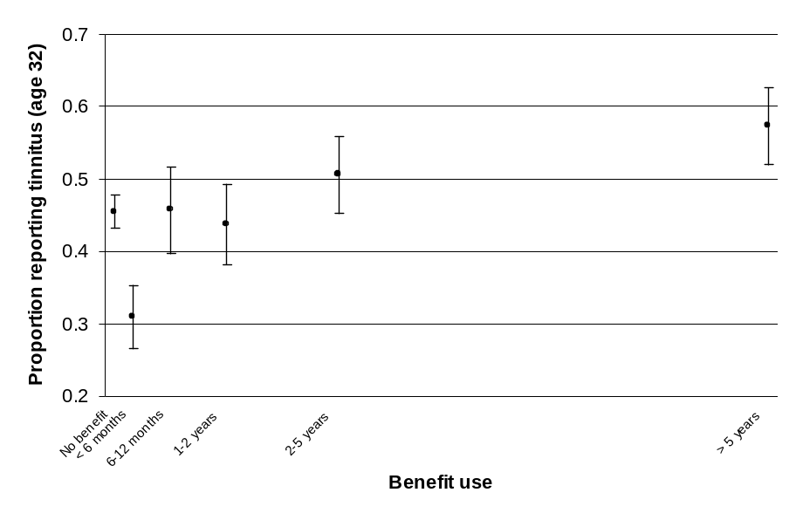

6 Relevance of these findings to other groups
The proportion of the New Zealand working-age population receiving main benefits was at an all-time high when the Dunedin Study members were in their 20s:

- Unemployment rates peaked in the early 1990s following major economic restructuring and recession. They were especially high for this cohort because of their youth and lack of an established position in the labour market.
- This group was also affected by the rapid growth in the rate of sole parenthood in the 1990s. Growth in sole parenthood may have partly reflected the effects of the difficult economic circumstances of that time on patterns of family formation and dissolution.

Figures 7 and 8 compare the rate of benefit receipt by age for the cohort born in the year to March 1973 with the rates for cohorts born five and 10 years earlier and later.

Over the age ranges that can be compared, earlier birth cohorts tended to have rates of benefit receipt at least as high as those experienced by the 1972/1973 cohort.

Figure 7: Estimated proportion of males in different birth cohorts receiving main benefits by age, selected March year birth cohorts
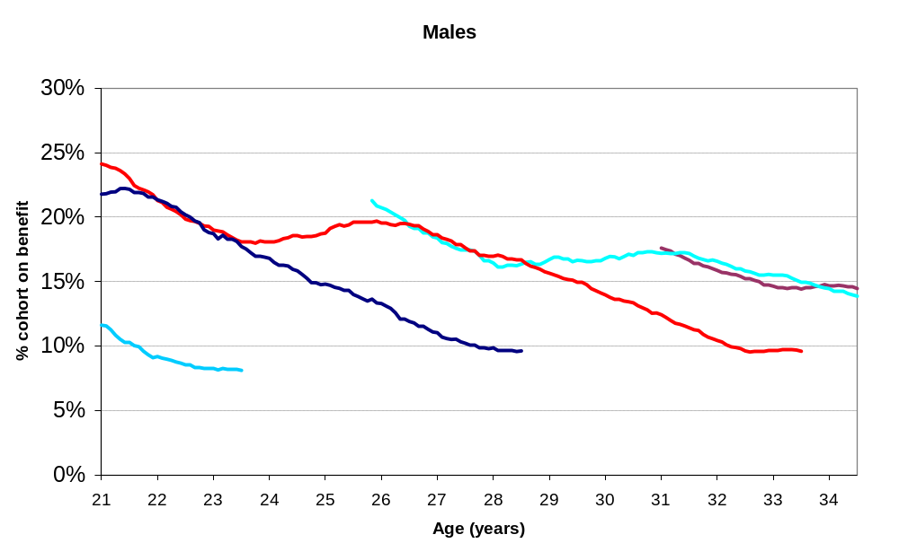
Notes: Percent receiving benefit is calculated as the number born in each March year receiving benefit at each age from Benefit Dynamics data, divided by an estimate of the size of the total population resident in this cohort at the time. This is estimated taking the March estimate of the population resident as the size of the population when members of the cohort were halfway through each year of life (eg the number of 21 year olds at March 1993 is taken as the estimate of the number in this age group when members of the cohort born in the year to March 1973 reached the age of 21.5). Linear interpolation was used to estimate the population between these points.
Sources: MSD’s Benefit Dynamics Data Set; Statistics New Zealand, Estimated Resident Population by Age

Figure 8: Estimated proportion of females in different birth cohorts receiving main benefits by age, selected March year birth cohorts
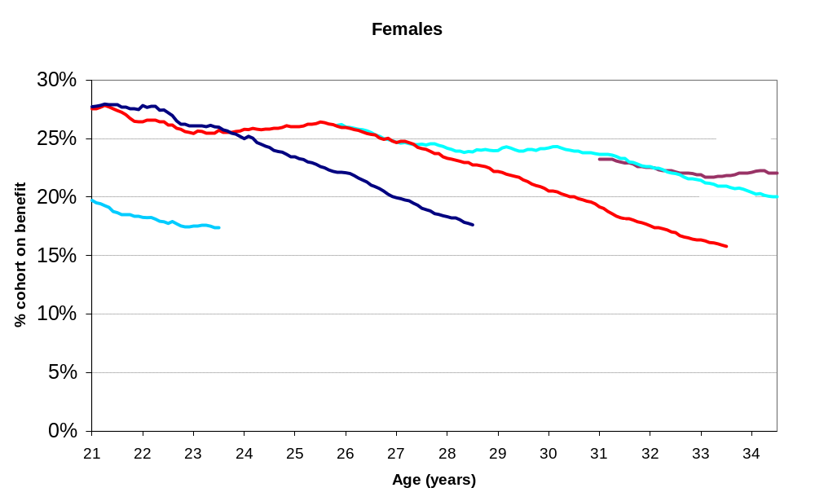
Notes: Percent receiving benefit is calculated as the number born in each March year receiving benefit at each age from Benefit Dynamics data, divided by an estimate of the size of the total population resident in this cohort at the time. This is estimated taking the March estimate of the population resident as the size of the population when members of the cohort were halfway through each year of life (eg the number of 21 year olds at March 1993 is taken as the estimate of the number in this age group when members of the cohort born in the year to March 1973 reached the age of 21.5). Linear interpolation was used to estimate the population between these points.
Sources: MSD’s Benefit Dynamics Data Set; Statistics New Zealand, Estimated Resident Population by Age

Up until 2007, rates of benefit receipt were lower for younger cohorts entering adulthood than they were for the Dunedin cohort. Falling unemployment led to much lower rates of receipt for young men especially. In addition, women in younger cohorts tended to have their children later, appeared to be less likely to parent alone and, where they did parent alone, were more likely to work full-time (Goodger and Wilson, 2007).

While the prevalence of benefit receipt may vary, it is reasonable to suppose that the factors identified by this report would tend to predict the risk of longer periods of benefit receipt in any socio-economic context. For example, for the cohorts who entered the labour market in the recessionary conditions prevailing in 2009, these early findings may indicate who is most at risk of longer-term benefit receipt.

What is less clear is how the prevalence of these factors is changing.

Compared to the 1973 birth cohort, children now are in some respects more likely to have had experiences that enhance outcomes, but in other respects are more likely to have had experiences that pose a risk to outcomes.

Participation in early childhood education, in particular, has increased substantially since the 1970s, as have efforts to promote the quality of early childhood education (see Hodgen, 2007). In other respects, children now are less fortunate than the 1973 cohort. Persistent low income associated with long-term benefit receipt by their carers is a much more common childhood experience now than in the 1970s.

While benefit receipt of carers has fallen to date for very recent birth cohorts, as many as one in five children who turned 15 in 2008 are estimated to have been supported by a main benefit for a total of seven or more of their first 14 years of life, and an estimated one in 10 spent a total of 11 or more of their first 14 years supported by a main benefit (Wilson and Soughtton, 2009).

One limitation of the current study is the lower than average representation of Mäori, Pacific and other ethnic groups in the Dunedin Study. These population groups make up a growing proportion of young people, and Mäori especially are over-represented in benefit uptake.

It is possible that that there are risk and protective factors that are particular to these groups, or that those factors identified may operate in different ways for them.

7 Directions for further research
The integration of benefit data into the Dunedin Study has the potential to provide new knowledge to inform a number of areas of policy development and service delivery.
Research that can support the design and delivery of early intervention
The childhood risk and protective factors examined in this study often co-occur and tend to be interrelated, making it difficult to isolate those that have a causal influence on outcomes (Fergusson et al, 2003; Melchior et al, 2007).

When seeking to identify or prioritise for services those children or young people most likely to become long-term benefit recipients or to have other negative outcomes, it does not matter whether a factor is causal or not.

However, for the purposes of identifying points at which interventions could make a difference, knowing which factors are causal is important.

There is a general consensus in the literature that improved family incomes, effective early-years interventions, high-quality early childhood education, the prevention of child abuse and family violence and effective interventions for conduct disorder/severe antisocial behaviour can have a positive causal influence on outcomes, and this informs many of the Ministry’s current areas of focus.

The early findings from this study suggest that, where these programmes are successful, people may spend less time on benefit in adulthood.

Further research on the causal paths that lead to long-term benefit receipt using the integrated data could strengthen the evidence base for the design and delivery of early intervention and prevention programmes.
Research that can support the targeting of more intensive services to benefit recipients with a high risk of longer-term benefit receipt
The findings in this report highlight the important role that the benefit system performs in providing a short-term safety net which, for this cohort, was accessed by a broad cross-section of young people.

On average, short-term benefit recipients tended to have experienced less childhood adversity and better outcomes in adulthood than either those who did not receive benefits or those who received benefits for longer periods. Not all benefit recipients need intensive services.

The associations highlighted here could be investigated further to provide information that might help in directing more intensive services early in a person’s benefit history to those most at risk of longer-term benefit receipt.
Research that can support the development of integrated services for benefit recipients and their families
The findings demonstrate that there are interrelationships between longer-term benefit receipt and other adverse outcomes in young adulthood, including educational disadvantage, economic adversity, poor mental health, high rates of substance abuse and health-risk behaviours such as smoking.

What distinguishes many people who experience long periods of benefit receipt is likely to be an accumulation of risk over their lifetime that combines to increase the likelihood of problems across a number of areas of life in adulthood.

Longer-term recipients have tended to make up a high proportion of the cross-section of people receiving benefit on a given date in recent years. Of those born in the same year as the Dunedin cohort who were receiving benefits at their 32nd birthday, for example, more than two-thirds had spent at least half their time on main benefits since 1993.

The findings reported here highlight the difficulties that some longer-term benefit recipients face, and suggest that policies focused on speeding the transition to work or improving work incentives may not be sufficient to address these difficulties.

The findings provide support for policies that seek to use contact in the process of benefit administration to address wider needs, but they also highlight the inherent difficulties in doing this. These difficulties include the need for skilled and sensitive engagement, the need for time to begin and maintain conversations, and the need to integrate services that potentially span mental health, drug and alcohol rehabilitation, education, justice and social services and link back to local communities.

Because most longer-term benefit recipients in the Dunedin cohort were parents by age 32, their experiences are now shaping the lives of their children. Some of their circumstances that have been highlighted in this initial research (for example, their relatively high rates of conduct disorder in adolescence, early childbearing, low education, low income, and poor mental health) suggest that their children, in turn, will be among those in younger cohorts with an elevated risk of poor outcomes in adulthood (see Jaffee et al, 2006).

This highlights the potential for gains in reducing the intergenerational transmission of disadvantage that can be made from working effectively with this group.

Further investigation of how the accumulation of risk over the lifetime combines to increase the likelihood of multiple problems for this cohort, and the investigation of associations between their experiences and those of their children (which could potentially draw on assessments of the offspring of study members), could strengthen the evidence base for integrated services that aim to improve outcomes for longer-term benefit recipients and their children.

References
American Psychiatric Association. (1980). Diagnostic and Statistical Manual of Mental Disorders (3rd edition). Washington DC: American Psychiatric Association.

Blakely, T., Tobias, M., Atkinson, J., Yeh, L-C., and Huang, K. (2007). Tracking Disparity: Trends in Ethnic and Socioeconomic Inequalities in Mortality, 1981–2004. Wellington: Ministry of Health.

Costello, A., Edelbrock, C., Kalas, R., Kessler, M., and Klaric, S.A. (1982). Diagnostic Interview Schedule for Children (DISC). Bethesda: National Institute of Mental Health.

Elley, W.B., and Irving, J.C. (1976). Revised socio-economic index for New Zealand. New Zealand Journal of Educational Studies, 11, 25–26.

Elley, W.B., and Irving, J.C. (1972). A socio-economic index for New Zealand based on levels of education and income from the 1966 census. New Zealand Journal of Educational Studies, 7, 153–167.

Fergusson, D.M., Boden, M., and Horwood, L.J. (2007). Exposure to single parenthood in childhood and later mental health, educational, economic, and criminal behavior outcomes. Archives of General Psychiatry, 64(9), 1089–1095.

Fergusson D.M., and Horwood L.J. (2003). Resilience to childhood adversity: Results of a 21 year study. In Suniya S. Luthar (ed), Resilience and Vulnerability: Adaptation in the Context of Childhood Adversities, Cambridge University Press, 2003, pp 130–155.

Fergusson, D., Poulton, R., Horwood, J., Milne, B., and Swain-Campbell, N. (2003). Comorbidity and Coincidence in the Christchurch and Dunedin Longitudinal Studies, A report for the New Zealand Ministry of Social Development, Ministry of Education and the Treasury.

Fergusson D.M., and Woodward L.J. (2000). Family socio-economic status at birth and rates of university participation. New Zealand Journal of Educational Studies, 2000, 35(1), 25–36.

Goodger, K., and Wilson, M. (2007). The changing nature of sole parenthood in New Zealand, presentation to the Social Policy, Research and Evaluation Conference 2007: Wellington.

Hodgen, E. (2007). The Continuing Contribution of Early Childhood Education to Young People's Competency Levels, Wellington: Ministry of Education.

Jaffee, S.R., Belsky, J., Harrington, H.L., Caspi, A., and Moffitt, T.E. (2006). When parents have a history of conduct disorder: How is the caregiving environment affected? Journal of Abnormal Psychology Vol. 115, No. 2, 309–319.

McLaren, K. (2003). Reconnecting Young People: A Review of the Risks, Remedies and Consequences of Youth Inactivity. Youth Transitions Report Series 2003, Ministry of Social Development.

Melchior, M., Moffitt, T.E., Milne, B.J., Poulton, R., and Caspi, A. (2007). Why do children from socio-economically disadvantaged families suffer from poor health when they reach adulthood? A lifecourse study. American Journal of Epidemiology, 166, 966–974.

Moos, R., and Moos, B. (1981). Family Environment Scale Manual. Palo Alto: Consulting Psychological Press.

Poulton, R., Caspi, A., Milne, B.J., Thomson, W.M., Taylor, A., Sears, M.R. (2002). Association between children's experience of socio-economic disadvantage and adult health: a life-course study. The Lancet, 360, 1640–1645.

Quay, H.C., and Peterson, D.R. (1987). Manual for the Revised Behavior Problem Checklist. Miami.

Rosenberg, M. (1965). Society and the Adolescent Self-Image. Princeton, NJ: Princeton University Press.

Rutter, M., Tizard, J., and Whitmore, K. (1970). Education, Health and Behaviour. London: Longmans.

Seth-Purdie, R. (2000). Multiple risk exposure and the likelihood of welfare receipt, Family Matters No. 57 Spring/Summer.

Silva, P.A., and McCann, M. (1996). An introduction to the Dunedin study. In P.A. Silva and W.R. Stanton (eds), From child to adult: the Dunedin Multidisciplinary Health and Development Study, Oxford University Press, Auckland, pp 1–23.

Wechsler, D. (1974). Manual for the Wechsler Intelligence Scale for Children–Revised. New York, NY: Psychological Corporation.

Wilson, M. (1999). The duration of benefit receipt: New findings from the benefit dynamics data set, Social Policy Journal of New Zealand, Issue 13:59–82.

Wilson, M., and Soughtton, D. (2009). Children in families supported by main benefits: An update, Social Policy Journal of New Zealand, Issue 36.

Appendix 1 Summary of associations
Table A1 shows bi-variate associations between the total time study members spent on benefits and a selection of measures of their early life experiences, their transition to adulthood, and their outcomes in other areas of life at age 32.

Standardised regression co-efficients (βs) were calculated using linear regression with the percentage of time spent on benefit between 1 January 1993 and the age 32 assessment as the outcome variable.

Analyses for sex-by-predictor interactions were conducted for each model. In the few cases where sex interaction terms were significant (p<0.05), separate analyses were conducted by sex.

Table A1 Associations between total time spent in receipt of benefit and other lifecourse factors
 | Time receiving benefit, 1 January 1993 (aged 19–20) – age 32 assessment |  |  |  |  |  |  |  |  |  |  |  |  |  | Correlationª
* indicates associations that are significant at the p<0.01 level for all in the study and/or benefit recipients | No time |  | up to ¹/₂ yr |  | ¹/₂ <- 1 yr |  | 1 <- 2 yrs |  | 2 <- 5 yrs |  | >5 yrs |  | All |  | All in study |  | Benefit recipients
 | Mean | (SE) | Mean | (SE) | Mean | (SE) | Mean | (SE) | Mean | (SE) | Mean | (SE) | Mean | (SE) | β | p | β | p
Number of study members | 499 |  | 113 |  | 70 |  | 80 |  | 89 |  | 89 |  | 940
Proportion of study members | 0.53 |  | 0.12 |  | 0.07 |  | 0.09 |  | 0.09 |  | 0.09 |  | 1.00
Socio-economic background
Parental occupational status score age 0–15* | 3.81 | (0.05) | 3.95 | (0.10) | 4.00 | (0.14) | 3.85 | (0.14) | 3.50 | (0.12) | 3.34 | (0.12) | 3.77 | (0.04) | -0.14 | <0.001 | -0.21 | <0.001
With father with at least School Certificate (y/n) | 0.39 | (0.02) | 0.44 | (0.05) | 0.42 | (0.06) | 0.41 | (0.06) | 0.41 | (0.05) | 0.34 | (0.05) | 0.40 | (0.02) | -0.03 | 0.448 | -0.05 | 0.264
With mother with at least School Certificate (y/n)* | 0.38 | (0.02) | 0.50 | (0.05) | 0.37 | (0.06) | 0.38 | (0.05) | 0.37 | (0.05) | 0.22 | (0.04) | 0.37 | (0.02) | -0.11 | <0.001 | -0.19 | <0.001
Age of mother at her first birth (years)* | 22.69 | (0.16) | 23.08 | (0.32) | 22.70 | (0.43) | 22.76 | (0.43) | 22.16 | (0.44) | 21.44 | (0.42) | 22.57 | (0.12) | -0.11 | 0.001 | -0.16 | 0.001
Mothers' weekly hours of paid work age 3–13 | 10.45 | (0.39) | 10.53 | (0.89) | 10.25 | (1.04) | 9.67 | (1.09) | 10.18 | (0.98) | 8.50 | (0.85) | 10.17 | (0.29) | -0.06 | 0.085 | -0.07 | 0.172
Family structure and stability
Years in sole parent family age 0–11* | 0.31 | (0.05) | 0.38 | (0.14) | 0.31 | (0.15) | 0.65 | (0.21) | 0.48 | (0.17) | 1.15 | (0.21) | 0.44 | (0.05) | 0.17 | <0.001 | 0.17 | <0.001
Number of changes in caregiver age 0–11* | 0.17 | (0.03) | 0.16 | (0.06) | 0.11 | (0.04) | 0.18 | (0.06) | 0.35 | (0.08) | 0.80 | (0.14) | 0.24 | (0.02) | 0.27 | <0.001 | 0.32 | <0.001
Number of changes in residence age 0–11* | 1.92 | (0.10) | 2.35 | (0.29) | 2.06 | (0.29) | 1.90 | (0.27) | 2.82 | (0.31) | 2.82 | (0.26) | 2.15 | (0.08) | 0.12 | <0.001 | 0.12 | 0.015
Religiosity
Participating in religious activities at age 11 (y/n) | 0.22 | (0.02) | 0.19 | (0.04) | 0.23 | (0.05) | 0.21 | (0.05) | 0.20 | (0.04) | 0.31 | (0.05) | 0.22 | (0.01) | 0.05 | 0.155 | 0.08 | 0.107
Family environment
Family cohesion score age 7–9* | 7.65 | (0.06) | 7.54 | (0.13) | 7.78 | (0.12) | 7.59 | (0.15) | 7.34 | (0.18) | 7.15 | (0.17) | 7.56 | (0.05) | -0.12 | <0.001 | -0.14 | 0.004
Family expressiveness score age 7–9 | 6.13 | (0.07) | 6.14 | (0.15) | 5.93 | (0.17) | 6.22 | (0.15) | 5.90 | (0.21) | 6.06 | (0.15) | 6.10 | (0.05) | -0.03 | 0.357 | -0.03 | 0.499
Family conflict score age 7–9* | 3.45 | (0.08) | 3.16 | (0.18) | 3.25 | (0.22) | 3.38 | (0.21) | 3.52 | (0.22) | 3.99 | (0.21) | 3.45 | (0.06) | 0.09 | 0.01 | 0.15 | 0.003
Maternal malaise score age 5–9* | -0.06 | (0.04) | -0.10 | (0.07) | -0.03 | (0.09) | -0.07 | (0.10) | 0.18 | (0.11) | 0.26 | (0.11) | -0.01 | (0.03) | 0.13 | <0.001 | 0.16 | 0.001
Harsh discipline score age 7–9 – males | 4.52 | (0.39) | 2.76 | (0.37) | 3.66 | (0.54) | 4.16 | (0.58) | 5.28 | (0.97) | 5.06 | (0.72) | 4.30 | (0.25) | - | - | 0.16 | 0.015
Harsh discipline score age 7–-9 – females | 2.77 | (0.19) | 4.92 | (0.72) | 3.11 | (0.71) | 3.55 | (0.57) | 4.03 | (1.19) | 3.36 | (0.52) | 3.26 | (0.19) | - | - | -0.08 | 0.261
Child abuse
With extreme physical abuse age 0–11 – males (y/n)* | 0.01 | (0.01) | 0.00 | (0.00) | 0.03 | (0.03) | 0.00 | (0.00) | 0.08 | (0.04) | 0.23 | (0.08) | 0.03 | (0.01) | 0.30 | <0.001 | - | -
With extreme physical abuse age 0–11 – females (y/n) | 0.05 | (0.01) | 0.00 | (0.00) | 0.00 | (0.00) | 0.08 | (0.04) | 0.06 | (0.04) | 0.06 | (0.03) | 0.05 | (0.01) | 0.05 | 0.328 | - | -
With physical contact sexual abuse age 0–11 (y/n)* | 0.08 | (0.01) | 0.10 | (0.03) | 0.09 | (0.03) | 0.09 | (0.03) | 0.10 | (0.03) | 0.15 | (0.04) | 0.09 | (0.01) | 0.08 | 0.01 | 0.10 | 0.036
Table A1 continued
 | Time receiving benefit, 1 January 1993 (aged 19–20) – age 32 assessment |  |  |  |  |  |  |  |  |  |  |  |  |  | Correlationª
* indicates associations that are significant at the p<0.01 level for all in the study and/or benefit recipients | No time |  | up to ¹/₂ yr |  | ¹/₂ <- 1 yr |  | 1 <- 2 yrs |  | 2 <- 5 yrs |  | >5 yrs |  | All |  | All in study |  | Benefit recipients
 | Mean | (SE) | Mean | (SE) | Mean | (SE) | Mean | (SE) | Mean | (SE) | Mean | (SE) | Mean | (SE) | Β | p | β | p
Child cognitive ability, self-esteem, behaviour
IQ score age 7–13* | 0.07 | (0.04) | 0.29 | (0.07) | 0.10 | (0.12) | 0.14 | (0.10) | -0.14 | (0.11) | -0.45 | (0.11) | 0.04 | (0.03) | -0.20 | <0.001 | -0.29 | <0.001
Self-esteem score age 11–13* | 0.02 | (0.05) | 0.22 | (0.08) | 0.32 | (0.11) | 0.06 | (0.10) | -0.26 | (0.13) | -0.35 | (0.12) | 0.01 | (0.03) | -0.16 | <0.001 | -0.26 | <0.001
Hyperactivity score age 5–11* | 1.18 | (0.04) | 1.01 | (0.07) | 1.02 | (0.10) | 1.27 | (0.11) | 1.43 | (0.12) | 1.57 | (0.12) | 1.22 | (0.03) | 0.15 | <0.001 | 0.23 | <0.001
Neuroticism score age 5–11 – males | 1.61 | (0.06) | 1.55 | (0.13) | 1.48 | (0.15) | 1.71 | (0.20) | 1.74 | (0.16) | 2.10 | (0.15) | 1.65 | (0.05) | 0.10 | 0.026 | 0.13 | 0.044
Neuroticism score age 5–11 – females | 1.76 | (0.07) | 1.73 | (0.14) | 1.78 | (0.15) | 1.85 | (0.16) | 1.98 | (0.14) | 1.60 | (0.12) | 1.77 | (0.05) | -0.04 | 0.452 | -0.07 | 0.299
Antisocial behaviour score age 5–11* | 1.40 | (0.05) | 1.22 | (0.10) | 1.22 | (0.11) | 1.50 | (0.16) | 1.58 | (0.13) | 1.96 | (0.16) | 1.44 | (0.04) | 0.15 | <0.001 | 0.22 | <0.001
Behaviour and mental health in adolescence
Socialised aggression score age 13–15 – males* | -0.05 | (0.05) | -0.13 | (0.09) | 0.08 | (0.15) | -0.14 | (0.13) | 0.10 | (0.13) | 0.98 | (0.27) | 0.04 | (0.04) | 0.30 | <0.001 | - | -
Socialised aggression score age 13–15 – females* | -0.16 | (0.04) | -0.28 | (0.08) | -0.02 | (0.12) | -0.03 | (0.09) | 0.17 | (0.16) | 0.61 | (0.17) | -0.04 | (0.04) | 0.36 | <0.001 | - | -
Inattention score age 13–15* | -0.07 | (0.04) | -0.24 | (0.07) | 0.03 | (0.12) | -0.09 | (0.09) | 0.10 | (0.11) | 0.38 | (0.11) | -0.02 | (0.03) | 0.15 | <0.001 | 0.22 | <0.001
Hyperactivity score age 13–15 | -0.08 | (0.04) | -0.01 | (0.09) | 0.01 | (0.11) | 0.01 | (0.10) | -0.05 | (0.09) | 0.21 | (0.11) | -0.03 | (0.03) | 0.09 | 0.006 | 0.10 | 0.051
Conduct disorder score age 13–15* | -0.09 | (0.04) | -0.18 | (0.08) | -0.08 | (0.11) | 0.05 | (0.11) | 0.09 | (0.11) | 0.44 | (0.11) | -0.02 | (0.03) | 0.18 | <0.001 | 0.23 | <0.001
Psychosis score age 13–15* | -0.08 | (0.04) | -0.14 | (0.06) | 0.07 | (0.12) | -0.04 | (0.08) | 0.09 | (0.10) | 0.29 | (0.13) | -0.02 | (0.03) | 0.14 | <0.001 | 0.18 | <0.001
Anxiety score age 13–15 – males* | -0.12 | (0.06) | -0.29 | (0.09) | -0.14 | (0.12) | 0.09 | (0.18) | 0.00 | (0.14) | 0.43 | (0.19) | -0.07 | (0.04) | 0.15 | 0.001 | 0.21 | 0.002
Anxiety score age 13–15 – females | -0.06 | (0.06) | 0.11 | (0.13) | 0.17 | 0.19 | 0.18 | (0.16) | 0.23 | (0.17) | 0.02 | (0.11) | 0.02 | (0.04) | 0.03 | 0.476 | -0.05 | 0.52
Any diagnosed mental health condition last 12 mos at 15 (y/n)* | 0.20 | (0.02) | 0.12 | (0.03) | 0.13 | (0.04) | 0.20 | (0.05) | 0.29 | (0.05) | 0.46 | (0.06) | 0.22 | (0.01) | 0.21 | <0.001 | 0.31 | <0.001
Diagnosed depression in last 12 mos at 15 (y/n) | 0.03 | (0.01) | 0.02 | (0.01) | 0.04 | (0.03) | 0.04 | (0.02) | 0.04 | (0.02) | 0.07 | (0.03) | 0.04 | (0.01) | 0.05 | 0.158 | 0.06 | 0.249
Diagnosed anxiety in last 12 mos at 15* (y/n) | 0.10 | (0.01) | 0.07 | (0.03) | 0.07 | (0.03) | 0.13 | (0.04) | 0.10 | (0.03) | 0.18 | (0.04) | 0.11 | (0.01) | 0.08 | 0.012 | 0.13 | 0.01
Diagnosed conduct disorder in last 12 mos at 15 (y/n)* | 0.07 | (0.01) | 0.04 | (0.02) | 0.04 | (0.03) | 0.05 | (0.03) | 0.15 | (0.04) | 0.24 | (0.05) | 0.08 | (0.01) | 0.22 | <0.001 | 0.29 | <0.001
Diagnosed attention deficit disorder in last 12 mos at 15 (y/n) | 0.02 | (0.01) | 0.01 | (0.01) | 0.01 | (0.01) | 0.01 | (0.01) | 0.04 | (0.02) | 0.04 | (0.02) | 0.02 | (0.00) | 0.08 | 0.022 | 0.11 | 0.024
Transition to adulthood
Months unemployed (from leaving school to age 21)* | 3.51 | (0.31) | 3.21 | (0.57) | 2.65 | (0.55) | 8.19 | (1.32) | 11.47 | (1.51) | 12.94 | (1.68) | 5.46 | (0.32) | 0.33 | <0.001 | 0.31 | <0.001
Had child prior to age 21 (y/n)* | 0.04 | (0.01) | 0.00 | (0.00) | 0.01 | (0.01) | 0.04 | (0.02) | 0.09 | (0.03) | 0.34 | (0.05) | 0.07 | (0.01) | 0.33 | <0.001 | 0.40 | <0.001
Table A1 continued
 | Time receiving benefit, 1 January 1993 (aged 19–20) – age 32 assessment |  |  |  |  |  |  |  |  |  |  |  |  |  | Correlationª
* indicates associations that are significant at the p<0.01 level for all in the study and/or benefit recipients | No time |  | up to ¹/₂ yr |  | ¹/₂ <- 1 yr |  | 1 <- 2 yrs |  | 2 <- 5 yrs |  | >5 yrs |  | All |  | All in study |  | Benefit recipients
 | Mean | (SE) | Mean | (SE) | Mean | (SE) | Mean | (SE) | Mean | (SE) | Mean | (SE) | Mean | (SE) | β | p | β | p
Socio-economic status at 32
Occupational status score* | 3.50 | (0.07) | 3.65 | (0.15) | 3.57 | (0.18) | 3.19 | (0.16) | 2.78 | (0.17) | 2.33 | (0.16) | 3.34 | (0.05) | -0.25 | <0.001 | -0.32 | <0.001
Personal pre-tax income ($NZ 000)* | 47.97 | (1.59) | 61.77 | (4.38) | 46.37 | (4.85) | 46.46 | (3.64) | 32.41 | (2.28) | 20.94 | (1.31) | 45.34 | (1.18) | -0.25 | <0.001 | -0.36 | <0.001
With degree qualification (y/n)* | 0.25 | (0.02) | 0.41 | (0.05) | 0.41 | (0.06) | 0.29 | (0.05) | 0.20 | (0.04) | 0.06 | (0.02) | 0.26 | (0.01) | -0.15 | <0.001 | -0.29 | <0.001
Diagnosed mental health condition at 32
Any diagnosed mental health condition last 12 mos (y/n)* | 0.31 | (0.02) | 0.34 | (0.04) | 0.44 | (0.06) | 0.36 | (0.05) | 0.55 | (0.05) | 0.55 | (0.05) | 0.37 | (0.02) | 0.17 | <0.001 | 0.17 | <0.001
With anxiety disorder in last 12 mos (y/n)* | 0.20 | (0.02) | 0.19 | (0.04) | 0.23 | (0.05) | 0.19 | (0.04) | 0.28 | (0.05) | 0.38 | (0.05) | 0.22 | (0.01) | 0.14 | <0.001 | 0.18 | <0.001
With substance disorder in last 12 mos (y/n)* | 0.09 | (0.01) | 0.09 | (0.03) | 0.14 | (0.04) | 0.15 | (0.04) | 0.22 | (0.04) | 0.28 | (0.05) | 0.13 | (0.01) | 0.19 | <0.001 | 0.18 | <0.001
Physical health at 32
Systolic blood pressure (mmHg)* | 111.29 | (0.54) | 114.25 | (1.27) | 115.25 | (1.66) | 112.67 | (1.52) | 112.28 | (1.30) | 108.49 | (1.31) | 111.90 | (0.41) | -0.09 | 0.005 | -0.20 | <0.001
Smoke tobacco (y/n)* | 0.27 | (0.02) | 0.20 | (0.04) | 0.19 | (0.05) | 0.39 | (0.05) | 0.52 | (0.05) | 0.74 | (0.05) | 0.34 | (0.02) | 0.34 | <0.001 | 0.43 | <0.001
Reporting tinnitus (y/n)* | 0.45 | (0.02) | 0.31 | (0.04) | 0.46 | (0.06) | 0.44 | (0.06) | 0.51 | (0.05) | 0.57 | (0.05) | 0.45 | (0.02) | 0.09 | 0.004 | 0.17 | <0.001
ª Standardised regression co-efficient calculated using linear regression with the % of time spent on benefit between 1 January 1993 and the age 32 assessment as the outcome variable. Analyses for sex by predictor interactions were conducted for each model. Where sex interaction terms were significant (p<0.05), separate analyses were conducted by sex (sex interactions were found for the harsh discipline, severe physical punishment, childhood neuroticism, socialised aggression scores at age 13–15, and the anxiety score at age 13–15). Given the preliminary nature of these analyses we have chosen not to adjust for multiple testing. Thus some caution is required when interpreting associations.

Appendix 2 Timeline
5–6 April 2001 | Long Road to Knowledge: Longitudinal Research and Social Policy Seminar. The Ministry of Social Policy (MSP) invited Richie Poulton and David Fergusson to present talks on the potential for benefit to the MSP from the findings of the Dunedin and Christchurch studies. As a result of this seminar, the report Comorbidity and Coincidence in the Christchurch and Dunedin Longitudinal Studies was published (Fergusson et al, 2003). The idea of integrating the MSD’s benefit administration data into the Dunedin Study was first mooted at the seminar.
2001 | Further suggestion from MSD to DMHDS that DMHDS seek permission for searches of IRD and benefit receipt data. It was decided that IRD data would be too difficult to obtain because of compliance and practical issues.
15 November 2001 | The MSD and DMHDRU first discussed implementing the plan in earnest.
23 July 2003 | MSD draft proposal in preparation.
21 August 2003 | Approval in principle received from Otago Ethics Committee for DMHDS age 32 assessment. Final approval received 30 September 2004.
3 November 2003–30 June 2005 | Phase 32 assessment and consent for access of study member benefit records.
24 March 2006 | The MSD and DMHDRU begin discussion of the process of matching MSD’s SWIFT data to the DMHDS data base.
May 2006 | Memorandum of Understanding between the MSD and DMHDRU signed (see Appendix 3).
May 2006 | Meeting with MSD analysts and advisors to discuss areas of interest.
May/June 2006 | DMHDRU name, sex, and date of birth data brought to MSD’s National Office in Wellington where it was matched against MSD records. All matches on names and aliases with the correct sex and date of birth were downloaded and taken to the DMHDRU. No records of DMHDS data were left on MSD computers.
September 2006 | Matching process completed.

Appendix 3 Memorandum of Understanding



MEMORANDUM OF UNDERSTANDING

BETWEEN

THE DUNEDIN MULTIDISCIPLINARY HEALTH AND DEVELOPMENT UNIT AT THE UNIVERSITY OF OTAGO

AND

THE MINISTRY OF SOCIAL DEVELOPMENT

1. Parties
The Ministry of Social Development (“MSD”)

AND

The Dunedin Multidisciplinary Health and Development Research Unit at the University of Otago (“DMHDRU”)

2. Background
DMHDRU has monitored a cohort of approximately 1000 people born in 1972-1973 (“Participants”). Participants were first assessed at age 3, and subsequently at ages 5, 7, 9, 11, 13, 15, 18, 21, 26, and 32. Participants provide extensive information about themselves at the assessments. DMHDRU has produced over 900 publications to date.

3. Purpose
The Parties have proposed that information about each Participant’s benefit history be included as DMHDRU data. It is anticipated that the inclusion of benefit information will help MSD and DMHDRU to understand the factors that cause people to move on to and off a benefit. It may also help the Parties to identify any effect on the mental or physical health of the Participants that may result from being on a benefit.

The Parties have proposed that the benefit information be provided to DMHDRU by MSD. The information will have to be provided in such a way that the privacy of MSD clients and Participants is protected.

4. Term
This Memorandum will have effect from the date that it is signed by all Parties and will end on 23 June 2006.

5. Objectives
This Memorandum is intended to establish the Parties’ roles and responsibilities in relation to the single exchange of information. The primary objective of this Memorandum is to provide for the single exchange of information while safeguarding the privacy of the individuals to whom the information relates.

The single exchange of information is intended to provide DMHDRU with quality information regarding the Participants that are clients of MSD.

6. Roles and Responsibilities
DMHDRU will:

- Assign a suitable nominee to match the Participant’s details with those held by MSD;
- Provide an undertaking to MSD confirming that the Participants have authorised MSD to disclose their personal information to DMHDRU for the purposes of research;
- Provide an undertaking to MSD confirming that any information disclosed to the nominee by MSD about non-Participants during the matching process will not be disclosed to any other party;
- Only retain information from MSD systems that relates to Participants; and
- Not take any adverse action against any individual as a result of the information received from MSD pursuant to this Memorandum.

The information provided by MSD to DMHDRU will be disclosed on the basis that it is to be used for research purposes only and will not be published in a form that can be reasonably expected to identify any individual. The disclosure of information by MSD to DMHDRU therefore complies with Principle 11 of the Privacy Act 1993.

The exchange of information will occur only once under this memorandum and the process is described in Annex A.

MSD will:
- Create batch programmes to enable DMHDRU to match the details of the Participants held by DMHDRU with the information held by MSD;
- Supply sufficient information to DMHDRU to enable it to confirm that the information supplied by MSD relates to a Participant; and
- Immediately destroy any information about Participants supplied to MSD by DMHDRU.

7. Effect of this Memorandum
This Memorandum is intended to confirm the intentions of each Party. It does not constitute or create any legally binding or enforceable obligations on the part of either Party.

8. Costs

MSD will pay to DMHDRU a maximum fee of $1000.00.

MSD will arrange and pay for flights, accommodation for one night, and taxis for the nominee to perform the match. MSD will reimburse the nominee for meals (excluding alcohol) while in Wellington on the production of valid tax receipts.

9. Termination

Either Party may terminate this Memorandum by giving two weeks notice in writing to the other Party.

10. Amendments

Any amendments to this Memorandum shall be made in writing and will be signed by all Parties.

11. Execution
Signed for and on behalf of the Ministry of Social Development by its duly authorised signatory:

__________________________ __________________________
Signed Date

__________________________
Print Name

__________________________
Designation

Signed for and on behalf of the Dunedin Multidisciplinary Health and Development Unit at The University of Otago by its duly authorised signatory:

__________________________ __________________________
Signed Date

__________________________
Print Name

__________________________
Designation
ANNEX A

THE INFORMATION SHARING PROCESS

DMHDRU will assign a suitable nominee to perform the match. The nominee will bring a diskette to MSD which will contain the following information about Participants:
- Name or names;
- date of birth;
- sex.

Batch programmes will be run by MSD which:
- Will use the data on the diskette to interrogate files which will supply the SWN of the individual and their address history; then
- Will use the SWN to obtain the following information:
    - Dates of benefit receipt by the individual;
    - Types of benefit received; and
    - Whether the individual is the primary recipient of the benefit.

That information will then be downloaded on to the diskette. MSD address history information will be compared with information on the location of Participants held by DMHDRU.

Any information that is not about a Participant will be deleted from the diskette. Address history information of participants will be deleted from the diskette.

Participant information will be retained in the care of the Director of DMHDRU.

Note that the Christchurch Health and Development Study records self-reported receipt of main benefits between assessments and has generated a number of studies that consider benefit receipt at a point in time or over a window of time (eg Seth-Purdie, 2000; Fergusson et al, 2007).
A timeline outlining documenting the evolution of the collaboration from its proposal stage is attached as Appendix 2.
Attached as Appendix 3.
Address matches were not required to be contemporaneous. Often addresses of parents, friends, partners, relatives etc may have been used as good contact addresses either for MSD or DMHDS. It was decided that it would be unlikely for two people born on the same day and with the same names to have happened to have lived at the same address, so any address match between the two sets of records was accepted as evidence.
See Wilson (1999) for a discussion of this data.
Because the electronic records on which the Benefit Dynamics Data Set is based are only reliably available from the beginning of 1993, this date marks the beginning of the benefit history measures integrated into the study.
There are other more minor potential sources of difference. At age three, the Dunedin sample was reasonably representative of Dunedin children but the fathers slightly under-represented those in lower socio-economic occupations compared to all New Zealand males in the labour force, and children of mothers who were unmarried at the time the children were born were less likely to be followed up and included in the age three base sample (Silva and McCann, 1996, pp 12–13). There is also a strong income gradient in mortality over the age range covered by the study (Blakely et al, 2007), so we would expect that members of the DMHDS cohort excluded from this analysis because they had died by age 32 to have had higher than average rates of prior benefit receipt. We do not imagine that these more minor factors would have had an impact on our findings.
Population estimates are used to obtain an estimate of the resident population in the cohort as at March each year. Linear interpolation is used to obtain estimates for the intervening months.
Sex interactions were only found for the harsh discipline, severe physical punishment, childhood neuroticism, socialised aggression scores at age 13–15, and the anxiety score at age 13–15.

