Measuring and monitoring material hardship for New Zealand children:
MSD research and analysis used in advice for the Budget 2015 child hardship package

Prepared by Bryan Perry

Ministry of Social Development
Wellington

May 2015

Introduction

The papers and communication material relating to the child hardship (CH) package in Budget 2015 include survey-based information on child material hardship. The policy development process for the CH package used a range of material hardship and income information.

This MSD report documents the more detailed research and analysis that sits behind the tables, graphs and other information provided by MSD for officials’ advice to Ministers and for the policy development process. This material hardship information comes both from already-published MSD research and from new research and analysis that has been carried out and will be published in more detail later in 2015.

The report uses and in places extends previous MSD work published in various Living Standards reports and in Section L of the Household Incomes Report, all of which are available on the MSD website.

The report uses data from MSD’s 2008 Living Standards Survey (LSS) and Statistics New Zealand’s Household Economic Survey (HES) which has included a suite of material hardship indicators since 2006/07. There is some limited use of Statistics New Zealand’s longitudinal Survey of Family, Income and Employment (SoFIE).

Outline of Contents

Section A outlines how poverty and material hardship are conceptualised and defined in this report. This is set in the context of a wider material wellbeing framework involving household income, the stock of physical and financial assets, and other factors that impact on material wellbeing. This section is a summary of what is published elsewhere (eg in MSD’s 2014 Household Incomes Report).

Section B gives an overview of the deprivation and material wellbeing indices used in this report and in other MSD research, and also of the NZiDEP measure used in SoFIE and elsewhere. It also notes the main data sources available for New Zealand deprivation indicators.

Section C compares New Zealand’s population, child and 65+ hardship rates with those in other countries through the use of the EU’s new 13-item material deprivation index (EU-13) which we can closely replicate for New Zealand. Previous MSD research on international hardship comparisons used a 9-item EU index (see Perry, 2009). Hardship rates for New Zealand are very close on both indices and country rankings are reasonably similar. EU-13 is however a more robust and reliable index.

Section D introduces MSD’s 17-item material deprivation index (DEP-17). It reports the DEP-17 hardship rates at various levels of severity for children and others by selected individual and household characteristics, and describes the differing composition of those in different depths of hardship. The lived experience of hardship for children is described for different depths of family hardship (ie for different DEP-17 scores) using a set of child-specific deprivation items. This also assists in identifying a plausible range of hardship thresholds.

Section E briefly reports on the differing trends in material hardship rates for different depths of hardship (2006/07 to 2011/12).

Section F returns to the framework outlined in Section A which drew attention to the fact that while household income is an important factor in determining household material wellbeing, other factors are relevant too. This means that the overlap between the low-income group and those in material hardship is significantly less than 100%, and that any policy-induced increase in income for low-income families has both “coverage” of the target group (those in more severe material hardship) and “spill-over” to others. This section reports on the degree of coverage and spill-over for different income and hardship thresholds. The section also notes the impact of persistent low income on hardship rates using SoFIE data.

Section G outlines how MSD plans to monitor trends in child material hardship using existing HES data and new HES data that Statistics New Zealand are working on being ready to collect for the 2015/16 HES.

Several Appendices contain more detailed tables and other background information that support the analysis and findings reported in Sections C and D.

Section A
Poverty and material hardship

The wellbeing of New Zealand’s children across multiple domains is a goal and on-going commitment for parents, wider family members, communities, schools, NGOs and governments alike. Society as a whole invests considerable resources into promoting the healthy development of each new generation both as a valued outcome in itself and also to “lay the groundwork for responsible citizenship, economic prosperity, healthy communities and successful parenting of the next generation” (Shonkoff, 2011).

Material wellbeing is one aspect of overall child wellbeing – other domains are generally taken to include outcomes for physical health and safety, personal development and education, and social and emotional wellbeing. Promoting the material wellbeing of children has value in its own right and because of its potential impact on other aspects of child wellbeing.

There is a particular public policy interest in children whose material wellbeing is below a minimum acceptable level – those identified as living in significant material hardship or deprivation.

Household income is often used as an indicator of household material wellbeing. There is no doubt that income is a very important factor in determining a household’s level of material wellbeing – especially for those with a minimal stock of basic household goods and appliances and low or zero cash reserves – but it is not the only factor.

The diagram below provides a framework for thinking through the relationship between household income, financial and physical assets, other factors and material wellbeing.

It shows, for example, how households with the same income can experience quite different actual day-to-day living standards because of different asset levels or because of different sets of “other factors”.

Household income
Discretionary spend / desirable non-essentials

Resources available for consumption

Basic needs / essentials
Financial and physical assets

Other factors
eg assistance from outside the household (family, community, state), high or unexpected health or debt servicing costs, lifestyle choices, ability to access available resources

Material wellbeing or living standards

What is meant by “poverty” and “material hardship”

In the more economically developed countries (MEDCs) poverty is generally understood as “exclusion from a minimum acceptable way of life in one’s own society because of a lack of adequate resources”. A household is considered “poor” when its resources are not adequate to meet its consumption needs for the basics or necessities.

In MEDCs poverty has traditionally been measured using household income as an indicator of resources with poverty lines set in a variety of ways. In recent years more direct non-income measures of day-to-day living standards have been developed and are now widely used to measure hardship (deprivation). “Poverty” is sometimes used as a synonym for “unacceptably low income”, and sometimes more generally to cover both low income and material hardship.

Whatever the language used, most would agree that there are children in New Zealand today whose actual day-to-day living standards are below a minimum acceptable level. It is not just that these children have less than others who are better off, it is that they are going without things that the bulk of New Zealand society considers that all children should have and none should be without.

Figure A.1 below shows how different life is for children in households with low living standards. Households with children are ranked by their material wellbeing (living standards) from high to low using MSD’s Economic Living Standards Index (ELSI), and the children from these households are grouped into deciles (ten equal groups). Then, for each child in each household, the number of enforced lacks of basics is counted out of a list made up of 12 child-specific items and 8 general household items that relate to deprivation but which also are not a part of the index itself. This helps avoid circularity in the calibration process.

The day-to-day life experiences of children from poor families / families experiencing material hardship are typically very different from those of the vast bulk of the children (eg the top 75 to 80%), whose families report virtually no deprivations at all from the list. A more detailed analysis of the low living standards zone is given in Section D.

Figure A.1
Life for children in families with low living standards is very different than for the vast majority of children: % with 6+ and 8+ deprivations out of a set of 20 (8 general household, 12 child-specific)
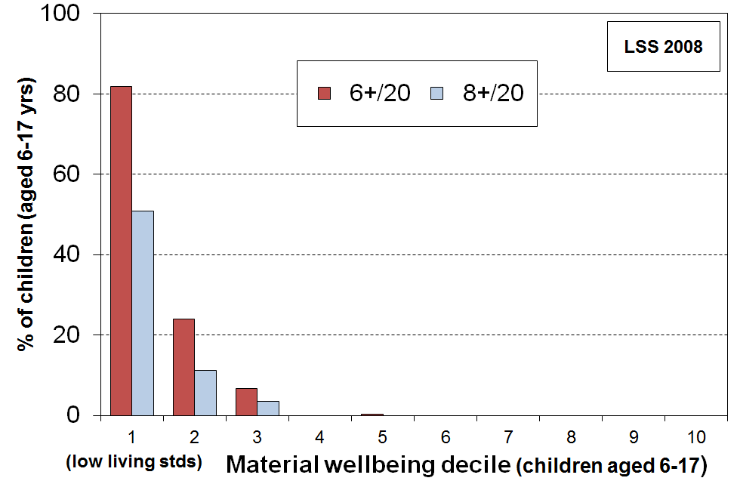

While the use of material deprivation or hardship indices as well as income measures is a welcome advance, there are some fundamental aspects of the notion of “poverty” that mean that it will always be an awkward term. For example:

- Judgement calls are needed to decide where to draw the lines to identify the (income) poor or those in material hardship. Different judgements lead to different reported levels of hardship or poverty, though the range of plausible thresholds is in practice relatively narrow once all the evidence is considered. This ambiguity and difference in value judgements can be dealt with in part by accepting that poverty and hardship exist on a spectrum from more to less severe, and by regularly and as a matter of course using a range of measures to track progress. This is further discussed in Section D.

- Whatever else poverty is understood to be, it is in its essence an unacceptable state-of-affairs – it carries with it the implication that something should be done about it. How best to address child poverty is a vigorously contested area where empirical evidence, social norms, personal values, views on inter-generational equity, political philosophy and pragmatic compromise all play legitimate parts. Different judgements on these matters lead to different “solutions” to child poverty.

- Yet, just as with the question of where to set low-income or material hardship thresholds, there is in practice a fairly limited range of options for governments when it comes to seeking to reduce child poverty. All MEDCs have adopted a multi-pronged approach, reflecting the range of causes of child poverty. The difference from one government to another and one state to another reflects to a large degree the different understandings of the relative size of the impact of different causes, decisions on trade-offs with other priorities, and the consequent different weightings given to the different interventions.

Including causes, consequences and correlates: a wider use of “poverty”

Sometimes “poverty” is used in a wider sense to include some of the causes, consequences and correlates of poverty (ie “poverty” as used in this report). This report maintains a narrower focus on the core measures of poverty and hardship. This allows discussion of causes and consequences to be conducted in an easily understood manner, and for the relationship with correlates to be investigated and understood. When the concept of poverty is used too widely it becomes a catch-all for so many different poor outcomes that analysis and communication become very difficult.
Section B
Data sources and Indices

This section notes the main data sources that include deprivation indicators and other non-income items that can be used to assist in monitoring material deprivation or hardship. It then gives a brief overview of the deprivation and material wellbeing indices used in this report and in other MSD research.

There are three general types of deprivation indicators that are of relevance to the child material hardship focus of this report: general household items (eg being able to keep the house warm); individual adult respondent items (eg having a set of clothes for important or special occasions); and child-specific items (eg two sets of warm winter clothes for each child, a separate bed for each child).
- MSD’s Living Standards Surveys (2000, 2004 and 2008) have a large number of items of each type.
- Statistics New Zealand’s Household Economic Survey (HES) includes a set of 25 items of the general household and adult respondent types from 2006/07 to 2011/12, then a revised set of 29 items from 2012/13 on.
- Statistics New Zealand’s General Social Survey (GSS) has the same 25 items as the HES in 2008, 2010 and 2012, then a smaller 9 item set in 2014.
- Statistics New Zealand’s longitudinal Survey of Family, Income and Employment (SoFIE) has an 8 item set of the general household and adult respondent types.

Index | Description | Data sources
EU-9 | A 9 item material deprivation index used officially by the EU. | LSS 2008
EU-13 | A 13 item material deprivation index about to be formally adopted by the EU to replace EU-9. | LSS 2008  HES 2015/16 and later
DEP-17 | A 17 item deprivation index developed and used by MSD (sometimes referred to as “MSD’s material deprivation index”) . | LSS 2008  HES 2012/13 and later
ELSI  ELSI-SF | ELSI is MSD’s prototype full-spectrum index using 40 non-income items to cover the range from low to high material living standards. The short-form (SF) version uses 25 items. It has been replaced by the MWI. | LSS 2000, 2004 and 2008  HES 2006/07 to 2011/12 have ELSI-SF items  GSS 2008, 2010 and 2012 have ELSI-SF items
MWI  MWI-SF | MSD’s Material Wellbeing Index (MWI) is a 24 item index covering the full spectrum of material wellbeing from low to high. It was developed as a ‘mark 2 ELSI’, incorporating what was learnt from using the prototype. The short-form (SF) version has 9 items. | LSS 2008  HES 2012/13 and later  GSS 2014 (MWI-SF only)
NZiDep | NZiDep is an 8 item deprivation index developed by Wellington School of Medicine researchers. | SoFIE (and the 2006/07 NZ Health Survey)
NZDep | Unlike all the indices above, NZDep is not a household- or family-based index. It is based on information from households within a small area, using Census items such as income, benefit status, whether a household owns their home, car ownership and so on. NZDep uses the average score from all households in the area, then ranks the small areas using a decile system. There is naturally some variation of material wellbeing across households in a given small area, even though they all have the same NZDep score. | Census
Section C
International comparisons

GDP per capita is a commonly used indicator for making international comparisons of average living standards across countries. It does not, however, give any information on the distribution of living standards across households within countries. International comparisons of material wellbeing at the household level are traditionally done by using household incomes, with poverty lines set at 50% or 60% of the median household income. International league tables which rank countries on their income poverty rates are now commonly created and published.

There is growing unease about the robustness of the household income approach for international comparisons of material hardship on both theoretical-conceptual and empirical grounds. The income approach produces incongruous results. For example, on this approach the Czech Republic has a poverty rate of 9%, lower than the rates for Denmark and Finland (12%), and Germany (16%), yet the poverty lines in each of the latter three countries are all above the median household income level for the Czech Republic. Partly in response to these concerns, the EU developed and in 2009 adopted a 9-item deprivation index based on non-income items / deprivations as one of its primary social inclusion indicators. At the time the pool of available items was very limited in the source data from the EU-SILC (Survey of Income and Living Conditions). The pool of items was enlarged in 2009 and EU researchers have developed a new 13-item index based on this expanded dataset. It is likely that the EU will shortly adopt the new index as its official one.

In developing the 2008 Living Standards Survey (2008 LSS), the EU’s plans for their 9-item index (EU-9) and their 2009 EU-SILC enlargement were monitored and MSD included the relevant questions in LSS 2008. Deprivation scores for New Zealand have been created for EU-9, with comparative international findings published in Perry (2009). The new and improved EU index (EU-13) is made up of the thirteen items listed in Table C.1. The items are scored as “enforced lacks” – that is, the items were not possessed because of the cost rather than for some other reason. For EU-13 those with 5 or more enforced lacks are described as experiencing material deprivation, and those with 7 or more as in severe material deprivation.

Table C.1
Composition of EU-13
have a meal with meat, fish or chicken every second day
keep the home adequately warm
replace worn-out clothes by some new ones
have two pairs of properly fitting shoes
replace worn-out furniture
have access to a car / van for personal use
avoid arrears in mortgage or rent, utility bills or HP instalments
spend a small amount of money each week on oneself
have both a computer and an internet connection
have regular leisure activities
have a get together with friends/family for a drink/meal at least monthly
have one week’s annual holiday away from home
ability to face unexpected expenses of NZD1500

A comparison with EU-9 is provided in Appendix 1.

A feature of EU-13 and many other similar indices is that they use a mix of items that tap into or reflect different depths of material deprivation. For example, there is a strong consensus that “keeping the home adequately warm” is a necessity on any standard, whereas “having a week’s holiday away from home” is not necessary for survival, but is considered a necessity by around 50% (in the EU) for having a “minimum acceptable standard of living”. Rather than being a weakness of the index, the use of a range of items is a strength as it allows for the fact that there is some variation among those less well-off as to what they cut back on to try to make ends meet. An index with an almost total focus on the very bottom end could not reflect these nuances in its rankings.

When using “deprivation indices” such as EU-13 it is important to recognise what they are and what they are not:
- They are designed as instruments to rank households by their differing degrees of material hardship, using a mix of items that tap into differing levels of hardship and which are reasonably equally applicable to people in different age groups and household types.
- They do not purport to use the (13) most important or most serious deprivations – the selection process for such an approach would be fraught and would not be likely to command widespread support.

In the international comparisons that follow, the graphs use 20 European countries (19 EU countries plus Norway).

The EU currently has 27 member states (Table C.2) – the 15 “old” member states from western and southern Europe, the 10 “new” member states added in 2004 (Malta, Cyprus and eight eastern European countries), plus Bulgaria and Romania added in 2007. Bulgaria and Romania are omitted from the graphs that follow as their general standard of living is much lower than New Zealand’s. Malta and Cyprus are very small and are usually omitted. There is no tradition of comparing New Zealand with Hungary, Poland, Latvia and Lithuania, so they too are omitted from the graphs. Estonia, Slovenia, Slovakia and the Czech Republic are included as their rankings are now often in the same ballpark as New Zealand and some of the “old” EU-15. Norway is not part of the EU-27, but data is generally available for Norway as it participates in EU-SILC. The international comparisons that follow therefore use 20 European countries for the graphs (27-2-6+1), though a fuller suite is reported on in the tables.

Table C.2
EU countries
“Old” Member States |  | “New” Member States
Belgium | BE | 2004 Enlargement
Denmark | DK | Czech Republic | CZ
Germany | DE | Estonia | EE
Ireland | IE | Cyprus | CY
Greece | EL | Latvia | LV
Spain | ES | Lithuania | LT
France | FR | Hungary | HU
Italy | IT | Malta | MT
Luxembourg | LU | Poland | PL
Netherlands | NL | Slovenia | SI
Austria | AT | Slovakia | SK
Portugal | PT
Finland | FI | 2007 Enlargement
Sweden | SE | Bulgaria | BG
United Kingdom | UK | Romania | RO
Material hardship comparisons with OECD countries not in the EU (eg Japan, USA, Australia and Canada) are not possible as there are as yet no national surveys in these countries with all the relevant items in them.

Comparisons for the whole population

Using the EU-13 index, 11% of the New Zealand population had 5 or more enforced lacks, ranking New Zealand alongside Austria, Spain, the UK, Belgium and Ireland, at the median for the 20 selected European countries and a little below the median for the full 27 EU members (12%). Many of the newer EU countries had much higher rates of deprivation, as did Portugal and Greece. See Figure C.1 and Table C.3.

Using the EU’s “severe deprivation” measure (7+/13), country rankings were very similar to those using the 5+/13 measure (correlation =0.98). New Zealand’s “severe deprivation” rate of 4% was a little below the EU’s median “severe” rate of just under 6%.

Figure C.1
Material deprivation rates (% with 5+ and 7+ enforced lacks), EU-13, whole population
20 European countries + NZ, ranked on % with 5+, (EU-SILC 2009, NZ LSS 2008)
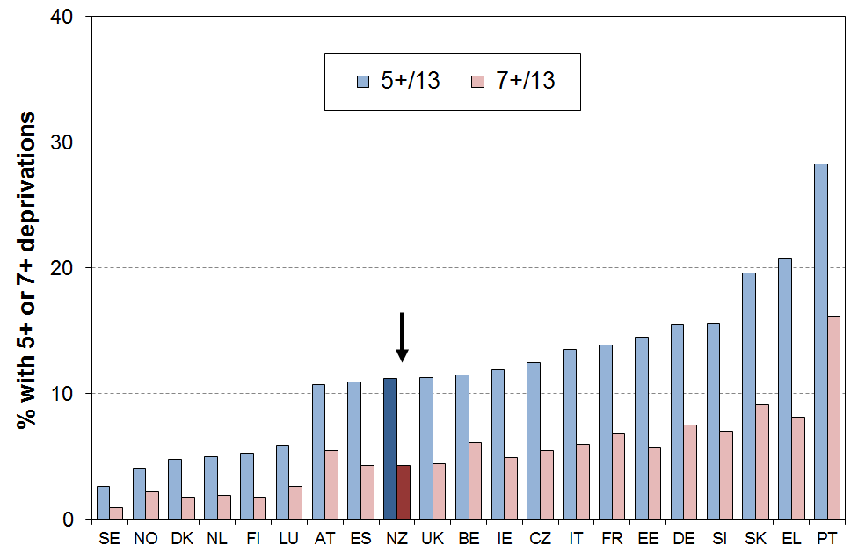

Table C.3
Material deprivation rates (% with 5+ and 7+ enforced lacks), EU-13, whole population
EU-25 + NO + IS + NZ, ranked on % with 5+, (EU-SILC 2009, NZ LSS 2008)
 |  | % with 5+/13  “standard” MD | % with 7+ /13  “severe” MD |  |  | % with 5+/13  “standard” MD | % with 7+ /13  “severe” MD
Sweden | SE | 3 | 1 | Czech Republic | CZ | 13 | 6
Iceland | IS | 3 | 2* | Italy | IT | 14 | 6
Norway | NO | 4 | 3* | France | FR | 14 | 7
Denmark | DK | 5 | 2 | Estonia | EE | 15 | 6
Netherlands | NL | 5 | 2 | Germany | DE | 16 | 8
Finland | FI | 5 | 2 | Slovenia | SI | 16 | 7
Luxembourg | LU | 6 | 3 | Malta | MT | 19 | 7
Austria | AT | 11 | 6 | Slovakia | SK | 20 | 9
Spain | ES | 11 | 4 | Greece | EL | 21 | 8
New Zealand | NZ | 11 | 4 | Poland | PL | 26 | 14
United Kingdom | UK | 11 | 4 | Portugal | PT | 28 | 16
Belgium | BE | 11 | 6 | Lithuania | LT | 31 | 18
Ireland | IE | 12 | 5 | Latvia | LV | 43 | 26
Cyprus | CY | 12 | 4 | Hungary | HU | 44 | 26

* Estimated by author.
Comparisons for those aged 65+

Older New Zealanders have a much lower material deprivation rate (3%) than their counterparts in almost all European countries (Figure C.2 and Table C.4). New Zealand ranks alongside Sweden, Luxembourg, Denmark and the Netherlands for having very low material deprivation rates for those aged 65+, using the 5+ threshold with the EU-13 index. Using the “severe deprivation” threshold of 7+/13, New Zealand still ranks at the top of the chart. Even richer western European countries such as Germany (10%) and France (11%) have much higher rates than New Zealand. Many of the newer eastern European EU members have very high rates (eg Hungary at 36%), with Portugal only a little better at 32%.

Figure C.2
Material deprivation rates (% with 5+ and 7+ enforced lacks), EU-13, those aged 65+
20 European countries + NZ, ranked on % with 5+, (EU-SILC 2009, NZ LSS 2008)
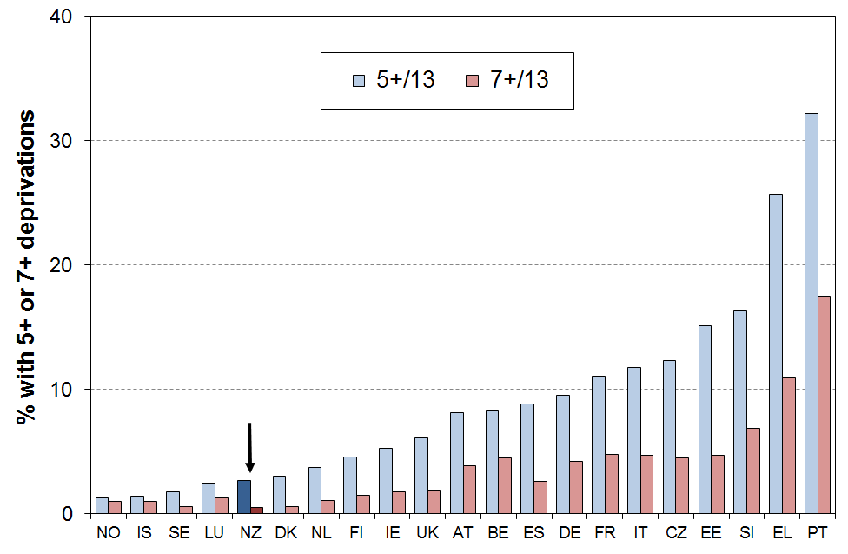

Table C.4
Material deprivation rates (% with 5+ and 7+ enforced lacks), EU-13, those aged 65+
EU-25 + NO + IS + NZ, ranked on % with 5+, (EU-SILC 2009, NZ LSS 2008)
 |  | % with 5+/13  “standard” MD | % with 7+ /13  “severe” MD |  |  | % with 5+/13  “standard” MD | % with 7+ /13  “severe” MD
Norway | NO | 1 | <1* | France | FR | 11 | 5
Iceland | IS | 1 | <1* | Italy | IT | 12 | 5
Sweden | SE | 2 | 1 | Czech Republic | CZ | 12 | 5
Luxembourg | LU | 3 | 1 | Estonia | EE | 15 | 5
New Zealand | NZ | 3 | 1 | Cyprus | CY | 16 | 5
Denmark | DK | 3 | 1 | Malta | MT | 16 | 6
Netherlands | NL | 4 | 1 | Slovenia | SI | 16 | 7
Finland | FI | 5 | 2 | Slovakia | SK | 23 | 10
Ireland | IE | 5 | 2 | Greece | EL | 26 | 11
United Kingdom | UK | 6 | 2 | Poland | PL | 29 | 13
Austria | AT | 8 | 4 | Portugal | PT | 32 | 18
Belgium | BE | 8 | 5 | Hungary | HU | 36 | 19
Spain | ES | 9 | 3 | Lithuania | LT | 36 | 21
Germany | DE | 10 | 4 | Latvia | LV | 47 | 25

* Estimated by author.

Comparisons for children (aged 0-17 years)

New Zealand children have a material hardship rate of 18% on the EU-13 measure (5+/13 threshold). This ranks New Zealand at the ‘low’ (ie higher hardship rates) end of the old EU for hardship rates for children, similar to Italy, Ireland and France (17%), and the UK (16%), and better than Germany (21%) and Greece (22%). In contrast to the comparisons for those aged 65+, New Zealand’s child deprivation rates are much higher than countries like Sweden, Denmark, Norway, Finland and the Netherlands (3-6%). See Figure C.3 and Table C.5.

Using the “severe” deprivation threshold (7+/13), New Zealand’s rate for children is 8%. This is a little higher than the median, similar to Belgium, Italy and France. There is however no evidence of any greater depth of hardship for New Zealand children when compared with countries with similar “standard” EU hardship rates (ie the ratio of the more “severe” hardship rate to the “standard” rate is in the middle of the bunch).

Figure C.3
Material deprivation rates (% with 5+ and 7+ enforced lacks), EU-13, those aged 0-17 years
20 European countries + NZ, ranked on % with 5+, (EU-SILC 2009, NZ LSS 2008)
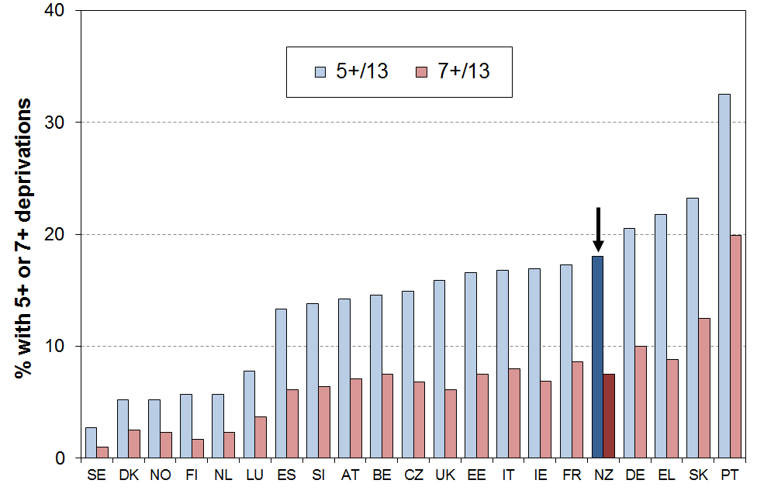

Table C.5
Material deprivation rates (% with 5+ and 7+ enforced lacks), EU-13, 0-17 yrs
EU-25 + NO + IS + NZ, ranked on % with 5+, (EU-SILC 2009, NZ LSS 2008)
 |  | % with 5+/13  “standard” MD | % with 7+ /13  “severe” MD |  |  | % with 5+/13  “standard” MD | % with 7+ /13  “severe” MD
Sweden | SE | 3 | 1 | Estonia | EE | 17 | 8
Iceland | IS | 4 | 2 | Italy | IT | 17 | 8
Denmark | DK | 5 | 2 | Ireland | IE | 17 | 7
Norway | NO | 5 | 2 | France | FR | 17 | 9
Finland | FI | 6 | 2 | New Zealand | NZ | 18 | 8
Netherlands | NL | 6 | 2 | Germany | DE | 21 | 10
Luxembourg | LU | 8 | 4 | Greece | EL | 22 | 9
Cyprus | CY | 10 | 4 | Malta | MT | 23 | 9
Spain | ES | 13 | 6 | Slovakia | SK | 23 | 13
Slovenia | SI | 14 | 6 | Poland | PL | 27 | 15
Austria | AT | 14 | 7 | Lithuania | LT | 30 | 19
Belgium | BE | 15 | 8 | Portugal | PT | 33 | 20
Czech Republic | CZ | 16 | 7 | Latvia | LV | 45 | 30
United Kingdom | UK | 16 | 6 | Hungary | HU | 52 | 33

* Estimated by author.

Another aspect to be considered in assessing how children in New Zealand are faring relative to their counterparts in other countries is to compare the child deprivation rate with that for the population as a whole. The ratio of these two figures is called the risk ratio (see Box below).

Figure C.4 shows that for most countries the risk ratio is greater the 1.0, meaning that for most countries children are over-represented in hardship figures (the median is 1.2).

The child hardship risk ratio for New Zealand is 1.6, higher than for any of the 20 European countries in the comparison.

When the other EU countries (except for Bulgaria and Romania) are added to the comparison, the median risk ratio drops a little below 1.2 as more of the extra countries have ratios below 1.2 (eg Poland and Cyprus) than above 1.2 (eg Iceland and Malta). New Zealand’s relative position remains unchanged when these other countries are included.

Using the original 9-item index, the ratio for New Zealand is 1.4, higher than all the other countries except the UK (1.5). The median ratio was 1.2 using the EU-9 index.

Figure C.4
Deprivation rates for children (0-17 yrs) relative to overall population deprivation rate
(% with 5+ enforced lacks using the EU-13 index)
20 European countries + NZ, (EU-SILC 2009, NZ LSS 2008)
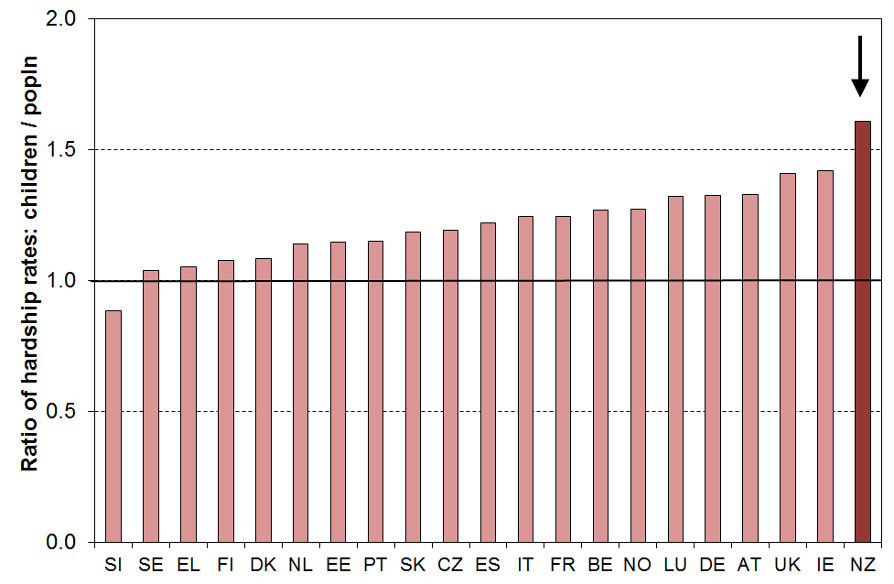

Risk ratio

The risk ratio is a very useful statistic that can be used to succinctly summarise the over- or under-representation of a population subgroup in a hardship category.

The risk ratio can most easily be understood as the ratio of the subgroup’s hardship rate to that for the population as a whole.

An example illustrates the idea. If children have a hardship rate of 20% on a particular measure and the population hardship rate is 10%, then the risk ratio for children is 2 (20/10).

It also means that if children made up 25% of the population overall, then they would make up 50% (2 x 25%) of those in hardship.

Both aspects – the actual deprivation rates and the risk ratios – are important for assessing differences across countries. Figure C.5 combines information from Figures C.3 and C.4 on the one graph.

The countries in the bottom left quadrant (eg Denmark, Netherlands, Finland and Sweden) have below median child deprivation rates and below median risk ratios for children.

In contrast, countries in the top right quadrant (eg the UK, Ireland, Germany and New Zealand) have both above median child deprivation rates and above median risk ratios.

Figure C.5
Deprivation rates for children relative to overall population deprivation rate
(% with 5+ enforced lacks using the EU-13 index)
20 European countries + NZ (EU-SILC 2009, NZLSS 2008)
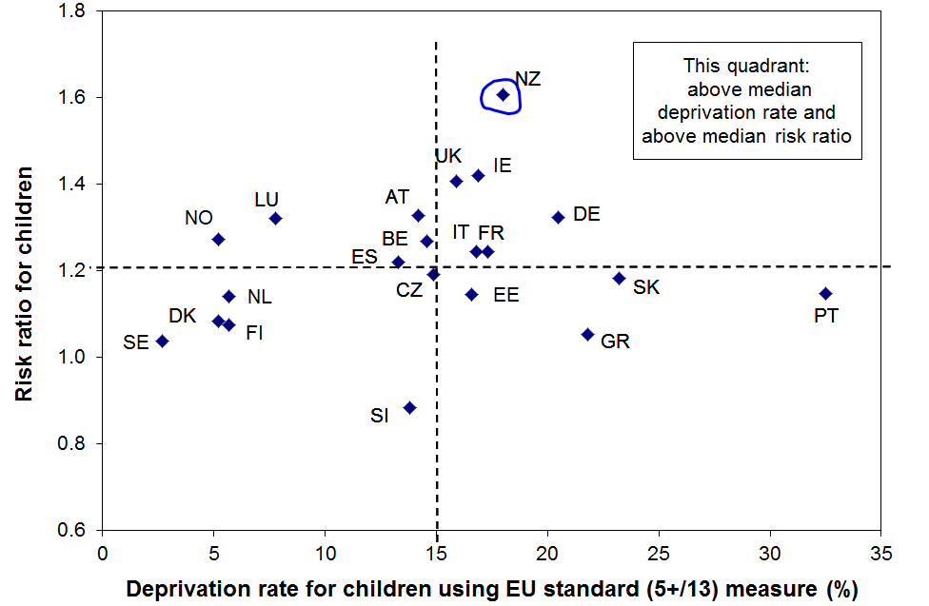

Section D
Measuring hardship using a deprivation index (DEP-17)

This section uses a 17-item material deprivation index (DEP-17) to compare the relative positions of different population subgroups, based on data from the 2008 Living Standards Survey (LSS). The section opens with a description of the index and its relationship with MSD’s Material Wellbeing Index (MWI) and the EU-13 index, then reports the distribution of DEP-17 scores across the population. It addresses the question of where to set the material hardship threshold (cf “the poverty line”), and finishes with a comparison of selected findings using the DEP-17 and EU-13 indices.

The 17 items are shown in Table D.1 below. The DEP-17 score for each respondent (one per household) is simply the sum of all reported enforced lacks or deprivations. This score is attributed to the respondent and to each other person in the respondent’s household, where there are any. This is the same approach as is taken with household income. The right-hand columns in Table D.1 show respectively the proportion of all individuals and of children who live in households where the respondent indicated a deprivation of the particular item.

Table D.1
Composition of DEP-17 (LSS2008),
and the % of people in households for which the respondent reported various deprivations
Item |  | ALL | 0-17 yrs
Enforced lack of essentials (for respondent or household as a whole)
 | meal with meat, fish or chicken (or vegetarian equivalent) at least each 2nd day | 2 | 3
 | two pairs of shoes in good repair and suitable for everyday use | 5 | 8
 | suitable clothes for important or special occasions | 7 | 10
 | presents for family and friends on special occasions | 6 | 7
 | home contents insurance | 12 | 16
Economised, cut back or delayed purchases ‘a lot’ because money was needed for other essentials (not just to be thrifty or to save for a trip or other non-essential)
 | went without or cut back on fresh fruit and vegetables | 10 | 14
 | bought cheaper cuts of meat or bought less than wanted | 27 | 37
 | put up with feeling cold to save on heating costs | 10 | 14
 | postponed visits to the doctor | 11 | 15
 | postponed visits to the dentist | 26 | 35
 | did without or cut back on trips to the shops or other local places | 15 | 21
 | delayed repairing or replacing broken or damaged appliances | 12 | 19
 | In arrears more than once in last 12 months (because of shortage of cash at the time, not through forgetting)
 | rates, electricity, water | 11 | 18
 | vehicle registration, insurance or warrant of fitness | 9 | 15
 | Financial stress and vulnerability
 | borrowed money from family or friends more than once in the last 12 months to cover everyday living costs | 13 | 19
 | feel ‘very limited’ by the money available when thinking about purchase of clothes or shoes for self (options were: not at all, a little, quite limited, and very limited) | 19 | 29
 | could not pay an unexpected and unavoidable bill of $500 within a month without borrowing | 19 | 25
Reading note for table:
The figures in Table D.1 are based on the information provided by the household’s respondent. For example, in the fresh fruit and vegetables row, 10% of the population were in households where the respondent said they went without or cut back “a lot” (rather than “a little” or “not at all”), and 14% of children (aged 0-17yrs) were in such households. It does not mean that 14% of children went without fresh fruit or vegetables. The responses to the child-specific items are provided in a later table (Table D.8).
MSD’s Material Wellbeing Index (MWI) covers the full spectrum of material living standards from low to high, and at its lower end the MWI performs very well as a deprivation index. When the focus is solely on the material hardship end of the spectrum, the advantage of using DEP-17 compared with using the low-scoring range of the MWI is that it is simpler for readers and others to intuitively grasp the meaning of the index scores. For example, the meaning of a DEP-17 score of “9” is very clear – this household reports 9 of the 17 deprivation items. On the other hand an MWI score of “9” is a composite score constructed from the number of enforced lacks of essentials (deprivations) that a household does not have and the number of non-essentials possessed or accessible for use. This is not as easy to communicate.

DEP-17, like the EU-13 and many other similar indices, uses a mix of items that tap into or reflect different depths of material deprivation. For example, not being able to have a good meal each day would generally be considered to be a more serious deprivation than having to delay repairing or replacing broken appliances, and having to repeatedly put up with feeling cold to save on heating costs more serious than not being able to afford contents insurance. All four are however needed for a household to be able to sustain a minimum acceptable and independent standard of living in a country like New Zealand.

DEP-17 differs from EU-13 in that it has a larger proportion of items covering the more severe end of the hardship spectrum and a smaller proportion of items covering the less severe end of the hardship spectrum. For example, DEP-17 does not use the “one week’s holiday away from home” item nor the “leisure activities” item, and its question on emergency savings is set at $500 rather than the $1500 figure in EU-13. DEP-17 also covers a wider range of domains where material deprivation can be revealed.

DEP-17 nevertheless still uses a range of items reflecting differing degrees of hardship. Rather than being a weakness of the index, the use of this range of items is a strength as it allows for the fact that there is some variation among those less well-off as to what they cut back on to try to make ends meet. An index with an almost total focus on the severe hardship end could not reflect these nuances in its rankings.

Figure D.1 uses selected items from DEP-17 to illustrate how the different component items discriminate across different parts of the DEP-17 spectrum. For example, the “meal with meat” item is focussed on the severe hardship end, whereas the “putting up with being cold” item applies to some households above the hardship zone, while still being very predominant among those with higher DEP-17 scores (high deprivation). Being unable to cope with ”an unexpected $500 bill” is something reported by a good number of households above the hardship zone, but still has very high relevance for identifying the more seriously deprived.

Figure D.1
Reported deprivations by DEP-17 score: different items discriminate at different parts of the spectrum
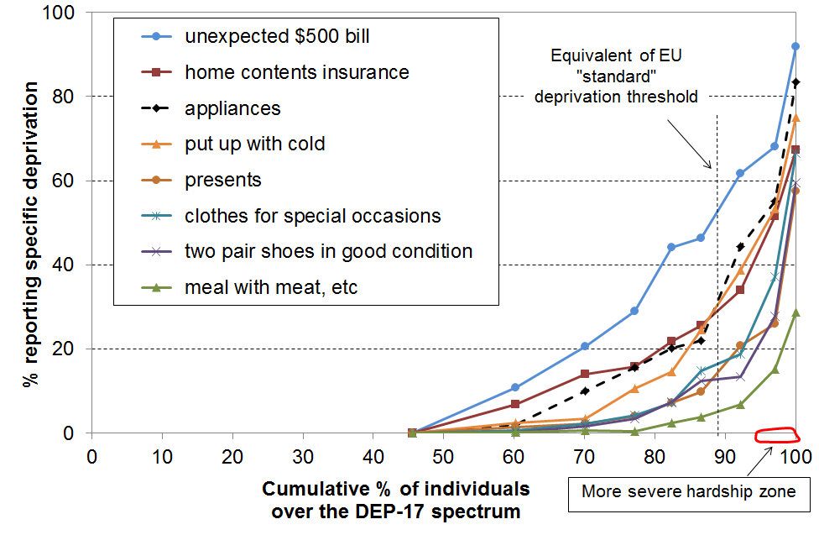
Note: See Appendix 2 for the distribution for all 17 items.
When using deprivation indices such as DEP-17 (and EU-13) it is important to recognise what they are and what they are not:
- They do not purport to use the (13 or 17) most important or most serious deprivations – the selection process for such an approach would be fraught and would not be likely to command widespread support.
- Rather they are designed as instruments to rank households by their differing degrees of material hardship, using a balanced set of indicators that cover a range of domains and degrees of depth of deprivation, reflect the same underlying concept (or “latent variable”), and which apply reasonably well to people in different age groups and household types.

Tables D.2 and D.3 and Figure D.2 below show the distribution of DEP-17 scores for the population and for children (aged 0-17 yrs) using the 2008 LSS data.

The bulk of the population (71%) lives in households reporting two or fewer deprivations from the list of 17. 6% report 9 or more out of the 17.

Table D.2
Distribution of the DEP-17 scores (% individuals), LSS 2008
Score | 0 | 1 | 2 | 3 | 4 | 5 | 6 | 7 | 8 | 9 | 10 | 11+
ALL (%) | 46 | 15 | 10 | 7 | 5 | 4 | 3 | 3 | 2 | 1 | 1 | 3
0-17 yrs (%) | 33 | 14 | 11 | 10 | 6 | 6 | 4 | 4 | 4 | 2 | 2 | 6

Table D.3
Cumulative distribution of the DEP-17 scores (% individuals), LSS 2008
Score | 0+ | 1+ | 2+ | 3+ | 4+ | 5+ | 6+ | 7+ | 8+ | 9+ | 10+ | 11+
ALL (%) | 100 | 54 | 40 | 30 | 23 | 18 | 14 | 11 | 8 | 6 | 4 | 3
0-17 yrs (%) | 100 | 67 | 53 | 42 | 32 | 26 | 21 | 17 | 13 | 10 | 8 | 6

Figure D.2
Cumulative distribution of the DEP-17 scores for the population and for those aged 0-17 yrs
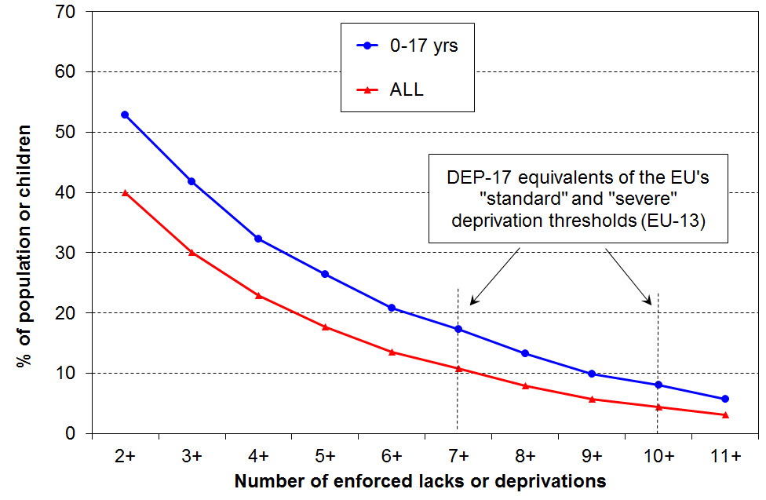

Choosing a hardship threshold for DEP-17

The tables and graph above invite the question – where should the line be drawn so that we can say how many are in hardship and how many are not?

The challenge here is much the same as the one faced when using household income as the indicator of material wellbeing – what low-income threshold or thresholds should be used to identify those in “income poverty” and those “not in poverty”? Material hardship, like income poverty, comes in degrees. There is no clear delineation between those “in hardship” and those “not in hardship” that science can identify independent of judgment. This is not to say that any threshold will do nor that all are equally open to challenge. Some thresholds are clearly much more plausible and defensible than others.

This report uses DEP-17 thresholds in the range of 6+ to 11+ out of 17 to examine the characteristics of households with low living standards. It makes no attempt to set “the” threshold, but works within a framework of material hardship existing on a spectrum from less to more severe. The more severe hardship zone is taken as 9+ or more and there would be few who would consider such households to not be in hardship at all (ie not experiencing unacceptably low living standards). There is more room for debate as to where the “less severe hardship” zone should start and finish. For the 2008 LSS data this report uses 7+ as the start of the less severe hardship zone. It also reports using 6+ for sensitivity analysis. The more detailed analysis of the data for children in the next sub-section provides some support for this judgment call.

For the purposes of reporting on the composition of those at different depths of hardship and for tracking hardship rates over time for different hardship levels, the approach adopted here is pragmatic, defensible, and produces findings useful for public debate and policy development.

For the purposes of being able to say “New Zealand’s material deprivation rate is Y%”, or “there are X thousand children in hardship in New Zealand”, this approach does not deliver. That is a consequence of the position taken above in the second paragraph. It is in fact the same position as is taken in the Household Incomes Report for “income poverty”. It means that the focus can be on understanding what is happening at different depths of hardship, avoiding what are often sterile debates about exactly how many are deemed to be “in hardship”, a debate based on the erroneous assumption that such a simple binary division can be robustly made. Using the approach adopted in this report, it could be argued that “success” would be for trend lines at all levels (7+ to 11+) to fall over the medium term. This is a demanding standard.

Table D.4 shows the hardship rates for the whole population and for children using different depths of hardship (in the 7+ to 11+ range), together with the 6+ rates for sensitivity analysis. For children it also shows the number of children and numbers of households with children under the different thresholds.

Table D.4
Cumulative distribution for higher DEP-17 scores (% individuals), LSS 2008
DEP-17 score | 6+ | 7+ | 8+ | 9+ | 10+ | 11+
ALL (%) | 14 | 11 | 8 | 6 | 4 | 3
0-17 yrs (%) | 21 | 17 | 13 | 10 | 8 | 6
# of children | 220k | 180k | 140k | 100k | 80k | 60k
# of households with children | 110k | 90k | 70k | 50k | 40k | 30k

Calibrating DEP-17: rationale for the report’s choice of the 7+ to 11+ range for its monitoring and analysis of child material hardship

DEP-17 is a good ranking instrument for households with low living standards, but there is no straightforward way of just looking at the DEP-17 item list and concluding that a household is experiencing material hardship (ie unacceptably low living standards) if it has, say, 4+ or 8+ or some other count of the 17 deprivation. This is in part because as noted above DEP-17 includes a few items that some would say are not “absolute essentials” for a minimum acceptable standard of living in New Zealand in 2015. This makes it difficult to use the internal logic of the index by itself to set a range of defensible thresholds that would command widespread support.

To provide support for the report’s choice of the particular range of thresholds (7+ to 11+ out of 17, with 6+ used for further sensitivity analysis), the analysis which follows makes use of 18 child-specific items that are also in the 2008 LSS dataset. There is a very good case for considering them to be essentials for children, items that no child should have to go without. The 18 child-specific items are listed in Table D.5. None of them are used in DEP-17.

Table D.5
18 child-specific items used for calibrating DEP-17 for school-aged children (aged 6-17 yrs)
Enforced lack of essentials |  | Economised, cut back or delayed purchases ‘a lot’ because money was needed for other essentials (not just to be thrifty or to save for a trip or other non-essential)
 | Two pairs of shoes in a good condition that are suitable for daily activities (for each child) | Child(ren) continued wearing shoes or clothes that were worn out or the wrong size
 | Two sets of warm winter clothes for each child | Postponed child’s visit to the dentist
 | A waterproof coat for each child | Postponed child’s visit to the doctor
 | Fresh fruit and vegetables daily | Did not pick up child’s prescription
 | A meal with meat, fish or chicken (or vegetarian equivalent) each day | Unable to pay for a child to go on a school trip or other school event
 | A separate bed for each child | Child(ren) went without music, dance, kapa haka, art, swimming or other special interest lessons
 | Enough bedrooms so that children aged over 10 of the opposite sex are not sharing a room | Had to limit your child(ren)’s involvement in sport
 | Have children’s friends around to play and eat from time to time | Made do with very limited space for children to study or play
 | Have children’s friends to a birthday party
 | All the school uniform required by the school(s) for each child

Figure D.3 shows that children in families with scores of 7+ on DEP-17 have a significantly higher chance of missing out on 4 or more of these child-specific items that most would consider essentials for all school-aged children, and which the vast majority of children have or do.

Figure D.3: Multiple deprivation for children aged 6-17, using child-specific items
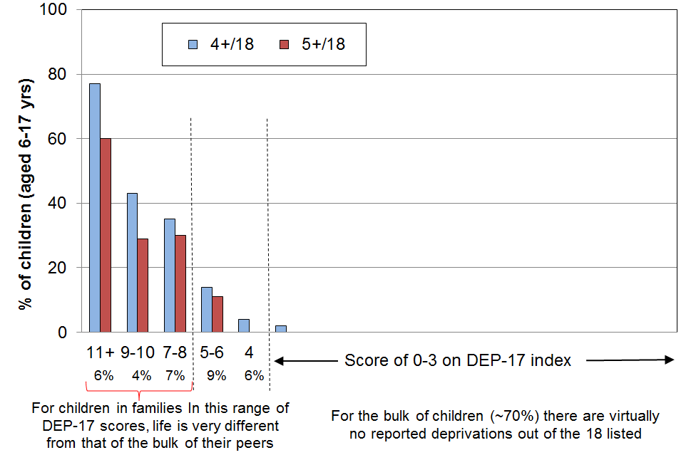

Using a mix of child-specific and general household items to calibrate DEP-17

Children live in households. The more general household items that some households do not possess or the financial stress some households live with also have an impact on children. Using a mix of child-specific and general household deprivation items can give a broader-based and more comprehensive calibration.

In what follows, 20 items are used that relate specifically to school-aged children or to their households. All the items are at the more severe end of the spectrum. Only four of the 20 items are in DEP-17 itself (see Table D.6 below). The children are ranked by the DEP-17 score of their respective households, then the number of deprivations from the list of 20 is calculated for each school-aged child.

Table D.6
20 items used for calibrating DEP-17 for school-aged children (aged 6-17 yrs)
Child-specific items | General household items
- warm winter clothes for each child  - two pairs good shoes for each child  - waterproof coat for each child  - children continued wearing worn out clothes and shoes  - separate bed for each child  - separate bedroom for older and opposite sex children  - able to have friends to birthday party  - each child has all school uniform required by school(s)  - able to pay for school trips for each child  - able to attend music, dance, art and swimming lessons  - sport participation  postponed doctor for children | - could not keep main rooms warm  - cut back or went without fresh fruit and vegetables “a lot”  - delayed repair or replacement of appliances (“a lot”)  - late payment of vehicle wof /reg (more than once in last year)  - late payment of electricity / water / gas (more than once)  - received help from food bank or other community group (more than once)  - dampness or mould in dwelling (major problem)  - crime/vandalism in the area (major problem)
Note: the 4 shaded items are also in DEP-17

Figure D.4 and the associated Table D.7 (next page) show again how different life is for those children in lower living standards households. In particular, they show the significant rise in the numbers missing out on the basics for DEP-17 scores of around 7+/17.

Figure D.4
Multiple deprivation for children aged 6-17: using a mix of child-specific and general household items
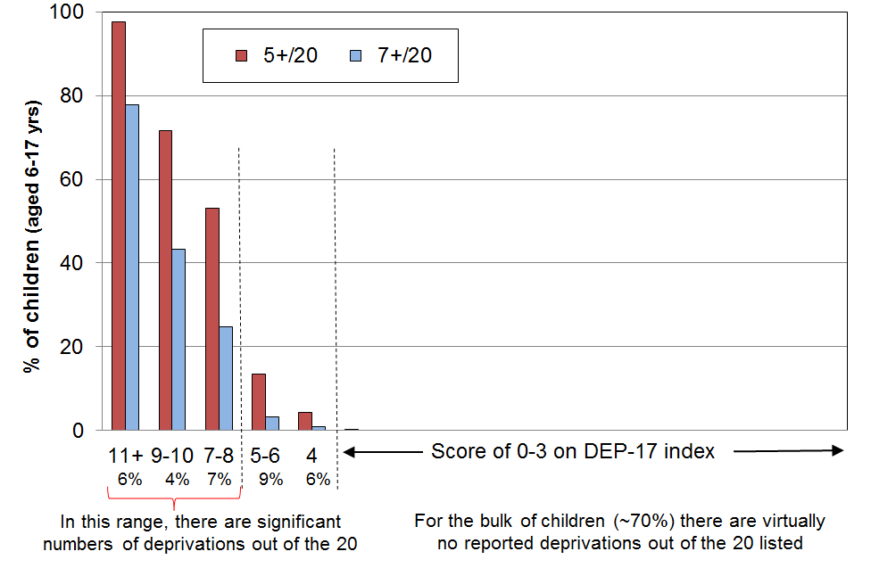

Table D.7
Multiple deprivation for children aged 6-17 years, using 20 items listed in Table D.6
LSS 2008 | 0-1 | 2 | 3 | 4 | 5-6 | 7-8 | 9-10 | 11+ | All
Distribution of children (6-17yrs) across DEP-17 (%) | 47 | 11 | 10 | 6 | 9 | 7 | 4 | 6 | 100
5+ out of 20 | 0 | 0 | 0 | 4 | 13 | 53 | 72 | 98 | 14
6+ out of 20 | 0 | 0 | 0 | 4 | 8 | 35 | 60 | 95 | 11
7+ out of 20 | 0 | 0 | 0 | 0 | 3 | 25 | 43 | 78 | 8
8+ out of 20 | 0 | 0 | 0 | 0 | 2 | 18 | 24 | 70 | 7
avg number of deprivations out of 20 | 0 | 0 | 0 | 2 | 3 | 5 | 6 | 10 | 1.9
Reading note: anything under 1.5% = 0

DEP-17 thresholds and EU-13 thresholds

The hardship figures produced by the “standard” EU threshold (5+/13) are almost identical to those produced by the 7+ threshold using DEP-17 for the population as a whole and for children. The EU’s “more severe” deprivation threshold (7+/13) gives figures that lie in the “more severe” range for DEP-17. This does not prove that this report’s selection of a threshold range is correct, but it does provide strong independent support for it.

Given the multi-threshold approach adopted in the report, what range of information can be reported about child material hardship in New Zealand?

There are five main types of information that can be reported:

- a tangible description of material wellbeing / hardship at various depths of hardship (as determined by DEP-17), using individual items and clusters of individual items (see next sub-section for an example of this for children)

- comparisons of hardship rates among different population groups (see later in this section)

- comparisons of how the composition of those in hardship varies for different depths of hardship (see later in this section)

- comparisons of hardship rates with those prevailing in earlier years (see Section E)

- comparisons with other countries using the same deprivation index (see Section C above).

Children’s deprivations of necessities, and other restrictions in their day-to-day lives, by their family’s DEP-17 score (material hardship level), LSS 2008

One of the strengths of the non-income approach to measuring material hardship is that it can give a real sense of the day-to-day experiences of restriction and deprivation for those identified as poor or in hardship. The findings reported above have done that to some degree already. The table on the next page (Table D.8) provides a detailed picture of the day-to-day experiences of New Zealand children living in various degrees of hardship.

The first and second rows in the table show how children are distributed across the living standards spectrum (all children and school-age children).

The top half of the table shows the differing experiences of school-age children in relation to 12 child-specific items that most New Zealanders are likely to consider that all children should have. The lower half introduces wider family and community factors that impact on children of all ages.

The overwhelming impression is that life for those children in the hardship zone on the DEP-17 measure, and especially for those among the most deprived 10%, is very different from that experienced by the vast majority of New Zealand children. All this well illustrates what it means in practice to be “excluded from the minimum acceptable way of life in one’s own society”.

There is more here than just “relative disadvantage”. There is no gradient across the whole spectrum, reflecting what could be called “acceptable inequality”. There is severe lack for many in the higher deprivation zone, compared with the bulk of children. Many of the lacks and deprivations are of such fundamental importance to child health and wellbeing that they would be part of an “absolute core” that the wider population would consider that no child in an MEDC should be without.

The lower part of the table shows the considerable levels of financial strain, housing issues and other negative factors that are reported by parents in families in high deprivation households. In a later table (Table 3.1 in Appendix 3), the high levels of dissatisfaction with life for this group are noted.
Care needed when using Table D.8 and similar tables

Tables similar to Table D.8 are already published in Perry (2009) using the previous 14-item index (an early version of DEP-17), and in Perry (2014) using ELSI as the means of ranking households. Some parts of Table D.8 are also published using household income as the ranking instrument (eg Table L.6, Perry (2014)).

When using the information In Table D.8 and similar ones it is important to be clear what ranking method is being used, especially as the gradient using income is not a steep as when using DEP-17 or the MWI or ELSI.

See Tables 3.3A and 3.3B in Appendix 3 for related analysis.
Table D.8
Children’s restrictions by DEP-17 score of their family (children aged 6-17 yrs), LSS 2008 (%)
DEP-17 score | All | 0 | 1 | 2 | 3-4 | 5-6 | 7-8 |  | 9-10 | 11+
Distribution of children (6-17yrs) across DEP-17 (%) | 100 | 36 | 14 | 12 | 16 | 7 | 6 |  | 5 | 5
Distribution of children (0-17yrs) across DEP-17 (%) | 100 | 33 | 14 | 11 | 16 | 10 | 8 |  | 4 | 6
Enforced lacks of children’s items
friends to birthday party | 7 | 0 | 0 | 2 | 2 | 10 | 14 |  | 25 | 50
friends over for a meal | 6 | 0 | 0 | 2 | 4 | 12 | 7 |  | 21 | 40
waterproof coat for each child | 8 | 0 | 0 | 3 | 6 | 12 | 18 |  | 25 | 54
warm winter clothes for each child | 4 | 0 | 0 | 0 | 0 | 0 | 7 |  | 18 | 36
two pair strong / sturdy shoes for each child | 8 | 0 | 2 | 5 | 5 | 7 | 17 |  | 39 | 44
separate bed for each child | 4 | 0 | 0 | 0 | 4 | 7 | 7 |  | 11 | 28
separate bedrooms for children of opposite sex (10+ yrs) | 8 | 0 | 2 | 5 | 5 | 15 | 15 |  | 9 | 39
all school uniform items required by the school | 4 | 0 | 0 | 0 | 0 | 4 | 11 |  | 12 | 33
Economising ‘a lot’ on children’s items to keep down costs to enable other basic things to be paid for
continued with worn out shoes/clothes for the children | 9 | 0 | 0 | 3 | 8 | 11 |  | 26 | 36 | 60
bought second-hand clothing instead of new | 16 | 1 | 10 | 10 | 17 | 24 |  | 43 | 47 | 69
postponed child’s visit to dentist | 3 | 0 | 0 | 0 | 1 | 5 |  | 15 | 5 | 23
postponed child’s visit to doctor | 3 | 0 | 0 | 0 | 0 | 3 |  | 12 | 9 | 24
did not pick up prescription for children | 2 | 0 | 0 | 0 | 0 | 0 |  | 12 | 2 | 12
child (ren) went without glasses or contact lenses | 2 | 0 | 0 | 0 | 2 | 2 |  | 4 | 8 | 20
unable to pay for school trip | 4 | 0 | 0 | 0 | 0 | 4 |  | 16 | 11 | 36
went without music, dance, kapa haka, art, swimming, etc | 10 | 2 | 0 | 4 | 8 | 13 |  | 32 | 33 | 48
involvement in sport had to be limited | 9 | 0 | 0 | 2 | 5 | 16 |  | 30 | 28 | 45
made do with very limited space for children to study or play | 9 | 0 | 2 | 8 | 9 | 13 |  | 23 | 36 | 45
Multiple restrictions
4+ out of 18 | 11 | 0 | 0 | 0 | 3 | 14 |  | 35 | 43 | 77
5+ out of 18 | 8 | 0 | 0 | 0 | 0 | 11 |  | 30 | 29 | 60
6+ out of 18 | 6 | 0 | 0 | 0 | 0 | 3 |  | 22 | 18 | 54
Children’s serious health problems reported by respondent (6-17 yrs)
serious health problems for any child in the last year (eg diabetes, asthma, mental health problems or learning difficulties) | 29 | 22 | 22 | 30 | 29 | 36 |  | 39 | 31 | 56
Enforced lacks, economising ‘a lot’ or financial stress reported by respondent in child’s family (0-17 yrs)
meal with meat , fish or chicken at least each second day | 3 | 0 | 0 | 0 | 0 | 2 |  | 6 | 15 | 86
keep main rooms warm | 9 | 0 | 3 | 3 | 8 | 12 |  | 14 | 33 | 46
one week’s holiday away from home in last year | 33 | 9 | 25 | 31 | 42 | 55 |  | 55 | 63 | 86
cut back or did without fresh fruit and vegetables (‘a lot’) | 14 | 0 | 0 | 7 | 12 | 17 |  | 43 | 52 | 79
postponed visit to doctor (‘a lot’) | 14 | 0 | 0 | 9 | 12 | 32 |  | 43 | 56 | 72
delayed repair or replacement of appliances (“a lot”) | 20 | 0 | 2 | 13 | 17 | 28 |  | 54 | 69 | 84
received community help in last 12 months (‘> once’) | 8 | 0 | 2 | 2 | 5 | 12 |  | 25 | 26 | 46
pawned/ sold something to meet everyday costs | 8 | 0 | 0 | 5 | 5 | 10 |  | 22 | 35 | 46
not enough income to meet basics | 26 | 4 | 11 | 19 | 33 | 44 |  | 49 | 74 | 86
Housing condition and local community safety
overall physical condition of house (poor/very poor) | 7 | 0 | 3 | 4 | 5 | 9 |  | 25 | 20 | 35
difficult to keep house warm in winter (major problem) | 22 | 7 | 14 | 17 | 24 | 30 |  | 39 | 59 | 71
dampness or mould (major problem) | 17 | 5 | 7 | 14 | 18 | 26 |  | 36 | 51 | 56
crime or vandalism in the area (major problem) | 11 | 6 | 5 | 9 | 10 | 13 |  | 19 | 23 | 36

Using DEP-17 for reporting hardship rates and composition of those in hardship for different population groups, for different depths of hardship

Table D.9 (next page) shows the following for children:

Family type
- While hardship rates are higher for children from sole parent families than from two parent families for all levels of hardship (left-hand columns), at the less severe hardship levels around half of children in hardship come from two parent and half from sole parent families (right-hand columns). This reflects the fact that there are many more children in two-parent than in sole-parent families.
- Children from sole parent families are however more likely than those in two parent families to be in the more severe hardship zone (9+,11+).

Main income source for parents
- Beneficiary families have higher hardship rates than working families, with those who move between benefit and work having rates somewhere in between.
- Nevertheless, at the less severe hardship levels (eg 7+) children in hardship are split evenly between beneficiary and working families. This reflects the fact that there are many more working families than beneficiary families.
- Beneficiary families are more likely than working families to be in more severe hardship, though around a third of children in more severe hardship are from working families (families that have no core benefit income at all).

Number of children
- Larger families (4+ children) have higher hardship rates on average, and are also more predominant in deeper hardship than in lesser hardship zones.

Tenure
- Unsurprisingly, children in Housing New Zealand homes are considerably over-represented in the deeper hardship zone. This is what we would expect given the selection criteria for access to this accommodation.

Urban/rural split
- There was no measurable difference in depth of hardship for an urban/rural split across the country.

Table D.9
Hardship rates and composition for different family and personal characteristics,
by different levels of hardship (using DEP-17): children (0-17yrs)
LSS 2008 | Hardship rates |  |  |  |  | Composition
 | what % of this group of children are in hardship, using the different thresholds? |  |  |  |  | what % of all children in hardship (using a given threshold) are in this group / cell? |  |  |  |  | Over-all
 | 6+ | 7+ | 8+ | 9+ | 11+ | 6+ | 7+ | 8+ | 9+ | 11+
All children (0-17 yrs)
Hardship rates for children | 21 | 17 | 13 | 10 | 6 | - | - | - | - | -
Children as % of all people in hardship | - | - | - | - | - | 39 | 41 | 42 | 47 | 48 | 26
Family type
Sole parent | 46 | 40 | 32 | 27 | 16 | 48 | 53 | 58 | 65 | 70 | 25
Two parent | 17 | 12 | 8 | 5 | 2 | 52 | 47 | 42 | 35 | 30 | 75
Main income source for parent(s)
Benefit (no movement off or onto benefit) | 61 | 52 | 43 | 35 | 20 | 40 | 44 | 48 | 54 | 55 | 16
Some movement | 42 | 35 | 29 | 23 | 13 | 10 | 10 | 11 | 12 | 12 | 5
Paid work (no main benefit income) | 15 | 11 | 7 | 5 | 2 | 50 | 46 | 41 | 35 | 33 | 79
Number of children in household
1 | 22 | 17 | 13 | 9 | 4 | 22 | 21 | 21 | 21 | 16 | 23
2 | 20 | 15 | 12 | 8 | 4 | 34 | 34 | 32 | 32 | 31 | 40
3 | 25 | 20 | 16 | 11 | 7 | 23 | 24 | 25 | 24 | 28 | 22
4+ | 35 | 28 | 21 | 16 | 10 | 22 | 22 | 22 | 23 | 25 | 15
Ethnicity (total)
European | 18 | 14 | 10 | 8 | 3 | 42 | 41 | 37 | 35 | 33 | 59
Maori | 39 | 33 | 27 | 19 | 11 | 29 | 31 | 33 | 33 | 33 | 19
Pacific | 51 | 43 | 36 | 30 | 19 | 20 | 22 | 24 | 28 | 31 | 10
Other | 19 | 12 | 8 | 4 | 3 | 9 | 7 | 7 | 6 | 5 | 12
Tenure of the household
Owned, FT, or Other - with payments | 15 | 10 | 8 | 5 | 3 | 33 | 28 | 27 | 25 | 24 | 51
Owned, FT, or Other - no payments | 4 | 4 | 3 | 1 | 1 | 2 | 3 | 3 | 1 | 1 | 13
Private landlord | 36 | 29 | 23 | 17 | 8 | 42 | 45 | 46 | 47 | 39 | 28
Housing New Zealand | 70 | 61 | 46 | 36 | 26 | 22 | 25 | 24 | 26 | 37 | 8
FT = Family Trust

* * * * * * * * * * * * * * * * * * * * * * * * * * * * *

The same approach can be applied to the population as a whole. The results are reported in Table D.10 below.
Table D.10
Hardship rates and composition (%) for different family and personal characteristics,
by different levels of hardship (using DEP-17): all individuals, or under 65s as shown
LSS 2008 | Hardship rates |  |  |  |  | Composition
 | what % of this group are in hardship, using the different thresholds? |  |  |  |  | what % of all those in hardship (using a given threshold) are in this group / cell? |  |  |  |  | ALL
 | 6+ | 7+ | 8+ | 9+ | 11+ | 6+ | 7+ | 8+ | 9+ | 11+
Population | 13 | 11 | 8 | 6 | 3 | 100 | 100 | 100 | 100 | 100 | 100
Age group
0-17 | 21 | 17 | 13 | 10 | 6 | 40 | 41 | 43 | 45 | 47 | 25
18-24 | 13 | 10 | 7 | 4 | 2 | 10 | 9 | 8 | 7 | 6 | 10
25-44 | 15 | 11 | 8 | 6 | 3 | 30 | 29 | 28 | 28 | 26 | 27
45-64 | 10 | 8 | 6 | 4 | 2 | 19 | 18 | 18 | 19 | 19 | 25
65+ | 3 | 2 | 1 | 1 | 0 | 3 | 2 | 2 | 1 | 0 | 13
Family type
65+ single | 5 | 3 | 2 | 1 | 0 | 2 | 2 | 1 | 1 | 0 | 5
65+ couple | 1 | 1 | 0 | 0 | 0 | 1 | 0 | 0 | 0 | 0 | 8
<65 single | 15 | 11 | 8 | 6 | 3 | 21 | 21 | 21 | 20 | 16 | 20
<65 couple | 7 | 5 | 3 | 2 | 1 | 9 | 8 | 6 | 6 | 8 | 9
<65 SP with deps | 43 | 38 | 30 | 25 | 15 | 32 | 36 | 39 | 45 | 49 | 10
<65 2P with deps | 12 | 9 | 7 | 4 | 2 | 34 | 33 | 32 | 27 | 26 | 39
Main income source for family (for under 65s)
Benefit (no move), with dep ch | 59 | 50 | 42 | 34 | 19 | 26 | 29 | 33 | 40 | 41 | 7
Benefit (no move), no dep ch | 40 | 30 | 22 | 14 | 8 | 9 | 9 | 9 | 9 | 9 | 4
Some movement, with dep ch | 40 | 32 | 27 | 20 | 11 | 6 | 7 | 7 | 8 | 9 | 3
Some movement, no dep ch | 39 | 26 | 20 | 10 | 7 | 4 | 4 | 4 | 3 | 4 | 2
Paid wk (no ben), with dep ch | 14 | 10 | 7 | 4 | 2 | 38 | 35 | 32 | 29 | 27 | 46
Paid wk (no ben), no dep ch | 8 | 6 | 4 | 2 | 1 | 17 | 17 | 15 | 11 | 11 | 38
Family type and main income source for under 65s with dependent children
Sole parent (benefit) | 60 | 52 | 44 | 37 | 22 | 37 | 39 | 43 | 50 | 52 | 11
Sole parent (market) | 22 | 21 | 14 | 11 | 7 | 11 | 13 | 12 | 12 | 13 | 9
Two parent (benefit) | 45 | 39 | 28 | 18 | 9 | 9 | 10 | 9 | 8 | 7 | 4
Two parent (market) | 10 | 8 | 6 | 3 | 2 | 42 | 38 | 36 | 29 | 27 | 75
Ethnicity (total)
European | 10 | 8 | 6 | 4 | 2 | 55 | 54 | 54 | 49 | 48 | 74
Maori | 30 | 25 | 18 | 14 | 7 | 32 | 32 | 32 | 36 | 31 | 14
Pacific | 35 | 29 | 23 | 19 | 11 | 17 | 18 | 19 | 22 | 24 | 7
Other | 13 | 11 | 6 | 4 | 2 | 7 | 7 | 6 | 5 | 4 | 7
Tenure of the household
Owned or FT - with payments | 11 | 8 | 6 | 3 | 2 | 31 | 27 | 27 | 25 | 24 | 42
Owned or FT - no payments | 3 | 2 | 2 | 1 | 0 | 5 | 5 | 5 | 3 | 4 | 26
Private landlord | 27 | 21 | 16 | 10 | 5 | 46 | 48 | 48 | 49 | 44 | 27
Housing New Zealand | 58 | 50 | 37 | 27 | 18 | 18 | 20 | 20 | 23 | 29 | 5
Core benefit type
Unemployment Benefit | 41 | 34 | 26 | 24 | 17 | 9 | 9 | 9 | 10 | 12 | 11
Domestic Purposes Benefit | 56 | 47 | 39 | 33 | 20 | 57 | 58 | 60 | 64 | 65 | 49
Sickness Benefit | 43 | 34 | 25 | 14 | 5 | 16 | 15 | 14 | 10 | 6 | 18
Invalids Benefit | 43 | 37 | 28 | 20 | 13 | 18 | 18 | 18 | 16 | 17 | 20
Other (eg Emergency Benefit) | group too small for the reporting of results |  |  |  |  |  |  |  |  |  | 2
Comparison of hardship rates for selected population groups using EU-13 and DEP-17

EU-13 and DEP-17 have only three items in common and two others that are broadly similar. The bulk of the items in one are therefore not in the other.

One of the general findings about the use of non-income measures of material wellbeing and of deprivation indicators in particular is that material hardship indices with quite different sets of component items rank households in similar ways, provided that the indices are constructed following careful protocols for item selection.

Table D.11 illustrates this finding for EU-13 and DEP-17. The indices produce very similar hardship rates for different population groups and for two hardship thresholds.

Table D.11
Comparisons of hardship rates for different sub-groups
using different indices (EU-13 and DEP-17) and two thresholds
LSS 2008 | “Standard” EU hardship |  | “More severe” EU hardship
 | EU-13 (5+) | DEP-17 (7+) | EU-13 (7+) | DEP-17 (10+)
ALL | 11 | 11 | 4 | 4
0-17 | 18 | 17 | 8 | 8
65+ | 3 | 2 | ~1 | ~1
2P <65 | 11 | 9 | 4 | 3
SP <65 | 35 | 38 | 17 | 22
Couple <65 | 5 | 5 | 2 | 1
European (total) | 8 | 8 | 3 | 3
Maori (total) | 24 | 25 | 9 | 11
Children (market) | 11 | 10 | 4 | 4
Children (benefit) | 51 | 51 | 24 | 28
Reading note: thresholds for DEP-17 were selected to make the DEP-17 population hardship rates equal to or very close to the same as the two EU rates (11% and 4%)

For further information on the validity and reliability of DEP-17, see Appendix 3.

Section E
Material hardship trends for different depths of hardship

This section briefly reports on how trends in hardship rates seem to be different for those in more severe hardship compared with those in less severe hardship or in “near hardship”.

The Household Economic Survey (HES) included the same set of non-income measures / hardship indicators in each survey from 2006-07 to 2011-12 – the 25 items used to construct the short-form of the Economic Living Standards Index (ELSI). This data series allows us to monitor trends in material hardship rates for that period.

DEP-17 cannot be constructed for 2006-07 to 2011-12 as the required items are not available in those years. However, a version of MSD’s ELSI can be used to monitor trends over that period as the low scoring ELSI zones are a good proxy for DEP-17 for the lower 20% or so.

Figure E.1 shows how the recession and recovery impacted much more on hardship rates using less severe thresholds (the top three lines) than when using more severe thresholds.

Figure E.1
Trends in material hardship rates for the whole population, using five different thresholds
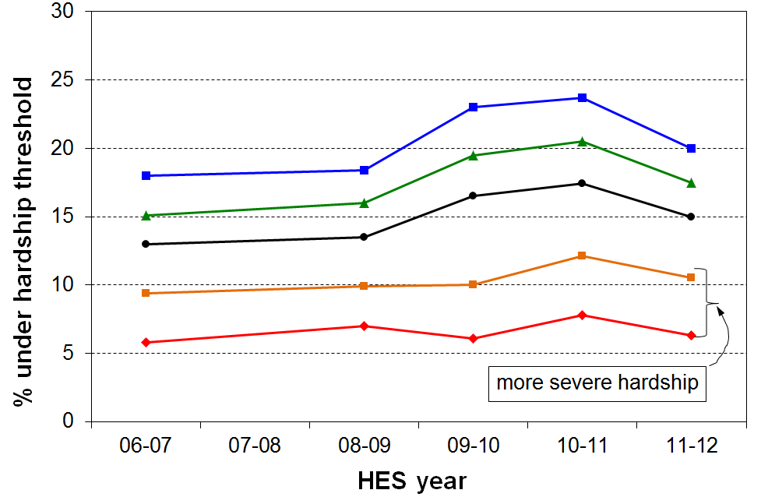

Further analysis is needed before this preliminary finding can be considered to be an established new piece of knowledge. The finding is however supported to some degree by what we know of the composition of the population at different parts of the material wellbeing distribution:
- A large proportion of those in less severe hardship and those “just getting by” are in households where there are adults in paid employment. When employment for the second earner disappears or hours diminish these households feel the pinch very rapidly, as indicated in the top three lines.
- Those in deeper hardship are predominantly those in receipt of a main working-age benefit, with some in working households on low wages. Benefit rates were maintained in real terms during the recession so the deeper hardship rates were more steady.
- The deeper hardship rates could have been expected to rise a little (more than they do), however, as some low-wage jobs disappeared.

The analysis to date is for the population as a whole, and not just families with dependent children.
Impact of Working for Families (WFF)

Table E.1 below shows the change in material hardship rates for children from 2004 to 2008, driven mainly by the introduction of the WFF package. The deprivation index used was a 14-item one, similar to DEP-17. The 7+/14 threshold (bottom row) gives numbers similar to the 9+/17 threshold for DEP-17. The data is from the 2004 and 2008 Living Standards Surveys.

Table E.1
Impact of WFF on child material deprivation rates
threshold  (out of 14) | 2004  (%) | 2008  (%) | decrease  (percentage point)
4+ | 26 | 23 | 3
5+ | 19 | 17 | 2
6+ | 13 | 12 | 1
7+ | 10 | 10 | 0
Note: the 7+/14 threshold is at the “more severe” level, similar to the 9+/17 using DEP-17.
The relevance of the findings in Table E.1 is that they provide further support for the finding implicit in Figure E.1 above – namely, that it is more difficult to improve hardship rates for those in more severe hardship than for those in less severe hardship.
The WFF package was much larger than the Budget 2015 CH package, but the extra financial support in WFF was spread over a much wider income range. Both low-income working families and beneficiary families in private rental accommodation received meaningful increases in financial support through the WFF package.

Section F
Low income and material hardship

The framework used in Section A drew attention to the fact that while household income is an important factor in determining household material wellbeing, other factors are relevant too. It is repeated here for convenience.

Household income
Discretionary spend / desirable non-essentials

Resources available for consumption

Basic needs / essentials
Financial and physical assets

Other factors
eg assistance from outside the household (family, community, state), high or unexpected health or debt servicing costs, lifestyle choices, ability to access available resources

Material wellbeing or living standards

The framework shows how households with the same income can experience quite different actual day-to-day living standards because of different asset levels or because of different sets of “other factors”. It shows why the overlap between a low-income group and those in material hardship is much less than 100% (typically 45 to 55% when the two groups are of similar size and the thresholds used are mid-range), and why any policy-induced increase in income for low-income families has both “coverage” of the Budget 2015 target group (those in more severe material hardship) and “spill-over” to others.

The coverage and spill-over issues are illustrated in the stylised Venn diagrams below. The left-hand circle in each case represents those in households below a given low-income threshold. The right-hand circles in each pair represent those in less and more severe hardship respectively. The degree of overlap shown is in accord with typical analysis of the HES data (see Table F.1 below).
Coverage
Spill-over
Spill-over
Coverage

Deprivation
More severe deprivation
Low income
Low income

The stylised overlap diagrams illustrate several relevant matters:
Low income
- There are a good number of families with income above traditional low-income thresholds (“poverty lines”) who experience material hardship in different degrees, and some below the line who get by.
- For a given income level, the coverage is better for deeper material hardship, though the spill-over is higher too.
- Similarly, for a given hardship level, a higher income threshold gives better coverage but higher spill-over (not illustrated).
The overlap between low-income households and households in hardship increases for deeper hardship levels

The lower chart in Figure F.1 shows that of the 100,000 children in more severe hardship (DEP-17 scores of 9+/17), seven out of ten (69%) are from families with incomes below the 60% of median threshold (after housing costs), compared with 61% when using a less stringent hardship threshold as in the top diagram (7+/17).

Figure F.1
Proportion (%) of children in hardship by family income band
(five “hardship” thresholds)
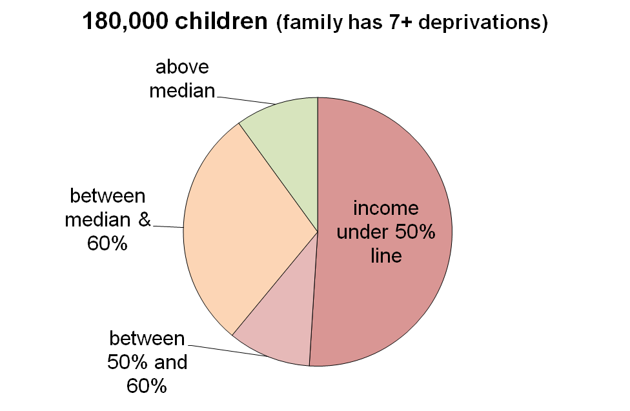
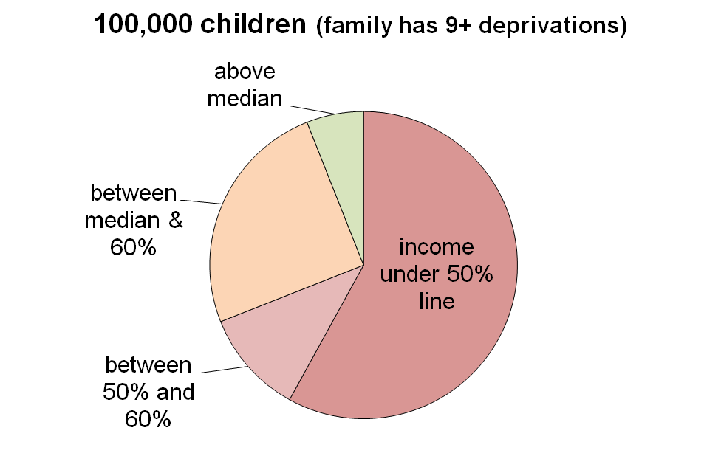
Table F.1 gives more detail for the overlap and spill-over analysis, using five deprivation thresholds and the four income bands. For example, using the 9+ column, 58% are in the coverage zone when a low-income threshold of 50% of the median is used, leaving 42% in the spill-over zone. This means that if the incomes of only those in the under 50% zone were raised, 58% of those in more severe hardship would be covered as well as a good number not in severe hardship (though likely many of these would be in lesser hardship or not far above that).

Table F.1
Proportion (%) of children in hardship by family income band
for five “hardship” thresholds
# of enforced lacks of basics (deprivations) | 6+ | 7+ | 8+ | 9+ | 11+
 | 21% | 17% | 13% | 10% | 6%
# of children | 220k | 180k | 140k | 100k | 60k
income under a 50% of median AHC line | 47 | 51 | 55 | 58 | 58
income between 50% and 60% lines | 9 | 10 | 10 | 11 | 12
income between 60% line and median | 31 | 29 | 27 | 25 | 24
income above the median | 13 | 10 | 8 | 6 | 6

Using longitudinal data: the impact of remaining longer on low income

The longer that households have low income the greater is their risk of (higher) material deprivation

This is not a surprising finding, but it is useful to have it confirmed from analysis of New Zealand longitudinal data from SoFIE (see Figure F.2). It is also worthwhile drawing attention to it, as it is not always to the fore in discussions around poverty and hardship figures.

The relatively flat line for older households reflects the fact that such households often have resources other than current income with which to support consumption for basic needs. This is in line with the income-wealth-consumption-material-wellbeing framework outlined above.

Figure F.2
Increasing material hardship for longer periods on low income
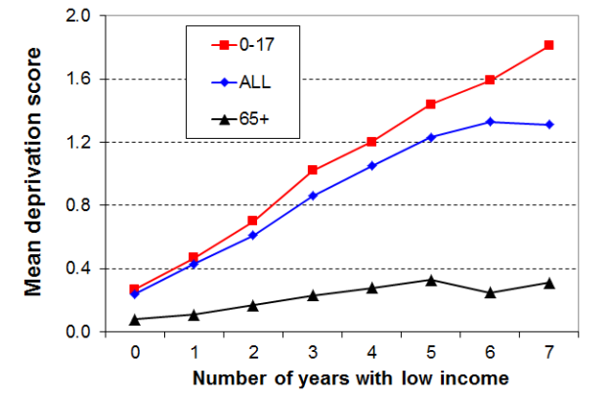
Note: the deprivation index used in this analysis is the 8-item NZiDep – see Section A for more information – and the low-income threshold is 60% of median gross household income (approximately the same as 70% of median disposable income threshold).
Source: Carter and Imlach Gunasekara (2012) via Perry (2014)

The cumulative impact of lower low income leads to higher deprivation

The low-income threshold used in the analysis in Figure F.2 produced poverty rates above the usual cross-sectional ones – that is, it was a relatively generous threshold. When a lower threshold is used, more in line with the 60% BHC cross-sectional threshold, the cumulative impact of on-going lower low income leads to higher reported deprivation, as expected. Figure F.3 shows this for the whole population.

Figure F.3
Higher material hardship for periods on lower low income
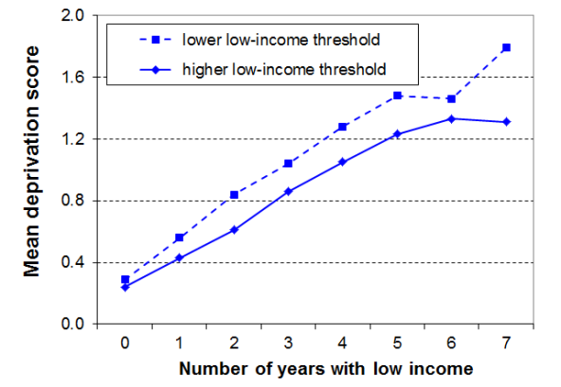
Source: Carter and Imlach Gunasekara (2012) via Perry (2014)

Section G
Monitoring child material hardship

MSD reports on trends in child and population material hardship in a special section in its annual Household Incomes Report (HIR). To date, the trends have been based on the Economic Living Standards Index (ELSI) measure for HES 2006/07 to 2011/12, with the Material Wellbeing Index (MWI) used for the first time in the 2014 HIR, using HES 2012/13 data. In addition, international comparisons have been published using data from the 2008 Living Standards Survey.

Starting with the 2015 Incomes Report MSD (or in a separate report published at the same time) will also report on trends in child material hardship using its new material deprivation index (DEP-17), based on data from Statistics New Zealand’s HES. As discussed in Section D, the ELSI and MWI measures function well as deprivation indices in their low score zones. The advantage of a simple deprivation index like DEP-17 is that it is easier for readers and users to understand.

International comparisons will be able to be updated and kept current using EU-13, as Statistics New Zealand has agreed to add a few more deprivation items to the current suite in the HES to allow this, starting with the 2015/16 HES. The results from this are expected to be available at the time of the 2017 HIR. Comparing internationally using the same non-income items is a very important way of providing a robust assessment of progress.

The suite of child-specific indicators that are available in the 2004 and 2008 Living Standards Surveys have proved very valuable in understanding the particular circumstances of children from families in more severe hardship and those from lower-income families. Statistics New Zealand has agreed to include a suite of around twenty child-specific indicators in the HES, every three years. They are hopeful of being ready to include these items in the 2015/16 HES starting on 1 July 2015. The suite includes almost all those listed in Section D plus a few new ones. This child-specific data will greatly enhance our ability to monitor and understand trends in child material hardship.

What “material hardship line” will the monitoring use?

Households can be ranked on indices such as DEP-17 across the spectrum of hardship from more to less severe. As discussed in Section D, there can be legitimate debate about where to draw the line between those in hardship and those not, just as with income poverty measures.

This report takes the view that while some careful thought needs to go into selecting defensible thresholds, spending great time and effort on a debate about what “the” threshold should be is not that useful, as for one thing, it is never really resolvable. It commends instead an approach that monitors trends using a few thresholds set at different depths of hardship within a plausible range. “Success” would be for all these trend lines to fall. The most at-risk groups can be identified and trends for the population overall and for population groups can be monitored.

The 2019 Household Incomes report

The 2015 Budget package is to be implemented from 1 April 2016. The 2017/18 HES will be the first to pick up a full year’s impact of the package, along with impacts from other factors. This will be reported on in the 2019 Household Incomes Report.

References

Boarini, R., & Mira d'Ercole, M. (2006), 'Measures of material deprivation in OECD countries.' OECD Social, Employment and Migration Working Papers #37, OECD: Paris .
Carter, K. & Imlach Gunasekara, F. (2012). ‘Dynamics of Income and Deprivation in New Zealand, 2002-2009. A descriptive analysis of the Survey of Family, Income and Employment (SoFIE).’ Public Health Monograph Series No. 24. Wellington: Department of Public health, University of Otago, Wellington.
Dickes, P., Fusco, A., & Marlier, E. (2010), 'Structure of national perceptions of social needs across EU countries', Social Indicators Research, 95(1), 143-167.
Gordon et al (2013), ‘The Impoverishment of the UK: PSE first results from the 2012 Living Standards Survey’. PSE Report, available at http://www.poverty.ac.uk/pse-research/pse-uk-reports
Gordon, D. & Nandy, S. (2012) ‘Measuring child poverty and deprivation’. In Minujin, A. and Nandy, S. (Eds) Global child poverty and well-being. Bristol: Policy Press.
Guio, A.-C., Gordon, D., & Marlier, E.(2012), ‘Measuring material deprivation in the EU: Indicators for the whole population and child-specific indicators’, Eurostat Methodologies and Working Papers, OPOCE: Luxembourg.
Guio, A.-C, & Marlier, E. (2013), ‘Alternative vs, current measures of material deprivation at EU level: What difference does it make?’ ImPRovE Paper No. 13/07, Antwerp.
Mack, J., & Lansley, S. (2015), Breadline Britain:The rise of mass poverty, London: One World Publications.
Main, G. & Bradshaw, J. (2014), ‘Child Poverty and Social Exclusion: Final Report of the 2012 PSE Study’, PSE Report, available at http://www.poverty.ac.uk/pse-research/pse-uk-reports
Perry, B. (2009), ‘Non-income measures of material wellbeing and hardship: first results from the 2008 New Zealand Living Standards Survey, with international comparisons.’ Working Paper 01/09, Ministry of Social Development, Wellington.
Perry, B. (2014). Household Incomes in New Zealand: Trends in Indicators of Inequality and Hardship, Ministry of Social Development: Wellington.
Salmond, C., Crampton, P., & Atkinson, J. (2007). NZDep2006 Index of Deprivation.
Salmond, C., King, P., Crampton, P., & Waldegrave, C. (2006), 'NZiDEP: A New Zealand index of socioeconomic deprivation for individuals', Social Science and Medicine, 62(6), 1474-1485.
Shonkoff (2011), “Building a Foundation for Prosperity on the Science of Early Child Development”, Pathways, Stanford University.

Appendix 1

EU-13 and EU-9

Previous MSD research on international hardship comparisons used a 9-item EU index (see Perry, 2009). Hardship rates for New Zealand are very close on both the EU-9 and the new EU-13 indices and country rankings are reasonably similar on both. EU-13 is however a more robust and reliable index. It also allows more reliable comparisons of child hardship rates using both less and more severe hardship thresholds. We can replicate EU-13 for New Zealand to a very good degree from the LSS 2008 data, and will be able to update the comparisons using the enhanced HES datasets from HES 2015/16.

Table 1.1
Composition of EU-13 compared with EU-9
EU-13 | EU-9
Items from EU-9 not used in EU-13
x | phone
x | colour TV
x | washing machine
Items in both EU-9 and EU-13
have a meal with meat, fish or chicken every second day
keep the home adequately warm
have access to a car / van for personal use
avoid arrears in mortgage or rent, utility bills or HP instalments
have one week’s annual holiday away from home
ability to face unexpected expenses of NZD1500
New items in EU-13, but not in EU-9
replace worn-out clothes by some new ones | x
have two pairs of properly fitting shoes | x
replace worn-out furniture | x
spend a small amount of money each week on oneself | x
have both a computer and an internet connection | x
have regular leisure activities | x
have a get together with friends/family for a drink/meal at least monthly | x

Appendix 2

DEP-17 component items and their distribution across DEP-17 scores

Table 2.1
Proportion of population in households whose respondent reported an enforced lack of component items for DEP-17, by DEP-17 score (LSS 2008)
 | ALL | 0 | 1 | 2 | 3 | 4 | 5-6 | 7-8 | 9-10 | 11+
Population % with a given DEP-17 score |  | 46 | 15 | 10 | 7 | 5 | 7 | 5 | 3 | 3
Component items
(see Table D.1 for full descriptions)
meal with meat etc | 2 | 0 | 0 | 0 | 0 | 2 | 4 | 9 | 20 | 29
two pair of shoes | 5 | 0 | 0 | 2 | 4 | 8 | 13 | 17 | 31 | 60
presents | 6 | 0 | 2 | 2 | 4 | 7 | 13 | 23 | 28 | 58
clothes for special occasions | 7 | 0 | 0 | 2 | 4 | 7 | 16 | 23 | 47 | 67
arrears in vehicle bills (reg or WoF) | 9 | 0 | 2 | 5 | 8 | 18 | 28 | 34 | 47 | 73
fruit and vegetables | 10 | 0 | 0 | 6 | 11 | 17 | 25 | 49 | 51 | 78
put up with feeling cold | 10 | 0 | 3 | 3 | 11 | 15 | 27 | 47 | 57 | 75
doctor postponed | 11 | 0 | 2 | 8 | 12 | 20 | 28 | 41 | 53 | 75
arrears in electricity / water | 11 | 0 | 3 | 7 | 16 | 25 | 25 | 44 | 53 | 76
home contents insurance | 12 | 0 | 7 | 14 | 16 | 22 | 30 | 37 | 58 | 67
appliances – repair / replace | 12 | 0 | 0 | 10 | 16 | 20 | 28 | 48 | 64 | 84
borrowed from family or friends | 13 | 0 | 4 | 11 | 22 | 23 | 36 | 44 | 60 | 76
local trips | 15 | 0 | 8 | 19 | 21 | 29 | 38 | 48 | 65 | 77
“very limited” re purchase of clothes or shoes | 19 | 0 | 8 | 20 | 25 | 36 | 55 | 74 | 79 | 94
cannot pay unexpected $500 bill | 19 | 0 | 11 | 21 | 29 | 44 | 51 | 63 | 73 | 92
dentist postponed | 26 | 0 | 26 | 35 | 58 | 58 | 58 | 65 | 69 | 92
meat | 27 | 0 | 23 | 35 | 44 | 52 | 66 | 82 | 89 | 94
Note: proportions <1.5% are suppressed and indicated by “-“.
.

Appendix 3

Validity and reliability of DEP-17

Selection of items and the validity and reliability of DEP-17

Validity is about the index measuring what it claims it measures (material hardship). There is no single test to establish validity – it is built up from a range of evidence.

Table 3.1 uses items from LSS 2008 that are not DEP-17 items, but which are very likely to be strongly associated with material hardship. The information in the table both further fills out the profile for living conditions for the various DEP-17 scores and also provides evidence to support the validity of DEP-17 as measuring what it claims to measure, at least at this clumped level.

The figures in the columns in the body of the table are percentages of those with a given DEP-17 score who report the respective deprivations, financial stress, housing problems, and so on.

The gradients are clear and strong in each case, all showing the expected much greater hardship for those with higher DEP-17 scores, and much lower for those with lower DEP-17 scores. This gives good support not only for the validity of DEP-17 (“concurrent validity”), but also shows that there are clear distinctions in living conditions for those with the higher DEP-17 scores.

Table 3.1
Proportion of population in households whose respondent reported an enforced lack of selected non-component items for DEP-17, by DEP-17 score (LSS 2008)
DEP-17 score | 0 | 1 | 2 | 3 | 4 | 5-6 | 7-8 | 9-10 | 11+ | ALL
Population % with a given DEP-17 score | 46 | 15 | 10 | 7 | 5 | 7 | 5 | 3 | 3
good bed for respondent(enforced lack) | 0 | 2 | 3 | 9 | 8 | 11 | 13 | 27 | 44 | 5
attend funeral / tangi (enforced lack) | 0 | 1 | 2 | 7 | 10 | 13 | 21 | 23 | 45 | 21
hairdresser once every three months (enforced lack) | 1 | 4 | 9 | 14 | 19 | 32 | 39 | 58 | 61 | 12
a night out at least once a fortnight (enforced lack) | 4 | 14 | 23 | 25 | 32 | 40 | 46 | 52 | 67 | 18
used food bank (more than once in previous 12 mnths) | 0 | 1 | 1 | 3 | 8 | 11 | 19 | 23 | 38 | 4
pawned goods to get cash for necessities (more than once in previous 12 mnths) | 1 | 2 | 5 | 6 | 7 | 11 | 22 | 32 | 40 | 6
small amt of money for self each week (up to $10)? (no) | 6 | 15 | 20 | 22 | 22 | 29 | 48 | 54 | 67 | 17
major problem with draughts in accommodation | 3 | 8 | 10 | 13 | 16 | 19 | 26 | 41 | 48 | 11
major problem with damp and mould in accommodation | 3 | 7 | 12 | 16 | 20 | 28 | 41 | 33 | 54 | 12
house too small | 3 | 6 | 8 | 8 | 15 | 16 | 24 | 27 | 32 | 8
self-rated physical quality of house – poor or very poor | 1 | 3 | 5 | 6 | 7 | 8 | 20 | 20 | 35 | 5
crime/vandalism in area (major problem) | 4 | 6 | 8 | 10 | 14 | 15 | 18 | 25 | 31 | 8
self-rated material standard of living (low / very low) | 1 | 4 | 7 | 9 | 16 | 23 | 35 | 47 | 44 | 9
self-rated health, poor or fair (<65) | 8 | 11 | 15 | 18 | 24 | 30 | 43 | 45 | 62 | 17
dissatisfied / very dissatisfied with life (from HES) | 3 | 5 | 6 | 10 | 21 | 13 | 22 | 39 | 49 | 9

The strong gradients in Table 3.1 raise the question – “if these items show the gradients so clearly why are they not in DEP-17?”

The simplest response is that an index with a large number of items becomes unwieldy and very unattractive to use in surveys (crowding out of other items given a fixed time budget for survey length). There has to be some rationing of items, so some good items are inevitably left out.

The more substantial rationale has to do with maintaining the integrity and validity of the index. For example, while the items in Table 3.1 show clear gradients at the clumped level of each DEP-17 score, they may not meet the required criteria at the household level. Also, an item may not be appropriate or relevant for all sub-groups (eg hair cut for those without hair), an item may not be wanted by the vast majority (eg 32% of respondents either did not want a night out each fortnight, or had a reason other than cost for not doing so), or the item may not pass the factor analysis test for being sufficiently correlated with the rest of the items (eg house has a major problem with draughts).

The concurrent validity can be examined another way. The conceptual opposite of an enforced lack or of a forced economising (“a lot”) is a freedom to consume. Table 3.2 shows the gradient for cumulative freedoms out of a list of 12 (these include: having a holiday away from home each year for at least a week, having an overseas holiday every three years; never having to economise or spend less than desired on meat, fruit and vegetables, hobbies, repairing/replacing furniture and appliances; no restriction when considering a spot purchase of a non-essential $250 item; can easily find $2000 for an unexpected bill, and so on ).

Table 3.2
Proportion of population in households whose respondent reported multiple “freedoms to consume”,
by DEP-17 score (LSS 2008)
DEP-17 score | 0 | 1 | 2 | 3 | 4 | 5-6 | 7-8 | 9-10 | 11+ | ALL
Population % with a given DEP-17 score | 46 | 15 | 10 | 7 | 5 | 7 | 5 | 3 | 3
4+ ‘freedoms’ from a list of 12 | 97 | 82 | 69 | 53 | 46 | 26 | 13 | 6 | 0 | 72
6+ ‘freedoms’ from a list of 12 | 87 | 58 | 35 | 21 | 12 | 9 | 2 | 0 | 0 | 54
8+ ‘freedoms’ from a list of 12 | 68 | 27 | 11 | 5 | 3 | 0 | 0 | 0 | 0 | 36

Tables 3.3A and 3.3B shows the decile distribution of the “not enough income” and the “not enough” / “only just enough income” responses for households with different levels of material wellbeing. The material wellbeing rankings for households are done in two ways: first, using MSD’s Material Wellbeing Index (MWI) and, second, using household disposable income adjusted for household size and composition (equivalised).

Table 3.3A
Proportion of population in households whose respondent reported “not enough income” for basics of food, accommodation, clothing, other necessities, by deciles (HES 2012/13):
comparisons for the material wellbeing ranking done by the MWI and by household income
Decile | 1 | 2 | 3 | 4 | 5 | 6 | 7 | 8 | 9 | 10 | ALL
MWI | 70 | 40 | 25 | 16 | 6 | 4 | 3 | 3 | 1 | 0 | 16
Household income (equivalised disposable) | 42 | 34 | 30 | 21 | 13 | 9 | 6 | 5 | 2 | 1 | 16

Table 3.3B
Table 3.3A repeated for “not enough” or “only just enough” income
Decile | 1 | 2 | 3 | 4 | 5 | 6 | 7 | 8 | 9 | 10 | ALL
MWI | 97 | 85 | 76 | 62 | 42 | 41 | 27 | 20 | 11 | 4 | 46
Household income (equivalised disposable) | 76 | 71 | 62 | 62 | 48 | 39 | 37 | 29 | 25 | 10 | 46
Reading note for Tables 3.3A and B: the response options for the question in the HES are: not enough, only just enough, enough, more than enough.

The expected gradients from low to high material wellbeing are clear. The distribution is however much more tightly bunched at the lower end when the MWI is used rather than household income. Using the framework outlined in Section A, the more bunched low end using MWI rankings reflects the fact that respondents are highly likely to take as a given both their stock of household goods and appliances, and also the “other” factors that assist or place extra demand on the household budget. In other words, the response is an intelligent one about the adequacy of household income given their particular circumstances. MWI scores reflect the impact on living standards of these other factors as well as that of the household income, whereas household income is a more indirect measure of material wellbeing, a proxy that cannot take account of other key factors.

As with any evidence for validity, this does not prove it for MWI (and DEP-17), but it does add strong support to the case.

Reliability

DEP-17 shows a more than satisfactory level of reliability (internal consistency), using Cronbach’s alpha. For indices of this sort a Cronbach’s alpha of 0.7 to 0.8 is considered respectable, and 0.8 to 0.9 is very good. DEP-17 has an alpha of 0.87, with very good scores for sub-groups as well. The EU-13 scores are given for comparison.

Table 3.4
Cronbach’s alpha for DEP-17 and EU-13 (LSS 2008)
 | DEP-17 | EU-13
Whole population | 0.87 | 0.78
0-17 yrs | 0.84 | 0.76
65+ yrs | 0.84 | 0.74
Maori | 0.86 | 0.76
Rural | 0.87 | 0.76

Challenges for both the income and non-income (material deprivation) approaches

For measuring and monitoring material wellbeing at a household level the more direct approach using deprivation indicators / non-income measures has many advantages over the use of household income. For example: it captures the impact on a household’s material living standards of income levels and all the other factors that come into play (financial and physical assets, special demands on the family budget, help from outside the household, and so on); it gives a tangible grounded picture of what life is like for those in different degrees of hardship.

The limitations of household income as a measure of household material wellbeing are well-documented and well-understood. These apply even when using income for analysis within a country. For international comparisons, the use of household income is seriously limited, especially when compared with the relative robustness of using the same material deprivation index across countries.

Deprivation or material hardship indices have their challenges too. The most obvious one is the opportunity that exists for respondents to interpret questions differently and therefore to introduce “noise” to the indices. This undoubtedly occurs, but the way that quite different indices (sets of items) produce very similar rankings of households is an encouraging sign. Another challenge, when using “enforced lacks” (items not possessed “because of the cost”), is that there is some evidence of “adaptive preferences” having an impact on responses – for example, some older respondents adapt to their circumstances and say that they do not have an item because they do not want it, rather than for costs reasons. This approach no doubt helps maintain a sense of dignity and being in control of one’s life, even though a more objective assessment of household circumstances may be less optimistic.. This issue is addressed in part by also using other types of items that are not as susceptible to this limitation.

There is noise and limitation in any measurement of this sort (whatever the approach), but there is no evidence to suggest that the findings in this report are compromised by such matters. It is only when the data is pushed to yield too much detailed analysis or precision that issues arise.

Appendix 4

Using MWI as a reasonable proxy for DEP-17

These two tables support the use of MWI as a proxy for DEP-17 at the hardship end of the DEP-17 range (7+ and higher).

Table 4.1
Using DEP-17 to rank households
Multiple deprivation for children aged 6-17 years, LSS 2008
Multiple deprivation – using 20 items: 12 child-specific items and 8 general household items
 | 0-1 | 2 | 3 | 4 | 5-6 | 7-8 | 9-10 | 11+ | All
Distribution of children (6-17yrs) across DEP-17 (%) | 47 | 11 | 10 | 6 | 9 | 7 | 4 | 6 | 100
5+ out of 20 | 0 | 0 | 0 | 4 | 13 | 53 | 72 | 98 | 14
6+ out of 20 | 0 | 0 | 0 | 4 | 8 | 35 | 60 | 95 | 11
7+ out of 20 | 0 | 0 | 0 | 0 | 3 | 25 | 43 | 78 | 8
8+ out of 20 | 0 | 0 | 0 | 0 | 2 | 18 | 24 | 70 | 7
9+ out of 20 | 0 | 0 | 0 | 0 | 0 | 8 | 10 | 56 | 4
10+ out of 20 | 0 | 0 | 0 | 0 | 0 | 6 | 5 | 47 | 3
avg number of deprivations out of 20 | 0 | 0 | 0 | 2 | 3 | 5 | 6 | 10 | 1.9
Reading note: any cell with under 1.5% is reported as zero.

Table 4.2
Using the MWI to rank households as a proxy for using DEP-17
Multiple deprivation for children aged 6-17 years, LSS 2008
Multiple deprivation – using 20 items: 12 child-specific items and 8 general household items
 | 0 | 1 | 2 | 3 | 4 | 5-6 | 7-8 | 9-10 | 11+ | All
Distribution of all children (0-17 yrs) across DEP-17 (%) | MWI does not work as a proxy for DEP-17 for these lower scores |  |  |  |  | 11 | 8 | 4 | 6 | 100
Distribution of children (6-17yrs) across DEP-17 (%) |  |  |  |  |  | 10 | 8 | 4 | 6 | 100
5+ out of 20 | 0 | 0 | 0 | 1 | 2 | 11 | 42 | 72 | 94 | 14
6+ out of 20 | 0 | 0 | 0 | 0 | 1 | 7 | 29 | 61 | 91 | 11
7+ out of 20 | 0 | 0 | 0 | 0 | 0 | 3 | 21 | 44 | 72 | 8
8+ out of 20 | 0 | 0 | 0 | 0 | 0 | 0 | 14 | 31 | 61 | 7
9+ out of 20 | 0 | 0 | 0 | 0 | 0 | 0 | 5 | 21 | 49 | 4
avg number of deprivations out of 20 | 0 | 0 | 0 | 2 | 3 | 4 | 5 | 6 | 10 | 1.9

Table 4.3 (=D.6)
20 items used for calibrating DEP-17 for school-aged children (aged 6-17 yrs)
Child-specific items | General household items
- warm winter clothes for each child  - two pairs good shoes for each child  - waterproof coat for each child  - children continued wearing worn out clothes and shoes  - separate bed for each child  - separate bedroom for older and opposite sex children  - able to have friends to birthday party  - each child has all school uniform required by school(s)  - able to pay for school trips for each child  - able to attend music, dance, art and swimming lessons  - sport participation  postponed doctor for children | - could not keep main rooms warm  - cut back or went without fresh fruit and vegetables “a lot”  - delayed repair or replacement of appliances (“a lot”)  - late payment of vehicle wof /reg (more than once in last year)  - late payment of electricity / water / gas (more than once)  - received help from food bank or other community group (more than once)  - dampness or mould in dwelling (major problem)  - crime/vandalism in the area (major problem)
Note: the 4 shaded items are also in DEP-17

Although there would be a difference of views on just what that minimum acceptable level would be, albeit most judgement calls would lie within a relatively narrow range .
Examples of the 12 child specific items are: no waterproof coat, no warm winter clothes, no separate bed, incomplete school uniform, unable to have friends to birthday party, participation in sport restricted “a lot” (because of lack of money or the need to use available money for other basics). Examples of the 8 general household deprivations: inability to keep main rooms warm, dampness and mould a major problem, received help with food / clothes from a food bank or community group more than once in last 12 months (same reasons as for child items). See Section D for more detail.
In this context, a correlate is a characteristic sometimes or often found to be present among families with low income or experiencing material hardship (eg lower educational attainment).
In 2009, MSD published findings based on the 2008 Living Standards Survey. This included a prototype 14-item deprivation index which was used in the evaluation of the impact of the Working for Families package (Perry, 2009). DEP-17 is a refreshment and further development of the 14-item index using 17 indicators, all of which are now available on a regular basis from the Household Economic Survey (HES), starting in 2012/13.
These figures are for a 60% of median poverty line (2012 EU-SILC data). See also MSD’s 2014 Household Incomes Report (Section J), and Perry (2009) for more on the limitations of household income measures for international comparisons of poverty rates.
Guio, Gordon and Marlier (2012), and Guio and Marlier (2013).
For each country, the amount is set at a suitable value close to (±5%) the per month national income poverty line (60% of median) for the one person household. There is no adjustment for household size or composition.
Dickes et al (2010) for the EU as a whole; Gordon et al (2013), and Mack and Lansley (2015) for the UK.
The OECD has published findings from some preliminary investigations they carried out on measures of material deprivation in OECD countries, doing the best they could given the data gaps and comparability issues they faced for non-EU nations (see Boarini and Mira d’Ercole (2006) and OECD (2008)). In Canada, Ontario has developed a 10-item deprivation index which was incorporated into Statistics Canada’s Survey of Labour and Income Dynamics in 2009.
See MSD’s 2014 Household Incomes Report, Section K, for more on the MWI.
See Appendix 4 for some evidence for this.
See Appendix 3 for analysis which gives a profile across DEP-17 scores using items not in DEP-17 (such as housing conditions, self-rated health and life satisfaction). The information there also provides evidence to support the validity of DEP-17 as measuring what it claims to measure.
Further internal review of the SAS coding and analysis used in the preliminary advice to Ministers has led to minor changes in some of the numbers in Table D.4 compared with the original. The table below notes the differences (original numbers in brackets). The changes to the SAS coding also had some minor flow-on impacts for some other tables (eg Tables D.8 and D.9). The policy implications of the key findings and messages are not affected. DEP-17 score 6+ 7+ 8+ 9+ 10+ 11+ 0-17 yrs (%) 21 (23) 17 (18) 13 (14) 10 8 6 # of children 220k (240k) 180k 140k (150k) 100k 80k `60k # of households with children 110k (120k) 90k 70k (75k) 50k 40k 30k
See Gordon and Nandy (2012) and Main and Bradshaw (2014) for a child deprivation index for the UK using a mixed item approach.
See Tables C.3, C.5 and D.3 above, and the more detailed comparison in Table D.11 below.
See n13 above.
See n13 above.
For example: items need to cover a range of domains and a range of hardship depths; items need to be applicable to all age groups and to both market income and state income households; preferably 10 or more items; and some sort of factor analysis to check that the same underlying notion is being reasonably well reflected by the selected items in the indicator set.
The set of indicators was changed in 2012-13, with around half being dropped and a similar number of new ones added. MSD is currently working on options to enable a valid material hardship time series from 2006-07 to 2013-14 and beyond to be reported in a fuller report later in 2015. The HES 2013-14 data was not available for MSD at the time the child material hardship advice was being provided for the consideration of a Budget 2015 package.
See Perry (2009), pp42ff, for a discussion of FRILS, a version of ELSI that is more robust for over time measurement. The introduction of the MWI and DEP-17 mean that FRILS will not be needed from HES 2012-13 on.
The 2008 LSS has the items for ELSI, MWI and DEP-17 in it. MSD analysis of the 2008 LSS shows that the lower end of ELSI and of MWI are good proxies for DEP-17 for the bottom quintile. See Appendix 4.
The first row in Table E.1 is from Perry (2009) Table C.11. The other rows are from later analysis using the same methodology but a range of other thresholds.
For each country, the amount is set at a suitable value close to (±5%) the per month national income poverty line (60% of median) for the one person household. There is no adjustment for household size or composition.

