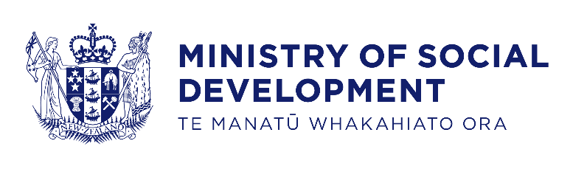
Changes to the management of Job and Training Support Funds
We would like to let you know of an upcoming change to the administration and management of Job and Training Support Funds currently managed by Workbridge.
MSD and Workbridge have mutually agreed the administration and management of these funds will go back to MSD. The funds will transition from Workbridge to MSD during the first quarter of 2023.
MSD and Workbridge will be working closely together to ensure a smooth and seamless transition. We want to reassure everyone that the Support Funds programme will continue.
For more information please contact sftransition@msd.govt.nz
For enquiries regarding your current support or Support Fund applications contact Workbridge via https://supportfunds.co.nz or call 0508 967 527.

End of information: Changes to the management of Job and Training Support Funds

